
HYDROLOGICAL MODELLING OF NITRATE LOADING OF ASEJIRE DAM
BY
KEHINDE JOSEPH BAMIDELE
HND/23/CEC/FT/0128

SUBMITTED TO THE DEPARTMENT OF CIVIL ENGINEERING, INSTITUTE OF TECHNOLOGY, KWARA STATE POLYTECHNIC, ILORIN

IN PARTIAL FULFILMENT OF THE REQUIREMENT FOR THE AWARD OF HIGHER NATIONAL DIPLOMA (HND) IN CIVIL ENGINEERING

JUNE, 2025

DECLARATION
I, Kehinde Joseph Bamidele, hereby declare that this project report titled “Hydrological Modelling of Nitrate Loading of Asejire Dam” was written by me and is a record of my personal research work. It has not been presented in any previous application for a diploma or degree at any other institution. All references and sources used in this work are duly acknowledged.
___________________________
Student's Signature & Date

CERTIFICATION
This is to certify that this research study was conducted by Kehinde Joseph Bamidele HND/23/CEC/FT/0128 and had been read and approved as meeting the requirement for the award of Higher National Diploma (HND) in Civil Engineering of the Department of Civil Engineering, Institute of Technology, Kwara State Polytechnic, Ilorin.

……………………………………. …………………………..
ENGR. A. SANNI DATE
Project Supervisor

……………………………………. …………………………..
ENGR. A. NAALLAH DATE
Head of Department

……………………………………. …………………………..
ENGR. DR. MUJEDU KASALI ADEBAYO DATE
External Examiner

DEDICATION
This project is dedicated to Almighty God for His infinite mercy and guidance throughout the course of this work. Special dedication also goes to my beloved parents and family for their unwavering support, encouragement, and prayers.

ACKNOWLEDGEMENT
I begin by expressing my deepest gratitude to the Almighty God, who has blessed me with the wisdom, strength, and resilience to complete this project.
I extend my sincere appreciation to my project supervisor, Engr. A. Sanni, for his invaluable guidance, support, and encouragement throughout this journey. His expertise and constructive feedback were instrumental in shaping this project.
To my family, I express my heartfelt gratitude for their unwavering support and love. My parents, Mr. and Mrs. Dayo Abel Bamidele , who inspired me to choose this interesting course who motivated me to make this milestone a success, thank you for being a constant source of motivation, encouragement, and financial support. I appreciate your love.
To my beloved Sisters and my brothers, thank you for your patience, understanding, and support. You are my rock, and I am grateful for your love.
I also acknowledge the entire staff of the Department of Civil Engineering at Kwara State Polytechnic, Ilorin, for their dedication, enlightenment, and support towards the success of my academics.
To my friends and colleagues, I appreciate your encouragement, advice, and camaraderie
Thank you all for being part of my journey.

TABLE OF CONTENTS

TITLE PAGE i
DECLARATION ii
CERTIFICATION iii
DEDICATION iv
ACKNOWLEDGEMENT v
TABLE OF CONTENTS vi
ABSTRACT viii
CHAPTER ONE 1
1.1 INTRODUCTION 1
1.2 PROBLEM STATEMENT 4
1.3 AIM AND OBJECTIVES 5
1.4 SIGNIFICANCE OF THE STUDY 5
1.5 SCOPE OF THE STUDY 5
CHAPTER TWO 6
LITRATURE REVIEW 6
2.1 OVERVIEW OF NITRATE POLLUTION IN WATER BODIES 6
2.2 SOURCES OF NITRATE POLLUTION 6
2.3 HYDROLOGICAL MODELLING IN WATER QUALITY STUDIES 6
2.4 NITRATE TRANSPORT MECHANISMS 7
2.5 PREVIOUS STUDIES ON NITRATE POLLUTION AND HYDROLOGICAL MODELING 7
2.6 HYDROLOGIC MODELLING 10
CHAPTER THREE 11
METHODOLOGY 11
3.1 STUDY AREA DESCRIPTION 11
3.2 MODEL SELECTION 12
3.3 MODELING TOOL AND GIS INTERFACE 14
3.4 MODEL INPUT DATA COLLECTION PROCESSING 15
3.5 WATERSHED DELINEATION IN SWAT 19
3.6 WATERSHED DELINIATION INTO SUB BASINS AND HYDROLOGICAL RESPONSE UNITS (HRUS) 19
3.7 SWAT SETUP AND RUN 20
CHAPTER FOUR 22
RESULT AND DISCUSSION 22
4.1 DEVELOPMENT OF HYDROLOGICAL MODEL TO SIMULATE NITRATE AND FLOW 22
4.2 SPATIAL VARIATION OF NITRATE CONCENTRATION AND FLOW 23
4.3 ESTIMATION OF TOTAL NITRATE AND FLOW IN THE WATERSHED 26
CHAPTER FIVE 30
CONCLUSION AND RECOMMENDATION 30
5.1 CONCLUSION 30
5.2 RECOMMENDATIONS 30
REFERENCES 32

ABSTRACT
This study presents a hydrological assessment of nitrate loading in the Asejire Dam watershed using the Soil and Water Assessment Tool (SWAT). The study aimed to develop a hydrological model to simulate streamflow and nitrate transport, estimate total nitrate flow, and evaluate spatial variation across the watershed. The model incorporated Digital Elevation Models (DEM), soil and land use data, and meteorological inputs from 2001 to 2019. Results revealed significant spatial variation in both streamflow and nitrate loading across 79 delineated sub-basins. Sub-basins with intensive agricultural activities and high runoff rates contributed disproportionately to the overall nitrate burden. The total nitrate load in the watershed was estimated at approximately 56.5 million kilograms, with peak flows exceeding 1300 m³/s in certain sub-basins. The study concludes that the SWAT model is a reliable tool for assessing watershed-scale nitrate pollution and provides a foundation for future water quality management, especially in nitrate-sensitive regions like Asejire Dam.

CHAPTER ONE

1.1 INTRODUCTION
Water is an essential resource for human survival and ecological sustainability. The presence of nitrates in water bodies has become a significant environmental concern due to its potential health hazards, including methemoglobinemia (blue baby syndrome) and eutrophication, which can lead to excessive algal blooms. Asejire Dam, a critical water reservoir in Nigeria, supplies water for domestic, agricultural, and industrial purposes. However, nitrate contamination from agricultural runoff, wastewater discharge, and other anthropogenic sources has raised concerns about water quality and ecosystem health.
According to Gayathri et al. (2015), a model is a simplified representation of real-world system. The best model is the one which give results close to reality with the use of least parameters and model complexity. Models are mainly used for predicting system behaviour and understanding various hydrological processes. A model consists of various parameters that define the characteristics of the model.
Hydrology can be treated as an important subject for the people and their environment. It treats water of the earth, their occurrence, circulation and distribution, their chemical and physical properties and their reaction with the environment including their relation to living things . It also deals with the relationship of water with the environment within each phase of hydrologic cycle. Due to rapid urbanization and industrialization including deforestation, land cover change, irrigation, various changes have been occurred in hydrologic systems (Gayathri et al., 2015). This study employs hydrological modeling to assess the nitrate loading in Asejire Dam, providing insights into its sources, transport pathways, and potential management interventions.
Asejire Dam, situated in oyo State, Nigeria, plays a critical role in providing water for irrigation, domestic use, and hydroelectric power generation. With increasing pressures from agricultural activities and urbanization, the integrity of this vital water resource has come under threat. One of the primary concerns is the loading of nitrates into the reservoir, which poses significant risks to water quality, aquatic ecosystems, and human health. Understanding both hydrologic processes and nitrate loading is essential for effective management of water resources in this region. Water resources are critical for sustaining ecological balance, supporting agricultural activities, and meeting the demands of growing populations. In this context, the Asejire Dam, located in Nigeria, plays a vital role in regulating water flow and managing resources for irrigation, hydroelectric power generation, and local water supply. However, the increasing pressure from agricultural runoff, urbanization, and climate variability poses challenges associated with water quality deterioration, particularly concerning nitrate loading.
A watershed is a geographic area where all water drains to a common point, whether a stream, river, or lake. Water moves through a network of drainage pathways, including surface runoff and groundwater flow. Watershed delineation, the process of defining watershed boundaries, is crucial in understanding hydrological dynamics. Using Digital Elevation Models (DEMs), Geographic Information Systems (GIS), and hydrological models, researchers can accurately assess water flow patterns and pollutant distribution.
Watershed is the area of land that drains down slope to the lowest point of terrain. The water moves by gravity means in a network of drainage pathway that maybe underground or on the surface into a specified body of water, river or stream. Although there are many ways for water to enter a stream, much of it will enter as run-off from the land. This land is what forms the stream watershed. However, in some regions, the water drains to a central depression such as a lake or Marsh with no surface water exists. It’s possible to delineate watershed boundaries manually using a topographic map that shows stream channels, or contour plots. The watershed boundaries will follow major ridges lines around the channel and meet at the bottom where the water flows out of the watershed, commonly referred to as mouth of the stream or river. In contour plots, droplets of water usually travel along lines normal to the contour lines down the hills. As the ground retains water for longer periods, more water will reach the downstream mouth of the area. Delineation and analysis of watershed can be performed in many forms according to the needs of the user and available resources. There is a dozen of methods for collecting DEM data such as field surveying, aerial photogrammetry, laser scanning, GPS and others. Each method has its own advantages and disadvantages and the created DEM inherent varying degrees of errors (Rasheed, S. A, 2013).
The Soil and Water Assessment Tool (SWAT) is widely used for simulating hydrological processes, sediment transport, and pollutant distribution within watersheds. SWAT employs a water balance approach, dividing a drainage basin into sub-basins and further into Hydrologic Response Units (HRUs). These units help in understanding how land use, soil properties, and topography influence water movement and pollutant loading. The SWAT model allows the simulation of hydrologic, sediment, and pollutants processes as well as crop growth and management practices in a watershed by using the water balance approach. The SWAT operates by first dividing the drainage basin into sub-basins. Each sub-basin is further partitioned into a number of hydrologic response units (HRUs). These are distinctive topography-soil–land use combinations. The simulations for each HRU are subsequently aggregated for the sub-basin by a weighted mean. Neitsch et al., 2011) documentation provides a detailed model functioning literature.
Modern agricultural practices involve extensive use of nitrogen-based fertilizers to enhance crop yields. However, inefficient application often results in excess nitrogen leaching into groundwater and surface water bodies. This nitrate loading contributes to environmental issues at local, regional, and global scales. Understanding hydrological processes and nitrate transport is crucial for developing effective pollution control measures.
In modern agriculture, intensive fertilizer applications are used to maintain optimum yields. However, the high application rates of nitrogenous fertilizer and the low efficiency associated with its use mean that superfluous nitrogen (N) remains in the soil. This excess nitrogen could eventually move from the soil into the atmosphere or into water bodies. This source of nitrogen loading has produced a series of environmental problems at the local, regional or global scales. Nitrate is a primary contaminant of freshwater systems, often originating from agricultural practices, such as excessive fertilizer application and livestock waste. Once in water bodies, nitrates can lead to eutrophication—a process that depletes oxygen levels in water, harms aquatic life, and poses health risks to humans. Understanding the dynamics of hydrologic processes and nitrification is crucial for effective water resource management, particularly in regions that serve multifunctional roles. (Ahtiainen et. al. 2015).

1.2PROBLEM STATEMENT
The rising nitrate concentrations in Asejire Dam pose a significant threat to water quality, aquatic biodiversity, and public health. Although periodic monitoring of water quality has been conducted, there is limited research focused on the hydrological processes responsible for nitrate transport and retention within the dam’s watershed. A comprehensive hydrological modeling approach is required to accurately assess the sources, transport mechanisms, and impacts of nitrate pollution. Understanding the dynamics of nitrate loading through hydrological modeling is essential for effective water resource management and pollution control.

1.3AIM AND OBJECTIVES
The aim of this study is to apply hydrological modeling techniques to analyze nitrate loading in Asejire Dam. The specific objectives are:
- Developing a hydrological model to simulate nitrate and flow in the study area
- Analyze the spatial variation of nitrate flow in the study area
- Estimate the total nitrate flow in the watershed

1.4 SIGNIFICANCE OF THE STUDY
This research provides valuable insights into nitrate pollution dynamics in Asejire Dam, offering data-driven recommendations for water resource management. Findings from this study will benefit policymakers, environmental agencies, and researchers by informing strategies for sustainable water quality management and pollution control.

1.5 SCOPE OF THE STUDY
The study focuses on Asejire Dam and its catchment area, assessing nitrate sources, transport mechanisms, and seasonal variations and also the application of SWAT in Asejire Dam Watershed. The research encompasses watershed delineation, hydrological modeling, nitrate loading assessment, and scenario analysis of land management practices.

CHAPTER TWO

LITRATURE REVIEW

2.1 OVERVIEW OF NITRATE POLLUTION IN WATER BODIES
Nitrate contamination is a global concern, primarily resulting from agricultural activities, wastewater discharge, and atmospheric deposition. High nitrate levels can lead to ecological disruptions, including eutrophication and hypoxic conditions in aquatic ecosystems.

2.2 SOURCES OF NITRATE POLLUTION
- Agricultural runoff (fertilizers and manure)
- Industrial and domestic wastewater
- Atmospheric deposition
- Soil nitrogen mineralization

2.3 HYDROLOGICAL MODELLING IN WATER QUALITY STUDIES
Hydrological models simulate water movement and pollutant transport within watersheds. Common models include:
- SWAT (Soil and Water Assessment Tool): Predicts the impact of land use and management on water quality.
- MIKE SHE: An integrated model for simulating hydrological processes.
- HEC-HMS (Hydrologic Modeling System): Used for rainfall-runoff simulation.

2.4 NITRATE TRANSPORT MECHANISMS
Nitrate transport occurs through various pathways, including:
- Surface runoff
- Subsurface flow
- Groundwater discharge
- Atmospheric deposition

2.5 PREVIOUS STUDIES ON NITRATE POLLUTION AND HYDROLOGICAL MODELING
Several studies have demonstrated the application of hydrological models in assessing nitrate dynamics. Research findings highlight the role of land use changes, climate variability, and anthropogenic activities in influencing nitrate loading.
Mohammad et al., (2007) work on the modeling nitrate contamination of groundwater in agricultural, the framework utilizes the national land cover database (NLCD) of the United State Geological Survey (USGS) grid and a geographic information system (GIS) to account for the spatial distribution of on-ground nitrogen sources and corresponding loadings. The framework employs a soil nitrogen dynamic model to estimate nitrate leaching to groundwater. These estimates were used in developing a groundwater nitrate fate and transport model. The framework considers both point and non-point sources of nitrogen across different land use classes. The methodology was applied for the Sumas–Blaine aquifer of Washington State, US, where heavy dairy industry and berry plantations are concentrated. Simulations were carried out using the developed framework to evaluate the overall impacts of current land use practices and the efficiency of proposed protection alternatives on nitrate pollution in the aquifer watersheds.
Baonanet al., (2019) investigate the effect of hydrogeological conditions and surface loads on shallow groundwater nitrate pollution, Nitrate pollution in groundwater has become a widespread problem worldwide, but understanding of the factors influencing groundwater nitrate pollution remains limited. Numerous studies have attributed nitrate pollution mostly to surface conditions and have neglected the role of hydrogeology. Therefore, this study used the Shaying River Basin as the study area and developed a least squares surface fitting (LSSF) model to systematically analyze the effect of hydrogeological conditions and surface pollution loads on groundwater nitrate pollution. Intrinsic vulnerability and total soil nitrogen (TSN) were used to represent hydrogeological conditions and surface pollution loads, respectively. The results showed that the concentrations of NO –N in shallow groundwater ranged from 0.002 to 256.29mg/L (with an average of 14.38mg/L). The concentration had an overall decreasing trend along the flow path. These findings provide helpful information for those tasked with managing and controlling groundwater quality.
Chau &Chatpet (2019) examine the hydrological and nitrate loading modeling of watershed. Water pollution is largely associated with the growth of agriculture, urbanization, and industrialization, non-point sources area approximately covered 89% of the total area, those sources became the significant contributors of water pollutants. Water quality researches of the watershed were carried out with many different watershed models, but the SWAT model has not been applied to allot the pollutant loading from diffuse sources. Therefore, the main objective of this study is to apply the SWAT model to simulate flow and nitrate. The results of the study can be a useful tool for the management of surface water resources.
Deng et al., (2011) work on Modeling nitrogen loading in a small watershed in southwest China using a DNDC model with hydrological enhancements, the degradation of water quality has been observed worldwide, and inputs of nitrogen (N), along with other nutrients, play a key role in the process of contamination. The quantification of N loading from non-point sources at a watershed scale has long been a challenge. Process based models have been developed to address this problem. Because N loading from non-point sources result from interactions between biogeochemical and hydrological processes, a model framework must include both types of processes if it is to be useful.
Gayathri et al. (2015), review on hydrological models. It was argued that even complex modeling does not provide better results. Climate change and soil heterogeneity has got an important role in finding out surface runoff. This research discusses briefly about variable infiltration capacity model (VIC), TOPMODEL, HBV, MIKESHE and soil and water assessment tool (SWAT) model. VIC performs well in moist areas and can be efficiently used in the water management for agricultural purposes. Requirement of large data and physical parameters makes the use of MIKE SHE models limited to smaller catchments. Only a little direct calibration is required for SWAT model to obtain good hydrologic predictions. HBV model gives satisfactory results and TOPMODEL can be used in catchments with shallow soil and moderate topography.
Baonanset al. (2019) work on effect of hydrogeological conditions and surface loads on shallow groundwater nitrate pollution in the Shaying river basin.Nitrate pollution in groundwater has become a widespread problem worldwide, but understanding of the factors influencing groundwater nitrate pollution remains limited. Numerous studies have attributed nitrate pollution mostly to surface conditions and have neglected the role of hydrogeology. Therefore, this study used the Shaying River Basin as the study area and developed a least squares surface fitting (LSSF) model to systematically analyze the effect of hydrogeological conditions and surface pollution loads on groundwater nitrate pollution. Intrinsic vulnerability and total 3 soil nitrogen (TSN) were used to represent hydrogeological conditions and surface pollution loads, respectively. The results showed that the concentrations of NO–N in shallow groundwater ranged from 0.002 to 256.29 mg/L (with an average of 14.38 mg/L). The concentration had an overall decreasing trend along the flow path.

2.6 HYDROLOGIC MODELLING
Hydrologic modeling is crucial for predicting water flow and quality in watersheds. Various hydrologic models exist, with the SWAT model being widely used to simulate hydrology and water quality in agricultural watersheds. Previous studies have shown that SWAT effectively captures rainfall-runoff processes, allowing for the assessment of land-use impacts on water quality.
According to Sorooshianet al., (2008), a model is a simplified representation of real-world system. The best model is the one which give results close to reality with the use of least parameters and model complexity. Models are mainly used for predicting system behaviour and understanding various hydrological processes. A model consists of various parameters that define the characteristics of the model. A runoff model can be defined as a set of equations that helps in the estimation of runoff as a function of various parameters used for describing watershed characteristics. The two important inputs required for all models are rainfall data and drainage area. Along with these, water shed characteristics like soil properties, vegetation cover, watershed topography, soil moisture content, characteristics of ground water aquifer are also considered. Hydrological models are now a day considered as an important and necessary tool for water and environment resource management.

CHAPTER THREE

METHODOLOGY

3.1STUDY AREA DESCRIPTION
Asejire Dam, located in southwestern Nigeria, serves as a major water supply source, asejire Dam is located 30km east of Ibadan, in Egbeda Local Government area of Oyo state. The dam is located between Latitude 07º 21′N and Longitude 04º 07′E and has elevation of 137m above sea level. The annual mean Temperature is 27.3ºC, annual rainfall is 1500mm- 2500mm, and annual mean humidity is 79% (Tijani et al., 2011).The dam's watershed is characterized by diverse land uses, including agriculture, urban settlements, and forested areas. The climate is tropical, with distinct wet and dry seasons influencing hydrological processes.
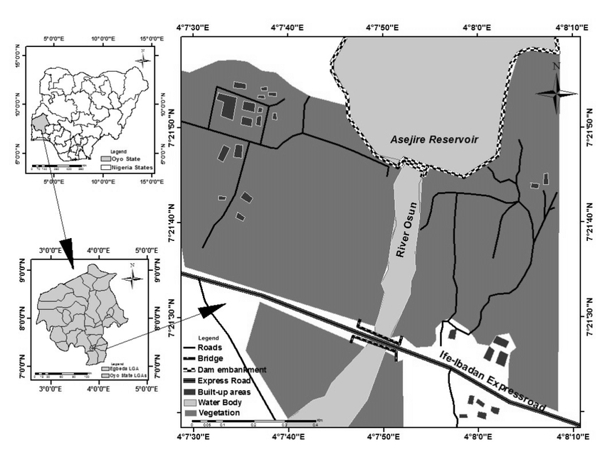
(Source: google.com)
FIGURE 3.1: MAP OF ASEJIRE DAM , OYO STATE , NIGERIA
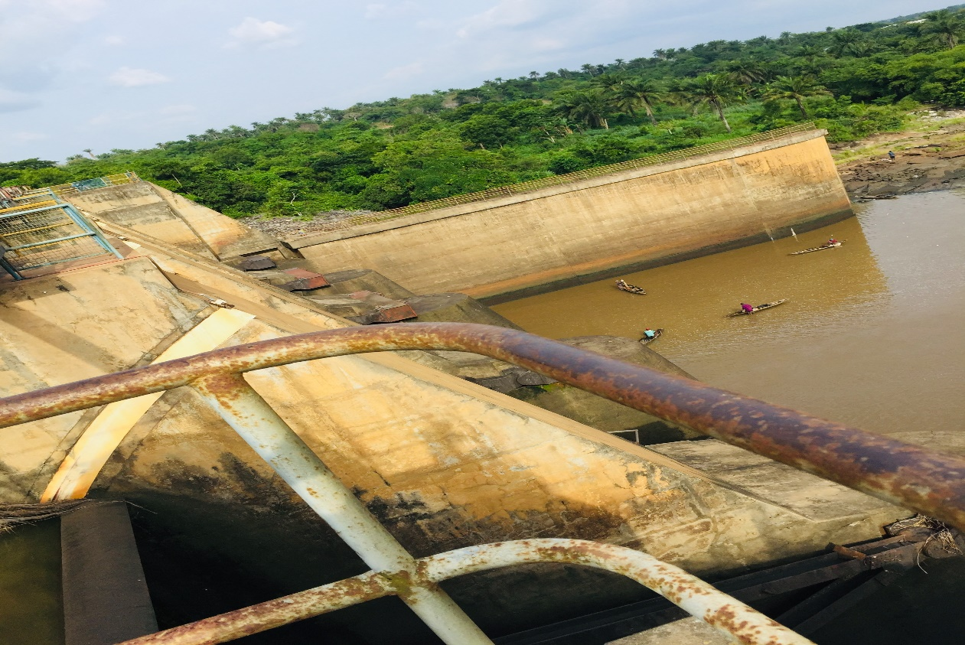
(Source: Googleearth.com)
FIGURE 3.2: A PICTURAL REPRESENTATION OF ASEJIRE DAM

3.2 MODEL SELECTION
The model used in this study is the soil and water Assessment Tool, SWAT (neitschet al., 2005). The selection of SWAT for this study was based on many reasons which are listed as follows
- SWAT is an existing, readily available software freely available on SWAT website
- It has several user’s groups e.g SWAT Africa, SWATworld and waterbase Goggle group which serves as plus to the acceptability of the tool among researchers.
- Its availability and efficacy in prediction of different hydrological processes has also been reported in many studies (Adeogunet al., 2015) which make it attractive to engineers and other users.
3.2.1 INTRODUCTION TO SWAT MODEL DESCRIPTION
The modeling tool was interfaced with Map Window GIS to simulate the hydrology and predict the flow into sub-basins in the watershed. The model developed by the Agricultural Research Service of the United Stated Department of Agriculture (ARS-USDA) simulates eight components of the environment system, i.e., hydrology, generation of weather data, Sedimentation process, soil energy balance, crop growth, nutrient and pesticide leaching and agricultural management (Neitschet al., 2002). SWAT is a semi-distributed model using process descriptions that are either empirically or physically limited in its process basis, operating on a daily time step. SWAT uses hydrologic response units (HRUs) to describe the spatial heterogeneity in terms of land cover and soil type.
The model simulates the hydrologic processes at four levels:
- the soil surface
- the intermediate unsaturated zone.
- the shallow and deep aquifers.
- the open channels.
Relevant hydrologic components such as evapotranspiration, sur-face runoff, groundwater ﬂow and soil moisture change are estimated at the level of each HRUs. Streamﬂow in the main channel is the sum of the surface runoff, the literal and baseﬂow. For predicting the runoff volumes, SWAT use a modiﬁed computational efﬁcient version of the Soil Conservation Service Curve Number (SCS CN) method (SCS-USDA 1972), relating runoff to soil type, land use and management practices. In addition, SWAT uses an empirical procedure for channel routing. The base flow recession constant is calculated using an equation suggested by Steadman & Rycroft (1983), a function of the overall basin topography, drainage pattern, soils and geology composition of the watershed.
3.2.2 THE CONCEPTUAL MODEL
SWAT incorporates the effects of weather, surface runoff, evapotranspiration, irrigation, sediment transport, groundwater flow, crop growth, nutrient yielding, pesticide yielding and water routing, as well as the long-term effects of varying agricultural management practices. In the SWAT model, the watershed is partitioned into sub basins that are further subdivided into one or several homogeneous hydrological response units (HRUs) with relatively unique combinations of land cover, soil and topographic conditions. The hydrological component of the model calculates soil-water balance at each time step based on daily amounts of precipitation, runoff, evapotranspiration, percolation and base flow.

3.3 MODELING TOOL AND GIS INTERFACE
A geodata model and geographic information system (GIS) interface for the Soil and Water Assessment Tool (SWAT). The SWAT data model is a system of geodatabases that store SWAT geographic, numeric, and text input data and results in an organized fashion. Thus, it is proposed that a single and comprehensive geodatabase be used as the repository of a SWAT simulation. The SWAT interface uses programming objects that conform to the Component Object Model (COM) design standard, which facilitate the use of functionality of other windows-based applications within SWAT. In particular, the use of MS Excel for data analysis and visualization of results is demonstrated.

3.4 MODEL INPUT DATA COLLECTION PROCESSING
The spatially distributed data (GIS input) needed for the running of Map Window SWAT include the DEM, soil data, land use and stream network layers. Weather data are also necessary for prediction of stream flow in the watershed. The GIS interface of the model was used to discretize the catchment area and geo-processed the spatial data into formats required by the model.
3.4.1 DIGITAL ELEVATION MODEL (DEM)
The topographical data used for this study was obtained from the Shuttle Radar Topography Mission (SRTM) final version, a 90-meter resolution Digital Elevation Model (DEM) developed by CGIAR (2012). The CGIAR-CSI GeoPortal provides SRTM 90m DEM data for a significant portion of the world. To enhance the usability of this DEM data, it has undergone processing to fill data gaps and meet the needs of various user groups. CGIAR (2012) aims to promote the use of geospatial science and applications in sustainable development and resource conservation efforts, particularly in developing countries. In this study, the SRTM DEM was utilized for watershed delineation into sub-basins and derivation of topographic parameters, including terrain slope, channel slope, and reach length. Digital Elevation Model of the study which is as shown in figure
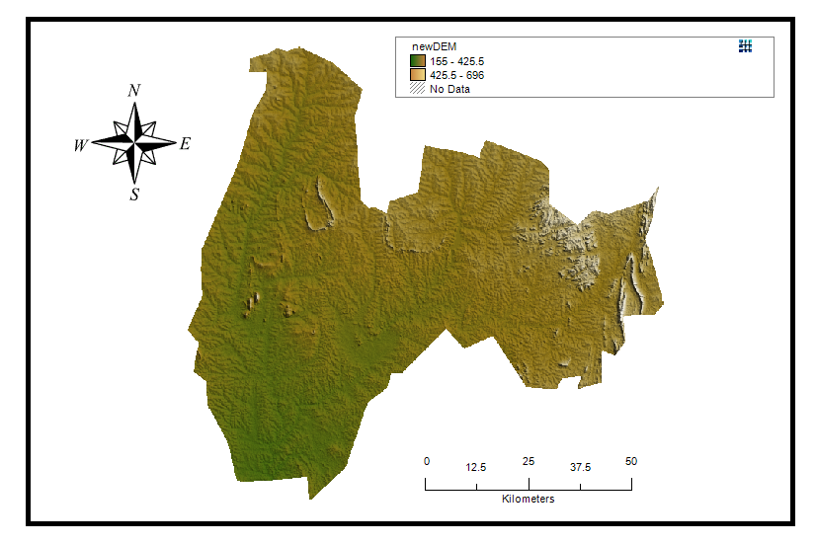
FIGURE 3.4.1: DIGITAL ELEVATION MODEL (DEM)
3.4.2 LAND COVER/LAND USE
The land use map required for SWAT analysis was obtained from the Global Land Cover Characterization (GLCC) database, which was developed by the United States Geological Survey (USGS). This database has a spatial resolution of 1 km and represents land use in 24 distinct classes (GLCC, 2012). The land use data from GLCC was used to estimate vegetation and other parameters for the watershed area. To enhance accuracy, field visits to the watershed area were conducted to gather on-site information regarding land use and land cover. Information collected during these visits was utilized to update the GLCC database and generate the final land use map for this study.
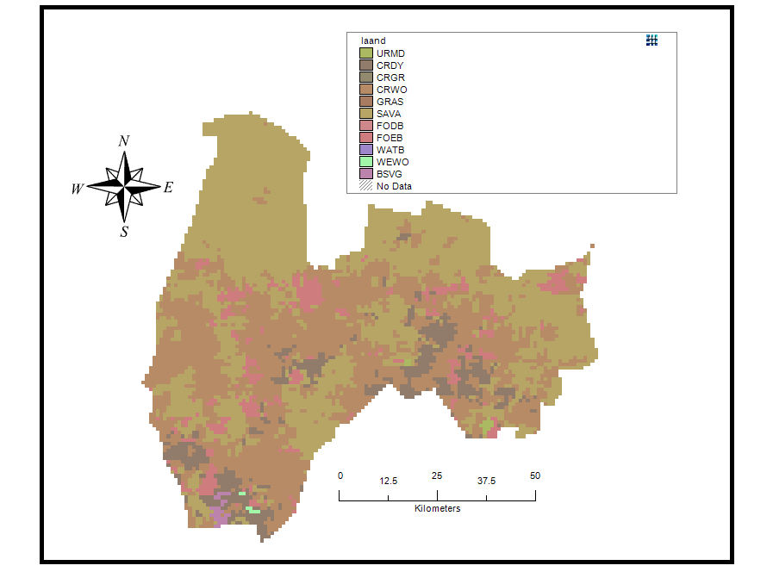
FIGURE3.4.2: LAND COVER/LAND USE
3.4.3 DIGITAL SOIL DATA
The necessary digital soil information for this study was derived from the Harmonized World Soil Database (HWSD), a comprehensive global digital soil map developed by the Food and Agriculture Organization of the United Nations (FAO). The database was accessed on May 30, 2013, and comprises detailed soil data essential for the analysis conducted in this research.
The HWSD is an invaluable resource that contains soil data from various sources around the world, harmonized to ensure consistency and comparability across regions. This database has been used extensively in environmental modeling, land management, and agricultural planning. For this study, the digital soil data obtained from HWSD provided crucial input parameters for understanding the watershed's characteristics and evaluating its hydrological processes.
The digitized soil map was completed in January 2003 data for 16,000 different soil mapping units containing two layers (0 - 30 cm and 30-100 cm depth). Seven soil units are then extracted from the database and completed by additional information gathered by taken soil samples from different locations within the watershed area. 16 soil samples were collected from two different layers (0 - 30 cm and 30 - 100 cm depth) and the samples were analyzed and used to update the model parameters.
3.4.4 WEATHER DATA
To effectively drive hydrological balance simulations within the SWAT model, daily weather variables such as minimum and maximum temperatures, wind, relative humidity, and solar radiation are required. These vital data inputs were sourced from the Nigerian Meteorological Agency (NIMET) based is an organization known for its reliable meteorological data collection in Nigeria. The dataset acquired encompassed a 19-years period, ranging from January 1, 2001, to December 31, 2019. NIMET's comprehensive and long-term meteorological records are indispensable for studying and comprehending the region's climatic patterns and any possible changes that may have occurred. These data serve as crucial input parameters for hydrological modeling, enabling researchers and policymakers to evaluate water resource availability, potential hydropower production, and the impacts of climate change on the area.

3.5 WATERSHED DELINEATION IN SWAT
Employing the Digital Elevation Model (DEM), we delineated the watershed boundaries of Asejire dam within the SWAT model. This process was pivotal in defining the spatial extent for our hydrological simulations, providing a precise framework for evaluating the hydrological process and nitrate loading

3.6 WATERSHED DELINIATION INTO SUB BASINS AND HYDROLOGICAL RESPONSE UNITS (HRUS)
The Soil and Water Assessment Tool (SWAT) model was employed for sub-basin delineation of the watershed and further division of sub-basins into Hydrologic Response Units (HRUs). SWAT is a continuous-time, watershed-scale model that effectively simulates long-term yields to determine the impacts of land management practices (Arnold and Allen, 1999).
To initiate the delineation process, the Automatic Watershed Delineation (AWD) dialogue box was activated from the model interface, and the base Digital Elevation Model (DEM) was selected. The elevation units were set to meters, corresponding to the base DEM's units. A focusing mask encapsulating the watershed was drawn and saved as a shape file. The model's threshold size for sub-basins was established, with options to set it by area or number of cells. For this study, a threshold value of 20 km² was chosen. To complete the settings, an outlet point shape file was created and selected.
Following the execution of AWD, the selected watershed was delineated into a total of 79 sub-basins, which were then further divided into 176 HRUs. Each HRU possesses a unique combination of land use, slope, and soil characteristics.
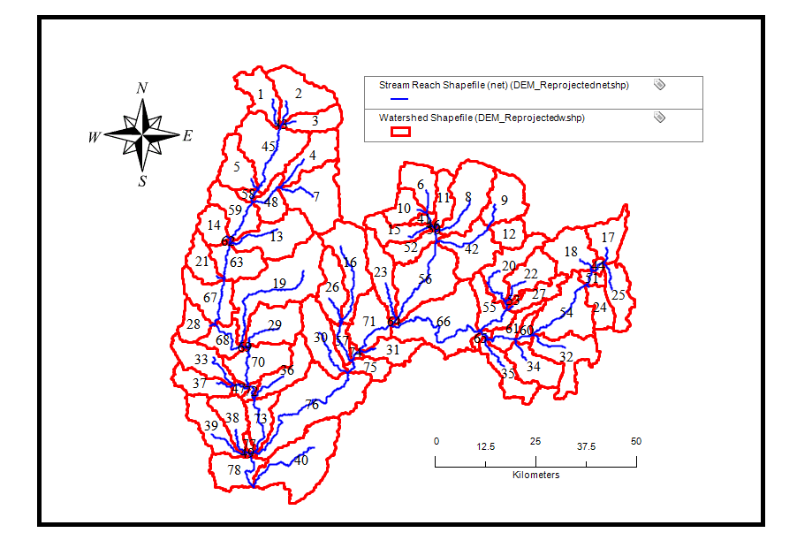
FIGURE 3.6: WATERSHED DELINIATION INTO SUB BASINS AND HYDROLOGICAL RESPONSE UNITS (HRUs)

3.7 SWAT SETUP AND RUN
In this phase, the simulation period (start and end date) for the modeling exercise was defined, and the weather sources were selected from the SWAT database. The simulation period for this study spanned from January 1, 2001, to December 31, 2019. Essential files required to run SWAT were prepared at this stage, and the appropriate weather sources were chosen before initiating the SWAT model.
Several methods for simulating surface runoff were available to choose from at this point, including the Curve Number and Green-Ampt methods. Additionally, channel water routing methods such as the variable or Muskingum method could be selected. The potential evapotranspiration method was employed in this study, specifically designed to compute river drop. The chosen method was either Priestley, Penman-Monteith, or Hargreaves.
Prior to executing the SWAT model, all necessary files were generated, and the appropriate weather sources were confirmed to ensure accurate model simulations.

CHAPTER FOUR

RESULT AND DISCUSSION

4.1 DEVELOPMENT OF HYDROLOGICAL MODEL TO SIMULATE NITRATE AND FLOW
This chapter presents and discusses the results obtained from the hydrological modeling of the Asejire Dam watershed using the SWAT model. The model aimed to simulate streamflow, predict nitrate loading, and analyze the spatial variation in flow and concentration across different sub-basins.The SWAT model successfully delineated the Asejire watershed into 79 sub-basins and 176 Hydrological Response Units (HRUs) based on land use, soil, and topographic data. The simulation covered the period from January 1, 2001, to December 31, 2019, using input data such as digital elevation models (DEM), land use/land cover data, soil information, and climatic variables
Flow simulation across the watershed was performed using SWAT's water balance module. The flow-in values across the sub-basins demonstrated notable spatial variation, ranging from less than 1 m³/s to over
1300 m³/s in some high-output regions. Sub-basins such as 78, 77, and 76 again showed dominant contributions to streamflow, which correlates with their larger areas and potentially more pronounced runoff dynamics.

FIGURE 4.1: DEVELOPMENT OF HYDROLOGICAL MODEL TO SIMULATE NITRATE AND FLOW

4.2 SPATIAL VARIATION OF NITRATE CONCENTRATION AND FLOW
The spatial analysis of nitrate concentration and flow across the Asejire watershed revealed significant variability influenced by land use, topography, and hydrological characteristics. Sub-basins located in intensive agricultural zones recorded the highest nitrate concentrations, reflecting runoff from fertilizer application and limited vegetative buffer.
Sub-basin 78 emerged as the most critical hotspot, with both the highest nitrate load (7,409,790.55 kg) and peak flow (1389.95 m³/s). Sub-basins 77 and 76 followed similar patterns, indicating that high-flow sub-basins with expansive agricultural activity are major contributors to overall nitrate pollution.
Flow distribution varied with watershed size and slope. Sub-basins with larger drainage areas and steeper gradients generated higher runoff, which directly influenced nitrate transport. In contrast, sub-basins with dense vegetation and moderate slopes recorded lower flows and nitrate levels due to better retention and filtration.
The results confirm a strong spatial correlation between flow intensity and nitrate concentration. High-flow sub-basins not only deliver more water but also act as primary pathways for nitrate transport. These areas should be prioritized for intervention through improved land use practices and runoff control measures.
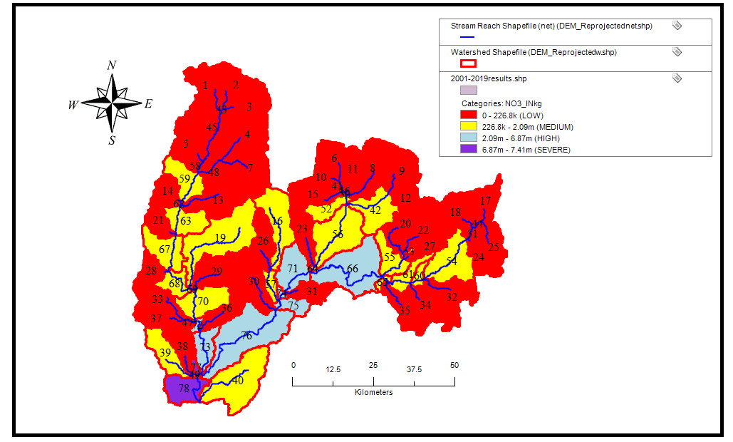FIGURE 4.2 SPATIAL VARIATION OF NITRATE CONCENTRATION AND FLOW

4.2.1 SPATIAL VARIATION FOR NITRATE LOADING
The spatial variation of nitrate loading in the Asejire watershed showed that a few sub-basins contributed disproportionately to total pollution. Sub-basins located in predominantly agricultural areas recorded the highest nitrate loads due to fertilizer runoff and poor land management practices.
Sub-basin 78 had the highest nitrate loading at 7,409,790.55 kg, followed closely by Sub-basins 77 and 76. These sub-basins also recorded the highest flow rates, indicating a direct link between runoff volume and nitrate transport. Sub-basins with steep slopes and large drainage areas showed higher flow and pollutant movement.
This variation emphasizes the need for focused management in high-risk sub-basins. Implementing best agricultural practices, such as buffer zones and optimized fertilizer use, can significantly reduce nitrate loading and improve water quality across the watershed.
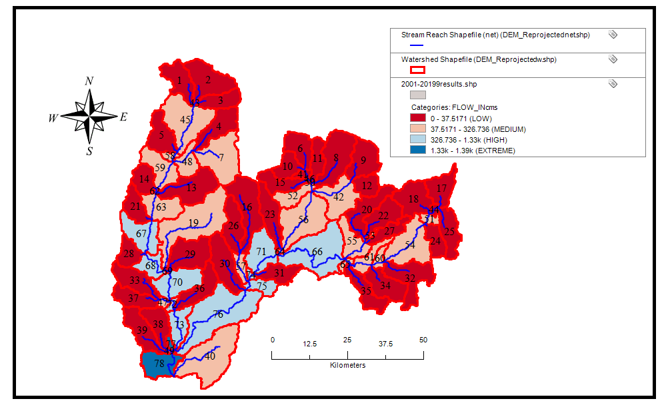
FIGURE 4.2.1: SPATIAL VARIATION FOR NITRATE LOADING

4.3 ESTIMATION OF TOTAL NITRATE AND FLOW IN THE WATERSHED
The total simulated nitrate loading across the entire watershed was approximately 56,476,272.7 kg, while the total modeled streamflow was around 12,070.37 m³/s.
Table 4.1: Sub-basins Sorted by Nitrate Load

Sub-basin | Area (km²) |  | Flow-in (m³/s) | Nitrate Load (kg)
0 | 0.00 | 0.00 |  | 0.00
1 | 88.18 | 18.35 |  | 32383.73
2 | 130.15 | 26.09 |  | 48271.60
3 | 64.94 | 13.01 |  | 24146.07
4 | 96.16 | 21.41 |  | 42423.10
5 | 87.29 | 18.63 |  | 35877.62
6 | 77.65 | 16.27 |  | 33492.96
7 | 168.76 | 37.77 |  | 75660.85
8 | 151.20 | 31.29 |  | 62756.60
9 | 103.68 | 21.74 |  | 44319.81
10 | 55.76 | 12.11 |  | 39446.35
11 | 51.68 | 11.38 |  | 42264.24
12 | 50.71 | 11.34 |  | 45503.92
13 | 140.72 | 32.04 |  | 119623.12
14 | 59.83 | 14.60 |  | 67620.48
15 | 68.77 | 16.27 |  | 97227.70
16 | 158.58 | 37.52 |  | 258491.82
17 | 79.71 | 17.06 |  | 68741.26
18 | 109.14 | 22.58 |  | 42293.69
19 | 271.98 | 65.04 |  | 412637.34
20 | 102.95 | 24.61 |  | 152209.43
21 | 64.91 | 15.49 |  | 118989.27
22 | 88.43 | 20.25 |  | 97837.91
23 | 96.33 | 24.34 |  | 194055.45
24 | 54.13 | 11.65 |  | 36858.11
25 | 82.56 | 16.96 |  | 30742.02
26 | 92.43 | 23.31 |  | 183704.29
27 | 52.55 | 12.59 |  | 78618.64
28 | 54.81 | 13.83 |  | 108087.02
29 | 123.49 | 29.33 |  | 177606.97
30 | 122.57 | 27.42 |  | 185126.37
31 | 64.11 | 15.31 |  | 145364.76
32 | 128.67 | 29.21 |  | 143323.45
33 | 90.98 | 20.25 |  | 81747.13
34 | 96.60 | 22.65 |  | 127534.00
35 | 81.72 | 18.70 |  | 153041.14
36 | 88.81 | 21.13 |  | 129824.66
37 | 71.41 | 17.07 |  | 105914.84
38 | 77.31 | 17.22 |  | 151237.28
39 | 99.06 | 22.64 |  | 261687.10
40 | 232.21 | 55.70 |  | 540561.34
41 | 14.04 | 31.39 |  | 86519.75
42 | 126.22 | 61.83 |  | 245944.94
43 | 0.76 | 39.15 |  | 72432.25
44 | 9.28 | 35.83 |  | 102444.95
45 | 192.37 | 98.15 |  | 182860.24
46 | 1.61 | 47.91 |  | 183691.46
47 | 11.95 | 39.61 |  | 193160.42
48 | 59.93 | 72.80 |  | 145317.66
49 | 1.80 | 40.09 |  | 413009.28
50 | 1.15 | 59.51 |  | 226850.30
51 | 20.59 | 62.53 |  | 151945.64
52 | 57.82 | 104.74 |  | 388183.60
53 | 6.53 | 46.31 |  | 260925.13
54 | 164.34 | 111.27 |  | 364490.81
55 | 78.45 | 76.81 |  | 532247.75
56 | 193.97 | 208.94 |  | 826784.77
57 | 33.50 | 67.56 |  | 493249.80
58 | 14.25 | 119.65 |  | 224207.44
59 | 98.19 | 215.49 |  | 437176.47
60 | 22.63 | 145.00 |  | 546736.19
61 | 52.48 | 179.51 |  | 811073.88
62 | 2.52 | 230.33 |  | 504708.93
63 | 92.20 | 284.37 |  | 707823.58
64 | 3.43 | 233.36 |  | 1021683.31
65 | 12.51 | 200.30 |  | 983678.42
66 | 238.80 | 332.04 |  | 2085517.54
67 | 111.26 | 326.74 |  | 1013363.84
68 | 60.98 | 354.55 |  | 1206711.86
69 | 0.78 | 418.80 |  | 1612822.62
70 | 117.15 | 474.12 |  | 1915089.23
71 | 111.59 | 589.07 |  | 3213283.76
72 | 11.23 | 515.45 |  | 2112283.25
73 | 72.58 | 553.34 |  | 2383222.82
74 | 9.05 | 605.64 |  | 3359082.52
75 | 44.73 | 683.12 |  | 3907365.90
76 | 297.57 | 779.41 |  | 4485482.56
77 | 9.53 | 1331.52 |  | 6867855.89
78 | 91.24 | 1389.95 |  | 7409790.55

CHAPTER FIVE

CONCLUSION AND RECOMMENDATION

5.1 CONCLUSION
This study successfully applied the SWAT model to simulate hydrological processes and nitrate loading in Asejire Dam's watershed. Key outcomes include:
- A spatially distributed hydrological model was developed, capturing both nitrate loading and streamflow across 79 sub-basins.
- Significant spatial variation in nitrate and flow was observed, with specific sub-basins contributing disproportionately to overall nutrient and water loads
- Agricultural activity was identified as a major driver of nitrate pollution, with runoff being the principal transport mechanism.
These insights underscore the important of targeted watershed management practices, especially in high risk sub-basins, to improve water quality and sustain ecosystem health.

5.2 RECOMMENDATIONS
- Land Use Management: Encourage best agricultural practices, such as optimized fertilizer application and buffer strips, particularly in high nitrate sub-basins.
- Riparian Zone Restoration: Promote riparian vegetation to filter surface runoff before it reaches water bodies
- Monitoring and Data Collection: Enhance spatial and temporal monitoring of nitrate and hydrological parameters to support model calibration and future scenario development
- Policy Implementation: Develop and enforce policies that control land use charge and agricultural intensification within critical sub-watersheds
- Scenario Analysis: Future studies should consider climate change impacts , land use transitions, and conservation scenarios using the calibrated model to explore management alternatives.

REFERENCES
Abu El-Nasr, A., Arnold, J.G., Feyen, J. and Berlamont, J., 2005. Modeling the hydrology of a catchment using a distributed and a semi distributed model. Hydrological Processes 19, 573–587.
Adeogun, A. G., Sule, B. F., Salami, A. W. &Okeola, O. G. (2014). GIS-Based Hydrological Modelling using SWAT: Case study of upstream watershed of Jebba.
A.I.A.S.S. Andrade et al. (2009) , “multi-method assessment of nitrate and pesticide contamination in shallow alluvial groundwater as a function of hydrogeological setting and land use Agric”. Water Manag.

Chau N. T. and Chatpet Y. 2019 “International Journal of GEOMATE”, Vol.17, Issue 60, pp.43- 48. Geotec., Const. Mat. & Env., DOI: https://doi.org/10.21660/2019.60.4687

Easton,Z.M., Fuka,D.R., White,E.D., Collick,A.S., BirukAshagre,B., McCartney,M., Awulachew,S.B., Ahmed,A.A. and Steenhuis,T.S., 2010. “A multi basin SWAT model analysis of runoff and sedimentation in the Blue Nile, Ethiopia”. Hydrology and earth system sciences 14, 1827-1841

Gayathri K. Devi et al. (2015) “International Conference on Water Resources, Coastal and Ocean Engineering (Icwrcoe 2015)” Aquatic Procedia 4 1001 – 1007.

Mohammad N. A. and Jagath K. 2007, “Modeling nitrate contamination of groundwater in agricultural watersheds” Journal of Hydrology 343, 211– 229.

Staley N. A., Wynn T., Benham B., Yagow G., and Tech V. 2006, “Modeling Channel Erosion at the Watershed Scale: Model Review and Case Study,” no.

Setegn, S. G., Srinivasan, R., &Dargahi, B. (2008). Hydrological modelling in the Lake Tana Basin, Ethiopia using SWAT model. The Open Hydrology Journal, 2 (1).
Srinivasan, R., Ramanarayanan, T. S., Arnold, J. G., &Bednarz, S. T. (1998). Large area hydrologic modeling and assessment part II: model application 1. JAWRA Journal of
the American Water Resources Association, 34(1), 91-101.SRTM, C. C. (2010). CGIAR-CSISRTM 90m Digital Elevation Data.

Wu, Y.-H., Yevjevich, V., and Woolhiser, D. A. 1978. ‘Effects of surface roughness and its spatial distribution on runoff hydrographs’, Wu, Y.-H., Woolhiser, D. A, and Yevjevich, V. 1982.

Yefang J. et al. 2015. “Modeling land-based nitrogen loads from groundwater dominated agricultural watersheds to estuaries to inform nutrient reduction planning”, Journal of Hydrology Volume 529, Part 1, Pages 213-230.
Pisinaras V., Petalas C., Gikas G. D., Gemitzi A., and Tsihrintzis V. A. 2010, “Hydrological and water quality modeling in a medium-sized basin using the Soil and Water Assessment Tool (SWAT),” Desalination, vol. 250, no. 1, pp. 274–286,

