DESIGN AND IMPLEMENTATION OF CRIME RATE PREDICTION AND PREVENTION SYSTEM USING DECISION TREE

BY

ABIKOYE EMMANUEL ADESOLA ND/23/COM/PT/0095
MUHAMMED RAJI OLAMILEKAN ND/23/COM/PT/0118
OGUNJOBI TAOFEEK OWOYEMI ND/23/COM/PT/0100

SUBMITTED TO THE DEPARTMENT OF COMPUTER SCIENCE,
INSTITUTE OF INFORMATION AND COMMUNICATION TECHNOLOGY
KWARA STATE POLYTECHNIC, ILORIN.

IN PARTIAL FULFILLMENT OF THE REQUIREMENTS FOR THE AWARD OF NATIONAL DIPLOMA (ND) IN
COMPUTER SCIENCE

JUNE, 2025.

CERTIFICATION
This is to certify that this project was carried out by ABIKOYE EMMANUEL ADESOLA ND/23/COM/PT/0095, MUHAMMED RAJI OLAMILEKAN ND/23/COM/PT/0118, OGUNJOBI TAOFEEK OWOYEMI ND/23/COM/PT/0100 in the Department of Computer Science, Institute of Information Communication Technology, Kwara State Polytechnic, Ilorin, Kwara State.

…………………………………. ….………………………
MRS. AKANBI , M. B. Date
Project Supervisor

…………………………………. ….………………………
MR. OYEDEPO, F. S. Date
Head of Department

…………………………………. ….………………………
External Examiner Date

DEDICATION
This project work was dedicated to Almighty God who inspired us and directed our ways during our academic stay in the polytechnic.

ACKNOWLEDGEMENT
All praise is due to Almighty God the Lord of the universe. I praise him and thank him for giving me the strength and knowledge to complete my ND programand also for our continued existence on Earth.
I appreciate the utmost effort of my supervisor, Mrs Akanbi M.B whose patience, support, and encouragement have been the driving force behind the success of this research work. He gave useful corrections, constructive criticisms, comments, recommendations, and advice and always ensures that excellent research is done. My sincere gratitude goes to the Head of the Department Mr. Oyedepo F. S., and other members of staff of the Department of Computer Science, Kwara State Polytechnic, Ilorin, for their constant cooperation, constructive criticisms, and encouragement throughout the program.

TABLE OF CONTENTS
Title page i
Certification ii
Dedication iii
Acknowledgments iv
Table of Contents v
Abstract vi
CHAPTER ONE: GENERAL INTRODUCTION
1.1 Background to the Study 1
1.2 Statement of the Problem 3
1.3 Aim and Objectives 3
1.4 Significance of Study 4
1.5 Scope of Study 4
1.6 Organization of the Report 4
CHAPTER TWO: LITERATURE REVIEW
2.1 Review of Related Pastworks 6
2.2 Review of General Study 8
CHAPTER THREE: RESEARCH METHODOLOGY AND
ANALYSIS OF THE SYSTEM
  - Research Methodology 10
  - Analysis of the Existing System 11
  - Problem of the Existing System 12
  - Analysis of the Proposed System 12
  - Advantages of the Propose System 13

CHAPTER FOUR: DESIGN, IMPLEMENTATION AND
DOCUMENTATION OF THE SYSTEM
  - Design of the System 15
    - Output Design 15
    - Input Design 16
    - Database Design 18
    - Procedure Design 20
  - Implementation of the System 21
    - Choice of programming language 21
    - Hardware support 21
    - Software Support 22
  - System Documentation 22
    - Operating the System 23
    - Maintaining of the System 23
CHAPTER FIVE: SUMMARY CONCLUSION AND
RECOMMENDATION
5.1 Summary 24
5.2 Conclusion 24
5.4 Recommendations 25
References 26

ABSTRACT
Crime rate prediction plays a crucial role in maintaining public safety and implementing effective law enforcement strategies. With the advancement in technology and the availability of vast amounts of data, machine learning algorithms have emerged as powerful tools for predicting crime rates. One such algorithm is the Decision Tree, which is widely used for classification and regression tasks. The problem statement focuses on the challenge of accurately predicting crime rates due to the complex and dynamic nature of criminal activities. Traditional methods of crime analysis may not capture the underlying patterns and trends effectively. Therefore, the problem calls for the application of machine learning techniques, specifically Decision Trees, to develop a crime rate prediction model that can overcome these limitations. The goal is to leverage the power of predictive analytics to provide accurate and timely crime rate estimates, which can assist law enforcement agencies and policymakers in resource allocation, proactive measures, and targeted interventions for enhancing public safety.A relevant dataset was gathered and contained the input features (independent variables) and the target variable (dependent variable) to be predicted. The dataset includes a sufficient number of instances representing different scenarios. Clean and preprocess the dataset to handle missing values, outliers, and inconsistencies. This involves techniques such as data imputation, outlier removal, and normalization to ensure the data is in a suitable format for analysis.

CHAPTER ONE
GENERAL INTRODUCTION
1.1 BACKGROUND TO THE STUDY
In the past, the use of forensic science techniques has been largely concentrated on more serious crimes such as rape and homicide. Increasingly, however, forensic techniques are being deployed across a wider range of crime types and are more routinely being used to aid the investigation of volume crimes such as burglary, vehicle crime and robbery (HMIC, 2022). Technological developments such as the establishment of DNA databases and automated fingerprint searching systems have meant considerable changes in the way in which forensic techniques have been applied to crime investigations. These developments are not, however, sufficient in themselves to bring about wholesale change in the investigative process. For this to happen they need to be embedded within, and linked to, existing ‘human’ actions in the investigative process.
Today, police officers and intelligence agents are utilising the expertise of forensic scientists with the latest investigative techniques to provide invaluable evidence of a crime. Computer Forensics World is a growing community of professionals involved in the digital forensics industry. It is an open resource, free for all to access and to use. It strongly encourages the sharing of information and peer to peer assistance (Marie-Helen & Michelle, 2022).
The traditional and age-old system of intelligence and criminal record maintenance has failed to live up to the requirements of the existing crime scenario. Manual processes neither provide accurate, reliable and comprehensive data round the clock nor does it help in trend prediction and decision support. It also results in lower productivity and ineffective utilization of manpower. The solution to this ever-increasing problem lies in the effective use of Information Technology. Crime Investigation Information System uses computer-generated records as an interface for integrating and accessing massive amounts of location-based information, (Herchelle, Milind&Nishant, 2023).
Crime investigation system allows police personnel to plan effectively for emergency response, determine mitigation priorities, analyses historical events, and predict future events. Crime investigation system helps identify potential suspects to increase investigators suspect base when no leads are evident. The ability to access and process information quickly while displaying it in a spatial and visual medium allows agencies to allocate resources quickly and more effectively. In the mission-critical‘ nature of law enforcement, information about the location of a crime, incident, suspect, or victim is often crucial to determine the manner and size of the response. Crime investigation software helps co-ordinate vast amounts of location-based data from multiple sources. It enables the user to layer the data and view the data most critical to the particular issue or mission. It is used world over by police departments, both large and small, to provide solutions for crime analysis, criminal investigation, traffic safety, community policing, Intranet/Internet mapping, and numerous other tasks. Crime investigation system helps crime officers determine potential crime sites by examining complex seemingly unrelated criteria and displaying them all in an interface.
Reading in the daily newspapers about nabbing criminals through modern methods of DNA testing and finger printing has aroused the interest of many a potential Sherlock Holmes Many a youngster today enjoy watching programmers like Cold Files and Detectives on Discovery channel, finding out how much easier it is to collect evidence about a crime today.
To support this initiative, a range of interactive facilities are available, including surveys, forums and posting areas for information and papers. As with all user groups and communities, its success ultimately depends upon its members. Greater involvement by larger numbers will always create a more vibrant and useful experience. The responsibilities of computer forensic professionals include preservation, collection, and analyzing data/evidence traced on computers to determine the facts in question. They must also provide credible and reliable expert testimony even in court, if necessary. Though this sounds very straightforward, but it is not a child’s play. A computer forensics’ examination involves vast aspects to be covered; therefore documentation of information which is informative, consolidated, and accurate is paramount to the success of the case. Computer Forensics place distinctive force on the sound treatment of potential evidence to clog it from being altered or tampered with. It is also referred as Digital Forensics, (Bharat, et al., 2023).

1.2 STATEMENT OF THE PROBLEM
The use of forensic science to assist in the gamut of activities in the criminal justice system has been recognized worldwide. Evidence from the United Kingdom, Australia and the United State of America has clearly shown that the advancement in forensic science has increased and fast track the process of identification of suspects and the administration of justice. The absence of forensic science in crime investigation makes the criminal justice system tardy or shoddy resulting in the victimization of innocent citizens and escape of offenders from paying for their misdeeds and being reformed and this is the case of Nigeria.
Crimes such as kidnap, abduction, rape, murder, cybercrime and terrorism have tremendously advanced in terms of how they are committed. The archaic and anachronistic traditional eyewitnesses’ account and confession ways of investigating crimes by the Nigeria law enforcement agencies have proven ineffective and inefficient. These sophisticated crimes need sophisticated techniques such as forensic science in order for them to be curbed. It is, however, a thing of great surprise that in Nigeria, a country of over one hundred and seventy million (170 million) people with diverse cultures and backgrounds, there seems to be no interest in developing the forensic science to assist in the resolution of crimes; convicting the wrongdoers and exonerating the innocent. The research examined the state of forensic science in crime investigation and administration of justice in Nigeria and suggest ways to maximizing the potentials of forensic science.

1.3 AIM AND OBJECTIVES OF THE STUDY
The aim of this project is to computerize the existing Criminal Investigation System. Specifically, the objectives are as follows:
- to apply forensic techniques in to investigation of crimes.
- to identify ways of improving forensic investigative techniques in Nigeria
- to identify the strengths and weaknesses of the use of forensics in the investigation of volume crime; and,
- to identify the way in which forensic science contributes to the effective and efficient detection (and conviction) of crime.
1.4 SIGNIFICANCE OF THE STUDY
Implementation of a crime information system will help the security, detectives and the masses to get useful information on individuals with crime records. The system will be develop and a benefit for maintaining a database of all crime records and their biometric details, enable a quick search on the database to retrieve crime information, enable Nigerian police to track previous crimes committed by a suspect and make crime control easier for the police.

1.5 SCOPE AND LIMITATIONS OF THE STUDY
The scope of this project will be focus mainly on the design and implementation of a computer-based application that will cater for recording of criminal data in police station.
The limitations faced by this research project include financial constraints and reluctance of the personnel in the police station. The project did not cover the Prison and the Magistrate Segment, which could also be automated.

1.6 ORGANIZATION OF THE REPORT
This is the overall organizational structure of the work as presented in this project write-up.
Chapter one of this project deals with the introduction to the general work in the project. It also entails the statement of the problem, aims and objectives of this project, the significance of the study, the scope and limitation of the study and organization of the report.
Chapter two deals with the review related journals and books, historical background of the study, as well as computerization current state of the art.
Chapter three covers the methods used for data collection, description of the current procedure, problems of existing system, description of the proposed system and the basic advantages of the proposed web based application.
Chapter four entails design, implementation and documentation of the system. The design involves the system design, output design form, input design form, database structure and the procedure of the system. The implementation involves the implementation techniques used in details, choice of programming language used and the hardware and software support. The documentation of the system involves the operation of the system and the maintenance of the system.
Chapter five deals with the summary, experience gained, conclusion, recommendation and references.

CHAPTER TWO
LITERATURE REVIEW
2.1 REVIEW OF RELATED WORK
Alisigwe and Oluwafemi (2019) presents a journal titled “The State of Forensic Science in Crime Investigation and Administration of Justice in Nigeria” in Nigeria crime rates and insecurity have become high over the last years. Nigeria has been on the global crime map since 1980 and the nature of crimes ravaging Nigeria includes armed robbery, murder, rape, fraud, human trafficking, kidnapping, drug trafficking, and terrorism. The sophistication in terms of how these crimes are perpetrated in Nigeria has made traditional crime investigative techniques unproductive and ineffective. The Nigeria Police Force and other security agencies still rely mainly on eye witness testimonies, circumstantial evidence, and confessionswhere others failed, a combination of two or all is considered a thorough and detailed investigation as far as they are concerned. Whereas, the most important source of evidence; forensic evidence which is more reliable, authentic, concrete and productive are criticized and underutilized. With the use of available secondary data, the research work examined the state of forensic science in crime investigation and administration of justice in Nigeria.

Deshmukh, Arun, Tushar, Ajinkya , Rahul and Chaitali, (2015) present a journal titled “Crime Investigation using Data Mining”, Crime rate is increasing very fast in India because of increase in poverty and unemployment. With the existing crime investigation techniques, officers have to spend a lot of time as well as man power to identify suspects and criminals. However crime investigation process needs to be faster and efficient. As large amount of information is collected during crime investigation, data mining is an approach which can be useful in this perspective. Data mining is a process that extracts useful information from large amount of crime data so that possible suspects of the crime can be identified efficiently. Numbers of data mining techniques are available. Use of particular data mining technique has greater influence on the results obtained. So the performance of three data mining techniques { J48, Nave Bayes and JRip will be compared against sample crime and criminal database and best performing algorithm will be used against sample crime and criminal database to identify possible suspects of the crime. Data mining is a process of extracting knowledge from huge amount of data stored in databases, data warehouses and data repositories. Clustering is the process of combining data objects into groups. The data objects within the group are very similar and very dissimilar as well when compared to objects of other groups.

Bharat, et al. (2015), review a paper on Computer Forensic Technology. The present era undoubtedly is an era of technological revolution which has witnessed unprecedented growth in use of electronic devices especially the mobiles and computers. In fact every facet of our life, directly or indirectly, to a large extent is dependent on computers. The Computer/Mobiles, the intelligent devices, are not limited to performing official responsibilities only; rather these have occupied an important place to perform one’s day to day functions in just one click whether it is SMS, MMS, Internet access or Online Transactions etc. However, this advancement in technology has also raised the concerns over misuse of these machines by anti-social elements and it becomes essential for the security agencies to remain ahead with regularly update about the tools and techniques available to identify and investigate a crime done with the help of Mobile/Computer.

Gianni and Fabrizio, (2017) wrote and presented a journal titled “Computer Forensics Investigation an Approach to Evidence In Cyberspace” In the recent years, analysing a computer or a digital device has become a necessity in the field of criminal investigations. However, during the forensic analysis some ordinary mistakes are often made. This paper aims at defining a new approach to the problem of evidence examination, studying the practical experience of a case study within the Italian legal system concerning techniques of forensic computer analysis based on command line. The user of this type of approaches has to guarantee efficient level of both technical skills and highly qualified and specialized legal competences in order to analyse digital systems in conformity with international best practices, and national and European regulations. Moreover, although many specific hardware and software are adopted in the forensic tests, one of the main objectives of this research has been the only use of the personal computer in order to prove the possibility to obtain the same results minimizing the costs. The case study has focused on forensic analysis of various magnetic and optical devices (mass memory), such as hard disk, pen drives, cards and CD / DVD.

Pankaj, et al. (2015), explained Digital forensics- A technological revolution in forensic sciences. Computer Forensics World is a growing community of professionals involved in the digital forensics industry. It is an open resource, free for all to access and to use. Digital investigations and crime regularly cross international and language borders today. Open database connectivity technology is now providing access to a wide range of database technologies, such as neural networks and pattern recognition databases, which are being used to analyze shoe prints and tool marks. These new computer-aided analysis tools can link and chart case information, allowing the investigator to question the data and pose scenarios as well as suggest and follow possible investigative paths. As a result, connections that often took weeks or months to come to light are revealed in a fraction of the time. Forensics is just beginning to get looked at, but the problems are cost and government is slow to adopt new technology. In this paper we discussed about the kingdom of Digital Forensics and Computer Forensic World. The study consists of Computer Forensic World, Digital Forensics (MEK, AFF, and Keyword Search etc.), and the Future Forensics Labs.

Marie-Helen and Michelle (2014) concluded that forensic science applies natural, physical, and social sciences to resolve legal matters. The term forensics has been attached to many different fields: economics, anthropology, dentistry, pathology, toxicology, entomology, psychology, accounting, engineering, and computer forensics. Forensic evidence is gathered, examined, evaluated, interpreted, and presented to make sense of an event and provide investigatory leads. Various classification schemes exist for forensic evidence, with some forms of evidence falling under more than one scheme. Rules of evidence differ between jurisdictions, even between countries that share similar legal traditions. This makes the sharing of evidence between countries particularly problematic, at times rendering this evidence inadmissible in national courts. Several measures have been proposed and organizations created to strengthen forensic science and promote best practices for practitioners, researchers, and academicians in the field.

Ate, et al. (2015) opined that the importance of modern technology in forensic investigations is discussed. Recent technological developments are creating new possibilities to perform robust scientific measurements and studies outside the controlled laboratory environment. The benefits of real-time, on-site forensic investigations are manifold and such technology has the potential to strongly increase the speed and efficacy of the criminal justice system. However, such benefits are only realized when quality can be guaranteed at all times and findings can be used as forensic evidence in court. At the Netherlands Forensic Institute, innovation efforts are currently undertaken to develop integrated forensic platform solutions that allow for the forensic investigation of human biological traces, the chemical identification of illicit drugs and the study of large amounts of digital evidence. These platforms enable field investigations, yield robust and validated evidence and allow for forensic intelligence and targeted use of expert capacity at the forensic institutes. This technological revolution in forensic science could ultimately lead to a paradigm shift in which a new role of the forensic expert emerges as developer and custodian of integrated forensic platforms.

Aakash, Gautami, Omkar, and Varsha, (2017) presents a paper on“Criminal Investigation Tracker with Suspect Prediction”, whenever a case against the crime is filed the investigation always starts from the scratch right away from the evidences found at the crime location and the eye witnesses present at the crime location. On the basis of the statement given by the eye witnesses about the crime and the criminal who committed that crime. The process of the investigations starts. As to reduce the stress of the police officers we implemented a system as criminal investigation tracker with suspect prediction that will help the officers to speed up the process of investigation and track status of ongoing case by predicting out the primary suspects on the basis of the records which consists of compendium of the people associated to the case, former criminal background proofs recovered from crime location, etc. This digitized system makes the work easy for an officer to check the status of the case online and even allows him to add up the new important information related to the case as it’s when needed. The proposed system consists of suspect prediction algorithm to predict and suggest the suspects in the logical order (Aakash, Gautami, Omkar, &Varsha, 2017).

Adeyinka, Ndako, and Faith, (2013) also present a journal titled” Design and Implementation of Crime Investigation System using Biometric”, reliable criminal suspects’ recognition is an important problem in crime investigation process. Biometrics recognition is becoming an irreplaceable part of many identification systems. While successful in some niche markets, the biometrics technology has not yet delivered its promise of full proof automatic crime suspects’ recognition, especially in a developing country like Nigeria. The study proposes and implements a biometrics based crime investigation system for the Nigerian Police Force. The software was designed using Visual BASIC programming language.

Herchelle, Milind and Nishant, (2016) write and present a journal on “Crime Investigation System using Biometrics”, a fingerprint is the feature pattern on the finger. It is proved through strong evidences that each fingerprint is almost unique in nature. Each individual retains his own fingerprints with the permanent and durable uniqueness. Hence fingerprints are being adapted for identification and forensic investigation. The fingerprint recognition problem can be grouped into two sub-categories: one is termed as fingerprint verification and while the other is termed as fingerprint identification. Additionally, apart from the manual approach of fingerprint recognition by the experts, fingerprint recognition here is usually referred as AFRS (Automatic Fingerprint Recognition System), which is drastically program-based. The proposed system presents the variation of Fast Fourier Transform on finger print recognition by fast fingerprint minutiae extraction and recognition algorithm that improves the clarity between the ridge and valley structures of the supposed to be provided finger print images in accordance with the frequency as well as the orientation of the local ridges and extracting correct minutiae (Herchelle, Milind and Nishant, 2016).

2.2 REVIEW OF RELATED CONCEPTS
Technology can be regarded as a vital catalyst in the transition of scientific findings and insights into innovation. Added value of science is materialized through technology enabling society to fully benefit from new discoveries. Such benefits are very diverse (e.g. health, economic, trade, transport, communication, sustainability, conservation of cultural heritage, safety, security and justice) but have in common that they raise the quality of life and provide progress and prosperity in societies (assuming that these benefits outweigh the potential misuse and threats that are also associated with new scientific findings). The cycle of science, innovation and growth is the rationale behind the very substantial and structural investment of developed countries in science programmes. From this broad and generic perspective, it is very interesting to take an in-depth look at the interface between technology and forensic science. Contemporary forensic institutes operate state-of-the-art laboratories where evidence is studied with modern instruments. Without this often high-tech and expensive equipment, the forensic expert would not be able to generate the forensic findings that so often are of vital importance to solve a crime and assure high-quality rulings in a court of law. Ideally, new technology is made ‘fit-for-forensic-purpose’ in such a way that accredited and efficient use in the forensic laboratory is enabled, evidential value is established and criminalistic interpretation is incorporated. Contemporary forensic STR DNA profiling is the most obvious and striking example of such a merger of scientific discovery, technological advancements and forensic application and interpretation.

2.2.1 OVERVIEW OF THE CONTRIBUTION OF FORENSIC SCIENCE TO POLICE INVESTIGATIONS
The contribution of forensics to the detection of crime before the detailed research into the application of forensic techniques to volume crime is explored, it is useful to summarize several studies that have attempted to set the contribution of forensics to the overall process of crime investigation in a wider context. The limited amount of work that has been undertaken on criminal investigations indicates that the majority of detected cases are not solved through the use of forensic evidence. Previous reviews of the research have concluded that forensic science is central to the detection of only a minority of crimes (see for instance reviews by Peterson, Bender and Gilliland (1982), Horvath and Meesig (1996) and Jansson, 2005)). The literature on the relative contribution of different investigative techniques is not large but most of it tends to support the limited role of forensics. A useful starting point in exploring the overall contribution of forensic material is to examine cases that relied in some way upon physical evidence. As the report goes on to consider in more detail, while it is relatively straightforward to identify those cases which involve the use of physical evidence, understanding the actual contribution of forensics to detections is more complex. One of the first studies to explore the contribution of physical evidence was the RAND study in the US in the mid 1970s (Greenwood et. al. (1975), and in particular the work of Petersilia, (1978)). The general conclusions from the RAND study was that investigators do not investigate crime in a way the public is often encouraged to believe. Most crimes are detected by offenders being arrested at the scene, or by critical information gathered from eyewitnesses. If these are absent there is little chance of a detection (for a fuller summary see Jansson, 2005). The use of physical evidence to detect offences was no exception to this general rule. The study revealed that between 1.2 per cent and 1.5 per cent of all burglaries were cleared up as result of fingerprints found at crime scenes (Greenwood, op. cit.). Steer’s 1974 study of a sample of detections in the Thames Valley police area in England found very limited use of physical evidence (Steer, 1980), albeit measured on a different basis to the RAND study. Of a random sample of detected offences in the police area (n=340), only three (0.9%) were detected as a result of fingerprint searches, with no other physical evidence categories listed. From a sample of more serious detected crimes (n=99), a similar proportion was detected by fingerprint matching. In terms of detections, Coupe and Griffiths’ (1996) study of burglary investigations in England revealed that forensic techniques were used in 17 per cent of detected burglaries. However, physical evidence was perceived as essential to detection in only six per cent of ‘primary’ detections.
Physical evidence as corroborative evidence, a means for identifying suspects, or as an intelligence tool? A second theme to emerge from the broader research on physical evidence and detections has been the effort to assess the particular contribution that such evidence makes to the investigative process. The joint FSS/ACPO report Using Forensic Science Effectively (ACPO/FSS 1996) classifies evidence into one of three headings: inceptive (pointing directly to an unknown offender); corroborative (tending to confirm an existing hypothesis); and mandatory (necessary to satisfy a specific legal requirement). A series of studies in the US during the 1970s showed that, apart from generally low levels of utilisation in volume crimes, physical evidence was primarily a corroborative tool (either to confirm a suspicion or eliminate a doubtful suspect). It was much less frequently used to develop suspect sets along inceptive lines. For instance, Rosenthal and Travnicek (1974) undertook a study designed to explore how to increase the utilisation of physical evidence in crime investigation and prosecution. On the basis of data collected in three study sites in the US, they concluded that while its overall usage was variable, physical evidence was used only to corroborate existing investigative conclusions. The corroborative model of the application of forensic science was identified as an international phenomenon in Horvath and Meesig’s review of the research literature (1996). Ericson’s (1981) study of detectives in Canada also noted that, while forensic materials and scientific analysis did not play a major role in investigations, it did help to convict a suspect once identified. It was particularly effective in gaining ‘leverage’ during police interviews to gain confessions. Although the situation in Japan was reversed (with confessions being corroborated by forensic evidence after the event), the general principle still applied (Miyazawa, 1992).

2.2.2 FORENSIC SCIENCE
Forensic science is a multi-disciplinary subject drawing principally from chemistry and biology, psychology and social sciences. Forensic science describes the application of scientific techniques and knowledge to legal problems and law enforcement. Forensic science has been absorbed as part of policing and national security as it helps in investigating almost all kinds of crimes, disasters and suspected behavior of individuals (Prahlow, 2010). Forensic science provides multiple options that would help in tracking and apprehending perpetrators of such dastardly acts by agents of the criminal justice system. Forensic evidence provides an additional option that could be better than witness testimonies and confessions (forced or otherwise), the reason being that forced confessions are obtainable from suspects following the application of extreme torture, and false witnesses are procurable in impoverished societies. These would eventually lead to a miscarriage of justice. But it can be ameliorated by the provision of empirical forensic evidence, a sub-set of forensic science.
Forensic science shelters many areas of sciences and consolidate them together to create an area of science called forensics. Forensic science uses chemistry (pH and other chemical tests, spectroscopic analysis, chromatography,), biology (fingerprinting, entomology, DNA testing, behavior, hairs), and physical science (ballistics, blood spatter analysis, structural analysis). Forensic science is an umbrella term that has numerous areas under it. At a crime scene, there are many experts who cover different fields as per their specialties. In broad term, all these people are referred to be forensic scientists (Cardinetti&Cammarota, 2005)

2.2.3 FORENSIC INVESTIGATION
Forensic investigation refers to the use of science or technology in the investigation and establishment of facts or evidence to be used in criminal justice or other proceedings. According to Kent, the forensic process is composed of the following phases; a collection of data from the crime scene, the examination of all collected data both manually and automated, analysis of the results of the examined data, the last phase is the reporting of the analyzed results. (Kent, 2006).

CHAPTER THREE
RESEARCH METHODOLOGY AND ANALYSIS OF THE NEW SYSTEM
3.1 RESEARCHMETHODOLOGY
COMPUTER FORENSIC INVESTIGATION PROCESS:
Computer forensic investigation process was introduced by Pollitt in 1984. The main purpose of this model is to produce technically trustworthy and legally suitable results. The block diagram below represents the four.
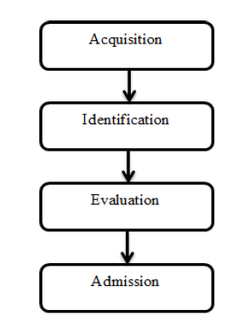
Figure 3.1: Computer Forensic Investigation Process
In Acquisition Phase, clues are gathered in suitable way with authority’s approval. This phase is monitored by Identification Phase. In this phase, digital evidences are identified from the acquired evidences and are converted to human understandable form. Next is Evaluation Phase, where it is determined that components identified in previous phase are relevant to case and are acceptable. Last is the Admission Phase. In this phase, evidences gathered are presented in court of law.
ABSTRACT DIGITAL FORENSIC MODEL (ADFM):
After inspiration from DFRWS, an enhanced model was introduced by Reith, Carr and Gunsch. It is known as Abstract Digital Forensic Model (ADFM) in 2002. Three additional phases were introduced in this model along with steps involved in DFRWS. The nine steps of model are described in diagram below:
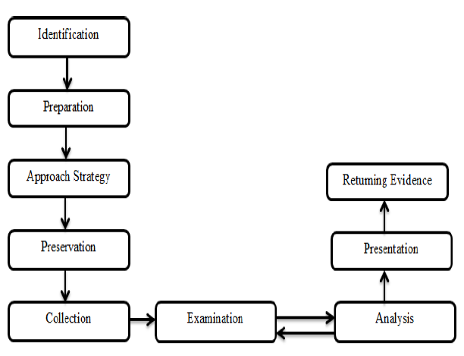
Figure 3.2: Abstract Digital Forensic Model (ADFM)

3.2 ANALYSIS OF THE EXISTING SYSTEM
Two of the most significant advances in criminal investigation has been the development of fingerprinting and DNA profiling. While this has been working perfectly in advance countries like the US and Britain, to the arrest and conviction of millions of criminals’ suspects, the Nigerian case is pathetic. Although the Nigeria police are assumed to have been trained up to this scientific level, the challenge is that the Federal Government is not procuring the instrument for the police to display their work.
In relation to a criminal investigation, forensic evidence provides a better option compared to the traditional eye witness testimonies and confessions which is mostly falsified. The Nigerian Police is known for gathering confessions from suspects following the application of force and extreme torture. Eyewitnesses are usually stage played to provide cooked and falsified evidence against a suspect. The consequence of this is that during prosecutions, virtually all the confessional statements are challenged on grounds of police coercion and the unchallenged ones perverse the administration of justice in Nigeria.
The evidence consists of legal proofs presented to the court in the form of witnesses, records, documents, objects and other means, for the purpose of administration of justice in the court of law. For evidence to be valid in court, it has to be logical, credible, genuine, rational, relevant and material. Eye witness testimonies and confession in Nigeria lack the above characteristics.

3.3 PROBLEMS OF THE EXISTING SYSTEM
It is unfortunate that in this era of advanced forensic crime investigative techniques, the Nigeria Police Force still largely depend on the traditional investigative techniques for crime investigation. In a society where the increase in crime rate is alarming, where crimes are no longer committed in the normal traditional way and the criminal has become more sophisticated in their operation, forensic science provides a better alternative to detecting, apprehending and administering justice to these criminals.
For Nigeria to have survived the past 59 years of prosecuting criminal cases without fully applying forensic science as a fundamental tool is a major concern. The country has not utilized and maximized the benefits and potentials of Forensic Science.

3.4 ANALYSIS OF THE PROPOSED SYSTEM
Unfortunately, while the traditional methods of proof, eyewitness’ account and confession characterize the present criminal justice system, the criminals are now becoming clever and more scientific. It is therefore pertinent that the system embraces this new approach because it has proven to be reliable in other developed countries such as Australia, USA, UK, Canada and even in South Africa. Forensic evidence is the most dependable and reliable compared to traditional proofs. On the other hand, the use of computers in the management of criminal records and crime investigation tends to be very efficient due to the fact that less time is spent on the investigation of crimes since it is automated; giving accurate and reliable criminal investigation results. With the introduction of biometrics technology which is an advanced computer techniques now widely adopted as a front line security measure for both identity verification and crime detection, and also offers an effective crime deterrent. Biometrics embrace a range of techniques such as fingerprinting and handwriting recognition for identity verification using physical data and behavioral patterns. In the recent past, fingerprint images were obtained by "ink-technique" which is also referred as off- line fingerprint acquisition. It is essentially based on the development of pattern recognition systems, today electronic or optical sensors such as cameras and scanning devices are used to capture images, recordings or measurements of a person’s unique characteristics. This digital data is then encoded and can be stored and searched on demand, via a computer. Such biometric search is not only very rapid (often taking place in real time), it is also a process that is accepted globally in establishing forensic evidence in a law court. It cannot be over emphasized that there is need to provide for adequate, efficient and effective technological knowhow especially in the area of crime investigation which will make their job simpler and faster, as well as prompt and effective in their service delivery.

3.5 ADVANTAGES OF THE PROPOSED SYSTEM
Forensic science has made dramatic scientific breakthroughs such as DNA matching, hair fingerprints, and blood spatter analysis. Forensic science disciplines have produced valuable evidence that has contributed to the successful prosecution and conviction of criminals as well as to the exoneration of innocent people.
Advantages of today’s forensic techniques at a crime scene is fingerprinting , DNA testing , comparison of samples found in a crime scene compared to back then and assuming.
Forensic scientists collect, save, and analysis scientific evidence during the investigation. While some forensic scientists travel to the scene of the crime to collect the evidence themselves, others occupy a laboratory role, performing analysis on objects brought to them by other individuals. In addition to their laboratory role, forensic scientists testify as expert witnesses in both criminal and civil cases and can work for either the prosecution or the defense. While any field could technically be forensic, certain sections have developed over time to encompass most of forensically related cases.
A successful implementation of the Crime Records Investigation System will greatly increase the efficiency of the Nigerian Police Force officers and will help to ensure that criminal records are managed properly monitoring of criminal suspects in the country. Thus, the problem of delay in retrieving criminal suspects records for reference purposes and for appropriate court action or prosecution to be taken can be reduced drastically and the efficiency in the management of criminal records and investigation of criminal case being rendered by the Nigerian Police Force will greatly be improved upon.

CHAPTER FOUR
DESIGN, IMPLEMENTATION AND DOCUMENTATION OF THE SYSTEM
  - DESIGN OF THE SYSTEM
The proposed system is designed in modules with the modules working together to perform the goal of crime tracking record System in order to enhance the performance of the existing system as earlier discussed in chapter three.
The ability to analyze and give focus to the system is explained in the following formats which are output design, input design, database design and procedure design.
    - OUTPUT DESIGN
The output to be extracted from the proposed system are
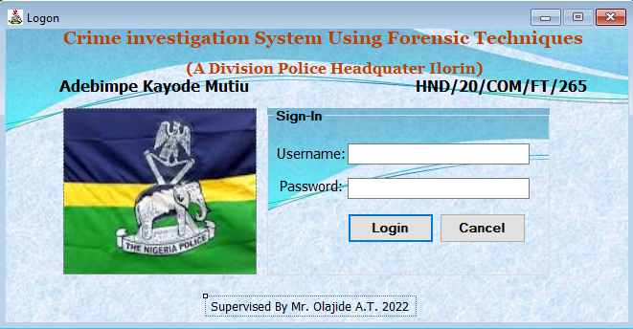
Figure 4.1 Login Page. This display the details of login page.

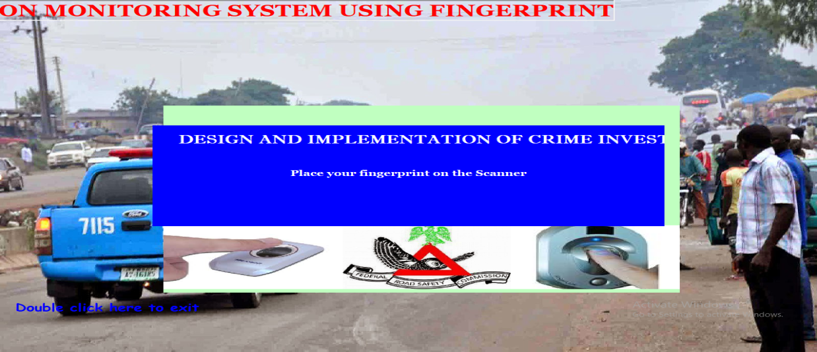
Figure 4.2: Finger Authenticate. This is where all criminal records are authentication.
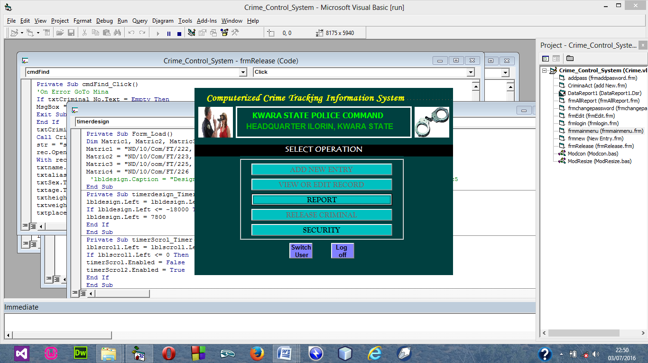
Figure 4.3 Security Menu. These allow the admin to change the password of any account.
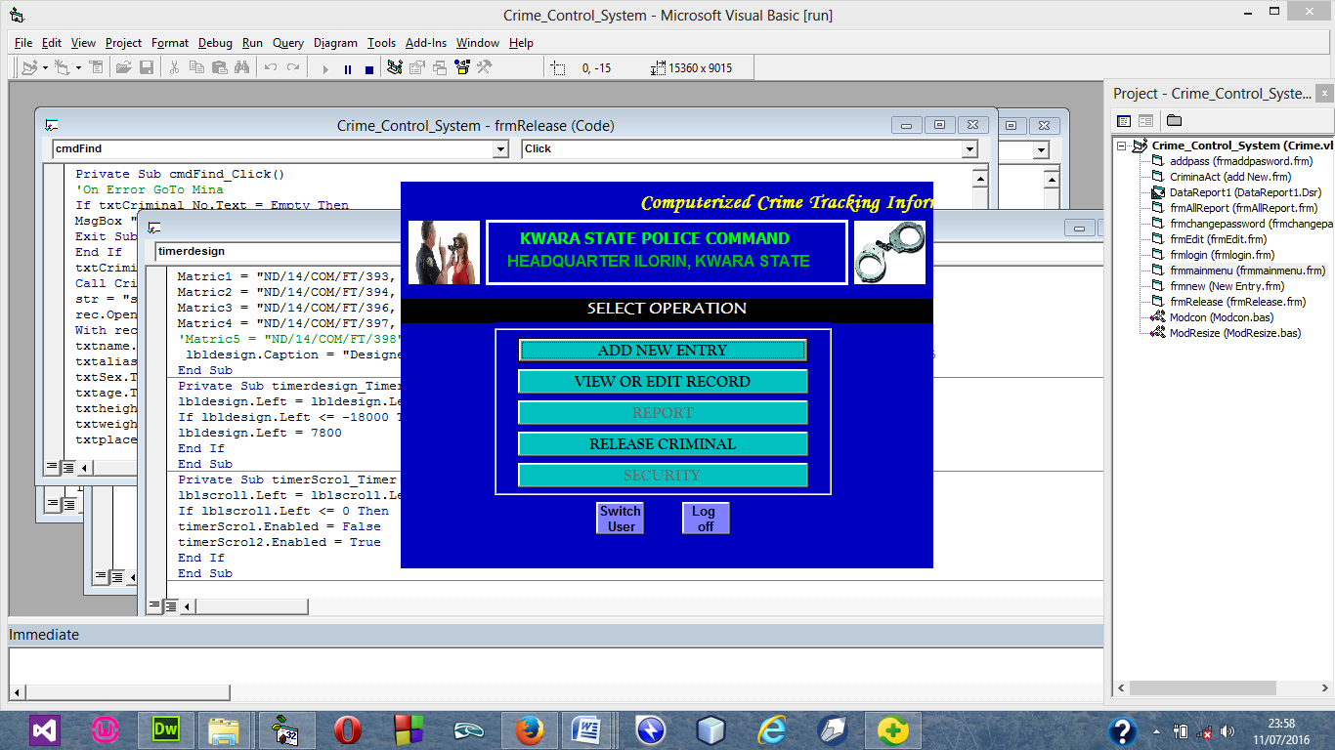
Figure 4.4 User Main Menu. These Allow user to make use of the system.

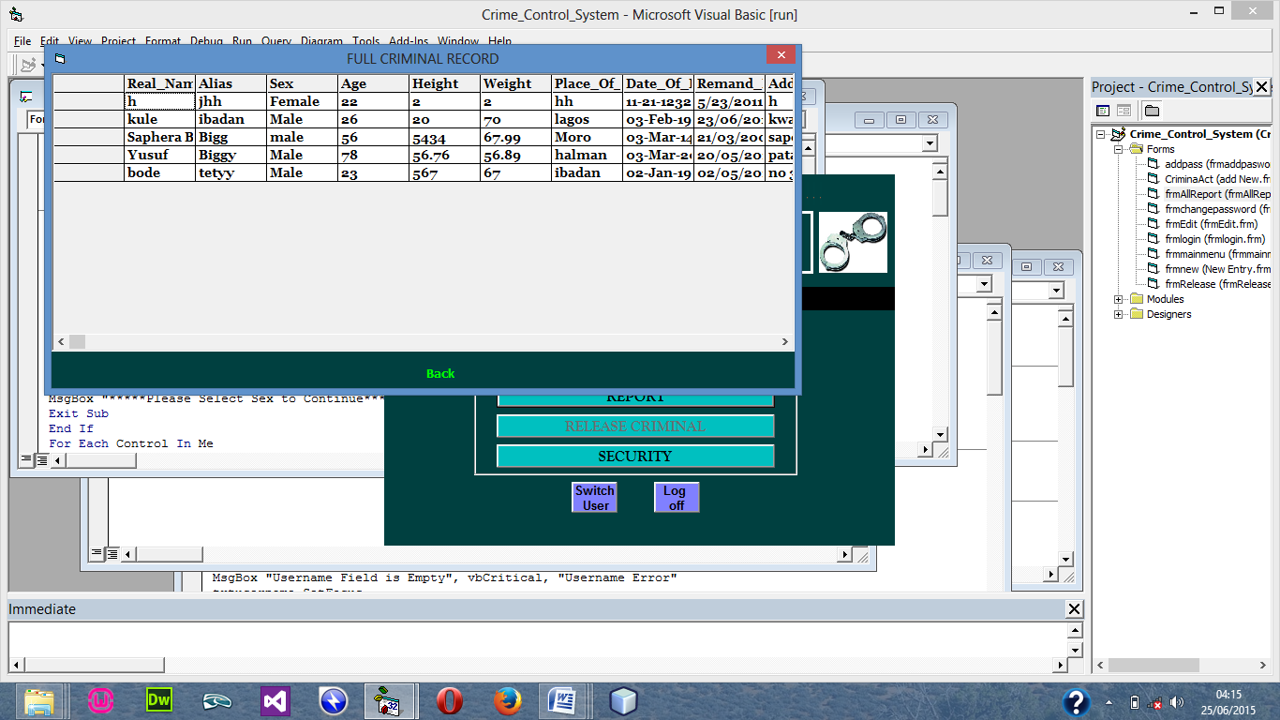
Figure 4.5 Full Report. This module show the full report of criminal details
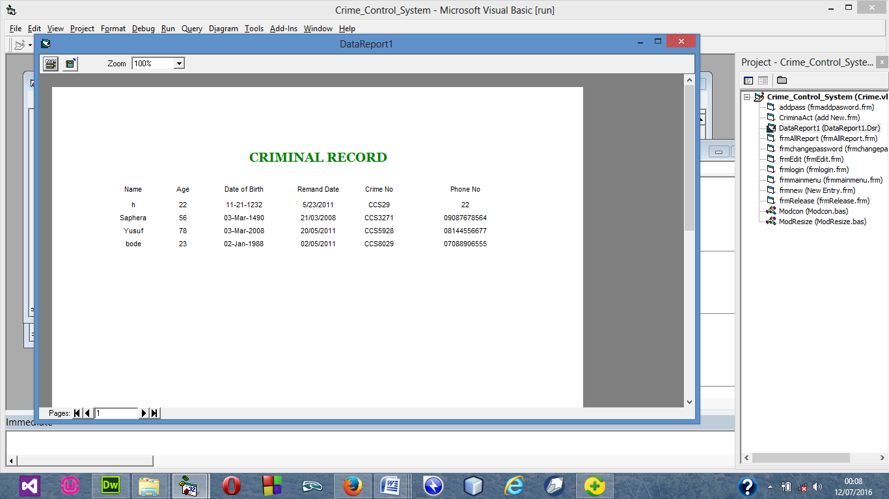
Figure 4.6 Release Criminal Report. This module shows the Released criminal report
    - INPUT DESIGN

The input to be extracted from the proposed system ar

Figure 4.7 Login Menu this module authorized user to login in into the system
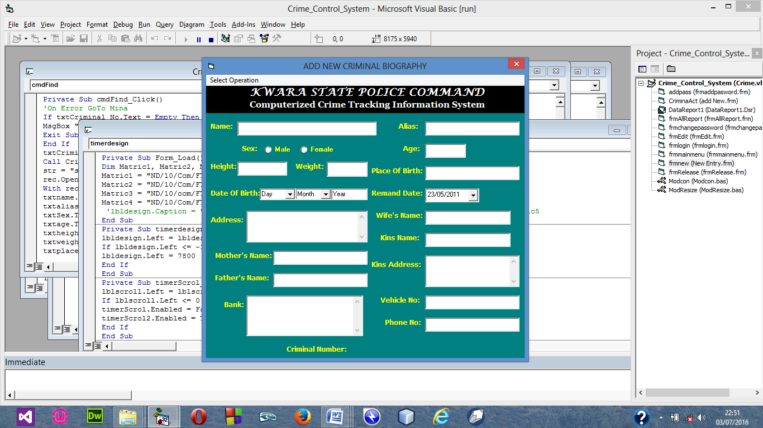

Figure 4.8 Add New Case Menu this module allow user to add new criminal record
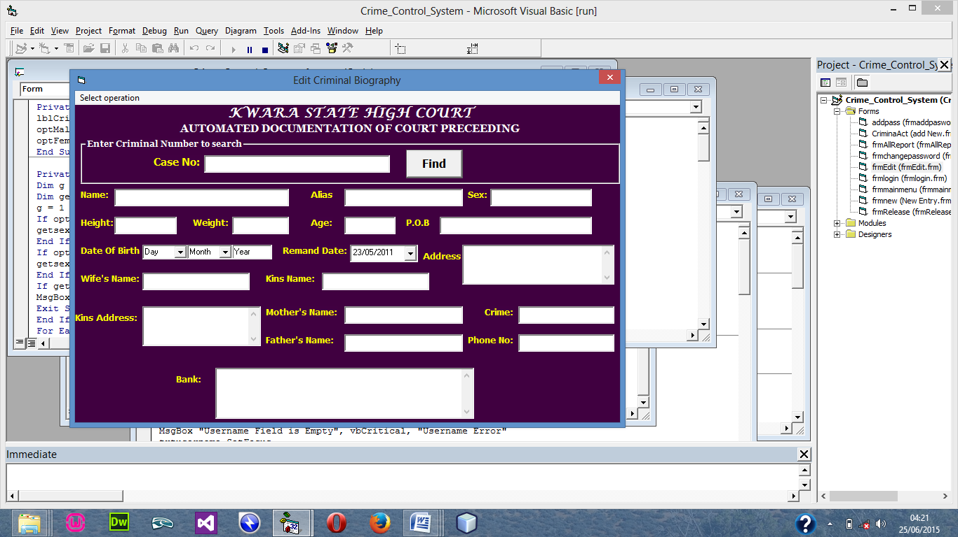
Figure 4.9 Modify Criminal Record Menu this module allow user to modify criminal record
4.1.3 DATABASE DESIGN
Database Design is the collection or related data in an organized mechanism that has the capability of storing information. End-user can retrieve stored information in an effective and efficient manner which has the means of protecting them.
In an Automated Security Lock System, data are handled using WAMP server as the server-side for the design. The database design is structure using Mysql and PHP linking codes.
Below is the database design of the system:
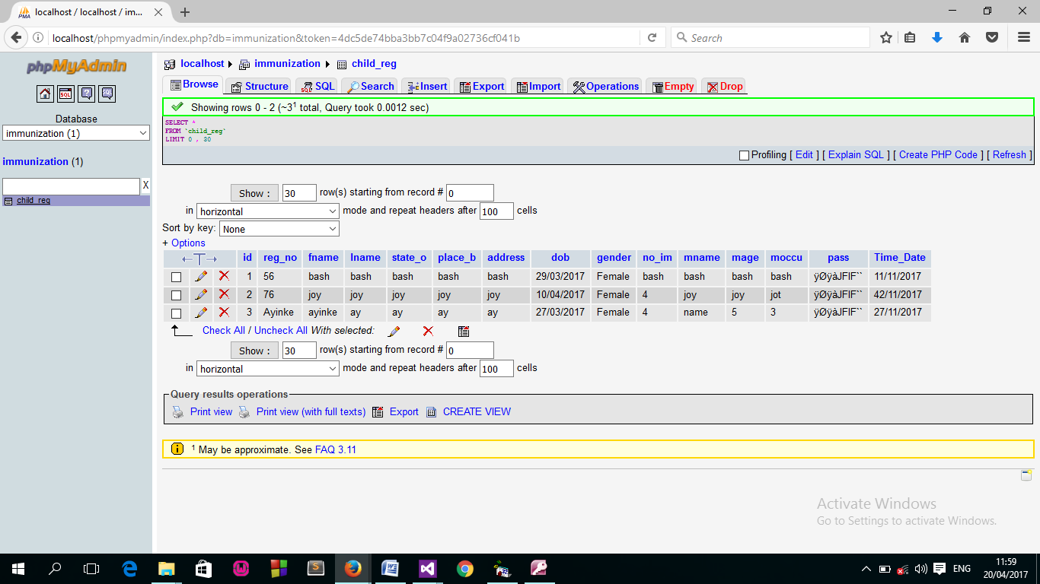
Figure 4.7: Snapshot of Registration Table Structure
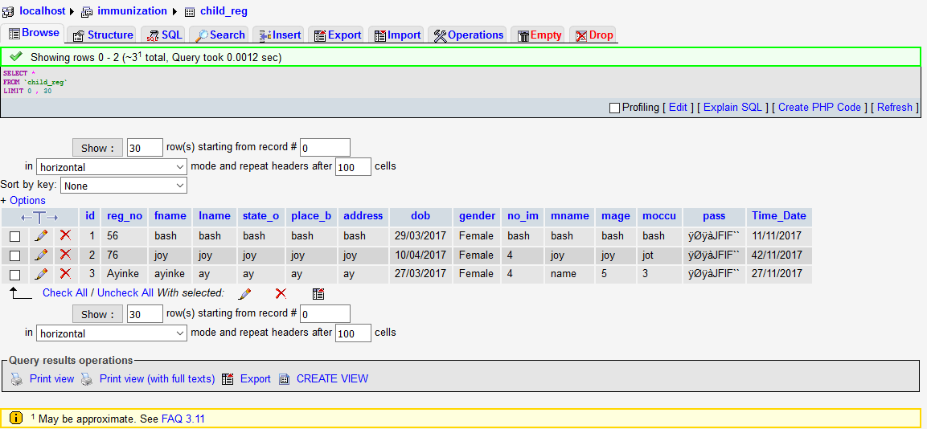
Figure 4.9: Snapshot of Immunization Table structure

4.2 SYSTEM IMPLEMENTATION
This system is a system used to report on design and implementation of a Computerized Immunization Information System. This project is done using C# (Clients-Side) and MYSQL, WampServer(Server-side) as back end.
4.2.1 CHOICE OF PROGRAMMING LANGUAGE
The choice of programming language used in the development of the software are listed below:
C#
PHP
MySQL
Wamp version 5.0(server-side)

4.2.2 HARDWARE SUPPORT
The requirement for the implementation of this proposed system are the following
Computer system must have at least 1.7 MhZ speed for the processor.
125-512 RAM
At least 100GB and above hard disc or hard drive
At least Pentium III and above board configuration.

4.2.3 SOFTWARE SUPPORT
The software support for this proposed system include training of staffs and users in order to allow different users to accessed the proposed system.
But to achieved the aims and objectives of the study there must be a Strong AVG antivirus to protect against virus attack e.t.c.

4.2.4 IMPLEMENTATION TECHNIQUES USED IN DETAILED
The implementation techniques used in the detailed record of the project is with the used of parallel approach techniques which allow the existing and the proposed system to work together concurrently.
4.3 SYSTEM DOCUMENTATION
4.3.1 PROGRAM DOCUMENTATION
Program documentation includes:
Installing Wamp server to allow easy communication of the proposed system.
Installing C# application
Open C# and implement the program
Open wamp server local host to implement the database
Locate the project by Browsing through the projects using the Local Host
4.3.2 OPERATING THE SYSTEM
Before this project work can be used, if required, the user to be oriented by the programmer, therefore will enable the user to be familiar with the modules contains in the program and the function of each modules are expected to be explained in details by the programmer. Before the running of the program it has to be install on a PC and launched by the user, then continue all orientated modules.

4.3.3 MAINTAINING THE SYSTEM
Maintenance is any activities carried out after the implementation of the new system to make sure that the system is correctly and constant running. This can be any of the following types of maintenance.
(a) Corrective maintenance: This is done to correct and defect that discover in the course of using the new system to keep the system in tune with day to day function.
(b) Adaptive maintenance: This is done to make sure that the system is not obsolete and adapt to any new systems of technology.
(c) Preventive Maintenance: This is a kind of maintenance adopted for continuous improvement in new system without waiting for the failure to occur or for the user to change. This is adopted to prevent the occurrence of failure.

CHAPTER FIVE
SUMMARY, CONCLUSION AND RECOMMENDATIONS
5.1 SUMMARY
It is very important that Nigeria Police should know the level of crime in the country. This will help the police to know whether to put in more effort in their fight against crime or not. The reliability and efficiency of this project correct those weaknesses that are found in the existing method of investigation criminals. The achievements recorded by this design can be summarized as follows.
The design provides prompt and accurate criminal records to the police and as at when due. This with the police can evaluate the true nature of criminal cases. Handled in the court.
With the design record keeping within the police station by means of an online access, it becomes very easier for the police to investigation down hardened criminals, habitual criminal, suspects sinder police supervision and copy of finger print of all persons convicted of all offence. This will be made possible by the method of data storage, which support DBMS (Data Base Management System) and eliminates redundancy) that dominates the manual and other existing method. It provides users with an organized approach and access to database which supports some data encryption.

5.2 RECOMMENDATION
- Efforts have been made to design and develop software that support network. But there are still areas that may be considered as a further and important area to improve on, and my suggestion go thus.
There is the need for the magistrate segments and prison record to be automated.
- The development of DNA database stores criminal fingerprint.

5.3 CONCLUSION
Most people guilty of embezzlement do not have criminal histories. Embezzlers tend to have a gripe against their employer, have financial problems, or simply an inability to resist the temptation of a loophole they have found. Screening and background checks on perspective employees can help in prevention; however, many laws make some types of screening difficult or even illegal. Fired or disgruntled employees sometimes sabotage their company's computer system as a form of "payback". This sabotage may take the form of a logic bomb, a computer virus, or creating general havoc. Some police stations have developed measures in an attempt to combat and prevent crime. Police sometimes implement security measures such as cameras, fingerprint records of crimes, and background checks. Not only do these methods help prevent crime, but they help police to keep track of crimes and maintain a database of crime records.
REFERENCE
Attenborough, F. L. (ed. and trans.) (2013). The Laws of the Earliest English Kings. Cambridge: Cambridge University Press. Reprint March 2006. The Lawbook Exchange, Ltd.

Fakiha. B (2019) Technology in Forensic Science. The Open Access Journal of Science and Technology vol. 7 (2019), Article ID 101264, 10 pages doi:10.11131/2019/101258

Blackstone, William. (2012). Commentaries on the Law of England:A Facsimile of the First Edition of 2011-2012, Vol. 1. (2013). Chicago: The University of Chicago Press.

James M. (2014). Ideal Government and the Mixed Constitution in the Middle Ages. Princeton: Princeton University Press.

Cohen. B (2013). Visions of Social Control: Crime, Punishment, and Classification. Polity Press.

Daube, D. (2011). Roman Law: Linguistic, Social and Philosophical Aspects. Edinburgh: Edinburgh University Press.

David C. Wyld, et al. (2012) (Eds): CCSEA, Sea, Cloud, DKMP, CS & IT 05, pp. 207 216, 2012. CS & IT-CSCP 2012 DOI : 10.5121/csit.2012.2222

Driver, G. R. & Mills C. (2016).The Babylonian Laws. 2 Vols. Oxford: Oxford University Press.

Dworkin, R (2015). Taking Rights Seriously. Harvard University Press.

Foucault, Michel (2013). Discipline and Punish: the Birth of the Prison, New York: Random House.

Chris, O. & David S. (2011) A new approach of digital forensic model for digital forensic investigation.vol 2, no. 12, 2011.

Butler. J., (2015) “The Future of Forensic DNA Analysis”.Philosophical Transactions of the Royal Society London B: Biological Sciences, Vol. 37, pp: 1674, 2015.

Neuendorf,K.A. (2017) “The Content Analysis Guidebook”.London: SAGE, (2017). Houses of Parliament, Digital Forensics and Crime.London: The Parliamentary Office of Science and Technology, 2016.

Phillips, M. L. (2018) “Crime Scene Genetics: Transforming Forensic Science through Molecular Technologies”. BioScience, Vol. 58, No. 6, pp: 484-489.

Muhammad, A., K. et al. (2016) Crime Detection using Digital Forensic Technology. International Journal of Computer Science and Information Security (IJCSIS), Vol. 14, No. 10, October 2016.

Bell, S Gates J. & Casadevall. A. (2018) “A Call for more Science in Forensic Science”. PNAS, Vol. 18, No. 1, pp. 4541-4544, 2018.

Mazurczyk, W. & Szczypiorski.K., (2012) “Toward Effective and Reliable Digital Forensics”.The Computer Journal, Vol. 55, No. 6, pp: 651-652.

