KWARA STATE POLYTECHNIC ILORIN, KWARA STATE.
INSTITUTE OF TECHNOLOGY
DEPARTMENT OF CIVIL ENGINEERING

MODELLING OF HYDROLOGICAL AND NITRATE LOADING OF GURARA DAM
BY
AFOLABI PETER SEUN
HND/23/CEC/FT/0060

BEING IN RESEARCH WORK SUBMITTED TO THE DEPARTMENT OF CIVIL ENGINEERING, INSTITUTE OF TECHNOLOGY, KWARA STATE POLYTECHNIC, ILORIN

IN PARTIAL FULFILMENT OF THE REQUIREMENT FOR THE AWARD OF HIGHER NATIONAL DIPLOMA (HND) IN CIVIL ENGINEERING
JUNE 2025.
CERTIFICATION
This is to certify that this research study was conducted by AFOLABI PETER SEUN (HND/23/CEC/FT/0060) and had been read and approved as meeting the requirement for the award of Higher National Diploma (HND) in Civil Engineering of the Department Civil Engineering, Institute of Technology, Kwara State Polytechnic, Ilorin.

………………………. …………………………
ENGR. A. SANNI DATE
Project Supervisor

…………………………………… ……………………..
ENGR. A. NAALLAH DATE
Head of Department

……………………………. ……………………..
ENGR. DR. MUJEDU KASALI ADEBAYO DATE
External Examiner
DEDICATION
This project is dedicated solemnly to ALMIGHTY GOD, who is the sole inspiration of all things, without whom there would not be, and neither would this project.
Appreciation goes to my loving parents for their support in the fulfillment of my Higher National Diploma (HND) both orally and financially. May God allow them to eat the fruit of their labor (Amen)
ACKNOWLEDGEMENT
Thank you, ALMIGHTY GOD, for a successful journey. It hasn't been easy but all praise goes to the Almighty for making it possible., also appreciate all the staffs of Kwara State Polytechnic Ilorin.
I extend sincere thanks to my project supervisor and also my lecturer, Engr. A. SANNI, for his invaluable guidance, mentorship, and patience. His insights and encouragement have been instrumental in shaping this work.
To my Father Mr Ayobami Afolabi and my Mother Mrs Bola Afolabi, I honestly don't even know how to thank you enough, you've been my strength through it all, and l'm forever grateful to have a family like you.
To all my backbones thank you from the bottom of my heart. You made this HND journey unforgettable. To my amazing friends, I'm always proud of you, and I'm blessed to have you in my life. Special shout-out to my boss, Mr Amao, softy bread, Kamal and other I can never forget you. Your encouragement means the world to me. It really boosts my confidence and motivates me to keep going.
Thank you for being my rock, love you so much.
TABLE OF CONTENTS
Content | Page
Title Page | i
Certification | ii
Dedication | iii
Acknowledgement | iv
Abstract | v
Table of Contents | vi
List of Figures | vii

CHAPTER ONE: INTRODUCTION
1.1 Background to the Study 1
1.2 Statement of the Problem 3
1.3 Aim and Objectives 3
1.4 Scope of the Study 4
1.5 Justification 4

CHAPTER TWO: LITERATURE REVIEW
2.0 Introduction 5
2.1 Nitrate Loading 10
2.2 Hydrologic Modelling 11
2.3 Types of Models 13

CHAPTER THREE: RESEARCH METHODOLOGY
3.1 Description of the Study Area 15
3.2 Model Selection 16
3.2.1 SWAT Model Description 17
3.2.2 The Conceptual Model 18
3.3 Modeling Tool and GIS Interface 19
3.4 Model Input Data Collection 19
3.4.1 Digital Elevation Model (DEM) 20
3.4.2 Land Cover/Land Use 21
3.4.3 Digital Soil Data 22
3.4.4 Weather Data 23
3.5 Watershed Delineation in SWAT | 24
3.6 Sub-basin and HRU Delineation 25
3.7 SWAT Setup and Run 26

CHAPTER FOUR: RESULTS AND DISCUSSION
4.1 Hydrological Model Simulation 27
4.2 Spatial Variation of Nitrate and Flow 29
4.3 Total Nitrate and Flow Estimation 31

CHAPTER FIVE: CONCLUSION AND RECOMMENDATION
5.1 Conclusion 32
5.2 Recommendation 33
REFERENCES 35

LIST OF FIGURES
Figure | Title | Page
Figure 3.1 | DEM of the Study Area | 21
Figure 3.2 | Land Use Map of the Study Area | 22
Figure 4.1 | Watershed Delineation into Subbasins | 28
Figure 4.2 | Spatial Variation of Nitrate in the Watershed | 30
Figure 4.3 | Spatial Variation of Flow in the Watershed | 31

ABSTRACT
This study applies the Soil and Water Assessment Tool (SWAT) to simulate hydrological processes and nitrate loading in the Gurara Dam watershed located in Kaduna State, Nigeria. The increasing levels of nitrate pollution resulting from agricultural runoff, urbanization, and climate variability pose significant threats to water quality and ecosystem health in the region. The research involved watershed delineation, subdivision into sub-basins and hydrologic response units (HRUs), and input of digital elevation, land use, soil, and climate data. Using 19 years of historical weather data (2001–2019), the model effectively simulated streamflow and nitrate input across multiple sub-basins. Results revealed that sub-basins 1 through 4 contributed disproportionately to both streamflow and nitrate loading, suggesting intense land-use pressures, likely from fertilizer application and surface runoff. Spatial analysis highlighted critical areas for targeted intervention. The total nitrate load in the watershed was estimated at 967,247.55 kg, with a total streamflow of 435.72 m³/s over the modeled period. The findings underscore the importance of hydrologic modeling in identifying pollution hotspots and guiding watershed management practices. Recommendations include the implementation of nutrient management strategies, enforcement of land-use regulations, and community engagement to safeguard water quality and promote sustainable resource use in the Gurara Dam catchment.

CHAPTER ONE
INTRODUCTION
1.1 Background to the Study
Gurara Dam, situated in Kaduna State, Nigeria, plays a critical role in providing water for irrigation, domestic use, and hydroelectric power generation. With increasing pressures from agricultural activities and urbanization, the integrity of this vital water resource has come under threat. One of the primary concerns is the loading of nitrates into the reservoir, which poses significant risks to water quality, aquatic ecosystems, and human health. Understanding both hydrologic processes and nitrate loading is essential for effective management of water resources in this region.
Water is an essential resource for domestic, agricultural, industrial, and ecological functions. In many regions, particularly in developing countries like Nigeria, the sustainable management of water resources is a critical concern due to increasing demands from growing populations and economic development. Dams serve as key infrastructure in achieving water security by providing water for irrigation, domestic supply, hydroelectric power, and flood control. Among the numerous dams in Nigeria, Gurara Dam, located in Kaduna State, plays a central role in supplying potable water to the Federal Capital Territory (FCT) and surrounding areas (Obeta, 2019).
Despite its significance, the environmental sustainability of the Gurara Dam is being threatened by rising levels of water pollution, especially nitrate contamination.Nitrates are highly soluble and mobile in water, often entering surface water bodies through agricultural runoff, leaching from fertilizers, improper waste disposal, and effluent discharge (Afolabi et al., 2017). High concentrations of nitrates can lead to eutrophication, deterioration of aquatic habitats, and health risks such as methemoglobinemia, commonly known as “blue baby syndrome” (World Health Organization, 2011).
The understanding of hydrological dynamics—which includes rainfall-runoff relationships, evapotranspiration, infiltration, and groundwater flow—is crucial in assessing how water moves through the catchment and transports nutrients like nitrates. Modelling these hydrologic and nitrate loading processes provides a scientific approach to predicting pollutant loads and planning interventions for water quality protection (Gassman et al., 2007). With increasing reliance on Gurara Dam for municipal water supply, it is critical to develop and validate models that can simulate the interactions between land use, hydrology, and nitrate transport under various scenarios.
Water resources are critical for sustaining ecological balance, supporting agricultural activities, and meeting the demands of growing populations. In this context, the Gurara Dam, located in Nigeria, plays a vital role in regulating water flow and managing resources for irrigation, hydroelectric power generation, and local water supply. However, the increasing pressure from agricultural runoff, urbanization, and climate variability poses challenges associated with water quality deterioration, particularly concerning nitrate loading.
Watershed is the area of land that drains down slope to the lowest point of terrain. The water moves by gravity means in a network of drainage pathway that maybe underground or on the surface into a specified body of water, river or stream. Although there are many ways for water to enter a stream, much of it will enter as run-off from the land. This land is what forms the stream watershed.
However, in some regions, the water drains to a central depression such as a lake or Marsh with no surface water exists. It’s possible to delineate watershed boundaries manually using a topographic map that shows stream channels, or contour plots. The watershed boundaries will follow major ridges lines around the channel and meet at the bottom where the water flows out of the watershed, commonly referred to as mouth of the stream or river. In contour plots, droplets of water usually travel along lines normal to the contour lines down the hills. As the ground retains water for longer periods, more water will reach the downstream mouth of the area.
Delineation and analysis of watershed can be performed in many forms according to the needs of the user and available resources. There are a dozen of methods for collecting DEM data such as field surveying, aerial photogrammetry, laser scanning, GPS and others. Each method has its own advantages and disadvantages and the created DEM inherent varying degrees of errors (Rasheed,S.A, 2013).
1.2 Statement Of The Problem
Agricultural intensification and urbanization have led to increased nutrient loading, particularly nitrates, in water bodies. This has resulted in eutrophication, loss of aquatic biodiversity, and contamination of drinking water sources. Effective modeling tools are needed to understand and mitigate these impacts.
1.3 Aim And Objectives
The primary aim of this study is to use the SWAT model to simulate hydrological processes and nitrate loading in a watershed.
The specific objectives are:
- To develop a hydrological model to simulate nitrate and flow in the study area.
- To analyze the spatial variation of nitrate and flow in the study area.
- To estimate the total nitrate and flow in the watershed.
1.4 Scope Of The Study
This study focuses on the application of SWAT in Gurara DamWatershed. The research encompasses watershed delineation, hydrological modeling, nitrate loading assessment, and scenario analysis of land management practices.
1.5 Justification
Given the increasing threat of nitrate pollution to water quality, this study provides critical insights into sustainable watershed management. By leveraging SWAT, stakeholders can identify effective strategies to reduce nitrate pollution while ensuring agricultural productivity.

CHAPTER TWO
LITERATURE REVIEW
2.0 Introduction
The Gurara Dam, located in Nigeria's north-central region, plays a pivotal role in water supply, irrigation, and hydroelectric power generation. However, increasing concerns about nitrate contamination and hydrologic instability in the catchment call for an in-depth investigation grounded in scientific modeling and empirical data. The modeling of hydrological and nitrate loading is particularly crucial for effective water resource planning, management, and pollution control in the dam’s watershed.
Hydrological modeling serves as a tool to simulate and understand the complex movement of water through a watershed, including surface runoff, infiltration, percolation, and groundwater recharge. These models enable scientists and policymakers to predict the effects of natural and anthropogenic factors on water quantity and quality. Meanwhile, nitrate loading models are essential for assessing nutrient pollution, which is one of the leading causes of eutrophication and water quality deterioration in reservoirs globally (Gassman et al., 2007; Camargo & Alonso, 2006).
Watersheds like that of the Gurara Dam are influenced by a range of environmental factors such as land use change, agricultural intensification, population growth, and climate variability, which all contribute to nutrient loading. For instance, improper application of nitrogen-based fertilizers can lead to leaching and runoff, carrying excess nitrate into surface and groundwater systems (USEPA, 2013). The integration of hydrological and water quality modelsallows for the quantification and spatial distribution of nitrate sources, as well as the evaluation of management practices aimed at reducing nutrient pollution.
Gurara dam has a high economic growth rate but is still facing water scarcity. Wijitkosum [2019] analyzed the water situation in the Watershed which was subject to the economic plan of the government. Gurara dam was on the brink of a water shortage and this problem was at the peak during the maximum water usage and minimum water asset. As a result of the economic value, it is necessary to conduct a hydrological and water quality modeling research in Gurara dam. The results show the accuracy of the flow simulation, helping planners to come up with a reasonable flow and water quality management.
Netnapa [2020] applied the Soil and Water Assessment Tool (SWAT) model for evaluations streamflow, sediment, nutrient loading simulations in the Gurara dam. That author demonstrated that the SWAT model could be a useful tool for water resources management in the Gurara dam.
The water flow change at the outlet of the river watershed affected the nutrient loads. Previous studies in the Gurara dam have not estimated the relationship between flow and nitrate in LTW. In this study, ArcGIS integrated with the SWAT model, which can realistically represent the spatial variability of watershed characteristics, will be used to study upstream and downstream areas in the Gurara dam. SWAT model is selected for this study because it is included channel degradation routine with detail appropriate for watershed management. The results could be a useful tool for water resources planning in Gurara.
This literature review presents a critical synthesis of prior research on watershed hydrology, nitrate pollution sources and impacts, and modeling approaches applicable to water quality studies. Emphasis is placed on models such as SWAT (Soil and Water Assessment Tool)and HEC-HMS (Hydrologic Engineering Center – Hydrologic Modeling System), which are widely recognized tools for simulating watershed-scale processes and pollutant dynamics. Additionally, the review explores studies conducted in both global and Nigerian contexts, identifying research gaps and highlighting opportunities for improved nitrate management in the Gurara Dam catchment.
Chau and Chatpet (2019) examine the hydrological and nitrate loading modeling of watershed.Water pollution is largely associated with the growth of agriculture, urbanization, and industrialization, non-point sources area approximately covered 89% of the total area, those sources became the significant contributors of water pollutants. Water quality researches of the watershed were carried out with many different watershed models, but the SWAT model has not been applied to allot the pollutant loading from diffuse sources. Therefore, the main objective of this study is to apply the SWAT model to simulate flow and nitrate. The results of the study can be a useful tool for the management of surface water resources.
Smith, K.B. et al., (2018) utilized hydrological modeling to assess the impact of watershed delineation on water quality parameters in a semi-arid region. Their study emphasized the utility of models in understanding the complex interactions between land use, soil characteristics, and hydrological processes. In this study, they employed hydrological modeling to evaluate how watershed delineation affects water quality parameters in a semi-arid region. The results of their study indicated that the choice of watershed delineation method significantly influenced the estimation of water quality parameters. Specifically, they found that different delineation methods led to variations in the predicted flow paths, which subsequently affected the distribution of pollutants and nutrient loads within the watershed.
Gayathri et al., (2015) examine the hydrological models Climate change and soil heterogeneity has got an important role in finding out surface runoff. In this paper, we are going to discuss briefly about variable infiltration capacity model (VIC), TOPMODEL, HBV, MIKESHE and soil and water assessment tool (SWAT) model. VIC performs well in moist areas and can be efficiently used in the water management for agricultural purposes. Requirement of large data and physical parameters makes the use of MIKE SHE models limited to smaller catchments. Only a little direct calibration is required for SWAT model to obtain good hydrologic predictions. HBV model gives satisfactory results and TOPMODEL can be used in catchments with shallow soil and moderate topography.
Baonanet al., (2019) investigate the effect of hydrogeological conditions and surface loads on shallow groundwater nitrate pollution,Nitrate pollution in groundwater has become a widespread problem worldwide, but understanding of the factors influencing groundwater nitrate pollution remains limited. Numerous studies have attributed nitrate pollution mostly to surface conditions and have neglected the role of hydrogeology. Therefore, this study used the Shaying River Basin as the study area and developed a least squares surface fitting (LSSF) model to systematically analyze the effect of hydrogeological conditions and surface pollution loads on groundwater nitrate pollution. Intrinsic vulnerability and total soil nitrogen (TSN) were used to represent hydrogeological conditions and surface pollution loads, respectively. The results showed that the concentrations of NO –N in shallow groundwater ranged from 0.002 to 256.29mg/L (with an average of 14.38mg/L). The concentration had an overall decreasing trend along the flow path.These findings provide helpful information for those tasked with managing and controlling groundwater quality.
Deng et al.,(2011) work on Modeling nitrogen loading in a small watershed in southwest China using a DNDC model with hydrological enhancements,the degradation of water quality has been observed worldwide, and inputs of nitrogen (N), along with other nutrients, play a key role in the process of contamination. The quantification of N loading from non-point sources at a watershed scale has long been a challenge. Processbased models have been developed to address this problem. Because N loading from non-point sources result from interactions between biogeochemical and hydrological processes, a model framework must include both types of processes if it is to be useful.
Mohammad etal., (2007) work on the modeling nitrate contamination of groundwater in agricultural,the framework utilizes the national land cover database (NLCD) of the United State Geological Survey (USGS) grid and a geographic information system (GIS) to account for the spatial distribution of on-ground nitrogen sources and corresponding loadings. The framework employs a soil nitrogen dynamic model to estimate nitrate leaching to groundwater. These estimates were used in developing a groundwater nitrate fate and transport model. The framework considers both point and non-point sources of nitrogen across different land use classes. The methodology was applied for the Sumas–Blaine aquifer of Washington State, US, where heavy dairy industry and berry plantations are concentrated. Simulations were carried out using the developed framework to evaluate the overall impacts of current land use practices and the efficiency of proposed protection alternatives on nitrate pollution in the aquifer watersheds.
The SWAT model allows the simulation of hydrologic, sediment, and pollutants processes as well as crop growth and management practices in a watershed by using the water balance approach. The SWAT operates by first dividing the drainage basin into sub-basins. Each sub-basin is further partitioned into a number of hydrologic response units (HRUs). These are distinctive topography-soil–land use combinations. The simulations for each HRU are subsequently aggregated for the sub-basin by a weighted mean. Neitsch et al.2011) documentation provides a detailed model functioning literature.
According to (Baonan et. al 2019) Groundwater is one of the most important sources of drinking water in many cities and rural communities, accounting for approximately 20% of the world's fresh water supply. In addition, groundwater is widely used in municipal, industrial, and agricultural activities. However, population growth and agricultural/industrial development threaten groundwater quality and quantity. Elevated concentrations of nitrate in groundwater have received widespread attention because they threaten human health. Recent studies have shown that nitrate pollution in groundwater has a variable tendency from a point to a strip and from shallow to deep.
Although the aforementioned studies demonstrate the effects of surface loads and hydrogeological conditions on groundwater nitrate pollution, respectively, they are limited in scope. On one hand, the types and quantities of hydrogeological parameters selected are not uniform and comprehensive in each study. On the other hand, there is a lack of methods to assess the comprehensive impact of hydrogeological conditions and surface loads on groundwater pollution simultaneously. Considering these concerns, it is urgently necessary to take some measures to conduct a more comprehensive study (Baonan et. al 2019).
In modern agriculture, intensive fertilizer applications are used to maintain optimum yields. However, the high application rates of nitrogenous fertilizer and the low efficiency associated with its use mean that superfluous nitrogen (N) remains in the soil. This excess nitrogen could eventually move from the soil into the atmosphere or into water bodies.
This source of nitrogen loading has produced a series of environmental problems at the local, regional or global scales. Nitrate is a primary contaminant of freshwater systems, often originating from agricultural practices, such as excessive fertilizer application and livestock waste. Once in water bodies, nitrates can lead to eutrophication—a process that depletes oxygen levels in water, harms aquatic life, and poses health risks to humans. Understanding the dynamics of hydrologic processes and nitrification is crucial for effective water resource management, particularly in regions that serve multifunctional roles. (Ahtiainen et. al. 2015).
Modeling hydrologic processes and nitrate loading involves the integration of hydrological and environmental science principles. This process typically employs advanced computational models to simulate the interaction between precipitation, surface runoff, infiltration, groundwater flow, and nitrate transport. These models can provide insights into how different land-use practices, climate scenarios, and watershed management strategies impact the quality and quantity of water resources.(Gayathri et.al 2015).
The Soil and Water Assessment Tool (SWAT) model for evaluations streamflow, sediment, nutrient loading simulations in the Lam Takong River basin. That author demonstrated that the SWAT model could be a useful tool for water resources management in the Lam Takong River basin (Chau and Chatpet 2019).
2.1 Nitrate Loading
Nitrate is a common pollutant in surface waters, often originating from agricultural runoff, wastewater, and atmospheric deposition. Eutrophication caused by excess nitrates can lead to oxygen depletion in aquatic systems, affecting fish populations and overall ecosystem health. Research in similar contexts has demonstrated the significant role of land management practices in nitrate loading levels.
2.2 Hydrologic Modelling
Hydrologic modeling is crucial for predicting water flow and quality in watersheds. Various hydrologic models exist, with the SWAT model being widely used to simulate hydrology and water quality in agricultural watersheds. Previous studies have shown that SWAT effectively captures rainfall-runoff processes, allowing for the assessment of land-use impacts on water quality.
According to Sorooshianet al., (2008), a model is a simplified representation of real-world system. The best model is the one which give results close to reality with the use of least parameters and model complexity. Models are mainly used for predicting system behaviour and understanding various hydrological processes. A model consists of various parameters that define the characteristics of the model. A runoff model can be defined as a set of equations that helps in the estimation of runoff as a function of various parameters used for describing watershed characteristics. The two important inputs required for all models are rainfall data and drainage area. Along with these, water shed characteristics like soil properties, vegetation cover, watershed topography, soil moisture content, characteristics of ground water aquifer are also considered. Hydrological models are now a day considered as an important and necessary tool for water and environment resource management.
2.3 Types of models
- Empirical models (Metric model)
These are observation-oriented models which take only the information from the existing data without considering the features and processes of hydrological system and hence these models are also called data driven models. It involves mathematical equations derived from concurrent input and output time series and not from the physical processes of the catchment. These models are valid only within the boundaries. Unit hydrograph is an example of this method. Statistically based methods use regression and correlation models and are used to find the functional relationship between inputs and outputs. Artificial neural network and fuzzy regression are some of the machine learning techniques used in hydro informatics methods.
- Conceptual methods (Parametric models)
This model describes all of the component hydrological processes. It consists of a number of interconnected reservoirs which represents the physical elements in a catchment in which they are recharged by rainfall, infiltration and percolation and are emptied by evaporation, runoff, drainage etc. Semi empirical equations are used in this method and the model parameters are assessed not only from field data but also through calibration. Large number of meteorological and hydrological records is required for calibration. The calibration involves curve fitting which makes the interpretation difficult and hence the effect of land use change cannot be predicted with much confidence. Many conceptual models have been developed with varying degree of complexity. Stanford Watershed Model IV (SWM) is the first major conceptual model developed by Crawford and Linsley in 1966 with 16 to 20 parameters.
- Physically based model
This is a mathematically idealized representation of the real phenomenon. These are also called mechanistic models that include the principles of physical processes. It uses state variables which are measurable and are functions of both time and space. The hydrological processes of water movement are represented by finite difference equations. It does not require extensive hydrological and meteorological data for their calibration but the evaluation of large number of parameters describing the physical characteristics of the catchment are required (Abbott et al., 1986 a). In this method huge amount of data such as soil moisture content, initial water depth, topography, topology, dimensions of river network etc. are required. Physical model can overcome many defects of the other two models because of the use of parameters having physical interpretation. It can provide large amount of information even outside the boundary and can applied for a wide range of situations.

CHAPTER THREE
RESEARCH METHODOLOGY
3.1 Description of the Study Area
The Gurara Dam is located in KadunaState, Nigeria.The Gurara Dam was designed and constructed with the main purpose of supplying water to the Lower Usuma Dam in the FCT to meet the demand for water. The dam, situated about 75km from the Abuja city center, has a crest of 3.2km in length, maximum height of 54m, and a reservoir capacity of 880MCM. The intake of the conveyance pipeline is located on the right bank, about 1.6km upstream from the dam. It has a 45m-high intake tower comprising four independent 4m-high and 2.5m-wide intakes equipped with stop-logs and fixed scree located at different elevations to allow withdrawal of water of the required quality
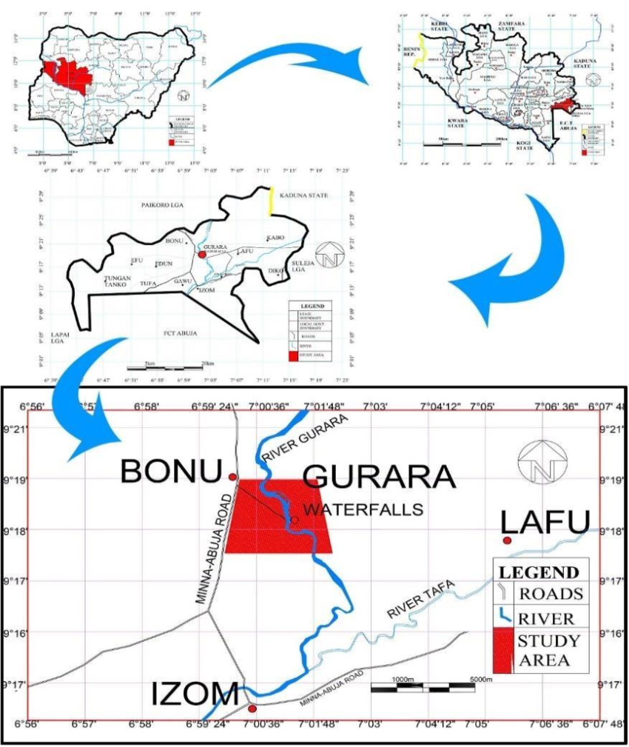
Multi-scale map showing the study area around the gurara waterfalls in nigeria.

3.2 Model Selection
The model used in this study is the soil and water Assessment Tool, SWAT (neitschet al., 2005). The selection of SWAT for this study was based on many reasons which are listed as follows
- SWAT is an existing, readily available software freely available on SWAT website
- It has several user’s groups e.g SWAT Africa, SWATworld and waterbase Goggle group which serves as plus to the acceptability of the tool among researchers.
- Its availability and efficacy in prediction of different hydrological processes has also been reported in many studies (Adeogunet al., 2015) which make it attractive to engineers and other users.
3.2.1 Introduction To Swat Model Description
The modeling tool was interfaced with Map Window GIS to simulate the hydrology and predict the flow into sub-basins in the watershed. The model developed by the Agricultural Research Service of the United Stated Department of Agriculture (ARS-USDA) simulates eight components of the environment system, i.e., hydrology, generation of weather data, Sedimentation process, soil energy balance, crop growth, nutrient and pesticide leaching and agricultural management (Neitschet al., 2002). SWAT is a semi-distributed model using process descriptions that are either empirically or physically limited in its process basis, operating on a daily time step. SWAT uses hydrologic response units (HRUs) to describe the spatial heterogeneity in terms of land cover and soil type.
The model simulates the hydrologic processes at four levels:
- the soil surface
- the intermediate unsaturated zone.
- the shallow and deep aquifers.
- the open channels.
Relevant hydrologic components such as evapotranspiration, sur-face runoff, groundwater ﬂow and soil moisture change are estimated at the level of each HRUs. Streamﬂow in the main channel is the sum of the surface runoff, the literal and baseﬂow. For predicting the runoff volumes, SWAT use a modiﬁed computational efﬁcient version of the Soil Conservation Service Curve Number (SCS CN) method (SCS-USDA 1972), relating runoff to soil type, land use and management practices. In addition, SWAT uses an empirical procedure for channel routing.
The base flow recession constant is calculated using an equation suggested by Steadman & Rycroft (1983), a function of the overall basin topography, drainage pattern, soils and geology composition of the watershed.
3.2.2 The Conceptual Model
SWAT incorporates the effects of weather, surface runoff, evapotranspiration, irrigation, sediment transport, groundwater flow, crop growth, nutrient yielding, pesticide yielding and water routing, as well as the long-term effects of varying agricultural management practices. In the SWAT model, the watershed is partitioned into sub basins that are further subdivided into one or several homogeneous hydrological response units (HRUs) with relatively unique combinations of land cover, soil and topographic conditions. The hydrological component of the model calculates soil-water balance at each time step based on daily amounts of precipitation, runoff, evapotranspiration, percolation and base flow.
3.3 Modeling Tool And Gis Interface
A geodata model and geographic information system (GIS) interface for the Soil and Water Assessment Tool (SWAT). The SWAT data model is a system of geodatabases that store SWAT geographic, numeric, and text input data and results in an organized fashion. Thus, it is proposed that a single and comprehensive geodatabase be used as the repository of a SWAT simulation.
The SWAT interface uses programming objects that conform to the Component Object Model (COM) design standard, which facilitate the use of functionality of other windows-based applications within SWAT. In particular, the use of MS Excel and MATLAB functionality for data analysis and visualization of results is demonstrated.
3.4 Model Input Data Collection Processing
The spatially distributed data (GIS input) needed for the running of Map Window SWAT include the DEM, soil data, land use and stream network layers. Weather data are also necessary for prediction of stream flow in the watershed. The GIS interface of the model was used to discretize the catchment area and geo-processed the spatial data into formats required by the model.

3.4.1 Digital Elevation Model (Dem)
The topographical data used for this study was obtained from the Shuttle Radar Topography Mission (SRTM) final version, a 90-meter resolution Digital Elevation Model (DEM) developed by CGIAR (2012). The CGIAR-CSI GeoPortal provides SRTM 90m DEM data for a significant portion of the world. To enhance the usability of this DEM data, it has undergone processing to fill data gaps and meet the needs of various user groups. CGIAR (2012) aims to promote the use of geospatial science and applications in sustainable development and resource conservation efforts, particularly in developing countries. In this study, the SRTM DEM was utilized for watershed delineation into sub-basins and derivation of topographic parameters, including terrain slope, channel slope, and reach length. Digital Elevation Model of the study which is as shown in figure
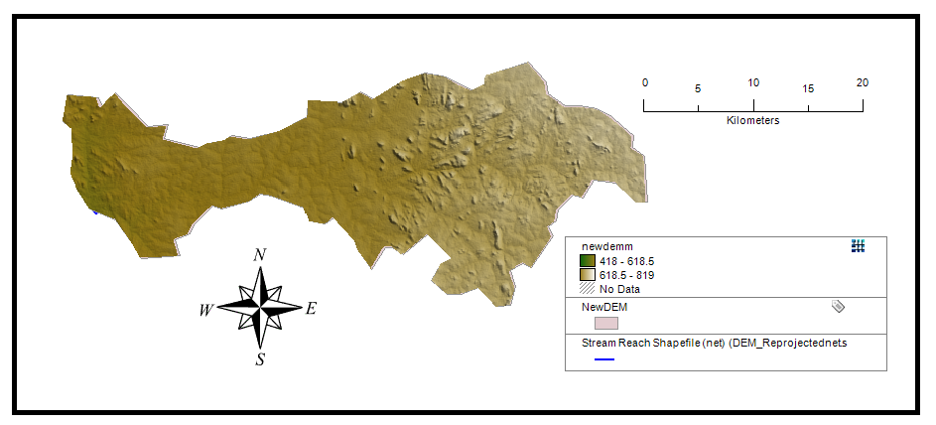
Figure 3.1 DEM of the study area
3.4.2 Land Cover/Land Use
The land use map required for SWAT analysis was obtained from the Global Land Cover Characterization (GLCC) database, which was developed by the United States Geological Survey (USGS). This database has a spatial resolution of 1 km and represents land use in 24 distinct classes (GLCC, 2012). The land use data from GLCC was used to estimate vegetation and other parameters for the watershed area. To enhance accuracy, field visits to the watershed area were conducted to gather on-site information regarding land use and land cover. Information collected during these visits was utilized to update the GLCC database and generate the final land use map for this study.
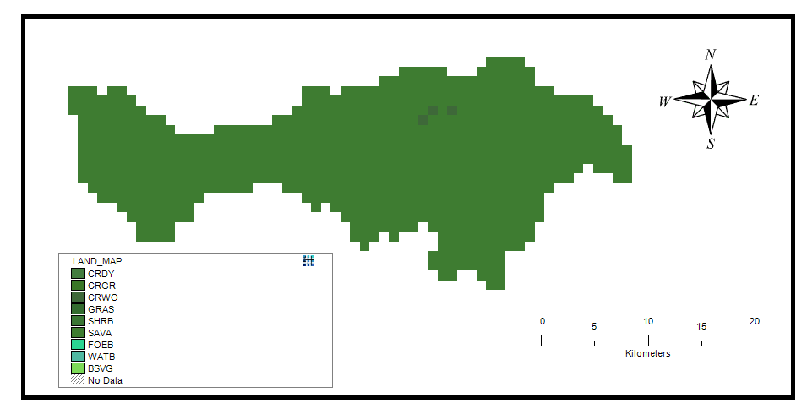
Figure 3.2 land use map of the study area
3.4.3 Digital Soil Data
The necessary digital soil information for this study was derived from the Harmonized World Soil Database (HWSD), a comprehensive global digital soil map developed by the Food and Agriculture Organization of the United Nations (FAO). The database was accessed on May 30, 2013, and comprises detailed soil data essential for the analysis conducted in this research.
The HWSD is an invaluable resource that contains soil data from various sources around the world, harmonized to ensure consistency and comparability across regions. This database has been used extensively in environmental modeling, land management, and agricultural planning. For this study, the digital soil data obtained from HWSD provided crucial input parameters for understanding the watershed's characteristics and evaluating its hydrological processes.
The digitized soil map was completed in January 2003 data for 16,000 different soil mapping units containing two layers (0 - 30 cm and 30-100 cm depth). Seven soil units are then extracted from the database and completed by additional information gathered by taken soil samples from different locations within the watershed area. 16 soil samples were collected from two different layers (0 - 30 cm and 30 - 100 cm depth) and the samples were analyzed and used to update the model parameters.
3.4.4 Weather Data
To effectively drive hydrological balance simulations within the SWAT model, daily weather variables such as minimum and maximum temperatures, wind, relative humidity, and solar radiation are required. These vital data inputs were sourced from the Nigerian Meteorological Agency (NIMET) based is an organization known for its reliable meteorological data collection in Nigeria. The dataset acquired encompassed a 19-years period, ranging from January 1, 2001, to December 31, 2019. NIMET's comprehensive and long-term meteorological records are indispensable for studying and comprehending the region's climatic patterns and any possible changes that may have occurred. These data serve as crucial input parameters for hydrological modeling, enabling researchers and policymakers to evaluate water resource availability, potential hydropower production, and the impacts of climate change on the area.
3.5 Watershed Delineation In Swat
Employing the Digital Elevation Model (DEM), we delineated the watershed boundaries of Gurara dam within the SWAT model. This process was pivotal in defining the spatial extent for our hydrological simulations, providing a precise framework for evaluating the hydrological process and nitrate loading
3.6 Watershed Deliniation Into Sub Basins And Hydrological Response Units (Hrus)
The Soil and Water Assessment Tool (SWAT) model was employed for sub-basin delineation of the watershed and further division of sub-basins into Hydrologic Response Units (HRUs). SWAT is a continuous-time, watershed-scale model that effectively simulates long-term yields to determine the impacts of land management practices (Arnold and Allen, 1999).
To initiate the delineation process, the Automatic Watershed Delineation (AWD) dialogue box was activated from the model interface, and the base Digital Elevation Model (DEM) was selected. The elevation units were set to meters, corresponding to the base DEM's units. A focusing mask encapsulating the watershed was drawn and saved as a shape file. The model's threshold size for sub-basins was established, with options to set it by area or number of cells. For this study, a threshold value of 20 km² was chosen. To complete the settings, an outlet point shape file was created and selected.
Following the execution of AWD, the selected watershed was delineated into a total of 5 sub-basins, which were then further divided into 6 HRUs. Each HRU possesses a unique combination of land use, slope, and soil characteristics.
3.7 Swat Setup And Run
In this phase, the simulation period (start and end date) for the modeling exercise was defined, and the weather sources were selected from the SWAT database. The simulation period for this study spanned from January 1, 2001, to December 31, 2019. Essential files required to run SWAT were prepared at this stage, and the appropriate weather sources were chosen before initiating the SWAT model.
Several methods for simulating surface runoff were available to choose from at this point, including the Curve Number and Green-Ampt methods. Additionally, channel water routing methods such as the variable or Muskingum method could be selected. The potential evapotranspiration method was employed in this study, specifically designed to compute river drop. The chosen method was either Priestley, Penman-Monteith, or Hargreaves.
Prior to executing the SWAT model, all necessary files were generated, and the appropriate weather sources were confirmed to ensure accurate model simulations.
CHAPTER FOUR
RESULT AND DISCUSSION
4.1 Development Of Hyrological Model To Simulate Nitrate And Flow
The hydrological model was developed to simulate nitrate input (NO₃_IN in kg) and streamflow (FLOW_IN in m³/s) for each subbasin. The simulation output reflects the hydrological and pollutant transport behavior within the delineated watershed.
The results indicate a wide range of nitrate and flow values across the subbasins. Subbasin 1 recorded the highest nitrate input (258,509.75 kg) and the highest streamflow (115.26 m³/s), signifying its dominant role in both pollutant loading and water discharge. Subbasins 2, 3, and 4 also exhibited significantly high values of both nitrate and flow, pointing to intense land-use activities, likely agricultural or urban in nature.
On the other hand, subbasins such as 7, 8, and 6 showed relatively lower nitrate and flow values, which may correspond to either smaller catchment areas, lower human intervention, or natural land covers like forests.
These simulations demonstrate that the model can effectively capture the dynamics of both flow and nitrate transport, making it a reliable tool for watershed-scale hydrological assessment and water quality management.
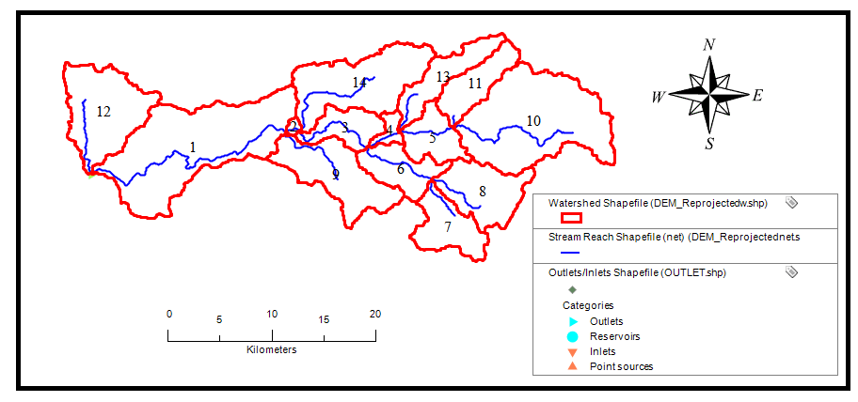
Fig 4.1 watershed delination into different subbasins
4.2 Spatial Variation of Nitrate Concentration and Flow
The spatial distribution of nitrate and streamflow across the 15 subbasins (excluding the zero-value subbasin 0) highlights the heterogeneous nature of the watershed.
- Nitrate Concentration Trends: Subbasins 2, 3, 4, and 1 show exceptionally high nitrate loading. For instance, subbasin 2, despite its small area (1.84 km²), contributed 173,957.54 kg of nitrate, suggesting point-source pollution or highly concentrated land use practices such as fertilizer application.
- Flow Distribution Trends: Similarly, subbasins 1, 3, 4, and 2 show the highest flow values, reinforcing their importance in the overall hydrological connectivity of the basin.
These spatial variations can be attributed to differences in land use, topography, soil properties, and anthropogenic activities. Subbasins with low flow and nitrate contributions (e.g., subbasin 7 and subbasin 6) could represent more forested or less developed areas.
Figure 4.2 and Figure 4.3 will provide a visual map of spatial distribution for both nitrate loading and streamflow, offering better insight into subbasin-level variations.
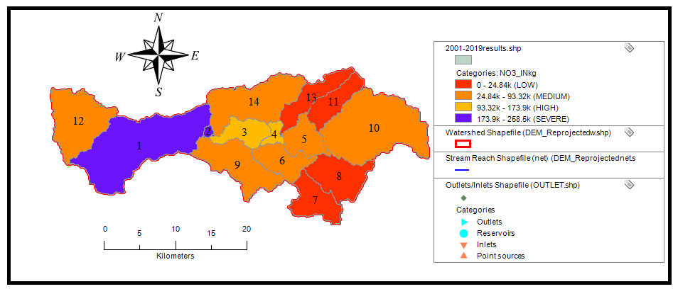
Fig 4.2 Spatial Variation of Nitrate inthe Watershed
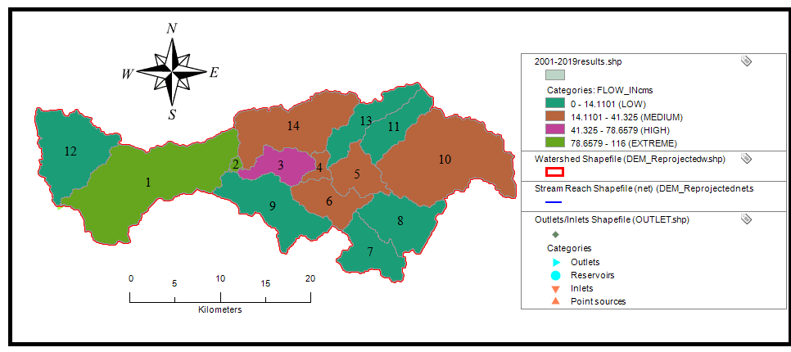
Fig 4.3 Spatial Variation of Flow in the Watershed
  - Estimation of total nitrate and flow in the watershed
To evaluate the overall impact of the watershed, total nitrate and flow values were computed by aggregating data from all contributing subbasins.
- Total Area Modeled: 596.72 km²
- Total Nitrate Input: 967,247.55 kg
- Total Streamflow: 435.72 m³/s
These aggregate values underscore the watershed's significant output in both water and pollutant terms. The high nitrate load poses a potential risk to downstream water bodies, particularly if the receiving water is used for domestic or agricultural purposes.
The findings stress the importance of targeted management in high-contributing subbasins, particularly subbasins 1, 2, 3, and 4, which collectively account for a large proportion of the total nitrate and flow.
CHAPTER FIVE
CONCLUSION AND RECOMMENDATION
Conclusion
- The hydrological model effectively simulated nitrate and streamflow across the watershed, highlighting significant variation among subbasins. Subbasins 1, 2, 3, and 4 contributed the most to nitrate loading and flow, likely due to intensive land use. In contrast, subbasins like 6, 7, and 8 showed minimal contributions, indicating lower human impact. The model proved to be a reliable tool for watershed assessment and management.
- The spatial analysis reveals significant variability in nitrate and streamflow across the watershed. Subbasins 2, 3, 4, and 1 contribute disproportionately high nitrate loads and flow, likely due to intensive land use or localized pollution sources. In contrast, subbasins like 6 and 7 show minimal contributions, indicating less disturbed or more natural landscapes. These variations reflect the influence of land use, topography, and human activity on watershed behavior, emphasizing the need for targeted management in high-impact areas.
- The watershed, covering 596.72 km², generates a substantial total nitrate load of 967,247.55 kg and a total streamflow of 435.72 m³/s. These figures highlight the watershed’s significant contribution to downstream water bodies. The high nitrate levels pose potential risks to water quality, especially where water is used for domestic or agricultural purposes, emphasizing the need for effective nutrient management strategies.
Recommendation
- Implement Nutrient Management Strategies: Encourage best management practices (BMPs) such as controlled fertilizer application, use of cover crops, and buffer strips to reduce nitrate runoff in high-loading areas.
- Strengthen Land Use Regulations:Introduce stricter controls on agricultural and urban development in subbasins contributing the highest nitrate loads.
- Establish Riparian Buffer Zones:Create vegetated buffer zones along streams to filter pollutants before they reach water bodies.
- Promote Community Awareness:Educate local stakeholders and farmers on the impacts of nitrate pollution and promote sustainable land-use practices.
- Monitor Downstream Water Quality:Set up regular monitoring of downstream water sources, especially those used for drinking or irrigation, to track nitrate concentrations and prevent contamination.
- Targeted Rehabilitation Programs:Focus restoration and pollution control efforts on the most contributing subbasins to maximize the effectiveness of interventions.

REFERENCES
Arnold J. G., Kiniry J. R., Srinivasan R., Williams J. R., Haney E. B., and Neitsch S. L., “Soil & Water Assessment Tool: Input/output documentation. version 2012,” Texas Water Resour. Institute, TR-439, pp. 207–208, 2013.
Camargo, J. A., & Alonso, Á. (2006).Ecological and toxicological effects of inorganic nitrogen pollution in aquatic ecosystems: A global assessment. Environment International, 32(6), 831–849.https://doi.org/10.1016/j.envint.2006.05.002.
Carpenter, S. R., Caraco, N. F., Correll, D. L., Howarth, R. W., Sharpley, A. N., & Smith, V. H. (1998). Nonpoint pollution of surface waters with phosphorus and nitrogen. Ecological Applications, 8(3), 559–568.https://doi.org/10.1890/1051-0761(1998)008[0559:NPOSWW]2.0.CO;2.
Krause P., Boyle D. P., and Bäse F., “Comparison of different efficiency criteria for hydrological model assessment,” Adv. Geosci., vol. 5, pp. 89–97, 2005. [10]
Swiss Federal Institute of Aquatic Science and Technology (Eawag), User manual SWAT-CUP. 2015.
Vitousek, P. M., Aber, J. D., Howarth, R. W., Likens, G. E., Matson, P. A., Schindler, D. W., ... & Tilman, D. (1997). Human alteration of the global nitrogen cycle: Sources and consequences. Ecological Applications, 7(3), 737–750. https://doi.org/10.1890/10510761(1997)
Winchell M., Srinivasan R., Di Luzio M., and Arnold J. G., “ArcSWAT Interface for SWAT2012,” Texas AgriLife Res. United States Dep. Agric. Agric. Research Serv., 2013. [8]
Zhao W. J., Sun W., Li Z. L., Fan Y. W., Song J. S., and Wang L. R., “A Review on SWAT Model for Stream Flow Simulation,” Adv. Mater. Res., vol. 726–731, pp. 3792–3798, 2013.

