A COMPARATIVE STUDY OF THE ENGINEERING PROPERTIES OF SANDCRETE BLOCK PRODUCED IN ILORIN WEST LOCAL GOVERNMENT.
BY

IDRESS ABEEBLLAH OPEYEMI
HND/23/CEC/FT/0022

BEING A PROJECT RESEARCH SUBMITTED TO THE
DEPARTMENT OF CIVIL ENGINEERING TECHNOLOGY, INSTITUTE OF TECHNOLOGY, KWARA STATE POLYTECHNIC, ILORIN.

IN PARTIAL FULFILLMENT OF THE REQUIREMENTS FOR THE AWARD OF HIGHER NATIONAL DIPLOMA (HND) IN DEPARTMENT OF CIVIL ENGINEERING TECHNOLOGY.

JULY, 2025
Abstract
This research presents a comparative study of the engineering properties of sandcrete blocks produced by various manufacturers within Ilorin West Local Government Area of Kwara State, Nigeria. Sandcrete blocks are widely used in building construction due to their affordability and ease of production. However, the quality and strength of blocks produced differ significantly across various production sites due to inconsistencies in raw materials, mixing ratios, and curing practices. This study aims to assess and compare critical engineering properties such as compressive strength, bulk density, water absorption rate, and dimensional stability of sandcrete blocks obtained from selected block manufacturing sites in the area.
Samples were collected from five different manufacturers and subjected to standard laboratory tests in accordance with Nigerian Industrial Standards (NIS 87:2004) and relevant ASTM procedures. The results revealed substantial variation in compressive strength, with some blocks falling below the minimum required strength of 2.5 N/mm² for non-load-bearing walls and 3.45 N/mm² for load-bearing walls. Factors contributing to the variation include improper mixing ratios, inadequate curing periods, and the use of substandard materials.
The findings underscore the need for strict quality control measures and enforcement of regulatory standards in sandcrete block production to ensure safety, durability, and structural integrity in building projects. The study recommends regular monitoring by regulatory agencies and capacity-building training for local block manufacturers.

CERTIFICATION
This is to certify that this research study was conducted by IDRESS ABEEBLLAH OPEYEMI HND/23/CEC/FT/0022 and had been read and approved as meeting the requirement for the award of Higher National Diploma (HND) in Civil Engineering, Institute of Technology, Kwara State Polytechnic, Ilorin.

__________________________ ____________________
ENGR. M. GARUBA DATE
(Project Supervisor)

_________________________ ____________________
ENGR. A. NA’ALLAH DATE
(Head of Department)

_________________________ _____________________
ENGR DR. MUJEDU KASALI ADEBAYO DATE
EXTERNAL EXAMINER

DEDICATION
I dedicate this project to Almighty Allah who has made everything possible during the course of my study and also dedicated to my beloved families, most especially my parent. Allah spare their live to reap what they have sowed [Amen]

ACKNOWLEDGMENT
All praise and adoration goes to Almighty Allah the Alpha and Omega of my life who has been my strength right from the beginning of my life to this present moment. He, who made the completion of higher national diploma (HND) program to be a successful one, may his name be praise forever.
My deepest appreciate goes to my parent MR. & MRS. IDRESS for their support financially, spiritually and physically, I pray that they will eat the fruit of their labour.
My gratitude and recognition to my supervisor ENGR. M. GARUBA for his useful comments which greatly helps in bringing this project work to reality.
I am also grateful to my entire lecturer for their assistance, encouragement throughout the project, may almighty Allah continue to guide you all.
My thanks and sincerely appreciation to the head of department of Civil Engineering Technology in person of ENGR.A. NA'ALLAH for making it successful.

TABLE OF CONTENT
Table of Content i
Title Page ii
Certification iii
Dedication iv
Acknowledgment v
Table of Content vi
List of Table vii
CHAPTER ONE
  - Introduction 1
  - Statement of the Problem 3
  - Aim and Objectives 3
  - Justification of the Study 4
  - Significance of Study 4
  - Scope of the Study. 4
CHAPTER TWO
2.0 Literature Review 5
2.1 Blocks 5
  - Sandcrete Blocks 6
  - Quality of Sandcrete Blocks 10
  - Constituents of a Sandcrete Block 13
  - Manufacture of Sandcrete Blocks 17

CHAPTER THREE
3.0 Methodology 22
3.1 Materials 22
3.2 Equipment 23
3.3 Mode of Production/Mix Ratio 24
CHAPTER FOUR
4.0 Data Analysis and Result 27
4.1 Water Absorption Test 27
4.2 Compressive Strength Test Results 30
CHAPTER FIVE
5.0 Conclusion and Recommendation 31
5.1 Conclusion 31
5.2 Recommendation 31
Reference 32.

LIST OF TABLE
Table 4.1.1 Water Absorption Test At Ages 7 Days For Sandcrete Block. 27
Table 4.1.2 Water Absorption Test At Ages 14 Days For Sandcrete Block. 28
Table 4.1.3 Water Absorption Test At Ages 28 Days For Sandcrete Block. 29
Table 4.2 Shows the Compressive Strength of Sandcrete Block Made with Mix Ratio
1:6 at different age test. 30

CHAPTER ONE
1.0 INTRODUCTION
Sandcrete blocks are a type of building material made from a mixture of sand, cement, and water. The sand used in making the blocks is usually sourced locally and can be a mixture of sharp sand, gravel, or stone dust. The cement used can be either ordinary Portland cement or a mixture of Portland cement and pozzolanic materials like fly ash, rice husk ash, or ground granulated blast furnace slag.
Sandcrete blocks are composite materials produced from cement, sand and water, molded into different sizes (Barr, 2022). Nigerian industrial standard defines a block as a masonry unit exceeding the size of a brick in any dimension.
Sandcrete block are composite materials made up of cement, fine aggregates (sand) and water produced by extrusion (NIS 978:2017). Over 90% of the buildings in Nigeria are made of sandcrete blocks (Baiden and Tuuli, 2016).
In Nigeria, Togo, and other poor nations, sandcrete blocks are frequently used to create foundations, dividing walls, and other walling components. (NIS 87:2000) came up with the best strategy to regulate the manufacturing process, evaluate the quality of the materials used in block production, and produce reference papers that covered the minimum specifications and applications for various types of sandcrete blocks in Nigeria.
According to Ogunbayo et al. (2018), successful housing projects require a standard design, good planning, and high-quality building materials. These elements must be monitored and controlled by governmental regulations and construction experts.
When hardened, sandcrete blocks often have significant compressive strengths, and these strengths typically increase with density. In NIS 978:2017, the range of the minimum strength requirement is given as 1.5 N/mm2 for 150 mm and 3.5 N/mm2 for 225 mm sandcrete hollow blocks.
Abdullahi (2015) holds the view that the types of manufacturing procedures employed and the characteristics of the material composition led to variation in the blocks' production quality. The research also emphasized that certain sandcrete blocks made in Minna, Niger State, Nigeria, did not meet the minimum Nigerian Industrial Standard (NIS) criterion for compressive strength. And as a result of poor practices with the predetermined blend design.
According to Afolayan, Arum, and (2018), quality management practices have a direct impact on the strength of sandcrete blocks. Found that low voids in sand properties and water sprinkling type curing tend to improve compressive strength of sandcrete blocks. According to (Abdullahi 2015), optimal material selection and a correct curing procedure improve the quality of sandcrete blocks. The constant building collapses and casual attitude toward material testing to determine the strength and behavior of building materials under applied loads are two of the biggest problems facing the construction industry today. According to Sholanke, Fagbenle, Aderonmu, and Ajagbe (2015), the usage of subpar building materials, such as blocks and bricks, is what causes structures to collapse.
In order to guarantee excellent quality, it is also vital to make sure that the manufacture of sandcrete blocks and bricks is standardized and controlled. Another important aspect of sandcrete blocks is their thermal insulation properties. Sandcrete blocks have good thermal insulation properties, which means that they can help to regulate the temperature inside buildings, making them comfortable to live or work in.

1.1 Statement of the Problem
In recent years, there has been growing concern regarding the quality and durability of sandcrete blocks produced for construction in Ilorin West Local Government. A significant proportion of these blocks are produced by small-scale, informal manufacturers who may not adhere to standardized production processes. As a result, the engineering properties of the blocks may vary significantly, leading to potential issues such as low compressive strength, high water absorption, poor thermal insulation, and reduced durability over time.
1.2 Aim and Objectives
AIM:
The aim of this project is to conduct A Comprehensive Study of the Engineering Properties of Sandcrete Blocks Produced in Ilorin West Local Government Area, Kwara State.
OBJECTIVES:
- To Evaluate the Compressive Strength of sandcrete blocks produced in Ilorin West Local Government.
- To examine water absorption characteristics of sandcrete blocks to assess their durability and susceptibility to water damage.
- To identify any local factors such as variation in sand quality, climate conditions, and production practices that may influence the properties of sandcrete blocks.
- To recommend guidelines and best practices for improving the quality of sandcrete blocks in Ilorin West Local Government.

1.3 Justification of the Study
The need for a study on the engineering properties of sandcrete blocks produced in Ilorin West Local Government arises from several practical, technical, and economic considerations. Sandcrete blocks are essential construction materials for various projects, especially in the context of affordable housing and infrastructure development in Nigeria
1.4 Significance of Study
Proper investigation of the quality of commercial hollow sandcrete blocks produced in the municipality aids in establishing whether the standards are adhered to, thereby reducing the risk of loss of life and properties.
1.5 Scope of the Study
The study will focus on:
- Location: Sandcrete blocks produced within Ilorin West Local Government, Kwara State.
- Materials: Sand, cement, and other additives used by local block producers.
- Testing Parameters: Compressive strength, density, water absorption, porosity, and the impact of various mix ratios.
- Timeframe: the study will span a period of 7days, 14days and 28days with fieldworks, laboratory tests and data analysis conducted in phases.

CHAPTER TWO
LITERATURE REVIEW
2.1 Blocks
Blocks are commonly used in construction in many parts of the world. They are the dominant units for modern wall construction in Nigeria and indeed West Africa. They are of many types depending on the constituent materials. The constituents also determine the structural characteristics of the blocks. The major types are sandcrete blocks (water, cement and sand), sandcrete blocks, concrete blocks, bricks (burnt clay and additives) and mud blocks. The blocks are made by mixing sand, cement, and water, and then casting them into molds. The resulting blocks are strong, durable, and relatively inexpensive, making them a popular building material. However, there have been concerns about the quality of sandcrete hollow blocks, especially in terms of their strength, durability, and resistance to environmental factors such as moisture and temperature.
Blocks are constructed using concrete or cement. They may include a hollow core to make them lighter and to improve their insulation properties. They have been in use since the 1930s when they were commonly used for the inner leaf of cavity walls. At this point they were made from an aggregate of stone or industrial waste such as clinker or breeze, hence the term ‘breezeblock’. A standard block is 440 mm x 215 mm, the equivalent of 3 bricks high and 2 long, the maximum size that one person can comfortably lift. They are available in a range of widths from 50 mm to 300 mm.
The kind of block selected for a particular application will depend on its:
- Density.
- Load-bearing characteristics.
- Appearance.
- Weight and handling properties.
- Thermal characteristics, such as U-value or thermal mass.
Mainly there are two types of concrete blocks depending on how they look like other than the mechanical properties and they are;
- Solid blocks
- Hollow Blocks
2.1.1 Solid Block
Normally blocks have a rectangular solid shape. Usually, they are available in widths 100mm, 125mm, 150mm, and 200mm. Solid blocks are commonly used, which are heavy in weight and manufactured from dense aggregate. They are very strong and provide good stability to the structures. So for large work of masonry like for load bearing walls these solid blocks are preferable. They are available in large sizes compared to bricks. So, it takes less time to construct concrete masonry than brick masonry.
2.1.2 Hollow block
As the name implies, it is a hollow section with a regular shape. They are also available in the same widths as solid blocks. Less weight, less cost of the structure, etc. has made the use of this type of hollow block. There is no much to discuss the types of solid blocks. However, there are many types of concrete blocks made as hollow blocks.
2.2 Sandcrete Blocks
Sandcrete blocks and bricks are masonry units manufactured from a mixture of cement, sand and water, and it plays a crucial role in the building construction. Sandcrete blocks are largely used for load bearing and non-load bearing walls and foundations (The Constructor, 2022). Oyetola (2016) argued that sandcrete has been in use throughout West Africa for over 5 decades as a popular building material for preparation of building blocks and bricks. They posit that it is predominantly used and suitable for load and non-load bearing walls, or for foundations. The material constituents, their mix, presence of admixtures and the manufacturing process are important factors that determine the properties of sandcrete blocks. In Nigeria, 95% of walling materials in buildings are made of sandcrete blocks. Anwar et al. (2020) put forward that Sandcrete walls have adequate strength and stability, provide good resistance to weather and ground moisture, durable and easy to maintain. They also provide reasonable fire, heat, airborne and impact sound resistance. As material for walls, its strength is less than that of fired clay bricks, but sandcrete is considerably cheaper. Chandrasekhar et al. (2013) argued that Sandcrete is the main building material used for the construction of walls. In many parts of Nigeria, Sandcrete hollow blocks are the major cost component of the most common buildings. The blocks are usually manufactured with the use of a vibrating machine (Laguerbe, 2019).
Kamiyo (2017) opine that hollow sandcrete blocks as shown in Figure 2.1, containing a mixture of sand, cement and water are used extensively in many countries of the world especially in Africa. In many parts of Nigeria, sandcrete block is the major cost component of the most common buildings. The high and increasing cost of constituent materials of sandcrete blocks has contributed to the non-realization of adequate housing for both urban and rural dwellers. Hence, availability of alternatives to these materials for construction is very desirable in both short and long terms as a stimulant for socio-economic development. In particular, materials that can complement cement in the short run, and especially if cheaper, will be of great interest. argued that over the past decade, the presence of mineral admixtures in construction materials has been observed to impart significant improvement on the strength, durability and workability of cementitious products. The author added that in the areas prone to flood, hydrothermal properties of the buildings construction materials are of importance. Also, energy requirements for residential and commercial buildings are known to be influenced by building design and by the materials used.

Types of Hollow Sandcrete Blocks
- Stretcher block; are used to join the corner in the masonry. Stretcher blocks are widely used concrete hollow blocks in construction. They are laid with their length parallel to the face of the wall.
- Corner block; are used at the ends or corners of masonry. The ends may be window or door openings etc. they are arranged in a manner that their plane end visible to the outside and other end is locked with the stretcher block.
- Pillar block; is also called as double corner block. Generally these are used when two ends of the corner are visible. In case of piers or pillars these blocks are widely used.
- Jamb block; are used when there is an elaborated window opening in the wall. They are connected to stretcher and corner blocks. For the provision of double hung windows, jamb blocks are very useful to provide space for the casing members of window.
- Partition block; are generally used to build partition walls. Partition blocks have larger height than its breadth. Hollow part is divided into two to three components in case of partition blocks.
- Lintel block; or beam block is used for the purpose of provision of beam or lintel beam. Lintel beam is generally provided on the top portion of doors and windows, which bears the load coming from top. Concrete lintel blocks have deep groove along the length of block as shown in figure. After placing the blocks, this groove is filled with concrete along with reinforcement.
- Frogged brick block; contains a frog on its top along with header and stretcher like frogged brick. This frog will help the block to hold mortar and to develop the strong bond with top laying block.
- Bull nose block; are similar to corner blocks. Their duties also same but when we want rounded edges at corner bull nose bricks is preferred.
2.2.1 Properties of Sandcrete Hollow Blocks:
Several studies have investigated the properties of sandcrete blocks. A study by Olutoge et al. (2017) investigated the thermal conductivity of sandcrete hollow blocks and found that the blocks have a low thermal conductivity, making them a suitable material for insulation.
2.2 Advantages of Hollow Sandcrete Blocks
Construction building blocks for walls are embedded with many gains to construction that are too important to be ignored. Perhaps before you embark on your next construction work, you may need to consider these advantages of using concrete hollow cellular block masonry in buildings before making that important choice.
Rapid Execution of work made from molds that produce hollow cinder blocks of similar shapes, sizes, and weight, it is easy to deploy hollow concrete blocks in construction works, all that is needed is to fit the right hollow brick to the right place. Then, the same solid block size and shape help quickly assemble them to form any particular shape required in a construction job (Asanduff, 2022).
2.2.2 Performance of Sandcrete Blocks:
The performance of sandcrete hollow blocks has also been investigated in various studies. A study by Agbede et al. (2018) investigated the effect of curing time on the compressive strength of sandcrete hollow blocks. The study found that longer curing times led to higher compressive strength. Another study by Adeyeye and Oyedepo (2014) investigated the effect of water absorption on the strength and durability of sandcrete hollow blocks. The study found that blocks with higher water absorption rates had lower strength and durability.
2.2.3 Environmental Factors:
Environmental factors such as moisture and temperature can affect the properties and performance of sandcrete hollow blocks. A study by Adegoke and Adegoke (2018) investigated the effect of moisture on the compressive strength of sandcrete hollow blocks. The study found that moisture significantly reduced the strength of the blocks. Another study by Oyedepo and Olofinnade (2015) investigated the effect of temperature on the thermal conductivity of sandcrete hollow blocks. The study found that higher temperatures led to higher thermal conductivity.
2.2.3 Highly Durable
Construction blocks compacted by high pressure and vibration make the building strong, resilient, and hardened to severe load and weight.
2.2.4 Better Insulation Properties
The air in the construction building block does not allow heat or cold in or out of the building. No wonder hollow concrete blocks are insulated against heat, dampness, and sound. Hollow blocks keep the house cool in summer and warm in winter.
2.2.5 Low Maintenance
To maintain hollow breeze blocks buildings is not expensive, compared to other building materials that are available.
2.2.6 Cost-Efficient
It helps minimize building construction materials used at a construction site, though it minimizes the cost of building block construction. For example, one concrete hollow masonry block replaces five traditional bricks, which helps in reducing construction costs. Hollow block constructions also helps to save labor hours by reducing both mortar and labor costs.
2.3 Quality of Sandcrete Blocks
Quality is defined as ―fitness for purpose‖ or compliance with specification (Anosike, 2011). They authors argued further that it is the overall characteristics needed by a product or service to satisfy stipulated and implied needs. ISO 8402-1986 standard defines quality as "the totality of features and characteristics of a product or service that bears its ability to satisfy stated or implied needs". In addition, the manufacturing business dictionary, defined quality as a measure of excellence or a state of being free from defects, deficiencies, and significant variations, brought about by the strict and consistent adherence to measurable and verifiable standards to achieve uniformity of output that satisfies specific customer or user requirements. Ogunsanmi et al. (2011) identified quality as one of the three key elements for developing risk classification model for design and build projects. This therefore follows that quality is a significant factor that cannot be undermined in the construction of projects. Nunnally (2007) argued that quality management and quality assurance on the other hand have been adopted to include all aspects of producing and accepting a construction project which meets all required quality standards. He further asserts that quality management includes such activities as specification development, process control, product acceptance, laboratory and technician certification, training and communication. The author concluded that quality control, which is a part of the quality management process, is primarily concerned with the process control function. The Standard Organization of Nigeria (SON) established through Act 56 in 1971 is the sole statutory body that is vested with the responsibility of standardizing and regulating the quality of all products in Nigeria including sandcrete blocks. The Nigerian Industrial Standard (NIS) for sandcrete block is a standard reference document developed by the SON which prescribes the minimum requirement and uses of sandcrete blocks.
2.3.1 Standardization and Regulation of the Quality
In Nigeria, the fulcrum of Standardization and Regulation of quality for all products is vested in the Standards Organization of Nigeria (SON). Established by Act No. 56 of 1971 and with three amendments in 1976, 1984 and 1990, SON as a corporate body have the sole responsibility for National Policy on Standards, Standards Specification, Quality Control and Metrology, Manufactured Industrial and imported products and services. The Act No. 20 of 1976 which amended the previous one conferred on the Honorable Minister of Industry the power to declare Mandatory Industrial Standards in Respect of products or processes recommended by the Nigerian Standards Council (UNESCO 2008). The Act No. 32 of 1984 changed the name of the agency to Standards Organization of Nigeria (SON) from Nigeria Standards Organization (NSO). This was aimed at eliminating conflicting identity with the then Nigerian Security Organization. Finally, the Act No. 18 of 1990 conferred on SON partial autonomy from the Ministry of industry. This amendment gave far-reaching transformation to the Organization succession and a common seal, and may sue or be sued in its corporate name. The statutory functions of Standards Organization of Nigeria by section 3, subsections (1) of 1971 Act No. 56 are as follows:
- To compile Nigeria Industrial Standards.
- To compile an inventory of products requiring standardization.
- To organize test and do everything necessary to ensure compliance with standards designated and approved by the Council.
- To compile and publish general scientific or other data.
- To ensure reference standards for calibration and verification of measures and measuring instrument.
- To undertake investigations as necessary into the quality of facilities, materials and products in Nigeria, and establish a quality assurance system including certification of factories, products and laboratories.
- To establish and maintain such number of Laboratories or other institutions as may be necessary for the performance of its functions under this Act.
- To foster interest in the recommendation and maintenance of acceptable standards by industry and the general public.
- Register and regulate standard marks and specification.
- To undertake preparation and distribution of standard samples.
- To develop method for testing of materials, supplies and equipment including items purchased for use of departments Government of the Federation or State and Private establishment.
    - Standard Requirements of a Sandcrete Block
The Federal Building Code First edition, stipulates that the application of all materials and components used in the construction of buildings must be such that will achieve aesthetics, durability, functionality, character and affordability (Afolayan et al., 2008; Anosike, 2011). Locally available building materials should be integrated for their additional advantages of availability, identity, job creation and affordability.
2.3.3 Molds, types and sizes
Sandcrete blocks are molded using mainly metal molds: There are two main types of blocks molded in Nigeria. They are solid and hollow blocks with sizes in length x breath x height. The National Building Code stipulates as follows:
Sandcrete Blocks shall mean a composite material made up of cement, sharp sand and water.
i. Blocks shall be molded for sandcrete using metal (wood) molds of:
450mm x 225mm x 225mm (hollow)
450mm x 150mm x 225mm (hollow)
450mm x 225mm x 225mm (Solid)
450mm x 150mm x 225mm (Solid)
450mm x 100mm x 225mm (Solid)
2.4 Constituents of a Sandcrete Block
A Sandcrete block consists of the following constituents;
2.4.1 Cement
Cement is seldom used on its own, but rather to bind sand and gravel (aggregate) together. Cement mixed with fine aggregate produces mortar for masonry, or with sand and gravel, produces concrete. Concrete is the most widely used material in existence and is behind only water as the planet's most-consumed resource.
Types of Cement
Portland cement, a form of hydraulic cement, is by far the most common type of cement in general use around the world. This cement is made by heating limestone (calcium carbonate) with other materials (such as clay) to 1,450 °C (2,640 °F) in a kiln, in a process known as calcination that liberates a molecule of carbon dioxide from the calcium carbonate to form calcium oxide, or quicklime, which then chemically combines with the other materials in the mix to form calcium silicates and other cementitious compounds. The resulting hard substance, called 'clinker', is then ground with a small amount of gypsum into a powder to make ordinary Portland cement, the most commonly used type of cement (often referred to as OPC). Portland cement is a basic ingredient of concrete, mortar, and most non-specialty grout. The most common use for Portland cement is to make concrete. Concrete is a composite material made of aggregate (gravel and sand), cement, and water. As a construction material, concrete can be cast in almost any shape, and once it hardens, can be a structural (load bearing) element. Portland cement may be grey or white.
Other Types of Cements
Pozzolan-Lime Cements: are mixtures of ground pozzolan and lime. These are the cements the Romans used, and are present in surviving Roman structures like the Pantheon in Rome. They develop strength slowly, but their ultimate strength can be very high. The hydration products that produce strength are essentially the same as those in Portland cement.
Slag-lime Cements: ground granulated blast-furnace slag is not hydraulic on its own, but is "activated" by addition of alkalis, most economically using lime. They are similar to pozzolan lime cements in their properties. Only granulated slag (i.e., water-quenched, glassy slag) is effective as a cement component.
Supersulfated cements contain about 80% ground granulated blast furnace slag, 15% gypsum or anhydrite and a little Portland clinker or lime as an activator. They produce strength by formation of ettringite, with strength growth similar to a slow Portland cement. They exhibit good resistance to aggressive agents, including sulfate. Calcium aluminate cements are hydraulic cements made primarily from limestone and bauxite. The active ingredients are monocalcium aluminate CaAl2O4 (CaO · Al2O3 or CA in cement chemist notation, CCN) and mayenite Ca12Al14O33 (12 CaO · 7 Al2O3, or C12A7 in CCN). Strength forms by hydration to calcium aluminate hydrates. They are well-adapted for use in refractory (high-temperature resistant) concretes, e.g., for furnace linings.
Calcium sulfoaluminate cements are made from clinkers that include ye'elimite(Ca4(AlO2)6SO4 or C4A3S in Cement chemist's notation) as a primary phase. They are used in expansive cements, in ultra-high early strength cements, and in "low-energy" cements. Hydration produces ettringite, and specialized physical properties (such as expansion or rapid reaction) are obtained by adjustment of the availability of calcium and sulfate ions. Their use as a low-energy alternative to Portland cement has been pioneered in China, where several million tonnes per year are produced.[47][48] Energy requirements are lower because of the lower kiln temperatures required for reaction, and the lower amount of limestone (which must be endothermicallydecarbonated) in the mix. In addition, the lower limestone content and lower fuel consumption leads to a CO₂ emission around half that associated with Portland clinker. However, SO₂ emissions are usually significantly higher.
Natural cements corresponding to certain cements of the pre-Portland era, are produced by burning argillaceous limestones at moderate temperatures. The level of clay components in the limestone (around 30–35%) is such that large amounts of belite (the low-early strength, high-late strength mineral in Portland cement) are formed without the formation of excessive amounts of free lime. As with any natural material, such cements have highly variable properties.
Geopolymer cements are made from mixtures of water-soluble alkali metal silicates, and aluminosilicate mineral powders such as fly ash and metakaolin.
Polymer cements are made from organic chemicals that polymerise. Producers often use thermoset materials. While they are often significantly more expensive, they can give a water proof material that has useful tensile strength.
Sorel Cement is a hard, durable cement made by combining magnesium oxide and a magnesium chloride solution
Fiber Mesh Cement or fiber reinforced concrete is cement that is made up of fibrous materials like synthetic fibers, glass fibers, natural fibers, and steel fibers. This type of mesh is distributed evenly throughout the wet concrete. The purpose of fiber mesh is to reduce water loss from the concrete as well as enhance its structural integrity. When used in plasters, fiber mesh increases cohesiveness, tensile strength, impact resistance, and to reduce shrinkage; ultimately, the main purpose of these combined properties is to reduce cracking.
2.4.2 Aggregates
These include both coarse and fine, from natural sources, blast furnace slag, crushed clay and furnace clinker. The British Standard (BS-882) defined aggregate as a granular material obtained by processing natural materials while Taylor (2002) defined aggregates as mineral filler materials used in concrete. Aggregates are either natural or manufactured and occupy about 75% of the volume of concrete. Sand, gravel, crushed rock and other mineral fillers are used as aggregates. Aggregates are major components in the production of concrete (Otunyo&Okechukwu, 2017).
2.4.3 Water
Water reacts with cement to bring about hydration. The workability and strength of sandcrete depends to a large extent on the amount of water used in mixing. Water to be used for the production of concrete or sandcrete must be free of suspended particles, inorganic salts, acids and alkalis, oil contamination and algae. Potable water that meets the NIS (2007) standard is recommended for the production of sandcrete blocks.
2.5 Manufacture of Sandcrete Blocks.

The production of sandcrete blocks can be discussed under the following sub headings: (a) Batching and Mixing (b) Compaction and Demoulding (c) Curing and (d) Storage and Transportation.
(a) Batching and Mixing
Batching is the process of measuring out the various quantities of the components. This can be done by mass or by volume. Of the two, batching by mass is professionally preferable as it eliminates errors due to the variations contained in a specific volume. However, most producers, especially those that batch manually, use the volume batching process because it is simpler and much more convenient than weight batching. Manual batching is done using head pans, wheel barrows or specially constructed wooden gauge boxes with a bag of cement taken to be twice the volume of a head pan and the same volume as a wheel barrow. The use of the wooden boxes for batching is becoming obsolete. Cements is usually supplied in bags of 50kg net weight. Batching using head pans or wheel barrows does not make for uniformity as these volumes measured are greatly dependent on the state and size of the head pans or wheel barrows. It should be noted that sand is usually supplied wet and it is in this wet condition that it is most often used. The quantity of water added to the mix must therefore be adjusted to compensate for the water in the wet sand.
Furthermore, since sandcrete is a zero slump concrete, the amount of mixing water added is of great importance. Too little or too much water will cause the block to fail immediately after demoulding. Mixing is done either manually (with shovels or spades) or mechanically (using concrete mixers of various capacities). Large producers generally use mixers. This offers a more uniform and homogenous mix, especially when the volume is large. In manual mixing the components are mixed using shovels or spades and turned over several times until a homogenous mix is obtained. Whatever method is adopted, adequate mixing is necessary to achieve uniform colour and texture between block batches, prevent variations in strength and minimize web cracks (Portland Cement Association, 1975).
(b) Compaction.
Compaction is a very important process in block production. Compaction is achieved by mechanical vibration or manual (hand) compaction. Manual compaction is less effective and is adopted by small scale producers. One block is produced at a time using a locally manufactured mould. The compaction is effected using a tamping rod. Great care is needed in demoulding the block in order not to introduce cracks in it. There are basically three types of machines used in block moulding in Nigeria. Some of these in addition to compaction also vibrate the blocks. The machine type greatly affects the quality and the required water used in the block production. The three major types of machines are (i) Egg laying machines (ii) Electric vibrating machine and (III) Manual hand press machines.
(i) Egg laying machine: The egg laying machines are usually of the Rosa Commetta type that can lay up to ten blocks at a time. This is usually used for mass production and the process can be automated, leading to great hourly output of about 300 -500 blocks. Both pressure and vibration are applied and blocks of high quality can be produced with these machines. The blocks are usually laid on bare surfaces without pallets and are removed for storage after 2-3 days of production.
(ii) Vibrating Machines: These machines are commonly used by medium scale producers. They are electrically operated or diesel powered. The majority of the machines are designed to produce one block at a time with the block vibrated for about 10 to 15 seconds. Few, however, can produce up to three blocks at a time. The blocks are produced on pallets and carried to the place of temporary storage. They can provide adequate compaction. Care must be taken while moving the green blocks on the pallet to the place of temporary storage so as to prevent cracks resulting from vibration while moving the blocks.
(iii) Hand Press Machine: The hand press machine is manually operated. Demoulding is achieved through a series of levers. The hand press machine does not compact as well as the egg laying and vibrating machines and hence produces blocks of lower quality. One block is moulded at a time.
(c) Curing: Curing of sandcrete blocks is necessary to enable the blocks develop adequate or optimum strength by allowing for proper hydration of the cement. Green blocks that are exposed to high temperatures loose water rapidly by evaporation, resulting in weak blocks. Thus it is recommended that newly produced blocks be placed in covered shades and protected from the adverse effect of the elements. Suggest curing by sprinkling with water as the best method of curing, from strength and convenience point of view. 42 This is the most common method employed by commercial block producers. Sprinkling should be done at least twice in a day. NIS 87 (2004) requires that the blocks be left on the pallets for at least 24 hours and be cured for at least 3 days. Adequate care must be taken when removing the pallets for another production so that cracks are not induced in the blocks.
(d) Storage of Cured Blocks: Cured blocks are removed to storage to provide space for new productions. The blocks need adequate care at this stage. Many blocks are normally damaged at this stage due to poor handling. NIS 87: (2004) requires that the blocks be stacked not more than 5 courses high. The blocks are now ready for use.
2.2.6 Factors Affecting the Strength of Sandcrete Blocks
The factors that affect the quality and strength of sandcrete blocks can be divided into three namely
(i) Those related to the quality and relative proportions of the constituents
(ii) Those related to the manufacturing process and
(iii) Age of the block.
(i) Factors Related To The Quality And Relative Proportions Of The Constituents.
Of interest here are (i) aggregate gradation
(ii) cement /aggregate ratio
(iii) water/cement ratio.
Aggregate gradation - has a great influence on both the strength and physical properties of the blocks. The ideal gradation is a well graded aggregate which will provide a dense pack where spaces between the big particles will be filled by the smaller ones. Such gradation also makes for minimum volume change due to shrinkage. Poorly graded or gap graded aggregate produce less dense blocks and may also be less workable.
The cement/aggregate ratio - is one of the most important factors affecting the strength of blocks. An increase in this ratio leads to an increase in strength. Gooding and Thomas (1997) showed that whereas doubling the compaction effort produced a 23% increase in compressive strength of sandcrete blocks, doubling the cement content produced a whopping 140% increase. NIS 87: (2004) recommends cement/sand ratio of 1:6 for sandcrete block production.
The water/cement ratio - is very important in sandcrete block production. Unlike concrete which is allowed to set in forms, sandcrete blocks are demoulded immediately after compaction. This greatly reduces the range of water/cement ratio over which the blocks can be made. The water/cement ratio should be such that allows for proper hydration of the cement yet allowing the green blocks to stand unsupported after demoulding. Uzomaka (1975) gave suitable water/cement ratios for block production as ranging from 0.4 to 0.6. Like concrete, strength of blocks is known to decrease with increase in water/cement ratio. Too dry a mix will lead to fracture during demoulding while high water/cement ratio will cause shrinkage and distortion in blocks (Tyler, 1961).
(b) Factors Related To The Manufacturing Process.
The two most important factors here are the degree of compaction and the curing process. Omoregie (2012) showed that the strength of sandcrete blocks is improved with better compaction. The degree of compaction is greatly dependent on the type of moulding machine used. Umenwaliri and Ezenwamma (2008) studied the effect of production methods on the strength of sandcrete blocks and concluded that the production method (compaction) affects the strength of the blocks. Strength of vibrated block is improved when additional surcharge is provided. It should be noted, however, that increasing compaction does not necessarily imply a more economic production (Gooding and Thomas, 1997).
2.2.7 Properties and Strength Characteristics of Sandcrete Blocks
The properties exhibited by sandcrete blocks are dependent on their production condition different methods employed in the production and the properties of the constituent materials. Factors like curing temperature, presence of admixture, water (salty or portable), compaction method, time difference between mixing and compaction greatly affect the property of sandcrete blocks (Oyekan G.I and Kamiyo O.M, 2018). The quality of blocks produced however, differs from each industry (Abdullahi 2005, 126). Alohan Omoregie 2012) claims that there is evidence to suggest a wide variation in compressive strength from one block manufacturer to another and also within block samples from a single source. This problem has been attributed to poor quality control and substandard constituent materials.
Why assessing the quality and properties of sandcrete blocks manufactured in Ilorin west local government?
The need for this assessment has arisen from two major considerations namely:
(I) To ascertain whether or not standards are being complied with as regards sandcrete block production.
(II) To provide additional information about the engineering properties of sandcrete blocks manufactured in the local government.

CHAPTER THREE
3.0 METHODOLOGY
The study were focus on sandcrete blocks produced in Ilorin West Local Government Area. The area was chosen due to its significant role in local construction activities and the prevalence of sandcrete block production.
Sampling and Data Collection
The sandcrete block used were sourced from three different place within Ilorin west local Government 1. Wahabillahi Taofeeq Block Industry at Agbo Oba 2. Sulu Block Industry Oloje 3. Kesmora Block Industry Gaa – Saka. (1:6, 1:8, 1:10) and varying raw materials.
Laboratory Testing
The collected samples will be subjected to various laboratory tests to determine their engineering properties. The following tests will be conducted:
- Compressive Strength Test: Using a hydraulic compression testing machine, the compressive strength of the blocks will be determined according to the standard procedure outlined in BS 6073: Part 2.
- Water Absorption Test: The water absorption capacity of the blocks will be determined by immersing the blocks in water for 7days, 14days and 28days and measuring the increase in weight.
Durability Test: The blocks will be exposed to varying environmental conditions (moisture, temperature, and chemical exposure) for a specified period, after which their weight loss, strength retention, and appearance will be assessed.
3.1 Materials
There are different materials used in sandcrete block production. The sandcrete block is made up of the following materials; sharp sand, cement and water

3.1.1 Sharp Sand
Sand is used in sandcrete block as the principal component of aggregate used in their production. Sand used for sandcrete block production shall be clean and free from deleterious materials.
3.1.2 Portland cement (binder)
Portland cement to be used for the production of sandcrete blocks must comply with all the prescribed requirements in BS 12 and NIS 444-1: 2003 respectively. The brand of Ordinary Portland cement obtained from a major cement dealer in Ede Osun state was used for all the production.
3.1.3 Water
The strength and workability of sandcrete depends greatly on the amount of water used in mixing. Potable water conforming to the specification of EN 1008: (2002) was used for both specimen preparations and curing.
Adequate mixing is necessary to achieve uniform colour and texture between block batches, prevent variations in strength and minimize web cracks. The material constituents, their mix, presence of admixtures and manufacturing process are important factors that determine the properties of sandcrete blocks and bricks. Cement, as a binder, is the most expensive input into the production of sandcrete blocks.
3.2 Equipments
The equipments include:
- 9 inches block mould
- Headpan
- Paint buckets
- Shovel
- 300 × 500mm size of 1 × 12 inches wooden pallet.
3.3 Mode of Production/Mix Ratio
In the manufacture of the blocks, hand mixing is generally employed and the materials are turned over a number of times until an even color and consistency are attained (Goncalves& 2017). It was observed that batching by volume was adopted by most block manufacturers. In the production of the 225mm sandcrete block, a mix of 1:7 was used i.e the mix ratio varies from 1 bag of cement to 7 wheel barrows of sand. The amount of water required was determined by trial and error because the sand itself contained little amount of water i.e it was partially saturated. This ranges from 2 to 4 paint buckets of water. Manual method of mixing was adopted. The general procedure for mixing was as follows.
- Seven (7) wheel barrows of sand was measured unto a concrete platform on the ground.
- One (1) bag of Cement was mixed thoroughly with the sand until even colour was formed. The mix was done with shovel for about three times.
- Water is added the fourth time and then the whole mix was mixed again for about two times.
- Then the mixture is poured into the 225mm (9 inches) mould and vibrated adequately by hard tapping and hitting of the mould on the ground.
- The mould, containing the mixture is then turned upside down on a wooden pallet at the desired location where the blocks shall be moulded.
NOTE: the desired location must be a leveled ground.
- Then the removable steel plate resting at the bottom of the mould is then removed alongside the whole mould, thus the 225mm sandcrete block is moulded.
- Steps [i] to [vi] is repeated 5 times, making it a total of 5 bags of cement that was used.
- After 24 hours of production, the blocks were removed from the wooden pallets with their header face on the ground.
- Water are then sprinkled on the blocks every 7days, 14days and 28days for curing.
- Then the blocks, having attained strength and well bonded, was stacked in an open space, ready to be used.
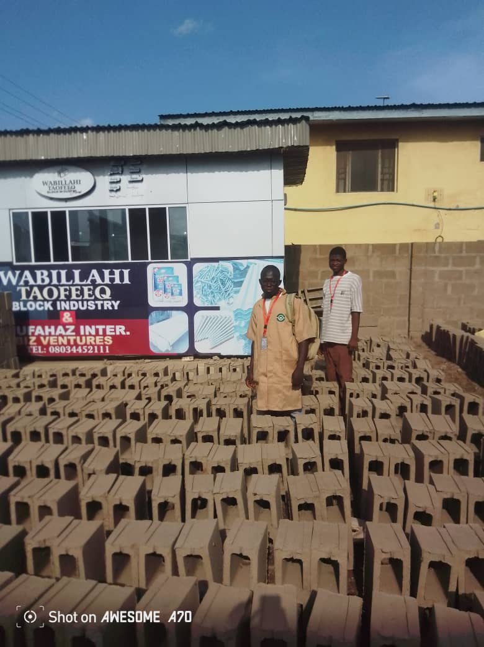

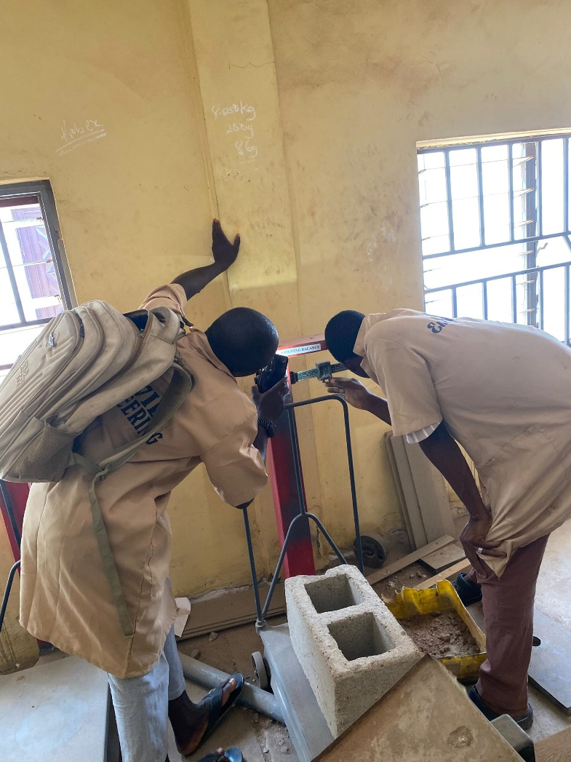

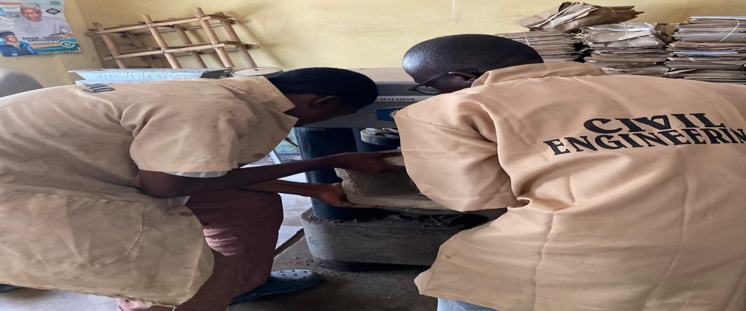

CHAPTER FOUR
4.0 DATA ANALYSIS AND RESULT
4.1 WATER ABSORPTION TEST
Table 4.1.1 WATER ABSORPTION TEST AT AGES 7 DAYS FOR SANDCRETE BLOCK.
1 | Mix ratio | 1:6 | 1:7 | 1:6 | 1:7 | 1:6 | 1:7
2 | Identification mark | 1 |  | 2 |  | 3
3 | Date of test | 03 |  | 03 |  | 2025
4 | Mass of block when dry (M1)kg | 14.600 | 16.400 | 14.400 | 15.800 | 14.600 | 16.100
5 | Mass of block when wet (kg) | 16.300 | 17.400 | 16.400 | 17.000 | 16.200 | 17.100
6 | Water absorption (%) | 11.6 | 6.1 | 13.9 | 7.6 | 11 | 6.2
7 | Average water absorption (%) |  |  | 12.2 | 6.3

Table 4.1.2 WATER ABSORPTION AT AGES 14 DAYS FOR SANDCRETE BLOCK
1 | Mix ratio | 1:6 | 1:7 | 1.6 | 1:7 | 1:6 | 1:7
2 | Identification mark | 1 |  | 2 |  | 3
3 | Date of test | 11 |  | 03 |  | 2025
4 | (M₁) Mass of block when dry kg | 16.300 | 17.400 | 16.100 | 17.400 | 16.300 | 17.200
5 | Mass of block when wet (kg) | 17.900 | 18.700 | 17.800 | 18.500 | 18.300 | 18.400
6 | Water absorption (%) | 9.8 | 7.5 | 9.6 | 8.8 | 10.4 | 6.9
7 | Average water absorption (%) |  |  | 9.9 | 7.7

Table 4.1.3 WATER ABSORPTION AT AGES 28 DAYS FOR SANDCRETE BLOCK
1 | Mix ratio | 1:6 | 1:7 | 1.6 | 1:7 | 1:6 | 1:7
2 | Identification mark | 1 |  | 2 |  | 3
3 | Date of test | 25 |  | 03 |  | 2025
4 | (M₁) Mass of block when dry kg | 15.800 | 17.300 | 16.000 | 17.300 | 16.200 | 17.200
5 | Mass of block when wet (kg) | 17.600 | 19.000 | 17.700 | 19.100 | 17.500 | 19.000
6 | Water absorption (%) | 11.4 | 9.8 | 10.6 | 10.4 | 8.0 | 10.5
7 | Average water absorption (%) |  |  | 10 | 10.2

4.1.1 DISCUSSION ON WATER ABSORPTION TEST
From the test carried out on water absorption capacity of the three b Block Industry (Wahabillahi Taofeeq Block Industry AGBO-OBA, 2. Sulu Block Industry Oloje, 3. Kesmora Block Industry, block).It was discovered that Wahabillahi Taofeeq Block Industry Agbo Oba have the highest water absorption capacity for the nominal mix ratio (1:6).
4.2 COMPRESSIVE STRENGTH TEST RESULTS
Table 4.12 shows the compressive strength of sandcrete block made with mix ratio 1:6 at different age test.
S/N | Weight of cube | Load (N/mm²) | Compressive strength (N/mm²) | Average  compressive strength | Density kg/ m³ | Unit weight KN/m³ | Age
1 | 14.600 | 48 | 1.06 | 1.03 | 1442 | 14 | 7 days
2 | 14.400 | 46 | 1.02 |  | 1422 | 13.9 | 7 days
1 | 16.300 | 65 | 1.44 | 1.43 | 1610 | 15.8 | 14 days
2 | 16.500 | 64 | 1.42 |  | 1630 | 16 | 14 days
1 | 15.400 | 85 | 1.88 | 1.86 | 1521 | 15 | 28 days
2 | 16.000 | 85 | 1.88 |  | 1580 | 15.5 | 28 days

4.2.1 DISCUSSION OF RESULT FOR COMPRESSIVE STRENGTH TESTS.
- From the tests carried out on the compressive strength of the three block industry in Ilorin west (Wahabillahi Taofeeq Block Industry Agbo OBA, 2. Sulu Block Industry Oloje, 3. Kesmora Block Industry, block). It was discovered that Wahabillahi Taofeeq Block Industry block have the highest compressive strength for the two nominal mix ratio (1:6 and 1:7) followed by Sulu Block Industry Oloje block and Kesmora Block Industry block.
- So we discovered that out of 100% of block industry in Ilorin west about 70% are using 1:8 to mix ratio that is the why that the compressive strength is low. So the remain 40 are using 1:7 mix ratio

CHAPTER FIVE
5.0 CONCLUSION AND RECOMMENDATION
5.1 CONCLUSION
Based on the research carried out, the following conclusions are made concerning the objectives of the study.
The majority of sandcrete blocks produced in Ilorin West fall short of the required engineering standards, particularly in terms of compressive strength and density. This has serious implications for the structural integrity of buildings using such blocks, particularly in load-bearing scenarios. The lack of quality control and standardization in local block production is a significant concern.
Recommendations
- It is recommended that workshops and seminars should be organized periodically to enlighten producers of sandcrete blocks on the importance of adhering to Standard.
- Engineers should always test for compressive strength of sandcrete blocks and their rate of water absorption before recommending or allowing it for usage.
- Finally, government should enforce strict compliance with NIS guidelines by all block manufacturing factories in the city.

REFERENCES
Akinmoladun, O. T., & Akinmoladun, I. O. (2021). “The Influence of Sand and Cement Ratios on the Compressive Strength of Sandcrete Blocks.”Journal of Construction and Building Materials, 32(2), 123-131.
Adebayo, J. O., & Olutoge, F. A. (2019). “Compressive Strength and Durability of Sandcrete Blocks with Varying Sand Quality and Cement Content in Nigeria.”
Journal of Civil Engineering Research, 14(4), 124-130.
Adesanya, D.A., et al. (2019), "The Effect of Mix Ratios on the Engineering Properties of Sandcrete Blocks in Nigeria."
Akanbi, A.M., et al. (2021), "Durability and Mechanical Properties of Sandcrete Blocks in Nigerian Climate."
Jiboye, A. D., & Akinsola, F. E. (2020). “Analysis of the Engineering Properties of Sandcrete Blocks in Southwestern Nigeria.” Engineering Science and Technology, an International Journal, 23(1), 95-103.
Alhassan, M. S., & Omoniyi, T. A. (2018). “Investigating the Quality Control of Sandcrete Block Production in Nigeria.” African Journal of Engineering and Technology, 11(2), 147-156.
Sariribabu A.,(2015) “Behaviour of concrete on Replacement of sand with Quarries Stone dust as fine Aggregate “ IJIRET, Issue1, pp 18503-18510

