DESIGN AND IMPLEMENTATION OF CONGESTION CONTROL SYSTEM FOR MULTI-USER TELECOMMUNICATION NETWORKS

BY
OSENI SODIQ OLAYEMI
HND/23/COM/FT/0312
SUBMITTED TO THE DEPARTMENT OF COMPUTER SCIENCE, INSTITUTE OF INFORMATION AND COMMUNICATION TECHNOLOGY
KWARA STATE POLYTECHNIC, ILORIN.

IN PARTIAL FULFILLMENT OF THE REQUIREMENTS FOR THE AWARD OF HIGHER NATIONAL DIPLOMA (HND) IN
COMPUTER SCIENCE

JULY, 2025.

CERTIFICATION
This is to certify that this project was carried out by OSENI SODIQ OLAYEMI of Matriculation Number: HND/23/COM/FT/0312 in the Department of Computer Science, Institute of Information Communication Technology, Kwara State Polytechnic, Ilorin, Kwara State.

…………………………………. ….………………………
MR. SADIQ, K. A. Date
Project Supervisor

…………………………………. ….………………………
MR. OYEDEPO, F. S. Date
Head of Department

…………………………………. ….………………………
External Examiner Date

DEDICATION
I dedicate this project work to Almighty God who inspired me and directed my ways during my academic stay in the polytechnic.

ACKNOWLEDGEMENT
All praise is due to Almighty God the Lord of the universe. I praise him and thank him for giving me the strength and knowledge to complete my HND program and also for our continued existence on Earth.
I appreciate the utmost effort of my supervisor, Mr. Sadiq, K. A. whose patience, support, and encouragement have been the driving force behind the success of this research work. He gave useful corrections, constructive criticisms, comments, recommendations, and advice and always ensures that excellent research is done. My sincere gratitude goes to the Head of the Department Mr. Oyedepo F. S., and other members of staff of the Department of Computer Science, Kwara State Polytechnic, Ilorin, for their constant cooperation, constructive criticisms, and encouragement throughout the program.
Special gratitude to my parents, who exhibited immeasurable financial, patience, support, prayers, and understanding during the period in which I was busy tirelessly with my studies, special thanks go to my lovely siblings
My sincere appreciation goes to my friends and classmates.

TABLE OF CONTENTS
Title page i
Certification ii
Dedication iii
Acknowledgement iv
Abstract v
Table of contents vi
CHAPTER ONE: GENERAL INTRODUCTION
1.1 Background of the Study 1
1.2 Statement of the Problem 2
1.3 Aim and Objectives of the Study 3
1.4 Significance of the Study 3
1.5 Scope of the Study 4
1.6 Organization of the Study 4
CHAPTER TWO: LITERATURE REVIEW
2.3 Review of Related Work 5
2.2 Review of General Text 10
CHAPTER THREE: METHODOLOGY AND ANALYSIS OF THE SYSTEM
  - Research Methodology 13
  - Analysis of the Existing System 14
  - Problem of the Existing System 14
  - Description of the Proposed System 14
  - Advantage of the New System Over the Existing System 15

CHAPTER FOUR: DESIGN, IMPLEMENTATION AND DOCUMENTATION OF THE SYSTEM
  - Design of the System 16
4.1.1 Output Design 16
4.1.2 Input Design 17
4.1.3 Database Design 19
4.1.4 Procedure Design 21
  - System Implementation 21
4.2.1 Choice of Programming Language 21
4.2.2 Hardware Support 22
4.2.3 Software 22
    - Implementation Techniques used in Details 22
  - Program Documentation 22
4.3.1 Operating the System 22
4.3.2 Maintaining the System 23
CHAPTER FIVE: SUMMARY, CONCLUSION AND RECOMMENDATION
5.1 Summary of findings 24
5.2 Conclusion 24
5.3 Recommendations for future work 24
References 26
APPENDICES
Source program listing
Computer output listing

ABSTRACT
The study of congestion control on GSM network in Nigeria is necessary as congestion remains a major challenge to telecommunication service provision both to service providers and the subscribers as well. The subscribers are threatened to quite service providers who fail to meet up with the services required of them. Invariably, quitting the service providers will not solve the problems; instead it will create more problems. In science, problem paves way for research and development and that is the brain child of this project work. Analytical method used in this project is recommended as the best control measure for GSM congestion. This research work has made it possible for some of the key performance indicators to reach a bench mark as recommended by the International Telecommunication Union. Hence the proposed system will be develop in Software Application which makes use of the following C# (CSHARP) as the programming language due to its user friendliness while MYSQL is used as the back end (Database).

CHAPTER ONE
INTRODUCTION
- Background of the Study
In the realm of telecommunication networks, the issue of congestion stands as a significant challenge. With the proliferation of multi-user systems, the demand for efficient congestion control mechanisms becomes imperative. Congestion not only leads to degraded network performance but also hampers user experience and can result in financial losses for network operators. Thus, the design and implementation of a robust Congestion Control Service System (CCSS) are vital for ensuring smooth operation and optimal performance of multi-user telecommunication networks (Dong et al., 2018).
Traditional telecommunication networks were primarily designed to handle voice traffic, with relatively stable and predictable patterns of usage. However, the advent of the internet and digital communication has led to a paradigm shift, with networks now tasked with supporting a diverse range of applications, including real-time video streaming, online gaming, and cloud computing. As a result, modern telecommunication networks are characterized by dynamic traffic patterns, fluctuating user demands, and heterogeneous data types (Al-Fuqaha et al., 2015).
Congestion in telecommunication networks occurs when the demand for network resources exceeds the available capacity, leading to packet loss, increased latency, and decreased throughput. This can occur due to various factors such as sudden spikes in user activity, network failures, or inefficient routing algorithms. Without effective congestion control mechanisms in place, these issues can escalate, resulting in network instability and service disruptions (Al-Fuqaha et al., 2015).
One of the key challenges faced by operators of modern telecommunication networks is congestion. Congestion occurs when the demand for network resources exceeds the available capacity, leading to degradation in performance and quality of service. In the context of multi-user networks, congestion can manifest in various forms, such as packet loss, increased latency, and reduced throughput. Left unchecked, congestion can severely impact user experience, resulting in frustration, dissatisfaction, and potential churn (Dong et al., 2018).
To address the issue of congestion, various congestion control mechanisms have been developed over the years. Traditional approaches, such as the Transmission Control Protocol (TCP) congestion control algorithms, have played a crucial role in ensuring the stability and reliability of network communication. However, these mechanisms were primarily designed for single-user environments and may not be well-suited for the complexities of modern multi-user networks (Jacobson, 1988).
Furthermore, the emergence of new technologies and communication paradigms, such as the Internet of Things (IoT) and 5G networks, poses additional challenges for congestion control. These technologies introduce new types of devices, applications, and traffic patterns, further exacerbating the problem of congestion in telecommunication networks (Botta et al., 2016).
In light of these challenges, there is a growing need for innovative congestion control solutions tailored specifically for multi-user telecommunication networks. Such solutions must be capable of adapting to the dynamic nature of modern networks, accommodating diverse traffic patterns, and ensuring equitable resource allocation among users. By developing advanced congestion control mechanisms, researchers and practitioners can contribute to the enhancement of network performance, the improvement of user experience, and the optimization of network resource utilization (Mirkovic et al., 2002).
1.2 Statement of the Problem
Traditional approaches, such as TCP congestion control algorithms, may not be well-suited for modern networks characterized by diverse traffic patterns and dynamic user behaviors. As a result, there is a pressing need to develop tailored congestion control solutions that can adapt to the complexities of multi-user telecommunication networks and mitigate congestion effectively. It has been observed that calls across different networks are always difficult to connect, at times diverted and also attract more cost. This creates room for users to be confused as how much is deducted from their call credits or are compelled to having multiple GSM lines. As the network increases, more users makes call across different networks and there is need to record the call time, call network, and line identification and be able to put calls across the networks without much congestions.

1.3 Aim and Objectives
The aim of this study is to design and implement a Congestion Control Service System (CCSS) specifically tailored for multi-user telecommunication networks. The objectives include:
- Analyzing the characteristics of multi-user telecommunication networks to identify the underlying causes of congestion.
- Designing a novel CCSS architecture that can dynamically adapt to varying network conditions and user demands.
- Implementing the proposed CCSS and conducting extensive simulations to assess its performance in mitigating congestion.
- Validating the effectiveness of the CCSS through real-world experiments on a testbed or simulated environment.
1.4 Significance of the Study
The significance of this study lies in its potential to address the critical issue of congestion in multi-user telecommunication networks. By developing a tailored Congestion Control Service System, this research aims to improve network performance, enhance user experience, and reduce operational costs for network operators. Additionally, the insights gained from this study can contribute to the advancement of congestion control techniques in the broader field of network management and optimization.
1.5 Scope of the Study
This research covers network connectivity and traffic control of network in Nigeria. The system covers all forms of congestion within the network in forms of voice calls, data connection, SMS, Push SMS and Video calls across the network. Both call identification, recording and network interconnectivity.

1.6 Organization of the Study
For easy study and proper understanding of this project write-up, It is planned and organized into five chapters. The description of what each chapter contains is explained below:
Chapter One: This contains an Introduction to the whole write-up, the problem of the study, aims and objectives of the study, the significant of the study, the scope and limitation of the study, and organization of the report.
Chapter Two: It focuses on the literature review of the study, organization of the board of director, computerization of the current state of the art.
Chapter Three: It presents data collection method employed, analysis of data and existing system, advantages of the proposed system, design and implementation, programming language used with reasons, hardware and software support.
Chapter Four: It deals with the system design implementation and documentation, design of the system, output design, input design, file system, procedural design, and documentation of the new system.
Chapter Five: This centres the summary, experienced gained, recommendation and conclusion.

CHAPTER TWO
LITERATURE REVIEW
2.1 REVIEW OF RELATED WORK
Okwor, Ani1, Godwin & Ogbuabor (2015) also presented a journal titled “Congestion control of the GSM network in Nigeria” The study of congestion control on GSM network in Nigeria is necessary as congestion remains a major challenge to telecommunication service provision both to service providers and the subscribers as well. The subscribers are threatened to quite service providers who fail to meet up with the services required of them. Invariably, quitting the service providers will not solve the problems; instead it will create more problems. In science, problem paves way for research and development and that is the brain child of this project work. Analytical method used in this project is recommended as the best control measure for GSM congestion. This research work has made it possible for some of the key performance indicators to reach a bench mark as recommended by the International Telecommunication Union. Chapter five gives a summary of the recommendation made for the service providers to create a mutual benefit between the service providers and subscribers.
Abdel-Rahim & Dixon (2015) also presented a journal titled “ Guidelines for Designing and Implementing Traffic Control Systems for Small- and Medium-Sized Cities in Idaho” In order to achieve the strategic goals of reducing congestion, improving safety on the state highway system and maintaining both operational and capital costs at minimum levels, Idaho Transportation Department (ITD) is investing in the deployment of Intelligent Transportation System (ITS) signal integration projects in a number of cities throughout the state. Because the traffic signal technology and associated capabilities are so dynamic, there are few, if any, design or process criteria and standards to guide implementation of such projects. It is difficult for traffic engineers to determine what type of traffic signal control system, supporting software, communication and detection systems they need. In addition, the implementations of such systems are often faced with many technical difficulties, especially with the limited technical resources available for the staff designing, implementing and operating the signal control systems.

Usikalu et al., (2017) also presented a journal titled “Design and Construction of Density Based Traffic Control System” Congestion is a serious issue due to vehicular traffic. One of the known causes of traffic congestion is the amount of time spend waiting for the red light to change to green. The changing of traffic light is hard-coded and it is not reliant on traffic volume. There is therefore need to simulate and optimize traffic control to better accommodate density based traffic rather than time based. This system attempts to lessen possibilities of traffic jams brought about by traffic lights to a reasonable degree. This project, a density based traffic control system is been implemented to solve this problem. The system entails programming an Arduino using Arduino integrated development environment (IDE) to enable traffic lights give the right of access to the road by selecting the lane with the high number of cars. The traffic lights are modified to chip away at an auspicious premise until there is a signal identified by the infrared sensors. The sensor identifies an object (i.e. a vehicle, a motorcycle etc) and signals the Arduino to control the traffic lights for its individual path. Once there is no sign identified by any of the four sensors the traffic lights keep on dealing with an auspicious premise. The mean response time of the sensor was found to be 0.39 seconds. Further research is recommended to produce the device on a large scale to be deployed to all roads in the country.

Wischik, Raiciu, Greenhalgh & Handley (2019) also presented a journal titled “Design, implementation and evaluation of congestion control for multipath TCP” Multipath TCP, as proposed by the IETF working group mptcp, allows a single data stream to be split across multiple paths. This has obvious benefits for reliability, and it can also lead to more efficient use of networked resources. We describe the design of a multipath congestion control algorithm, we implement it in Linux, and we evaluate it for multihomed servers, data centers and mobile clients. We show that some ‘obvious’ solutions for multipath congestion control can be harmful, but that our algorithm improves throughput and fairness compared to single-path TCP. Our algorithm is a drop-in replacement for TCP, and we believe it is safe to deploy.

Oden (2018) also presented a journal titled “Congestion Control in GSM Network a Case Study of 9mobile Nigeria” Traffic Congestion of GSM has always been a major problem and challenge in Nigeria to the service provider and the subscribers. This work deals greatly with the traffic control congestion and management in mobile wireless communications with the aim of guaranteeing customers satisfaction so as to provide very accurate and reliable throughput whenever wireless network is utilized. Also increase reliability and error free data transfer in mobile communication, so as to ensure concurrent access to users without any interference or congestion. The research was developed by exploring the use 9mobile and critically analyzed the call data for a period of busy hour for a week that was collected, and these data are used to describe a model to estimate the maximum number of calls a channel can handle concurrently based on the number of 9mobile’s channel. The data are used to determine the total load per call setup attempts, the effective load or successful call setup (times), the available channels or successful TCH assignments and also the blocking rate or TCH congestion ratio (%). This was done using correlated analysis hypothesis. In this work, from the result analysis obtained graphically, it was discovered that a lot of available channels are being underutilized especially in areas with low blocking ratio where the available channels exceeded the required channels for transmitting the effective load. Therefore, in reducing impulsive congestion in most of these cells, excess channels that are been underutilized should be converted to other cells that may be experiencing congestion. Thereby will help to reduce traffic congestion and save a lot of cost from been wasted on acquiring more cells or more channels for effective transmission on congested cells should be setting up. Microsoft Visual BASIC programming language was used because of its powerful features with the visual studio 2012 development environment.

2.2 Review of General Study
2.2.1 Traditional Congestion Control Mechanisms
Traditional congestion control mechanisms, such as TCP (Transmission Control Protocol) congestion control, have been the backbone of network traffic management for decades. TCP uses algorithms like Tahoe, Reno, and New Reno to manage congestion by adjusting the rate of data transmission based on network feedback. These algorithms typically rely on packet loss as a primary indicator of congestion, which can be too late to prevent network performance degradation.
TCP Tahoe and Reno: These early versions of TCP congestion control introduced the concepts of slow start, congestion avoidance, and fast retransmit. However, they often suffer from inefficiencies in high-speed and long-distance networks due to their conservative nature.
TCP New Reno: This version improved upon Reno by better handling multiple packet losses within a single transmission window, yet it still relies heavily on packet loss as a congestion signal, which can result in suboptimal performance.

2.2.2 Advanced Congestion Control Algorithms
To address the limitations of traditional TCP, various advanced algorithms have been developed. These include:
TCP Cubic: Widely used in Linux systems, TCP Cubic improves network utilization by using a cubic function to control the congestion window growth, allowing for faster recovery from congestion events. However, its performance can vary significantly with changing network conditions.
Compound TCP (C-TCP): Developed by Microsoft, C-TCP combines loss-based and delay-based approaches to improve throughput and fairness in high-speed networks. It adjusts the congestion window based on both packet loss and changes in round-trip time (RTT).
Bottleneck Bandwidth and Round-trip propagation time (BBR): BBR, developed by Google, aims to achieve high throughput and low latency by modeling the network path and adjusting the sending rate based on estimated bottleneck bandwidth and RTT. Despite its innovative approach, BBR can sometimes be aggressive, leading to fairness issues with coexisting traffic.
2.2.3 Congestion Control in Multi-User Environments
In multi-user telecommunication networks, managing congestion is particularly challenging due to the diverse and dynamic nature of user demands. Several studies have focused on developing algorithms specifically tailored for such environments:
Fair Queuing Algorithms: Algorithms like Deficit Round Robin (DRR) and Weighted Fair Queuing (WFQ) aim to allocate network resources fairly among users. While these methods ensure fairness, they may not fully address the efficiency and responsiveness required in rapidly changing network conditions.
Adaptive Rate Control: Techniques like Adaptive Video Streaming adjust the bitrate of video streams in real-time based on current network conditions. These methods help maintain user experience but can be complex to implement and manage.
Quality of Service (QoS) Mechanisms: QoS frameworks prioritize traffic based on predefined criteria, ensuring that critical applications receive the necessary bandwidth. While effective in controlled environments, QoS can be difficult to enforce in heterogeneous and large-scale networks.
2.2.4 Machine Learning-Based Approaches
The advent of machine learning has opened new avenues for congestion control:
Reinforcement Learning (RL): RL-based algorithms, such as PCC (Performance-oriented Congestion Control), dynamically adjust sending rates based on feedback from the network environment. These methods can outperform traditional algorithms by learning optimal strategies over time but require significant computational resources and extensive training data. Supervised Learning: Supervised learning models predict network conditions and adjust control parameters accordingly. These models can improve responsiveness but depend heavily on the quality and quantity of training data.
2.2.5 Network Capacity
Various attempts have been made to define the capacity of the network; the Erlang capacity, which has been used in telephony networks, is a probabilistic definition. It specifies the arrival rate of calls that the system can allow so that the probability of blocking of calls on arrival is lower than some threshold. Altman (2004) in giving another definition to capacity, which is more appropriate for wireless phone, declares that capacity is taken to be the rate of calls that the system can allow so that the probability that the quality of service not attained is sufficiently minimal. Here calls are not blocked when exceeding the limit of the system to provide the required quality of service. From the above definitions, the transmission rate used by a cell is a fixed constant, which may be class dependent. Most packet losses observed over a unicast audio connection are caused by congestion in the network.

CHAPTER THREE
RESEARCH METHODOLOGY AND ANALYSIS OF THE SYSTEM
3.1 RESEARCH METHODOLOGY
The methodology for developing and implementing the congestion control algorithm starts with initialization, where parameters like congestion window sizes and threshold values are set, and the network environment is configured using Python for its extensive libraries and ease of use. Network monitoring follows, involving the continuous collection and analysis of data on traffic load, packet transmission rates, round-trip times (RTT), and packet loss rates. Congestion detection compares these metrics against thresholds, applying pattern recognition to identify early signs of congestion, all implemented with Python's robust data analysis capabilities.
Upon detecting congestion, the algorithm notifies the sender and adjusts the sending rate using AIMD principles, ensuring fair resource allocation through algorithms and QoS criteria managed in Python. Dynamic adaptation involves real-time parameter adjustments and machine learning for improved decision-making, leveraging Python's versatility. Proactive congestion avoidance measures like traffic shaping and load balancing are also coded in Python. Continuous performance monitoring evaluates key metrics, providing feedback to refine strategies and tune algorithm parameters, ensuring the congestion control system remains effective and efficient amidst evolving network conditions and user demands.
Algorithm Steps for Congestion Control
The congestion control algorithm is designed to efficiently manage network traffic and prevent congestion in multi-user telecommunication networks. Here are the detailed steps of the algorithm:
- Initialization
Set initial parameters: congestion window size (CWND), maximum window size (MAX_CWND), slow start threshold (SSTHRESH), and monitoring intervals.
Configure the network environment and initialize variables.

- Network Monitoring
Collect data on traffic load, packet transmission rates, round-trip times (RTT), packet loss rates, and other relevant metrics.
Use tools and libraries in Python to log and analyze this data continuously.
- Congestion Detection
Compare the collected metrics against predefined threshold values for congestion indicators such as RTT and packet loss.
Implement pattern recognition techniques to identify potential congestion scenarios using Python's machine learning libraries if necessary.
- Congestion Notification
Implement a feedback mechanism to notify the sender about detected congestion. This can involve sending explicit congestion notifications (ECN) or adjusting packet headers.
- Rate Adjustment
If congestion is detected:
Reduce the congestion window size (CWND) using the multiplicative decrease principle (e.g., CWND = CWND / 2).
Set SSTHRESH to the current CWND value.
If no congestion is detected:
Increase the congestion window size (CWND) using the additive increase principle (e.g., CWND = CWND + 1).
Ensure the CWND does not exceed the maximum window size (MAX_CWND).
- Fairness Enforcement
Use fair queuing algorithms to ensure equitable resource allocation among users.
Implement priority management based on Quality of Service (QoS) criteria to prioritize critical traffic.
- Dynamic Adaptation
Continuously adjust congestion control parameters in real-time based on current network conditions.
Use learning mechanisms (e.g., reinforcement learning) to improve the algorithm's decision-making capabilities over time.
- Congestion Avoidance
Implement proactive measures such as traffic shaping, which controls the flow of data to prevent congestion.
Use load balancing techniques to distribute traffic evenly across the network.
Efficiently manage buffer sizes in routers and switches to minimize packet loss.
- Performance Monitoring
Continuously monitor network performance by evaluating key metrics such as latency, throughput, packet loss, and jitter.
Use Python tools to collect and analyze performance data.
- Feedback Loop
Analyze performance data to provide feedback and refine congestion control strategies.
Periodically tune algorithm parameters based on feedback to adapt to evolving network conditions and user demands.
3.2 ANALYSIS OF THE EXISTING SYSTEM
The existing congestion control systems in multi-user telecommunication networks are primarily based on traditional algorithms like TCP Reno, TCP Tahoe, and TCP Cubic. These algorithms rely on mechanisms such as slow start, congestion avoidance, fast retransmit, and fast recovery to manage network traffic. While they are effective to some extent, they often struggle with scalability and efficiency in modern, high-speed, and highly variable network environments. For instance, TCP Reno and Tahoe use a linear increase and multiplicative decrease approach, which can lead to suboptimal performance in networks with large bandwidth-delay products. Additionally, these traditional algorithms are not well-equipped to handle the dynamic and bursty nature of contemporary network traffic, resulting in frequent packet loss, increased latency, and reduced throughput.
Moreover, the existing systems lack advanced mechanisms for real-time adaptation and fairness enforcement, which are crucial for ensuring equitable resource allocation among multiple users. They often fail to adequately prioritize different types of traffic based on Quality of Service (QoS) requirements, leading to issues in applications that demand low latency and high reliability, such as video conferencing and online gaming. The absence of proactive congestion avoidance measures and limited capabilities for learning and adaptation further exacerbate these problems. Consequently, there is a pressing need for more sophisticated congestion control systems that can dynamically adjust to changing network conditions, employ advanced predictive analytics, and ensure fair and efficient resource utilization across diverse network scenarios.
3.3 PROBLEMS OF THE EXISTING SYSTEM
- Lack of Scalability: Traditional congestion control algorithms like TCP Reno and TCP Tahoe are not well-suited for high-speed, large bandwidth-delay product networks, leading to inefficient bandwidth utilization and poor performance.
- Frequent Packet Loss and Increased Latency: The linear increase and multiplicative decrease approaches of these algorithms often result in frequent packet loss and increased latency, especially in environments with high variability and bursty traffic patterns.
- Insufficient Real-Time Adaptation: Existing systems are typically reactive rather than proactive, meaning they respond to congestion only after it has occurred, leading to suboptimal performance and poor resource utilization.
- Inequitable Resource Distribution: Traditional congestion control algorithms do not adequately enforce fairness among multiple users, resulting in unequal resource distribution and degraded service for some users or applications.
- Lack of Quality of Service (QoS) Prioritization: These systems do not have advanced mechanisms to prioritize different types of traffic based on QoS requirements, causing latency-sensitive applications, such as video conferencing and online gaming, to suffer from delays and interruptions.

3.4 DESCRIPTION OF THE PROPOSED SYSTEM
The proposed congestion control system is designed to address the limitations of traditional algorithms by incorporating advanced techniques for real-time adaptation, fairness enforcement, and proactive congestion avoidance. At its core, the system utilizes a dynamic congestion control algorithm that continuously monitors network traffic and adjusts transmission rates based on current conditions. This algorithm employs a combination of statistical methods, predictive analytics, and machine learning to detect potential congestion early and adapt accordingly.
The system begins by initializing essential parameters, such as the congestion window size (CWND), slow start threshold (SSTHRESH), and monitoring intervals. It then collects real-time data on traffic load, packet transmission rates, round-trip times (RTT), and packet loss rates. This data is analyzed to identify trends and detect early signs of congestion. Upon detecting congestion, the system uses a feedback mechanism to notify the sender and dynamically adjusts the sending rate using additive increase/multiplicative decrease (AIMD) principles. This ensures that the congestion window is reduced during congestion and increased gradually when the network is clear.
To ensure fair resource allocation among users, the proposed system incorporates fair queuing algorithms and prioritizes traffic based on predefined Quality of Service (QoS) criteria. This helps to maintain equitable bandwidth distribution and prioritizes latency-sensitive applications, such as video conferencing and online gaming. The system also implements proactive congestion avoidance measures, such as traffic shaping and load balancing, to prevent congestion before it occurs. Additionally, it employs a learning mechanism, such as reinforcement learning, to improve its decision-making capabilities over time, adapting to evolving network conditions and user demands. Continuous performance monitoring and a feedback loop allow for the periodic tuning of algorithm parameters, ensuring the system remains efficient and effective in diverse network scenarios.
3.5 ADVANTAGE OF THE PROPOSED SYSTEM OVER THE EXISTING SYSTEM
The proposed congestion control system offers several significant advantages over existing traditional algorithms, addressing their limitations and enhancing overall network performance.
- Enhanced Scalability and Efficiency: Unlike traditional algorithms like TCP Reno and TCP Tahoe, the proposed system is designed to handle high-speed, large bandwidth-delay product networks efficiently.
- Reduced Packet Loss and Latency: The proposed system's proactive approach to congestion detection and avoidance minimizes packet loss and reduces latency.
- Real-Time Adaptation: One of the critical advantages of the proposed system is its ability to adapt in real-time to changing network conditions.
- Fair Resource Allocation: The proposed system incorporates fair queuing algorithms and prioritizes traffic based on predefined Quality of Service (QoS) criteria.
- Proactive Congestion Avoidance: By implementing proactive measures such as traffic shaping and load balancing, the proposed system can prevent congestion before it occurs.

CHAPTER FOUR
4.0 DESIGN IMPLEMENTATION AND DOCUMENTATION OF THE SYSTEM
4.1 DESIGN OF THE SYSTEM
System design and specification is very important in every software development. At this stage, the developer puts every factor into consideration while making this design. In the course of the design, the system has to be designed in a way that there will be a close relationship between the inputs and outputs. Also, the design format must be made in a way that it will be acceptable to the end users.
4.1.1 OUTPUT DESIGN
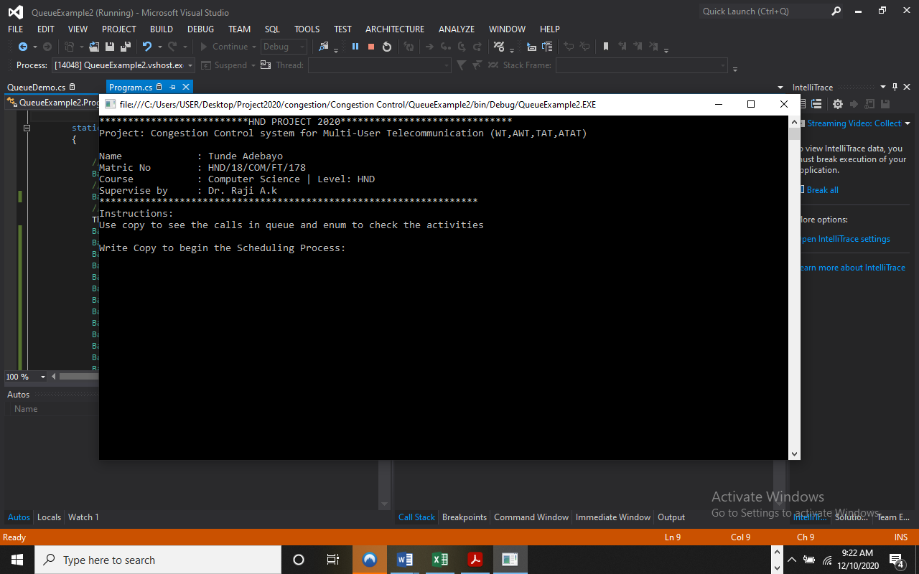
Figure 4.1: Runtime First Page Interface
Show information about the developer and display process to follow.

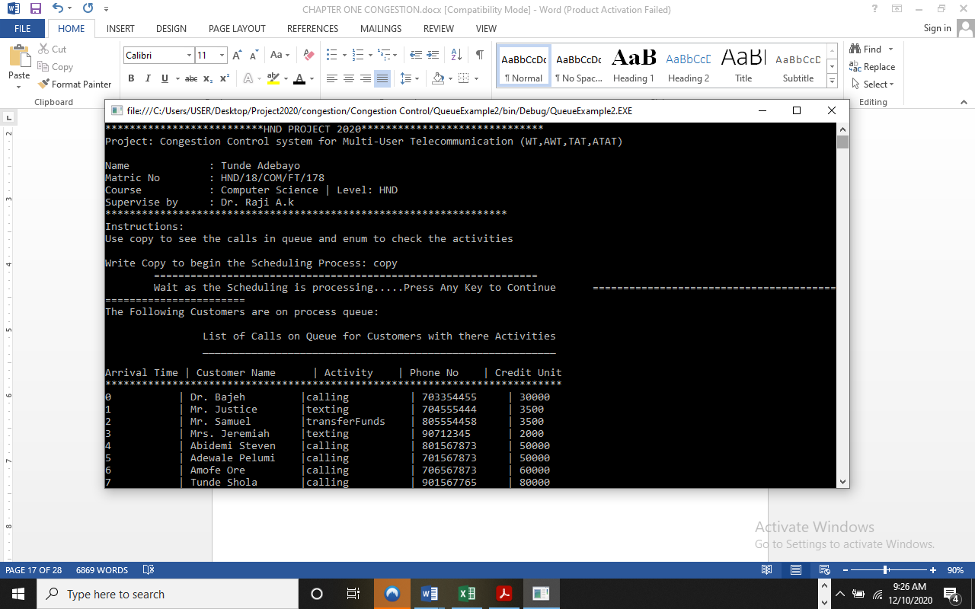
Figure 4.2: List of Call Page Interface
This shows the list of ongoing call with available credit unit.

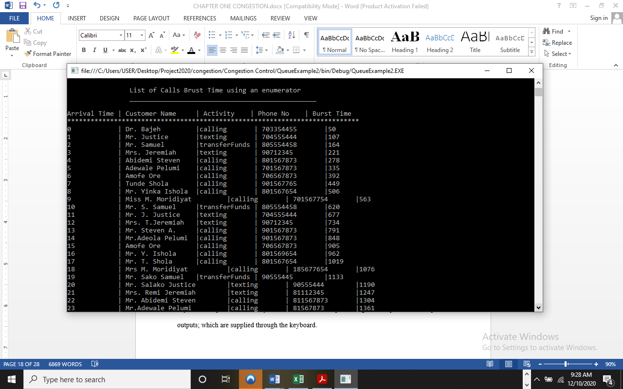
Figure 4.3: List of Calls Burst Time Module
This display list of all burst time users and their details.

4.1.2 INPUT DESIGN
It is also necessary to denote that data inputted in the computer for processing determines what the output will be. The inputs are use in collecting information the student through the keyboard. Inputs are necessary information needed for processing so as to produce the expected outputs; which are supplied through the keyboard.

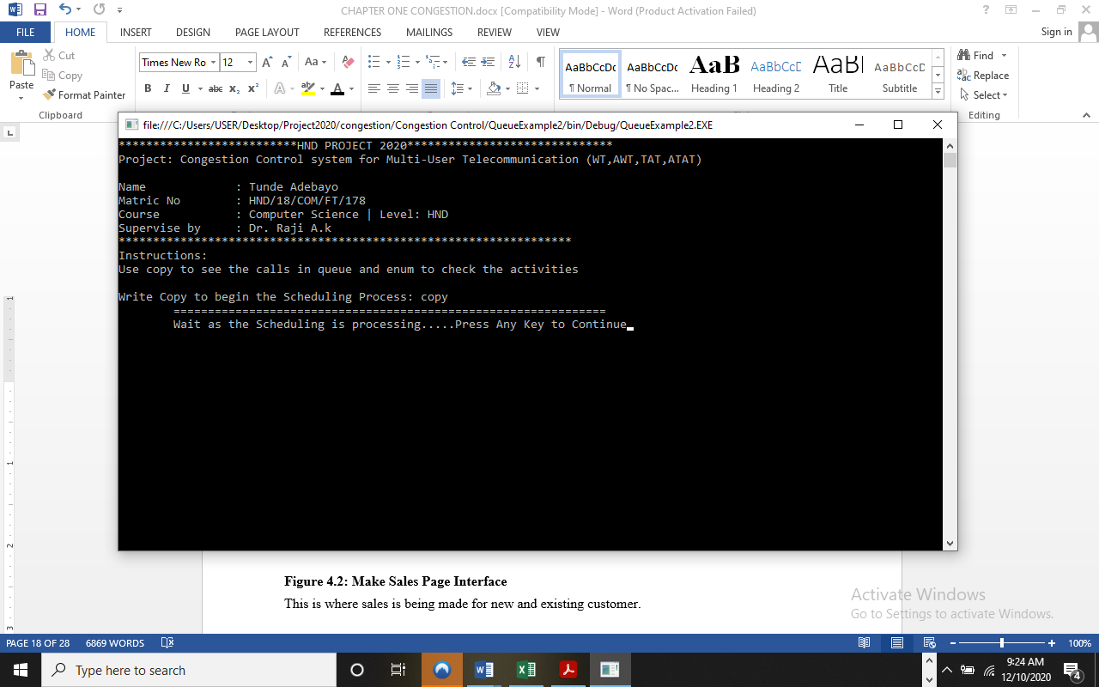
Figure 4.4: Input Interface for operation.
The input environment to begin a schedule
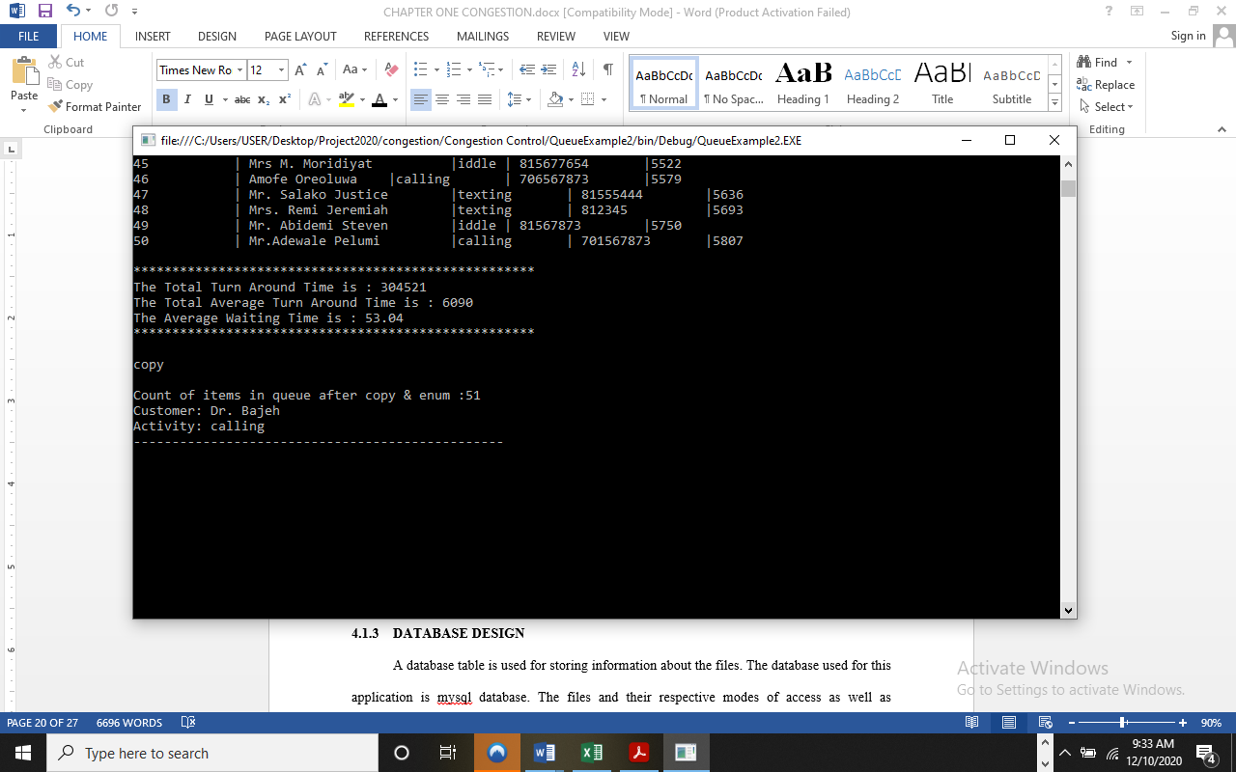
Figure 4.5: input Copy Page
This allow to write and display the calling schedule.

RESULT
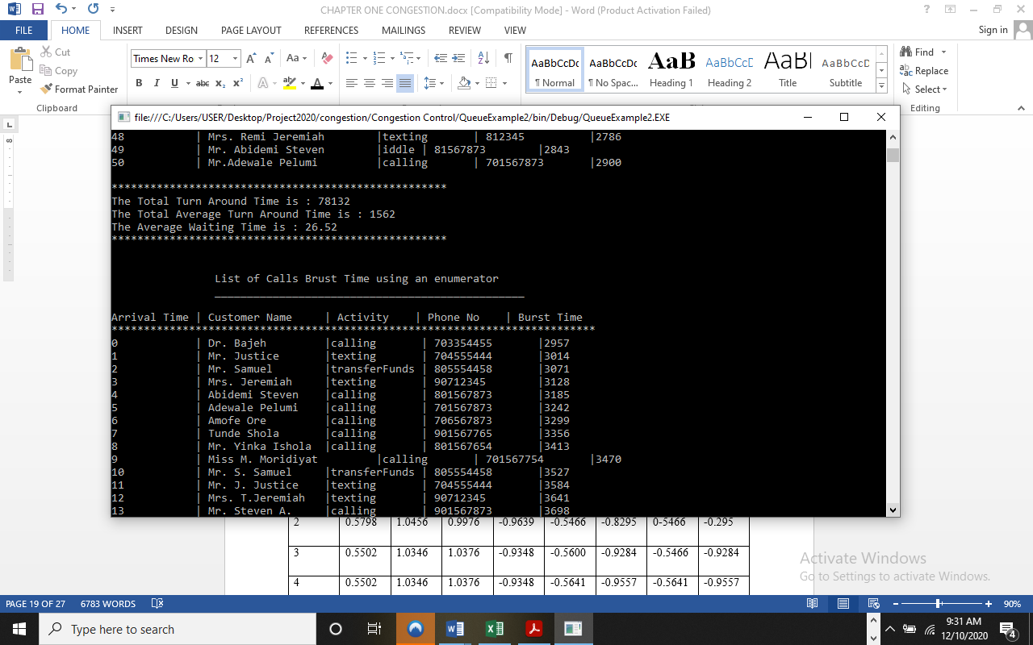
Figure 4.6: call and waiting time result.
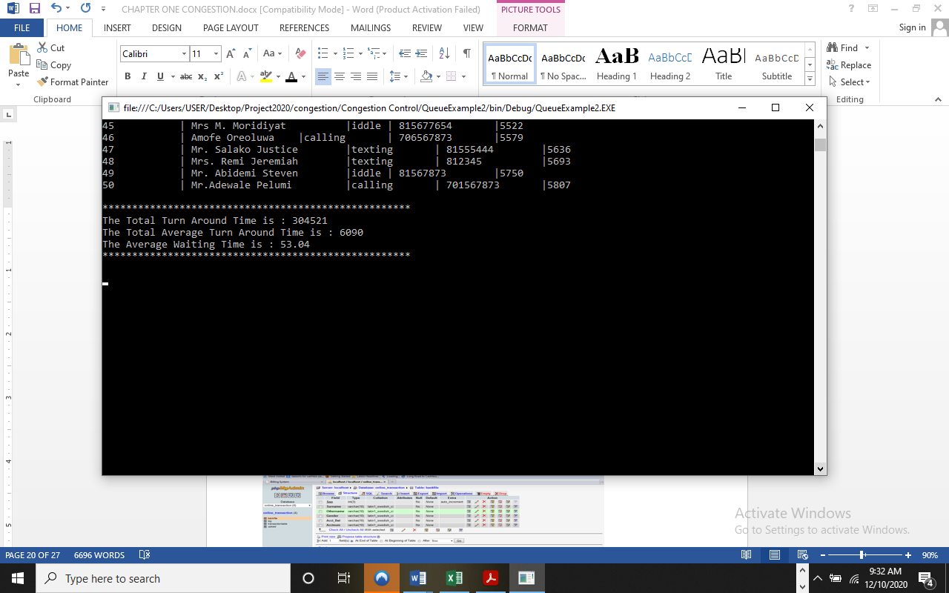
Figure 4.7: Burst time waiting and call time
4.1.3 DATABASE DESIGN
A database table is used for storing information about the files. The database used for this application is mysql database. The files and their respective modes of access as well as information they hold are given below;
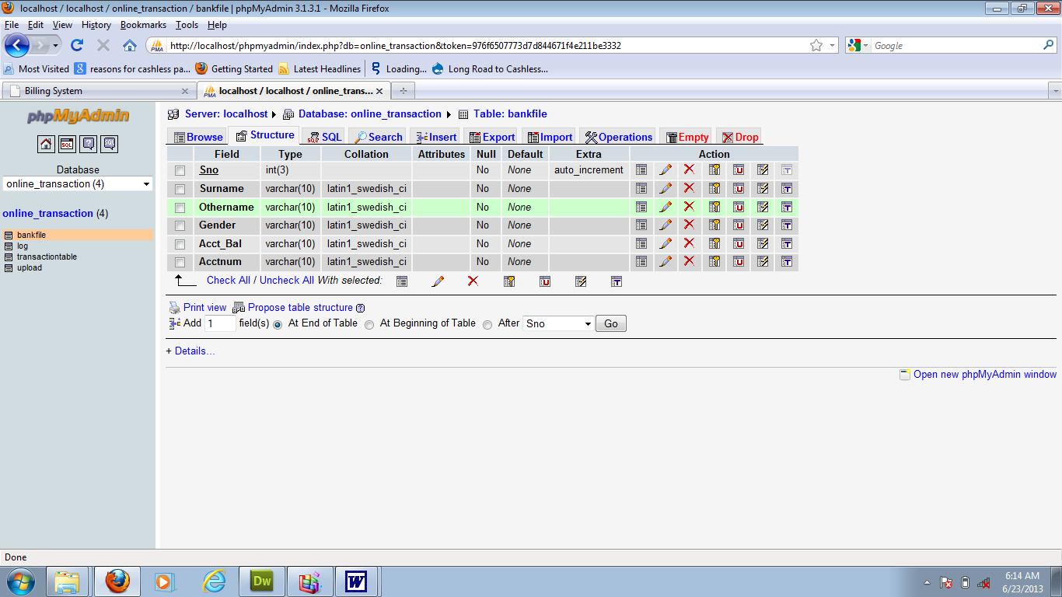

Table 4.1: Users Data Table
This are user’s data table where data are stored and retrieved.
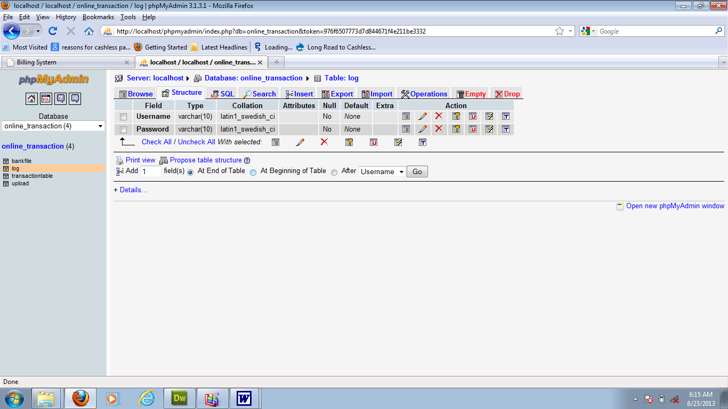

Table 4.2: Process Details Data table
This is where Products data are stored and retrieved
4.1.4 PROCEDURE DESIGN
Procedures are steps which verify the whole process i.e which are everything put together to produce the desired output. This involves the organization of the source document and end with the output result.
Documents are sent to various departments to be filled by the employees and later returned to the personnel department which are analyzed to determine which record goes into the computer.
After selecting the necessary data, this serves as input to the computer system.

4.2 IMPLEMENTATION OF THE SYSTEM
It is always good to develop new ideas, to implement them on a computer and eventually to relish the satisfaction of achieving a successful result. The implementation process involves converting the system design into a complete and tested EDP that is fully operational and that can be used by the system users to meet their business needs. During implementation phase, the hardware and the software must be implemented.
Implementation of a system can be explained in six steps:-
1. Review design specification
2. Code, test and document programs
3. Train users
4. Perform system test
5. Convert to new system
6. Evaluate and maintain the new system

4.2.1 CHOICE OF PROGRAMMING LANGUAGE
The application is designed using C# as the programming language and MYSQL for database management. Hence, the database testing simply involves running it directly from a Mozilla Firefox web browser on local host server provided by Apache 2.0 in WampServer 2.0 application.
In preparation for the installation of the new system, the method of changeover is given serious consideration to determine the success of the new system. Suitable changeover technique for this system is pilot changeover. The pilot changeover operates by applying the new system bit-by-bit until it covers the whole of the operations. The result obtained from using the pilot method on a small portion of the operations would be used in determining the suitability of the need system for the rest of the operations. This method is similar to testing small sample of a distribution if the test yields a good result then the whole system because fully operational and the manual/existing system is eliminated.
4.2.2 HARDWARE SUPPORT
The computer configuration required to run the software is;
Computer/memory processor PC with a 48dx, MHZ or Pentium, Intel or higher processor required.
Memory: 2GB of RAM
Cache memory: 512KB
Hard disk Minimum size 500GB
Recommended 200GB
Virtual Memory 32Bits
Cache memory 512KB
4.2.3 SOFTWARE
I. Microsoft Visual Studio
ii. MY SQL Database Management Software
iii. Operating system window 07 professional
v. Graphic software paint shop and choosing these two formats GIF (Graphic Image Format)
vi. Scanner software, Mira scans
vii. Web browser software MOZILLA

4.3 PROGRAM DOCUMENTATION
4.3.1 OPERATING THE SYSTEM
Step 1: Boot your computer and click on start button on task bar
Step 2: Click on document
Step 3: Locate Visual Studio and click it
Step 4: Locate your application and click it
Step 5: Choose user and enter the password
Step 6: Click on Options
6.1 Click on Main (toSelect Function)
4.3 Click on Sales (to Make Sales)
4.4 Click on Report (to view Sales Report)
4.5 Click on Help (to view the help page)
4.5 Click on About (to view the about page)
Step 5: Logout

4.3.2 MAINTAINING THE SYSTEM
The use of the term maintenance for software is different from other references to maintenance. Unlike the tires on your car, software does not “wear out”. If this is the case, then why does software maintenance account for such a high percentage of the Total Cost of Ownership for software?
The software maintenance definition refers to changes for defect correction, performance improvements, or adaptations to a changed environment (enhancements). According to this definition, if we build software that is defect-free, performs well, and contains user-controlled parameters to adjust processing rules in response to changing requirements then most maintenance would not be necessary.
Why does this happen? There are many reasons but the most common reasons are time constraints and lack of experience. Adding validation logic takes time. So, people make assumptions about the quality of in-bound data. Assumptions are also made about the volume of transactions and the impact on performance and the stability of the automated business processes. Finally, it is common for new software to be developed by younger developers who don’t understand the maintenance impacts of their designs.
The reality is that business requirements change and most of these assumptions are flawed. Transaction volumes increase, changing business processes require new transactions or new validation criteria, and software users will use the software incorrectly. The cost of software maintenance and the total cost of ownership can dramatically be reduced if developers build software that adjusted to changes in transaction volumes; validated all inbound data and provide user-configurable options for decision logic and data validation.

CHAPTER FIVE
5.0 SUMMARY, RECOMMENDATIONS AND CONCLUSION
5.1 SUMMARY
This research have demonstrated a working multipath congestion control system. It brings immediate practical benefits in result a seamlessly balance traffic over 3G and WiFi radio links, as signal strength faded in and out enables the same simulation code to run on a variety of data paths, it increases the “velocity” of development and improves maintainability, and facilitates new capabilities such as the congestion manager-style aggregation and sophisticated signal processing.
The implementation achieves high fidelity compared to native data path implementations at low CPU overhead. The use of fold functions and summarization reduces overhead, but not at the expense of correctness or accuracy.

5.2 CONCLUSION
In this research work, a new design method for the congestion controller of the simulation networks is introduced. The developed approach can theoretically guarantee the system performances, including the disturbance rejection and the implied stability of the closed-loop system. This property is useful for congestion controller design. This system studies a control system with time-delay using a model following method which is one of the effective means of solving time-delay problems in a control system. The method can efficaciously control time-delay under disturbances and has excellent practicability.

5.3 RECOMMENDATION
The density based traffic control system has been designed, constructed and tested to ensure validation of its function and operations. In this research, we have succeeded in minimizing the traffic congestions created by the fixed time based traffic light system. The system is effective and the cost of production is very low. Future work is recommended in order to produce the device on a large scale and deploy to all roads in order to reduce traffic congestion in places like Lagos where traffic congestion has become a big issue. Congestion is a canker worm that has devastated GSM network starting from the year 1986 to date. Researchers have been trying their best to ensure that it is brought under control.
The bench mark created by the international telecommunication union has not been achieved even in the developed nations, a reason being that service providers are bent on making fabulous gains instead of satisfying their customers.

REFERENCES
Damon W., Costin R., Adam G. & Mark H. (2009) Design, implementation and evaluation of congestion control for multipath TCP. International Journal of Engineering Research & Technology (IJERT) ISSN: 2278-0181
Gaoxiong Z., Wei B., Ge C., Kai C., Dongsu H., Yibo Z. & Lei C. (2013) Congestion Control for Cross-Datacenter Networks.
Hannan B. L., Amjad A., Junaid Q., Ali K. B., Muhammad B., & Fiaz M. (2019) Socially-Aware Congestion Control in Ad-Hoc Networks: Current Status and The Way Forward.
Keith W. & Hari B. (2013) Computer-Generated Congestion Control.
Mughele E. S., Wole O. & Tunde A. (2012) Congestion Control Mechanisms and Patterns of Call Distribution in GSM Telecommunication Networks: The Case of MTN Nigeria.
Okwor J. A. & Godwin O. O. (2015) Congestion control of the GSM network in Nigeria.
Shin-ichi K. (2016) Proposed congestion control method for cloud computing environments.
Sara L. (2005) Congestion Control in Wireless Cellular Networks.
Wei L., Fan Z., Kaushik C., & Waleed M. (2016) Adaptive Congestion Control with Reinforcement Learning.
Yuxin L., Danhong Z. & Dong Z. (2018) Delay-based virtual congestion control in multi-tenant datacenters.

