INTEGRATION OF VISUAL CRYPTOGRAPHY WITH ADVANCED ENCRYPTION STANDARD (AES) FOR ENCRYPTED MESSAGE EXCHANGE IN NETWORKED SYSTEMS

BY

BIFFO HAMIDAT OMOLARA
HND/23/COM/FT/0294

A PROJECT REPORT SUBMITTED TO THE

DEPARTMENT OF COMPUTER SCIENCE
INSTITUTE OF INFORMATION AND COMMUNICATION TECHNOLOGY, KWARA STATE POLYTECHNIC ILORIN

IN PARTIAL FULFILLMENT OF THE REQUIREMENT FOR THE AWARD OF HIGHER NATIONAL DIPLOMA (HND) IN COMPUTER SCIENCE

2025
CERTIFICATION
This is to certify that this project is written by BIFFO HAMIDAT OMOLARA, with matriculation number HND/23/COM/FT/0294 in Computer Science Department, Institute of Information and Communication Technology, Kwara State Polytechnic, Ilorin.

------------------------------------- ----------------------
MR. ISIAKA. O. S. Date
(Project Supervisor)

--------------------------------- ----------------------
MR. OYEDEPO, F.S. Date
(Head of Department)

----------------------------------- ---------------------
External Supervisor Date

DEDICATION
This project is dedicated to Almighty Allah for his mercy on me and my families their support and understanding.

ACKNOWLEDGEMENT
My infinite gratitude goes first to Almighty Allah the most beneficent and most merciful for his protection, divine guidance over life Tim’s of difficulties throughout my time of studies
My appreciation goes to my amiable supervisor in person MR ISIAKA,O.SALMAN for his advice and supervisory attention.Also special thanks to MR F.S.OYEDEPO the head of department for his fatherly advice throughout my stay in the department and to all my lecturers in the computer science department. I want to say a big thanks to you all
My profound gratitude goes to my grandmother ALH.TOHIBAT ADELEKE and to my mother MRS.GANIYAT OMOLOLA BIFFO may almighty Allah lengthening their life’s to reap the fruit of their labour(amen)
I am extremely thankful to my small mummy MRS.ADEMOLA DAMILOLA OLAGUNJU (owo mama Moro) for the support both mentally and financially. May almighty Allah reward her abundantly.
I want to also appreciate MR OLADEJO AYOBAMI,MR OLADEJO SHERIFFDEEN and MR OLAGUNJU IDRIS(Dad Moro) for their supportive actions towards my academy. May almighty Allah bless them.
My sincerely appreciation also goes to my family most especially BIFFOAISHAT,BIFFO ABDULSAMAD, BIFFO ZAINAB,OLOYEDE AISHAT, OLOYEDE FATIMOH,OLOYEDE RUKOYAH, AFOLABI ABDULQUADRI and also to all my friends Hashabi, sly, Ahmad, Mt, Suliyat,Roddy boy, shadow and those that are numerous to mention who has support in one way or the other. I say a big thanks to you all.

TABLE OF CONTENTS
PAGE
TITLE PAGE i
CERTIFICATION ii
DEDICATION iii
ACKNOWLEDGEMENT iv
TABLE OF CONTENTS v – vi
ABSTRACT vii
CHAPTER ONE: GENERAL INTRODUCTION
  - INTRODUCTION 1
  - STATEMENT OF THE PROBLEM 3
  - AIM AND OBJECTIVES 3
  - SIGNIFICANT OF THE STUDY 4
  - SCOPE AND LIMITATION 4
  - ORGANIZATION OF THE REPORT 4
CHAPTER TWO: LITERATURE REVIEW
  - REVIEW OF RELATED PAST WORKS 5
  - CRYPTOGRAPHY CONCEPT 6
2.2.1 SYMMETRIC KY CRYPTOSYSTEMS 6
2.2.2 PUBLIC KEY CRYPTOSYSTEMS 7
  - ENCRYPTION AND DECRYPTION TECHNIQUES 7
2.3.1 ADVANCED ENCRYPTION STANDARD 7
2.4 PHISHING PROCESS 8
2.5 VISUAL CRYPTOGRAPHY 8
2.5.1 VISUAL CRYPTOGRAPHY MODEL 8
2.5.2 VISUAL CRYPTOGRAPHY SCHEMES 9
CHAPTER THREE: METHODOLOGY AND ANALYSIS OF THE EXISTING SYSTEM
3.1 RESEARCH METHODOLOGY 11
3.2 ANALYSIS OF THE EXISTING SYSTEM 12
3.3 PROBLEMS OF THE EXISTING SYSTEM 12
3.4 DESCRIPTION OF THE PROPOSED SYSTEM 13
3.5 ADVANTAGES OF THE PROPOSED SYSTEM 13
CHAPTER FOUR: DESIGN, IMPLEMENTATION AND DOCUMENTATION
4.1 DESIGN OF THE SYSTEM 14
4.1.1 OUTPUT DESIGN 14
4.1.2 INPUT DESIGN 15
4.1.3 DATABASE DESIGN 16
4.1.4 PROCEDURE DESIGN 16
4.2 SYSTEM IMPLEMENTATION 17
4.2.1 CHOICE OF PROGRAMMING LANGUAGE 17
4.2.2 HARDWARE AND SOFTWARE REQUIREMENTS 17
4.2.3 IMPLEMENTATION TECHNIQUE USED 17
4.3 SYSTEM DOCUMENTATION 17
4.3.1 PROGRAM DOCUMENTATION 17
4.3.2 OPERATING THE SYSTEM 18
4.3.3 MAINTAINING THE SYSTEM 18
CHAPTER FIVE: SUMMARY, CONCLUSION AND RECOMMENDATION
5.1 SUMMARY OF THE FINDING 19
5.2 CONCLUSION 19
5.3 RECOMMENDATION 19
REFERENCES 20
FLOWCHARTS 21
SOURCE CODE 27

ABSTRACT
The rapid growth of networked communication systems necessitates robust methods for ensuring the confidentiality and integrity of transmitted messages. This research focuses on the integration of Visual Cryptography and the Advanced Encryption Standard (AES) to develop a secure framework for encrypted message exchange in networked systems. Visual Cryptography is utilized to divide sensitive data into multiple shares, ensuring that no meaningful information can be derived from any individual share. AES, a highly efficient symmetric encryption algorithm, is employed to encrypt the original message before generating the visual shares, thereby adding an additional layer of security. The combined approach leverages the simplicity of Visual Cryptography and the strength of AES to protect against unauthorized access and data breaches during transmission. The proposed framework is tested for scalability, computational efficiency, and resistance to common attack vectors. Results indicate that the integration of these techniques significantly enhances the security of message exchange while maintaining efficient performance. This study contributes to advancing secure communication protocols in environments where confidentiality is paramount. The software will be built with HTML, CSS, PHP as the front end, and MySQL as the database server.

CHAPTER ONE

GENERAL INTRODUCTION

1.1 INTRODUCTION
In recent years, the security of exchange messages has become a major concern. Encryption has emerged as a solution and is now an important part of the information security system. Many techniques are required to safeguard the shared data. The current work focuses on cryptography to secure data/information while it is being transmitted over a network. To begin, the data that will be transmitted from sender to receiver in the network must be divided into shares using visual cryptography and encrypted using the encryption algorithm. Second, the receiver can view the original data by employing a decryption technique.
Cryptography is a branch of science that studies encryption techniques. It aids in the creation of written or generated codes that allow information to be kept private. Cryptography is the study of concealing information and is used when communicating over an untrustworthy medium, such as the internet, where information must be protected from third or unknown parties. The encryption algorithm can be used in two ways in cryptography: substitution and transposition. Substitution refers to the process of mapping each element of input text, such as a bit, letter, or group of letters or bits, into another element, whereas transposition refers to the process of rearranging the elements of input text. There will be no data loss in this manner. Cryptography employs two types of keys, symmetric and asymmetric. A symmetric key means that the same key is used on both the transmitter and reception sides, whereas an asymmetric key uses different keys on both sides. DES (Data encryption standard), 3-DES (Triple-DES), AES (Advanced encryption standard), and VCS (Visual cryptography standard) are the most popular cryptographic methods today.
This project is implemented using Advanced Encryption Standard (AES) techniques and the performance of encrypt techniques based on the analysis of its stimulated time during encryption and decryption. The results of the experiments are provided to analyze the algorithm's effectiveness. Many encryption algorithms are widely available and used in information security. They are classified as Symmetric (private) and Asymmetric (public) key encryption. In symmetric keys encryption or secret key encryption, only one key is used to encrypt and decrypt data. Asymmetric keys employ two keys: private and public keys. The public key is used for encryption, while the private key is used for decryption (e.g. AES). Public key encryption is based on mathematical functions that are computationally intensive.
There are numerous examples of strong and weak keys in cryptography algorithms such as AES. AES employs a variety of keys with lengths ranging from 128,192,256 bits. To solve the key distribution problem, asymmetric key encryption or public key encryption is used. Asymmetric keys employ two keys: private and public keys. The public key is used for encryption, while the private key is used for decryption (E.g. AES and Digital Signatures). Because users typically use two keys: the public key, which is known to the public, and the private key, which is known only to the user. There is no need to distribute them prior to transmission. However, public key encryption is based on mathematical functions, is computationally intensive, and is inefficient for small mobile devices. Because they require more computational processing power, asymmetric encryption techniques are nearly 1000 times slower than symmetric techniques.
Encryption in cryptography is the process of encoding messages or information so that only authorized parties can read it. Encryption does not prevent interception in and of itself, but it does deny the interceptor access to the message content. In an encryption scheme, the plaintext message or information is encrypted using an encryption algorithm, resulting in cipher text that can only be read after it has been decrypted. An encryption scheme typically employs a pseudo-random encryption key generated by an algorithm for technical reasons. It is theoretically possible to decrypt the message without the key, but for a well–designed encryption scheme, large computational resources and skills are required, and an authorized recipient can easily decrypt the message with the key provided by the originator to recipients but not unauthorized interceptors. To address the security issue of secret images, we require a suitable secure algorithm that will allow us to secure our data over the internet. The system visual information can be securely transmitted over the internet with the help of Visual Cryptography.
Several researchers have addressed the security of cryptographic shares. Many techniques have been developed to ensure the secure transmission of shares and the confidentiality of messages. The Least Significant Bit substitution technique was discovered to be the foundation for the proposed model. The model's main idea is to secure the shares by encrypting the secret into the image before creating the shares. Using the LSB substitution technique, the secret information or image that must be protected is first encrypted into any cover medium, such as an image or text. As a result, the encrypted image containing the secret information is the encryption's output. The double encryption technique may protect the secret, but the likelihood of information disclosure is high due to the use of the LSB technique in basic encryption. The encryption technique used is very easy for an intruder to track. In order to overcome the aforementioned difficulty, the proposed system is built with high security.
The proposed scheme combines the benefits of visual cryptography and public key cryptography. This scheme improves the security of VC shares by encrypting them with the AES algorithm of Public Key Cryptography, which provides strong security for the transmission of sensitive information in the form of images, printed text, and handwritten material. Visual Cryptography (VC) is one of the encryption techniques used to encrypt secret images in such a way that the human visual system can decrypt them if the correct key images are used. Moni Naor and Adi Shamir proposed the technique for the first time in 1994. Visual cryptography, according to them, is a technique for encrypting a secret image into shares so that stacking a sufficient number of shares of the secret image reveals the original image. Shares are typically binary images displayed as transparencies. Visual cryptography does not require any complicated computation to recover the secret image. Simply stacking the shares and viewing the original (secret) image that appears on the stacked shares is the decryption method. Visual cryptography is a technique used for the secure transfer of images in the military, handwritten documents, text images, and so on.
Visual Cryptography shares exist in their normal form during network transmission in sequence. However, a third party cannot predict the Secret information with a single share, but there is a chance of recovering the secret image if hackers are able to collect all the shares that are passing in sequence over the network. To get out of this, we need to improve share security. For the same reason, we used both Public Key Cryptography and Visual Cryptography, so that even if hackers obtain all of the shares, they cannot recover the original secret without access to the private key.
1.2 STATEMENT OF THE PROBLEM
The existing procedure used by the organization to secure their information, messages, images, and database is being hijacked/hacked by the hackers. Many organizations struggle to protect their databases from hackers. The message and information in the database are not securely secured to the point where hackers or unauthorized users can easily interpret the information in the database if they gain access to it. To address this issue, strong and unbreakable message security must be implemented.
1.3 AIM AND OBJECTIVES
The aim of this project is to design a visual cryptography scheme for exchanging messages using the AES algorithm. This aim can be accomplished by pursuing the following objectives:
- To design a web application capable of displaying information about the organization as well as a procedure for sending data into a database.
- To develop a web application capable of inserting and displaying encrypted data from a database.
- To design a web application that can display decrypted data from a database.
- To design a web application that uses a database to track staff relationships, such as the frequency of their visits, complaints, and feedback.
1.4 SIGNIFICANT OF THE STUDY
The significance of this research is to encourage organizations to improve the level of security and secrecy provided by different encryption algorithms. The message encryption and decryption algorithm is designed and implemented to provide confidentiality and security in the transmission of messages, information, and image-based data, as well as database storage. This proposed encryption and decryption system can ensure security.
1.5 SCOPE AND LIMITATION OF THE STUDY
The scope of this study is limited to message encryption and decryption only, with no monitoring of the messages' actual transportation over the network.
1.6 ORGANIZATION OF THE REPORT
This report is divided into five chapters. The first chapter introduces the new system, its goal and objectives, its significance, the scope of the proposed system, and technical terms. The second chapter reveals the subject's literature review. The techniques of encryption and decryption, the phishing process, the concept of cryptography, and visual cryptography were all discussed. The third chapter includes the research methodology, data analysis of the existing system, which includes the description of the current procedure, problem of the existing procedure, description of the proposed system, and advantages of the proposed system. The fourth chapter reveals the system design, system implementation, including the output input file structure, and system procedure design. It also includes detailed implementation techniques, programming languages used with reason, hardware and software support, and documentation. The fifth chapter contains a summary of the investigation, recommendations, and the report's conclusion.

CHAPTER TWO
LITERATURE REVIEW
2.1 REVIEW OF RELATED PAST WORKS
Shivaputra, Sheshadri, & Lokesha (2015) proposed four major transformation functions for the encryption process, all of which are iterative, with the number of rounds of iteration determined by the secret key size in bits. The size of the secret key is 192 bits, and the size of the data is also 192 bits. To obtain the encrypted image, this algorithm for AES Encryption is iteratively run for 12 rounds. As a result, this procedure makes the encrypted data/image more robust and impervious to statistical attacks. The 192-bit key is more robust, averaging for encryption at a very effective rate of encryption and decryption. The analytical procedures included Histogram Analysis, Correlation Coefficient Analysis, and Time Analysis, which were used to parameterize the effectiveness and robustness of the proposed image encryption/decryption process. The proposed procedure is more effective for real-time, medical process, and data-realistic applications where data/images must be transferred/transmitted, stored across bandwidths, and across various applications where shared data access is required with data confidentiality as a high priority and necessity.
According to Nandini & Rekha (2017), the rise in data theft, eavesdropping, and hacking necessitates the need for robust data protection schemes. Many algorithms have previously been proposed to improve the speed and security parameters of cryptographic algorithms. The most well-known algorithms in use today are Advanced Encryption Standard (AES) for data and visual cryptography (VC) for images. The project's goal is to combine the AES and VC algorithms to create a highly secure encryption algorithm. The algorithms were simulated in MATLAB, and the architecture was downloaded onto the Spartan 3E FPGA.
Ramya, Vinolyn & Edington (2016) proposed a strong encryption technique for the secure transmission of cryptographic shares. The disadvantage of revealing the secret due to transparent decryption in visual cryptography is overcome by encrypting the secret information. Though the main advantage of Visual Cryptography is the ease of decryption, high security breaches could be a major issue. As a result, the decryption part has been made much more complex, reducing the risk of sensitive information leakage. The three-layered encryption and decryption process provides a high-end security model for the proposed work. When the three-layered stego image is transmitted over the network, an intruder may become confused during the decryption process. Each layer has been constructed with different information that completely covers the original message that is to be transmitted. As a result of the proposed model's requirement, the information is secure.
According to Guru & Nayana (2017), the security of transmitted data is the most critical issue, as network technology has advanced and massive amounts of information are transmitted via the internet. Visual cryptography strategy is one of the most secure techniques for privacy safeguards, as it allows the encryption of secret image or data by transferring it into the secure percentage and is capable of recovering the secret image or data. Because of this behavior, visual cryptography is especially useful for low computation load requirements. In this paper, we discuss information security through the use of a Visual Cryptography scheme that employs an exclusive new technique for splitting images and rotating their pixels using a generated random number.
2.2 CRYPTOGRAPHY CONCEPT
Cryptography is a valuable tool for safeguarding multimedia content. Before being distributed over the internet, all multimedia files are encrypted. Because of the encryption, the file is useless to anyone who does not have access to the keys. As a result, the key for decrypting the content should not be disclosed to anyone other than the content provider. Encryption is a method of protecting information from unauthorized attacks by converting it into a format that no attacker can recognize. Data encryption is the process of transforming data, such as text, image, audio, and so on, so that it is unreadable, invisible, or impenetrable during transmission. To recover the original data, the receiver simply reverses data encryption, also known as data decryption (Stallings, 2012).
The encryption process can be described as C = E (P, K)
Where,
P = Original data, E = Encryption Algorithm, K = Encryption Key and C= Cipher message, which is transmitted and can be subject to attack
The decryption procedure can be described as P= D (C, K)
Where,
C = Cipher message; D= Decryption Algorithm, K= Decryption Key and P= Recovered data
2.2.1 SYMMETRIC KEY CRYPTOSYSTEMS
All classical cryptosystems developed prior to 1970 are examples of symmetric key cryptosystems. Aside from that, the majority of cryptosystems developed after 1970 are symmetric. Advanced Encryption Standard (AES) and Data Encryption Standard (DES) are two popular examples of modern symmetric keys (Singhall & Raina, 2011). All symmetric keys share a common interest in that they are based on a secret shared by communicating parties. The secret can be used as an encryption key as well as a decryption key. The disadvantage of symmetric key is that it cannot handle a large communication network. Conversely, symmetric keys require a smaller size to provide the same level of security as public key cryptosystems, making communication faster and memory requirements smaller.
2.2.2 PUBLIC KEY CRYPTOSYSTEMS
There are two distinct keys in this type of cryptosystem: a public key that is known to the public and a secret key that is known only to the owner. Because a different key is used for decryption and encryption, this system is referred to as 'asymmetric' (the public and private key). The data is encrypted with a public key and can only be decrypted with a private key.
2.3 ENCRYPTION AND DECRYPTION TECHNIQUES
Encryption is the process of converting information or data into a code, usually in order to prevent unauthorized access. There are numerous encryption algorithms available for encryption and decryption. There are two types of encryption algorithms: symmetric key encryption algorithms and asymmetric key encryption algorithms. A single key is used for both encryption and decryption in symmetric key encryption, whereas two keys are used in asymmetric key encryption (also known as public key encryption). The public key is used to encrypt data, while the private key is used to decrypt it (Nandini & Rekha, 2017).
2.3.1 ADVANCED ENCRYPTION STANDARD
The Advanced Encryption Standard (AES) is a symmetric-key algorithm with a 128-bit block size. It can handle lengths of 128, 192, and 256 bits. When compared to the data encryption standard, AES is a superior algorithm with advanced features (DES). There is no feistel network in AES, as there is in standard DES. The cipher is composed of rounds, the number of which is determined by the key length: 10 rounds for a 128-bit key, 12 rounds for a 192-bit key, and 14 rounds for a 256-bit key. The entire algorithm is based on a 4x4 byte matrix. The first round includes four different transformation functions: sub bytes, shift rows, mix columns, and add round key. The final round includes three transformations; the mix columns function is not used. Each transformation accepts one or more 4X4 matrices as input and outputs a 4x4 matrix. Decryption does recover the plaintext if all four rounds are reversible.

2.4 PHISHING PROCESS
Phishing is a common online transactional attack. Phishing is a method of data theft in which attackers send bogus emails from various websites in order to obtain the users' personal information. Users will enter their passwords or other private information unknowingly, believing it is a legitimate website. Attackers collect stolen data and use it to gain access to websites' private areas. Anti-phishing image-based authentication techniques have been proposed to address this. They will be more secure and eliminate phishing if they use image steganography and visual cryptography.
2.5 VISUAL CRYPTOGRAPHY
Nowadays, in addition to text, multimedia information is widely available on the Internet. As a result, the security of these secret and confidential images is a legitimate concern. To address these concerns, Shamir and Naor proposed a new field of cryptography known as visual cryptography in 1994. Visual cryptography is a type of cryptography that is used to encrypt printed texts, handwritten notes, and images so that only the human visual system can decrypt them (Guru & Nayana, 2017). This distinguishing feature of visual cryptography renders decryption impossible even with the aid of a brute force attack, as it necessitates constant human intervention to determine whether the decoded image is valid or not.
Visual cryptography, which is based on the basic theory of secret sharing, applies the same sharing scheme to images in such a way that no single share reveals information about the original image. Its applications include sharing multimedia information secrets over the network and thresholding access to a bank account, for example, out of 6 participants only n such that 2<=n<=6 can combine their share of the key given to them and access the bank account (Guru and Nayana, 2017).
2.5.1 VISUAL CRYPTOGRAPHY MODEL
The most basic version of the visual cryptography model is based on binary images, where the message is simply a combination of black and white pixels, but advanced versions are also available for gray scale and color images. From a cryptographic standpoint, the user will be given a key that is one of the original image's transparencies. Aside from that, the validator's cipher text is another source of transparency (Gary, 1999). Placing the key over the cipher text will reveal the original plaintext image. This system is similar to the one-time pad scheme in that the encrypted message provides no information about the original message to a cryptanalyst. This adds to the benefits of visual cryptography. The following are the critical parameters for any (k, n) VCS.
- m - The number of sub-pixels that each pixel is subdivided into. The resolution of the pixel is expected to decrease as m increases.
- a - The relative difference is for contrast loss and should thus be as large as possible.
- k - The minimum shares required to re-compute the image.
- n - The total number of shares into which the image will be divided.
For an n-share scheme, the original binary image is divided into n images, each representing a share. Each share is yet another collection of black and white sub-pixels. The number of sub-pixels per pixel is determined by the pixel expansion constant. Each pixel in the original image can be represented by a 2-D array of n x m. When the entire sets of shares are stacked on top of each other, a valid solution to the scheme must meet the two conditions listed below.
- For a white pixel, the hamming weight of “or”-ed m vector is < d – am.
- For a black pixel, the hamming weight of “or”-ed m vector is at least d.
Where “d” is some fixed threshold and “a” is the contrast relative difference, generally >0.
2.5.2 VISUAL CRYPTOGRAPHY SCHEMES
The schemes that we will be discussing are as follows
- 2 out of N general scheme - This scheme means that if image is divided into N shares then at least 2 shares are needed to re-compute the image.
- 3 out of N general scheme – This scheme means that if image is divided into N shares then at least 3 shares are needed to re-compute the image.
Before delving into the two schemes, it is important to understand the basis matrices and the share distribution algorithm (Ramya, Vinolyn & Edington, 2016).
Basis Matrices – The core of the visual cryptography scheme consists of two matrices. One is responsible for all white pixels, while the other is responsible for all black pixels.
Share distribution Algorithm - The algorithm for distributing shares is as follows:
For each pixel, do the following
- Generate a random permutation of the set – {1, 2, 3, …, m}
- If P is a black pixel, then apply the permutation to columns of S¹
- Else if it is a white pixel, then apply the permutation to columns of S⁰
- Now each row in the new matrix comprises the m sub pixels of the pixel P in the each share.
The algorithm described above employs random permutations of the basis matrix. Because a different permutation is used for each pixel, confusion is introduced. This ambiguity adds to the algorithm's security.
(A) 2 out of N Visual Sharing Scheme
For a (2, n) VCS, the solution is obtained as follows for S⁰ and S¹
- S⁰ – It is the matrix which has all rows of column 1 set as 1 and all other cells as 0.
- S¹ – It is the identity matrix.
From these S⁰ and S¹, the collection C⁰ is obtained by all permutations of S⁰ and C¹ is the collection of all permutations of S¹
(B) 3 out of N Visual Sharing Scheme
For a (3, n) VCS, the solution is obtained by the following algorithm
- Generate a B matrix, which is of the dimension n x (n-2) containing only 1’s
- Generate I as Identity matrix of n dimension
- Concatenate B and I to form the n x (2n-2) matrix
- C⁰ – All matrices obtained by permuting c(BI)
- C¹ - All matrices obtained by permuting BI

CHAPTER THREE
METHODOLOGY AND ANALYSIS OF THE EXISTING SYSTEM
3.1 RESEARCH METHODOLOGY
The methodology of proposed scheme is given in figure 3.1
Figure 3.1: Proposed System Methodology
Encryption using AES
Encryption using AES
Decryption using AES
Decryption using AES
Share 1
Share 2
Phase 1
Phase 2
Phase 3
Phase 4
Decoded Secret Image
Secret Image

- Phase 1 - Generating the Shares of Secret Image: Visual Cryptography is implemented during this phase. It entails creating shares from a secret image using the Visual Cryptography (2, 2) scheme. First, the secret image is captured and converted to a binary image, after which each pixel in the secret image is subdivided into eight subpixels.
- Phase 2 - Encrypting the generated Shares: This is the second phase of the proposed approach, in which the system encrypts shares generated in the first phase. The AES algorithm is used to encrypt the shares. The first step is to generate the AES key, and then perform the encryption using the public key. Thus, encrypted shares are the result of the second phase.
- Phase 3 - Decrypting the Shares using AES: The decryption of the shares occurs at the destination side. Using the AES decryption algorithm, the system converts the encrypted shares back into their original form, which was encrypted at the sender's end. Here, for the purpose of decrypting the shares.
- Phase 4 - Visual Cryptography decryption: The process of Visual Cryptographic decryption is carried out in the final stage. The original secret image will be recovered here by performing a binary XOR operation on both decrypted shares.
3.2 ANALYSIS OF THE EXISTING SYSTEM
These days, online and information transfer security is very important, and there are many hack attempts to the huge application that keeps users private data, credit card validation and encryption/decryption are easily check a credit card number is valid or not, and helps to encrypt and decrypt the numbers safely stored on database. Many online stores now keep users' private data, such as credit card numbers, for improved user experiences, such as shopping with the same user without having to fill out all of the details again. Yes, it has an advantage for the user in that they can shop in a few clicks after entering their account information. So the security concern is how these websites store users' credit card numbers. Clients may request that the information they collect from users be encrypted and stored in a database. You would have to be cautious to protect your data in this increasingly virtual online world. Learn the fundamentals of encoding and decoding important information such as passwords and entire messages.
3.3 PROBLEM OF THE EXISTING SYSTEM
There are some issues with the current system that make it difficult to adapt to a high-tech and modern system of providing security to information or messages.
- Difficulties encrypting and decrypting exchange messages with a specific algorithm.
- The computer system was developed in isolation from the operational activities.
- An organization's database is not well secured because proper security measures, such as encrypting and decrypting techniques, are not implemented.

3.4 DESCRIPTION OF THE PROPOSED SYSTEM
In order to secure the secret shares and shares, the proposed scheme generates the shares of Visual Cryptography using the basic Visual Cryptography model and then encrypts both shares using the AES algorithm of Public Key Cryptography. During the decryption phase, the AES decryption algorithm extracts secret shares and stacks them to reveal the secret image. This project, on the other hand, consists of pre-planned and pre-investigation information, as well as that information concerning the transfer of information using AES Algorithms to secure information on the network. As a result, a good and clear understanding of what information is required to assist in achieving success in this project assignment was carefully considered.
3.5 ADVANTAGE OF THE PROPOSED SYSYTEM
The proposed system, which is the development of visual cryptography for message exchange using the AES encryption algorithm, is expected to improve services and optimize operation. The following are the primary benefits of the proposed system:
- Enable an organization to have a secured database.
- To prevent hackers or unauthorized users from interpreting the information in the database if they gain access to it.
- Only the database administrator has access to readily available information.
- Improve record keeping method.
- A cost-effective and all-inclusive method of handling information acquisition, distribution, and storage in a database.

CHAPTER FOUR
DESIGN AND IMPLEMENTATION OF THE SYSTEM
4.1 DESIGN OF THE SYSTEM
A system design is concerned with the analysis of a new system. Proper analysis and design of the available data will allow for the proposed system to be realized.
4.1.1 OUTPUT DESIGN
This section specifies the design's output after feeding the new data facts about data transfer using the AES Algorithm. In relation to the various operations that can be performed on the application, information can be viewed from the database in an encrypted and decrypted manner by authorized staff/personnel, as shown in figures 4.1 and 4.2.
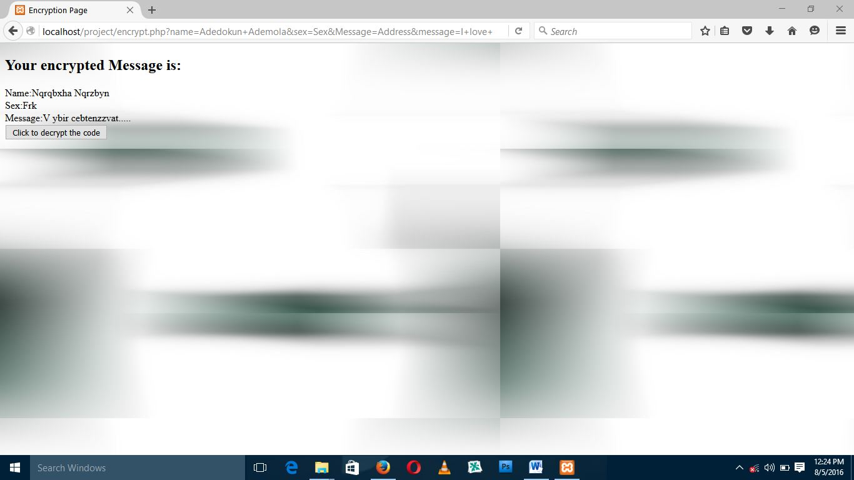
Figure 4.1: Resulting Messages after Encryption
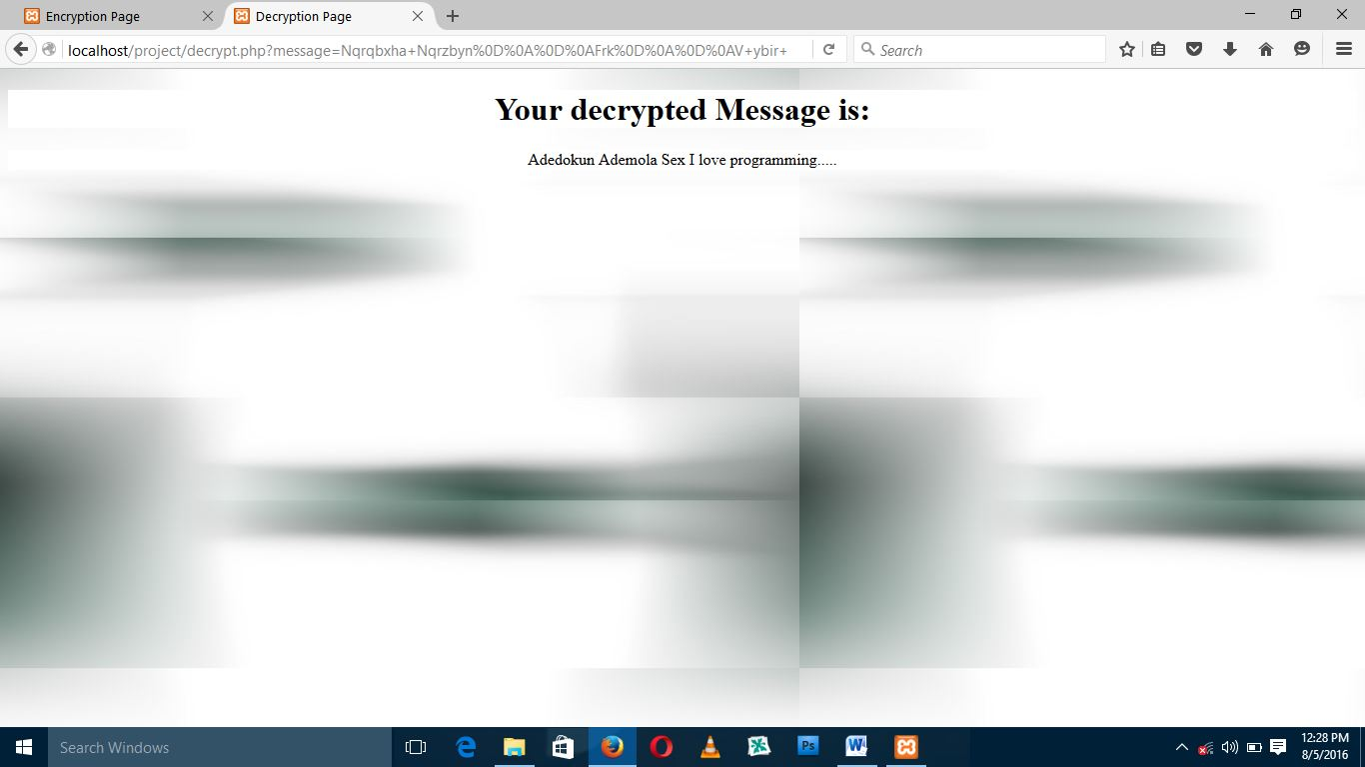
Figure 4.2: Actual Message recover after Decryption

4.1.2 INPUT DESIGN
This is explained under the input design as how data are fed into the system or how data are to be organized so that the processing state can be successful. The input design for this project work, as depicted in figures 4.3–4.5, is restricted to the most common operations such as name, sex, address, and message.
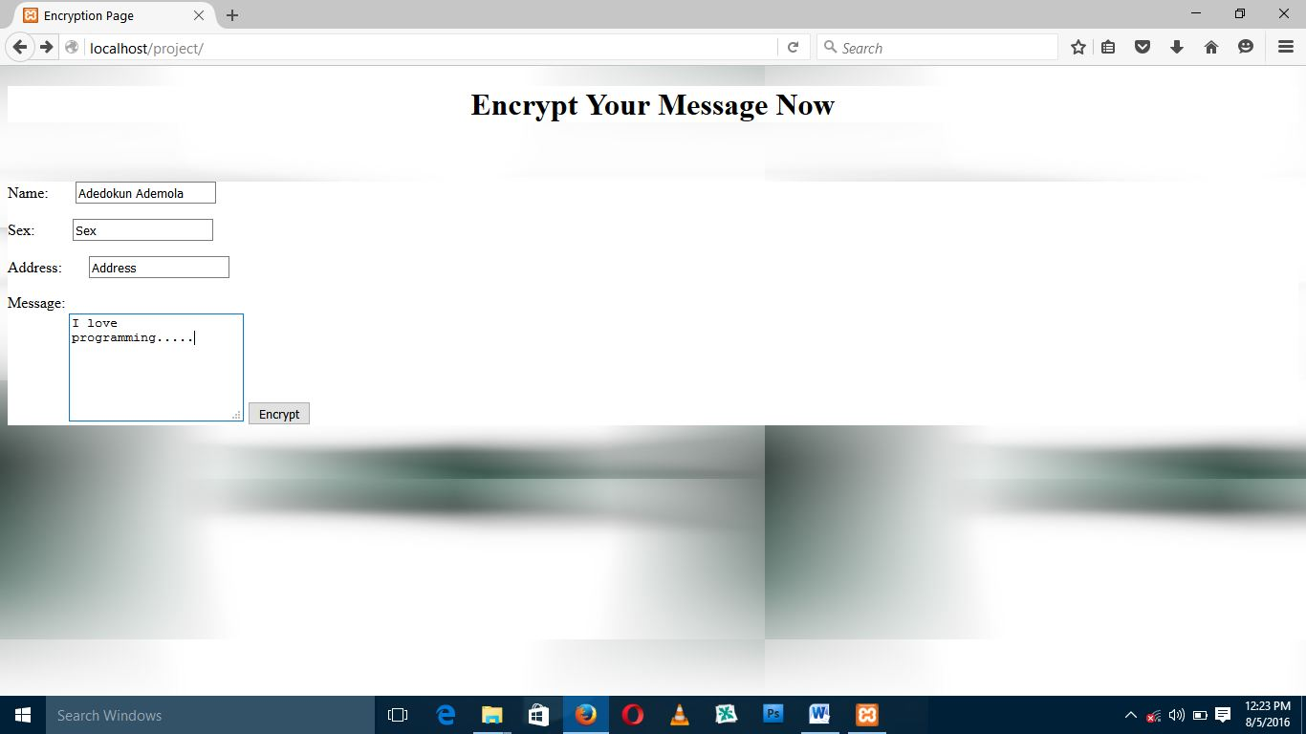
Figure 4.3: Message to be Exchanged

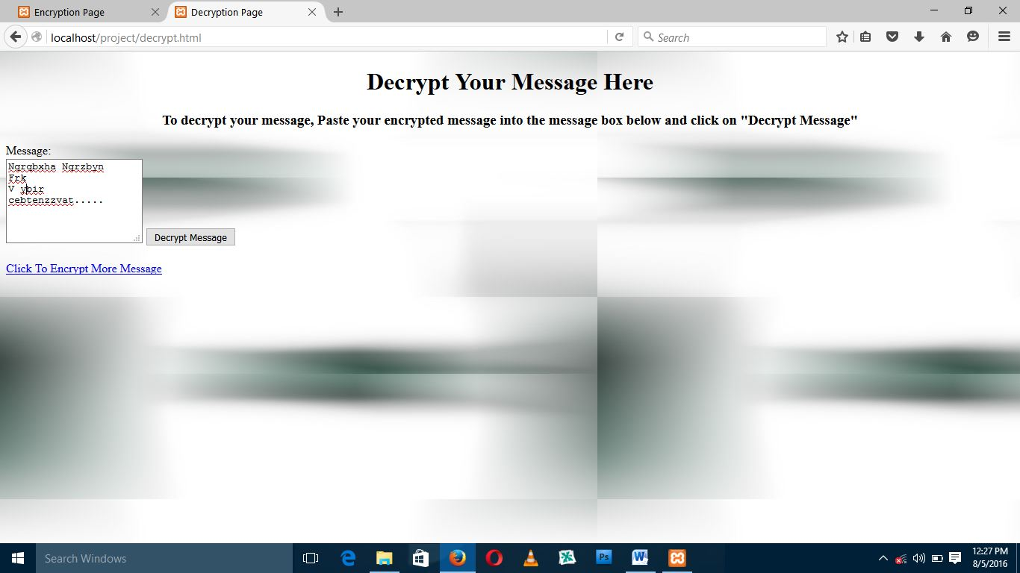
Figure 4.5: Decrypting Message Page
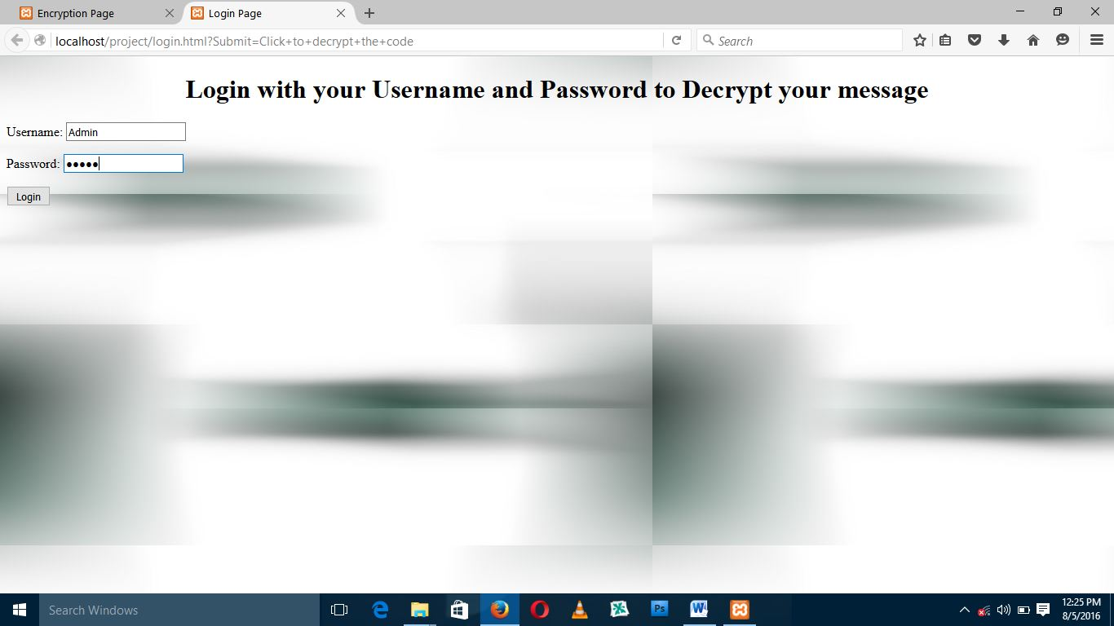
Figure 4.4: Login Page to Decrypt

4.1.3 DATABASE DESIGN
Database Name – AES Encryption and it is designed with Wamp Server and MySQL.
Table 4.1 – Database Name.
FIELD NAME | DATA TYPES | WIDTH | DESCRIPTION
Name | Alphabet | 30 | The full name of the sender
Address | Alphabet | 30 | Address of the sender
Sex | Alphanumeric | 6 | Gender of the sender
Message | Alphabet | 80 | The message to be encrypted

4.1.4 PROCEDURE DESIGN
The procedure is the arrangement, steps, and how the flow of a program with the program's arranging and structuring. Because the program is divided into modules, the methodology used is an event driven programming language, which makes the program much more efficient in terms of execution, program write time, storage utilization, and maintenance.

4.2 SYSTEM IMPLEMENTATION
4.2.1 CHOICE OF PROGRAMING LANGUAGE USED WITH REASONS
HTML, CSS, PHP, and MySQL were the programming languages used for the design and implementation of visual cryptography to exchange messages using the AES Algorithm. The following were the reasons for using the aforementioned program.
- It is an event programming language.
- It is a scripting language.
- It is an object oriented programming language.
- It is a server based language.
- It has a graphical user interface that makes it easy to be used.
- It enhances the connection to the database program.
4.2.2 HARDWARE AND SOFTWARE REQUIREMENT
To install and run the program, the user needs a
- PC (Pentium IV),
- Windows Operating System,
- PHP/MYSQL,
- 1GB of RAM,
- Macromedia Dreamweaver Software Application to design the interface and
- Wamp Server to connect the database
4.2.3 IMPLEMENTATION TECHNIQUES USED
The new system will be operational alongside the old one in order to test the new system's dependability and efficiency. This method of changeover is known as a parallel changeover method.
4.3 SYSTEM DOCUMENTATION
4.3.1 PROGRAM DOCUMENTATION
The program is installed by selecting Wamp Server from the start menu, navigating to the set up folder where the modules are saved on the internet, double-clicking, and then following the instructions on the screen. The application will be installed in the Wamp Server folder.
4.3.2 OPERATING THE PROGRAM
Click the start button on the Windows start bar, then move the mouse pointer to all programs, click the Wamp Server to locate the application's folder, and then click it. The user will be taken to the Home page, from which he or she can navigate to other pages one by one.
4.3.3 MAINTAINING THE SYSTEM
The term "system maintenance" refers to the process of modifying a system. It refers to the ease with which changes can be made to the system under certain conditions. It also refers to the addition, deletion, or modification of a portion or the entire program. Programs with structure and a feature of maintainability are considered to be good. The newly proposed system could be modified to handle certain operations such as displaying the Homepage, sending encrypted data into the database, and decrypting it back into normal form. In general, to make changes to any of these operations, go to the code environment and make the necessary changes, and the changes will be effected immediately, making system maintenance very simple.

CHAPTER FIVE
SUMMARY, RECOMMENDATION AND CONCLUSION
5.1 SUMMARY OF THE FINDING
One of the most important issues in real life is ensuring the security of secret data that is shared on a daily basis. The system can decrypt the secret images in the scheme of Visual cryptography without the need for cryptographic computations. In this proposed scheme, the secret image is first taken and then divided into shares after being converted into binary image, and then the shares of binary image are encrypted and decrypted using AES algorithm, so that even if an unauthorized person obtains all of the shares, he/she cannot recover the original secret image without the availability of the private key. This type of system can be implemented in a variety of fields such as military, defense, and other places where data confidentiality is required. This project work specified on the design and implementation of the integrated exchange messages using AES Algorithm, though there are many algorithms to be used to encrypt and decrypt information, but the one used for this program is AES Algorithm, because it is one of the easiest ways to encrypt and decrypt information, how the information transfer is encrypted and how it is decrypted was analyzed and implemented in this project.
5.2 CONCLUSIONS
Visual cryptography is one of the techniques for protecting image-based secrets. The strategy by breaking into shares, visual cryptography is used to encrypt a secret image or document. To exploit this property, a third party can recover the secret image if the shares of the secret image are passed in sequence over a network. This project presents a method for encrypting Visual Cryptography generated image shares using Public key Encryption. The AES algorithm is used to provide double security for the document. As a result, shares of secret image do not exist in their original form for third parties (those attempting to create fake shares) to alter. The proposed scheme offers shares that are more secure and resistant to a variety of attacks. This scheme also provides strong security for the public network's documents, handwritten text, images, and so on.
5.3 RECOMMENDATION FOR FUTURE WORKS
There are numerous future extensions available, such as visual quality and image size. It has been discovered that there are numerous enhancements and extensions available as the visual quality and size of the revealed image. The following are the major areas of future scope:
- Compression of encrypted shares to reduce bandwidth requirement.
- Color image shares can be generated using the VC (2, 3) scheme and the VC (2, 4) scheme to make the shares more unreadable.
REFERENCES
Chanu Y. J, (2008). A short survey on image steganography and steganalysis techniques, BRUCE Publication China.
Creighton T. R. Hager (2009). Performance and energy efficiency of block ciphersin personal digital assistants.
Farhan S.M., Khan S.A. & Jamal H. (2009). An 8-bit systolic AES architecture for moderate data rate applications. Microprocessors and Microsystems 3(3) 221–231.
Gary C. K. (1999). An Overview of Cryptography: Cryptographic. Bent Publication London.
Guru P.M.B. & Nayana G.B. (2017). Design and implementation of visual cryptography system for transmission of secure data. International Journal on Recent and Innovation Trends in Computing and Communication, ISSN: 2321-8169 Volume: 5 Issue: 7, Pg 718 – 721. Available @ http://www.ijritcc.org.
Hsiao S.F., Chen M.C., Tsai M.Y. & Lin C.C. (2005). System on chip implementation of the whole advanced encryption standard processor using reduced XOR-based sum-of-product operations. IEEE Proc. Inf. Security., 152(1), 21–30.
Kazlauskas K. & Kazlauskas J. (2009). Key-dependent SBox generation in AES block cipher system. informatics, Vol. 20, No. 1, 23–34.
Lambić D. & Živković M. (2013). Comparison of random SBOX generation methods publications Del’institut Mathématiquen Ouvellesérie, tome 93 (107), 109–115.
Ming-Haw J., Jian-Hong C. & Zih-Heng C. (2007). Diversified mixcolumn transformation of AES. 6th International Conference on Information, Communications & Signal Processing, 10-13.
Nandini C.S & Rekha K.R (2017). A Review of AES & Visual Cryptographic techniques for added security. Perspectives in Communication, Embedded-Systems and Signal-Processing (PiCES) ISSN: 2566-932X, Vol. 1, Issue 2, Pg 6–7.
Navita A. & Himanshu S (2013), An efficient pixel-shuffling based approach to simultaneously perform image compression, cryptograhy and steganography, Mc-GrawHill publication, London
Ramya A.M.G., Vinolyn V. & Edington A.M. (2016). Visual Cryptography: A three tier encryption technique. International Journal of Engineering Trends and Technology (IJETT) – Vol. 40 No. 7, Pg 380 – 383. Downloaded from http://www.ijettjournal.org.
Sharif S. O. & Mansoor S.P. (2010). Performance analysis of stream and block cipher algorithms. 3rd International Conference on Advanced Computer Theory and Engineering (ICACTE).
Shivaputra, Sheshadri H S and Lokesha V (2015); A naïve visual cryptographic algorithm for the transfer of a compressed medical images. iJES ‒ Volume 3, Issue 4, pg 26 – 36. Downloaded from http://dx.doi.org/10.3991/ijes.v3i4.5190.
Singhal1 N. & Raina J.P.S. (2011). Comparative analysis of AES and RC4 algorithms for better utilization. International Journal of Computer Trends and Technology PP 177-181.
Stallings W. (2012). Cryptography and network security principles and practice. Fifth Edition, Prentice Hall.
Yousif F., Rohiem A. E. & Elbayoumy A. (2009). “A Novel SBOX of AES Algorithm Using Variable Mapping Technique”. 13th International Conference on Aerospace Sciences & Aviation Technology, ASAT-13.
PROGRAM FLOWCHAT

Login to Decrypt

Encrypted Message
Message Encryption
Homepage
Start
Stop

HOMEPAGE FLOWCHART
No
Yes
No
Yes
Yes
No
Start
Select Option
Is Message Encryption?
Is Encrypted Message?

Is Login to Decrypt?
Stop
Login to Decrypt
Encrypted Message
Message Encryption

MESSAGE ENCRYPTION FLOWCHART
Add more Information?
Return
Start
Enter the Information
Add Information to Database
Close Database
Open Database
Yes
No

ENCRYPTED MESSAGE FLOWCHART
Select File Name
Start
Open Database
Enter Username and Password
Display Original Message
Enter Encryption Key
Display Encrypted Message
Return
Close Database
Save Encrypted Message

LOGIN TO DECRYPT FLOWCHART
Return
Start
Enter Username and Password
Is Username and Password correct?
Decrypted Message
Yes
No

DECRYPTED MESSAGE FLOWCHART
Select File Name
Start
Open Database
Enter Username and Password
Display Encrypted Message
Enter Description Key
Display Original Message
Return
Close Database
Save Original Message

SOURCE CODE
Encryption Page
<!DOCTYPE html PUBLIC "-//W3C//DTD XHTML 1.0 Transitional//EN" "http://www.w3.org/TR/xhtml1/DTD/xhtml1-transitional.dtd">
<html xmlns="http://www.w3.org/1999/xhtml">
<head>
<meta http-equiv="Content-Type" content="text/html; charset=iso-8859-1" />
<title>Encryption Page</title>
</head>

<body background="back.jpg"><h1><center><div style="background:#FFFFFF">Encrypt Your Message Now</div></center></h1><br /><br/>
<div style="background-color:#FFFFFF;size:auto;border:thick"><form action="encrypt.php" name="form1" method="get">
Name: &nbsp;&nbsp;&nbsp;&nbsp;&nbsp;
<input name="name" type="text" />
<P>
Sex: &nbsp;&nbsp;&nbsp;&nbsp;&nbsp;&nbsp;&nbsp;&nbsp;
<input type="text" name="sex" />
<P>
Address: &nbsp;&nbsp;&nbsp;&nbsp;&nbsp;
<input name="Message" type="text">
<P>
Message: <br />&nbsp;&nbsp;&nbsp;&nbsp;&nbsp;&nbsp;&nbsp;&nbsp;&nbsp;&nbsp;&nbsp;&nbsp;&nbsp;&nbsp;&nbsp;&nbsp;<textarea value="Maximum of 5000characters" name="message"rows="6">Maximum of 5000 characters</textarea>
<input type="submit" value="Encrypt" />
</form></div>
</body>
</html>

Encryption.php

<!DOCTYPE HTML PUBLIC "-//W3C//DTD HTML 4.01//EN" "http://www.w3.org/TR/html4/strict.dtd">
<html>
<head>
<meta http-equiv="Content-Type" content="text/html; charset=iso-8859-1">
<title>Encryption Page</title>
</head>

<body background="back.jpg">
<h2>Your encrypted Message is:</h2></div>
<div class="message">
<?php
$name=$_GET["name"];
$sex=$_GET["sex"];
$message=$_GET["message"];
if($message==""){
echo "Enter variable";
}
else
{
$encrypt_name=str_rot13($name);
$encrypt_sex=str_rot13($sex);
$encrypt_message=str_rot13($message);
echo "Name:" .$encrypt_name. "<br/>";
echo "Sex:" .$encrypt_sex. "<br/>";
echo "Message:" .$encrypt_message. "<br/>";

}
?></div>
<form action="/project/login.html" method="get" name="form1" target="_blank">
<label>
<input type="submit" name="Submit" value="Click to decrypt the code">
</label>
</form>
<p>&nbsp;</p>
</body>
</html>

Login Page

<!DOCTYPE html PUBLIC "-//W3C//DTD XHTML 1.0 Transitional//EN" "http://www.w3.org/TR/xhtml1/DTD/xhtml1-transitional.dtd">
<html xmlns="http://www.w3.org/1999/xhtml">
<head>
<meta http-equiv="Content-Type" content="text/html; charset=iso-8859-1" />
<title>Login Page</title>
</head>

<body background="back.jpg">
<h1 align="center">Login with your Username and Password to Decrypt your message</h1>
<form action="/project/warning.php" method="get" name="login">
Username:
<input type="text" name="username"/><p>
Password: <input type="password" name="password" /><p>
<input type="submit" value="Login" />
</form>
</body>
</html>

Warning Page

<!DOCTYPE html PUBLIC "-//W3C//DTD XHTML 1.0 Transitional//EN" "http://www.w3.org/TR/xhtml1/DTD/xhtml1-transitional.dtd">
<html xmlns="http://www.w3.org/1999/xhtml">
<head>
<meta http-equiv="Content-Type" content="text/html; charset=iso-8859-1" />
<title>Error</title>
</head>

<body background="back.jpg">
<?php
$username=$_GET["username"];
$password=$_GET["password"];
if ($username=="Admin"&&$password=="admin")
{
header('Location:decrypt.html');
}
else
{
echo "Invalid Username or Password";
}
?><br />
<a href="login.html"> Retry</a>
</body>
</html>

Decryption Page
<!DOCTYPE HTML PUBLIC "-//W3C//DTD HTML 4.01//EN" "http://www.w3.org/TR/html4/strict.dtd">
<html>
<head>
<meta http-equiv="Content-Type" content="text/html; charset=iso-8859-1">
<title>Decryption Page</title>
</head>

<body background="back.jpg"><h1 align="center"><div style="background:#FFFFFF">Your decrypted Message is:</div></h1><div align="center" style="background-color:#FFFFFF; size:24"><?php
$message=$_GET["message"];
$decrypt_message=(str_rot13($message));
echo $decrypt_message;
?></div>
</body>
</html>

