PREVENTION OF DISTRIBUTED DENIAL OF SERVICE ATTACK (DDOS) USING HYBRID SYSTEM
BY
JIMOH AMINAT OLAJUMOKE
HND/23/COM/FT/0209

SUBMITTED TO THE DEPARTMENT OF COMPUTER SCIENCE,
INSTITUTE OF INFORMATION AND COMMUNICATION TECHNOLOGY
KWARA STATE POLYTECHNIC, ILORIN.

IN PARTIAL FULFILLMENT OF THE REQUIREMENTS FOR THE AWARD OF HIGHER NATIONAL DIPLOMA (HND) IN
COMPUTER SCIENCE

JUNE, 2025.

CERTIFICATION
This is to certify that this project was carried out by JIMOH AMINAT OLAJUMOKE
of Matriculation Number: HND/23/COM/FT/0209 in the Department of Computer Science, Institute of Information Communication Technology, Kwara State Polytechnic, Ilorin, Kwara State.

…………………………………. ….………………………
MR. BOLAJI-ADETORO, D. F. Date
Project Supervisor

…………………………………. ….………………………
MR. OYEDEPO, F. S. Date
Head of Department

…………………………………. ….………………………
External Examiner Date

DEDICATION
I dedicate this project work to Almighty God who inspired me and directed my ways during my academic stay in the polytechnic.

ACKNOWLEDGEMENT
All praise is due to Almighty God the Lord of the universe. I praise him and thank him for giving me the strength and knowledge to complete my HND program and also for our continued existence on Earth.
I appreciate the utmost effort of my supervisor, Mr. Bolaji-adetoro, D. F. whose patience, support, and encouragement have been the driving force behind the success of this research work. He gave useful corrections, constructive criticisms, comments, recommendations, and advice and always ensures that excellent research is done. My sincere gratitude goes to the Head of the Department Mr. Oyedepo F. S., and other members of staff of the Department of Computer Science, Kwara State Polytechnic, Ilorin, for their constant cooperation, constructive criticisms, and encouragement throughout the program.
Special gratitude to my parents, who exhibited immeasurable financial, patience, support, prayers, and understanding during the period in which I was busy tirelessly with my studies, special thanks go to my lovely siblings
My sincere appreciation goes to my friends and classmates.

TABLE OF CONTENTS
Title page i
Certification ii
Dedication iii
Acknowledgments iv
Table of Contents v
Abstract vi
CHAPTER ONE: GENERAL INTRODUCTION
1.1 Background to the Study 1
1.2 Statement of the Problem 2
1.3 Aim and Objectives 2
1.4 Significance of Study 3
1.5 Scope of Study 3
1.6 Organization of the Report 4
1.7 Definition of Terms 4
CHAPTER TWO: LITERATURE REVIEW
2.1 Review of Related Works 6
2.2 Cloud Computing 10
2.3 Overview of Securing Cloud Network 11
CHAPTER THREE: RESEARCH METHODOLOGY AND
ANALYSIS OF THE SYSTEM
  - Research Methodology 14
  - Analysis of the Existing System 14
  - Problem of the Existing System 15
  - Analysis of the Proposed System 15
  - Advantages of the Propose System 15
CHAPTER FOUR: DESIGN, IMPLEMENTATION AND
DOCUMENTATION OF THE SYSTEM
  - Design of the System 17
    - Output Design 17
    - Input Design 18
    - Database Design 20
    - Procedure Design 21
  - Implementation of the System 22
    - Choice of programming language 22
    - Hardware support 23
    - Software Support 23
    - Implementation Techniques used in Details 23
  - System Documentation 23
    - Operating the System 23
    - Maintaining of the System 24
CHAPTER FIVE: SUMMARY CONCLUSION AND
RECOMMENDATION
5.1 Summary 25
5.2 Conclusion 25
5.4 Recommendations 26
References

Abstract
Cloud computing is a long-held imagination of computing as a utility discussed that cloud has the possibility to change a large part of the IT industry. Currently, it is growing as a computing key platform for sharing resources including infrastructure resources, application resources and software resources. Regardless of the huge amount of online resources, these cloud systems are facing serious security problems. Distributed denial of service (DDOS) is a type of DOS attacks. The only exception between DDOS and DOS attacks is DDOS sends several malicious packets from multiple hosts (zombies) to the victim node. DDOS generates more traffic than DOS attack. These zombies together form a Botnet, and will generate large amount of distributed attack packets to the victim node. This aim of this project is to develop a Secured Cloud Network against DDos attack using IP filtering. IP scoring is another technique that gets some attributes from TCP and IP headers and then uses classification algorithm or statistic theorems to analyze packets. It has a high filtering accuracy and easy to deployed, but it is not suitable for handling large amounts of attack traffic. Also scoring has a costly processing operation.

CHAPTER ONE
GENERAL INTRODUCTION
1.1 BACKGROUND TO THE STUDY
Cloud computing is a long-held imagination of computing as a utility discussed that cloud has the possibility to change a large part of the IT industry. Currently, it is growing as a computing key platform for sharing resources including infrastructure resources, application resources and software resources. Regardless of the huge amount of online resources, these cloud systems are facing serious security problems. Distributed denial of service (DDOS) is a type of DOS attacks. The only exception between DDOS and DOS attacks is DDOS sends several malicious packets from multiple hosts (zombies) to the victim node. DDOS generates more traffic than DOS attack. These zombies together form a Botnet, and will generate large amount of distributed attack packets to the victim node. DDOS attacks will block the legitimate access to the server, exhaust their resources and caused considerable financial loss and have become one of the most serious security threats to the internet. While it is easy to start an attack with some attack tools and it is not easy to stop it. Therefore, these critical services and infrastructure need protection. Network performance degradation, revenue loss, and service unavailability at significant time are some of the issues that motivated us to offer protection for these collaborative applications. For example DDOS attacks such as SYN flood, HTTP flood, UDP flood, and buffer overflow have been posing a serious threat to resource canters (Atlas 2020).
DDOS attacks could harm a company’s image and reputation. They could also affect the assurance of users. In recent years, DDOS attacks have been used as a tool of cyber warfare, retribution, and protest. Latest events happened in the December 2010 that disabled Visa and MasterCard Websites for more than a day. Recently, many researchers on DDOS defence have been worked and lots of new techniques have been put forward. In DDOS attack there are three main branches of the research: detection of attack, filtering of attack and attack traceback. The majority of the present DDOS defences are proposed through currency based technique, where a sender is required to expend scarce resources to verify his legitimacy before sending packets. Although the currency based network shows to be more secure than the conventional open internet, they generally require the changes to both end systems and intermediary routers (Raj, 2019).
IP scoring is another technique that gets some attributes from TCP and IP headers and then uses classification algorithm or statistic theorems to analyze packets. It has a high filtering accuracy and easy to deployed, but it is not suitable for handling large amounts of attack traffic. Also scoring has a costly processing operation. Wrongly use of detection methods able to recognize packets that match a known pattern or signature. But, these methods fail to detect unknown anomalies. Anomalies can be an old type of attack that has changed its pattern in an obtrusive manner to avoid detection. Or it can completely be a new form of attack. Methods of anomaly detection are used to detect the traffic patterns that differ from the modelled of normal traffic behaviour. The identified anomalies can be either a normal or attacktraffic. Though, normal traffic modelling is not an easy task in today internet that growing continuously. In recent times, mechanisms such as stateful firewall and intrusion detection or prevention systems (IDS, IPS) are used for the detection and prevention of DDOS attacks. But these methods are vulnerable to DDOS attack as the state tables in firewall were overwhelmed by moderate size DDOS attack. A DDOS defence mechanism should be able to differentiate attack packets from legitimate ones with high accuracy, Minimum resource consumption and low false negative and positive rate. We are specially focused on detection and mitigation of DDOS attacks in the cloud computing which is purely on the service oriented architecture (SOA) system .In this paper, we propose a based DDOS mitigation system called the Cloud Confidence DDOS Filtering (C2DF), (Adrien & Martin 2021).
1.2 STATEMENT OF THE PROBLEM
Over the year system administrator has lot of problem in keeping user login logout session, as well as users who uses the application in specific time. The fully distributed and open structure of cloud computing and services becomes an even more attractive target for potential intruders. It involves multi-mesh distributed and service oriented paradigms, multi-tenancies, multi-domains, and multi-user autonomous administrative infrastructures which are more vulnerable and prone to security risks. Securing cloud network against Ddos attack using packet filtering will be introduce to keep users performance details on cloud secured.
  - AIM AND OBJECTIVES OF THE STUDY
This aim of this project is to develop a Secured Cloud Network against DDos attack using IP filtering and the objectives are as follows;
- Create application and integrate intrusion detection functions which cater for security infrastructure.
- To improve significantly by defending cloud DDoS attack
- To offers higher quality of services to the legitimate users
- To handle the securing cloud network against DDoS attack using packet filtering.
  - SIGNIFICANCE OF THE STUDY
To defend flooding distributed denial-of-service (DDoS) attacks in the Internet. An easy, yet very disruptive, way to cause unfairness to the legitimate users is to deplete the network bandwidth by sending high rate unresponsive flows from multiple sources. The network congestion created by such malicious flows causes most legitimate packets to be dropped at routers without reaching their destinations. Congestion control in IP networks is typically done at each router through queue management, and the network is entirely dependent on the end hosts to react to congestion. However, when the network is under attacks which use packet floods, existing queue management algorithms reveal significant shortcomings in protecting legitimate flows.
1.5 SCOPE OF THE STUDY
Distributed Denial of Service (DDoS) attacks have been plaguing the Internet for several years. They cause economic losses due to the unavailability of services and potentially serious security problems due to incapacitation of critical infrastructures. Such severe implications lead the research community to strive to find DDoS countermeasures. In spite of all the ideas that have been developed, a practical and comprehensive defense system has yet to be deployed Internet wide. Through a novel taxonomy, this paper classifies and describes DDoS countermeasures developed by industry and academia. To our knowledge, our taxonomy is the first to unify such a large body of work into a single, detailed classification.
1.6 ORGANISATION OF THE REPORT
This is the overall organizational structure of the work as presented in this project write-up. Chapter one of this project deals with the introduction to the general work in the project. It also entails the statement of the problem, aims and objectives of this project, the significance of the study, the scope and limitation of the study and organization of the report.
Chapter two focuses on the review related journals and books, historical background of the study, as well as computerization current state of the art.
Chapter three covers the methods used for data collection, description of the current procedure, problems of existing system, description of the proposed system and the basic advantages of the proposed web based application.
Chapter four entails design, implementation and documentation of the system. The design involves the system design, output design form, input design form, database structure and the procedure of the system. The implementation involves the implementation techniques used in details, choice of programming language used and the hardware and software support. The documentation of the system involves the operation of the system and the maintenance of the system.
Chapter five contains with the summary, experience gained, conclusion, recommendation and references.
1.7 DEFINITION OF TECHNICAL TERMS
Security: protection from hostile forces, but it has a wide range of other senses: for example, as the absence of harm (e.g. freedom from want); as the presence of an essential good (e.g. food security); as resilience against potential damage or harm (e.g. secure foundations); as secrecy (e.g. a secure telephone line); as containment (e.g. a secure room or cell); and as a state of mind (e.g. emotional security).
Cloud computing: is the on-demand availability of computer system resources, especially data storage (cloud storage) and computing power, without direct active management by the user.
Distributed denial-of-service :(DDoS) attack occurs when multiple systems flood the bandwidth or resources of a targeted system, usually one or more web servers. A DDoS attack uses more than one unique IP address or machines, often from thousands of hosts infected with malware.
Packet
The first reported type of network firewall is called a packet filter, which inspect packets transferred between computers. Packets may be filtered by source and destination IP addresses, protocol, source and destination ports.
packet filtering
is “controlling access to a network by analyzing the incoming and outgoing packets and letting them pass or halting them based on the IP address of the source and destination.

CHAPTER TWO
LITERATURE REVIEW
2.1 REVIEW OF RELATED WORKS
Vikash (2020) review statistical and distributed packet ﬁlter against DDoS attacks in Cloud environment, Distributed Denial of Service (DDoS) attacks are a serious threat to Cloud. These attacks consume large amount of resources and increase the service usage cost by a signiﬁcant factor. Due to multi-tenancy and self-provisioning properties of Cloud, traditional DDoS detection techniques cannot be directly applied. Hence, there is a need for Cloud-speciﬁc DDoS detection framework. In this paper, a statistical and distributed network packet ﬁltering model is proposed against DDoS attacks in Cloud. The key idea of this scheme is to distribute multiple packet ﬁlters among individual virtual machines, which generate and share collective proﬁle of normal behaviour with a coordinator node at constant intervals. Statistics of selected network attributes construct the normal behaviour proﬁle. Based on the deviation from normal behaviour a decision is made whether to accept or reject the incoming packet. The coordinator node monitors ﬁlter and distribute the averaged proﬁle to newly provisioned nodes. Individual proﬁles have low memory and storage requirements and are updated dynamically. Simulation study indicates the effectiveness of this scheme in detecting DDoS attacks in Cloud.
Adrien & Martin (2021) A survey of denial-of-service and distributed denial of service att acks and defenses in cloud computing, Cloud Computing is a computing model that allow subiquitous, convenient and on-demand access to a shared pool of highly configurable resources (e.g., networks, servers, storage, applications and services). Denial-of-Service (DoS) and Distributed Denial-of-Service (DDoS) attacks are serious threats to the Cloud services’ availability due to numerous new vulnerabilities introduced by the nature of the Cloud, such as multi-tenancy and resource sharing. In this paper, new types of DoS and DDoS attacks in Cloud Computing are explored, especially the XML-DoS and HTTP-DoS attacks, and some possible detection and mitigation techniques are examined. This survey also provides an overview of the existing defense solutions and investigates the experiments and metrics that are usually designed and used to evaluate their performance, which is helpful for the future research in the domain.
Zalak & Hardik (2020) Analysis of Detection and Prevention of DDoS Attack in Cloud, Cloud computing is the most dynamic field used by the IT industry. Most Probably every industry of the public sectors are taking on the cloud computing today, there are many cloud platforms are in demand like, openstack, AWS etc. The cloud has become the most important part of the global infrastructure but there are no borders to safeguard from the critical attacks. In cloud computing, providing the secure and reliable services is the big challenge. DoS and DDoS attacks are the top attacks in the cloud network as it prevents the legitimate users to use the cloud services and sometimes it also can crash the cloud server after having too much requests from unauthorized domains. It causes unavailability of the services to the authorized users. DoS attack is the security breach to make the network resources unavailable to the users by spoofing the IP. This Paper contains the survey about some detection and prevention techniques of DDoS attack in cloud.
Rashmi & Kailas (2020) review DDoS Attack & Its Eﬀect In Cloud Environment, Cloud computing is blooming technology and adopted by many companies. But there are many issues and one of them is DDOS. It can eﬀect organizations depending on cloud for their business. This paper explains DDoS attack, its eﬀect in cloud computing and things needs to be considered while selecting defense mechanisms for DDoS.
Iqra et al (2021) A review of techniques to detect and prevent distributed denial of service (ddos) attack in cloud computing environment, Cloud computing has become one of the most demanding services over the internet. It has gained remarkable fame for past few years.But it is under the severe threats of internet security. One of the severe threats is Distributed Denial of Service (DDoS). DDoS occurs when a huge amount of packets are sent to a server from various computers. Botnet is one of the major causes that launch DDoS attack. Botnet is actually a network of bots or zombie computers that are under the control of attacker. Several techniques are available in the literature that provides solution to avoid DDoS attack.A survey on DDoS detection and prevention techniques and their comparative analysishave been done in this paper.
Priyanka et al (2020) review enhanced cbf packet filtering method to detect ddos attack in cloud computing environment, Tremendous and extraordinary growths in the field of internet, intranet, extranet and its users have developed an innovative era of great global competition and contention. Denial of service attack by multiple nodes is accomplished of disturbing the services of rival servers. The attack can be for multiple reasons. So it is a major threat for cloud environment. Due to low effectiveness and large storage conventional defending approaches cannot be easily applied in cloud security. The effects of various attacks can decrease the influence of a cloud. So, in view of this challenge task, this paper aims at enhancing a proposed method for cloud security. We propose a modification to the confidence Based Filtering method (CBF) which is investigated for cloud computing environment based on correlation pattern to mitigate DDoS attacks on Cloud. The modification introduces nominal additional bandwidth and tries to increase the processing speed of the victim initiated server.
Mohammed et al (2020) Review data security analysis for ddos defense of cloud based networks, Distributed computing has become an effective approach to enhance capabilities of an institution or organization and minimize requirements for additional resource. In this regard, the distributed computing helps in broadening institutes IT capabilities. One needs to note that distributed computing is now integral part of most expanding IT business sector. It is considered novel and efficient means for expanding business. As more organizations and individuals start to use the cloud to store their data and applications, significant concerns have developed to protect sensitive data from external and internal attacks over internet. Due to security concern many clients hesitate in relocating their sensitive data on the clouds, despite significant interest in cloud-based computing. Security is a significant issue, since data much of an organizations data provides a tempting target for hackers and those concerns will continue to diminish the development of distributed computing if not addressed. Therefore, this study presents a new test and insight into a honeypot. It is a device that can be classified into two types: handling and research honeypots. Handling honeypots are used to mitigate real life dangers. A research honeypot is utilized as an exploration instrument to study and distinguish the dangers on the internet. Therefore, the primary aim of this research project is to do an intensive network security analysis through a virtualized honeypot for cloud servers to tempt an attacker and provide a new means of monitoring their behavior.
Kiruthika & Subbulakshmi (2021) Review a comparative analysis of security methods for ddos attacks in the cloud computing environment, Cloud security is of the major concern in the deployment and protection of cloud deployment models. In this paper, detailed investigations on the recent DDoS attacks and comparative analysis of the various DDoS security solutions in the cloud computing environment are carried out. The comprehensive study of the cloud DDoS solutions clearly exemplifies the techniques, deployment layer, benchmark datasets, tools and performance metrics. The Cloud DDoS Detection and defense model using learning algorithms is designed to protect the cloud infrastructure considering the pitfalls in the existing procedures for real world problems. The model is based on anomaly detection and thus it is capable of protecting the public/private cloud from zero-day attacks. The availability of the cloud applications.
Pourya et al (2020) high rate ddos filtering method in cloud computing, Distributed Denial of Service (DDOS) attacks have become one of the main threats in cloud environment. A DDOS attack can make large scale of damages to resources and access of the resources to genuine cloud users. Old-established defending system cannot be easily applied in cloud computing due to their relatively low competence and wide storage. In this paper we offered a data mining and neural network technique, trained to detect and filter DDOS attacks. For the simulation experiments we used KDD Cup dataset and our lab datasets. Our proposed model requires small storage and ability of fast detection. The obtained results indicate that our model has the ability to detect and filter most type of TCP attacks. Detection accuracy was the metric used to evaluate the performance of our proposed model. From the simulation results, it is visible that our algorithms achieve high detection accuracy (97%) with fewer false alarms.
Mettildha et al (2020) Review Cloud computing is becoming one of the fastest growing field in the information technology. Cloud computing allows us to scale our servers in magnitude and availability in order to provide service to greater number of end users. Moreover, cloud service model are charged based on a pay-per-use basis of the cloud’s server and network resource. In cloud computing where infrastructure is shared by potentially millions of users, Distributed Denial of Service (DDoS) attacks have the potential to have much greater impact than against single tenanted architectures. With this model, a conventional DDoS attack on server and network resources is transformed in a cloud environment to a new breed of attack that targets the cloud user’s economic resource, namely Economic Denial of Service attacks. In this paper, we propose a novel solution, named DDoS and EDoSShield, to avoid the Denial of service and Economic Denial of Sustainability (EDoS) attack in the cloud computing systems.
2.2 CLOUD COMPUTING
Cloud Computing (CC) represents a revolution in Information Technology (IT) where computing resource, storage and other services are offered over the internet. CC ensures data and service availability, and fast accessibility and possibility of expanding. According to National Institute of Standards and Technology (NIST) Cloud Computing (CC) is a model for enabling ubiquitous, convenient, on- demand network access to a shared pool of configurable computing resources (e.g., networks, servers, storage, applications, and services) that can be rapidly provisioned and released with minimal management effort or service provider interaction. Cloud Computing is experiencing conventional attacks like Address Resolution Protocol spoofing, IP spoofing, DNS poisoning, Flooding, Routing Information Protocol attacks, Denial of Service (DoS), Distributed Denial of Service (DDoS), etc. So that, it is important to deploy intrusion detection for Cloud Computing. FCM clustering algorithm is used in IDS; there are several attributes which make fuzzy systems suitable for IDS and can be explained as follows; the ability of Fuzzy systems to combine inputs from different sources. There is a class of intrusions which is not clearly recognized (e.g. at what threshold should an alarm be set?). Alarm rates that might happen with intrusion are usually unknown. Back Propagation (BP) artificial neural network has the ability to solve several problems confronting the other present techniques used in intrusion detection. There are three advantages of intrusion detection based on neural network; Neural network provides elasticity in intrusion detection process, where the neural network has the ability to analyse and ensure that data right or partially right.
Cloud Computing is getting widespread in the business and IT industry. Clouds Computing can be defined as an Internet based computing where Virtual shared servers provide all the required resources to the Cloud customer. The main advantage of Cloud Computing is that the customers can able to select what they want and at any location. It also aims to reduce the maintenance cost and operational cost. The third party provider commonly known as Cloud provider provides all physical infrastructure for rent so Cloud customer need not to own the physical infrastructure, thus reduces the cost of physical infrastructure.
Deshmukh et al., 2019, proposed FC-ANN approach in cloud environment. The proposed intrusion detection model in the first places the training dataset is divided into homogenous subgroups via fuzzy clustering technique. Cloud Computing resulting subsets are used to train ANN learning algorithms. Then emulation of the ANN models to reduce the error is used by using the whole dataset. The membership grades are created using fuzzy clustering model used to merge the results. Finally, New ANN is trained using the merge results.
2.3 OVERVIEW OF SECURING CLOUD NETWORK AGAINST DDOS ATTACK USING PACKET FILTERING
Cloud computing architecture enables the efficient use of computing resources, which are provided as a service over a network. The name is based on the cloud symbol; It is the base of the complex infrastructure of the system. Cloud computing services are entrusted with remote user data, software, and computation. Depending on the resources of the cloud, cloud computing has been developed and divided into three layers. The provisional computational resources are utilized on demand as per the need of the application. The user does not need to possess the necessary hardware or software which is usually needed to run the application. On-demand resource allocation and pooling is the major aspect of a cloud computing environment. The users have the option for self service which facilitates the user to avail computing resources as and when required. On-demand scalability and elasticity of the cloud environment allow rapid provisioning and expansion as per the requirement of the computational resources. This layer provides hardware computing resources as a service. For, e.g., Users will have a virtualized server depending on their infrastructure requirement of the application. The users will not have control over the orchestration layer but will have control over the Operating system, the application deployed as well as storage.
Database stores and manages user information, system log, transaction of user and system. System managers can quickly cope with the non-predictable situation in Cloud Computing system through the assistance of the database that periodically intercommunicates with AAA and host OS. Storage center stores private data of users. All users’ data is logically isolated, so nobody can access the data except owners of the data and users who have been given access right by owner. After a user is assigned a guest OS, the connection between the guest OS and data owned by the user in storage center is then established.
2.3.1 Ddos Attack Detection & Prevention In Cloud
The ways to resist and restrict DoS and DDoS started evolving in the early decades. Since the late 1990s, the idea of intrusion detection systems (IDS) has evolved. IDS refer to hardware and software that detect and record suspicious, anomalous, or inappropriate activities. An intrusion prevention system (IPS) has functions similar to those of IDS but is more sophisticated in that it is capable of taking the necessary measures to prevent or reduce malicious activities. This work combines IDS and IPS in what is called an intrusion detection and prevention system (IDP). Numerous studies have focused on the use of one of the IDS techniques, which include anomaly-based detection (AD), signature-based detection (SD), or a hybrid of both. Intrusion Prevention Systems offers a defensive layer to protect networking systems. IPS can be termed as a proactive network technique combining the firewall techniques and intrusion detection systems. IPS evades or blocks the attacks from affecting the network or precisely intruding into the network by probing various datasets and data records and utilizing attack pattern recognition sensors. On successful identification of an attack, the Intrusion Prevention System blocks the attack and logs the felonious data. The IPS identifies attack patterns using signatures which perform matching of the inbound and outbound data. The IPS also performs host detection of both inbound as well as outbound packets and tries to block the threat activity before any indemnities are caused by the attack.
2.3.2 DDoS Coutermeasures
DDoS countermeasures are classified into three types such as Detection, Mitigation and Defense methods. DDoS detection is highly tedious because of the lookalike pattern of genuine and malicious packets. Unlike, other security attacks, the traffic flows are normal from source and at the intermediate network whereas at the target it becomes high coordinated and intense. An efficient DDoS detection18 system enables with the classification of genuine and malicious flows. Mitigating techniques throttles the DDoS traffic and reduces the attack effects, whereas defense techniques filters all DDoS flows and provides sufficient bandwidth to legitimate flows.
Security Issues The goal of such proposed architecture is to mitigate the risk of the EDoS attacks against the cloud services. The main idea is to verify whether a request coming from a user is originated by a human or it is an automated one. The objective of such verification is to distinguish between legitimate and malicious users. This is achieved by directing the first request to a V-Node that is responsible for the verification process using UNIQUE QUESTION TESTING. The subsequent requests coming from the bots will be blocked by the VF (because they will fail the verification phase) and will not reach the victim (i.e., customer) and thus the customer will not be charged for these requests. Such proposed architecture is mainly used for protecting the cloud application services from the impact of application EDoS attacks. The non-HTTP traffic such as network layer attacks which targets the protected cloud service will be dropped by the VF pass through it. One challenge related to security is the IP spoofing attacks. These are more dangerous for cloud resources and services in the public and private cloud network.

CHAPTER THREE
RESEARCH METHODOLOGY AND ANALYSIS OF THE NEW SYSTEM
3.1 RESEARCH METHODOLOGY
The method used is Packet ﬁltering algorithm for individual node. This method uses the supervised learning technique to detect abnormal behaviour and it works in two phases: non-intrusive phase and intrusive phase. The proﬁle generator and packet ﬁlter components of DDoS ﬁlter apply to non-intrusive phase and intrusive phase of this algorithm, respectively.
Non- intrusive phase
Step 1: Generate profile of normal behavior using network attributes
Step 2: Calculate weight of different attributes
Step 3: Calculate deviation threshold
Intrusive phase
Step 1: Ajust threshold dynamically with network load
Step 2: Calculate rating of incoming packet from its attribute profile.
Step 3: Rating threshold
Step 3.1: Discard packet and generate message
Step 3.2: Accept packet and update profile
3.2 ANALYSIS OF THE EXISTING SYSTEM
Due to multi-tenancy and self-provisioning properties of Cloud, traditional DDoS detection techniques to detect attack cannot be applied. Multi-tenancy in Cloud can lead to insider attack in the network. When multiple tenants are running their services in the Cloud, attacker can pose as a tenant and can use the same resources to create DDoS attack from the internal network itself. Traditional techniques focus more on outsider attacks in case of DDoS. When load on the servers increases, in the normal scenario, self-provisioning ensures smooth functioning by automatically provisioning new nodes for the service. However, due to DDoS attacks, network load is highly increased, which causes an inﬁnite recursive increment in self-provisioning in its attempt to improve the utilization and subsequently wasting the resources.
3.3 PROBLEMS OF THE EXISTING SYSTEM
Security and privacy we are talking about the user data that is stored on cloud service providers data centers. A CSP should abide by the rules of not sharing confidential data or any data that matters to the users. The data centers must be secure and privacy of the data should be maintained by a CSP. Cloud Computing is on-demand compute service and supports multi tenancy, thus performance should not suffer over the acquisition of new users. The CSP should maintain enough resources to serve all the users and any ad-hoc requests
3.4 ANALYSIS OF THE PROPOSED SYSTEM
The security is a main concern for a cloud computing. Customers are still not comfortable in keeping all data about companies in a cloud because of vulnerability from various places. Since Cloud is accessed by various persons the next challenge of cloud is Privacy. So it is important to ensure costumer that the confidential information are not accessed by any other users by a Cloud service provider. Lack of Standards, There are no proper standards have been followed in a cloud environment, so it is necessary to provide a proper standard. Loss of Control, The important issue in cloud environment is that the data may be lost when the person is not using it for a period of time. So providing a control of data to the user is a important work by an Cloud service provider.
3.5 ADVANTAGES OF THE NEW SYSTEM OVER THE EXISTING SYSTEM
Cloud Computing’ is very much in vogue nowadays. In the Advantages of cloud computing instead of storing data, applications, and software on in-premises hardware, they are stored on remote servers.
- Allows companies to focus on their core areas of business: Earlier, businesses had to allocate human resources, time, money, and effort to manage in-premises hardware. Cloud takes care of all the hardware and software aspects of businesses.
- Users can access data, run applications/software from the remote server.
- Computing services are provided by remote entities such as databases, software, analytics as well as intelligence

CHAPTER FOUR
DESIGN, IMPLEMENTATION AND DOCUMENTATION OF THE SYSTEM
  - DESIGN OF THE SYSTEM
The proposed system is designed in modules with each modules working together to perform the electronic voting system in order to enhance the performance of the existing system as earlier discussed in chapter three.
The ability to analyze and give focus to the system is explained in the following formats which are output design, input design, database design and procedure design.
    - OUTPUT DESIGN
The output and output to be extracted from the proposed system are as shown below
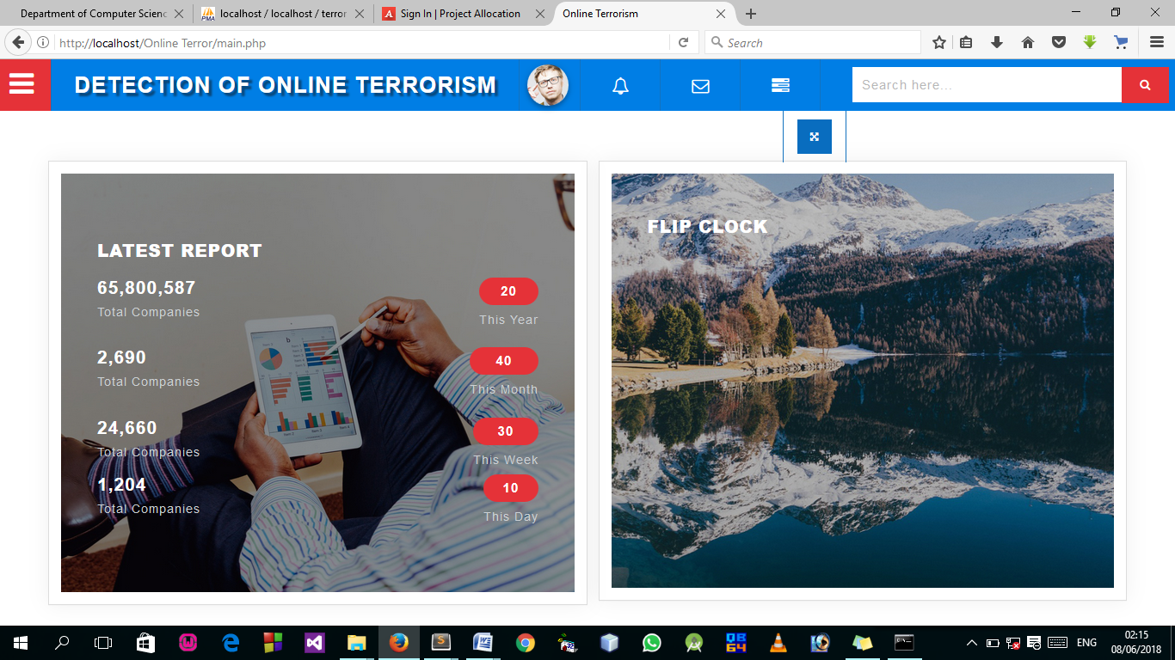Fig 4.1: Index Page
This Page is the welcome page that display the welcome content
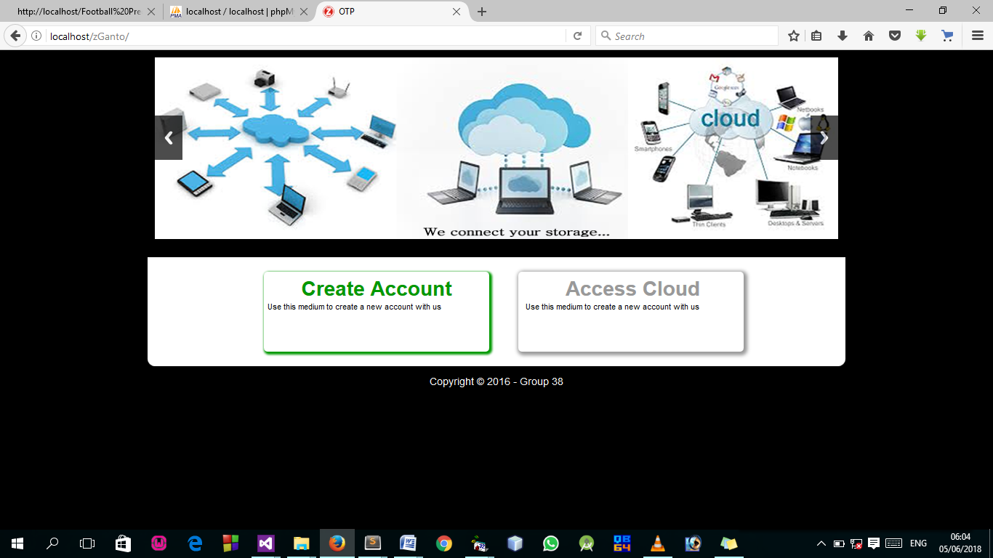Fig 4.2: Index page output design: This is the page for creating account to access local cloud computing.
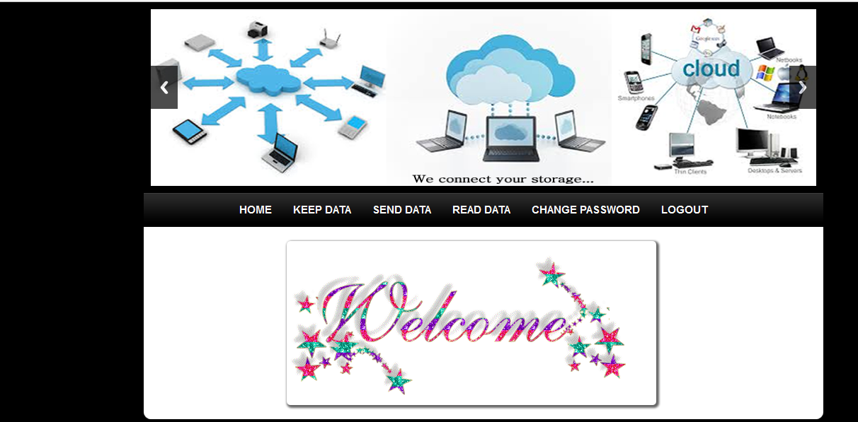
Fig 4.3 User Welcome Page output design: This is the welcome page where icons are selected, a click on any of this icon channel the user to another page.
4.1.2 INPUT DESIGN

It is also necessary to denote that data inputted in the computer for processing determines what the output will be. The inputs are use in collecting information the student through the keyboard. Inputs are necessary information needed for processing so as to produce the expected outputs; which are supplied through the keyboard.
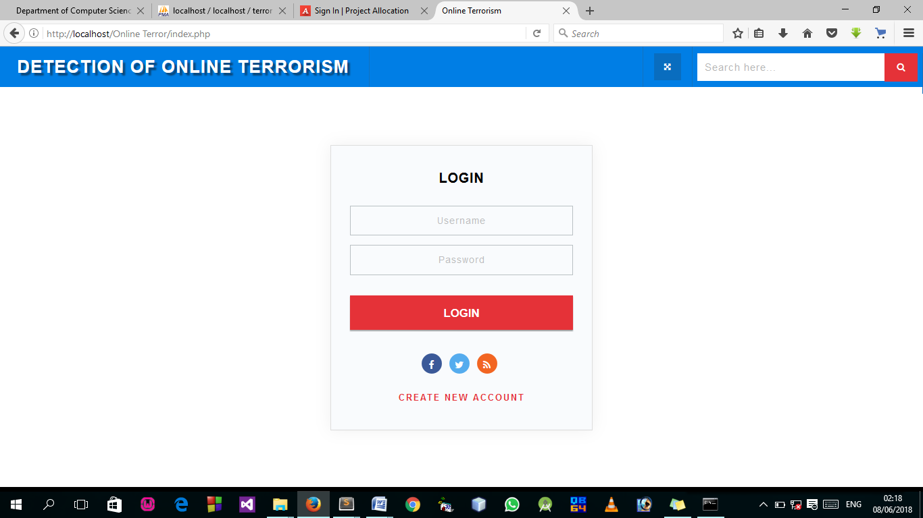
Fig 4.4: Login Page
This Page allow authorized user to log into the system.

Fig 4.5: Sign Up Page
This Page allow user to their details and gain access to the system.
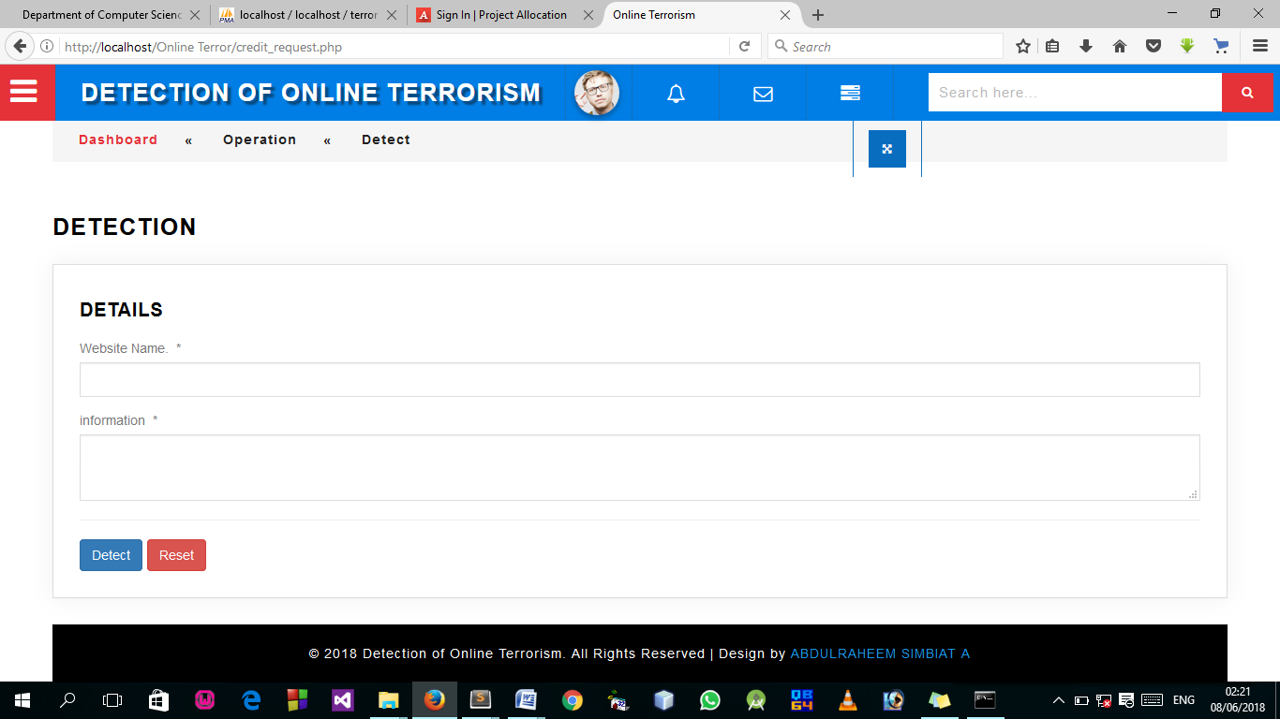
Fig 4.6: Detection Page
This is where the terrorism detection takes place.
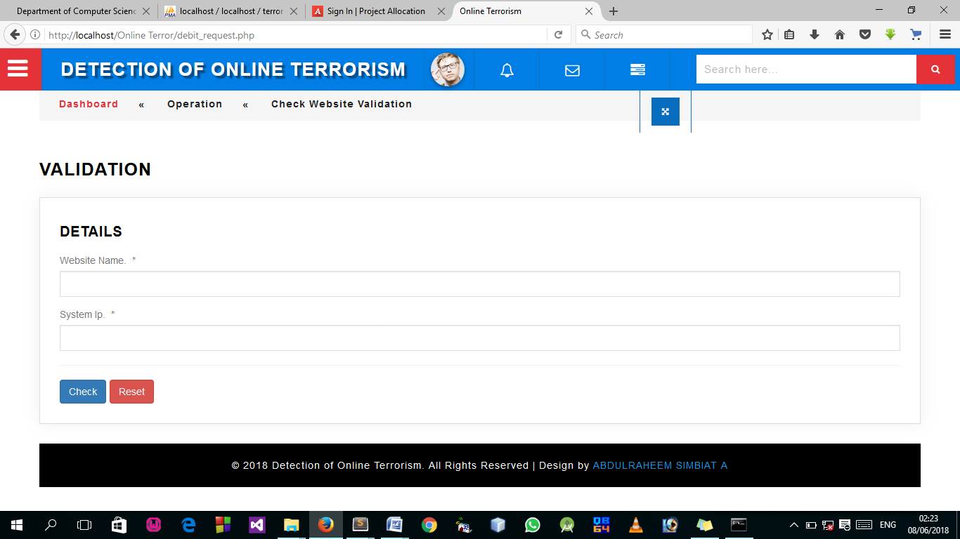
Fig 4.7: Detection Page
This page allow user to check if website is still valid or not.
4.1.3 DATABASE DESIGN
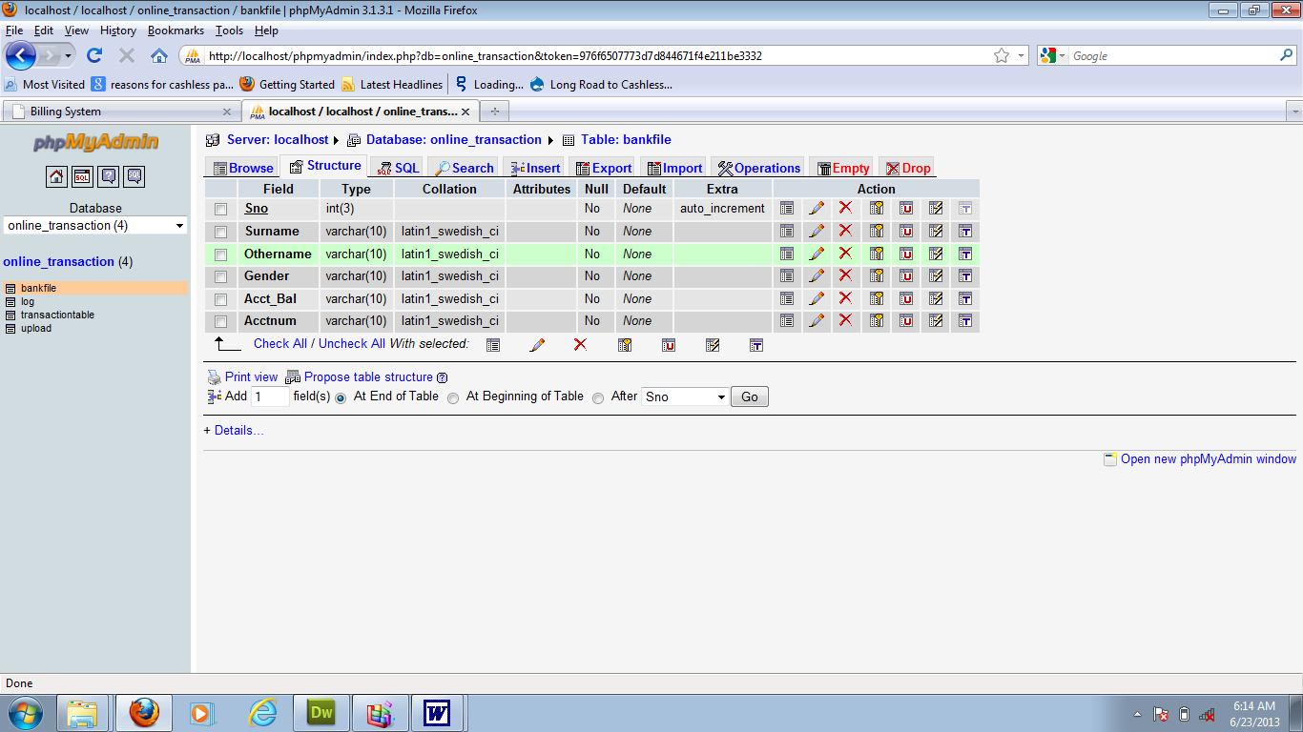
A database table is used for storing information about the files. The database use for this application is mysql database. The files and their respective modes of access as well as information they hold are given below;

Table 4.1: Registration structure
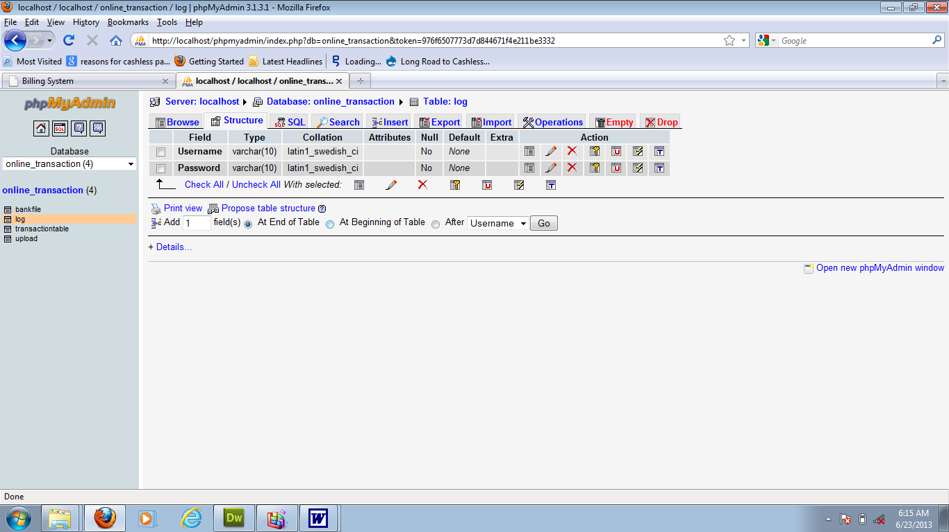
Table 4.2: Admin Login Table structure
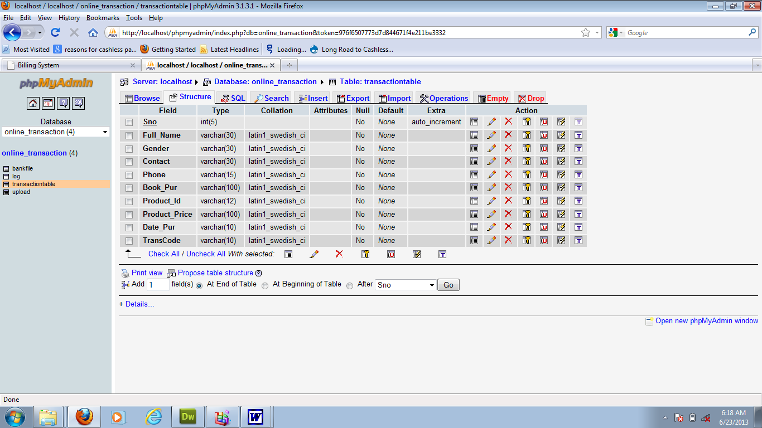
Table 4.3: user Personal Data table
4.1.3 PROCEDURE DESIGN
Procedures are steps which verify the whole process. That is everything put together to produce the desired output. This involves the organization of the source document and end with the output result.
Documents are sent to various departments to be filled by the employees and later returned to the personnel department which are analysed to determine which record goes into the computer.
After selecting the necessary data, this serves as input to the computer system.
4.2 IMPLEMENTATION OF THE SYSTEM
It is always good to develop new ideas, to implement them on a computer and eventually to relish the satisfaction of achieving a successful result. The implementation process involves converting the system design into a complete and tested EDP that is fully operational and that can be used by the system users to meet their business needs. During implementation phase, the hardware and the software must be implemented.
Implementation of a system can be explained in six steps:-
1 Review design specification
2 Code, test and document programs
3 Train users
4 Perform system test
5 Convert to new system
6 Evaluate and maintain the new system
4.2.1 CHOICE OF PROGRAMMING LANGUAGE
The application is designed in Sublime web development package which involves the use of PHP server-side scripting language, MYSQL for database management and HTML (with other embedded functionalities) for the page design and layout settings. Hence, the program testing simply involves running it directly from a Mozilla Firefox web browser on local host server provided by Apache 2.0 inWampServer 2.0 application.
In preparation for the installation of the new system, the method of changeover is given serious consideration to determine the success of the new system. Suitable changeover technique for this system is pilot changeover. The pilot changeover is operated by applying the new system bit-by-bit until it covers the whole of the operations. The result obtained from using the pilot method on a small portion of the operations would be used in determining the suitability of the need system for the rest of the operations. This method is similar to testing small sample of a distribution, if the test yields a good result then the whole system becomes fully operational and the manual/existing system is eliminated.
4.2.2 HARDWARE SUPPORT
- Minimum of Microcomputer Pentium II- Intel 533 MHZ processor, 128 MB RAM, 3.5GB HDD, 3.5”FDD, 14” VGA Monitor Windows 2000 Enhanced keyboard, mouse and pad.
- Scanner
- Printer
- HP DeskJet 3820c series
4.2.3 SOFTWARE SUPPORT
  - Interface Design Language, windows Notepad for help interface design Hypertext Mark-up Language (HTML)
- ii MY SQL Database Management Software
- iii Programming PHP (Hypertext Pre-processor)
- Operating system window 07 professional
- Graphic software paint shop and choosing these two formats GIF (Graphic Image Format)
- Scanner software, Mira scan
- Web browser software MOZILLA

4.3 PROGRAM DOCUMENTATION
4.3.1 OPERATING THE SYSTEM
Step 1: Boot your computer and click on start button on task bar
Step 2: Launch wamp server
Step 3: Login to your Application
Step 4: Click on Options
4.1 Click on Dashboard(to view operations)
4.2 Click on Detect(to Detect online Terrorism)
4.3 Click on Check (to check for website validation)
Step 5: Logout

4.3.3 MAINTAINING THE SYSTEM
The use of the term maintenance for software is different from other references to maintenance. Unlike the tires on your car, software does not “wear out”. If this is the case, then why does software maintenance account for such a high percentage of the Total Cost of Ownership for software?
The software maintenance definition refers to changes for defect correction, performance improvements, or adaptations to a changed environment (enhancements). According to this definition, if we build software that is defect-free, performs well, and contains user-controlled parameters to adjust processing rules in response to changing requirements, then most maintenance would not be necessary.
Why does this happen? There are many reasons but the most common reasons are time constraints and lack of experience. Adding validation logic takes time. So, people make assumptions about the quality of in-bound data. Assumptions are also made about the volume of transactions and the impact on performance and the stability of the automated business processes. Finally, it is common for new software to be developed by younger developers who don’t understand the maintenance impacts of their designs.
The reality is that business requirements change and most of these assumptions are flawed. Transaction volumes increase, changing business processes require new transactions or new validation criteria, and software users will use the software incorrectly. The cost of software maintenance and the total cost of ownership can dramatically be reduced, if developers build software that adjusted to changes in transaction volumes; validated all inbound data and provide user-configurable options for logic decision and data validation.

CHAPTER FIVE
SUMMARY, CONCLUSION AND RECOMMENDATIONS
5.1 SUMMARY
Distributed Denial of Service (DDoS) attacks are a serious threat to Cloud. These attacks consume large amount of resources and increase the service usage cost by a signiﬁcant factor. Due to multi-tenancy and self-provisioning properties of Cloud, traditional DDoS detection techniques cannot be directly applied. Hence, there is a need for Cloud-speciﬁc DDoS detection framework. In this paper, a statistical and distributed network packet ﬁltering model is proposed against DDoS attacks in Cloud. The key idea of this scheme is to distribute multiple packet ﬁlters among individual virtual machines, which generate and share collective proﬁle of normal behaviour with a coordinator node at constant intervals. Statistics of selected network attributes construct the normal behaviour proﬁle. Based on the deviation from normal behaviour a decision is made whether to accept or reject the incoming packet. The coordinator node monitors ﬁlter and distribute the averaged proﬁle to newly provisioned nodes. Individual proﬁles have low memory and storage requirements and are updated dynamically. Simulation study indicates the effectiveness of this scheme in detecting DDoS attacks in Cloud.

5.2 CONCLUSION
This project proposed a statistical and distributed packet ﬁltering algorithm and framework for detection of DDoS attacks in Cloud. This scheme is able to handle DDoS attacks with high accuracy and high detection rate. While statistical approach of this model provides high speed of detection, distributed nature of ﬁltering scheme improves scalability and ﬂexibility. Robustness is ensured by using a coordinator node, which constantly monitors other nodes. Performance of the proposed method is evaluated using the dataset and in Cloud. This packet ﬁltering model is able to detect attacks from outside as well as from one tenant to another in the Cloud. All these features and its real-time detection ability make this scheme suitable for defence against DDoS attacks in Cloud environment.

5.3 RECOMMENDATIONS
It is recommended the new system to any organization or enterprises to implement the system to their day to day basis for the effective secured of transfer of data.
For Federal information systems and those operated on behalf of the US Government, the Federal Information Security Management Act (FISMA) of 2002 and the associated NIST standards and special publications (e.g. FIPS 199, FIPS 200, SP 800-53 etc.) do apply to cloud systems. In the context of cloud computing, the following are additional general recommendations, broken into five groups for readability: Management, Data Governance, Security and Reliability, Virtual Machines, and Software and Applications.

REFERENCES
Al-Duwairi, B. et al., (2020). SIEM-based detection and mitigation of IoT-botnet DDoS attacks. International Journal of Electrical and Computer Engineering, 10(2), 2182–2191. https://doi.org/10.11591/ijece.v10i2.pp2182-2191
Bhardwaj, K., et al., (n.d.). Towards IoT-DDoS Prevention Using Edge Computing.
Galeano-Brajones, J., et al (2020a). Detection and mitigation of DoS and DDoS attacks in iot-based stateful SDN: An experimental approach. Sensors (Switzerland), 20(3). https://doi.org/10.3390/s20030816
Galeano-Brajones, J., et al (2020b). Detection and mitigation of DoS and DDoS attacks in iot-based stateful SDN: An experimental approach. Sensors (Switzerland), 20(3). https://doi.org/10.3390/s20030816
Lee, S. H., et al., (2022). Detection and Prevention of DDoS Attacks on the IoT. Applied Sciences (Switzerland), 12(23). https://doi.org/10.3390/app122312407
Lima Filho, F. S. et al., (2019). Smart Detection: An Online Approach for DoS/DDoS Attack Detection Using Machine Learning. Security and Communication Networks, 2019. https://doi.org/10.1155/2019/1574749
Abdelwahab, O. F., et al., (2021). Efficient Combination of RSA Cryptography, Lossy, and Lossless Compression Steganography Techniques to Hide Data. Procedia Computer Science, 182, 5–12. https://doi.org/10.1016/j.procs.2021.02.002
Adam, K. et al., (2021). The impact of the soft errors in convolutional neural network on GPUS: Alexnet as case study. Procedia Computer Science, 182, 89 94. https://doi.org/10.1016/j.procs.2021.02.012
Alotaibi, D. (2021). Survey on Network Slice Isolation in 5G Networks: Fundamental Challenges. Procedia Computer Science, 182, 38–45. https://doi.org/10.1016/j.procs.2021.02.006
Basori, A. H., et al., (2021). Intelligent socio-emotional control of pedestrian crowd behavior inside smart city. Procedia Computer Science, 182, 80–88. https://doi.org/10.1016/j.procs.2021.02.011
Boughaci, D. (2021). Solving optimization problems in the fifth generation of cellular networks by using meta-heuristics approaches. Procedia Computer Science, 182, 56–62. https://doi.org/10.1016/j.procs.2021.02.008
El-Ganiny, M. Y. et al., (2021). A preamble based channel estimation methods for FBMC waveform: A comparative study. Procedia Computer Science, 182, 63–70. https://doi.org/10.1016/j.procs.2021.02.009
Faisal, A. et al., (2021). Diversity Schemes in Multi-hop Visible Light Communications for 6G Networks. Procedia Computer Science, 182, 140–149. https://doi.org/10.1016/j.procs.2021.02.019
Gaber, L., et al., (2021). Fast auto-correction algorithm for digital VLSI Circuits. Procedia Computer Science, 182, 95–102. https://doi.org/10.1016/j.procs.2021.02.013

PROGRAM SOURCE CODE

<!DOCTYPE html>
<html lang="en">
<head>
<title>CEE LOGIN</title>
<meta charset="UTF-8">
<meta name="viewport" content="width=device-width, initial-scale=1">
<link rel="icon" type="login-ui/image/png" href="images/icons/favicon.ico"/>
<link rel="stylesheet" type="text/css" href="login-ui/vendor/bootstrap/css/bootstrap.min.css">
<link rel="stylesheet" type="text/css" href="login-ui/fonts/font-awesome-4.7.0/css/font-awesome.min.css">
<link rel="stylesheet" type="text/css" href="login-ui/fonts/Linearicons-Free-v1.0.0/icon-font.min.css">
<link rel="stylesheet" type="text/css" href="login-ui/vendor/animate/animate.css">
<link rel="stylesheet" type="text/css" href="login-ui/vendor/css-hamburgers/hamburgers.min.css">
<link rel="stylesheet" type="text/css" href="login-ui/vendor/select2/select2.min.css">
<link rel="stylesheet" type="text/css" href="login-ui/vendor/daterangepicker/daterangepicker.css">
<link rel="stylesheet" type="text/css" href="login-ui/css/util.css">
<link rel="stylesheet" type="text/css" href="login-ui/css/main.css">
</head>
<body>
<div class="limiter">
<div class="container-login100" style="background-image: url(login-ui/images/bg-01.jpg);">
<div class="wrap-login100">
<div class="login100-form-title" style="background-image: url(login-ui/images/bg-01.jpg);">
<span class="login100-form-title-1"> COMPUTER BASED TEST (CBT) EXERCISE </span>
</div>
<form method="post" id="examineeLoginFrm" class="login100-form validate-form">
<div class="wrap-input100 validate-input m-b-26" data-validate="Username is required"> <span class="label-input100">Matric No.</span>
<input class="input100" type="text" name="username" placeholder="Enter your Matric Number">
<span class="focus-input100"></span>
</div>
<div class="wrap-input100 validate-input m-b-18" data-validate = "Password is required">
<span class="label-input100">Password (Surname)</span>
<input class="input100" type="password" name="pass" placeholder="Enter password">
<span class="focus-input100"></span>
</div>
<div class="container-login100-form-btn" align="right">
<button type="submit" class="login100-form-btn"> Login </button>
</div>
</form>
marquee behavior='scroll' bgcolor="#008000"><h3> <font color='#FFFFFF'> Designed by HND 2 (2020/2021 Academic Session) Computer Science Department CBT Group Member</font></h3></marquee>
</div>
</div>
</div>
<script src="login-ui/vendor/jquery/jquery-3.2.1.min.js"></script>
<script src="login-ui/vendor/animsition/js/animsition.min.js"></script>
<script src="login-ui/vendor/bootstrap/js/popper.js"></script>
<script src="login-ui/vendor/bootstrap/js/bootstrap.min.js"></script>
<script src="login-ui/js/main.js"></script>

</body>
</html>

<script type="text/javascript" >
function preventBack(){window.history.forward();}
setTimeout("preventBack()", 0);
window.onunload=function(){null};
</script>
<?php
$examId = $_GET['id'];
$selExam = $conn->query("SELECT * FROM exam_tbl WHERE ex_id='$examId' ")->fetch(PDO::FETCH_ASSOC);
$selExamTimeLimit = $selExam['ex_time_limit'];
$exDisplayLimit = $selExam['ex_questlimit_display'];
?>
<div class="app-main__outer">
<div class="app-main__inner">
<div class="col-md-12">
<div class="app-page-title">
<div class="page-title-wrapper">
<div class="page-title-heading">
<div>
<?php echo $selExam['ex_title']; ?>
<div class="page-title-subheading">
<?php echo $selExam['ex_description']; ?>
</div>
</div>
</div>
<div class="page-title-actions mr-5" style="font-size: 20px;">
<form name="cd">
<input type="hidden" name="" id="timeExamLimit" value="<?php echo $selExamTimeLimit; ?>">
<label>Remaining Time : </label>
<input style="border:none;background-color: transparent;color:blue;font-size: 25px;" name="disp" type="text" class="clock" id="txt" value="00:00" size="5" readonly="true" />
</form>
</div>
</div>
</div>
</div>
<div class="col-md-12 p-0 mb-4">
<form method="post" id="submitAnswerFrm">
<input type="hidden" name="exam_id" id="exam_id" value="<?php echo $examId; ?>">
<input type="hidden" name="examAction" id="examAction" >
<table class="align-middle mb-0 table table-borderless table-striped table-hover" id="tableList">
<?php
$selQuest = $conn->query("SELECT * FROM exam_question_tbl WHERE exam_id='$examId' ORDER BY rand() LIMIT $exDisplayLimit ");
if($selQuest->rowCount() > 0)
{
$i = 1;
while ($selQuestRow = $selQuest->fetch(PDO::FETCH_ASSOC)) { ?>
<?php $questId = $selQuestRow['eqt_id']; ?>
<tr>
<td>
<p><b><?php echo $i++ ; ?> .) <?php echo $selQuestRow['exam_question']; ?></b></p>
<div class="col-md-4 float-left">
<div class="form-group pl-4 ">
<input name="answer[<?php echo $questId; ?>][correct]" value="<?php echo $selQuestRow['exam_ch1']; ?>" class="form-check-input" type="radio" value="" id="invalidCheck" >

<label class="form-check-label" for="invalidCheck">
<?php echo $selQuestRow['exam_ch1']; ?>
</label>
</div>
<div class="form-group pl-4">
<input name="answer[<?php echo $questId; ?>][correct]" value="<?php echo $selQuestRow['exam_ch2']; ?>" class="form-check-input" type="radio" value="" id="invalidCheck" >
<label class="form-check-label" for="invalidCheck">
<?php echo $selQuestRow['exam_ch2']; ?>
</label>
</div>
</div>
<div class="col-md-8 float-left">
<div class="form-group pl-4">
<input name="answer[<?php echo $questId; ?>][correct]" value="<?php echo $selQuestRow['exam_ch3']; ?>" class="form-check-input" type="radio" value="" id="invalidCheck" >
<label class="form-check-label" for="invalidCheck">
<?php echo $selQuestRow['exam_ch3']; ?>
</label>
</div>
<div class="form-group pl-4">
<input name="answer[<?php echo $questId; ?>][correct]" value="<?php echo $selQuestRow['exam_ch4']; ?>" class="form-check-input" type="radio" value="" id="invalidCheck" >
<label class="form-check-label" for="invalidCheck">
<?php echo $selQuestRow['exam_ch4']; ?>
</label>
</div>
</div>
</div>
</td>
</tr>
<?php }
?>
<tr>
<td style="padding: 20px;">
<input name="submit" type="submit" value="Submit" class="btn btn-xlg btn-primary p-3 pl-4 pr-4 float-right" >
</td>
</tr>
<?php
}
else
{ ?>
<b>No question at this moment</b>
<?php }
?>
</table>
</form>
</div>
</div>

<div class="app-main__outer">
<div class="app-main__inner">

<?php
@$exam_id = $_GET['exam_id'];

if($exam_id != "")
{
$selEx = $conn->query("SELECT * FROM exam_tbl WHERE ex_id='$exam_id' ")->fetch(PDO::FETCH_ASSOC);
$exam_course = $selEx['dept_id'];
$exmneLevel = $selEx['exmne_year_level'];

$selExmne = $conn->query("SELECT * FROM examinee_tbl et WHERE department='$exam_course'AND exmne_year_level='$exmneLevel' ORDER BY matric_no ASC");
?>
<div class="app-page-title">
<div class="page-title-wrapper">
<div class="page-title-heading">
<div><b class="text-primary">STUDENT'S RESULT</b><br>
<!-- <span class="border" style="padding:10px;color:black;background-color: yellow;">Excellence</span>
<span class="border" style="padding:10px;color:white;background-color: green;">Very Good</span>
<span class="border" style="padding:10px;color:white;background-color: blue;">Good</span>
<span class="border" style="padding:10px;color:white;background-color: red;">Failed</span>
<span class="border" style="padding:10px;color:black;background-color: #E9ECEE;">Not Answering</span> -->
</div>
</div>
</div>
</div>

<div class="col-md-12">
<div class="main-card mb-3 card">

<div class="content-header">

<div class="card-header">
<?php echo $selEx['ex_title']; ?> : <?php echo $selEx['ex_description']; ?>

</div>

<div class="right-title">

<a href="export.php?exam_id=<?=$exam_id;?>" class="btn btn-rounde btn-sm btn-info" style="float:right;"> Write to CSV</a>

</div>

</div>

<div class="table-responsive">
<table class="align-middle mb-0 table table-borderless table-striped table-hover" id="tableList">
<thead>
<tr>
<th width="50%">Matric Number</th>
<th>Score</th>
<th>Grade</th>
</tr>
</thead>
<tbody>
<?php
while ($selExmneRow = $selExmne->fetch(PDO::FETCH_ASSOC)) { ?>
<?php
$exmneId = $selExmneRow['exmne_id'];
$selScore = $conn->query("SELECT * FROM exam_question_tbl eqt INNER JOIN exam_answers ea ON eqt.eqt_id = ea.quest_id AND eqt.exam_answer = ea.exans_answer WHERE ea.axmne_id='$exmneId' AND ea.exam_id='$exam_id' AND ea.exans_status='new' ORDER BY ea.exans_id DESC");
$selAttempt = $conn->query("SELECT * FROM exam_attempt WHERE exmne_id='$exmneId' AND exam_id='$exam_id' ");
$over = $selEx['ex_questlimit_display'] ;
@$score = $selScore->rowCount();

