DESIGN AND IMPLEMENTATION OF LOAN CREDIBILITY PREDICTION SYSTEM USING DECISION TREE ALGORITHM
BY
OLANIBA KHADIJAT TOBILOBA
HND/23/COM/FT/0206

SUBMITTED TO THE DEPARTMENT OF COMPUTER SCIENCE, INSTITUTE OF INFORMATION AND COMMUNICATION TECHNOLOGY
KWARA STATE POLYTECHNIC, ILORIN.

IN PARTIAL FULFILLMENT OF THE REQUIREMENTS FOR THE AWARD OF HOGHER NATIONAL DIPLOMA (HND) IN
COMPUTER SCIENCE

JUNE, 2025.
DEDICATION
I dedicate this project work to Almighty God who inspired me and directed my ways during my academic stay in the polytechnic.

.

ACKNOWLEDGEMENT
I give thanks to Almighty God for granting me success for the completion of my programme.
My utmost appreciation goes to my able supervisor Mr Bolaji-Adetoro D.F. for her motherly support and her moral advice throughout this project. My profound appreciation goes to the Head of Department (H.O.D) Mr Oyedepo F.S. for his fatherly support and also my gratitude goes to my lecturers Mr. Sidiq, Mr. Oyedepo, Mr. Olajide, Dr. Mrs. Dada, Mrs. Akanbi and all the staff of the Computer Science department both teaching and non-teaching staff.

Abstract
With the enhancement in the banking sector lots of people are applying for bank loans but the bank has its limited assets which it has to grant to limited people only, so finding out to whom the loan can be granted which will be a safer option for the bank is a typical process. So in this paper, I try to reduce this risk factor behind selecting the safe person so as to save lots of bank efforts and assets. This is done by mining the Big Data of the previous records of the people to whom the loan was granted before and on the basis of these records/experiences the machine was trained using the machine learning model which give the most accurate result. The main objective of this paper is to predict whether assigning the loan to particular person will be safe or not. This paper is divided into four sections (i)Data Collection (ii) Comparison of machine learning models on collected data (iii) Training of system on most promising model (iv) Testing

TABLE OF CONTENTS
Title page i
Certification ii
Dedication iii
Acknowledgement iv
Abstract v
Table of contents vi
CHAPTER ONE: GENERAL INTRODUCTION
1.1 Background of the Study 1
1.2 Statement of the Problem 2
1.3 Aim and Objectives of the Study 3
1.4 Significance of the Study 3
1.5 Scope of the Study 3
1.6 Organization of the Study 3
1.7 Definition of Terms 4
CHAPTER TWO: REVIEW OF RELATED PAST WORK
2.1 Review of Related Works 5
2.2 Loan System Creditability Prediction System using Decision Tree Algorithm 8
CHAPTER THREE: RESEARCH METHODOLOGY AND ANALYSIS OF THE SYSTEM
  - Decision Tree Algorithm 9
  - Analysis of the Existing System 14
  - Problems of the Existing System 14
  - Analysis of the Proposed System 15
  - Advantage of the New System Over the Existing System 18

CHAPTER FOUR: DESIGN IMPLEMENTATION AND DOCUMENTATION OF THE SYSTEM
4.1 Design of the System 19
4.1.1 Output Design 19
4.1.2 Input Design 21
    - Database Design 22
    - Procedure Design 23
4.2 Implementation of the System 24
4.2.1 Choice of Programming Language 24
4.2.2 Hardware Support 25
4.2.3 Software Support 25
4.3 Program Documentation 26
4.3.1 Operation the System 26
4.3.2 Maintaining the System 26
CHAPTER FIVE: SUMMARY, CONCLUSION AND RECOMMENDATION
5.1 Summary 28
5.2 Conclusion 28
5.3 Recommendation 29
References
APPENDICES
Program Flowchart of the proposed system
Source program listing

CHAPTER ONE
GENERAL INTRODUCTION
1.0 BACKGROUND TO THE STUDY
Nowadays, Banks struggle a lot to get an upper hand over each other to enhance overall business due to tight competition. Banks have realized that retaining the customers and preventing fraud must be the strategy tool for healthy competition. Availability of the huge quantity of data, creation of knowledge base and efficient utilization of the same have helped banks to open up efficient delivery channels. Business decisions can be optimized through data mining. Customer segmentation, banking profitability, credit scoring and approval, predicting payment from customers, marketing, detecting fraud transactions, cash management and forecasting operations, optimizing stock portfolios and ranking investments are some of the areas where data mining techniques can be used in the banking industry (Dileep and Kulkarni, 2021).
Credit risks which account for the risk of loss and loan defaults are the major source of risk encountered by banking industry. Data mining techniques like classification and prediction can be applied to overcome this to a great extent. There are mainly two objectives that is to be achieved through these techniques. They are: i. Identification of the relevant attributes that signal the capacity of borrowers to pay back the loan ii. Determining the best model(s) to evaluate credit risk. Decision Tree Induction Algorithm is one of the best techniques to achieve this objective. The model thus developed will provide a better credit risk assessment, which will potentially lead to a better allocation of the bank’s capital, (Gerritsen, 2020).
Lack of planning and control of cash resources is the reason often given for the failure of many businesses. However, good forecasting can help to meet set goals. Faced with intense competition and rising demand for loans by borrowers, most banks are exploring ways to use their data assets to gain a competitive advantage over others. The business of lending is gradually becoming a major target for many banks; as a result, there is high competition among the financial institutions in this regard. With the increasing economic globalization and improvements in information technology, large amounts of financial data are being generated, stored and analyzed, and in the light of changing business environments, managers are seeing the need for more flexible predictive models. Financial forecasting describes the process by which firms plan and prepare for the future. The forecasting process provides the means to express its goals and priorities and to ensure that they are internally consistent. It also assists the firm in identifying the asset requirements and needs for external financing. (Etemadi et al, 2020).
1.2 STATEMENTS OF THE PROBLEM
There are numerous areas in which data mining can be used in the banking industry to support customer relationships management. Data mining technique will help to distinguish borrowers who repay loans promptly from those who do not. It also helps to predict the credit worthiness of borrower by analyzing the behavior and reliability of the customers. With data mining techniques, banks can do a thorough profiling and ranking of their branches with respect to loan fraud risk. In developing countries like India, Bankers face more problems with the fraudsters. Using data mining technique, it is simple to build a successful predictive model and visualize the report into meaningful information to the user. Data mining can be applied to reduce the risk associated with lending due to fraud as well as find an appropriate solution to the borrower’s need for funds, with proper assessment of risk and the inclusion of sufficient control systems to ensure repayment. Loan officers are tasked with entering borrower’s credit data while the system does risk computation and sends the result to the database for approval decision by loan committee at head office. The decision is sent to loan database which is then assessed by the loan officer.

1.3 AIM AND OBJECTIVES
The aim of this research work is to develop a Loan Creditability Prediction System using Decision Tree Algorithm. The objectives are as follows:
- To develop a system that identify relevant attributes that signal the capacity of borrowers to pay back the loan.
- determine the best model(s) to evaluate credit risk.
- implement the system in C# as the programming language.

1.4 SIGNIFICANCE OF THE STUDY
The main importance of this system is that it helps financial institutions to recognize the importance of the information it has about its customers . Also, it helps to find patterns that distinguish borrowers who repay promptly from those who don’t. This system helps to get rid of credit risks which account for the risk of loss and loan defaults which are the major source of risk encountered by banking industry.
1.5 SCOPE AND LIMITATION OF THE STUDY
The scope of this study focuses mainly on the development of a Loan Creditability Prediction System using Decision Tree Algorithm. It does not go beyond this.
1.6 ORGANISATION OF REPORT
This report is divided to five chapters as stated below. Chapter one deals with the general introduction and overview of the whole research. It also discusses the statement of the problem, aim and objectives of the proposed system, significance of the study, scope and limitations of the project as well as organization of the report.
Chapter two deals with the literature review, it reviews the related topics to the project, discussion of related aspect of the project topic relative to computer technology is also treated.
Chapter three deals with analysis of the system which include the data collection method employed, the description of the existing system and its problems and the description of the proposed system and possible advantages it will provide the will solve problems encountered in the existing manual system.
While chapter four deals with the design, implementation and the description of the proposed system. It also covers description of the output design, input design, database design and procedure design. The implementation techniques used, the programming language used in developing the new system and system requirements for running the system. And it talks about the program documentation as well user documentation.
Finally, chapter five presents a brief summary of the work done, experience gained and problems encountered in the course of the project, conclusion and recommendation.
1.7 DEFINITION OF TERMS
Loan: A thing that is borrowed, especially a sum of money that is expected to be paid back with interest.
Creditability: The quality of being creditable.
Prediction: A thing predicted; a forecast.
Algorithm: A process or set of rules to be followed in calculations or other problem-solving operations, especially by a computer.
Decision Tree: A decision tree is a flowchart-like structure in which each internal node represents a "test" on an attribute (e.g. whether a coin flip comes up heads or tails), each branch represents the outcome of the test, and each leaf node represents a class label (decision taken after computing all attributes).
CHAPTER TWO
LITERATURE REVIEW
2.1 REVIEW OF RELATED WORKS
Sudhamathy and Jothi, (2020) the author introduces a framework to effectively identify the Probability of Default of a Bank Loan applicant. The metrics derived from the predictions reveal the high accuracy and precision of the built model. The model proposed an effective prediction model for predicting the credible customers who have applied for bank loan. Decision Tree is applied to predict the attributes relevant for credibility. This prototype model can be used to sanction the loan request of the customers or not. The model proposed has been built using data from banking sector to predict the status of loans. This model uses three classification algorithms namely j48, bayes Net and naïve Bayes. The model is implemented and verified using Weka. The best algorithm j48 was selected based on accuracy. An improved Risk prediction clustering Algorithm that is Multi-dimensional is implemented in to determine bad loan applicants. In this work, the Primary and Secondary Levels of Risk assessments are used and to avoid redundancy, Association Rule is integrated. A decision tree model was used as a classifier and for feature selection genetic algorithm is used. The model was tested using Weka. The work developed two data mining models for credit scoring that helps in decision making of giving loans for the banks in Jordan. Considering the rate of accuracy, the regression model is found to perform better than radial function model.
Lara and Rayo, (2020) develops many credit scoring models that are based on the multilayer approach. The work proves its performance than the other models that uses logistic regression techniques. The results show that the neural network model performs better than the other three techniques. The work compares support vector machine based models for credit-scoring developed using the various default definitions. The work concluded that the broad definition models are better than the narrow definition models in their performance. Financial data analysis is done susing the techniques such as Decision Tree, Random forest, Boosting, Bayes classification, Bagging algorithm and others. Support Vector Machine, Decision Tree, Logistic Regression, Neural Network, Perceptron model, all these techniques are combined in this model. The effectiveness of applying the above techniques on credit scoring is studied. The analysis results show the performance is outstanding based on accuracy. The aim of the study is to introduce a discrete survival model to study the risk of default and to provide the experimental evidence using the Italian banking system.
Soni and Varghese (2021) wrote an article on “Algorithm For the Loan Credibility Prediction System” Now a day’s people approach or select bank loans to fulfill their needs, which are very common. This practice has been increasing day by day especially for business, education, marriage, agriculture as well. But several people take advantage and misuse the facilities given by the bank. With technology developing at such a peak stage in these days, data mining plays a key role in computer science to solve such issues. Classification is the most suitable predictive modeling technique in data mining to predict the loan repayment capability of a customer in a banking industry. There are various methods to improve the accuracy of a classification algorithm. The accuracy of random forest classification algorithm can be improved using Ensemble methods, Optimization techniques and Feature selection. Various feature selection methods are available. In this research work a novel hybrid feature selection algorithm using wrapper model and fisher score is introduced. The main objective of this paper is to prove that new hybrid model produces better accuracy than the traditional random forest algorithm. This paper also compares the result obtained from other classification methods and feature selection methods to prove that proposed algorithm produces better classification accuracy. The experiments were being done using tools such as weka, R, and python programming. This research aims at introducing a new technique which can increase the progress of banking sector. The accuracy level of this new algorithm in finding the potential of the customer is much higher than the data mining classification algorithm and thus it proves to be very helpful for bank officers
Semiu and Akanmu (2021) wrote an article “A Boosted Decision Tree Model for Predicting Loan Default in P2P Lending Communities” Loan Default Prediction For Social Lending Is An Emerging Area Of Research In Predictive Analytics. The Need For Large Amount Of Data And Few Available Studies In The Current Loan Default Prediction Models For Social Lending Suggest That Other Viable And Easily Implementable Models Should Be Investigated And Developed. In View Of This, This Study Developed A Data Mining Model For Predicting Loan Default Among Social Lending Patrons, Specifically The Small Business Owners, Using Boosted Decision Tree Model. The United States Small Business Administration (Usba) PubliclyAvailable Loan Administration Dataset Of 27 Features And 899164 Data Instances Was Used In 80:20 Ratios For The Training And Testing Of The Model. 16 Data Features Were Finally Used As Predictors After Data Cleaning And Feature Engineering. The Gradient Boosting Decision Tree Classifier Recorded 99% Accuracy Compared To The Basic Decision Tree Classifier Of 98%. The Model Is Further Evaluated With (A) Receiver Operating Characteristics (Roc) And Area Under Curve (Auc), (B) Cumulative Accuracy Profile (Cap), And (C) Cumulative Accuracy Profile (Cap) Under Auc. Each Of These Model Performance Evaluation Metrics, Especially Roc-Auc, Showed The Relationship Between The True Positives And False Positives That Implies The Model Is A Good Fit.
Sivasree and Rekha (2020) wrote an article on “Loan Credibility Prediction System Based on Decision Tree Algorithm” Data mining techniques are becoming very popular nowadays because of the wide availability of huge quantity of data and the need for transforming such data into knowledge. Techniques of data mining are implemented in various domains such as retail industry, telecommunication industry, biological data analysis, intrusion detection and other scientific applications. Data mining techniques can also be used in the banking industry which help them compete in the market well equipped. In this paper we introduce an effective prediction model for the bankers that help them predict the credible customers who have applied for loan. Decision Tree Induction Data Mining Algorithm is applied to predict the attributes relevant for credibility. A prototype of the model is described in this paper which can be used by the organizations in making the right decision to approve or reject the loan request of the customers.
Nirmala, et al (2021), wrote an article on “Online Loan Application and Verification for Personal Loan” Online loan application is a project developed to provide an easy way to apply loan. Users can get information about applying loan and can apply online. By using this application user’s can save lot of time. Users need to fill the details of identity cards like PAN and bank account details. All the user’s details will be verified by the bank authority and status of loan. User can get notification regarding loan whether approved or rejected. Users can download the details of the loan after approved. User can apply get all the information about the loan from anywhere and at anytime.
Antim, et al (2020), wrote an article on “Loan Management System” LOAN MANAGEMENT SYSTEM is a very efficient process to handle all loan related transaction in a very accurate and convenient way. It is very helpful for those banking staffs who are in the charge of loan management, it provides a very reliable and convenient form for every loan and emi related transaction and their related details. It also generates a very customer friendly and understandable form for their transaction information as the receive form after a transaction which contains all the information related to next emi date, remaining amount etc.
Ugwu, Offoh, and Musa (2020), wrote an article on “An improved model for financial institutions loan management system” The inability of financial instructions, especially the Microfinance Banks, to forecast for the need of borrowers in order to make provision for them has been a cause for concern. Applications are made and most times the reply is that funds are not available. This paper demonstrated the design and implementation of neural network model for development of an improved loan-based application management system. The back propagation algorithm was used to train the neural network model to ascertain corrections between the data and to obtain the threshold value. The data was collected over a period of three years from UCL machine learning repository. The system was designed using object oriented methodology and implemented with Java programming language and MATLAB. The results obtained showed the mean squared error values 1.09104e-12, 5.56228e-9 and 5.564314e-4 for the training, testing and validation respectively. It was seen from the result that neural network can forecast the financial market with minimum
2.2 LOAN SYSTEM CREDITABILITY PREDICTION SYSTEM USING DECISION TREE ALGORITHM
A. Data Mining
Data mining is the process of analyzing data from different perspectives and extracting useful knowledge from it. It is the core of knowledge discovery process. The various steps involved in extracting knowledge from raw data as depicted in figure-1. Different data mining techniques include classification, clustering, association rule mining, prediction and sequential patterns, neural networks, regression etc. Classification is the most commonly applied data mining technique, which employs a set of pre-classified examples to develop a model that can classify the population of records at large. Fraud detection and credit risk applications are particularly well suited to classification technique. This approach frequently employs Decision Tree based Classification Algorithms. In classification, a training set is used to build the model as the classifier which can classify the data items into its appropriate classes. A test set is used to validate the model.
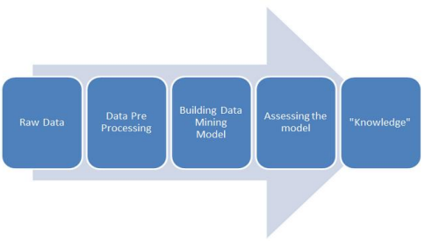
Figure 2.1: Steps in Knowledge Extraction
A Decision Tree is a structure that includes a root node, branches, and leaf nodes. Each internal node denotes a test on an attribute, each branch denotes the outcome of a test, and each leaf node holds a class label. The topmost node in the tree is the root node. An example of Decision Tree is depicted in figure2.

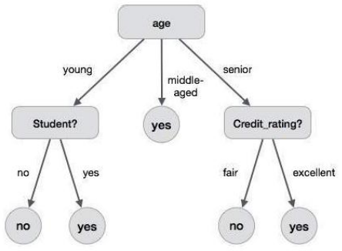
Figure 2.2: Decision Tree Induction

B. Data Mining in Banking
Due to tremendous growth in data the banking industry deals with, analysis and transformation of the data into useful knowledge has become a task beyond human ability. Data mining techniques can be adopted in solving business problems by finding patterns, associations and correlations which are hidden in the business information stored in the data bases (Bharati, 2018). By using data mining techniques to analyze patterns and trends, bank executives can predict, with increased accuracy, how customers will react to adjustments in interest rates, which customers are likely to accept new product offers, which customers will be at a higher risk for defaulting on a loan, and how to make customer relationships more profitable. Globalization and the stiff competition had led the banks focus towards customer retention and fraud prevention. To help them for the same, data mining is used. By analyzing the past data, data mining can help banks to predict credible customers. Thus they can prevent frauds, they can also plan for launching different special offers to retain those customers who are credible. Certain areas that effectively utilize data mining in banking industry are marketing, risk management and customer relationship management.
Marketing: It is one of the most widely used areas of data mining in the banking industry. The consumer behavior with reference to product, price and distribution channel can be analyzed by the marketing department. The reaction of the customers to the existing and new products can also be known. This information can be used by the banks to promote the products, improve quality of products and services, and gain competitive advantages. Bank analysts can also analyze the past trends, determine the present demands and forecast the customer behavior of various products and services, in order to grab more business opportunities.
Risk Management: It is widely used for managing risks in the banking industry. Bank executives need to know the credibility of customers they are dealing with. Offering new customers credit cards, extending existing customers’ lines of credit, and approving loans can be risky decisions for banks, if they do not know anything about their customers. Banks provide loans to their customers by verifying the various details relating to the loan, such as amount of loan, lending rate, repayment period etc. Even though, banks are cautious while providing loan, there are chances of loan repaying defaults by customers. Data mining technique helps to distinguish borrowers who repay loans promptly from those who default.
Customer Relationship Management: Data mining can be useful in all the three phases of a customer relationship cycle such as customer acquisition, increasing value of the customer and customer retention. Customer acquisition and retention are very important concerns of any industry, especially the banking industry. Banks have to cater the needs of the customers by providing the services they prefer. This will ultimately lead to customer loyalty and customer retention. Data mining techniques help to analyze the customers who are loyal from those who shift to other banks for better services. If the customer is shifting from his bank to another, reasons for such shifting and the last transaction performed before shifting can be known, and this will help the banks to perform better and retain their customers.

CHAPTER THREE
RESEARCH METHODOLOGY AND ANALYSIS OF THE SYSTEM
3.1 DECISION TREE ALGORITHM
The reference model for our work is cross-industry standard process for data mining (CRISP-DM) fig 3.1 which is well-known to develop Data Mining projects.
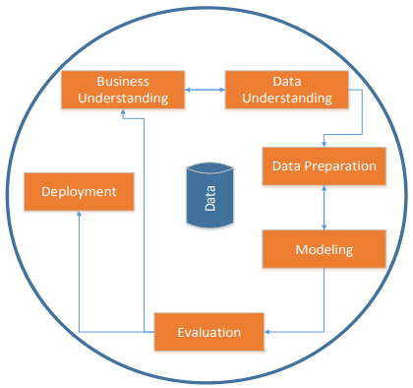
Figure 3.1: CRISP-DM framework
According to this methodology, the steps of research can be described as follows:
A. Business understanding
Business understanding: It is the initial phase which focuses on understanding the project objectives and requirements from a business perspective, then converting this knowledge into a data mining problem definition and a preliminary plan designed to achieve the objectives.

B. Data understanding.
The data understanding phase focuses on initial data collection, familiarization of data, identification of data quality problems, and interesting subsets to form hypotheses for hidden information etc.
C. Data preparation
The data preparation phase covers all activities to construct the final dataset (data that will be fed into the modelling tool from the initial raw data). There is no prescribed order for data preparation tasks. Sometimes tasks are to be repeatedly performed, like selection of table, record and attribute as well as transformation and cleaning of data for modelling tools.
D. Modeling
Various modelling techniques are selected and applied in this phase. Typically, there are several techniques for the same data mining problem type. Since some techniques have specific requirements on the form of data, sometimes it needs to go back to the data preparation phase.
E. Evaluation
This phase is to be covered before proceeding to the final deployment of the model, to be certain that business objectives are properly achieved. Consideration and successful implementation of all important business issues are to be confirmed. At the end of this phase, a decision on the use of the data mining results should be reached.
F. Deployment
Creation of the model is generally not the end of the project. The knowledge gained will have to be organized and presented in such a way that the customer can use it.
  - ANALYSIS OF THE EXISTING SYSTEM
The existing system used in the banking or financial institutions is a manual method where people were given loan giving them the deadline of the loan given to them. This system cause some banks to experience debt because some people with default loan. The prediction in this system is done manually where the person leasing the loan will need to forecast by himself who loan should be given next.
  - PROBLEMS OF EXISTING SYSTEM
Some problems of the existing system are listed below:
- Necessity for a borrower to visit the branch: For many lenders and their customers, the loan process begins with a hurdle: the necessity for the customer to visit a physical branch. Filling out application forms delays the processing of the loan and eats away at loan officers’ time.
- Labor intensity for a lender: Although labor-intensive, the manual application process is not entirely without value. It does allow the loan origination officer to conduct an initial check of whether all the required information has been supplied. Furthermore, the lender can ensure that regulatory requirements for documentation and KYC standards are being met. Finally, an in-person meeting allows the customer to discuss any unusual circumstances that might not be properly addressed by the application forms. On the other hand, if the customer forgets any required documents, he or she must visit the branch again on a later date. In addition, if the loan officer discovers that the customer is wholly ineligible for a loan, both the loan officer and the customer’s time has been wasted.

Wasted time, analyzing fairly simple cases: Finally, the underwriting process, or the analysis of creditworthiness and the loan decision, takes additional time if done manually. Again, the manual consumer lending process is not without some advantages. Problems with applications that require human judgment to determine whether a loan should be approved can be addressed on the spot. However, the manual process means that underwriters spend nearly as much time on normal, unproblematic loan files – which for most lenders account for a majority of underwriting volume – as they do on those that require extra attention..

Data entry errors: Assuming, however, that the customer completes an application and meets all the necessary requirements for moving on, the next hurdle to overcome is data management. The loan origination officer will need to follow at least these steps: Enter the customer’s information into the bank’s system

Upload or enter information from supporting documents

Alert the personnel conducting the verification and underwriting processes that a new application has been received

These steps take time and increase the risk of error or mis-entry. As the departments that handle verification and underwriting may be in different locations, and may even use a different local system, the number of handling and communication steps between the bank and the customer increases. Each added step increases the time and potential for error in the overall process.

  - DESCRIPTION OF THE PROPOSED SYSTEM
3.4.1 PROPOSED MODEL
The proposed model focuses on predicting the credibility of customers for loan repayment by analyzing their behavior. The input to the model is the customer behavior collected. Based on the output from the classifier, decision on whether to approve or reject the customer request can be made. Decision Tree Induction data mining technique is used to generate the relevant attributes and also make the decision in the model. Data mining model of the proposed system is as depicted in figure4.
A. Problem Understanding
The data mining model is initiated with collection of details regarding the banking sector and the existing loan processing procedures. The challenges and the main risks associated with the loan approval/rejection in banking sector are thus better understood.
B. Data Understanding
In Data Understanding phase, the bank dataset of customer details, which is required for data mining, is collected and got familiarized with. Various attributes needed are also studied.
C. Data Filtering
The attributes in the bank data set are filtered and the relevant attributes needed for prediction are selected. After that the incomplete and noisy records in the dataset are removed and prepared for mining.
D. System Modelling
In this stage the system is developed in an efficient and user-friendly manner so that even those users with less technical knowledge can also use it comfortably. The system provides the most relevant attributes that help in determining whether to approve or reject the loan application. This aids in predicting the credibility of future customers.

E. System Evaluation
In the final stage, the designed system is tested with test set and the performance is assured.
3.4.2 ARCHITECTURE OF PROPOSED MODEL
Architecture of the proposed model is as shown in the figure5.
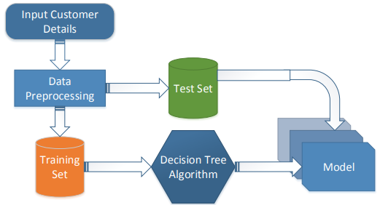
Figure 3.2: Architecture of Proposed Model
A. Input
The main highlight of this Loan Credibility Prediction System is that it uses Decision Tree Induction Data Mining Algorithm to screen/filter out the loan requests. A Decision Tree is developed by performing data mining on an existing bank dataset containing 4520 records and 17 attributes.
B. Data Pre-processing
Initially the Attributes which are critical to make a Loan Credibility Prediction is identified with Information Gain as the attribute-evaluator and Ranker as the search-method. Manual preprocessing is also performed.
C. Data Filtering
Final dataset after preprocessing is divided in such a way that there is 66 % training set and 34 % test set. Test set is used to validate the final result of the classifier.
D. Decision Tree Algorithm
An efficient Decision Tree is formulated with Decision Tree Induction Algorithm. It produces a model with the most relevant 6 attributes. Attribute with rank-1 is placed as the root node of the Decision tree, other attributes from Rank-2 to Rank-6 constitute the intermediate nodes. A decision is made at each node and the leaf node gives us the final result. That is, if the customer possess the minimum loan repayment capacity, then the future risks can be avoided. The main benefit of applying Data Mining is that we can always rely on the result of the algorithm to accept or reject the loan application.

3.5 ADVANTAGES OF THE PROPOSED SYSTEM
The proposed system has the following advantages over the existing system:
- It is reliable when it comes to Loan Creditability Prediction: This proposed system is very reliable as customers don’t need to be afraid of data loss or loan dismiss.
- Its accuracy is of highest order: It is very accurate in prediction than the existing system
- It saves time and energy: It is very fast in prediction as it is automatic.

CHAPTER FOUR
IMPLEMENTATION AND DOCUMENTATION OF THE SYSTEM
4.1 DESIGN OF THE SYSTEM
Generally, all efforts are geared toward designing a system program that eliminates all the setbacks of the existing manual method. This new approach is simple, efficient and guaranteed.
The proposed is designed in order to meet the goal and objective of the organization. The design of the system is intended to solve the various problems of online goods ordering
4.1.1 OUTPUT DESIGN
It refers to the report expected to be generated from files in database. The generated reports are lists of view, index page e.t.c.. Below are the snapshot of the output designs
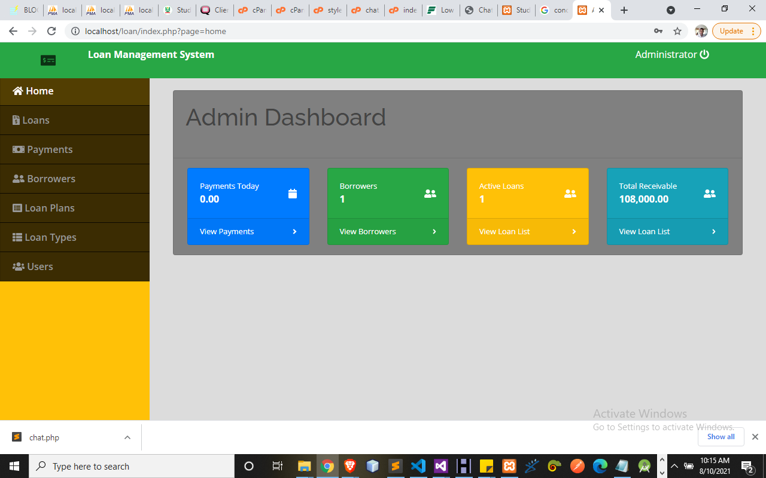
Figure 4.1 Admin Dashboard: This is the main menu of the system where all functions can be carried out through navigation.
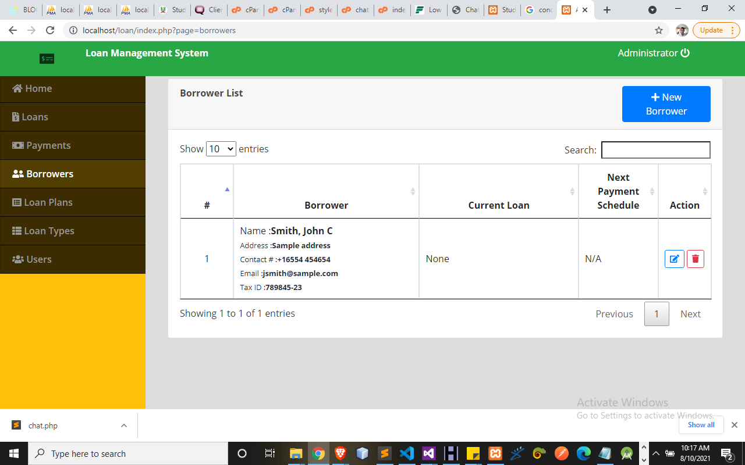Figure 4.2 Borrower List: This display list of all members who are on loan to make payment.
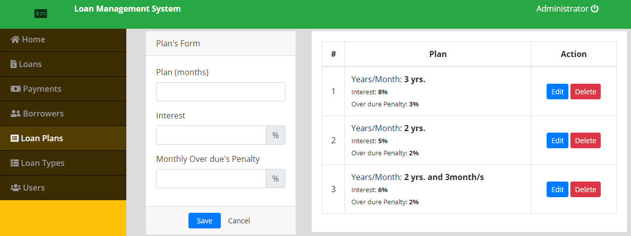
Figure 4.3 Loan Plan: This allow admin to set the type of loan user can apply
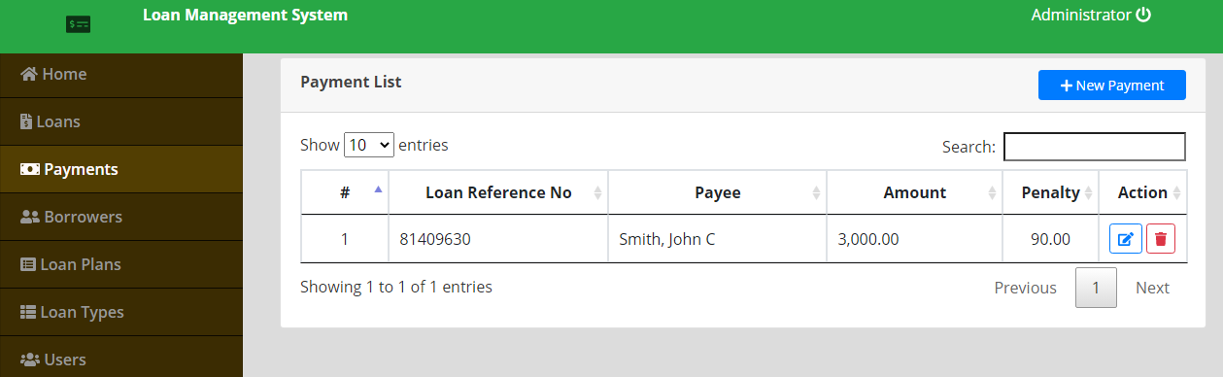Figure 4.4 Payment List: This display the list of all payments made in the system.
4.1.2 INPUT DESIGN
Design is a way of mapping and arranging part into a whole, which satisfies the objective involved. The input design refers to the type of all data used to feed information into the database via the program and the format and the input used for the system. Below are the snapshots of the input designs
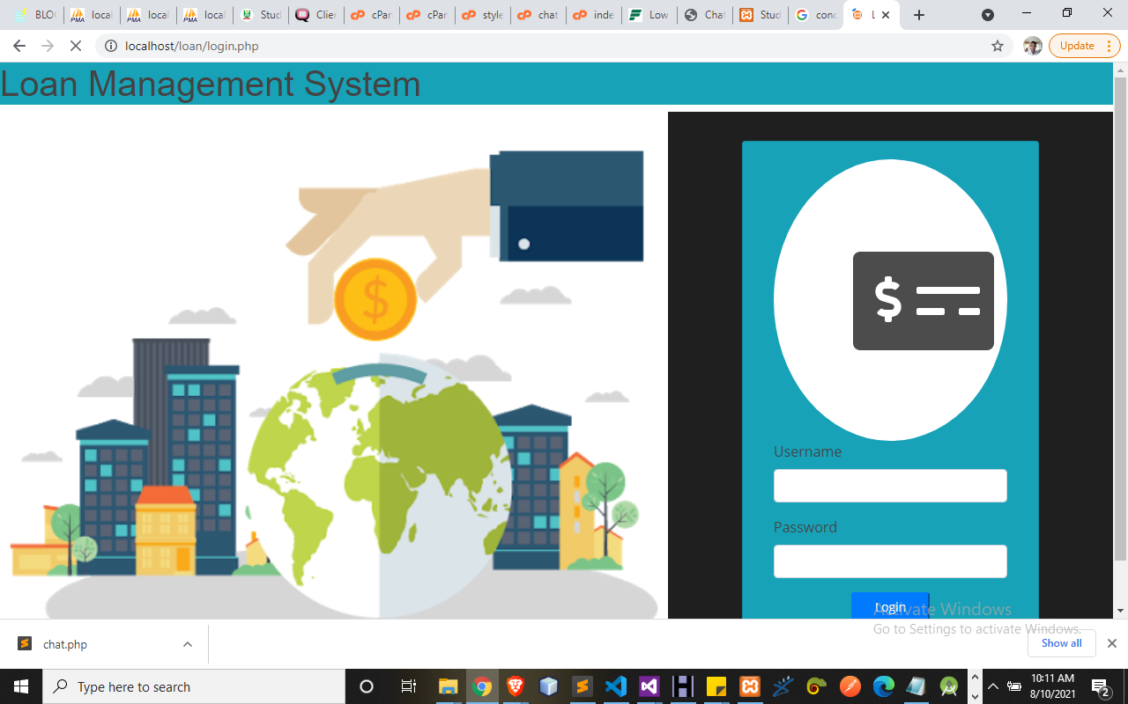
Figure 4.5 Login Page: This allow the admin get access into the system.

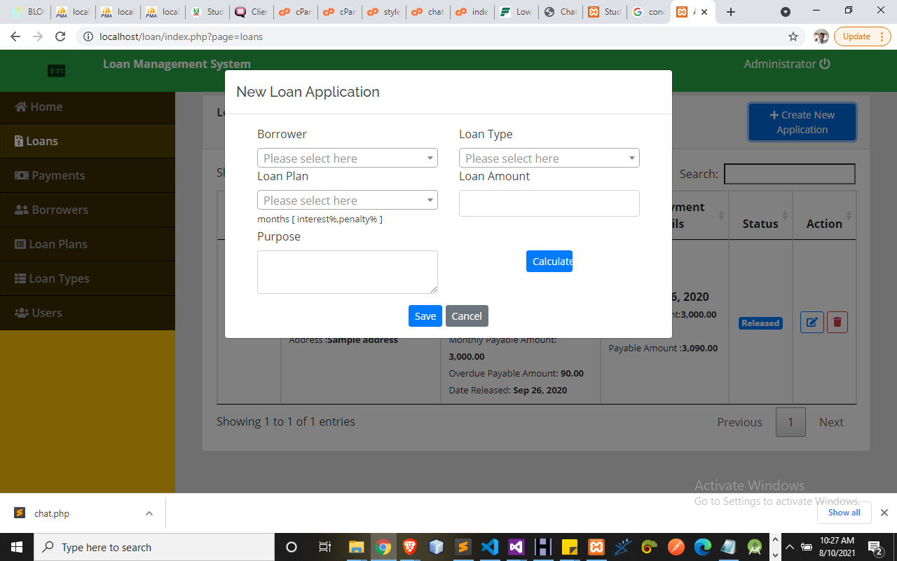
Figure 4.6 Loan Application: This allow user apply for loan here.
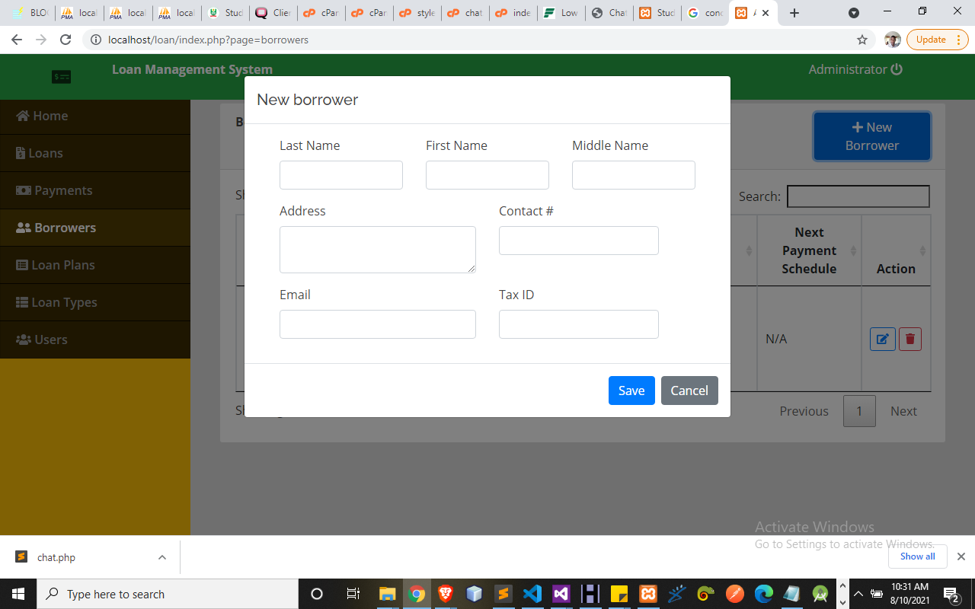
Figure 4.7 New Borrower: This allow user to borrow money
4.1.3 DATABASE DSIGN
Database entails the organization and access mode that are implemented in carrying out our specified operations upon the records of the file.
The files used in this system have records that have been organized randomly (random organization) and for this purpose, it will be more appropriate to access the records of the files randomly (random access mode).

Table 4.1 Loan Database
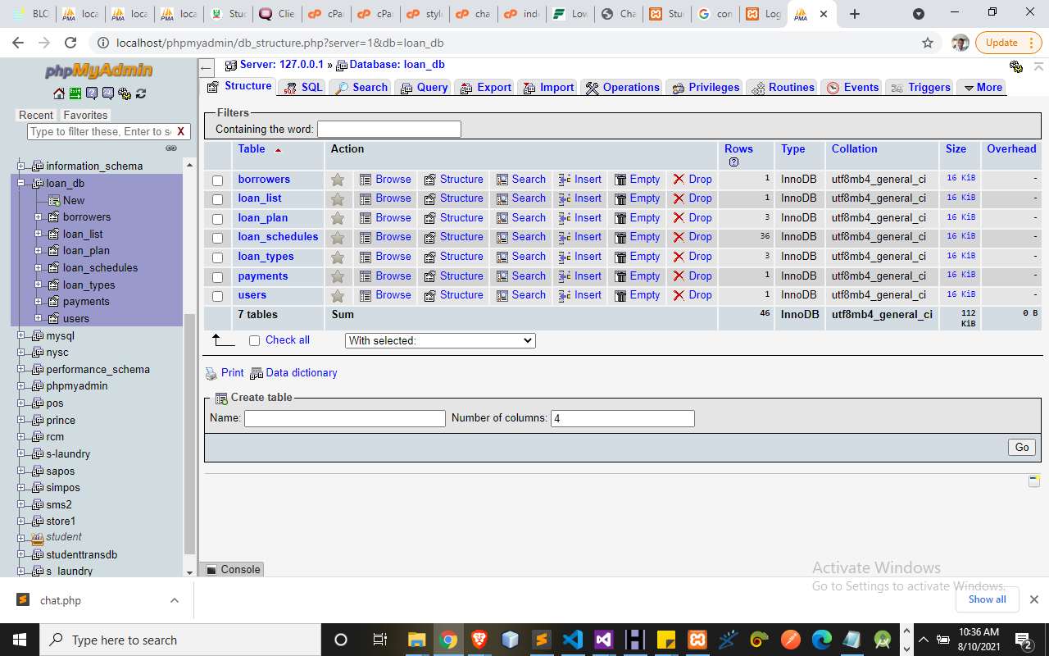
This display the abstraction of loan database management
Table 4.2: Borrower Table
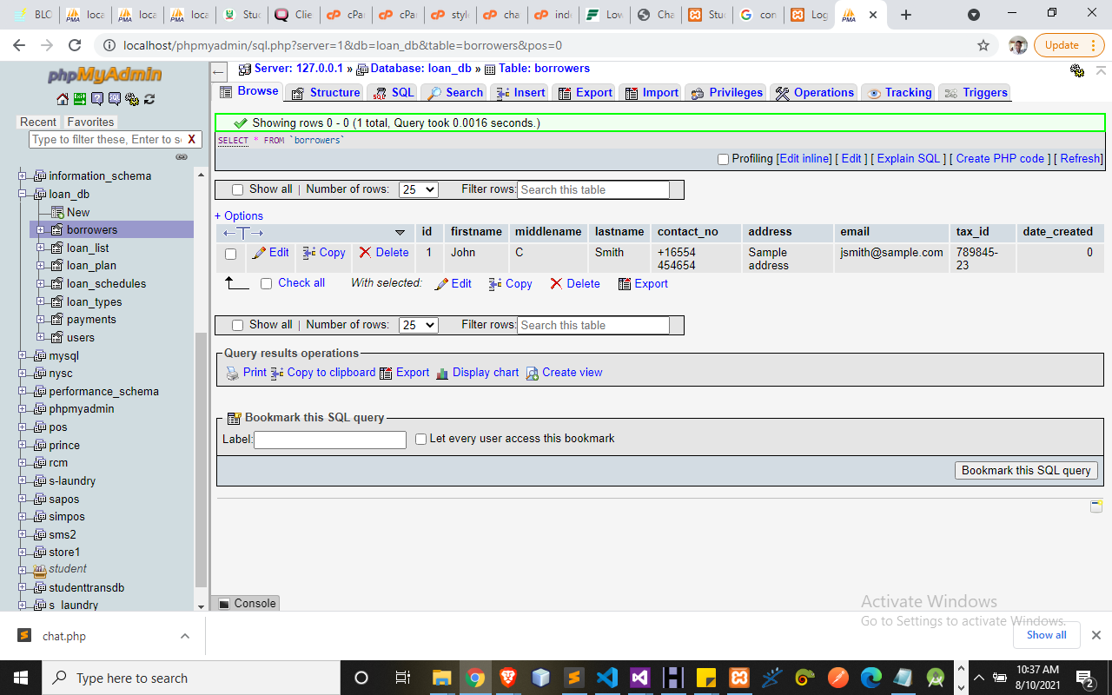
This display the list of all borrower in the database.
4.1.3 PROCEDURE DESIGN
Procedures are steps which verify the whole process i.e which are everything put together to produce the desired output. This involves the organization of the source document and end with the output result. Documents are sent to various departments to be filled by the employees and later returned to the personnel department which are analysed to determine which record goes into the computer. After selecting the necessary data, this serves as input to the computer system.
4.2 IMPLEMENTATION OF THE SYSTEM
It is always good to develop new ideas, to implement them on a computer and eventually to relish the satisfaction of achieving a successful result. The implementation process involves converting the system design into a complete and tested EDP that is fully operational and that can be used by the system users to meet their business needs. During implementation phase, the hardware and the software must be implemented.
Implementation of a system can be explained in six steps:-
1. Review design specification
2. Code, test and document programs
3. Train users
4. Perform system test
5. Convert to new system
6. Evaluate and maintain the new system

4.2.1 CHOICE OF PROGRAMMING LANGUAGE
The application is designed in Adobe CS4 Dreamweaver web development package which involves the use of PHP server-side scripting language, MYSQL for database management and HTML (with other embedded functionalities) for the page design and layout settings. Hence, the program testing simply involves running it directly from a Mozilla Firefox web browser on local host server provided by Apache 2.0 in WampServer 2.0 application.
In preparation for the installation of the new system, the method of changeover is given serious consideration to determine the success of the new system. Suitable changeover technique for this system is pilot changeover. The pilot changeover operates by applying the new system bit-by-bit until it covers the whole of the operations. The result obtained from using the pilot method on a small portion of the operations would be used in determining the suitability of the need system for the rest of the operations. This method is similar to testing small sample of a distribution if the test yields a good result then the whole system because fully operational and the manual/existing system is eliminated.
4.2.2 HARDWARE SUPPORT
The computer configuration required to run the software are;
Computer/memory processor PC with a 48dx, MHZ or Pentium, Intel or higher processor required.
Memory: 8GB of RAM
Cache memory: 512KB
Hard disk Minimum size 500GB
Recommended 200GB
Virtual Memory 32Bits
Cache memory 512KB
4.2.3 SOFTWARE SUPPORT
Software Support services are generally technical support or break/fix services that are delivered for specific software product.
The computer tools required to run the software are;
I. Interface Design Language, windows Notepad for help interface design Hypertext Mark-up Language (HTML)
ii. MY SQL Database Management Software
iii. Programming PHP (Hypertext Pre-processor)
iv. Operating system window 07 professional
v. Graphic software paint shop and choosing these two formats GIF (Graphic Image Format)
vi. Scanner software, Mira scans
- Web browser software MOZILLA
4.3 PROGRAM DOCUMENTATION
4.3.1 OPERATING THE SYSTEM
Step 1: Boot your computer and click on start button on task bar
Step 2: Launch WampServer
Step 3: Locate Online_goods
Step 4: Click on Options
4.1 Click on Product (to view available product)
4.2 Click on About Us (to view the about us page)
4.3 Click on Contact Us (to send message to the admin)
4.4 Click on Order Now (to order for your bags)
Step 5: Logout.
4.3.2 MAINTAINING THE SYSTEM
The use of the term maintenance for software is different from other references to maintenance. Unlike the tires on your car, software does not “wear out”. If this is the case, then why does software maintenance account for such a high percentage of the Total Cost of Ownership for software?
The software maintenance definition refers to changes for defect correction, performance improvements, or adaptations to a changed environment (enhancements). According to this definition, if we build software that is defect-free, performs well, and contains user-controlled parameters to adjust processing rules in response to changing requirements then most maintenance would not be necessary.
Why does this happen? There are many reasons but the most common reasons are time constraints and lack of experience. Adding validation logic takes time. So, people make assumptions about the quality of in-bound data. Assumptions are also made about the volume of transactions and the impact on performance and the stability of the automated business processes. Finally, it is common for new software to be developed by younger developers who don’t understand the maintenance impacts of their designs. The reality is that business requirements change and most of these assumptions are flawed. Transaction volumes increase, changing business processes require new transactions or new validation criteria, and software users will use the software incorrectly. The cost of software maintenance and the total cost of ownership can dramatically be reduced if developers build software that adjusted to changes in transaction volumes; validated all inbound data and provide user-configurable options for decision logic and data validation.
CHAPTER FIVE
SUMMARY, CONCLUSION AND RECOMMENDATIONS
5.1 SUMMARY
Nowadays, Banks struggle a lot to get an upper hand over each other to enhance overall business due to tight competition. Banks have realized that retaining the customers and preventing fraud must be the strategy tool for healthy competition. Availability of the huge quantity of data, creation of knowledge base and efficient utilization of the same has helped banks to open up efficient delivery channels. Business decisions can be optimized through data mining. Customer segmentation, banking profitability, credit scoring and approval, predicting payment from customers, marketing, detecting fraud transactions, cash management and forecasting operations, optimizing stock portfolios and ranking investments are some of the areas where data mining techniques can be used in the banking industry. There are numerous areas in which data mining can be used in the banking industry to support customer relationships management. Data mining technique will help to distinguish borrowers who repay loans promptly from those who do not. It also helps to predict the credit worthiness of borrower by analyzing the behavior and reliability of the customers. With data mining techniques, banks can do a thorough profiling and ranking of their branches with respect to loan fraud risk. In developing countries like India, Bankers face more problems with the fraudsters.
5.2 CONCLUSION
In this project, we have presented a loan credibility prediction system that helps the organizations in making the right decision to approve or reject the loan request of the customers. This will definitely help the banking industry to open up efficient delivery channels. Decision Tree Induction Algorithm is used for the prediction. Incorporation of other techniques that outperform the performance of popular data mining models have to be implemented and tested for the domain.

5.3 RECOMMENDATION
All of the foregoing appears to show that the Nigerian commercial banks are inefficient in their lending function and thus contribute less than they can to the country's economic development and growth. The logical question at this point appears to be obvious: what can be done to improve the efficiency of these institutions and ensure they contribute to economic development to the maximum of their ability? It will be unrealistic to think that once the management techniques and tools have been well sharpened and intelligently applied, all the lending problems will disappear. In advanced countries where the banking environments possess, at least, most of the essential elements such as infrastructural facilities, skilled manpower, efficient and well integrated financial systems, this may be so.

REFERENCE
Aboobyda, et al (2020). “Developing Prediction Model of Loan Risk in Banks Using Data Mining”, Machine Learning and Applications: An International Journal (MLAIJ), vol. 3, no.1, pp. 1–9.
Blanco, et al (2021). “Credit scoring models for the microfinance industry using neural networks: evidence from Peru”, Expert Systems with Applications, vol. 40, pp. 356–364.
Dileep, (2020) “A Review: Application of Data Mining Tools in CRM for Selected Banks”, (IJCSIT) International Journal of Computer Science and Information Technologies, Vol. 4 (2), 199 – 201.
Francesca, (2021) “A Discrete-Time Hazard Model for Loans: Some Evidence from Italian Banking System”, American Journal of Applied Sciences,vol. 9, no.9), pp. 1337–1346.
Harris, (2021) “Quantitative credit risk assessment using support vector machines: Broad versus Narrow default definitions”, Expert Systems with Applications, vol. 40, pp. 4404–4413.
Hussain, & Shorouq, (2020). “Credit risk assessment model for Jordanian commercial banks: Neuralscoring approach”, Review of Development Finance, Elsevier, vol. 4, pp. 20–28.
Kavitha, (2020). “Clustering Loan Applicants based on Risk Percentage using K-Means Clustering Techniques”, International Journal of Advanced Research in Computer Science and Software Engineering, vol. 6(2), pp. 162–166.
Semiu, & Akanmu, (2019). “A Boosted Decision Tree Model for Predicting Loan Default in P2P Lending Communities” International Journal of Engineering and Advanced Technology (IJEAT) ISSN: 2249 – 8958, Volume-9 Issue-1, October 2019.
Sivasree, (2021). “Loan Credibility Prediction System Based on Decision Tree Algorithm” International Journal of Engineering Research & Technology (IJERT) ISSN: 2278-0181 IJERTV4IS090708 www.ijert.org (This work is licensed under a Creative Commons Attribution 4.0 International License.) Vol. 4 Issue 09, September.
Somayyeh, & Abdolkariz (2020). “Natural Customer Ranking of Banks in Terms of Credit Risk by Using Data Mining A Case Study: Branches of Mellat Bank of Iran”, Jurnal UMP Social Sciences and Technology Management, vol. 3, no. 2, pp. 307–316.
Soni, P.M. & Varghese Paul (2019) wrote an article on “Algorithm For the Loan Credibility Prediction System” International Journal of Recent Technology and Engineering (IJRTE) ISSN: 2277-3878, Volume-8, Issue-1S4, June 2019

SYSTEM FLOWCHART
Start
Splash Screen

Login
Main Menu
Registration
Stop
Borrow Loan
Withdraw
Logout
Loan Payment

SPLASH SCREEN
Start
Display Splash
Stop
Open Database

Close Database

LOGIN
No
Yes
No
Yes
Start
Enter Username and Password
Is any field empty?
Is Username and Password Correct?
Main Menu
Return
Invalid Username and Password
All field are required to proceed
Open Database

Close Database

MAIN MENU
No
No
No
Start
Select option
End Select
Return
Open Database

Close Database

Yes
No
Is it option Registration?
Registration
Yes
No
Is it option Deposit?
Borrow Loan
Yes
No
Is it option Withdraw?
Withdraw
Yes
No
Is it option Face Recognition?
Loan Payment
Yes
Is it option Logout?
Logout

REGISTRATION
No
Yes
Start
Return
Enter Registration Details
Is any Field Empty
?
Display User Details
All Field are required to Proceed
Open Database

Close Database

Save to Database

BORROW
Start
Stop
Open Database

Open Database

Borrow Loan

WITHDRAWAL
Start
Stop
Open Database

Open Database

Withdraw

LOAN PAYMENT
Start
Stop
Open Database

Open Database

Make Loan Payment

LOGOUT
No
Yes
Start
Do you want to Logout?
Return
Click on Login
Welcome Page
Main Menu
Open Database

Close Database

PROGRAM SOURCE CODE

<!DOCTYPE html>
<html lang="en">
<head>
<title>CEE LOGIN</title>
<meta charset="UTF-8">
<meta name="viewport" content="width=device-width, initial-scale=1">
<link rel="icon" type="login-ui/image/png" href="images/icons/favicon.ico"/>
<link rel="stylesheet" type="text/css" href="login-ui/vendor/bootstrap/css/bootstrap.min.css">
<link rel="stylesheet" type="text/css" href="login-ui/fonts/font-awesome-4.7.0/css/font-awesome.min.css">
<link rel="stylesheet" type="text/css" href="login-ui/fonts/Linearicons-Free-v1.0.0/icon-font.min.css">
<link rel="stylesheet" type="text/css" href="login-ui/vendor/animate/animate.css">
<link rel="stylesheet" type="text/css" href="login-ui/vendor/css-hamburgers/hamburgers.min.css">
<link rel="stylesheet" type="text/css" href="login-ui/vendor/select2/select2.min.css">
<link rel="stylesheet" type="text/css" href="login-ui/vendor/daterangepicker/daterangepicker.css">
<link rel="stylesheet" type="text/css" href="login-ui/css/util.css">
<link rel="stylesheet" type="text/css" href="login-ui/css/main.css">
</head>
<body>
<div class="limiter">
<div class="container-login100" style="background-image: url(login-ui/images/bg-01.jpg);">
<div class="wrap-login100">
<div class="login100-form-title" style="background-image: url(login-ui/images/bg-01.jpg);">
<span class="login100-form-title-1"> COMPUTER BASED TEST (CBT) EXERCISE </span>
</div>
<form method="post" id="examineeLoginFrm" class="login100-form validate-form">
<div class="wrap-input100 validate-input m-b-26" data-validate="Username is required"> <span class="label-input100">Matric No.</span>
<input class="input100" type="text" name="username" placeholder="Enter your Matric Number">
<span class="focus-input100"></span>
</div>
<div class="wrap-input100 validate-input m-b-18" data-validate = "Password is required">
<span class="label-input100">Password (Surname)</span>
<input class="input100" type="password" name="pass" placeholder="Enter password">
<span class="focus-input100"></span>
</div>
<div class="container-login100-form-btn" align="right">
<button type="submit" class="login100-form-btn"> Login </button>
</div>
</form>
marquee behavior='scroll' bgcolor="#008000"><h3> <font color='#FFFFFF'> Designed by HND 2 (2020/2021 Academic Session) Computer Science Department CBT Group Member</font></h3></marquee>
</div>
</div>
</div>
<script src="login-ui/vendor/jquery/jquery-3.2.1.min.js"></script>
<script src="login-ui/vendor/animsition/js/animsition.min.js"></script>
<script src="login-ui/vendor/bootstrap/js/popper.js"></script>
<script src="login-ui/vendor/bootstrap/js/bootstrap.min.js"></script>
<script src="login-ui/js/main.js"></script>

</body>
</html>

<script type="text/javascript" >
function preventBack(){window.history.forward();}
setTimeout("preventBack()", 0);
window.onunload=function(){null};
</script>
<?php
$examId = $_GET['id'];
$selExam = $conn->query("SELECT * FROM exam_tbl WHERE ex_id='$examId' ")->fetch(PDO::FETCH_ASSOC);
$selExamTimeLimit = $selExam['ex_time_limit'];
$exDisplayLimit = $selExam['ex_questlimit_display'];
?>
<div class="app-main__outer">
<div class="app-main__inner">
<div class="col-md-12">
<div class="app-page-title">
<div class="page-title-wrapper">
<div class="page-title-heading">
<div>
<?php echo $selExam['ex_title']; ?>
<div class="page-title-subheading">
<?php echo $selExam['ex_description']; ?>
</div>
</div>
</div>
<div class="page-title-actions mr-5" style="font-size: 20px;">
<form name="cd">
<input type="hidden" name="" id="timeExamLimit" value="<?php echo $selExamTimeLimit; ?>">
<label>Remaining Time : </label>
<input style="border:none;background-color: transparent;color:blue;font-size: 25px;" name="disp" type="text" class="clock" id="txt" value="00:00" size="5" readonly="true" />
</form>
</div>
</div>
</div>
</div>
<div class="col-md-12 p-0 mb-4">
<form method="post" id="submitAnswerFrm">
<input type="hidden" name="exam_id" id="exam_id" value="<?php echo $examId; ?>">
<input type="hidden" name="examAction" id="examAction" >
<table class="align-middle mb-0 table table-borderless table-striped table-hover" id="tableList">
<?php
$selQuest = $conn->query("SELECT * FROM exam_question_tbl WHERE exam_id='$examId' ORDER BY rand() LIMIT $exDisplayLimit ");
if($selQuest->rowCount() > 0)
{
$i = 1;
while ($selQuestRow = $selQuest->fetch(PDO::FETCH_ASSOC)) { ?>
<?php $questId = $selQuestRow['eqt_id']; ?>
<tr>
<td>
<p><b><?php echo $i++ ; ?> .) <?php echo $selQuestRow['exam_question']; ?></b></p>
<div class="col-md-4 float-left">
<div class="form-group pl-4 ">
<input name="answer[<?php echo $questId; ?>][correct]" value="<?php echo $selQuestRow['exam_ch1']; ?>" class="form-check-input" type="radio" value="" id="invalidCheck" >

<label class="form-check-label" for="invalidCheck">
<?php echo $selQuestRow['exam_ch1']; ?>
</label>
</div>
<div class="form-group pl-4">
<input name="answer[<?php echo $questId; ?>][correct]" value="<?php echo $selQuestRow['exam_ch2']; ?>" class="form-check-input" type="radio" value="" id="invalidCheck" >
<label class="form-check-label" for="invalidCheck">
<?php echo $selQuestRow['exam_ch2']; ?>
</label>
</div>
</div>
<div class="col-md-8 float-left">
<div class="form-group pl-4">
<input name="answer[<?php echo $questId; ?>][correct]" value="<?php echo $selQuestRow['exam_ch3']; ?>" class="form-check-input" type="radio" value="" id="invalidCheck" >
<label class="form-check-label" for="invalidCheck">
<?php echo $selQuestRow['exam_ch3']; ?>
</label>
</div>
<div class="form-group pl-4">
<input name="answer[<?php echo $questId; ?>][correct]" value="<?php echo $selQuestRow['exam_ch4']; ?>" class="form-check-input" type="radio" value="" id="invalidCheck" >
<label class="form-check-label" for="invalidCheck">
<?php echo $selQuestRow['exam_ch4']; ?>
</label>
</div>
</div>
</div>
</td>
</tr>
<?php }
?>
<tr>
<td style="padding: 20px;">
<input name="submit" type="submit" value="Submit" class="btn btn-xlg btn-primary p-3 pl-4 pr-4 float-right" >
</td>
</tr>
<?php
}
else
{ ?>
<b>No question at this moment</b>
<?php }
?>
</table>
</form>
</div>
</div>

<div class="app-main__outer">
<div class="app-main__inner">

<?php
@$exam_id = $_GET['exam_id'];

if($exam_id != "")
{
$selEx = $conn->query("SELECT * FROM exam_tbl WHERE ex_id='$exam_id' ")->fetch(PDO::FETCH_ASSOC);
$exam_course = $selEx['dept_id'];
$exmneLevel = $selEx['exmne_year_level'];

$selExmne = $conn->query("SELECT * FROM examinee_tbl et WHERE department='$exam_course'AND exmne_year_level='$exmneLevel' ORDER BY matric_no ASC");
?>
<div class="app-page-title">
<div class="page-title-wrapper">
<div class="page-title-heading">
<div><b class="text-primary">STUDENT'S RESULT</b><br>
<!-- <span class="border" style="padding:10px;color:black;background-color: yellow;">Excellence</span>
<span class="border" style="padding:10px;color:white;background-color: green;">Very Good</span>
<span class="border" style="padding:10px;color:white;background-color: blue;">Good</span>
<span class="border" style="padding:10px;color:white;background-color: red;">Failed</span>
<span class="border" style="padding:10px;color:black;background-color: #E9ECEE;">Not Answering</span> -->
</div>
</div>
</div>
</div>

<div class="col-md-12">
<div class="main-card mb-3 card">

<div class="content-header">

<div class="card-header">
<?php echo $selEx['ex_title']; ?> : <?php echo $selEx['ex_description']; ?>

</div>

<div class="right-title">

<a href="export.php?exam_id=<?=$exam_id;?>" class="btn btn-rounde btn-sm btn-info" style="float:right;"> Write to CSV</a>

</div>

</div>

<div class="table-responsive">
<table class="align-middle mb-0 table table-borderless table-striped table-hover" id="tableList">
<thead>
<tr>
<th width="50%">Matric Number</th>
<th>Score</th>
<th>Grade</th>
</tr>
</thead>
<tbody>
<?php
while ($selExmneRow = $selExmne->fetch(PDO::FETCH_ASSOC)) { ?>
<?php
$exmneId = $selExmneRow['exmne_id'];
$selScore = $conn->query("SELECT * FROM exam_question_tbl eqt INNER JOIN exam_answers ea ON eqt.eqt_id = ea.quest_id AND eqt.exam_answer = ea.exans_answer WHERE ea.axmne_id='$exmneId' AND ea.exam_id='$exam_id' AND ea.exans_status='new' ORDER BY ea.exans_id DESC");
$selAttempt = $conn->query("SELECT * FROM exam_attempt WHERE exmne_id='$exmneId' AND exam_id='$exam_id' ");
$over = $selEx['ex_questlimit_display'] ;
@$score = $selScore->rowCount();

