

KWARA STATE POLYETCHNIC, ILORIN
INSTITUTE OF TECHNOLOGY
DEPARTMENT OF CIVIL ENGINEERING

EFFECT OF PROXIMITY OF SEWAGE FACILITY ON GROUND WATER
(YANKARI HOSTEL)
BY
BADMUS TAOHEED AYANSOLA
HND/23/CEC/FT/0229

SUBMITTED TO THE DEPARTMENT OF CIVIL ENGINEERING, INSTITUTE OF TECHNOLOGY, KWARA STATE POLYTECHNIC, ILORIN
JUNE, 2025

DECLARATION
We hereby declare that this project work titled 'Effect of Proximity of Sewage Facility on Groundwater' was carried out by BADMUS TAOHEED AYANSOLA of the Department of Civil Engineering, Institute of Technology, Kwara State Polytechnic, Ilorin, in partial fulfillment of the requirements for the award of the Higher National Diploma (HND).

__________________ ______________
Signature Date

CERTIFICATION
This is to certify that this research study was conducted by BADMUS TAOHEED AYANSOLA (HND/23/CEC/FT/0229) and had been read and approved as meeting the requirement for the award of Higher National Diploma (HND) in Civil Engineering, Institute of Technology, Kwara State Polytechnic, Ilorin.

______________________ _______________
Engr, (Mrs) K. O. Olorunfemi Date
Project Supervisor

______________________ _______________
Engr, A. Na’Allah Date
Head of Department

______________________ ______________
ENGR. DR. MUJEDU KASALI ADEBAYO Date
External Supervisor

ACKNOWLEDGEMENT
I begin by expressing my deepest gratitude to the Almighty God, who has blessed me with the wisdom, strength, and resilience to complete this project.
I extend my sincere appreciation to my project supervisor, Engr. K. O. Olorunfemi for his invaluable guidance, support, and encouragement throughout this journey. His expertise and constructive feedback were instrumental in shaping this project.
To my family, I express my heartfelt gratitude for their unwavering support and love. My Dad, Mr. BADMUS SULAIMON, who made me choose this interesting course, and Mom, Mrs. BADMUS FALEELAHT, who motivates me to make this milestone a success, thank you for being a constant source of motivation, encouragement and financial support. I appreciate your love.
I also acknowledge the entire staffs of the department of Civil Engineering in the Institute of Polytechnic, Ilorin, for their dedication, enlighten and support towards the success of my academics.
To my friends, guardians and colleagues, whose names could not be mentioned one by one, I appreciate your encouragement, advice, and camaraderie.
Thank you all for being part of my journey.

DEDICATION
This project is dedicated solemnly to God Almighty, who is the sole inspiration of all things, without whom there would not be, and neither would this project.
Appreciation goes to my loving parents for their support in the fulfillment of my Higher National Diploma (HND) both orally and financially. May God allow them to eat the fruit of their labor (Amen)

ABSTRACT
This study examines the effect of proximity of sewage facility on groundwater used for domestic purposes in Ilorin, Nigeria. Groundwater samples were collected from two boreholes located at estimated distances of 40 meters (Sample A) and 15 meters (Sample B) from a sewage disposal system. The samples underwent comprehensive physicochemical and microbiological analyses in accordance with the Nigerian Industrial Standard for Drinking Water Quality (NIS 977:2017). The analytical results revealed that Sample B, which was closer to the sewage source, recorded higher concentrations of total dissolved solids, total hardness, alkalinity, nitrate, and coliform bacteria compared to Sample A. While both samples maintained acceptable pH levels, the presence of coliforms—especially in Sample B—exceeded the permissible limits, indicating microbial contamination. The findings establish a clear relationship between the proximity of sewage systems and the deterioration of groundwater quality. The study underscores the importance of adhering to recommended setback distances when locating boreholes, implementing regular water quality monitoring, and enforcing effective wastewater management strategies to safeguard public health and ensure the sustainability of groundwater resources.

TABLE OF CONTENT
Title page i
Certification ii
Dedication iii
Acknowledgment iv
Abstract v
Table of Content vi
List of figure
List of plate
CHAPTER ONE
  - Introduction 1
  - Problem Statement 2
  - Aim and Objective 3
  - Scope of Study 4
  - Justification of the Study 4
  - Significance of the Study 4
CHAPTER TWO
2.0 literature review 6
2.1 Overview of Relevant Theories and Concepts 6
2.1.1 Groundwater and Its Importance 9
2.1.2 Source of Groundwater Contamination 9
2.1.3 Theories of Contaminant Transport 10
2.1.4 Water Quality Guidelines 10
2.2 Sewage system and their potential impact on groundwater 11
2.3 Health and environmental consequences 12
2.4 Analysis of Existing Research 13
2.4.1 International Research 13
2.4.2 Nigerian Context 14
CHATER THREE
3.0 Research methodology 16
3.1 Research Design 16
3.2 Study Area 16
3.3 Population and Sampling 21
3.3.1 Target Population 21
3.3.2 Sampling Method 21
3.4 Data collection method 21
3.4.1 Physical parameter 21
3.4.2 chemical parameter 22
3.4.3 Microbiological parameter 22
3.5 Data Analysis Techniques 22
3.6 Quality Control Measures 23
3.7 Ethical Considerations 23
3.8 limitation of the Study 24
CHAPTR FOUR
4.0 Results and discussion 25
4.1 Physico-Chemical Analysis Summary 25
4.2 Microbiological Analysis Summary 27
4.3 Discussion 27
CHAPTER FIVE
5.0 Conclusion and recommendation 28
5.1 conclusion 28
5.2 Recommendation 28
REFERENCE 29

CHAPTER ONE

1.0 INTRODUCTION
Groundwater serves as a primary source of drinking water for many communities, making its protection essential for public health. However, it is increasingly under threat from various forms of contamination, particularly from sewage facilities. Sewage systems, especially when poorly managed or located near water sources, pose a significant risk to groundwater through leaching of harmful pathogens, chemicals, and organic matter. The concern is more critical in areas where residents depend solely on shallow wells or boreholes for potable water.
Sewage facilities, including septic tanks, soakaways, and centralized treatment plants, are designed to manage human waste safely. But when they are poorly maintained, improperly sited, or located too close to water sources, they can become major sources of contamination. Pathogens (such as E. coli and coliform bacteria), nutrients (like nitrates and phosphates), and heavy metals can infiltrate the groundwater through percolation, threatening the health of those who consume it.
Kwara state polytechnic Hostel, a student residential facility, relies heavily on groundwater sources for daily activities like drinking, cooking, and sanitation. However, the presence of a nearby sewage facility raises concerns about potential contamination of the groundwater used by residents. This study investigates the effect of the proximity of this sewage facility on the quality of groundwater around Yankari Hostel, providing insights into environmental safety and public health risks.

1.1 Problem Statement
Despite the benefits of modern sewage systems in managing waste, improper siting of these facilities poses a significant public health and environmental challenge. This study investigates the extent to which the proximity of sewage facilities affects the quality of nearby groundwater in Kwara state polytechnic Hostel.
In recent years, there have been increasing reports of water quality deterioration in areas with high human activities and inadequate waste disposal systems, but the nearby sewage facility poses a potential risk to this crucial resource. Without proper investigation, the residents might unknowingly be exposed to contaminated water, which can lead to waterborne diseases such as diarrhea, typhoid, and cholera, as well as long-term chemical poisoning from nitrates and heavy metals. Despite the critical nature of this issue, there has been no formal assessment or monitoring of the groundwater quality around Yankari Hostel. This study addresses this gap by examining whether the proximity of the sewage facility significantly impacts groundwater quality.
1.2 Aim and Objectives of the Study
Aim:
To investigate the effect of the proximity of a sewage facility on groundwater at Kwara state polytechnic Hostel.
Specific Objectives:
- To evaluate the physical, chemical, and microbiological properties of groundwater samples collected at different distances from the sewage facility.
- To compare the measured water quality parameters against WHO and Nigerian drinking water standards.
- To analyze the relationship between the distance from the sewage facility and the levels of contamination.
- To propose recommendations for minimizing groundwater contamination risks in the study area.
1.3 Scope of the Study
The study focuses on two borehole water samples: Sample A (farther from sewage site) and Sample B (closer to sewage site). It assesses their physico-chemical and microbiological parameters.
1.4 Justification of the Study
The study is justified on several grounds. First, water is a fundamental human right, and ensuring its safety is a public health priority. Second, hostel residents mainly students represent a vulnerable group, often lacking the means to detect or treat contaminated water. Third, by identifying the impact of the sewage facility on groundwater, this study can provide evidence-based recommendations to hostel management, local authorities, and environmental agencies to improve water safety practices. Lastly, the findings will contribute to the body of knowledge on groundwater contamination risks in urban residential environments.
1.5 Significance of the study
This study is significant because it provides site-specific data on groundwater quality, which can guide the development of effective water management strategies. For hostel management, the findings will offer practical insights into protecting student health and ensuring access to safe water. For policymakers and environmental regulators, the research will highlight the importance of enforcing safe siting distances between sewage facilities and water sources. Additionally, the study will serve as a reference for future researchers examining similar contamination issues in other residential or institutional settings.

CHAPTER TWO
2.0 LITERATURE REVIEW
Groundwater contamination from sewage facilities has emerged as a significant environmental and public health concern worldwide, particularly in developing countries where rapid urbanization and inadequate sanitation infrastructure place enormous pressure on groundwater resources. This chapter presents a comprehensive review of existing literature related to the proximity of sewage facilities and its effects on groundwater quality. It includes theoretical underpinnings, mechanisms of contamination, types of pollutants, health and environmental risks, global and local empirical studies, regulatory frameworks, and identification of research gaps. The aim is to contextualize the present study within the broader scientific discourse and justify its necessity.
2.1 Overview of Relevant Theories and Concepts
Groundwater is water that resides beneath the Earth’s surface in soil pore spaces and in the fractures of rock formations. It constitutes about 30% of the world’s freshwater resources. The relationship between sewage systems and groundwater contamination has been widely studied in various parts of the world. Many studies have confirmed that improperly managed or poorly located sewage facilities can lead to significant contamination of groundwater sources. In a study conducted by Emenike et al. (2017) in southwestern Nigeria, it was found that groundwater sources near latrines and septic tanks showed high levels of coliform bacteria, which are indicators of faecal contamination. The study emphasized that the proximity of sewage systems to wells and other water sources was a significant risk factor for contamination (Emenike et al., 2017).
Similarly, a study in Kenya by Ndiritu et al. (2020) highlighted that septic tanks placed within 20 meters of wells caused elevated levels of nitrates and microbial contamination in groundwater. These findings are consistent with those of other studies, which argue that the percolation of waste through soil layers can lead to the migration of pathogens and other pollutants into groundwater (Ndiritu et al., 2020).
In the context of Nigeria, studies in Lagos and Ibadan have shown that areas with inadequate sewage infrastructure are often associated with high levels of contamination in nearby boreholes and wells. In Kwara State, where Kwara Polytechnic is located, research on groundwater quality in residential areas has revealed concerns over water contamination due to improper disposal of waste (Oluwaseun & Ayoola, 2022).
This review of the literature establishes a clear link between proximity to sewage facilities and groundwater contamination, underscoring the need for careful planning and monitoring in residential and academic environments.
- Groundwater Vulnerability
Groundwater vulnerability refers to the susceptibility of an aquifer to contamination due to its natural characteristics (such as soil permeability, depth of water table, and type of geological materials) and human activities. Areas where the water table is shallow, soil is sandy or fractured, or where human activities (like sewage disposal) are intense, tend to have high vulnerability
- Contamination Pathways
Sewage facilities can leak or discharge waste materials into surrounding soils. Through percolation and infiltration, contaminants such as nitrates, phosphates, pathogens, and heavy metals can reach the groundwater, especially in areas with permeable soils or cracked infrastructure (USEPA, 1998). The closer a water source is to the contamination site, the higher the risk of exposure.
- Water Quality Indicators
The World Health Organization (WHO) and Nigerian Standards for Drinking Water Quality (NSDWQ) identify key parameters to assess water quality:
• Physical indicators (color, turbidity, taste, pH)
• Chemical indicators (nitrate, phosphate, lead, cadmium)
• Microbiological indicators (total coliforms, E. coli)
Elevated levels of these indicators suggest contamination and pose health risks.
2.1.1 Groundwater and Its Importance
Groundwater accounts for approximately 30% of the world's freshwater. It is particularly important in areas with limited surface water sources; it refers to the water found beneath the earth’s surface in soil pore spaces and fractures in rock formations. It serves as a major source of drinking water, particularly in developing countries where piped surface water systems are limited. In Nigeria, groundwater from wells and boreholes is essential for domestic use, irrigation, and small-scale industries.
2.1.2 Sources of Groundwater Contamination
Sources include agricultural runoff, industrial discharges, landfills, and importantly, sewage systems. Groundwater can be contaminated by both natural processes (such as mineral leaching) and human activities. Anthropogenic sources, particularly sewage systems, septic tanks, soak away and latrines, pose significant risks when they leak or overflow. Contaminants such as nitrates, phosphates, ammonia, heavy metals, and pathogenic microorganisms can infiltrate the soil and reach the groundwater, especially in areas with permeable soils or shallow water tables (Freeze & Cherry, 1979).
2.1.3 Theories of Contaminant Transport
Contaminant transport in groundwater is governed by several processes:
- Advection: Movement of contaminants with flowing groundwater.
- Dispersion: Spreading of contaminants due to variations in groundwater velocity.
- Diffusion: Movement from high to low concentration zones.
- Sorption and Retardation: Interaction of contaminants with soil particles, which can slow down migration (Bear, 1972).
Understanding these mechanisms helps explain how sewage-derived pollutants migrate through the subsurface to affect groundwater quality.
2.1.4 Water Quality Guidelines
The World Health Organization (WHO) and the Nigerian Standards for Drinking Water Quality (NSDWQ) provide benchmarks for safe drinking water. Parameters commonly assessed include:

Parameter | WHO Standard (2011) | NSDWQ Standard (Nigeria)
Total coliforms | 0 CFU/100 ml | 0 CFU/100 ml
Nitrate | ≤50 mg/L | ≤50 mg/L
Lead | ≤0.01 mg/L | ≤0.01 mg/L
Ph | 6.5–8.5 | 6.5–8.5

However, regulatory enforcement remains weak in many parts of Nigeria due to limited institutional capacity, inadequate monitoring, and public unawareness (NESREA, 2011). The lack of comprehensive hydrogeological surveys further impedes effective zoning and siting of sanitation systems.
2.2 Sewage Systems and Their Potential Impact on Groundwater
Sewage refers to wastewater from domestic, institutional, or commercial sources, often rich in organic matter, pathogens, nutrients, and trace inorganic pollutants. Sanitation systems are designed to safely manage this waste, but when poorly constructed, maintained, or located too close to water sources, they can act as point sources of groundwater contamination.
Types of Sanitation Systems
- Septic tanks: On-site systems that rely on sedimentation and anaerobic digestion, often discharging partially treated effluent into soak-away pits.
- Pit latrines: Unlined or lined pits designed to collect human waste; leakage is common, especially in sandy or fractured soils.
- Sewage treatment plants: Centralized systems designed to treat large volumes but prone to leaks, overflows, or illegal discharges if mismanaged.
Key Pollutants of Concern
- Microbiological contaminants: Total coliforms, fecal coliforms (E. coli), viruses, protozoa, and helminths.
- Chemical contaminants: Nitrates, nitrites, ammonium, phosphates, chlorides, sulfates.
- Heavy metals: Lead, cadmium, mercury, arsenic (often introduced through mixed waste streams).
- Emerging contaminants: Pharmaceuticals, personal care products, microplastics.
- The presence and migration of these pollutants in groundwater depend on factors such as soil type, water table depth, hydraulic conductivity, and rainfall patterns (Howard et al., 2003).
2.3 Health and Environmental Consequences
Groundwater contamination has severe public health implications. Microbial contamination can cause diarrhea, cholera, dysentery, typhoid fever, and hepatitis A, particularly among vulnerable populations such as children and the elderly (WHO, 2011). Chemical contaminants, notably nitrates, are linked to “blue baby syndrome” (infant methemoglobinemia), while chronic exposure to heavy metals can lead to neurotoxicity, renal damage, and cancer (Okoye et al., 2014).
Environmental consequences include:
- Eutrophication of connected surface waters.
- Bioaccumulation of toxic substances in aquatic ecosystems.
- Degradation of groundwater-dependent ecosystems (GDEs), such as wetlands and springs
2.4 Analysis of Existing Research
2.4.1 International Research
Globally, numerous studies have explored the relationship between sewage proximity and groundwater quality
- Graham & Polizzotto (2013) in South Asia reported that pit latrines less than 10–15 m from shallow wells significantly increased fecal contamination, though chemical contamination (nitrates, chlorides) could persist at distances of 50 m or more.
- Godfrey et al. (2006) in Tanzania found elevated nitrate and coliform levels in wells located downslope and within 20 m of sanitation facilities, exacerbated by sandy soils and shallow water tables.
- Cairncross et al. (2010) highlighted that poorly maintained septic tanks in peri-urban Latin America were major contributors to microbial contamination, despite having theoretical protective distances.
2.4.2 Nigerian Context
In Nigeria, groundwater serves as the primary drinking water source for up to 60% of the population (Nwankwoala, 2011). However, rapid urbanization, population growth, and limited sanitation infrastructure have compounded the risks of groundwater pollution.
- Afolabi et al. (2015) in Lagos observed that shallow wells within 20–25 m of septic tanks had nitrate levels exceeding WHO standards, posing risks of methemoglobinemia in infants.
- Chukwu (2008) in Enugu reported elevated total coliform counts in boreholes located near household soak-away pits, particularly during rainy seasons.
- Yusuf et al. (2017) in Ilorin measured significantly higher heavy metal concentrations (Pb, Cd) in groundwater samples collected near sewage discharge points compared to control locations.
- Nkansah & Ephraim (2012) in Ghana found that groundwater samples from wells near latrines had total coliform counts far above permissible levels, with seasonal fluctuations linked to rainfall and recharge rates.
These studies highlight the critical need for local assessments that account for specific hydrogeological conditions, land use patterns, and sanitation practices
Health and Environmental Consequences.
.

CHAPTER THREE
3.0 RESEARCH METHODOLOGY
3.1 Research Design
The study adopts a case study research design, focusing on Kwara state polytechnic Hostel as the unit of analysis where two borehole samples were collected from different proximities to a known sewage facility. The research uses both quantitative (physical, chemical, microbiological water quality measurements) and spatial (distance-based sampling) approaches. This design allows for an in-depth assessment of how groundwater quality changes with proximity to a sewage facility.
3.2 Study Area
Kwara State Polytechnic Hostel is a student residential area within a university setting. It is situated in an environment where groundwater serves as the primary water source for residents. The hostel features several boreholes used for domestic purposes, located at varying distances from a nearby sewage facility comprising septic tanks and soak aways. The geological setting is characterized by shallow aquifers, making groundwater susceptible to contamination from surface activities.
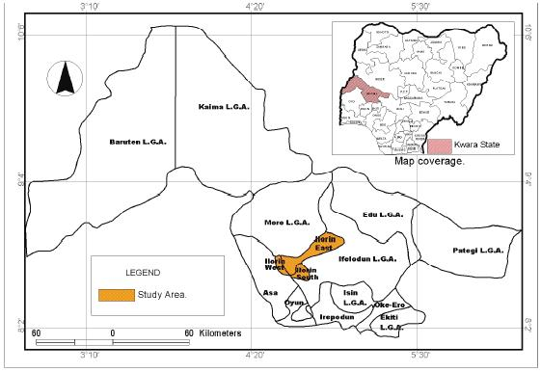
fig. 3.1: map showing the location of kwara polytechnic area.

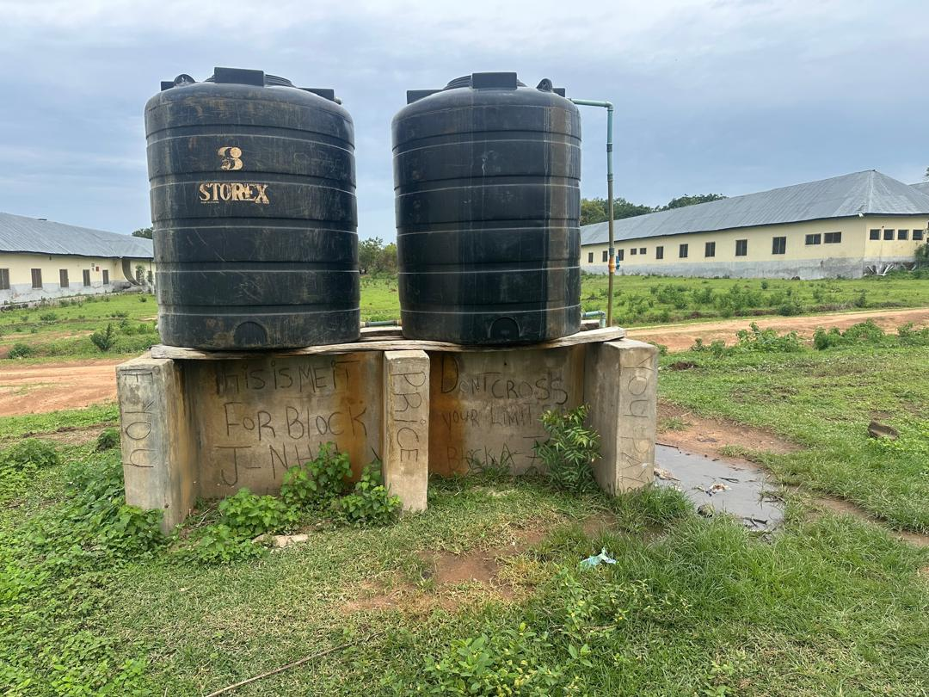
Plate 3.1: Borehole water (sample A)
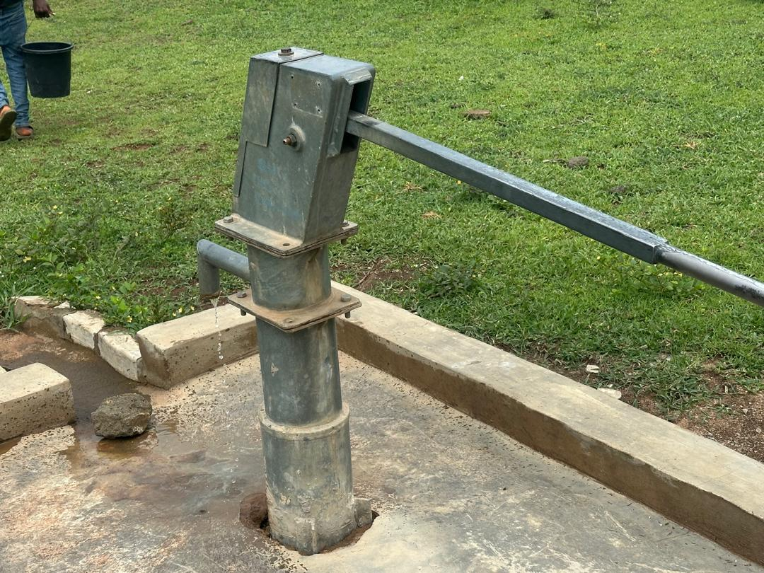
Plate 3.2: Borehole Water (sample B)
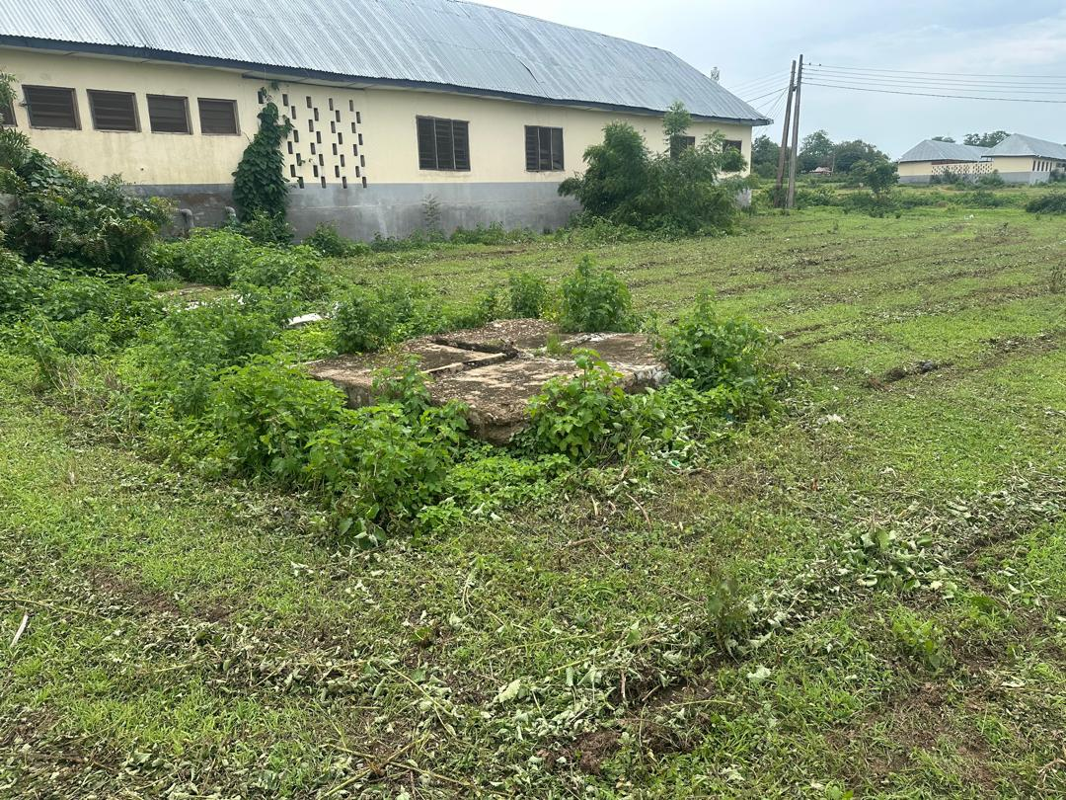
Plate 3.3: Located soak away at Yankari Hostel (K)

3.4 Population and Sampling
3.4.1 Target Population
The target population includes all groundwater sources (boreholes) located around Kwara state polytechnic Hostel that are in use for drinking, cooking, and sanitation.

3.4.2 Sampling Method
Two 2-liter samples of borehole water were collected:
- Sample A –40m from the sewage facility.
- Sample B –15m to the sewage facility.
This gradient-based sampling approach allows assessment of how water quality changes as distance from the contamination source increases.
3.5 Data Collection Methods
3.5.1 Physical Parameters
The following were measured on-site using portable instruments:
- pH — measured with a digital pH meter
- Temperature — measured with a thermometer
- Turbidity — measured using a turbidity meter
These indicators provide quick assessments of basic water quality conditions.

3.5.2 Chemical Parameters
Water samples were collected in sterile 1-liter plastic bottles, labeled, and transported in coolers to the laboratory for chemical analysis, which included:
- Nitrate (NO₃⁻) — using spectrophotometric method
- Phosphate (PO₄³⁻) — using colorimetric method
- Heavy metals (lead, cadmium) — using atomic absorption spectrophotometry (AAS)
3.5.3 Microbiological Parameters
For microbial analysis:
- Total coliform counts and
- E. coli presence
Were determined using the membrane filtration method or multiple-tube fermentation method following WHO guidelines. Sterile sampling bottles were used, and samples were processed within 7 days to ensure accuracy.
3.6 Data Analysis Techniques
Collected data were analyzed using the following approaches:
- Descriptive statistics (mean, range, standard deviation) to summarize water quality results.
- Comparative analysis against WHO and Nigerian drinking water standards to determine compliance.
- Correlation analysis (using Pearson’s correlation coefficient) to assess the relationship between distance from sewage facility and contamination levels.
Graphical presentation (bar charts, scatter plots, line graphs) to visualize spatial trends in contamination.
3.7 Quality Control Measures
To ensure data reliability:
- All instruments were calibrated before use.
- Sampling bottles were sterilized and rinsed with sample water before collection.
- Duplicate samples were collected and analyzed to check for consistency.
- Standard laboratory protocols were strictly followed.
3.8 Ethical Considerations
- Approval: Ethical approval was obtained from the university’s research ethics committee.
- Consent: Permission was secured from hostel management before accessing sampling points.
- Confidentiality: Data were used solely for research purposes, and no personal or sensitive information was collected.
- Feedback: Study findings will be shared with the hostel authorities to aid in improving water management practices.
3.9 Limitations of the Study
The study faced some limitations:
- Only five sampling points were selected, limiting the generalizability of results.
- Sampling was conducted during a single season (dry or wet), which may not account for seasonal variations.
- The focus was on sewage-related contamination; other potential contamination sources (e.g., agricultural runoff) were not assessed.

CHAPTER FOUR
4.0 RESULTS AND DISCUSSION
4.1 Results
Physico-Chemical Analysis results for different sampling location
Parameter/unit | Sample A | Sampe B | WHO
Turbidity (NTU) | 0.5 | 0.9 | 5.0
Electric conductivity (µS/cm) | 200.0 | 374.0 | 1000
PH | 6.51 | 7.82 | 6.5- 8.5
Total dissolved solids (mg/l) | 120.2 | 224.4 | 500
Total hardness (mg/l) | 51.5 | 97.6 | 100
Total alkalinity (mg/l) | 87.6 | 192.0 | 100
Hydrogen sulphide (mg/l) | 0.0 | 0.0 | 0.01
Chloride (mg/l) | 5.8 | 8.8 | 100
Sulphate (mg/l) | 4.2 | 5.6 | 100
Nitrate (mg/l) | 2.1 | 3.5 | 10.0
Nitrite (mg/l) | 0.0 | 0.01 | 0.02
Sodium (mg/l) | 14.6 | 17.4 | 100
Temperature ℃ | 29.1 | 29.1 | 0
colour | 0.3 | 0.5 | 3
Filterable solids (mg/l) | 11.4 | 16.5 | 500
Iron (mg/l) | 0.07 | 0.11 | 0.3
Magnesium (mg/l) | 0.9 | 2.2 | 2.0
Coliform count (cfu/ml) | 1.0 | 2.0 | 0
Total viable plate count (cfu/ml) | 63.0 | 93.0 | -

Observation:
Sample B showed higher concentrations of major indicators (alkalinity, hardness, nitrate, etc.), indicating possible contamination due to sewage proximity.
4.2 Microbiological Analysis results
parameter | Sample A | Sample B | NIS
Total viable plate count | 63 cfu/ml | 93 cfu/ml | _
Coliform count | 1 cfu/ml | 2 cfu/ml | 0 cfu/ml
e. coli | 0 cfu/ml | 0 cfu/ml | 0 cfu/ml
Observation:
Sample B had a higher coliform count (2 cfu/mL) than Sample A (1 cfu/mL), violating the NIS standard of zero coliforms in potable water.
4.3 Discussion
Sample B’s elevated values in multiple indicators strongly suggest that its closer proximity to the sewage facility has compromised its quality. While both samples were deemed “fair” by the analyst, Sample A is safer for consumption. This supports earlier findings (Adewuyi & Badmus, 2020) and indicates the risk of pathogen and nutrient infiltration into the groundwater system.

CHAPTER FIVE
5.0 CONCLUSION AND RECOMMENDATIONS
5.1 Conclusion
This study confirms that proximity to a sewage facility significantly affects groundwater quality. Sample B demonstrated a closer sewage site and higher values in microbial and chemical contaminants, highlighting the need for safer borehole siting.
5.2 Recommendations
- Enforce minimum safe distances between boreholes and sewage facilities.
- Conduct regular water quality assessments in susceptible areas.
- Implement community-based education on groundwater protection
- Treat borehole water before consumption, especially near sewage sites.
- Government agencies should enforce water safety regulations more strictly.

REFERENCES
Adelana Oluwaseun, A., Ayoola, A., et al. (2002). Groundwater quality in Nigeria: Impacts of urbanization and sewage pollution. Journal of African Earth Sciences.
Adewuyi, T.O., Ndiritu, & Badmus, B.S. (2020). Water quality assessment of groundwater near waste dumpsites. Environmental Monitoring and Assessment, 192(3), 157.
Emenike, Afolabi, O. A., et al. (2018). Microbial and chemical quality of water sources near sewage disposal points in Nigeria. Nigerian Journal of Environmental Sciences.
Standards Organisation of Nigeria (2017). Nigerian Industrial Standard for Drinking Water Quality, NIS 977:2017.
WHO (2017). Guidelines for Drinking-water Quality, 4th ed. World Health Organization.

