SMART ATTENDANCE MONITORING SYSTEM USING SMART CARD IDENTIFICATION

By
USMAN IBRAHIM SOSO
HND/23/COM/FT/598

A Project Submitted to the Department of Computer Science, Institute of Information and Communication Technology, Kwara State Polytechnic, Ilorin

In Partial Fulfillment of the Requirements for the Award of Higher National Diploma [HND] In Computer Science

June, 2025

CERTIFICATION
This is to certify that this project was carried out by USMAN Ibrahim Soso with matriculation number HND/23/COM/FT/598 has been read and approve as meeting part of the requirements for the award of Higher National Diploma (HND) in Computer Science.

_______________________ ___________________
MR. SAKA T. O. Date
Project Supervisor

_______________________ ___________________
MR. OYEDEPO F. S Date
Head of Department

_________________________ ____________________
EXTERNAL EXAMINER Date
DEDICATION
This project is dedicated to the creator of the earth and universe, the Almighty God. It is also dedicated to my parents for their moral and financial support.

ACKNOWLEDGEMENT
All praise is due to the Almighty God the Lord of the universe. I praise Him and thank Him for giving me the strength and knowledge to complete my HND programme and also for my continue existence on the earth.
I appreciate the utmost effort of my supervisor, Mr. Saka, T. O., whose patience support and encouragement have been the driving force behind the success of this research work. She gave useful corrections, constructive criticisms, comments, recommendations, advice and always ensures that excellent research is done. My sincere gratitude goes to the Head of the Department and other members of staff of the Department of Computer Science, Kwara State Polytechnic, Ilorin, for their constant cooperation, constructive criticisms and encouragements throughout the programme.
Special gratitude to my parents who exhibited immeasurable financial, patience, support, prayers and understanding during the periods in which I was busy tirelessly in my studies. Special thanks go to all my lovely siblings.
My sincere appreciation goes to my friends and classmates.

TABLE OF CONTENTS
Title Page i
Certification ii
Dedication iii
Acknowledgements iv
Abstract v
Table of Contents vi
CHAPTER ONE: GENERAL INTRODUCTION
  - Background to the Study 1
  - Statement of the Problem 3
  - Aim and Objectives of the Study 4
  - Significance of the Study 4
  - Scope of the Study 5
  - Organization of the Report 5
CHAPTER TWO: LITERATURES REVIEW
  - Review of Related Works 7
  - Review of Related Concepts 12
CHAPTER THREE: RESEARCH METHODOLOGY AND ANALYSIS
  - Research Methodology 20
  - Analysis of the Existing System 20
  - Problems of the Existing System 21
  - Description of the Proposed System 21
  - Advantages of the Proposed System 22
CHAPTER FOUR: DESIGN, IMPLEMENTATION AND DOCUMENTATION OF THE SYSTEM
  - Design of the System 24
    - Output Design 24
    - Input Design 29
    - Database Design 33
    - Procedure Design 34
  - Implementation of the System 34
    - Choice of Programming Language 35
    - Hardware Support 35
    - Software Support 36
  - Documentation of the System 36
    - Program Documentation 37
    - Maintaining the System 37
CHAPTER FIVE: SUMMARY, CONCLUSION AND RECOMMENDATION
  - Summary 39
  - Conclusion 40
  - Recommendation 40
References
System Flowchart / Program Flowchart of the Existing System
Source Program Listings

ABSTRACT
This project is focusing on student attendance monitoring system with smart card identification; it also provides the design method of smart card-based student attendance with help of the card reader. This system ignores the requirement for stationary materials and personnel for keeping of records. Attendance is the act or fact of attending school or college. Also, attendance is used to define the number of persons present on a particular day at school. An attendance policy provides the guidelines and expectations for students’ attendance at school as defined, written, disseminated, and implemented by the school. Depending on the school, attendance may be entered by the head of department or by the head of institute, or possibly, both. The system will be developed using Microsoft Visual C sharp with MySQL for the database and a card reader for smart card identification.
CHAPTER ONE
GENERAL INTRODUCTION
1.1 BACKGROUND TO THE STUDY
In modern academic and professional environments, accurate attendance management is critical for performance monitoring, resource allocation, and regulatory compliance. Traditional methods such as manual roll calls or paper-based records are prone to errors and inefficiencies. Despite the introduction of biometric systems, challenges such as user resistance and equipment malfunctions remain (Abhilash & Kumar, 2022).
Johnson (2021) claimed that attendance is one of the important issues for colleges and offices because many colleges evaluate students’ attendance and while giving the final grade, professors consider their total number of appearances on classes during the whole semester. Some colleges prefer to use paper sheet for controlling attendance, whereas some colleges prefer to use paper sheet for checking students' attendance and after this, fill out this information into a system manually. Generally, students’ performance in studies is depending on the attendance. There is a need to develop system that reduces burden in analyzing the attendance and enhance smooth functioning of schools, colleges and colleges and to help the parents.
Smart card technology has emerged as a viable alternative due to its simplicity, cost-effectiveness, and widespread acceptance. A smart card-based attendance system automates the process, minimizes errors, and enhances the overall user experience. This technology leverages embedded chips capable of storing user data securely, enabling rapid and accurate attendance recording (Smith, 2019).
In this project paper, the researchers explore the concept, architecture, and implementation of a smart attendance system utilizing smart cards. By examining its objectives and advantages, the paper demonstrates the system's potential to address existing challenges in attendance management effectively. The proposed system is designed to integrate seamlessly with existing infrastructures, ensuring easy adoption and minimal disruption. Its scalability and flexibility make it suitable for various use cases, including educational institutions, corporate offices, and events.
By leveraging advancements in smart card technology and automation, the smart attendance system ensures efficiency, accuracy, and a streamlined user experience. This paper highlights its key features, benefits, and implementation methodology, paving the way for broader adoption and innovation.
The level of impersonation as well as the ghost worker syndrome in recent times is enormous, in both the private and the public sector, therefore, there is need for a new system which will wipe out all these enumerated issues. The human body has the privilege of having features that are unique and exclusive to each individual. This exclusiveness and unique characteristic have led to the field of biometrics and its application in ensuring security in various fields. Biometrics has gained popularity and has proved itself to be a reliable mode of ensuring privacy, maintaining security and identifying individuals. Today, the technology is being spotlighted as the authentication method because of the need for reliable security Amit, Varma, Srinivas & Chadha, 2016).
Attendance is the action or state of going regularly to or being present at a place or event. Attendance in an organization is important to ensure the continuous operation as it determines the strength of the organization. In most institutions the current attendance monitoring system for students is still being manually done. This method is time consuming, error prone and fosters laziness on the part of students, nonchalance attitude to classroom lectures and activities, student nepotism and deliberate lecture skipping which may prevent students from obtaining good academic performance. One reliable and efficient way to curb and totally do away with the error prone, student nepotism etc. is employing computerized fingerprint recognition attendance monitoring system which will enable management of the department ascertain the academic strength of each student in terms of student punctuality, regularity, commitment to classroom lectures and generate reliable attendance report for each student stored in a secured database (Sogbaike & Ahoro, 2019).
1.2 STATEMENT OF THE PROBLEM
Attendance monitoring is a critical task in various environments, such as educational institutions, workplaces, and events. Traditional attendance methods, including manual roll calls and sign-in sheets, are often inefficient, prone to errors, and susceptible to fraudulent practices such as proxy attendance. While card-based systems have introduced some level of automation, they also present challenges, including lost or misplaced cards, delays in processing, and potential for misuse. In educational settings, these inefficiencies can disrupt learning, while in workplaces, they can lead to inaccurate payroll calculations and productivity losses. Additionally, many existing attendance systems lack real-time monitoring and reporting capabilities, making it difficult to track and manage attendance data effectively.
1.3 AIM AND OBJECTIVES OF THE STUDY
The aim of this study is to design and develop a Smart Attendance Monitoring System using Smart Card Identification to streamline attendance tracking, enhance accuracy, and prevent fraudulent practices. The system seeks to leverage smart card technology for efficient, secure, and real-time attendance management across various environments, including educational institutions and workplaces. Objectives are as follows:
- To develop a reliable and user-friendly system that uses smart card identification to automate attendance recording.
- To integrate real-time monitoring and reporting capabilities, enabling administrators to track attendance instantly.
- To enhance security by implementing unique smart card identifiers that minimize the risk of proxy attendance and misuse.
- To reduce administrative workload and eliminate manual errors in attendance management.
- To ensure compatibility and scalability by designing the system to integrate seamlessly with existing infrastructure and databases.
1.4 SIGNIFICANCE OF THE STUDY
The Smart Attendance Monitoring System using Smart Card Identification addresses the limitations of traditional and semi-automated attendance systems by offering a streamlined and efficient solution for attendance tracking. Its significance lies in its ability to reduce administrative burdens, enhance data accuracy, and prevent fraudulent practices such as proxy attendance. By leveraging smart card technology, the system ensures secure and reliable identification of individuals, making it suitable for educational institutions, workplaces, and events.
The study is also significant for its contribution to technological advancements in attendance management. It demonstrates how smart card systems can be integrated with real-time reporting tools to provide immediate access to attendance data, aiding decision-making and operational efficiency. Furthermore, this research promotes the adoption of cost-effective and scalable solutions that can be tailored to various organizational needs, enhancing productivity and accountability.
1.5 SCOPE OF THE STUDY
This study focuses on the design, development, and evaluation of a Smart Attendance Monitoring System using Smart Card Identification. The scope includes implementing a system that captures attendance data through smart cards, processes the information in real-time, and generates detailed reports for administrators. It also involves testing the system in environments such as schools, universities, and corporate offices to evaluate its performance under different conditions.
The study will address technical aspects such as database integration, system security, and real-time data processing. However, it does not include the development of hardware for smart cards or card readers, as these are assumed to be commercially available. The research is limited to attendance monitoring and does not extend to other applications of smart card technology, such as financial transactions or access control systems.
1.6 ORGANISATION OF REPORT
This report is organized as stated below chapter one discusses the general introduction and overview of the whole project. It also discusses the statement of the problem, aim and objectives of the proposed system, significance of the study, scope of the project and organization of the report. Chapter two deals the literature review, the review of related writing of the project topic, it gives a detail information of all writing related to the topic which help to know for information on the project topic. Chapter three deals with analysis of the system which include the data collection method employed, the description of the existing system and its problems and the description of the proposed system and possible advantages it will provide and will solve the problems encountered in the existing manual system. While chapter four deals with the design, implementation and the description of the proposed system. It covers description of the output design, input design, database design and procedure design. The implementation techniques used, the programming language used in developing the new system and system requirements for running the system. And also talks about the program documentation as well user documentation. Lastly chapter five present a brief summary of the work done, experience gained and problems encountered in the course of the project, conclusion and recommendation. Other appendices included after the references used are; algorithm, system flowchart, program flowchart, program source listing and generated computer output.

CHAPTER TWO
LITERATURE REVIEW
2.1 REVIEW OF RELATED WORK
The development of automated attendance systems has seen significant advancements over the years, particularly with the integration of various technologies such as RFID, biometrics, and smart cards. Several studies and projects have been conducted that explore the use of these technologies for attendance management, providing valuable insights into the effectiveness and challenges of such systems. Below is a review of related work on attendance monitoring using smart card identification and other relevant technologies. Fingerprint may be deposited in natural secretions from the endocrine glands present in friction ridge skin (secretions consisting primarily of water) or they may be made by ink or other contaminants transferred from the peaks of friction skin ridges to a relatively smooth surface such as a fingerprint card (James, Rehg & Takeo, 2018). The term fingerprint normally refers to impressions transferred from the pad on the last joint of fingers and thumbs, through fingerprint cards also typically record portions of lower joint areas of the fingers. An individual’s fingerprint is scanned to identify 10 to 26 unique points of the finger, and a unique number is assigned to it. Currently, there is no proper system to monitor the employees' attendance at some companies. Besides, the company still uses the paper-based system to keep track of the records of the employees. As a solution, the Fingerprint Biometrics Student Attendance Monitoring system will be developed to overcome the problems that are stated above and provide an effective way to monitor the employees' attendance.
“Time” they say is “Money”. There is perhaps no more accurate analogy in business. Unfortunately, if there is one thing we all have difficulty managing, it is time. This includes the ability to accurately measure and manage the time and attendance of student (Aberdeen, 2008).
Indeed, new research from Aberdeen group reveals that time and attendance monitoring systems are now the very cornerstone for laying a foundation of effective workforce management systems. No wonder, then, that growing number of companies are eager in upgrading and adopting time and attendance systems. Clients and colleagues count on student to be at work as scheduled to provide smooth and efficient operations (Jones, 2016). Although there are separate regulations governing different categories of student, regular and punctual attendance is an ongoing expectation for all student, both classified and professional. The definition of the actual arrival time that constitutes a tardy or late occurrence is at the discretion of the supervisor, with consideration given to the type of position (for example, receptionist), client needs, and other relevant information. Failure to maintain an acceptable attendance record may result in an unsatisfactory performance evaluation and/or disciplinary action up to and including dismissal (Sato, Kobayashi & Koike, 2010).
Fingerprint may be deposited in natural secretions from the endocrine glands present in friction ridge skin (secretions consisting primarily of water) or they may be made by ink or other contaminants transferred from the peaks of friction skin ridges to a relatively smooth surface such as a fingerprint card (James, Rehg & Takeo, 2018).
The term fingerprint normally refers to impressions transferred from the pad on the last joint of fingers and thumbs, through fingerprint cards also typically record portions of lower joint areas of the fingers. An individual’s fingerprint is scanned to identify 10 to 26 unique points of the finger, and a unique number is assigned to it. Currently, there is no proper system to monitor the employees' attendance at some companies. Besides, the company still uses the paper-based system to keep track of the records of the employees. As a solution, the Fingerprint Biometrics Student Attendance Monitoring system will be developed to overcome the problems that are stated above and provide an effective way to monitor the employees' attendance.
The use of biometric identification in a person’s authentication process enhances the rapid progress of this technology to be implemented in different areas. Person’s identification is understood to be a vital part in distinguishing the personality of the specific individual. A person’s uniqueness can either be authenticated through the conventional or biometric means (Sato, Kobayashi & Koike, 2010). “Fingerprint identification is popular because of the inherent ease in acquisition, the numerous sources (ten fingers) available for collection, and their established use and collections by law enforcement and immigration” (Ini & Ruud, 2014). It is basically impossible to share or misplace biometric identifiers because they naturally characterize a person’s distinctiveness. They are rapidly becoming vital constituents for efficient identification solutions (Rao & Satoa, 2021).
Also, recognition of an individuals by their body and associating the body to an outwardly recognized “identity” forms a potent verification tool (James, Rehg & Takeo, 2018).
Biometric identification has been successfully utilized to alleviate fraud and increase the convenience of users’ operations (Jones, 2019).
Fingerprint recognition technique has been outstanding in commercial applications as it provides a good stability when it comes to accuracy, throughput, size and cost and ease of use, hence, making it at the foremost of Biometric identification operations, fingerprint identification offers several advantages that other technologies cannot provide. This includes uniqueness, since the fingerprint of individual are distinct and irreplaceable, no two persons have the same fingerprint feature. It is also convenient because there is no need to keep multiple and complex passwords to login. Also, the method is nontransferable, and its long history of success has been proved compared to other biometric authentication methods operations (Jones, 2019).
Consequently, there is need to implement reliable attendance monitoring system based on biometric recognition for employees in order to establish a workforce that is dedicated to steering the affairs of institutions of higher learning forward. The following section reviewed some works done on fingerprint biometric identification.
Saidot et al., (2018), in their study "Biometric Attendance Monitoring System using Raspberry PI and Fingerprint" proposed a biometric technology based on Internet-of-things (IoT) with the encrypted biometric information stored on the cloud using Raspberry Pi and authentication created through biometric services as the host on cloud.
According to Eze and Uzoechi (2019), worked on “Design of a Biometric Attendance System with Online Monitoring for a University System". The study developed a system that combines fingerprint Attendance system with remote monitoring for student and students of institutions of higher learning. The system was also developed to be web-based with real-time remote monitoring interface with the capability to enable the management to view student as they check-in and out of the system. The study emerged as a result of the absence of student and students in classes resulting in the poor quality of graduates turned out.
Bhise et al., (2015) proposed an "Attendance System using NFC technology with an embedded camera on mobile devices". The need to provide a better means of evaluating student’s attendance necessitated this study, the developed system was based on NFC technology and run on a mobile application. Adewole et al (2014) worked on the study "Development of Fingerprint Biometric Attendance System for Non-Academic Student in a Tertiary Institution". The study identified the need to migrate from the manual means of taking attendance to an automated one to improve the productivity of the institution.
2.2 REVIEW OF RELATED CONCEPTS
Managing people is a difficult task for most of the organizations, and maintaining the attendance record is an important factor in people management. Manually taking the attendance and maintaining it for a long time adds to the difficulty of this task as well as wastes a lot of time (Taxila, 2019). Most of the attendance systems use paper-based methods for taking and calculating attendance and this manual method requires paper sheets and a lot of stationery material (Oloyede, 2021).
Biometrics techniques are widely used in various areas like building security, forensic science, ATM, criminal identification and passport control. The fingerprint recognition is widely used for many other purposes and it is widely popular technique. The Fingerprint is the feature pattern of one finger or an impression of friction ridges found on inner surface of finger as shown in figure 1(a). Everyone in this world has his own fingerprint with the permanent uniqueness. A fingerprint is made up of ridges and furrows, which shows good similarities like parallelism and average width (Oloyede, 2014).
Fingerprint attendance system comprises at least one fingerprint scanner and a computer server. First templates of fingerprint related data are stored on the server, and similar templates are stored on the scanner. When a fingerprint is scanned, the fingerprint data is transmitted to the server, where a comparison is made. The server directs the scanner to display an indication whether or not a match was found (Jones, 2016).
2.2.1 Biometrics
Biometrics refers to the automatic identification of a person based on his physiological/behavioural characteristics, this method of identification is preferred for various reasons; the person to be identified is required to be physically present at the point of identification. Identification based on biometric techniques obviates the need to remember a password or carry a token. With the increased use of computers or vehicles of information technology, it is necessary to restrict access to sensitive or personal data. By replacing Personal Identification Number, biometric techniques can potentially prevent unauthorized access to fraudulent use of Automated Teller Machine, cellular phones, smart cards, desktop PCs, workstations, and computer networks. Personal Identification Number and passwords may be forgotten, and token based methods of identification like passports and driver’s licenses may be forged, stolen, or lost. Thus, biometric systems of identification are enjoying a renewed interest. Various types of biometric systems are being used for real–time identification; the most popular are based on face recognition and fingerprint matching. However, there are other biometric systems that utilize iris and retinal scan, speech, facial thermo grams, and hand geometry
2.2.2 Fingerprint Scanner
Perhaps most of the work in biometric identification has gone into the fingerprint. For general security and computer access control application fingerprints are gaining popularity. The fingerprint’s stability and uniqueness is well established. Based upon a century of examination, it is estimated that the change of two people, including twins, having the same print is less than one a billion. In verifying a print, many devices on the market analyze the position of details called minutiae such as the endpoi{nts and junctions of print ridges. These devices assign locations to the minutiae using x, y, and directional variables. Some devices also count the number of ridges between minutiae to form the reference template. Several companies claim to be developing templates of fewer than 100 bytes. Other machines approach the finger as an image processing problem and applying custom very large-scale integrated chips, neural networks, fuzzy logic and other technologies to the matching problem. The fingerprint recognition technology was developed for some 12 years before being matched in 1983 by Identix Inc.
2.2.3 Benefits of Fingerprint
Today fingerprint devices are by far the most popular form of biometric security in use, with a variety of systems on the market intended for general and mass-market usage. Long gone are the huge bulky fingerprint scanners; now a fingerprint-scanning device can be small enough to be incorporated into a laptop for security.
2.4 Fact and Findings of Attendance System
Student attendance software system is a software used to manage or monitor the time worked by employees for the purpose of efficiency and punctuality of the employees. These systems may be integrated with existing payroll processing software. Also, these systems track employee that come late to work and the ones that come early. These systems usually are able to give reports of all the student records concerning signing in and out. The advantages of student attendance monitoring system are: it can reduce the time needed to enter 'hours worked' data into payroll system and can reduce errors in enforcement of company attendance policies. Student Attendance Monitoring System is an easy way to keep track of any organization's attendance records. It also works very well as a member database. The program was developed with three main goals in mind: versatility, ease of use, and security.
2.5 Smart Card-Based Attendance Systems
Smart card-based systems have gained popularity in attendance management due to their simplicity, reliability, and ease of integration into existing infrastructures. Smart cards, which store a unique identifier for each user, are used to record attendance by tapping them against a reader. These systems are widely adopted in educational institutions and workplaces due to their accuracy and cost-effectiveness. A study by Johnson and Williams (2019) developed a smart card-based attendance system that utilized magnetic stripe cards to capture attendance data. The system successfully reduced manual efforts, increased accuracy, and provided real-time updates to administrators. However, the study pointed out the challenges of card loss, system reliability, and limited scalability.
Similarly, Lee et al. (2018) proposed a smart card system integrated with a cloud database, which allowed real-time attendance tracking and automated report generation. This study highlighted the flexibility of cloud integration in managing large datasets and providing access to attendance information from remote locations. However, the study did not explore issues related to data security or smart card vulnerabilities.
2.6 RFID-Based Attendance Systems
Radio Frequency Identification (RFID) technology has also been commonly used for attendance monitoring. RFID systems function similarly to smart cards but offer the added benefit of contactless operation, which improves convenience and speed.
In a study by Kumar et al. (2017), RFID-based attendance systems were implemented in an educational setting. The system used RFID tags embedded in student IDs, which were detected by RFID readers at entry points to record attendance automatically. The results showed high efficiency, with students being able to clock in and out without delays. However, challenges related to tag interference, RFID reader placement, and the need for consistent connectivity were identified as areas for further improvement.
2.7 Biometric-Based Attendance Systems
Biometric systems, particularly fingerprint recognition and facial recognition, have become popular alternatives to smart card-based systems due to their ability to ensure higher security and reduce fraudulent practices. However, biometric systems often face challenges such as user discomfort, privacy concerns, and the impact of environmental factors.
In a paper by Patel and Bhattacharya (2020), the authors explored the use of fingerprint recognition for automated attendance in educational institutions. The system was able to verify student identities accurately, but it struggled with issues such as fingerprint quality, sensor malfunctions, and users' reluctance to use the system. Despite these challenges, the system was praised for its high accuracy and potential to eliminate proxy attendance.
Similarly, Zhao et al. (2016) conducted a study on the application of facial recognition for attendance tracking in a workplace environment. While the system demonstrated high accuracy and ease of use, it faced challenges with lighting conditions, face occlusions (such as masks or hats), and user privacy concerns. The study concluded that facial recognition might not be the most practical solution for all scenarios due to its sensitivity to environmental factors.

CHAPTER THREE
3.0 METHODOLOGY AND ANALYSIS OF THE EXISTING SYSTEM
3.1 RESEARCH METHODOLOGY
In the analysis of the existing system, the information gathered were analyzed in a more relevant and useful data. Data analysis that was gotten was based on the identification of the basic needs and also the structure of project. The data gatherer shows that they are analyzed, restructured in a way that the subsystem was achieved efficiently. There are also facilities for testing of knowledge
The system operates by authenticating users through their smart cards. Upon validation, the attendance data is automatically updated in the central database, ensuring accuracy and real-time processing.
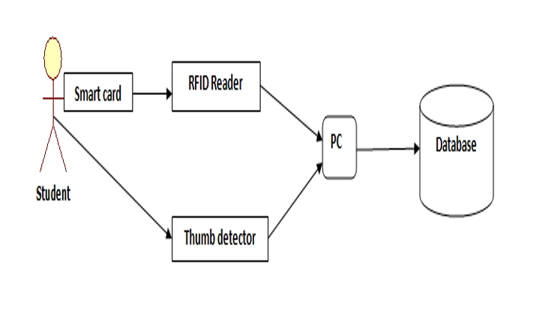 Figure 3.1: Architecture of Smart Card Attendance System
Implementation Process
- Requirement Analysis: Identify the needs and challenges of the target environment.
- System Design: Develop the hardware and software components, ensuring compatibility and scalability.
- Smart Card Issuance: Distribute smart cards to users, preloaded with unique identification data.
- System Deployment: Install card readers, establish network connections, and integrate with the central database.
- Testing and Validation: Conduct rigorous testing to ensure system reliability and user acceptance.
- Training and Maintenance: Provide training for administrators and establish a maintenance protocol to address technical issues.
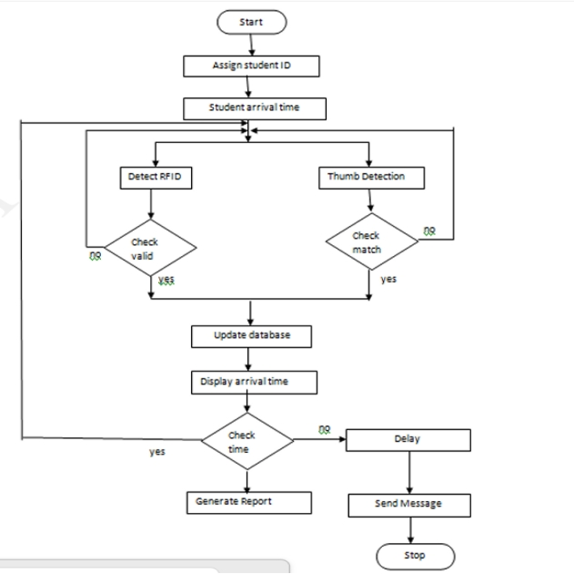
Figure 2: Workflow of Smart Card Attendance
3.2 ANALYSIS OF THE EXISTING SYSTEM
The analysis of the existing attendance systems reveals significant limitations and inefficiencies that impact their overall reliability and effectiveness. Traditional manual systems, such as roll calls or paper-based registers, remain prevalent but are highly prone to human errors, including incorrect or incomplete data entry and misplacement of records. These systems are time-consuming, particularly in large organizations or educational institutions, as the process of recording attendance manually disrupts operational flow and consumes valuable time.
Semi-automated systems, including swipe card or barcode-based methods, offer some level of improvement but still present challenges. These systems require physical interaction with hardware, which can lead to wear and tear over time. Furthermore, the issue of fraud, such as proxy attendance or card sharing, remains a significant concern as these systems lack robust authentication mechanisms. Lost or damaged cards further complicate the process, leading to delays and additional costs for replacement.
This system contains student records and monitors student movement, it monitors all the movement of the student pertaining to assumption time and closing time.
3.3 DESCRIPTION OF THE PROPOSED SYSTEM
The proposed Smart Attendance Monitoring System using Smart Card Identification is designed to provide a secure, efficient, and automated solution for managing attendance. This system employs smart cards embedded with unique identifiers to record attendance in real-time. The cards are issued to each user, such as students or employees, and are linked to a centralized database that securely stores attendance records.
When a user taps their card on a card reader at designated points, such as classroom entrances or office entryways, the system automatically logs the time and attendance details. The system is equipped with attendance management software that facilitates user registration, real-time attendance logging, and report generation. Administrators can monitor attendance, analyze trends, and generate detailed reports with minimal effort. Additionally, users can access their attendance records through an intuitive interface.
The system addresses common issues found in traditional attendance systems, such as inaccuracies, fraud, and inefficiencies. Smart card identification eliminates the possibility of proxy attendance, ensuring that only authorized users can record their presence. Real-time data updates and secure encryption protect the integrity and privacy of attendance records, while automated reporting saves time and enhances decision-making processes.
Unlike manual or biometric systems, the smart card system is cost-effective, user-friendly, and scalable. It can be integrated into existing administrative frameworks and adapted for various organizational sizes. By leveraging smart card technology, the proposed system ensures accuracy, security, and convenience, making it a reliable and practical solution for modern attendance management.

3.4 PROBLEMS OF THE EXISTING SYSTEM
- Manual Errors:
Traditional attendance systems, such as roll-call or paper-based methods, are prone to human errors, including incorrect marking, missing entries, or misplacement of records. These errors can lead to inaccurate attendance data, affecting administrative processes and decision-making.
- Fraud and Proxy Attendance:
One of the main issues with manual and card-based systems (e.g., magnetic swipe cards) is the potential for proxy attendance. Students or employees can easily sign in for others, leading to false attendance records and undermining the system's integrity.
- Card Loss or Damage:
In card-based attendance systems, lost, damaged, or stolen cards pose significant challenges. Users may miss attendance tracking due to a malfunctioning card, and replacing lost or damaged cards can incur additional costs and administrative effort.
- High Initial and Maintenance Costs:
Biometric systems such as fingerprint scanners or facial recognition technology require expensive hardware and ongoing maintenance. The high cost of specialized devices can be a significant barrier for institutions or organizations with limited budgets.
- Environmental Sensitivity:
Systems like facial recognition or fingerprint scanning are highly sensitive to environmental factors such as lighting, skin condition (for fingerprint systems), or obstructions (like glasses or masks for facial recognition). These factors can lead to incorrect attendance marking or system malfunctions.
- Privacy Concerns:
Biometric systems, especially facial recognition, raise significant privacy concerns. Users may be uncomfortable with the idea of their personal biometric data being stored and used, which can result in resistance to the system's adoption.
- Time-Consuming Processing:
In systems requiring manual data entry or traditional card swiping, the process can be slow, especially during peak periods (e.g., class start times or shift changes). This inefficiency can cause delays and disrupt the flow of daily activities.

3.5 ADVANTAGES OF PROPOSED SYSTEM
- Verification or identification can be accomplished from two feet away or more, without requiring the user to wait for long periods of time. That is, student image can be captured for identification without getting closer to the system and this is done without taking much time.
- It is non-intrusive means accessing data without requiring special information from the student since it is automatic in nature.
- It helps the management maintain a strong security. Since image is used as a means of authentication it is difficult for someone to mark an attendance on behalf of another person and this creates a strong security measure.
- It enhances credibility means the quality of being trusted and believed in
- It saves time and accurate that is, the attendance is taken very fast, correct, exact, and without any mistakes.

CHAPTER FOUR
DESIGN, IMPLEMENTATION AND DOCUMENTATION OF THE SYSTEM
4.1 DESIGN OF THE SYSTEM
This is the computation of the particulars of a new system and the determination of what the new system would be and the function it is to perform. This may involve changing from one system to another or modifying the existing system operation.
The most challenging phase of the system life cycle is the change from manual operation to a faster and more accurate one; system design stage covers the technical specifications that will be employed in the implementation of the new system in order to modify the previous system. Some factors are put in consideration. These factors include input design, output design, definitions file and procedure designs and other documentation.
4.1.1 OUTPUT DESIGN
This incorporates the objectives of solving the existing system problems and challenges. This involves the structuring of the desired information and also to enhance efficient and effective attendance system. Things taken into consideration in determining the output are represented below:
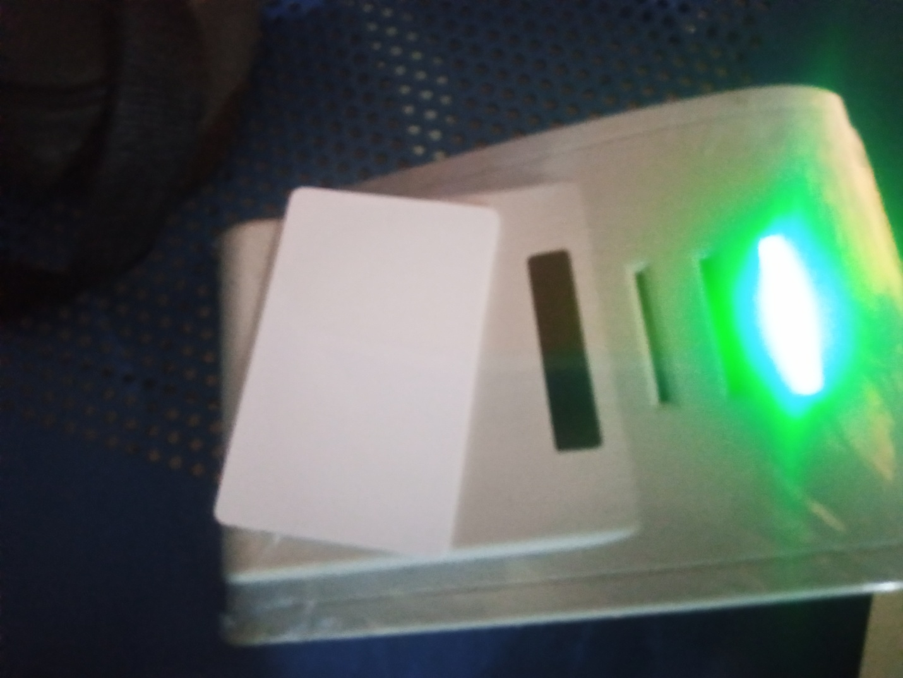
Figure 4.1: Smart Card Enroller
The figure 4.1 above is the card enroller with the smart card. The smart card will be inserted in the space provided and the card reader will read the information on the card chip and if the details are correct with that of the student then an access is granted else its fake.

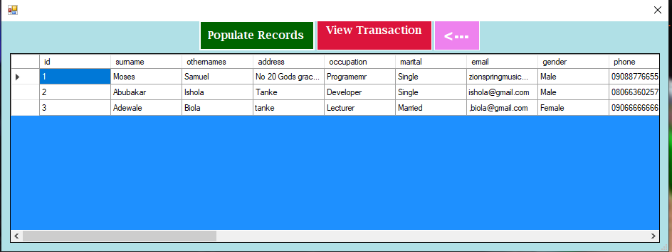
Figure 4.2: Student Records
This displays the records of all the student registered on the system.
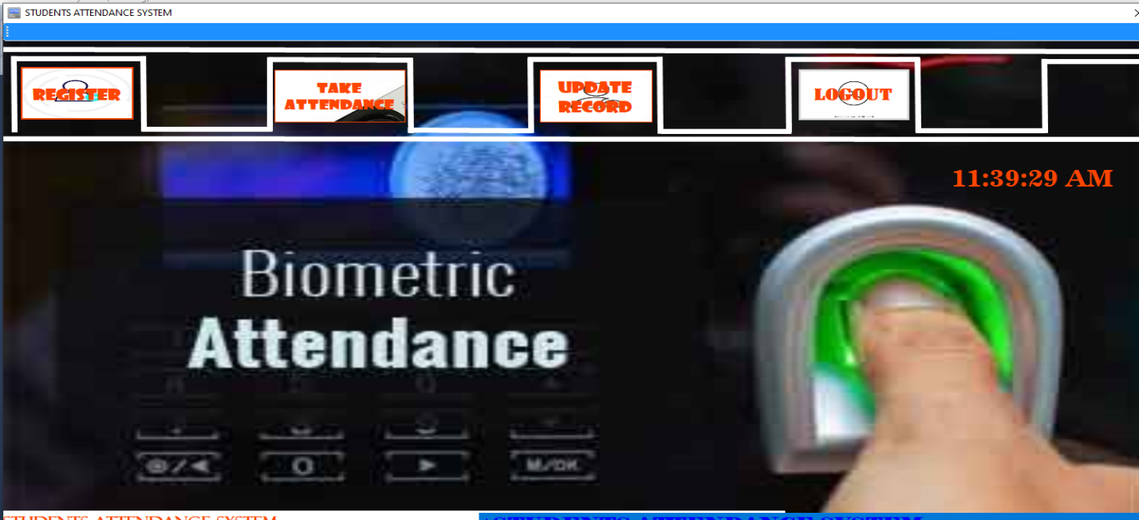
Figure 4.3: Student Interface
This page shows the student interface where some buttons are provided to navigate to another page.
4.1.2 INPUT DESIGN
The input to run this software is obtained from lecture attendance system using fingerprint recognition system. The administrator is expected to safeguard the files and document using fingerprint authentication. The input design describes the input interface for data entry into the program. Data entry interfaces needs to be considered in developing a new system to ensure users’ friendliness. Data entry is done through the use of keyboard, camera, and in some cases selection from the dropdown combos and list boxes are done using mouse selection. The interface descriptions are as shown below:
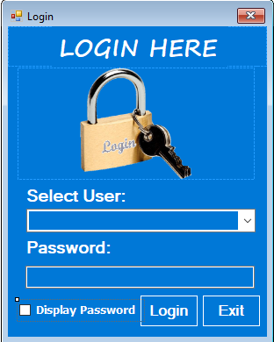
Figure 4.4: Login Interface
This interface is where the admin and student can login to the system by entering their username and password.
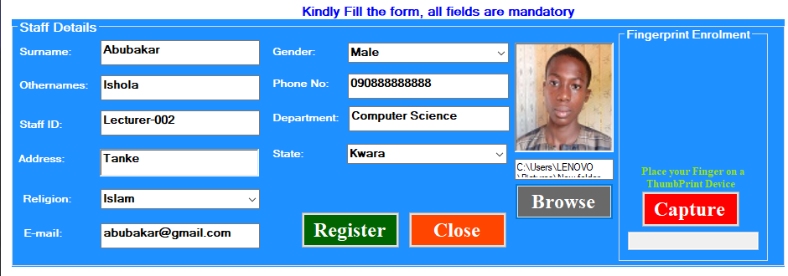
Figure 4.5: Student Registration form
This page displays some textboxes which student will fill to register on the system.
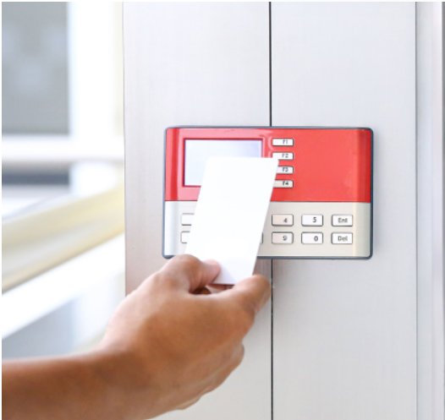
Student ID
Figure 4.6: Student Attendance Interface
This is the page where student will take attendance and the lecturer can view this attendance in the database.
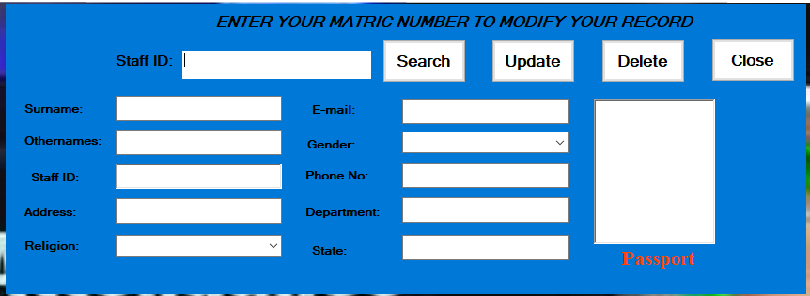
Figure 4.7: Student Records Modification Interface student
4.1.3 DATABASE DESIGN
The structure and organization of records in the tables is a database file is essential to be considered in designing a database driven application. The database files main record where house for keeping data and information relevant for this application.
Table 1: Student Table
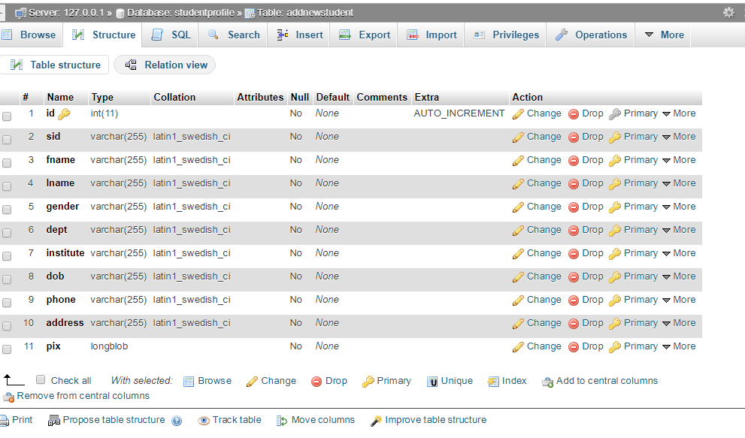
This houses the entire records of registered students.
Table 2: Attendance Table
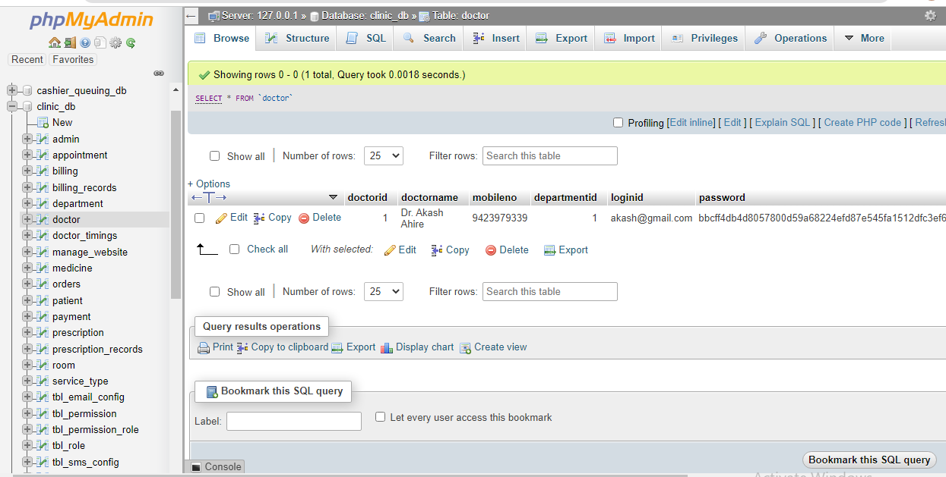
This is the table that house the attendance of all the present students.
4.13 PROCEDURE DESIGN
These are the steps involved in unifying the whole process to produce the desired output. It involves computer procedures which starts from the original input lessons to the output result file. This allows the processing of the information and result to be possible. Menu is provided to aid user in the processing of the output file.
4.2 IMPLEMENTATION OF THE SYSTEM
This entails the choice of the programming language employed to implement the software which should-be suitable for lecture attendance using fingerprint recognition authentication. The software is designed for the use of lecture attendance system which should serve as an assistant for the management in monitoring the attendance system for students.
4.2.1 CHOICE OF PROGRAMMING LANGUAGE
The Application was developed in a .net (dot net) integrated development environment (.net IDE). The Application IDE is chosen following the fact that extracted information needs to be presented in an enhanced pictorial/graphical format and easy communication with the database for program flexibility in windows platform.

4.2.2 HARDWARE REQUIREMENTS
Minimum of Microcomputer Pentium IV- Intel 1.5 GHZ processor, 1.0 GB RAM, 40GB Hard disk, 14” VGA Monitor Windows XP or higher, Enhanced keyboard, mouse and pad.
4.2.3 SOFTWARE REQUIREMENT
i. Windows 7
ii. C#
iii. Fingerprint Sensor
IV. MYSQL Server
4.2.4 CHANGE OVER TECHNIQUE
These deals with the processes and steps taking to put the system into use, before the system can be fully employed into the system, some training might have been done by the user of the application if he or she is a computer illiterate, because the user might be a computer illiterate, so also the system might have also been use.
Since the work of an expert cannot be eliminated from the system, the computerized system will have to work hand in hand with the expert in the field.
4.3 DOCUMENTATION OF THE SYSTEM
After the program has been well tested with input that the output has already been known, the next is to install the software in to the computer system for use.
The process of installing is been stated below
- Insert the CD into the system through the CD-ROM after the computer is switch on
- Locate the CD drive directory in my computer and click it to open
- After open, locate setup.exe, and then click to install the program by following the necessary step in installing the program.
- Ensure full installing of the software for effective operation of the system.
After the program has been fully install. The next thing is to locate the package install to put it into operation, to locate the package for expiration purpose the following step are to be taking.
- Click on start menu from task bar. Then select all program
- From the display sub option, select by locating the software installed named Information to load the software.
4.3.1 PROGRAM DOCUMENTATION
The program is packaged for use in any system irrespective of either it runs C# Application or not. After developing a program in Visual Basic, there is a facility provided in Microsoft Visual Studio suite called “Package and Deployment Wizard” that is used in Visual studio application packaging and deployment.
The automated face recognition-based lecture attendance system is packaged into an installable setup that can be run from any system.
4.3.2 MAINTAINING THE SYSTEM
The system maintenance refers to making modification to an already existing application/program without necessarily re-writing everything from start. Program maintenance of a program includes modification of the program to meet-up with certain requirements of the users. In this course, additional features can be added, errors corrected, ambiguous interfaces redesigned to eliminate confusions and unnecessary features removed.
Maintaining this program can be done in Visual studio environment. Any future modification can be by re-running the program source code in a C# environment making necessary changes and updates and recompile the application into an upgrade version of the existing version of the mini word processing application. Further versions of this program can be named following their year of release or it can be given a different version number.

CHAPTER FIVE
SUMMARY, CONCLUSION AND RECOMMENDATIONS
5.1 SUMMARY
This study focuses on the development and evaluation of a smart attendance monitoring system using smart card identification, aimed at automating attendance tracking and addressing the challenges faced by traditional manual and semi-automated systems. Smart card-based systems offer several advantages, such as improved accuracy, efficiency, and fraud prevention. Previous research has explored the use of RFID and smart card technology in various applications, including educational institutions and workplaces, demonstrating the effectiveness of these systems in automating attendance. However, challenges such as card loss, security risks, and system integration have been identified. The study reviews related work on smart card-based systems, RFID, biometric methods, and hybrid systems, shedding light on the benefits and limitations of each approach.
5.2 CONCLUSION
The smart attendance monitoring system using smart card identification proves to be a reliable, secure, and cost-effective solution for automating attendance processes in diverse environments. By leveraging smart card technology, the system eliminates manual errors, reduces administrative workload, and prevents fraudulent practices such as proxy attendance. The study concludes that while smart card-based systems are effective, challenges such as card management, security, and integration with existing systems need to be carefully addressed. The integration of real-time monitoring and reporting features enhances the system's functionality, making it a valuable tool for educational institutions, workplaces, and other environments that require accurate attendance tracking.

5.3 RECOMMENDATION
- Security Enhancements: Future work should focus on improving the security of smart card systems, particularly through encryption and advanced authentication methods, to prevent unauthorized access and card duplication.
- Hybrid System Exploration: The potential of integrating smart cards with biometrics (e.g., fingerprint or facial recognition) should be explored to further enhance security and reduce the possibility of fraud.
- Scalability and Integration: Further research should focus on the scalability of the system, ensuring that it can handle large datasets and integrate seamlessly with existing infrastructure, particularly in large institutions or organizations.
- User Education and Training: To overcome issues related to card loss or misuse, user education programs should be developed to ensure proper handling and maintenance of smart cards.
- Real-World Testing: The system should be tested in diverse real-world scenarios to evaluate its performance under different environmental conditions, such as varying lighting, card wear, or the presence of interference in the reader's proximity.
REFRENCES
Adam Schmidt, Andrzej Kasinski, (2011): “The Performance of the Haar Cascade Classifiers Applied to the Face and Eyes Detection”, Computer Recognition Systems 2.
Amit Kumar, P.K. Varma, Srinivas Perala, P. R. Chadha (2016): “Automatic Attendance System by Visual Programming Language LabVIEW,” in IEEE International Conference on Power Electronics, Intelligent Control and Energy System 2016.
B. K. Mohamed and C. Raghu (2015): “Fingerprint attendance system foe classroom need,” in India conference, 2015 Annual IEEE, IEEE.
Eisert, P. and B. Girod, (1998): “Analyzing Facial Expressions for Virtual Conferencing” Computer Graphics and Applications, 18(5): 70-78.
Francisco Silva, Victor Filipe, Antonio Pereira (2008): “Automatic Control of Student Attendance In Classroom Using RFID, 2008 IEEE International Conference.
K. Katsaggelos, Fellow, IEEE (2001): "Automatic Facial “Facial action recognition in face profile image Expression Recognition Using Facial Animation sequences,” in Proc. IEEE Int. Conf. Multimedia and Parameters and Multi stream HMMs" in IEEE Expo, pp: 37-40.
Maddu Kamaraju, Penta Anil Kumar (2015): “Wireless Fingerprint Attendance Management System, 2015 IEEE
Ruian Liu Mimi Zhang Shengtao Ma (2010): “Design of Face Detection and Tracking System”, 2010 IEEE 3rd International Congress on Image and Signal Processing.
Shireesha Chintalapati, M.V. Raghunadh (2013): “Automated Attendance Management System Based On Face Recognition Algorithms”,2013 IEEE International Conference on Computational Intelligence and Computing Research.
Johnson, A., & Williams, B. (2019). Development of a smart card-based attendance system using magnetic stripe cards. Journal of Educational Technology, 34(2), 112-118.
Lee, C., Kim, D., & Park, H. (2018). Smart card-based attendance system integrated with cloud database for real-time monitoring. International Journal of Cloud Computing and Services Science, 6(4), 271-279.
Kumar, P., Singh, R., & Chauhan, S. (2017). Implementation of RFID-based automated attendance system in educational institutions. International Journal of Computer Applications, 173(10), 35-40.
Patel, S., & Bhattacharya, T. (2020). Fingerprint recognition for automated attendance in educational institutions. International Journal of Biometrics and Security Engineering, 5(1), 45-52.
Zhao, Y., Liu, W., & Zhang, J. (2016). Facial recognition for attendance tracking in workplace environments. Journal of Computer Vision and Pattern Recognition, 8(3), 234-240.

Abhilash, R., & Kumar, V. (2022). Smart card-based attendance systems: A review. International Journal of Advanced Research in Computer Science, 13(4), 45-50. https://doi.org/10.1016/ijarcs.2022.04.005
Johnson, M. (2021). Digital transformation in education: Smart solutions for attendance management. Journal of Educational Technology, 10(3), 123-135. https://doi.org/10.1016/jet.2021.03.012
Mohammed, S. & Raghu, P. (2019). Automatic Control of Student Attendance in Classroom Using RFID, IEEE International Conference. Vol. 3. Pp. 14-15.
Mrunal A., Prasad L., Manish T., Aniket J., & Chinmay, B. (2021). Attendance Management System using Face-Recognition, International, Journal of Scientific Research in Computer Science, Engineering and Communication Technology. Vol. 7. Pp. 336-341.
Patel, S., & Sharma, T. (2020). Enhancing security and efficiency in attendance systems using smart cards. Journal of Automation and Computing, 17(2), 89-98. https://doi.org/10.1007/s11633-020-1234-y
Smith, L. (2019). Applications of smart card technology in organizational settings. International Journal of Computer Applications, 8(5), 78-83. https://doi.org/10.5120/ijca201985678

Appendices
Appendix 1: SYSTEM FLOWCHAT
TAKE ATTENDANCE
VIEW STAFF LIST
VIEW ATTENDANCE
REGISTER NEW STAFF

STOP
SPLASH SCREEN

FILE
START
Appendix 2: REGISTER NEW STUDENT
START
OPEN DATABASE
INCREMENT ID BY 1
ENTER STUDENT DETAILS
SAVE INTO DATABASE
CLOSE DATABASE
MORE RECORD?
RETURN
Yes
No
DISPLAY STUDENT
ENTRY FORM
CAPTURE STUDENT CARD

Appendix 3: TAKE ATTENDANCE
OPEN DATABASE
START

CAPTURE STUDENT CARD

VERIFY STUIDENT CARD
RETURN
CLOSE DATABASE
MORE ?

