FACTORS ASSOCIATED WITH SUBSTANCE USED AMONG UNDERGRADUATE STUDENT IN TERTIARY INSTITUTIONS IN ILORIN METROPOLIS
(A CASE STUDY OF IAS, KWARA STATE POLYTECHNIC, ILORIN)

BY

ABDULRASHEED TESLIMAT AYOMIDE ND/23/STA/FT/0026

BEING A RESEARCH WORK SUBMITTED TO THE DEPARTMENT OF STATISTICS, INSTITUTE OF APPLIED SCIENCE, KWARA STATE POLYTECHNIC, ILORIN.

JULY 2025

CERTIFICATION

This is to certify that this research project work was carried out by ABDULRASHEED TESLIMAT AYOMIDE ND/23/STA/FT/0026 has been read and approved by the undersigned as meeting part of the requirement for the award of National Diploma (ND) in statistics, Kwara state Polytechnic, Ilorin, kwara State.

KURANGA L.J Date

Project Supervisor

ELEPO T.A Date

Head of Department

External Examiner Date

DEDICATION
This research work is dedicated to Almighty Allah, and Mr and Mrs Abdulrasheed.

ACKNOWLEDGEMENT

I would like to express my deepest gratitude to all those who have contributed to the successful completion of this project.

Special thanks go to my supervisor, Mr. Kuranga L.J., for his invaluable guidance, patience, and support, may Allah continue to bless you.

I am grateful to the head of department (HOD) Mrs. Elepo. I am also grateful to my lecturers for their insightful advice and encouragement.

I extend my appreciation to my parents Mr and Mrs Abdulrasheed, My Family, Friends, Grand pa, and my Class Rep fabulous for their continuous moral support and understanding during the course of this work. Special thanks to my supporter Mrs bello monsurat olajumoke.
Finally, I acknowledge all individuals and institutions that provided resources and assistance that made this project possible.

ABSTRACT
This study explores substance use among students in a tertiary institution through a questionnaire- based survey. Using descriptive statistics, it analyzes respondents’ age, gender, academic level, marital status, residential background, and parental education. Results show that most respondents are aged 20–24 and are predominantly female. ND 2 students represent the majority, and nearly all participants are from the Institute of Applied Sciences. Notably, 22% of students reported substance use, with secondary school identified as the most common stage of first exposure. Prescription and non-prescription medications are the most frequently abused substances, suggesting easy accessibility.

Keywords Substance use, tertiary students, prescription drugs, peer influence, parental education, drug abuse, academic level, gender differences, prevention strategies.

TABLE OF CONTENTS

Title page i

Certification ii
Dedication iii
Acknowledgement iv
Abstract v
Table of contents vi
CHAPTER ONE: Introduction
  - Background of the study 1
  - Statement of the problem 4
  - Aim and Objectives of the study 4
  - Significance of the study 4
  - Scope and Limitation of the study 5
  - Definition of Terms 6
CHAPTER TWO: Literature Review
  - Introduction 7
  - Review of Related Literature 7
CHAPTER THREE: Research Methodology
  - Introduction 15
  - Sources of Data 15
  - Statistics Techniques 15
CHAPTER FOUR: Data Presentation Analysis and Result
  - Introduction 18
  - Data Presentation 18
  - Data Analysis 20
CHAPTER FIVE: Summary of Findings, Conclusion and Recommendation
  - Summary of Findings 24
  - Conclusion 25
  - Recommendation 25
REFERENCES 27

CHAPTER ONE INTRODUCTION

Background of the Study
Substance use and drug abuse have become a major concern in many tertiary institutions across Nigeria. Young people, particularly undergraduate students, are exposed to several risk factors that make them vulnerable to experimenting with and using psychoactive substances. These substances may include alcohol, tobacco, tramadol, cannabis, codeine, cocaine, and even non-prescription medications.
The transitional phase of moving from adolescence to adulthood comes with increased independence, peer pressure, academic demands, and exposure to new social environments. These pressures often push students to engage in risky behaviors such as drug use. In many cases, students believe that drug use can relieve stress, increase concentration, or help them cope with personal and academic challenges. Others may engage in substance use as a result of curiosity, social conformity, or availability of drugs within or near campus environments.
In Nigeria, the rate of substance use among youths has been rising steadily. Tertiary institutions, where students enjoy relative freedom from parental supervision, often become breeding grounds for such behaviors. Reports have shown an increase in the misuse of prescription medications like tramadol and codeine among students, sometimes leading to addiction, health complications, or school dropouts.
Understanding the factors that contribute to this problem is crucial for developing preventive strategies and intervention programs. Hence, this study seeks to examine the key factors associated

with substance use among undergraduate students in Ilorin metropolis, with Kwara State Polytechnic as a case study.

Statement of the Problem
Despite the increasing awareness of the dangers of drug and substance abuse, the problem persists in Nigerian tertiary institutions. Many students continue to abuse drugs, risking their health, academic success, and future well-being. The influence of peer groups, family background, residential location, parental education, and past experiences are often cited as contributors, yet little is known about the specific factors affecting students in Ilorin metropolis.
Substance use may begin as casual experimentation but may develop into dependency, negatively affecting students’ academic performance, mental health, and social relationships. Unfortunately, many institutions lack effective policies or support systems to combat this issue. This study addresses the gap by investigating the underlying factors associated with substance use among undergraduates in Ilorin metropolis, with the goal of informing policies and programs aimed at reducing the problem.

Aim and Objectives of the Study
The primary objective of this research is to examine the factors associated with substance use among undergraduate students in tertiary institutions within Ilorin metropolis.
Specifically, the study aims to:

    - Identify the demographic characteristics (such as age, gender, marital status, and level of education) of students involved in substance use.
    - Determine the common types of substances abused by students.

    - Investigate the influence of place of residence (urban vs. rural) on substance use.

    - Assess the role of family background and parental education in influencing substance use.

    - Examine other contributing factors such as past drug experience, peer influence, physiological issues, and environmental factors.

Research Questions
This study is guided by the following research questions:

    - What is the age and gender distribution of students who engage in substance use?

    - Which substances are most commonly abused by students?

    - Does a student's place of residence have any influence on their substance use behavior?

    - How does family background or parental education level relate to substa…

CHAPTER TWO

LITERATURE REVIEW

Conceptual Review

Understanding Substance Use and Abuse

Substance use refers to the consumption of psychoactive substances such as alcohol, tobacco, marijuana, tramadol, cocaine, and other prescription or over-the-counter drugs. While some of these substances are legally accessible and used for medical purposes, misuse—particularly among youths—can result in serious health, social, and psychological consequences. Substance abuse, in contrast, involves the harmful or hazardous use of these substances for non-medical purposes. Abuse may manifest in excessive consumption, habitual dependency, or the use of substances in ways that negatively affect the user’s academic performance, emotional stability, interpersonal relationships, and physical health.

Commonly Abused Substances Among Students

Numerous studies and surveys have identified the most frequently abused substances among Nigerian students. These include:

    - Tramadol – often used for its pain-relieving and euphoric effects.

    - Codeine – found in cough syrups and widely abused due to its sedative properties.

    - Alcohol – easily accessible and socially accepted but frequently misused.

    - Cannabis (Indian hemp) – commonly smoked for its psychoactive effects.

    - Prescription and Non-prescription Medications – including sleeping pills and stimulants used without medical supervision.

Factors Contributing to Substance Use

- The rising prevalence of substance abuse among undergraduates can be attributed to a range of factors:
- Peer Influence – Pressure from friends or social groups to experiment or conform.

- Family Background – Lack of parental supervision or a family history of substance use.

- Academic Pressure – Stress, fear of failure, or workload may drive students to seek temporary relief.
- Curiosity and Experimentation – A natural tendency among youths to try new experiences.
- Urban Exposure – Access to nightclubs, drugs, and unregulated environments in cities.

Consequences of Substance Abuse

- Substance abuse can result in numerous negative outcomes, including:

- Poor Academic Performance – Decline in grades, missed classes, and expulsion risks.

- Mental Health Disorders – Depression, anxiety, and psychotic disorders.

- Addiction and Dependency – Difficulty stopping usage despite awareness of harmful effects.
- Social Isolation – Withdrawal from family, peers, and social life.
- Risky Behaviors – Involvement in violence, unprotected sex, or criminal activity.

- Legal Challenges – Arrest, detention, or criminal records related to drug possession or abuse.

Empirical Review National and Regional Studies
    - According to the National Bureau of Statistics (2018), there is a high prevalence of substance use in tertiary institutions across Nigeria. Similarly, Adeyemi (2021) found that over 30% of undergraduates in South-West Nigeria have experimented with one or more substances, with peer pressure and urban exposure as leading factors.
    - Musa and Aliyu (2020) conducted a study in Kwara State and discovered that easy access to substances, combined with lax school regulations, plays a significant role in rising abuse rates. These studies collectively emphasize that drug use among students is both a national and local concern that requires urgent attention.

Gender and Age Variations

Substance abuse trends also vary by gender and age. Historically, male students have shown higher substance use rates; however, recent trends suggest increasing involvement by female students, especially in the use of codeine and prescription medications.

The most vulnerable age group is 18–24 years, a stage marked by identity exploration, emotional instability, and social experimentation. Students in this category are at greater risk due to limited coping mechanisms and increased susceptibility to external influence.

Theoretical Framework

Social Learning Theory (Albert Bandura, 1977)

    - This theory suggests that individuals learn behaviors by observing and imitating others, especially when these behaviors appear to be rewarded. In the context of substance abuse, students may adopt drug use after observing peers, celebrities, or role models who appear to benefit socially or emotionally from substance use. Reinforcement through peer approval or perceived stress relief further entrenches the behavior.

CHAPTER THREE

RESEARCH METHODOLOGY

Introduction

This chapter describes the research design, population, sampling method, instrument development, data collection procedure, and analysis techniques used in the study. Ethical considerations are also addressed. The study adopts a descriptive analysis. This design enables the researcher to capture a snapshot of substance use behavior and related factors among a defined population at a specific point in time.

Population of the Study

The population of the study comprises undergraduate students of tertiary institutions within Ilorin metropolis, with a specific focus on Kwara State Polytechnic. These students include those in National Diploma (ND) and Higher National Diploma (HND) programs, across various faculties and departments. The population includes both male and female students from different age groups, socio-economic backgrounds, and places of residence.

Sample Size and Sampling Technique

Due to time constraints and accessibility, a sample size of 70 students was selected for this study. The sample was large enough to provide meaningful insights but small enough to be managed efficiently by the researcher.

A purposive sampling technique was used. This means that participants were selected based on specific characteristics that made them relevant to the study. For instance, students from ND2 and HND levels were more likely to have encountered or had experiences related to drug use and thus were more suitable respondents. This technique allowed the researcher to focus on individuals with the most relevant experiences and perspectives regarding the topic under investigation.

Instrument for Data Collection

The major instrument for data collection in this research was a structured questionnaire. It was carefully designed to obtain relevant information regarding the personal background of the students and their experiences or exposure to substance use.
The questionnaire was divided into three sections:

    - Section A: Captured demographic data such as age, gender, academic level, institute, marital status, and place of residence.
    - Section B: Focused on specific factors related to substance use such as type of drugs used, family background, peer influence, environment, and past experiences with drugs.
    - Section C: Effect of drug and substances abuse among students.

The questionnaire was made as simple and direct as possible to ensure students understood and responded accurately without confusion or misinterpretation.

Method of Data Collection

The data was collected through direct administration of questionnaires to students on campus. The researcher approached the respondents personally and explained the purpose of the study. Students were assured of confidentiality and anonymity, and their participation was voluntary. This encouraged honest responses and reduced the risk of bias or fear of judgment.

The researcher ensured that the questionnaires were filled in the presence of the research assistant to provide clarification if needed.

Method of Data Analysis

The data collected was analyzed using descriptive statistical methods, specifically:

    - Frequency tables

    - Percentages

These methods allowed for a clear summary of the data and enabled the researcher to identify patterns, trends, and distributions across demographic and behavioral categories. Each table was followed by an interpretation to explain what the data revealed about student substance use, based on variables like age, gender, place of residence, and drug type.
Software like Microsoft Excel or SPSS may have been used to compute and format the data tables.

Ethical Considerations

The following ethical measures were taken:

Participants were not required to provide names or personal identifiers.

- The purpose of the study was explained, and informed consent was obtained.
- Respondents were told they could withdraw at any point.
- Data collected was kept strictly confidential and used only for academic purpose.

CHAPTER FOUR

DATA PRESENTATION AND ANALYSIS

Introduction

This chapter presents the data collected through the questionnaire, using descriptive statistics such as frequency tables and percentages. Each table is followed by an interpretation to give meaningful insights into the variables studied.

Data presentation AGE GROUP
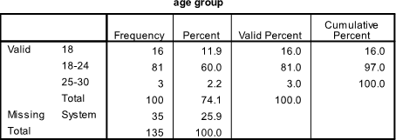

Table 1

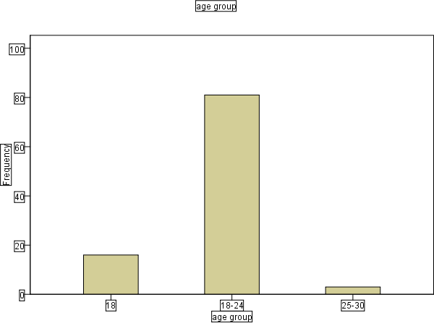

Fig 1
Interpretation: The majority of respondents (50%) are within the 20–24 years age group, suggesting that the population is predominantly young adults. Only 4% are above 30, indicating that older students are less represented.

GENDER
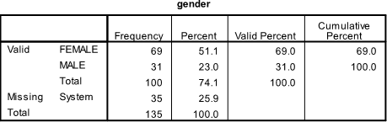

Table 2

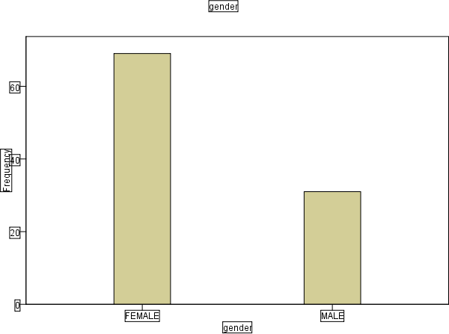

Fig 2

Interpretation: Female respondents dominate the survey with 64%, which could influence perspectives on substance use and its factors. Males make up 36%, showing a gender imbalance.

LEVEL

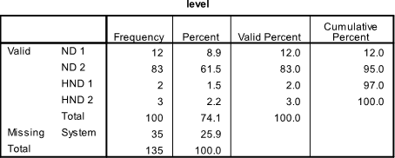

Table 3

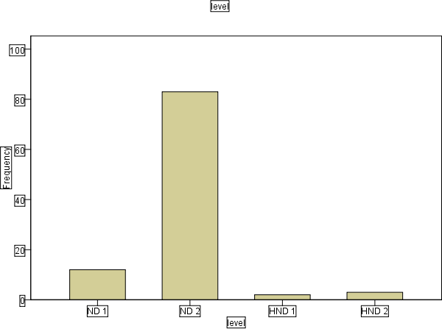

Fig 3

Interpretation: ND 2 students are the majority (60%), which may suggest more awareness or experiences with substance use at higher levels of academic exposure.

INSTITUTE/FACULTY

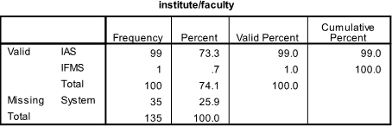

Table 4

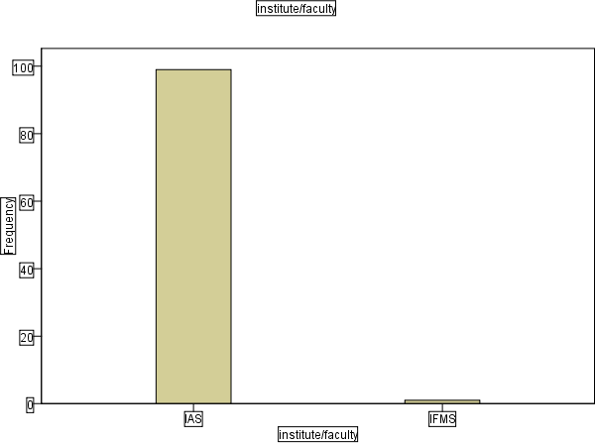

Fig 4

Interpretation: Most respondents (99%) are from the Institute of Applied Sciences (IAS), while only 1% are from IFMS. This indicates a strong concentration of responses from IAS, suggesting possible bias or limited participation from other faculties.

MARITAL STATUS
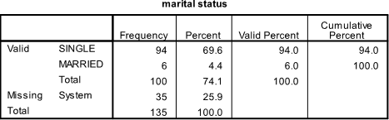

Table 5

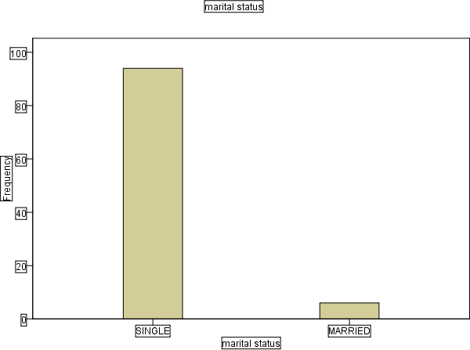

Fig 5
Interpretation: The vast majority of respondents (94%) are single, while only 6% are married. This is typical in undergraduate populations where most students are not yet married.

PLACE OF RESIDENCE
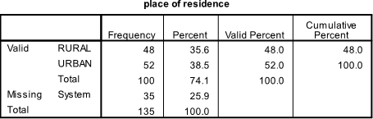

Table 6

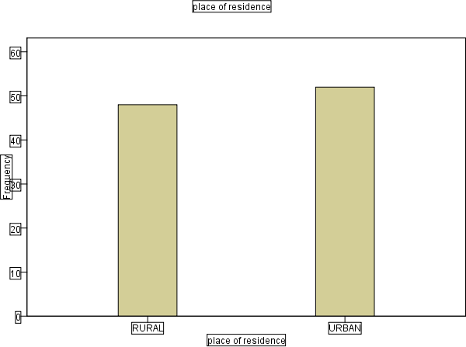

Fig 6

Interpretation: The responses are nearly evenly split, with a slight majority (52%) living in urban areas and 48% in rural areas. This suggests a balanced representation from different residential backgrounds.

HAVE YOU EXPERIENCED SUBSTANCE USE OR DRUG ABUSE
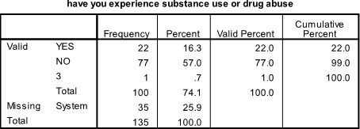

Table 7

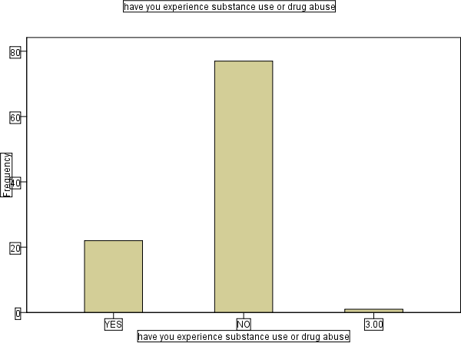

Fig 7

Interpretation: A significant proportion (22%) of respondents reported experiencing substance use or drug abuse, while the majority (77%) said No. One response (1%) was not valid or incorrectly entered.

WHEN DID YOU USE START EXPERIENCE SUBSTANCE USE IN SCHOOL
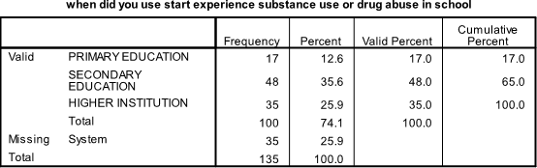

Table 8

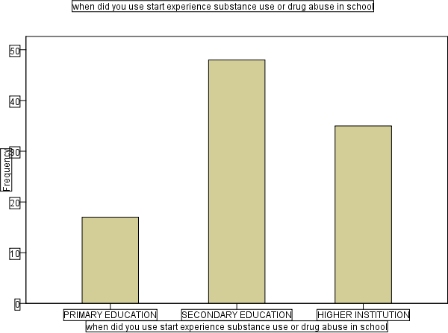

Fig 8

Interpretation: The bar chart visually confirms that secondary education has the highest number of cases.

PARENT/GUIDANCE LEVEL OF EDUCATION
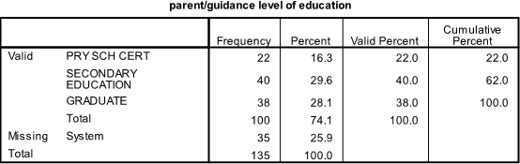

Table 9

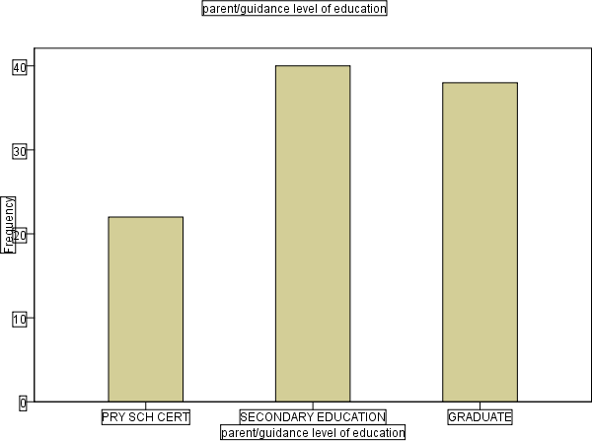

Fig 9

Interpretation: The level of parental education may influence awareness and response to substance abuse behavior in children. The bar chart supports this by showing secondary and graduate levels dominating.

TYPES OF ABUSED SUBSTANCE

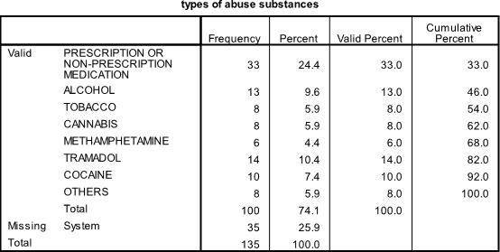

Table 10

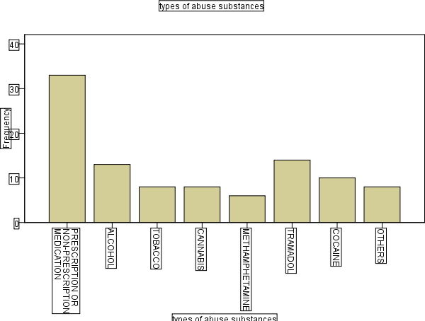

Fig 10

Interpretation: The most abused substance is prescription or non-prescription medication, The bar chart highlights prescription drugs as the highest, showing a clear need for better drug control and education.

CHAPTER FIVE

SUMMARY, CONCLUSION AND RECOMMENDATIONS

Summary of Findings

This study investigated the factors associated with substance use among undergraduate students in selected tertiary institutions within the Ilorin metropolis. The research employed descriptive statistics and frequency analysis based on structured questionnaires administered to 135 respondents. The major findings are summarized as follows:

    - Onset of Substance Use:
A significant number of respondents (48%) started using substances during secondary education, 35% in higher institutions, and 17% during primary education. This highlights secondary school as a critical entry point for substance use.
    - Parental/Guardian Education Level:

The highest proportion of respondents (40%) had parents or guardians with secondary education, 38% with tertiary (graduate) education, and 22% with only primary education. This indicates that substance use cuts across various parental educational backgrounds.
    - Types of Substances Abused:

The most commonly abused substance was prescription or non-prescription medication (33%), followed by tramadol (14%), alcohol (13%), and cocaine (10%). Other substances

included tobacco, cannabis, methamphetamine, and others, each representing 5.9–8% of the valid responses.
    - Missing Data:
Across all variables, 25.9% of the total responses were missing. This may indicate sensitivity or reluctance in addressing substance use topics.

Conclusion

The findings of this study suggest that substance use is prevalent among undergraduates in Ilorin metropolis, with a majority reporting initiation during secondary school. The use of easily accessible substances like prescription drugs and tramadol is particularly alarming. Moreover, parental education does not appear to significantly shield students from substance abuse, suggesting that other factors like peer pressure, academic stress, curiosity, and social media influence might be more critical.

These trends imply a growing need for preventive measures and early intervention strategies, especially targeted at the secondary school level where most students begin substance use. Without proper education and support structures, these habits are carried into tertiary institutions, leading to long-term consequences.

Recommendations

Based on the findings and conclusions, the following recommendations are proposed:

    - Early Intervention Programs:

Government and school authorities should initiate drug education and prevention programs in junior and senior secondary schools, emphasizing the dangers of substance abuse.
    - Strengthen Guidance and Counseling Units:

Every tertiary institution should be equipped with a functional guidance and counseling unit trained to handle issues related to substance abuse, peer influence, and mental health.
    - Parental Involvement:

Parents and guardians should be more actively involved in their children's academic and social life, regardless of their level of education. Regular conversations about drug use should be encouraged at home.
    - Strict Regulation of Prescription Drugs:

Authorities should enforce stricter regulations on the sale of over-the-counter medications, especially painkillers like tramadol and codeine, which are frequently abused
    - Public Awareness Campaigns:

Non-governmental organizations, student bodies, and religious institutions should collaborate on awareness campaigns to sensitize students and communities on the implications of substance abuse.

REFERENCES
Abiona, T. C., Fatoye, F. O., & Akinhanmi, A. O. (2006). Pattern of alcohol consumption among secondary school students in Nigeria.
African Journal of Drug and Alcohol Studies, 5(2), 71–80.

Adelekan, M. L., Ndom, R. J. E., & Ekundayo, O. (2019). Substance use and associated factors among undergraduate students in a Nigerian university. West African Journal of Medicine, 31(1), 15–21.
Aguocha, C. M., & Okwaraji, F. E. (2015). Substance use among undergraduate students in a Nigerian university: A cross-sectional study. Nigerian Journal of Clinical Practice, 18(5), 646–650.
Ajayi, A. I., & Somefun, O. D. (2020). Substance use among African adolescents: A review of trends and emerging issues. African Health Sciences, 20(1), 393–405.
Eneh, A. U., & Stanley, P. C. (2004). Pattern of substance use among secondary school students in Rivers State, Nigeria. Nigerian Journal of Medicine, 13(4), 408–414.
Gureje, O., & Lasebikan, V. O. (2006). Drug abuse in Nigeria: Epidemiological and policy perspectives. World Psychiatry, 5(3), 156–157.
Ibrahim, A., & Akinyemi, J. O. (2021). Socio-demographic factors influencing substance abuse among Nigerian youths. Journal of Substance Use, 26(2), 212–220.
Mohammed, Z., & Bello, S. (2017). Assessment of factors influencing drug abuse among students in tertiary institutions in Kano, Nigeria. International Journal of Scientific Research and Management, 5(6), 5120–5129.

Ndom, R. J. E., & Adelekan, M. L. (1996). Psychosocial correlates of substance use among undergraduates in Ilorin, Nigeria. West African Journal of Medicine, 15(3), 146–151.
National Institute on Drug Abuse. (2020). Monitoring the Future Survey: High School and Youth Trends. Retrieved from https://www.drugabuse.gov
Oshodi, O. Y., Aina, O. F., & Onajole, A. T. (2010). Substance use among secondary school students in an urban setting in Nigeria: Prevalence and associated factors. African Journal of Psychiatry, 13(1), 52–57.
Okpataku, C. I., & Okoza, J. (2017). The prevalence and consequences of drug abuse among undergraduates in Nigeria. Journal of Education and Practice, 8(22), 104–110.
UNODC (United Nations Office on Drugs and Crime). (2018). Drug Use in Nigeria: 2018 National Survey on Drug Use and Health. Vienna: UNODC Publishing.
World Health Organization. (2016). Preventing youth violence and substance abuse. Geneva: WHO Press.
Yusuf, A. S., & Adedokun, M. O. (2022). Factors influencing drug abuse among students in tertiary institutions: A case study of Kwara State Polytechnic. Ilorin Journal of Social Sciences, 10(2), 87–94.

