
EFFECT OF RAIN WATER ON STRUCTURAL INTEGRITY OF INSTITUTE OF TECHNOLOGY (IOT) COMPLEX

BY
SAKARIYAU MONSURAT FUNMILOLA
HND/23/CEC/FT/0238

THE DEPARTMENT OF CIVIL ENGINEERING,
INSTITUTE OF TECHNOLOGY (IOT),
KWARA STATE POLYTECHNIC, ILORIN.

IN PARTIAL FULFILLMENT OF THE REQUIREMENTS FOR THE AWARD OF HIGHER NATIONAL DIPLOMA (HND) IN CIVIL ENGINEERING.
JULY, 2025

CERTIFICATION
This is to certify that this research was conducted by SAKARIYAU MONSURAT FUNMILOLA (HND/23/CEC/FT/0238) and had been read and approved as meeting the requirements for the award Higher National diploma (HND) in Civil Engineering of the Department of Civil Engineering, Institute of Technology, Kwara State Polytechnic, Ilorin.
ENGR. (MRS.) K. O. OLORUNFEMI DATE
(Project Supervisor)
ENGR. A. NA’ALLAH DATE
(Head of Department)

ENGR. DR. MUJEDU KASALI ADEBAYO DATE
(External Examiner)

DEDICATION
This research work is dedicated to the Almighty Allah, most beneficent, ever-merciful for making me a living soul up till today.
ACKNOWLEDGEMENTS
My sincere gratitude goes to Almighty Allah for HIs favour, mercy, kindness and wisdom he bestowed upon me throughout my program.
He makes a way where there is no way all I have to say is thank you Allah.
I would like to acknowledge the immeasurable and valuable contribution made by my parents in person of MR and MRS SAKARIYAU, May Almighty Allah grant you Long Life and Prosperity to Reap the fruits of your labour.
I would like to acknowledge the support and word of advice made by my husband in person of LAWYER I. ABDULAZEEZ, May Allah bless you.
I owe my profound gratitude to my project supervisor in person of Engr. K.O OLORUNFEMI for her useful advise and relentless effort to see that this project is succeed.
My sincere gratitude goes to the Head of Department in person of Engr. A. NA’ALLAH and others Lectures in the Department for impacting their knowledge in me.
Finally, My special greeting goes to all my family members, Friends, and Colleagues in need and indeed and to all those who have contributed positively in one way or the other toward the success of my program my Allah be with you all.

TABLE OF CONTENTS
Title page i
Certification ii
Dedication iii
Acknowledgement iv
Table of contents v
Abstract vi
CHAPTER ONE
1.0 Introduction 1
1.1 Statement of Problem 2
1.2 Aim 4
1.3 Justification of the Study 4
1.4 Scope of the Study 6
1.5 Methodology 6
1.6 Description of the study area 7
CHAPTER TWO
2.0 Literature Review 9
2.1 Rainwater as a Deteriorative Agent 10
2.2 Concrete 11
2.3 Building envelope vulnerabilities 13
2.4 Mechanisms of Structural Deterioration 15
2.5 Hydraulic Structure 17
2.6 Drainage Systems 19
CHAPTER THREE:
3.0 Methodology 22
3.1 The methodology is structured into three main phases22
3.2 Visual Inspection 23
3.3 Structural Integrity Testing Using Rebound Hammer 26
3.4 Administration of Questionnaires to HODs 31
3.5 Ethical Considerations 32
CHAPTER FOUR
RESULTS AND DISCUSSIONS 34
CHAPTER FIVE: CONCLUSION AND RECOMMENDATIONS
5.1 Conclusion 59
5.2 RECOMMENDATION 62
References 66

ABSTRACT
This project investigates the environmental impact of rainwater on the structural integrity of the Institute of Technology (IOT) building at Kwara State Polytechnic. Using visual inspection techniques use of rebond hammer (a non destructive testing machine) and structured questionnaires distributed to departmental heads, the study identifies common rain-induced defects such as leakages, damp walls, peeling, cracks, and fading. Results showed that fading and peeling are the most prevalent issues, while leakages and dampness are also widespread causing weekness in the walls,, particularly in Agriculture and Bio-Environmental departments. These findings highlight the significance of routine maintenance, proper waterproofing, and the use of weather-resistant materials in prolonging the lifespan of institutional buildings. The study concludes that proactive structural care and effective rainwater management are essential to prevent long-term deterioration and ensure the safety and functionality of educational facilities.

CHAPTER ONE
1.0 Introduction
The structural integrity of buildings is essential for ensuring the safety, functionality, and longevity of constructed facilities. One of the primary environmental factors that can impact building structures is rainwater, which, depending on frequency and intensity, can lead to gradual deterioration of structural materials. In regions where rainfall is frequent or intense, the potential for damage to concrete, steel, and other construction materials becomes a significant concern. For institutional buildings like the Institute of Technology (IOT), maintaining structural integrity is critical not only for protecting the physical infrastructure but also for ensuring a safe learning environment.
Rainwater can affect structures in various ways. Water infiltration can lead to corrosion in steel reinforcements, weaken the bond in concrete, and promote erosion in exposed materials. Furthermore, prolonged exposure to rain can exacerbate the formation of cracks, mold, and other forms of deterioration that compromise the durability of building materials. In certain cases, rainwater, especially when acidic due to pollution, can react chemically with building materials, accelerating the degradation process.
This study aims to evaluate the impact of rainwater on the structural integrity of the Institute of Technology’s buildings by examining material durability, assessing common types of rainwater-related damage, and providing recommendations for improved weather resilience. By understanding these effects, this research will contribute to more sustainable construction practices and provide insights for future building design and maintenance to withstand environmental challenges.
1.1 Statement of Problem
The durability and safety of building structures are essential for institutional structures. Structural failure could have significant consequences cracks, deflection, deteriorate and collapse for students, staff, and the continuity of educational activities. However, exposure to rainwater poses a persistent threat to the integrity of these structures, particularly in regions with frequent and intense rainfall. Rainwater infiltration, combined with pollutants that may cause acidic rain, can accelerate degradation processes such as corrosion, weakening of concrete, and erosion of external materials.
Despite the critical role of structural maintenance, there is limited research on the specific impacts of rainwater exposure on the Institute of Technology's buildings. Without proper understanding and mitigation, the structural components may suffer from gradual damage that could lead to costly repairs, safety risks, and reduced lifespan of the buildings. This problem highlights the need for a detailed investigation into how rainwater affects the materials used in IOT's construction, as well as the development of practical recommendations to enhance the buildings' resistance to water-related deterioration.
This study seeks to address this gap by assessing the impact of rainwater on the structural integrity of IOT, focusing on identifying vulnerabilities in construction materials and evaluating the effectiveness of current preventive measures.
1.2 Aim
To investigate the effect of rainfall on structural integrity of the Institute Of Technology (IOT) complex

Objectives
- To assess the types of damage caused by rainwater on IOT buildings.
- To analyze the impact of rainwater damages on specific building element in IOT building using rebound hammer
- To evaluate the current preventive measures in place for mitigating rainwater damage at IOT
- To suggest ways to mitigate rainwater damages on IOT in future based on findings from study
1.3 Justification of the Study
Ensuring the structural integrity and longevity of buildings is essential for any institution, particularly one like the Institute of Technology (IOT), which hosts a large population of students, staff, and visitors daily. The impact of environmental factors, especially rainwater, poses a continuous threat to the structural health of buildings. Without proper knowledge and preventive measures, exposure to rainwater can lead to accelerated deterioration of building materials, resulting in safety hazards, increased maintenance costs, and reduced lifespan of the infrastructure.
Despite the importance of this issue, there has been limited research specifically focused on understanding the effects of rainwater on the structural materials used at IOT. This study is therefore justified as it aims to fill this knowledge gap by investigating the vulnerability of IOT buildings to rainwater damage. Findings from this study will provide insights that can help inform future construction and maintenance practices, leading to safer, more resilient structures that require less frequent and less costly repairs.
Moreover, by identifying effective methods to counteract rainwater-induced damage, this research can contribute to sustainable building management practices, helping the Institute allocate resources more efficiently and preserve its infrastructure for the long term. This study is timely and relevant as it addresses both the safety and economic aspects of infrastructure maintenance in a high-rainfall region.
1.4 Scope of the Study
This study focuses on examining the effects of rainwater on the structural integrity of the buildings at the Institute of Technology (IOT). Specifically, the research will assess the extent of rainwater-induced damage to primary structural elements and materials used in IOT buildings, such as concrete and steel. The study will evaluate how exposure to rainwater affects material strength, durability, and resistance to corrosion and erosion.
1.5 Methodology
This study utilized a combination of field assessments, field experiments, and data analysis to evaluate the effect of rainwater on the structural integrity of IOT buildings.
- Field Assessment
Visual Inspection: visual inspections of the IOT buildings to identify visible signs of rainwater-related damage, such as cracks, corrosion, discoloration, mold, or damp patches was done.

- Damage Documentation:
Record and document the location, extent, and type of damage on structural elements (walls, columns, beams, and foundations).
- Field Experiments
Using rebound hammer to conduct integrity test
1.6 Description Of The Study Area
The Institute of Technology (IOT) Complex is one of the foundational academic arms of Kwara State Polytechnic, Ilorin. The Building was built in Year 2022, It houses several engineering and technology-based departments, including Civil, Mechanical, Mechatronics, Agriculture and Bio Environmental, Electrical and Electronics, Railway, Water Resources, Mining and Mineral Resources, Metallurgical, Welding and Fabrication Engineering. The building accommodates lecture halls, offices, laboratories, and workshops, making it a high-traffic, multifunctional facility. Which comprises of two storeys Building, the ground floor accommodate laboratories and workshops, the first floor accommodation lecture rooms and the second accommodate Office. Due to its age, exposure to weather, and daily use, the IOT building provides an ideal case study for examining the environmental impact of rainwater on structural integrity.
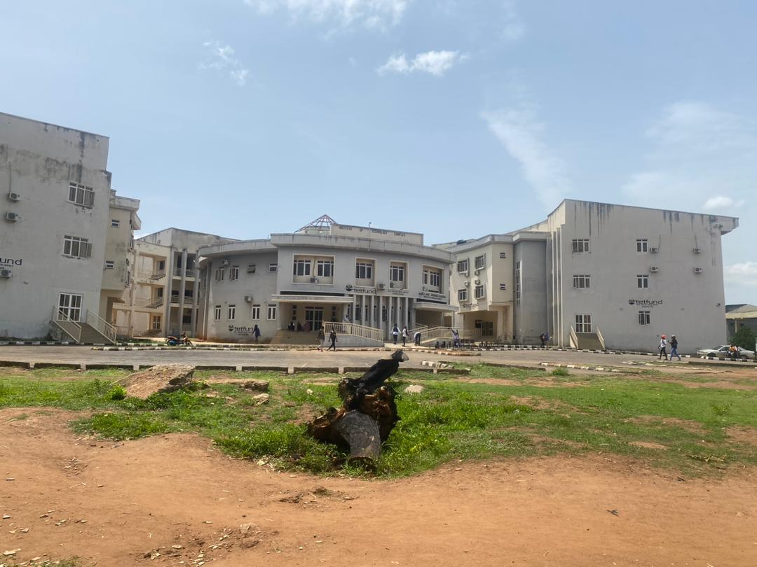
Plate 1.1 General view of I.O.T. complex

CHAPTER TWO
2.0 Literature Review
Rainwater, a vital component of the hydrological cycle, plays a significant role in shaping the built environment. While it is essential for human survival and ecological balance, its interaction with buildings can lead to a wide range of structural and material degradation issues. The structural integrity of buildings is largely influenced by climatic factors, and rainwater, especially when improperly managed, can have deleterious effects over time. This literature review seeks to explore, in depth, the various ways in which rainwater affects the structural components of buildings, the mechanisms of deterioration, and mitigation strategies.
The effect of rainwater on the structural integrity of buildings has been a focus of several studies due to its significant impact on the durability and safety of construction materials. This section reviews existing literature to provide a comprehensive understanding of rainwater's effects, degradation mechanisms, and mitigation strategies.

2.1 Rainwater as a Deteriorative Agent
2.1.1 Chemical Composition of Rainwater
Rainwater is naturally slightly acidic due to the presence of dissolved carbon dioxide forming carbonic acid. According to Goudie & Viles (2010), the average pH of rainwater ranges from 5.0 to 5.6, but this can be lower in urban or industrial areas where pollutants like sulfur dioxide and nitrogen oxides lead to acid rain. Acid rain accelerates corrosion and material degradation, especially in buildings made of concrete, limestone, and steel.
2.1.2 Moisture Intrusion and Capillary Action
Rainwater infiltrates buildings through cracks, porous materials, joints, or roofing failures. Once inside, it can travel through capillary action within walls and floors. Hall & Hoff (2002) emphasized that moisture migration in porous building materials significantly reduces their mechanical strength. Over time, repeated wetting and drying cycles cause swelling, shrinkage, and micro-cracking.

2.1.3 Effects on Structural Materials
2.2.1 Concrete
Concrete, the most widely used construction material, is susceptible to water-induced damage. Rainwater permeates concrete, especially when not properly cured or sealed, leading to several issues:
- Carbonation: Rainwater reacts with carbon dioxide to form carbonic acid, which neutralizes the alkaline environment of concrete, reducing its ability to protect embedded steel reinforcement (Papadakis et al., 1991).
- Chloride Penetration: In coastal or polluted environments, rainwater can carry chlorides that penetrate concrete and corrode steel reinforcement. Corrosion expands steel, leading to spalling and cracking (Mehta & Monteiro, 2006).
- Freeze-Thaw Cycles: In temperate climates, rainwater that infiltrates concrete can freeze and expand, causing cracking and scaling. Neville (2011) notes that durability of concrete under freeze-thaw conditions is heavily dependent on the water-cement ratio and air entrainment.
2.2.2 Masonry
Masonry units (bricks and stones) and mortar are vulnerable to rainwater infiltration due to their porous nature.
- Salt Efflorescence: As rainwater dissolves soluble salts in masonry, it transports them to the surface where they crystallize. This not only stains the surface but also causes flaking and powdering of bricks.
- Cracking and Erosion: Repeated wet-dry cycles expand and contract the material, weakening mortar joints and eroding soft bricks. This was observed in historical buildings, as documented.
2.2.3 Timber
Wooden structural components are highly sensitive to moisture.
- Fungal Decay: Persistent dampness from rainwater leads to fungal growth such as dry rot and wet rot. These fungi digest the cellulose in wood, compromising structural stability.
- Dimensional Instability: Wood absorbs rainwater, swells, and shrinks upon drying, which causes warping, cracking, and joint loosening.
2.2.4 Steel
Steel, although strong and versatile, corrodes rapidly in the presence of water and oxygen. Albrecht & Hall (2003) describe how rust formation increases the volume of steel, leading to delamination in reinforced concrete and weakening of steel joints and connections.
2.3 Building envelope vulnerabilities
2.3.1 Foundations
Water infiltration into soil beneath foundations affects load-bearing capacity.
- Soil Erosion and Settlement: Rainwater can erode soil or change its consistency, leading to differential settlement.
- Expansive Soils: Clay-rich soils swell upon wetting and shrink on drying, exerting cyclical stress on foundations.
2.3.2 Wall Assemblies
Walls absorb direct rainfall and splash back from ground surfaces. Over time, rain penetration leads to:
- Interstitial Condensation: Moisture trapped within wall cavities causes hidden decay and corrosion.
- Paint Peeling and Plaster Damage: Internal finishes deteriorate due to prolonged damp conditions.
2.3.3 Roof Systems
Roofs serve as the primary defense against rainwater. However, poor design, materials, or maintenance can lead to leakage.
- Flat Roofs: These are particularly vulnerable to ponding and leakage. Griggs (2012) emphasizes that even minor drainage failures can allow water to seep into roofing membranes and eventually the structure.
- Gutters and Downpipes: Blocked or damaged rainwater goods result in overflows that saturate walls. This is a common cause of dampness in traditional buildings (English Heritage, 2008).
2.4 Mechanisms of Structural Deterioration
2.4.1 Corrosion of Reinforcement
As mentioned, rainwater-induced corrosion is a leading cause of structural failure in reinforced concrete. According to Broomfield (2003), corroding steel expands up to six times its original volume, generating internal pressure that cracks and spalls concrete.
2.4.2 Biological Growth
Rain-exposed damp surfaces promote algae, moss, and lichens. These organisms retain moisture and penetrate surfaces, exacerbating material decay (May, 2005).
2.4.3 Thermal and Hygroscopic Movements
Rainfall alters the moisture content of building materials, causing them to expand or contract. Over time, this leads to fatigue and structural weakening (Straube & Burnett, 2005).
1. Material Selection
- Use of water-resistant concrete with proper mix design and low permeability.
- Treated and seasoned timber for structural use.
- Weather-resistant coatings and finishes.
2. Design Improvements
- Sloped roofs with sufficient overhangs.
- Adequate drainage design for rainwater harvesting or disposal.
- Use of damp-proof courses and membranes in walls and floors.
3. Maintenance
- Regular inspection and cleaning of gutters and downpipes.
- Repointing of mortar joints in masonry.
- Sealing cracks and joints in concrete.
4. Protective Technologies
- Use of hydrophobic impregnations or sealants to reduce water ingress (Hoff, 2007).
- Cathodic protection systems to mitigate steel reinforcement corrosion.
5. Knowledge Gaps and Research Directions
Despite extensive research, some areas remain underexplored:
- Long-term effects of climate change on rainfall patterns and building durability.
- Development of self-healing materials that respond to water damage.
- Integration of smart sensors for real-time moisture monitoring in structures.

2.5 Hydraulic Structure
Hydraulic structures, such as drains, culverts, gutters, and water channels, play a crucial role in managing rainwater to protect buildings from water-related damage. In the context of this study, the absence or inefficiency of hydraulic structures can exacerbate rainwater infiltration, leading to structural degradation. Properly designed hydraulic structures are essential for directing rainwater away from foundations and walls to prevent erosion, water logging, and moisture-related issues like cracks and corrosion. If hydraulic structures at IOT are poorly maintained or undersized for the campus's rainfall intensity, rainwater can accumulate around buildings, weakening the foundation and leading to long-term damage. This study will assess the adequacy of existing hydraulic structures and propose improvements such as increasing drainage capacity or introducing permeable pavements to manage rainwater effectively.
2.5.1 Hydrologic Cycle
The hydrologic cycle describes the continuous movement of water through evaporation, condensation, precipitation, infiltration, and runoff. Evaporation: Rainwater that accumulates on roofs, walls, or ground surfaces evaporates due to heat. Slow evaporation on building materials can lead to water retention, encouraging cracks, dampness, and corrosion, which weaken the structure.
Transpiration: Plants around the building release moisture into the air through transpiration. Vegetation can help regulate moisture levels near structures. However, roots absorbing water near foundations can affect soil stability and undermine structural integrity if not properly managed.
Condensation: Moisture in the air turns into water droplets on cold surfaces like walls or ceilings. Condensation inside or on building elements can cause damp patches, mold growth and material deterioration, especially in poorly ventilated areas.
Runoff: Rainwater flows over surfaces such as rooftops, walkways, and surrounding land. Poor drainage or uncontrolled runoff can lead to foundation erosion, surface cracking and flooding, which compromise structural strength.
Infiltration: Some rainwater seeps into the ground through cracks or porous surfaces. If water infiltrates beneath the building, it can weaken the soil, cause foundation settlement and lead to structural failures over time.
2.6 Drainage Systems:
Inefficient drainage systems contribute to water stagnation, increasing the risk of structural damage to both foundations and walls.
This study evaluates how rainwater impacts these components and recommends interventions to improve their durability and resilience.
2.6.1 Rain and Wind Direction
Rain and wind direction play a significant role in determining the areas of a building most exposed to rainwater, as well as the patterns of water infiltration and structural damage:
2.6.2 Wind-Driven Rain:
Strong winds can drive rainwater horizontally, causing it to penetrate through window openings, cracks, and improperly sealed joints.
Buildings facing the predominant wind direction during rainfall are more susceptible to wind-driven rain impacts.
Localized Effects:
The direction and intensity of wind-driven rain often create uneven rainwater distribution on building surfaces, leading to localized damage. For instance, leeward sides may experience less exposure, while windward sides face higher rain impact and subsequent wear.
2.6.3 Drainage Orientation:
Improperly designed roofs and gutters that do not account for wind-driven rain may lead to pooling or overspills, especially during heavy downpours combined with strong winds.

CHAPTER THREE
3.0 Methodology
This chapter provides a comprehensive overview of the methodologies adopted to assess the structural integrity of selected buildings. The chosen methods include visual inspection, integrity testing using a rebound hammer, and structured questionnaires administered to Heads of Departments (HODs) in the assessed buildings. These methodologies were selected to ensure a triangulated approach that combines physical assessment, empirical data collection, and user-reported structural experiences. This combination provides both objective and subjective insight into the existing condition and performance of the buildings. The methodology is structured into three main phases
- Visual Inspection – to provide a qualitative overview of the buildings’ physical conditions.
- Non-Destructive Testing (NDT) using the Rebound Hammer Test – to determine the compressive strength and integrity of concrete elements.
- Survey using Questionnaires – administered to HODs to understand perceived structural performance and maintenance culture.
The combination of these approaches ensures that findings are not only technically sound but are also validated by the occupants’ experiences and insights.
3.1 Visual Inspection
3.1.1 Purpose of Visual Inspection
Visual inspection remains a foundational technique in building condition assessment. It is often the first step in any structural appraisal as it enables the identification of obvious defects, surface-level anomalies, and patterns that may suggest deeper structural issues. The primary purpose of visual inspection in this study is to identify:
- Signs of deterioration such as cracks, spalling, corrosion, and efflorescence.
- Evidence of water ingress, which might be associated with rainwater penetration.
- Defects in construction details, materials, or workmanship.
- Indicators of load-bearing element distress (e.g., column or beam deformation).
- General aging characteristics of materials and finishes.
3.1.2 Visual Inspection Process
A checklist-based approach was used to ensure consistency during inspections. The checklist, adapted from international best practices (e.g., British Standard BS EN 1504-9:2008 and ASTM D4788-03), included items under the following categories:
- Structural Components:
- Beams, columns, slabs, staircases
- Non-Structural Components:
- Wall finishes, floor finishes, ceilings, and roofing
- Signs of Defects:
- Cracks (location, type, and width)
- Surface spalling or scaling
- Rust stains or exposed reinforcements
- Settlement signs or tilting
- Paint peeling, mold growth, and damp patches
- Deflections and joint separations
3.1.3 Tools and Materials Used
The visual inspection utilized a range of simple tools to aid in accurate documentation:
- Crack width gauges – to measure crack width accurately (from hairline to >5mm)
- Measuring tapes and spirit levels – to assess deformation and out-of-plumb components
- High-resolution camera – to photograph defects and anomalies
- Binoculars or drone (where necessary) to inspect high-rise areas safely
3.1.4 Assessment Criteria
Each defect was classified based on its severity and possible structural implications, following a defect classification scale:
- Minor: Aesthetic or superficial, e.g., hairline cracks or efflorescence
- Moderate: Indicative of possible underlying issues, e.g., crack widths between 1-3 mm, partial spalling
- Severe: Defects that compromise structural safety, e.g., large cracks (>3 mm), exposed and corroded reinforcement, visible deflection or sagging
Documentation included location, type, severity, and estimated causes of the defects, allowing for cross-referencing with test results and questionnaire responses.
3.2 Structural Integrity Testing Using Rebound Hammer
3.2.1 Overview of Rebound Hammer Test
The rebound hammer, also known as the Schmidt Hammer, is one of the most widely used non-destructive testing (NDT) tools for assessing the surface hardness and indirectly estimating the compressive strength of concrete. The method is based on the principle that the rebound of a spring-driven mass depends on the surface hardness of the concrete. Developed by Ernst Schmidt in 1948, the rebound hammer test offers a quick and cost-effective way of assessing in-situ concrete strength without causing any damage to the structure.
3.2.2 Purpose of the Test
The rebound hammer test was conducted to achieve the following objectives:
- Estimate the surface compressive strength of concrete elements such as columns, beams, and slabs.
- Detect areas of weakness or low-quality concrete that may not be visible through inspection.
- Establish a non-destructive, comparative baseline for structural integrity.
- Correlate rebound values with visual defect locations to validate observations.
3.2.3 Equipment and Calibration
The equipment used was a Proceq Schmidt Rebound Hammer (Type N), suitable for testing concrete with compressive strengths ranging from 10 to 70 MPa. Before use, the hammer was calibrated as per manufacturer specifications and ASTM C805/C805M-13a standards to ensure accuracy. Calibration involved:
- Testing against a standard test anvil
- Checking rebound consistency
- Adjusting internal spring tension if needed
3.2.4 Testing Procedure
The test was conducted in line with ASTM C805 and BS EN 12504-2:2012 standards. The procedure involved the following steps:
- Surface Preparation: Concrete surfaces were cleaned of dust, paint, or loose particles. Rough or uneven surfaces were smoothened to ensure flat contact with the plunger.
- Selection of Test Points: Each structural element (e.g., column, beam, slab) was divided into zones. At least 10 test readings were taken per zone, and average values were calculated.
- Orientation of Testing: Tests were conducted in vertical (columns), horizontal upward (slabs), and horizontal lateral (beams) directions, adjusting for gravitational influence.
- Test Execution:
- The hammer was pressed perpendicularly against the test surface until the spring-loaded mass was released.
- The rebound number was read from the scale.
- Any irregular readings (e.g., due to honeycombing) were discarded, and retests conducted.
- Data Analysis: Rebound numbers were correlated with compressive strength values using manufacturer charts. Any values falling below 20 were flagged as poorquality concrete
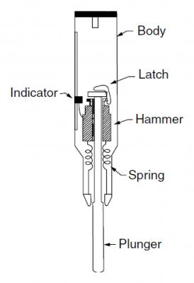
Fig. 3.1 Sketch diagram of rebound hammer
Table 3.1 Structural table for interpretation of rebound hammer result
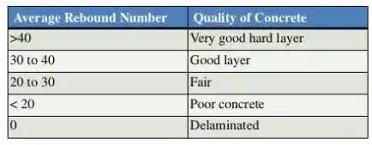
3.3 Administration of Questionnaires to HODs
3.3.1 Rationale
Heads of Departments (HODs) Civil, Mechanical, Electrical and Electronic, Water Resources, Mechanotronics, Welding and Fabrication, Metallurgical, Agric and Bio-Environmental, Railway, Mining and Mineral Resources Engineering as administrative custodians of academic buildings, possess long-term experience regarding structural performance, maintenance history, and occupant safety concerns. Their input provides vital subjective evidence that complements physical inspection and NDT outcomes.
3.3.3 Sample Size and Selection
Purposive sampling was employed to select HODs from departments and most structurally exposed buildings. A total of 10 questionnaires were administered, achieving a 92% response rate. This was considered sufficient for thematic analysis due to the unique insights each department offered.
3.3.4 Data Collection Procedure
Questionnaires were distributed in person and retrieved after 3–5 days to allow for thoughtful responses. Respondents were briefed on the purpose of the study and assured of confidentiality.
3.3.5 Data Analysis
Responses were coded and analyzed using:
- Descriptive statistics: for closed-ended questions (frequencies, percentages)
- Thematic analysis: for open-ended responses, highlighting key trends such as water leakage concerns, recurring maintenance issues, and suggestions for structural audits
Findings from the questionnaires were cross-referenced with the outcomes of visual inspections and rebound hammer tests to validate consistency and provide a holistic picture.

3.4 Ethical Considerations
All methodologies adopted in this research complied with ethical standards, including:
- Informed consent from all HODs participating in the questionnaire.
- No identifiable personal data collected.
- Non-destructive methods ensured the safety and functionality of assessed buildings were not compromised.

CHAPTER FOUR
  - RESULTS AND DISCUSSIONS
Visual Inspection and Its Importance in Building Assessment
Visual inspection is one of the most fundamental and widely used methods for assessing the physical condition of buildings. It involves systematically examining structural and non-structural components to identify visible signs of distress, deterioration, or damage. In building diagnostics, visual inspection serves as a first-line assessment tool to detect surface defects such as cracks, leakage, dampness, peeling paint, corrosion, and fading—many of which are directly linked to environmental factors like rainfall.
These findings are crucial for maintenance planning, risk assessment, and prioritization of repairs.
4.1: Pictorial view of IOT building showing damages caused by the rain water.
From the visual inspection assessment of IOT building the various damages done to the building, exterior and interior damages are shown on Plate 4.1 – 4.4.

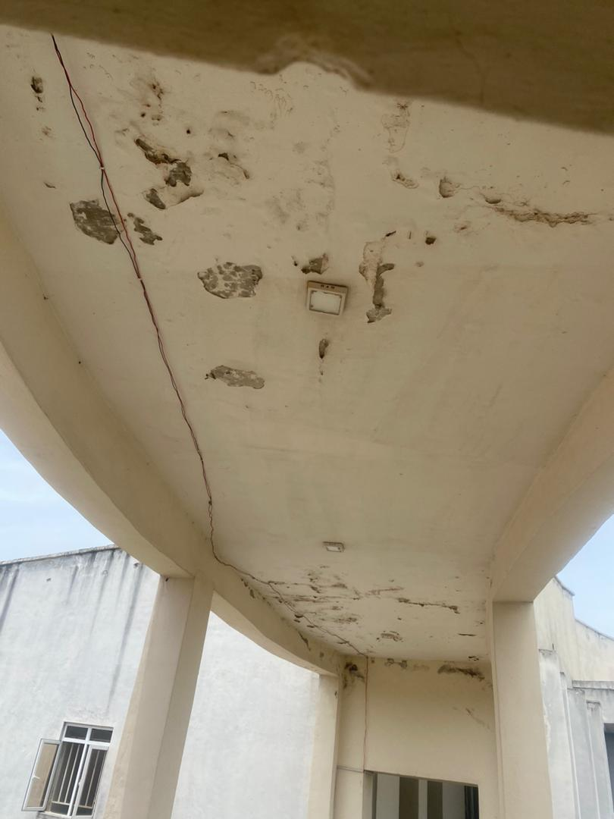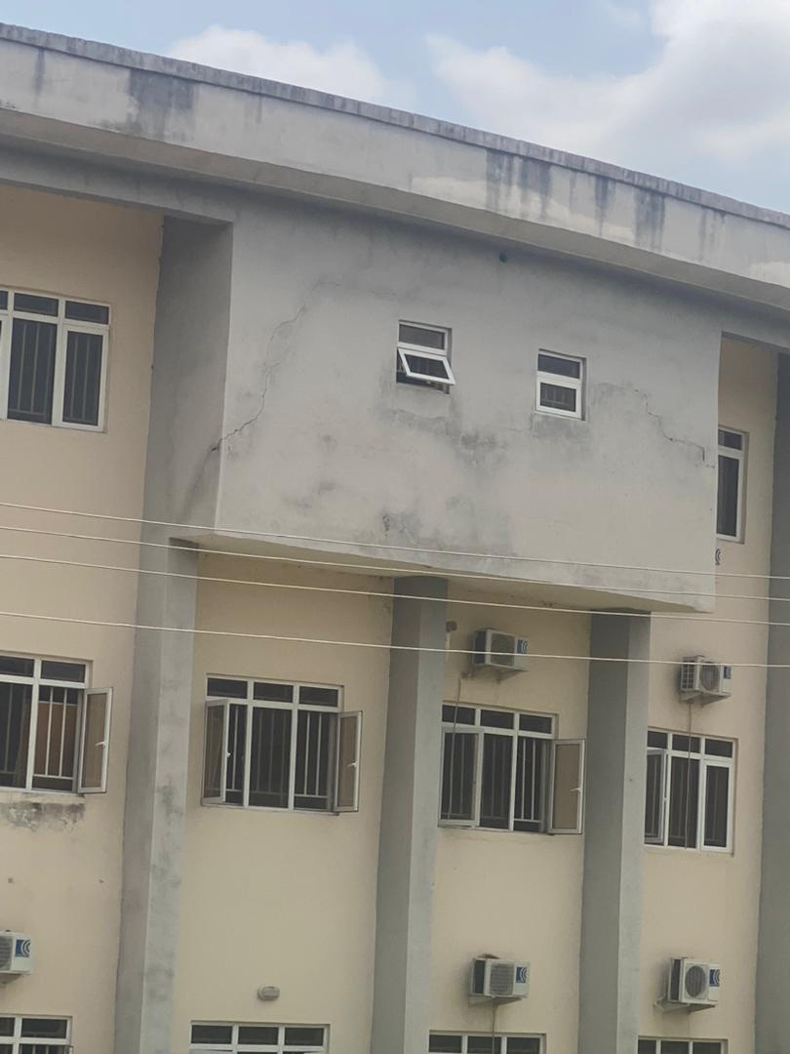
Plate 4.1 Pealing observed Plate 4.2 Cracks observed
on I.O.T. complex on the exterior walls
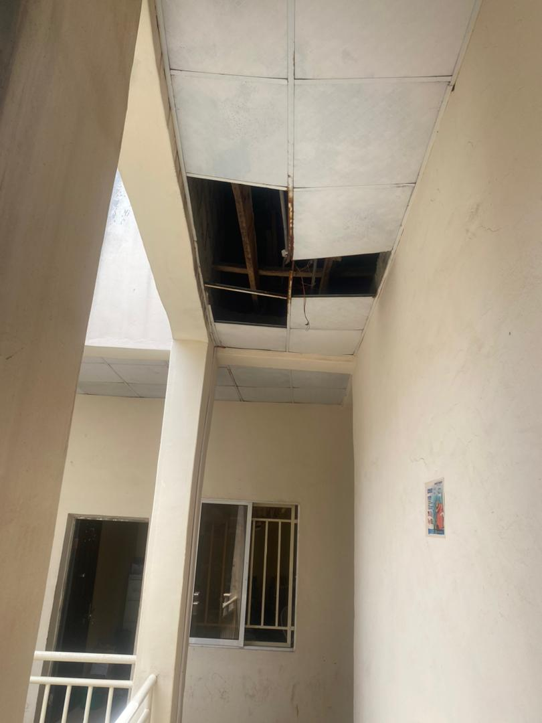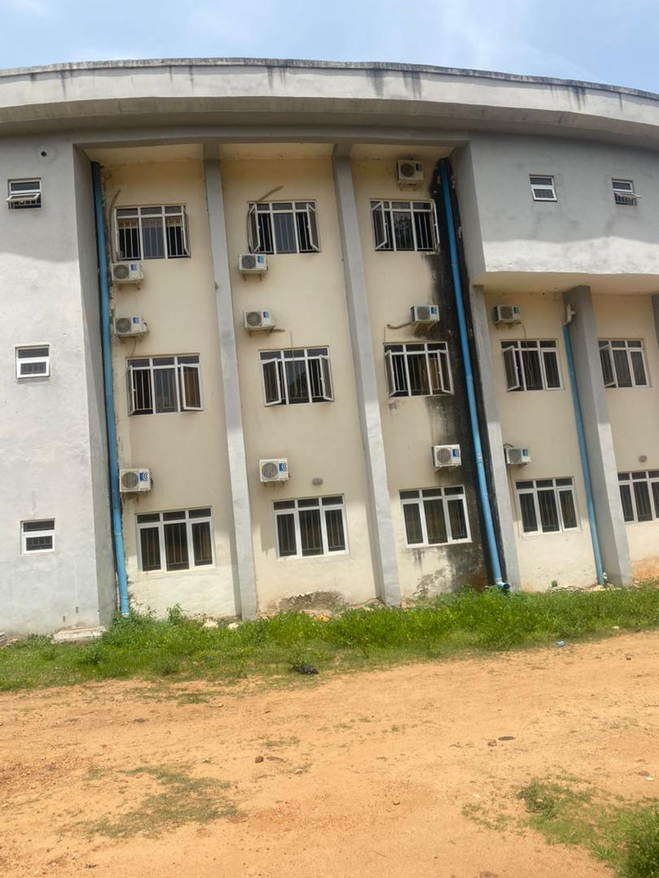
Plate 4.3 Roof damages Plate 4.4 Dampness through the roof gutter
To access the types and extent of structural damage caused by rainwater on IOT building. Institute of Technology (IOT) Complex is sub-divided into two parts, the Directorate building and the Main building.
The affected material/element, description of damage and the extent of damage done is presented.
Table 4.1: The directorate building (front elevation)
NO | ELEMENT | DESCRIPTION OF DAMAGE | EXTENT
1 | Painting | Bubbling and blistering of painted surface and also discoloration or staining (especially from moisture absorption) | Aesthetic degradation making the structure look poorly maintained and also shortens the lifespan of the paint
2 | Blockwork | Cracking due to repeated wetting and drying cycles and also seepage of water through block pores. | Structural weakening overtime due to water ingress and also loss of load bearing capacity since water reaches reinforcement in load bearing blocks
3 | Concrete work | Corrosion of embedded steel reinforcement and also cracks due to freeze thaw cycles in area temperature variation | Compromised structural integrity especially in beams, slabs and columns
4 | Roofing | Roof leaks through joints, cracks, or poor flashing and rust corrosion of metal roofing sheet | Interior water damage including ceilings, electrical system, and insulation and also structural failure in cases of prolonged rood deterioration
5 | Plastering | Damp patches and wetness on plastered surfaces and cracking or bulging of plaster | Surface failure, requiring re-plastering and reduced thermal and acoustic performance

Table 4.2: The directorate building (Back elevation)
NO | ELEMENT | DESCRIPTION OF DAMAGE | EXTENT
1 | Painting | Discoloration or staining (especially from moisture absorption) and growth of mold and mildew on walls | Shortened lifespan of the paint, requiring frequent repainting and health hazards due to mold development in damp areas
2 | Block work | Weakening of mortar joints and Cracking due to repeated wetting and drying cycles | Structural weakening over time due to water ingress and loss of load-bearing capacity if water reaches reinforcement in load-bearing blocks
3 | Concrete work | Reduced durability due to water-chemical interaction (e.g., carbonation) and scaling or spalling (flaking of the surface layer) | Costly repairs if reinforcement is corroded and long-term deterioration of the concrete element if unchecked
4 | Roofing | Rotting of timber rafters or decking (in wooden roofs) and dislodging or cracking of roof tiles | Increased energy costs due to loss of insulation and protection and interior water damage including ceilings, electrical systems, and insulation
5 | Plastering | Detachment (delamination) of plaster from wall surfaces and efflorescence and mold growth | Unhealthy indoor environment due to mold and mildew and surface failure, requiring re-plastering

Table 4.3: The directorate building (right elevation)
NO | ELEMENT | DESCRIPTION OF DAMAGE | EXTENT
1 | Painting | Growth of mold and mildew on walls | Aesthetic degradation making the structure look poorly maintained
2 | Block work | Seepage of water through block pores | Loss of load-bearing capacity if water reaches reinforcement in load-bearing blocks
3 | Concrete work | Corrosion of embedded steel reinforcement (if water seeps in) | Compromised structural integrity, especially in beams, slabs, and columns
4 | Roofing | Dislodging or cracking of roof tiles | Increased energy costs due to loss of insulation and protection
5 | Plastering | Damp patches and wetness on plastered surfaces | Surface failure, requiring re-plastering

Table 4.4: The directorate building (left elevation)
NO | ELEMENT | DESCRIPTION OF DAMAGE | EXTENT
1 | Painting | Bubbling or blistering of painted surfaces | Shortened lifespan of the paint, requiring frequent repainting
2 | Block work | Cracking due to repeated wetting and drying cycles | Surface degradation leading to increased maintenance costs
3 | Concrete work | Reduced durability due to water-chemical interaction (e.g., carbonation) | Compromised structural integrity, especially in beams, slabs, and columns
4 | Roofing | Rotting of timber rafters or decking (in wooden roofs) | Increased energy costs due to loss of insulation and protection
5 | Plastering | Detachment (delamination) of plaster from wall surfaces | Reduced thermal and acoustic performance
Table 4.5: The main building (front elevation)
NO | ELEMENT | DESCRIPTION OF DAMAGE | EXTENT
1 | Painting | Growth of mold and mildew on walls | Health hazards due to mold development in damp areas
2 | Block work | Efflorescence (white salt deposits on the surface) | Structural weakening over time due to water ingress
3 | Concrete work | Corrosion of embedded steel reinforcement (if water seeps in) | Costly repairs if reinforcement is corroded
4 | Roofing | Rust and corrosion of metal roofing sheets | Interior water damage including ceilings, electrical systems, and insulation
5 | Plastering | Efflorescence and mold growth | Reduced thermal and acoustic performance

Table 4.6: The main building (back elevation)
NO | ELEMENT | DESCRIPTION OF DAMAGE | EXTENT
1 | Painting | Peeling and flaking of paint | Aesthetic degradation making the structure look poorly maintained
2 | Block work | Cracking due to repeated wetting and drying cycles | Loss of load-bearing capacity if water reaches reinforcement in load-bearing blocks
3 | Concrete work | Cracks due to freeze-thaw cycles in areas with temperature variation | Long-term deterioration of the concrete element if unchecked
4 | Roofing | Rust and corrosion of metal roofing sheets | Increased energy costs due to loss of insulation and protection
5 | Plastering | Damp patches and wetness on plastered surfaces | Surface failure, requiring re-plastering

Table 4.7: The main building (right elevation)
NO | ELEMENT | DESCRIPTION OF DAMAGE | EXTENT
1 | Painting | Discoloration and staining (especially from moisture absorption) | Shortened lifespan of the paint, requiring frequent repainting
2 | Block work | Seepage of water through block pores | Surface degradation leading to increased maintenance costs
3 | Concrete work | Cracks due to freeze-thaw cycles in areas with temperature variation | Costly repairs if reinforcement is corroded
4 | Roofing | Rotting of timber rafters or decking (in wooden roofs) | Interior water damage including ceilings, electrical systems, and insulation
5 | Plastering | Cracking and bulging of plaster | Surface failure, requiring re-plastering

Table 4.8: The main building (left elevation)
NO | ELEMENT | DESCRIPTON OF DAMAGE | EXTENT
1 | Painting | Bubbling or blistering of painted surfaces | Shortened lifespan of the paint, requiring frequent repainting
2 | Block work | Efflorescence (white salt deposits on the surface) | Surface degradation leading to increased maintenance costs
3 | Concrete Work | Corrosion of embedded steel reinforcement (if water seeps in) | Long-term deterioration of the concrete element if unchecked
4 | Roofing | Roof leaks through joints, cracks, or poor flashing | Structural failure in cases of prolonged roof deterioration
5 | Plastering | Detachment (delamination) of plaster from wall surfaces | Unhealthy indoor environment due to mold and mildew

4.2: VISUAL INSPECTION BASED ON THE DEPARTMENTAL SECTION
This section presents the results of the condition assessment of the IOT building based on visual inspections and structured questionnaires administered to the Heads of Departments. The data collected were analyzed and represented using pie charts to provide a clear and comparative visual overview of the most prevalent rain-induced defects affecting each department as shown in fig 4.1 – 4.10.
The five key indicators evaluated include:
- Leakages
- Damp Walls
- Peeling (Paint/Plaster)
- Cracks
- Fading
These parameters were selected based on their visibility and frequency during inspections, as well as their significance in reflecting the structural and environmental vulnerability of the building. Each pie chart illustrates the percentage distribution of these defects within a specific department, offering insights into the extent and type of damage primarily attributed to rainfall exposure. The charts serve not only as a diagnostic tool but also highlight the areas requiring urgent maintenance, improved water protection measures, or long-term structural interventions.
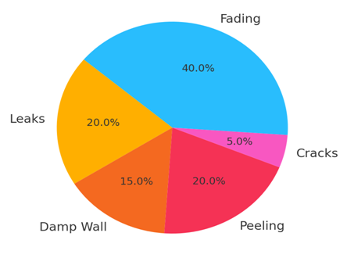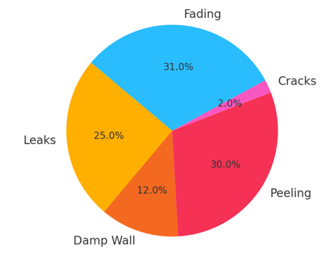
Fig 4.1: Effect of rain water on Fig 4.2: Effect of rain water on
Civil Engineering Department Mechanical Engineering Department

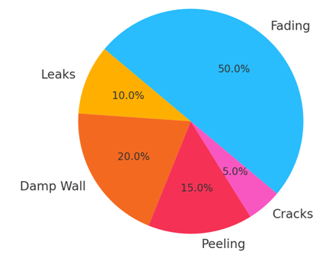
Fig 4.3: Effect of rain water on
Electrical and Electronic Department Agric
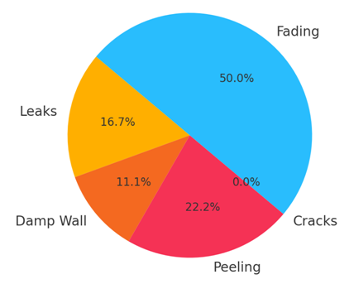
Fig 4.4: Effect of rain water on
Agricultural & Bio-Environmental Engineering Department

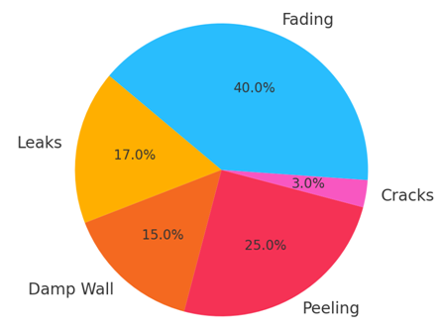
Fig 4.5: Effect of rain water on
Mining & Mineral Resources Engineering Department
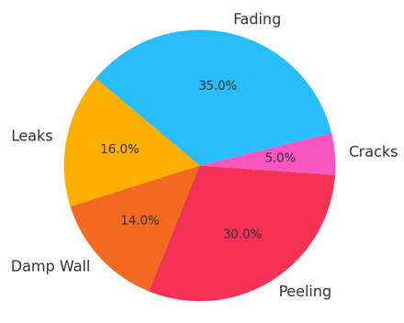
Fig 4.6: Effect of rain water on
Metallurgical Engineering Department
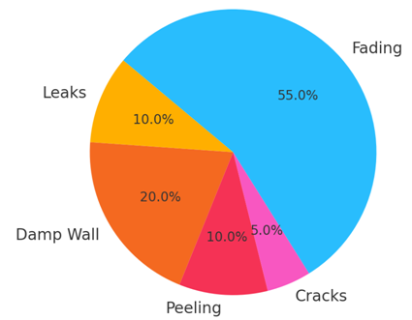
Fig 4.7: Effect of rain water on
Mechatronics Engineering Department
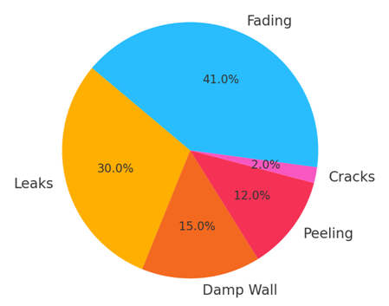
Fig 4.8: Effect of rain water on
Railway Engineering Department
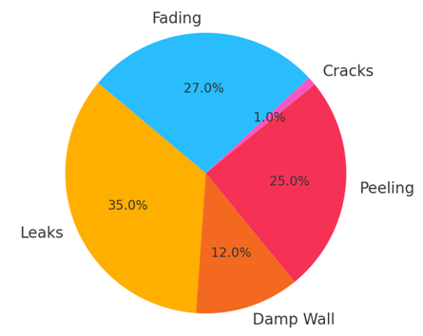
Fig 4.9: Effect of rain water on
Welding and Fabrication Engineering Department
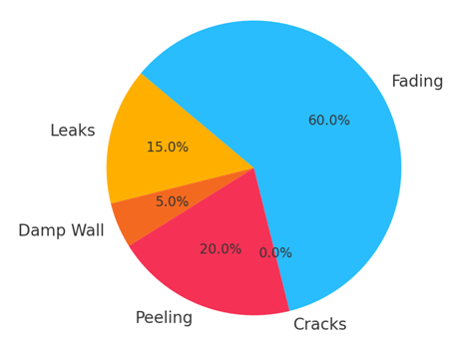
Fig 4.3: Effect of rain water on
Water Resources Engineering Department

The data indicates that rainwater has a significant impact on both structural and aesthetic integrity of the IOT building. Departments situated on upper floors or facing windward sides experience more leakage and fading. The presence of peeling and dampness suggests inadequate surface preparation and poor water drainage systems.
Both the visual inspection and HOD feedback confirm that prolonged rain exposure leads to material deterioration, requiring consistent maintenance and potentially signaling deeper structural issues if left unaddressed.
4.3 RESULTS OF THE INTEGRITY TEST
Integrity test of IOT building both directorate and the main building for interior and exterior of the building using rebound hammer
Table 4.1: Structural integrity test of the interior of the directorate building
BUILDING  COMPONENT | POINT  A | POINT  B | POINT  C | AVERAGE REBOUND NO | COMPRESSIVE STRENGTH | REBOUND READING
FLOOR SLAB | Rebound No | Rebound No | Rebound No | Average Rebound No | Strength | Rebound Reading
1 | 15 | 10 | 20 | 14.3 | NIL | Poor
2 | 10 | 19 | 17 | 15.3 | NIL | Poor
3 | 22 | 18 | 11 | 17 | NIL | Poor
COLUMN
1 | 20 | 20 | 20 | 20 | NIL | Fair
2 | 22 | 19 | 15 | 18.7 | NIL | Poor
3 | 20 | 20 | 20 | 20 | NIL | Fair
BEAM
1 | NIL | NIL | NIL | NIL | NIL | NIL
2 | NIL | NIL | NIL | NIL | NIL | NIL
3 | NIL | NIL | NIL | NIL | NIL | NIL
WALL
1 | 18 | 13 | 17 | 16 | NIL | Poor
2 | 20 | 22 | 20 | 20.2 | NIL | Fair
3 | 19 | 10 | 11 | 13.3 | NIL | Fair
LINTEL
1 | 21 | 26 | 20 | 22.3 | NIL | Fair
2 | 20 | 23 | 25 | 22.7 | NIL | Fair
3 | 22 | 24 | 20 | 22 | NIL | Fair

Table 4.2: Structural integrity of the exterior of the directorate building

BUILDING  COMPONENT | POINT  A | POINT  B | POINT  C | AVERAGE REBOUND NO | COMPRESSIVE STRENGTH | REBOUND READING
FLOOR SLAB | Rebound No | Rebound No | Rebound No | Average Rebound No | Strength | Rebound Reading
1 | 18 | 10 | 10 | 12.7 | NIL | Poor
2 | 20 | 25 | 20 | 22.6 | NIL | Fair
3 | 20 | 20 | 21 | 20.1 | NIL | Fair
COLUMN
1 | 22 | 21 | 19 | 20.7 | NIL | Fair
2 | 20 | 20 | 20 | 20.0 | NIL | Fair
3 | 19 | 20 | 18 | 19 | NIL | Poor
BEAM
1 | NIL | NIL | NIL | NIL | NIL | NIL
2 | NIL | NIL | NIL | NIL | NIL | NIL
3 | NIL | NIL | NIL | NIL | NIL | NIL
WALL
1 | 18 | 15 | 10 | 14.3 | NIL | Poor
2 | 15 | 10 | 15 | 13.3 | NIL | Poor
3 | 17 | 13 | 11 | 13.6 | NIL | Poor
LINTEL
1 | 21 | 25 | 22 | 22.6 | NIL | Fair
2 | 20 | 25 | 25 | 23.3 | NIL | Fair
3 | 25 | 24 | 21 | 23.3 | NIL | Fair

Table 4.3: Structural integrity of the interior of the main building
BUILDING  COMPONENT | POINT  A | POINT  B | POINT  C | AVERAGE REBOUND NO | COMPRESSIVE STRENGTH | REBOUND READING
FLOOR SLAB | Rebound No | Rebound No | Rebound No | Average Rebound No | Strength | Rebound Reading
1 | 12 | 10 | 10 | 10.7 | NIL | Poor
2 | 20 | 20 | 20 | 20 | NIL | Fair
3 | 23 | 24 | 20 | 20.3 | NIL | Fair
COLUMN
1 | 25 | 21 | 20 | 22 | NIL | Fair
2 | 21 | 26 | 22 | 23 | NIL | Fair
3 | 20 | 20 | 23 | 21 | NIL | Fair
BEAM
1 | NIL | NIL | NIL | NIL | NIL | NIL
2 | NIL | NIL | NIL | NIL | NIL | NIL
3 | NIL | NIL | NIL | NIL | NIL | NIL
WALL
1 | 19 | 15 | 13 | 15.7 | NIL | Poor
2 | 17 | 13 | 18 | 16 | NIL | Poor
3 | 14 | 16 | 18 | 16 | NIL | Poor
LINTEL
1 | 25 | 25 | 20 | 23.3 | NIL | Fair
2 | 20 | 29 | 27 | 25.3 | NIL | Fair
3 | 25 | 24 | 21 | 23.3 | NIL | Fair

Table 4.4: Structural integrity of the exterior of the main building
BUILDING  COMPONENT | POINT  A | POINT  B | POINT  C | AVERAGE REBOUND NO | COMPRESSIVE STRENGTH | REBOUND READING
FLOOR SLAB | Rebound No | Rebound No | Rebound No | Average Rebound No | Strength | Rebound Reading
1 | 15 | 12 | 17 | 14.7 | NIL | Poor
2 | 20 | 21 | 19 | 20 | NIL | Fair
3 | 18 | 18 | 16 | 17.3 | NIL | Poor
COLUMN
1 | 20 | 21 | 20 | 20.3 | NIL | Fair
2 | 24 | 26 | 22 | 24 | NIL | Fair
3 | 20 | 25 | 23 | 22.6 | NIL | Fair
BEAM
1 | NIL | NIL | NIL | NIL | NIL | NIL
2 | NIL | NIL | NIL | NIL | NIL | NIL
3 | NIL | NIL | NIL | NIL | NIL | NIL
WALL
1 | 10 | 13 | 12 | 11.7 | NIL | Poor
2 | 12 | 13 | 11 | 12 | NIL | Poor
3 | 14 | 14 | 18 | 15.3 | NIL | Poor
LINTEL
1 | 25 | 23 | 27 | 25 | NIL | Fair
2 | 26 | 29 | 27 | 27.3 | NIL | Fair
3 | 20 | 24 | 29 | 24.3 | NIL | Fair

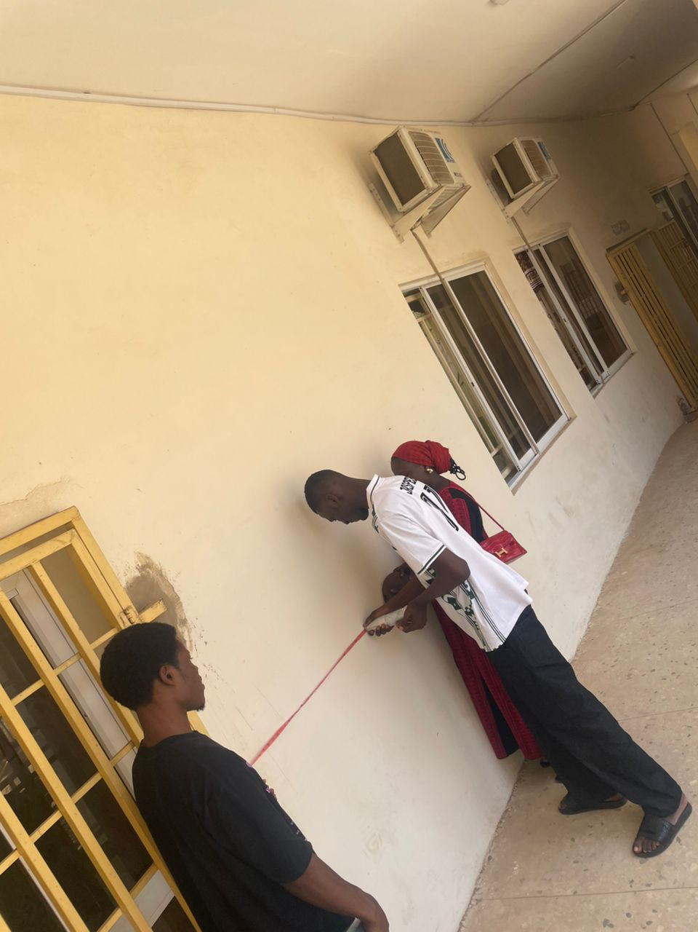
Plate 4.5: The students taking the destructing compressive strength of the wall with use of rebound hammer

CHAPTER FIVE
CONCLUSION AND RECOMMENDATIONS
5.1 CONCLUSION
This project has provided an in-depth investigation into the environmental impact of rainwater on the structural integrity and surface condition of the IOT building. The study focused on identifying common defects associated with rainwater infiltration, using a combination of visual inspection techniques and questionnaire responses from the Heads of Departments. The defects assessed included leaks, damp walls, peeling surfaces, cracks, and fading, all of which are critical indicators of environmental wear and long-term structural vulnerability.
Through the data gathered and represented via pie charts, it became evident that fading and peeling were the most prevalent forms. Based on the results obtained from the project work,, The following conclusion are hereby made;
- Fading of the paint and peeling are the most prevalent for of rain induces.
- The Department mostly affected by the effect of the rain water agric and Bio-Environmental and railway Engineering Department.
- Based on the integrity tests carried out, Columns, Wall and slabs of directorate building are structured okay compared to the main building which is exposed to rainfall significantly affect in the structural strength and durability of the building. The wall have value less 20N/mm² which shows that they are weakened not structurally okay. Although this might not pose any significant threat to the building. Signs of moisture penetration, surface cracks, and material degradation particularly in exposed areas like the walls.
- Department such as Electrical Electronics, Mechanical, and Water Resources Engineering recorded very high fading levels-suggesting prolonged and repeated exposure to direct rainfall.
- Conversely, leakage and damp walls, which are more structural in nature, were most commonly observed in departments like Mechanical, Welding & Fabrication, and Railway Engineering—implying issues with roof integrity, water drainage systems, or poor waterproofing.
Importantly, this research underscores the critical need for routine inspection, preventive maintenance, and the use of weather-resistant materials in both the design and retrofitting of public buildings. Ignoring early signs of water-related defects can lead to compounding structural problems, higher repair costs, and potential safety hazards. The role of proper roof design, wall coatings, sealants, and drainage systems cannot be overstated in preventing moisture penetration.
In conclusion, the study has successfully demonstrated that rainwater has a significant negative impact on buildings if not properly managed. It highlights the value of regular inspections and responsive maintenance practices in preserving the structural integrity of institutional facilities. It is recommended that management should invest in sustainable maintenance strategies, weatherproof construction materials, and periodic condition assessments to ensure the longevity, safety, and aesthetic quality of the IoT building and similar infrastructure.
5.2 RECOMMENDATION
Following the extensive investigation into the environmental impact of rainwater on the structural integrity of the IoT building—through visual inspections and structured questionnaires—several patterns of rain-induced damage were identified. These defects, which include leaks, damp walls, peeling, cracks, and fading, pose significant risks to the durability and usability of the building. Based on these findings, the following recommendations are proposed to mitigate current issues and prevent future deterioration:
Firstly, a comprehensive preventive maintenance program should be implemented. This program must include periodic visual inspections (at least quarterly), with detailed documentation of observed defects. Special attention should be given to roofs, exterior walls, drainage systems, and water-prone areas. Regular maintenance will ensure early detection of damage and help avoid costly repairs or irreversible structural compromise.
Secondly, there is a need for a complete overhaul and improvement of the building envelope and waterproofing systems. Areas prone to water ingress should be treated with high-quality waterproof coatings and weather-resistant materials. The installation and repair of roof flashings, gutters, and proper drainage outlets must be prioritized to ensure efficient channeling of rainwater. All cracks, wall penetrations, and joint openings should be sealed with appropriate waterproofing compounds to prevent moisture intrusion.
In line with this, all future repairs, renovations, or extensions to the IoT building should make use of durable, rain-resistant materials. This includes the use of UV-resistant and anti-fungal paints, polymer-modified plasters, high-quality roofing sheets, and moisture-tolerant internal finishes. Selecting such materials will significantly reduce issues like peeling and fading, while also enhancing the building’s overall resistance to weather effects.
Beyond visual inspection, the adoption of advanced non-destructive testing (NDT) methods is strongly recommended. Tools such as moisture meters, infrared thermography, and rebound hammer tests can detect hidden water ingress, weakened concrete, and internal dampness. These technologies will offer a more thorough diagnosis of the building’s health and supplement the data gathered through visual inspection.
Additionally, training of maintenance personnel is critical. Staff responsible for building upkeep should be trained to recognize early signs of damage, apply protective coatings correctly, and follow a standardized procedure for reporting and rectifying faults. Empowering staff through knowledge will foster a proactive maintenance culture within the institution.
Effective building maintenance also depends on institutional support and financial commitment. The university administration should allocate a dedicated annual budget for building inspections, repairs, waterproofing, and upgrades. Maintenance decisions should not be delayed due to a lack of funds or administrative bottlenecks. Collaboration among departments, maintenance staff, and management must be encouraged to ensure smooth execution of maintenance plans.
Looking forward, future building projects within the institution should integrate rainwater control features at the design stage. These should include rain screen façades, extended roof overhangs, ventilated cavities, and proper slope grading on roofs and walkways. Incorporating such features will significantly reduce the direct impact of rainfall and improve indoor environmental conditions.
Furthermore, a formal building condition policy should be developed. This policy should mandate routine inspections, maintenance scheduling, and data-driven intervention planning. Creating a digital or physical database of common building defects and their management records will improve monitoring and accountability.
Lastly, there should be a mechanism in place for user engagement and feedback. Departmental heads and occupants should be encouraged to report visible defects as soon as they arise. Regular feedback surveys can be used to track user satisfaction and identify areas that require urgent attention.
In conclusion, the above recommendations, if adopted and consistently implemented, will drastically improve the durability, safety, and aesthetic quality of the IoT building. This will not only extend the lifespan of the structure but also create a healthier and more conducive learning environment. Effective rainwater management and maintenance are not optional—they are essential to the sustainability and performance of academic infrastructure.
References
Adekunle, A., & Olorunfemi, O. (2019). “Effects of Rainwater Leakage on Building Durability: A Case Study of Ilorin.” Journal of Environmental Engineering and Landscape Management, 27(3), 123–134.
American Concrete Institute (ACI) Committee 201. (2008). Guide for Conducting Evaluations of Concrete Structures (ACI 562R-08). ACI.
ASTM International. (2017). ASTM E514-16: Standard Test Method for Water Penetration and Leakage Through Masonry. ASTM.
Broomfield, J. (2006). Corrosion of Steel in Concrete: Understanding, Investigation and Repair. Taylor & Francis.
British Standards Institution. (2006). BS 8100: Code of Practice for Strengthening and Repair of Buildings. BSI.
Dayaratnam, P. (2006). Building Materials and Construction (2nd ed.). Oxford & IBH Publishing.
Fan, C. (2020). “Structural Responses to Moisture Ingress in Coastal Regions.” Coastal Engineering Journal, 62(4), 350–364.
Ghosh, S. K., & Sinha, P. (2017). “Influence of Rainwater Characteristics on Corrosion of Reinforced Concrete.” Journal of Materials in Civil Engineering, 29(9), 04017123.
Koksal, F., & Ulusoy, U. (2008). “Durability of Concrete Exposed to Chloride Environments and Wetting–Drying Cycles.” Cement and Concrete Composites, 30(9), 682–693.
Mehta, P. K., & Monteiro, P. J. M. (2014). Concrete: Microstructure, Properties, and Materials (4th ed.). McGraw-Hill Education.
Nigerian Meteorological Agency. (2019). Annual Rainfall Data for Kwara State. NIMET.Neville, A. M. (2016). Properties of Concrete (5th ed.). Pearson Education.
Okeke, P. U., & Eze, P. (2020). “Rainwater Ingress and Its Impact on Structural Integrity of University Buildings.” Construction and Building Materials, 244, 118290.
Olatunji, S. (2015). “Rainwater Harvesting and Its Effects on Building Foundations.” International Journal of Civil and Structural Engineering, 6(4), 312–319.
Olutoge, F. A., & Ojelabi, O. (2018). “Assessment of Water Penetration on Concrete Structures in Tropical Climates.” Journal of Civil Engineering Research, 7(2), 45–52.
Papadakis, V. G., & Fardis, M. N. (1991). “Mixed-Mode Fracture Behavior of Concrete.” Journal of Structural Engineering, 117(8), 2367–2388.
- Zhang, L., Bryan, J., & Mendis, P. (2014). “Investigation of Surface Water Penetration in Masonry Structures.” Journal of Building Performance, 5(1), 12–23.

