
PROJECTREPORT
ON
DESIGIN AND CONSTRUCTION OF
3KVA INVERTER USING A 24VOLTS
BATTERY
PRESENTED BY:

OLADOKUN MOSES OLUWASHEGUN
HND/23/SLT/FT/1148
SUBMITTED TO THE DEPARTMENT OF DEPARTMENT OF SCIENCE LABORATORY TECHNOLOGY, (PHYSICS UNITS), INSTITUTE OF
APPLIED SCIENCE, KWARA STATE POLYTECHNIC, ILORIN, KWARA STATE
IN PARTIAL FULFILLMENT FOR THE AWARD OF HIGHER NATIONAL DIPLOMA (HND) IN SCIENCE LABORATORY TECHNOLOGY, KWARA
STATE POLYTECHNIC, ILORIN
SUPERVISED BY:
MR. AGBOOLAA.O
2024/2025 SESSION
CERTIFICATION
This is to certify that this project work was carried out by OLADOKUN MOSES OLUWASHEGUN with the Matriculation Number HND/23/SLT/FT/1148. This project has been read and approved as meeting part of the requirement for the award of Higher National Diploma (HND) in science laboratory technology, Kwara State Polytechnic, Ilorin.

—————————. —————————
MR AGBOOLA, A.O. DATE
(PROJECT SUPERVISOR)

—————————. —————————
MR. SALAHU,B. DATE
(HEAD OF UNIT).

————————— —————————
DR.USMAN A. DATE
(HEAD OF DEPARTMENT)

————————— —————————
EXTERNAL SUPERVISOR DATE

DEDICATION
This project is dedicated to Almighty God whose supremacy in the knowledge of everything is absolute. And to my entire family member.

ACKNOWLEDGMENT
Glory be to Almighty God, the lord of the world, who has been through his mercy for sparing our lives till today.
This project would not have been possible if not because of the invaluable inputs and assistance of some people who in one way or the other made an immense contribution measuring a betterment of life.
Firstly, words are not enough of how I could express my profound and in-depth love towards my supervisor, Mr Agboola A.O, who not only played the role of a supervisor but also combined it with that if a father. I will forever be grateful to you. May the Almighty continue to bless you abundantly in all your endeavors in life.
I will now direct my profound gratitude to my parents Mr. and Mrs. Oladokun who have provided the needed financial assistance right from the day of birth up to this stage. May Almighty God grant them long life in good health so that they can be able to reap the fruits of their labor, and continue to guide them in their shortcomings (AMEN).
Likewise, I appreciate friends, Siblings and family who in one way or the other supported me financially, physically and the like, thanks so much for playing the good part.

TABLE OF CONTENTS
Front page
Certification
Dedication
Acknowledgment
Table of contents
Abstract
CHAPTER ONE
1.0. Introduction
1.1. Aim and objective
1.2. Purpose
1.3. Scope
1.4. Limitations
CHAPTER TWO
2.1 Review of History of an Inverter
2.2 How to Choose the Right Inverter
2.3 Difference Between Sine Wave and Modified Sine Wave Inverters
2.4 Inverter Capacity
2.5 Safety of Inverter
2.6 Inverter Rating
2.7 Why Choose a Modified Sine Wave Inverter?
2.8 Types of Inverter
CHAPTER THREE
3.0 Methodology
3.1 Materials And Methods
3.2 Oscillatory and power section
3.3 Component Selection
3.4 Casing And Packaging
3.5 Circuit Diagram and Operation
CHAPTER FOUR
4.1 Testing and evaluation under load condition
4.2 Power Rating
4.3 Design Specifications
4.4 Challenges Encountered
4.5 Protection And Safety Features
CHAPTER FIVE
5.1 Summary
5.2 Conclusion
5.3 Recommendations
References

ABSTRACT
This project focuses on the design and construction of a 3KVA inverter powered by a 24-volt battery system, aimed at providing a reliable and cost-effective alternative energy solution for domestic and small office applications. With increasing global concerns over energy security, environmental degradation, and unreliable grid electricity—especially in developing regions—there is a critical need for sustainable power backup systems. The project addresses this challenge by developing an inverter capable of converting direct current (DC) from a 24V battery into alternating current (AC) at 220V, which is suitable for powering common household appliances such as fans, lighting systems, laptops, and refrigerators. The design methodology involved selecting and integrating key components including MOSFETs, a step-up transformer, capacitors, a charge controller, cooling fans, and protective devices. The inverter employs a modified sine wave output due to its simplicity and cost-effectiveness, while maintaining operational compatibility with a wide range of appliances. An oscillator circuit was implemented to generate a 50Hz square waveform used to switch the MOSFETs, which in turn drove the transformer to step up the voltage to the desired AC level.
The constructed system was tested under varying load conditions and demonstrated a stable output voltage and frequency, indicating reliable performance. Challenges encountered during the project included heat dissipation, oscillator stability, and sourcing suitable high-current components. These were addressed through design optimizations and system recalibrations.
CHAPTER ONE
1.0 Introduction
The need for alternative energy sources has become increasingly important due to global energy crises, environmental concerns, and the growing demand for sustainable power solutions. Conventional electricity generation methods, such as fossil fuel-based power plants, contribute significantly to carbon emissions and environmental degradation. To address these challenges, renewable energy sources such as solar power have gained widespread attention, (Becquerel, A. 1839)
Solar power systems rely on photovoltaic (PV) panels to harness energy from the sun and convert it into direct current (DC) electricity. However, most household and industrial appliances operate on alternating current (AC), making it necessary to use an inverter to convert DC to AC. This project focuses on the design and construction of a 3KVA solar inverter using a 24V battery system, which serves as an efficient and sustainable power backup solution.
A 3KVA inverter is suitable for powering multiple household and office appliances, including lights, fans, computers, televisions, and small refrigerators. The system will incorporate advanced power conversion techniques, battery management strategies, and safety mechanisms to ensure reliable operation, (Lander, C. W. 1993).
This project aims to develop a cost-effective, durable, and environmentally friendly inverter system that enhances energy security and reduces dependence on grid electricity.

1.1 Objectives Of The Project
The main objectives of this project include:
- Designing and constructing a 3KVA inverter that can efficiently convert DC power from a 24V battery system into stable 220V AC power.
- Implementing a pure sine wave output, which ensure compatibility with a wide range of appliances and reduces power losses.
- Enhancing battery protection mechanisms to prevent overcharging, deep discharge, and thermal damage.
- Developing an efficient power management system that optimizes energy usage and extends battery lifespan.
- Testing and evaluating the performance of the inverter under real-world conditions to ensure reliability and efficiency.

1.2 Purpose Of The Project
The purpose of this project is to develop a renewable and sustainable energy solution that provides a reliable backup power supply. The key reasons behind this project include:
- To mitigate power outages: Many regions, particularly in developing countries, experience frequent power failures. A solar inverter system ensures continuous electricity supply, improving productivity and quality of life.
- To promote the use of renewable energy: Solar energy is an abundant and eco-friendly source of power. Utilizing it through an efficient inverter system helps reduce dependence on fossil fuels.
- To provide an affordable alternative to fuel-powered generators: Unlike petrol or diesel generators, solar inverters have low operational costs, require minimal maintenance, and do not produce harmful emissions.
- To increase energy independence: A solar inverter system allows individuals and businesses to generate and store their own electricity, reducing reliance on unstable power grids.

1.3 Significance Of The Project
The importance of this project lies in its contribution to energy efficiency, sustainability, and economic benefits. Key points include:
- Environmental Sustainability: Solar energy is clean and renewable, helping to combat climate change by reducing greenhouse gas emissions.
- Cost-Effectiveness: Although the initial investment in solar power systems is high, they offer long-term savings by reducing electricity bills and generator fuel costs.
- Reliable Power Supply: A 3KVA solar inverter ensures an uninterrupted power source, which is crucial for homes, offices, hospitals, and rural areas.
- Technology Advancement: This project contributes to innovative power electronics, enhancing the efficiency of renewable energy systems.
- Energy Accessibility: Many remote communities lack access to electricity. Solar inverters provide an off-grid power solution, enabling economic and social development.

1.4 Limitations Of The Project
While this project offers numerous advantages, some limitations exist:
- Weather Dependency: Solar energy production is dependent on sunlight availability, which varies based on geographic location and weather conditions.
- Battery Lifespan: Rechargeable batteries have a limited life cycle and require periodic replacement.
- Limited Load Capacity: A 3KVA inverter can only power small-to-medium appliances. High-energy-consuming devices like air conditioners require higher power ratings.
- Technical Complexity: Designing and constructing an efficient inverter system requires expertise in electrical engineering, power electronics, and circuit design.

CHAPTER TWO

LITERATURE REVIEW
2.1 Review of History of an Inverter
An inverter is an essential component in electrical systems that converts direct current (DC) into alternating current (AC). The development of inverters dates back to the early 20th century when mechanical rotary converters were used to transform DC to AC. With advancements in power electronics, semiconductor-based inverters emerged in the mid-20th century, leading to the modern solid-state inverters used today. The evolution of inverters has been driven by the increasing need for reliable power conversion in various applications, including renewable energy systems, uninterruptible power supplies (UPS), and industrial machinery.

2.2 How to Choose the Right Inverter
Choosing the right inverter depends on multiple factors, including the intended application, power requirements, and budget. Some key considerations include:
- Power Output: The inverter should match or exceed the total wattage of connected devices.
- Waveform Type: Sine wave inverters are ideal for sensitive electronics, while modified sine wave inverters are more affordable but may not be suitable for all applications.
- Input Voltage: The inverter must be compatible with the battery voltage (e.g., 12V, 24V, 48V).
- Efficiency and Load Handling: High-efficiency inverters minimize energy losses, and overload protection is essential for durability.
- Portability and Features: Some inverters include additional features like USB charging ports, remote control, and smart monitoring.

2.3 Difference Between Sine Wave and Modified Sine Wave Inverters
Inverters produce different types of AC output waveforms, which affect their compatibility with various devices.
- Sine Wave Inverter: Produces a smooth, continuous waveform similar to utility grid power, making it ideal for sensitive electronics, medical equipment, and appliances with motors.
- Modified Sine Wave Inverter: Generates a stepped or squared waveform, which can cause interference and inefficiency in some devices. While it is more affordable, it may not be suitable for high-precision electronics or inductive loads like refrigerators and compressors.

2.4 Inverter Capacity
The capacity of an inverter is measured in watts (W) or kilowatts (kW) and determines the maximum load it can support. Factors affecting inverter capacity include:
- Total Load Calculation: Summing up the wattage of all connected devices.
- Peak vs. Continuous Power: Some appliances require higher startup power (surge power) compared to their continuous running power.
- Battery Bank Size: A larger capacity inverter requires a corresponding battery bank to sustain power delivery over time.

2.5 Safety of Inverter
Inverter safety is crucial to prevent electrical hazards, overheating, and damage to appliances. Safety features include:
- Overload and Short-Circuit Protection: Prevents damage from excessive power draw or faults.
- Overvoltage and Undervoltage Protection: Ensures stable operation by shutting down during abnormal voltage conditions.
- Cooling Mechanisms: Heat sinks and cooling fans help prevent overheating.
- Grounding and Isolation: Proper grounding minimizes the risk of electric shocks and interference.

2.6 Inverter Rating
The rating of an inverter refers to its maximum power output, typically labeled in watts (W) or kilowatts (kW). Common ratings include:
- Continuous Power Rating: The stable output an inverter can provide over an extended period.
- Surge Power Rating: The temporary peak power an inverter can deliver to handle motor startups and high-power demands.
- Efficiency Rating: Expressed as a percentage, it indicates how much DC power is effectively converted into usable AC power.
2.7 Why Choose a Modified Sine Wave Inverter?
Modified sine wave inverters are often chosen due to their affordability and suitability for basic applications. Some reasons to choose a modified sine wave inverter include:
- Cost-Effectiveness: Cheaper than pure sine wave inverters.
- Adequate for Simple Devices: Works well with non-sensitive devices like lights, fans, and some tools.
- Lower Complexity: Easier to manufacture and repair compared to sine wave inverters.
However, they may not be ideal for appliances with motors, medical equipment, or devices requiring precise voltage regulation.

2.8 Types of Inverter
Inverters can be classified based on waveform output, application, and technology. Common types include:
- Sine Wave Inverter: Produces smooth AC power similar to the grid, ideal for sensitive electronics.
- Modified Sine Wave Inverter: Uses a stepped waveform, suitable for less-sensitive appliances.
- Grid-Tied Inverter: Designed to connect to the power grid for solar energy systems, without requiring batteries.
- Off-Grid Inverter: Used in standalone systems with battery storage, ideal for remote locations.
- Hybrid Inverter: Combines grid-tied and off-grid functionality, managing both solar power and battery storage efficiently.
This literature review provides an overview of inverters, helping to understand their history, selection criteria, types, and safety considerations.

CHAPTER THREE
3.0 METHODOLOGY
3.1 Materials And Methods
The design and construction of the 3KVA solar inverter using a 24V battery involved selecting and assembling key components such as a 24V battery bank, charge controller, step-up transformer, buzzer, MOSFETs, integrated circuits, capacitors, and cooling fans. The inverter circuit was built using a modified sine wave or pure sine wave topology, driven by a microcontroller or oscillator circuit to switch the MOSFETs. A step-up transformer was used to convert the 24V DC to 220V AC. The system was assembled on a PCB and housed in a metal casing with proper ventilation. Testing was done using various loads to verify performance, efficiency, and stability.
3.2 Oscillatory And Power Section
The oscillatory and power section forms the heart of the inverter system, responsible for generating the alternating signal and converting DC power to usable AC output. The oscillatory section typically consists of a waveform generator, often built using a microcontroller, timer IC (such as the 555 timer), or crystal oscillator circuit. This section produces a square wave or modified sine wave signal that controls the switching of the power transistors or MOSFETs. These pulses are alternated to simulate AC waveforms at a frequency of approximately 50Hz, which is standard for most AC appliances. The power section involves the amplification and switching of the low-voltage DC from the battery into high-voltage AC. It includes high-power MOSFETs or IGBTs configured in an H-bridge or push-pull arrangement. These switching devices are driven by the oscillatory signals and are responsible for converting the 24V DC into a pulsating AC waveform, which is then stepped up using a transformer to around 220V AC. This section also incorporates protective components like heat sinks, fuses, and filter capacitors to ensure stable operation and protect against overheating or overloading. Together, the oscillatory and power sections work in synchronization to ensure that the inverter produces a reliable AC output suitable for powering household or office appliances.
3.3 Component Selection
The proper selection of components is critical to ensure the reliability, efficiency, and safety of the inverter system. Each component was carefully chosen based on the power rating, voltage compatibility, thermal performance, and cost-effectiveness to meet the requirements of a 3KVA inverter operating with a 24V battery system.
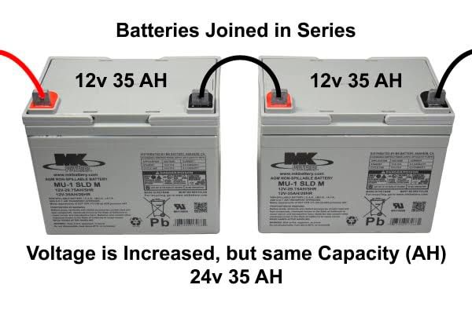
• Battery (24V Battery): A pair of 12V batteries connected in series to supply a stable 24V DC. Batteries were selected for their ability to handle prolonged discharge cycles, which is essential for inverter applications.

•MOSFETs: High-current, fast-switching MOSFETs were used to handle the DC-to-AC conversion efficiently. They are capable of switching large currents with minimal losses.
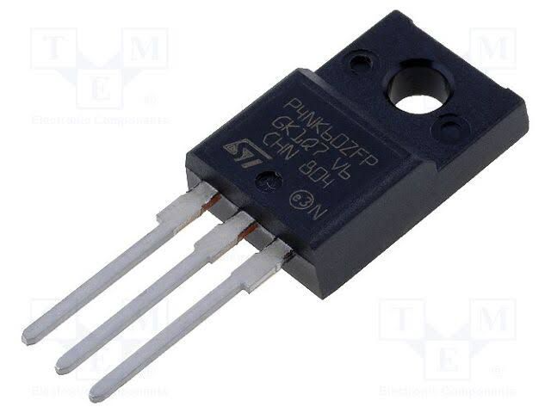
•Transformer (24V-0-24V to 220V): A step-up transformer is used to convert the low-voltage AC signal from the MOSFETs into standard 220V AC output. It was chosen based on the required power output (3KVA) and designed to handle high current without overheating.
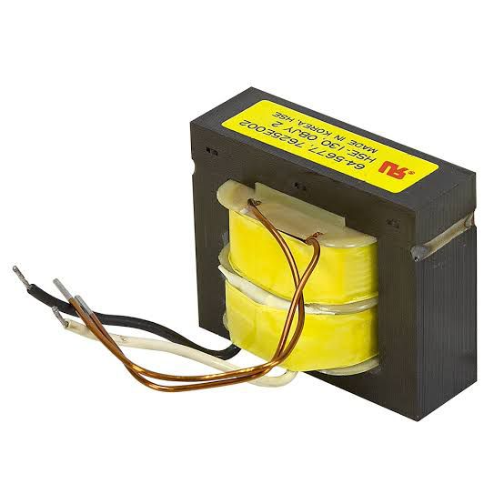
•Capacitors and Filters: Used for smoothing and filtering the output waveform to reduce noise and harmonics. High-voltage electrolytic capacitors were selected to withstand output surges.

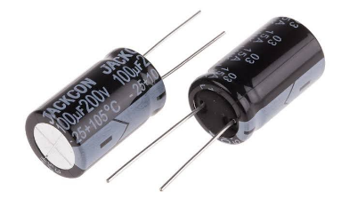
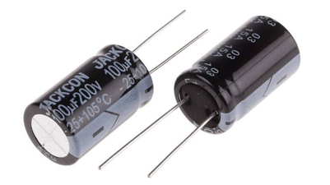
•Cooling Fan: Effective heat dissipation components are essential to prevent thermal damage to the MOSFETs and other power components. A 24V fan were included to maintain a safe operating temperature.
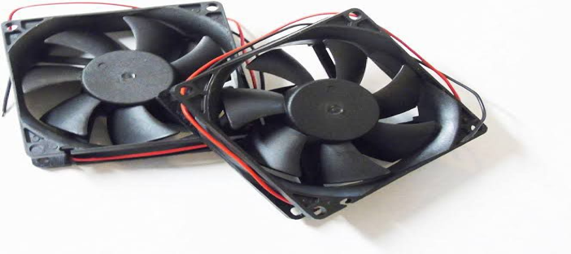
•Protection Devices (Fuses, Diodes): Fuses were added to protect against overcurrent, while flyback diodes were used across the MOSFETs to prevent voltage spikes during switching.
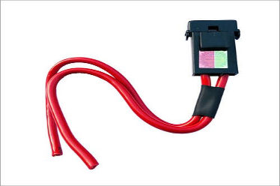
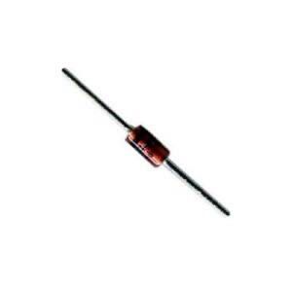
•Charge Controller: A solar charge controller regulates the voltage and current coming from the solar panels to prevent overcharging or damaging the batteries.

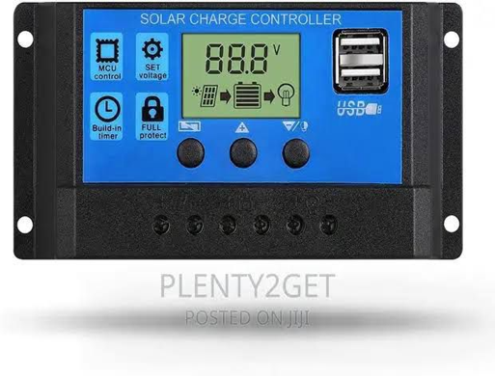
3.4 Casing And Packaging
For this project, a plastic enclosure was chosen due to its strength, heat resistance, and ability to provide proper shielding against electrical interference. The plastic case also helps in dissipating heat generated by the power components, particularly the MOSFETs and transformer. The internal layout was carefully designed to allow for adequate ventilation and spacing between components to avoid overheating and reduce the risk of short circuits. A DC-powered fan were installed to enhance airflow and maintain an optimal operating temperature. Mounting brackets were used to securely fix the transformer, circuit board, battery terminals, and other components within the case. Input and output terminals, switches, and indicators were placed on the outer panel for easy access and user operation. The packaging also includes fuse holders and status LEDs to enhance user interaction and safety. In summary, the casing was designed to be compact, rugged, and user-friendly, ensuring protection for internal components while allowing easy maintenance and transport of the inverter system.
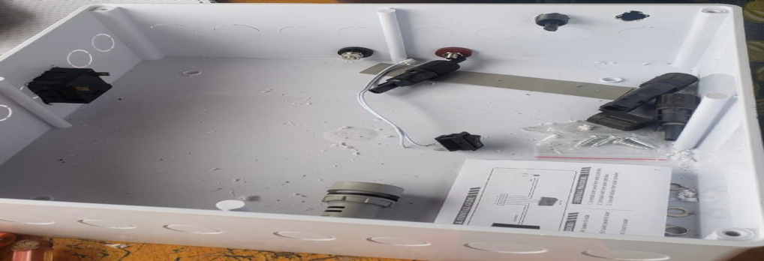
3.5 Circuit Diagram And Operation
The circuit of the 3KVA inverter is designed to convert 24V DC from the battery into 220V AC using a combination of oscillator, driver, switching, and transformer stages. The main parts of the circuit include the oscillator section, MOSFET switching stage, and a step-up transformer.
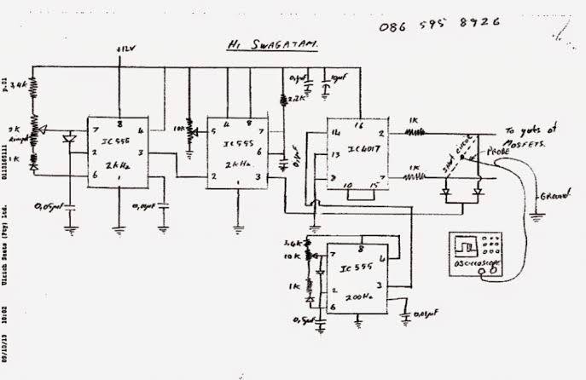
The circuit diagram of an inverter system
The operation begins with the oscillator section, which uses a timer IC (like NE555) or a microcontroller to generate a stable square wave signal at 50Hz. This signal is fed into a MOSFET driver circuit, which boosts the signal to a suitable level to switch the high-power MOSFETs. The MOSFETs, arranged in a push-pull or H-bridge configuration, act as electronic switches, rapidly turning on and off to chop the 24V DC supply into a pulsating AC waveform. These pulses are fed into the primary winding of the step-up transformer, which increases the voltage from 24V (AC equivalent) to approximately 220V AC at the secondary winding. Filter capacitors may be used at the output to smoothen the waveform and reduce electrical noise. The result is a modified sine wave or quasi-sine wave suitable for powering household or office appliances. Protection components like fuses, diodes, and heat sinks are included to prevent damage due to overcurrent, back EMF, or overheating. The circuit is designed for efficient operation, providing a stable AC output while maintaining the integrity of the components and overall system.
CHAPTER FOUR
4.0 SYSTEM CONSTRUCTION AND TESTING
4.1 Testing And Evaluation Under Load Condition
The constructed 3KVA inverter was tested under various load conditions to evaluate its performance and stability. The testing involved connecting the inverter to a 24V battery bank and gradually applying electrical loads, starting from light appliances such as energy-saving bulbs and fans, up to heavier loads like a refrigerator and electric pressing iron. Throughout the testing, the output voltage remained stable around 220V AC, and the frequency stayed close to 50Hz. The inverter operated efficiently under partial and full loads, with only moderate heating observed in the transformer and MOSFETs during prolonged high-load operation. Adequate ventilation and heat sinks helped maintain safe temperatures. Overall, the inverter performed reliably within its rated capacity, making it suitable for household or office use.
4.2 Power Rating
The power rating of the inverter defines its maximum load-handling capacity and determines the types of appliances it can support. In this project, the inverter was designed with a power rating of 3KVA (3000VA), which corresponds to a maximum power output of approximately 2400 watts, assuming a power factor of 0.8. This rating indicates that the inverter can effectively power a combination of household or office appliances such as fans, televisions, lighting systems, laptops, and refrigerators, provided the total load does not exceed its rated capacity. The system operates using a 24V DC battery input, which is stepped up to 220V AC output, making it suitable for standard electrical devices. Careful consideration was given to component selection including transformer size, wire gauge, and switching devices to ensure the system could consistently deliver the rated power without overheating or voltage drops.
4.3 Design Specifications
The inverter was designed to produce a modified sine wave output, which is a stepped approximation of a pure sine wave, suitable for most household appliances. Unlike a smooth sine wave, the modified sine wave consists of a square-like waveform that changes polarity with a short zero-voltage pause between cycles, reducing harmonic distortion compared to a pure square wave. This waveform is easier and cheaper to generate using basic oscillator and switching circuits, making it ideal for low to medium-cost inverter systems. The output frequency was maintained at approximately 50Hz, and the RMS voltage was kept close to 220V AC. This design allows compatibility with common appliances like lights, fans, and chargers, though sensitive electronics may require a pure sine wave inverter for optimal performance. Below is the graphical representation of the modified sine wave produced by the inverter:
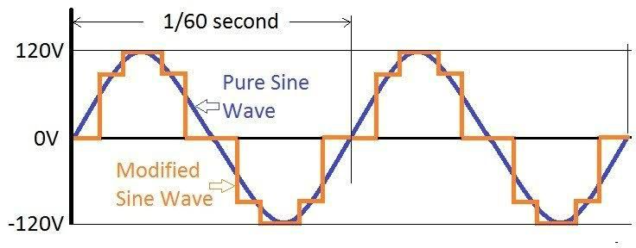
4.4 Challenges Encountered
During the design and construction of the 3KVA solar inverter using a 24V battery, several challenges were encountered that affected the development process. One major challenge was ensuring the stability of the oscillator circuit, as slight variations in frequency affected the output waveform quality. Another issue was heat generation in the MOSFETs and transformer during extended high-load testing, which required the addition of larger heat sinks and improved ventilation. Component sourcing also posed difficulties, especially in obtaining high-current-rated MOSFETs and transformers suitable for 3KVA operation. Additionally, achieving consistent output voltage under varying load conditions required careful calibration of the control circuit. Despite these setbacks, adjustments and redesigns were implemented to overcome the issues and ensure reliable inverter performance.
4.5 Protection And Safety Features
To ensure reliable and safe operation of the 3KVA solar inverter, several protection and safety features were integrated into the design. A fuse was included at the input stage to prevent damage from overcurrent or short circuits, while reverse polarity protection diodes were used to safeguard against incorrect battery connections. Cooling fan were installed to manage thermal buildup in the MOSFETs and transformer, reducing the risk of overheating.
Additionally, the system was designed with overload protection, which automatically shuts down the inverter when the connected load exceeds its rated capacity. Proper insulation, spacing of high-voltage components, and a metallic casing were also employed to prevent electrical shocks and ensure user safety. These features collectively enhance the durability and safe functioning of the inverter system under various operating conditions.

CHAPTER FIVE
SUMMARY, CONCLUSION, RECOMMENDATIONS
5.1 Summary
This project focused on the design and construction of a 3KVA inverter system powered by a 24V battery, intended to serve as a reliable and sustainable power backup for household and office appliances. The motivation for the project stemmed from persistent power outages in many regions and the increasing demand for alternative, eco-friendly energy solutions. The inverter system was developed to convert direct current (DC) from a battery source into alternating current (AC), which is compatible with standard electrical appliances.
Chapter One introduced the context of the study, emphasizing the growing importance of renewable energy sources, especially solar power, as a response to environmental concerns and energy insecurity. The chapter also laid out the objectives and significance of the inverter system, highlighting its environmental, economic, and technical relevance.
In Chapter Two, a comprehensive literature review explored the historical evolution of inverters, their classifications, waveform types (pure sine wave vs. modified sine wave), and the principles guiding inverter selection and capacity. The review also explained key safety measures and identified the benefits and limitations of different inverter technologies.
Chapter Three outlined the methodology for constructing the inverter. The system utilized major components including a 24V battery bank, MOSFETs, capacitors, a step-up transformer, cooling fans, and protective elements such as fuses and diodes. Emphasis was placed on efficient component selection, circuit design, casing for ventilation, and layout for ease of use and maintenance.
In Chapter Four, the inverter was tested under various load conditions. The system demonstrated stable voltage and frequency output, withstanding both partial and full loads efficiently. However, issues such as heat dissipation, oscillator frequency stability, and sourcing high-rated components were encountered and resolved through system refinements.
5.2 Conclusion
The design and construction of a 3KVA inverter using a 24V battery presented in this project provides a compelling solution to the challenge of unreliable power supply, especially in energy-deprived areas. Through careful integration of electrical components and innovative power conversion techniques, the system demonstrates that clean, renewable, and efficient electricity generation is attainable at a small scale and with limited resources.
The inverter system met its design expectations by converting 24V DC from a battery source into a stable 220V AC output capable of supporting basic appliances such as lighting, fans, laptops, and refrigerators. The modified sine wave output, while not as refined as pure sine wave inverters, provides a cost-effective and adequate alternative for general domestic and light industrial use.
Additionally, the project’s outcome illustrates the importance of component matching and thermal management in inverter systems. The challenges faced—especially heat dissipation and oscillator stability—highlighted the complex interplay between circuit design, power electronics, and real-world operating conditions. Addressing these challenges required technical adjustments that improved the overall performance and safety of the system.
Furthermore, the incorporation of protective elements such as fuses, cooling systems, and overload shutdown mechanisms enhanced the reliability and user safety of the system. The project's success not only contributes to local technological innovation but also strengthens the case for broader adoption of renewable energy technologies in Nigeria and other developing nations.
In conclusion, the project achieves its primary aim of creating a reliable, low-cost backup power solution that addresses both energy access and environmental concerns. It also offers valuable insights and a practical blueprint for future improvements and larger-scale inverter system development.
5.3 Recommendations
- Upgrade to Pure Sine Wave Output: For improved compatibility with sensitive electronic appliances, future designs should incorporate pure sine wave inverters, despite their higher cost.
- Enhanced Cooling Mechanisms: The use of heat sinks and DC-powered fans was effective but should be supplemented with automatic thermal regulation to prevent overheating during extended usage.
- Digital Monitoring Features: Incorporating digital display units or microcontroller-based monitoring can provide real-time feedback on voltage, current, and battery status, improving user interface and maintenance.
- Improved Oscillator Stability: Future iterations should consider advanced oscillator circuits with precise frequency control, such as crystal oscillators or programmable microcontrollers.
- Component Standardization and Sourcing: To ensure consistent quality and scalability, efforts should be made to source high-grade, standardized components, potentially through institutional partnerships or local fabrication.

REFERENCES
Becquerel, A. (1839). La production de l’électricité par le rayonnement solaire. Comptes Rendus, 9, 561–567.
Chapman, S. J. (2002). Electric Machinery Fundamentals (4th ed.). McGraw-Hill.
Krein, P. T. (1998). Elements of Power Electronics. Oxford University Press.
Lander, C. W. (1993). Power Electronics. McGraw-Hill.
Rashid, M. H. (2004). Power Electronics: Circuits, Devices, and Applications (3rd ed.). Pearson Education.
Singh, M. D., & Khanchandani, K. B. (2006). Power Electronics. Tata McGraw-Hill.

