CONSTRCUTION OF EXTENSION BOX

BY

OLANREWAJU MICHAEL DAMILOLA
ND/23/EEE/PT/0178

A PROJECT SUBMITTED TO:
DEPARTMENT OF ELECTRICAL ELECTRONIC ENGINEERING, INSTITUTE OF TECHNOLOGY (IOT), KWARA STATE POLYTECHNIC, ILORIN.

IN PARTIAL FULFILLMENT OF THE REQUIREMENTS FOR THE AWARD OF NATIONAL DIPLOMA (ND) IN ELECTRICAL ELECTRONIC ENGINEERING

2025

CERTIFICATION
This is to certify that this project was carried out by KAMALDEEN RIDWAN AYO with Matriculation Number ND/23/EEE/PT/0178 in the department of Electrical electronic engineering, Institute of Technology, Kwara State Polytechnic, Ilorin.

__________________ __________________
ENGR. ABDULLAHI K.A DATE
Project Supervisor

__________________ __________________
ENGR. DR. O.A LAWAL DATE
Head of Department

__________________ __________________
External Supervisor DATE

DEDICATION
This research work is dedicated to Almighty ALLAH for His mercy and protection on me throughout this program.

ACKNOWLEGEMENT
My sincere appreciation goes to Almighty ALLAH for the gift of life, knowledge, wisdom, strength and peace of mind He bestowed on me. I shall forever glorify His name.
My special thanks also go to my parent for their support, both morally and financially, before and during my program, I shall forever be grateful, May you live long to enough to reap the fruit of your labour. Amin.
I will be indebted if I fail to acknowledged my supervisor ENGR. ABDULLAHI K.A for taking his time to scrutinize and make proper corrections and guidance where applicable for the overall success of this research work

TABLE OF CONTENTS
TITLE PAGE i
CERTIFICATION ii
DEDICATION iii
ACKNOWLEDGMENT iv
CHAPTER ONE

INTRODUCTION

1.1 BACKGROUND OF THE STUDY
1.2 AIMS AND OBJECTIVES
1.3 SIGNIFICANCE OF THE PROJECT
1.4 SCOPE OF THE PROJECT
1.5 LIMITATION OF THE PROJECT

1.6 DEFINITION OF TERMS
CHAPTER TWO
2.0 LITERATURE REVIEW
2.1 CONCEPT OF ELECTRICAL EXTENSION BOX
2.2 HISTORICAL BACKGROUND
2.3 REVIEW OF SIMILAR PROJECTS
2.4 COMPONENTS AND THEIR FUNCTIONS
2.6 SUMMARY OF REVIEW
CHAPTER THREE
3.0 SYSTEM DESIGN AND IMPLEMENTATION
3.1 INTRODUCTION
3.2 BLOCK DIAGRAM OF THE SYSTEM

3.3 DESCRIPTION OF THE SYSTEM
3.4 COMPONENTS USED AND THEIR FUNCTIONS
3.5 CIRCUIT DESIGN AND EXPLANATION
3.6 CONSTRUCTION PROCEDURE
3.7 SAFETY CONSIDERATIONS
CHAPTER FOUR
TESTING, RESULTS, AND DISCUSSION
4.1 INTRODUCTION
4.2 TESTING PROCEDURE
4.3 RESULTS AND OBSERVATION
4.4 DISCUSSION
CHAPTER FIVE
CONCLUSION AND RECOMMENDATIONS
- SUMMARY
5.1 CONCLUSION
5.3 CHALLENGES FACED
5.4 RECOMMENDATIONS
5.5 SUGGESTIONS FOR FUTURE PROJECTS
REFERENCES

CHAPTER ONE

INTRODUCTION
An electrical extension box is a practical and essential device designed to provide additional power outlets beyond what is available from a standard wall socket. In homes, workshops, laboratories, and offices, there is often a need to power multiple devices or appliances simultaneously, especially in locations where sockets are limited. This project focuses on the design and construction of a functional and safe electrical extension box that can distribute power efficiently, protect against overload, and ensure user convenience.

1.1 BACKGROUND OF THE STUDY
The increasing use of electrical appliances and gadgets has led to a higher demand for multiple power sources. However, most buildings are constructed with a limited number of power outlets. To solve this problem, extension boxes are used to provide additional outlets for power distribution. This project aims to design a durable and cost-effective extension box with safety measures such as fuses, switches, and indicator lights.

1.2 AIMS AND OBJECTIVES
The aim of this project is to design and construct a reliable and portable electrical extension box. The objectives include:
1. To provide multiple power outlets from a single source.
2. To ensure user safety through the use of fuse and switches.
3. To use quality and affordable materials.
4. To produce a box that is durable, simple to operate, and easy to maintain.

1.3 SIGNIFICANCE OF THE PROJECT
This project is significant as it helps to solve the problem of limited power outlets. It will be helpful in various places such as homes, classrooms, laboratories, and workshops. Additionally, the knowledge gained from the design and construction process will benefit students and engineers in understanding basic wiring and safety principles.

1.4 SCOPE OF THE PROJECT
The scope of this project covers the design and construction of a four-outlet extension box with a fuse for protection, a control switch, and an indicator light. The box is intended for low voltage AC appliances.

1.5 LIMITATION OF THE PROJECT
This project is limited to indoor usage and low power devices. It is not suitable for heavy-duty equipment or outdoor applications. The number of outlets is limited to four, and the fuse rating restricts the total load capacity.

1.6 DEFINITION OF TERMS
- Fuse: A protective device used to prevent excess current flow.
- Socket: A point where an electrical device can be connected to the power supply.
- Switch: A device for making or breaking the connection in an electric circuit.
- Indicator Light: A small lamp used to show when the extension box is powered.

CHAPTER TWO
2.0 LITERATURE REVIEW
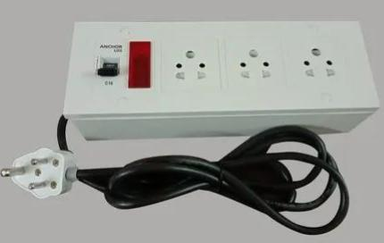
Electrical extension boxes have become essential components in both domestic and industrial environments, as they provide additional power outlets beyond what is built into a space. In this chapter, we examine the concept, historical background, development, and design standards of extension boxes. We also look into similar works, components used, and the safety regulations governing their use

2.1 Concept of Electrical Extension Box
An electrical extension box is a portable electrical device designed to provide multiple outlets from a single power source. It is commonly used where multiple appliances need to be powered but limited wall sockets are available. The box consists of sockets, wires, fuse, switches, indicator lamps, and sometimes USB ports. Its major functions include safe power distribution, circuit protection, and mobility.

2.2 Historical Background
The history of power extension devices* traces back to the era of rapid industrialization in the late 19th and early 20th centuries, when electricity began to power homes, factories, and offices. As electrical infrastructure spread, so did the demand for multiple power outlets to operate various appliances and machinery.
In the early days, extension devices were basic—consisting of simple wires and plugs used to extend power from one point to another. These early models lacked safety features and were often bulky and exposed.
Over time, as electrical devices became more diverse and safety standards improved, power extensions evolved significantly. Manufacturers began designing compact, insulated units with multiple outlets, built-in fuses, and individual switches. These additions not only enhanced safety but also improved convenience and energy control.
Today, modern power extension units may include surge protection, USB ports, circuit breakers, and smart controls, reflecting a long journey from basic wire extensions to multifunctional, safe, and user-friendly devices.
2.3 Review of Similar Projects
Several student and commercial projects have focused on developing extension boxes with added safety and convenience. Some designs include surge protection, in-built meters, and USB charging ports. Others are made with smart features that can cut off supply when the current exceeds a set limit.
This project focuses on a manually operated, fused four-outlet box, specifically built for affordability, safety, and practical learning.

2.4 Components and Their Functions
Sockets – Serve as the connection point for plugging appliances.
Switches – Used to control power supply to each outlet.
Fuse – Protects the circuit from overload or short circuit by breaking the circuit when current exceeds the rated value.
Indicator Lamp – Shows when the unit is powered.
Cables – Used for internal and external wiring, usually copper-insulated cables.
Casing – Encloses and protects all internal components.
2.5 Safety Considerations
When designing an extension box, safety is paramount. Standards such as wiring color codes (e.g., brown for live, blue for neutral, and green/yellow for earth) must be followed. All joints should be soldered or properly clipped. The fuse should be rated to match the load capacity (typically 13A or 15A). Enclosures must be made from non-conductive and heat-resistant materials such as plastic or rubber.
2.6 Summary of Review
The literature has shown that extension boxes play a critical role in safe power distribution. They have evolved from basic wire extensions to intelligent, fuse-protected, and user-friendly devices. This project builds upon the knowledge from previous designs while focusing on simplicity, affordability, and user safety

CHAPTER THREE

3.0 SYSTEM DESIGN AND IMPLEMENTATION
3.1 Introduction
This chapter outlines the practical steps taken in designing and constructing the electrical extension box. It describes the major system blocks, their connection, the function of each component, and how they work together to produce a functional and safe device. The goal was to develop a reliable, user-friendly extension box using affordable materials while observing all safety precautions.
3.2 Block Diagram of the System
The system is designed using simple and safe electrical components arranged in the following logical sequence: Power Plug → Fuse → Control Switch → Indicator Lamp → Socket Outlets
Each section plays a critical role in managing and distributing power safely to the connected appliances.
Power Plug → Fuse → Control Switch → Indicator Lamp → Socket Outlets
3.3 Description of the System
The extension box receives AC power (220V) from a wall socket through a three-pin plug and cable.

The live wire is first passed through a fuse which serves as protection against excess current.

From the fuse, it goes to a control switch that allows the user to manually turn ON or OFF the entire system.

An indicator lamp is connected in parallel with the switch to show power availability.

Finally, the output is distributed evenly to four sockets arranged within the casing.
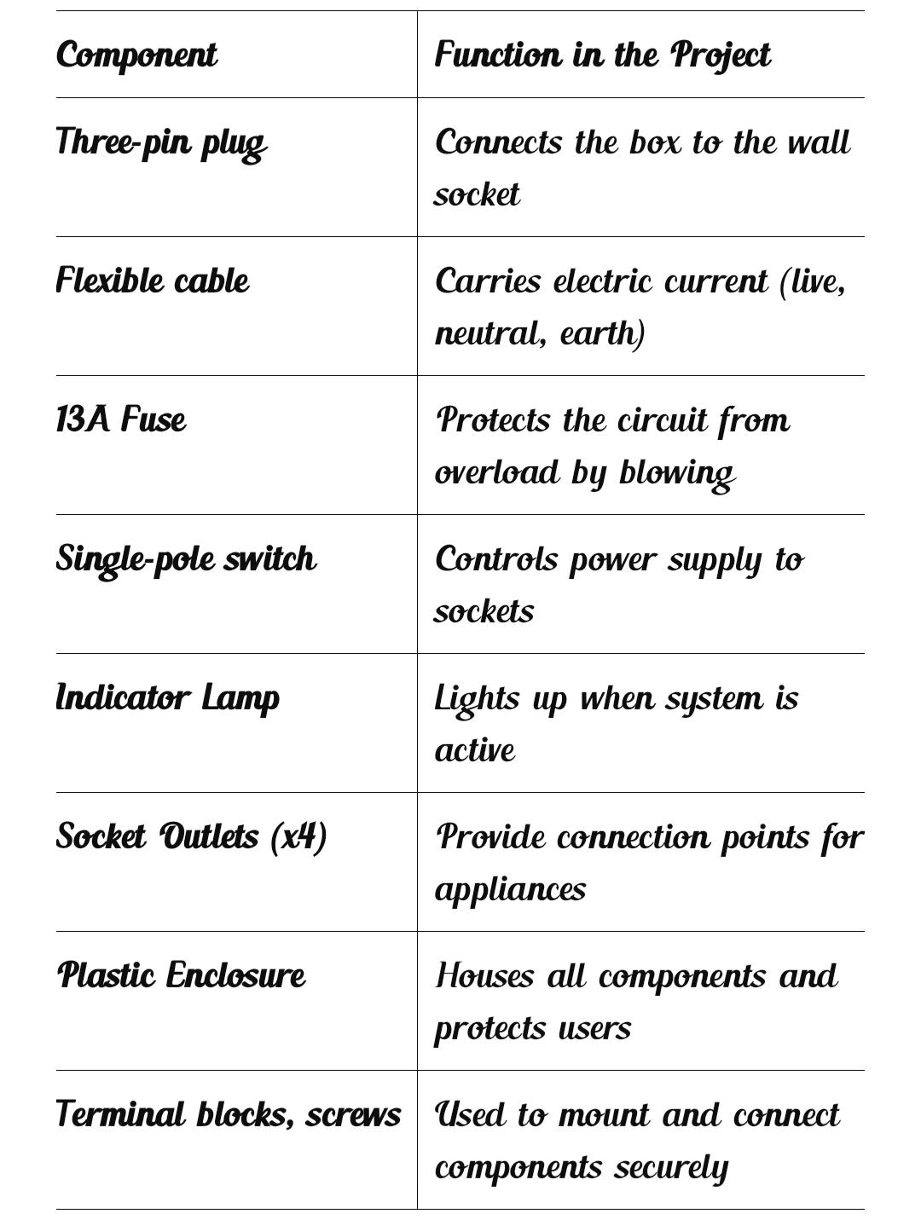
3.4 Components Used and Their Functions

All wires used are 1.5mm² copper, which is standard for low-load power distribution.
3.5 Circuit Design and Explanation
Live wire goes from the plug to the fuse, then to the switch, then to all sockets.

Neutral and Earth wires are split from the plug and sent directly to all sockets.

The indicator lamp is connected across the live and neutral to light up when power flows.

When the switch is ON and the fuse is intact, current flows through the system.

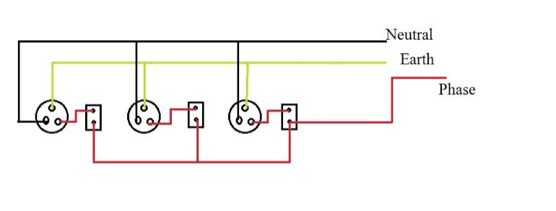
. CIRCUIT DIAGRAM OF ELECTRICAL EXTENSION BOX

3.6 Construction Procedure
- Measured and cut openings in the plastic box for sockets, switch, and indicator.
- Connected all internal wiring as per the design, using terminal blocks and clips.
- Soldered where necessary for solid connections.
- Installed components into the box and screwed them in place.
- Tested for continuity, insulation, and load performance before sealing the box.

3.7 Safety Considerations
All wires were neatly arranged and insulated to avoid contact and shock.

Fuse rating matched the expected maximum current draw.

Earth wire was properly connected to all sockets and the plug.

Casing is made of flame-retardant plastic to prevent fire hazard.

All terminals were tightened and checked to avoid sparking.

CHAPTER FOUR
TESTING, RESULTS, AND DISCUSSION
4.1 Introduction
This chapter presents the testing procedures, observations, and analysis of the results obtained after the construction of the electrical extension box. The tests were conducted to confirm that the box operates as intended and that all the safety and functional features are working properly.
4.2 Testing Procedure
After assembling all components, the system was subjected to several tests to ensure correct wiring, safe operation, and durability. The following tests were carried out:
- Continuity Test – To verify that all connections were properly made and that current could flow through the circuit without obstruction.

- Insulation Resistance Test – To ensure that no short circuit or unwanted connection existed between live, neutral, and earth wires.

- Fuse Test – A short overload test was conducted to ensure the fuse blows when the rated current (13A) is exceeded.

- Switch Operation Test – Checked to confirm the switch effectively opens and closes the power path to the sockets.

- Indicator Test – The lamp was observed for proper functioning, turning ON when power is available and OFF when disconnected.

- Load Test – Various electrical appliances (fan, phone charger, laptop) were connected to confirm proper output and socket integrity.

4.3 Results and Observation

Test | Expected Outcome | Observation
Continuity Test | Current should flow properly | Passed – all connections intact
Fuse Test | Fuse should blow when overloaded | Passed – fuse broke at high load
Switch Test | Switch should cut or restore power | Passed – switch worked properly
Indicator Lamp | Should glow when powered | Passed – bright and stable
Load Test | Should power appliances | Passed – sockets worked properly

All components responded correctly. There was no sign of heating, short circuit, or voltage drop. The box functioned safely even under minor stress.

4.4 Discussion
The test results confirmed that the design and construction of the extension box met the expected standards. The device is safe for domestic and laboratory usage, and the protective measures worked as planned. The fuse provided real protection, the indicator lamp served its purpose, and the sockets held firmly during plug-ins and removal.

Some minor observations:

Excessive wire length was trimmed to reduce clutter inside the box.

All screws were tightened for mechanical stability.

The earth wire was firmly bonded to the plug and sockets.

CHAPTER FIVE
CONCLUSION AND RECOMMENDATIONS
- Summary
This project successfully explored the design and construction of a reliable and safe electrical extension box. From identifying the need for extra socket outlets in homes and laboratories, to constructing and testing a functioning model, the process was carefully executed using affordable and available materials.
The extension box consists of basic components like a plug, cable, fuse, switch, indicator lamp, and multiple socket outlets enclosed in a durable plastic casing. Safety precautions such as proper grounding, correct fuse rating, and organized internal wiring were observed to ensure the device is suitable for everyday use.
Testing showed that the extension box performed well under load, and all components (fuse, switch, sockets, and lamp) responded correctly.

5.1 Conclusion
From the result of the tests carried out, the extension box was confirmed to be functional, efficient, and safe for powering low-voltage electrical devices. The box allows multiple devices to be connected to a single power source without compromising safety.
It also demonstrates the importance of basic electrical knowledge and how simple components can be combined to build useful systems. The project was a great learning experience and proves that even students can design and build practical solutions to real-life problems.

5.3 Challenges Faced

Sourcing quality components within a student budget.

Ensuring all joints and wiring were safely and properly arranged in a small casing.

Limited testing tools and time.

Despite these challenges, the final product met all objectives.

5.4 Recommendations
In future improvements, a surge protector or circuit breaker can be added for extra protection.
USB ports could be included to support modern phone and gadget charging.

Indicator LEDs for each socket can help users monitor usage.

More socket outlets can be added for heavy-duty models, provided the wire and fuse ratings are upgraded.

5.5 Suggestions for Future Projects
Smart extension boxes with wireless ON/OFF control.

Energy-monitoring extensions that track current usage.

Waterproof extension boxes for outdoor purposes.

REFERENCES

- Muhammad H. Rashid (2017). Electrical and Electronic Principles and Technology. 5th Edition, Pearson Education Limited.

- Theraja, B.L. & Theraja, A.K. (2002). A Textbook of Electrical Technology: Volume 1. S. Chand and Company Ltd., New Delhi.

- Delmar Cengage Learning (2008). Electrical Wiring Residential. 17th Edition.

- Online Tech Tips (2021). How to Wire an Extension Socket Box Safely. Retrieved from: https://www.onlinetechtips.com

- Nigeria Electrical Wiring Regulation (2015). National Electrical Code and Wiring Standards, Federal Ministry of Power.

- Engineering Projects Ideas (2023). Extension Box Circuit with Switch and Fuse Protection. Retrieved from: https://www.elprocus.com

- EEP – Electrical Engineering Portal (2022). Guidelines for Safe Electrical Installation. Retrieved from: https://electrical-engineering-portal.com

