STUDY OF SURFACE REFRATIVITY VARIATIONS AND ITS IMPLICATIONS ON VHF/UHF RADIO SIGNAL FIELD STRENGHT AND RADIO HORIZON DISTANCE OF ABAKALIKI, EBONYI STATE, SOUTH - EASTERN NIGERIA.

PRESENTED BY

SHITTU MISTURAH BUKOLA
HND/ 23 /SLT /FT/0409

A PROJECT SUBMITTED TO THE DEPARTMENT OF SCIENCE LABORATORY TECHNOLOGY (PHYSICS & ELECTRONICS UNITS) INSTITUTE OF APPLIED SCIENCES, KWARA STATE POLYTECHNIC, ILORIN NIGERIA.

IN PARTIAL FULFILLMENT OF THE REQUIREMENT FOR THE AWARD OF HIGHER NATIONAL DIPLOMA IN SCIENCE LABORATORY TECHNOLOGY.

JULY, 2025

CERTIFICATION PAGE
This is to certify that the project work was carried out and reported by SHITTU MISTURAH BUKOLA HND/ 23 /SLT /FT/0409 , in the department of Science Laboratory Technology [SLT] Institute of Applied science [IAS] and has been read and approved as meeting the requirement for the award of Higher National Diploma [HND].

Mr. BELLO A.M.A DATE
(PROJECT SUPERVISOR)

Mr. SALAU BASHIR DATE
H.O.U.PHYSICS/ ELECTRONICS)

Dr. USMAN ABDULKAREEM DATE
(H.O.D.SLT)

EXTERNAL EXAMINER DATE

DEDICATION
I dedicate this Project to Almighty GOD, the giver of knowledge and to our parents.

ABSTRACT
The study of diurnal and seasonal variations of surface radio refractivity,Ns over Abakaliki(6.3249 N,8.1137 E or 6 20 N and 8 06 E ) the capital city of Ebonyi State within Southeastern Nigeria was carried out using meteorological parameters. Two–year (January 1 , 2021- December 31, 2022) data of hourly summary of atmospheric, temperature and relative humidity for warri was obtained from the data management unit of Nigeria meteorological Agency ( NIMET). The data was recorded for January 1, 2021-December 31,2022. The data were used to obtain the values of refractivity, refractivity gradient and K-factor. The data were processed and analysed using Microsoft Excel (2016) and Origin pro 8.5.
The analysis of the results showed that radio refractivity and K-factor have high values of 384 N-units and 1.50 respectively, in the wet season. In the dry season, the average values recorded for radio refractivity and K-factor are 369 N-units and 1.43 respectfully. In contrast, refractivity gradient has its highest values in the dry season with – 47.3 N-units/km in February lowest value in the wet season with -52.3 N-units/km in October. The radio horizon distance within 1km for a transmitter height of 100m over Abakaliki varies from 42.70km to 43.59km. The radio refractivity, refractivity gradient and K-factor demonstrate high seasonal and diurnal variations . The propagation condition observed in Abakaliki is super refractive.The computed results provide interesting insights into how Ns , dN/dh and k-factor valuesaffect VHF and UHF field signal strength and radio horizon distance in the study area of A bakaliki.The implications of these results on microwaves/ radio waves propagation within the Abakaliki troposphere are increased field strength variations in the wet season but reduced radio horizon distance and vice-versa during the dry/harmattan season.

Title page | TABLE OF CONTENT | i
Certification Dedication Acknowledgement Abstract  Table of content |  | ii iii iv v vi
CHAPTER ONE  1.0 Introduction  1.1 Motivation |  | 1-4
1.2 Aim and Objectives  1.3 Justification of Project  1.4 Scope of Project |  | 4
CHAPTER TWO

  - Literature review 5
    - Natural sources 5
    - Terrestrial sources 5-6
  - Cosmic sources 6-7
    - Human activity sources 7-8
  - previous and related works 8-12
CHAPTER THREE
  - Material and methodology
  - The study area 13
  - Geology of the study area 13-15
  - Sample collections 15
  - Sample measurement 15-16
  - Radon Dose Assessment 17
    - Estimation of Annual Effective Dose by Inhalation 17-18
    - Estimation of Annual Effective Dose by injection 18-19

CHAPTER FOUR
  - Result and discussion 20
  - Radon concentration in borehole water 20
  - Annual effective dose due to ingestion and inhalation 20-21
CHAPTER FIVE
  - Conclusion and recommendation 22
  - Conclusion 22
  - Recommendations 23
References 24-26

CHAPTER ONE

INTRODUCTION

Motivation

The transmission of radio waves and propagation of microwaves through the lower part of the atmosphere of the earth known as the troposphere. They are affected by natural phenomena due to variations of meteorological parameters such as pressure, temperature, relative humidity and saturated vapour pressure at very high frequency and beyond( > 300 MHz). According to Oyedum and Gambo (1994),depending on the prevailing radio waves propagation mechanisms, the possible effects range from sudden brek in existing microwaves radio links to the extension of radio signals beyond the normal radio horizons.

Line-of-sight (LOS) microwaves links are prone to severe fading due to the atmospheric refraction of the radio waves propagated along the radio links. Hence, the refractive fading of radio waves can substantially radio communications and telecommunications services of terrestrial LOS microwaves links. These and many such effects can be analyzed using the results of estimations of surface refractivity, refractivity gradient, k-factor and radio refractive indices derived using meteorological parameters measured at specific locations (Adeyemi and Emmanuel,2011 ).The knowledge of these parameters are necessary and essential for the design of reliable and efficient telecommunications terrestrial and satellite radio communications and telecommunications systems (Muhammad, Oyedum,Ndanusa,Jibrin Kimpa andAbdullahi,2020).
  - Previous Related Works Done
The global telecommunications networks depend onVHF,UHFand Microwavesradio frequency bands for radio waves transmmissions using the LOS radio waves propagation mechanisms along terrestrial paths. Fading , ducting,sub-refraction and super-refraction which often result due to atmospheric refraction in the troposphere have been observed on these paths,most especially during the dry season known as the harmattan in Sub-Saharan Africa between October and March (De Casel,1986;Owolabi and Williams,1974).High incidences of super-refraction and ducting in the West African sub-region have been reported by Owolabi and Ajayi(1974) while many others (owolabi and Oyedum,1974,Muhammad et al.,2020) indicate strong transhorizon VHF and UHF radiosignals at various distances and locations in Nigeria.
The inhomogeneity of the earth medium has resulted in bending around obstacles (atmosphere) of an electromagnetic wave thereby leading to reduction in the propagation of their respective speed and causing fading, interference and attenuation(Javeed et al., 2018). The vertical refractivity gradient been an important factor in computation of different parameters such as K-factor, β₀, and so on. (Adediji et al., 2011) defined this; that the hypothetical spherical of the earth without atmosphere for which propagation paths follow straights lines, the heights and ground distances being the same as for the actual earth in an atmosphere with a constant vertical gradient of reactivity.
Moreover, the integrity of a communication and the transmission medium is always a major source of deviation of the purity of the signal based on the surface at 100 m altitude (Adediji et al., 2011).
Multipath scattering effect of micro waves arise as a result of large scale variations in atmospheric radio refractive index, such as horizontal layers with very diﬀerent refractivity (Adediji & Ajewole, 2008).The eﬀect becomes identifiable, due to the same signal that takes place and the rays reaching at diﬀerent times interval thereby superposed with each other during propagation via the troposphere. The outcome of this large scale variation in the atmospheric refractive index is that radio waves propagating through the atmosphere become progressively curved towards the earth. Thus, the range of the radio waves is estimated by the height dependence of the refractivity. Therefore, the refractivity of the atmosphere will not only aﬀect the curvature of the ray path but will also provide some insight into the fading of radio waves through the troposphere.
Specifically, in reference to the data presented by (Adediji & Ajewole, 2008) stated that the information on radiosonde measurements lacks the spatial and temporal resolutions which are crucial factors for the measurement of small-scale variations particularly in the lower atmosphere. Though, this analytical approach gave an interesting results, but yielded not to spatial resolution to observe the small scale changes in the vertical distribution of radio refractivity and propagation eﬀects over Ogbomoso which is one the town in south western state of Nigeria has a case study.
Hence, this study is aim in optimizing the distribution of radio refractivity gradient and effective earth radius factor over Ogbomoso, South west Nigeria.

1.3. Problem of Statement
Most of the previous work done on this subject in Nigeria is based on surface refractivity while refractivity gradients were based on extrapolated data from radiosonde measurements

1.4 Aim and Objectives

1.4.1 Aim
The aim of the study is basically to investigate parametric optimization in Distribution of Radio Refractivity gradient and effective earth radius factor (K-factor) over Ogbomosho south western Nigeria.

1.4.2 Objectives
- To obtain the surface weather parameters (at mospheric pressure, temperature and relative humidity) and at altitudes of 50, 100, 150 and 200m respectively from which the radio refractivity and refractivity gradient are determined.
- To validate model performance by comparing with the existing ITU-R model.

1.5 Scope of the study
The scope of the study is hereby limited to optimize the parametric distribution of radio refractivity gradient and effective earth radius factor (K-factor) over south western state Nigeria only base on the analysis (data) obtained from the Nigerian Meteorological Agency (NIMET).

CHAPTER TWO

LITERATURE REVIEW

2.1 Brief Introduction
This chapter discuses the concept of Troposphere, atmospheric parameters, (temperature, pressure and relative humidity), classification of propagation of the atmosphere .

2.2 The Troposhere
Troposphere is the part of the atmosphere that is closely related to human life, it extends from the earth surface to an altitude of about 10-17km at the earth’s poles at the earth equator (Chinelo & Chukwunike, 2016). Troposphere consists of two layers, the upper boundary and the lower boundary. The upper boundary is defined as the point at which the temperature in the atmosphere begins to increase with height WHILE the lower boundary is the region where everything related to weather take place. The lower boundary contain 75% of the total mass of the planetary atmosphere and 99% of the mass of water vapor(Gunashekar et al., 2006). There are various number of meteorological parameters characterized by the atmosphere such as pressure, temperature, relative humidity, the direction and speed of wind, precipitation, evaporation and radiation(Gunashekar et al., 2006). However, the following are discussed pressure, temperature and relative humidity as they have great influence on refractivity.

2.2.1 Temperature
Temperature variation in the atmospheric condition can be subjectively described in terms of relative concept of cold or heat. The objective quantity corresponding to these concepts is the temperature which is measured precisely with the use of thermometer. Temperature is measured either in degree Celsius or degree Kelvin(H.Sizun, 2004). The temperature in kelvin is connected to the temperature in Celsius by the following formula:
Where T is the temperature in degree kelvin and t is temperature in degree Celsius.

2.2.2 Pressure
The force per unit area exerted by the atmosphere on a surface by virtue of its weight is referred to as atmospheric pressure. It is equivalent to the weight of a vertical column of the air extending above a surface of unit area to the outer limit of the atmosphere(H.Sizun, 2004). Atmospheric pressure can be measured either using a direct reading barometer or a recording barometer called barograph. Under normal atmospheric condition, the atmospheric pressure decreases with increasing altitude.
P= 2.2
Where p is the pressure, F is the normal force; A is the area of the boundary.

2.2.3 Relative humidity
Relative humidity, H of the air is defined as the ratio between the actual quantity of vapor contained in the air and the maximum quantity of vapor that the air could contain at the same temperature. Relative humidity is expressed in percentage(H.Sizun, 2004).

2.2.4 Saturation vapor pressure
The vapor pressure that the air would have if it were saturated is the saturation vapor pressure. This parameter can be evaluated using different methods, usually expressed in. Saturation water vapor can be determined from the relative humidity H, expressed in percentage and from the water vapor partial pressure, expressed in , by using the following equation(H.Sizun, 2004):
…………………………………………….. 2.3
where is the water vapor pressure.
…………………………………………2.4
t=temperature in Celsius

2.3 Refractive index and refractivity of the troposphere
Refractive index (n) describes how light propagates through a medium. It determines how much light is bent or refracted when it enters through a medium. It also determines the amount of light that is reflected when reaching the interface (Adelakun et al., 2020).`
………………………………………….. 2.5
Where c= speed of light in vacuum, v= phase velocity of light in the medium
Recall that snell law of refraction is expressed as;
…………………………………. 2.6
and are the incidence angle and refraction respectively. n1 and n2 are the refractive indices which determine the amount of light reflected between the interface.

The refractive index n, is related to refractivity, N(Adediji et al., 2011), as follows;
………………………………. 2.7
To effectively evaluate the propagation signal level of radio wave, a radio propagation model such as variation of radio refractivity is required (Chinelo & Chukwunike, 2016).
The radio refractivity, (N), can be expressed by(ITU, 2015):
……………... 2.8

The dry term of radio refractivity is given by:

The wet term of radio refractivity is given by:
2.10
Where P is the atmospheric pressure , T is the absolute temperature in Kelvin and e is the water vapour pressure.

2.4 Refractivity gradient
The time rate of change in Radio Refractivity Gradient (G) can be expressed as (Adelakun et al., 2020) :
2.11
height in kilometer to surface and altitude refractivity respectively.
2.12
Where Refractivity, h= height of refractivity=0 and H= 7.30km.
where and are refractivity and height and are corresponding .

2.5 Effective Earth Radius (K-factor)
K-factor can be used to characterize refractive condition as normal refraction or standard atmosphere, sub –refraction, super-fraction and ducting, it is given as (Aremu et al., 2018):
2.13
Around the earth surface the value of is approximately -40N-units/km which will give a K-factor of 1.333 this is referred to as normal refraction or standard atmosphere.

2.6 Classification of propagation condition of the atmosphere
The propagation condition of the atmosphere can be classified base on the value of refractivity gradient and effective earth radius. Depending on the existing condition in the troposphere, a radio wave will undergo any of the type of refraction sub-refraction, super refraction or ducting.

2.6.1 Sub-refraction:
Durine sub-refraction condition, the radio waves moves away from the earth’s surface and the line of sight range and the range of propagation decreases correspondingly. Refractivity N increases with respect to height in sub-refractivity (Chinelo & Chukwunike, 2016). Sub-refraction can be represented mathematically as:
2.14

2.6.2 Super- refraction
During super-refraction condition, electromagnetic waves are bent downward towards the earth. The waves can skip large distance on reaching the earth surface and being reflected from it. The wave thereby gives abnormal large ranges beyond the line of sight due to multiple reflections (Chinelo & Chukwunike, 2016). Super-refraction can be represented mathematically as:
2.15

2.6.3 Ducting
During ducting, the waves bend downward with a curvature greater than that of the earth. The bended energy then becomes trapped between a boundary or layer in the troposphere and the earth’s surface. High signal strength can be obtained at very long range in the wave guided-like propagation (Chinelo & Chukwunike, 2016) . Ducting can be represented mathematically as:
2.16
Fig 2.1 is the graphical representation of the various classification of propagation condition of the atmosphere.

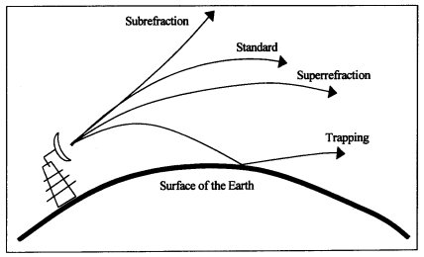
Figure 2.1 illustration of classification of propagation condition of the atmosphere.

2.6 Review of Relevant Literature
Research indicates that several studies have been carried out in Nigeria and around the globe on refractivity, refractivity gradient and effective earth radius (K-factor). The following works has been done, some of which includes:
Gunashekar et al. (2006) studied transhorizon radiowave propagation due to evaporation ducting. The result obtained showed that the influence of evaporation ducts on the over-sea radiowave propagation needs to be thoroughly investigated.
Adediji et al. (2011) worked on distribution of radio refractivity gradient and effective earth radius (K-factor) over Akure, south western Nigeria. The research showed that the refractivity is generally high during the rainy season at all the levels.
Aremu et al.(2018) studied effects of radio refractivity gradient and K-factor on radio signal over Ibadan, south western, Nigeria. The study revealed that the surface radio refractivity gradient, G, has higher value in the dary season and lower values in the rain (wet) season, this is due to the rise in atmospheric moisture content in the region.
Adelakun et al.(2020) studied quantitative analyses of complexity and non linear trend of radio refractivity gradient in the troposphere. The result showed that the high radio refractivity gradient, which signify that chaoticity was observed during the rainy season while low refractivity gradient which imply high chaocity was noticed during the dry season.
Chinelo & Chukwunike, (2016) worked on the study of surface radio refractivity in Awka, eastern, Nigeria using meteorological parameters on the troposphere during dry and wet season. The result showed that variation in weather are more signifant during thr rainy season than the dry season in Awka, due to the increase in the tropospheric temperature and humidity, and it therefore causes very high radio refractivity within the period.

CHAPTER THREE
METHODOLOGY
3.1 Study Area
The study area is Abakaliki, the capital city of Ebonyi state, south-Eastern Nigeria. It was founded in the mid-17th century. The population was approximately 915,438 people in the 2006 national population census (Hoieberg et al 2010). The principal inhabitants of the city are the Igbo people, although there are people from other parts of Nigeria who are resident in this city. The weather condition is being featured into wet season, which start from March and end in October while the dry season runs from November to February. In Abakaliki, the wet season is warm, oppressive, and overcast and the dry season is hot, muggy, and partly cloudy.

3.2 Data Collections
A two year- hourly summary of atmospheric pressure, temperature and relative humidity for Abakaliki was obtained from the Data Management of Nigeria Meteorological Agency (NiMet). The data for Abakaliki was recorded in 1-hour interval from January 1, 2021– December 31, 2022. The data recorded cover 24 hours each day from 00:00 hours to 23:00 hours local time at 1-hour interval. The data covers both the dry, wet and transition months of the years.
3.3 Data Analysis
The value of atmospheric temperature, pressure and relative humidity collected undergo the following data analysis process.
- The data were average over each hour to give twenty-four data points representing diurnal variation for each day. The twenty-four hours’ data for each day were average over the month to obtain the diurnal variation for the month and later average for the year. The data was used to determine the diurnal variation of radio refractivity.
- The average monthly hourly data of atmospheric parameters for each month was later average to give a data point for each month. The data was used to determine seasonal variation of radio refractivity.
The data were used to calculate the surface radio refractivity using the Microsoft Excel (2016) for the data analysis and Origin-Pro 8.5 software for plotting graph

CHAPTER FOUR
RESULTS AND DISCUSSSIONS
4.1 Diurnal Variation of Radio Refractivity, Refractivity Gradient and K-factor.
This part presents the result of the diurnal variation of radio refractivity, refractivity gradient and K-factor over Abakaliki, south-east, region of Nigeria.
4.1.1 Diurnal variation of refractivity for dry and wet season
The diurnal variation of refractivity over Abakaliki is depicted in Figure 4.1(a) and 4.1(b). The diurnal variation of surface refractivity at Abakaliki in the dry season is shown in Figure 4.1(a). The refractivity indicates a high value of about 385N-units to about 380 N-units during the early days of the month of November (between day 1 – 9). The value of refractivity start dropping below the normal range on the 8th day of February and reach a minimum of about 311 N-units on the 10th day of the month of February. This variation was ascribed to the response of the earth to solar insolation which is the major force behind the weather condition as detected. The result shows that the refractivity over Abakaliki for dry season is as a result of variation in the wet term of the refractivity.

Figure 4.1(a): Diurnal refractivity for dry season in Abakaliki.
The diurnal variation of surface refractivity at Abakaliki in the wet season is shown in Figure 4.1(b). The refractivity indicates a high value of about 391N-units to about 385 N-units between day 9 to day 15 in the month of May. The minimum value of refractivity were recorded to be 361 N – Unit on two different day (day 14 and 28 ) in the month of March.

Figure 4.1(b): Diurnal refractivity for wet season in Abakaliki.
4.1.2 Diurnal variation of refractivity gradient for dry and wet season
The diurnal variation of refractivity gradient over Abakaliki is presented in Figure 4.1(c) and 4.1(d).
The diurnal variation of refractivity gradient at Abakaliki in the dry season is shown in Figure 4.1(c). From this figure, it was shown that the fist minimum refractivity gradient occur in the early days of the month of November which has a refractivity gradient of about -51 N-unit/km.

It gradually increased to its maximum of about -44 N-unit/km around the 19th day of January. It then decreased to another minimum of about -49 N-unit/km around 27th of that same month before it increased to the maximum of -43 N-unit/km in the month of February.

figure 4.1(c): Diurnal refractivity gradient for dry season in Abakaliki
The diurnal variation of refractivity gradient at Abakaliki in the wet season is shown in Figure 4.1(d).
The refractivity gradient drop to a first minimum of about -52 N-unit/km in the month of April, before it get to its lowest on a three different day ( 9th, 13th and 16th ) in the month of May.
However, there was a rapid increase in the month of March on a two different day ( 15th and 29th) of about -50 refractivity gradient.
According to the analysis, the curve does not follow a regular pattern in the wet season in Abakaliki.

Figure 4.1 (d) Diurnal Refractivity Gradient for the Season in Abakaliki
4.1.3 Diurnal variation of K-factor for dry and wet season
The diurnal variation of K-factor over Abakaliki is presented in Figure 4.1(e) and 4.1(f).
The diurnal variation of K-factor at Abakaliki in the dry season is shown in Figure 4.1(e). The K-factor shows a high value of about 1.51 to about 1.50 during the early month of dryness in Abakaliki.

The value of K-factor start dropping beyond the normal range in the month of January before it reached the minimum of about 1.37 in the month of February. This variation was attributed to the response of the earth to solar insolation which is the major force behind the weather state detected. The result reveals that the K-factor over Abakaliki for dry season is as a result of variation in the dry term of the K-factor.
figure 4.1(e): Diurnal of hourly K-factor for dry season in Abakaliki
The diurnal variation of K-factor at Abakaliki in the wet season is shown in Figure 4.1(f). The K-factor has its minimum of about 1.46 around the 14th and 27th day of March . It gradually increased to maximum of about 1.51 to 1.52 around 10th to 16th day of May. It then decreased to another minimum of about 1.47 in the month of August before it increased for the rest of the month.

4.2.1 Seasonal variation of radio refractivity
Radio refractivity varies with season of the year. The average monthly variation of refractivity over Abakalik for the two years is depicted in Figure 4.2(a). The refractivity shows high value of about 375N-unit in March and 384N-unit in May before it drops gradually till it reaches a minimum value of about 362N-unit in December.
Generally, the refractivity shows seasonal variation with high values in the rainy season and low values in the dry season. This is in correlation with previous studies (Adediji & Ajewole, 2008). The high values observed in the wet season, according to Willoughby et al. (2002), is usually due to the atmospheric moisture content of water vapour during this period which in due course increase the humidity in the atmosphere and consequently the radio refractivity.
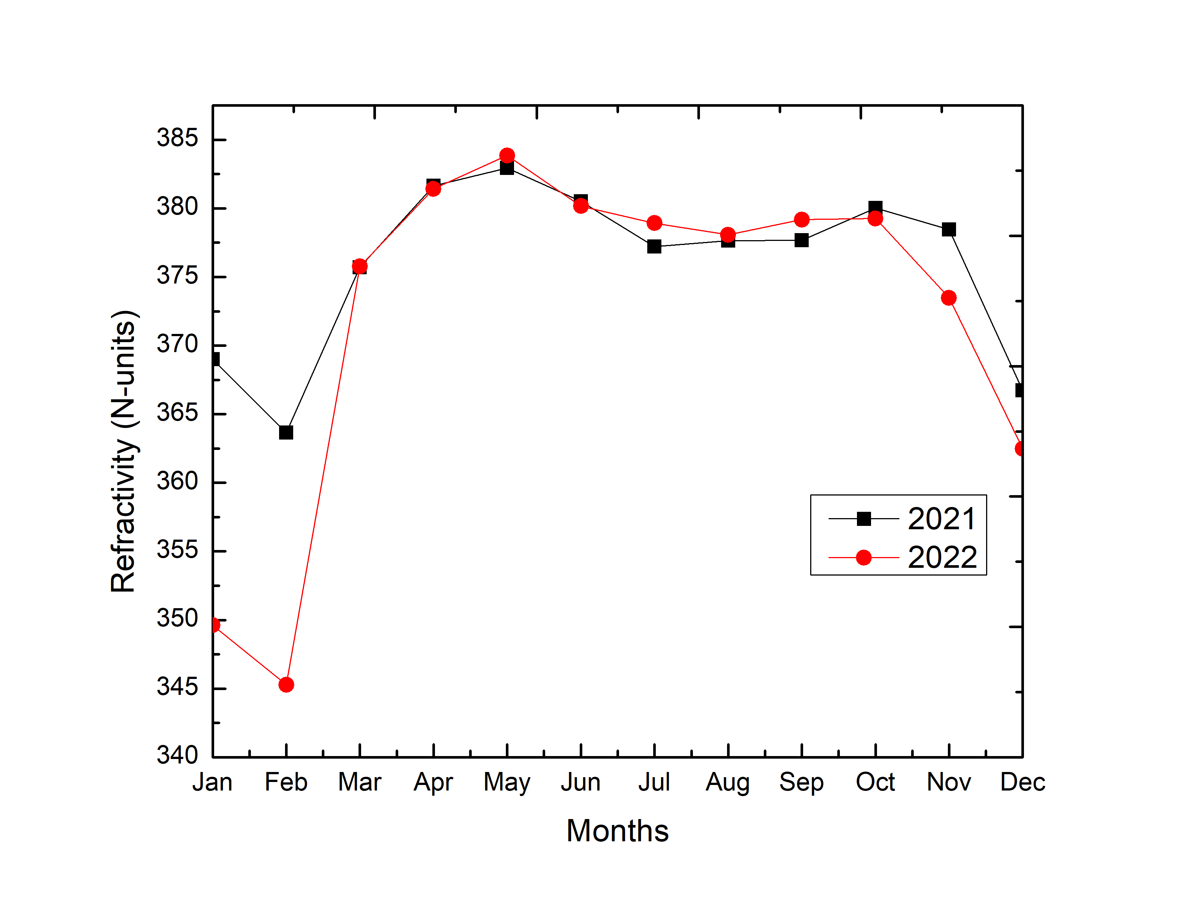
figure 4.2(a): Seasonal Variations of monthly radio refractivity in Abakaliki
4.2.2 Season variation of refractivity gradient
The seasonal variation of radio refractivity gradient over Abakaliki is shown in Figure 4.2(b). The highest value of -47.3 N-units/km was recorded in the month February. A steady decrease was observed until May with a value of about – 52.5 N- units/km before it witnessed a little increase in the month of July(51.8 N-units/km) and drop again to a minimum value of -52 N-units/km in month of October. The slight increase in the month of July may be caused by the brief break in rain fall which lasted for about 2 to 3 weeks. The low values observed in the wet season, according to Willoughby et al. (2002), is usually due to the fact that the month of October is the transition mark and experience break in water vapour content in the

atmosphere. From November there was high speed of increase in refractivity gradient which continue till the end of the year.
Generally, radio refractivity gradient shows high value in dry season and low value in rainy season. According to Willoughby et al (2002), is usually caused by low humidity in dry season while pressure is almost constant in rainy season but the temperature fluctuates rapidly and consequently the humidity. This is in agreement with previous studies (Willoughby et al., 2002).
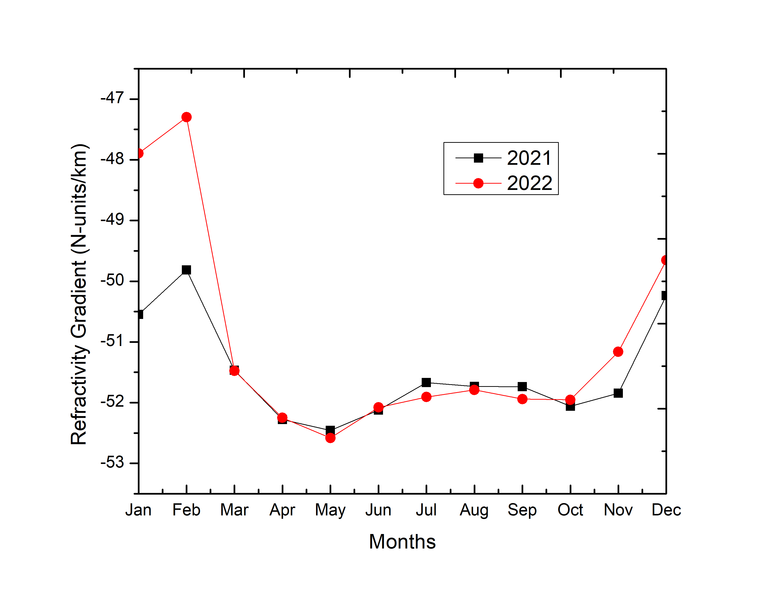
figure 4.2(b): Seasonal of monthly radio refractivity gradient in Abakaliki

4.2.3 Season variation of K-factor
The seasonal variation of K-factor over Abakaliki is shown in Figure 4.2(c). The refractivity shows very low value of about 1.43 in the month of January. Then increased gradually to the value of about 1.50 in the month of May. There is a steady increase in the values between
the month of May and October which happens to be the peak of the rainy period for Abakaliki. It then drops for the rest of the year.
Generally, in Abakaliki there is high value of K-factor in the rainy season and low value in the dry season. During rainy season, the atmosphere is mostly dominated by moist content of water vapour which eventually increases the humidity in the atmosphere and consequently the surface K-factor. These result agrees with the work of Willoughby et al. (2002) .The values ranges from 1.43 to 1.49 in dry season. It increases during the rainy season with the values ranging from 1.47 to 1.49.
4.3 Implications of the Results Obtained
Using the equation(1) as provided by Bean and Dutton (1968) , the Field Strength Variation,FSV is defined to be :
FSV = (Nsmax - Nsmin) x 0.2 dB (1)
Where Nsmax and Nsmin are the maximum and minimum values of surface refractivity respectively.
In this project, Nsmax =384 N-unit and Nsmin = 375 N-unit were the values determined for wet season for the two years,2021 and 2022 investigated for Abakaliki. On the other the corresponding values of 369 N-unit and 345 N-unit were estimated for the dry season in the same station. Therefore, using equation(1) above, the FSV value 1.8 dB was estimated for the wet season while 4.8 dB was computed as the dry season FSV value .The implications of these FSV results to VHF/UHF radio frequency bands in Abakaliki are that the higher Ns values obtained in the wet season result lower FSV-values and thus better radio waves propagation in the wet season in Abakaliki. And vice-versa in the dry season leading to poor propagation conditions of radio waves experienced in the dry season months of October to February. The lower values of 1.8 dB obtained in the wet season might be caused by reduced insulations during this period
Furthermore, the radio horizon distance was evaluated using the formula established by Bean and Dulton (1968) as a expressed in equation(2) as follows
Drh = (2kah)^{1/2} (2)
Where k is the effective radius factor of the station, a is the equivalent radius of the earth which has a value of 6376km and h is the transmitter height which is 100m in this work. The results determined in this project show that the k – factor ranges from 1.43 to 1.49. substituting these values into equation 2 above indicate that the radio horizon distance in Abakaliki varies from 42.70km to 43.59km.

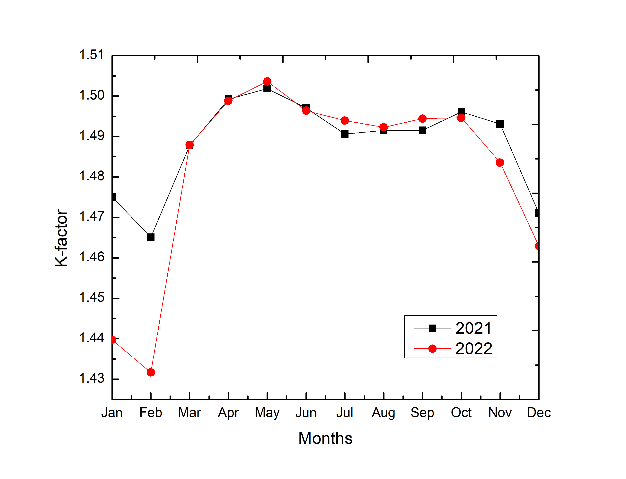
figure 4.2(c): Seasonal Variations of monthly K-factor in Abakaliki

CHAPTER FIVE

CONCLUSIONS AND RECOMMENDATIONS

5.1 Conclusions
In the study area of Abakaliki, radio refractivity displayed diurnal variability with high values in the early hours of the day, late hours of the day and low values during the day time in the dry season. During the wet season, the refractivity is very high in the month of March compare to the other months. Little value intervals were observed between the early and late hours of the day. Summarily, refractivity shows high values during the wet season this is due to rise in relative humidity and low values during the dry season due to increase in temperature and low relative humidity.
Refractivity reveals seasonal variation with high values in the wet season and low values in the dry season due to increases humidity in the atmosphere and consequently the radio refractivity
Refractivity gradient shows diurnal variability with almost the same ranging values both in the wet and dry season. However, it shows seasonal variation with high values in the dry season and low values in the wet season due to the atmospheric moisture content in Warri.
Effective earth radius(K-factor) displayed diurnal variability with high values in the early hours of the day, low values during the day time and high values during late hours of the day low values during the day time in the dry season. The values fluctuates during the wet season, it rises in the early hours, reduces in the noon, rises again in the evening then reduces in the late hours of the day.
Effective earth radius(K-factor) displayed seasonal variability with high values in the wet season and low values in the dry season. The propagation condition mostly observed in Warri is super-refractive.

5.2 Recommendations.
The following recommendations were made after the study:
- To provide more radio propagation laboratory stations across the climatic region of Nigeria.
- To equip the laboratories with needed equipment such as refract meter, thermometer, barometer which will aid in determining the meteorological parameters.
- To propose a simple linear model that relates directly the environmental parameters that affect the variation of the refractivity with it’s profile, as a tool to predicts the well-known phenomena in radio wave propagation, such as; sub-refraction, super refraction, and ducting in Nigeria.

References

Adediji, A. T., & Ajewole, M. O. (2008). Vertical profile of radio refractivity gradient in Akure south-west Nigeria. Progress In Electromagnetics Research C, 4. https://doi.org/10.2528/pierc08082104
Adediji, A. T., Ajewole, M. O., & Falodun, S. E. (2011). Distribution of radio refractivity gradient and effective earth radius factor (k-factor) over Akure, South Western Nigeria. Journal of Atmospheric and Solar-Terrestrial Physics, 73(16). https://doi.org/10.1016/j.jastp.2011.06.017
Adelakun, A. O., Ojo, J. S., & Edward, O. V. (2020). Quantitative analyses of complexity and nonlinear trend of radio refractivity gradient in the troposphere. Advances in Space Research, 65(9). https://doi.org/10.1016/j.asr.2019.09.055
Adeline, I. A., & Eme, O. I. (2015). Census Politics in Nigeria : An Examination of 2006 Population Census CENSUS POLITICS IN NIGERIA : AN EXAMINATION OF 2006 POPULATION CENSUS. January. https://doi.org/10.12816/0011166
Aremu, O. A., Oyinkanola, L. O. A., Akande, A., & Azeez Waheed, A. (2018). Effects of Radio Refractivity Gradient and K-Factor on Radio Signal over Ibadan, South Western, Nigeria. Global Scientific Journals, 6(5), 248–253.
Chinelo, I., & Chukwunike, O. (2016). The Study of Surface Radio Refractivity in Awka, South Eastern Nigeria. Journal of Geography, Environment and Earth Science International, 6(2). https://doi.org/10.9734/jgeesi/2016/25880
Gunashekar, S. D., Siddle, D. R., & Warrington, E. M. (2006). Transhorizon radiowave propagation due to evaporation ducting. Resonance, 11(1). https://doi.org/10.1007/bf02835686
H.Sizun. (2004). Radio wave propagatoin for telecommunication application.
ITU. (2015). The radio refractive index : its formula and refractivity data P Series Radiowave propagation. 11.
Javeed, S., Alimgeer, K. S., Javed, W., Atif, M., & Uddin, M. (2018). A modified artificial neural network based prediction technique for tropospheric radio refractivity. PLoS ONE, 13(3). https://doi.org/10.1371/journal.pone.0192069
Willoughby, A. A., Aro, T. O., & Owolabi, I. E. (2002). Seasonal variations of radio refractivity gradients in Nigeria. Journal of Atmospheric and Solar-Terrestrial Physics, 64(4), 417–425. https://doi.org/10.1016/S1364-6826(01)00111-0

