DESIGN AND DEVELOPMENT OF A WEB-BASED AI-ENABLED HERBAL MEDICINE SOLUTIONS

BY

ABDULWAHAB ABDULQUDUS AYINLA
ND/23/COM/FT/0097

SUBMITTED TO:

DEPARTMENT OF COMPUTER SCIENCE

INSTITUTE OF INFORMATION AND COMMUNICATION TECHNOLOGY

KWARA STATE POLYTECHNIC, ILORIN

IN PARTIAL FULFILLMENT OF THE REQUIREMENT FOR THE AWARD OF NATIONAL DIPLOMA (ND) IN COMPUTER SCIENCE

SUPERVISED BY
DR. ABDULRAHMAN T. A.
JUNE, 2025.

CERTIFICATION

This is to certify that this project research was carried out by [your name] with the matriculation number [your matric], has been read and approved as meeting part of the requirements for the Award of National Diploma (ND) in Computer Science.

____________________________ _____________________
DR. ABDULRAHMAN T.A Date
Project Supervisor

____________________________ _____________________
MR. OYEDEPO F.S Date
Head of Department

____________________________ _____________________
External SupervisorDate

DEDICATION

This project is dedicated to the Almighty God for his protection and guidance from the start of this project to its completion.

ACKNOWLEDGEMENT

We give thanks to Almighty God for granting us success for the completion of our program.

Our utmost appreciation goes to our able supervisor Dr. Abdulrahman T.A. for his fatherly support and his moral advice throughout this project.

Special thanks to the Head of Department, Mr. Oyedepo F.S., Dr. Raji A.K., Mr Ayeni J.K., and other members of the staff of the Department of Computer science for their support always.

Our sincere gratitude also goes to our beloved parents for their moral and financial support throughout this project. We say a big thank you and may God bless you immensely (Amen).

TABLE OF CONTENTS
Title Page
Certification
Dedication
Acknowledgements
Table of Contents
Abstract
CHAPTER ONE: GENERAL INTRODUCTION
1.1 Background to the Study
1.2 Statement of the Problem
1.3 Aim and Objectives
1.4 Significance of the Study
1.5 Scope of the Study
1.6 Organization of the Report
1.7 Definition of Terms
CHAPTER TWO: LITERATURE REVIEW
2.1 Review of Related Works
2.2 Review of General Texts
2.3 Historical Background
CHAPTER THREE: METHODOLOGY AND SYSTEM ANALYSIS
3.1 Research Methodology
3.2 Analysis of the Existing System
3.3 Problems of the Existing System
3.4 Description of the Proposed System
3.5 Advantages of the Proposed System
CHAPTER FOUR: SYSTEM DESIGN AND IMPLEMENTATION
4.1 Design of the New System
4.1.1 Output Design
4.1.2 Input Design
4.1.3 Database Design
4.1.4 Process/Procedure Design
4.2 System Implementation
4.2.1 Programming Language Used
4.2.2 Hardware Requirements
4.2.3 Software Requirements
4.2.4 Implementation Strategy
4.3 System Documentation
4.3.1 Program Documentation
4.3.2 User Manual / Operating Instructions
4.3.3 System Maintenance Guidelines
CHAPTER FIVE: SUMMARY, CONCLUSION, AND RECOMMENDATIONS
5.1 Summary of Findings
5.2 Conclusion
5.3 Recommendations
References
Appendices
Appendix A: Program Flowchart
Appendix B: Source Code

ABSTRACT

The increasing global interest in natural and alternative healthcare solutions has sparked a resurgence in the use of herbal medicine. However, access to reliable information and personalized guidance remains a challenge for many users. This project presents the design and development of a web-based, AI-enabled platform dedicated to herbal medicine solutions. The system integrates a user-friendly interface with an intelligent backend powered by machine learning algorithms to provide accurate information, recommend herbal remedies based on user-input symptoms, and ensure safety by identifying potential herb-drug interactions. Key features include a comprehensive herbal database, a symptom analysis module, and interactive tools for user engagement and education. The platform aims to bridge the gap between traditional herbal knowledge and modern digital technologies, offering an accessible, personalized, and evidence-informed tool for users and practitioners alike. The development process follows best practices in web development and AI integration, ensuring scalability, security, and effectiveness. This solution has the potential to enhance healthcare delivery, especially in underserved areas, and contribute to the digital transformation of traditional medicine.

CHAPTER ONE

GENERAL INTRODUCTION
1.1 BACKGROUND TO THE STUDY
The practice of using herbs for medicinal purposes has ancient roots, deeply connected with human history and culture. Traditional medicine systems around the world, including Traditional Chinese Medicine, have long relied on plants for healing and wellness (Li & Zhang, 2013; Zhou et al., 2024). This time-tested approach to healthcare utilizes the complex chemical compounds found in plants to address a wide range of ailments. As modern medicine advances, there's a growing recognition of the potential benefits of integrating traditional knowledge with contemporary science.
The increasing interest in natural and alternative medicine has fueled a renewal in the use of herbal remedies. Consumers are actively seeking natural solutions for health concerns, driving the demand for high-quality herbal products and reliable information. However, navigating the world of herbal medicine can be challenging. The efficacy of herbal remedies can vary widely, and accurate identification and proper usage are crucial for safety and effectiveness.
Artificial intelligence offers promising avenues for modernizing and enhancing traditional herbal medicine practices (Zhou et al., 2024). AI-powered systems can assist in identifying herbal plants, analyzing their chemical composition, and predicting their potential therapeutic effects. Furthermore, AI can play a crucial role in standardizing herbal medicine formulations and ensuring product quality.
Web-based platforms can serve as valuable tools for disseminating information about herbal medicine and connecting users with AI-powered solutions. A well-designed web platform can provide users with access to a wealth of knowledge about herbal plants, their traditional uses, and potential benefits. Such platforms can also facilitate personalized recommendations and guidance on the selection and use of herbal remedies.
Therefore, developing a web-based, AI-enabled herbal medicine solution has the potential to bridge the gap between traditional herbal knowledge and modern technology, empowering users to make informed decisions about their health and well-being. Such a system could provide a user-friendly interface for accessing information, identifying herbal plants, and obtaining personalized recommendations, promoting the safe and effective use of herbal medicine.

1.2 PROBLEM STATEMENT
Despite the growing popularity of herbal medicine, several challenges hinder its widespread adoption and integration into mainstream healthcare. One significant issue is the lack of standardization in herbal medicine practices. Traditional knowledge is often passed down through generations, leading to variations in formulations, preparation methods, and dosages. This inconsistency can make it difficult to assess the efficacy and safety of herbal remedies.

Another challenge lies in the accurate identification of herbal plants. Misidentification can have serious consequences, as some plants may be toxic or have adverse effects. Many individuals lack the expertise to correctly identify herbal plants, increasing the risk of accidental poisoning or ineffective treatment.

Furthermore, access to reliable information about herbal medicine can be limited. While numerous resources are available, they may not always be accurate or evidence-based. Consumers often struggle to differentiate between credible sources and unsubstantiated claims, making it difficult to make informed decisions. The integration of AI into herbal medicine faces its own set of hurdles. Developing accurate AI models requires large, high-quality datasets, which can be challenging to obtain for many herbal plants. Additionally, there is a need for robust validation methods to ensure the reliability and accuracy of AI-powered predictions. Therefore, the problem lies in the need for a reliable, standardized, and accessible system that leverages AI and web-based technologies to address the challenges associated with herbal medicine. Such a system should provide accurate information, assist in plant identification, and offer personalized recommendations, promoting the safe and effective use of herbal remedies.

1.3 AIM AND OBJECTIVES
The aim of this study is to design and develop a web-based AI-enabled herbal medicine solution that addresses the challenges identified in the problem statement. The platform aims to provide users with a reliable, accessible, and user-friendly tool for accessing information about herbal medicine and obtaining specified personalized recommendations.

To achieve this aim, the following objectives will be pursued:

Design a user-friendly web interface: The web interface will be designed to be flexible and easy to navigate, ensuring that users in different technical backgrounds can access the platform's features. The interface will include search functionality, detailed plant profiles, and personalized recommendation tools.

Develop a comprehensive database of herbal plants: This database will include information on plant identification, traditional uses, chemical composition, and potential therapeutic effects. Data will be gathered from reputable sources, including scientific literature, traditional medicine texts, and expert knowledge.

Develop an AI-based recommendation engine: This engine will provide personalized recommendations for herbal remedies based on user input, such as symptoms, medical history, and preferences. The engine will utilize machine learning algorithms to identify patterns and predict the potential benefits of different herbal formulations.
- Implement an AI-powered plant identification system: This system will utilize image recognition technology to assist users in identifying herbal plants. Users will be able to upload images of various plants, and the system will provide potential matches based on its database.

Integrate an OpenAI API for solution descriptions: This integration will enable the platform to provide users with detailed descriptions of recommended herbal solutions, including their traditional use, potential benefits, and their safety precautions.

1.4 SIGNIFICANCE OF THE STUDY
This study holds significant potential for advancing the field of herbal medicine and promoting its safety and effective use. By developing a web-based AI-enabled platform, this research can contribute to several key areas.

Firstly, the platform can enhance access to reliable information about herbal medicine. By consolidating data from diverse sources and presenting it in a user-friendly format, the platform can empower users to make informed decisions about their health and well-being (Mwangi et al., 2006). This is particularly important in a world where misinformation and unreliable sources can easily lead to unsafe practices.

Secondly, the AI-powered plant identification system can reduce the risk of misidentification and promote the safe use of herbal plants. This feature can be particularly valuable for individuals who are new to herbal medicine or who lack access to expert guidance. Misidentification of plants can have serious consequences, and an AI-powered system can provide an additional layer of safety and accuracy.

Thirdly, the AI-based recommendation engine can personalize herbal medicine recommendations, tailoring solutions to individual needs and preferences. This can improve the effectiveness of herbal treatments and enhance user satisfaction.

Fourthly, the integration of an OpenAI API can provide users with detailed descriptions of herbal solutions, enhancing their understanding of the potential benefits and risks (Vera & Palaoag, 2023). This can help users to make informed decisions about their health and to use herbal remedies safely and effectively. The integration of AI can provide users with a wealth of information that would otherwise be difficult to access.

Finally, this study can contribute to the modernization of traditional medicine practices, bridging the gap between ancient knowledge and contemporary technology (Zhou et al., 2024). By demonstrating the potential of AI and web-based platforms, this research can pave the way for further innovation in the field of herbal medicine.

The implementation of AI in traditional medicine can lead to the development of smarter herbal medication delivery systems using AI-powered chatbots (Vera & Palaoag, 2023). These systems can offer low-cost options for improving health and wellness and promote health and well-being (Vera & Palaoag, 2023). Furthermore, AI can aid in auxiliary TCM diagnosis (Feng et al., 2021). Such advancements underscore the potential of AI to enhance and modernize traditional medicine practices.

1.5 SCOPE OF THE STUDY
This study will focus on the design and development of a web-based AI-enabled herbal medicine solution. The scope of the study will encompass the following aspects:

Data Collection: Gathering data on herbal plants from reputable sources, including scientific literature, traditional medicine texts, and expert knowledge.

AI Model Development: Developing AI models for plant identification and recommendation, utilizing machine learning algorithms and image recognition technology.

Web Interface Design: Designing a user-friendly web interface that is intuitive and easy to navigate.

OpenAI API Integration: Integrating an OpenAI API to provide users with detailed descriptions of herbal solutions.

Testing and Evaluation: Testing the platform's functionality and evaluating its performance based on user feedback and objective metrics.

The study will primarily focus on herbal plants commonly used in traditional medicine systems. The platform will be designed to be scalable and adaptable, allowing for the future inclusion of additional plants and features.
1.6 ORGANIZATION OF THE REPORT
This report is structured as follows:
- Chapter One: Provides a general introduction to the study, including the background, problem statement, aim and objectives, significance, scope, and organization of the report.
- Chapter Two: Reviews the existing literature on herbal medicine, artificial intelligence, and web-based platforms. This chapter will provide a theoretical framework for the study and identify relevant research gaps.
- Chapter Three: Describes the methodology used in the study, including the data collection methods, AI model development techniques, web interface design principles, and testing procedures.
- Chapter Four: Presents the results of the study, including the performance of the AI models, the usability of the web interface, and the overall effectiveness of the platform.
- Chapter Five: Discusses the findings of the study, draws conclusions, and provides recommendations for future research and development.
1.7 DEFINITION OF TERMS
- Artificial Intelligence: The simulation of human intelligence processes by machines, particularly computer systems.
- Herbal Medicine: The use of plants or plant-derived substances for medicinal purposes.
- Machine Learning: A subset of AI that enables systems to learn from data without being explicitly programmed.
- Web-based Platform: A software application that is accessed through a web browser.
CHAPTER TWO
LITERATURE REVIEW

2.1 REVIEW OF RELATED WORKS
The integration of Artificial Intelligence into various sectors has spurred significant research, and healthcare is no exception (Briganti & Moine, 2020). Studies have explored AI's potential in diagnostics, drug discovery (Khan et al., 2021), and personalized medicine, showcasing its capacity to process vast amounts of data and identify patterns that might be missed by human observation (Briganti & Moine, 2020). The development of AI-based algorithms has even led to FDA approvals, paving the way for implementation in clinical practice (Briganti & Moine, 2020). These advancements highlight the transformative role AI can play in improving healthcare outcomes and deficiency.

In the realm of traditional medicine, AI is being explored for its potential to modernize practices and enhance the discovery of new drugs (Zhou et al., 2024). Traditional Chinese Medicine, with its rich history and complex prescriptions, has attracted attention from researchers seeking to leverage AI for data mining, quality standardization, and the identification of active compounds (Zhou et al., 2024). Platforms like ShennongAlpha are emerging as AI-driven tools for curating, acquiring, and translating knowledge related to natural medicinal materials (Yang et al., 2025). These platforms aim to address the challenges of standardized nomenclature and facilitate drug discovery by revealing relationships among symptoms, diseases, herbs, and prescriptions.

Web-based platforms are also playing a crucial role in enhancing access to healthcare information and facilitating communication between healthcare providers and patients. These platforms offer centralized, integrated, and easily accessible solutions for managing health-related data, automating routine tasks, and providing users with self-service access to information. In the context of herbal medicine, web-based platforms can empower users to make informed decisions about their health by consolidating data from diverse sources and presenting it in a user-friendly format. The web-based AI-enabled platform can enhance access to reliable information about herbal medicine.

AI-powered chatbots are emerging as valuable tools for delivering healthcare information and support (Vera & Palaoag, 2023). These chatbots can provide users with detailed descriptions of herbal solutions, answer their questions, and offer personalized recommendations. The implementation of AI in traditional medicine can lead to the development of smarter herbal medication delivery systems using AI-powered chatbots (Vera & Palaoag, 2023). These systems can offer low-cost options for improving health and wellness and promote health and well-being (Vera & Palaoag, 2023).
The integration of Artificial Intelligence into various sectors has spurred significant research, and healthcare is no exception (Briganti & Moine, 2020). Studies have explored AI's potential in diagnostics, drug discovery (Khan et al., 2021), and personalized medicine, showcasing its capacity to process vast amounts of data and identify patterns that might be missed by human observation (Briganti & Moine, 2020). For example, AI algorithms can analyze medical images to detect tumors or predict patient outcomes with greater accuracy than traditional methods (Briganti & Moine, 2020). The development of AI-based algorithms has even led to FDA approvals, paving the way for implementation in clinical practice (Briganti & Moine, 2020). These advancements highlight the transformative role AI can play in improving healthcare outcomes and efficiency.

In the realm of traditional medicine, AI is being explored for its potential to modernize practices and enhance the discovery of new drugs (Zhou et al., 2024). Traditional Chinese Medicine, with its rich history and complex prescriptions, has attracted attention from researchers seeking to leverage AI for data mining, quality standardization, and the identification of active compounds (Zhou et al., 2024). AI can assist in identifying potential drug candidates from traditional medicine formulas by analyzing large datasets of chemical compounds and their interactions (Zhou et al., 2024). Platforms like ShennongAlpha are emerging as AI-driven tools for curating, acquiring, and translating knowledge related to natural medicinal materials (Yang et al., 2025). These platforms aim to address the challenges of standardized nomenclature and facilitate drug discovery by revealing relationships among symptoms, diseases, herbs, and prescriptions.

Web-based platforms are also playing a crucial role in enhancing access to healthcare information and facilitating communication between healthcare providers and patients. These platforms offer centralized, integrated, and easily accessible solutions for managing health-related data, automating routine tasks, and providing users with self-service access to information. These platforms can provide up-to-date information on medicinal plants and their applications (Vera & Palaoag, 2023). In the context of herbal medicine, web-based platforms can empower users to make informed decisions about their health by consolidating data from diverse sources and presenting it in a user-friendly format. The web-based AI-enabled platform can enhance access to reliable information about herbal medicine.

AI-powered chatbots are emerging as valuable tools for delivering healthcare information and support (Vera & Palaoag, 2023). These chatbots can provide users with detailed descriptions of herbal solutions, answer their questions, and offer personalized recommendations. The implementation of AI in traditional medicine can lead to the development of smarter herbal medication delivery systems using AI-powered chatbots (Vera & Palaoag, 2023). These systems can offer low-cost options for improving health and wellness and promote health and well-being (Vera & Palaoag, 2023). These AI technologies are used for pattern diagnostics, symptom classifications, and finding drug candidate substances in the CAM or traditional medicine fields (Chu et al., 2022).

2.2 REVIEW OF GENERAL TEXT
AI-DRIVEN HERBAL MEDICINE SOLUTIONS

AI is being applied to various aspects of herbal medicine, including plant identification, quality control, and personalized recommendations. AI-driven systems can analyze images of plants to identify them accurately, reducing the risk of misidentification .For instance, an AI-based herbal plant identification system can be enhanced with a Graphics User Interface for easy interaction, which is especially useful in preserving knowledge of native herbal plants. Machine learning algorithms can be trained to identify the chemical compounds in herbs, ensuring quality and consistency. AI can also play a crucial role in quality control by detecting adulterants and ensuring that herbal products meet specified standards .

Furthermore, AI can personalize herbal medicine recommendations based on individual needs and preferences. AI systems can analyze patient data, such as medical history and lifestyle, to suggest herbal remedies that are most likely to be effective (Chu et al., 2022). Web-based AI-enabled platforms can enhance access to reliable information about herbal medicine, empowering users to make informed decisions about their health . AI-powered chatbots are also emerging as valuable tools for delivering healthcare information and support, providing detailed descriptions of herbal solutions, answering questions, and offering personalized recommendations . Moreover, AI can assist in matching patients with suitable herbal treatments by considering individual genetic factors and potential interactions with other medications .

The integration of AI and machine learning in robotics also presents opportunities for automating tasks such as the harvesting and processing of medicinal plants, ensuring greater efficiency and consistency in the supply chain . AI-driven robots can analyze data, recognize patterns, and make intelligent decisions, expanding the capabilities and usefulness of robotic systems in both structured and unstructured environments . This can lead to innovative solutions for managing health-related data, automating routine tasks, and providing users with self-service access to information.

OVERVIEW OF HERBAL MEDICINE

Herbal medicine has been practiced for centuries across various cultures, with a significant portion of the world's population relying on herbal remedies for their healthcare needs (Devine et al., 2022). Traditional medicine systems, such as Traditional Chinese Medicine and Ayurveda, have evolved over centuries, incorporating empirical knowledge and observations passed down through generations. The World Health Organization estimates that a substantial percentage of people in many countries use herbal medicine as a primary source of healthcare (Vera & Palaoag, 2023). WHO has also challenged the global community to build knowledge bases for the management of traditional herbal medicine (Devine et al., 2022).

Herbal medicine offers a potentially low-cost option for improving health and wellness (Vera & Palaoag, 2023). In fact, herbal medicine constitutes over 25 percent of the total drugs administered in the United States and about 80 percent in countries such as China, India, Nigeria, and Ghana. Individuals with limited access to healthcare often rely on herbal cures and medicines for various illnesses and diseases (Vera & Palaoag, 2023). By supporting the use of medicinal plants, efforts can be made to achieve the UN's Sustainable Development Goal of promoting health and well-being (Vera & Palaoag, 2023).

However, challenges exist, including the misidentification of plants, a lack of standardization, and potential interactions with conventional medications. It's important to accurately identify herbal plants, as misidentification can be catastrophic. Integrating AI with herbal medicine can accelerate research by analyzing large datasets of scientific literature and identifying potential drug candidates. By merging the use of medicinal plants with modern healthcare practices, there is an exciting opportunity to enhance healthcare outcomes and encourage a more comprehensive and sustainable approach to medicine (Vera & Palaoag, 2023).

The rise in popularity of herbal medicine has prompted the need for comprehensive conservation efforts, including the identification of substitute herbs with equivalent pharmacological effects (Chung et al., 2024). The integration of AI and traditional medicine in drug discovery offers a framework for identifying successful alternative drug molecules derived from plants (Khan et al., 2021).

KNOWLEDGE REPRESENTATION IN AI SYSTEMS

Knowledge representation is a critical aspect of AI systems for herbal medicine. AI systems need to represent knowledge about herbal plants, their properties, and their uses in a structured and organized manner. Ontologies, knowledge graphs, and semantic networks are some of the techniques used to represent knowledge in AI systems (Devine et al., 2022). These techniques allow AI systems to reason about herbal medicine and provide users with accurate and relevant information (Devine et al., 2022). Structured knowledge representation enables AI systems to provide more reliable and context-aware recommendations.

AI-driven platforms like ShennongAlpha use AI to standardize knowledge curation, enabling accurate differentiation and identification of natural medicinal materials. Integrating AI into the modernization of traditional Chinese medicine can help overcome major problems faced by the industry and further promote its modernization (Zhou et al., 2024). Formal medical knowledge representation supports deep learning algorithms, bioinformatics pipelines, genomics data analysis, and big data processes (McCloskey et al., 1987).

AI-assisted literature exploration can help identify innovative Chinese medicine formulas, reducing the impact of human civilization on ecosystems (Chung et al., 2024). The use of AI in traditional medicine can lead to the development of smarter herbal medication delivery systems using AI-powered chatbots. These systems can offer low-cost options for improving health and wellness and promote health and well-being. By adopting a design science research approach, a preliminary understanding of the herbal medicine ecosystem can be achieved (Devine et al., 2022).

The effective representation of knowledge in AI systems can enhance the accuracy and reliability of herbal plant identification systems, addressing a key challenge in the field. AI can also be utilized to develop systems that support prescription decisions using traditional contexts, and to explore the efficacy of herbal extracts and prescriptions (Chu et al., 2022).

2.3 HISTORICAL BACKGROUND

The use of herbal medicine dates back to ancient civilizations, with evidence of herbal remedies found in ancient Egyptian, Chinese, and Indian texts (Jansen et al., 2020). Traditional medicine systems, such as Traditional Chinese Medicine and Ayurveda, have evolved over centuries, incorporating empirical knowledge and observations passed down through generations (Song et al., 2024; Zhou et al., 2024). These systems are rooted in ancient knowledge and have been refined over centuries of use in treating various illnesses and promoting overall wellness (Song et al., 2024). In Africa, traditional herbal medicine has been a primary source of healthcare for centuries, with a rich history of knowledge and practice (Devine et al., 2022). Each culture has its set of ethnomedical beliefs and practices associated with health and illness, which shape diagnosis, treatment, and expected outcomes (Jansen et al., 2020).

Herbal medicine has played a significant role in the treatment of various illnesses for centuries (Song et al., 2024). WHO defines traditional medicine as the sum total of the knowledge, skills, and practices based on the theories, beliefs, and experiences indigenous to different cultures, whether explicable or not, used in the maintenance of health as well as in the prevention, diagnosis, improvement or treatment of physical and mental illness (Jansen et al., 2020).

The discovery of artemisinin, an antimalarial drug derived from a Chinese herb, highlights the potential of traditional medicine to provide novel therapeutic agents. Today, a substantial percentage of people in many countries still use herbal medicine as a primary source of healthcare. Herbal medicine constitutes over 25 percent of the total drugs administered in the United States and about 80 percent in countries such as China, India, Nigeria, and Ghana. Individuals with limited access to healthcare often rely on herbal cures and medicines for various illnesses and diseases.

SCIENTIFIC ADVANCEMENT IN HERBAL MEDICINE

Modern research has focused on identifying the active compounds in herbal plants and understanding their mechanisms of action. Scientific studies have validated the effectiveness of some herbal remedies for various health conditions. Integrating AI with herbal medicine can accelerate research by analyzing large datasets of scientific literature and identifying potential drug candidates.

The integration of AI and traditional medicine in drug discovery offers a framework for identifying successful alternative drug molecules derived from plants. AI-assisted literature exploration can help identify innovative Chinese medicine formulas, reducing the impact of human civilization on ecosystems. AI can also be utilized to develop systems that support prescription decisions using traditional contexts, and to explore the efficacy of herbal extracts and prescriptions.

Furthermore, AI-driven platforms like ShennongAlpha use AI to standardize knowledge curation, enabling accurate differentiation and identification of natural medicinal materials. Integrating AI into the modernization of traditional Chinese medicine can help overcome major problems faced by the industry and further promote its modernization (Zhou et al., 2024). By merging the use of medicinal plants with modern healthcare practices, there is an exciting opportunity to enhance healthcare outcomes and encourage a more comprehensive and sustainable approach to medicine.

HISTORY OF AI IN HEALTHCARE

The field of Artificial Intelligence emerged in the mid-20th century, with early research focusing on symbolic reasoning and problem-solving. In the 1980s, expert systems were developed to assist healthcare professionals in diagnosis and treatment planning. Machine learning, a subfield of AI, gained prominence in the 1990s with the development of algorithms that could learn from data.

AI has revolutionized medical technologies and can be commonly understood as the part of computer science that is able to deal with complex problems with many applications in areas with huge amounts of data but little theory (Briganti & Moine, 2020). The advent of deep learning in the 2010s, with its ability to process large amounts of data and extract complex features, has led to significant advances in AI applications across various domains. AI is now being used in medical imaging, diagnostics, drug discovery, and personalized medicine (Briganti & Moine, 2020).

AI-powered robots are also making a significant impact in healthcare. Surgical robots equipped with AI can perform minimally invasive procedures with high precision, reducing recovery times and improving outcomes. In rehabilitation, assistive robots learn patients’ movements and adapt their support accordingly. Social robots are used in elderly care to provide companionship and cognitive stimulation. The potential of AI to significantly transform numerous aspects of contemporary civilization is substantial (Yu et al., 2018).

The application of AI in healthcare is a compelling vision that has the potential of leading to significant improvements for achieving the goals of providing real-time, better personalized and population medicine at lower costs (Ahmed et al., 2020).

CHAPTER THREE

METHODOLOGY AND ANALYSIS OF THE SYSTEM
3.1RESEARCHMETHODOLOGY
This chapter details the methodology employed in the development of the proposed system, an AI-powered herbal remedy assistant. It covers the languages and tools used, the chosen mode of deployment, and the underlying model that drives the system. This section will provide a thorough explanation of the technical aspects involved in creating and implementing the proposed system.

The research methodology adopted for developing the proposed system follows an iterative and agile approach. This involves continuous cycles of planning, design, implementation, testing, and evaluation. The system development is divided into key phases:

Requirements Gathering: A thorough understanding of user needs and expectations regarding herbal medicine information is gathered through surveys, interviews, and analysis of existing systems

System Design: The system architecture is designed based on the requirements gathered, specifying the different modules, components, and their interactions. The design phase considers factors such as usability, scalability, security, and maintainability.

Implementation: The system modules are developed using the chosen programming languages and tools. Each module undergoes unit testing to ensure it functions correctly in isolation.

Integration and Testing: The developed modules are integrated and tested as a whole to verify their interaction and overall system functionality.

Deployment: The system is deployed on a suitable platform, making it accessible to end-users.

Evaluation: User feedback is collected and analyzed to assess the system's effectiveness, usability, and user satisfaction. Based on the evaluation results, further iterations and improvements are made to the system.

Data Collection and Preprocessing: Collection of data to be used in model development and training. Multimedia images and descriptions of available medicinal plants will be taken and stored on different media devices for safety

LANGUAGES AND TOOLS

The following languages and tools were utilized in the development of the proposed system:

TypeScript: The primary programming language used for its strong typing, which aids in code maintainability and reduces errors.

React: A JavaScript library for building user interfaces, chosen for its component-based architecture, virtual DOM for efficient updates, and large community support.

Tailwind CSS: A utility-first CSS framework that enables rapid UI development with a focus on consistency and maintainability.

Node.js: A runtime environment used as a Backend-as-a-Service, that allows execution of JavaScript code server-side, facilitating the creation of scalable and efficient backend functionalities.

MongoDB: A NoSQL database used for storing data, authentication information, and storage of chat histories, herbal remedies, and user profiles.

OpenAI API: This API powers the core herbal AI assistant functionality, allowing users to ask questions and receive relevant herbal remedies and plant information.

MODEL OF DEPLOYMENT

The proposed system is deployed as a web application, ensuring accessibility across various devices (desktops, tablets, and smartphones) with a standard internet connection. The deployment leverages a cloud-based infrastructure, providing scalability and reliability. Specifically, the application is hosted on Railway, utilizing services such as MongoDb for database management, and for storing assets and user data. This cloud-based architecture enables automatic scaling to handle fluctuating user traffic and ensures high availability, minimizing downtime. The web application follows a responsive design approach, adapting its layout and functionality to different screen sizes and resolutions, providing a consistent user experience across devices.

MODEL USED

The herbal AI assistant is powered by a Large Language Model accessed via the OpenAI API. This model has been fine-tuned with a curated dataset of herbal medicine knowledge, encompassing plant properties, traditional uses, potential interactions, and safety information. The dataset includes information extracted from reputable herbal medicine databases, scientific publications, and expert knowledge. The LLM is designed to understand user queries expressed in natural language, retrieve relevant information from its knowledge base, and generate informative and helpful responses.

3.2 ANALYSIS OF THE EXISTING SYSTEM
Before introducing The proposed system, it's essential to understand how people currently access herbal medicine information. Methods include books, websites, traditional healers, community knowledge, and other sources. Books offer in-depth knowledge, while websites provide easy access. Traditional healers offer personalized guidance, and community knowledge is passed down through generations. Other sources include specialized databases and educational courses. However, books can be outdated, and website quality varies. Traditional healers have limited accessibility, and community knowledge can be lost if not documented. Other sources may have limited accessibility.

3.3 PROBLEMS OF THE EXISTING SYSTEM
Current approaches to accessing herbal medicine information face several problems. These include unreliable information, a lack of standardization, accessibility barriers, difficulty in identification, and the risk of losing traditional knowledge. The internet, while a vast resource, is also filled with misinformation, making it difficult to discern trustworthy sources. Many websites contain exaggerated, anecdotal, or simply incorrect information about herbs and their uses. This is compounded by a lack of regulation and quality control in the herbal supplement industry.

Another significant issue is the lack of standardization in herbal medicine. Information can be inconsistent across different sources, with varying preparations, dosages, and uses recommended for the same herb. This makes it challenging for users to determine the appropriate and safe way to use herbal remedies. Furthermore, access to experts and traditional knowledge may be limited by geographical location or cultural factors. Much of this knowledge resides with elderly or indigenous populations, and is at risk of being lost without proper documentation. Finally, correctly identifying herbal plants can be difficult, and misidentification can have dangerous consequences. Addressing these problems is crucial to ensuring that individuals can access and utilize herbal medicine safely and effectively.

3.4 DESCRIPTION OF THE PROPOSED SYSTEM
The proposed system is an AI-powered platform designed to provide users with reliable and accessible information about herbal remedies, thus bridging the gap between people seeking reliable herbal knowledge and the experts who possess it. By combining traditional herbal knowledge with modern AI technology, The proposed system strives to empower individuals to make informed decisions about their health and well-being. The system comprises several key modules:

i. The Homepage: introduces users to the proposed system, showcasing its main value proposition and encouraging them to sign up or sign in to start using the herbal AI assistant.
ii. (Authentication Module)
Sign In: Allows existing users to log in to their accounts.
Sign Up: Enables new users to create an account.
Forgot Password: Helps users recover access to their accounts by resetting their password.
iii. Ask AI Module: The main interactive interface where users can ask questions about herbal remedies. It displays a chat interface with the AI assistant and shows herbal solutions with detailed plant information in response to user queries.
iv. Chat History Module: A page that shows all previous conversations between the user and the AI. Users can search through past chats and revisit specific conversations.
v. Chat Single View Module: A detailed view of a specific past conversation, allowing users to review the full chat history and solutions provided for a particular topic.
vi. Profile Page Module: Allows users to view and update their personal information, account settings, and preferences.
vii. About Page Module: Provides information about the proposed system’s mission, vision, and how the platform combines traditional herbal knowledge with modern AI technology.
viii. Blog Page Module: Features articles and research about herbal medicine, traditional remedies, and plant knowledge to educate users.

ix. Other Pages Module:
Contact Page: Enables users to get in touch with the proposed system’s team for support, feedback, or inquiries.
Privacy Policy Page: Details how user data is collected, used, and protected, ensuring transparency and compliance with data protection regulations.
Terms of Service Page: Outlines the rules and guidelines for using the proposed system’s platform, including disclaimers about medical advice.
FAQ Page: Answers common questions about the proposed system, herbal remedies, and how to use the platform effectively.
Pricing Page: Shows different subscription plans (Free, Premium, Professional) with their features and pricing details.
(Not Found Page: A 404 page that displays when users try to access a non-existent route.

3.5 ADVANTAGES OF THE PROPOSED SYSTEM

The proposed system will offers several advantages over existing systems for accessing herbal medicine information:

Reliability: By leveraging AI and expert-curated data, the proposed system aims to provide users with trustworthy information.

Accessibility: The platform is designed to be accessible to users regardless of their location or background.

Personalization: AI algorithms can tailor recommendations to individual user needs and preferences.

Efficiency:The proposed system can quickly provide users with relevant information, saving them time and effort.

Preservation: The platform can help preserve and promote traditional herbal knowledge.

CHAPTER 4
DESIGN AND IMPLEMENTATION OF THE SYSTEM

4.1 DESIGN OF THE NEW SYSTEM

This is the most crucial phase in the development of the system. The design of the system is the approach of work-out on how best to effectively use the system. The emphasis of system design is to develop a new system that helps to achieve the desired goal and objectives of the system and to overcome some of the shortcomings of the existing system.

4.1.1 OUTPUT DESIGN

An output is the information obtained from processing of data which has been fed into the system. The output from the system is drawn from the data entered into the system and this output has to undergo a lot of process. It has to extract required information from the database and present it in a desirable look and feel.
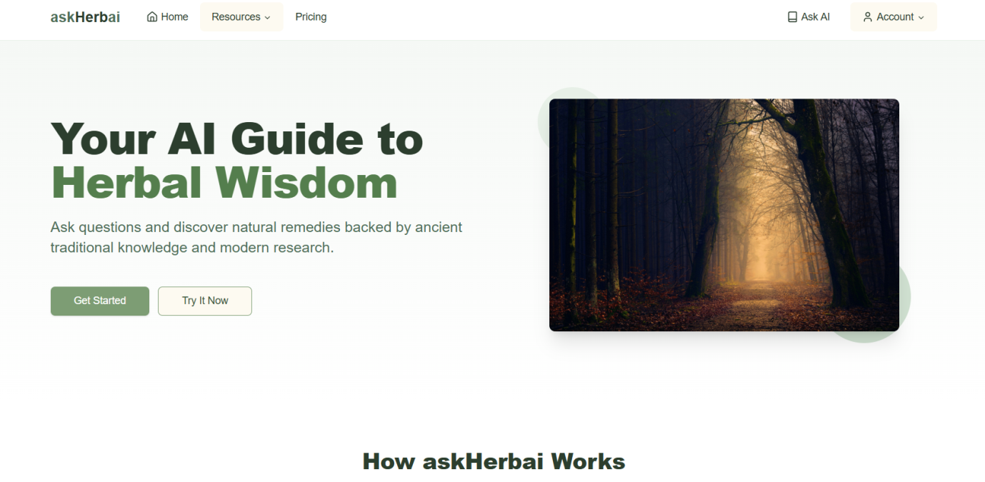
Fig 4.1 Homepage
This is the main page that welcomes users to the AI herbal assistant platform. It introduces the purpose of the system, highlighting its ability to provide natural remedy suggestions through AI. The homepage emphasizes the platform's value proposition combining traditional herbal wisdom with modern technology and encourages users to begin their journey by signing up or logging in to explore the features of the herbal assistant.

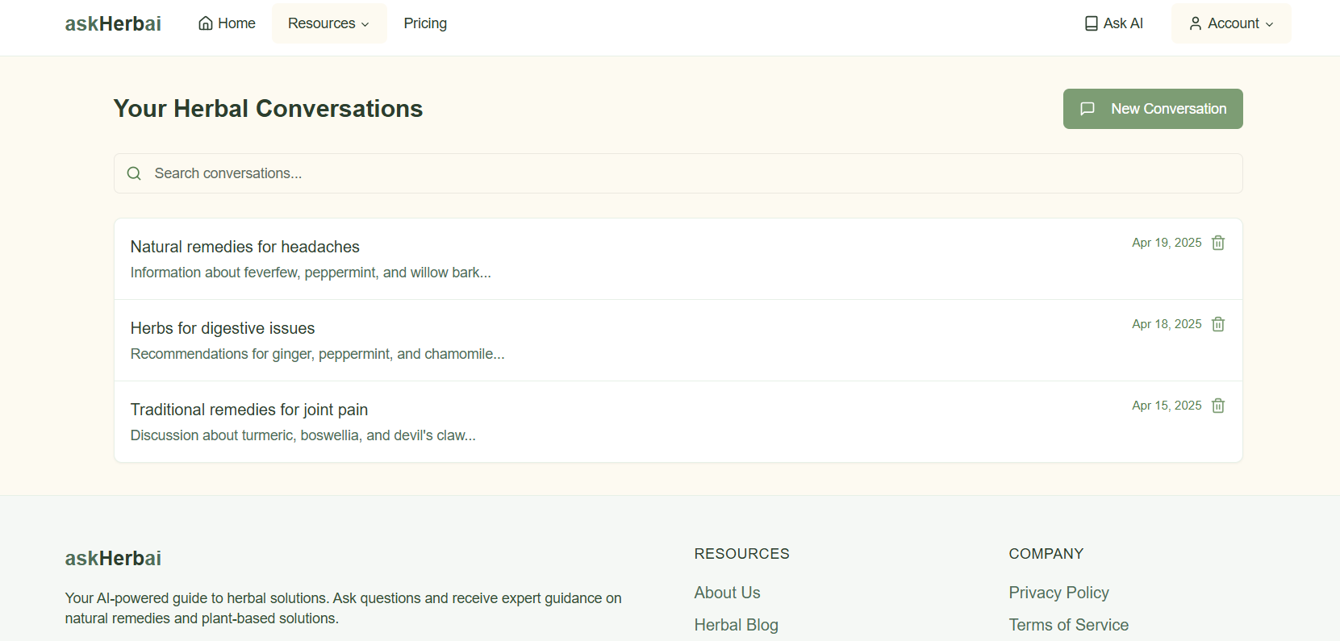
Fig 4.2 Chat History Module
This page serves as an archive of all user-AI interactions. Users can view a chronological list of previous conversations, enabling them to revisit useful responses or continue ongoing discussions. The search functionality helps users locate specific chats easily, offering a personalized history of their inquiries and herbal advice received.
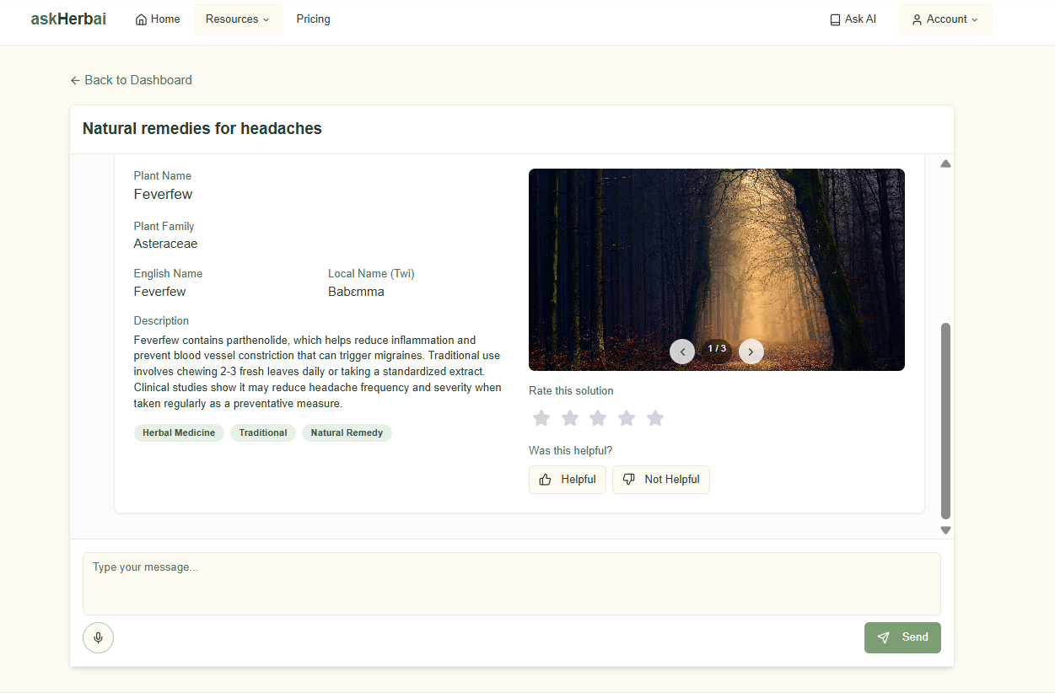
Fig 4.3 Chat Single View Module
This page provides an in-depth view of a selected past conversation between the user and the AI. It allows users to read through the entire chat session on a specific topic, review the AI’s recommendations, and possibly share or bookmark important responses for future reference.

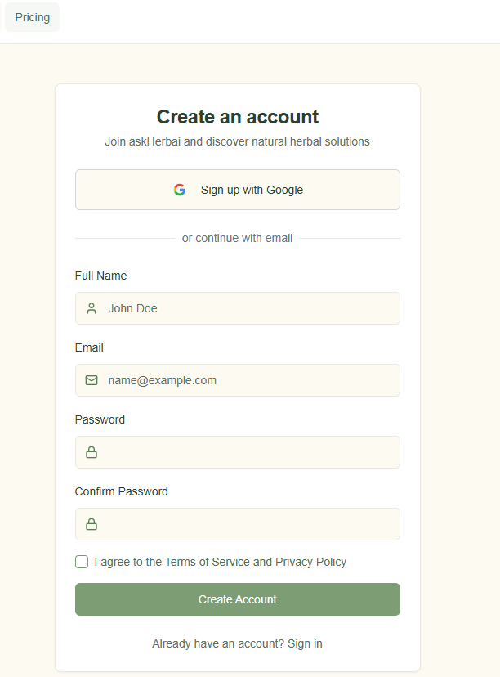
4.1.2 INPUT DESIGN
Inputs are raw data that are put into the computer for further processing. At this stage, the information gathered is analyzed and reconstructed into more relevant and useful data. Data analysis and restructuring was based on the identification of the basic needs and the structure required for the project and restructuring of these data were such achieved efficiently. The analysis and restructuring of these were such that the system is capable of presenting one frame at a time to the user. The system accepts data by choosing from a list of options. The keyboard is used in entering texts into text boxes in different forms. Below are snapshots of the input design.
Fig 4.4 Authentication Module
This is the main gateway for user access and security. The Sign In page allows returning users to securely access their accounts using their credentials, while the Sign Up page provides a straightforward registration process for new users. The Forgot Password feature ensures users can regain access to their accounts if they lose their login credentials, promoting seamless and secure account management.
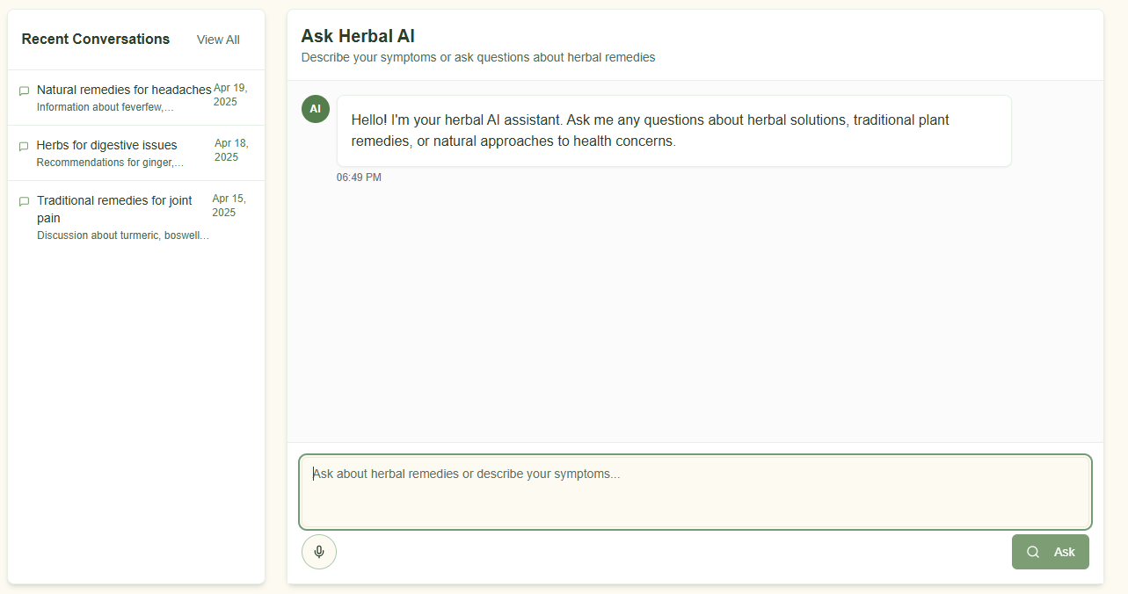
Fig 4.5 Ask AI Module
This is the main page for user interaction with the AI herbal assistant. It features a user-friendly chat interface where users can type in their questions about herbs and natural remedies. The AI then responds with intelligent suggestions, plant-based solutions, and relevant herbal information often accompanied by descriptions, uses, and visuals of the plants making this module the core functional component of the platform.
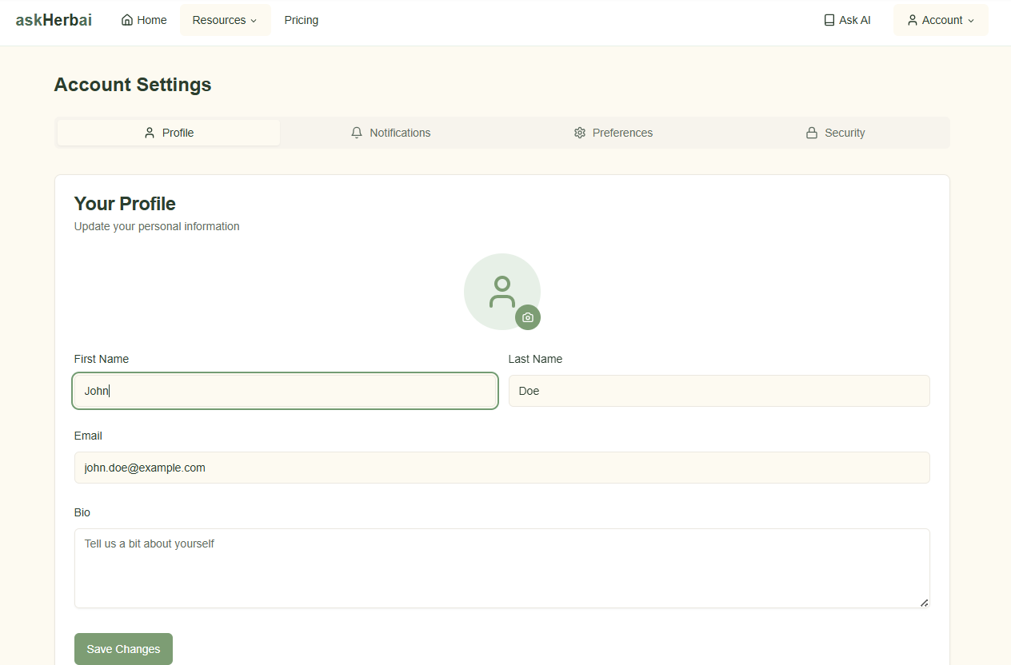
Fig 4.6 Profile Page Module
This is the main page where users can manage their account details and preferences. From updating personal information like name and email to adjusting settings such as notification preferences, this page ensures users have full control over their experience and how they interact with the platform
4.1.3 DATABASE DESIGN
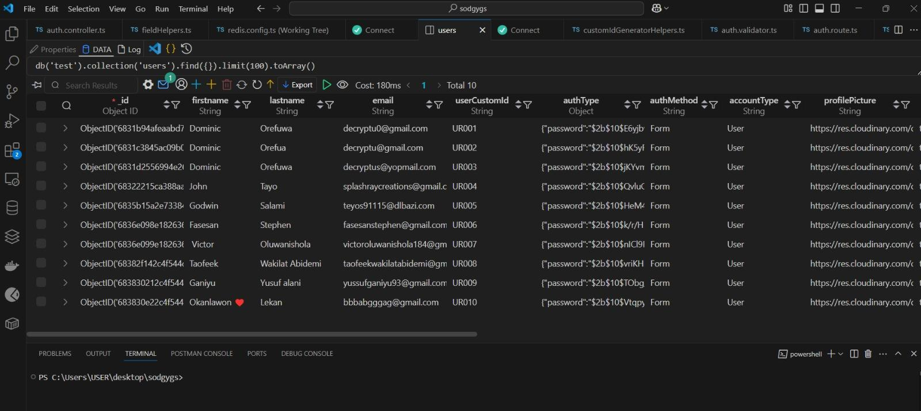
Fig 4.7 Database View
This shows the preview of some sections of the database design of the proposed system.

4.1.4 PROCEDURE DESIGN
This refers to the sequence of steps users or developers must follow to access and use the proposed AI herbal assistant system. The steps outlined below assume a local development environment:
a) Start the backend server by opening a terminal or command prompt and running:
cd backend, npm install, npm run dev
This will launch the Node.js backend and connect to the MongoDB database.
b) Ensure MongoDB is running. This can be done by starting MongoDB locally or using a cloud service like MongoDB Atlas with the correct connection string.
c) In a new terminal window, navigate to the frontend directory and run the following commands to start the React app: cd frontend, npm install,npm start
d) Once the frontend server starts successfully, open a web browser (e.g., Google Chrome, Mozilla Firefox).
e) Type the system's local development URL in the browser's address bar:
http://localhost:3000
f) The homepage of the AI herbal assistant will be displayed. From here, users can either sign up or sign in.
g) After authentication, users can navigate to the “Ask AI” module to interact with the AI assistant by entering herbal health-related questions.
h) Other features such as viewing past conversations (Chat History), reading blog posts, updating profile information, or accessing documentation pages (FAQ, Terms of Service, etc.) can be accessed from the main menu/navigation bar.
4.2 SYSTEM IMPLEMENTATION
4.2.1 CHOICE OF PROGRAMMING LANGUAGE
The proposed system is built using JavaScript, with ReactJS for the frontend and Node.js for the backend. JavaScript was chosen for its versatility, efficiency, and wide adoption in modern web development. ReactJS enables the creation of fast, responsive user interfaces through its component-based architecture and virtual DOM, which improves performance and reusability.
Node.js, running on the V8 JavaScript engine, handles backend processes with its non-blocking, event-driven architecture—ideal for building scalable APIs and handling real-time interactions. The unified use of JavaScript on both client and server sides simplifies development and maintenance. Combined with MongoDB, a flexible NoSQL database, the stack supports fast data retrieval and seamless AI-driven user interactions, making it well-suited for the system’s dynamic nature.
4.4.2 HARDWARE SUPPORT
The minimum hardware requirements for this system are listed below:

Hardware Description | Minimum Requirements
Processor | Intel Pentium 233 MHz or above/ AMD Athlon II X2 250
Memory | 256MB RAM
Hard disk space | Up to 3GB Recommended
Display | 65536 colors, set to at least 1024x768 resolution
Keyboard | 108 Standard

4.2.3 SOFTWARE SUPPORT
The minimum software requirements in developing this system are listed below:
Software Description | Minimum Requirements
Operating System (OS) | All 32-bits Microsoft Windows  (95/98/2000/XP/7/8/10)
Browser | Mozilla Firefox (15.0 & above), Internet Explorer  (8.0 & above), Google Chrome (20.0 & above.)
Web/Application Server | NodeJs Runtime
Database Server | MongoDb (NoSql)
Database Connectivity | NodeJs

4.2.4 IMPLEMENTATION TECHNIQUES
System implementation refers to the stage where the designed and analyzed system is developed, tested, and deployed for real-world usage. For the successful implementation of the proposed AI-powered herbal assistant platform, several tools and technologies were first installed and configured. These included Node.js, MongoDB, ReactJS, Visual Studio Code, and Postman for API testing. In addition, Git was used for version control, and Google Chrome served as the primary browser for development and testing.
Before development began, the environment was properly set up to ensure compatibility between the backend, frontend, and database. The backend API was built using Node.js with Express, while the frontend was developed using ReactJS to create a responsive and interactive user interface. MongoDB was used to store user data, chat history, and herbal remedy information in a flexible document format.
The system was implemented using the Agile methodology, which emphasizes iterative development and frequent testing. This approach was chosen to allow continuous feedback, flexibility, and quicker response to changes during development. Each module (authentication, AI interaction, chat history, etc.) was developed and tested in sprints to ensure modular and error-free deployment.
This structured yet flexible technique ensured that the platform was developed efficiently and remained scalable, user-friendly, and adaptable to real-world use.
4.3 SYSTEM DOCUMENTATION

4.3.1 PROGRAM DOCUMENTATION

The AI-powered herbal assistant system is organized into multiple functional modules, each handling a specific task such as user authentication, AI chat interaction, and chat history management. The backend of the application is developed with Node.js and Express, while the frontend is built using ReactJS. All code is structured using modular architecture and stored in a version-controlled environment using Git and GitHub. The database layer is managed with MongoDB. For development purposes, the backend is run on localhost:5000 and the frontend on localhost:3000, with communication enabled via RESTful APIs.

4.3.2 OPERATING THE SYSTEM

To run the system locally, follow the steps below:
a) Ensure Node.js and MongoDB are installed on the system.
b) Open a terminal or command prompt.
c) Navigate to the backend project folder and runnpm install, then npm run dev to start the server.
d) In a new terminal window, navigate to the frontend project folder and run npm install, then npm start to launch the React app.
e) Open a browser (e.g., Google Chrome) and go to http://localhost:3000 to access the AI herbal assistant platform.

4.3.3 MAINTAINING THE SYSTEM

To ensure optimal performance and security, the following maintenance practices should be followed:

Regularly update dependencies for both frontend and backend using npm update.

Keep MongoDB and Node.js versions up to date to avoid compatibility issues.

Periodically back up the MongoDB database to prevent data loss.

For cloud deployment, ensure that environment variables, database credentials, and API keys are securely managed using .env files and hosting platform configurations.

Monitor application logs and error reports to identify and fix issues promptly.

CHAPTER 5
SUMMARY, CONCLUSION AND RECOMMENDATIONS

5.1 SUMMARY

This project was aimed at designing and developing a web-based AI-powered platform that offers natural herbal medicine solutions to users. The system helps bridge the gap between individuals seeking reliable herbal information and the knowledge traditionally held by herbal practitioners. Built using modern technologies such as ReactJS for the frontend, Node.js/Express for the backend, and MongoDB as the database, the platform provides a user-friendly experience where users can interact with an AI assistant to receive accurate herbal recommendations. The system was designed using the Waterfall development model, which guided the sequential development phases from requirement gathering to implementation. Each chapter of this work covered different aspects such as system analysis, design, implementation, and documentation.

5.2 CONCLUSION

This project successfully demonstrated the integration of artificial intelligence with traditional herbal medicine in a web-based system. The platform empowers users to make informed decisions about their health by providing AI-driven responses based on a structured herbal database. It supports essential features such as user authentication, herbal consultations, chat history tracking, and blog content on natural remedies. The use of open-source tools like Node.js and MongoDB contributed to cost-effectiveness and scalability. By offering a digital herbal assistant, this system promotes better awareness of natural health alternatives and shows great potential for expansion into mobile platforms or integration with certified herbal experts in the future.

5.3 RECOMMENDATIONS
In light of the system development and the findings throughout this project, several recommendations are proposed to ensure the continued success, usability, and improvement of the AI-enabled herbal assistant platform. These recommendations aim to enhance the system’s functionality, security, and accessibility for a wider range of users. By adopting these suggestions, future versions of the platform can become even more effective in delivering trusted herbal knowledge and promoting alternative healthcare solutions.

The AI model used for herbal consultation should be periodically retrained or updated to include new herbal research and user interaction feedback.

A professional database administrator should oversee the MongoDB database to ensure data consistency, security, and performance optimization.

Future versions of the system can integrate multilingual support to reach users from diverse backgrounds.

It is recommended to expand the blog and educational content to enhance user trust and engagement.

Regular updates and maintenance should be carried out to ensure the platform remains functional, secure, and responsive to emerging health trends.

The inclusion of mobile app support and offline access could further improve accessibility and usage, especially in regions with limited internet connectivity.

REFERENCES
- Ahmed, Z., Mohamed, K. G., Zeeshan, S., & Dong, X. (2020). Artificial intelligence with multi-functional machine learning platform development for better healthcare and precision medicine. Database, 2020. https://doi.org/10.1093/database/baaa010

- Briganti, G., & Moine, O. L. (2020). Artificial Intelligence in Medicine: Today and Tomorrow. Frontiers in Medicine, 7. https://doi.org/10.3389/fmed.2020.00027

- Chu, H., Moon, S., Park, J., Bak, S., Ko, Y., & Youn, B.-Y. (2022). The Use of Artificial Intelligence in Complementary and Alternative Medicine: A Systematic Scoping Review. Frontiers in Pharmacology, 13. https://doi.org/10.3389/fphar.2022.826044

- Chu, H., Moon, S., Park, J., Bak, S., Ko, Y., & Youn, B.-Y. (2022). The Use of Artificial Intelligence in Complementary and Alternative Medicine: A Systematic Scoping Review. Frontiers in Pharmacology, 13. https://doi.org/10.3389/fphar.2022.826044

- Chung, M., Su, L.-J., Chen, C.-L., & Wu, L.-C. (2024). AI-assisted literature exploration of innovative Chinese medicine formulas. Frontiers in Pharmacology, 15. https://doi.org/10.3389/fphar.2024.1347882

- Feng, C., Shao, Y., Wang, B., Qu, Y., Wang, Q., Li, Y., & Yang, T. (2021). Development and Application of Artificial Intelligence in Auxiliary TCM Diagnosis [Review of Development and Application of Artificial Intelligence in Auxiliary TCM Diagnosis]. Evidence-Based Complementary and Alternative Medicine, 2021, 1. Hindawi Publishing Corporation. https://doi.org/10.1155/2021/6656053

- Jansen, C., Baker, J., Kodaira, E., Ang, L.-M., Bacani, A. J., Aldan, J. T., Shimoda, L. M. N., Salameh, M., Small‐Howard, A. L., Stokes, A. J., Turner, H., & Adra, C. N. (2020). Journal of Ethnopharmacology, 267, 113477. Elsevier BV. https://doi.org/10.1016/j.jep.2020.113477

- Khan, S. R., Rijjal, D. A., Piro, A., & Wheeler, M. B. (2021). Integration of AI and traditional medicine in drug discovery [Review of Integration of AI and traditional medicine in drug discovery]. Drug Discovery Today, 26(4), 982. Elsevier BV. https://doi.org/10.1016/j.drudis.2021.01.008

- Li, S., & Zhang, B. (2013). Traditional Chinese medicine network pharmacology: theory, methodology and application [Review of Traditional Chinese medicine network pharmacology: theory, methodology and application]. Chinese Journal of Natural Medicines, 11(2), 110. Elsevier BV. https://doi.org/10.1016/s1875-5364(13)60037-0

- Mwangi, J., Mungai, N., Thoithi, G., & Kibwage, I. (2006). Traditional herbal medicine in national healthcare in Kenya. East and Central African Journal of Pharmaceutical Sciences, 8(2). https://doi.org/10.4314/ecajps.v8i2.9720

- McCloskey, J. A., Crain, P. F., Edmonds, C. G., Gupta, R. C., Hashizume, T., Phillipson, D. W., & Stetter, K. O. (1987). Structure determination of a new fluorescent tricyclic nucleoside from archaebacterial tRNA. Nucleic Acids Research, 15(2), 683. https://doi.org/10.1093/nar/15.2.683

- Song, Z., Chen, G., & Chen, C. Y. (2024). AI Empowering Traditional Chinese Medicine? [Review of AI Empowering Traditional Chinese Medicine?]. Chemical Science. Royal Society of Chemistry. https://doi.org/10.1039/d4sc04107k

- Vera, M. C. S., & Palaoag, T. D. (2023). Implementation of a Smarter Herbal Medication Delivery System Employing an AI-Powered Chatbot. International Journal of Advanced Computer Science and Applications, 14(3). https://doi.org/10.14569/ijacsa.2023.0140358
Yang, Z., Yin, Y., Kong, C., Chi, T., Tao, W., Zhang, Y., & Tian, X. (2025). ShennongAlpha: an AI-driven sharing and collaboration platform for intelligent curation, acquisition, and translation of natural medicinal material knowledge. Cell Discovery, 11(1). https://doi.org/10.1038/s41421-025-00776-2

- Yu, K., Beam, A. L., & Kohane, I. S. (2018). Artificial intelligence in healthcare [Review of Artificial intelligence in healthcare]. Nature Biomedical Engineering, 2(10), 719. Nature Portfolio. https://doi.org/10.1038/s41551-018-0305-z

- Zhou, E., Shen, Q., & Hou, Y. (2024). Integrating artificial intelligence into the modernization of the traditional Chinese medicine industry: a review [Review of Integrating artificial intelligence into the modernization of traditional Chinese medicine industry: a review]. Frontiers in Pharmacology, 15. Frontiers Media. https://doi.org/10.3389/fphar.2024.1181183

- APPENDIX A
PROGRAM FLOWCHART
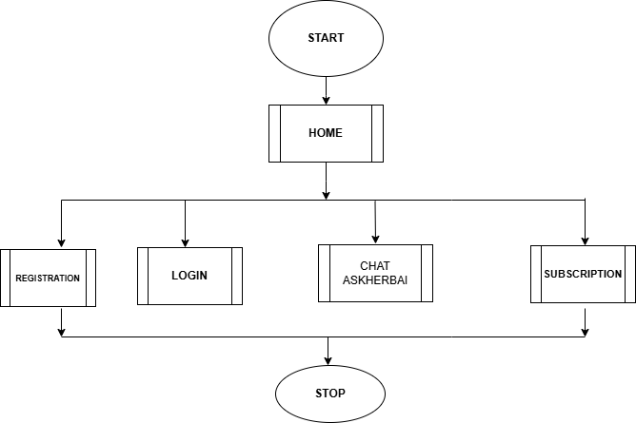
- REGISTRATION
- 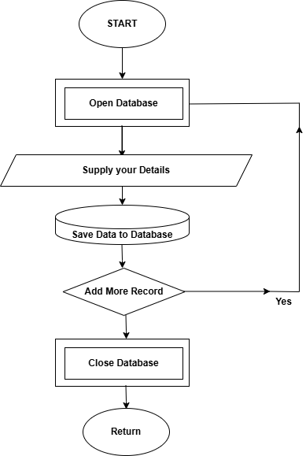

- LOGIN
- 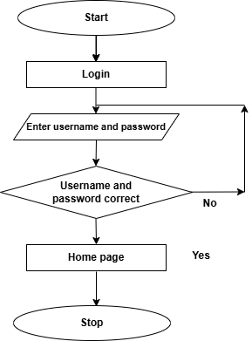

- CHAT ASKHERBAI
- 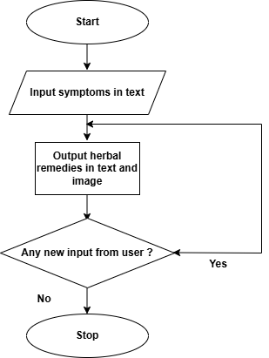

- APPENDIX B
PROGRAM SOURCE CODE
- <DOCTYPE html><html lang-"en">
- <head>
- <title> Kwarapoly Portal </title>
- <meta charset="utf-8">
- <meta name="viewport" content="width device-width, initial-scale = 1">
- <link rel="shortcut icon" href="images/kplogo.png"/>
- <link rel="stylesheet" type="text/css" href="css/bootstrap.min.css"
- <link rel="stylesheet" href="css/sp8cial.css">
- <link rel="stylesheet" href="css/style.css">
- <link rel="stylesheet" type="text/css" href="font/all.css">
- <script src="https://code.jquery.com/jquery-3.2.1.slim.min.js" integrity="sha384-
- KJ302DKtlkvYIK3UENzmM7KCkRr/rE9/Qpg6aAZGJwFDMVNA/GpGFF93hXpGSKKN" crossorigin="anonymous"></script>
- <script src="https://cdnjs.cloudflare.com/ajax/libs/popper.js/1.12.9/umd/popper.min.js" integrity-"sha384-
- ApNbgh9B+Y1QKtv3Rn7W3mgP×hU9K/ScQsAP7hUibX39j7fakFPskvXusvfa0b40' crossorigin="anonymous"></script><script sro="https://maxcdn.bootstrapedn.com/bootstrap/4.0.0/js/bootstrap.min.is"
- integrity="sha384-
- JZR6Spejh4U02d8jOt6vLEHfe/JQGiRRSQQXSIFWpilMquVdAyjUarS+76PVCmY|' crossorigin="anonymous"></script>
- </head>
- <body class="bg-grey">
- <nav class-"navbar navbar-expand-Ig py-|g-3 navbar-dark sticky-top" style="back ground-color:
- rgb(2, 156, 90);">
- <div class="container">
- <! - logo -->
- <a href-"homepage.html" class-"navbar-brand mr-Ig-5"><img src="images/me.png" alt=“” class='logo-dark" height="60” />
- </a>

