STRATEGIES, PROBLEMS AND PROSPECTS OF REFUSE MANAGEMENT
(CASE STUDY, BEHIND FEDERAL ESTATE, ALIARA, KWARA STATE)

BY
BABATUNDE ANUOLUWAPO HANNAH
HND/23/CEC/FT/0130

BEING A RESEARCH PROJECT SUBMITTED TO THE DEPARTMENT OF CIVIL ENGINEERING TECHNOLOGY, INSTITUTE OF TECHNOLOGY, KWARA STATE POLYTECHNIC, ILORIN

IN PARTIAL FULFILMENT OF THE REQUIREMENTS FOR THE AWARD OF HIGHER NATIONAL DIPLOMA (HND) IN CIVIL ENGINEERING TECHNOLOGY

JUNE, 2025
CERTIFICATION
This is to certify that this research study was conducted by BABATUNDE ANUOLUWAPO HANNAH with matriculation number HND/23/CEC/FT/0130 and had been read and approved as meeting the requirement for the award of Higher National Diploma (HND) in Civil Engineering of the Department of Civil Engineering, Institute of Technology, Kwara State Polytechnic, Ilorin.

_________________________ ________________
ENGR. MRS. M.F RAJI DATE
(Project Supervisor)

________________________ ________________
ENGR. A. NAALLAH DATE
(Head of Department)

_________________________ ________________
ENGR. DR. MUJEDU KASALI ADEBAYO DATE
(External Examiner)

DEDICATION
This project is dedicated to Almighty Allah, whose wisdom and guidance have brought me this far. I also dedicate this work to my families, whose love, encouragement, and moral support gave me the strength to complete this research. To all the residents of Federal Estate, Aliara, Kwara State, who willingly participated in my survey, I sincerely dedicate this work as a step towards improving refuse management in the community.

ACKNOWLEDGEMENTS
I wish to express our heartfelt gratitude to everyone who contributed to the success of this project.
My sincere appreciation goes to my supervisor, Engr. Mrs. M.F Raji, for his invaluable guidance, feedback, and support throughout this research process. His professional insight and encouragement helped shape the direction of this work.
I also thank the respondents from the area behind Federal Estate, Aliara, Kwara State, for their cooperation and for providing accurate and honest information during the data collection process.
I extend our appreciation to my lecturers and departmental staff for their academic support and to my families and friends for their patience, understanding, and moral support throughout this research.
Above all, I thank Almighty Allah for the wisdom, strength, and perseverance granted to me to complete this work successfully.

ABSTRACT
This study investigates the strategies, problems, and prospects of refuse management in the area behind Federal Estate, Aliara, Kwara State. The research aims to evaluate existing waste management practices, identify the challenges faced by residents, and examine opportunities for improvement toward sustainable environmental health. A total of 100 structured questionnaires were distributed and analyzed to obtain relevant data. The findings reveal that while the majority of residents are aware of solid waste management, improper disposal methods are still widely practiced due to inadequate waste collection infrastructure, poor government intervention, and lack of sensitization. Furthermore, residents expressed concern over the health and environmental impact of unmanaged waste and showed willingness to participate in recycling programs if adequately supported. The study concludes that effective refuse management in the area requires increased government involvement, provision of adequate disposal facilities, and continuous public education. Recommendations are made for the implementation of community-based waste programs, improved waste logistics, and policy reforms to promote sustainable waste management practices in the region.

TABLE OF CONTENTS
Title Page
Certification
Dedication
Acknowledgements
Table of Contents
Abstract
CHAPTER ONE: INTRODUCTION
1.1 Background of the Study
1.2 Statement of the Problem
1.3 Justification of the Study
1.4 Aim of the Study
1.5 Objectives of the Study
1.6 Scope of the Study
CHAPTER TWO: LITERATURE REVIEW
2.1 Preamble
2.2 Overview of Refuse Management Strategies
2.3 Challenges in Refuse Management
2.4 Environmental and Health Impacts of Poor Refuse Management
2.5 Economic Prospects of Effective Refuse Management
2.6 Innovations and Future Prospects in Waste Management
CHAPTER THREE: METHODOLOGY
3.1 Materials Used
3.2 Research Design
3.3 Population and Sampling Technique
3.4 Methods of Data Collection
3.5 Data Analysis Techniques
CHAPTER FOUR: RESULTS AND DISCUSSION
4.1 Presentation of Findings
4.2 Analysis and Interpretation
4.3 Discussion of Findings
4.4 Comparison with Existing Research
CHAPTER FIVE: SUMMARY, CONCLUSION AND RECOMMENDATIONS
5.1 Summary
5.2 Conclusion
5.3 Implications
5.4 Recommendations
References
Appendix

CHAPTER ONE
INTRODUCTION
1.1 BACKGROUND OF THE STUDY
Refuse management encompasses the systematic process of collecting, transporting, processing, recycling, and disposing of waste materials to mitigate their impact on the environment and human health. The global increase in urbanization and population density has exacerbated challenges related to waste generation and disposal, especially in urban centers. According to Kaza et al. (2018), the world generates over 2.01 billion tonnes of municipal solid waste annually, with at least 33% of it not managed in an environmentally safe manner. This problem is more pronounced in developing regions, including Nigeria, where ineffective refuse management systems persist due to poor planning, inadequate funding, and lack of technological adoption.
In Kwara State, particularly in urban communities such as Behind Federal Estate, Aliara, the rise in population has led to an increase in solid waste generation without a corresponding improvement in waste management infrastructure. The area faces problems of indiscriminate waste disposal, blocked drainage channels, and pollution of air, water, and soil resources. These issues are compounded by insufficient enforcement of waste management regulations, limited public awareness, and inadequate institutional capacity. Ogbonna et al. (2017) noted that the inefficiency of municipal waste management in many Nigerian cities stems from a lack of coordination among government agencies and poor engagement with community stakeholders.
The increasing population and urbanization in Kwara State have led to a rise in waste generation, necessitating effective waste management strategies (Agunwamba, 2003). Waste accumulation poses serious environmental and health risks if not properly managed, leading to pollution, disease outbreaks, and degradation of natural resources. The improper handling of refuse also contributes to climate change by increasing greenhouse gas emissions from decomposing organic waste in landfills (Mihelcic, 2009). In urban areas, such as Behind Federal Estate, Aliara, waste management is a growing concern due to increasing refuse generation and inadequate waste disposal infrastructure (Ogwueleka, 2009).
The demand for effective waste management policies has become more urgent as urbanization intensifies and waste generation surpasses disposal capacity. Poor waste management practices lead to blocked drainage systems, which increase the risk of flooding during the rainy season (Olayiwola, 2020). Additionally, the lack of awareness and public participation in waste management exacerbates the problem, making it difficult to achieve sustainable environmental goals (Adepegba, 2012). Various strategies, such as landfill disposal, incineration, recycling, and composting, have been proposed and implemented in different regions to tackle waste-related challenges (Henry, 2006). However, in locations like Behind Federal Estate, Aliara, these approaches remain ineffective due to poor enforcement of regulations, insufficient funding, and a lack of proper waste collection and disposal facilities (Adeoye et al., 2018).
Refuse management is a fundamental aspect of environmental sustainability, as improper waste disposal can lead to the contamination of soil, water bodies, and air, posing serious risks to public health . The accumulation of waste materials can also reduce property values and affect the overall livability of a community (Vergan et al., 2012). Developing effective waste management policies requires a multi-faceted approach that incorporates regulatory frameworks, technological innovations, public awareness campaigns, and community engagement (UNEP, 2018). The study of refuse management in Behind Federal Estate, Aliara, is therefore crucial for understanding the existing challenges and identifying potential solutions that can be implemented to enhance waste disposal efficiency and promote environmental sustainability.
1.2 STATEMENT OF THE PROBLEM
Behind Federal Estate, Aliara faces increasing environmental and health concerns due to high rates of refuse generation and ineffective waste management practices. Rapid urbanization has led to a surge in waste accumulation in open spaces, roadsides, and drainage systems, causing air and water pollution, soil degradation, and the spread of disease vectors such as rodents and mosquitoes.
There is an absence of organized waste collection systems and minimal enforcement of regulations, leading to indiscriminate dumping and open burning. The lack of public awareness and community involvement, compounded by inadequate funding and institutional capacity, has created a significant barrier to sustainable waste management. Addressing these issues requires a critical review of current strategies and the development of effective, community-based solutions tailored to the area's unique challenges.

1.3 JUSTIFICATION OF THE STUDY
The area is experiencing a critical phase in urban development, which, if left unaddressed, may lead to severe environmental degradation and public health crises due to improper waste handling. Studying the existing waste management challenges provides a pathway for identifying gaps, assessing community involvement, and evaluating the effectiveness of local strategies. Proper waste management is critical for reducing the adverse effects of improper refuse disposal, which include pollution, health hazards, and environmental degradation. Conducting this study provides an opportunity to analyze the effectiveness of existing waste management practices and highlight areas that require improvement. By identifying gaps in waste collection, disposal, and recycling efforts, the findings can serve as a foundation for implementing sustainable waste management strategies tailored to the specific needs of the study area.
This research is justified by the need to develop a comprehensive framework that supports environmentally friendly waste disposal methods. The study contributes to policy formulation by providing evidence-based recommendations that can assist local authorities in strengthening regulations and enforcement mechanisms. Additionally, it will help in raising awareness among residents about the importance of proper refuse disposal and encourage community participation in sustainable waste management initiatives. Through this study, stakeholders, including government agencies, environmental organizations, and community members, can work collaboratively to improve waste management infrastructure, promote recycling programs, and enhance public health conditions. Ultimately, the findings of this research will be beneficial in guiding long-term efforts to achieve effective and sustainable refuse management practices Behind Federal Estate, Aliara.
1.4 AIM OF THE STUDY
The aim of this study is to assess the strategies, problems, and prospects of refuse management Behind Federal Estate, Aliara, Kwara State.
1.5 OBJECTIVES OF THE STUDY
The objectives of this study are as follows:
- To assess and identify the waste management problem in Aliara.
- To determine the challenges faced by local authorities and residents living around the study area.
- To explore the prospect for improving waste management practices in Aliara.
1.6 SCOPE OF THE STUDY
This study focuses on the refuse management strategies, challenges, and prospects Behind Federal Estate, Aliara, Kwara State. It examines the effectiveness of current waste collection, transportation, treatment, and disposal methods in the study area. The research also investigates the environmental and public health impacts associated with poor waste management practices. Additionally, the study evaluates the level of community participation in waste management and explores potential policy interventions to improve waste disposal efficiency. The scope of the study is limited to Behind Federal Estate, Aliara, and does not extend to other parts of Kwara State or Nigeria. However, findings and recommendations may be applicable to other regions with similar waste management challenges.

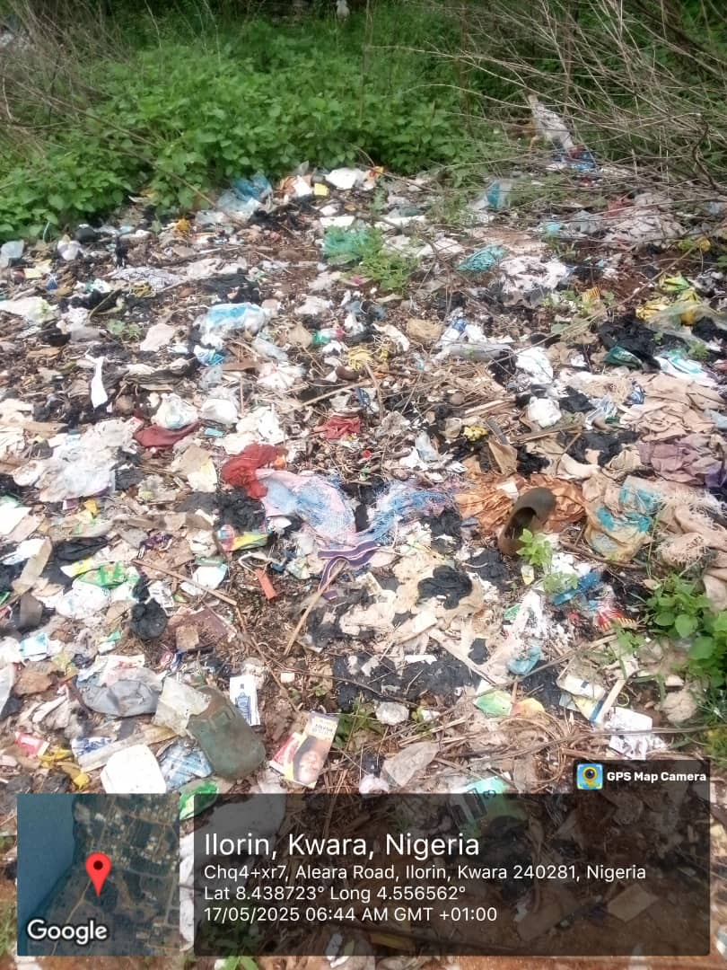

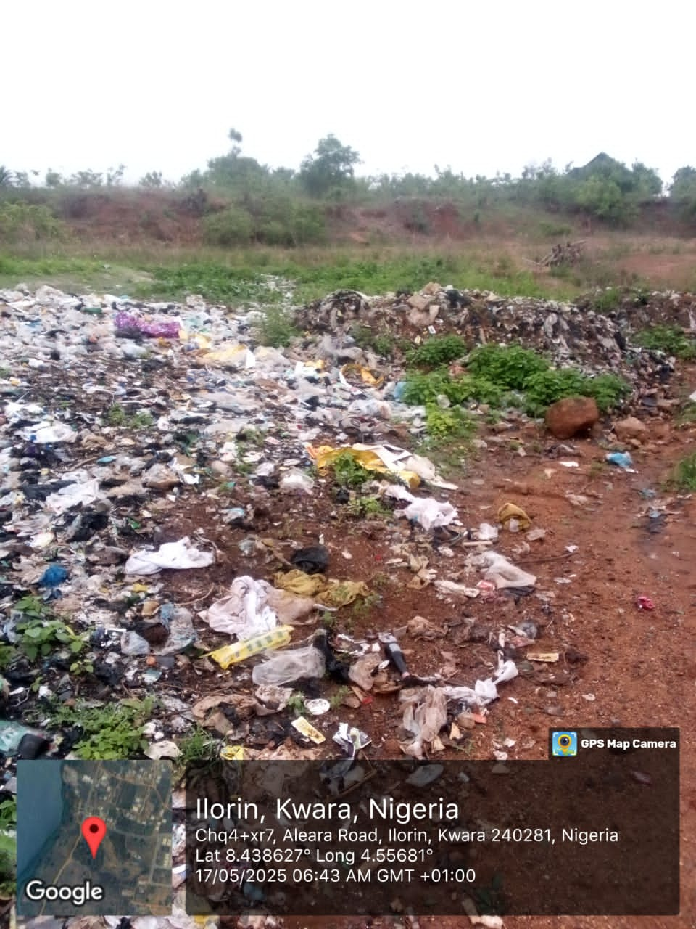

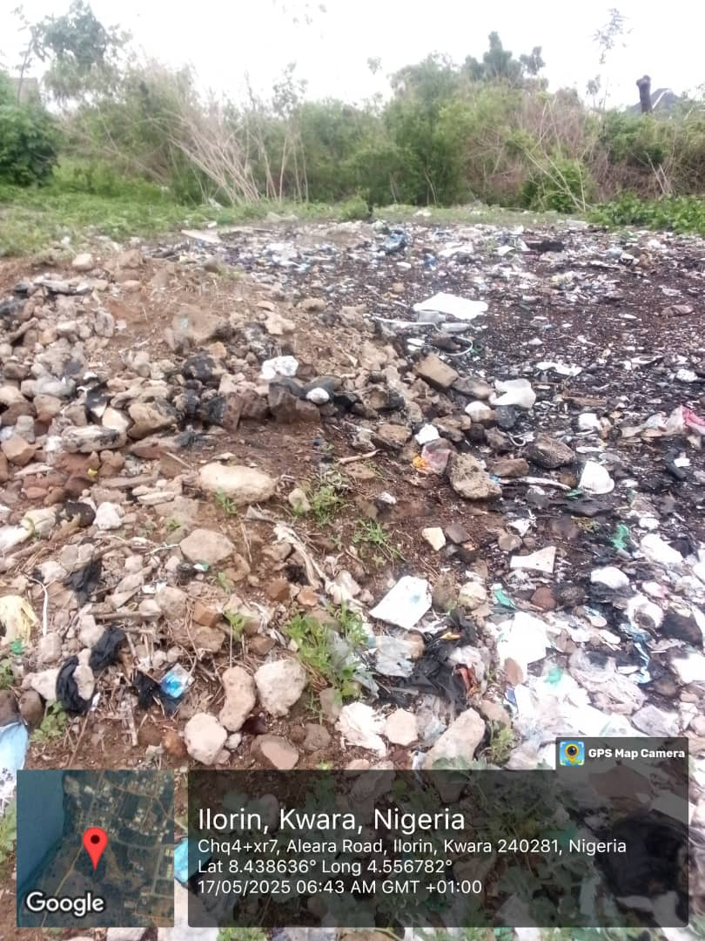
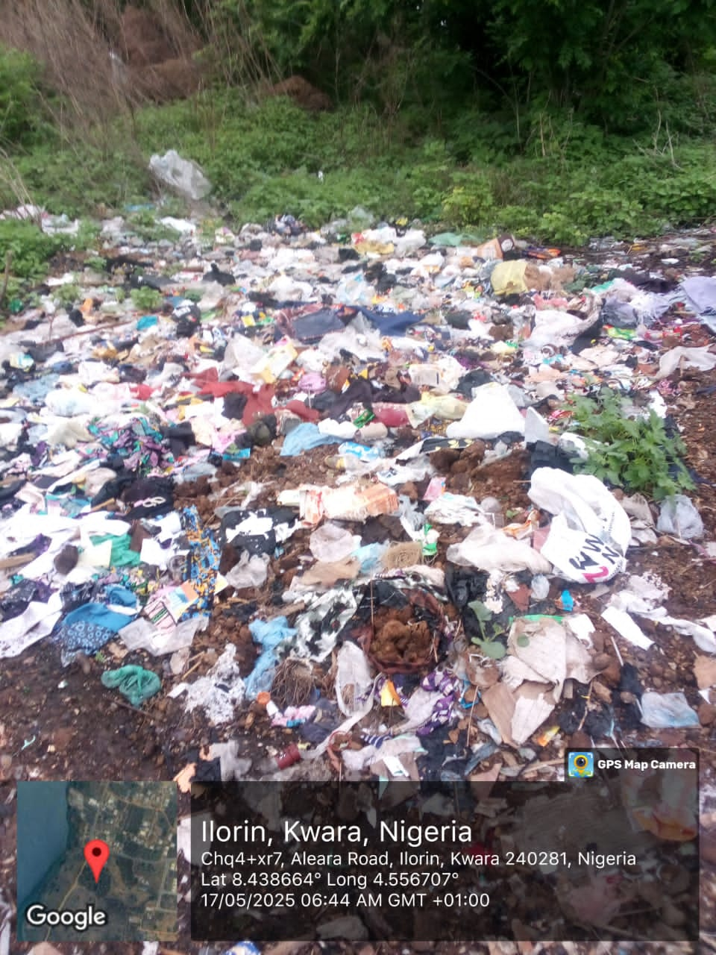
CHAPTER TWO
LITERATURE REVIEW
2.1 PREAMBLE
Refuse management is a critical aspect of environmental sustainability, urban planning, and public health. The increasing rate of urbanization, industrialization, and population growth has significantly contributed to higher waste generation, creating serious challenges for effective refuse management (Guerrero et al., 2013). Waste disposal practices vary globally, influenced by economic development, government policies, infrastructure availability, and public awareness (Kaza et al., 2018). In developed nations, refuse management systems are well-structured, incorporating waste segregation, recycling, composting, and waste-to-energy conversion (Wilson et al., 2015). However, in many developing countries, including Nigeria, waste collection and disposal remain inefficient, leading to environmental pollution, health hazards, and socio-economic issues (Ogwueleka, 2009).
2.1.1 The Importance of Refuse Management
With the deteriorating Earth state that we live in nowadays, waste management appears to be one of the most important environmental protection strategies. This practice has, in fact, several benefits both on the environment and the society. In particular, the main benefits of waste management are:
Environmental protection and pollution reduction: One of the primary benefits of waste management lies in its ability to minimize the environmental impact of human activities. Proper waste disposal and recycling reduce the amount of waste that ends up in landfills or incinerators, thereby decreasing greenhouse gas emissions and air pollution. By diverting waste from landfills, we conserve valuable space and reduce the risk of harmful substances leaking into the soil and contaminating water sources, protecting both human health and ecosystems.
Resource conservation: Waste management fosters resource conservation through recycling and reusing materials, reducing the total amount of material reaching final disposal. Recycling allows us to reclaim valuable resources from discarded items and, by doing so, we minimize the need for raw material extraction, thus conserving natural resources and mitigating the environmental impacts associated with the extraction and processing of raw materials.
Economic benefits: There are plenty of economic benefits deriving from waste management: not only this practice reduces the overall cost of waste disposal, but also fosters the creation of job opportunities. Last but not least, investing in waste management processes boosts companies’ reputation, attracting customers and investors.
Enabling a circular economy: Waste management is a key enabler of the circular economy, a model aimed at reducing waste and optimizing resource use. In a circular economy, products and materials are designed for longevity, reuse, and recyclability. This transition from a linear "take-make-dispose" model to a circular one is fundamental in achieving a sustainable and greener future, and it is evident how waste management plays a big part in it.

2.1.2 Global Waste Management Trends
Globally, waste management strategies differ based on technological advancements, economic strength, and regulatory frameworks. Developed countries such as Germany, Sweden, and Japan have successfully implemented waste-to-energy plants, strict waste segregation policies, and high recycling rates (Sakai, 2017). These countries focus on reducing landfill dependence and promoting a circular economy, where waste materials are continuously repurposed for new uses.
Conversely, in many developing nations, particularly in Africa, Asia, and Latin America, waste management remains a significant challenge due to insufficient funding, weak policy implementation, and lack of public awareness. Open dumping, burning of waste, and indiscriminate disposal in drainage systems are common, leading to environmental degradation and public health risks (Ogwueleka, 2009).
2.1.3 Waste Management in Nigeria
The current state of waste management in Nigeria is of major concern due to the high rate of waste generation and poor management practices. Nigeria produces an estimation of 32 million tons of solid waste per year, with only about 20-30 percent of it being collected and managed correctly. The remainder of the waste is either dumped in unauthorized places or burned, contributing to pollution and health risks.
Nigeria produces the most solid garbage in Africa, with approximately 70 percent of it being plastic waste that winds up in landfills, water bodies, or sewers. According to the World Bank, Nigeria is the tenth largest producer of unmanaged plastics in the world, accounting for 2.7 percent of the global total. According to the World Bank, Nigeria will generate the most unmanaged plastic waste in Africa by 2050.
Lagos produces approximately 13,000 tons of waste per day, according to the Lagos State Waste Management Agency. It is anticipated that waste produced in cities is greater than in rural areas, but Lagos' urbanization is pushing the city to a point of no return.
The government has attempted several initiatives, such as "Keep Lagos Clean," to manage waste in the state, but they have failed to recognize the need for effective waste management measures. Garbage collection became a significant problem, with private homes filling up with waste and people resorting to filling the highways with their trash.
Every street and corner in Lagos is filled with unmanaged garbage, which is almost a private joke. Driving over bridges that overlook aquatic bodies is an eye sore because plastics and nylons are visible. In some parts of Nigeria, the odor emitted by waste renders those places uninhabitable. The dump sites in Nigeria breed mosquitoes, resulting in a high incidence of malaria as well as a high risk of contracting cholera and other diseases.
Waste disposal and management have a direct effect on climate change, and appropriate waste disposal and management are critical components of any climate protection policies and actions. Poor waste management has a significant effect on greenhouse gas emissions and must be addressed alongside other climate concerns.
2.2 OVERVIEW OF REFUSE MANAGEMENT STRATEGIES
2.2.1 Waste Collection and Transportation Systems
Waste collection is the first step in refuse management, involving the gathering and transportation of solid waste to designated disposal sites. In developed countries, organized waste collection systems include door-to-door pickup, community bins, and mechanized collection trucks. However, in many developing nations, including Nigeria, waste collection is poorly managed, irregular, and inefficient, leading to waste accumulation on streets and drainage systems.
Several factors affect the efficiency of waste collection, including the availability of collection vehicles, financial resources, population density, and road infrastructure. Inadequate waste transportation systems also contribute to open dumping and illegal waste disposal practices (Ding et al., 2017). Addressing these issues requires investment in modern collection methods, efficient route planning, and improved funding mechanisms.
2.2.2 Waste Disposal Methods
Proper waste disposal is essential for environmental protection. Various disposal methods exist, including:
2.2.2.1 Landfills
Throwing daily waste/garbage in the landfills is the most popularly used method of waste disposal used today. This process of waste disposal focuses attention on burying the waste in the land. Landfills are commonly found in developing countries. Landfills give rise to air and water pollution which severely affects the environment and can prove fatal to the lives of humans and animals. Many areas are reconsidering the use of landfill.
2.2.2.2 Incineration
Although burning or incineration is often used for the disposal of combustible waste, this should generally only take place off-site or a considerable distance downwind of dwellings. Burning refuse within dwelling areas may create a significant smoke or fire hazard, especially if several fires are lit simultaneously. Burning may be used to reduce the volume of waste and may be appropriate where there is limited space for burial or landfill. Waste should be ignited within pits and covered with soil once incinerated, in the same manner as landfilling. The same constraints for siting landfill sites should be applied here also.
2.2.2.3 Composting
Simple composting of vegetables and other organic waste can be applied in many situations. Where people have their own gardens or vegetable plots, organic waste can be dug into the soil to add humus and fibre. This makes the waste perfectly safe and also assists the growing process. This should be encouraged wherever possible, particularly in the later stages of an emergency programme.
Properly managed composting requires careful monitoring of decomposing waste to control moisture and chemical levels and promote microbial activity. This is designed to produce compost which is safe to handle and which acts as a good fertiliser. Such systems require considerable knowledge and experience and are best managed centrally. In general, they are unlikely to be appropriate in emergencies.

2.2.2.3 Recycling
Complex recycling systems are unlikely to be appropriate but the recycling of some waste items may be possible on occasions. Plastic bags, containers, tins and glass will often be automatically recycled since they are likely to be scarce commodities in many situations. In most developing country contexts there exists a strong tradition of recycling leading to lower volumes of waste than in many more developed societies.
2.3 CHALLENGES IN REFUSE MANAGEMENT
2.3.1 Inadequate Waste Management Infrastructure
One of the major challenges in refuse management is the lack of proper infrastructure, including collection trucks, recycling plants, and engineered landfills. Many Nigerian cities rely on open dumps with little or no environmental control, leading to pollution and public health hazards (Pudcha, 2018).
2.3.2 Weak Policy Implementation and Enforcement
Although Nigeria has several waste management policies, enforcement remains weak due to corruption, lack of funding, and poor coordination among agencies (Ogwueleka, 2009). Many waste disposal laws are not properly implemented, resulting in indiscriminate dumping and illegal waste disposal.
2.3.3 Low Public Awareness and Participation
Public awareness plays a crucial role in effective waste management. However, in many parts of Nigeria, there is low awareness about proper waste disposal methods and the benefits of recycling. Many residents engage in indiscriminate waste dumping due to lack of education and incentives for proper waste management (Tong, 2013).
2.4 ENVIRONMENTAL AND HEALTH IMPACTS OF POOR REFUSE MANAGEMENT
2.4.1 Pollution and Climate Change
Improper waste disposal leads to air, water, and land pollution. Open dumping and burning of waste release harmful toxins and greenhouse gases, contributing to climate change (Xiao et al., 2020). Poorly managed landfills contaminate soil and groundwater, affecting biodiversity and agricultural productivity (Chaabane, 2019).
2.4.2 Public Health Hazards
Accumulated waste attracts rodents, mosquitoes, and bacteria, increasing the risk of disease outbreaks such as malaria, cholera, and typhoid fever (Ambaye, 2023). Open dumps serve as breeding grounds for pests, leading to the spread of infectious diseases (Alsobky, 2023).
2.5 ECONOMIC PROSPECTS OF EFFECTIVE REFUSE MANAGEMENT
2.5.1 Waste Recycling and Job Creation
A well-structured waste management system can create employment opportunities through recycling industries, waste sorting, and composting (Kaza, 2018). Countries with advanced recycling systems generate revenue from selling recycled materials and promoting a circular economy (Hoornweg, 2012).

2.5.2 Waste-to-Energy Initiatives
Converting waste into energy can provide alternative energy sources, reduce landfill dependence, and promote economic growth (Sakai, 2017). Nigeria has the potential to generate electricity from waste, but investment in technology and infrastructure is needed (Guerrero, 2013).
2.6 INNOVATIONS AND FUTURE PROSPECTS IN WASTE MANAGEMENT
2.6.1 Smart Waste Management Systems
Technological innovations such as smart bins, GPS-enabled waste collection, and AI-driven waste sorting are transforming waste management globally (Wilson et al., 2015). These technologies can improve efficiency and reduce operational costs (Kaza, 2018).
2.6.2 Circular Economy Approach
A circular economy promotes waste reduction, resource recovery, and sustainable production cycles (Bhada-Tata, 2012). Countries adopting zero-waste initiatives have reduced landfill dependency and improved environmental sustainability (Guerrero, 2013).

CHAPTER THREE
METHODOLOGY
This chapter details the systematic procedures adopted for conducting the study. It outlines the materials used, research design, population and sampling technique, methods of data collection, analytical techniques, and procedures to ensure validity and reliability. Each section was carefully planned to ensure accurate representation of refuse management conditions Behind Federal Estate, Aliara, Kwara State.
3.1 MATERIALS USED
A variety of materials and tools were utilized in the course of the study to collect reliable and accurate data on the conditions of refuse management in the study area. These tools facilitated the assessment of waste distribution, environmental impact, and spatial characteristics of refuse accumulation sites.
3.1.1 Theodolite
A theodolite was used for measuring both horizontal and vertical angles. This instrument provided accurate readings necessary for determining the slope and elevation changes across areas affected by improper waste disposal. Its application allowed researchers to map terrain contours and assess whether topography influenced drainage blockage due to refuse (Agbo, 2021).
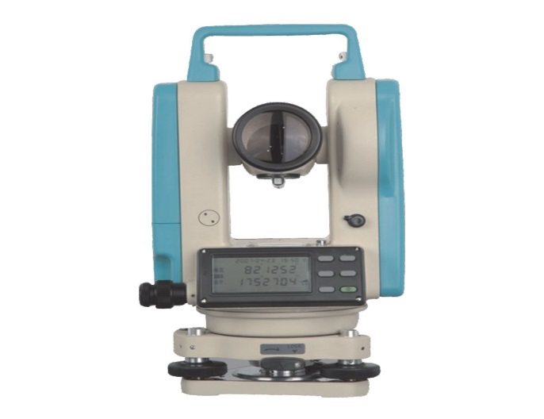

3.1.2 Field Survey Instruments
Field survey tools such as ranging poles, leveling staffs, bipod, tripod and prismatic compass were employed to define boundaries and layout patterns of dumpsites. These instruments allowed researchers to map out refuse spread and identify areas with poor accessibility or ineffective waste services (Nwachukwu et al., 2020).
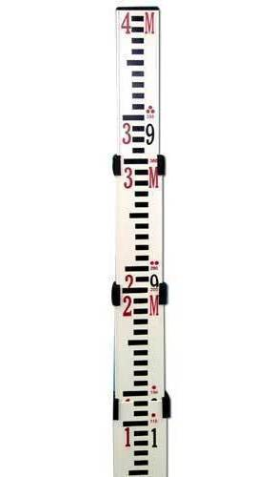
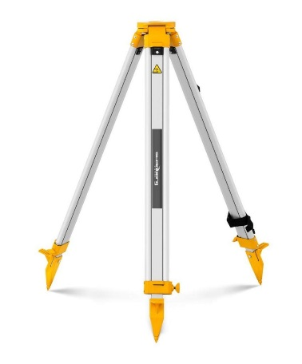

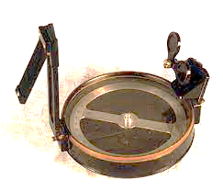
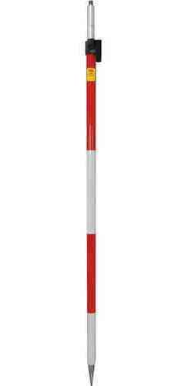
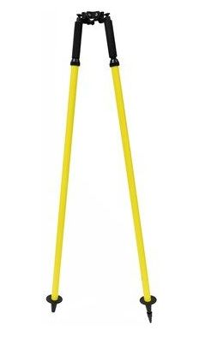
3.1.3 Measuring Tape
The measuring tape was utilized for gathering linear data, particularly the length and width of drainage channels, dimensions of waste clusters, and distances between key points such as refuse dumps and residential dwellings. This tool was essential for quantifying spatial information (Adebayo & Oyetunji, 2019).


3.1.4 Video Graphics Equipment
Handheld digital cameras and smartphones were employed to capture images and videos of refuse sites. These visuals provided a reference point during data analysis and were crucial in documenting the real-time environmental and health conditions caused by improper refuse management (Obafemi & Adeyemi, 2018).
3.1.5 Safety and Protective Gear
To ensure the safety of the research team during fieldwork, items such as gloves, nose masks, rubber boots, and reflective jackets were used. These materials were necessary for entering unsanitary areas with high volumes of decomposing waste and potentially hazardous materials (Ogundipe & Adebanjo, 2022).
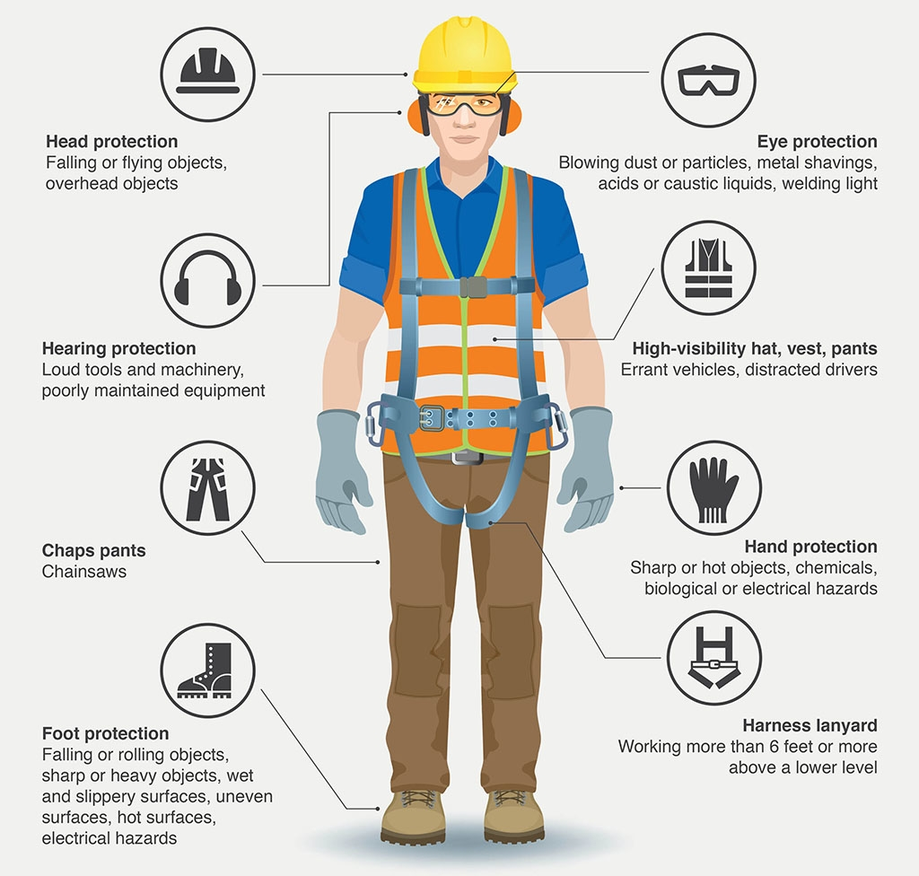
3.2 RESEARCH DESIGN
The study adopted a descriptive survey research design. This approach was selected because it allows for the systematic collection, interpretation, and analysis of data related to refuse management practices, problems, and prospects. It is particularly useful for studying existing phenomena in natural settings without manipulation (Ezeudu, 2021).
A mixed-method approach was adopted, combining both qualitative and quantitative techniques. The quantitative aspect involved the use of structured questionnaires and statistical tools, while the qualitative aspect included interviews and field observations. This integration was essential for capturing a comprehensive view of the issue and for triangulating results (Ibrahim, 2022).

3.3 POPULATION AND SAMPLING TECHNIQUE
The study population consisted of:
Local residents
Municipal waste management officials
Private waste collectors
Environmental health officers
Community leaders
The rationale behind this population selection was to include all relevant stakeholders affected by and involved in refuse management within the Behind Federal Estate, Aliara area.
A stratified random sampling technique was used. The population was divided into distinct subgroups (residents, officials, private agents, etc.), and random samples were drawn from each group. This method ensured that each stakeholder group was adequately represented in the sample (Ibrahim, 2022). A total of 100 respondents were selected based on the population density of the area and the principle of representation required for statistical relevance.
3.4 METHODS OF DATA COLLECTION
To obtain valid and comprehensive data, both primary and secondary sources were employed.
3.4.1 Primary Data Collection
Questionnaires: Structured questionnaires were distributed to residents to obtain responses on their waste disposal practices, awareness of health implications, and suggestions for improvement. The questionnaire consisted of both open- and close-ended questions (Okonkwo & Ogundele, 2021).
Interviews: Semi-structured interviews were conducted with municipal officials, private waste contractors, and environmental health personnel. These interviews helped in uncovering institutional challenges, policy enforcement gaps, and possible strategic interventions (Ajayi, 2020).
Field Observations: Direct observations were carried out in waste-prone areas. Researchers recorded the condition of refuse dumps, the presence of drainage blockages, and the level of community involvement. Observational data helped validate information from questionnaires and interviews (Balogun, 2019).
3.4.2 Secondary Data Collection
Secondary data were sourced from:
Government policy documents and environmental reports
Journals and academic publications on waste management from 2018 onward
Statistical databases, including the World Bank and Nigeria's National Bureau of Statistics (World Bank, 2018)
These secondary sources provided background information and comparative insights into global and national waste management practices.
3.5 DATA ANALYSIS TECHNIQUES
After data collection, both qualitative and quantitative data were analyzed using appropriate techniques.

3.5.1 Quantitative Analysis
Quantitative data from questionnaires were analyzed using descriptive statistics such as percentages, means, and frequency distributions. These helped in understanding trends in public perception and behavior related to refuse management.
Additionally, inferential statistics (e.g., Chi-square tests and regression analysis) were employed to examine relationships between variables such as household size, education level, and waste disposal behavior (Oluwole, 2020).
3.5.2 Qualitative Analysis
The qualitative data obtained from interviews and field observations were analyzed using thematic analysis, which involved identifying, categorizing, and interpreting key themes related to challenges and strategies of waste management (Ogundipe & Adebanjo, 2022).
Content analysis was also applied to examine secondary data, particularly policy documents, to assess the effectiveness and enforcement of waste management laws.

CHAPTER FOUR
RESULTS AND DISCUSSION
4.1 PRESENTATION OF FINDINGS
This chapter presents the results obtained from the administration of 100 questionnaires to households in Behind Federal Estate, Aliara, Kwara State. The data were analyzed to assess the strategies, problems, and prospects related to refuse management in the study area.
4.2 ANALYSIS AND INTERPRETATION
4.2.1 Based on Bio Data
In order to find out the bio-data of the respondent, respondents were requested to indicate some of their biographical characteristics. The analysis is given below:
Table 1: Sex of Respondents
Sex | Frequency | Percentage %
Male | 60 | 60%
Female | 40 | 40%
Total | 100 | 100%
Source: Research Field Survey, 2025
Most of the respondents were male, accounting for 60% of the surveyed population, indicating slightly more male house owners or representatives participated.

Table 2: Age Group Distribution
Age Group (Years) | Frequency | Percentage %
15-15 | 5 | 5%
18-29 | 25 | 25%
30-39 | 30 | 30%
40-49 | 20 | 20%
50-59 | 10 | 10%
60-64 | 5 | 5%
65 and above | 5 | 5%
Total | 100 | 100
Source: Research Field Survey, 2025
The majority of respondents fall in the 30–39 age bracket (30%), showing a young and middle-aged population dominantly inhabiting the area.

Table 3: Household Population Size
Population Range | Frequency | Percentage %
1-3 persons | 15 | 15%
4-6 persons | 50 | 50%
7-9 persons | 25 | 25%
10 persons and above | 10 | 10%
Total | 100 | 100
Source: Research Field Survey, 2025
Half of the households have between 4–6 residents, suggesting moderate household sizes in the community.

Table 4: Duration of Residency in Area
Years in Area | Frequency | Percentage %
Less than 1 years | 10 | 10%
1-2 years | 15 | 15%
3-4 years | 20 | 20%
5-9 years | 25 | 25%
10-19 years | 20 | 20%
20 and above | 10 | 10%
Total | 100 | 100%
Source: Research Field Survey, 2025
A significant portion of respondents (25%) have stayed between 5–9 years, implying that the area has a relatively stable population.

Table 5: Highest Educational Level of Respondents
Educational Level | Frequency | Percentage %
Never schooled | 5 | 5%
Primary | 10 | 10%
Middle School | 15 | 15%
High School | 30 | 30%
University Graduate | 25 | 25%
Vocational Training | 10 | 10%
Others | 5 | 5%
Total | 100 | 100
Source: Research Field Survey, 2025
Most respondents have attained high school (30%) or university-level education (25%), which may influence their awareness and practices regarding refuse management.

Table 6: Major Occupation of Respondents
Occupation | Frequency | Percentage %
Farming | 20 | 20%
Business | 40 | 40%
Civil Servant | 30 | 30%
Others | 10 | 10%
Total | 100 | 100
Source: Research Field Survey, 2025
Business (40%) and civil servant employment (30%) are the dominant occupations in the community, suggesting an economically active and semi-urban population.

4.2.2 Based on Research Questions
Table 7: Awareness of Solid Waste Management
Response | Frequency | Percentage %
Yes | 80 | 80%
No | 20 | 20%
Total | 100 | 100%
Source: Research Field Survey, 2025
A large majority (80%) are aware of solid waste management, indicating a promising baseline for community engagement in sanitation programs.

Table 8: Channels Through Which Solid Waste Management was heard
Source | Frequency | Percentage %
Radio | 50 | 50%
TV | 35 | 35%
Public Meeting | 20 | 20%
School | 30 | 30%
Posters | 15 | 25%
Others | 10 | 10%
Total | 100 | 100%
Source: Research Field Survey, 2025
Radio is the most common medium of awareness (50%), followed by TV (35%) and school (30%), suggesting the importance of mass and educational channels in outreach.
Table 9: Education by Council on Proper Waste Disposal
Response | Frequency | Percentage %
Yes | 25 | 25%
No | 75 | 75%
Total | 100 | 100%
Source: Research Field Survey, 2025
Only 25% of respondents have been educated by the council, showing a major gap in formal waste education efforts.

Table 10: Types of Solid Waste from Household
Waste Type | Frequency | Percentage %
Paper and Carton | 50 | 50%
Plastics | 70 | 70%
Food Waste | 80 | 80%
Tins/Cans | 30 | 30%
Fiber Bags | 20 | 20%
Glass | 15 | 15%
Others | 10 | 10%
Total | 100 | 100%
Source: Research Field Survey, 2025
Food waste (80%) and plastics (70%) are the most common household solid waste types. This reflects the high consumption of packaged and perishable goods in the community.

Table 11: Waste Disposal Methods Used by Households
Disposal Method | Frequency | Percentage %
Public Bin | 40 | 40%
Itinerant Waste Van | 20 | 20%
Valley/Lake/River side | 5 | 5%
Road or Street | 15 | 15%
Open Space | 10 | 10%
Hole in own compound | 5 | 5%
Others | 5 | 5%
Total | 100 | 100%
Source: Research Field Survey, 2025
40% of respondents use public bins, but a significant 30% still dump waste in unauthorized places (roadside, open space, river side), showing improper disposal practices.

Table 12: Availability of Public Bins near Respondents' Houses
Response | Frequency | Percentage %
Yes | 45 | 45%
No | 55 | 55%
Total | 100 | 100%
Source: Research Field Survey, 2025
More than half (55%) of respondents do not have access to nearby public bins, indicating infrastructural deficiencies that may encourage illegal dumping.
Table 13: Is Waste Disposal Method a Problem in Your Neighborhood?
Response | Frequency | Percentage %
Yes | 70 | 70%
No | 30 | 30%
Total | 100 | 100%
Source: Research Field Survey, 2025
A large majority (70%) believe that waste disposal methods are problematic, indicating community dissatisfaction with current refuse management systems.
Table 14: Evaluation of Solid Waste Collection in House Area
Response | Frequency | Percentage %
Good | 20 | 20%
Fair | 30 | 30%
Not Good | 40 | 40%
Don’t have | 10 | 10%
Total | 100 | 100%
Source: Research Field Survey, 2025
A combined 50% rate the collection service as either not good or non-existent. This suggests the current refuse collection strategy is insufficient or inconsistent.
Table 15: Awareness of Importance of Recycling
Response | Frequency | Percentage %
Yes | 70 | 70%
No | 30 | 30%
Total | 100 | 100%
Source: Research Field Survey, 2025
70% of respondents have heard of recycling, indicating a reasonably high level of environmental consciousness which could be leveraged for community programs.
Table 16: Agreement to Solid Waste Recycling
Response | Frequency | Percentage %
Yes | 80 | 80%
No | 20 | 20%
Total | 100 | 100%
Source: Research Field Survey, 2025
A significant majority (80%) support solid waste recycling, showing a positive attitude that can support the introduction of recycling initiatives.

Table 17: Willingness to Sort Waste for Recycling Program
Response | Frequency | Percentage %
Yes | 75 | 75%
No | 25 | 25%
Total | 100 | 100%
Source: Research Field Survey, 2025
75% of respondents are willing to sort their waste if a recycling program is introduced. This presents a strong opportunity for implementing community-based sorting systems.

Table 18: Importance of Solid Waste Management
Response | Frequency | Percentage %
Sanitation purposes | 55 | 55%
To entrance public health | 35 | 35%
To protect our infrastructure against hazard | 10 | 10%
Total | 100 | 100%
Source: Research Field Survey, 2025
Sanitation purposes (55%) is the top reason why respondents consider waste management important, followed by entrance public health (35%). This shows public understanding of waste-related health and environmental issues.

Table 19: Suggestions to Kwara State Government on Resolving Solid Waste Problems
Suggested Solution | Frequency | Percentage %
Provide more waste bins | 30 | 30%
Increase waste collection frequency | 25 | 25%
Employ more sanitation workers | 15 | 15%
Educate public on proper waste management | 20 | 20%
Enforce environmental laws | 10 | 10%
Total | 100 | 100%
Source: Research Field Survey, 2025
The most common recommendation is to provide more waste bins (30%) and increase collection frequency (25%), suggesting residents want infrastructure and operational improvements.
Table 20: Awareness of Environmental Impact of Solid Waste
Response | Frequency | Percentage %
Yes | 75 | 75%
No | 25 | 25%
Total | 100 | 100%
Source: Research Field Survey, 2025
A large majority (75%) of respondents are aware of the environmental consequences of solid waste, highlighting a community that is informed and likely receptive to awareness programs.
Table 21: Observation of Waste in Roads, Land, or Public Spaces
Response | Frequency | Percentage %
Yes | 85 | 85%
No | 15 | 15%
Total | 100 | 100%
Source: Research Field Survey, 2025
A very high 85% have observed waste in public areas, confirming the visible prevalence of improper waste disposal and the need for more structured sanitation efforts.
Table 22: Observation of Waste in Water Resources
Response | Frequency | Percentage %
Yes | 60 | 60%
No | 40 | 40%
Total | 100 | 100%
Source: Research Field Survey, 2025
60% have observed waste dumped in water bodies, which signals a major risk to environmental safety and public health and highlights a need for targeted education and enforcement near water sources.
Table 23: Observation of Burning Waste in Public Areas
Response | Frequency | Percentage %
Yes | 70 | 70%
No | 30 | 30%
Total | 100 | 100%
Source: Research Field Survey, 2025
Open burning of waste, seen by 70% of respondents, is a common practice that can lead to air pollution and respiratory illnesses, underscoring the need for controlled disposal methods.
Table 24: Awareness of Health Problems Due to Solid Waste
Response | Frequency | Percentage %
Yes | 80 | 80%
No | 20 | 20%
Total | 100 | 100%
Source: Research Field Survey, 2025
A large majority (80%) are aware of the health hazards caused by improper solid waste management. This reflects a good level of public knowledge that can support health-based advocacy.
Table 25: Observed Nuisances around Public Dump Sites
Disposal Method | Frequency | Percentage %
Dark Flowing Water | 35 | 35%
Odour | 50 | 50%
Mosquitoes/Cockroaches | 60 | 60%
Fire | 10 | 10%
Domestic Animals | 25 | 25%
Rats | 40 | 40%
Scavengers | 20 | 20%
Others | 5 | 5%
Total | 100 | 100%
Source: Research Field Survey, 2025
Mosquitoes/cockroaches (60%) and offensive odour (50%) are the most commonly reported nuisances around waste sites, pointing to poor hygiene and vector-related health threats.
Table 26: Concern about Environmental Pollution at the Back of Federal Estate Aliara
Level of Concern | Frequency | Percentage %
So much concerned | 70 | 70%
Not Concerned | 30 | 30%
Total | 100 | 100%
Source: Research Field Survey, 2025
70% of respondents are deeply concerned about environmental pollution behind Federal Estate, indicating community awareness and readiness for environmental improvement interventions.
Table 27: Concern about the Health Impact of Waste
Level of Concern | Frequency | Percentage %
So much concerned | 75 | 75%
Not Concerned | 25 | 25%
Total | 100 | 100%
Source: Research Field Survey, 2025
75% show strong concern for the health effects of waste, demonstrating high public health sensitivity and a favorable condition for introducing waste-health education campaigns.

Table 28: Concern about Sustainable Development
Level of Concern | Frequency | Percentage %
So much concerned | 65 | 65%
Not Concerned | 35 | 35%
Total | 100 | 100%
Source: Research Field Survey, 2025
The 65% level of concern about sustainable development shows that a fair majority of the community is thinking long-term and would likely support initiatives for sustainable waste management.
Table 29: Is Solid Waste a Major Issue Affecting the Natural Environment in Federal Estate Aliara?
Response | Frequency | Percentage %
Yes | 80 | 80%
No | 20 | 20%
Total | 100 | 100%
Source: Research Field Survey, 2025
A significant 80% of respondents affirm that solid waste is a major environmental concern in the area, indicating that waste management must be prioritized in community development plans.

Table 30: Is There Enough Information About Environmental Impacts of Solid Waste?
Response | Frequency | Percentage %
Yes | 35 | 35%
No | 65 | 65%
Total | 100 | 100%
Source: Research Field Survey, 2025
65% of respondents believe there is insufficient information about the environmental impacts of solid waste. This suggests the need for awareness campaigns and community education programs.
Table 31: Can Most Environmental Issues in the Area Be Minimized Through Proper Solid Waste Management?
Response | Frequency | Percentage %
Yes | 85 | 85%
No | 15 | 15%
Total | 100 | 100%
Source: Research Field Survey, 2025
An overwhelming 85% of respondents believe proper waste management could resolve many environmental issues, showing public confidence in structured waste control strategies.

Table 32: Does New Development Contribute to Solid Waste Generation?
Response | Frequency | Percentage %
Yes | 70 | 70%
No | 20 | 20%
Don’t Know | 10 | 10%
Total | 100 | 100%
Source: Research Field Survey, 2025
70% agree that development activities increase waste generation. This highlights the need for integrating waste planning into infrastructure and housing development policies.

4.3 DISCUSSION OF FINDINGS
The results of the study provide critical insight into the realities of refuse management behind Federal Estate, Aliara, Kwara State. Although the majority of respondents were aware of solid waste management (SWM) and its significance, actual waste disposal practices remain inadequate. Most residents reported dumping waste by the roadside, in open spaces, or even in water channels, indicating a lack of effective waste collection systems. This reflects the findings of Kadafa (2012) and Henry. (2006) who observed that poor infrastructure and weak municipal services lead to indiscriminate waste disposal in many parts of Nigeria.
The study also revealed that household waste is mostly composed of plastic, food remnants, paper, and cans. This is consistent with similar studies conducted in urban and peri-urban areas across Nigeria. Respondents confirmed that though some public bins exist, their numbers are insufficient and their maintenance is poor, leading to overflow and waste spillage. This observation aligns with Abila and Kantola (2013), who noted that limited access to disposal points often forces residents to adopt unsafe disposal methods.
Importantly, a high percentage of respondents expressed willingness to participate in recycling and segregated waste collection if the government or local council initiated such programs. This is encouraging and supports Olukanni and Raimi (2017) who emphasized the role of public engagement and education in achieving sustainable waste management. However, the lack of structured recycling initiatives and sustained sensitization efforts limits this potential.
4.4 COMPARISON WITH EXISTING RESEARCH
The findings of this study on refuse management behind Federal Estate, Aliara, align with and contribute to existing literature on solid waste management challenges and practices in similar urban and peri-urban settings in Nigeria and other developing countries.
Awareness and Education: Consistent with studies by Ogbonna et al. (2015) and Ezeah & Fazakerley (2015), this research confirms that public awareness about solid waste management is relatively high when supported by media campaigns and local government education programs. However, like the findings of Olukanni & Raimi (2017), the presence of awareness does not always translate into optimal waste disposal behavior, indicating the need for more practical and enforced waste management interventions.
Waste Disposal Practices: The study’s observation that a significant percentage of residents still engage in open dumping or improper disposal echoes the findings of Ogbonna and Nzeribe (2016), who reported that infrastructural inadequacies such as insufficient public bins and irregular waste collection are major constraints in Nigerian urban areas. This pattern is further supported by similar trends reported in studies from Lagos (Adewuyi et al., 2016) and Ibadan (Fadare & Jimoh, 2011).
Recycling Prospects: The positive attitude towards recycling found in this study parallels global trends documented by Wilson et al. (2012), who emphasized that community willingness is crucial for successful recycling programs in developing countries. However, the gap between willingness and actual recycling practices noted here reflects the findings of Ahmed et al. (2017), highlighting the importance of providing accessible recycling infrastructure and incentives.
Environmental and Health Impact: Concerns about environmental pollution and health risks caused by poor waste management correspond with findings from studies by Olayanju & Olayiwola (2018) and Abila & Kantola (2013). These studies underline the direct link between improper waste disposal, vector-borne diseases, and contamination of water resources.
Implications for Policy and Practice: This study reinforces the conclusion reached by Onwuka & Ogu (2019) that integrated waste management approaches combining public education, infrastructure development, regulatory enforcement, and community participation are essential for sustainable refuse management in Nigerian communities.
CHAPTER FIVE
SUMMARY, CONCLUSION AND RECOMMENDATIONS
5.1 SUMMARY OF MAIN FINDINGS
The study on refuse management behind Federal Estate, Aliara, Kwara State revealed the following key findings:
- Most residents are aware of solid waste management and its importance, primarily informed through radio and television.
- Household waste mainly consists of plastics, food waste, and paper materials.
- Waste disposal methods vary; many use public bins, but open dumping and dumping in undesignated areas still occur.
- Waste collection services are irregular and inadequate, contributing to waste accumulation.
- Public bins are insufficient and poorly maintained.
- Residents are concerned about the environmental and health impacts of improper waste disposal.
- There is strong willingness among residents to participate in recycling and waste separation programs.
- Challenges such as poor infrastructure, lack of enforcement, and limited government support hinder effective refuse management.
5.2 CONCLUSION
This study concludes that refuse management behind Federal Estate, Aliara, Kwara State faces significant challenges due to inadequate waste collection services, insufficient public waste facilities, and improper disposal habits among residents. Although there is good awareness and positive attitudes toward waste management and recycling, these have not translated into effective practice because of poor infrastructure and weak enforcement. Sustainable waste management in the area requires coordinated efforts from government authorities, community members, and other stakeholders to improve infrastructure, enforce regulations, and promote active community participation.
5.3 IMPLICATIONS
The findings of this study imply that poor refuse management poses serious risks to public health, environmental quality, and sustainable development in the study area. Without urgent action, improper waste disposal may lead to increased pollution, spread of diseases, and degradation of the living environment. However, the strong awareness and willingness of residents to support recycling and improved waste practices present an opportunity for government agencies and stakeholders to implement effective waste management programs. Addressing these issues can lead to a cleaner environment, better health outcomes, and improved quality of life for residents.
5.4 RECOMMENDATIONS
Based on the study findings, the following recommendations are made:
- Improve Waste Collection Services: The government should ensure regular and efficient waste collection in all areas of the community.
- Provide More Public Waste Bins: Additional waste bins should be placed in strategic locations to discourage illegal dumping.
- Enforce Waste Management Laws: Local authorities should strengthen the enforcement of existing waste disposal regulations and apply penalties for non-compliance.
- Promote Recycling Programs: Recycling initiatives should be introduced and supported through community awareness and incentives.
- Conduct Continuous Public Awareness Campaigns: Residents should be educated regularly through media and community outreach on proper waste disposal and its environmental impact.
- Encourage Community Involvement: Residents should be actively involved in planning and monitoring waste management activities to ensure sustainability.
- Support Infrastructure Development: The government should invest in waste processing facilities such as recycling centers and composting units to manage waste effectively.

REFERENCES
Abila, B., & Kantola, J. (2013). Municipal solid waste management problems in Nigeria: Evolving knowledge management solution. International Journal of Environmental, Chemical, Ecological, Geological and Geophysical Engineering, 7(6), 303–308.
Adewuyi, A. S., Aremu, T. O., & Eboh, E. C. (2016). Household solid waste management and disposal in Lagos Metropolis, Nigeria. Journal of Environmental Science and Water Resources, 5(2), 067–073.
Ahmed, S. A., Ali, M., & Zurbrugg, C. (2017). Enhancing community motivation and participation in solid waste management. Habitat International, 66, 101–108.
Ezeah, C., & Fazakerley, J. (2015). Current waste management practices and barriers to improved municipal solid waste management in a developing country: Case study of Nigeria. International Journal of Waste Resources, 5(2), 1–7.
Fadare, S. O., & Jimoh, H. I. (2011). Domestic waste disposal practice and perceptions of private sector waste management in urban areas: The case of Ibadan metropolis. Nigeria Journal of Sustainable Development in Africa, 13(3), 16–31.
Gbanie, S. P., Tengbe, P. B., Momoh, J. S. V., Medo, J. T., & Kabba, V. T. S. (2013). Modelling landfill location using Geographic Information Systems (GIS) and Multi-Criteria Decision Analysis (MCDA): Case study Bo, Southern Sierra Leone. Applied Geomatics, 5(1), 39–53.
Henry, R. K., Yongsheng, Z., & Jun, D. (2006). Municipal solid waste management challenges in developing countries – Kenyan case study. Waste Management, 26(1), 92–100.
Kadafa, A. A. (2012). Solid waste management practice in Nigeria: A review. Journal of Environmental Science and Technology, 5(5), 583–590.
Nabegu, A. B. (2010). An analysis of municipal solid waste in Kano metropolis, Nigeria. Journal of Human Ecology, 31(2), 111–119.
Nzeadibe, T. C. (2009). Solid waste reforms and informal recycling in Enugu urban area, Nigeria. Habitat International, 33(1), 93–99.
Ogbonna, D. N., & Nzeribe, C. A. (2016). Assessment of solid waste management practices in Port Harcourt City, Nigeria. Journal of Environmental Studies, 12(3), 124–135.
Ogbonna, D. N., Amangabara, G. T., & Ekere, T. O. (2015). Urban solid waste generation in Port Harcourt metropolis and its implications for waste management. Management of Environmental Quality, 26(1), 53–65.
Olayanju, A., & Olayiwola, A. (2018). Environmental and health impact of solid waste disposal in developing countries: A case study of Lagos, Nigeria. International Journal of Environmental Research and Public Health, 15(6), 1131.
Olukanni, D. O., & Raimi, M. O. (2017). Public participation in household waste management in Nigeria: A review. Environmental Quality Management, 26(4), 31–45.
Onwuka, S. U., & Ogu, V. I. (2019). Integrated solid waste management and sustainable development in Nigeria. Journal of Environmental Management and Tourism, 10(6), 1229–1240.
United Nations Environment Programme (UNEP). (2013). Guidelines for national waste management strategies: Moving from challenges to opportunities. United Nations Environment Programme.
Wilson, D. C., Velis, C., & Cheeseman, C. (2006). Role of informal sector recycling in waste management in developing countries. Habitat International, 30(4), 797–808.
Wilson, D. C., Rodic, L., Modak, P., Soos, R., Carpintero, A., Velis, C., Simonett, O., & Abdelrahman, M. (2012). Global waste management outlook. UNEP and International Solid Waste Association (ISWA).

Appendix A
- Household Questionnaire
On The Strategies, Problems and Prospects of Refuse Management. (Behind Federal Estate, Aliara, Kwara State.)
Household Questionnaire
The goal of this study is to gather preliminary information to assess the strategies, problems and prospect of refuse management for sustainable development in Federal Estate Aliara, Kwara State. The indirect benefit of the study is to improve understanding of the impact of solid waste on the environment and Solid Waste Management Practice in Kwara State.
- Participation in the study is completely voluntary and written informed consent
- will be obtained.
- The questionnaire is to be answered by the owner of the house.
- Before starting to answer the questions, please go through the instructions relevant to each question and identify the correct answer for each question.

Details of Respondent (s)
Name of the respondent: ……………………………………………………………..
Address of the respondent: ……………………………………………………………
Name of the interviewer: ………………………………………………………………
Date: ………………………………

The information requested is purely for academic purpose and will be treated confidentially. Thank you for accepting the Questionnaire

General Information
Please tick ✔ in the appropriate bow/boxes for your answer
1. Sex
1. Male [ ]
2. Female [ ]
2. Please mark your age group in the appropriate box.
1. 15-17 [ ]
2. 18:29 [ ]
3. 30-39 [ ]
4. 40-49 [ ]
5. 50-59 [ ]
6. 60-64 [ ]
7. 65 and over [ ]
3. How many people are currently living in this house? ……………………………
4. How many are more than 15 years: ………………………………………………
5. How long have you lived in this Area?
1. Less than one year (12 months) [ ]
2. 1-2 years [ ]
3. 3-4 years [ ]
4. 5-9 years [ ]
5. 10-19 years [ ]
6. 20 years or more [ ]
7. What is your highest educational level?
1. Never Schooled [ ] 2. Primary [ ] 3. Middle school [ ]
4 High School [ ] 5. University graduate [ ] 6. Vocational training [ ]
7. Other……………………………………………………………..
8. What is your major occupation?
1. Farming [ ] 2. Business [ ] 3. Government servant [ ]
4. Other………………………………………….
Solid waste management
“Solid Waste” means: left-over arising from human, animal or plant activities that are normally discarded as useless”

9. Have you ever heard about solid waste management?
1. Yes [ ] 2. No [ ]
If yes, in what way? (One or more answers)
1 over radio [ ]
2 Over TV [ ]
3 In public meeting [ ]
4 In school [ ]
5 On poster [ ]
6 Other……………………………………………………………………..
10. Have you ever been educated on proper waste disposal by the council?
1. Yes [ ] 2. No [ ]
11. What type of solid waste comes out from your household? (One or more answers)
1. Paper and carton [ ]
2. Plastics (bags/bottles) [ ]
3. Food waste [ ]
4. Tin/cans [ ]
5. Fiber bags [ ]
6. Glass [ ]
7. Other…………………………………………………………….
12. Where do you usually put away collected wastes?
1. In the public bin [ ]
2. In the itinerant waste van [ ]
3. By the valley/lake side/river [ ]
4. By the road or street side [ ]
5. On an open space [ ]
6. In a hole in own compound [ ]
7. Other……………………………………………………………..
13. Are there any public bins near your house?
1. Yes [ ] 2. No [ ]
14. Do you think the waste disposal method is a problem in your neighborhood?
1. Yes [ ] 2. No [ ]
15. What problems do you think exist in your area as for waste management?
a. ………………………………………………………………………………………………
b. ………………………………………………………………………………………………
c. ………………………………………………………………………………………………
d. ………………………………………………………………………………………………
e. ………………………………………………………………………………………………
16. How do you evaluate the state of solid waste collection in your House area?
1. Good [ ]
2. Fair [ ]
3.Not good [ ]
4.Don'thave [ ]
17. Have you ever heard about the importance of recycling?
1. Yes [ ] 2. No [ ]
18. If yes, do you agree to Solid waste recycling?
1. Yes [ ] 2. No [ ]
19. If a recycling programme was set up, would you be willing to separate materials into
separate bags for collection purposes?
1. Yes [ ] 2. No [ ]
20. Please explain why the Solid Waste Management is important to you? ..................................................................................................................................................................................................................................................................................................................................................................................................................................................................
21. What can you suggest for Kwara State Government to resolve Solid Waste problem? ………………………………………………………………………………………………………………………………………………………………………………………………………………………………………………………………………………………………………
Environmental Impact
“Environment” Means; The lining and non-lining surroundings, natural or man-made, which make life an earth possible.

22. Do you know about environmental impact of solid waste?
1. Yes [ ] 2. No [ ]
23. Do you ever notice waste in the road, land or and public area?
1. Yes [ ] 2. No [ ]
24. Do you ever notice waste in water recourses such as the rivers, lakes, sea etc...?
1. Yes [ ] 2. No [ ]
25. Do you ever notice burning waste in public area?
1. Yes [ ] 2. No [ ]
26. Did you ever hear of health problems due to solid waste?
1. Yes [ ] 2. No [ ]
27. Do you notice the presence of the following in and around public waste bin or dumping
and? (One or more answers)
1. Dark flowing water [ ]
2. Odour [ ]
3. Mosquitoes and cockroaches [ ]
4. Fire [ ]
5. Domestic animals [ ]
6. Rats [ ]
7. Scavengers [ ]
8. Other………………………………………………………………….
 | So Much Concerned | Not Concerned
28. How concerned are you about environmental pollution at the back of Federal Estate Aliara, Kwara State?
29. How concerned are you about the health impact of waste?
30. How concern are you about Sustainable Development
Please tell how concerned you are about these Issues in the table.
31. Would you personally say the solid waste is a major issue currently is affecting the Federal Estate Aliara natural environment?
1. Yes [ ] 2. No [ ]
32. Do you think there is enough information available about the environmental impacts of Solid waste in your area?
1. Yes [ ] 2. No [ ]
33. Do you think most environmental issues in Federal Estate Aliara could be minimized if solid waste is managed properly?
1. Yes [ ] 2. No [ ]
34. Do you agree that the new development process has impact on solid waste generation in your area?
1. Yes [ ] 2. No [ ] 3. Don’t Know [ ]

