KWARA STATE POLYTECHNIC ILORIN, KWARA STATE.
INSTITUTE OF TECHNOLOGY
DEPARTMENT OF CIVIL ENGINEERING

ASSESSMENT OF ROAD PAVEMENT DETERIORATION AND MAINTENANCE STRATEGY (KILANKO ROAD OFFA GARAGE

BY
RAIMI KABIRU OLAWUMI
HND/23/CEC/FT/0032

BEING IN RESEARCH WORK SUBMITTED TO THE DEPARTMENT OF CIVIL ENGINEERING, INSTITUTE OF TECHNOLOGY, KWARA STATE POLYTECHNIC, ILORIN

IN PARTIAL FULFILMENT OF THE REQUIREMENT FOR THE AWARD OF HIGHER NATIONAL DIPLOMA (HND) IN CIVIL ENGINEERING
JUNE 2025.
CERTIFICATION
This is to certify that this research study was conducted by RAIMI KABIRU OLAWUMI (HND/23/CEC/FT/0032) and had been read and approved as meeting the requirement for the award of Higher National Diploma (HND) in Civil Engineering, Institute of Technology, Kwara State Polytechnic, Ilorin.

___________________________ _________________
ENGR, (MISS) M. F. RAJI Date
Project Supervisor

___________________________ __________________
ENGR, A. B. NA’ALLAH Date
Head of Department

_____________________ _________________
ENGR. DR. MUJEDU KASALI ADEBAYO Date
External Supervisor

DEDICATION
I dedicate this project to Almighty Allah for sparing my life throughout my curse of study, also to my lovely parent in person of Alhaji and Alhaja Raimi Amole for their moral and financial supports during my study may Almighty Allah Blessing you all.

AKNOWLEDGEMENT
All praise, adoration glorification to Almighty Allah who gave me the golden opportunity to be among the existing soul, the provider of all things in life the beginning and end of the life, the creator of my soul, and the wisest in the whole universe, for giving me the strength to complete the pursuit.
I am also grateful to my supervisor ENGR (MISS) M.A RAJI for the time she took to supervise the project work, I pray that Almighty Allah continue to bless you and protect you.
Thanks also Engr ABDDULRASHEED.M. WOPA, for his guiding and mentorship. May Allah reward you beautifully.
My profound appreciation goes to my beloved and caring parent Alhaji and Alhaja Raimi for contributing, financially, morally, spiritually to my life, may God protect and guide them and make them reap the fruit of their labour on me.
I will forever remain grateful and indebted to my father indeed DR Gasali Olorunlambe the formal Head of Department marketing in kwara state polytechnic Ilorin, for their encouragements during my Academy may Almighty Allah continue to bless you and your family.
Also grateful to my one and only brother Adigun Simeon Adeoye and Olawuyi Isaac for their moral support and my sister Abigeal also to my junior brother Jamiu may God be with you and protect you all and also to my family member, blood is thicker than water. I love you all.
My profound also goes to all my friend in time of Mashood(schorlar), Abd Basit, Saheed Idris, Miqdad, Ibraheem, Adekunle, Sodiq (Wisdom), Taofeeq(rep), Suliyat, Titi, Hikmat, Nafisat. May God bless you all.

TABLE OF CONTENTS
Content | Page
Title Page | i
Certification | ii
Dedication | iii
Acknowledgement | iv
Abstract | v
Table of Contents | vi
List of Figures | vii
List of Tables | viii

Chapter One – Introduction
1.0 Background of Study 1
1.1 Statement of the Problem 3
1.2 Aim and Objectives of the Study 4
1.3 Justification of the Study 4
1.4 Scope of the Study 5

Chapter Two – Literature Review
2.0 Introduction 6
2.1 Performance and Failure Criterion of Pavement Distresses 7
2.2 Factors Affecting Pavement Failures 9
2.3 Pavement Deterioration and its Types 10

Chapter Three – Research Methodology
3.0 Description of the Study Area 15
3.1 Research Design 16
3.2 Data Type 17
3.3 Data Sources 17
3.4 Data Collection Techniques 18
3.5 Material Used 18

Chapter Four – Data Presentation and Analysis
4.0 Introduction 19
4.1 Data Collection and Assessment Procedures 20
4.2 Pavement Distress Inventory and Quantification 21
4.3 Spatial Distribution and Correlation Analysis 22
4.4 Underlying Causes of Deterioration 23
4.5 Structural and Functional Condition Indices 24

Chapter Five – Conclusion and Recommendations
5.0 Conclusion 26
5.1 Recommendations 27
5.2 Areas for Further Study 28
REFERENCES 29

LIST OF FIGURES
Figure | Title | Page
Fig. 1 | Element of Flexible Pavement | 8
Fig. 2 | High Severity Alligator Cracking | 11
Fig. 3 | Longitudinal Cracking | 12
Fig. 5 | Low Severity Transverse Crack | 13
Fig. 6 | Potholes Caused by Poor Drainage | 14
Fig. 7 | High Severity Ravelling of Asphalt Surface | 14
Fig. 4.1 | Annotated Map of Distress Severity Distribution | 22

ABSTRACT
This study assesses the extent and causes of pavement deterioration along the Kilanko–Offa Garage Road in Ilorin, Kwara State, Nigeria, with the aim of proposing sustainable maintenance strategies. The 4.18 km corridor serves as a vital link for residential, commercial, and institutional activities, yet suffers from extensive surface failures due to a combination of factors such as traffic overload, poor drainage, and inadequate maintenance. The research adopts a field-based methodology involving visual inspection, photographic documentation, GPS mapping, and structured interviews with road users and maintenance officials. Findings revealed five primary distress types: fatigue cracking, rutting, potholes, longitudinal and transverse cracking, and edge failures. High-severity defects were spatially linked to heavy axle loads and ineffective drainage systems. Structural evaluation yielded a Pavement Condition Index (PCI) average of 58 (fair), while the International Roughness Index (IRI) exceeded the acceptable threshold at 5.2 m/km, indicating degraded ride quality. The study concludes that localized structural failures, coupled with reactive maintenance practices, have reduced pavement lifespan. It recommends a two-tier approach: immediate surface sealing and deep patching, alongside drainage rehabilitation and full-depth reclamation in severely affected sections. Regular inspections and quality-controlled repairs are essential for sustaining performance and improving road safety.

CHAPTER ONE

INTRODUCTION
1.0 BACKGROUND OF STUDY
Road transportation in these modern worlds has now transformed to an important element in the physical development of any society as it controls the direction and extent of development. Good roads promote the economic growth of a nation, states and locality by creating an enabling environment for movement of goods and services, oil and gas products, solid materials, raw and finished products are moved to points of need via road. A good network of road will reduce haulage vehicle accident, thereby minimizing human and materials losses. Eze, (2012).
The networks of road have existed since ages in a part of the world. There were no motor-able roadways in Nigeria before the first world war. The road network that developed result from the post-world war by effort on the parts of those concerned. The first real roads were constructed with stones generally well above the ground level. Eze, (2012).
The purpose of highway maintenance is to keep the road in a satisfactory condition so that the flow of traffic is not obstructed. If immediate repairs are not taken in time, the first party to be affected will be the road users who may be put into a situation of inconvenience with the highway department who may have to bear heavy expenditure by way of extensions of the damage if not rectified immediately. Eze, (2012).
The agency which constructs the roads is normally responsible for its repair.
In the case of National Highway, sometimes both construction and maintenance may be transferred to the state government, such as expenditure being debited to the entre.
The inventory of road pavement condition is to collect the list and data of the constructed roads. Such as: Road name, Kilometer post, Road length, Existence of road facilities. (Tarawneh and Sarireh, 2013).
Various news sources, including Fokus Borneo (March 2021) and Koran KALTARA (March 2021), have reported significant damage to specific points along the provincial road segment, particularly on Jalan Amal Lama in Tarakan City. This damage manifests as sinkholes and sizable potholes on the road surface and is attributed to factors such as heavy traffic, loads exceeding design limits, poor subgrade soil conditions, and inadequate pavement materials. Consequently, maintenance efforts are essential to ensure the longevity of the roads. Therefore, comprehensive road condition data-based planning becomes crucial. Many factors cause damage to pavement. Among them is damage caused by excessive vehicle loads which can result in a decrease in the design life of the road. One of the many repair methods is to repair or add a new layer of hardness. (Retno et.al., 2024).

STATEMENT OF THE PROBLEM
Roads in many urban areas of Nigeria, including Ilorin, are plagued by rapid deterioration. The Kilanko–Offa Garage road has become nearly impassable in some areas. Issues like cracking, potholes, edge breaks, and complete surface failure have been identified. This not only affects transportation efficiency but also endangers lives and damages vehicles.Despite the importance of this road, maintenance activities have been irregular or non-existent. There is a need to systematically assess the level of deterioration and identify feasible maintenance options.

AIM AND OBJECTIVES OF THE STUDY
Aim
The aim of this project is to access the road pavement deterioration and maintenance strategy at some areas in kwara state.
The objectives of this study are:
    - To assess the current condition of the Kilanko-Offa Garage road pavement.
    - To identify the causes of road pavement deterioration on the Kilanko-Offa Garage road section.
    - To recommend sustainable maintenance strategies for the Kilanko-Offa Garage road section.

JUSTIFICATION OF THE STUDY
Road pavement construction is of great importance to the social –economic development of any society. This research is willing to assess the road pavement deterioration and maintenance strategy. So that it will eradicate the problem in which the pavement is subjected to such problems like; potholes, bleeding, traffic congestion, accidents, e.t.c and to provide possible solutions to the problem that arises.
Such solution like;
- To increase the level of safety against highway attacks which usually occur at failed section
- To reduce traffic congestion in order to regulate traffic flow
- To reduce the rate of accident on roads
- To create pavement surface with adequate fiction, light reflectance, effective camber and smooth surface.

SCOPE OF THE STUDY
The study focuses on accessing the current condition of the Kilanko-Offa Garage road pavement in ilorin, kwara state,Nigeria. The scope of the study includes visual inspection and condition survey of the road pavement, as well as analysis of the factors contributing to its deterioration. The study is limited to the Kilanko-Offa Garage road pavement and does not include other road or transportation infrastructure in the study area.

CHAPTER TWO
LITERATURE REVIEW
2.0 INTRODUCTION
Deterioration of road pavement is a very serious problem that causes unnecessary delay in traffic flow, distorts pavement aesthetics, damages of vehicle and most significantly, causes road traffic accidents that had resulted in loss of lives and properties. Pavement surface deformation affects the safety and riding quality on the pavement as it may lead to premature failures.During the present study a systematic and detailed literature review of the research problem has been carried out in order to establish a conceptual framework about pavement distress types, their associated causes and alternative maintenance and rehabilitation options.
Pavement Deterioration varies depending on factors includes the
type of construction material, the type of subgrade, drainage system, and climate and traffic levels. These problems range from very minor to very serious and to a complex one. Moreover, they can be localized or affect major parts of pavement layers of the road. (Tarun, Z. 2013).

2.1 PERFORMANCE AND FAILURE CRITERION OF PAVEMENT DISTRESSES
Pavement performance evaluation is an important activity in the maintenance and rehabilitation works. It includes evaluation of existing distresses, road roughness, structural adequacy, traffic analysis, material testing and study of drainage condition. This section deals with types of bituminous surfaces, types and causes of distresses.
Generally, concepts of pavement performance include some consideration of structural performance, functional performance, and safety. The structural performance of a pavement relates to its physical condition, i.e. occurrence of cracking, faulting, raveling or other condition which would adversely affect the load carrying capacity of the pavement structures or would require maintenance. The functional performance of a pavement concerns how well the pavement serves the user (AASHTO, 1993).
A typical flexible or bituminous pavement structure consists of the following pavement courses: sub- base, base, and bituminous wearing surface. The wearing surface is the uppermost layer of the pavement structure. In a flexible pavement, it is a mixture of bituminous binder material and aggregate. The binder may be sprayed on the surface followed by application of aggregate and referred to as a bituminous surface treatment. The binder and aggregate may be mixed in a central plant or mixed in place on the road and referred to as hot or cold mixes. The wearing surface may range in thickness from less than 2.5cm, as in the case of a surface treatment, to several centimeters of high-quality paving mixture such as
hot-mix asphalt concrete. The wearing surface has four principal functions: to protect the base from abrasive effects of traffic, to distribute loads to the underlying layers of pavement structure, to prevent surface water from penetrating into the base and subgrade, and to provide a smooth riding surface for traffic. (Alebachew, F., 2005) .
The base and sub-base are made using different materials designated the upper and lower base or sub- base. Where the soil is considered to be very weak, a capping layer may also be introduced between the sub-base and the soil foundation. This may be of an inferior type of sub-base material, or it may be the upper part of the soil improved by some form of stabilization (e.g. with lime or cement).
The soil immediately below the sub base (or capping layer) is generally referred to as the subgrade and the surface of the subgrade is termed the formation level. The elements of a flexible pavement as defined above are shown in figure below. (Alebachew, F., 2005) [2].

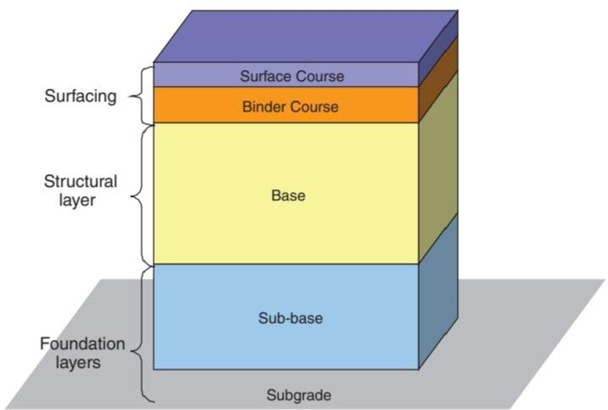

Fig 1: element of flexible pavement
Pavement deformation in the wheel path will start immediately following the passage of commercial vehicles over a flexible pavement. This permanent deformation in a well-designed pavement is fairly evenly distributed between the asphalted materials, the unbound base and sub-base, and the sub grade. In bituminous materials it may arise from additional compaction under traffic and from sideways displacement. (Girmay, T., 2016).

2.3 FACTORS AFFECTING PAVEMENT FAILURES
A variety of factors contributing to pavement deterioration were investigated by many researchers “The Behavior. of Flexible Pavement on Expansive Soil”, “Asphalt Pavement, a practical guide to design, production, and maintenance for Engineers and Architects”, have revealed that pavement failure is attributed solely to poor design or method of construction. Lack of proper consideration of traffic loading, climate issues, materials quality and drainage issues are main causes of pavement failure due to poor design.
On the other hand lack of proper supervision of the construction, low quality construction materials, poor workmanship are the main causes of pavement failure attributed due to construction.
Furthermore, he also suggested that poor highway facilities, no local standard of practice, poor laboratory and in-situ tests on soil and weak local professional bodies in highway design, construction and management will lead pavement failures.Hence, proper pavement design shall have great contributions to Protect premature pavement failure, Limit the stresses induced to the subgrade by traffic to a safe level at which subgrade deformation is insignificant, Ensuring that the road pavement layers themselves do not deteriorate to any serious extent with in a specific period of time, Determining pavement thickness by evaluating subgrade properties, subbase, base properties, and surfacing materials property, traffic loading and environmental factors.

2.4 PAVEMENT DETERIORATION AND ITS TYPES
Pavement deterioration is the process by which distress (defects) develop in the

pavement under the combined effects of traffic loading and environmental conditions

Types Of Pavement Deterioration
The four major categories of common asphalt pavement surface distresses are:
- Cracking
- Surface deformation
- Disintegration (potholes, etc.)
- Surface defects (bleeding, etc.)
    - CRACKING
The most common types of cracking are:
      - Fatigue cracking
      - Longitudinal cracking
      - Transverse cracking
      - Block cracking
      - Slippage cracking
      - Reflective cracking
      - Edge cracking

FATIGUE CRACKING (ALLIGATOR CRACKING)
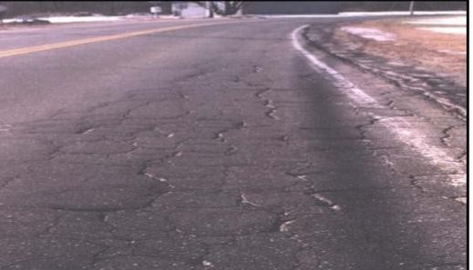
Fatigue cracking is commonly called alligator cracking. This is a series of interconnected cracks creating small, irregular shaped pieces of pavement. It is caused by failure of the surface layer or base due to repeated traffic loading (fatigue). Eventually the cracks lead to disintegration of the surface, as shown in Figure. The final result is potholes. Alligator cracking is usuallyassociated with base or drainage problems. Small areas may be fixed with a patch or area repair. Larger areas require reclamation or reconstruction. Drainage must be carefully examined in all cases.

Fig:2. High severity alligator cracking

LONGITUDINAL CRACKING
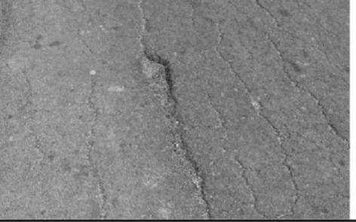
Longitudinal cracks are long cracks that run parallel to the center line of the roadway. These may be caused by frost heaving or joint failures, or they may be load induced. Understanding the cause is critical to selecting the proper repair. Multiple parallel cracks may eventually form from the initial crack. This phenomenon, known as deterioration, is usually a sign that crack repairs are not the proper solution
Fig:3. Longitudinal Cracking

TRANSVERSE CRACKING
Transverse cracks form at approximately right angles to the centerline of the roadway. They are regularly spaced and have some of the same causes as longitudinal cracks. Transverse cracks will initially be widely spaced (over 20 feet apart). They usually begin as hairline or very narrow cracks and widen with age. If not properly sealed and maintained, secondary or multiple cracks develop, parallel to the initial crack. The reasons for transverse cracking, and the repairs, are similar to those for longitudinal cracking. In addition, thermal issues can lead to
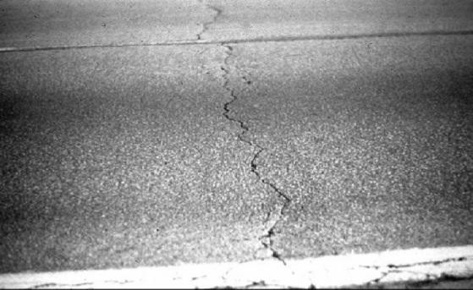
low-temperature cracking if the asphalt cement is too hard. Figure shows a low-severity transverse crack.

Fig:5. Low severity transverse crack

BLOCK CRACKING
Block cracking is an interconnected series of cracks that divides the pavement into irregular pieces. This is sometimes the result of transverse and longitudinal cracks intersecting. They can also be due to lack of compaction during construction. Low severity block cracking may be repaired by a thin wearing course. As the cracking gets more severe, overlays and recycling may be needed. If base problems are found, Reclamation or reconstruction may be needed. Figure shows medium to high severity block cracking.

SLIPPAGE CRACKING
Slippage cracks are half-moon shaped cracks with both ends pointed towards the oncoming vehicles. They are created by the horizontal forces from traffic. They are usually a result of poor bonding between the asphalt surface layer and the layer below. The lack of a tack coat is a prime factor in many cases. Repair requires removal of the slipped area and repaving. Be sure to use a tack coat on the new pavement.

REFLECTIVE CRACKING
Reflective cracking occurs when a pavement is overlaid with hot mix asphalt concrete and cracks reflect up through the new surface. It is called reflective cracking because it reflects the crack pattern of the pavement structure below. As expected from the name, reflective cracks are actually covered over cracks reappearing in the surface. They can be repaired in similar techniques to the other cracking noted above. Before placing any overlays or wearing courses, cracks should be properly repaired.

EDGE CRACKING
Edge cracks typically start as crescent shapes at the edge of the pavement. They will expand from the edge until they begin to resemble alligator cracking. This type of cracking results from lack of support of the shoulder due to weak material or excess moisture. They may occur in a curbed section when subsurface water causes a weakness in the pavement. At low severity the cracks may be filled. As the severity increases, patches and replacement of distressed areas may be needed. In all cases, excess moisture should be eliminated, and the shoulders rebuilt with good materials. Figure shows high severity edge cracking.

SURFACE DEFORMATION
Pavement deformation is the result of weakness in one or more layers of the pavement
that has experienced movement after construction. The deformation may be accompanied by cracking. Surface distortions can be a traffic hazard.
The basic types of surface deformation are:
- Rutting
- Corrugations
- Shoving
- Depressions
- Swell

RUTTING
Rutting is the displacement of pavement material that creates channels in the wheel path. Very severe rutting will actually hold water in the rut. Rutting is usually a failure in one or more layers in the pavement. The width of the rut is a sign of which layer has failed. A very narrow rut is usually a surface failure, while a wide one is indicative of a subgrade failure. inadequate compaction can lead to rutting. Figure shows an example of rutting due to subgrade Failure. Minor surface rutting can be filled with micropaving or paver-placed surface treatments. Deeper ruts may be shimmed with a truing and leveling course, with an overlay placed over the shim. If the surface asphalt is unstable, recycling of the surface may be the best option. If the problem is in the subgrade layer,reclamation or reconstruction may be needed.
- EDGE CRACKING
Edge cracks typically start as crescent shapes at the edge of the pavement. They will expand from the edge until they begin to resemble alligator cracking. This type of cracking results from lack of support of the shoulder due to weak material or excess moisture. They may occur in a curbed section when subsurface water causes a weakness in the pavement. At low severity the cracks may be filled. As the severity increases, patches and replacement of distressed areas may be needed. In all cases, excess moisture should be eliminated, and the shoulders rebuilt with good materials. Figure shows high severity edge cracking.
  - SURFACE DEFORMATION
Pavement deformation is the result of weakness in one or more layers of the pavement that has experienced movement after construction. The deformation may be accompanied by cracking. Surface distortions can be a traffic hazard.The basic types of surface deformation are:
- Rutting
- Corrugations
- Shoving
- Depressions
- Swell
    - RUTTING
Rutting is the displacement of pavement material that creates channels in the wheel path. Very severe rutting will actually hold water in the rut. Rutting is usually a failure in one or more layers in the pavement. The width of the rut is a sign of which layer has failed. A very narrow rut is usually a surface failure, while a wide one is indicative of a subgrade failure. Inadequate compaction can lead to rutting. Figure shows an example of rutting due to subgradeFailure. Minor surface rutting can be filled with micropaving or paver-placed surface treatments. Deeper ruts may be shimmed with a truing and leveling course, with an overlay placed over the shim. If the surface asphalt is unstable,recycling of the surface may be the best option. If the problem is in the subgrade layer, reclamation or reconstruction may be needed.
    - CORRUGATION
Corrugation is referred to as washboarding because the pavement surface has become distorted like a washboard. The instability of the asphalt concrete surface course may be caused by too much asphalt cement, too much fine aggregate, or rounded or smooth textured coarse aggregate. Corrugations usually occur at places where vehicles accelerate or decelerate. Minor corrugations can be repaired with an overlay or surface milling. Severe corrugations require a deeper milling before resurfacing.
    - SHOVING
Shoving is also a form of plastic movement in the asphalt concrete surface layer that creates a localized bulging of the pavement. Locations and causes of shoving are similar to those for corrugations. Figure shows an example of shoving. Repair minor shoving by removing and replacing. For large areas, milling the surface may be required, followed by an overlay.
    - DEPRESSIONS
Depressions are small, localized bowl-shaped areas that may include cracking. Depressions cause roughness, are a hazard to motorists, and allow water to collect. Depressions are typically caused by localized consolidation or movement of the supporting layers beneath the surface course due to instability. Repair by excavating and rebuilding the localized depressions. Reconstruction is required for extensive depressions.
    - SWELL
A swell is a localized upward bulge on the pavement surface. Swells are caused by an expansion of the supporting layers beneath the surface course or the subgrade. The expansion is typically caused by frost heaving or by moisture. Subgrades with highly plastic clays can swell in a manner similar to frost heaves (but usually in warmer months). Repair swells by excavating the inferior subgrade material and rebuilding the removed area. Reconstruction may be required for extensive swelling.
  - DISINTEGRATION
The progressive breaking up of the pavement into small, loose pieces is called disintegration. If The disintegration is not repaired in its early stages, complete reconstruction of the pavement maybe needed.
The two most common types of disintegration are:
- 1. Potholes
- 2. Patches

    - POTHOLES
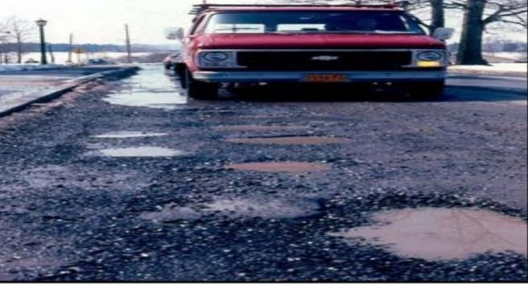
Potholes are bowl-shaped holes similar to depressions. They are a progressive failure. First, small fragments of the top layer are dislodged. Over time, the distress will progress downward into the lower layers of the pavement. Potholes are often located in areas of poor drainage, as seen in Figure. Potholes are formed when the pavement disintegrates under traffic loading, due to inadequate strength in one or more layers of the pavement, usually accompanied by the presence of water. Most potholes would not occur if the root cause was repaired before development of the pothole. Repair by excavating and rebuilding. Area repairs or reconstruction may be required for extensive potholes.
Fig: 6. Potholes cause by poor drainage
    - PATCHES
A patch is defined as a portion of the pavement that has been removed and replaced. Patches are usually used to repair defects in a pavement or to cover a utility trench.
Patch
failure can lead to a more widespread failure of the surrounding pavement. Some people do not consider patches as a pavement defect. While this should be true for high quality patches as is done in a semi permanent patch, the throw and roll patch is just a cover. The underlying cause is still under the pothole. To repair a patch, a semi-permanent patch should be placed. Extensive potholes may lead to area repairs or reclamation. Reconstruction is only needed if base problems are the root source of the potholes.
  - SURFACE DEFECTS
Surface defects are related to problems in the surface layer. The most common types of surface distress are:
- Ravelling
- Bleeding
- Polishing
- Delamination
    - RAVELLING
Ravelling is the loss of material from the pavement surface. It is a result of insufficient adhesion between the asphalt cement and the aggregate. Initially, fine aggregate breaks loose and leaves small, rough patches in the surface of the pavement. As the disintegration continues, larger aggregate breaks loose, leaving rougher surfaces.
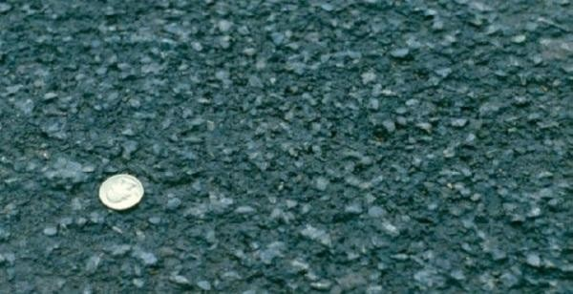
Ravelling can be accelerated by traffic and freezing weather. Some ravelling in chip seals is due to improper construction technique. This can also lead to bleeding. Repair the problem with a wearing course or an overlay.
Fig: 7. High severity ravelling of asphalt surface
    - BLEEDING
Bleeding is defined as the presence of excess asphalt on the road surface which creates
patches of asphalt cement. Excessive asphalt cement reduces the skid-resistance of a pavement, and it can become very slippery when wet, creating a safety hazard. This is caused by an excessively high asphalt cement content in the mix, using an asphalt cement with too low a viscosity (too flowable), too heavy a prime or tack coat, or an improperly applied seal coat. Bleeding occurs more often in hot weather when the asphalt cement is less viscous (more flowable) and the traffic forces the asphalt to the surface. Figure 13 shows an example of bleeding during hot weather.
    - Polishing
Polishing is the wearing of aggregate on the pavement surface due to traffic. It can result in a dangerous low friction surface. A thin wearing course will repair the surface.

CHAPTER THREE
RESEARCH METHODOLOGY
  - DESCRIPTION OF THE STUDY AREA
Ilorin, the capital of Kwara State, is located in the North-Central geopolitical zone of Nigeria. It lies between latitude 8°30'N and longitude 4°33'E. The study area, Kilanko–Offa Garage Road, is located within Ilorin South Local Government Area of Kwara State, Nigeria. Ilorin is the capital of Kwara State and serves as a major commercial and administrative center in the North-Central geopolitical zone of Nigeria.
The road in focus is approximately 4.18 kilometers long and serves as a vital link connecting several residential, commercial, and institutional neighborhoods.The road starts from Kilanko and terminates at the Offa Garage axis, intersecting with other local roads that feed into the city center. It is frequently used by commercial minibuses, taxis, motorcycles, and private vehicles. The area experiences moderate to heavy rainfall, especially during the wet season, which greatly affects the integrity of the road pavement. The economic and social importance of this road to local residents cannot be overstated, as it serves as the primary access route for schools, markets, hospitals, and religious centers.

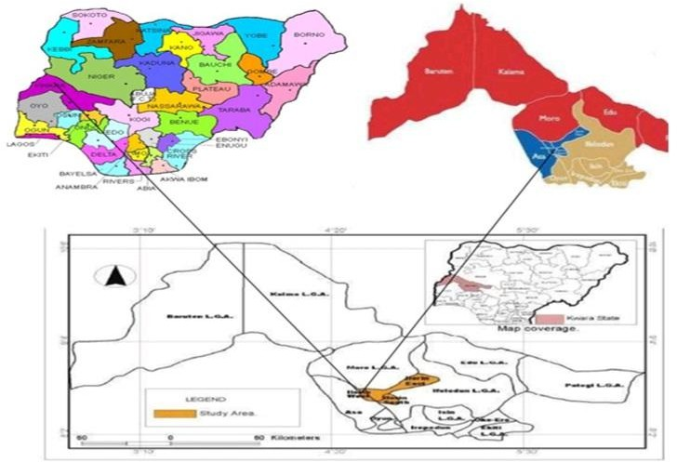

RESEARCH DESIGN
In order to achieve the above mentioned objectives, the following methodology will be adopted;
- Literature review to acquire background information about general description of pavement
distress including distress type, cause, and possible maintenance.
- Field work
- Investigation of soils and rocks along the road alignment
- Collection of representative soils samples along the road alignment at kilometer interval and photographs at representative locations
- Record pavement distresses walking along the road alignment

The identified distress will be quantified and recorded using the following estimators
- Distress type - identify types of physical distress existing in the pavement.
- Distress severity - estimating the distress items in three damage levels i.e. low (L), medium (M) and high (H) severity.
- Distress extent - Denote relative area (percentage of the road section) affected by each combination of distress type and severity.
Pre-field work phase: to conduct this research the perquisite requirements was collected such as available materials to collect geological and engineering geological data and literature review. During the field work phase: In this phase the engineering geological and distress type of the asphalt was studied based on field description and in -situ tests.
  - DATA TYPE
Both qualitative and quantitative data will be collected to counter balance the limitation of one by another. This data will be generate through personal interview and personal observation obtained from persons who related with our research topic and area.
  - DATA SOURCES
All the necessary data required for the study will be obtained from the primary and secondary source; such as from government office annual and inventory reports, previous study and books. The primary data from collected house hold survey
  - DATA COLLECTION TECHNIQUES
Data that are collected for the study of evaluation on safe transporting system functioning Schemes were gathered through employing multiple methods including making field observation and reading different literatures related to the study.
3.5 MATERIAL USED
The material used to conduct the research in field material includes (geological hammer, GPS,
Burton compass, camera, books and internet websites).

CHAPTER FOUR

DATA ANALYSIS

4.0 INTRODUCTION
This chapter delivers a comprehensive analysis of pavement condition and performance along the 4.18 km Kilanko–Offa Garage corridor. We begin by detailing the inspection methodology and data consolidation process, proceed to classify and quantify pavement distresses, map their spatial distribution, analyze distress severity relative to traffic and drainage factors, and finally appraise structural and functional condition indices to inform maintenance priorities.

4.1 DATA COLLECTION AND ASSESSMENT PROCEDURES
Field inspection was carried out in three phases over two weeks. Phase 1 entailed a systematic visual survey at 100 m intervals, during which an inspection team recorded distress type, severity (low, medium, high), and extent (area or length) using standardized checklists. Phase 2 involved high-resolution photography and GPS logging to geo-reference each condition snapshot. Phase 3 consisted of semi-structured interviews with 50 frequent road users—including commercial drivers and pedestrians and five local maintenance officials to capture qualitative insights into performance complaints and past repair efficacy.
To ensure consistency, distress coding followed the Manual for Road Distress Survey (MORDS) guidelines. Severity thresholds were calibrated during a pilot transect: cracks wider than 3 mm or ruts deeper than 10 mm were classified as high severity. Data from all phases were consolidated in a GIS database to enable spatial analysis and correlation with subgrade drainage features.

4.2 PAVEMENT DISTRESS INVENTORY AND QUANTIFICATION
Five principal distress types were identified:
- Fatigue Cracking: Network-like cracking developed under repeated loading. Medium severity covered roughly 25% of the carriageway, while high-severity fatigue cracks where clustering exceeded 1 m²—affected about 8% of the length.
- Longitudinal and Transverse Cracks: Typically appearing parallel or perpendicular to traffic flow. Combined, these cracks occupied around 18% of the surface at medium severity and 5% at high severity.
- Rutting: Wheel-path depressions averaging 12 mm in depth at high-severity locations, especially between km 1.5 and km 2.8, impacting 22% of the length.
- Potholes: Ranging from 0.2 to 1 m², these distresses were concentrated at intersections and near drainage outlets, accounting for 12% of observed defects.
- Edge Failures and Shoulder Drop-Off: Occurring where shoulder support was compromised, affecting the outer 0.5 m of pavement, covering 15% of the corridor.
Severity distribution is illustrated in Figure 4.1 (annotated map), highlighting clusters of high-severity fatigue cracking between km 0.8–1.2 and pronounced rutting near drainage inlets at km 2.3–2.7.

4.3 SPATIAL DISTRIBUTION AND CORRELATION ANALYSIS
GIS overlay of distress locations on the drainage network revealed a strong spatial correlation (R² ≈ 0.72) between high-severity cracking and adjacent clogged or absent gutters. Similarly, rut depth measurements correlated (R² ≈ 0.65) with axle load frequency data, indicating that sections with heavy commercial traffic experienced deeper ruts. Heat maps of user-reported roughness corroborated these findings, with 82% of drivers rating comfort as "poor" in identified trouble spots.

4.4 UNDERLYING CAUSES OF DETERIORATION
The primary drivers of pavement failure emerged as:
- Excessive Traffic Loading: Commercial minibuses and articulated trucks comprise 45% of daily traffic, regularly exceeding the design axle load, accelerating fatigue cracking and rut formation.
- Inadequate Drainage: Field inspections found over 60% of drainage channels either blocked by debris or eroded, allowing water to weaken the pavement base, particularly at edges.
- Substandard Construction Materials: Laboratory tests on core samples indicated non-uniform aggregate gradation and high penetration bitumen application rates, which diminished adhesive strength and fatigue resistance.
- Maintenance Lapses: Historical records and official interviews revealed reliance on cold-mix patching without edge sealing, resulting in recurrent pothole re-emergence within six months of treatment.

4.5 STRUCTURAL AND FUNCTIONAL CONDITION INDICES
Two indices were computed:
- Pavement Condition Index (PCI): Averaged 58 (fair) across the corridor, with low-severity sections scoring above 65 and high-distress areas falling below 45.
- International Roughness Index (IRI): Spot measurements yielded an average IRI of 5.2 m/km, exceeding acceptable limits (≤ 4.0 m/km) for an arterial route.
These metrics underscore the corridor’s overall fair structural condition undermined by localized severe defects. Targeted interventions—particularly in zones with PCI < 50 and IRI > 6.0 m/km—should be prioritized to restore acceptable performance.

CHAPTER FIVE

CONCLUSION AND RECOMMENDATIONS

5.0 CONCLUSION
This study confirms that the Kilanko–Offa Garage road pavement has deteriorated beyond its original design expectations due to combined effects of excessive loading, poor drainage, and lapses in maintenance. The predominance of medium to high severity fatigue cracking and rutting, coupled with localized potholes and edge failures, threatens the safety and efficiency of road users.

5.1 RECOMMENDATIONS
A two-tier maintenance program is recommended. In the short term, apply a chip seal surface treatment across the full carriageway to arrest moisture ingress and seal existing cracks, alongside deep patching of potholes and edge failures. Simultaneously, clear and reconstruct drainage channels to ensure rapid runoff. For sections exhibiting severe structural failure—particularly between km 2.0 and km 3.0 implement full-depth reclamation using properly graded aggregates and hot-mix asphalt to reestablish base integrity.
Furthermore, establish a routine maintenance schedule with biannual inspections and prompt repairs using quality-controlled materials. Training for local maintenance crews on best-practice sealing and patching techniques will improve repair longevity. Finally, monitor pavement performance over a two-year period to evaluate the effectiveness of these interventions and guide future rehabilitation planning.

5.2 AREAS FOR FURTHER STUDY
Future research should examine the long-term performance of the chip seal under local climatic conditions and traffic volumes, as well as explore cost–effective options for integrating recycled materials into reclamation works.

REFERENCE
Ihueze, C. C. and Okafor, E. C. (2009). “Multivariate Time Series Analysis for Optimum Production Forecast”: A Case Study of 7up Soft Drink Company in Nigeria.
Ihueze, C. C. and Mgbemena, C. O. (2014). “Modeling Hyperelastic Behavior of Natural Rubber/Organomodified Kaolin Composites Oleochemically Derived from Tea Seed Oils (Camellia sinensis) for Automobile Tire Side Walls Application”. Journal of Scientific Research & Reports 3(19): 2528-2542.
Kwiatkowski, D., Phillips, P. C. B., Schmidt, P., and Shin, Y. (1992). “Testing the Null Hypothesis of Stationarity Against the Alternative of a Unit
Root”. Journal of Econometrics, 54(1-3): 159-178.

Kuo, C.Y., J.D. Frost, J.S. Lai, and Wang, L. B. (1996). “Three-dimensional image analysis of aggregate particles from orthogonal projections”.
Kweka, J.P and Morrissey, O. (1999). “Government Spending and Economic Growth. Empirical Evidence from Tanzania” (1965-1996) DSA Annual Conference Inc. New Haven.

Laguna, M. and Mart´ı, R. (2003). “Scatter research-Methodology and implementations”. In C. Kluwer Academic Publishers.
Lenth, R. V. (2009). “Response-Surface Methods in R, Using RSM”. Journal of Statistical Soft-ware, 32(7), 1–17. URL http://www.jstatsoft.org/v32/i07/.Lingle, J. J. (1956). “Discussion in Proc.”. AAPT, vol 25, p. 103.
Liu, D. C. and Nocedal, J. (1989). “On the limited memory BFGS method for large scale optimization”. Mathematical Programming 45, 503-528.
McCullagh, P. and Nelder, J. A. (1989). “Generalized Linear Models (Second Edition). Chapman & Hall Ltd”.
Rogers, Martin (2002). “Highway Engineering. Blackwell Science”. Oxford, UK. Wikipedia, the free Encyclopedia (2017). http://en.wikipedia.org/wiki/transport.

