DESIGN AND IMPLEMENTING OF SMART SOLAR BASED CBT EXAMINATION MONITORING SYSTEM
By

AKINADE RIDWAN ADEMOLA
HND/23/COM/FT/0177

A PROJECT SUBMITTED TO THE
DEPARTMENT OF COMPUTER SCIENCE,
INSTITUTE OF INFORMATION AND COMMUNICATION
TECHNOLOGY
KWARA STATE POLYTECHNIC, ILORIN.

IN PARTIAL FULFILLMENT OF THE REQUIREMENTS FOR THE AWARD OF HIGHER NATIONAL DIPLOMA (HND) IN COMPUTER SCIENCE

JUNE, 2025
CERTIFICATION
This is to certify that this project was carried out by AKINADE RIDWAN ADEMOLA with Matriculation Number HND/23/COM/FT/0177. It has been read and approved as meeting part of the requirements for the award of Higher National Diploma in computer science.

_________________________ _________________________
DR. AGBOOLA M.O (PhD) Date
Project Supervisor

_________________________ _________________________
F. S. OYEDEPO Date
Head of Department

_________________________ _________________________
External Examiner Date

DEDICATION
This project is dedicated to the Almighty Allah, the owner and giver of wisdom, knowledge and understanding, the sustainer of life and the God of universe. Thanks to him for sparing my life and make it possible for me to pursue my education to this level successfully.
I also give thanks to my loving and caring parent, MR. AND MRS. AKINADE God will let you eat the fruit of your labour, and to my loving and supporting sisters and brothers whose encouragement has made sure that I gave it all it takes to finish what have started.
I really appreciate all your effort and I pray the Almighty God protection and mercy will never depart from you all. (AMEN)

ACKNOWLEDGEMENT
Acknowledgments all praise is due to Almighty Allah for His grace, guidance, and strength throughout the course of this project. I am grateful to numerous individuals and institutions whose support and contributions were vital to the successful completion of this work.
Foremost, I extend my sincere appreciation to Dr. AGBOOLA M.O., whose exceptional guidance, expertise, and unwavering support were instrumental in navigating the complexities of this research. His invaluable insights and constructive feedback greatly shaped the direction and quality of this project.
I am deeply thankful to my parents, Mr. and Mrs. AKINADE, for their constant encouragement, prayers, and moral support throughout this journey. Their words of wisdom and emotional backing kept me focused and motivated during challenging periods. My heartfelt appreciation also goes to my entire family and friends, whose patience and uplifting presence provided strength and inspiration at every stage of this endeavor.
I would also like to acknowledge the Head of the Department of Computer Science, Mr. Oyedepo F. S., along with other dedicated staff members of the Department. Their insightful critiques and academic support were invaluable in refining the scope and content of this work.
Lastly, I am sincerely grateful to all the participants and respondents who willingly provided their time, data, and perspectives for this research. Their contributions played a crucial role in the empirical validation and practical relevance of this study.

ABSTRACT
This project presents the design and implementation of a Smart Solar-Powered Closed-Circuit Television (CCTV) Surveillance System for Computer-Based Test (CBT) examination monitoring. The study addresses the persistent issue of examination malpractice in Nigerian educational institutions and the challenge of unreliable power supply which hampers the effectiveness of traditional surveillance systems. By integrating solar photovoltaic technology with modern video surveillance infrastructure, the system ensures continuous and autonomous monitoring of examination environments. The solution comprises solar panels, batteries, inverters, and strategically installed CCTV cameras connected to a recording and monitoring network. The system offers cost-effective, eco-friendly, and uninterrupted surveillance, particularly in areas with limited access to grid electricity. It enhances real-time monitoring and serves as a deterrent against examination malpractice. The successful implementation demonstrates the potential of renewable energy in strengthening the integrity of academic assessments while reducing dependence on conventional power sources.
Keywords: Solar energy, CCTV surveillance, Computer-Based Test, examination malpractice, renewable energy, real-time monitoring, energy independence.

TABLE OF CONTENTS

Title Page i

Certification ii

Dedication iii

Acknowledgements iv

Abstract v

Table of Contents vi

CHAPTER ONE:

GENERAL INTRODUCTION
1.1 Background to the Study 1
1.2 Statement of the Problem 2
1.3 Aim and Objectives 3
1.4 Significance of the Study 3
1.5 Scope of the Study 3
1.6 Organization of the Study 4
1.7 Definition of Terms 4
CHAPTER TWO:
LITERATURE REVIEW
2.1 Review of Related Works 6
2.2 Review of General Texts 9

CHAPTER THREE:

RESEARCH METHODOLOGY

3.1 Research Methodology 12

3.2 Solar Energy System Setup 12

3.2.1 Types of Solar Panels 12

3.2.2 Panel Connection Methods 12

3.2.3 Battery Storage 13

3.2.3.1 Types of Battery 13

3.2.3.2 Battery Connection Types 13

3.2.4 Charge Controller 13

3.2.4.1 Types of Charge Controller 13

3.2.5 Inverter 14

3.2.5.1 Types of Inverter 14

3.3 Solar System Installation Procedure 14

3.3.1 Site Assessment and Orientation 15

3.3.2 Mounting the Solar Modules 15

3.3.3 Electrical Interconnection of Modules 15

3.3.4 Charge Controller Installation 16

3.3.5 Battery Bank Configuration 16

3.3.6 Inverter Installation 16

3.3.7 Load Distribution and Final Integration 17

3.3.8 System Testing and Commissioning 17

3.4 CCTV Surveillance System Setup 17

3.4.1 Camera Types Deployed 17

3.4.2 Key System Components 18

3.4.3 Types of Cabling 18

3.4.4 Video Recorders 18

3.4.5 Storage Options 18

3.4.6 Display & Switching Equipment 18

3.4.7 Lenses and Viewing Angles 18

3.5 Installation Procedure for Closed-Circuit Television (CCTV) System 19

3.5.1 System Planning and Camera Positioning 19

3.5.2 Mounting of Cameras and Brackets 20

3.5.3 Cable Routing and Management 20

3.5.4 Connector Assembly 20

3.5.5 Integration with Power Supply Unit 21

3.5.6 Connection to Digital Video Recorder (DVR) 21

3.5.7 Display Integration and Network Configuration 21

3.5.8 Camera Configuration and System Calibration 21

3.5.9 Final Testing and Quality Assurance 22

CHAPTER FOUR:

SYSTEM DESIGN AND IMPLEMENTATION
4.1 Solar Panel Installation 23
4.2 Battery Storage, Charge Controller, and Inverter System 24
4.3 CCTV Camera Installation with DVR and Power Box 25
4.4 System Testing and Performance Evaluation 26

CHAPTER FIVE:

SUMMARY, CONCLUSION AND RECOMMENDATIONS
5.1 Summary 27
5.2 Conclusion 27
5.3 Recommendations 28
Reference
CHAPTER ONE
GENERAL INTRODUCTION
1.0 BACKGROUND TO THE STUDY
In the past decade of years there us an increase in demand for reliable and abundant power derived from renewable energy sources. Renewable energy plays important role in the energy crisis of the country. The government began to decrease the usage of conventional energy sources and inspiring people to use renewable energy sources like hydro and solar. Renewable energy is rapidly gaining importance as an energy resource as fuel prices fluctuate. The globe population is increasing day by day and also the demand for energy is increasing accordingly. Electricity is one amongst the foremost important factor of our everyday. It should be in a proper way for complete and proper utilization of our electricity. But just in case of our country there is surplus supply with electricity in many areas but there are such a lot of areas which could not even access electricity.
The demand for security is growing and addressing environment concerns is increasingly urgent. The integration of solar power with surveillance technologies offers a groundbreaking solution. Solar powered monitoring systems equipped with cutting edge innovations have the potential to transform to transform security practices especially in areas with limited unreliable or absent access to traditional electrical grids. This fusion of solar powered and surveillance commonly known as “Solar-powered CCTV and Surveillance Technology” presents a sustainable cost-efficient and flexible approach to meeting modern surveillance needs.
The global landscape is witnessing profound shift in security paradigms. Traditional security system relying heavily on fossil fuels and grid dependent electricity sources pose economics burdens and contribute significantly to green house gas emission, thus exacerbating environment crises (Zelazna et al; 2020). In addition many regions worldwide including remote areas disaster-stricken regions and wildlife habitats require surveillance for various purposes but lack access to a stable power supply.
Over time the issue of tacking examination malpractices both within the formal school settings and other examinants has become a growing concern to the stakeholders including the government, school administrators and society. It has become so rampant that the core values of the school system are now been eroded. Besides youth are no longer convinced about the cultural values and reward for hard work, several techniques such as use of invigilators to monitor examination, accrediting candidates for examination with photo albums from examination regulatory bodies, use of candidate’s identity cards or biometrics machines have been made to salvage the situation in the past. These techniques however seem not to have yielded to desired results as the cases of examination malpractice keep increasing. In the event of a beach, these techniques may provide enough evidence needed for prosecution of the culprit and their conspirators that may have destroyed the evidence. This lead to the introduction of a Solar-powered Surveillance system which intends to complement the effort of the human invigilators through Solar powered video Surveillance system the behavior and activities of people can be monitored using electronic equipment such as Closed Circuit Television (CCTV) systems. Solar powered CCTV system is surveillance infrastructure mounted at a predetermined location inside CBT examination hall to ensure optimal coverage which collects images that are transferred to a monitoring station or are stored for subsequent analysis and review to prevent crime by deterring potential offender because of their activities. One of the Objectives of using a CCTV system is to detect suspicious behaviors in real-time so that proactive measures can be taken. However in examination scenarios in Nigeria, this is not the case because detection of infringement or suspicious behavior in real-time is subject to the operators uninterrupted vigilance and also uninterrupted power supply which help through Solar powered CCTV. Some candidate perpetrate malpractice during examinations and get away with without been caught despite the installation of a CCTV system, this is due several factors such as fatigue on the part of the CCTV Operator also when power supply went off suddenly this may affect area of coverage of some candidates may be occluded from view to mention a few. All the challenges could influence the outcome of Solar powered video Surveillance. This study was carried out to assess the extent Solar powered CCTV Systems which are used in monitoring activities during CBT examination.

1.2 STATEMENT OF THE PROBLEM
If there is one factor that has perpetually maintained the Status of Nigeria as a less developed country, it is electricity Sector. Till date many households and industrial business cannot be guaranteed of 24 hours supply of electricity from the National grid. At this stage of Nigeria’s Social and economic development, the country cannot deliver sufficient energy to the citizens despite huge financial resources that have been expended in the sector and this is the major reasons why most people did not show interest on installation of CCTV in the homes, institutions and offices. Many started using CCTV and later they packed it up because of the high cost of powering it with gasoline generator. Because of these problems there is a need to design a solar powered CCTV surveillance which reduces the cost of energy consumed and eliminates noise environmental pollution that associated with running of generator.

1.3 AIM AND OBJECTIVES
The aim of this research work is the design and implementation of Smart Solar based CBT examination monitoring system. The objectives are as follows:
- Design and implementation of computer based test (CBT) examination system.
- Installation of solar panel surveillance camera and inverter for monitoring of the CBT examination.
1.4 SIGNIFICANCE OF THE STUDY
The solar powered surveillance is energy independence. These systems operate autonomously, relying on sunlight to generate electricity. The autonomy is particularly valuable in remote or off grid area with limited access to reliable grid power. As a result, solar powered surveillance system offer uninterrupted monitoring, reducing vulnerabilities associated with power outages or fuel supply interruption.
Solar-powered Surveillance System can prove to be cost-effective. While the initial installation cost including Solar panels and batteries can be relatively high, ongoing operational expenses are significantly reduced.
Solar energy is abundant and free, eliminating the need for costly fuel or electricity bills. These systems reduce greenhouse gas emission and dependence on fossil fuel by harnessing renewable energy. Solar powered surveillance aligns with sustainability goals in a era characterized by growing emphasis on environmental responsibility making it an attractive choice for organizations and governments committed to reducing their carbon footprint (Fripp, 2012; Mohtasham, 2015; Shalsavari and Akbari, 2018).
The primary use of solar-powered closed circuit television (CCTV) is to provide steady warning and deterring burglary, thieves, examination malpractice and other criminal in examination hall.

1.5 SCOPE OF THE STUDY
The scope of this is on using photovoltaic (Pv) solar powered units to provide reliable power for CCTV systems installed inside CBT examination hall. Each solar-powered unit will comprise solar photovoltaic panels, solar panel monitoring hardware, a solar charger / regulator, an inverter, batteries, a ground–mounted battery / equipment and the wiring / conducts required for a fully functional system. Additional components such as mounting bracket, structural supports for indoor installation and other necessary equipment for proper integration with the CBT examination hall will also be included.

1.6 ORGANISATION OF THE STUDY
This report is divided to five chapters as stated below:
Chapter one deals with the general introduction and overview of the whole research. It also discusses the statement of the problem, aim and objectives of the proposed system, significance of the study, scope of the study as well as organization of the study.
Chapter two deals with the literature review, it reviews the related topics to the project, discussion of related aspect of the project relative to surveillance technology is also treated.
Chapter three deals with analysis of the system which include the data collection method employed, the description of the existing problems and the description of the proposed system and possible advantages, it will provide the solution to the problem encountered in the existing traditional power system.
While Chapter four deals with the design, implementation and the description of the proposed system.
Finally, chapter five present a brief summary of the work done, experience gained and problem encountered in the course of the project, conclusion and recommendation.

1.7 DEFINITION OF THE TERM
Renewable Energy: This refers to energy derived from natural resources that are replenished constantly on a human timescale. Example include: sunlight, wind, rain, tides, geothermal heat and biomass.
Solar Power: Solar Power refers to the generation of energy through solar photovoltaic (PV) system, converting sunlight into electricity. Solar-powered systems are a sustainable alternative for powering devices including surveillance technology like CCTV, especially in a remote or off-grid area.
Computer-Based Test (CBT): is an assessment or examination administered through a computer rather than using traditional paper and pencil. It is commonly used in educational, professional, and certification settings for a variety of purposes, including academic exams, standardized testing, and professional qualifications.
Examination: Defined as a formal test of knowledge, skills or ability in a specific subject typically administered through oral, written or practical exercise.
Examination malpractice: This refers to intentional act of wrong doing during examinations to give candidate unfair advantages. It includes actions such as cheating impersonating or leaking examination content. This malpractice violates the rules governing the fair conduct of exams.
Closed Circuit Television (CCTV): CCTV system are designed to provide surveillance for broader areas and extended periods serving as a force multiplier. They integrate components like cameras, lenses, data distribution system and power management to monitor and protect against threats.
Photovoltaic (PV): Refers to the technology that directly converts sunlight into electricity using semiconducting materials that exhibit the photovoltaic effect. The term “Photovoltaic” is derived from “Photo” (light) and “Voltaic” (electricity).
Inverter: A device that converts direct current (DC) electricity generated by solar panels into alternating current (AC), which is usable by most appliances.
Charge Controller: Is a device that regulates the voltage and current coming from the solar panels to prevent overcharging the batteries.
Battery: An energy storage device that stores electricity generated by solar panels for later use, especially in off-grid or hybrid systems.
Carbon Footprint: The total greenhouse gas emissions caused by an individual, organization, or product, often reduced by using solar power.

CHAPTER TWO
LITERATURE REVIEW
2.1 REVIEW OF RELATED WORKS
Anshu Prakash Murdan and Seeneevaseen Careber (2019) worked on Autonomous Solar Powered Wireless Monitoring and Surveillance system. The report aims to design and implement a low cost autonomous solar powered wireless monitoring system with live video broadcasting capabilities. The systems aim to use renewable energy and open source technologies for increased scalability, cost-effectiveness and accessibility. The methodology of this study was divided into three blocks which are power block, camera system and communication block. The power block incorporate solar panel charge controller and battery for energy supply. The camera system incorporate USB camera and arduino yun micro controller for capturing and transmitting live video. Communication block incorporate wifi-module and IOT platform for remote monitoring and motion triggered email notification. Motion detection was implemented using PIR sensor. Temboo IOT platform was used to handle cloud storage and notification systems. Software was developed for email alerts, video streaming and voltage / temperature monitoring using open source tools. The system performed as expected, was successful power generation from solar panel and effective wireless communication for live video streaming. Motion detection and email notification worked reliably. The system was in a real condition and demonstrated scalability and autonomy. While the system was functional further optimization of energy efficiency and robustness could improve its usability in diverse environments. The system can be deployed in remote location or areas without reliable electricity supply. Further development can include enhance energy storage solution and additional security features. The process successfully demonstrated and effective autonomous and renewable energy powerd surveillance system. The system applicable for residential, commercial and remote environment and can reduces energy cost and carbon footprint.
Dr. Froilan D mobo (2021) worked implementation of solar panel with CCTV in the national Road. The study aims to implement solar powered streetlights with CCTV cameras along the National Road with the objectives of identifying suitable solar lighting technologies with CCTV for national roads, evaluating the applicability and benefits of solar technology on highway services. Determine the economics and environmental impacts of solar technologies in highway services areas. The methodology includes research design, a descriptive research approach was utilized to objectively observe and analyze the situation. Data was collected in some area where the absence of lights poses safety risk. The data was gathered from 30 respondents to access the implementation feasibility. The solar-powered streetlights and CCTV can enhance road safety by reducing accidents and proving real time monitoring for traffic management. Solar panels offer environmental benefits. It reduces greenhouse gas emission compared to traditional energy sources. The study highlights a need for further exploration of maintenance strategies and additional application of the system such as integrating advance analytics for traffic management. The implementation is cost-effective and environmental sustainable offering long-term benefits like reduced electricity costs. It ensures safer travel at night and provides a foundation on national road to develop as an industrialized province. Strongly recommend implementation of solar panels with CCTV cameras to enhance road safety and replaced accidents. The project is a significant step toward improving road safety and energy efficiency on the road. It provides a sustainable solution for traffic monitoring and economics savings while promoting renewable energy use.
Rani, et al (2021) worked on IOT based smart solar energy monitoring system. The study proposed to develop an IOT enabled monitoring system for solar energy plants to enhance their efficiency, improve maintenance and provide real-time monitoring capabilities. It seeks to automate solar power plant observation for maximum energy output by addressing challenges such as defect. The research utilized an IOT based system centered on ATmega 328 micro controller to monitor and transmit solar plant data. The methodology includes installing sensors for voltage, current and power measurement, using a wifi module to transmit the collected data to the IOT platform “Thingspeak”, displaying the data in a user-friendly graphical interface for real-time monitoring. The IOT based system effectively track and analyzes solar plant performance allowing for easier maintenance and diagnostics. Regular monitoring enhance power output and diagnostics discrepancies only. The system relies on stable internet connectivity and further integration of machine learning for predictive analytics and decision-making is recommended to improve the adaptability. Future enhancement should include machine learning integration of smarter decision making and systems upgrades for offline data processing. The IOT based solar monitoring system is an effective scalable and cost-efficient solution to monitor solar power plants in real-time. It provides significant value in optimizing energy generation and facilitating maintenance.
Liupeng, et al (2022) worked on solar powered module design of wireless video monitoring system. The study aims to design a solar powered module for wireless video monitoring systems that overcomes the limitation of traditional battery powered system. To ensures reliable energy supply for remote and rigorous environmental areas by integrating solar panels with lead acid batteries. The methods include system design, development of standalone photovoltaic module comprising solar panels, a charge controller, a lead-acid battery and an inverter energy management, Implementation of an automatic solar tracking system for maximizing power output and a protection circuit to prevent overcharging and over discharging of the battery, use of JN5139 module for wireless video transmission and dynamic power management technology to minimize energy consumption during operation. The solar power module demonstrated high reliability low cost and suitability for use in harsh environments such as rivers, mountains and forest. The integration of tracking and protection circuit improved energy efficiency and extended battery life. The solar tracking system accuracy required further improvement. This study does not discuss long-term durability or maintenance challenges in detail. The studies enhance the accuracy of the solar tracking system and explore the integration of alternative battery technology of better performance and longevity. The proposed solar powered module offers a sustainable and reliable solution for powering wireless video monitoring in remote and challenging environment.
Uchema et al (2023) worked on a review of solar powered CCTV and surveillance Technologies. The study proposed to review the current state advancement and practical applications of solar powered surveillance Technologies, to explore the benefits limitations and future directions of integrating solar energy with surveillance system such as CCTV cameras, drone and sensor network. The method includes the literature review and analysis of solar powered surveillance technologies, covering historical evolution, technological advancements and real-world application. Comparison of different technologies (CCTV cameras, drones and sensor networks) in terms of strengths, weakness and suitability for various surveillance needs. Solar powered surveillance offers energy independence sustainability and adaptability especially in remote and off grid areas. Key components like solar powered CCTV cameras are versatile while drone provides aerial perspectives and sensor network support localized environmental monitoring. Solar energy reduces operational costs and aligns with global sustainability goals. Challenges include weather dependence, maintenance requirements, high upfront cost and limited night surveillance due to energy storage constraints. Regulatory and security challenges as well as limited durability in extreme conditions require further exploration. Strongly recommend to invest in energy storage solution, AI integration and hybrid system to enhance reliability and efficiency. Solar powered surveillance technologies provide sustainable and cost-effective solution for diverse application include security environmental monitory.
Amachi M. Eziechina, Uchena C. Ugboaja and Ugochukwu E.Esiagu (2020) worked on closed-circuit television surveillance: An anti-dote to examination malpractice in high institution in Nigeria. The study proposed the deployment of CCTV surveillance in examination invigilation as a solution to reduced examination malpractice in Nigerian institutions, enhancing the credibility of the examination process. To examined the functionalities and components of CCTV systems and their application in examination halls. Presenting data on examination malpractice trends and discussed the potential of CCTV to deter and document malpractice incident. Examination malpractice in Nigeria is rampant and increasingly sophisticated. CCTV surveillance can deter potential malpractice. It improves invigilation and provides evidence for malpractice cases. Strongly recommend the adoption of CCTV in examination halls to reduce malpractice through deterrence, monitoring and evidence provision. Concluded that deploying of CCTV could ensure fairer examination and restore credibility’s to the Nigerian education systems.
Uche, et al (2020) worked on video surveillance in examination monitoring. The study aim to access the efficacy of video surveillance system, particularly CCTV in monitoring examinations in Nigerian tertiary institutions, it evaluate the conventional use of CCTV systems in detecting real-time infringements. To determine if CCTV systems are effective used in examination venues, to access weather automation enhances CCTV effectiveness to identify operational challenges faced by institutions in deploying CCTV systems. Methodology involves field surveys and document analysis. Responses were collected from 73 lecturers and ICT personnel from tertiary institutions via online questionnaires distributed to 200 individuals. Descriptive and inferential statistics including ANOVA were used to analyze the data. CCTV systems are becoming increasing relevant for monitoring examinations as indicated by significant F-statistics (20.575, P-value < 0.05). Conventional manual monitoring is effective for real time detection due to operator fatigue and inefficient. Automation significantly improves the effectiveness of CCTV systems in real time recognition of suspicious activities. The major challenges including financial constraints, lack of technical expertise, vandalism and unreliable power supply. The study indentifies that automation could address many challenges but does not detail implementation strategies. Institutions should prioritize automation of CCTV system to enhance real-time detection and reduce reliance on human operators. Adequate funding, stakeholder training and reliable power supply should be ensured. CCTV systems play a critical role in examination monitoring but require automation for optional effectiveness. Addressing operational challenges is crucial to leveraging the full potential of video surveillance in curbing examination malpractices.
Omprakash sigh, et al (2020) worked on IOT based smart solar street light battery / panel fault detection. The study proposed to design and implement a cost-effective technological advance IOT-based solar street light system. To enable fault detection in street light batteries and solar panels and provide theft detection, to conserve energy by reducing unnecessary electricity usage. The methodology includes hardware components such as Arduin Uno, ESP23 micro controller, Node MCU, solar panels relays and LEDs. The software component includes PHP for serves side scripting and my SQL for database management. Data is collect through sensors and transmitted via wifi module to a server where is monitored and analyzed. Fault detection triggers alerts via SMS. The system effectively detects faults and thefts in batteries and solar panels. Monitored dada is accessible via web interface. The major challenges includes limited scalability and integration for large-scale implementation, lacks emphasis on cyber security concerns in IOT infrastructure. The system is cost-effective practical and eco-friendly, addressing energy conservation and timely maintenance. It is recommended for broader application to enhance urban infrastructure reliability. Future work can include scaling for larger network and addressing IOT security issues.
Ehigiamusoe, et al (2022) worked on the effect of CCTV in examination monitoring in institution of higher learning. The study aims to evaluate student’s opinions and perceptions on the use of CCTV systems for monitoring examination. It determines the effectiveness of CCTV system in reducing examination malpractice and its associated challenges. The study involved the development and distribution of a questionnaire through Google forms shared on departmental whatsapp platform. A total of 279 students participated in the survey. The collected data were analyzed using statistical package of social sciences (SPSS). 85.7% of respondents disagreed that examination malpractice is a good practice. A majority agreed that CCTV reduced malpractice. It increases awareness during exams and reduces student-lecturer interaction during examinations. A decline in malpractice was seen as a confidence booster for students. The limitation focuses on technical challenges or cost-related implication of CCTV deployment. Strongly recommend broader implementation of CCTV surveillance in educational institutions o curb examination malpractice, regular training and orientation for students and staff on the ethical importance of examinations. The study concluded that CCTV effectively minimizes examination malpractice and creates a more disciplined and transparent examination environment
Tunson, (2020) worked on implementation of CCTV based attendance taking support system using deep face recognition. The study aim to design and implement a CCTV based attendance taking system using deep face recognition technology. To evaluates the effectiveness and feasibility of integrating such systems for educational attendance purpose while leveraging existing CCTV infrastructure. The system utilized pre trained deep face recognition models like arcface and face vet attendance data of 120 students were collected using facial recognition through CCTV cameras in real-time settings. The system architecture included job masters, workers and a central database to handle attendance processing efficiently experiments were conducted to evaluate system accuracy and performance under varying environmental conditions using multiple classification algorithms like SVM, Naïve Bages and KNN. Arcface was found to be the most accurate feature extractor, achieving a system accuracy of 92.7% with an error reduction after applying summarization algorithms. The system proved effective in identifying students but accuracy declined in real-world environments due to challenges like motion and blur and lighting. The system struggled with identifying unknown faces and maintaining consistent accuracy across environmental changes. Further optimization of face recognition algorithms to enhances accuracy in challenging environments. Integration of addition policies and support systems to complements the automated attendance process. The study demonstrated that CCTV based attendance systems using deep face recognition are feasible and scalable. Despite some environmental challenges the proposed system provides a reliable alternative to traditional attendance taking method leveraging existing infrastructure effectively.

CHAPTER THREE
METHODOLOGY AND ANALYSIS OF THE SYSTEM
3.1 RESEARCH METHODOLOGY
This chapter discusses the methodology employed in the research, focusing on the design, implementation, and evaluation of the solar-powered CCTV surveillance system for monitoring Computer-Based Test (CBT) examinations. It describes the problems associated with conventional methods, the proposed solution, and the system design approach. Additionally, it outlines the hardware and software requirements, as well as the system architecture and implementation strategy.
3.2 DATA COLLECTION METHODS
To ensure comprehensive analysis, data was collected through the following methods:
- Primary Data: Interviews with examination officers, ICT professionals, and students to identify challenges in conventional monitoring systems.
- Secondary Data: Literature reviews on solar energy applications in surveillance technology, research articles on examination malpractice, and reports on sustainable power solutions.
3.3 ANALYSIS OF THE EXISTING SYSTEM
In most educational institutions, examinations are monitored using human invigilators and conventional CCTV systems. However, these methods present significant limitations, making them less effective in preventing examination malpractice.
3.4 PROBLEMS OF EXISTING SYSTEM
Challenges in Manual Invigilation:
1. Human Error – Invigilators may experience fatigue, reducing their attentiveness.
2. Corruption – Some invigilators accept bribes from candidates.
3. Limited Coverage – Large examination halls make it difficult to monitor every candidate.
Limitations of Conventional CCTV-Based Surveillance:
1. Unreliable Power Supply – Frequent power outages disrupt monitoring.
2. High Cost of Operation – CCTV systems require electricity or fuel-powered generators, increasing expenses.
3. Lack of Automation – Conventional systems do not detect malpractice automatically, relying on human operators.
4. Storage Limitations – Video footage may be lost if storage space is insufficient.
3.5 PROPOSED SYSTEM: SMART SOLAR-BASED CBT EXAMINATION MONITORING SYSTEM
3.5.1 System Overview
The Smart Solar-Based CBT Examination Monitoring System is designed to:
- Provide uninterrupted power using solar energy.
- Automate monitoring through AI-based motion detection.
- Enable real-time remote access for exam supervisors.
- Ensure secure video storage using cloud and local backup.
3.5.2 Objectives of the Proposed System
The system aims to:
1. Design and implement a solar-powered surveillance system to ensure continuous monitoring.
2. Enhance security in examination halls by integrating solar-powered CCTV
3. Reduce electricity costs by eliminating reliance on the national grid and fuel generators.
4. Enable real-time access and playback of recorded footage through cloud storage.
5. Enabling off-site supervision via networked surveillance.
3.5.3 Advantages of the Proposed System
The proposed system has the following advantages over existing system:
- Solar Power Supply Ensures 24/7 monitoring without power interruptions.
- Cloud & amp: Local Storage Prevents data loss and ensures easy retrieval.
- Remote Monitoring Allows exam supervisors to access live feeds from anywhere.
- Cost-Efficiency Reduces electricity expenses and generator maintenance costs.
3.6 SYSTEM DESIGN
3.6.1 Hardware Components
- Solar Photovoltaic Panels
- Charge Controller
- Battery Storage Unit
- Inverter
- CCTV Cameras
- Digital Video Recorder (DVR)
- Network Router and Connectivity Devices
3.6.2 Software Components
- Video Management System (VMS)
- Remote Surveillance Application
- Power Monitoring Software
3.6.3 Component Function
- Solar Panels (250W): Converts sunlight into electrical energy.
- Battery (12V, 200Ah): Stores power for night-time use.
- Inverter (1kVA): Converts DC power to AC for CCTV cameras.
- Digital Video Recorder (DVR): Stores surveillance footage for later review.
- Charge Controller: Regulates power flow to prevent overcharging or discharging of the battery.
- CCTV Cameras: Captures and transmits video footage.
- Cloud Storage: Server Saves and retrieves examination footage.
- Network Router: Enables remote access to surveillance footage.
- Video Management System (VMS): Organizes and controls recorded video footage.
- Remote Surveillance Application: Enables remote monitoring from any location.
- Power Monitoring Software: Tracks solar energy usage and battery status.
3.7 SYSTEM IMPLEMENTATION
3.7.1 Installation Process
The system was implemented in five phases:
1. Solar Power System Setup
• Installed solar panels on the examination hall rooftop.
• Connected batteries, charge controllers, and inverters for energy storage.
2. CCTV Camera Installation
• Placed CCTV cameras at strategic positions to cover the entire hall.
• Configured night-vision and motion detection features.
3. Network and Storage Integration
• Set up cloud storage and local backup for video footage.
• Configured wireless access for remote monitoring.
4. Testing &amp; Optimization
• Conducted system tests to ensure smooth operation.
• Fine-tuned motion detection sensitivity and camera angles.
3.8 SYSTEM TESTING AND PERFORMANCE EVALUATION
The system was tested based on the following parameters:
Power Efficiency: Solar energy generation was monitored using power tracking software, ensuring optimal battery storage and backup supply.
Surveillance Coverage: Camera placement was assessed to ensure full examination hall visibility, with adjustments made to minimize blind spots.
Operational Reliability: The system was tested under different conditions, including power fluctuations, to evaluate stability and response times.
User Feedback: Examination officers and students provided feedback on usability, security, and effectiveness of the monitoring system. A satisfaction rate of 85% was recorded based on initial pilot testing.

3.9 CHALLENGES ENCOUNTERED AND SOLUTIONS
- Weather Dependence Installed high-capacity batteries for energy storage.
- High Initial Cost Long-term cost savings from reduced electricity expenses.
- Limited Night-Time Monitoring Used infrared-enabled night-vision cameras.
- Network Interruptions Enabled offline local storage for backup.

CHAPTER FOUR
SYSTEM DESIGN AND IMPLEMENTATION
4.1 SOLAR PANEL INSTALLATION
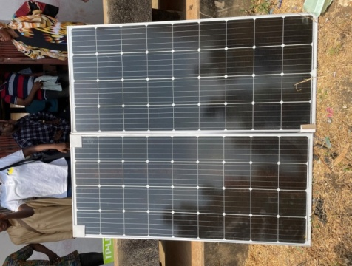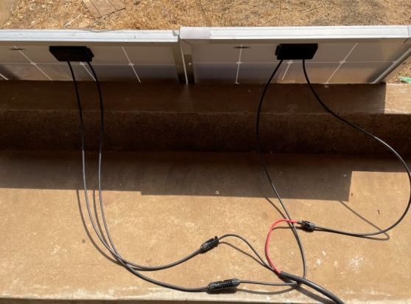
Fig. 4.1: Optimally Positioned Solar Panels for Maximum Sunlight Exposure
Description: This figure shows solar panels strategically installed in an open area with clear exposure to direct sunlight. The panels are positioned at an optimal tilt and orientation to maximize solar energy capture throughout the day. Their placement ensures efficient power generation, providing a reliable and uninterrupted power source for the CCTV surveillance system during examination periods.

4.2 BATTERY STORAGE, CHARGE CONTROLLER, AND INVERTER SYSTEM
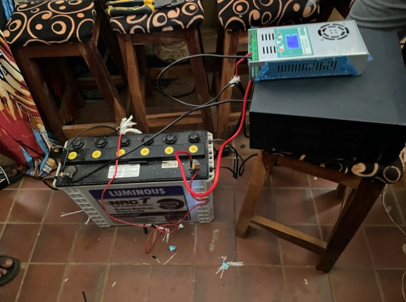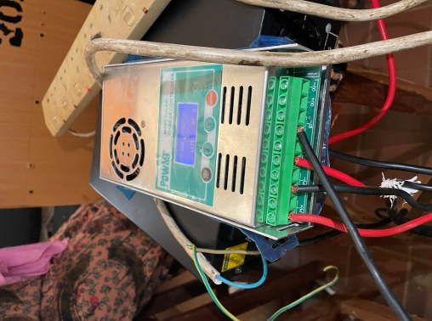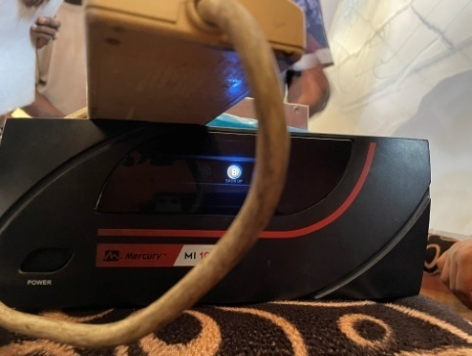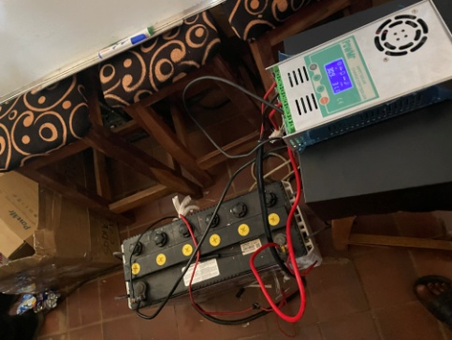
Fig. 4.2: Battery Bank, Charge controller and Inverter Setup
Description: This image showcases the integrated energy management system, including the battery bank, charge controller, and inverter. The battery bank stores energy harvested from the solar panels, while the charge controller regulates the voltage and current coming from the panels to prevent overcharging and ensure battery longevity. The inverter then converts the stored DC power into AC, which is used to power the CCTV surveillance system. This configuration ensures a stable and efficient backup power solution, especially critical during periods of low sunlight or grid failure.

4.3 CCTV CAMERA INSTALLATION WITH DVR AND POWER BOX
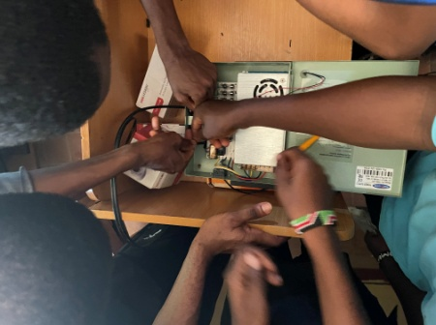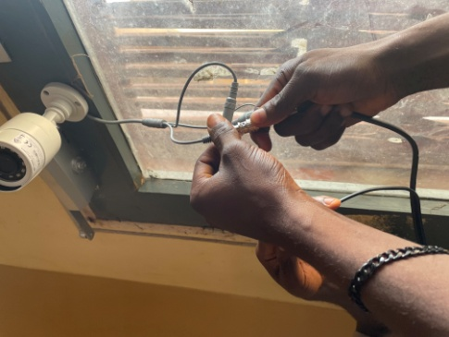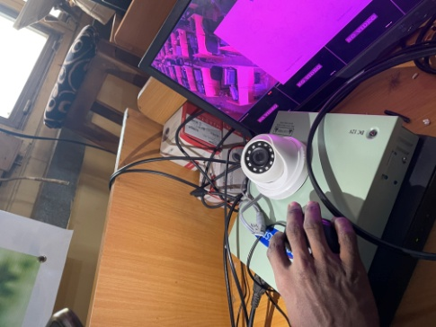
Fig. 4.3: CCTV Cameras with DVR and Power Box Installation
Description: This figure presents the installation of CCTV cameras along with essential system components such as the Digital Video Recorder (DVR) and power box. The CCTV cameras are strategically mounted to cover all angles of the examination hall, enabling high-definition surveillance. The DVR is responsible for recording and storing video footage for future reference, while the power box ensures a stable electrical supply to all connected devices. Together, these components form a comprehensive surveillance setup capable of operating continuously and reliably during examination sessions.

4.5 SYSTEM TESTING AND PERFORMANCE EVALUATION
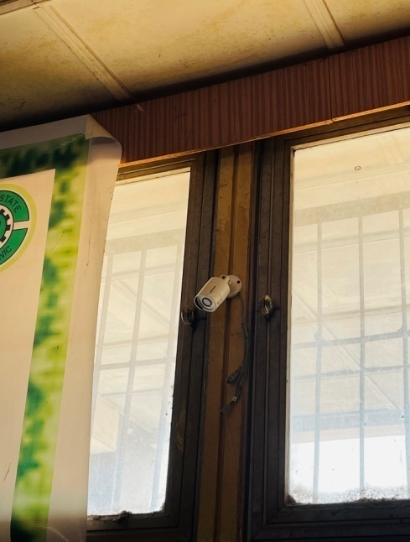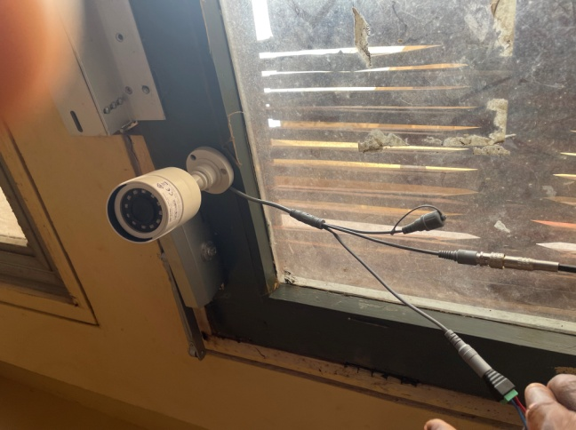
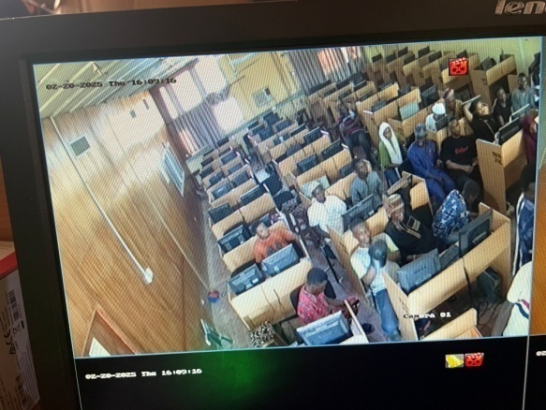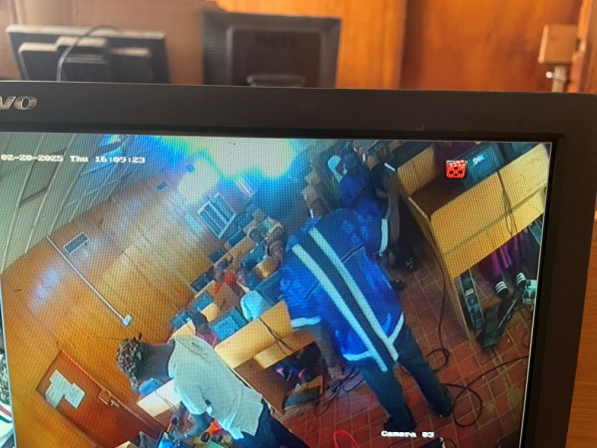
Fig. 4.5: Live Feed from the Surveillance System
Description: This figure captures a real-time feed from the installed CCTV surveillance system during an actual examination session. It demonstrates the system’s capability to deliver high-resolution video output with minimal latency. The continuous live feed confirms the stability of the power supply and the effectiveness of the integrated components, including the solar energy system, DVR, and network infrastructure. This stage of the implementation validates the overall system design, confirming its readiness for operational deployment and its capacity to ensure secure and uninterrupted monitoring throughout examination periods

CHAPTER FIVE
SUMMARY, CONCLUSION AND RECOMMENDATIONS
5.1 SUMMARY
This project focused on the design and implementation of a solar-powered CCTV surveillance system for monitoring examination environments. The primary aim was to enhance security and integrity during examinations while ensuring energy efficiency through the use of renewable power sources.
Chapter One introduced the problem statement, project objectives, and the motivation behind the implementation of a standalone surveillance system powered by solar energy. Chapter Two reviewed relevant literature, including various technologies and methodologies adopted in similar systems.
Chapter Three described the research methodology, design principles, and system analysis used throughout the project.
Chapter Four presented a step-by-step visual documentation of the system's implementation, including the installation of solar panels, battery storage, CCTV cameras, DVR, and the network monitoring infrastructure.
5.2 CONCLUSION
The completed system successfully integrates solar energy technology with a CCTV surveillance network tailored for examination environments. It addresses key challenges such as power instability and limited supervision resources during examinations. The system ensures continuous monitoring through an independent power supply, offering a scalable and sustainable solution for academic institutions. Its performance during testing confirmed reliability, clear video output, and ease of remote access, demonstrating that renewable energy can effectively support security infrastructure.
5.3 RECOMMENDATIONS
Based on the outcomes of this project, the following recommendations are proposed:
- Scalability: The system design should be expanded to cover additional sensitive areas such as administrative offices, server rooms, and library sections.
- Maintenance: Periodic maintenance of the solar panels and camera hardware is essential to ensure long-term performance and reliability.
- Storage Capacity: A higher-capacity DVR or cloud-based backup should be considered to accommodate extended video retention and redundancy.
- Real-Time Alerts: Integration of motion-based alerts and AI-driven monitoring software could further enhance the responsiveness of the system.
- Training: Staff should be trained on how to operate, monitor, and maintain the system to ensure sustainability after deployment.

