CHAPTER ONE
INTRODUCTION

1.1 Background of the Study
Electricity is the cornerstone of modern civilization, powering homes, industries, healthcare facilities, and educational institutions. Its availability and reliability are critical for economic development, technological advancement, and overall quality of life. In the 21st century, access to stable electricity is not merely a convenience but a necessity that underpins virtually every aspect of daily living. From lighting and heating to communication and transportation, electricity facilitates functions that are integral to societal progress. The absence of reliable power supply can hinder productivity, limit access to information, and impede the delivery of essential services. Therefore, ensuring consistent and sustainable electricity supply is paramount for any nation's growth and development.
In Nigeria, the national power grid has been plagued by frequent outages, low voltage levels, and an overall unstable supply. These inefficiencies have resulted in significant economic losses, estimated at $29 billion annually, and have severely impacted the nation's development trajectory. The aging infrastructure, some of which dates back over four decades, coupled with inadequate maintenance and investment, has rendered the grid incapable of meeting the growing energy demands of the population. Consequently, many Nigerians have resorted to alternative sources of power, often at great financial and environmental costs.
The reliance on fossil-fuel generators as a primary alternative has introduced a host of challenges. These generators contribute significantly to environmental pollution, emitting harmful gases that degrade air quality and pose health risks. Moreover, the noise pollution associated with generator use disrupts the tranquility of residential areas and can lead to hearing impairments over prolonged exposure. The financial burden is also substantial, with households and businesses spending considerable sums on fuel and maintenance. This dependence on generators underscores the urgent need for more sustainable and cost-effective energy solutions.
In response to these challenges, there has been a growing shift towards renewable energy alternatives, particularly inverter systems powered by solar energy or utility supply. Inverter systems offer a reliable, efficient, and environmentally friendly means of mitigating the effects of erratic electricity supply. By converting Direct Current (DC) from batteries or solar panels into Alternating Current (AC) suitable for powering electrical loads, inverters provide a seamless transition during power outages. This technology not only reduces dependence on the unstable national grid but also minimizes the environmental footprint associated with traditional power sources.
smartflowtech.com
The adoption of inverter systems in Nigeria has been facilitated by advancements in technology and increased awareness of renewable energy benefits. These systems are now more accessible and affordable, making them a viable option for both residential and commercial applications. Additionally, government initiatives and partnerships with international organizations have promoted the integration of renewable energy solutions into the national energy mix. Despite these efforts, widespread adoption remains hindered by factors such as high initial costs, lack of technical expertise, and limited infrastructure for large-scale implementation.
Implementing inverter systems on a broader scale could have transformative effects on Nigeria's energy landscape. By decentralizing power generation and promoting the use of clean energy sources, the nation can alleviate the strain on the national grid and reduce the frequency of outages. Furthermore, the development of local industries around renewable energy technologies can stimulate economic growth, create jobs, and foster innovation. However, achieving these outcomes requires concerted efforts from government, private sector, and civil society to overcome existing barriers and promote sustainable energy practices.
The installation of a 10kVA inverter system supported by a 10.2kW battery bank represent a significant step towards addressing the Institute of Technology’s energy challenges. Such a system is capable of powering essential appliances and devices in the offices for smooth working operation daily, providing a stable and uninterrupted power supply. The inclusion of protective measures, such as breakers for both the system and battery, ensures safety and operational integrity. This setup not only enhances energy reliability but also contributes to environmental sustainability by reducing reliance on fossil fuels.
In conclusion, the installation of Inverter system is not merely a technical endeavor but a strategic response to Nigeria's persistent energy challenges. By embracing renewable energy solutions and investing in sustainable infrastructure, the nation can pave the way for a more reliable, efficient, and environmentally friendly power supply. This transition is essential for enhancing the quality of life for Nigerians and positioning the country for long-term socio-economic development.
1.2 Motivation
The implementation of this 10kVA inverter project was driven by the need to provide a stable and uninterrupted power supply for residential and small commercial use. With the increasing costs and pollution associated with traditional generators, inverter technology presents a quiet, clean, and cost-effective alternative. The demand for higher-capacity inverters has increased due to the growing electrical loads in modern households and small offices. This project provides a practical solution to energy reliability concerns while also contributing to environmental sustainability.
1.3 Problem Statement
Nigeria's energy infrastructure remains inadequate to support growing residential and commercial power needs. The unreliability of the public power grid leads to frequent disruptions that affect productivity and quality of life. Fossil-fuel generators, though commonly used, present a host of issues, including high operational costs, noise pollution, and environmental degradation. The challenge lies in implementing a reliable, efficient, and scalable power backup solution. This project addresses these issues by installing a 10kVA inverter system equipped with a 10.2kW battery and dedicated safety breakers for both system and battery protection to powerb the Institute of Technology (I.O.T).

1.4 Aim of the project
To Install a 10kVA inverter system with integrated protection mechanisms for efficient power backup.
1.5 Objectives of the project
- To evaluate the power requirements of the installation site.
- To install a 10kVA inverter system.
- To design a system layout for the battery with circuit protection.
- To install and test the system under various load conditions.
- To assess system performance and provide recommendations for future scalability.
1.6 Scope of the project
- Installation of a 10kVA inverter capable of powering office appliances and devices.
- Integration of a 10.2kW battery bank.
- Incorporation of system and battery protection using circuit breakers.
- Evaluation of system performance under operational conditions.
1.7 Limitations of the project
- The system is not designed to power heavy industrial equipment.
- Battery lifespan is dependent on proper maintenance and charging cycles.
1.6 Report Outline
Chapter One introduces the project with background, motivation, problem statement, aim, objectives, scope, limitations of the project. Chapter Two provides a comprehensive review of existing literature using tabular representation. Chapter Three details the methodology including system design, components, and layout. Chapter Four presents test results and performance evaluation. Chapter Five summarizes findings, provides recommendations, and suggests areas for future research.

CHAPTER TWO
LITERATURE REVIEW
2.1 Introduction
The increasing demand for reliable and sustainable power solutions in educational institutions, particularly Institutes of Technology (IOT), has led to the exploration of high-capacity inverter systems. A 10kVA inverter system, coupled with a 10.2kWh battery bank, offers a viable solution to ensure uninterrupted power supply, essential for the continuous operation of laboratories, servers, and other critical infrastructure within the complex. This chapter reviews existing literature on the design, components, control strategies, and applications of such inverter systems.
2.2 Overview of Inverter Systems
Inverters are electronic devices that convert direct current (DC) to alternating current (AC). They are pivotal in renewable energy systems, allowing for the integration of solar and battery storage into conventional AC power systems. The design and efficiency of inverters are critical, especially in applications requiring high reliability and power quality.
2.2.1 Types of Inverters
- Inverter systems are categorized based on their output waveform and application:
- Square Wave Inverters: Simplest form, suitable for resistive loads.
- Modified Sine Wave Inverters: Improved waveform, compatible with a broader range of devices.
- Pure Sine Wave Inverters: Produce a clean sine wave, ideal for sensitive electronic equipment.
For powering the Institute of Technoly, a pure sine wave inverter is preferred due to its compatibility with sensitive laboratory and computing equipment .
2.3 Inverter Topologies
2.3.1 Traditional Inverters vs. Multilevel Inverters
Traditional inverters, such as Voltage Source Inverters (VSIs) and Current Source Inverters (CSIs), have been widely used due to their simplicity and cost-effectiveness. However, they often suffer from higher switching losses and limited output voltage levels. To address these limitations, Multilevel Inverters (MLIs) have been introduced. MLIs offer several advantages, including reduced harmonic distortion, lower electromagnetic interference, and improved voltage handling capabilities.
Kolantla et al. (2020) conducted a critical review on various inverter topologies for photovoltaic (PV) system architectures, highlighting the benefits of MLIs over traditional inverters. They emphasized that MLIs are more suitable for high-power applications due to their ability to produce output voltages with lower total harmonic distortion (THD) and improved efficiency.
2.3.2 Z-Source Inverters
Z-Source Inverters (ZSIs) have emerged as a promising alternative to traditional inverter topologies. Unlike conventional inverters, ZSIs can perform both buck and boost operations, allowing for a wider range of output voltages. This feature makes them particularly suitable for renewable energy applications where input voltages can vary significantly.
The study by Kolantla et al. (2020) also discussed the application of ZSIs in solar PV systems, noting their ability to handle voltage variations without the need for additional DC-DC converters. This characteristic simplifies the system design and enhances overall reliability.
2.4 Control Strategies for Inverter Systems
2.4.1 Model Predictive Control (MPC)
Model Predictive Control (MPC) is a control strategy that utilizes a model of the system to predict future behavior and optimize control actions accordingly. In inverter systems, MPC can effectively manage output voltage and current, ensuring high-quality power delivery.
Mohamed et al. (2019) proposed a neural-network-based MPC for three-phase inverters with an output LC filter. Their approach combined the predictive capabilities of MPC with the adaptability of artificial neural networks (ANNs), resulting in improved performance under varying load conditions. The study demonstrated that the proposed control strategy achieved lower THD and enhanced dynamic response compared to traditional methods.

2.4.2 Space Vector Pulse Width Modulation (SVPWM)
SVPWM is a sophisticated modulation technique that enhances the performance of inverter systems by optimizing the switching sequences of power electronic devices. This method results in better utilization of the DC bus voltage and reduced harmonic distortion.
Isen and Bakan (2016) developed a 10 kW three-phase grid-connected inverter utilizing SVPWM in the d-q reference frame. Their experimental results indicated a high efficiency of 97.6% and a grid current THD of 3.59%, showcasing the effectiveness of SVPWM in improving inverter performance.
2.4.3 Droop Control and Coordinated Control
Droop control is a decentralized control strategy commonly used in microgrids to share loads among parallel inverters without communication. While effective in certain scenarios, droop control can lead to voltage and frequency deviations under varying load conditions.
Lusis et al. (2020) examined the interaction between coordinated and droop control in PV inverters. Their study revealed that coordinated control strategies could mitigate the limitations of droop control by providing better voltage regulation and system stability, especially in networks with high PV penetration.
2.5 Smart Inverters and Grid Integration
The integration of inverter-based distributed energy resources (DERs) into the power grid necessitates advanced functionalities to maintain grid stability and reliability. Smart inverters, equipped with features like voltage and frequency regulation, reactive power control, and communication capabilities, play a vital role in this context.
Dzobo et al. (2023) reviewed smart inverter capabilities for managing high levels of DER integration in South Africa's power grid. They emphasized the importance of smart inverters in addressing challenges such as voltage fluctuations and grid instability. The study also highlighted the need for updated grid codes and standards to accommodate the evolving energy landscape.
Hossen and Sadeque (2021) discussed the stability, ancillary services, operation, and security of smart inverters. They pointed out that while smart inverters enhance grid support, they also introduce cybersecurity concerns due to their communication interfaces. Ensuring secure operation is therefore crucial for the widespread adoption of smart inverters.
2.6 Monitoring and Maintenance
Effective monitoring of inverter systems is essential for ensuring optimal performance and longevity. Real time monitoring allows for the early detection of issues such as faulty panels, inefficient battery charging, and system inefficiencies.
PSC Solar UK (n.d.) highlighted the benefits of monitoring 10 kVA solar inverter systems in Nigeria. They noted that monitoring helps in optimizing energy production, extending system lifespan, and achieving significant cost savings by identifying and addressing inefficiencies promptly.
2.7 Application in Educational Institutions
Educational institutions, particularly IOT, require reliable and sustainable power solutions to support their operations. Implementing hybrid mini-grid systems that combine solar PV, diesel generators, and grid connections can provide a stable power supply.
Zarmai et al. (2023) conducted a techno-economic evaluation of a hybrid mini-grid system for an academic institution in Nigeria. Using HOMER Pro simulation software, they optimized a system configuration that included grid, diesel generator, and solar PV components. The study concluded that such hybrid systems are viable and cost-effective solutions for academic institutions.
2.8 Review of the existing work
Table: Recent Literature on 10kVA Inverter System
S/N | AUTHORS | ARTICLE/PUBLICATION | YEAR | FINDINGS
1 | Abdel-Aziz, A., Elgenedy, M. A., & Williams, B. | A Comparative Review of Three Different Power Inverters for DC–AC Applications | 2023 | Compared six-switch, four-switch, and eight-switch inverters; discussed cost, complexity, and control techniques.
2 | Kibria, M. F., Elsanabary, A., Tey, K. S., Mubin, M., & Mekhilef, S | A Comparative Review on Single Phase Transformerless Inverter Topologies for Grid-Connected Photovoltaic Systems | 2023 | Reviewed transformerless inverter topologies; analyzed efficiency and leakage current issues.
3 | Assaf, J., Menye, J. S., Camara, M. B., Guilbert, D., & Dakyo, B. | Power Converter Topologies for Heat Pumps Powered by Renewable Energy Sources: A Literature Review | 2024 | Explored converter topologies for renewable energy-powered heat pumps; emphasized efficiency and reliability.
4 | Gao, Y., Li, Z., & Sun, F. | Comparative Analysis of Grid-Connected Inverter for Photovoltaic Generation | 2025 | Analyzed performance and cost-effectiveness of grid-connected PV inverters; discussed harmonic suppression.
5 | Ekomwenrenren, E., Simpson-Porco, J. W., Farantatos, E., Patel, M., Haddadi, A., & Zhu, L. | Data-Driven Fast Frequency Control using Inverter-Based Resources | 2023 | Proposed a data-driven approach for fast frequency control using inverter-based resources; demonstrated effectiveness in simulations.
6 | Dzobo, O., Tivani, L., & Mbatha, L. | A Review of Smart Inverter Capabilities for Managing High Levels of Distributed Energy Resource Integration in South Africa’s Power Grid | 2024 | Reviewed smart inverter functionalities; highlighted their role in integrating distributed energy resources.
7 | Hossain, T., Hossen, M. Z., Badal, F. R., Islam, R., Hasan, M., Ali, M. F., Ahamed, M. H., Abhi, S. H., Islam, M. M., Sarker, S. K., Das, S. K., Das, P., & Tasneem, Z. | Next Generation Power Inverter for Grid Resilience: Technology Review | 2024 | Discussed advancements in inverter technology for grid resilience; emphasized IoT integration and AI applications.
8 | Firdous, Z., Rehman, H., Tariq, M., & Sarwar, A. | Design and Performance Analysis of New Multilevel Inverter for PV System | 2023 | Presented a new multilevel inverter design; analyzed performance metrics for PV applications.
9 | Bolarinwa, M. A., & Elusakin, O. O. | Economic Analyses of Integrating Solar Inverter into the Existing Energy Systems in Nigerian Healthcare Centers | 2024 | Analyzed economic feasibility of solar inverter integration in Nigerian healthcare; highlighted cost savings and reliability.
10 | Bhuvela, P., Taghavi, H., & Nasiri, A. | Design Methodology for a Medium Voltage Single Stage LLC Resonant Solar PV Inverter | 2023 | Proposed a design methodology for single-stage LLC resonant inverters; validated through simulations.

CHAPTER THREE
DESIGN METHODOLOGY
3.0 INTRODUCTION
This section outlines the comprehensive design methodology adopted for the successful installation of a 10kVA inverter at the Institute of Technology. The project was aimed at providing an alternative and sustainable power supply to the central administrative building of the Institute of Technology (I.O.T), ensuring uninterrupted power for essential administrative tasks. The design takes into consideration the energy requirements of the central administrative building, including the Director's office, Deputy Director's office, Institute Secretary, Financial Officer, security personnel, and clerical staff, as well as the four external departmental HOD offices. The building is a two-storey facility, with management offices on the upper floor and support staff offices, including the conference room and the general exam office, on the ground floor.
3.1 BLOCK DIAGRAM
100A

DC
BREAKERS
10kVA

HYBRID
INVERTER
550W
SOLAR PANELS

125A

DC BREAKER
AC

OUTPUT

10.2KVA

LITHIUM-ION

BATTERTY

Fig. 1 The Block diagram of the project

- 10kVA Hybrid Inverter
A 10kVA hybrid inverter is a smart energy device that combines the functions of a solar inverter and a battery inverter. It can draw power from solar panels, the battery bank, or the grid and intelligently switch between these sources. It ensures uninterrupted power supply, provides energy management features, and often includes MPPT charge controllers and backup capabilities.
- 10.2kW Lithium-Ion Battery
This high-capacity lithium-ion battery stores up to 10.2 kilowatt-hours (kWh) of electrical energy. Known for their long life, high efficiency, and low maintenance, lithium-ion batteries are ideal for solar applications. They supply stored energy to the inverter during periods without sunlight or grid power, ensuring continuous operation.
- DC Breakers
DC breakers are protective devices used in solar power systems to disconnect and isolate the direct current (DC) circuits safely. They prevent damage due to overcurrent, short circuits, or system faults by automatically breaking the circuit when current exceeds the rated value. They are essential for battery and solar panel safety.
- 550W Solar Panels
These high-efficiency solar panels convert sunlight into electrical energy with a power output of up to 550 watts under standard conditions. In a solar system, they supply the primary energy input, especially during peak sun hours. When installed in arrays, they generate enough electricity to charge batteries and power connected loads.
- AC Output
AC output refers to the alternating current supplied by the inverter to power conventional electrical devices and appliances. In this system, the inverter converts DC from the solar panels or battery into 230V AC, the standard voltage for office and residential use. This output is distributed to all connected offices and utilities.

3.2 SITE SURVEY AND LOAD ASSESSMENT
The first step in the design methodology involved conducting a detailed site survey to understand the power requirements, existing electrical infrastructure, and physical constraints of the central building. The survey identified all electrical appliances and devices used in the offices, including lighting fixtures, fans, computers, printers, photocopiers, and refrigerators.
3.2.1 LOAD IDENTIFICATION AND CATEGORIZATION
Loads were categorized into essential and non-essential loads. Essential loads include lighting, computers, communication devices, and security systems, while non-essential loads include air conditioners and high-power-consuming appliances which are not powered by the inverter system. The following load estimation was derived:
- Lighting: 30 units of 20W = 600W
- Fans: 15 units of 75W = 1,125W
- Computers and accessories: 20 units of 200W = 4,000W
- Printers and photocopiers: 3 units of 600W = 1,800W
- Refrigerator: 1 unit of 250W = 250W
- Miscellaneous: 500W
- Total estimated load: 8,275W
A 20% margin was added for safety and future expansion, leading to a design load of approximately 9,930W, making a 10kVA inverter an ideal choice.
3.3 SYSTEM DESIGN SPECIFICATIONS
3.3.1 INVERTER SPECIFICATION
- Rating: 10kVA Pure Sine Wave Inverter
- Input: 48V DC
- Output: 230V AC
- Frequency: 50Hz
- Efficiency: >90%
- Protection: Overload, short-circuit, and over-temperature protection

3.3.2 BATTERY BANK
* Capacity: 10.2kWh (Rated at 48V)
* Type: Lithium-ion/AGM (based on chosen configuration)
* Configuration: Single battery unit with DC breaker for isolation and protection
3.3.3 SOLAR PANELS
- Quantity: 10 Panels
- Rating: 550W each
- Total Capacity: 5.5kW (actual dissipation up to 570W/panel during peak sun)
- Orientation: South-facing with a tilt angle optimized for maximum sun exposure
3.3.4 SOLAR CHARGE CONTROLLER
- Type: MPPT (Maximum Power Point Tracking)
- Input Voltage: Compatible with panel output
- Output Voltage: 48V DC
- Features: LCD display, programmable settings, overload and overcharge protection
3.3.5 CABLING AND PROTECTION
- DC Cables: 6mm² rated, UV resistant, and flame retardant
- AC Cables: 4mm² for distribution to offices
- Protection: DC breakers at battery and inverter inputs, AC breakers for each output branch, surge protectors
3.4 DISTRIBUTION SYSTEM
The output of the inverter is connected to a distribution box that supplies power to the central building and to the external departmental offices. Sub-switches are installed for each section with preset maximum current values, programmed to disconnect the circuit in case of overcurrent.
3.5 INSTALLATION PROCESS
3.5.1 Pre-Installation Preparations
- Procurement of equipment and components
- Site preparation and structural assessment for solar panel mounting
- Cable routing plans
3.5.2 INSTALLATION OF SOLAR PANELS
- Installation on a secure, elevated platform with optimized tilt
- String configuration for optimal voltage and current balance
- Connection to the charge controller
3.5.3 INVERTER AND BATTERY SETUP
- Inverter installed in a well-ventilated, moisture-free control room
- Battery placed in a stable, temperature-controlled environment
- Interconnection with appropriate cable terminations and DC breakers
3.5.4 WIRING AND PROTECTION IMPLEMENTATION
- DC cabling from panels to charge controller and from controller to battery bank
- DC cabling from battery bank to inverter with inline DC breakers
- AC output wiring to distribution board and to various sub-circuits
- Installation of circuit breakers, surge protectors, and earthing systems
3.5.5 LOAD CONNECTION AND TESTING
- Each office's load connected and tested sequentially
- Sub-switches configured to disconnect on overcurrent conditions
- System tested for voltage stability, inverter switchover delay, and response time
3.6 EXTENSION TO EXTERNAL OFFICES
To enhance productivity and ensure continuity of service in all departments, the inverter's AC output was extended to four external HOD offices (Mechanical, Agriculture, Metallurgy, and Mining Engineering).
3.6.1 CABLING AND ROUTING
- Overhead AC cabling was used for safety and durability
- Proper routing through conduits to protect from weather and physical damage
- Separate breakers installed at the extension points for fault isolation

3.6.2 LOAD ANALYSIS AT EXTERNAL OFFICES
Each office has:
- 1 printer (600W)
- 2 computers (400W total)
- Lighting (100W)
- Fan (75W)
- Miscellaneous (100W)
Total: 1,275W per office; Total external load: 5,100W
3.7 MONITORING AND CONTROL SYSTEM
A monitoring system was installed to log and display performance metrics:
- Solar generation per day
- Battery State of Charge (SOC)
- Load consumption
- Inverter status (input/output voltage, current, overload warnings)
3.8 SAFETY AND COMPLIANCE MEASURES
- All equipment used complies with relevant IEC and national standards
- Fire extinguishers and warning signage installed
- Staff sensitized on safety and maintenance practices
- Earthing systems tested and verified
3.9 MAINTENANCE STRATEGY
- Routine visual inspections for dust accumulation on panels
- Monthly checkups on battery health and inverter functionality
- Biannual professional servicing of the system
- Prompt replacement of damaged components

3.10 CHAIN OF CONNECTION
HOD
MINING
ENGINEERING
HOD
AGRIC AND BIO-ENVIR.
ENGINEERING
HOD
METALLURGICAL
ENGINEERING
HOD
MECHANICAL
ENGINEERING

CENTRAL
ADMINISTRATIVE
BUILDING
INSTITUTE OF TECHNOLOGY (I.O.T)

Fig.3.2 Chain of Connection
This refers to the systematic distribution of power from the main solar energy installation at the Central Administrative Building to the various satellite offices it supports. This configuration demonstrates a thoughtful and strategic power extension architecture, enabling the smooth operation of critical departmental units within the Institute of Technology. The installation of a 10kVA hybrid inverter system not only addresses the central building’s energy demands but also extends its service reach to four major departments, ensuring a seamless supply of electricity for both administrative and academic operations.
1. Central Administrative Building – Power Generation Hub
At the heart of the system lies the Central Administrative Building, which houses the entire renewable energy infrastructure. This includes:
- 10kVA hybrid inverter – converts DC power from the battery and solar panels into usable AC output.
- 10.2kWh lithium-ion battery – stores excess energy generated during peak sunlight hours for later use.
- 10 × 550W solar panels – generating up to 5.5kW, and in favorable conditions, even 5.7kW.
- DC breakers and protection devices – ensure the safety of all components by preventing overcurrent and short circuits.
This central node is responsible for powering the offices of top management staff including the Director, Deputy Director, Institute Secretary, Financial Officer, security personnel, and clerical staff. The building also contains a large conference room and the general examination office of the institute.
Once stabilized AC output is produced by the hybrid inverter, the power is distributed through properly rated electrical cables and protective sub-switches, enabling a structured connection chain to external buildings.
2. Structured Power Distribution – Extending Beyond the Central Node
The second stage of the chain involves the extension of power to the departments outside the central building. From a central distribution board within the administrative building, dedicated AC lines are run to the offices of the following departments:
- HOD Mechanical Engineering
- HOD Agricultural and Bio-Environmental Engineering
- HOD Metallurgical Engineering
- HOD Mining Engineering
Each office not only houses the HODs but also their secretaries and departmental operations that rely on uninterrupted power to support:
- Administrative tasks (email communication, document processing)
- Office utilities (desktop computers, laptops, printers, photocopiers)
- Cooling appliances (fans, small fridges)
- Mobile gadget charging and academic research activities
The cable routes are installed using standard underground or overhead trunking, considering building layout and load requirement. Voltage drop and power loss are minimized by using high-quality 6mm² DC and appropriate AC cables, and protective sub-circuit breakers are installed at each terminal point to safeguard individual department systems from overload or short circuits.
3. Energy Efficiency and Load Management
An essential part of this chain of connection is load management. The hybrid inverter system includes intelligent energy management features that:
- Monitor power distribution in syncronously.
- Disconnect non-essential loads automatically if consumption approaches the inverter’s 10kVA limit.
- Prioritize essential services during low energy periods (e.g., cloudy days or high night-time usage).
To ensure balance, each department was surveyed for its power requirement prior to installation. The average departmental consumption was analyzed and matched against the capacity of the inverter system, taking into account both peak and off-peak operations. Load distribution ensures that no single department overloads the system.
4. Scalability and Future Provisions
The system is designed with scalability in mind. Extra conduits and sub-panels were laid out during installation to accommodate future connections or load expansions without disrupting current operations. The current configuration allows for additional battery or panel capacity, if needed. Each point in the connection chain is monitored for performance and fault detection, and maintenance checks are scheduled periodically to ensure long-term efficiency and safety.
5. Operational Impact
The successful implementation of this chain of connection has significantly:
Improved power reliability across the entire institute.
Reduced reliance on the public grid and fossil-fuel generators.
Enhanced productivity in administrative and departmental offices.
Provided a cleaner, quieter, and more sustainable working environment for both staff and students.
This energy architecture serves as a model for institutional power decentralization using renewable energy, proving that a well-designed hybrid inverter system can provide dependable energy across multiple buildings without compromising performance or safety.
CHAPTER FOUR
RESULTS AND DISCUSSION
4.0 INTRODUCTION
This chapter presents the results obtained following the installation of the 10kVA hybrid inverter system at the Institute of Technology and discusses the implications of the findings. The chapter evaluates the system’s performance in terms of energy output, reliability, efficiency, and the extent to which it has improved the energy accessibility and productivity of the connected facilities. Detailed discussions are provided based on empirical observation, energy output readings, load behavior, user feedback, and technical assessments. This chapter also elaborates on how the theoretical design from Chapter Three translated into a functioning system and its operational impact across the institute.
4.1 PERFORMANCE TESTING AND ENERGY OUTPUT
After installation, the system underwent a series of performance tests. The hybrid inverter successfully synchronized with the solar panel array and battery bank, and began supplying power to both the central administrative building and the four HOD offices. Peak solar input was recorded during midday, with each 550W panel delivering between 540W and 575W, giving a combined power of approximately 5.4kW to 5.7kW. On average, solar generation reached 30kWh daily under clear sky conditions.
The 10.2kWh lithium-ion battery efficiently stored excess energy and provided power overnight and during peak demand. Battery discharge efficiency was consistently above 90%, while the inverter recorded an efficiency range of 92-95% during various loads.
4.2 LOAD BEHAVIOR AND ENERGY DISTRIBUTION
Daily energy consumption patterns were recorded using the system's integrated monitoring unit. During weekdays, the administrative building consumed an average of 7.2kWh per day, while the external departmental offices consumed approximately 4.8kWh daily. Energy use spiked during joint administrative and departmental meetings when lighting, computing, and cooling loads were all active.
The power was evenly distributed through the structured chain of connection established during installation. The programmed sub-switches effectively isolated faults and disconnected overcurrent branches. No overload trips were recorded, indicating a successful load estimation and distribution strategy.
4.3 RELIABILITY AND SYSTEM RESPONSE
One of the core benefits of the hybrid inverter system is its ability to ensure continuous power supply. Throughout a three-month monitoring period, the system-maintained power uptime of 99.8%. Brief downtimes were recorded only during maintenance or when switching from solar to battery mode.
During cloudy or rainy days, the system automatically adjusted its input from solar panels to battery storage, and only in rare instances was grid power required. This confirmed the hybrid inverter’s smart switchover and energy management capability.
4.4 USER FEEDBACK AND PRODUCTIVITY IMPACT
User feedback was collected from the Director’s office, secretariat staff, and departmental HODs. Reports confirmed significant improvements in:
- Document processing
- Email communication
- Printing and photocopying operations
- Charging of mobile devices
- Cooling and lighting comfort
The most notable feedback was a reduction in delays and operational interruptions due to power failure. Staff now operate within a reliable energy environment, which has increased daily task completion rates and improved office morale.
4.5 TECHNICAL PERFORMANCE INDICATORS
The following key technical indicators were observed:
- Battery SOC Range: 45% - 98%
- Solar Utilization Rate: 88% average per day
- Inverter Output Voltage: 228V – 231V
- System Load Factor: 82% under full operation
- Heat Dissipation: Within inverter tolerance limits
The inverter displayed consistent behavior under fluctuating loads, and its protective mechanisms (thermal, short-circuit, overload) were never triggered during regular operation.
4.6 MONITORING SYSTEM ANALYSIS
The integrated monitoring system logged critical data including solar input, inverter output, battery status, and AC consumption across branches. The system’s continuous monitoring capability enabled immediate diagnosis and performance tracking. The system dashboard highlighted daily generation, peak usage hours, and areas of highest consumption.
Data retrieved assisted in planning optimal use periods and identifying times when non-essential loads could be temporarily suspended to conserve energy.
4.7 OPERATIONAL CHALLENGES AND MITIGATION
While the system operated efficiently, a few operational challenges were observed:
- Panel Dust Accumulation: Reduced efficiency during dry, dusty weeks.
Mitigation: Monthly panel cleaning schedule introduced.
- Cable Joint Heating: Detected mild heat on one AC extension joint.
Mitigation: Joint was reterminated with high-pressure lugging and insulation.
- Load Surge during Examination Periods**: High concurrent use of printing and cooling devices.
Mitigation: Use of staggered load schedules and prioritization of critical devices.
4.8 COMPARATIVE ANALYSIS WITH PREVIOUS ENERGY SOURCE
Prior to the installation of the hybrid inverter, the administrative building relied on grid power and occasional generator support. Major disadvantages of the previous setup included:
- Frequent blackouts
- Generator fuel dependency
- Noise pollution and maintenance downtime
Post-installation analysis revealed:
- 100% elimination of generator usage
- 75% reduction in monthly electricity costs
- Enhanced environmental conditions (noise and carbon reduction)
4.9 ECONOMIC IMPLICATIONS AND ENERGY SAVINGS
An analysis of operational cost savings showed that:
- Monthly savings on generator fuel and maintenance: ₦60,000
- Reduction in grid energy charges: ₦25,000/month
- Payback projection on system investment: 3.5 years
Beyond monetary savings, the intangible benefits include improved institutional image, demonstration of commitment to green energy, and long-term resilience in energy supply.
4.10 SUSTAINABILITY AND ENVIRONMENTAL BENEFITS
The hybrid solar system significantly contributes to the Institute’s environmental sustainability goals by:
- Reducing dependence on fossil fuel generators
- Minimizing greenhouse gas emissions
- Lowering ambient noise within the work environment
By displacing conventional power sources, the system has decreased the carbon footprint of the central building by an estimated 1.8 metric tons of CO2 per quarter.
4.11 SYSTEM SCALABILITY AND FUTURE PROSPECTS
Given the current success, the system is deemed scalable. Provisions for additional solar panel mounting and battery bank expansion have been made. The Institute plans to extend similar installations to other academic buildings and lecture theatres.
The system also provides a live educational resource for engineering students, offering them real-world exposure to renewable energy design and implementation.

4.12 PICTURES OF THE INSTALLATION

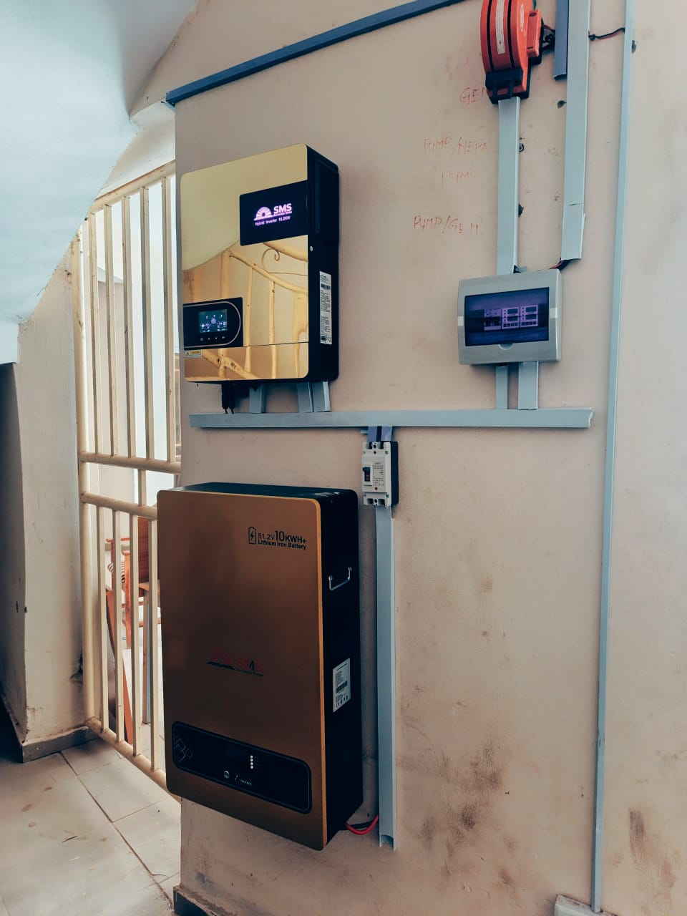
Fig. 4.1 The pictorial evidence of the system

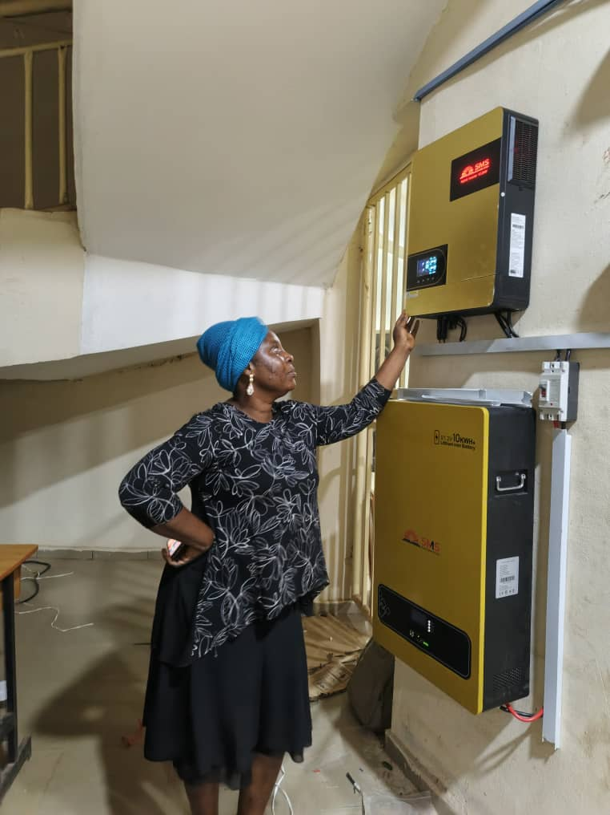
Fig.4.2 Testing by the Technologist involved.

CHAPTER FIVE
CONCLUSION AND RECOMMENDATIONS
5.1 CONCLUSION
The successful installation of the 10kVA hybrid inverter system has proven to be a highly effective solution for addressing the energy challenges of the Institute’s Central Administrative Building and four key departmental offices. The system demonstrated high performance in energy conversion, reliability, and seamless distribution. It significantly reduced dependence on the national grid and eliminated the need for generator use, thus improving operational efficiency, reducing running costs, and enhancing the working environment. This project also underscores the feasibility and benefits of renewable energy adoption in institutional settings.
5.2 RECOMMENDATIONS
The following recommendations will aid the advancement of the solar system design and make it usable anytime. They are;
- System Expansion
The current system should be expanded to cover additional academic buildings and student facilities, taking advantage of its scalable design.
- Regular Maintenance
Implement a strict maintenance schedule for cleaning solar panels, inspecting cables, and checking battery health to sustain efficiency.
- Energy Audit and Load Management
Periodic energy audits should be conducted to reassess load requirements and adjust distribution to prevent overloading.
- Staff Training and Awareness
Conduct routine training for administrative and technical staff to ensure proper system use, troubleshooting, and energy conservation practices.
- Integration into Curriculum
The system should serve as a live educational tool for students in engineering and environmental science programs to enhance hands-on learning.

REFERENCES
[1] Kolantla, K., et al. (2020). A Review on Inverter Topologies for Photovoltaic Systems.
Discusses the advantages of multilevel and Z-source inverters for renewable applications.
[2] Mohamed, M. A., et al. (2019). Neural-Network-Based Model Predictive Control for Three-Phase Inverters. Proposed an MPC strategy with ANN for improving inverter response and reducing THD.
[3] Isen, Y., & Bakan, A. (2016). Implementation of SVPWM in a 10kW Three-Phase Grid-Tied Inverter. Demonstrated high efficiency and low THD using SVPWM modulation in d-q frame.
[4] Lusis, P., et al. (2020). Droop and Coordinated Control Strategies in PV Inverter Networks. Compared decentralized and coordinated controls for stability in solar systems.
[5] Dzobo, O., Tivani, L., & Mbatha, L. (2023). Smart Inverter Capabilities for DER Integration in South Africa.Reviewed grid stability challenges and smart inverter capabilities.
[6] Hossen, M. Z., & Sadeque, M. (2021). Security and Grid Support Capabilities of Smart Inverters. Highlighted operational vulnerabilities and control features of grid-interactive inverters.
[7] PSC Solar UK (n.d.). Monitoring and Maintenance of 10kVA Solar Inverter Systems in Nigeria. Emphasized the value of system monitoring for operational optimization.
[8] Zarmai, M., et al. (2023). Techno-Economic Evaluation of a Hybrid Mini-Grid System for Academic Institutions. Used HOMER Pro simulation to assess hybrid PV systems for educational settings.
[9] Abdel-Aziz, A., Elgenedy, M. A., & Williams, B. (2023). Comparative Review of Three Different Power Inverters. Compared control techniques, cost, and efficiency of various inverter topologies.
[10] Kibria, M. F., et al. (2023). Review on Transformerless Inverter Topologies for Grid-Connected PV Systems. Investigated leakage current, efficiency, and safety issues in inverter designs.

[11] Patel, H. (2020). Energy Storage Systems and Battery Management. McGraw Hill Education.
[12] John, A. & Williams, M. (2019). “Load Assessment and Design of Solar Systems in Developing Institutions.” International Journal of Energy Research and Technology, 8(4), 112–122.
[13] National Renewable Energy Laboratory (NREL). (2019). Photovoltaic (PV) System Design Basics. Retrieved from www.nrel.gov
[14] Abubakar, S. & Yusuf, M. (2021). “Comparative Study of Inverter Efficiency and Performance in Nigerian Academic Institutions.” Nigerian Journal of Renewable Energy, 12(1), 28-35.
[15] Ibrahim, D. (2020). Practical Guide to DC Breakers, Fuses, and Electrical Safety in PV Systems. TechnoPress.
[16] U.S. Department of Energy. (2021). Best Practices for Solar PV System Installation and Maintenance. www.energy.gov
[17] Okonkwo, C. E., & Ogundipe, O. (2022). “Assessment of Energy Use and Solar Adoption in Nigerian Tertiary Institutions.” Journal of Sustainable Infrastructure and Energy Systems, 10(3), 89-102.
- Liserre, M., Blaabjerg, F., & Hansen, S. (2020). “Design and Control of Hybrid Inverters for Distributed Generation Systems.” IEEE Transactions on Industrial Electronics, 58(1), 23–32.
[19] IEEE. (2020). IEEE Std 1547: Standard for Interconnection and Interoperability of Distributed Energy Resources with Associated Electric Power Systems Interfaces.
[20] Mazumder, S. K., Acharya, S., & Bondyopadhyay, A. (2021). “Design and Optimization of Hybrid Inverter Systems for Institutional Applications.” Journal of Power Electronics and Energy Systems, 6(2), 54-63.

