ASSESSMENT OF PALM KERNEL OIL AS A NATURAL SURFACTANT IN HYBRID FOAM CONCRETE FOR BUILDING INSULATION APPLICATION

BY

IDRIS KAMALDEEN OLAMILEKAN
HND/23/CEC/FT/0233

SUBMITTED TO
A RESEARCH PROJECT SUBMITTED TO
THE DEPARTMENT OF CIVIL ENGINEERING,
INSTITUTE OF TECHNOLOGY,

KWARA STATE POLYTECHNIC, ILORIN KWARA STATE.

IN PARTIAL FULFILLMENT OF THE REQUIREMENTS FOR THE AWARD OF HIGHER NATIONAL DIPLOMA (HND) IN CIVIL ENGINEERING.

JULY, 2025.

CERTIFICATION
This is to certify that this research study was conducted by IDRIS, Kamaldeen Olamilekan (HND/23/CEC/FT/0233) and has been read and approved as meeting the requirement for the award of Higher National Diploma (HND) in Civil Engineering of the Department of Civil Engineering, Institute of Technology, Kwara State Polytechnic Ilorin..

……………………………… ……………………………
ENGR. R.O. SANNI DATE
Project Supervisor

……………………………… ……………………………
ENGR. A. B. NAALLAH DATE
Head of Department

……………………………… ……………………………
ENGR. DR. MUJEDU KASALI ADEBAYO DATE
External Examiner

DEDICATION
This work is dedicated to Almighty God for his unmerited grace and steady fast love given to me throughout my Academic pursuit of Higher National Diploma (HND) in Kwara State Polytechnic, Ilorin.
It is also dedicated to my beloved family Mr. & Mrs. Idris.

ACKNOWLEDGEMENT
My Appreciation goes to Almighty Allah for his guidance and protection over my life up till this moment and the mercy he has granted me in the course of my pursuit of this Higher National Diploma (HND) may his name be highly glorified.
My profound appreciation goes to my honest l, dedicated and experience supervisor Engr. R.O. Sanni whose official as well is sure how pursue me throughout my project work and made very useful comment, contribution and correction.
I am very grateful to the Head of Department of Civil Engineering Engr. Naallah for his encouragement and all lecturers in my department for their support and advices.
I will like to express my gratitude to my family most especially to my lovely parents Mr. and Mrs Idris for their limitless effort in aspect of finance prayer and encouragement, I pray you shall be one to reap the fruit of your labor (Amen).
Thank you all.

Table of Contents
CERTIFICATION i
DEDICATION ii
ACKNOWLEDGEMENT iii
List of Tables vii
List of Figures viii
ABSTRACT ix
CHAPTER ONE 10
INTRODUCTION 10
1.1 Background to the Study 10
1.2. Problem Statement 12
1.3. Justification of the Study 13
1.4. Aim of the Study 14
1.5. Objectives 14
1.6. Scope of Study 14
1.6.1. Material Scope 15
1.6.2. Experimental Scope 15
1.6.3. Limitations 16
CHAPTER TWO 17
LITERATURE REVIEW 17
2.1 Preamble 17
2.2 What is foam concrete 18
2.3 Classification of foam concrete 19
2.4 Application of foam concrete 19
2.5 Previous research on foam concrete 20
2.6 Thermal insulation property 22
2.7 Challenges in current research 23
2.7.1 The status of heat transfer research 24
2.7.2 Compressive strength 25
2.8 PROPERTIES OF FOAMED CONCRETE 30
2.8.1 Fresh State Properties 30
1. Rheology 31
2. Rate of hardening 32
3. Stability 36
2.8.2 Hardened State Properties 39
CHAPTER THREE 44
RESEARCH METHODOLOGY 44
3.1. Materials 44
3.1.1. Binder 45
3.1.2. Fine Aggregates 47
3.1.3. Palm Kernel Oil 47
3.1.4. Water 48
3.1.5. Sodium Lauryl Sulfate (foaming agent) 48
3.2. Methods 48
3.2.1. Mix Design Preparation 49
3.2.2. Preparation of Foam 49
3.2.3. Mixing and Casting 50
3.2.4. Testing of Foam Concrete 51
3.2.4.2. Thermal insulation Properties Test 52
3.3. Selected image of workplace moment 54
CHAPTER FOUR 55
RESULTS AND DISCUSSIONS 55
4.1. Properties of Hybrid Foam Concrete 55
4.1.1. Slump Test (Workability Test) 55
4.1.2. Thermal Insulation Performance 55
4.1.3. Compressive Strength Test 58
CHAPTER FIVE 60
CONCLUSION AND RECOMMENDATION 60
5.1. Conclusion 60
5.2. Recommendation 60
REFERENCES 62

List of Tables

Table | Title | Page
2.1 | Typical rheology of sand and fine fly ash, FAf aggregate mixes | 33
3.1 | Physical and Mechanical Properties of Cement | 45
3.2 | Chemical Composition of cement (%) | 45
4.1 | Slump test | 54`
4.2 | 7th, 14th and 28th Days Thermal Insulation Properties | 55

List of Figures
Figure | Title | Page
2.1 | Examples of Foam concrete applications a) insulation wall, b) running track sub-base | 19
2.2 | Actual pore structure image of foam concrete | 22
2.3 | Shortcomings of current heat conductivity method | 23
2.4 | Bingham model | 33
3.1 | Material appearance. (a) Portland limestone cement, (b) hybrid stone dust, (c) fine aggregate, (d) sodium lauryl sulfate. | 44
3.2 | Photograph of the foam generated. | 49
3.3 | Pictures depicting foam concretes incorporating foaming agent (SLS). | 50
3.4 | Photographs (in alphabetical order from top left to bottom right) of the FC preparation, casting and testing phases in cubic shapes of 150mm side. | 53

ABSTRACT
This study investigates the potential of palm kernel oil (PKO) as a natural surfactant in hybrid foam concrete (HFC) for building insulation applications. Foam concrete, known for its lightweight, thermal insulation, and sustainability benefits, traditionally relies on synthetic surfactants, which pose environmental concerns. PKO, a biodegradable byproduct of palm oil extraction, is explored as an eco-friendly alternative to enhance foam stability and concrete performance. The research evaluates the mechanical, thermal, and physical properties of HFC with varying PKO concentrations (0%, 1%, and 1.5%). Key tests include slump tests for workability, compressive strength assessments at 7, 14, and 28 days, and thermal insulation performance under ambient conditions. Results indicate that PKO incorporation reduces workability but significantly improves thermal insulation, with HFC demonstrating lower heat transfer compared to conventional concrete. The compressive strength of HFC increases with PKO content, peaking at 3.0 N/mm² for 1% PKO at 28 days. The findings highlight PKO’s viability as a sustainable surfactant, offering a balance between thermal efficiency and structural integrity. Recommendations include optimizing PKO dosage for practical applications and further exploring long-term durability. This study contributes to the development of eco-friendly construction materials aligned with global sustainability goals.
Keywords: Foam concrete, palm kernel oil, natural surfactant, thermal insulation, compressive strength, sustainable construction.

CHAPTER ONE

INTRODUCTION

1.1 Background to the Study
Foam concrete is a lightweight concrete that air-voids are entrapped or entrained in the solid concrete body (Sahraoui et al., 2025), which has been used in the non-structural and structural construction since 1920s(Roobankumar & SenthilPandian, 2024; Song et al., 2024). In the last century, foam concrete developed quickly, especially for the present, energy saving spreads all over the world (Du et al., 2024; Tu et al., 2024). Foam concrete with advantages of light weight, good insulation, sound absorption, fire resistance and low manufacturing cost is widely used in construction industries (Du et al., 2024). Using foam concrete to partly replace the traditional concrete as non-bearing walls or ceilings can not only reduce the buildings weight leading to reduced dead-loads on the foundation and make the buildings more energy-efficient, but also can reduce CO2 emission during the construction and the whole service life of building, therefore, it is regarded as an environmentally friendly material (Y. Li et al., 2025; Tu et al., 2024; Xuquan et al., 2025).
Now most of foam concrete applications are related to its thermal insulation properties and mechanical properties (Alassane et al., 2025; W. Zhang et al., 2025). Generally, thermal insulation properties increase with decreasing the density of foam concrete, while the mechanical properties are in the same trend as the density variation. In fact, the low compressive strength of foam concrete limits its applications in thermal insulation field. Therefore, the application of foam concrete has to consider the balance between the thermal insulation properties and mechanical properties. The macroscopic thermal insulation properties and mechanical properties are directly influenced by the microscopic pore features, such as porosity, pore size, pore area fraction, pore distribution, pore shape factor, etc (Alassane et al., 2025; Shi et al., 2024).
Currently study on foam concrete focuses on the influence of the porosity on the compressive strength and heat conductivity (Falliano et al., 2018; Ramamurthy et al., 2009; Shi et al., 2024), which neglects pore features’ influence, including pore size, pore shape factor, pore area fraction and pore size distribution, etc. Although the porosity of foam concrete is regarded as an primary role in determining the compressive strength and heat conductivity(Amran et al., 2022; Erdogmus et al., 2023; Jones & McCarthy, 2005), knowing the pore features is helpfu3.l to understand how these microscale pore features affect the macro physical properties, which can also provide a theoretical tool to design, evaluate and optimize the foam concrete producing process (Guo et al., 2021).
However, pore features of foam concrete are statistical data obtained from experimental specimens, which vary in different samples (Jiang et al., 2024; Kadela et al., 2017), especially for the pore size, pore shape factor, pore area fraction, pore distribution et al. Besides the porosity of foam concrete, pore size is regarded as another important factors afftecting the compressive strength of foam concrete (Xuquan et al., 2025; W. Zhang et al., 2025), in which the smaller size of pores leads to higher compress strength. Moreover, the compressive strength model of foam concrete related with porosity and pore size is empirical model. Therefore it is necessary to study the pore features of foam concrete by quantitative method.
Although, using EPS beads to replace foam is an effective way to study the influence of pore size on compressive strength, the ratio of EPS beads size to sample size and different size EPS beads mixing together are ignored before, and these research works have real significantly meaning for industrial production. Further, heat conductivity is an important index to evaluate energy saving efficiency of building, and a good model of heat conductivity can predict the heat conductivity of foam concrete more accurately that can reduce the experimental cost effectively. Finally, the comparison of temperature field between traditional concrete and foam concrete during fire accidence is studied to illustrate its well thermal insulation property.

1.2. Problem Statement
The construction industry is increasingly focused on the development of sustainable building materials to meet growing environmental concerns and energy efficiency goals. Among these materials, foam concrete is recognized for its lightweight, insulating properties, making it an ideal solution for thermal insulation in building applications. However, the production of foam concrete relies on synthetic surfactants that may have detrimental environmental impacts due to their petrochemical origins and non-biodegradability.
Palm kernel oil (PKO), a byproduct of palm oil extraction, has shown potential as a natural, biodegradable alternative surfactant in various industrial applications. However, limited research has explored its feasibility as a natural surfactant in foam concrete production, particularly for thermal insulation applications in the building sector. This research aims to assess the effectiveness of palm kernel oil as a sustainable surfactant in hybrid foam concrete, evaluating its impact on the material's properties such as density, thermal conductivity, and compressive strength.
The study will investigate whether PKO-based surfactants can reduce environmental impacts while maintaining or improving the performance of foam concrete for building insulation purposes. The findings could contribute to the development of eco-friendly, high-performance building materials, aligning with global sustainability goals in the construction industry.

1.3. Justification of the Study

Despite the growing interest in hybrid foam concrete as a sustainable building material, there is limited research on the effectiveness of palm kernel oil as a surfactant in improving the properties of foam concrete. The growing demand for sustainable construction materials has driven the exploration of lightweight concrete solutions, such as foam concrete, which offers significant advantages in terms of reduced density, enhanced thermal and acoustic insulation, and improved fire resistance. (H. Zhang et al., 2021; Zhuo et al., 2022). Foam concrete, which is produced by incorporating air voids through foaming agents or gas-producing reactions, presents a promising alternative to conventional heavy concrete, addressing the issues of weight and thermal inefficiency in building structures. However, despite its benefits, foam concrete’s performance is highly influenced by several factors, including the production method, the materials used, and the control of the pore structure during mixing, transportation, and placement.
The incorporation of agro-wastes, such as rice husk ash, bagasse ash, and palm kernel oil, into foam concrete offers potential environmental and economic benefits by reducing material costs and promoting waste recycling. Yet, the integration of these agro-wastes into foam concrete has not been fully optimized, and their effects on the mechanical properties, durability, and overall performance of foam concrete remain under-researched. Moreover, the stability and uniformity of the foam structure during the production process, particularly with varying foaming agent concentrations and types of agro-waste, pose challenges that need to be addressed to enhance the material's consistency and reliability for construction applications.
Specifically, the effectiveness of palm kernel oil (PKO) as a natural surfactant in HFC requires comprehensive investigation.

1.4. Aim of the Study
This study aim is to Assess Palm Kernel Oil as a Natural Surfactant in Hybrid Foam Concrete for Building Insulation Application.

1.5. Objectives
- Assess the mechanical and physical properties of palm kernel oil-based foam concrete, including compressive strength and workability.
- Investigate the thermal insulation performance of foam concrete incorporating palm kernel oil.
- Compare the thermal performance of foam concrete with conventional alternatives.
- Evaluate the feasibility of using palm kernel oil as a natural surfactant in hybrid foam concrete.

1.6. Scope of Study
The scope of this study will cover the following aspects.
This study will primarily focus on assessing the use of palm kernel oil (PKO) as a surfactant in hybrid foam concrete for building insulation applications within the context of tropical and sub-tropical regions, particularly where palm oil production is prevalent. However, the findings and conclusions may also be relevant to other regions where there is interest in sustainable building materials and natural surfactants.

1.6.1. Material Scope
- The study will investigate the impact of varying concentrations of palm kernel oil (PKO) as a surfactant in foam concrete. PKO will be used as an alternative to synthetic surfactants commonly used in foam generation. The study will also examine the effects of PKO on the mechanical and thermal properties of foam concrete.
- This research will focus on foam concrete, which is lightweight and has enhanced thermal insulation properties. The control group for comparison will consist of foam concrete prepared with conventional synthetic surfactants, such as alkyl sulfonates or protein-based foaming agents.
- Different dosages of palm kernel oil will be tested to determine the optimal level for foam generation and its impact on the properties of the concrete.

1.6.2. Experimental Scope
- The study will evaluate the compressive strength and durability of foam concrete samples. Specimens will be tested at various curing ages to assess the long-term performance of the foam concrete.
- The thermal conductivity of foam concrete will be measured to determine its insulation efficiency. Since foam concrete is primarily used for thermal insulation in buildings, this parameter is critical for assessing the material's suitability for energy-efficient building applications.
- The workability and density of the foam concrete will be assessed to ensure that the inclusion of PKO does not negatively affect the mixing or handling characteristics of the material.

1.6.3. Limitations
- This study will focus exclusively on foam concrete, and the results may not be directly applicable to other types of lightweight or insulated concretes.
- While the study will explore the use of PKO, it will not delve into the comparative performance of other natural surfactants like coconut oil, which could be a potential avenue for future research.
- Although the study will primarily focus on regions where palm oil is produced in abundance (e.g., Southeast Asia, West Africa), the use of PKO in foam concrete could potentially be expanded globally. However, the availability and cost of PKO will vary by region.

CHAPTER TWO

LITERATURE REVIEW

2.1 Preamble
Concrete remains one of the most widely used manmade construction materials in the world. Traditional concrete is composed of Portland cement, sand, aggregates and water (Zhuo et al., 2022), and its density ranges from 2240 to 2600 kg/m3 (Valaskova et al., 2018) with a compressive strength in a range of 20 – 80 MPa (Decký et al., 2016). Global cement consumption was about 41 billion tons in 2015 [20]. Generally, unreinforced concrete is used in a
compressive condition whereas reinforced concrete can be subjected to tensile loading. The latter is used extensively in applications such as buildings, bridges, tunnels, reservoirs, marine structure and other infrastructural projects.
Although concrete plays an important role in modern construction and buildings, its whole life negative impacts cannot be neglected. The cement production process releases great amount of CO2. Production of 1 kg cement generates 0.9 kg CO2 (J. Li et al., 2018). Overall concrete production contributes 8% of global CO2 emission (Yuan et al., 2022), and is one of the biggest sources of global warming gas. The concrete industry also consumes 40% of world energy, 12% of world water consumption and generates 40% of waste to landfill (Sahraoui et al., 2025). Therefore, there is an urgent demand to improve concrete industries to be more environmentally friendly and sustainable.
Since the 1970s energy crisis, energy saving has become a common goal internationally. It then becomes important for the building/construction industry to develop improved materials to make buildings more energy efficient. Thermal insulation is one of the effective measures to achieve energy savings in buildings (Roobankumar & SenthilPandian, 2024). Foam concrete is a type of lightweight concrete with good thermal insulation properties that makes buildings more energy efficient than traditional fully solid Portland concrete. Due to its lower density, foam concrete is easier to transport from one location to another, and it is easier to cut than traditional concrete. Foam concrete also doesn’t contain any easily combustible substances and can be used as an excellent fire barrier in the construction of buildings (Du et al., 2024). In addition, due to air pores embedded into concrete, it has excellent sound absorbing properties (Y. Li et al., 2025). As energy efficient material with a relatively low production cost, a minimum strength is required as well as insulation and sound absorption, it has attracted interest from both researchers and construction industry.

What is foam concrete
Generally speaking, foam concrete is made of cement, water and air bubbles(foam), and the volume of foam in concrete determines the density of foam concrete, which can range from 300kg/m3 to 1800kg/m3 (Wang et al., 2024), much lower than traditional solid Portland concrete.
The first patent for foam concrete can be dated back to 1923 (Alassane et al., 2025). Its construction applications as a lightweight non- and semi-structural material have increased significantly in the last decade. The first comprehensive review of foam concrete was presented by Valore in 1954 (Erdogmus et al., 2023; Falliano et al., 2018; Jones & McCarthy, 2005). In 2000, Narayanan and Ramamurthy (Amran et al., 2022) reviewed the properties of foam concrete, including water absorption, capillarity properties, durability, thermal conductivity, fire resistance and acoustic properties. In 2007, Zhuo et al. (2022) focused their research on the characteristics of air voids in foam concrete. Decký et al. (2016) reviewed research developments on microstructure and properties of foam concrete, in which different models of volume fraction and strength are considered. To date, foam concrete has been widely accepted by industries and academics, and more and more different kinds of foam concrete have been developed, including higher compressive strength and environmental-friendly foam concrete (Baldo et al., 2022; Yuan et al., 2022).

Classification of foam concrete
Foam concrete can be broadly classified into three classes according to the method of pore formation (Alassane et al., 2025) as listed as below:
- Gas concrete, where gas forming chemicals are mixed into lime or concrete mortar during the liquid or plastic stages and gas is generated by a chemical reaction;

- Foam concrete in which the pre-formed foam is mixed with concrete and water. This method has the lowest production cost, but pore size and volume fraction in the concrete is difficult to control;
- A combination of the above methods.

Application of foam concrete
With the advantages mentioned above, foam concrete has a wide spread of applications, such as roof decks, heat and sound insulation walls, and road sub-base etc (Alassane et al., 2025; Shi et al., 2024)

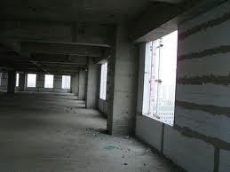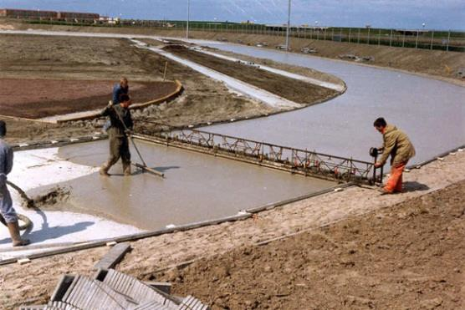
a
b

Figure 2. 1 Examples of Foam concrete applications a) insulation wall, b) running track sub-base (Shi et al., 2024)
Two applications of foam concrete are depicted in Figure 2.1. In the first, it is used as an insulation wall, which can make the building more energy efficient. In the second, it is used as a sub-base of a running track, an application where minimized strength is required. These diverse applications indicate that foam concrete has a large market potential as the energy efficiency and lower production costs become more important for its market acceptance. It is predicted that the use of foam concrete in industrial and civil buildings will be greatly expanded.

Previous research on foam concrete
Historically, researchers have paid much attention to chemical composition and physical properties (Guo et al., 2021; Jones & McCarthy, 2005; Sahraoui et al., 2025), mechanism of chemical reaction (Baldo et al., 2022; J. Li et al., 2018), and relationships between pore volume fraction and mechanical/thermal insulation properties of foam concrete (Erdogmus et al., 2023). Other researchers investigated stress distribution, failure mechanism (Alassane et al., 2025), creep and shrinkage, and cracking caused by shrinkage (Tu et al., 2024). All the research can be summarized as either the relationship between chemical composition and properties or the relationship between micro-structure and properties.
When the chemical composition is known, the final properties of foam concrete are dependent its structure. Most of previous models are related to the pore volume fraction, which means that if the pore volume fraction is known, thermal properties and mechanical properties can be deduced. This is based on the assumption that all void spaces are uniform in size and distribution and of a spherical shape. These models didn’t consider the influences of irregular pore shape and variable pore sizes on the final properties.

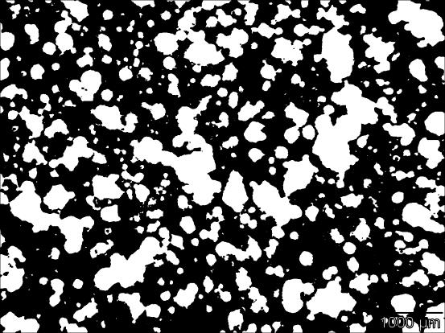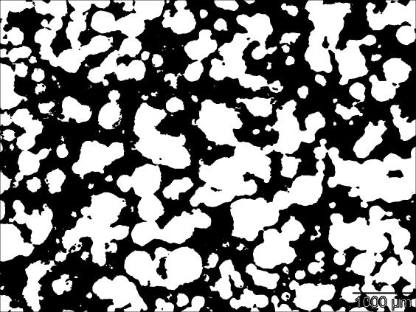
a
b
Figure 2. 2 Actual pore structure image of foam concrete1

A pore structural morphology of foam concrete is imaged in Figure 2.2, in which the white colour part represents for the porous regions and the black part represents for the matrix binder regions. In Figure 2.2 a), volume fraction of 13% is depicted and in Figure 2.2 b) volume fraction of 20% is depicted. These images demonstrate that the pore size ranges from 0.1mm to several mm, and as the pore volume fraction increases, the average pore size also increases.
It is also indicated in Figure 2.2 that the pore size is variable and the pore shape is not uniformly spherical. It is apparent that the volume fraction only doesn’t reflect the real pore structure of foam concrete, and that the roles of these irregular pores in affecting the properties need to be studied.
It becomes very useful to quantitatively and accurately describe the internal pores structure and to establish a relationship between the irregular pore structure and properties. The ability to design and control pore structure for high efficiency and low cost by using modelling approach instead of relying solely on the experimental method has significant advantage.
  - Thermal insulation property
Thermal insulation is one of the main applications for foam concrete. The thermal insulation ability depends on three factors: the heat conductivity, the density and the specific heat. The density of foam concrete can be readily obtained from its volume and mass, but the heat conductivity and the specific heat properties require some special facilities for their determination, which involves high cost. Therefore, the ability to theoretically calculate heat conductivity and the specific heat for foam concrete is highly desirable.

Challenges in current research
Although foam concrete has been developed for nearly 90 years (Song et al., 2024), many aspects remain to be investigated, such as light weight, thermal insulation and mechanical properties/weight ratio. New research needs to be based on appropriate understanding of the mechanisms of thermal, mechanical and physical/chemical behaviour of foam concrete from the micro-scale to macro-scale (Roobankumar & SenthilPandian, 2024).
More broadly, the research on foam concrete includes chemical composition design, pore structure design, creep and shrinkage mechanism, process optimization, and failure mechanisms (Du et al., 2024; Y. Li et al., 2025)
The two most important factors for foam concrete applications are thermal insulation and compressive strength. Therefore, the factors controlling these two properties and their interdependence are the primary focus of industries and researchers.
Consequently, the main emphasis of this foam concrete research is listed below:
- How can the pore structure features be quantitatively and accurately described?
- Can a relationship between irregular pore structure features and properties be established?
- Can an effective numerical design method be developed to control the pore structure that has low cost and high efficiency instead of traditional experimental methods?
Establishing relationships between void pore features and compressive strength/thermal insulation is a complex issue because pore features including pore shape, pore size and pore size distribution must all be considered (Y. Li et al., 2025). Researchers have found it difficult even to quantitatively describe pore features.

The status of heat transfer research
The existing heat transfer models for foam concrete neglect the inner radiation within the void pore. It is a difficult process to find a model that quantitatively considers not only macro-pore features but also inner radiation. The influences of pore features on heat transfer including conductivity, convection and radiation still remain to be established or modified. While the heat conductivity of foam concrete is a key parameter related to heat transfer, features of the existing modelling methodologies are provided in Figure 2.3.

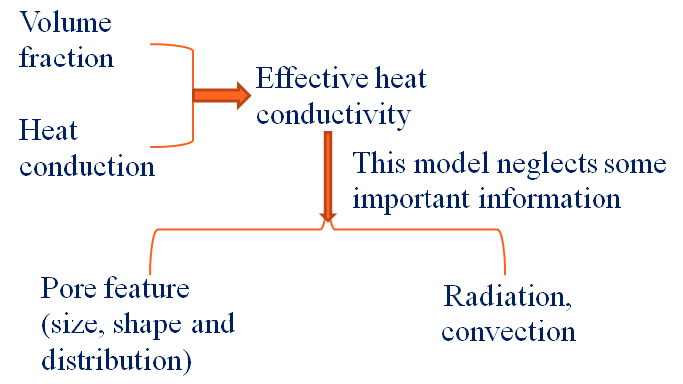
Figure 2. 3 Shortcomings of current heat conductivity method

As illustrated in Figure 2.3, the existing modelling methodology for the effective heat conductivity is based on pore volume fraction and heat conduction only, which neglects the impact of pore features, such as inner radiation and convection in void pore.

Compressive strength
Mechanical properties, especially compressive strength of foam concrete, decline as the void and pores volume fraction increases in general. However, there has been little quantitative relationship published to describe the influences of pore features on compressive strength as most of models focused on the relationship between pore volume fraction and compressive strength (Alassane et al., 2025). This reflects the difficulty in identifying and quantifying void pore features, such as pore size, size distribution, pore area fraction, and pore separation (Falliano et al., 2018).
- Experimental research

Many previous researchers have used the experimental approaches to study compressive strength (Decký et al., 2016; Erdogmus et al., 2023; Kadela et al., 2017; Zhuo et al., 2022). The experimental method is a direct way to provide a relationship between pores features in foam concrete and compressive strength, but at a higher cost than theoretical analysis and numerical simulation methods. Furthermore, the experimental method takes long times to get result due to concrete inherit slow-hardening properties. Moreover, results are always affected by experimental conditions, such as temperature, moisture content, curing time etc, all of which affect the precision of experimental results. At present, most research on foam concrete continues to use the experimental approach to study the relationship.
Because the pores in foam concrete are irregular shape and their size ranges from μm to mm (Jiang et al., 2024; Jones & McCarthy, 2005), the influence of pores size on compressive strength is difficult to quantify. Using EPS beads to replace the foam in foam concrete can directly study the size effect. Expanded polystyrene (EPS) has a spherical shape for which the radius can be selected by a sieving method, and it is easy to measure its size.
Further, EPS has far lower strength compared with concrete, and consequently can be regarded as pores embedded into concrete matrix. Therefore, using EPS beads to substitute for the pores in concrete is an effective way to study the pore size impact on compressive strength. Hence it can be regarded as an idealized material of uniform size in concrete.
EPS concrete is a kind of lightweight concrete in which EPS beads are embedded into cement paste to imitate void to reduce its density significantly. EPS concrete with low density and high thermal insulation properties arouses great interest from both industries and research institutes around the world for its potential wide applications. These include energy saving construction material, sub-base material for pavement and railway track beds, construction material for floating marine structures, energy absorbing material for the protection of buried military structures and fenders in offshore oil platforms (Guo et al., 2021; Jiang et al., 2024).

Although there are lots of advantages and potential applications, the mechanical properties of EPS concrete are one of the weaknesses (H. Zhang et al., 2021). In general, mechanical properties of EPS concrete declines as its density decreases. In the past decade, there were many researchers investigating to EPS concrete (Guo et al., 2021; Jiang et al., 2024; J. Li et al., 2018; Yuan et al., 2022) with many publications related to mechanical properties. The relationship between EPS beads and its mechanical properties would aid the design of EPS concrete to better fit these applications, especially density, heat insulation and mechanical properties.
Jiang et al. (2024) studied the size effect of EPS beads on the compressive strength and failure of EPS concrete. In their model, EPS beads were assumed to be distributed uniformly within the concrete, and then the damage initiation and distribution in the specimen were calculated. Their research work indicated that there was no size effect on the compressive strength. However, their model was just a 2D model that couldn’t reflect the 3D dimensional situation. Uniform distribution of EPS beads does not reflect real illustration. Decký et al. (2016) used the experimental method and numerical method to investigate the influences of size effect of EPS beads on compressive strength and reported that a difference of compressive strength between the big size and small size of EPS beads could reach 40% with the same density. They concluded that the finer EPS beads produced the higher compressive strength.
Baldo et al. (2022) studied the impact of size on the compressive strength using numerical fitting method, in which they utilised an exponent equation to describe the relationship among the EPS volume fraction, EPS size and compressive strength.
Baldo et al. (2022) studied the effect of size on the compressive strength of EPS concrete. Their work demonstrated that the fine polystyrene yielded the highest compressive strength and that crumbled polystyrene had the lowest compressive strength. In their paper, compressive strength was expressed as a power function of density corresponding to the three kinds of polystyrene. However, all the samples’ compressive strengths were less than 1 MPa, and the difference for
compressive strength between the fine polystyrene and large polystyrene samples was about 0.1~0.2 MPa.
Decký et al. (2016) investigated the effect of EPS on compressive strength, split tensile strength, moisture migration and absorption, for which they derived a fitting function between compressive strength and EPS concrete density. Their research didn’t explain from the influence of EPS bead size on the compressive strength.
There was also others research on the EPS structure (Decký et al., 2016), fabrication and physical properties (Yuan et al., 2022), and numerical simulation (Sahraoui et al., 2025).
Although there has been some research focused on the effects of EPS bead size on compressive strength, both theoretical and numerical methods are still necessary for quantitative EPS concrete research.
- Theoretical analysis method
Theoretical analysis is an economical means to research compressive strength. Many researchers have applied stress analysis method to the analyse of the failure models of concrete (Song et al., 2024). Although the theoretical analysis method is based on physical model, it requires strong mathematical skills and this method still has problem in dealing with complex structures and multi-axis stress state or 3-dimensional problems, which limits its application to simple structures.
- Numerical simulation method
Numerical simulation is a highly efficient and low cost researching method, which can also solve complex structural problems. Finite element method (FEM) is one of the most widely used numerical methods in the concrete field (Sahraoui et al., 2025). Others adopted FEM to study the influence of aggregates on failure (Song et al., 2024) and some researchers used FEM to study the impact of inner pore structures on the macro-scale stress-strain relationship (Y. Li et al., 2025). However, precise calculation by FEM depends on the meshed size of grid unit. Finer meshed size can make results more precise, but employs longer calculation time.
Artificial neural network is another widely used method. Some researchers have adopted an artificial neural network method to investigate the influences of chemical composition on compressive strength (Wang et al., 2024), others have adopted this method to study the shrinkage of concrete (Alassane et al., 2025). Additionally, there have been some researchers using this method to other aspects of concrete (Falliano et al., 2018; Ramamurthy et al., 2009). However, there is less research with this method on the relationship between pore features and compressive strength. Although artificial neural network is a highly efficiency research method, it uses mathematical method to establish the correlation between each input parameter and output results, which lacks the physical meaning to explain the correlation mechanism.
There are also other numerical simulation methods used in concrete field (Amran et al., 2022; Erdogmus et al., 2023), such as numerical fitting (Guo et al., 2021) and fractional factorial method(Valaskova et al., 2018). All these numerical simulation methods present researchers with an economic and efficient tool to quantitatively describe concrete problems. Hence, using numerical simulation together with experimental verification can save the research costs and enhance research efficiency.

PROPERTIES OF FOAMED CONCRETE
The properties of foamed concrete are diverse, ranging from fresh state properties, early age properties to hardened state properties. For the purpose of the current study and this literature review in particular, discussion will be confined to three significant properties, namely, workability in the fresh state, rate of hardening and instability in the early age stage. Of the range of properties in the hardened state, discussion will be confined to compressive strength, modulus of elasticity and microstructure. In addition, other related properties will also be cited in this review.

Fresh State Properties
The fresh state of all cement–based materials may be only transient, but it is of major importance to the ultimate performance in the hardened properties (Song et al., 2024; Xuquan et al., 2025)). However, in most reported research, the fresh state of cement-based materials is usually described by its characteristics.
Generally, the properties of foamed concrete are described as free-flowing, self-levelling and self- compacting (Alassane et al., 2025). In basic terms, the workability of foamed concrete containing relatively large amounts of air pores is generally excellent; it has nearly fluid consistency, is easily pourable, homogeneous and small possibility of bleeding and segregation. Additionally, foamed concrete is readily placed without need of further consolidation (Xuquan et al., 2025).
The term ‘workability’, as commonly described in normal concrete, is limited in definition and methods of measurement; however, the principles of rheology are more for describing the behaviour of fresh concrete (Song et al., 2024).
For this reason, the fresh state of foamed concrete is clarified in terms of workability (as universally described in all cement–based materials) and of the use of rheological properties as described by researchers such Wang et al. (2024), Jones & McCarthy (2005) and Decký et al. (2016). Whilst many studies have been conducted on rheology of cement-based materials (Baldo et al., 2022; J. Li et al., 2018; W. Zhang et al., 2025), to date, the literature on the rheology of foamed concrete is very limited.

Rheology
Rheology, the science of the deformation and flow of matter, is concerned with the relationships between stress, strain, rate of strain and time. As the rheology of cementitious material is closely related with developing performance of concrete, the rheology is considered one of the most important factors for all cement–based materials (W. Zhang et al., 2025). Rheology is important in understanding how cement paste, grout, mortar and concrete perform in practical applications and the scope it offers for characterising their properties (Baldo et al., 2022).
Foamed concrete behaves like a non-Newtonian which follows the Bingham model. In basic terms, the workability of foamed concrete containing relatively large amounts of air pores is generally excellent - easily pourable, nearly fluid consistency, homogeneous and without possibility of bleeding and segregation and readily placed without need of further bconsolidation (Kadela et al., 2017). Foamed concrete has the tendency to manifest reduced self- levelling in the very low density range, because of the reduced dead weight and the increased cohesion of the concrete arising from the high volume of air (W. Zhang et al., 2025). This statement confirms an earlier study by Jones and McCarthy (2005) who found that lower density foamed concrete exhibited highest apparent yield stress which they claimed could be attributed to the reduced self-weight, higher air content and lower water content. They also found that, within the range of densities studied (1000-1400 kg/m3), the plastic viscosities of the foamed concrete were small. However, foamed concretes with sand exhibited higher yield values than foamed concretes with fly ash at higher densities (1400- 1800 kg/m3). This was attributed to much larger and more angular shaped sand particles with smaller surface area.
Jones and McCarthy (2005) stated that yield values of foamed concrete are typically less than 2 Nm, which is indicative of self-flowing behaviour. Replacing sand with coarse fly ash reduced the yield value, as shown in Table 2.2 (McCarthy, 2004). With increased plastic density, this effect is increased. However, in plastic viscosity, the decrease is smaller with increased plastic density. The yield values were obtained by plotting speed, (rev/sec) against torque.
Therefore, reducing the filler mean size particle greatly reduces the yield stress necessary to get the mix flowing and produces a more fluid concrete due to rounded particle morphology (Tu et al., 2024). This permits effective particle packing, reducing water demand without decreasing fluidity of the mix (Y. Li et al., 2025). Additionally, they noted that fly ash particles are less reactive than cement; hence the retardation effect of fly ash results in decreased viscosity and yield stress of fly ash cement.
All these basic knowledge of rheological behaviour of foamed concrete will be further investigated in this study that will include the effect of different types of surfactants to the rheological properties.

Rate of hardening
There is no standard method for determining the initial and final setting times of foamed concrete, although the methods given in BS 4550:1978 and ASTM C266-89 for cements provided the basis of suitable methods for the preparation of foamed concrete (Guo et al., 2021).
In previous studies, stiffening for all foamed concrete mixes did not appear to take place until 5 hours after casting at 200C (Xuquan et al., 2025). As shown in Figure 2.6, all foamed concrete mixes achieved the set limits given in BS 4550: 1978 up to 9 to 10 hours. The 'setting' time of foamed concrete is usually between 12 and 24 hours. The amount of foam incorporated into the mix has an effect on the stiffening time of foamed concrete since foaming agents have chemical similarities to retarding admixtures. Consequently, the stiffening time is inversely proportional to foamed concrete density (Jones & McCarthy, 2005).
The average setting time of foamed concrete with a 1-day strength of 1.0 N/mm2 was between 12 and 24 hours, although this could be improved with rapid hardening cement types, insulating formwork, raising the ambient temperature or using accelerators (Roobankumar & SenthilPandian, 2024). Accelerators can be used to increase the slow rate of stiffening and strength development of foamed concrete. Since the mechanism for accelerated curing is not fully understood, its use can be recommended only on empirical basis. Calcium chloride is regarded as the most effective accelerator which can be used in most conditions in foamed concrete because carbon steel reinforcement is rarely used with foamed concrete, unlike typical reinforced concrete (Du et al., 2024).

Table 2.2: Typical rheology of sand and fine fly ash, FAf aggregate mixes, from (Alassane et al., 2025)
Plastic density kg/m3 | Yield Value, Nm* | Plastic Viscosity, Ns/m2
Plastic density kg/m3 | Sand FA Decrease,% | Sand FA Decrease, %
1400 | 0.82 0.44 46 | 0.034 0.025 26
1600 | 1.13 0.52 54 | 0.040 0.032 20
1800 | 1.80 0.69 62 | 0.051 0.045 12

- Assessed using Brookfield RVT Viscometer
- Nm* is the yield value obtained from plotting graph speed (rev/sec) against torque (N/m)
Shear Stress
Slope = Plastic Viscosity η

Yield Stress

Shear Rate

Figure 2.5: Bingham model

11
PC/PFA. Flow time 77s. 1600 kg/m3
PC/Sand. Flow time 76s. 1600 kg/m3 PC/Sand. Flow time 80s. 1800 kg/m3 PC/PFA. Flow time 95s. 1800 kg/m3

PC/PFA. Flow time 65s. 1400 kg/m3
PC/Sand. Flow time 72s. 1400 kg/m3
3.5 N/mm2 BS 5075 : Part I limit
0.5 N/mm2 BS 5075 : Part I limit

10

9
Calculated plunger stress (N/mm2)

8

7

6

5

4

3

2

1

0
0 1 2 3 4 5 6 7 8 9 10 11 12
Time (hours)

Figure 2.6: Comparison of stiffening times of various foamed concrete (Jones, 2001)

Stability
In order to understand the importance of stability in relation to other properties of foamed concrete, it is imperative to define stability. Stability is one of the variables of the definitions of workability and consistency in normal concrete. Stability is cited as the ability to resist segregation, a condition which refers to the cohesion of the mix and rarely used as an objective and quantifiable description of a concrete mix (Amran et al., 2022). In self-consolidating concrete, which is highly flowable and contains relatively low content of cementitious materials, stability is essential to ensure an adequate air void system (H. Zhang et al., 2021). The air void system has to remain stable during agitation, placement and setting.
Stability in foamed concrete had been described for fresh state conditions of two materials; preformed foam and foamed concrete (Du et al., 2024; Y. Li et al., 2025; Song et al., 2024; Xuquan et al., 2025). The inclusion of foam in foamed concrete raises the expectation that the stability of the foam will have a strong influence on the latter, particularly when the volume of foam to base mix becomes greater than 50% (Alassane et al., 2025). Larger bubble size and more open cells which are characteristics of foams produced by synthetic surfactants, are said to be less stable compared to foams produced from protein-based surfactants (Falliano et al., 2018). Additionally, the stability of the foam was found to be affected by surface charges, ‘free’ water content, fly ash and chemical admixtures (Jones & McCarthy, 2005).
Jones and McCarthy (2005) conducted a study that suggested that the stability of foamed concrete can be assessed by comparing the calculated and actual quantities of foam required to achieve a plastic density and by visual observation. In their study incorporating fly ash in foamed concrete mixes, the foam stability was found to be affected by the high fly ash content which had caused the foam to collapse. This resulted in additional ‘free water’ which, in turn, required higher foam volume to achieve the target plastic density. By contrast, (Li et al., 2018) initially defined stability of foamed concrete mix as the state of condition at which measured density is equal to or nearly equal to design density. In a later study, Li et al. (2025) defined stability of foamed concrete as ‘the state of the mix at which the density ratio is closer to unity’. They affirmed that the stability of foamed concrete depends on three factors: the foam volume, consistency of the base mix and filler type.
Whilst appreciating the variety of definitions of stability in foamed concrete, earlier definitions had been descriptive of the fresh state properties of both, preformed foam and foamed concrete. However, in this current study, stability is identified as a characteristic of early age properties of foamed concrete. This feature may be akin to the stability found in normal concrete explained by (Ramamurthy et al., 2009) as cohesion of the mix, that is, resistance to segregation that has meaning only under a given set of.
The ideal mix design of any fluid concrete is located somewhere between being fluid enough to flow and fill to having acceptable stability to resist segregation and deformations (Erdogmus et al., 2023). This is comparable to foamed concrete, where, in most applications it is expected to flow and self level. Investigations into the properties of foamed concrete have been based on assumptions in primary studies when its stability has not been called into question. The literature reflects an assumption that foamed concrete stability is beyond doubt. For example, it had been stated that foamed concrete is said to exhibit stable consistency with low plastic shrinkage (Guo et al., 2021) and one of the advantages of using foamed concrete is that foamed concrete does not collapse after placement as it sets (H. Zhang et al., 2021). However, only passing references to stability have been made, little attention has been paid to exploring the validity of assumptions about stability. Research has been incomplete in this respect.

In preliminary work, concerns have been expressed about instability in foamed concrete. Decký et al. (2016) suggested the water: cement (w/c) ratio of the base mix should be kept fairly high to avoid water being extracted from the foam thus causing it to collapse. Baldo et al. (2022) noted foam collapse during mixing and transporting although the degree of collapse is unpredictable and varies with mix constituents. Segregation is often checked as measure of instability (Jones & McCarthy, 2005).
The paucity of literature in this area reinforces the lack of concern about stability in the past. In one recent study, Roobankumar & SenthilPandian (2024) found that stability of foamed concrete is affected by the water content in the base mix, the amount of foam added and other solid ingredients in the mix. Although this single piece of research has examined the constituent materials, in order to expand our understanding of the behaviour of foamed concrete, it is necessary to consider other possible factors that affect the stability.
The purpose of the present study is to examine the nature, structure and production of foamed concrete in an attempt to identify causal factors that give rise to potential instability in foamed concrete. Additionally, this study examines the relationship of stability with other properties namely, rheology and microstructure.

Hardened State Properties

2.8.2.1 Compressive Strength
In the past, strength was not the main issue when using foamed concrete (W. Zhang et al., 2025) as it was typically used in void filling, highway reinstatement and other underground works. The typical strength value for foamed concrete of densities between 800 – 1000 kg/m3 is between 1 – 8 N/mm2 Shi et al. (2024) which was sufficient for its purpose in underground works. With a minimum strength of 25 N/mm2, foamed concrete has the potential to be used as a structural material (Jones and McCarthy, 2005). Based on this objective, several research projects were undertaken to study the possibility of increasing compressive strengths (Jones & McCarthy, 2005; Shi et al., 2024). The summary of properties of foamed concrete indicating the typical compressive strength as defined by BCA (1994) is shown in Table 2.3.
The compressive strength of foamed concrete is affected by the density, cement type and content, water/cement ratio, surfactant type and curing regime (Jones and McCarthy, 2005). Density has been shown to be directly related to compressive strength, where increases in density resulted in increases in compressive strength (Amran et al., 2022; Falliano et al., 2018; Shi et al., 2024). As illustrated in Figure 2.7, this is explained by the greater air content in lower density which makes the foamed concrete weaker (Kadela et al., 2017). However, density is not directly reliable as an indicator of strength or quality, when constituents of the foamed concrete vary (Decký et al., 2016).
Typically, as reported by Song et al. (2024) higher cement content resulted in increased strength of normal concrete. Similarly, in foamed concrete, Jones & McCarthy (2005) found that an increase in cement content increased the strength for a range of values although the strength increase was found to be minimal above cement content 500kg/m3. Thus, owing to this minimal strength gain, adhering to an acceptable minimum cement content is both economical and practicable (Song et al., 2024)
For a given density, different combinations of other cements and different cementitious fillers (coarse fly ash, conditioned fly ash, incinerator bottom ash, demolition fines, china clay, quarry fines and others) influenced the compressive strengths (Jones and McCarthy, 2005). Keeping other factors constant, finer sand showed an increase in strength compared to coarser sand (Wang et al., 2024), Figure 2.8. In Figure 2.9, Jones (2000) noted that when coarse fly ash was used as filler, the strength showed significant increase between 28 to 56 days compared to the strength achieved when sand was used in which case only a marginal increase in strength occurred after 28 days. In that particular study, it was observed that at any given density, the 28-day compressive strengths of fly ash foamed concretes were higher than sand foamed concretes. The difference was further increased after 56-days. Other researchers found similar trends when using fly ash as cement replacement and/or coarse fly ash as fillers (Du et al., 2024; Jones & McCarthy, 2005; Song et al., 2024). The effect of other cements such as ground granulated blast furnace and silica fume also influenced the compressive strengths and other properties of foamed concrete, for example, the consistency and stability (Highway Agency and TRL, 2001).
It is well established that in normal concrete decreases in w/c ratio cause significant increase in strength. However, this trend is not confirmed in foamed concrete in the current literature. W. Zhang et al. (2025) observed that w/c ratio was not only less significant, but that, the strength increased with increases in the w/c ratio. On the other hand, Shi et al. (2024) found that strength decreased with increasing w/c ratio up to 0.45, and noted that above this reading, the trend is reversed, that is, where the strength increased with an increase in the water/cement ratio.
The surfactant used is also important as it gives the foamed concrete its final properties (Erdogmus et al., 2023). Protein-based surfactants produced more stable, smaller and stronger bubble structure, hence higher strength foamed concrete compared to synthetic surfactants which produces bigger bubbles (Falliano et al., 2018; Jones & McCarthy, 2005; Shi et al., 2024)). This higher performance by protein surfactants can be attributed to the ability to take on water and hold it within the protein structure. This makes it somewhat absorbent which allows hydration process; hence cement particles are well-bonded around air bubbles. As a result, the mechanical strength of the air matrix is stronger (Guo et al., 2021).
The curing regime has a significant effect on the strength of foamed concrete. In their study, Kadela et al. (2017) noted that highest strengths were obtained on specimens cured at 500C, then sealed in plastic bags, and kept at constant temperature of 220C. By contrast, she further showed that specimens that were water-cured gave low strengths which were probably due to build-up of pore water pressure in the saturated microstructure of the foamed concrete. Because of the variations, a curing regime must be established to maintain quality control. By the same note, the strength of foamed concrete cannot be equated with autoclaved aerated concrete. Although the latter results in higher strength, these results are controlled by the requirements of factory autoclaving (Jones and McCarthy, 2005). Furthermore, steam curing is used in the precast industry to obtain the highest possible strength at lowest density in the shortest (Valaskova et al., 2018). A summary of the effects of these parameters on the compressive strength are shown in Figure 2.10.
Although strength is not an issue in many applications of foamed concrete (Baldo et al., 2022), it is a main characteristic which relates to other properties, hence the reason for the study of compressive strength in almost all research on foamed concrete.

CHAPTER THREE

RESEARCH METHODOLOGY

3.1. Materials
The primary raw materials used in this study included Portland Limestone Cement (PLC), fine aggregate (sand), hybrid stone dust, water, palm kernel oil (PKO), and sodium lauryl sulfate (SLS). PLC was the primary binder in foam concrete production. Fine aggregates, typically sand, were used in the foam concrete for their particulate properties and to assist in the cohesion of the mix. Water was mixed with the cement in specified proportions to achieve a workable mix consistency. PKO helped to stabilize foam in the concrete mixtures. SLS was used to create air bubbles and reduce the density of the material while maintaining its strength.
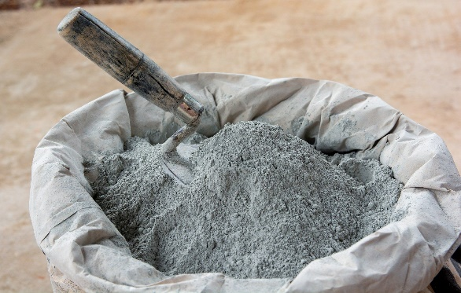 | 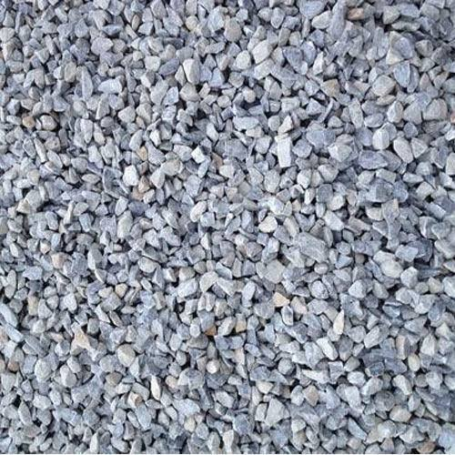
(a) | (b)
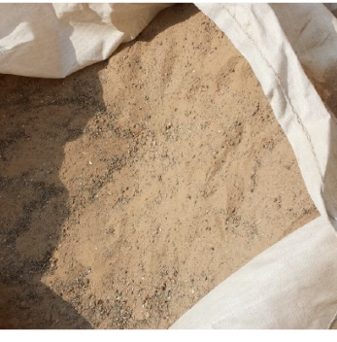 | 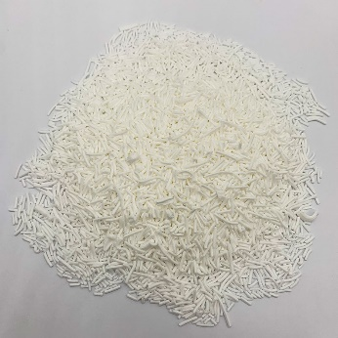
(c) | (d)
Fig. 3.1. Material appearance. (a) Portland limestone cement, (b) hybrid stone dust, (c) fine aggregate, (d) sodium lauryl sulfate.

3.1.1. Binder
The primary binder in foam concrete, known as cement, was sourced from a local supplier and conformed to the ASTM C150 standard for Portland limestone cement. The quality of the cement was checked for consistency in fineness, setting time, and compressive strength before use in the experiments. The physical and mechanical properties of the cement were presented in Table 3.1.
Portland limestone cement is a blend of clinker, limestone, and gypsum. The main chemical reactions during hydration are:
C₃S + H₂O → C-S-H + Ca(OH)₂​
Where:
C₃S (Tricalcium silicate)
C-S-H (Calcium-silicate-hydrate, the binding gel)
Ca(OH)₂ (Calcium hydroxide, also called Portlandite)
Table 3.1. Physical and mechanical properties of cement.
Properties | Results |  | Reference
Initial setting time (minute) | 100 | > 45 minutes | IQS: 5/1984
Final setting time (minute) | 320 | < 600 minutes | IQS: 5/1984
Fineness (Blaine m² /kg) | 300 | > 230 (m² /kg) | IQS: 5/1984
Soundness by Autoclave Method (%) | 0.02 | Not more than 0.8 | IQS: 5/1984
Compressive strength (MPa) |  |  | IQS: 5/1984
3 days | 21 | > 15 | IQS: 5/1984
7 days | 27 | > 2 | IQS: 5/1984

In addition, it is cheaper than other cement types such as high alumina cement, calcium sulfoaluminate cement and magnesium phosphate cement. Its chemical composition is given in Table 3.2.
Table 3.2. Chemical Composition.
Chemical composition of cement (%). | Reference
MgO 2.6 | ASTM C150
SiO₂ 18.7 | ASTM C150
Al₂O₃ 5.48 | ASTM C150
Fe₂O₃ 3.01 | ASTM C150
Na₂O 0.23 | ASTM C150
K₂O 1.22 | ASTM C150
SO₃ 3.25 | ASTM C150
CaO 62.3 | ASTM C150
Cl- 0.001 | ASTM C150
Loss on ignition 2.17 | ASTM C150
Insoluble residue 0.7 | ASTM C150

3.1.2. Fine Aggregates
A locally sourced river sand with particle sizes ranging from 0.075 mm to 4.75 mm was used. The sand was sieved and washed to remove impurities such as clay and organic matter to ensure quality. The grading was confirmed to conform to the requirements of ASTM C33 for fine aggregates.

3.1.3. Palm Kernel Oil
Palm Kernel Oil was used as a natural surfactant in foam concrete. PKO was derived from the seeds of the oil palm and was available from multiple suppliers in both raw and refined forms. The PKO used was sourced from a reputable supplier that provided oil suitable for industrial applications. The oil was filtered and stored in an airtight container to maintain its properties. The PKO was incorporated into the foam mix at varying concentrations to assess its impact on foam stability and concrete properties.

3.1.4. Water
Water used in the mix was potable and clean, sourced from a local supply, and in accordance with ASTM C94 standards for mixing concrete.

3.1.5. Sodium Lauryl Sulfate (foaming agent)
A commercial foaming agent, SLS, depending on the standard mix, was used to generate foam. The foaming agent was purchased from a supplier specializing in concrete additives, and its properties were verified according to ASTM C869 (Standard Specification for Foaming Agents). The foam produced by the agent was used in varying volumes to create foam concrete.

3.2. Methods
The methodology involved preparing foam concrete with varying concentrations of palm kernel oil and evaluating its properties. The experiments focused on assessing the impact of PKO on the foam stability, mechanical properties, and physical properties of foam concrete. The following outlined the key experimental procedures.

3.2.1. Mix Design Preparation
The first step in the experiment was preparing the foam concrete mix design. The mixes were prepared according to the following steps:
- The cement was weighed and mixed with fine aggregates (sand) at a specified weight ratio, typically 1:2 by weight of cement to sand, depending on the target density.
- Water was added in the amount necessary to achieve suitable workability for the mix. A water-to-cement ratio of 0.8 to 1.5 was used.
- The palm kernel oil was incorporated into the foaming agent at concentrations of 0%, 1%, and 1.5% by weight of cement. The PKO was mixed into the water phase of the foam concrete mix to ensure uniform distribution.
- The foaming agent was added in the correct amount to generate foam, which was then mixed with the slurry. The amount of foam was adjusted to achieve a target density (typically between 800 kg/m³ and 1,600 kg/m³) for the foam concrete.

3.2.2. Preparation of Foam
There are two primary techniques used in foam concreting: the pre-foaming method and the mix-foaming method. Both approaches regulate the mixing process and influence the quality of foamed concrete.
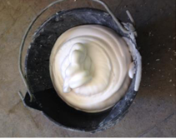
Fig. 3.2. Photograph of the foam generated.
The pre-foaming method was used and it involved separately producing the base mix and stabilizing the preformed aqueous foam before thoroughly integrating the foam into the base mix. The pre-formed foam was generated using wet method. The wet method generated foam by spraying the foaming agent solution through a fine mesh, producing bubbles typically ranging from 2 to 5 mm in size. However, wet foam was comparatively less stable than dry foam.

3.2.3. Mixing and Casting
Once the foam was prepared, it was carefully incorporated into the cement-sand-water mixture. The following procedure was used for mixing and casting:
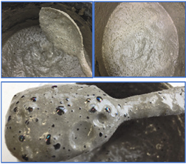
Fig. 3.3. Pictures depicting foam concretes incorporating foaming agent (SLS).
- The foam was gently folded into the wet mix to avoid collapsing the air bubbles in the foam.
- This step was critical to maintain the desired air content and stability of the foam. The resulting foam concrete was poured into molds of standard size (e.g., 150 mm × 150 mm × 150 mm for cube samples) and vibrated to ensure uniform distribution and minimal air pockets.
- The foam concrete was left to cure under standard conditions (ambient temperature of 20–25°C, with 60% humidity) for 24 hours before being demolded. The specimens were further cured in water for up to 28 days.

3.2.4. Testing of Foam Concrete
The various properties tests were carried out in the fresh state and after the foam concrete had been cured.

3.2.4.1. Slump Test
- Standard Code: ASTM C143 – The slump test was conducted in accordance with the Standard Test Method for Slump of Hydraulic-Cement Concrete.
- Procedure:
- A slump cone (base diameter: 200 mm, top diameter: 100 mm, height: 300 mm) was placed on a flat, non-absorbent surface.
- The cone was filled with foam concrete in three layers, each tamped 25 times with a standard tamping rod.
- After filling, the cone was carefully lifted vertically, allowing the concrete to slump under its own weight.
- The height difference between the original cone height and the highest point of the slumped concrete was measured to determine the slump value.

3.2.4.2. Thermal insulation Properties Test
The thermal insulation test was conducted under the following environmental conditions:
- Date of Test: 22th April 2025.
- Time of Exposure: 12:00 PM to 2:00 PM
- Location: I.O.T yard, Kwara State Polytechnic, Ilorin, Nigeria.
- Weather Condition: Clear skies with direct sunlight.
- Ambient Temperature: Ranged between 38°C and 42°C during the test.
To assess the thermal performance of the foam concrete, a cube specimen was exposed to direct sunlight under ambient outdoor conditions. The specimen was positioned on a flat, non-conductive surface to minimize heat loss through conduction to the ground. Temperature readings were taken at both the front (sun-exposed) and rear surfaces of the cube at regular intervals of 30 minutes using a digital infrared thermometer. This procedure was continued over a specified duration to monitor the progression of heat transfer through the material. The recorded data provided insight into the thermal insulating properties of the foam concrete and the influence of its composition on heat resistance.

3.2.4.3. Compressive Strength Test
- Standard Code: ASTM C39 – The compressive strength test was conducted in accordance with the Standard Test Method for Compressive Strength of Cylindrical Concrete Specimens.
- Procedure: Cube samples (150 mm x 150 mm x 150 mm) of foam concrete was tested for compressive strength after 7, 14, and 28 days of curing.
- The specimen was placed in a universal testing machine, and the load was applied gradually at a rate of 0.25 MPa/s until failure occurs. The compressive strength was calculated by dividing the maximum load by the cross-sectional area of the specimen.

3.3. Selected image of workplace moment

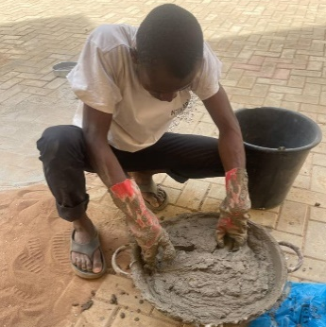 | 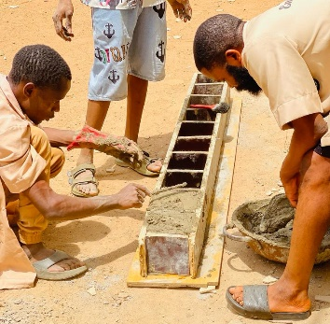 | 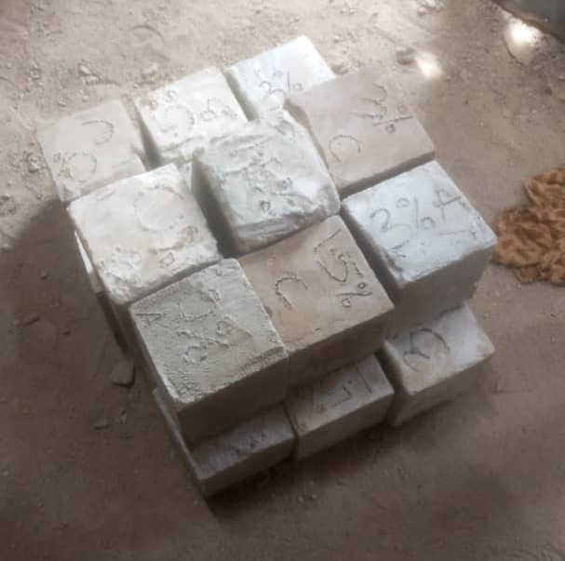
(a) | (b) | (c)
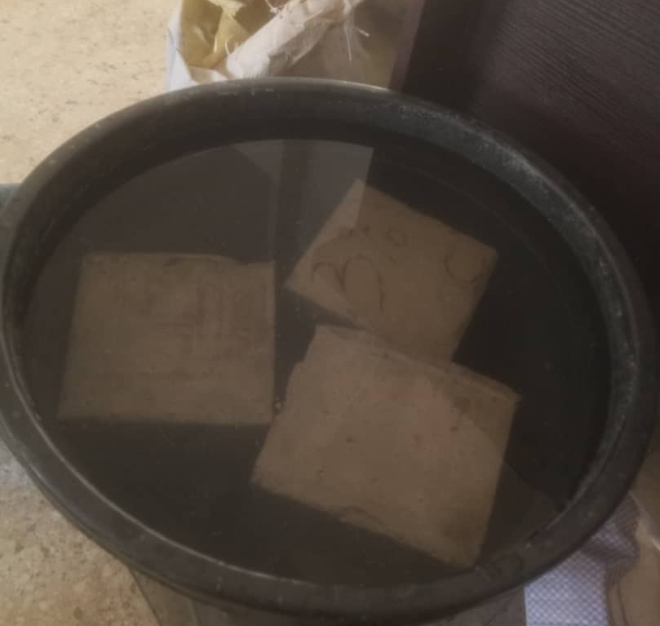 | 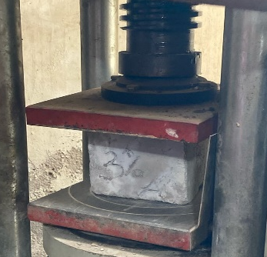 |   (g)
(d) | (e)
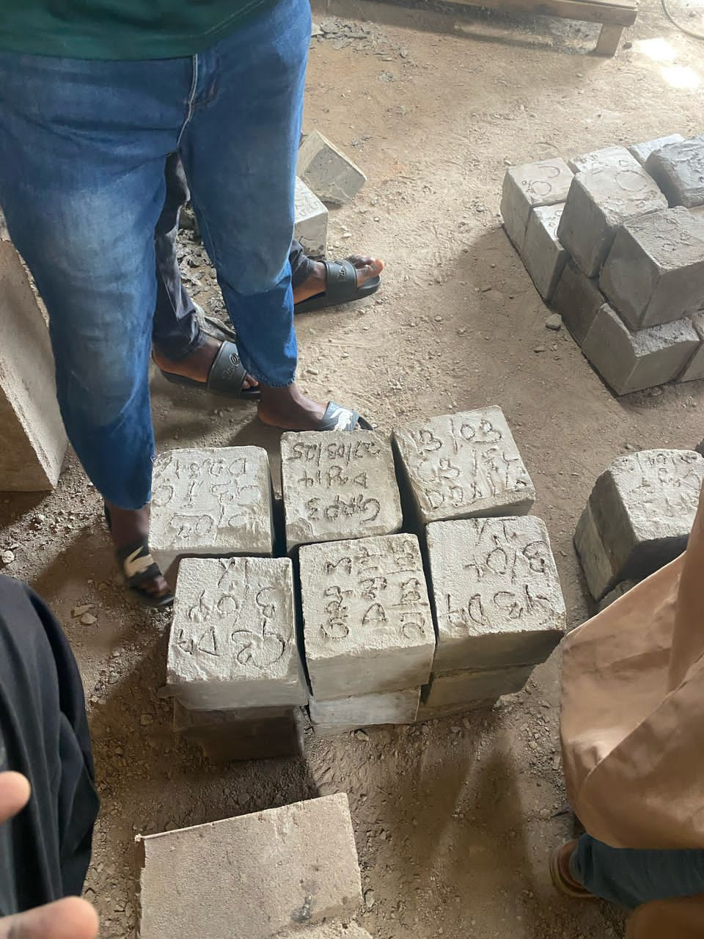
(f)
Fig. 3.4. Photographs (in alphabetical order from top left to bottom right) of the FC preparation, casting and testing phases in cubic shapes of 150mm side.

CHAPTER FOUR

RESULTS AND DISCUSSIONS

4.1. Properties of Hybrid Foam Concrete

4.1.1. Slump Test (Workability Test)
The slump test is carried out to evaluate the consistency and workability of freshly mixed concrete. The outcomes of this test serve as a reference for quality control during the proportioning and mixing, as well as for verifying conformity with specified requirements. In this project, concrete was batched by weight, and different proportions of PKO (0%, 0.5%, and 1%) were incorporated into the mix. A nominal mix ratio of 1:2 was used with a water-to-cement ratio of 0.8. The corresponding test results are presented in Table 4.1.
Table 4.1. Slump test
PKO Surfactant (%) | Wet weight of sample (g) | Dry weight of sample (g) | Water Absorption (%) | Slump Value (mm)
0 | 7001 | 6701 | 4.47 | 120
1.0 | 7150 | 6852 | 4.35 | 112
1.5 | 7280 | 6975 | 4.37 | 90

4.1.2. Thermal Insulation Performance
The thermal insulation property test is conducted on foam concrete to determine its ability to resist heat flow, which is a critical aspect of its performance in building applications. For this project, various cured concrete ages are tested which are incorporated with 1% of PKO and compared with conventional concrete.
The corresponding test results for the curing ages are presented in Tab1e 4.2.
Table 4.2. 7th, 14th and 28th Days Thermal Insulation Properties
Curing age (days) | Time (minutes) | Surface Temperature (ºC) | Opposite side Temperature (ºC) | Temperature Difference (ºC)
 | 0 | 27.00 | 27.00 | 0.00
 | 30 | 36.70 | 28.90 | 7.80
7 | 60 | 37.20 | 29.10 | 8.10
 | 90 | 40.20 | 30.50 | 9.70
 | 120 | 44.10 | 34.10 | 10.00
 | 0 | 27.00 | 27.00 | 0.00
 | 30 | 35.70 | 29.00 | 6.70
14 | 60 | 36.20 | 29.50 | 6.70
 | 90 | 38.80 | 31.20 | 7.60
 | 120 | 42.00 | 33.20 | 8.80
 | 0 | 27.00 | 27.00 | 0.00
 | 30 | 34.70 | 28.20 | 6.50
28 | 60 | 35.40 | 28.80 | 6.60
 | 90 | 38.20 | 31.10 | 7.10
 | 120 | 40.50 | 32.70 | 7.80
The corresponding test results obtain for Thermal insulation properties of conventional concrete is presented in Table 4.3.
Table 4.3. Thermal insulation properties of conventional concrete.
Curing age (day) | Time (minutes) | Surface Temperature (ºC) | Opposite side Temperature (ºC) | Temperature Difference (ºC)
 | 0 | 27.00 | 27.00 | 0.00
 | 30 | 37.40 | 30.00 | 7.40
28 | 60 | 40.60 | 32.50 | 8.10
 | 90 | 45.30 | 36.70 | 8.60
 | 120 | 52.00 | 42.20 | 9.80

Thermal insulation results obtained from the practical are given in the chart at Fig. 4.1. The more the day increases, the temperature value decreases.

Fig. 4.1.
The specimen containing foaming agent present a high thermal insulation performance. The temperature difference of hybrid foam concrete and conventional concrete is compared (Both cured for 28 days) In Fig. 4.2.

Fig. 4.2.

4.1.3. Compressive Strength Test
The compressive strength test is the most common test carried out on hardened concrete, because most of the desirable characteristics properties of concrete are qualitatively related to its compressive strength. The result of this test are used as a basis for quality control of concrete proportioning, mixing, placing operations and determination of compliance with specification. For this practical 150mmx150mmx150mm cube was use and the results are presented in Table 4.4.
Table 4.4. Compressive Strength of HFC cube at 7th, 14th and 28th days

Curing Age (Days) | Percentage of PKO (%) | Weight (g) | Failure Load (KN) | Compressive Strength (N/mm²) | Average Compressive Strength (N/mm²)
7 | 1 | 6801 | 40 | 1.778 | 1.8223
7 | 1 | 6853 | 42 | 1.867 | 1.8223
7 | 0.5 | 6977 | 47 | 2.089 | 2.045
7 | 0.5 | 6970 | 45 | 2.000 | 2.045
14 | 1 | 7015 | 50 | 2.222 | 2.311
14 | 1 | 7075 | 54 | 2.400 | 2.311
14 | 0.5 | 7094 | 55 | 2.444 | 2.556
14 | 0.5 | 7008 | 60 | 2.667 | 2.556
28 | 1 | 7281 | 70 | 3.111 | 3.000
28 | 1 | 7352 | 65 | 2.889 | 3.000
28 | 0.5 | 7377 | 72 | 3.200 | 3.134
28 | 0.5 | 7293 | 69 | 3.067 | 3.134

Fig. 4.3.

CHAPTER FIVE

CONCLUSION AND RECOMMENDATION

5.1. Conclusion
From the results obtained during this study, the following conclusion can be made;
- The slump test results showed a reduction in slump value with increasing PKO content, indicating decreased workability as PKO dosage increased. This suggests that while PKO improves other properties, it may reduce the ease of placement of the mix.
- HFC demonstrated improved thermal insulation performance over conventional concrete. The temperature difference between the surface and rare side of HFC increased with curing age, indicating better heat resistance. At 28 days, HFC showed significantly lower backside temperatures compared to conventional concrete, confirming its superior thermal performance.
- The compressive strength increased with higher PKO content and longer curing periods. HFC with 1% PKO surfactant achieved the highest average compressive strength of 3.0 N/mm² at 28 days, showing a steady gain in strength over time.

5.2. Recommendation
Based on the findings of this project, the following recommendations are made:
- A PKO dosage of 1% is recommended for achieving a balance between compressive strength and thermal insulation in foam concrete.
- Due to its enhanced thermal insulation, HFC is recommended for building applications in hot climates where thermal resistance is critical for indoor comfort and energy efficiency.
- Additional investigations should explore the long-term durability of HFC, including water permeability, shrinkage, and resistance to environmental degradation.
- Given the reduced workability at higher PKO levels, future studies may investigate incorporating superplasticizers or adjusting the water-cement ratio to improve workability without compromising performance.

REFERENCES
Alassane, C., Jean-Yves N’Zy, T. K., Klenam, D. E. P., Merenga, A. S., Asumadu, T. K., Obayemi, J. D., Rahbar, N., Migwi, C., & Soboyejo, W. O. (2025). Foam Concrete with Mineral Additives: From Microstructure to Mechanical/Physical Properties, Workability and Durability. Open Ceramics, 100812. https://doi.org/10.1016/j.oceram.2025.100812
Amran, M., Onaizi, A. M., Fediuk, R., Danish, A., Vatin, N. I., Murali, G., Abdelgader, H. S., Mosaberpanah, M. A., Cecchin, D., & Azevedo, A. (2022). An ultra-lightweight cellular concrete for geotechnical applications – A review. Case Studies in Construction Materials, 16. https://doi.org/10.1016/j.cscm.2022.e01096
Baldo, N., Rondinella, F., Daneluz, F., & Pasetto, M. (2022). Foamed Bitumen Mixtures for Road Construction Made with 100% Waste Materials: A Laboratory Study. Sustainability (Switzerland), 14(10). https://doi.org/10.3390/su14106056
Decký, M., Drusa, M., Zgútová, K., Blaško, M., Hájek, M., & Scherfel, W. (2016). Foam Concrete as New Material in Road Constructions. Procedia Engineering, 161, 428–433. https://doi.org/10.1016/j.proeng.2016.08.585
Du, X., Zhu, L., Li, Y., Wang, H., & Xu, K. (2024). Research on the damage evolution law of iron tailing sand based foam concrete under cyclic loading. Case Studies in Construction Materials, 21. https://doi.org/10.1016/j.cscm.2024.e04117
Erdogmus, E., Yaras, A., Ustaoglu, A., Hekimoğlu, G., Sarı, A., & Gencel, O. (2023). Thermal performance analysis of novel foam concrete composites with PCM for energy storage and environmental benefits in buildings. Energy and Buildings, 296. https://doi.org/10.1016/j.enbuild.2023.113413
Falliano, D., De Domenico, D., Ricciardi, G., & Gugliandolo, E. (2018). Experimental investigation on the compressive strength of foamed concrete: Effect of curing conditions, cement type, foaming agent and dry density. Construction and Building Materials, 165, 735–749. https://doi.org/10.1016/j.conbuildmat.2017.12.241
Guo, Y., Chen, X., Chen, B., Wen, R., & Wu, P. (2021). Analysis of foamed concrete pore structure of railway roadbed based on X-ray computed tomography. Construction and Building Materials, 273. https://doi.org/10.1016/j.conbuildmat.2020.121773
Jiang, L., Wang, K., Fang, H., Chen, B., Zhu, L., Zhang, Q., & Zhang, X. (2024). Protection performance of a novel anti-collision guardrail with recycled foamed concrete under vehicle collision. Engineering Structures, 305. https://doi.org/10.1016/j.engstruct.2024.117795
Jones, M. R., & McCarthy, A. (2005). Utilising unprocessed low-lime coal fly ash in foamed concrete. Fuel, 84(11), 1398–1409. https://doi.org/10.1016/j.fuel.2004.09.030
Kadela, M., Kozłowski, M., & Kukiełka, A. (2017). Application of Foamed Concrete in Road Pavement - Weak Soil System. Procedia Engineering, 193, 439–446. https://doi.org/10.1016/j.proeng.2017.06.235
Li, J., Huang, H., Wang, W., & Ding, Y. (2018). Compressive Properties and Anti-Erosion Characteristics of Foam Concrete in Road Engineering. IOP Conference Series: Earth and Environmental Science, 108(2). https://doi.org/10.1088/1755-1315/108/2/022066
Li, Y., Wei, J., Han, A., Xu, Y., Qiao, M., & He, D. (2025). Influence of geopolymer foam concrete on the mechanical performance of cold-formed steel built-up columns. Case Studies in Construction Materials, 22. https://doi.org/10.1016/j.cscm.2025.e04479
Ramamurthy, K., Kunhanandan Nambiar, E. K., & Indu Siva Ranjani, G. (2009). A classification of studies on properties of foam concrete. Cement and Concrete Composites, 31(6), 388–396. https://doi.org/10.1016/j.cemconcomp.2009.04.006
Roobankumar, R., & SenthilPandian, M. (2024). A review of utilization of waste polyurethane foam as lightweight aggregate in concrete. In Heliyon (Vol. 10, Issue 23). Elsevier Ltd. https://doi.org/10.1016/j.heliyon.2024.e40479
Sahraoui, M., Laouissi, A., Karmi, Y., Hammoudi, A., Hani, M., Chetbani, Y., Belaadi, A., Alshaikh, I. M. H., & Ghernaout, D. (2025). AI-Driven predicting and optimizing lignocellulosic sisal fiber-reinforced lightweight foamed concrete: A machine learning and metaheuristic approach for sustainable construction. Results in Engineering, 26. https://doi.org/10.1016/j.rineng.2025.105561
Shi, X., Ning, B., Wang, J., Cui, T., Zhao, W., & Li, A. (2024). Impact resistance of polyvinyl alcohol-polypropylene fiber toughened foamed concrete under low-velocity impact: experiments and 3D meso-scale modelling. Case Studies in Construction Materials, 21. https://doi.org/10.1016/j.cscm.2024.e03976
Song, Q., Zou, Y., Xu, S., Yang, Y., Bao, J., Xue, S., Zhang, P., & Sun, M. (2024). Performance study of foam concrete prepared by the synergistic utilization of agricultural waste and coal gangue based on double orthogonal experiments. Case Studies in Construction Materials, 21. https://doi.org/10.1016/j.cscm.2024.e03677
Tu, Q. C., Xia, Q. H., & Bai, Y. H. (2024). Preparation of coal gangue foam concrete modified by nanomaterials: Physical properties, pore structure, and electromagnetic properties. Case Studies in Construction Materials, 21. https://doi.org/10.1016/j.cscm.2024.e03603
Valaskova, V., Vlcek, J., & Drusa, M. (2018). Experimental and computational dynamic analysis of the foam concrete as a sub-base layer of the pavement structure. MATEC Web of Conferences, 211. https://doi.org/10.1051/matecconf/201821113002
Wang, X., Jin, Y., Ma, Q., & Li, X. (2024). Performance and mechanism analysis of natural fiber-reinforced foamed concrete. Case Studies in Construction Materials, 21. https://doi.org/10.1016/j.cscm.2024.e03476
Xuquan, H., Yuhao, Haojie, W., Xiuqing, X., Chunbiao, Q., Fei, X., & Xiaorong, Z. (2025). Recycle sludge incineration ash for efficient preparation of foam concrete: Performance, microstructure, and mechanisms. Next Sustainability, 6, 100125. https://doi.org/10.1016/j.nxsust.2025.100125
Yuan, X., Lu, Z., Yao, H., Tan, X., Zhao, Y., Tang, C., Cheng, M., & Gao, Y. (2022). Engineering Properties and Applications of Air-Foamed Lightweight Soil. In Advances in Materials Science and Engineering (Vol. 2022). Hindawi Limited. https://doi.org/10.1155/2022/4967037
Zhang, H., Liu, M., Shuo, Z., Zhao, Z., Sun, Y., Song, X., Wang, H., Zhang, X., & Wu, J. (2021). An experimental investigation of the triaxial shear behaviors of silt-based foamed concrete. Case Studies in Construction Materials, 15. https://doi.org/10.1016/j.cscm.2021.e00713
Zhang, W., Liu, D., Tang, Y., Cao, K., & Yang, C. (2025). An intelligent approach for predicting strength of roadbed foam lightweight concrete based on optimized XGBoost model. Case Studies in Construction Materials, 22. https://doi.org/10.1016/j.cscm.2025.e04702
Zhuo, Z., Ali, A., Zhu, C., Mehta, Y., Lein, W., DeCarlo, C., Elshaer, M., & Kennedy, D. (2022). Evaluating the potential of using foamed concrete as the insulation layer for pavements in cold regions. Construction and Building Materials, 341. https://doi.org/10.1016/j.conbuildmat.2022.127903

