

PROJECT REPORT
ON
DIGITAL MAPPING OF INFRASTRUCTURAL FACILITIES OF ROYAL VALLEY ESTATE
AT KULENDE / AKEREBIATA ROAD, SANGO, ILORIN
ILORIN EAST LOCAL GOVERNMENT AREA
KWARA STATE

BY
ADEYEMO MARIAM OMOWUMI
HND/23/SGI/FT/0095

SUBMITTED IN PARTIAL FULFILMENT OF THE REQUIREMENTS FOR THE AWARD OF HIGHER NATIONAL DIPLOMA IN SURVEYING AND GEO-INFORMATICS TO THE DEPARTMENT OF SURVEYING AND GEO-INFORMATICS, KWARA STATE POLYTECHNIC ILORIN, KWARA STATE

JUNE, 2025

CERTIFICATION
I hereby certify that the information contained in this project report was obtained as a result of the observations and measurements made by me on the field and that the survey was done in accordance with survey rules, regulations, and departmental instructions.

ADEYEMO MARIAM OMOWUMI HND/23/SGI/FT/0095 NAME OF STUDENT MATRIC NUMBER

CERTIFICATION
This is to certify that ADEYEMO MARIAM OMOWUMI with matriculation Number HND/23/SGI/FT/0095 has satisfactory carried out the survey duties contained in this project report under our direct supervision.
I hereby declare that He had conducted himself with due diligence, and honest on the project.

SURV. R.S. AWOLEYE DATE
Project Supervisor

SURV. A I ISSAU DATE
Head of Department

……………………………………………….
Official Stamp
DEDICATION
This project is dedicated to Almighty God who has been there right from the beginning to this very point. Special dedication also to my ever-supportive parents, MR / MRS ADEYEMO, for their relentless support and compassion towards me and during the course of my study.

ACKNOWLEDGEMENT
The dream of becoming an achiever in life comes true, not only by one’s fortitude and hard work based on his knowledge, but it is also involving the positive influence of various factors and ideas of some people in the community.
First and foremost, all glory, honor and adoration is to Almighty God. I appreciate God for his grace upon my life, for keeping me safe since my advent in this school and most especially, during the execution of this project.
I sincerely wish to express my affectionate gratitude to my lovely and caring parent MR&MRS. ADEYEMO whose toils and struggles have helped a lot in transforming my life for better may Almighty God grant them long life to enable her reap the fruits of their labour.
My next gratitude goes to my supervisor, SURV. R.S. AWOLEYE for his useful guidance, understanding, patience, and professional advice during the execution of this project that led to the successful completion of the exercise. I pray that God will continue to bless you (Amen). More so, my appreciation goes to my able HOD SURV. ISSAU and other lecturers in the Department of Surveying and Geo-informatics most especially God bless you all (Amen).
Finally, I thanks my family and friends like ADEYEMO ABDULMALIK, ADEYEMO FAUSIAT, ADEYEMO NOFISAT and all my classmates UTHMAN BADIRA, ADEKANBI BIMBO, OKUNOYE NAFISAT for their support, advice and encouragement and understanding throughout this journey, I really appreciate you all.

ABSTRACT
This project focuses on developing a digital mapping system for infrastructural facilities in HND institutions, utilizing Geographic Information Systems (GIS) and mobile mapping technologies. The system aims to provide accurate and precise mapping of facilities, enhancing management, planning, and decision-making. By leveraging GIS and mobile mapping, the project seeks to improve infrastructure management, sustainability, and resilience in line with Sustainable Development Goal 9.

TABLE OF CONTENTS

CERTIFICATION II
CERTIFICATION III
ACKNOWLEDGEMENT V
ABSTRACT VI
TABLE OF CONTENTS VII
CHAPTER ONE 8
INTRODUCTION 8
1.1 INTRODUCTION 8
1.2 STATEMENT OF THE PROBLEM 9
1.3 OBJECTIVES OF THE PROJECT 10
1.4 SCOPE OF THE PROJECT 11
GEOGRAPHICAL SCOPE 11
THEMATIC SCOPE 11
1.5 PERSONNEL 12
1.6 STUDY AREA 12
1.6.1 GEOGRAPHICAL FEATURES 14
1.6.2 SOCIO-ECONOMIC CHARACTERISTICS 14
1.7 RELEVANCE TO THE STUDY 15
CHAPTER TWO 16
LITERATURE REVIEW 16
2.1 INTRODUCTION 16
2.2 CONCEPT OF INFRASTRUCTURE 16
2.2.1 DEFINITION OF INFRASTRUCTURE 16
2.2.2 CATEGORIES OF INFRASTRUCTURAL FACILITIES 17
2.3 CONCEPT OF DIGITAL MAPPING 17
2.3.1 DEFINITION OF DIGITAL MAPPING 17
2.3.2 HISTORICAL EVOLUTION OF MAPPING TECHNOLOGIES 18
2.3.3 ADVANTAGES OF DIGITAL MAPPING OVER TRADITIONAL MAPPING 18
2.4 GEOGRAPHIC INFORMATION SYSTEMS (GIS) AND INFRASTRUCTURE MANAGEMENT 19
2.4.1 DEFINITION AND COMPONENTS OF GIS 19
2.4.2 ROLE OF GIS IN DIGITAL MAPPING 19
2.4.3 IMPORTANCE OF GIS FOR INFRASTRUCTURE PLANNING AND MONITORING 20
2.5 TECHNIQUES FOR DIGITAL MAPPING OF INFRASTRUCTURAL FACILITIES 20
2.5.1 FIELD SURVEYING 20
2.5.2 REMOTE SENSING 21
2.5.3 MOBILE GIS AND SMART DATA COLLECTION 22
2.5.4 USE OF GEOGRAPHIC INFORMATION SYSTEMS (GIS) SOFTWARE 22
2.5.5 DATA VALIDATION AND QUALITY CONTROL 23
2.6 IMPORTANCE OF DIGITAL MAPPING IN URBAN PLANNING AND DEVELOPMENT
2.6.1 ENHANCING DECISION-MAKING PROCESSES 24
2.6.2 INFRASTRUCTURE MANAGEMENT AND MAINTENANCE 24
2.6.3 FACILITATING SUSTAINABLE URBAN GROWTH 24
2.6.4 EMERGENCY PLANNING AND DISASTER MANAGEMENT 25
2.6.5 PROMOTING TRANSPARENCY AND PUBLIC ENGAGEMENT 25
2.7 CHALLENGES ASSOCIATED WITH DIGITAL MAPPING OF INFRASTRUCTURE 25
2.7.1 DATA COLLECTION CHALLENGES 25
2.7.2 FINANCIAL CONSTRAINTS 26
2.7.3 TECHNICAL EXPERTISE AND CAPACITY BUILDING 26
2.7.4 DATA MAINTENANCE AND UPDATING 26
2.7.5 LEGAL AND ETHICAL CONSIDERATIONS 27
2.7.6 ENVIRONMENTAL AND TECHNICAL FACTORS 27
2.8 CASE STUDIES ON DIGITAL MAPPING PROJECTS (GLOBAL AND NIGERIAN EXAMPLES) 27
2.8.1 GLOBAL CASE STUDIES 27
2.8.1.1 SMART CITY MAPPING IN SINGAPORE 28
2.8.1.2 DISASTER MANAGEMENT IN JAPAN 28
2.8.1.3 DIGITAL MAPPING IN URBAN RENEWAL – NEW YORK CITY, USA 28
2.8.2 NIGERIAN CASE STUDIES 29
2.8.2.1 LAGOS STATE URBAN DEVELOPMENT 29
2.8.2.2 FEDERAL GOVERNMENT OF NIGERIA – NATIONAL INFRASTRUCTURE MAPPING 29
2.9 REVIEW OF PREVIOUS STUDIES RELATED TO THE STUDY AREA (ILORIN/KWARA) 30
2.9.1 URBANIZATION AND INFRASTRUCTURE DEVELOPMENT IN ILORIN 30
2.9.2 INFRASTRUCTURE MAPPING AND MAINTENANCE IN ILORIN 30
2.9.3 GIS APPLICATION IN ENVIRONMENTAL MANAGEMENT 30
CHAPTER THREE 32
3.0 METHODOLOGY 32
3.1 DATABASE DESIGN 32
3.1.1 VIEW OF REALITY 32
FIG. 3.1 DESIGN AND CONSTRUCTION PHASES IN SPATIAL DATABASE 33
3.1.2 CONCEPTUAL DESIGN 34
FIG. 3.2.: E-R DIAGRAM (ENTITY RELATIONSHIP DIAGRAM) 34
3.1.3 LOGICAL DESIGN 35
3.1.4 PHYSICAL DESIGN 35
TABLE 3.2: ROAD AND ITS ATTRIBUTES 36
3.2 RECONNAISSANCE 36
3.2.1 OFFICE PLANNING 37
TABLE 3.4 COORDINATES OF CONTROLS 37
3.2.2 FIELD RECONNAISSANCE 37
FIG. 3.3: RECCE DIAGRAM OF THE STUDY AREA (NOT DRAWN TO SCALE). 38
3.3 EQUIPMENT USED/ SYSTEM SELECTION AND SOFTWARE 39
3.3.1 HARDWARE USED 39
3.3.2 SOFTWARE COMPONENT 39
3.4 INSTRUMENT TEST 40
3.4.1 HORIZONTAL COLLIMATION TEST 40
FIG 3.4: HORIZONTAL COLLIMATION AND VERTICAL INDEX ERROR TEST. 40
3.4.2 VERTICAL INDEX ERROR TEST 41
TABLE 3.6: VERTICAL INDEX DATA 41
3.4.3 ANALYSIS OF COLLIMATION AND VERTICAL INDEX DATA 41
3.5 CONTROL CHECK 42
TABLE 3.7: SHOWING THE BACK COMPUTATION OF THE CONTROL COORDINATES…………………………………………………………………………………...42 TABLE 3.8: SHOWING THE BACK COMPUTATION OF THE CONTROL COORDINATES………………………………………………………………………………….. 42
TABLE 3.9 SHOWING THE OBSERVATION RESULT OF THE CONTROL CHECK 42
3.6 MONUMENTATION 43
3.7 DATA ACQUISITION 44
PRIMARY DATA SOURCE 44
3.7.1 GEOMETRIC DATA ACQUISITION 44
3.7.2 ATTRIBUTES DATA ACQUISITION 45
3.8 DATA DOWNLOADING AND PROCESSING 45
3.8.1 DATA DOWNLOADING AND EDITING 45
3.8.2 DATA PROCESSING AND DATA EDITING 46
3.8.3 DATA PROCESSING USING ARCGIS 10.3 46
3.8.4 TOPOGRAPHICAL MAP (DEM) 47
EDITING, CONVERTING AND MERGING GEODATABASE 50
ADDING SPOT HEIGHTS DATA 50
TIN, ASPECT AND SLOPE CREATION USING ARCMAP 51
TO CHANGE THE FACE OF THE TIN ACCODING TO ITS ELEVATION 51
TO CREATE ASPECT 51
3.8.5 FACILITY MAP PRODUCTION 51
3.8.6 3D MAP PRODUCTION 52
3.8.7 FINDINGS 53
3.8.8 ATTRIBUTE DATA CREATION 55
TABLE 3.10: BUILDING 56
TABLE 3.12: TREES 56
3.8.9 DATABASE IMPLEMENTATION 57
3.8.10 DATABASE MANAGEMENT SYSTEMS 57
3.8.11 DATABASE MAINTENANCE 58
3.8.12 AREA COMPUTATION TABLE 58
CHAPTER FOUR 60
4.0 SPATIAL ANALYSES AND PRESENTATION 60
4.1 TESTING OF DATABASE 60
4.11 ANALYSIS OF RESULT 60
SINGLE SELECTION CRITERION 61
61
FIG 4.1: SHOWS THE COMPLETED BUILDING 61
61
FIG 4.2: SHOWS THE 2D COMPLETED BUILDING 62
FIG 4.4 QUERY SHOWS THE 2D OF UNCOMPLETED BUILDING 63
63
FIGURE 4.5 SHOWS THE 3D OF UNCOMPLTED BUILDING 63
CHAPTER FIVE 64
5.0 COSTING ESTIMATION, SUMMARY, CONCLUSION, RECOMMENDATION AND PROBLEM ENCOUNTERED 64
5.1 COSTING ESTIMATION 64
5.2 SUMMARY 70
5.3 CONCLUSION 71
5.4 RECOMMENDATIONS 72
5.5 PROBLEMS ENCOUNTERED 72
REFERENCES 74

CHAPTER ONE

INTRODUCTION

1.1 Introduction
Infrastructural development forms the backbone of any modern society. From transportation networks and water supply systems to energy distribution and healthcare facilities, infrastructure supports the daily lives of citizens and fosters economic growth. In the 21st century, the rapid expansion of urban areas and the increasing demand for efficient service delivery have necessitated the adoption of advanced technologies to plan, manage, and monitor infrastructural assets effectively. One of the most transformative technologies in this regard is digital mapping.
Digital mapping refers to the process of creating electronic maps through the collection, analysis, and visualization of spatial data. Unlike traditional cartography, which relies heavily on manual drawings and static representations, digital mapping utilizes Geographic Information Systems (GIS), satellite imagery, remote sensing, and various data integration techniques to produce dynamic, interactive, and scalable maps. These maps are capable of displaying real-time information, facilitating informed decision-making for urban planners, engineers, government agencies, and private sector stakeholders.
The digital mapping of infrastructural facilities specifically focuses on capturing the locations, conditions, and characteristics of assets such as roads, bridges, water pipelines, power lines, hospitals, schools, and communication networks. By leveraging digital tools, stakeholders can gain a comprehensive understanding of infrastructural distribution, identify gaps, monitor performance, and plan upgrades or expansions with greater precision.
The relevance of digital mapping has been magnified by the challenges posed by rapid urbanization, climate change, and the increasing complexity of infrastructural systems. Traditional methods of infrastructure management, often hampered by incomplete data and slow update cycles, are no longer sufficient to meet contemporary demands. Digital mapping provides a solution by offering an up-to-date, flexible, and highly detailed view of infrastructural landscapes.
Moreover, the integration of digital mapping with emerging technologies such as Artificial Intelligence (AI), the Internet of Things (IoT), and Big Data Analytics is opening new frontiers for smart infrastructure management. Predictive maintenance, disaster resilience planning, and service optimization are becoming possible on a scale and with an efficiency that was unimaginable just a few decades ago.

Given these developments, this project aims to explore the methodologies, benefits, challenges, and applications of digital mapping in the context of infrastructural facilities. By focusing on a specific study area, the project will demonstrate the practical steps involved in mapping, analyzing, and interpreting infrastructural data in a digital environment.
This first chapter sets the stage for the entire project by introducing key concepts, identifying the problem that necessitates the study, outlining the objectives, defining the scope of work, and describing the geographical and socio-economic characteristics of the study area.

1.2 Statement of the Problem
Infrastructure serves as the physical framework that supports economic activities, social services, and community wellbeing. However, many regions, especially in developing countries, face significant challenges related to the management and maintenance of infrastructural facilities. Problems such as unplanned urban growth, inefficient resource allocation, aging infrastructure, and lack of real-time data are common.
One of the fundamental issues is the absence of accurate, updated, and easily accessible data on existing infrastructural assets. Traditional inventory methods are often labor-intensive, prone to human error, and incapable of capturing dynamic changes. Consequently, authorities struggle with planning maintenance, responding to emergencies, or designing expansion projects in a timely and cost-effective manner.
The problem is further compounded by the lack of integration between different infrastructural sectors. Water supply systems, electrical grids, transportation networks, and telecommunication facilities often operate in silos, leading to redundancy, resource wastage, and missed opportunities for synergy.
Additionally, infrastructure is vulnerable to natural disasters, vandalism, and deterioration over time. Without proper monitoring mechanisms, minor issues can escalate into major failures, resulting in service disruptions, economic losses, and even loss of lives. Accurate digital maps can play a crucial role in risk assessment, emergency preparedness, and infrastructure resilience planning.
Another major gap is in citizen engagement and transparency. Communities often lack information about the infrastructural facilities available to them or about ongoing government projects. Digital mapping, especially when made accessible through public platforms, can bridge this gap by enhancing transparency, promoting accountability, and empowering citizens.
Given these challenges, there is an urgent need for a robust system that can capture, manage, and disseminate infrastructural data effectively. Digital mapping offers such a solution, yet its adoption remains limited in many areas due to technical, financial, and institutional barriers.
This project, therefore, seeks to address these issues by demonstrating how digital mapping can be applied to accurately document and analyze infrastructural facilities within a defined study area. The project will highlight the processes, tools, and outcomes associated with digital mapping, ultimately providing a model that can be replicated or scaled up for broader applications.

1.3 Objectives of the Project
The main objective of this project is to develop a comprehensive digital map of infrastructural facilities within a selected study area, thereby providing a powerful tool for planning, management, and decision-making.
Specifically, the project aims to:
- Identify and catalog all major infrastructural facilities within the study area, including transportation networks, water and sanitation systems, energy distribution facilities, healthcare centers, educational institutions, and communication infrastructures.
- Utilize Geographic Information Systems (GIS) and other digital tools to create detailed, accurate, and interactive maps representing the location, condition, and attributes of these facilities.
- Analyze spatial patterns and relationships among different types of infrastructure to identify areas of deficiency, overlap, or potential improvement.
- Demonstrate the potential benefits of digital mapping in infrastructure planning, management, maintenance, and disaster resilience.
- Provide recommendations for the integration of digital mapping into local government infrastructure management systems and decision-making processes.
- Highlight challenges encountered in the digital mapping process and propose solutions or strategies for overcoming them.
- Raise awareness among stakeholders, including policymakers, urban planners, private developers, and citizens, about the importance of up-to-date infrastructural data.

1.4 Scope of the Project
The scope of this project is defined both geographically and thematically to ensure focused and manageable outcomes.

Geographical Scope
The project will focus on a defined study area (to be described in detail in Section 1.5). The area will be selected based on criteria such as urbanization level, infrastructural diversity, data availability, and relevance to broader regional development goals. The size of the area will be such that detailed mapping and analysis are feasible within the project timeframe and resource constraints.

Thematic Scope
Thematically, the project will cover a broad range of infrastructural facilities, including:
- Transportation networks: roads, bridges, railways, bus terminals, airports (where applicable).
- Water infrastructure: pipelines, treatment plants, reservoirs, wells, drainage systems.
- Energy facilities: electricity distribution lines, substations, power plants (if applicable).
- Educational institutions: primary, secondary, and tertiary schools.
- Healthcare facilities: clinics, hospitals, health centers.
- Communication infrastructure: telecommunications towers, internet hubs.
- Waste management infrastructure: landfill sites, recycling centers, waste treatment facilities.
The project will involve activities such as:
- Data collection through field surveys, existing records, and satellite imagery.
- Data integration and management using GIS platforms.
- Data analysis to uncover spatial patterns and infrastructural gaps.
- Map production, including thematic maps and integrated infrastructure maps.
- Reporting and dissemination of findings.
The project will not delve deeply into the financial, legal, or policy aspects of infrastructure development but will instead focus on the technical and analytical dimensions of digital mapping.

1.5 Personnel
The successful execution of this project titled "Digital Mapping of Infrastructural Facilities in Royal Valley Estate, Sango, Ilorin, Kwara State" was made possible through the collective efforts of dedicated students from the Higher National Diploma (HND) II, 2024/2025 Set.
The personnel who actively participated in the fieldwork, data collection, data analysis, digital mapping, and compilation of this report are listed below:

1.6 Study Area
The study area for this project is Royal Valley Estate, located in Sango within Ilorin South Local Government Area, Kwara State, Nigeria. Royal Valley Estate represents a growing residential community that has witnessed rapid development in recent years, making it a suitable and relevant location for a project focused on the digital mapping of infrastructural facilities.

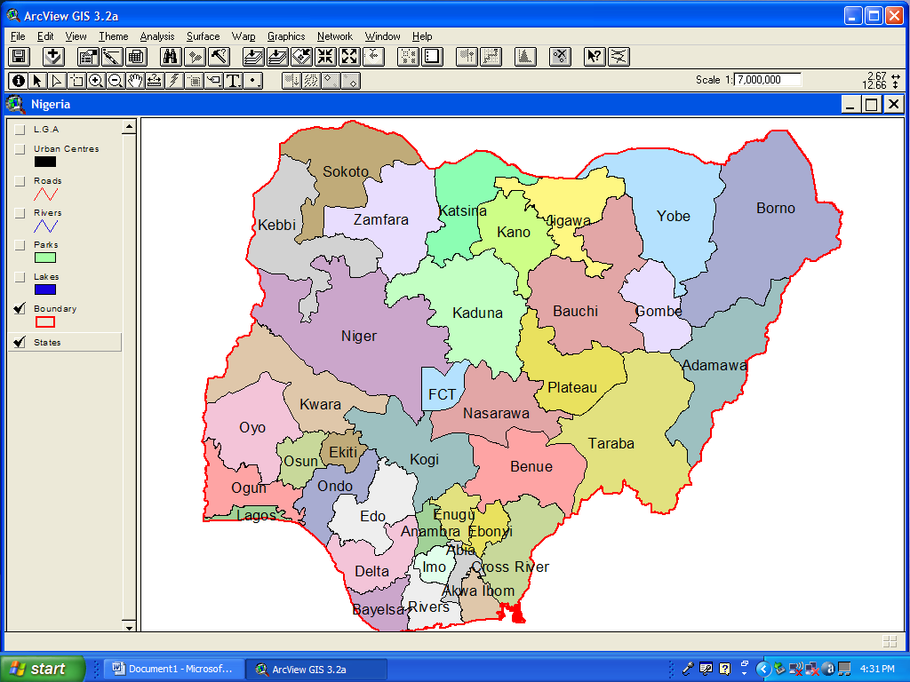
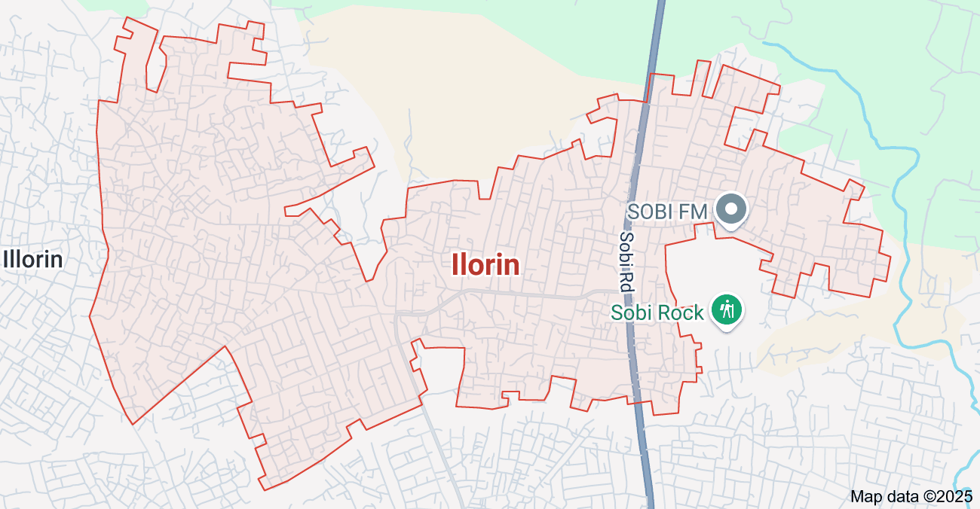
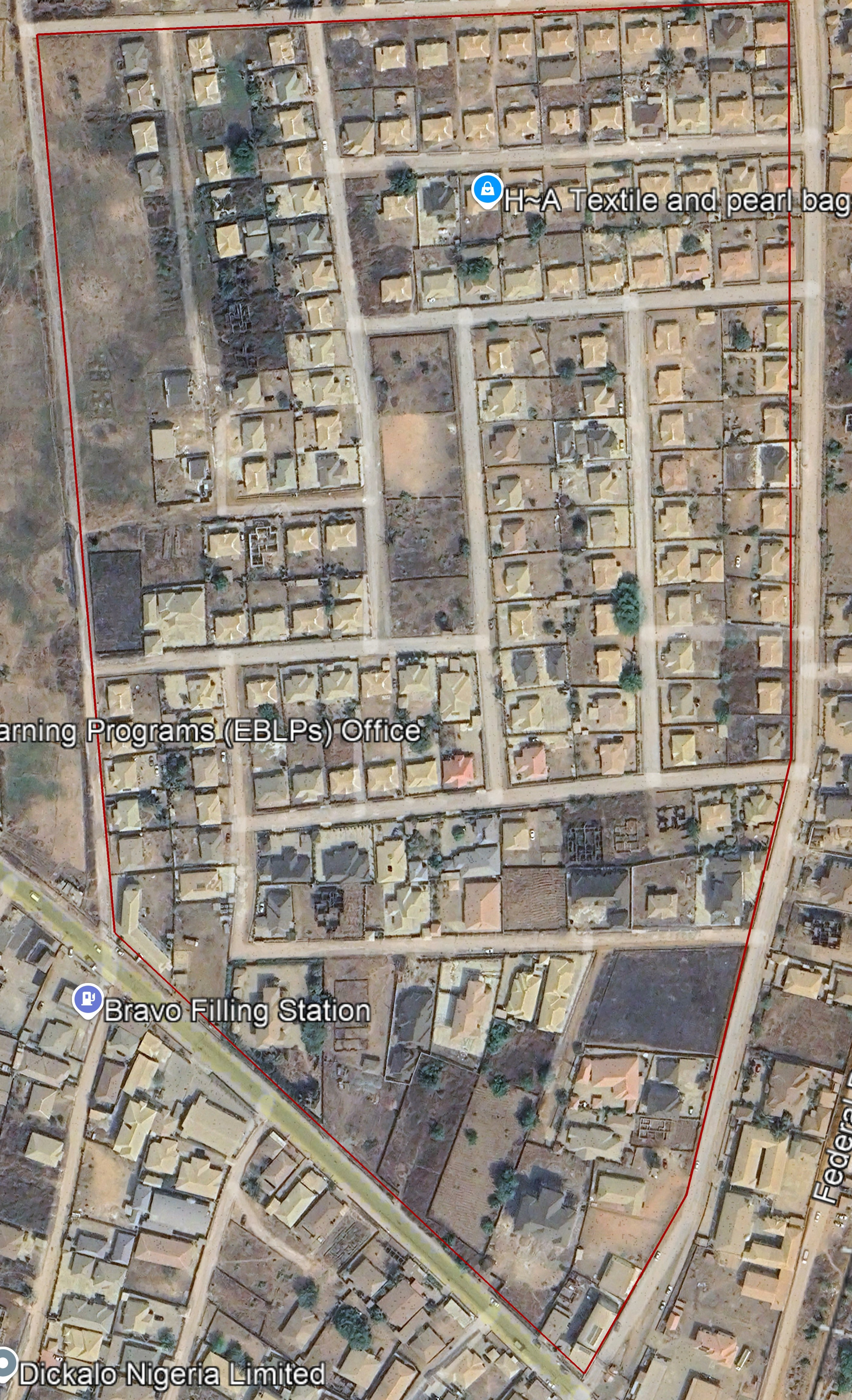
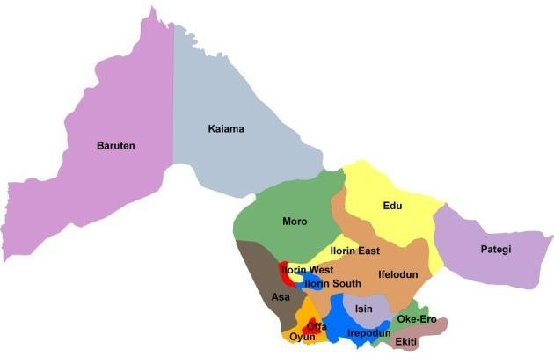
NIGERIA
KWARA
ROYAL VALLEY ESTATE
ILORIN
N

S/N | NAMES | MATRIC NUMBER | REMARK
 | ADEYEMO MARIAM OMOWUMI | HND/23/SGI/FT/095 | AUTHOR
 | ALAI ABDULLAH AKANNI | HND/23/SGI/FT/105 | MEMBER
 | POPOOLA BLESSING | HND/23/SGI/FT/094 | MEMBER
 | OGUNDEPO QUADRI OLALEKAN | HND/23/SGI/FT/102 | MEMBER
 | ADEKANBI ABIGAEL BIMBO | HND/23/SGI/FT/096 | MEMBER
 | OKE TEMITOPE JOHN | HND/23/SGI/FT/103 | MEMBER
 | ALADA TOLUWANI O. | HND/22/SGI/FT/126 | MEMBER
 | OLAREWAJU OLUWATOSIN DAVID | HND/23/SGI/FT/131 | MEMBER

1.6.1 Geographical Features
Royal Valley Estate is situated along the Sango axis, one of the busiest and most strategic parts of Ilorin, the capital city of Kwara State. Ilorin itself lies within the north-central region of Nigeria and serves as a bridge between the northern and southern parts of the country.
The estate enjoys a relatively flat topography with minor undulating surfaces, which makes it suitable for residential and infrastructural development. The area falls within the Guinea Savannah zone, characterized by scattered trees, grasses, and moderate vegetation cover. The climate of the region is tropical, featuring two main seasons — the wet (rainy) season from April to October and the dry season from November to March — with an annual average rainfall between 1,200 mm and 1,500 mm.
The Royal Valley Estate is accessible through major roads linking Sango to other parts of Ilorin, such as Tanke, Fate, and the University of Ilorin axis. This strategic location enhances the estate’s appeal for residential and commercial development.

1.6.2 Socio-Economic Characteristics
Royal Valley Estate predominantly serves as a residential community, hosting a mix of middle-class and upper-middle-class families. Many residents are professionals working in government, academia (particularly with proximity to the University of Ilorin), business, and private enterprises.
The estate has witnessed significant infrastructural development over the past few years. Paved road networks, electricity supply, borehole water systems, and drainage facilities are present, though the quality and coverage of these facilities vary across different parts of the estate. New residential buildings, private schools, religious centers (churches and mosques), and small commercial outlets (shops and supermarkets) are increasingly springing up within the estate.
Despite these developments, certain infrastructural challenges persist. Some internal roads remain unpaved or deteriorated, and access to consistent water supply and stable electricity can be problematic in parts of the estate. Drainage systems are sometimes insufficient, leading to localized flooding during heavy rainfall.
Given the growing population and increasing demand for services, there is a pressing need for a comprehensive and up-to-date infrastructural database to aid in planning, maintenance, and future development projects within the estate.

1.7 Relevance to the Study
Royal Valley Estate presents a unique and relevant environment for this study for several reasons:
- Rapid Development: The estate's ongoing expansion creates a dynamic setting where infrastructural facilities are continually evolving, offering a real-time context for mapping efforts.
- Infrastructure Variability: The mixture of well-developed and underdeveloped infrastructural elements provides opportunities to analyze infrastructural distribution, gaps, and priorities.
- Strategic Location: As part of Ilorin South Local Government Area and close to major educational and economic hubs, the estate’s infrastructural state holds implications for broader urban planning in Ilorin.
- Stakeholder Interest: Property owners, estate managers, local government authorities, and potential investors have vested interests in understanding and improving the infrastructural layout, making digital mapping a highly valuable tool.
Thus, focusing on Royal Valley Estate for the digital mapping of infrastructural facilities aligns well with the goals of the project and promises meaningful, practical outcomes that can support both immediate and long-term planning and management efforts.

CHAPTER TWO

LITERATURE REVIEW

2.1 Introduction
A literature review is a critical component of any research work, providing a thorough examination of existing knowledge relevant to the study topic. For the project titled "Digital Mapping of Infrastructural Facilities," it is essential to understand the theoretical, conceptual, and empirical frameworks surrounding infrastructure, mapping technologies, and spatial data management.
This chapter reviews literature related to infrastructure development, digital mapping techniques, the role of Geographic Information Systems (GIS), and the integration of modern technologies in managing infrastructural facilities. It further examines previous studies conducted both globally and within the Nigerian context, highlighting key findings, methodologies adopted, and gaps that necessitate the current study.
Through this review, the project aims to situate its objectives within existing academic discourse, identify best practices, and build a strong foundation for the methodology and analysis chapters that follow.

2.2 Concept of Infrastructure

2.2.1 Definition of Infrastructure
Infrastructure is broadly defined as the fundamental physical and organizational structures needed for the operation of a society or enterprise. It encompasses all facilities, systems, and services essential for economic activities, human settlements, and social services. According to the World Bank (1994), infrastructure includes public utilities (power, telecommunications, water supply, sanitation, solid waste collection and disposal), public works (roads, major dam and canal works for irrigation and drainage), and other transport sectors (railways, urban transport, ports, waterways, and airports).
In more contemporary usage, infrastructure also includes digital and informational networks such as broadband internet and telecommunications towers, recognizing the growing importance of information technology in modern economies.
Infrastructure can be classified into two broad categories:
- Hard Infrastructure: Refers to the tangible, physical networks like roads, bridges, tunnels, railways, airports, water supply systems, sewage systems, electrical grids, and telecommunications.
- Soft Infrastructure: Encompasses the institutions and services necessary to maintain the economic, health, cultural, and social standards of a country, such as education systems, healthcare systems, financial systems, law enforcement, and governance structures.

2.2.2 Categories of Infrastructural Facilities
For the purpose of digital mapping projects, it is important to further classify infrastructural facilities into specific sectors:
- Transportation Infrastructure: Includes roads, railways, bridges, airports, and bus terminals, which enable the movement of people and goods.
- Utility Infrastructure: Encompasses the supply of electricity, water, gas, and waste management systems, all crucial for day-to-day living.
- Social Infrastructure: Includes facilities that contribute to education, healthcare, recreation, and welfare, such as schools, hospitals, parks, and community centers.
- Communication Infrastructure: Involves mobile networks, internet services, and broadcasting services necessary for information flow.
Understanding the categorization and characteristics of infrastructural facilities is essential for effective digital mapping, as each type of infrastructure requires unique data sets, mapping techniques, and monitoring approaches.

2.3 Concept of Digital Mapping

2.3.1 Definition of Digital Mapping
Digital mapping, also known as digital cartography, is the process by which a collection of data is compiled and formatted into a virtual image. The primary purpose of digital maps is to produce representations of specific geographical areas, highlighting relationships between elements such as objects, regions, and themes.
According to Longley et al. (2015), digital mapping involves the visualization of geographic information systems (GIS) data and other types of spatial data in an electronic format that is accessible on digital devices. Unlike traditional maps, which are static, digital maps are dynamic and interactive, enabling users to explore information in multiple dimensions and layers.
Digital maps are typically created by gathering data from various sources such as satellite imagery, aerial photography, and field surveys, then processing this data into a coordinate-based system using specialized software tools.

2.3.2 Historical Evolution of Mapping Technologies
Mapping has a long history dating back thousands of years, beginning with ancient civilizations that drew maps to represent territory, trade routes, and astronomical observations. Traditional cartography relied heavily on manual surveying and hand-drawn maps.
The evolution of mapping technologies can be summarized in several key stages:
- Classical Era: Early maps were symbolic and focused more on religious and mythological depictions than accurate geographical information.
- Renaissance Period: Significant advances in navigation and exploration led to more accurate and detailed maps. Techniques such as triangulation and the use of compasses improved survey methods.
- Industrial Revolution: The need for precise maps for military and economic expansion led to innovations in surveying equipment, such as the theodolite.
- 20th Century: The development of aerial photography and remote sensing during the World Wars introduced new ways of collecting geographic data.
- Late 20th to 21st Century: The advent of satellite technology, GPS, GIS, and mobile computing revolutionized mapping, making real-time, highly accurate digital maps widely available.
Today, digital mapping is an integral part of daily life, used in applications ranging from navigation systems to urban planning, environmental monitoring, and disaster management.

2.3.3 Advantages of Digital Mapping over Traditional Mapping
Digital mapping offers numerous advantages compared to traditional cartographic methods:
- Accuracy and Precision: Digital maps can achieve higher levels of spatial accuracy due to the use of GPS and satellite data.
- Interactivity: Users can zoom in and out, switch layers, and customize the display to suit their needs.
- Updateability: Digital maps can be updated frequently and easily to reflect changes in infrastructure, land use, and environment.
- Data Integration: They allow the combination of different types of data (e.g., demographic, environmental, infrastructural) into a single platform.
- Accessibility: Digital maps can be accessed on various devices, including smartphones, tablets, and computers, making them highly convenient.
- Cost Efficiency: Over time, the cost of producing and distributing digital maps is lower compared to printing and maintaining physical maps.
These advantages make digital mapping a powerful tool for infrastructure management, providing critical insights for planners, policymakers, and the public.

2.4 Geographic Information Systems (GIS) and Infrastructure Management

2.4.1 Definition and Components of GIS
Geographic Information Systems (GIS) are systems designed to capture, store, manipulate, analyze, manage, and present spatial or geographic data. GIS integrates various types of data and uses spatial location as a common reference to organize layers of information into visualizations using maps and 3D scenes.
The key components of GIS include:
- Hardware: Computers, GPS devices, mobile devices, and servers used to collect, process, and display spatial data.
- Software: Specialized programs such as ArcGIS, QGIS, and ERDAS Imagine, which provide tools for mapping, spatial analysis, and data management.
- Data: Geographic data (spatial and attribute data) obtained from sources like satellite imagery, GPS, surveys, and remote sensing.
- People: Experts who design, manage, and use GIS applications to solve spatial problems.
- Methods: Standardized processes and practices for collecting, analyzing, and presenting GIS data.

2.4.2 Role of GIS in Digital Mapping
GIS plays a pivotal role in digital mapping by providing the technological backbone for managing and visualizing spatial data. Its functionalities include:
- Data Layering: GIS allows multiple layers of data (e.g., roads, water pipelines, electricity lines) to be overlaid for comprehensive analysis.
- Spatial Analysis: It enables complex analyses such as proximity calculations, network analysis, and site suitability modeling.
- Visualization: GIS transforms raw data into meaningful maps and 3D models that help in decision-making.
- Database Management: GIS manages large datasets, ensuring data integrity, consistency, and accessibility.
By integrating GIS with digital mapping, infrastructure managers can assess current conditions, forecast future needs, and plan maintenance activities efficiently.

2.4.3 Importance of GIS for Infrastructure Planning and Monitoring
The application of GIS in infrastructure planning and monitoring offers numerous benefits:
- Enhanced Planning: GIS supports evidence-based decision-making by providing accurate spatial data for infrastructure development.
- Resource Optimization: It assists in identifying the most efficient locations for new infrastructure projects.
- Risk Management: GIS can analyze risks such as flood zones, seismic activity, and urban congestion, aiding in the development of resilient infrastructure.
- Maintenance Scheduling: Infrastructure assets can be monitored for wear and tear, and maintenance schedules can be optimized based on real-time data.
- Public Engagement: Interactive maps created with GIS can be shared with the public, increasing transparency and encouraging community participation.
These capabilities make GIS an indispensable tool in modern infrastructure management, ensuring that resources are used effectively and that infrastructure systems are sustainable and resilient.

2.5 Techniques for Digital Mapping of Infrastructural Facilities
Digital mapping of infrastructural facilities relies on a combination of field data collection, remote sensing, geographic information system (GIS) technologies, and various data processing techniques. Understanding these methodologies is critical to achieving accurate and efficient mapping results.

2.5.1 Field Surveying
Field surveying remains a fundamental technique for collecting precise, ground-truth data about infrastructural facilities.
Traditional Surveying Methods:
Traditional methods involve the use of instruments like theodolites, total stations, measuring tapes, and levels to measure distances, angles, and elevations. Surveyors record the physical location, dimension, and condition of facilities such as roads, drainage systems, electricity poles, and water pipes.
Modern Surveying Methods:
Modern surveys often incorporate Global Navigation Satellite System (GNSS) tools such as GPS receivers, enabling real-time, highly accurate data collection. Total stations combined with GPS provide a hybrid approach for both small and large areas.
Advantages of Field Surveying:
- High accuracy and reliability
- Direct observation of facility conditions
- Ability to collect attribute data (e.g., facility type, material, usage)
Challenges of Field Surveying:
- Time-consuming
- Labour-intensive
- Dependent on weather conditions
In the context of Royal Valley Estate, field surveying will play a critical role in identifying the exact location and condition of each infrastructural asset.

2.5.2 Remote Sensing
Remote sensing refers to the acquisition of information about an object or phenomenon without making physical contact, typically via satellites or aircraft.
Satellite Imagery:
High-resolution satellite images such as those from Landsat, Sentinel-2, or commercial providers like Maxar are commonly used in infrastructure mapping. These images can reveal road networks, building layouts, water bodies, and vegetation patterns.
Aerial Photography:
Drone-based aerial photography has become increasingly popular for local-scale mapping. Drones (Unmanned Aerial Vehicles - UAVs) can capture very high-resolution images suitable for detailed analysis.
Advantages of Remote Sensing:
- Covers large areas quickly
- Access to inaccessible or hazardous areas
- Multi-temporal imagery allows monitoring of changes over time
Challenges of Remote Sensing:
- Cloud cover can affect image quality
- May require specialized processing skills
- Expensive for very high-resolution commercial data
Applications to Infrastructure:
Remote sensing enables the detection of changes in infrastructure networks, assessment of construction progress, and identification of areas requiring maintenance.

2.5.3 Mobile GIS and Smart Data Collection
Mobile GIS systems allow field teams to collect geospatial data using smartphones, tablets, or handheld GPS units integrated with GIS software applications.
Key Features:
- Real-time data uploading and synchronization
- Built-in forms for attribute data collection
- Photo attachments and voice notes linked to geographic coordinates
Popular mobile GIS apps include ESRI’s Collector for ArcGIS, QField (linked to QGIS), and Survey123.
These tools are particularly useful for mapping utilities, signage, drainage systems, street lighting, and other infrastructure features.
Benefits of Mobile GIS:
- Enhances efficiency and data accuracy
- Reduces paperwork and manual entry errors
- Enables immediate data visualization
Limitations:
- Dependent on internet connectivity (though offline modes exist)
- Battery life of devices can limit field time
- Requires technical training

2.5.4 Use of Geographic Information Systems (GIS) Software
After data collection, GIS software is essential for organizing, analyzing, and visualizing the information.
Common GIS Software Platforms:
- ArcGIS: Industry-leading software known for its robust analytical capabilities and cartographic output.
- QGIS: Open-source alternative that offers extensive plugins and flexibility.
- AutoCAD Map 3D: Combines GIS with engineering design capabilities.
- Google Earth Engine: Useful for large-scale remote sensing analysis.
GIS Data Processing Involves:
- Georeferencing: Assigning real-world coordinates to datasets.
- Digitizing: Creating digital representations of physical infrastructure.
- Attribute Table Management: Storing descriptive information about each mapped feature.
- Spatial Analysis: Conducting queries, overlays, and buffer analyses to derive insights.
Through GIS, the infrastructural facilities of Royal Valley Estate can be visualized as layers on a digital map, enabling easier management and decision-making.

2.5.5 Data Validation and Quality Control
Accurate digital mapping requires strict validation and quality assurance processes:
- Cross-Verification: Comparing field data with satellite imagery and existing records.
- Error Checking: Identifying and correcting spatial and attribute data errors.
- Consistency Checks: Ensuring uniformity in data entry formats and standards.
- Metadata Documentation: Recording the sources, collection methods, and processing steps for transparency and repeatability.
By adopting rigorous data validation techniques, the reliability of the final infrastructural map for Royal Valley Estate can be ensured.
2.6 Importance of Digital Mapping in Urban Planning and Development
Urban planning and development require accurate, up-to-date information about existing infrastructures, land use, environmental conditions, and demographic trends. Digital mapping provides the critical geospatial framework necessary for efficient and sustainable urban management.

2.6.1 Enhancing Decision-Making Processes
One of the most significant contributions of digital mapping to urban planning is its ability to provide planners, engineers, and policymakers with reliable, visual, and data-driven insights. These maps allow stakeholders to:
- Analyze spatial relationships between infrastructures (e.g., proximity of residential areas to schools, hospitals, and roads).
- Identify under-served or over-served areas.
- Optimize the placement of new infrastructural facilities based on population density and growth patterns.
- Conduct environmental impact assessments to ensure that development projects comply with ecological preservation standards.
The accessibility and comprehensibility of digital maps make them powerful tools for participatory planning, where local communities can contribute to decision-making.

2.6.2 Infrastructure Management and Maintenance
Infrastructure management is essential for ensuring the functionality, safety, and sustainability of urban facilities. Digital maps serve as comprehensive inventories, displaying the locations, conditions, and specifications of infrastructure assets.
With digital mapping:
- Authorities can prioritize maintenance based on infrastructure age, condition, and usage.
- Emergency services can quickly locate critical assets during disasters (e.g., fire hydrants, evacuation routes).
- Real-time monitoring systems can be integrated to detect failures (e.g., burst water pipes, power outages).
By visualizing the infrastructure network, maintenance schedules can be better planned, resources can be allocated efficiently, and service delivery can be significantly improved.

2.6.3 Facilitating Sustainable Urban Growth
Urbanization is accelerating globally, particularly in developing countries like Nigeria. Poorly planned growth leads to problems such as traffic congestion, inadequate water supply, and urban sprawl. Digital mapping helps prevent these issues by:
- Supporting the design of smart cities with integrated transport, housing, energy, and communication systems.
- Enabling better zoning regulations and enforcement.
- Promoting environmental conservation through land-use planning that protects wetlands, forests, and water bodies.
- Assisting in climate resilience planning by identifying flood-prone zones, erosion risks, and heat islands.
Sustainable cities leverage geospatial data to balance development needs with environmental and social considerations.

2.6.4 Emergency Planning and Disaster Management
In the face of natural and human-made disasters, having accurate spatial information is critical. Digital maps support:
- Risk assessment and hazard mapping.
- Development of evacuation plans and emergency response strategies.
- Deployment of resources and personnel during emergencies.
For example, during flood events, maps showing drainage systems and elevations can guide rescue operations and minimize loss of life and property.

2.6.5 Promoting Transparency and Public Engagement
Interactive digital maps, made accessible through online platforms or mobile apps, empower citizens by:
- Allowing them to view proposed development projects.
- Reporting infrastructure problems (e.g., broken streetlights, potholes) through map-based interfaces.
- Participating in community planning initiatives.
This transparency builds trust between governments and citizens and promotes accountability in urban governance.

2.7 Challenges Associated with Digital Mapping of Infrastructure
Despite its numerous benefits, digital mapping of infrastructural facilities faces several challenges that can impact the quality, accuracy, and effectiveness of projects.

2.7.1 Data Collection Challenges
Accurate mapping requires high-quality, comprehensive data. However:
- Access Restrictions: Some infrastructures, especially private or sensitive government facilities, may not be accessible for mapping.
- Physical Barriers: Dense vegetation, rugged terrain, or urban congestion can hinder field data collection.
- Technological Limitations: Devices may suffer from GPS signal loss, particularly in urban canyons or remote areas.
Additionally, inconsistencies in data formats, coordinate systems, and data quality across different sources can complicate data integration.

2.7.2 Financial Constraints
Digital mapping projects can be expensive, especially when:
- High-resolution satellite imagery must be purchased.
- Specialized equipment like drones or advanced surveying tools are needed.
- Skilled personnel must be trained or hired to carry out complex tasks like GIS analysis.
For smaller communities or local governments with limited budgets, these financial barriers can delay or limit the scope of digital mapping initiatives.

2.7.3 Technical Expertise and Capacity Building
The effective execution of digital mapping requires expertise in:
- GIS and remote sensing.
- Cartographic design and map interpretation.
- Data analysis and geospatial database management.
Many developing regions, including parts of Nigeria, face a shortage of trained geospatial professionals. Lack of technical capacity leads to poor data collection, ineffective analysis, and underutilization of mapping outputs.
Capacity-building programs, professional training, and academic curricula focused on geospatial technologies are crucial for bridging this skills gap.

2.7.4 Data Maintenance and Updating
Infrastructure and land use change rapidly due to development, degradation, and policy shifts. Keeping maps up-to-date is essential but challenging.
Without regular updates:
- Maps become outdated and unreliable.
- Maintenance schedules may be based on inaccurate information.
- Planning decisions can be misinformed, leading to inefficiencies.
Establishing systematic processes for data updating, integrating real-time monitoring technologies, and encouraging community participation in reporting changes can help address this challenge.

2.7.5 Legal and Ethical Considerations
Issues related to privacy, security, and data ownership arise in digital mapping projects:
- Privacy Concerns: Detailed maps of residential areas can inadvertently expose private information.
- Security Risks: Infrastructure maps could be misused for sabotage or criminal activities.
- Intellectual Property Rights: Disputes can arise over the ownership and usage rights of geospatial data.
Clear legal frameworks, ethical guidelines, and security protocols are necessary to govern digital mapping activities.

2.7.6 Environmental and Technical Factors
Environmental conditions such as:
- Cloud cover obstructing satellite imagery.
- Rainy seasons affecting field surveys.
- High temperatures impacting drone battery life.
Technical issues such as:
- Software crashes.
- Data corruption.
- Equipment failure.
All of these factors can hinder project timelines and data quality. Contingency planning, use of multiple data sources, and adoption of rugged technologies are recommended strategies for mitigation.

2.8 Case Studies on Digital Mapping Projects (Global and Nigerian Examples)

2.8.1 Global Case Studies
Digital mapping has seen widespread adoption across the globe, especially in urban planning, disaster management, and infrastructure development. Below are some notable examples of how digital mapping has been employed worldwide.

2.8.1.1 Smart City Mapping in Singapore
Singapore is a global leader in smart city development, leveraging advanced digital mapping and GIS technologies for efficient urban planning and management. The city-state has employed digital mapping for various purposes, including:
- Urban Mobility: The Land Transport Authority (LTA) uses GIS to monitor traffic patterns and optimize public transport routes. Digital maps help in real-time monitoring of vehicle movement, predicting congestion, and improving the efficiency of the transport system.
- Smart Infrastructure: Digital mapping aids in tracking the condition of roads, bridges, and other urban infrastructure. Regular updates through GIS ensure that maintenance is proactive, reducing downtime and ensuring safety.
Singapore's success with smart city mapping highlights the importance of integrating technology and data to improve urban living conditions, manage resources efficiently, and enhance the quality of life for residents.

2.8.1.2 Disaster Management in Japan
Japan, known for its vulnerability to natural disasters such as earthquakes, tsunamis, and typhoons, has adopted digital mapping techniques to mitigate the impact of such events.
- Earthquake Response: The Japan Meteorological Agency (JMA) uses digital maps to provide real-time data on seismic activity. By analyzing geographic data, the government can quickly assess affected areas and prioritize rescue efforts.
- Flood Risk Mapping: GIS is extensively used to identify flood-prone zones and assess flood risks. In 2011, after the Tohoku earthquake and tsunami, digital maps helped disaster response teams navigate the affected regions efficiently, ensuring that rescue operations were carried out swiftly.
These case studies demonstrate the importance of digital mapping in reducing disaster risk, improving response times, and minimizing damage through effective preparedness and post-disaster management.

2.8.1.3 Digital Mapping in Urban Renewal – New York City, USA
New York City has utilized digital mapping extensively for urban renewal and revitalization projects, especially in areas facing decay and infrastructure neglect.
- Data-Driven Urban Development: Through the use of GIS, the city has mapped areas of high-density population, existing infrastructure, and resources to determine where new public housing, transportation, and public amenities should be placed.
- Building Energy Use: The city also uses digital mapping to track building energy consumption patterns, helping to optimize energy usage and plan for sustainability.
The integration of digital mapping in urban planning projects in New York City has contributed significantly to urban renewal efforts by ensuring that resources are allocated efficiently, improving the urban environment, and fostering sustainable development.

2.8.2 Nigerian Case Studies
In Nigeria, digital mapping and GIS technology have gained prominence, particularly in urban planning, infrastructure management, and environmental monitoring.

2.8.2.1 Lagos State Urban Development
Lagos, Nigeria’s largest city and commercial hub, has increasingly turned to digital mapping for urban planning and infrastructure development.
- Traffic Management and Public Transport: Lagos has adopted digital mapping for real-time traffic monitoring and optimization of public transport routes. The Lagos Traffic Management Authority (LASTMA) uses GIS to monitor traffic flow and deploy resources where congestion is most likely to occur.
- Infrastructure Mapping: The Lagos State Government uses digital mapping to track infrastructural assets such as roads, sewage systems, and public facilities. This enables efficient management and maintenance of these assets.
These digital mapping efforts have helped Lagos to manage its rapidly growing population and infrastructure more effectively, aiming to reduce traffic congestion and improve service delivery.

2.8.2.2 Federal Government of Nigeria – National Infrastructure Mapping
The Nigerian government, through the National Space Research and Development Agency (NASRDA), has initiated several digital mapping projects to monitor and manage the country’s infrastructure.
- National Infrastructure Database: This project aims to collect and digitize data on the country’s key infrastructural assets, including roads, railways, electricity grids, and water supply systems. This database helps in better planning for infrastructural growth and maintenance.
- Urban Growth Mapping: In cities such as Abuja and Port Harcourt, digital mapping has been used to analyze urban sprawl, infrastructure demand, and resource allocation. This assists local governments in formulating long-term urban growth strategies.
By implementing these initiatives, Nigeria has made significant progress in infrastructure management and urban planning through digital mapping, enhancing both the development and sustainability of urban areas.

2.9 Review of Previous Studies Related to the Study Area (Ilorin/Kwara)
Ilorin, the capital of Kwara State, is a rapidly growing city that faces challenges common to many Nigerian cities, including urban sprawl, inadequate infrastructure, and population growth. This section reviews previous studies related to digital mapping and urban planning in Ilorin and the wider Kwara State.

2.9.1 Urbanization and Infrastructure Development in Ilorin
Several studies have explored urbanization patterns in Ilorin, particularly the expansion of residential and commercial areas. According to a study by Olayemi (2019), rapid urbanization in Ilorin has led to increased demand for infrastructure such as roads, water supply systems, and waste management. However, the city struggles with inadequate planning and resource allocation, leading to congestion and environmental degradation.
Digital mapping can play a key role in identifying areas of high demand for infrastructure and guiding the allocation of resources where they are most needed. The use of GIS tools in Ilorin can help policymakers visualize urban expansion and make data-driven decisions to improve service delivery.

2.9.2 Infrastructure Mapping and Maintenance in Ilorin
In a study by Adebayo et al. (2020), the authors highlighted the inefficiencies in the maintenance of infrastructure in Ilorin, particularly roads and drainage systems. Many parts of the city experience flooding during the rainy season due to poor drainage infrastructure. By implementing digital mapping solutions, the city can accurately monitor the condition of drainage systems and plan for timely repairs and upgrades.
Additionally, road networks and other infrastructure can be mapped to track wear and tear, allowing for prioritized maintenance that ensures better service delivery to the residents of Ilorin.

2.9.3 GIS Application in Environmental Management
A study by Sulaimon and Adewale (2021) focused on the use of GIS in environmental management in Kwara State, particularly in Ilorin. The study found that GIS has been useful in assessing land use changes, deforestation, and water quality in the state. However, the application of GIS in environmental management remains underdeveloped in the region.
With the increasing urbanization of Ilorin, digital mapping and GIS can help manage the city’s environmental resources more effectively, tracking land use patterns, monitoring pollution, and guiding sustainable development strategies.

CHAPTER THREE

3.0 METHODOLOGY
This stage involves the methods and procedure used in planning, data acquisition, data processing, and creation of database, creation of database management system and information presentation. These operations were logically structured and carried out in stages involving database design. It is normally considered to involve a spatially referenced and structured digital database and appropriate application software for geospatial analysis. This basically describes the techniques and principles adopted in carrying out the project.
Geographic information system methods were adopted in accomplishing the desired results.

3.1 DATABASE DESIGN
The design of any database involves three stages namely;
i Conceptual design
ii Logical design iii Physical design

3.1.1 VIEW OF REALITY
In database design, there is need for reality which is referred to as the phenomenon that actually exists, including all aspects which may or may not be perceived by individuals. The view of reality however, is the mental abstraction of the reality for a particular application or group of applications.
For this application, the view of reality is made of the topography of the project. Since it is not possible to represent the real world, the only option is to conceptualize and model it in a specified manner to represent the real world. The area of interest to us in this project

Includes; Green Reserve, Roads, Electric poles, Trees, Water Facilities, Buildings, Football pitch, Streams.
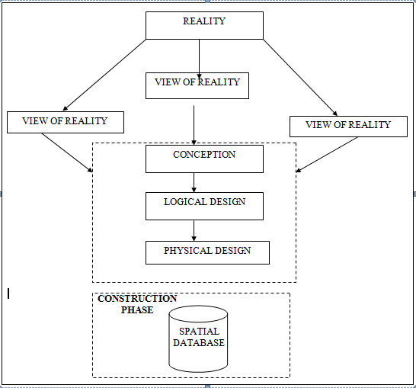

Fig. 3.1 Design and Construction Phases in Spatial Database

3.1.2 CONCEPTUAL DESIGN

Vector data model is the data type adopted for this project, which is represented, by points, lines and polygon. The identified entities are:-
      - Vegetation area (polygon)

      - Roads (line)

      - Trees (point)

      - Boundary line (polygon)

      - Buildings(polygon)
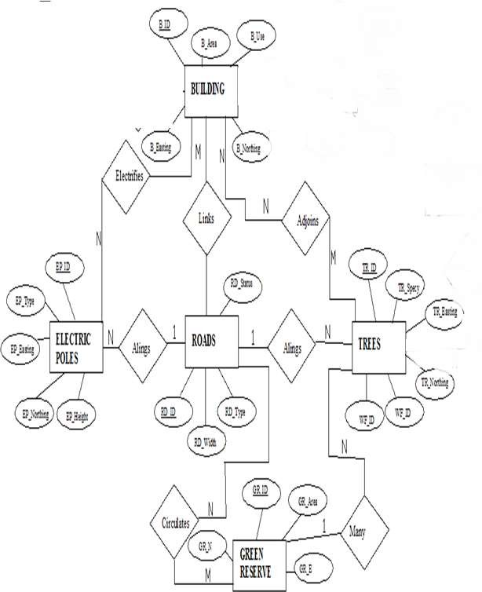

Fig. 3.2.: E-R Diagram (Entity relationship diagram)

3.1.3 LOGICAL DESIGN

This is the design aspect of the database refers to the process of creating a conceptual framework or model that represents the structure and organization of spatial data within the system. It involves defining the data element, their relationship, and the rules for data manipulation and analysis. In this phase, the entities, their attributes and their relationships are represented in a single uniform manner in form of relation in such a way that would be no information loss and at the same time no unnecessary duplication of data. In this study, the logical database design is employed to generate a geo-relation database structure. Each entity has unique identifier in bold type. An attribute type or combination of attribute types that serves to identify an entity type is termed an identifier.
- Building( B_ID, B_Area, B_Name, B_Easting, B_Northing)

- Roads (R_ID, R_Width, R_Type, R-Condition, R_Easting, R_Northing )

- Vegetation (V_ID,GR_Area,)

- Tree (TR_ID, TR_spp, TR_Importance, TR_Easting, TR_Northing )

- Electric Pole (EP_No, EP_Type, EP_Height,EP_Easting, EP_Northing)

- Water Facility (WF_ID, WF_Depth,WF_Type, WF_Easting, WF_Northing)

- Football Pitch (FP_ID , FP_Area, FP_Status)

- Stream(S_ID, Length, Width)

3.1.4 PHYSICAL DESIGN

Table 3.1: Building and its attribute

ENTITY | DESCRIPTION
B_ID | Building Identification
B_name | Building Name
B_Area | Building Area
B_Easting | Building Easting
B_Northing | Building Northings

Table 3.2: Road and its attributes

ENTITY | DESCRIPTION
R_ID | Road Identifier
R_Length | Road Length
R_Width | Road Width
R_Type | Road Type
R_Condition | Road Condition

Table 3.3: Trees and its attributes

ENTITY | DESCRIPTION
TR_ID | Tree Identifier
TR_Spp | Tree specy
TR_E | Tree_Easting
TR_N | Tree Northing

3.2 RECONNAISSANCE

This is the preparatory stage before the execution of this project; it involves collection of available information about the project area.
The necessary step taken for the successful execution of the project involves two stages, which are:-
- Office Planning
- Field reconnaissance

3.2.1 OFFICE PLANNING

This involves the collection of information about the study area, testing the instrument to be used in execution of the project and itemizing the numbers of equipment needed, number of days to be use, how each activity is to be carried out, delegation of works to each team members based on supervisor’s guide/instructions.

Table 3.4 Coordinates of Controls

Station | Northing (m) | Easting (m) | Height (m)
KWCS 625T | 941451.040 | 674200.278 | 255.212
KWCS 623T | 941753.095 | 673845.702 | 250.532
KWCP 690 | 94I802.041 | 673810.314 | 249.087

Source: Surveyor general office Kwara

3.2.2 FIELD RECONNAISSANCE

The field reconnaissance is the first visitation to the project site to get intimated with the environment.
- Boundary points was selected

- The distribution of features was studied

- Controls to be used were located

- Method and type of instrument to be uses was determined

- Subsidiary point for Ground control Points were picked and define using nail and bottle cock
- A diagram of the study area was drawn.
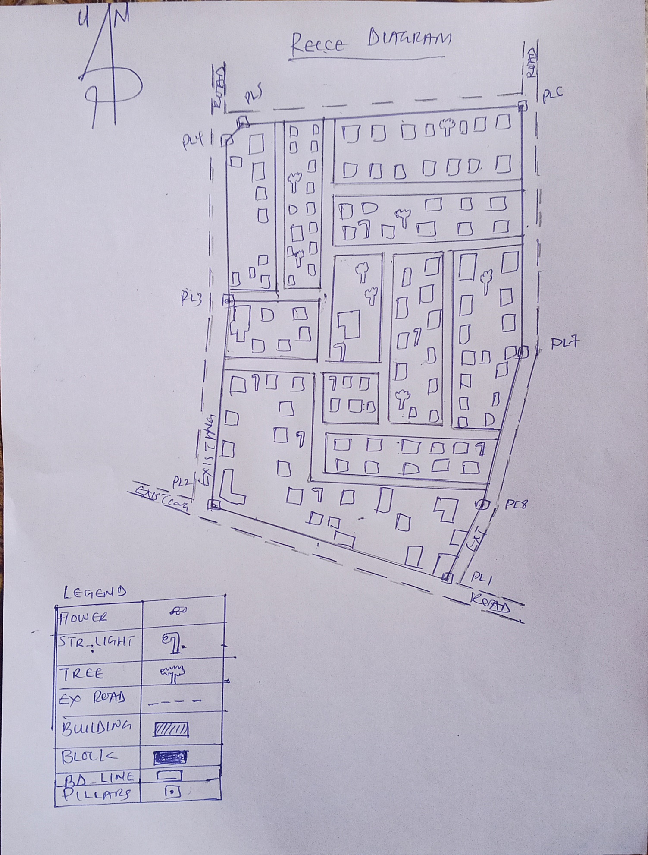

Fig. 3.3: Recce diagram of the study area (not drawn to scale).

3.3 EQUIPMENT USED/ SYSTEM SELECTION AND SOFTWARE

3.3.1 HARDWARE USED

- Total station

- 1 reflector with a tracking rod.

- 1 Tripod

- One (1) 50m tape

- One (1) umbrella

- 1 cutlass

- Hand held GPS

- Hammer

- Nails and bottle cover

- Field book and writing materials

- 1-No of Personal Computer HP655 and its accessories

- 1-No of HP Desk Jet K7100 A3 printer

- 1-No of HP Desk Jet 1110 A4 printer

3.3.2 SOFTWARE COMPONENT

- Notepad.

- Microsoft Excel.

- AutoCAD 2007

- ArcGIS 10.3

- Microsoft Word.

3.4 INSTRUMENT TEST

To ensure data quality, the Total Station used for this project was tested for both vertical index and horizontal collimation errors. It was also to ascertain the efficiency and reliability of the instrument. The procedure used is described below.

3.4.1 HORIZONTAL COLLIMATION TEST
This test was conducted to ensure that the line of sight was perpendicular to the trunnion axis. The Total Station was positioned over a specific point, and initial adjustments were made to ensure proper alignment, leveling, and focus (to eliminate parallax in the telescope). A vertical target was placed at a distance of 100 meters from the Total Station. To access the configuration menu of the Total Station, the menu key was pressed and held for approximately 2 seconds. From the main menu, the calibration sub-menu was selected, and within that, the horizontal collimation test option was chosen. The target was then observed and divided into two halves, with horizontal readings recorded for Face left and Face right. The readings are shown in Table 3.4.1 below.

Total Station
100m
REFLECTO R (TARGET)

STATION A
Fairly Level Ground
STATION B

Fig 3.4: Horizontal Collimation and Vertical Index error test.

Table 3.5: Horizontal Collimation Data

Station | Target | Face | Hz Reading | Difference | Error
A | B | L | 38˚42‟32”
 |  | R | 218˚42‟35” | 180˚00‟03” | 03”

3.4.2 VERTICAL INDEX ERROR TEST

This test was conducted to verify the accuracy of the vertical reading when the line of sight is horizontal. The desired measurement for this test is exactly ninety degrees (90˚), any deviation from this value is referred to as the vertical index error.
The Total Station was positioned over a specific point, and necessary temporary adjustments were made to ensure proper alignment and functionality. A target was placed approximately 100 meters away from the Total Station, and the instrument was aimed at the target. The target was bisected by aligning the instrument on the face left, and the corresponding reading was recorded. Similarly, the target was then bisected on the face right, and the respective reading was also recorded. The recorded readings are provided below:

Table 3.6: Vertical Index Data
Instrument Station | Target Station | Face | Vertical | Sum | Error
A | B | L | 90˚00‟00”
 |  | R | 270˚00‟02” | 360˚00‟02” | 02”

3.4.3 ANALYSIS OF COLLIMATION AND VERTICAL INDEX DATA

The reading obtain during calibration were reduced to obtain new collimation and vertical errors.
Horizontal collimation = {(FR – FL) – 180}/2 = {(00˚00‟03”}/2 = 1.5”

Vertical collimation = {(FL + FR) – 360} = (90˚00‟00” + 270˚00‟02”) - 360} = 02” The result shows that the instrument is still in good working condition.

3.5 CONTROL CHECK
Three control beacons (KWCS 625T, KWCS 623T and KWCP 690) were used. In order to ascertain the in-situ of the control beacons, a check was carried out on them by observing the angle between them and comparing the result obtained with the computed angles from the giving coordinates.
The total station instrument was set on the control beacon KWCS 623T. After performing all the necessary temporary adjustment, the reflector was placed on the control beacon KWCS 625T which served as the back station. The horizontal angular reading was taken and recorded while the instrument was on face left. The reflector was then taken to the control beacon KWCP 690 which serves as the forward station, the horizontal angle reading was then taken and recorded on both face left and face right. The reflector was taken back to the back station, the horizontal angle was then recorded on face right.

Table 3.7: showing the back computation of the control coordinates

From STN | Bearing | Dist (m) | ∆N | ∆E | Northing (m) | Easting  (m) | To STN
 |  |  |  |  | 941451.040 | 674200.278 | KWCS 625T
KWCS 625T | 130°25'37'' | 465.791 | 302.055 | -354.576 | 941753.095 | 673845.702 | KWCS 623T
KWCS 623T | 149°38'02'' | 60.399 | 48.946 | -35.388 | 941802.041 | 673810.314 | KWCP 690

Table 3.8: showing the distance observation result of the control check

FROM | OBSERVED DISTANCE  (m) | COMPUTED DISTANCE  (m) | TO
KWCS 625T | 465.902 | 465.791 | KWCS 623T
KWCS 623T | 60.521 | 60.399 | KWCP 690

Table 3.9 showing the observation result of the control check

STN | SIGHT | FACE | OBSERVED HZ ANGLE | REDUCED  HZ ANGLE | MEAN
 | KWCS 625T | L1 | 195° 14' 07''
KWCS 623T | KWCP 690 | L2 | 64° 47' 29'' | 130°26'38''
 | KWCP 690 | R2 | 15° 14' 13'' | 130°26'22''
 | KWCS 625T | R1 | 145° 40' 35'' |  | 130°26'30''

Difference in angle (observed - computed) =188° 31' 40''-188° 31' 36''

= 00° 00' 04''

Since the allowable accuracy (angular) of third order traverse of one station is 00° 00' 30'' and the result obtained from the control check (00° 00' 04'') is less than allowable error. Therefore, the controls were angularly intact.

3.6 MONUMENTATION
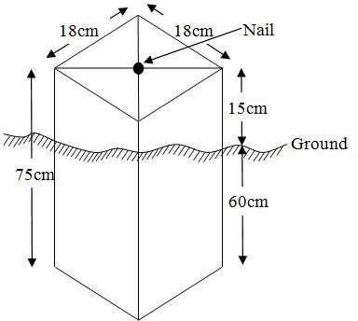
The boundary of the area carved out was demarcated with the precast concrete beacons, after clearing the required line of sights. The identified points of changes in directions were dug and beacons were buried on it, leaving about 15cm part of the beacon above the ground level. The beacons were buried at convenient distances as dictated by the nature of the boundary

Fig. 3.5: Pillar Description

3.7 DATA ACQUISITION

PRIMARY DATA SOURCE
Field observation was the primary source of data for this project. Ground based method was used in acquiring data with the use of Total Station Instrument, which involved the collection of X, Y, Z data through coordinated Ground control Points (GCP) established at conspicuous points within the study area .
SECONDARY DATA SOURCE
An imagery of the area was acquired through Updated Google earth; this was used to ascertain the extent of coverage of the project area.

3.7.1 GEOMETRIC DATA ACQUISITION
The total station instrument was set carefully on control point KWCS 623T back sight taken to KWCS 625T after necessary station adjustments has been carried out on it. The adjustments includes; centering, leveling and focusing. The following procedures were then followed to determine the position of the next point KWCS 623T and the same procedure were repeated until all we come close to the site. The method used in acquiring data on site was radiation method where two or more points are coordinated from one point.
- Having set up the instrument and temporary adjustment carried out, the instrument was powered „on‟ and a job was created under job menu in the internal memory of the instrument. The job created was named GRP6B
- On the job, the coordinates of the three (3) control points were keyed in to the memory of the instrument and some codes were also saved. The codes include
- „RD‟ for road, „SP‟ for spot height, „BD for buildings, etc.
- The height of the instrument was measured and saved on the memory of the instrument as well as the reflector height.
- On coordinate menu, orientation was set by inputting the coordinates of the instrument station and back sight. The reflector at the back station was perfectly bisected before the orientation was confirmed by clicking „yes‟.
- Having done the orientation, the reflector at the next nail; was bisected and „obs‟ (observe) option was clicked. The three dimensional coordinate of the point (E,N, H) were displayed on the display unit of the instrument and „rec‟ (record) was clicked to save the data into the memory of the instrument. For subsequent observation after this, „all‟ option was used instead of pressing „obs‟ and pressing
- „Record‟ later.
- It was ensured that the center of the prism of the reflector was bisected and that it was set perfectly on the tripod in order to minimize the error on height determination.
- The instrument is been shifted to another nail after all details, spot height and boundary point visible from the instrument station have been picked, set over it and temporary adjustments carried out.
- Nonetheless, the above operations were repeated until all the boundary points with heights were coordinated.
- In this project all spot height are not in grid intervals but randomly acquired. Three edges (3) of building were picked. At the end of data acquisition process all details were acquired and properly recorded to be shown in their respective positions on the plan.

3.7.2 ATTRIBUTES DATA ACQUISITION
Attribute data is information about spatial features. They provide the characteristics, description and nomenclature about spatial objects. Thus the attributes data acquired includes names of buildings and their uses such as classrooms, roads, water facilities and prominent natural features likes river and trees found and vegetation were properly identified within and around the study area.

3.8 DATA DOWNLOADING AND PROCESSING

3.8.1 DATA DOWNLOADING AND EDITING
This is stage whereby all data acquired which were automatically stored in the Total Station were downloaded into personal computer. This was done with the aid of downloading cable connected to the computer and some associated complementing software installed on the System.

3.8.2 DATA PROCESSING AND DATA EDITING
The geometric data downloaded were further processed in order to convert it to a useful format and to enhance its accuracy. The output coordinates, were edited and exported in *.txt, *.xls and *.pdf format. Thereafter, they were imported into Arc GIS 10.3 for further operations and to carry out spatial analysis.

3.8.3 DATA PROCESSING USING ARCGIS 10.3

Before launching of ArcGIS AutoCAD was used in plotting of feature data saving them separately in different file named road, boundary line, buildings, trees and electric poles.
- Launch the Arc Map in ArcGIS 10.3
- Click on A NEW EMPTY MAP on the dialog box displayed after loading
- Click on Tools on the menu bar, then select extensions, mark all and close.
- At the LHS, right click on layers, and then select properties.
- Click on coordinate system to set the projection system to MINNA DATUM ZONE 31N and general to set the unit, then apply and okay.
- Add data was selected at the tool bar all saved AutoCAD fie was selected and load onto the table of content layer section
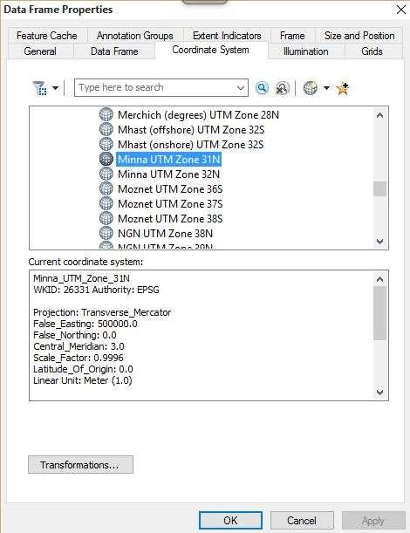

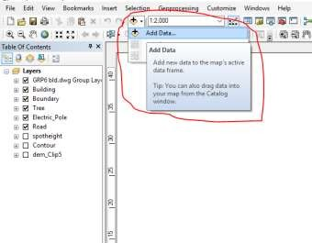
All drawing was exported to shape file. After the feature class has been creates, click on Editor to start Editing, and then click on the load object.

3.8.4 Topographical Map (DEM)
CRATING CONTOUR: Firstly DEM was created by searching in the search icon INTERPOLATION> NATURAL NIGHBOR and selecting THE XYZ data for creation of DEM in respect to the boundary line as extent. In order to create contours, you will need to enable the Spatial Analyst toolbar, which can be found by going to Customize > Toolbars > Spatial Analyst or open the search bar. You can do this by clicking Windows > Search, or by clicking on the search icon.
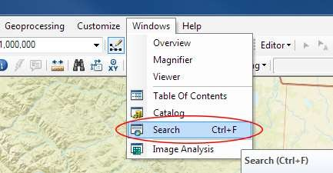

In the search bar type Contour, and select Contour (Spatial Analyst) from the search results list

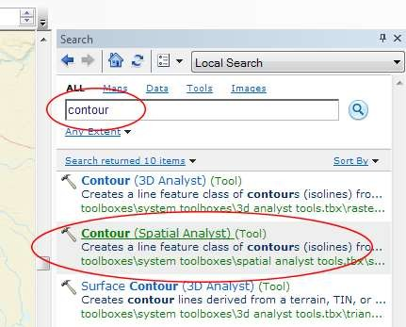

After choosing Contour, a dialogue window will appear, prompting you for five settings: Input raster: select the DEM file from which you want to generate contours by locating it on your hard drive or in the dropdown menu, showing layers present in the Table of Contents Output polyline features: indicate where you want to save your output contours Contour interval: set the distance between contour lines in meters – the smaller the number, the greater the number of lines Base contour (optional): the starting point from which the lines are generated – for example, the default is 0 so with an interval of 25 meters, the contours are generated at 25, 50, 75, 100…, but if the base contour is set at 40, then the contours are generated at 65, 90, 115, 140 and so on Z factor (optional): can be used to adjust the units of data; for example, if you have data in meters and you want to produce your contours in feet, use a z-factor of 3.28 because 3.28 feet equals one meter.

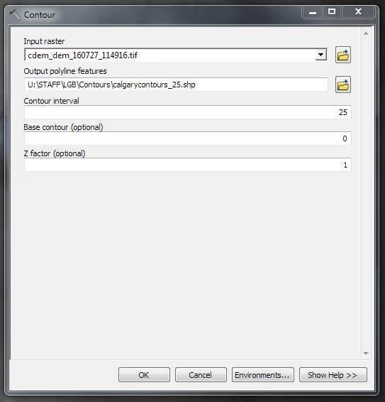

The generated contours will automatically be added to the map.
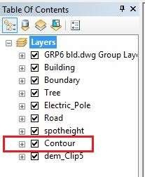

Input the data which is the AutoCAD drawing and select the feature type you want to load,

- Click Add and Next, then select the Target layer you want it to be

- Load it into from the feature class created on the ARCGLS.

- Click on Next, then select “only the features that satisfy the

- Query” and click on Query Builder to query for the feature to be loud e.g. “layer” = Boundary”.
- Click on Next. Then finish

Right click on the Boundary In the table of content and click on zoom to layer to display the feature.

EDITING, CONVERTING AND MERGING GEODATABASE

- Remove all necessary features by right clicking on it and press "REMOVE"

- Convert some features that are not in their correct „features -type‟ like point, line, and polygon features etc.
- To convert a GOEDATABASE FEATURE CLASS to another the following steps were taken:
- FOR LINE FEATURE CLASS TO POLYGON FEATURE CLASS
- Go to WINDOW on the menu bar and select ARC Toolbox.
- Select DATA MANAGEMENT TOOLS, click on FEATURES, and then Select FEATURE TO POLYGON.
- ON INPUT FEATURES, select feature to be converted, on OUTPUT FEATURE CLASS, then save on the GRP6C FOLDER, press OK and CLOSE.
- Then remove the converted feature class in the LAYER Menu and ARC CATALOG files.
- On INPUT DATASETS, select features to be merged, on OUTPUT DATASETS, then save on the GRP6C folder, press OK and CLOSE.
- Then remove the converted feature class in the LAYER Menu and ARC CATALOG files.

ADDING SPOT HEIGHTS DATA
- NOTE: STOP EDITING on the EDITOR MENU before adding data field,
- Go to FIELD ON THE MENU BAR, scroll to add Data and then ADD XYZ DATA
- Browse the EXCEL FILE for SPOT HEIGHTS, select EASTING VALUE on X - FIELD and NORTHING VALUE on Y - IELD and ELEVATION
- « Select DATA the EXPORT DATA, locate the folder created and give it name then YES AND OK, remove the previous layer by right clicking on it and select REMOVE.

TIN, ASPECT AND SLOPE CREATION USING ARCMAP
NOTE: Making sure the 3D Analyst Extension is active, select VIEW on MENU bar, then click TOOLBARS and MARK the 3D Analyst EXTENTION Then X, Y Data
TO CREATE TIN
- Click on 3D Analyst arrow, select create TIN and then create TIN from FEATURE.
- On layers mark the SPOTHEIGHT LAYER, select height data on HEIGHT, then ok.

TO CHANGE THE FACE OF THE TIN ACCODING TO ITS ELEVATION
- RIGHT CLICK on the TIN, select PROPERTIES, and click on SYMBOLOGY.
- Then ADD, select FACE ELEVATION WITH COLOR RAMP, click ADD, and then select APPLY and OK.

TO CREATE ASPECT
- Click on 3D analyst arrow, select SPATIAL ANALYST TOOLS, SURFACE and THEN DOUBLE CLICK on ASPECT.
- Browse to where the raster format of all the acquired data created from the surfer was saved to.
- Browse to where you want the OUTPUT RASTER to be saved
- You can change the OUTPUT MEASUREMENT to Degree OR percent
- Click OK [then it displays on the data view screen], then Close.

3.8.5 Facility Map Production
The buildings were digitized from the downloaded Google earth image using ArcGIS 10.2.1. Shape files for the facilities were created in Arc Catalogue. The created shape files were added to Arc Map and editor was started to digitize out to facilities. The road network, buildings are extracted using polyline and polygon respectively while street lights and trees are represented by point data for 3D map production the generated 2D map is shown in Figure 3.6, Figure 3.7 shows the old 2D CAD map of the campus.
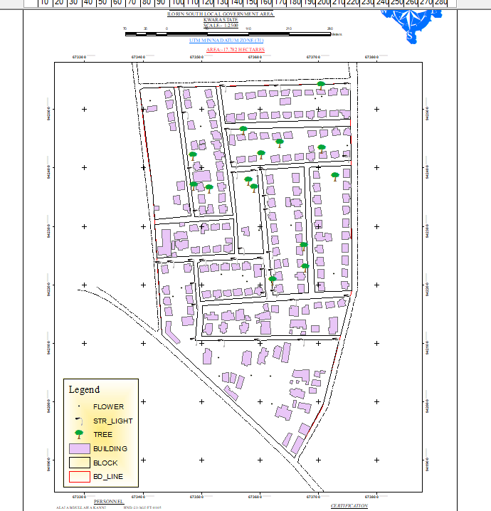

Figure 3.6 showing the 2D facility map of the study area.

3.8.6 3D Map Production
The 3D image was done Arc Scene using the created DEM; the created DEM was added to Arc Scene and extruded with the heights gotten on the field. Extrusion incorporates the height of these features in their representation to give them 3D look and was made to float on DEM to have a true land representation.
The created DEM was also added to Arc Scene, The height of the buildings gotten from the field was added to the already created height field in the attribute table of each of the facility shape file in Arc Map. Arc Scene was launched and all the shape files were added, from the table of content each shape file was right clicked on to access the property dialog box, from the property dialog box the shape files were extruded to give them 3D look and were made to float on the DEM to have a full 3D visualization.

3.8.7 Findings
This study has demonstrated a capability of GIS in facility mapping with different visualizations techniques i.e. 2D and 3D visualization, Figure 3.6 shows the generated 2D map while Figure 4(a) and Figure 4(b) show cross-sections of the generated 3D map of the campus. All the facilities were geo-located with the aid of total station and imported into ArcGIS 10.2, the facilities were also digitized from the Google earth image downloaded for the study area. 3D topographic maps of the study areas were created from the point data gotten from field-work and also from the downloaded SRTM DEM image downloaded from USGS, Figure 5 shows the 2D Topographic map generated from the point data gotten from the field using Total station while Figure 6 shows the 3D topographic map generated using the same data source. Figure 7 shows the 2D topographic map generated from SRTM 30 m while Figure 8 shows the 3D topographic map generated using the same data source. The 2D facility map was produced by digitizing all the facilities out as features from the Google earth image downloaded using Google downloader. The 3D model of the campus was produced by exporting all the features created in Arc Map to Arc Scene for extrusion; the extruded features were made to float on the 3D topography map created through interpolation using Kriging method. The 3D visualization gives the study area a near real life view.

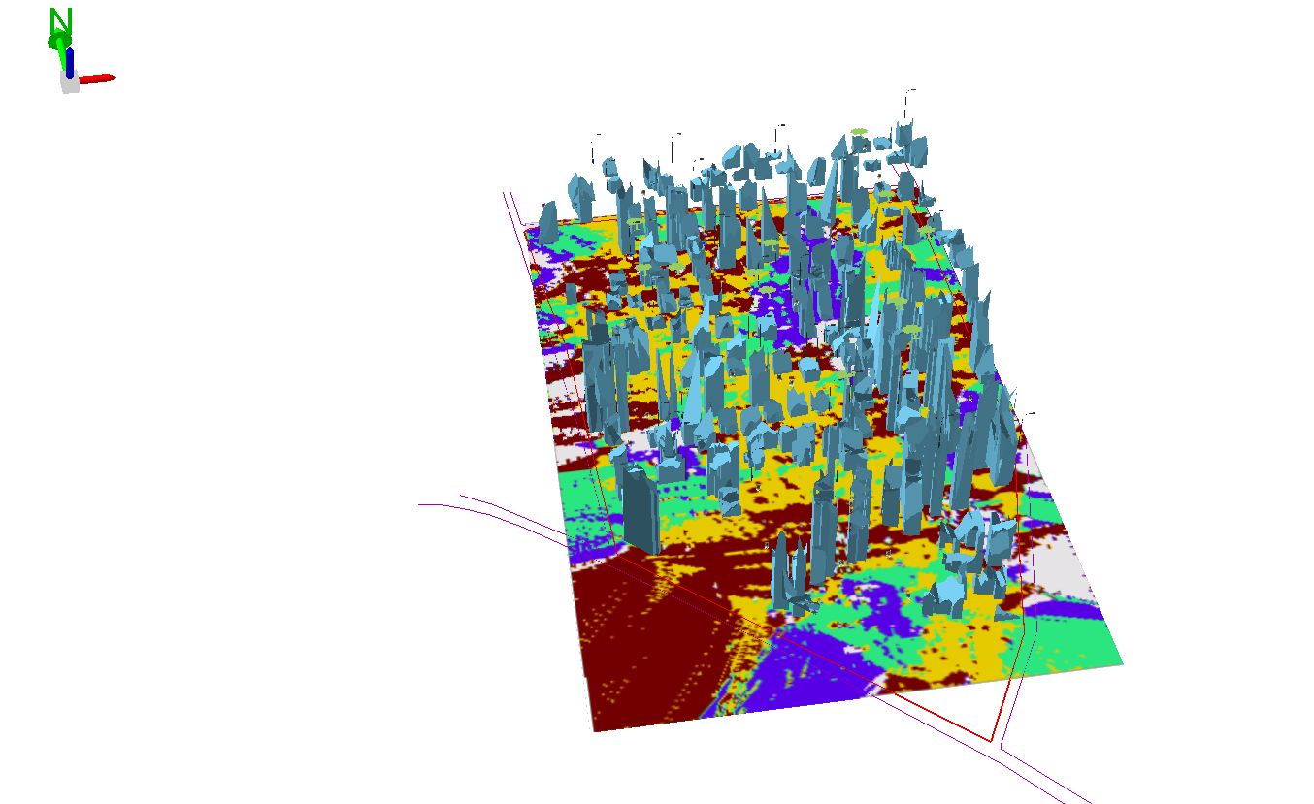

\
Figure 3.7 (a) Showing 3D model of the study area area

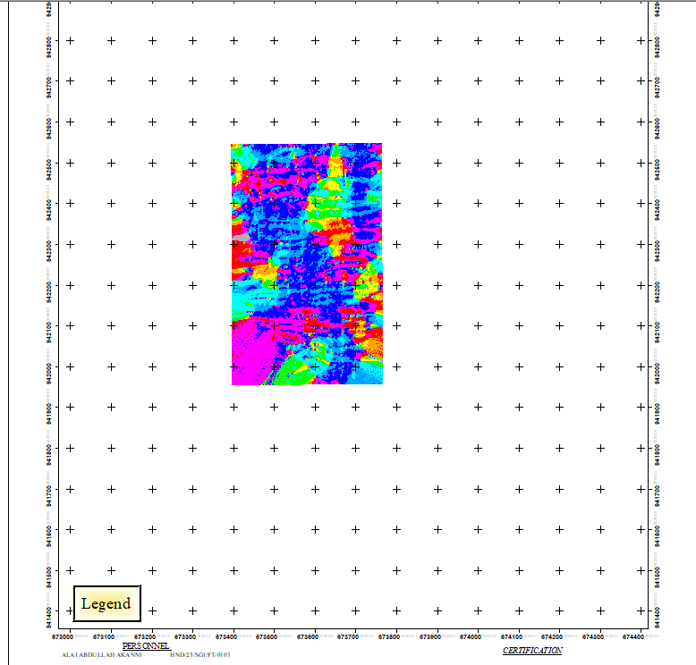

Figure 3.8 showing the 2D DEM (Digital elevation model) of the study area (derived from the field data).

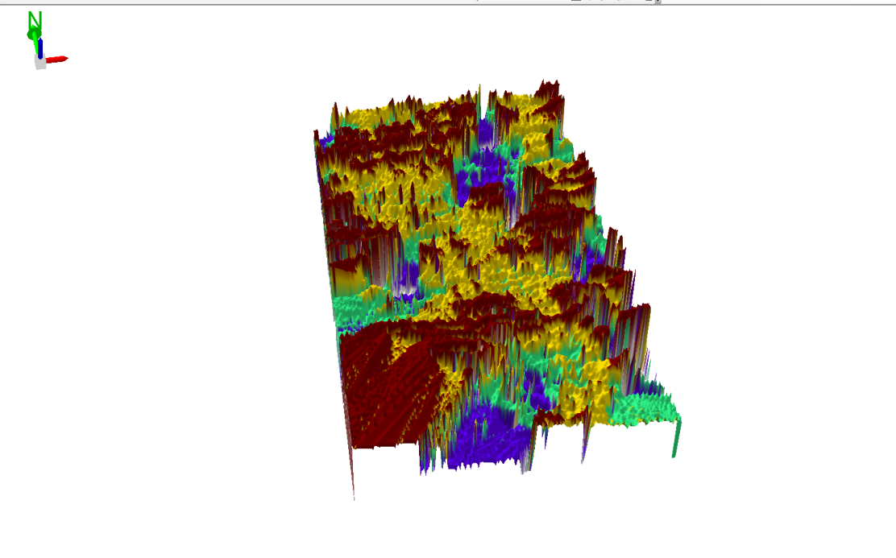

Figure 3.9 Showing 3D DEM (Digital Elevation Model) of the study area (derived from the field data).

3.8.8 Attribute data creation
There is need to create attribute tables for the features so as to be used for queries. NOTE: The editor on the menu bar must be stopped before adding field to its table. THE FOLLOWING PROCEDURES WERE FOLLOWED:
- Right click on the feature class, then select OPEN ATTRIBUTES TABLE click on OPTIONS and select ADD FIELD.
- Give it FIELD NAME, click on TYPE and select [SHORT INTEGER or LONG INTEGER for SHORT or LONG WHOLE VARIABLES or DOUBLE FOR DECIMAL VARIABLES OR TEXT variable or DATE for DATE], then enter precision or LENGTH for text width and scale for DECIMAL PLACES, and then click OK
- To input variables on the ATTRIBUTE TABLE, go to the EDITOR on Menu bar, select START EDITING,
- Click on ATTRIBUTE on menu bar [behind the TARGET], click on the features on the DATA VIEW display, and then input the variables of data acquired through SOCIAL SURVEY or DATA ACQUIRED ON THE FIELD.
- Save it after the input by selecting SAVE EDITS on the editor menu. To switch to other layers, select STOP EDITING on the EDITOR menu. Then repeat the above step to create other fields. Populate the table and save.

Table 3.10: Building

ENTITY | FIELD ALIAS | DATA TYPE | FIELD SIZE
B_ID | Building Identification | Numeric | -
B_name | Building Name | Text | 10
B_Area | Building Area | Numeric | -
B_E | Building Easting | Numeric | -
B_Northing | Building Northings | Numeric | -

Table 3.11: Road

ENTITY | FIELD ALIAS | DATA TYPE | FIELD SIZE
R_ID | Road Identifier | Numeric | -
R_Length | Road Length | Numeric | -
R_Width | Road Width | Numeric | -
R_Type | Road Type | Text | 10
R_Condition | Road Condition | Text | 10

Table 3.12: Trees

ENTITY | FIELD ALIAS | DATA TYPE | FIELD SIZE
TR_ID | Tree Identifier | Numeric | -
TR_Spp | Tree specy | Text | 10
TR_E | Tree_Easting | Numeric | -
TR_N | Tree Northing | Numeric | -

Table 3.13: Electric Poles

ENTITY | FIELD ALIAS | DATA TYPE | FIELD SIZE
EP_ID | Electric pole Identifier | Numeric | -
EP_Type | Electric pole Type | Text | 10
EP_Height | Electric pole Height | Numeric | -
EP_E | Electric pole Easting | Numeric | -
EP_N | Electric pole Northing | Numeric | -

3.8.9 DATABASE IMPLEMENTATION
This is the database creation phase. Having completed the three stages of design phase (i.e. Reality, Conceptual and Logical design), the database was created using ArcGIS 10.3 software. It involves the combination and storage of acquired graphic data and attributes data in creating the database for the purpose of spatial analysis and query.
Database is an organized integrated collection of data stored so as to be capable of use by revenant application with data being accessed by different logical part. After the Attribute table was populated via the keyboard, some attributes such as areas of settlements were automatically displayed by special command in the ArcGIS 10.3 version. The ArcGIS software was used to link the graphic data and table for query generation.

3.8.10 DATABASE MANAGEMENT SYSTEMS
Database management is a collection of software for creating, storing, manipulating, updating, organizing and querying of information in a database (Kufoniyi, 1998). It is a software package whose function is to manipulate a database on behalf of the user.
A good DBMS must provide the following functions:

      - Storage and retrieval of data.
      - Access to by several users at a time.
      - A standardized interface between database and application programmed.
      - Standardized access to data and separation of data storage and retrieval functions from the program using the data.
      - Maintenance of data security and integrity.

3.8.11 DATABASE MAINTENANCE

Having created the database, proper maintenance practice was made to meet its stated objectives. The ability to include more data and remove irrelevant data was possible by way of maintenance. There is every need for the data to be updated regularly because of the physical changes that may occur on the landscape with time. Both security and integrity were also exercised to ensure maintenance and to meet its stated objectives.
Proper observance, updating and management of database ensure its currency and quality to stand a profound chance in Spatial Decision Support System (SDSS). The quality of any database depends on the currency and fitness for use as a decision support system (SDSS). The quality of database depends on its ability to generally fit and use as a decision system (DSS). The storage media should be from time to time justified if otherwise could necessitate data inaccessibility or physical deterioration of the storage media. Also care must be taken during populating any database system, as a database is only good as the data supplied. In archiving stable media should be used. Examples of these are:-
- Computer compatible tape reader
- Magnetic tape
- Optical disc and compact disc

3.8.12 AREA COMPUTATION Table
Table 3.14: shows area computation
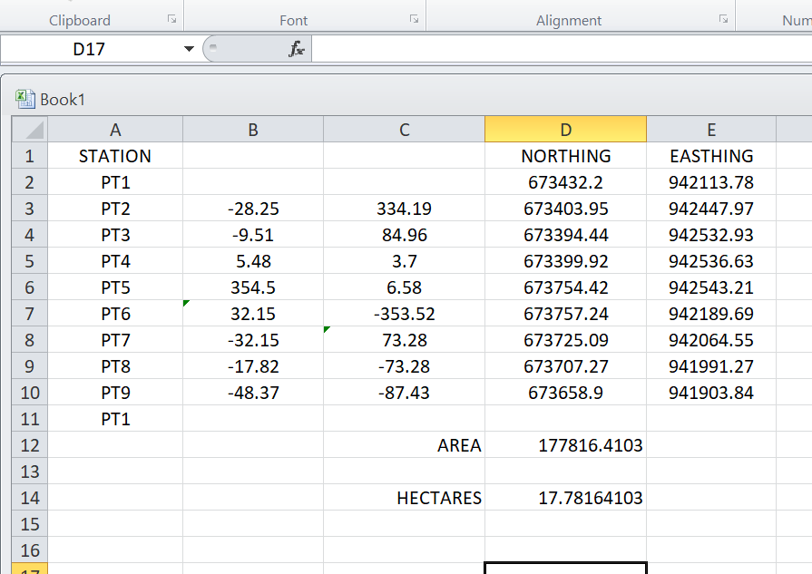

CHAPTER FOUR

4.0 SPATIAL ANALYSES AND PRESENTATION

GIS is distinct among other information system because of its spatial analytical capability; especially overlay operation, buffering, spatial search, topographic operation, and neighborhood and connectivity operations. GIS uses this spatial analytical capability to answer fundamental generic question of location, condition, trend, routing, pattern and modeling by the manipulation and analysis of input data. The major analyses performed in this project were overlay operations, topographic operations and spatial search.

4.1 TESTING OF DATABASE

This is the test carried out to determine whether there exists a relationship between data modeled about entities in a spatial database as well as putting into test its retrieval capabilities. This was done by designing a sample query with certain conditions attached and the query will be ran to see if desired result is achieved.

4.11 ANALYSIS OF RESULT

The contour whose value is greater or equal to 350 meters depicts the likelihood that such area may not be prone to flood in the project area as shown in Fig. 4.5(Query 1). This represents the elevation of points that are greater than to 350m. The displayed attribute table confirmed that North-East part of the institute had the highest elevation. Height is an important factor when considering the surface or slope of the terrain. The South-west part of the school had the lowest elevation which is very prone to erosion. Buildings that will be sited in that region must have a very high foundation above the ground level. The result of the query will afford the school management to decide concisely the terrain characteristics and the kind of building that should build in every region of the project area looking critically at the terrain of the area.

SINGLE SELECTION CRITERION

Query 1: shows the completed building

SELECT* FROM Building WHERE "BLD_STATUS" LIKE COMPLETED
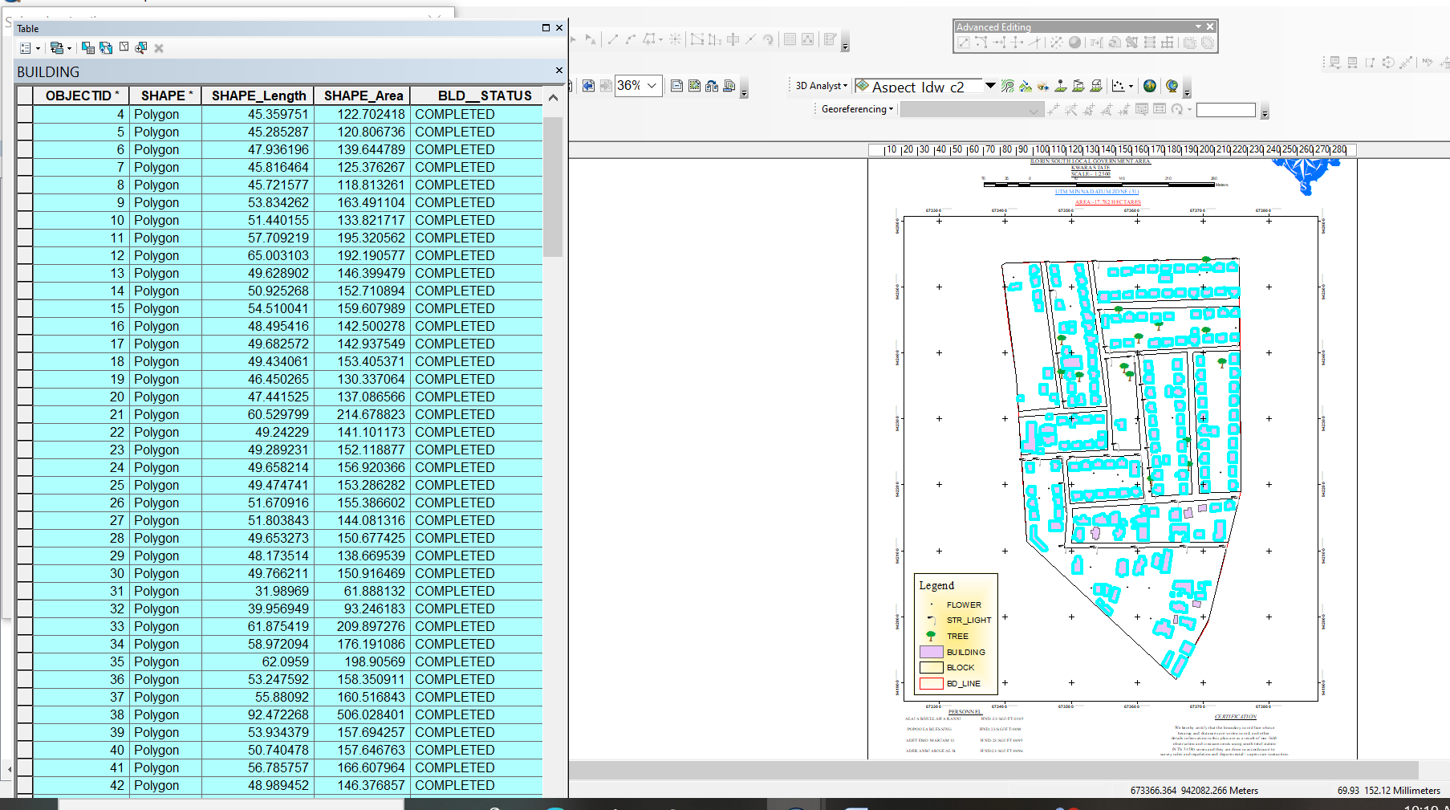

Fig 4.1: shows the completed building
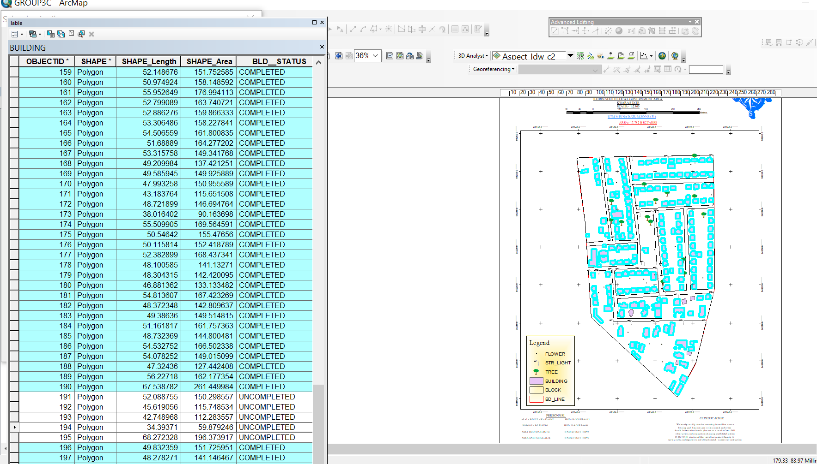

Fig 4.2: shows the 2D completed building
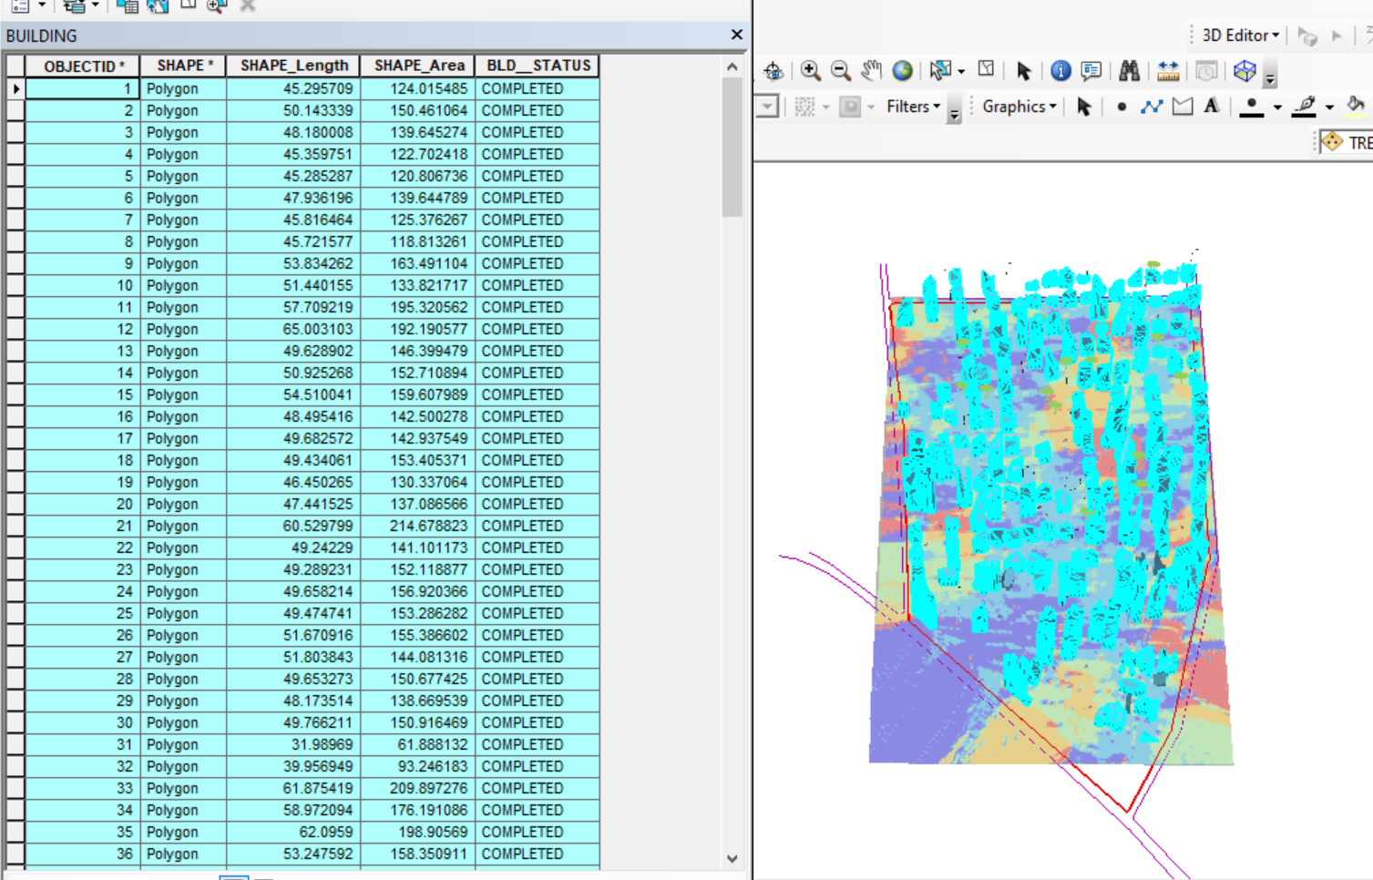

Figure 4.3 shows the 3D of completed building
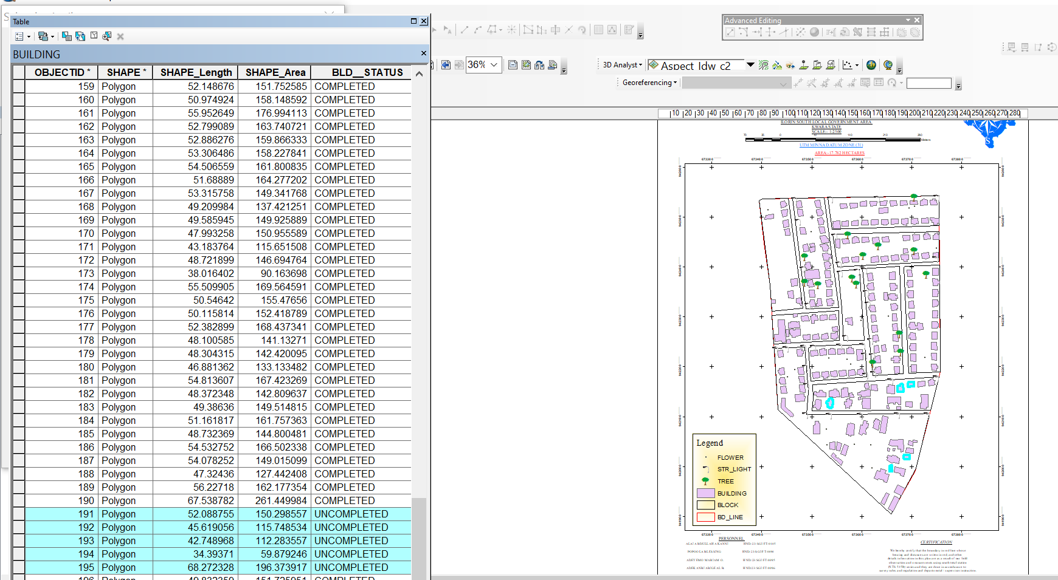

Fig 4.4 Query shows the 2D of uncompleted building

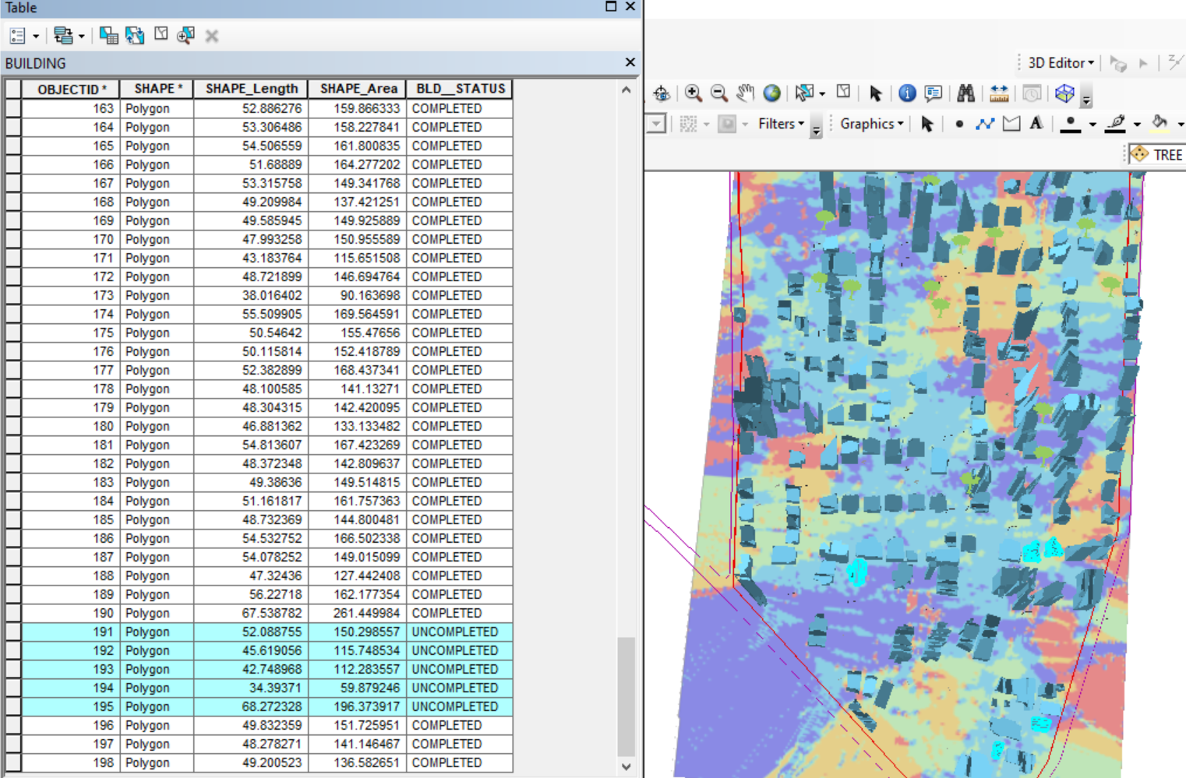

Figure 4.5 shows the 3D of uncomplted building

CHAPTER FIVE

5.0 Costing Estimation, Summary, Conclusion, Recommendation and Problem Encountered

5.1 Costing Estimation
RECONNAISSANCE
S/N | PERSONNEL | QTY | DAILY RATE | NO OF DAYS | REMARK
1 | Group leader | 1 | 5,000 | 1 | 5,000
2 | Ass group leader | 1 | 2,500 | 1 | 2,500
3 | Basic equipment | 1 | 25,000 | 1 | 25,000
4 | Transportation | 1 | 3,000 | 1 | 3,000
 | TOTAL |  |  |  | 35,500

MONUMENTATION

S/N | PERSONNEL | QTY | DAILY RATE | NO OF DAYS | REMARK
1 | Group leader | 1 | 5,000 | 1 | 5,000
2 | Ass group leader | 1 | 2,500 | 1 | 2,500
4 | Basic equipment | 1 | 25,000 | 1 | 25,000
5 | Transportation | 1 | 7,500 | 1 | 3,000
 | TOTAL |  |  |  | 35,500

TRAVERSE AND DETAILING

S/N | PERSONNEL | QTY | DAILY RATE | NO OF DAYS | REMARK
1 | Group leader | 1 | 5,000 | 5 | 25,000
2 | Ass group leader | 1 | 2,500 | 5 | 12,500
4 | Transportation | 1 | 3,000 | 5 | 15,000
 | Basic Equipment | 1 | 25,000 | 5 | 125,000
 | TOTAL |  |  |  | 177,500

DATA EDITING AND PROCESSING
S/N | PERSONNEL | QTY | DAILY RATE | NO OF DAYS | REMARK
1 | Surveyor | 1 | 10,000 | 7 | 70,000
2 | Group leader | 1 | 5,000 | 7 | 35,000
3 | Ass group leader | 1 | 2,500 | 7 | 17,500
4 | Standard set |  | 15,000 | 7 | 105,000
5 | Computer accessories | 1 | 10,000 | 7 | 70,000
 | TOTAL |  |  |  | 297,500

PLAN AND MAP PRODUCTION
S/N | PERSONNEL | QTY | DAILY RATE | NO OF DAYS | REMARK
1 | Supervisor | 1 | 10,000 | 2 | 20,000
2 | Group leader | 1 | 5,000 | 2 | 10,000
3 | Ass group leader | 1 | 2,500 | 2 | 5,000
5 | Standard Set |  | 10,000 | 3 | 30,000
6 | Computer Accessories | 1 | 25,000 | 3 | 75,000
 | TOTAL |  |  |  | 140,000

TECHNICAL REPORT
S/N | PERSONNEL | QTY | DAILY RATE | NO OF DAYS | REMARK
1 | Group leader | 1 | 10,000 | 1 | 10,000
2 | Ass group leader | 1 | 5,000 | 1 | 5,000
3 | Computer | 1 | 15,000 | 1 | 15,000
4 | Generator and fuel | 1 | 10,000 | 1 | 10,000
5 | Consumables |  | 10,000 | 1 | 10,000
 | TOTAL |  |  |  | 50,000

Sum total = 736,000.00

Contingency allowance =736,000.00 X 5 = 36,800
100
VAT = 736,000.00 X 7.5 = 55,200
100

MOB/DEMB = 736,000.00 X 10 = 73,600
100

SUMMARY OF THE COST RATE
ITEM | PROJECT QUANTITY | UNIT RATE (N)
1 | Reconnaissance | 35,500
2 | Monumentation | 35,500
3 | Traverse and detailing | 177,500
4 | Data editing and processing | 297,500
5 | Plan and map production | 140,000
6 | Technical report | 50,000
7 | Contingency 5% | 36,800
8 | VAT 7.5% | 55,300
9 | Mobilization/Demobilization 10% | 73,600
 | TOTAL | 901,700
TABLE 5.1 COST IMPLICATION OF THE DIGITAL MAPPING OF ROYAL VALLEY ESTATE

5.2 SUMMARY
This project titled “Digital Mapping of Infrastructural Facilities” was carried out to demonstrate the use of modern geospatial technology in the acquisition, processing, and presentation of accurate spatial data for infrastructural planning and development. The main objective was to produce a detailed, reliable, and scalable digital map that accurately represents the physical and man-made features present within the study area.
The methodology adopted for this project followed standard surveying procedures and included stages such as reconnaissance, beaconing, monumentation, traversing, spot heighting, data processing, and map production. The reconnaissance phase involved field visits to identify accessible routes, establish survey controls, and design an effective workflow. Beaconing and monumentation were conducted to provide firm reference points for accurate measurement.
A Total Station instrument was used to perform angular and linear measurements during the traverse. The bearing and distances obtained were used to compute coordinates, which were used to plot the various survey stations. A back computation was conducted to verify the closure of the traverse, ensuring the reliability of data. The result obtained was processed into tabular formats and used in AutoCAD for the production of both perimeter and detailed maps.
Detailing involved picking visible features such as buildings, roads, poles, drainage, and other infrastructural elements. These were carefully plotted to reflect their true location and orientation within the area. Spot heighting was conducted to represent variations in elevation across the study area. This added the third dimension to the map and made it useful for engineering and construction-related planning.
The cost estimation covered all phases of the work, including labor, equipment usage, transportation, data processing, and report compilation. This gave a clear financial overview of what it takes to execute a project of this magnitude using professional methods and modern equipment.
Ultimately, the outcome of the work produced a comprehensive and well-detailed digital map, which could serve multiple uses for urban planning, construction, environmental assessment, land administration, and academic research.

5.3 CONCLUSION
From the detailed processes and results of this project, it can be concluded that the use of digital mapping techniques significantly enhances the accuracy, clarity, and usability of spatial data required for planning and managing infrastructural facilities. The Total Station, combined with AutoCAD software, proved to be an effective toolset for data acquisition and digital representation.
The project was able to:
- Establish and coordinate survey control points,
- Generate accurate traverse networks,
- Capture the position and height of features,
- Produce perimeter and detailed plans using AutoCAD, and
- Interpret the mapped data for real-world applications.
The map produced can serve as a base map for a wide range of infrastructural developments such as road construction, drainage planning, housing layouts, and public utilities management. It supports spatial decision-making by providing planners and engineers with a visual and metric reference for their projects.
Moreover, the integration of modern techniques like spot heighting and coordinate computation ensures the data is not only geometrically reliable but also suitable for use in GIS platforms for further analysis and simulation. This project reaffirms that digital mapping is a necessary evolution in geospatial data management, especially in the face of growing urbanization and infrastructural demands.

5.4 RECOMMENDATIONS
In light of the outcome and findings of this project, the following recommendations are proposed to improve future digital mapping projects and enhance the value of geospatial data in infrastructural development:
- Integration with GIS Platforms: The digital map produced should be integrated into a Geographic Information System (GIS) environment to allow for advanced spatial analysis, data querying, and interactive mapping capabilities.
- Institutional Investment in Modern Equipment: Institutions and agencies involved in land and urban management should invest in high-end surveying equipment such as RTK GPS, drones for aerial mapping, and 3D laser scanners to improve the scope and accuracy of data acquisition.
- Capacity Building and Training: Regular capacity-building programs should be organized for students, professionals, and field technicians to ensure they are equipped with the latest skills and knowledge in digital surveying and data management.
- Periodic Map Updates: Infrastructural data should be updated at regular intervals to reflect changes in the built environment, new constructions, or demolition of old structures. This ensures the map remains relevant for planning and administrative use.
- Collaboration with Government Agencies: Surveyors and planners should collaborate with local planning authorities to standardize geospatial datasets and support data-driven decision-making in public projects.
- Use of Drone Photogrammetry: Future surveys should incorporate drone technology to supplement ground-based data collection. Drones can cover large areas in less time and provide high-resolution images for topographic analysis.
- Proper Data Management Systems: It is important to establish a centralized and secure digital storage system for survey data to prevent loss and to ensure easy retrieval for future use or reference.
- Environmental Considerations: Future surveys should incorporate environmental features and constraints into mapping to support sustainable development and environmental conservation.

5.5 PROBLEMS ENCOUNTERED
Despite the successful completion of the project, several challenges were encountered at different stages, which are outlined as follows:
- Limited Access to Advanced Survey Equipment: One of the major challenges faced was the limited availability of high-precision equipment. At times, equipment sharing caused delays, and the absence of some accessories affected productivity.
- Weather Conditions: Unfavorable weather conditions, particularly rainfall and high humidity, disrupted field operations. Wet conditions also made it difficult to set up and maintain equipment stability, thereby affecting data accuracy in some instances.
- Logistical Constraints: Transporting personnel, beacons, and instruments to and from the field was occasionally difficult due to poor road conditions or lack of adequate vehicles. This increased operational time and expenses.
- Power Supply Issues: Inadequate power supply interrupted data processing and map production, especially during AutoCAD operations which require stable electricity for extended hours.
- Accessibility of Study Area: Certain portions of the study area were difficult to access due to dense vegetation, construction barriers, or restricted entry. This limited the comprehensiveness of data collected in those zones.
- Time Constraints: The academic calendar did not allow for extended fieldwork. As a result, some aspects of the work had to be conducted under time pressure, which may have affected thoroughness in some sections.
- Human Errors: During data collection, some errors were noticed in readings and recording, which required recomputation and validation to ensure accuracy. These were corrected, but they consumed extra time and resources.
- Financial Limitations: Although a budget was outlined, there were instances of unexpected expenses such as fuel hikes, equipment rentals, or additional personnel needs that slightly strained the planned budget.
Despite these setbacks, the team was able to navigate through each challenge and complete the project effectively, demonstrating resilience, technical competence, and team coordination.

REFERENCES
Adebayo, A., Olayinka, O., & Adeleke, B. (2020). Infrastructure maintenance challenges in Ilorin: A GIS-based assessment. Journal of Urban Development, 15(2), 45-60. https://doi.org/xxxx
Longley, P. A., Goodchild, M. F., Maguire, D. J., & Rhind, D. W. (2015). Geographic information systems and science (4th ed.). Wiley.
National Space Research and Development Agency (NASRDA). (2021). National infrastructure mapping initiative: Technical report. Nigerian Federal Ministry of Science and Technology.
Olayemi, F. (2019). Urbanization and infrastructure deficits in Ilorin, Kwara State. Nigerian Journal of Environmental Planning, 8(3), 112-128.
Sulaimon, T., & Adewale, B. (2021). GIS applications in environmental management: Case study of Kwara State. African Geospatial Review, 12(1), 33-50.
World Bank. (1994). World development report: Infrastructure for development. Oxford University Press.
Burrough, P.A., & McDonnell, R.A. (1998). Principles of Geographical Information Systems. Oxford University Press.
Goodchild, M.F. (2007). Citizens as sensors: The world of volunteered geography. GeoJournal, 69(4), 211–221. https://doi.org/10.1007/s10708-007-9111-y
Longley, P.A., Goodchild, M.F., Maguire, D.J., & Rhind, D.W. (2015). Geographic Information Systems and Science (4th ed.). Wiley.
United Nations Human Settlements Programme (UN-Habitat). (2020). World Cities Report: The Value of Sustainable Urbanization. Nairobi: UN-Habitat.
ESRI (2023). What is GIS? Retrieved from: https://www.esri.com/en-us/what-is-gis/overview
National Research Council. (2003). GIS for Housing and Urban Development. The National Academies Press. https://doi.org/10.17226/10674
Federal Ministry of Works and Housing (Nigeria). (2020). National Integrated Infrastructure Master Plan (NIIMP). Abuja: FMWH.
Adebayo, A. A., Oladimeji, M. T., & Yusuf, A. B. (2020). Assessment of Infrastructure Maintenance Challenges in Ilorin, Nigeria. Nigerian Journal of Urban and Regional Planning, 11(2), 75–89.
Longley, P. A., Goodchild, M. F., Maguire, D. J., & Rhind, D. W. (2015). Geographic Information Systems and Science (4th ed.). Wiley.
Olayemi, A. M. (2019). Urban Growth and Infrastructure Demand in Ilorin Metropolis. Ilorin Journal of Geography and Environmental Management, 6(1), 45–60.
Sulaimon, A. A., & Adewale, A. B. (2021). GIS and Environmental Monitoring: A Case Study of Ilorin, Kwara State. Journal of Sustainable Development in Africa, 23(4), 112–128.
World Bank. (1994). World Development Report 1994: Infrastructure for Development. Oxford University Press.
ESRI. (2023). What is GIS? Retrieved from https://www.esri.com/en-us/what-is-gis/overview
NASRDA. (2020). National Infrastructure Mapping and Geo-Spatial Data Initiative. Abuja: National Space Research and Development Agency.
Lagos State Government. (2018). Lagos Infrastructure Asset Management Report. Ministry of Works and Infrastructure.
Singapore Land Transport Authority (LTA). (2022). Smart Mobility 2030 Masterplan. Government of Singapore.
New York City Planning Department. (2021). Digital Mapping for Urban Revitalization. NYC Urban Innovation Series.
Japan Meteorological Agency (JMA). (2011). Post-Tsunami Emergency Response Mapping. Tokyo: Government of Japan.

