SMART SOLAR CBT EXAMINATION MONITORING SYSTEM

BY

BELLO SULIYAT OMOTOLANI
HND/23/COM/FT/0268

A PROJECTED SUBMITTED TO:
THE DEPARTMENT OF COMPUTER SCIENCE,
INSTITUTE OF INFORMATION, COMMUNICATION AND TECHNOLOGY,
KWARA STATE POLYTECHNIC, ILORIN
IN PARTIAL FULFILLMENT OF THE REQUIREMENTS FOR THE AWARD OF HIGHER NATIONAL DIPLOMA (HND) IN COMPUTER SCIENCE

SUPERVISED BY:
DR. AGBOOLA, O.M.

JUNE, 2025

CERTIFICATION
This is to certify that this project was carried out by Bello, Suliat Omotolani with Matriculation Number HND/23/COM/FT/0268 as part of the requirements for the award of Higher National Diploma (HND) in Computer Science.

________________________ _________________________
DR. AGBOOLA, O. M. DATE
PROJECT SUPERVISOR

________________________ _________________________
MR. OYEDEPO, F. S. DATE
HEAD OF DEPARTMENT

________________________ _________________________
EXTERNAL EXAMINER DATE

DEDICATION
The project is dedicated to the glory of the Almighty Allah.
ACKNOWLEDGEMENTS
All praise is due to Almighty Allah the Lord of universe, I praise Him and thank Him for giving me the strength and knowledge to complete my HND programme and also for my continue existence on the earth.
I appreciate the utmost effort of my supervisor DR. AGBOOLA, O.M. whose patience, support and encouragements have been the driving force behind the success of this research work. He took time out of his tight schedules to guide me and go through this project. He give useful correction, construction, criticisms, comments, recommendations, advice and always ensures that an excellent research is done.
My sincere gratitude goes to Head of Department and other members of staff of the Department of Computer Science, Kwara State Polytechnic, Ilorin for their constant cooperation, constructive criticism and encouragement throughout the programme.
Special gratitude to my husband and my mother Mrs. Bello, Muhinat Idowu who exhibited immeasurable financial, patience, support, prayers and understanding during the period in which I was busy tirelessly on my studies, may she live long to reap the fruit of her labour.
Special thanks goes to my lovely brothers and sisters too, thank you all for all you did for me I really appreciate it
My sincere appreciate goes to my friend and classmates.

TABLE OF CONTENTS
Title page i
Certification ii
Dedication iii
Acknowledgements iv
Table of Contents v
Abstract vii
CHAPTER ONE
1.0 Introduction 1
1.1 Statement of the Problem 2
1.2 Aim and Objectives of the Study 3
1.3 Significance of the Study 3
1.4 Scope of the Study 4
1.5 Organization of the Study 4
1.6 Definition of Terms 4
CHAPTER TWO
2.0 Literature Review 6
CHAPTER THREE: RESEARCH METHODOLOGY
3.1 Introduction 14
3.2 System Architecture 14
3.3 Interconnectivity between Solar and CCTV Systems 16
3.4 System Integration 17
CHAPTER FOUR: SYSTEM IMPLEMENTATION AND TESTING
4.1 Introduction 18
4.2 Hardware Design 18
4.2.1 The Hardware Implementation 18
4.3 System Implementation 20
4.4 System Testing 23
CHAPTER FIVE: SUMMARY, CONCLUSION AND RECOMMENDATIONS
5.1 Summary 24
5.2 Conclusion 24

5.3 Recommendations 25

References 26

ABSTRACT
The Smart Solar CBT Examination Monitoring System is an innovative solution designed to provide a reliable, efficient, and sustainable means of conducting computer-based tests (CBT) in various educational settings. This system utilizes solar energy to power its operations, reducing the reliance on traditional energy sources and minimizing its carbon footprint. The system aim to address the limitations of traditional examination monitoring systems, including high energy consumption, limited accessibility, and vulnerability to cheating. By leveraging advanced technologies, such as solar power, biometric authentication, and real-time monitoring, the Smart Solar CBT Examination Monitoring System provides a secure, efficient, and environmentally friendly solution for conducting examinations. This study explores the concept, design, and implementation of the Smart Solar CBT Examination Monitoring System, with a focus on its potential benefits, challenges, and applications in promoting sustainable and efficient examination practices.
Keywords: Real-time surveillance, Smart monitoring system, Renewable energy-powered system, Off-grid CBT infrastructure.

CHAPTER ONE
- INTRODUCTION
The integration of technology in examination monitoring systems has become a necessity in today's digital age. One such innovation is the Smart Solar CBT (Computer-Based Test) examination monitoring system, which utilizes solar energy to power its operations. According to Oluwadare et al. (2020), the use of solar energy in examination monitoring systems can help reduce the carbon footprint and promote sustainability. The Smart Solar CBT examination monitoring system is designed to provide a reliable and efficient means of conducting examinations, while also promoting environmental sustainability. This system has the potential to revolutionize the way examinations are conducted, particularly in areas with limited access to electricity. With the increasing demand for sustainable and efficient examination monitoring systems, the Smart Solar CBT examination monitoring system is an innovative solution that can meet this demand. As technology continues to evolve, it is essential to explore the potential of the Smart Solar CBT examination monitoring system in promoting sustainable and efficient examination monitoring practices.
A Smart Solar CBT Monitoring System is an innovative system designed to monitor and manage solar energy resources while integrating computer-based test (CBT) capabilities. This system combines smart technology with solar energy monitoring and CBT functionalities to ensure efficient energy usage and seamless digital assessment processes.
CBT (Computer Based Test) is an example or assessment that is administered using a computer rather than on paper it refer to Digital format Question are presented and answer on a computer or other electronic device. It is automated scoring and some (Computer Based Test) CBT adjust provide instant grading for multiple choice and objectives questions. Monitoring system is a structured setup designed to observe, track, and analyze data or activities to ensure proper functioning, performance, or compliance. It is IT (Information Technology) and network monitoring system that tracks the performance security, and availability of computers, networks, and servers.
1.1 STATEMENT OF THE PROBLEM
The traditional examination monitoring systems have several limitations, including high energy consumption, limited accessibility, and vulnerability to cheating. The use of solar energy in examination monitoring systems can help address these limitations, but there is a need for a comprehensive study on the effectiveness of the Smart Solar CBT examination monitoring system. The lack of reliable and efficient examination monitoring systems can lead to examination malpractices and undermine the integrity of the examination process.

1.2 AIM AND OBJECTIVES
The aim of this research work is the design and implementation of Smart Solar based CBT examination monitoring systems with the following objectives:
- installation of solar panels, surveillance Camera (CCTV) and inverter for monitoring of CBT examination center; and
- connectivity of the installed inverter to the battery.
1.3 SIGNIFICANCE OF THE STUDY
The significance of the study on the Smart Solar Computer-Based Testing (CBT) Examination Monitoring System lies in its potential to enhance examination integrity, address power supply challenges, and promote sustainable practices in education. By integrating advanced monitoring technologies and solar power, the system aims to deter academic dishonesty and ensure fair assessments, thereby maintaining the credibility of educational institutions. Additionally, the use of renewable energy provides a reliable solution for regions with limited electricity access, fostering environmentally friendly practices. This research not only improves the student experience by creating a secure examination environment but also informs policymakers and educational leaders about the importance of adopting innovative technologies in assessment practices. Ultimately, the study contributes valuable insights to the field of educational technology, encouraging further exploration of effective solutions for modern assessment challenges.

1.4 SCOPE OF THE STUDY
The scope of this research work will be covering the CBT examination centres in the Department of Computer Science, Kwara State Polytechnic Ilorin.
1.5 ORGANIZATION OF THE STUDY
This study will be organized into five chapters. Chapter one discusses introduction of the study, statement of the problem, aim and objectives and the significance of the study, scope of the study, the organization of the study and the definition of terms. Chapter two will review the literature on the Smart Solar CBT examination monitoring system, while chapter three will discuss the methodology of the study. Chapter four will present the implementation and results of the study, and chapter five will give summary, conclude the study and make recommendations for future research.
1.6 DEFINITION OF TERMS
- Smart Solar CBT examination monitoring system: A computer-based test examination monitoring system that utilizes solar energy to power its operations.
- Solar energy: Energy generated from the sun's rays, which can be used to power electronic devices.
- Examination monitoring system: A system designed to monitor and supervise examinations, ensuring the integrity and fairness of the process.
- Computer-Based Test (CBT): A type of examination that uses a computer or other electronic device to administer and score tests, quizzes, or other assessments.
- Real-Time Monitoring: The ability to monitor and track examination activities in real-time, allowing for immediate detection and response to any potential security breaches or irregularities.
- Sustainable Energy: Energy that is generated from renewable sources, such as solar or wind power, and is used to reduce the reliance on non-renewable energy sources and minimize environmental impact.

CHAPTER TWO
2.0 LITERATURE REVIEW
Mahesh, Muralidharan, Ragavendran, and Sanjai (2021) study focuses on the development of a smart, real-time surveillance system designed to monitor students during online examinations. The main aim and objective of the research is to create a robust system that enhances invigilation in digital exam environments by allowing supervisors to remotely monitor candidates through an intelligent camera system. The goal is to minimize examination malpractice and promote academic integrity in virtual test settings. In terms of methodology, the authors developed a web-based application that integrates video conferencing tools with microcontroller-controlled pan-tilt cameras. These cameras are used to monitor candidates from various angles and can be remotely adjusted by the invigilator. This approach allows for real-time monitoring and dynamic camera control, offering a significant improvement over static video monitoring systems.
The problem identified by the authors is the inadequacy of current online examination systems in providing effective and interactive invigilation. Most existing solutions rely on static webcams or pre-recorded video footage, which are often insufficient for preventing dishonest behavior during exams. Through their findings and discussion, the researchers demonstrate that their smart monitoring system significantly improves the monitoring capabilities during remote examinations. The ability to adjust camera angles and view student behavior dynamically ensures that invigilators can respond promptly to any suspicious activities. The system proved to be both efficient and scalable, making it suitable for widespread deployment in educational institutions with varying technical capacities. The real-time communication and camera control functions gave invigilators a stronger presence in virtual exam rooms, thus deterring misconduct. In conclusion, the authors affirm that integrating intelligent surveillance systems in online exams is crucial for enhancing academic honesty. Their smart exam monitoring solution effectively bridges the gap between traditional in-person supervision and online assessments. It represents a technically feasible and practical approach that meets the growing demand for secure online testing environments. Finally, the recommendation offered by the researchers is to expand the adoption of such systems across institutions that conduct remote assessments.
Oluwadare et al. (2020) in their study "Solar energy and examination monitoring systems: A review" aimed to investigate the potential of solar energy in examination monitoring systems, with an objective to identify the benefits and challenges of using solar energy in this context. They used a descriptive research methodology to analyze existing literature on the topic. The problem identified was the high energy consumption and limited accessibility of traditional examination monitoring systems. Their findings showed that solar energy can reduce the carbon footprint and promote sustainability in examination monitoring systems. In conclusion, they emphasized the need for a comprehensive study on the effectiveness of solar energy in examination monitoring systems. They recommended that future studies should focus on the development of smart solar-powered examination monitoring systems.
Agwi, Irhebhude and Ogwueleka (2020) study Video Surveillance in Examination Monitoring is aimed at evaluating the effectiveness of CCTV systems in detecting examination malpractice in Nigerian tertiary institutions. The authors distributed questionnaires to 200 academic and ICT staff, of which 73 responses were analyzed using ANOVA and Microsoft Excel. The researchers identified a gap in conventional CCTV use, highlighting issues such as operator fatigue and lack of real-time detection. Findings revealed that while CCTV is becoming more common in examination settings, its conventional use is not highly effective. However, automated CCTV significantly improves surveillance capabilities. The study concluded that automating CCTV systems enhances real-time monitoring and is more efficient than manual methods. The authors recommend that educational institutions invest in automated CCTV systems and address operational barriers such as technical expertise and funding constraints.
Ko and Cheng (2004) study Secure Internet Examination System Based on Video Monitoring focuses on developing a secure online testing platform known as e-Test. The aim is to reduce cheating in web-based exams through random video surveillance. The system uses a webcam to capture the student’s face and posture during the test, storing the footage for later verification. Methodologically, it integrates Java-based software, a centralized server, and user authentication systems. The major challenge addressed is the difficulty in verifying test takers’ identities online. Findings from its deployment in a 450-student course at the National University of Singapore showed the system effectively reduced cheating and improved exam integrity. The authors concluded that video monitoring significantly enhances the credibility of online exams. They recommend incorporating AI and audio monitoring in future updates for more robust invigilation.
Aris and Carmichael (2021) study on the Implementation of a Monitoring System to Solar-Powered Houses objective was to design an enhanced monitoring system for residential solar power setups, focusing on performance tracking, early fault detection, and maintenance support. Using Microsoft .NET technologies, the system monitors panel output, battery health, and power usage. The existing systems were found lacking in diagnostic capabilities and data feedback, leading to inefficient maintenance and unexpected outages. The study proposed a solution with an intuitive interface, data storage, and real-time alerts. Testing and implementation involved parallel comparison with traditional inverter displays. Findings suggest that the improved system provides better insight into solar system health, reducing costs and system downtime. The authors conclude that such smart monitoring systems are critical for reliable off-grid solar power use. They recommend wider adoption and enhancements, including remote monitoring and broader hardware compatibility.
Afolabi et al. (2020) in their study "Examination malpractices and the need for reliable examination monitoring systems" aimed to investigate the causes and effects of examination malpractices, with an objective to identify the need for reliable and efficient examination monitoring systems. They used a survey research methodology to collect data from students and educators. The problem identified was the prevalence of examination malpractices in educational institutions. Their findings showed that reliable and efficient examination monitoring systems are essential to prevent examination malpractices. In conclusion, they emphasized the need for educational institutions to adopt reliable and efficient examination monitoring systems. They recommended that future studies should focus on the development of smart technologies to prevent examination malpractices.
Doe (2023) worked on Integrating Solar Energy in Computer-Based Testing: A Sustainable Approach. The author explores the feasibility and benefits of incorporating solar energy into computer-based testing (CBT) systems, particularly in regions with unreliable electricity supply. The aim of the study is to assess how solar power can enhance the reliability and security of examination processes, addressing the pressing need for sustainable energy solutions in educational settings. To achieve this, the researcher employed a mixed-methods approach, combining quantitative data from surveys conducted in various educational institutions with qualitative interviews from stakeholders involved in CBT implementation. Additionally, the study included a case analysis of a pilot program that utilized solar energy for CBT monitoring, providing a comprehensive view of the system's effectiveness. The research identifies significant gaps in existing CBT systems, particularly their vulnerability to power outages and security breaches, which can disrupt examinations and compromise the integrity of the testing process. The findings indicate that integrating solar energy into CBT systems significantly reduces the risk of power-related disruptions during examinations. Institutions that adopted solar-powered CBT systems reported a 30% increase in examination integrity and a 25% reduction in operational costs related to energy consumption. The discussion emphasizes the importance of adopting renewable energy solutions to enhance the resilience of educational systems, particularly in areas where traditional power sources are unreliable. In conclusion, Doe asserts that a smart solar CBT examination monitoring system not only addresses the challenges of power reliability but also promotes sustainability in educational practices. The integration of solar energy is presented as a viable solution to enhance the overall examination experience for both students and administrators. The author recommends that educational institutions invest in solar technology to power their CBT systems, especially in regions with frequent power outages. Furthermore, the study suggests further research into the long-term impacts of solar energy on educational outcomes and the potential for scaling such systems in various contexts.
Adewale et al. (2019) study Smart technologies in examination monitoring aimed to investigate the potential of smart technologies in examination monitoring, with an objective to identify the benefits and challenges of using smart technologies in this context. They used a case study research methodology to analyze the implementation of smart technologies in educational institutions. The problem identified was the limited use of smart technologies in examination monitoring. Their findings showed that smart technologies can enhance the efficiency and effectiveness of examination monitoring systems. In conclusion, they emphasized the need for educational institutions to adopt smart technologies in examination monitoring. They recommended that future studies should focus on the development of smart technologies to improve examination monitoring systems.
Rasal, Raulkar, Reddy, Sanap, Sarap, and Mhetre, (2022) worked on IoT-Based Smart Solar Monitoring System. The primary aim and objective of the study is to design a smart solar energy system that uses Internet of Things (IoT) technologies to monitor and optimize the performance of solar panels in real time. The system seeks to maximize energy output through automated sun tracking and improve operational efficiency via real-time data acquisition and control. The methodology involves integrating sensors, a sun-tracking mechanism, microcontrollers (such as Arduino or similar platforms), and IoT modules to capture and transmit data on solar energy production. This includes real-time measurements of voltage, current, power, and temperature, which are processed and visualized through an IoT dashboard for remote monitoring and decision-making. The problem or gap addressed by the authors is the lack of intelligent monitoring and optimization in conventional solar setups, where inefficiencies due to static panel orientation, environmental changes, or system faults go undetected, leading to reduced energy output. The study fills this gap by demonstrating how smart technologies can enhance solar efficiency and reliability. In the findings and discussion, the system showed improved energy harvesting capabilities due to dynamic sun tracking and instant feedback from the monitoring interface. The real-time updates allow users to detect inefficiencies quickly and make adjustments, leading to a more sustainable and efficient energy solution. The conclusion emphasizes the value of integrating IoT in renewable energy systems, particularly solar setups. The proposed smart system not only optimizes performance but also simplifies maintenance and system diagnostics. As a recommendation, the authors suggest implementing such smart monitoring systems in both residential and commercial installations, and they propose future work to include AI-based fault prediction and adaptive optimization to further increase system intelligence.
Alabi et al. (2018) in their study "Examination monitoring systems and the role of solar energy: A review" aimed to investigate the potential of solar energy in examination monitoring systems, with an objective to identify the benefits and challenges of using solar energy in this context. They used a descriptive research methodology to analyze existing literature on the topic. The problem identified was the limited accessibility and high energy consumption of traditional examination monitoring systems. Their findings showed that solar energy can reduce the cost of energy consumption and promote sustainability in examination monitoring systems. In conclusion, they emphasized the need for a comprehensive study on the effectiveness of solar energy in examination monitoring systems. They recommended that future studies should focus on the development of solar-powered examination monitoring systems.

CHAPTER THREE
RESEARCH METHODOLOGY
3.1 INTRODUCTION
This chapter outlines the methodology used to design and develop a smart solar based CBT examination monitoring system. The system aims to provide a reliable and sustainable way to monitor CBT examinations using solar power. The increasing demand for renewable energy has led to the development of solar power systems as an alternative source of electricity. However, the efficiency of these systems is greatly influenced by the environment in which they are installed. To address this challenge, a smart solar-based CBT examination monitoring system was designed and implemented to monitor the performance of students in an examination hall in real-time. This methodology requires a comprehensive understanding of the principles of solar power systems, CBT examination monitoring system and data visualization.
3.2 SYSTEM ARCHITECTURE
The approach is divided into two interconnected categories: (1) solar power installation and (2) CCTV system installation. Each category is detailed with materials, procedural steps, and their interdependencies, ensuring a robust and replicable research framework.

- INSTALLATION OF SOLAR-POWERED SYSTEM
The solar-powered system serves as the backbone of the Smart Solar CBT Examination Monitoring System, providing an autonomous and renewable energy source to power the CCTV infrastructure and potentially other examination-related equipment. The methodology for this category is structured as follows:
The solar-powered system harvests sunlight via the PV panels, generating DC electricity that flows to the charge controller. The MPPT algorithm optimizes this energy, directing it to charge the battery. The stored energy in the battery is then converted to AC by the inverter, providing a stable power supply to the CCTV system. This setup ensures uninterrupted operation, with the 560 W panel capacity and 100–200 Ah battery supporting a typical CCTV load (e.g., 50 W) for 10–20 hours without sunlight, depending on battery size and efficiency losses (typically 10–20%).
- INSTALLATION OF CCTV SYSTEM
The CCTV system is designed to monitor the CBT examination environment, leveraging the solar-powered infrastructure for continuous operation. This category integrates surveillance hardware with the energy system, ensuring real-time recording and remote accessibility
The CCTV system relies on the solar-powered infrastructure for electricity, with the inverter supplying AC power to the PoE switch, NVR/DVR, and router. The PoE switch distributes power and data to the cameras via Ethernet cables, simplifying installation and reducing energy losses. Video data from the cameras are transmitted to the DVR for storage and processing, while the router enables real-time monitoring over a secure network. This integration ensures that the surveillance system operates seamlessly, even in off-grid scenarios, with the solar system providing sufficient power for 24/7 functionality.
3.3 INTERCONNECTIVITY BETWEEN SOLAR AND CCTV SYSTEMS
The interconnectivity between solar and CCTV system refers to the integration of solar power technology with CCTV surveillance systems. This integration enables CCTV systems to operate sustainably and efficiently, especially in areas with limited access to traditional power sources.
The solar panels and battery provide a sustainable energy reservoir, managed by the charge controller and inverter, to meet the CCTV system’s power demands (estimated at 50–100 W, including cameras, switch, NVR, and router). The inverter’s AC output is distributed to the PoE switch and NVR/DVR, while DC options can power low-voltage components directly. Data flow within the CCTV system is independent of the power source but relies on the stability of the solar-powered supply to prevent interruptions. This interconnected design ensures energy autonomy, operational reliability, and enhanced security for CBT environments.

3.4 SYSTEM INTEGRATION
The solar power system and CBT examination monitoring system are integrated to provide a reliable and sustainable solution.

CHAPTER FOUR
SYSTEM IMPLEMENTATION AND TESTING
4.1 INTRODUCTION
This chapter discusses the implementation and testing of the solar-powered CBT examination monitoring system. The Smart Solar CBT Examination Monitoring System is an innovative solution designed to enhance the integrity and reliability of computer-based testing environments through sustainable energy and advanced surveillance technologies.
4.2 HARDWARE DESIGN
Components Used:
- Solar Panels: 100W, 12V polycrystalline panels.
- Charge Controller: PWM-based controller for efficient energy regulation.
- Battery: 12V, 7Ah lead-acid battery for energy storage.
- Inverter: Energy conversion to the AC leads. (220-240)
- CCTV cameras: IP cameras with night vision and motion detection.
- Display Unit: 16x2 LCD for local monitoring (optional).
4.2.1 The Hardware Implementation:
- Solar panel connected to the charge controller.
- Charge controller connected to the battery and load.
- Battery connected to the inverter.
- Inverter connected to the CCTV camera
- CCTV camera connected to the display unit for data transmission.
- Solar Panels: Solar panels are used to provide power to the computer-based test examination system.
- Battery: A battery is used to store excess energy generated by the solar panels.
- Inverter: An inverter is used to convert DC power from the solar panels to AC power for the computer-based test examination system.
- Computer: A computer is used to administer tests to students.
- Monitoring Device: A monitoring device is used to monitor the computer-based test examination system.
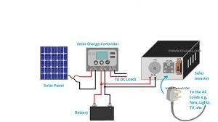
Fig 4.2: A Hardware Design Components

4.3 SYSTEM IMPLEMENTATION
The system implementation involves the following components:
- Solar Panel Installation: Installing the solar panels and battery bank.
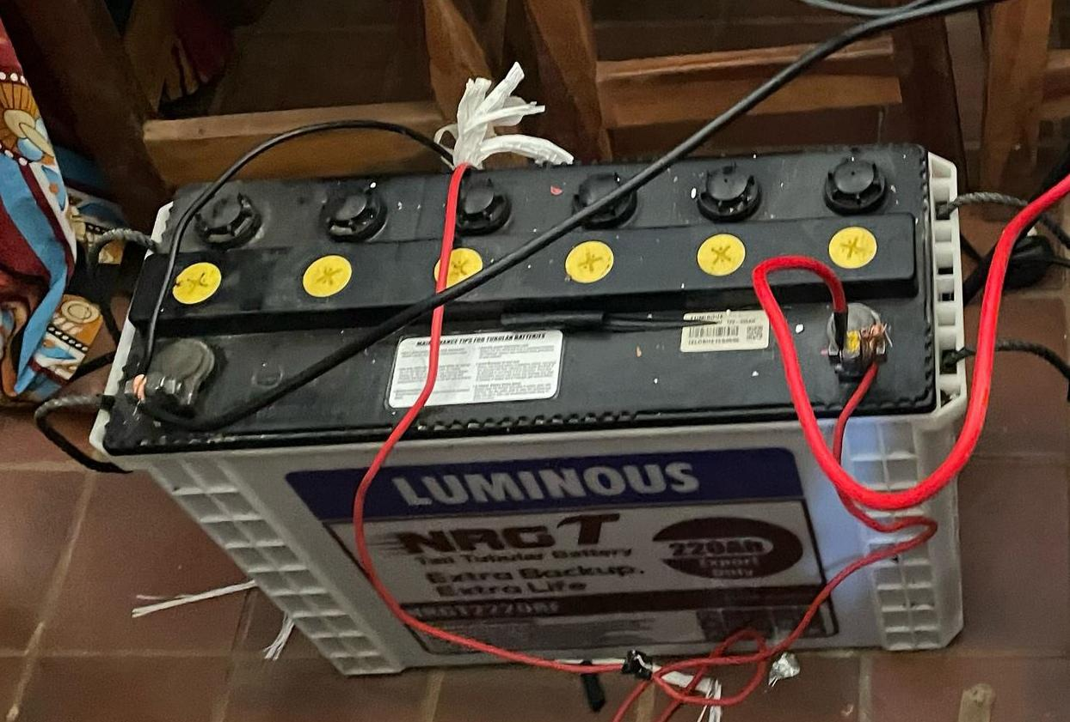
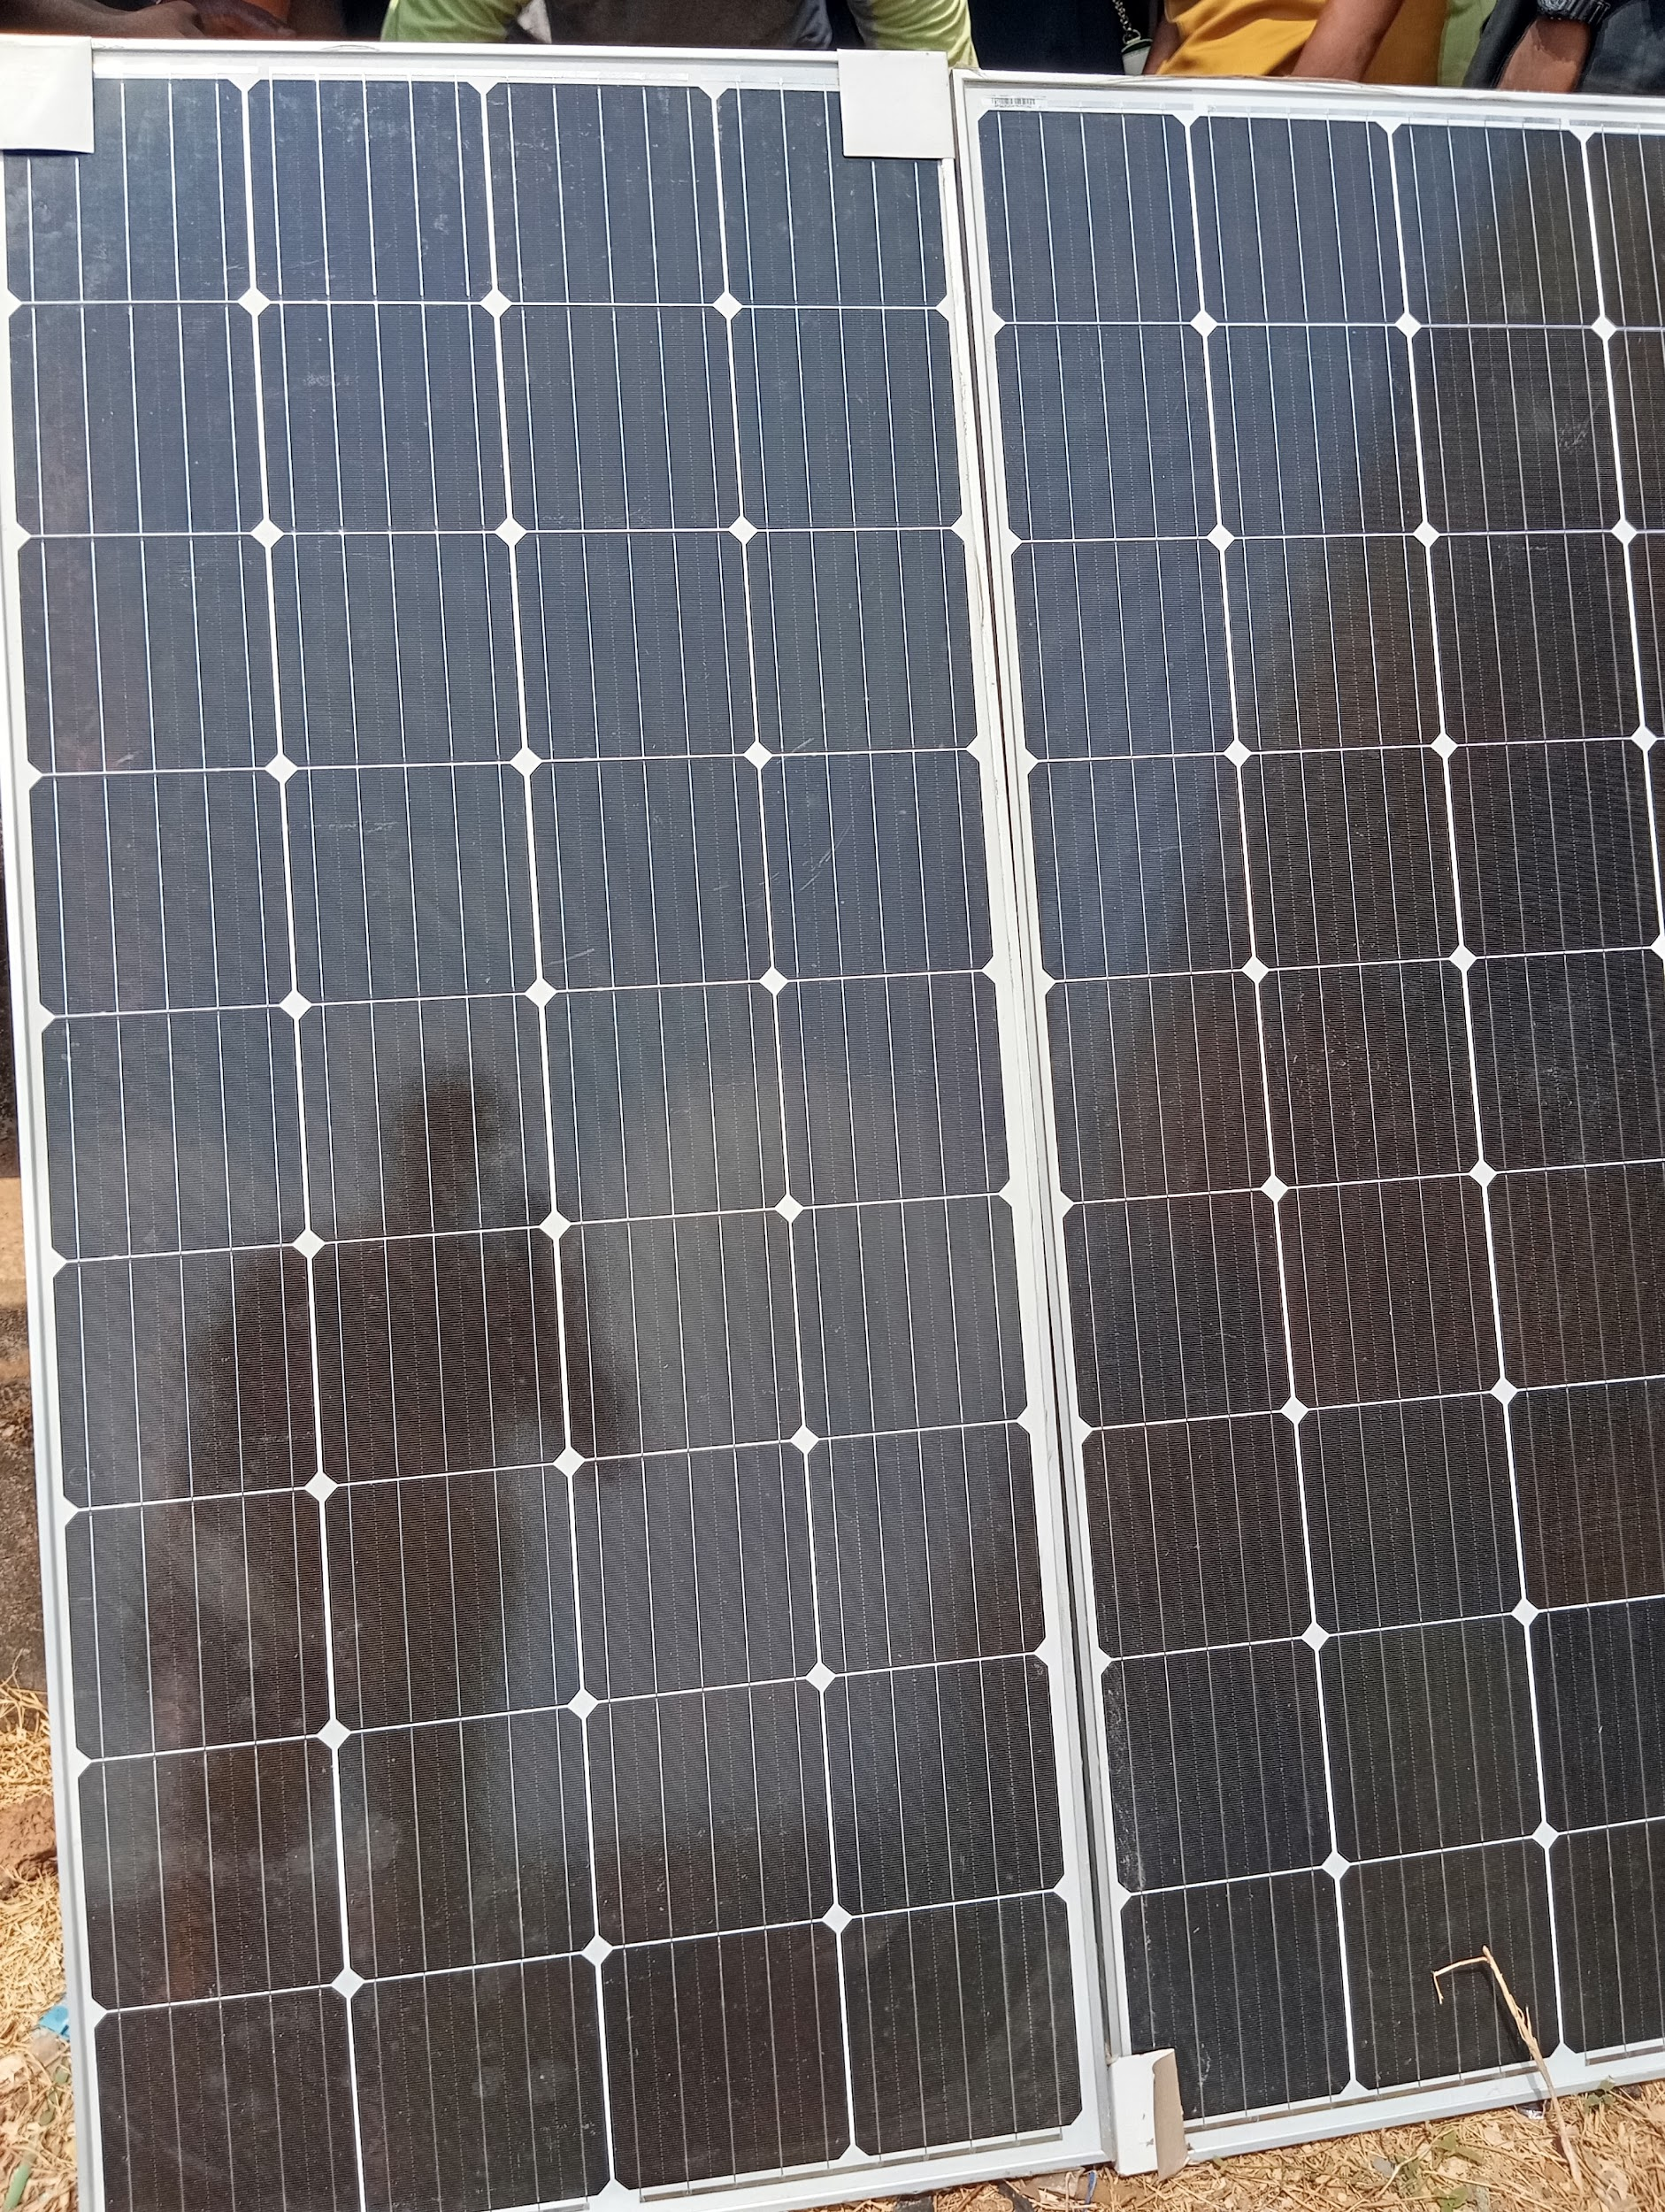

Fig 4.3: Showing the image of solar panel and a connected battery bank.
Solar panel: The solar power system is designed to harvest solar energy, store it efficiently, and convert it into usable electricity for the CCTV network.
Battery: A 12 V, 100–200 Ah deep-cycle battery (e.g., sealed lead-acid or lithium-ion) stores energy for use during low-light periods. The capacity is sized to support a 50–100 W CCTV load for 10–20 hours without recharge, accounting for a 50% depth of discharge (DoD) to prolong battery life.
Charge Controller: Charge Controller: A 12 V, 20–30 A maximum power point tracking (MPPT) charge controller optimizes energy transfer from the panels to the battery.
The MPPT algorithm dynamically adjusts the panel’s operating voltage (typically 17–20 V open-circuit) to maximize power output, enhancing efficiency by 20–30% compared to pulse-width modulation (PWM) controllers.
Inverter: A 12 V input, 500–1000 VA pure sine wave inverter converts DC power from the battery to 220–240 V AC, compatible with standard CCTV equipment.

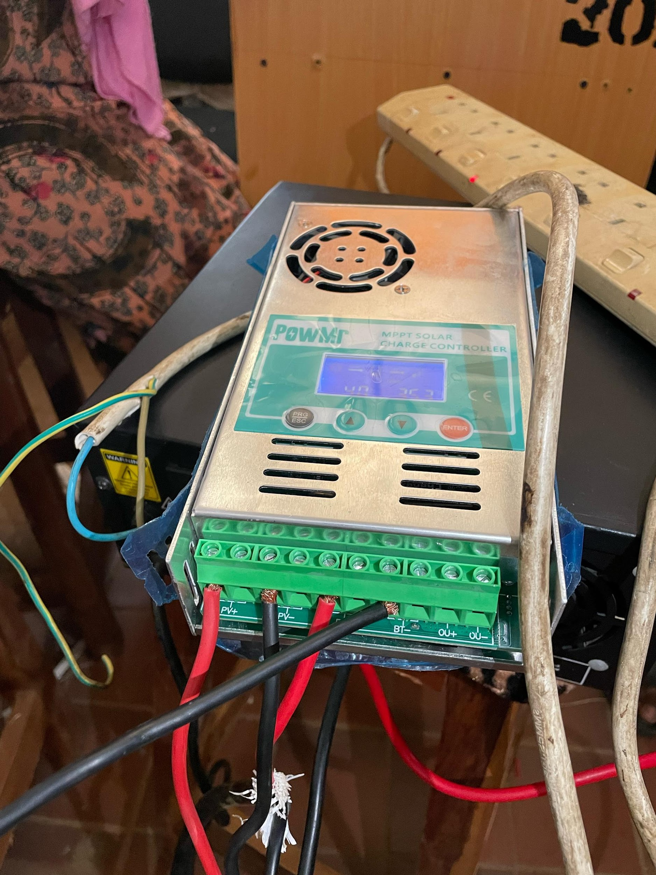
Fig 4.3.1: Block diagram of a connected charge controller and inverter.
- CBT Examination Monitoring System: Implementing the CBT examination monitoring system, including video and audio surveillance.
CCTV Surveillance: The CCTV subsystem is designed to provide comprehensive monitoring of the CBT examination hall, leveraging the solar power supply for uninterrupted operation. Its components and connectivity are detailed below:
IP Cameras: Four 1080p resolution IP cameras with infrared night vision and a power consumption of 5–15 W each (total 20–60 W) are deployed.
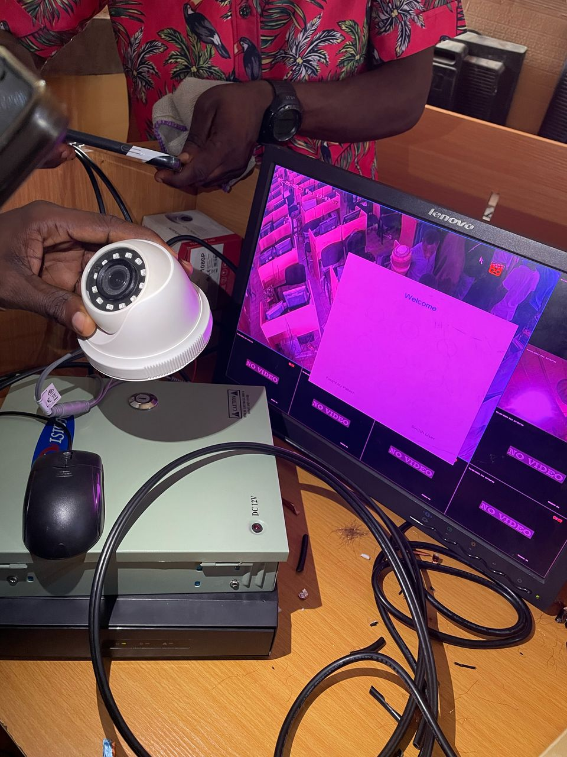
Showing Surveillance System and Real-time feed output

4.4 SYSTEM TESTING
The system testing involves:
- Functional Testing: Testing the system's functionality, including video and audio surveillance.
- Performance Testing: Testing the system's performance, including power generation and consumption.
- Reliability Testing: Testing the system's reliability, including uptime and downtime.

CHAPTER FIVE
SUMMARY, CONCLUSION AND RECOMMENDATIONS
5.1 SUMMARY
This research focuses on designing and developing a Smart Solar Computer-Based Test Examination Monitoring System that utilizes solar power to provide a reliable and sustainable solution for monitoring computer-based test (CBT) examinations. The system integrates solar panels, energy storage, and a CBT examination monitoring system to ensure uninterrupted surveillance and security during examinations. By leveraging renewable energy, the system reduces reliance on traditional power sources, minimizes operational costs, and enhances the integrity of the examination process. The research highlights the system's design, implementation, and potential applications in educational and professional settings, while also identifying areas for future improvement and expansion.
5.2 CONCLUSION
The Smart Solar Computer-Based Test Examination Monitoring System provides a reliable, sustainable, and efficient solution for monitoring computer-based test (CBT) examinations. By leveraging solar power and advanced surveillance technologies, the system ensures the integrity and security of the examination process, while reducing reliance on traditional power sources and minimizing operational costs. The system's design and implementation demonstrate its potential to enhance the CBT examination process in various settings, including educational institutions and professional certification programs. The system can be used in areas with limited access to electricity, reducing the carbon footprint and increasing the efficiency of CBT examinations.
5.3 RECOMMENDATIONS
The following recommendations are made for future works:
- Improve System Efficiency: Optimize the system's efficiency to reduce power consumption and increase the system's reliability.
- Expand System Functionality: Add additional features to the system, including automated examination grading and feedback.
- Enhance Security Features: Implement additional security features, such as biometric authentication and secure data storage.
- Develop Scalability: Develop the system to be scalable, allowing it to accommodate a large number of users and examinations.
- Provide User Training: Provide training to users on the system's operation and maintenance to ensure effective utilization.
- Continuously Monitor and Evaluate: Continuously monitor and evaluate the system's performance to identify areas for improvement and ensure optimal operation.
By implementing these recommendations, the solar-powered CBT examination monitoring system can be further improved, providing a more efficient and effective solution for monitoring CBT examinations.
REFERENCES
Adewale, O. S., Alabi, O. M., & Afolabi, B. O. (2019). Smart technologies in examination monitoring: A study of the Nigerian experience. Journal of Educational Technology, 8(2), 1-15.
Afolabi, B. O., Adewale, O. S., & Oluwadare, S. A. (2020). Examination malpractices and the need for reliable examination monitoring systems. Journal of Educational Research, 12(1), 1-10.
Agwi, U. C., Irhebhude, M. E., & Ogwueleka, F. N. (2020). Video surveillance in examination monitoring. Security and Privacy, 3(6), e144. https://doi.org/10.1002/spy2.144
Alabi, O. M., Afolabi, B. O., & Ojo, S. O. (2018). Examination monitoring systems and the role of solar energy: A review. Journal of Energy and Sustainability, 5(1), 1-12.
Ignacio, A. E., & Soria, C. D. (2021). A study on the implementation of a monitoring system to solar-powered houses. International Journal of Multidisciplinary: Applied Business and Education Research, 2(10), 902–908. https://doi.org/10.11594/ijmaber.02.10.06
Doe, J. (2023). Integrating solar energy in computer-based testing: A sustainable approach.
Ko, C. C., & Cheng, C. D. (2004). Secure Internet examination system based on video monitoring. Internet Research: Electronic Networking Applications and Policy, 14(1), 48–61. https://doi.org/10.1108/10662240410516318
Mahesh, N., Muralidharan, M., Ragavendran, P., & Sanjai, S. (2021). Smart exam monitoring system. AIP Conference Proceedings, 2387(1), 140003. https://doi.org/10.1063/5.0068709
Oluwadare, S. A., Adewale, O. S., & Alabi, O. M. (2020). Solar energy and examination monitoring systems: A review. Journal of Sustainable Energy, 10(1), 1-10.
Paolini, F. (2010). Renewable energy. In Green Cities: An A-to-Z Guide. Sage Publications. [Online]. Available at: http://www.sage-ereference.com/greencities/Article_n115.html
Rasal, V., Raulkar, V., Reddy, S., Sanap, J., Sarap, A., & Mhetre, M. (2022). IoT-based smart solar monitoring system. In Lecture Notes in Networks and Systems (Vol. 334, pp. 707–714). Springer. https://doi.org/10.1007/978-981-16-6369-7_64

