DESIGN AND CONSTRUCTION OF HOUSEHOLD FURNITURE (WARDROBE)

BY

RASHEED ZAOBAN AFOLABI
ND/23/CEC/PT/0161

SUBMITTED TO
THE DEPARTMENT OF CIVIL ENGINEERING, INSTITUTE OF TECHNOLOGY, KWARA STATE POLYTECHNIC, ILORIN
IN PARTIAL FULFILLMENT OF THE REQUIREMENT FOR THE AWARD OF NATIONAL DIOPLOMA (ND) CERTIFICATE IN CIVIL ENGINEERING

JUNE, 2025.
CERTIFICATION
This is to certify that the project was conducted by RASHEED ZAOBAN AFOLABI with matriculation number ND/23/CEC/PT/0161 us and had been read and approved as meeting the requirements of the Department of Civil Engineering, Institute of Technology, Kwara State Polytechnic, Ilorin.

__________________________ ____________________
Engr. (Dr.) E. O. Ibiwoye Date
Project Supervisor

__________________________ ____________________
Engr. A. SANNI Date
Part-Time Coordinator

__________________________ ____________________
ENGR. ABDULHAMEED ABDULRASAQ ADUAGBA Date
External Examiner

DEDICATION
This project is dedicated to Almighty God that kept me. We also honor our beloved parents who give hands in support to the fulfillment of our National Diploma (ND) both morally and financially. May God allow them to reap the fruits of their labour (Amen).
ACKNOWLEDGEMENT
Foremost, I give all praises, honour, glory with thank to the God Almighty who made the writing of this project possible with His total mercy on me from the beginning till the end.
My appreciation goes to my project supervisor Engr. (Dr.) E. O. Ibiwoye for his exceptional mentorship and technical expertise. His guidance and insightful suggestions have been instrumental in shaping the direction of this project.
I also express my gratitude to the Head of Department ENGR. NA’ALAH ABDULMUMEEN project coordinator ENGR. SAANI A. and other amiable lecturers for their expertise and assistance in various aspects of the project.
Am extending my greetings to my parents Mr. and Mrs. RASHEED for their unseasoned support and encouragement being it financially, spiritually in this journey of education.

ABSTRACT
This project is based on the design and construction of household furniture (Wardrobe). The project is aimed at increasing the practical skills of the students in the design and construction of wood work project. It also provides the opportunity to put to practice the theoretical works learnt and to apply modern technology in construction. The project is made up of Jive chapters. The chapter one comprises of the background, statement of problem, aim and objectives. Justification and scope of the study as well as the definition of major terms used. Chapter two deals with the literature review and timber as a primary and method used, while the chapter three discuss the materials and method used, while the chapter four is basically the design of the project and chapter five is the conclusion and recommendation.

TABLE OF CONTENTS
Title page i
Certification ii
Dedication iii
Acknowledgment iv
Abstract vi
Table of Content vii
CHAPTER ONE
Introduction 1
Significance/Important of the Project 2
Scope of Project 3
Aims and Objectives 3
Methodology 4
Definition of Terms 5
CHAPTER TWO
Literature Review 6
Timber as a Primary Source of Household Furniture 7
Classification of Timber 9
Conversion of Timber 10
Method of Conversion of Timber 10
Seasoning of Timber 12
Reason for Seasoning of Timber 12
Ways of Seasoning Timber 12
Natural Seasoning (air seasoning) 12
Artificial Seasoning (kiln seasoning) 13
Defect of Timber 14
Advantages of Timber over Metal 15
CHAPTER THREE
Materials used for the Construction 16
Tools and Equipment Used 18
Joint and Connections of Timber Correction 20
Types of Joints 21
Safety Precaution and Maintenance of Tools/Equipment 22
Dimensional Timber 23
Preservative used for Timber 23
CHAPTER FOUR
Design of Timber Structure 24
Design Concept 24
Principles of Designs 24
Design 25
Design Calculation for Engineering Timber Frame 25
Tools and Equipment 33
CHAPTER FIVE
Conclusion and Recommendation 40
Recommendation 40
References 41

CHAPTER ONE
INTRODUCTION
Engineering profession is an act of applying scientific knowledge gained through research to the maximum conversation of natural resources for the benefit and use of mankind. That is, it is an activity which repair and put things in order to contribute immensely to the welfare of man.
Household furniture is used in both private and public buildings. The buildings includes residential houses, offices, hotels e.t.c absence of household furniture in such place mentioned above usually create a vacuum and sense of incomplete furniture. This furniture may be different pattern and for the purpose of beautification and decoration.
Lumber (also known as timber) is wood in any of its stages from felling to readiness for use as structural materials for construction, or wood pulp for paper production.
Timber is supplied either rough or finished. Beside pulpwood, rough timber is the raw materials for furniture makers and other items requiring additional cutting and shaping. It is available in any species usually hardwoods finished timber is supplied in standard sizes, mostly for the construction industry, primarily softwood from coniferous species including Pire, fir and spruce (collectively

known as spruce-Pire-fir) cedar, and hemlock, but also some hardwood, for high-grade flooring.
Also taking good notice of the timber to be used in terms of timber structure just like the one we are producing is very important and can be approved by its improvement in an environment and very essential require to know the various defect and control measure is considered in this write up.
SIGNIFICANCE/IMPORTANT OF THE PROJECT
The scope and limitation of this project basically the design and construction of household furniture (itself). Household furniture is used in both private and public buildings. The building includes residential houses, offices; hostels e .t. c. absence of house furniture in such place mentioned above usually create a vacuums and sense of incomplete furniture.
The report covers all the structural component of timber, material properties, basic of design, and construction of techniques. The exits of the report will go as far as ascertaining the durability, convenience and the construction of household furniture.
Household furniture may be of different type but the purpose is to beauty fythe building. The project provides an opportunity to put to practice the theoretical marks learned and also to apply and modify principles of academics, description within the practical environment.
SCOPE OF PROJECT
Basically the scope of this project is to design and construct an household furniture. This project give more opportunity to know much about timber, the characteristics and properties of timber, also gives opportunity of working on timber. Also in this project we are able to deduce the fact that timber as a material in exhaustible in supply in as much as there are intelligent forestation programme with wide potential in adverse range of construction field.
AIMS AND OBJECTIVES
The practical project is designed and constructed to serve as a future reference constructed to serve mainly this purpose for which it is constructed for. The problem facing our engineering sector is how to develop techniques and procedures of the criteria design for engineering element. Any construction without designs for engineering elements. Any construction without design does not have any value to modern days of engineering in carrying out project, therefore the main aims and adjectives are:
- It increases experience of the student in design and construction of house hold furniture.
- To enlighten student on the practically aspect of household furniture.
- It increase the student knowledge on the type of materials, used for the construction.
- It shows the society the usefulness of wood to the construction companies.
- It enable engineers to limit themselves to concrete work but also to be involved in the design of timber structure.
METHODOLOGY
This is the method by which interviewer research is carried out.
There are two method of methodology namely:
  - Primary method
  - Secondary method
PRIMARY METHOD
This has to do with the use of questionnaire to acquire information from different source and to see or know peoples perspective or point of view towards a particular topic or have a personal encounter with people.
SECONDARY METHOD
This has to do with the used or citing textbooks, internet browsing, e.t.c
DEFINITION OF TERMS
Design: The design refers to the articles itself as the planning of its construction, operation and appearance. It may be made by hand or sometimes by machine with little effort of man.
Construction: This is an opportunity that follows the direction been given by the design in both the method and the materials used for the construction.
Household furniture: These are structure made of timber; it could be table, chair, cupboard, dining table, and bed etc.
PROPERTIES OF TIMBER
Strength: This is the ability of wooden materials to resist the load an tension force acting upon it.
Hardness: This is the resistance of the wood to an external attack.
Tension: It is the pulling force exerted on an object

CHAPTER TWO
LITERATURE REVIEW
Legal has replaced the attribute of people towards the past constructed articles in one way or the other. Early American wood workers called carpenters, cut tree, hired the trees into various slices, doors, window frames were sometimes made applying legs into boards with handsaw.
Some timber are specialized for making of furniture and upholstery starry-work with the introduction of power wood working equipment, a new group of wood workers called millennium originated.
Today, the furniture work are made convenience with new machine made into existent by modern technology where work can be done in limited time, no much stress and low capital.
The use of revered construction was also recorded during the time of the great pharaohs and subsequently in the Greek and Roman civilization. Nowadays, with the introduction of machines in 19th century, furniture was cut in large circular saw and by a large mechanical planner which was the force runner of the modern slice.
TIMBER AS A PRIMARY SOURCE OF HOUSEHOLD FURNITURE
Timber as written earlier, is a log of wood conveyed from the forest and converted into marketable sizes, suitable for structural uses or construction purposes. Timber is extracted from trees. Made of three main parts, which are: The Root, the Stem, and the Crown.
The root: is embedded in the ground and it absorb water and nutrients from the soil to the other part of the tree. It searches for various minerals salts in the moist ground.
The steam: is also known as the trunk, is the part of the tree which grows above the ground surface and transport food or nutrient from the root to the other part of the tree. Timber is extracted from this part of tree, it conduct sap from the root stored food and support the crown.
The crown: This consists of branches and twings that bear leaves, which transpiration takes place as well as photosynthesis.

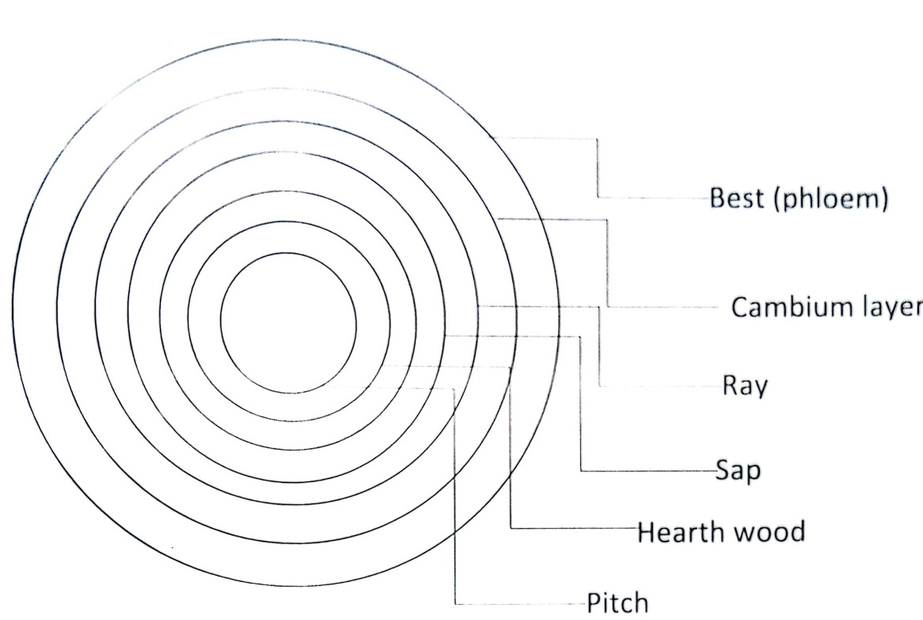

Pitch (Medullar)
This is the core formed from the free earliest growth as a young tree. It is located in the centre of the tree (log). It represents the first growth layer.
Heart Wood
This is the earliest part, the natural non-active stronger with timber and often darker in colour and it gives strength and support on the tree.
Sap wood (albunium)
This is the active of the tree, it receive and conduct sap from the roots quickly it out the leaves with time as the natures the part gradually becomes heartwood.

Rays
These are tips of small valley that allow sap to percolate across the area sap wood, they also store excess food in case of drought or damage tom the tree.
Cambium layer
This is microscopically this thin layer beneath the bank. It is where new wood is formed. It is a dynamic layer between the new bank and the sap wood. This layer is responsible for the strength and growth of the tree.
Best (phloem)
This is the part of the tree that conducts food throughout the whole of the tree from the leaves to the roots.
Bark
This is the outmost part of the tree functioning as moisture barrier, thermal insulator as well as an amour plate against extreme of temperature attack by insect or fungi.
CLASSIFICATION OF TIMBER
Timber is generally classified into two groups namely:
- The coniferous wood (Soft wood)
- The deciduous wood (Hard wood)

THE CONIFEROUS SOFT WOOD
Soft wood is gotten from coniferous trees. It's normally grown in cool region and these soft woods are usually evergreen with needle-like leaves and cone bearing in nature. It comprises mainly Tubular cemented together.
THE DECIDUOUS OR HARD WOOD
Hard wood are from deciduous trees. It's more complex than that of soft wood. The main feature of the structure is the presence of a large vascular system that passes the moisture from the roots to the leaves. The two types of hard wood are:
- Ring porous hard wood and
- Diffuse porous hard wood
CONVERSION OF TIMBER
The act of cutting down living trees is termed as falling. And once the tree has been fell, it branches will be removed leaving the trunk. Then conversion takes place.
CONVERSION
Conversion is defined as the act of cutting logs of wood into different shapes and sizes for different purpose.
METHOD OF CONVERRDION OF TIMBER
- Through hand through method
- Quarters sawn method
- Rotary cut method
THROUGH AND THROUGH METHOD
This is also known as tangential method. This method of conversion is the simplest and most economical. It is done by making tangentially sawn boards.
QUARTERS SAWN METHOD
This method of conversion is otherwise known as “Rift Sawn”. It can be wasteful and expensive, although it is necessary in large number of radical of near, radical sawn boards are required. They also produce a beautiful figure board most especially on hard wood.
ROTARY CUT METHOD
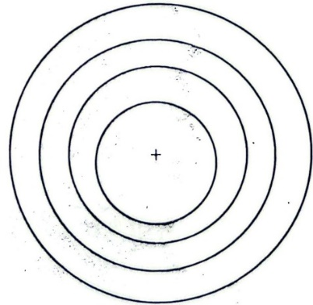
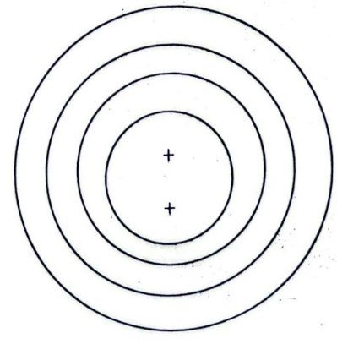
This method of conversion is done by working round the log by turning. It produces a board all which (except the center) has their growth ring across the board. It is usually seasonal more rapidly than other and stringing more in width drying and able to warp cup clerk due to their high seasoning.

SEASONING OF TIMBER
The term "seasoning" refers to the expulsion or removal of certain proportion of water or moisture content present in the cell wall of green timber.
REASON FOR SEASONING OF TIMBER
- Every time the moisture content (MC) reduces the timber shrinks especially tangentially.
- Consequently it will show fewer tendencies to wear, split or shake.
- Seasonal timber although lighter, stronger and more reliable.
- Dry well seasoning timbers is stronger.
- Timber with high M.C is difficult to finish i.e. paint, varnish etc.
- Dry well seasonal timber is easier to work with and consequently safer especially machine work.
WAYS OF SEASONING TIMBER
There are two main ways of seasoning timbers.
Natural (air) and artificial (kiln) drying. Both methods require the timber to be stacked and separated to allow full circulation of air flow around the stacks.
NATURAL SEASONING (AIR SEASONING)
This method of seasoning is also known as Air seasoning. It is natural in the sense that the timbers to be seasoned as stocked in an opening place in such a way so as to increase in dying without any artificial assistance where this timber is exposed. The moisture is being removed by the process of evaporation.
ADVANTAGES OF NATURAL SEASONING (AIR)
It is a cheap method with very low in the quality of timber if properly done.
DISADVANTAGES OF NATURAL SEASONING
It usually takes a long period for the moisture content to be removed.
Timber when exposed for long period they are liable to be attack by insects and fungi.
ARTIFICIAL SEASONING (KILN SEASONING)
This method of seasoning is also known as kiln seasoning. Timber is stacked and air dried on the trolley that is wheeled into kiln that is required to the type and thickness of material being conditioned. This is removed and tested until moisture content is removed to the required percentage.
ADVANTAGES OF KILN SEASONING (ARTIFICIAL)
- It provides uniform reduction of moisture throughout the whole stack.
- It is a fact method of seasoning.
DISADVANTAGES OF KILN SEASONING
- It is costly when embraced open.
- The loss in quality is high compare to loss in air seasoning.
DEFECT OF TIMBER
The defect in timber arises as a result of faulty procedure of delay in extraction and conversion to logs. The different type of defect in timber occurs at pitch and actually spread along the ray. This may form what is known as “star shake" while it crack developed tangentially along the growth ring may cause a "ring shake" separating an inner crack cause from an outering where this defect occur in timber. It is very difficult to saw the boards from the log and this leads to wastage.
The defect in timber can be grouped into two namely:
- Natural defect
- Artificial defect
NATURAL DEFECT
These are defect that occurs during the growth period of the tree e.g. growth defected seeds, grain irregularities and shakes. These defects are:
- Cracks or fissures
- Knots
ARTIFICIAL DEFECT
These are defect that occurs as a result of careless handling, incorrect conversation and seasoning technique, inadequate protection. Artificial defect are grouped into two they are:
- Conversion defect
- Seasoning defect
During conversion of timber to commercial form, the following defect may occur:
CHIPMARK: This defect is indicated by the marks or sigh placed by chips on the finished surface of timber.
WANE: This is the presence of original rounded surface in the finished product.
DIAGONAL GRAIN: improper sawing of timber.
TORN GRAIN: when a small depression is made on the finished surface due to falling of tools.
ADVANTAGES OF TIMBER OVER METAL
- Timber is easy to maintain while metal rust easily.
- Timber is easy to work upon i.e. easier.
- Timber requires relatively small quantity of energy to produce.
- Timber does not suffer from the problem of corrosion, rusting, and other changes due to chemical reaction.
- It is less expensive in construction compare to metal.
- It reduces construction time.
- The maintenance is less expensive compare to metal.
- In terms of weight, it is relatively lower than metal.
- It reduces construction waste through efficient controlled manufacturing than metal.
CHAPTER THREE
Wardrobe plays a vital role to ascertain the user profile from the fashion preferences. A wardrobe is important furniture work where we keep our various fashion wears such as clothes, shoes, bags etc. and is used in many places e.g (residential building, offices, hotel, motel, hospital). Since the project deals with wood, it allow student to have a practical knowledge about the timber and its characteristics material.
MATERALS USED FOR THE CONSTRUCTION
For the best and quality chair to be constructed, the materials (timber) used should be able to withstand any stress subjected to it. And be able to resist bending and shear when loaded. Therefore, materials must be chosen in term of durability, availability, weather.
The material used are discussed below:
- Timbers
- Nails
- Glue
- Foam
- Varnish
- Plywood
- Cloth
TIMBER
The type and size of timber to be used depend on the requirement i.e. the type of work and the purpose of the work is to serve the various sizes, includes:
2 by 2, 2 by 3, 2 by 4, 1 by 2 etc.
NAILS
These are metallic materials with flat head and pointed mouth. It is driven into the wood with the aid of hammer in order to join two members together. The type of nails used is the 2 ½ inches and ¾ inches nails.
GLUE
It serves the purpose of joining or binding two or more members together. It is viscous in texture and very hard when dried. It can hold the wood for a long time, even longer than a nail. The top bond glue is used.
PLYWOOD
It is a thin sheet of wood used for the seal of timber and also top table.
FOAM
This is a sponge like appearance used for stuffing chairs to make it comfortable for sitting and it is used to cover the wooden part of the chair.
VERNISH
These are material used when putting final coating on the chair. The outer wooden part and the amount of varnish to be applied on the initial colour of the timber.
CLOTH
This is a woven material from which clothes and other items are made e.g table cloth, wooden cloth etc. cloth is used to cover all the outer part of furniture chair for it good appearance.
TOOLS AND EQUIPMENT USED
There are different tools used in design and construction of timber structure. The quality and completion of the project depends largely on the quality and efficiency of the tools used. The major tools required for the project are described below:
- Saw
- Hammer
- Woodwork bench
- Plane
- Pinches
- Nail
- Sand paper
- Tri-square
- Gum (evostic)
- G-clamp
SAW
Saws are used for culling timber of the needed size, shape it with maximum amount of waste and effort used e.g. panel saw is used for ripping tenor for joints.
HAMMMER
This is also mainly for driving nails. It is also used for dawning in wooden edges or for stripling pinch. These are different types of hammer such as Lo hammer, Comb hammer, Pin hammer, Chib hammer etc.
WOODWORK BENCH
It is mainly constructed in wood and to carry out many activities such as smoothing of wood, cutting and nailing of woods.
PLANE
A plane consist of piece of sharpen steel called cutting iron/filled into a wooden or metal stole and it is used for producing smooth surface.
PINCHERS
It is used for withdrawing a nails from the wood.
SANDPAPER
It is used for scrapping and smoothing of furniture surface. It enables the polish to flow on the timber.

TRY-SQUARE
It is used to determine the squareness of edges and it has an angle 90.
GUM
It is used for joining the foam together.
G-CLAMP
It is a metallic clamp and it is used for holding small wood to the bench while sawing. It is called G-clamp because of it shape.
JOINT AND CONNECTIONS OF TIMBER CORRECTION
The use of simple is in assembling and fastening two or more piece of wood together. Therefore, the act are skill of assembling and fastening two or more pieces of wood together is called joining joint use in construction work are classified into the mainly group namely:
- Widening joint
- Farming joint
- Angle/Box joint

WIDENING JOINT
This act involves the joining of edge to edge to produce wide boards. They are butts, dowelled, tongued, riveted, slot-screwed joints etc.
FRAMING JOINT
There tends to edges are joined together to form a frame structure. They include half-lap, mitred, dowelled, mortise and Tenon and bridle joints.
ANGLE/BOX JOINT
It is divided into two; the corner angle joint and the ordinary angle joint. Corner angle joints consist butt, angle lap, dove tail etc. while the ordinary angle lap, include dowelled, housed pinned etc.
TYPES OF JOINTS
- Rebated butt or plan lap joint
- Plain butt
- Butt joint
- Mortise and Tenor joint
REBATED BUTT OR PLAN LAP JOINT
In this joints the end of pieces is flitted in to rebate worked across the end of another pieces.

PLAIN BUTT
This is the simplest and easier joint to use and it is very common in roof and shape fabricated house, construction work, and simple block construction.
BUTT JOINT
This is a joint that is being reinforced with a corner glue block (e.g) in cabinet making.
SAFETY PRECAUTION AND MAINTENANCE OF TOOLS/EQUIPMENT
- Roll up your sleeve and lock in your tie.
- Never run or play in the workshop
- Do keep your bench tidily, heaps of tools on the bench are:
    - Easily damage
    - Nuisance when working
- Always put on shoe to avoid injury
- Do not work or play with machine you are not introduced to.
- Call the attention of experienced staff when you do not understand any machine behaviour.
FINISHING
Wood finishing refers to the process of embellishing and/or protecting the surface of a wood material. The process starts with surfaces preparation, either by sanding by hand (typically using a sanding block or power sander), scrapping, or planning, imperfection or nail holes on the surface may be filled using wood filter often, the wood colour is changed by starting, bleaching, ammonia furring and a number of other techniques.
Finishing are of three type and they are: evaporation, reactive and coalescing finishes.
DIMENSIONAL TIMBER
Dimensional timber is a term used for timber that it’s finished/planed and cut to standardized width and depth specification width and depth specification in inches. Examples of common sizes is 2x4 (also 2 by 4 and other variant such as four by two in the UK, Australia, and New Zealand) 2 by 6 (pictured) and 4 by 4.
PRESERVATIVE USED FOR TIMBER
Special fastener should be used with treated timber because of the corrosive chemical used in preservation process.
To avoid decay and termite infestation, it is important to separate untreated wood from the ground and other source of moisture. The separations are required by many building codes and are considered necessarily to maintain wood elements in permanents structures at safe moisture content (MC) for decay protector.
There are two basic method of treating with and without pressure, non-pressure method are the application of preservative by brushing, spraying or dipping the pieces to be treated.
CHAPTER FOUR
DESIGN OF TIMBER STRUCTURE
DESIGN CONCEPT
Design is the international planning of an articles for a particular use. The term "design" refers to the "articles" itself as well as its planning of its construction operation and appearance.
A design should not be duplicated of what others have done.
PRINCIPLES OF DESIGNS
There are many principles designing work among which are:
- Balance
- Proportion
Balance: this is achieved when a object appear to have equal weight at all side. If the part is symmetrical the result is formal balance but if it is not symmetrical the result is informal balance.
Proportion: the stability among object design depends upon the proportion of its part of the object being coupled together, this is the leg of the dining table must be very strong to withstand the weight of the tip skid part and both are coupled together for the purpose of withstand the incoming weight in accordance with the principles of proportionality.

DESIGN
Design a house hold furniture (timber) element is normally carried out in accordance with BS 5268, structural use of timber part 2 which is based on the permissible stream philosophy in the design of flexural member.
DESIGN CALCULATION FOR ENGINEERING TIMBER FRAME
$$Design parameter:$$
$$ZXX = section modulus (m^{3})$$
$$G = Acceleration due to gravity (m/s^{2})$$
$$GK = dead load (kn/m^{3})$$
$$QK = live/impose load (mm^{2})$$
$$N = Ultimate moment (Nmm)$$
$$MR=moment of resistance (Nmm)$$
$$K7=depth factor$$
$$K3=duration of loading factor$$
$$K8=load shearing system factors$$
$$T9=dm=permissible stress(Nmm^{2})$$
$$A=cross-sectionalarea$$
$$TM,ADD,11=permissible stress parallel to grain.$$
$$M=bending moment$$

$$DC = cubical stress$$
$$KI = geometric proportion$$
$$Lxx = second moment of area$$
$$Sc = stress class of timber$$
$$E = modulus of elasticity$$
$$D = total deflection$$
$$Dp = permissible deflection$$

REFERENCE | CALCULATION | OUTPUT
Almost all the value were taken from table 98 of BS 5268 | Top Slab  Density of hard wood (dw) = 840kgms, gravity, (g) = 9.81m/s thickness = 350mm = 330 x 15x 10⁶KN.
Weight of finish KN³, dead load (gk) = 5.10 + weight of finishes = 0.10 + 0.020.12knwm⁻³ impose load (qk) = 0.5kw/m² (assumed) slab ultimate load (1.4gk + 1.6qk) where factor of safety = 1.5, total design load (n)
N = (1.4 x 0.12 + 1.6 x 0.5)
N = 0.968KN/m²
Section 6.7.2 | Bending
Charmarky | If members are not fast in bending the design moment (m) must not exceed the moment of resistance (MR) i.e. DM<MR design moments M=nl²/8.  MR=dm, adm=uznn where dm, adm, N: permissible bending stress parallel to grain sxx section modulus.  Dm, adm, n, dk² , k3 k7 k8= 1.5x1.04x0.8x1.0x1.17x1.7=1.604N/mm² | M= 0.17KNm,  Dm, admu²
 | MR = 1.606 x 12375 x 10⁻⁶  MR = 0.19KNm | MR 0.19  M<MR bending is safe
Shear stress table 9 | Shear  V=tgkg k8 | Tadm = 1.65
Bs 5268 applied shear stress (v) = applied moment vertical shear force | =1.5 x 1.01=1.64Nmm⁻²  Tv=n3fv/2a  Sfv=  2.7ax 10³/2=1395n(4185)1200=0.21Nmm⁻² | Nm⁻² (d<adm) the section is adequate in shear.
 | Ultimate load= 1.4g+1.6 qk, where QR=0.5KN/m2 (assumed).  N=0.2968+0.8  N=1.09KN  M=nl²/8=1.09x(1.18)² =1.517/8=0.18KNm, moments of resistance ME=dm, adm, n, zxn, zxx=bd²/6=36x75²/6=33750mm² | N=1.09kn  M=0.18KNm  Zxx=33750mm²
Section modulus m.g 11=125 (table 9,bs 5268) k3= 1.0, k8=1.1  Permissible factor= 0.003  dm= 5fl/ 384 emm | Dm,adm, 11, zxx,=dm,g, 11, zxx, k3, k7, k8.  Kn=(300)^{0.11}/75 dm, adm, 11, zxx,= 12.5x 1.16x1.1x1.0=215.95.  MR=dm,adm, 11 zxx .  Deflection:  Permissible deflection dp = 0.003 x span = 0.003 x 1050 = 3.015mm applied total deflection (dt)  Df(5fl⁴+12fl²/384emm+xx+5Emma)  [5x8.62n x 1050⁴ x 1050²/384 x 11800 x 27x 100³]  Dt=2.64+0.22=2.86 | K7= 1.16dm,  Adm, 11=15.95  Mr=  0.s4knmm<mr.  The therefore the section is adequate for bending  D=3.048mm.  Dt=2.68m.  Dt<dp the section is adequate for deflection.
Cross section area from the table (bs 526) depth (d) of sector,B= breathing sector Ga,1= | $$Lateral bucking$$  $$Permissible d/b=5$$  $$Bearing$$  $$Permissible bearing stress dc adm x =dc, g, ik3; k8= 2.8 x 1.0 x 1.1 =3.08 KN/mm2 applied bearing stress de, dx=f=w/z.$$ | Hence the section is adequate for lateral bucking
  - able 9
Bs
(5286)  K3= 1.0k8= 1.1 bearing length section used 36x75mm² | Blb Blb  2.99 x 10³/₂ = 1.95n Dc, d, l = 1495/330x15=0.363Nmm²<permissible | Sw= 0.0  55KNm²
Table 98 Bs 5268 total | BEAM SECTION  Assumed beam section = 36x95mm² self
Gk= dead load | Weight beam = (36x75x10⁶) x 840gm³ x 0.81 x 10⁻³ = 0.kgms.  Weight of finish as= 0.012knm⁻² self-weight of slab = 0.0136knm⁻² total dead load (GK)= 0.56+1.36+0.02= 0.212knm⁻² | Gk₂= 0.212KNM⁻²
 | Lateral bucking permissible, a/b=s. Actual a/b=75/36=2.08 and permissible ladm=tg k3 k₈= 1.5x1.0x1.0=1.65Nmm²  Tr= 3fr/2A  FV=w/2=286x10³/2=1480  Tr=3x1435  227x10⁻³=079Nmm⁻² | Tad  0.212KNM⁻²  Tr= 0.79Nm⁻²  Actual and permissible. The section is adequate in lateral bucking.

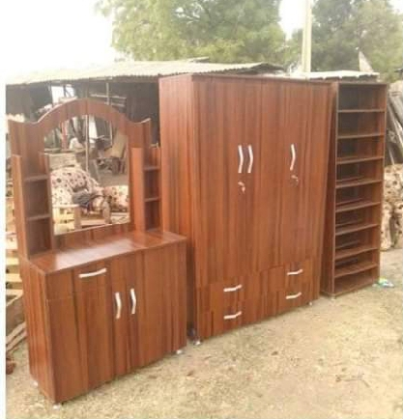
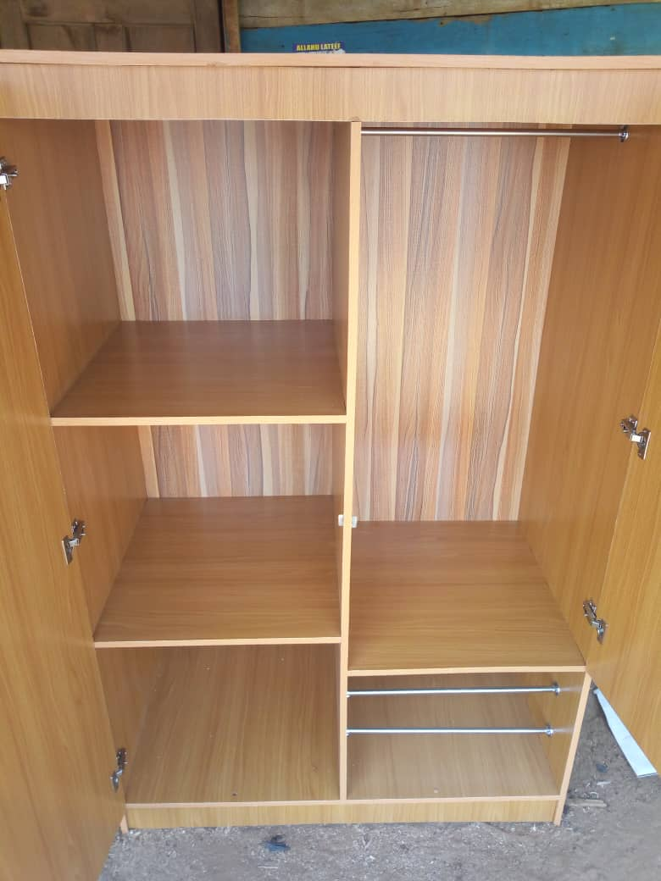

TOOLS AND EQUIPMENT
1. Measuring tape
2. Builder square
3. Tn-square
4. Chisels
5. Scissors
6. Hammers
7. Bar
8. Pinches
9. Saw
10. Ruler
11. G-cramp
12. Circular/cutting machine
13. Screw/drilling machine
14. Gum
15. Nails

1. Measuring tape:

This is a flexible ruler used to measure size or distance.


2. Builder square:
This is a perfect for determining the flatness of a surface plane or creating a true 90°angle on cutting size
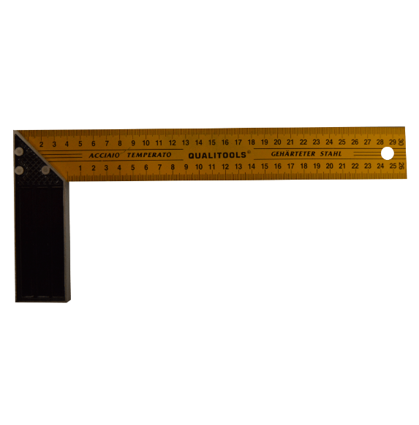

3. Tri-square:
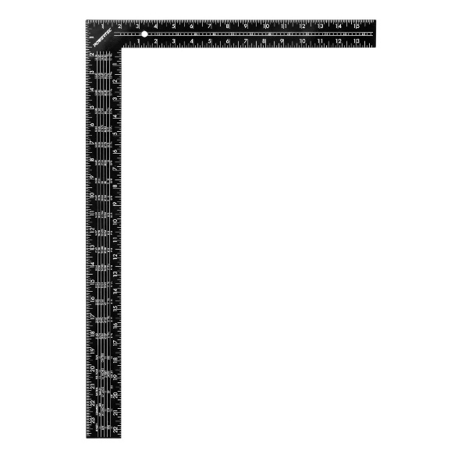
This is a wood working tools used for making and checking 900 angle on pieces of wood.

4. Chisels
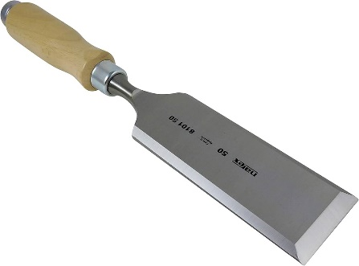
This is a total with a characteristically shaped cutting edge.

5. Scissors:
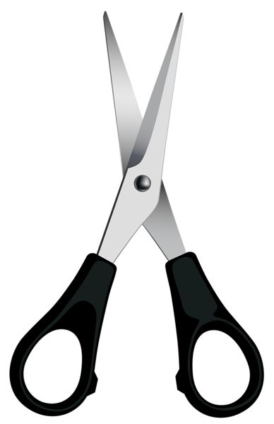
This is used for cutting materials, consisting of two blades laid one on top of the other.

6. Hammers:

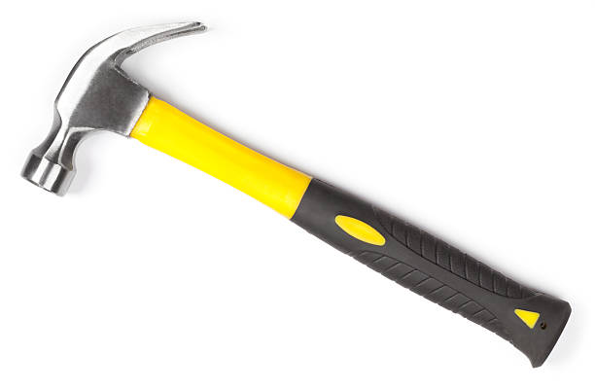
This a tool consisting of a weighted "head" fixed to a long handle that is swung to deliver an impact to a small area of an object.

7. Bar

This used for removing nails

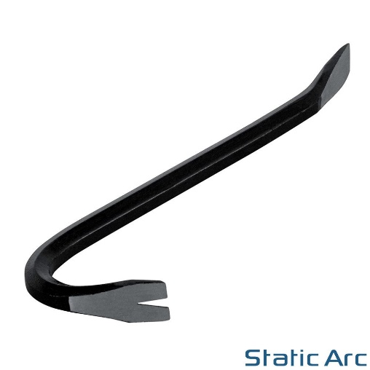

8. Pinches:
This are hand tools used in many situations where a mechanical advantage is require to pinch.

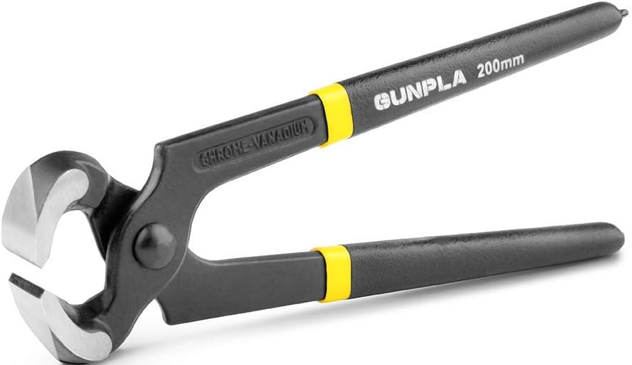

9. Saw:
A total consisting of a tough blade, wire or chain with a hard toothed edge, panel saw is used for ripping tennon for joint.

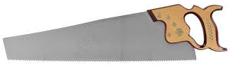

10. Ruler:
This is a device used in geometry and technical drawing as well as the engineering and construction, it is used for straighten and measuring.
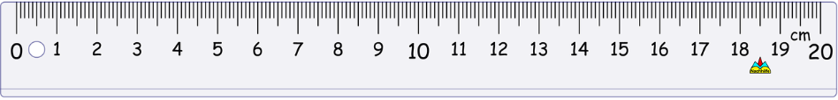
11. El-cramp:
This is a metal cramp it is used for holding small woods to the bench wood.

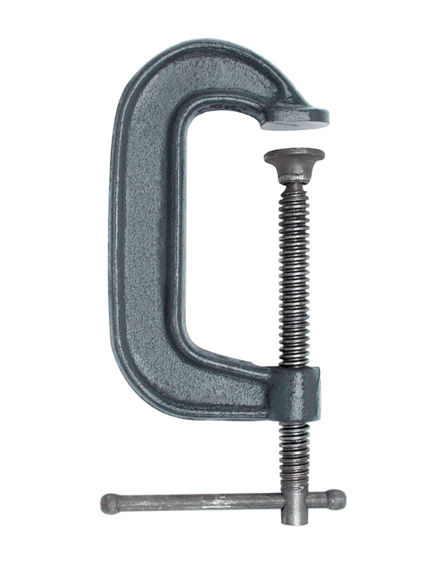

12. Circular cutting machine:
This is a machine tools used for cutting fasteners.

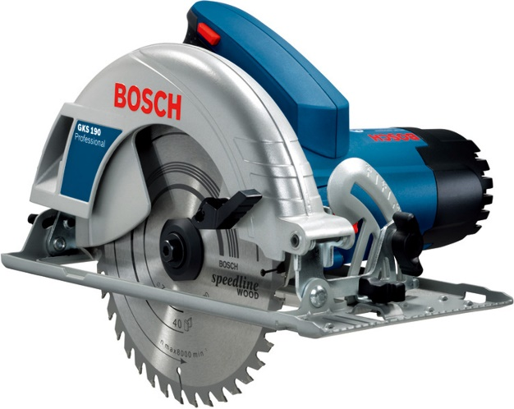
13. Screw drilling machine:
This is a machine tools primarily used for making a round hole or driving fasteners.
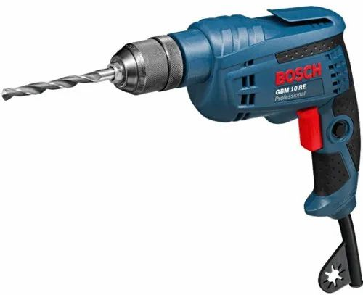

14. Gum:
This is any various or strictly substance that are exuded by certain plants.



15. Nails:
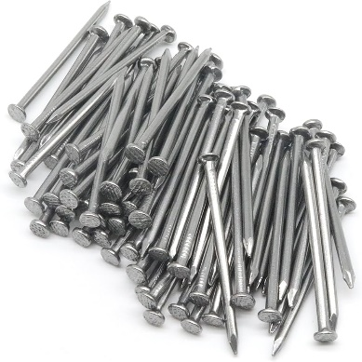
This is used for joining two wooden materials together.

CHAPTER FIVE
CONCLUSION AND RECOMMENDATION
In the conclusion of any structure, it is very essential to plan systematically towards the successfulness completion of project. And care must be taken in the order to avoid the deflection of such structure in the furniture.
Therefore, there are some things to be taken in your consideration such as, the load to be carried by the structure (lives and dead load), so as to know the materials to be used, the purpose of the work and method to be adopted.
Finally, construction of this project as described in the context has increased our technological development and exposed to the practical knowledge.
RECOMMENDATION
The experience gained during the design and construction of this project has improved the student practically and technically. It is however, essential to give the following recommendations.
Firstly, project like this should be given to student to groom or develop the technical ability in construction work. The student should also be provided with text book on the design and construction of timber frame.
Finally, the equipment required to carry out this project should be provided in the school workshop to make the construction on wood word easier.
REFERENCES
Bendik. B. and Colin Besant (1999) analysis of engineering structure publish by horowood publishing limited England.
Chanakay Arya (1994) design old structural element to British standard and curo codes first edition published by E and FN, spoon, London.
Charles H. Hayward (1951) the junior wood worker, printed and bond in great Britain by William Clows and sons, limited London.
George L, (1981) "the theory and practice of wood work", fourth edition printed in HongKong by Shee Wah Tony printing press L.T.D http://en.m.Wikipedia.org/wiki/chair.
http://stimber-orga.aii/ntep/menu.asp>id=86
James G, (1996) “Design and technology", published by the press syndicate of the university of Gam bridge second edition. Literature review on seasoning of timber
http://www.timber.org.an/NTEP/menu-asp?ide56required 16th May, 2013
Viustapha W.A etal, (2011) “design and constructions of structure for house use, ND-project submitted to the Department of Civil Engineering, Kwara state polytechnic Ilorin, Kwara state.
Victor O.O (2001) “Simplified Reinforced Concrete Design" (A Consultant/ Computer Based Approach) Vasons Concept Group 3, Adegbola Street, Lawanson, Surulere, Lagos state.

