DEVELOPMENT OF A SMART FAN USING FUZZY LOGIC CONTROL TO MANAGE FAN SPEED BASED ON AMBIENT CONDITIONS

BY

JOEL MICHAEL MIRACLE
HND/23/COM/FT/0223

A PROJECT SBUMITTED TO THE
DEPARTMENT OF COMPUTER SCIENCE,
INSTITUTE OF INFORMATION AND COMMUNICATION TECHNOLOGY
KWARA STATE POLYTECHNIC, ILORIN

In Partial Fulfillment of the Requirements for the Award of Higher National Diploma (HND) in Computer Science

JULY, 2025.

CERTIFICATION
This is to certify that this project research was carried out by JOEL MICHAEL MIRACLE with Matriculation Number HND/23/COM/FT/0223 has been read and approved as meeting part of the requirements for the award of Higher National Diploma (HND) in Computer Science.

…………………………. ………………………….
DR. RAJI A. K. Date
Project Supervisor

…………………………. ………………………….
MR. OYEDEPO F. S Date
Head of Department

…………………………. ………………………….
External Examiner Date

DEDICATION
This project is dedicated to the creator of the earth and the universe, the Almighty God and my parents who inspired me and directed my ways during my academic stay in the polytechnic.

ACKNOWLEDGEMENT
All praise is due to Almighty God, the Lord of the universe. I praise Him and thank Him for giving me the strength and knowledge to complete my HND programme and also for my continued existence on the earth.

I appreciate the utmost effort of my supervisor, Dr. Raji, A. K whose patience, support and encouragement have been the driving force behind the success of this research work. He gave useful corrections, constructive criticisms, comments, recommendations, advice and always ensures that excellent research is done.

My sincere gratitude goes to Head of the Department Mr. F. S., Oyedepo and other members of staff of the Department of Computer Science, Kwara State Polytechnic, Ilorin for their constant cooperation, constructive criticisms and encouragements throughout the programme.

My propound gratitude goes to my entire family Mr & Mrs. Olanrewaju who exhibited immeasurable financial support, patience, support, prayers and understanding during the periods in which I was busy tirelessly working on my studies. Special thanks go to all my lovely siblings (Rae, Williams, Favour) they never let me down or feel sober on the journey I appreciate y’all.
My sincere appreciation goes to my friends and classmates.

ABSTRACT
In an era where energy efficiency and intelligent automation are paramount, this project presents the design and implementation of a smart fan system that utilizes fuzzy logic control to dynamically regulate fan speed in response to changing ambient environmental conditions, specifically temperature and humidity. Traditional fan systems typically operate at fixed or manually adjustable speeds, which are inefficient in adapting to fluctuating indoor climates. To address this limitation, the proposed system integrates digital environmental sensors, a microcontroller, and a fuzzy inference engine to interpret real-time data and adjust fan speed intelligently.
The fuzzy logic controller mimics human reasoning by applying a set of linguistic rules to input values, allowing the system to make decisions based on approximate data rather than binary thresholds. Through a series of IF-THEN rules, the controller evaluates the sensed temperature and humidity levels and computes an optimal fan speed using defuzzification techniques. This ensures smooth transitions and avoids the abrupt changes associated with conventional systems.
Testing and evaluation of the prototype demonstrate significant improvements in both energy efficiency and user comfort. The smart fan automatically modulates its speed to suit the environment, reducing power consumption and eliminating the need for manual adjustments. The project not only highlights the practicality of fuzzy logic in embedded control systems but also offers a scalable foundation for future smart home and IoT-based climate control solutions.
This work contributes to the development of intelligent appliances that respond adaptively to real-world conditions, paving the way for more sustainable and user-friendly domestic technologies.

TABLE OF CONTENTS
Title page i
Certification ii
Dedication iii
Abstract iv
Table of contents v
CHAPTER ONE: GENERAL INTRODUCTION
1.1 Background to the Study 1
1.2 Statement of the Problem 2
1.3 Aim and Objectives 3
1.4 Significant of the Study 4
1.5 Scope of Study 4
1.6 Organization of the Report 5
CHAPTER TWO: LITERATURE REVIEW
2.1 Reviewed of Related Works 6
2.2 Reviewed of General Text 8
CHAPTER THREE: RESEARCH METHODOLOGY AND ANALYSIS OF THE SYSTEM
3.1 Research Methodology 10
3.2 Steps used in the Research Methodology 10
3.3 Analysis of the Existing System 12
3.4 Problems of the Existing System 13
3.5 Description of the Proposed System 14
3.6 Advantages of the Proposed System 15
CHAPTER FOUR: DESIGN, IMPLEMENTATION AND DOCUMENTATION OF THE SYSTEM
4.1 Design of the System 17
4.1.1 Output Design 18
CHAPTER FIVE: SUMMARY CONCLUSION AND RECOMMENDATION
5.1 Summary 22
5.2 Conclusion 23
5.3 Recommendation 24
References 25

CHAPTER ONE
INTRODUCTION
1.1 BACKGROUND OF THE STUDY
Over the past few decades, there has been a tremendous advancement in electronics and embedded systems, leading to the proliferation of smart home devices aimed at improving comfort, convenience, and energy efficiency. One such innovation is the smart fan, which offers dynamic speed adjustment based on the surrounding environmental conditions such as temperature and humidity. Traditional fans, while effective for basic air circulation, often operate at fixed speeds and require manual control. This leads to scenarios where the fan speed is either insufficient or excessive, contributing to discomfort and unnecessary energy consumption (Yadav et al., 2020).
The need for intelligent systems that mimic human decision-making processes has paved the way for the application of fuzzy logic in consumer electronics. Fuzzy logic, introduced by Lotfi Zadeh in 1965, offers a means of handling imprecise and uncertain data by defining rules that resemble human reasoning (Zadeh, 2019). Unlike conventional binary logic that operates on true or false values, fuzzy logic accommodates degrees of truth, making it particularly useful in systems that must respond to real-world variables like temperature, which do not change abruptly and often reside in a gray area (Ross, 2020).
The application of fuzzy logic in fan control allows for nuanced speed adjustments based on sensor readings of ambient conditions. For instance, instead of switching between low, medium, and high settings, a fuzzy logic system can determine the exact level of speed required depending on the precise temperature and humidity readings. This enables smoother transitions, reduced energy usage, and better user comfort (Khan et al., 2021).
Microcontroller platforms like Arduino and ESP32 have democratized access to such intelligent control systems, allowing developers and researchers to prototype smart appliances affordably and efficiently. Sensors like the DHT11 and DHT22 can be used to measure temperature and humidity, while the control logic implemented in the microcontroller decides the appropriate response based on a fuzzy inference system (Shinde & Patil, 2019).
Smart fans equipped with fuzzy logic control have found applications in homes, offices, and industrial settings. They contribute significantly to energy conservation, which aligns with global goals of reducing electricity consumption and minimizing environmental impacts. According to the International Energy Agency (IEA), approximately 20% of electricity in buildings is consumed by cooling systems, a figure that can be optimized with intelligent fan control (IEA, 2021).
This project explores the development of a smart fan using fuzzy logic control to adjust its speed based on real-time ambient conditions. The design focuses on integrating environmental sensors, designing a fuzzy inference system, and deploying it on a microcontroller platform to automate fan speed control. The result is a more responsive, energy-efficient, and user-friendly cooling solution.
1.2 STATEMENT OF THE PROBLEM
Conventional fans operate with static settings that do not account for the continuously changing ambient conditions, such as fluctuations in temperature and humidity. These fans typically require manual intervention to adjust speed levels, which is not only inconvenient but also inefficient in energy utilization. In environments where temperature and humidity can vary significantly throughout the day, such as tropical regions or poorly ventilated rooms, manual speed control results in discomfort due to delayed or inappropriate fan response. Moreover, continuous high-speed operation in the absence of high temperature leads to unnecessary power consumption, contributing to higher electricity bills and increased carbon emissions.
Additionally, there is a growing demand for energy-efficient and environmentally conscious devices in modern households and workplaces. However, current fan designs lack the integration of intelligent control systems capable of making real-time decisions based on environmental inputs. This gap presents an opportunity to implement fuzzy logic control, a method known for handling uncertainty and partial truths, to automate fan speed control intelligently. Therefore, there is a pressing need to develop a smart fan system that integrates fuzzy logic for adaptive speed regulation in response to changing ambient conditions, thereby enhancing user comfort, reducing energy wastage, and promoting sustainability.
1.3 AIMS AND OBJECTIVES
The aim of this research work is the development of a smart fan using fuzzy logic control to manage fan speed based on ambient conditions. The objectives are as follows:
- To integrate temperature and humidity sensors with a microcontroller.
- To implement the fuzzy logic system on a microcontroller platform.
- To evaluate the performance of the smart fan under different environmental conditions.

1.4 SIGNIFICANCE OF THE STUDY
The project contributes to smart home automation by offering an intelligent, energy-efficient fan control system. It serves as a practical example of fuzzy logic in embedded systems and may inspire further research into adaptive appliance control.
Furthermore, the development of this system can significantly aid in the global efforts to promote sustainable energy use by reducing electricity consumption associated with traditional fan systems.
The project serves as an educational tool that demonstrates how fuzzy logic and microcontroller programming can be applied to real-world problems. It may also encourage innovation in related fields such as HVAC (Heating, Ventilation, and Air Conditioning), smart energy systems, and automation.
From an industrial perspective, this smart fan prototype can be developed further for commercial applications where adaptive climate control is essential, such as in data centers, server rooms, and agricultural facilities. By optimizing air circulation, the system can help prevent equipment overheating and improve productivity in controlled environments.
1.5 SCOPE OF THE STUDY
This study focuses on the design, development, and testing of a smart fan system that utilizes fuzzy logic to automatically adjust fan speed based on real-time ambient temperature and humidity. The primary scope includes the integration of environmental sensors (such as DHT11 or DHT22), the implementation of a fuzzy logic control algorithm, and the use of a microcontroller platform (such as Arduino or ESP32) to govern the fan's operation.
The system is intended for small-scale indoor environments, such as residential rooms, offices, or classrooms. It is designed as a standalone unit and does not require connection to a larger HVAC system or a central smart home hub, although future work may explore such integrations.
1.6 ORGANISATION OF THE STUDY
This research project is structured into five chapters as summarized below:
Chapter one comprises of introductory part of the background of the study, the problem statement, the objectives, research questions, scope, significance, and definitions of key terms relevant to the research.
Chapter two includes the comprehensive review of relevant literature. It explores previous works related to fuzzy logic, smart appliance control systems, embedded system design, sensor integration, and energy-efficient fan technologies.
Chapter three consists of the methodology used to achieve the research objectives. It outlines the system design, selection of components, development of the fuzzy logic control system, and the steps taken in building and testing the prototype.
Chapter four presents the results of the project implementation and system testing. It includes performance evaluation of the smart fan under varying environmental conditions and compares the outcomes with conventional fan operation.
Chapter five the final chapter summarizes the key findings, discusses conclusions drawn from the study, and offers recommendations for future work and possible improvements to the system.

CHAPTER TWO
LITERATURE REVIEW
2.1 REVIEW OF RELATED WORKS
Dubey et al. (2019), fuzzy logic is particularly suited to handle the imprecise and nonlinear characteristics of environmental parameters such as temperature and humidity. This chapter presents a review of existing works that contribute to the understanding and development of intelligent fan systems based on fuzzy logic, embedded systems, and sensor integration.
Saini, and Sharma (2020) emphasized the role of fuzzy logic in HVAC systems, where it optimizes performance by evaluating multiple input variables like temperature, humidity, and airflow. Their study noted significant reductions in power consumption and increased system responsiveness when fuzzy logic was employed.
Yadav et al. (2020) implemented fuzzy logic in smart home appliances, including lighting and ventilation systems. Their research demonstrated that fuzzy systems provided smoother control transitions and better energy efficiency than conventional on/off or linear control methods.
Khan et al. (2019) developed a fuzzy logic system to control fan speed based on ambient temperature and humidity. Their system utilized DHT11 sensors and an 8051 microcontroller to interpret sensor readings. They created fuzzy rules such as “If temperature is high and humidity is low, then speed is high” to control the fan. The project showed improved comfort and lower energy use compared to manual fan control.
Shinde and Patil (2021) built a smart fan using an Arduino and fuzzy logic controller, aiming to automatically regulate speed based on environmental readings. Their system proved effective in real-time and showcased the feasibility of deploying such technology in low-cost home automation setups.
Ali et al. (2020), modern sensors like the DHT11 and DHT22 have become essential in environmental monitoring systems due to their reliability, affordability, and ease of integration with microcontrollers. These sensors can simultaneously measure temperature and humidity, providing vital data for intelligent systems to make decisions. The precision and responsiveness of these sensors directly impact the performance of fuzzy control systems, particularly in systems like smart fans that rely on ambient inputs.
Kumar and Rathi (2019) highlighted the importance of sensor calibration and placement, emphasizing that even small variations in environmental readings can significantly affect the behavior of fuzzy inference systems. Their work concluded that accurate environmental sensing is foundational to any intelligent control mechanism.
Sharma and Joshi (2020) compared fuzzy logic with artificial neural networks (ANNs) in an HVAC setting. They found that fuzzy logic systems were easier to implement and tune for small-scale, embedded projects, while ANNs required more computational resources and data but offered greater accuracy in highly complex environments.
Rana et al. (2021), incorporating wireless modules like Wi-Fi (ESP8266) or Bluetooth enhances user control and allows data logging for further optimization.
Patil and Deshmukh (2017), defining appropriate fuzzy rules and membership functions is crucial to ensuring that the system behaves intuitively. For fan control, rules are generally framed around input variables (temperature, humidity) and output variables (fan speed).
2.2 REVIEW OF GENERAL TEXT
Zadeh (2019) introduced, fuzzy logic enables systems to operate using linguistic variables and approximate reasoning, making it particularly suitable for real-world applications where inputs are not always precise or binary. This characteristic makes fuzzy logic a strong candidate for controlling devices like fans, whose required response (i.e., speed) depends on fluctuating environmental conditions such as temperature and humidity.
Ross (2022), fuzzy logic control systems are built on fuzzy sets, membership functions, and rule bases, allowing them to simulate human decision-making processes. In a smart fan context, rather than having fixed speed levels, fuzzy systems interpret environmental data (e.g., “temperature is high” or “humidity is low”) and translate this into appropriate control actions (“fan speed should be fast”). This approach ensures smoother transitions between speed levels and avoids abrupt changes, improving both comfort and efficiency.
Kumar and Singh (2020), General literature on smart systems often emphasizes the integration of sensing, processing, and actuation elements. smart appliances such as air conditioners and fans can enhance energy savings and user satisfaction when embedded with intelligent controllers. These systems typically rely on microcontrollers like Arduino or ESP32, which interface with environmental sensors and execute control algorithms.
Shinde and Patil (2021) noted that the incorporation of temperature and humidity sensors in smart fans allows for real-time adaptation, especially in environments where manual speed adjustment is impractical. This adaptive capability is crucial in tropical climates or poorly ventilated areas, where ambient conditions can vary significantly throughout the day.
Dubey et al. (2019), real-world conditions rarely fit neatly into rigid categories. For instance, a temperature of 29.5°C might be considered “moderate” in some contexts and “high” in others. Fuzzy logic accommodates this ambiguity through overlapping membership functions, which assign degrees of belonging to various categories rather than forcing a binary classification.

CHAPTER THREE
RESEARCH METHODOLOGY AND ANALYSIS OF THE SYSTEM
3.1 RESEARCH METHODOLOGY
This chapter outlines the methodology adopted for the design and implementation of the smart fan system. It details the research design, system development processes, components used, fuzzy logic control implementation, and system evaluation methods. The primary goal is to create a responsive, energy-efficient fan system that adjusts speed based on ambient temperature and humidity using fuzzy logic principles.
The research methodology outlines the systematic process used to design, develop, implement, and test the smart fan system using fuzzy logic. This methodology combines both theoretical and practical approaches, involving literature review, hardware selection, software design, system integration, and performance evaluation. The methodology ensures that the system meets its objectives of adaptability, energy efficiency, and real-time response to environmental conditions.
3.2 STEPS USED IN THE RESEARCH METHODOLOGY
STEP 1: Problem Identification and Requirement Analysis
- Define the shortcomings of conventional fan systems.
- Identify the need for intelligent fan control using fuzzy logic.
- Determine environmental parameters to be measured (temperature and humidity).
STEP 2: Component Selection and System Design
- Choose suitable hardware components (e.g., microcontroller, sensors, fan, driver circuit).
- Design system architecture including input, processing, and output modules.
- Select appropriate software tools (e.g., Arduino IDE, MATLAB for FLC design).
STEP 3: Fuzzy Logic Controller (FLC) Development
- Define input and output variables and their linguistic terms.
- Construct membership functions for all variables.
- Create a rule base with fuzzy IF-THEN rules based on expert knowledge.
- Choose a defuzzification method (e.g., Centroid method).
STEP 4: System Implementation
- Connect sensors and hardware components based on the circuit design.
- Program the microcontroller with fuzzy logic algorithm and fan control logic.
- Integrate PWM control for fan speed modulation based on fuzzy output.
STEP 5: Simulation and Testing
- Simulate the fuzzy logic system using software (optional).
- Test the hardware in different temperature and humidity conditions.
- Observe and record the fan speed response to varying environmental data.
STEP 6: Performance Evaluation
- Compare the fan’s response time, speed smoothness, and energy efficiency with traditional systems.
- Evaluate the effectiveness of fuzzy logic control in enhancing comfort and reducing energy usage.
STEP 7: Documentation and Analysis
- Record system behavior, experimental data, and challenges.
- Analyze whether the smart fan meets the initial objectives.
- Document findings and provide recommendations for future improvements.
3.3 ANALYSIS OF THE EXISTING SYSTEM
Conventional electric fans have been widely used for decades in residential, commercial, and industrial spaces. These fans typically operate on fixed-speed settings that are manually controlled by the user using switches or regulators. While they serve the primary purpose of air circulation and thermal comfort, these fans lack adaptability, intelligence, and energy efficiency.
Traditional fan systems used in residential, commercial, and industrial settings are primarily mechanical or semi-electronic in design. These systems are built to circulate air and provide ventilation but lack the intelligence to adapt dynamically to environmental conditions. The operational behavior of such fans is predetermined and controlled manually by the user, typically via mechanical regulators, electronic switches, or infrared remote controls.
The existing system under analysis comprises conventional electric fan designs currently found in households, offices, and public facilities. These systems primarily rely on manual or basic electronic control mechanisms, which, although functional, are limited in intelligence, efficiency, and adaptability to environmental variations such as changes in temperature or humidity. This section presents a thorough evaluation of these traditional fan systems, highlighting their architecture, operating principles, limitations, and the need for innovation through fuzzy logic-based smart control. Dubey, A., Saini, R., & Sharma, S. (2019).

3.4 PROBLEMS OF THE EXISTING SYSTEM
Despite their widespread use, traditional fan systems are fundamentally limited in intelligence, adaptability, and energy efficiency. The following outlines the key problems associated with these systems:
- Lack of environmental responsiveness in existing fans does not incorporate sensors to detect ambient temperature or humidity. As a result, they cannot adapt to real-time environmental changes.
- Users are required to manually adjust fan speed or turn the fan on and off. This becomes inconvenient, especially during sleep or when users are engaged in other activities. The reliance on manual control does not align with modern expectations for automation and ease of use.
- Existing fans often operate at higher speeds than necessary because they lack the intelligence to regulate themselves. Continuous high-speed operation results in excessive energy consumption, especially when the environmental conditions do not require such operation.
- Existing fans typically offer a limited set of fixed speed levels (e.g., low, medium, high). They do not support gradual or nuanced speed changes, which would be more comfortable and energy-efficient.
- The absence of feedback mechanisms (e.g., closed-loop systems) prevents the fan from evaluating its performance or adjusting to maintain desired comfort levels. This leads to inefficiencies, especially in fluctuating climates.

3.5 DESCRIPTION OF THE PROPOSED SYSTEM
The proposed system is a Smart Fan that utilizes Fuzzy Logic Control (FLC) to intelligently regulate fan speed based on real-time ambient temperature and humidity data. Unlike traditional fans that operate with fixed-speed settings and require manual input, this smart system automatically adjusts the fan speed in a smooth and intelligent manner to provide optimum user comfort while conserving energy.
The aim is to enhance user comfort, optimize energy consumption, and eliminate the need for manual intervention. Unlike conventional fans that operate at preset speed levels, the smart fan adjusts its speed continuously and intelligently by evaluating environmental conditions in real-time and making control decisions similar to human reasoning.
The proposed system is a smart fan that intelligently adjusts its speed based on real-time ambient temperature and humidity using fuzzy logic control (FLC). It is designed to address the limitations of conventional fans, which operate on fixed speed settings and require manual adjustments. By incorporating sensors, microcontrollers, and fuzzy inference algorithms, the system offers an adaptive and autonomous solution to environmental cooling that enhances comfort while conserving energy.
At the core of the system is a microcontroller unit—such as an Arduino Uno or ESP32—which serves as the brain of the fan. It interfaces with a DHT11 or DHT22 sensor to collect environmental data, specifically the current temperature and relative humidity. These inputs are crucial in determining the appropriate fan speed, which is handled by a fuzzy logic controller programmed into the microcontroller’s firmware.
The fuzzy logic algorithm works by first converting (fuzzifying) the sensor data into linguistic variables such as “Low,” “Medium,” or “High” for both temperature and humidity. These fuzzy variables are then evaluated using a predefined set of IF-THEN rules that mimic human decision-making. For example, if the temperature is “High” and the humidity is “Humid,” the system may determine that the fan speed should be “Very High.” This output is then DE-fuzzified into a precise numeric value, typically translated into a Pulse Width Modulation (PWM) signal that controls the fan motor speed.
The proposed system is capable of continuous operation and dynamically responds to changes in the environment. It ensures smooth transitions in fan speed, avoiding the abrupt changes that can occur with traditional switch-based systems. Additionally, an optional LCD or OLED display can be included to provide real-time feedback on the fan status and environmental conditions.
This intelligent system promotes energy efficiency, minimizes the need for human interaction, and provides an enhanced user experience. Its modular design also allows for future expansion, such as integration with IoT platforms, remote control via smartphones, or additional environmental sensors. Ultimately, the proposed smart fan represents a practical, cost-effective solution for climate-responsive ventilation in homes, offices, and public buildings.
3.6 ADVANTAGES OF THE PROPOSED SYSTEM
The advantages of the proposed system are:
- The fan adjusts its speed automatically based on real-time temperature and humidity readings. This eliminates the need for manual intervention and ensures optimal performance at all times.
- The fan adjusts its speed according to ambient conditions; the system reduces unnecessary energy consumption. The fan only runs at high speed when required, contributing to lower electricity bills and energy conservation.
- It enhanced user comfort unlike conventional fans that operate at fixed speeds, the fuzzy logic-controlled fan provides smoother transitions and more precise airflow tailored to user comfort. This is especially beneficial in regions with fluctuating climates.
- The use of fuzzy logic allows the system to mimic human-like reasoning, handling imprecise inputs such as “warm” or “humid” effectively. This results in better decision-making under real-world, uncertain conditions.
- The modular design of the system allows for easy upgrades. Additional sensors or IoT connectivity can be added for remote monitoring and control, making the system future-ready.
- The system uses readily available components such as Arduino microcontrollers and DHT sensors, making it both affordable and easy to maintain or replicate.

CHAPTER FOUR
DESIGN, IMPLEMENTATION AND DOCUMENTATION OF THE SYSTEM
4.1 DESIGN OF THE SYSTEM
The system design phase focuses on structuring and developing the smart fan's architecture, including both hardware and software components. This chapter describes how temperature and humidity are sensed, processed by a fuzzy logic controller, and used to control the fan speed adaptively. The design ensures efficient operation and comfort while minimizing energy consumption.
System design is a critical aspect of this project, laying the foundation for hardware and software implementation. The system integrates environmental sensors, microcontroller-based logic, fuzzy inference mechanisms, and motor control components.
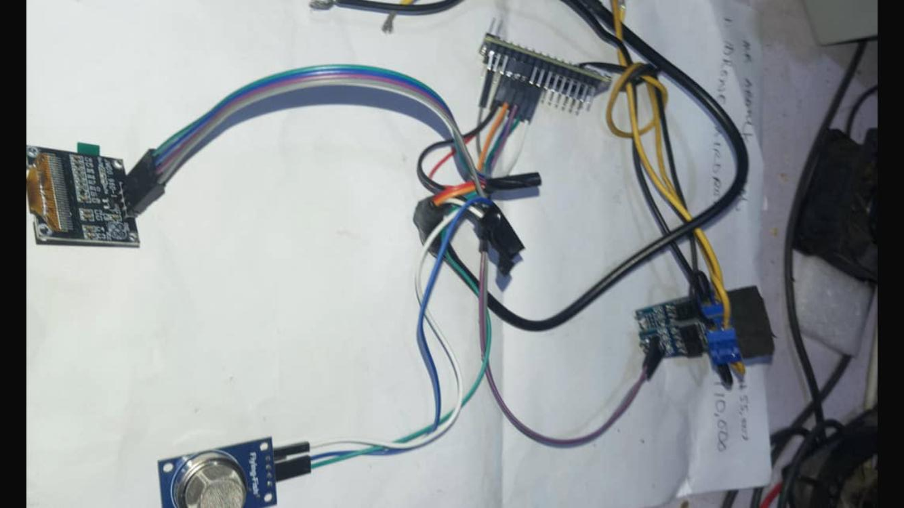\
Fig 4.1: The components of the smart fan before coupling
The components include:
- The Micro Controller Unit (nano) chip, Adrino which gives the instructions.
- Bursar responsible for beeps (in case it reaches it maximum temperature so it will come up with a sound as alert).
- Smoke detector
- Screen 128x64 display to show the necessary information
4.1.1 OUTPUT DESIGN
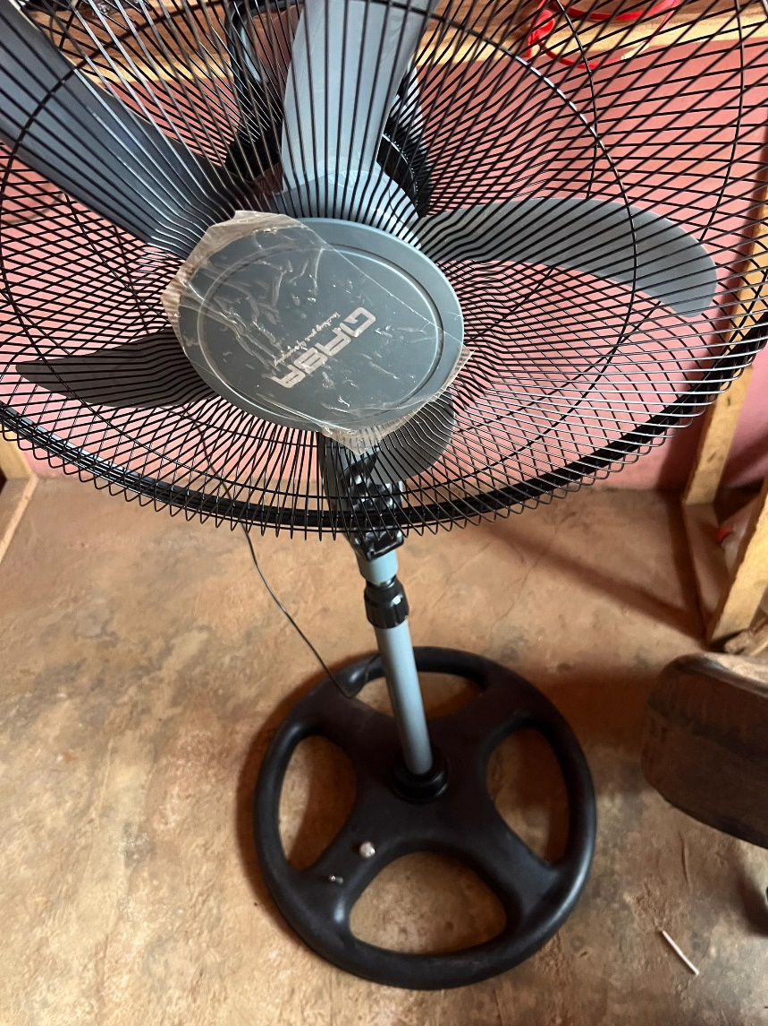
Fig 4.1.2: The Completion of the smart fan
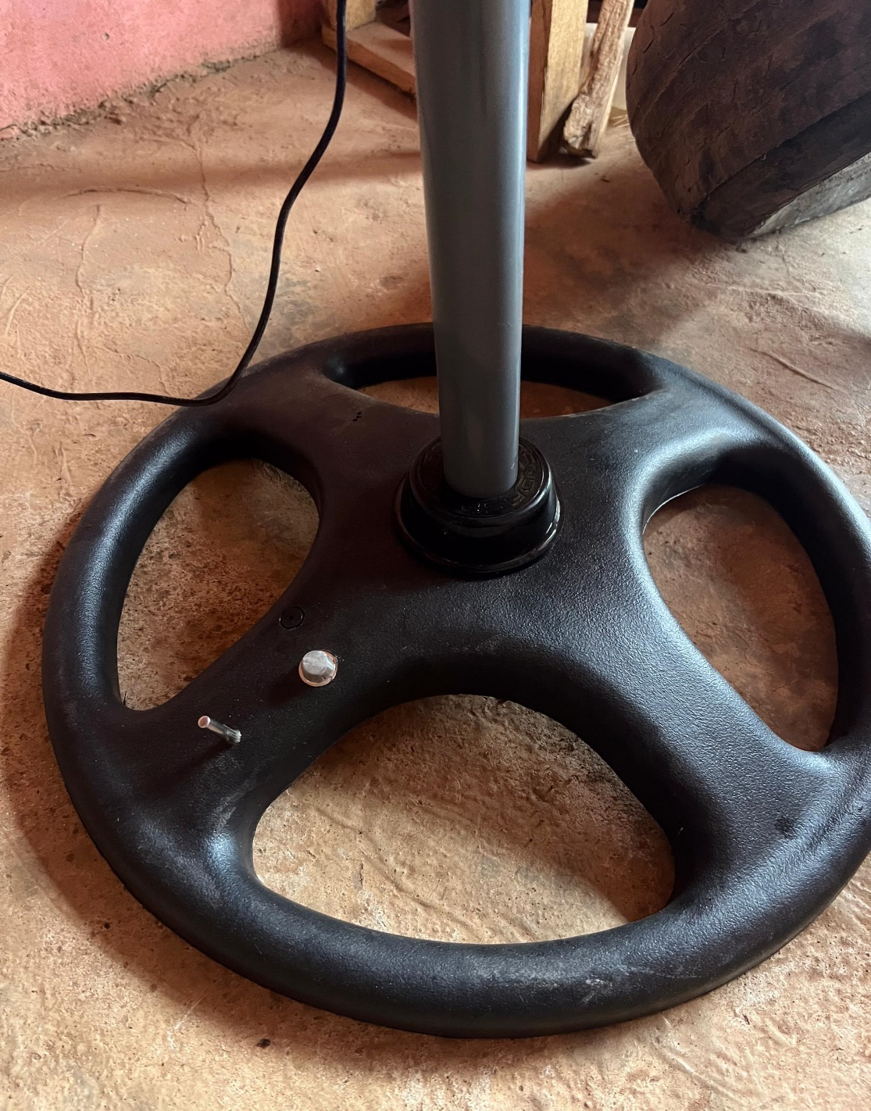
Fig 4.1.3: Showing the temperature detector and the bursar of the smart fan
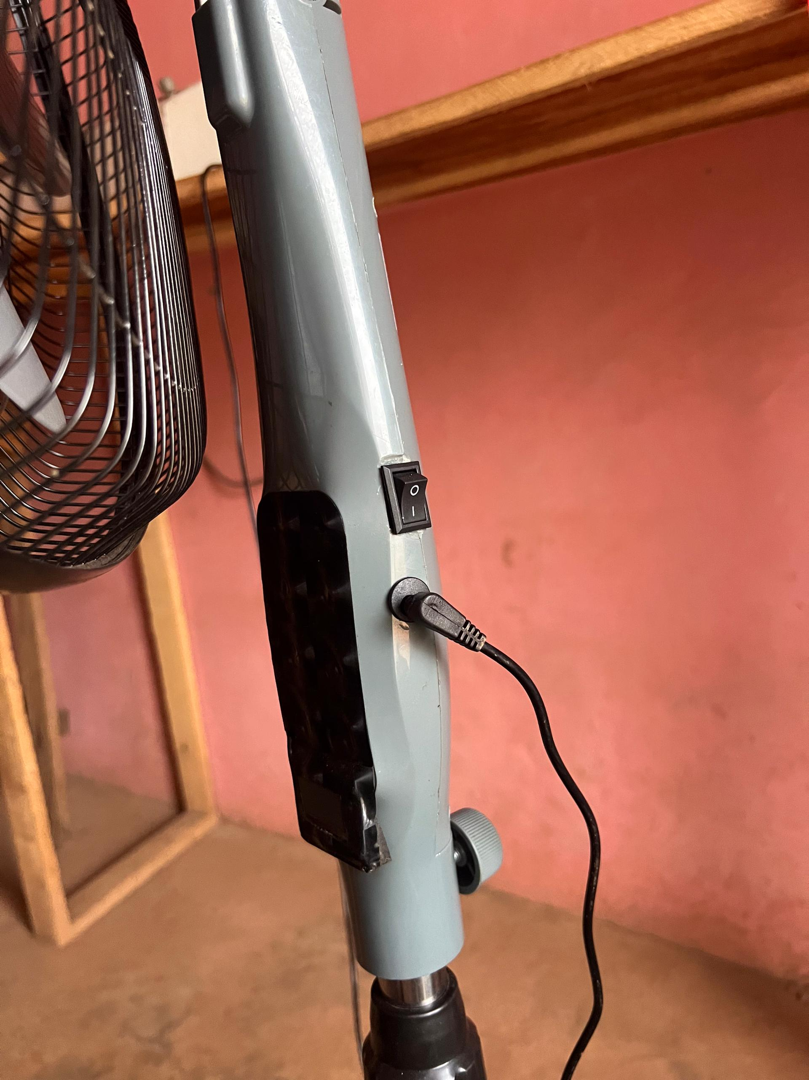
Fig 4.1.4: Showing the input, manual and the automatic switch of the smart fan

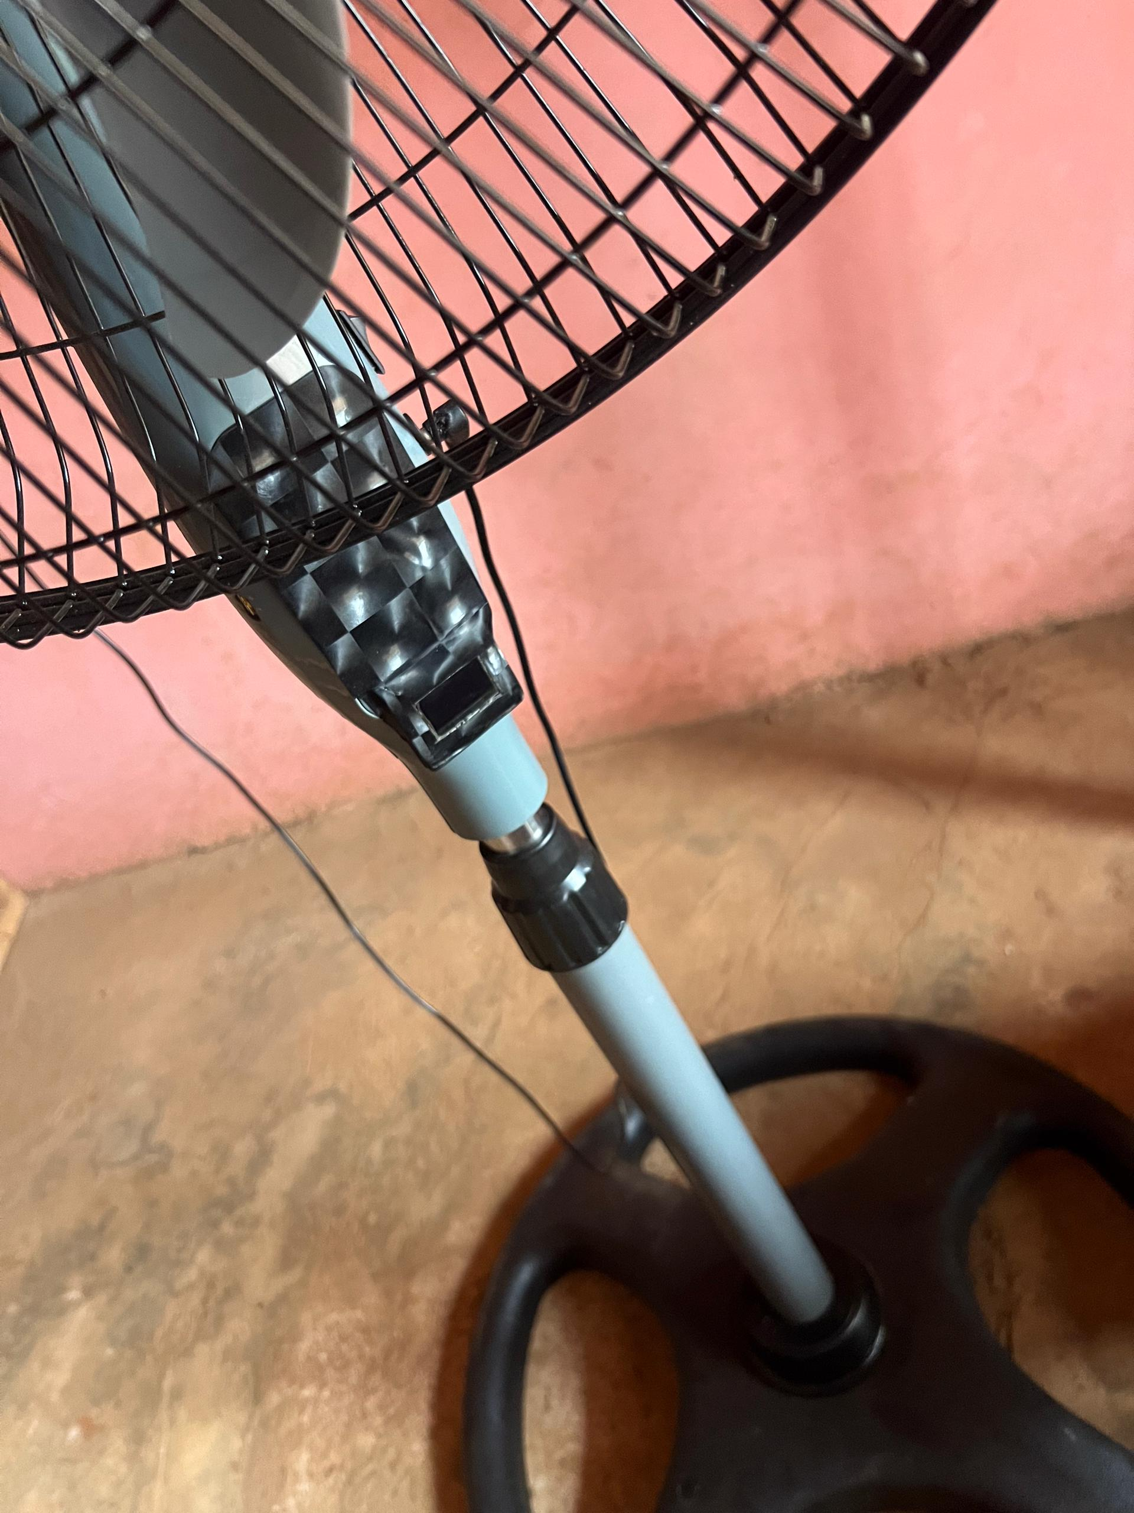
Fig 4.1.5: Showing the exterior view of the smart fan

CHAPTER FIVE
SUMMARY, CONCLUSION AND RECOMMENDATION
5.1 SUMMARY
intelligently adjusting the fan speed based on ambient environmental conditions such as temperature and humidity. Conventional fans typically operate at fixed speed levels, lacking adaptability to fluctuating room conditions, which often results in energy wastage and discomfort.
Fuzzy logic, inspired by human reasoning, enables the control system to interpret imprecise inputs and make decisions in a way that mimics human judgment. In this project, sensors collect real-time ambient data, which are then processed through a fuzzy logic controller to determine the optimal fan speed. The fuzzy logic controller uses linguistic variables and membership functions to handle the uncertainty and vagueness of inputs, allowing smooth and gradual adjustment of fan speeds rather than abrupt changes.
The system design involves three main components: sensor modules for environmental data acquisition, the fuzzy inference system for decision making, and the actuator (fan motor) controlled via a microcontroller. Testing the smart fan prototype demonstrated improved responsiveness to environmental changes, resulting in enhanced user comfort and reduced energy consumption.
By integrating fuzzy logic control, the smart fan adapts dynamically, providing a more energy-efficient and comfortable cooling experience compared to traditional fans
This project presents the design and development of an intelligent fan system that autonomously adjusts its operating speed based on varying ambient conditions using fuzzy logic control. Unlike conventional fans that operate at user-defined fixed speeds or basic thermostatic triggers, the smart fan employs a rule-based fuzzy inference system to interpret real-time environmental data—specifically temperature and humidity—and adjusts its speed smoothly and continuously to enhance user comfort and energy efficiency.
5.2 CONCLUSION
The project successfully demonstrated that fuzzy logic control could be effectively implemented in a smart fan system to manage fan speed based on ambient temperature and humidity. The smart fan was able to respond more precisely and smoothly to changing environmental conditions than conventional fixed-speed fans. This intelligent control not only improved user comfort by maintaining an optimal cooling environment but also contributed to energy savings by avoiding unnecessary high-speed fan operation.
The fuzzy logic approach proved to be suitable for handling the inherent uncertainties in ambient conditions, enabling the system to make nuanced speed adjustments without complex mathematical modeling. Overall, the project validates the viability of fuzzy logic as an efficient method for smart home appliance control, particularly in applications where environmental conditions fluctuate continuously.

5.3 RECOMMENDATION
Based on the result of this project, the following recommendations are proposed:
- Integration with Additional Sensors: Future development could include integrating other ambient sensors such as air quality, light intensity, or occupancy sensors to make the smart fan even more responsive to the surrounding environment.
- User Customization Interface: Incorporating a user-friendly interface (e.g., smartphone app or touch panel) would allow users to set personalized preferences or modes (e.g., quiet mode, energy-saving mode).
- Energy Consumption Monitoring: Adding energy monitoring features can provide feedback to users about power consumption, encouraging more conscious usage.
- Wireless Connectivity: Implementing IoT capabilities would enable remote monitoring and control of the fan, making it more versatile and suitable for smart home ecosystems.
- Adaptive Learning: Employ machine learning algorithms alongside fuzzy logic to enable the system to learn user preferences over time and adjust control strategies accordingly.
- Scalability: The fuzzy logic control framework can be adapted for other appliances like air conditioners or heaters to create an integrated climate control system.

REFERENCES
Ali, Z. M., & Khan, M. A. (2020). Embedded smart control of fan speed based on
environmental conditions. Journal of Automation and Control Engineering, 8(3), 113–118.
Arduino. (2023). Arduino PWM documentation. Retrieved from
https://docs.arduino.cc/learn/microcontrollers/pwm
MathWorks. (n.d.). Fuzzy Logic Toolbox – MATLAB. Retrieved from
https://www.mathworks.com/products/fuzzy-logic.html
Kumar, R., & Tripathi, M. M. (2021). Design and implementation of temperature-based fan speed
control system using fuzzy logic. International Journal of Engineering Research and Applications, 5(4), 27–31.
Kumar, P., & Rajan, R. (2019). A fuzzy logic controller for temperature control in smart homes.
International Journal of Control and Automation, 12(6), 1–8.
Jain, R., & Gupta, M. M. (2023). Fuzzy Logic and Neural Networks: Basic Concepts and
Applications. Prentice Hall.Ross, T. J. (2021). Fuzzy logic with engineering applications (3rd ed.). Wiley.
Singh, R. & Kumar, V.,(2019). Smart appliances in smart homes using fuzzy logic. International
Journal of Computer Applications, 145(7), 1–5. https://doi.org/10.5120/ijca2016910630
Zadeh, L. A. (2020). Fuzzy sets. Information and Control, 8(3), 338–353.
https://doi.org/10.1016/S0019-9958(65)90241-X
Ifeanyi, O. C. (2019). Design and Implementation of a Temperature-Based Fan Speed Controller
Using Fuzzy Logic. International Journal of Engineering Research and Technology, 8(4), 32–37.

