

KWARA STATE POLYTECHNIC OF ILORIN
CONSTRUCTION OF CREEP MEANSUREMEN APPARATUS WITH HEATING CHAMBER

BY

GANIYU MUIZE FATAI
ND/23/MCT/FT/0029

A PROJECT REPORT SUBMITTED TO THE DEPARTMENT OF MECHATRONICS ENGINEERING, INSTITUTE OF TECHNOLOGY
THE IN PARTIAL FULFILLMENT OF THE REQUIREMENTS FOR THE AWARD OF NATIONAL DEPLOMA IN MECHATRONIC ENGINEERING TECHNOLOGY ILORIN, NIGERIA

JULY, 2025

CERTIFICATION
The undersigned certify that this project report prepared by (Matric No, ND/23/MCT/FT/0029) Entitle Construction of Creep Measurement Apparatus with Heating Chamber" meets the requirement of the Department of Mechatronics Engineering for the award National Diploma (ND) in Mechatronics Engineering Kwara State Polytechnic, Ilorin.

_______________________ __________________
ENGR. IBISANKALE Sule M. Date
SUPERVISOR

_______________________ ___________________
ENGR. RAJI Idowu Adebayo. Date
HEAD OF DEPARTMENT

_______________________ ___________________
External Examiner Date

DECLARATION
I hereby declare that this research project titled: Construction of Creep Measurement Apparatus with Heating Chamber" is my work and has not been submitted by any other person for any degree or qualification at any higher institution, I also declare that the information provided therein is mine and those that are not mine are properly acknowledge.

________________________ ____________________
GANIYU MUIZE FATAI Signature and Date

DEDICATION
The work if merits, it is dedicated to Allah (SWT). And His holiest servant, PROPHET MOHAMMAD (SAW). And My Parent.

ACKNOWLEDGEMENT
In the name of Allah, the most beneficent, the most compassionate. Thanks be to Him, the one whose ever espousing guidance, compassion, protection and blessing have ever been my source of success. His peace and blessing continue to be upon the best mankind ever, prophet Muhammad (SAW).
My indeptness goes to my loving and caring parents, Alhaji and Alhaja GANIYU for their devotion assistance and strong determination to seeing me achieved the best both educationally and morally in life. May the possessor of majesty and honour never deprive them of the fruits of their labour and reward them.
My thanks goes to my supervisor ENGR. IBISANKALE SULE MOSHOOD (ENGR SIM) His openness, Co-operation and unassuming responses to my puzzle really helped me in getting ideas that are contained in this report. To the entire lecturers of Mechatronics Engineering Department, I say thank you all and Allah reward you accordingly.
My special regards to my follow Course Mate. Your physical, financial, moral and spiritual efforts are invaluable. I would say Allah alone can reward you for the care and concerns you almost demonstrate toward me Abundantly. I am really sorry that Bam wanting in word that could convey a near expression of my feelings. Mean while, I thank you all for your support inwards and indeeds. Without their co-operations, my programme would not have been so successful.
Finally and once again, my thanks goes to Allah (SWT). I am infact in debited to Him in gratitude.

ABSTRACT
This project undertaken is a report on the design and construction of creep measurement Apparatus with heating chamber which is used to determine the creep-time relation of aluminum metal at elevated temperature. The apparatus has been designed and constructed from available materials including low carbon steel sheet metal, mild steel bar, aluminium foil and zinc metal. It was tested, analyzed and found to function effectively and efficiently. Also, measures of recommendations are given and should be considered for further quality design and construction of creep measurement Apparatus with heating chamber.

TABLE OF CONTENTS
Title page i
Approval page ii
Dedication iii
Acknowledgements iv
Abstract v
Table of contents vi
List of Tables viii
List of Figures ix
CHAPTER ONE
INTRODUCTION
1.1 Creep Measurement
1.2 Literature Review
1.3 The needs for incorporating heating chamber with the Apparatus.
1.4 Objective for the design and construction of the Apparatus
CHAPTER TWO
ANALYSIS OF CREEP MEASUREMENT APPARATUS.
2.1 Related Creep Measurement Apparatus
2.2 The designed Creep Measurement Apparatus
2.3 Choice of Heating Chamber.
CHAPTER THREE
CONSTRUCTION OF THE CREEP MEASUREMENT APPARATUS
3.1 General description and its working principle
3.2 Components of the apparatus and material consideration
3.3 Dimension of the components parts
3.4 Construction process
3.5 Assembling the Component Part of the Apparatus
3.6 Design calculations for the Apparatus
CHAPTER FOUR
TESTING OF THE CREEP MEASUREMENT APPARATUS
4.1 Procedures for operating the Apparatus
4.2 Results and Discussion
CHAPTER FIVE
CONCLUSIONS AND RECOMMENDATION
5.1 Conclusion
5.2 Recommendation
Reference

LIST OF TABLE
Table 3.1 Dimension of the Component parts.
Table 4.1 Table of extension and time at a temperature of 200°C and constant load of 20N
Table 4.2 Table of extension and time at a temperature of 250°C and Constant load of 20N.
Table 4.3 Table of strain and time at 200°C
Table 4.4 Table of strain and time at 250°C

LIST OF FIGURE
Figure 2.1: Stress-Strain Curve with distinct yield point.
Figure 2.2: Creep-Time Relation
Figure 2.3: Effect of applied stresses on the creep-time Curve
Figure 2.4: Effect of increasing temperature on the Creep-time curve.
Figure 3.1 Shear force diagram
Figure 3.2: Bending moment diagram
Figure 4.1: Graph of strain against time at temperature of 200°C and 250°C.

CHAPTER ONE
INTRODUCTION
1.1 CREEP MEASUREMENT
Creep is the plastic deformation of materials at elevated temperature for long periods of times at a stresses which are usually lower than the yield strength. Creep is the variation of strain with time, under a constant applied stress and constant temperature. Creep occurs for most material's at stress below the yield strength and only if the temperature is elevated. It is more severe in materials that are subjected to heat for long periods and near melting point of the materials. The rate of this deformation is a function of the time, temperature and applied load. Depending on the magnitude of the applied stress and it time, the deformation may become so large that material can no longer perform its functions. Creep is not necessary a failure mode, but a deformation mechanism. Unlike brittle fracture, creep deformation does not occur suddenly when load is applied instead, strain accumulate as a result of long timed stress even though the stress remain constant. It is "Time dependent" deformation.
In some application operating at elevated temperature, such as steam or gas turbine, elevated temperature in these case is present over long period of time and the creep deformation may be kept small in order to maintain clearances between the moving and stationary parts of the turbine. Creep will cause the turbine blade to contact the casing lead to the failure of the blade. Also in the design of tungsten light bulb filaments, the sagging of the filament coil between its supports increases with time as a result of the deformation caused by the filament weight. If the deformation become so large, the adjacent turn of the coil touch one another causing an electrical shock and local overheating, which may lead to failure of the filament. Creep is slow, continuous deformation with time. The designed creep Measurement Apparatus is a device used to determine the creep curve of aluminium specimen at elevated temperature.
1.2 LITERATURE REVIEW
Creep deformation is not important only in a system where high temperatures are endured such as nuclear power plant, jet engines and heat exchanger but also in the design of many every day components. Creep occur at a relatively low temperatures for some materials as can be seen marked in plastic. When plastic material is loaded at room temperature for a long period of time in the designed creep Measurement Apparatus, strain accumulate as a result of long time stress which may later cause failure of the material. Plastic takes a long time to creep compared to that of metals. The complete strain versus time creep is just like that of the aluminium metal which is loaded in tension or compression. usually at a constant load inside a furnace which is maintained at elevated temperature. In order to be precise and brief, all materials will creep under the influence of load. Since the minimum temperature is relative to the melting point, creep deformations at elevated temperature can be seen also in plastic and low melting metals.
1.3 THE NEEDS FOR INCORPORATING HEATING CHAMBER WITH THE APPARATUS.
The range of temperature at which creep deformation may occur differs in various materials. Creep is usually of concern to Engineers and metallurgist especially when evaluating components that operate under high temperatures. For example, thousand degree of temperatures are required for tungsten before creep deformation can occur.
Generally, any material will creep upon approaching its melting point. As the temperature is high, loads which give to permanent deformation at room temperature cause material to creep. It occurs faster at high temperatures. However, what constitute a high temperatures is different for various metals. Most metals do not creep at room temperature since they have much higher melting points than solder. Thus, creep can still be a major concern when designing metallic components that have to function at high temperatures. For example, in the design of turbine blades for use in jet engine, they can be exposed to hot gases at up to about 1400°C. they are also under stress as a result of the high centrifugal force. These blades must withstand the high temperature without excessive creep which would cause them to strike the turbine enclosure. Also in steam turbine power plant, steam pipe carry superheated vapour under high temperature of about 565.5°C as jet engine temperatures may reach to 1000°C which initiate creep deformation in a weak zone.
For lattice diffusion of atoms to occur in a materials, neighbouring lattice sites in the crystal structure must be free. A given atom must also overcome the energy barrier to move from its current site. The diffusivity increases due to the higher temperature endure on the material. There is increase in the average energy of atoms in the material. Since all mechanism of steady state creep are dependent on diffusion, creep rate which have exponential dependent on temperature. Creep is monotonically increases function of temperature. These necessities lead to the design and construction of creep measurement Apparatus with heating chamber.

1.4 OBJECTIVE FOR THE DESIGNED AND CONSTRUCTION OF THE APPARATUS
The primary aim for the design and construction of creep measurement Apparatus with heating chamber is to determine the effect of high temperature on the materials but other are secondary. These are:
1. To study the creep behaviour of material at elevated temperatures.
2. To provide a factor of safety for the material of the test piece.
3. To study the effect of applied stresses on the creep-time curve.
4. To determine the extension at a given time interval in order to tabulate the readings.
5. To plot the graph of strain against time in order to obtain complete strain versus time curve for creep test.
6. To improve the desired properties of the material.

CHAPTER TWO
ANALYSIS OF CREEP MEASUREMENT APPARATUS
Creep is the continuous deformation with the passage of time when material is subjected to persistent stress. This deformation is plastic and occur if the applied stress is below the yield strength of the material. One of the approaches of interpretation of creep test data is to determine an empirical equation to fit a particular creep time curve at a given stress for a given temperate and material. A relationship between the creep strain, time and stress is required to select on allowable creep stress deformation. Microscopically material react to an applied stress. When the material strain is not permanent and return to zero after the applied stress is removed, it is elastic behaviour. The stress at which the material behaviour change from elastic to plastic is known as yield strength. In plastic deformation, strain is due to strain hardening. The process by which the material grows stronger as it deformed. There is another stress called ultimate tensile strength needed for further strain decreases result in necking of the material that is, decrease in the local area of the samples due to localization stress. If the material is plastically deformed too much, voids start to form which further weaken the material and eventually tears the material apart due to the ductile fracture.
Strain

Plastic Strain Fracture

Stress
0.2 offset yield point
Elastic Strain
Figure 2.1 Stress-strain Curve with distinct yield point.
For metals at higher values of stress or temperature, four distinct stages of creep are noticed. These stages are
- Initial Stage:- in which the total deformation is partially elastic and partially plastic.
following an instantaneous elastic strain region, the curve generally has three parts. These are:-
- Second Stage:-A primary creep where the rate of creep deformation decreases with time, indicating the influence of strain- hardening
- Third stage:- A secondary creep or steady state creep where the strain Increases steadily with time. The effect of strain counteracted by an annealing influence, which result in a stage of constant minimum creep rate.
- Final stage:-Tertiary creep where the rate of creep deformation increases and eventually causes failure. During the tertiary creep period, there is reduction in the cross sectional area of the specimen leads to higher stress.
Strain
2
3
4
1
Time

Stage 1= Initial elastic Strain
Stage 2= Primary Creep
Stage 3= Secondary creep
Stage 4= Tertiary Creep
Figure 2.2 The General Creep Curve.
As shown above creep is the plastic deformation of a material at a high temperature when subjected to a stress below the yield strength over a period of time. The effect of increase the stress and temperature is shown below.

$$δ_{3}$$
$$δ_{2}$$
$$δ_{1}$$
Time
Increasing Stress
Strain
$$δ_{1 >}$$
$$δ_{2>}$$
$$δ_{3}$$

Figure 2.3 Effect of applied Stresses on the creep Curve
$$T_{3}$$
$T_{2}$ $T_{1 >} T_{2>}$ $T_{3}$$$T_{2}$$
$$T_{2}$$

$T_{1}$ Increasing Temperature
$$T_{2}$$
$$T_{2}$$

Strain
Time

Figure 2.4 Effect of increase temperature on the creep-time curve.
2.1 RELATED CREEP MEASUREMENT APPARATUS.
There are various types of creep measurement apparatus. hey different size their sizes, capacities, mode of operation and the types of material they measured. These includes series 2100 direct load creep frames, series 2300/2500 lever arm creep frames and series 2600 pneumatic activated creep frames.
SERIES 2100 DIRECT LOAD CREEP FRAMES.
This is a type of creep measurement apparatus with a loading capacity up to about 44400N and used for stress rapture and creep. It is a low cost system and has a multi-station units that offer separate control for each individual component for maximum system flexibility. It is incorporated with electric weight elevator and automatically maintain a small clearance between the stack and injury upon specimen breakage.
SERIES 2300 LEVER ARM CREEP FRAMES
This is another creep measurement apparatus with a loading capacity up to 22240N. It is long life test machine to meet virtually any requirement. It comprises models available to perform stress relaxation and constant stress testing. It has manual or automatic leveling draw head as well as electric or hydraulic weight elevaators. All the model offer computer control with the versatile win CCSII soft ward from American Teaching System (ATS). This may involves flexibility test, preparation of specimen and generation of gueuing report and analysis of data.
SERIES 2600 PNEUMATIC-ACTUATED CREEP FRAMES
This apparatus is efficient and accurate for creep testing. It is designed specially for pneumatic actuator with frictionless rolling diaphram construction and non-rotating shaft with capacity up to 22200N. It as manual computer control with data acquisition, analysis and cyclic load capacity and more.
2.2 THE DESIGNED CREEP MEASUREMENT APPARATUS
The creep measurement apparatus constructed which is manually operation is a tension creep test. Specimen are usually subject to constant loads by lever system of loading. The creep information are usually measure by dial indicator with accuracy of 0.01mm and rang of 001-10mm which served as the extensometer to measured the extension for room temperature and the creep test at elevated temperature. The designed creep measurement apparatus with heating chamber consist of an electric furnace which is maintained at constant temperature with thermostatically controlled heater that are used to apply elevated temperature to the specimen.
2.3 CHOICE OF HEATING CHAMBER
Heat furnace are usually classified accordingly to the purpose for which the material is heated, the nature of the heat transfer to the material, the method of firing the furnace and method of handling the material through the furnace. The maximum temperatures are limited only by the nature of the material of the charge. The heating chamber are designed to operate at higher temperatures range. The temperature of the inner face of the heating chamber determines the characteristics of material required for the insulation. Fiber grass is used for insulation of the heating chamber, an insulator of this kind has less heat storage capacity and it use accordingly decreases the time period of heating and cooling the chamber and also decreases the stored heat loss for a given cycles of operation other advantages are its high heat insulating value and light weight.

CHAPTER THREE
CONSTRUCTION OF THE CREEP MEASUREMENT APPARATUS
3.1 GENERAL DESCRIPTION AND ITS WORKING PRINCIPLE
The creep measurement apparatus as a whole is rectangular in shape and it comprises of the two main components. These are:-
1. The rigid base plate
2. The top mechanism
The rigid base plate consists of the bottom base plate and the cover base plate. The bottom base plate was made and bent to shape to give provision for accommodation of the cover base plate. It also forms the handle through which the apparatus can be carried with ease. The cover base plate serves as the rigid base on which the mechanism rest. On it, there is stand for holding the weights to be used when performing the experiment.
The top mechanism consist of the bottom beam, lever arm, dial indicator, grip or stirrups, heating chamber, front bar, rear bar and other bars.
The creep measurement apparatus with heating chamber employs lever action to apply load to the specimen. The lever beam is notched to received the edge of the fulcrum which is at the top column rigidly attached to the base. Typically, specimen is loaded in tension usually at constant load inside the furnace (Heating chamber) attached to the front bar and is maintained at constant temperature with thermostatically controlled heater with the specimen bolted to two stirrup for self alignment. The lower stirrup is attached to the bottom beam by means of bolt and nut to allow height adjustment during set-up. The upper grip pivot on the lever arm. The weight hanger is bolt to the opposite end of the lever arm.
The tip the dial indicator attached to the front bar is aligned on the top flat edge of the upper stirrups. The dial indicator is set to zero.
The weight is suspended from the weight hanger and supported so that the specimen in the chamber is not loaded. After heating the specimen to the desire temperature, the hanger is lowered slowly to apply the load at equal interval of time.
3.2 COMPONENTS OF THE APPARATUS AND MATERIAL CONSIDERATION
The material used for the construction of the creep measurement apparatus are low carbon steel sheet metals, mild steel bar, aluminums foil, zinc metal and fiber grass.
The low carbon steel is ductile and can be easily bend to the required shape of part. The mild steel has relatively good tensile strength and also compressive strength. It can be worked upon easily. It has a high melting point and thus withstand high working temperate. However, it has poor corrosion resistance.
Therefore, the bar were painted to prevent corrosion. The aluminium foil is very malleable and ductile; can be rolled into cylindrical shape easily and the zinc metal has a high tensile strength, malleable and ductile between 100°-150°C, but brittle at room temperature and at a temperatures above 200°C with relatively high thermal conductivity.
THE BOTTOM BASE PLATE: This is made of low carbon steel sheet metal. It is made and bend to give provision for the accommodation of the cover base plate. It also form the handle through which the apparatus can be carried with ease.
THE COVER BASE PLATE: This is also made of low carbon steel sheet metal. It is serve as the rigid base on which the mechanism may rest. On it, there is a stand for holding the weight to be used.
THE MECHANISM: This consist of the following components.
1. The Heating Chamber: Is a fixed hollow cylinder having an outer casing of aluminium foil and inner casing of zinc metal. The heating element is a sinuous winding round the zinc metal mounted on the inner surface of the heating chamber with a thermostatically control devices. The heat insulation fibre grass are coated in the annular space between the outer and the inner casing of the chamber.
2. The Lever Arm: This is made of mild steel bar with thickness 6mm. It provides the region for weight hanger for loading It is then inserted into a stirrup, connected to the specimen and having its flat top touching the tip of dial indicator.
3. The Bottom Beam: This hold four mild steel bars supporting the lever arm. Tight in position to resist unpermitted relative movement of the bars. It is also made of mild steel bar.
4. The Stirrups: This is made of low carbon steel sheet. It is made and bent to accuracy so as to accommodate the specimen. Therefore, it hold the specimen in position inside the heating chamber with the aid of bolts and nuts.
5. The Dial Indicator: This is a sensitive measuring instrument that perform the function of an extensometer used to measures the extension of the specimen at an equal internal of time. It is an attached mechanism but not among the constructed components.
6. The Stopwatch: This is also an attached mechanism of the creep measurement apparatus but not among the constructed component. It is used to regulate the time. It works along with the dial indicator when the specimen is elongating.
3.3 DIMENSION OF THE COMPONENT PARTS
Components | Dimension |  |  | No. of  Pieces
 | Length | Breadth | Thickness
The bottom base plate | 1000mm | 300mm | 1.5mm | 1
The cover base plate | 650mm | 580mm | 1.5mm | 1
The lever arm | 550mm | 30mm | 6mm | 1
The bottom beam | 350mm | 30mm | 6mm | 1
The front bar | 300mm | 30mm | 6mm | 2
The rear bar | 250mm | 30mm | 6mm | 2
The stirrups or grips | 100mm | 35mm | 1.5mm | 2
The bar holding the dial indictor | 100mm | 20mm | 2.0mm | 1
The stand for the Wieght | 90mm | 60mm | 2.0mm | 2
Outer casing for the heating chamber | 250mm | 80mm | 1.5mm | 1
Inner casing of the heating chamber | 125mm | 75mm | 1.5mm | 1
Table: 3:1 Dimension of the component part of the Apparatus.

3.4 CONSTRUCTION PROCESSES
Here the work includes metal cutting, marking out, screwing, material measurement and so on. These are carried out to cut out and shape the component and give it the desire finished, correct fit with any mating part. These might be merely operation of assembly part together. During the process of cutting, fabrication and integration of the component parts to construct the apparatus, a clearance of + 2.0mm was taken into consideration so as to take care of the folding, welding, grinding effects and others in order to maintained their sizes. The sequences of operation are as follow:
MEASUREMENT AND MARKING OUT PROCESS
Measuring and marking out of the sheet metals and steel bars according to the dimension. These are carried out with measuring tape, try square, vernier caliper, scriber and punch.
CUTTING PROCESS
This involved the cutting out of the part marked out on the sheet metal and the steel bars according to the specification with the aid of hacksaw, chisel and so on.

BENDING AND FOLDING PROCESSES
The marked out region of the sheet metal and the bars which required folding or bending were made to give the required shape.
This is done to bend and fold the metal by means of special mechanism into section such as angles bars, L-section e.t.c.
DRILLING OPERATION
This operation involved the originating of a round hole on the component at appropriate position after cutting, bending and folding of the sheet metal and the steel bars to the required shape to give provision for bolts and nuts. It is performed using hand and electrical drilling machine.
WELDING OPERATION
Some parts were joined together to arrive at the required shape of the creep measurement apparatus. Electric arc welding machine was used to carry out this operation.
GRINDING AND FILLING OPERATIONS
The bars and the sheet metals that have been cut, welded are filed and grinded so that any hardening, distortion and scaling that may have occurred to the components is detrimental to its shape and for accurate and better surface finish. Grinding discard file of difference grades were used for the finishing operation.
PAINTING
The components parts of the apparatus were painted by spraying paint to every part. After painting, the components were hanged and allowed to dry for two days before assembly.
3.5 ASSEMBLING THE COMPONENT PARTS OF THE APPARATUS
The components of the creep measurement apparatus were assembled with bolts and nuts through the already drilled holes.
The procedures are as follows:
1. The bottom base plate is placed on a flat workshop bench.
2. The cover base plate is gently put inside the space provided by the bottom base plate and the bolts are tightened.
3. The front bars and the rears bars are welded to the bottom beam.
4. The top holes of the rear bars and the front bars are connected to the lever arm through the corresponding holes on the lever arm and the bolts are also tightened.
5. The front and the rear bars are placed on the rigid base plate at their bent positions which have been drilled at each bent, four bolts are tightened and the mechanism sits on the rigid base plate.
6. The upper stirrup is connected to the front edge of the lever arm and the bolt is inserted.
7. The lower stirrup is connected to the front edge of the bottom bean and the bolt is also inserted.
8. The heating chamber is placed between the upper and the lower stirrups and connected to the front bars by means of two bolts and nuts.
9. The specimen is inserted between the stirrups through the holes at the top and bottom of the heating chamber.
10. The dial indictors is attached to the bar that has been welded to the top edge of the front bar at right angle and adjusted until its tip is allowed to touch the flat top of the upper stirrup with aligned vertically to the specimen.
11. The weight hanger is placed at the rear end of the lever arm and the bolt inserted.
12. The timer is inserted into the rigid base plate and connected through an external circuit to the heating chamber and other electrical components inside the bottom base plate.
13. The stop watch is placed behind the set up.
With the above assembling procedures, the set up of the apparatus can be achieved completely within some minutes and then ready for test.
3.6 DESIGN CALCULATIONS FOR THE APPARATUS
Calculating the bending moment of the lever arm with a known weight of. 50N
A

330mm
B C
220mm
R^{A} R_{R} 50N

.

Fig 3.1: Free body Diagram
Let upward force $= 1 + ve$
Let Downward force $= - ve$
Taking moment about point B $\sum{M_{B}}$ $= 0$
Let the clockwise moment $= + ve$
Let the Anticlockwise moment $= - ve$
$$330 x R_{A} +50 x 220 = 0$$
$$330 x R_{A} + 11000 = 0$$
$$330 R_{A}= - 11000$$
$$R_{A} = - 11000/330$$
$$R_{A} = - 33.3N$$
$R_{A}= 33.3N$
The direction of the reaction at A is downward since the reaction is negative. The free body diagram is shown below:

A

330mm
B C
220mm
33.3N R_{R} 50N

Resolving the vertical component force $\sum{F_{v}}$ = 0
$$- R_{A} + R_{B} -50 = 0$$
$$where:$$
$$R_{A} = Reaction at point A$$
$$R_{B} = Reaction at point B,$$
$$- 33.3 + R_{B} - 50 = 0$$
$R_{B}$= $50 + 33.3$
$R_{B}$ = $+ 83.3N$
$$= 83.3N$$

The direction of the reaction at B remain upward since the reaction is positive. The free body diagram is shown below.

330mm

220mm
33.3 83.3N 50N

A B C

330m
220m
83.3N
33.3

Fig 3.2 Shear force Diagram
$$For bending moment$$
$$At Point A$$
$$Bending moment at point A$$
$$33.3x 0 = 0Nmm$$
$$At point B$$
$$Bending moment at point B$$
$$83.2 x 330 = 10989 Nmm$$
At point C
Bending moment at point C.
$$(- 33.3 x 550) + (83.3 x 220) = ONmm$$
The Resultant Bending moment =$10989 Nmm.$
$$10989 Nmm.$$

OA
OC
B

Fig: 3.3 Bending moment diagram

THE ASSEMBLED CREEP
MEASUREMENT APPARATUS
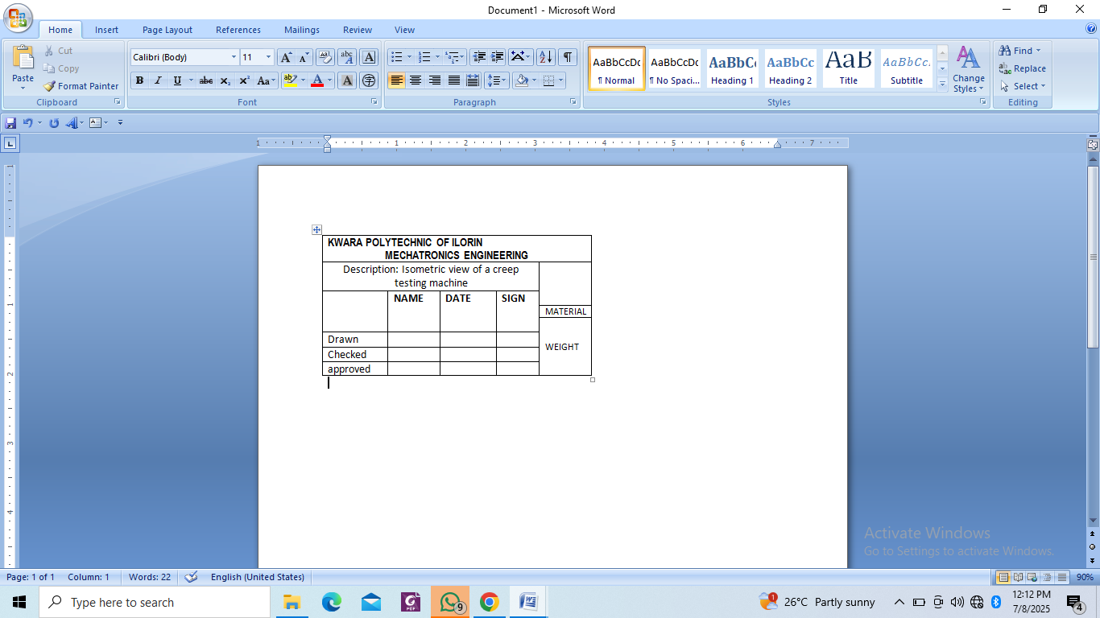
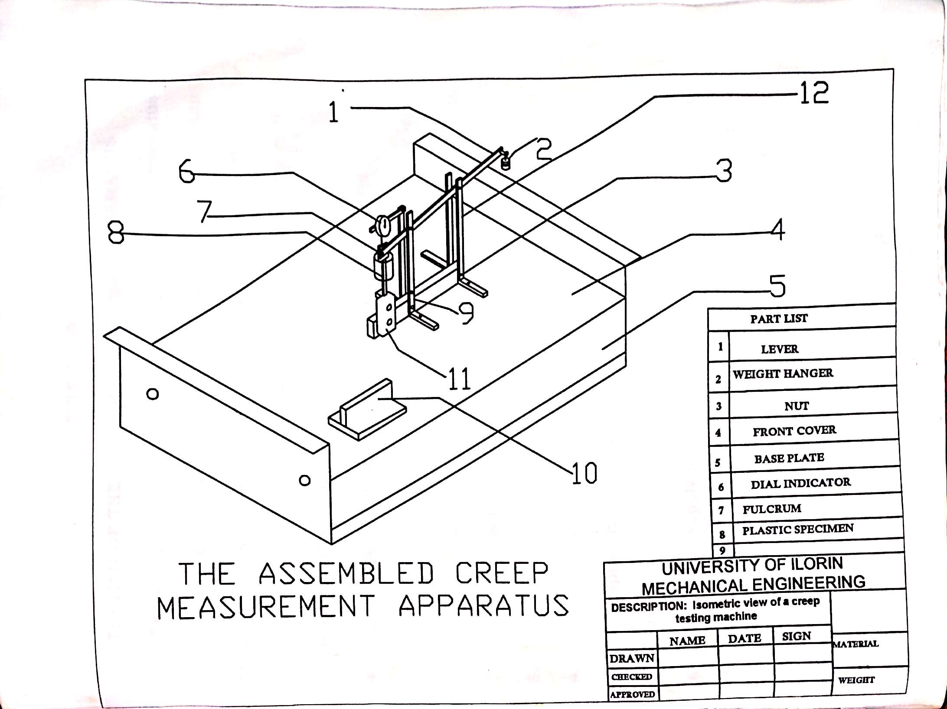
CHAPTER FOUR
TESTING OF THE CREEP MEASUREMENT APPARATUS
The aim for constructing the creep measurement apparatus is to determine and show the creep time curve of an aluminium specimen for the purpose of knowing it mechanical property and how it will operate to an agreement level of performance under the condition specified for it use.
4.1 PROCEDURES FOR OPERATING THE APPARATUS
1. The specimen is placed between the stirrups through a hole at the top and bottom end of the heating chamber
2. The dial indicator is set to zero
3. The thermostat is set to the elevated temperature required.
4. The stop watch is also set to zero.
5. The apparatus is plug to the power supply with the switch off.
6. The power supply is switch on and the test specimen loaded in tension by suspending the load from the weight hanger.
7. The lever arm is gently lowered until the specimen takes up the full load.
8. The stop watch is start.
9. The extension of the specimen during heating is recoded at suitable interval of time say 30 seconds.
10. The time for heating is taken and recorded using the timer.
11. The steps are repeated for another temperature value.
12. The extension of the specimen during heating at the same interval of time are also recorded.
4.2 RESULTS AND DISCUSSION
The apparatus tested and the reading is tabulated as shown below.
The graph of strain against time at the two temperature was plotted and shown below.
Table 4.1 Table of extension and time at a temperature of 200°C and constant of 20N
Extension during loading = 0.30mm
Load (N) | Extension (mm) | Time (Secs)
20 | 0.30 | 0.0
20 | 0.35 | 30
20 | 0.37 | 60
20 | 0.39 | 90
20 | 0.42 | 120
20 | 0.44 | 150
20 | 0.47 | 180

Table 4.2 Table of extension and time at a temperature of 250°C and constant load of 20N.
Extension during loading = 0.35mm
Load (N) | Extension (mm) | Time (Secs)
20 | 0.35 | 0.0
20 | 0.42 | 30
20 | 0.45 | 60
20 | 0.48 | 90
20 | 0.52 | 120
20 | 0.54 | 150
20 | 0.56 | 180
To determine the creep rate
$$Creep rate = \frac{change in strain}{Change in time}$$

$$Strain=\frac{Extension }{Oiginal length}$$
$$And the original length of the specimen = 110mm.$$
$$Strain and creep at 200°C$$
$$At 0 sec$$
$$Stain = 0.30/110 =0.0027$$
$$Creep = 0.0027/0 = 0/ sec$$
$$At 60 sec.$$
$$Strain = 0.37/110 = 0.0033$$
$$Creep = 0.0033/60 = 0.00005/ sec.$$
$$At 90 sec$$
$Stain = 0.39/110 =0.0035$
$$Creep = 0.0035/90 =0.000038/sec$$
$$At 120 sec.$$
$$Strain = 0.42/110 = 0.0038$$
$$Creep = 0.0038/120 = 0.000032 / sec.$$
$$At 150 sec.$$
$Strain = 0.44/110$ $= 0.0040$
$$Creep = 0.0040/130 = 0.000027 / sec.$$
$$At 180 sec.$$
$Strain = 0.47 / 110$ $= 0.0043$
$$Creep = 0.0043/180 = 0.000023/ sec$$
$$Strain and creep at 250°C.$$
$$At 0 sec.$$
$$Strain = extension/ original length$$
$$Strain = 0.35/110 = 0.0032$$
$$Creep = Strain/time 0.0032/0 = 0.sec$$
$$At 30 sec.$$
$$Strain = extension/ original length$$
$$Strain = 0.42/110 = 0.0038$$
$$Creep = 0.0038/30 = 0.00013/ sec$$
$$At 60 sec.$$
$Strain = 0.45/110$ $= 0.0041$
$$Creep = 0.0041/60 = 0.000068/ sec$$
$$At 90 sec.$$
$Strain = 0.48/110$ $= 0.0044$
$$Creep = 0.0044/90 = 0.000049/ sec.$$
$$At 120 sec.$$
$$Strain = 0.52/110 = 0.0047$$
$$Creep = 0.0047/120 = 0.000039/ sec$$
$$At 150 sec.$$
$$Strain = 0.54/110 = 0.0049$$
$$Creep = 0.0049/150 = 0.000033/ sec$$
$$At 180 sec.$$
$$Strain = 0.56/110 = 0.0051$$
$$Creep = 0.0051/180 = 0.000028/ sec$$
$$Stress = Force/Area. Force = 20N, Area = Area of Specimen = 110 x 10 = 1100mm2, stress = 20/1100 = 1.8 MN/m2$$

Table 4.3 Table of Strain and Time at 200⁰c
TIME (SECS) | STRAIN
0.0 | 0.0027
30 | 0.0031
60 | 0.0033
90 | 0.0035
120 | 0.0038
150 | 0.0040
180 | 0.0043

Table 4.4 Table Strain and Time at 250⁰c
TIME (SECS) | STRAIN
0.0 | 0.0032
30 | 0.0038
60 | 0.0041
90 | 0.0044
120 | 0.0047
150 | 0.0049
180 | 0.0051

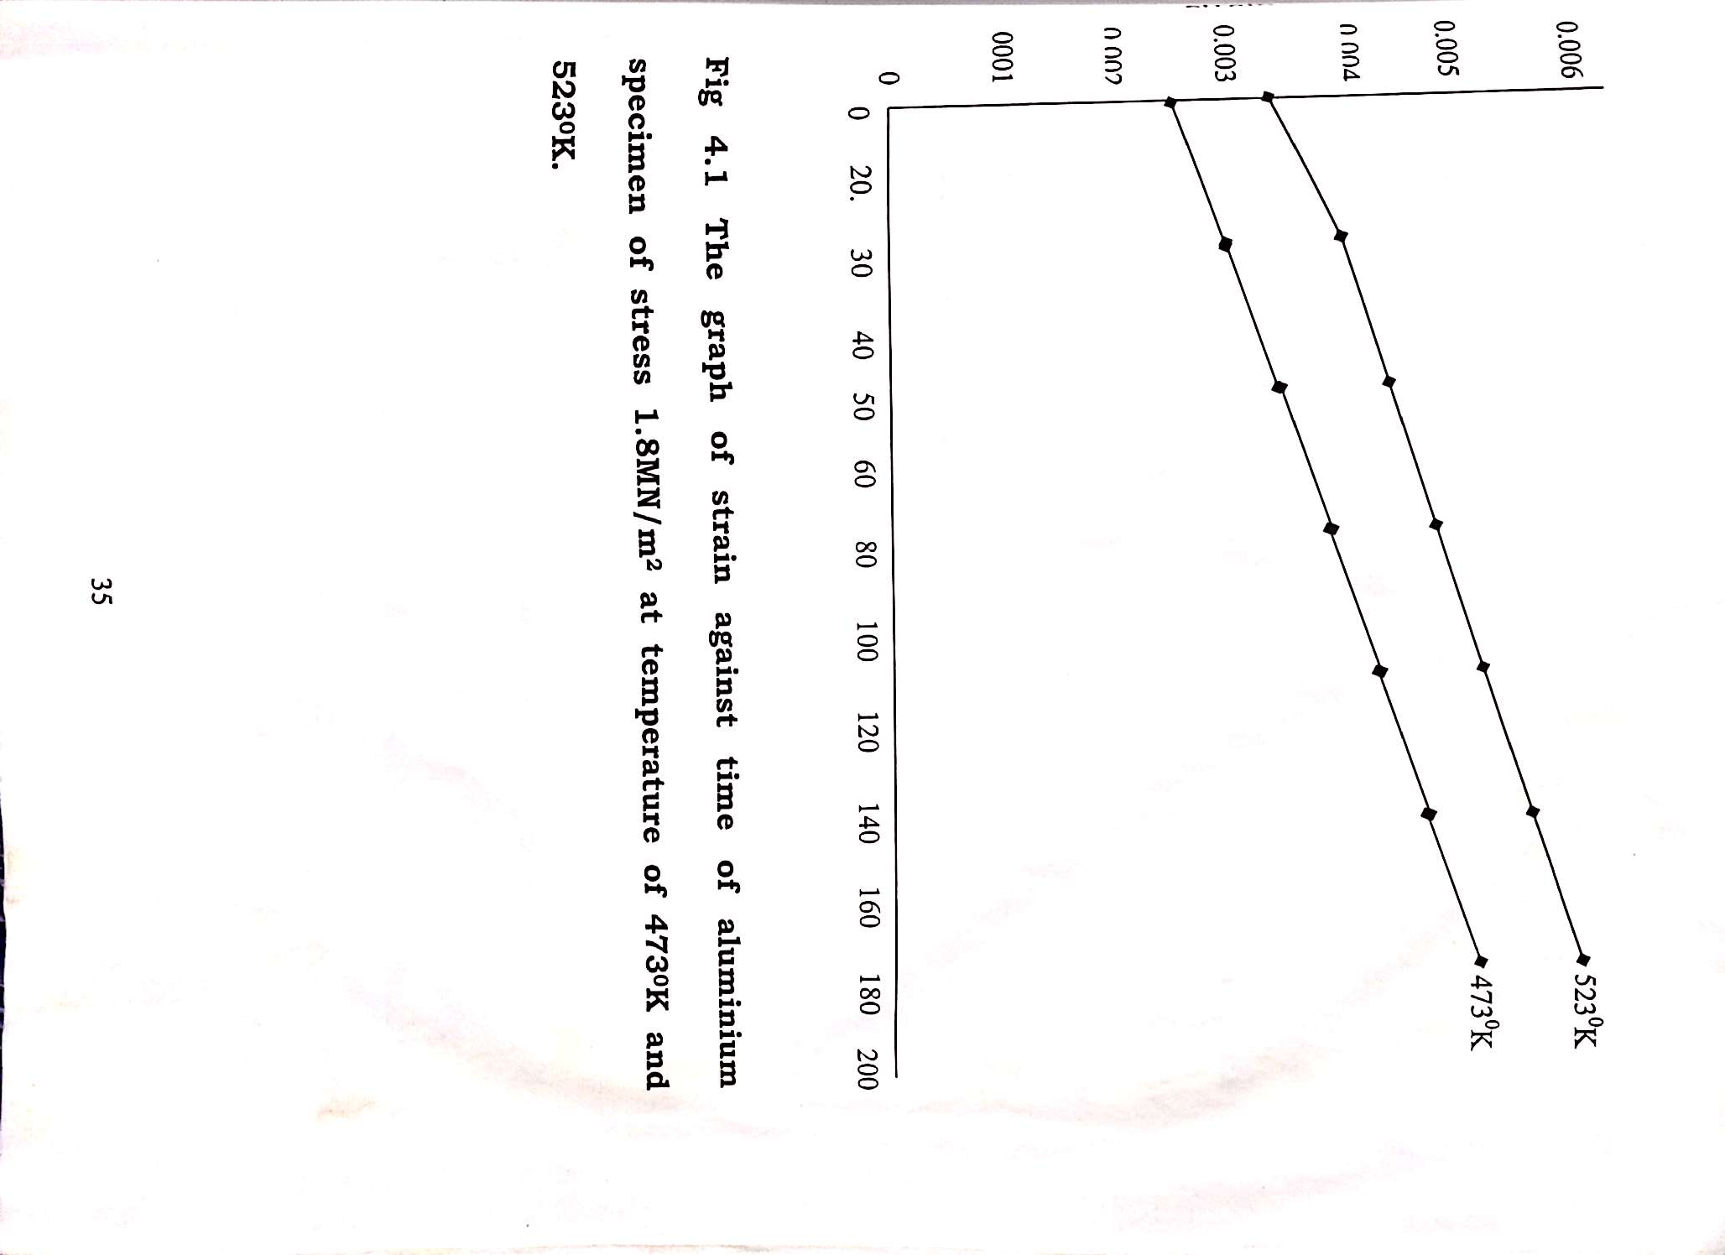

CHAPTER FIVE
CONCLUSION AND RECOMMENDATIONS
5.1 CONCLUSION
In order to determine the effect of temperature on creep and arrive at the required objectives of this report, the result and data analysis shows that the need for incorporating the heating chamber with the creep measurement apparatus is good and meets the t is intended for since the specimen show the creep curve of material at elevated temperature arrive at the required objectives of this report, the result and data analysis shows that the need for incorporating the heating chamber with the creep measurement apparatus is good and meets the t is intended for since the specimen show the creep curve of material at elevated temperature.
5.2 RECOMMENDATIONS
Having constructed the creep measurement Apparatus with heating chamber, it is tested and found to be effective.
For further construction of the apparatus with heating chamber, stainless steel should be used for the construction of the lever arm, bottom been and the bars to enhances preservation of the material. More practical work should be encourage on the designed and construction of the creep measurement Apparatus with heating chamber in order to determine the required heat input of the Heating device and thus there must be a standard calibration of the thermostat.
REFERENCES
Hertzberg, R.W. (1998). "Deformation and Fracture Machines of Engineering Materials" 3rd edition, Wiley and Sons, New York
Michael, F. Ashy and David, R.H Joens, (1999). "Engineering Materials," 2nd editions, Cambridge University, England.
Vermon John, (1992). "Introduction to Engineering Materials" 3rd edition, Macmillan education Ltd, London. C.
William, D.C, J.R (1996). "Introduction to materials science and Engineering" 4th edition, John Wiley and Sons, Inc Canada.

