ARTIFICIAL INTELLIGENCE (AI) BASED LANGUAGE TRANSLATION USING GOOGLE API

BY
OYIBO SAMUEL ADAH
HND/23/COM/FT/0015

A Project Submitted to the Department of Computer Science, Institute of Information and Communication Technology, Kwara State Polytechnic, Ilorin

In Partial Fulfillment of the Requirements for the Award of Higher National Diploma (HND) in Computer Science

June, 2025
CERTIFICATION
This is to certify that this project was carried out by OYIBO, Samuel Adah with matriculation number HND/23/COM/FT/0015, has been read and approved as meeting part of the requirements for the award of Higher National Diploma (HND) in Computer Science.

………………………………. ……………………………….
Mr. Olajide, A. T. Date
(Project Supervisor)

………………………………. ……………………………….
Mr. Oyedepo, F. S. Date
(Head of Department)

………………………………. ……………………………….
External Examiner Date
DEDICATION
This project is dedicated to the creator of the earth and universe, the Almighty God. It is also dedicated to my parents for their moral and financial support.

ACKNOWLEDGEMENT
All praise is due to the Almighty God the Lord of the universe. I praise Him and thank Him for giving me the strength and knowledge to complete my HND programme and also for my continue existence on the earth.
I appreciate the utmost effort of my supervisor, Mr. Olajide, A. T., whose patience support and encouragement have been the driving force behind the success of this research work. He gave useful corrections, constructive criticisms, comments, recommendations, advice and always ensures that an excellent research is done. My sincere gratitude goes to the Head of the Department and other members of staff of the Department of Computer Science, Kwara State Polytechnic, Ilorin, for their constant cooperation, constructive criticisms and encouragements throughout the programme.
Special gratitude to my parents who exhibited immeasurable financial, patience, support, prayers and understanding during the periods in which I was busy tirelessly in my studies. Special thanks go to all my lovely siblings.
My sincere appreciation goes to my friends and classmates.

TABLE OF CONTENTS
Title Page i
Certification ii
Dedication iii
Acknowledgements iv
Abstract v
Table of Contents vi
CHAPTER ONE: GENERAL INTRODUCTION
  - Background to the Study 1
  - Statement of the Problem 3
  - Aim and Objectives of the Study 3
  - Significance of the Study 4
  - Scope of the Study 4
  - Organization of the Report 5
CHAPTER TWO: LITERATURE REVIEW
2.1 Review of Related Works 6
2.2 Review of General Texts 9
2.2.1 Overview of Language Translator 9
2.2.2 Overview of Google API 10
2.2.3 Natural Language Processing 10
2.2.4 Artificial Intelligence in Language Processing 11
2.2.5 Overview of Yoruba Language 11
CHAPTER THREE: RESEARCH METHODOLOGY AND ANALYSIS
  - Research Methodology 13
  - Analysis of the Existing System 14
  - Problems of the Existing System 14
  - Description of the Proposed System 15
  - Advantages of the proposed system 15
CHAPTER FOUR: DESIGN, IMPLEMENTATION AND DOCUMENTATION OF THE SYSTEM
  - Design of the System 17
    - Output Design 17
    - Input Design 20
    - Procedure Design 22
  - Implementation of the System 23
    - Hardware Support 23
  - Documentation of the System 24
    - Maintaining the System 24
CHAPTER FIVE: SUMMARY, CONCLUSION AND RECOMMENDATION
  - Summary 26
  - Conclusion 26
  - Recommendation 27
References 28
Appendices

ABSTRACT
Artificial Intelligence (AI) has revolutionized language translation, making communication across linguistic barriers more accessible and efficient. This project delves into the realm of AI-based language translation, focusing on the utilization of Google API as a powerful tool for linguistic transformation. Through an examination of the capabilities, limitations, and implications of AI in translation, this research aims to contribute to the understanding and enhancement of automated language conversion technologies. This project will adopt the Google API translate from English language to Yoruba local Language. This project will be develop with HTML5, CSS, PHP, Google API and MYSQL database as the backend.

CHAPTER ONE
GENERAL INTRODUCTION
  - BACKGROUND TO THE STUDY
In our increasingly interconnected world, effective communication across languages is essential for fostering collaboration, understanding, and cultural exchange. However, linguistic diversity presents a significant barrier to seamless communication. This challenge has been addressed through the development of AI-based language translation systems, which leverage machine learning algorithms to interpret and render text from one language to another with remarkable accuracy and speed (Sharma & Sharma, 2021).
Artificial Intelligence, particularly in the form of neural machine translation models, has emerged as a game-changer in the field of language translation. These models, trained on vast amounts of multilingual data, are capable of capturing complex linguistic nuances and context, enabling more fluent and natural translations. Among the leading providers of AI-powered translation services is Google, whose API offers developers access to sophisticated language processing capabilities (Eludiora & Edojobi, 2016).
Ogundokun et al., (2021) stated that, the proliferation of AI-based language translation systems has transformed the way individuals and organizations interact across linguistic boundaries. From facilitating international business transactions to enabling seamless communication between people from diverse cultural backgrounds, automated translation technologies have become indispensable tools in our increasingly globalized society. Moreover, the democratization of access to these tools, through APIs provided by major tech companies like Google, has empowered developers and entrepreneurs to integrate translation capabilities into a wide range of applications and services.
Despite the tremendous advancements in AI-driven translation, achieving human-level fluency and comprehension remains an elusive goal. While neural machine translation models have demonstrated remarkable proficiency in handling standard language structures and common vocabulary, they often struggle with nuances such as idiomatic expressions, dialectal variations, and context-dependent meanings. Moreover, the quality of automated translations can vary significantly depending on factors such as the complexity of the source text, the language pair involved, and the availability of relevant training data (Kolhar & Alameen, 2021).
The increasing reliance on AI for language translation also raises important questions about the preservation of linguistic diversity and cultural heritage. While automated translation technologies facilitate communication across languages, they may inadvertently contribute to the homogenization of language and culture by promoting dominant languages at the expense of minority languages. Additionally, the standardization of language through automated translation algorithms may overlook the richness and complexity of local dialects and vernaculars, potentially eroding linguistic diversity and identity (Nabila, Ayu, & Surtono, 2022).
The widespread adoption of AI-based translation systems has implications for professional translators and language service providers. While automated translation tools can significantly streamline the translation process and increase productivity, they also pose a threat to traditional translation jobs. As AI continues to improve and become more sophisticated, there is a growing concern that human translators may be marginalized or displaced by technology. However, proponents argue that AI can complement human translators by automating routine tasks and allowing them to focus on higher-value activities such as editing, quality assurance, and cultural adaptation.
In light of these considerations, it is imperative to critically evaluate the capabilities and limitations of AI-based language translation, as well as its broader implications for society, culture, and the economy. By examining the performance of Google API for language translation and addressing key challenges and ethical concerns, this study aims to contribute to the ongoing discourse surrounding the responsible development and deployment of AI-driven translation technologies. Through a nuanced understanding of the opportunities and risks associated with automated translation, stakeholders can work towards harnessing the power of AI to foster cross-cultural understanding, promote linguistic diversity, and facilitate meaningful communication on a global scale.
1.2 STATEMENT OF THE PROBLEM
While AI-based language translation has made significant strides in recent years, challenges persist. Despite the impressive accuracy of modern translation systems, errors and inaccuracies still occur, particularly in contexts involving idiomatic expressions, cultural nuances, and specialized terminology. Additionally, concerns regarding privacy, data security, and bias in AI algorithms remain prevalent, raising questions about the ethical implications of automated translation technologies.
  - AIM AND OBJECTIVES OF THE STUDY
The aim of this project is to develop an AI-based language translation using Google API. To achieve this aim, the objectives are to:
- evaluate the accuracy and performance of Google API for language translation across different language pairs;
- implement an AI-based language translation with a focus on English to Yoruba language; and
- assess the impact of cultural and linguistic factors on the quality of automated translations generated by Google API.
  - SIGNIFICANCE OF THE STUDY
This project holds several implications for academia, industry, and society at large. By providing insights into the strengths and limitations of AI-based language translation, it can inform the development of more effective and reliable translation tools. Furthermore, understanding the ethical and societal implications of automated translation technologies is essential for promoting responsible AI deployment and mitigating potential harms. Ultimately, this research aims to contribute to the advancement of cross-cultural communication and collaboration in an increasingly globalized world.

1.5 SCOPE OF THE STUDY
This project focuses specifically on the use of Google API for AI-based language translation and does not encompass other translation platforms or techniques. The evaluation of translation accuracy and performance will be conducted across a select range of language pairs, with an emphasis on commonly spoken languages. While ethical considerations will be addressed, in-depth analysis of broader ethical issues in AI will be beyond the scope of this study. Additionally, this research primarily examines written text translation and does not extend to other modalities such as speech or image translation.
1.6 ORGANIZATION OF THE REPORT
This is the overall organizational structure of the work as presented in this project. Chapter one of this project deals with the general introduction to the work in the project. It also entails the aim and objectives of the project, significance of the study, the scope and organization of the project. Chapter two deals with the literature review and discussion of related aspect of the project topic. Chapter three covers the methodology, the analysis of the existing system, description of the current procedure, problems of existing system (procedure) itemized, description of the proposed system and the basic advantages of the proposed language translator. Chapter four entails design, implementation and documentation of the system. The design involves the system design, output design form, input design form, database structure and the procedure of the system. The implementation involves the implementation techniques used in details, choice of programming language used and the hardware and software support. The documentation of the system involves the operation of the system and the maintenance of the system. Chapter five deals with summary, conclusion and recommendation.

CHAPTER TWO
LITERATURE REVIEW
2.1 REVIEW OF RELATED WORKS
Kolhar and Alameen (2021) proposed an Artificial Intelligence based language translation platform. In the study, a machine translation (MT) system was developed as a learning technology. The proposed system was linked to a digital podium and projector to reduce multitasking. A total of 25 students from Prince Sattam Bin Abdulaziz University, Saudi Arabia participated in our experiment and survey related to the use of the proposed technology-enhanced MT system. An important reason for using this framework is to exploit the high service bandwidth (up to several bandwidths) made available for interactive translation services. The framework was deployed by linking it to a video camera, digital podium, and projector in each classroom for the translation operation. Accordingly. After employing the system, the effect on the understanding of the students of the technical aspects of the subject that was taught using English was evaluated. The results indicated that the use of the developed technology for translation during classroom sessions was beneficial. Furthermore, the engagement of students in the classes improved their performance and learning outcomes. The students also commented that the proposed framework is useful from two perspectives: vocabulary improvement and subject comprehension. Many of the students indicated that working on assignments and homework using the framework was useful because words difficult to understand were translated.
Nabila, Ayu and Surtono, (2021) Implemented a Google translate Application Programming Interface (API) as a text and audio translator. Through this translator program, it is craved that it can avail the general public to understand foreign language videos, can be useful in the world of education and technology, and can avail the persons with disabilities be up to communicate. The method used is a classification method that functions to detect the flow of shapes to instruct the class attribute as the task of the input attribute by generating automatic output through three stages, namely Machine Learning, Natural Language Processing, and Speech. The results showed that 90.38% of videos were successfully translated into text and audio, 9.62% of videos failed to be translated because the owner limited public interaction, and 89%-97% synchronization between text and audio. In this research, a text and audio translator program has been created using the Application Programming Interface (API). This program is a configuration of deep learning, machine translation, and text-to-speech designed using the high-level programming language python. The system used is a predictive system in which the system tries to predict the output equally the wishes of the user.
Kanglang and Afzaal developed an Artificial Intelligence (AI) and translation teaching. The paper presented the recent advancement in the use of AI and MT in the teaching translations to translators. The aim of the study was to investigate the pedagogical implications of AI for teaching translation studies. The study concluded that there is lack of critical reflection of challenges and jeopardies of AI in translation teaching, there is a weak connection to academic instructive perceptions, and that there is a need for further exploration of principled and enlightening approaches in the application of AI in translation teaching in higher education.
Eludiora and Odejobi (2016) developed an English to Yorùbá machine translator. The study formulated a computational model for English to Yorùbá text translation process. The modelled translation process was designed, implemented and evaluated. This was with a view to addressing the challenge of English to Yorùbá text machine translator. This machine translator can translate modify and nonmodify simple sentences (subject verb object (SVO)). Digital resources in English and its equivalence in Yorùbá were collected using the home domain terminologies and lexical corpus construction techniques. The English to Yorùbá translation process was modelled using phrase structure grammar and re-write rules. The re-write rules were designed and tested using Natural Language Tool Kits (NLTKs). Parse tree and Automata theory based techniques were used to analyse the formulated model. Unified Modeling Language (UML) was used for the software design. The Python programming language and PyQt4 tools were used to implement the model. The developed machine translator was tested with simple sentences. The results for the Basic Subject-Verb-Object (BSVO) and Modified SVO (MSVO) sentences translation show that the total Experimental Subject Respondents (ESRs), machine translator and human expert average scores for word syllable, word orthography, and sentence syntax accuracies were 66.7 percent, 82.3 percent, and 100 percent, respectively. The system translation accuracies were close to a human expert.
Sharma and Sharma (2021) worked on language translation using machine learning. s. In the study, comparisons between a neural network using the Recurrent Neural Network (RNN) and a mathematical-based network and an n-gram model of two French-English Machine Translation (MT) methods were developed. A quantitative analysis of both types of stress shows that the use of RNN yields a very positive effect. This paper reveals the details of the Deep Neural Network (DNN) and the concept of indepth learning in the field of natural language processing i.e., machine translation. Now the DNN of the day plays a major role in leaning technologies. A repetitive neural network (RNN) is the best way to learn a machine. It is a combination of a recurrent neural network and a recurrent neural network (similar to the Recursive autoencoder). The paper outlined how to train a repetitive neural network for rearrangement for a source to identify. The default encoder helps to reconstruct the vectors of the target language. Therefore, powerful hardware (GPU) support is required. The GPU improves system performance by reducing training time.
Arikpo and Dickson (2018) proposed an automated English-to-local language translator using natural language processing. The paper reported the development of an automated English-to-local-language translator as a model to bridge the communication gap in Nigeria and other multilingual settings. Object-oriented methodology was used in the design and implementation of the machine translator. Java technology was used for the development the software. Computational linguistics dispositions and potential methods to automate natural language were explored and applied to the development of a machine translator. The translator was modelled using the transfer-based approach to machine translation with the objective of restoring the meaning of an English text in a translated verse. The scope of implementation was English-to-Efik language translation. Five English–Efik generative rules were declared in the translator system’s shell. A bilingual dictionary containing 500 words and 25 corpuses was designed to provide optimum direct translations regarding the Efik language. The quality of translation is influenced by the size of bilingual dictionary provided and accuracy of generative rules declared in the system’s shell. The software successfully translates English text to Efik using the words and corpuses available in a bilingual dictionary.
Ogundokun et al., (2021) worked on android based language translator application. The study developed an android phone language converter app in other to make learning and language translation easy and facilitates stress-free communication. The proposed language translation uses Google's real-time translation API natural language processing with Java programming language to develop the application. The most used languages globally (i.e., English, Spanish, Arabic, Hindi, French, and Chinese) were used for the android application translation. This application can be useful for Tourists for communication purposes, thus allowing them to integrate with the local people and access the right information. The system will also be able to evaluate language translation to determine their suitability for everyday conversation; given the fact that it is an android application, one will always be willing to use their phone to learn, compared to having them on a computer or learn from a physical tutor when your phone can be your tutor. The application was evaluated based on the classification time the memory usage, and the battery life all through distinctive use.
Rishita, Raju and Harris (2019) implemented a machine translation using natural language processing. The paper discussed the building of a deep neural network that functions as a part of end-to-end translation pipeline. The completed pipeline would accept English text as input and return the French Translation. The project has three main parts which are preprocessing, creation of models and Running the model on English Text.
2.2 REVIEW OF RELATED CONCEPTS
2.2.1 Language Translator
Language translators are sophisticated tools designed to convert text or speech from one language into another, enabling effective communication across linguistic barriers. These tools have become increasingly important in our interconnected global society, where individuals and businesses interact with diverse cultures and languages. The development of language translation technology has undergone significant advancements, moving beyond simple word-for-word translation to more context-aware and nuanced interpretations. The fundamental process of language translation involves three main steps: input analysis, transfer, and output generation. During input analysis, the translator analyzes the source text to understand its grammar, syntax, and semantics. The system then transfers this information into an intermediate representation, often in the form of an abstract language. In the transfer stage, the system generates an equivalent representation in the target language, considering the linguistic and cultural nuances specific to that language. Finally, in the output generation stage, the translated text is produced and presented to the user.
Machine translation, a subfield of artificial intelligence, plays a pivotal role in modern language translation. Statistical machine translation and neural machine translation are two prominent approaches. Statistical machine translation relies on statistical models to determine the most probable translation based on large bilingual corpora. On the other hand, neural machine translation employs deep learning techniques, such as recurrent neural networks (RNNs) and transformers, to capture complex relationships and context between words, resulting in more accurate and natural-sounding translations. While language translators have made significant strides, challenges persist. Translating idiomatic expressions, cultural nuances, and maintaining the appropriate tone are complex tasks that continue to require human intuition and understanding. Additionally, the quality of translations can vary depending on the language pair, with some languages having more robust translation models than others. Despite these challenges, language translators contribute immensely to breaking down language barriers and fostering communication on a global scale (Nwafor & Andy, 2022).
2.2.2 Machine Learning Overview
Machine learning (ML) is a subset of artificial intelligence (AI) that focuses on developing algorithms and models capable of learning from data and making predictions or decisions without explicit programming. The primary goal of machine learning is to enable computers to automatically improve their performance on a specific task over time through experience. This is achieved by exposing the system to large amounts of data, allowing it to identify patterns, make connections, and generalize knowledge from examples. There are several types of machine learning, with supervised learning, unsupervised learning, and reinforcement learning being the main categories. In supervised learning, the algorithm is trained on a labeled dataset, where the input data is paired with corresponding output labels. The algorithm learns to map inputs to outputs and can then make predictions on new, unseen data. Unsupervised learning involves exploring patterns and structures within unlabeled data, aiming to discover inherent relationships or groupings. Reinforcement learning, on the other hand, involves an agent interacting with an environment, learning to make decisions by receiving feedback in the form of rewards or penalties.
Machine learning models leverage mathematical and statistical techniques to represent complex relationships within data. Common algorithms include decision trees, support vector machines, neural networks, and ensemble methods like random forests. Deep learning, a subset of machine learning, focuses on neural networks with multiple layers, known as deep neural networks, allowing them to capture intricate patterns and representations in data. The applications of machine learning are vast and diverse. From image and speech recognition to recommendation systems, fraud detection, and autonomous vehicles, machine learning is transforming industries and enhancing various aspects of our daily lives. As the field continues to evolve, researchers are exploring new techniques, improving model interpretability, and addressing ethical considerations to ensure responsible and ethical deployment of machine learning technologies (Limbu, 2020).
2.2.3 Overview of Google API
Google API, a suite of application programming interfaces (APIs) provided by Google, offers developers access to a wide range of powerful tools and services for building innovative applications and solutions. Among the most prominent APIs offered by Google is the Google Cloud Translation API, which enables developers to integrate automated language translation capabilities into their applications with ease. Leveraging sophisticated machine learning algorithms, the Translation API can translate text between thousands of language pairs, delivering accurate and fluent translations in real-time.
In addition to language translation, Google API provides developers with access to a wealth of other AI-powered services, including natural language processing, image recognition, and speech-to-text conversion. These services empower developers to build intelligent applications that can understand, interpret, and interact with human language, images, and audio data. By abstracting away the complexity of machine learning and providing simple, easy-to-use APIs, Google enables developers to leverage advanced AI capabilities without the need for specialized expertise in machine learning or data science.
Google API offers robust documentation, developer tools, and support resources to help developers integrate and optimize AI-driven features in their applications. From comprehensive documentation and code samples to developer forums and customer support channels, Google provides a wealth of resources to assist developers at every stage of the development lifecycle. Whether building mobile apps, web services, or enterprise solutions, developers can harness the power of Google API to enhance the functionality, intelligence, and user experience of their applications (Limbu, 2020).
2.2.4 Language Processing or Natural Language Processing (NLP)
Language processing, also known as natural language processing (NLP), is a subfield of artificial intelligence (AI) that focuses on enabling computers to understand, interpret, and generate human language. It involves the development of algorithms and models that can analyze and manipulate natural language data, allowing machines to interact with humans in a way that resembles human communication. The field encompasses a wide range of tasks, from simple language understanding to more complex applications such as machine translation, sentiment analysis, and chatbot development.
One fundamental aspect of language processing is syntactic and semantic analysis. Syntactic analysis involves parsing the grammatical structure of sentences, determining the relationships between words, and identifying the parts of speech. Semantic analysis, on the other hand, goes beyond syntax to understand the meaning of words and their relationships within a given context. This involves considering the nuances of language, including figurative expressions and cultural references.
Another crucial component of language processing is machine learning, which plays a significant role in training models to understand and generate language. Supervised learning, unsupervised learning, and reinforcement learning are common approaches used in NLP. Supervised learning involves training models on labeled datasets, where the algorithm learns to map input data (e.g., sentences) to corresponding output labels (e.g., sentiment labels). Unsupervised learning involves exploring patterns and structures within the data without explicit labels, while reinforcement learning focuses on learning through trial and error with a reward-based system.
One of the challenges in language processing is the ambiguity and variability inherent in natural language. Words can have multiple meanings, and context is crucial for accurate interpretation. Additionally, cultural and regional variations further complicate language understanding (Limbu, 2020).

2.2.5 Overview of Yoruba Language
Yoruba is a major ethnic group in Nigeria, with a rich cultural heritage and a population concentrated in the southwestern part of the country. The Yoruba people are known for their vibrant traditions, art, music, and religion. The Yoruba language, belonging to the Niger-Congo language family, is spoken by millions of people not only in Nigeria but also in neighboring countries such as Benin and Togo. It is recognized as one of the four official languages of Nigeria and holds significant historical importance. Yoruba has several dialects, and its linguistic richness is reflected in its tonal nature, where the pitch or tone of a word can change its meaning.
Language is a vital aspect of cultural identity, and both Yoruba and the Akungba dialect play significant roles in preserving the heritage of the respective communities. Through these languages, the Yoruba people and the Akungba community convey their history, stories, values, and traditions from generation to generation. Efforts to document and promote these languages contribute to the preservation of cultural diversity and the celebration of linguistic heritage in the broader context of Nigeria and West Africa. As with many indigenous languages, there is a growing awareness of the importance of language preservation to maintain the unique cultural fabric that defines the Yoruba people and the Akungba community (Ajibola, 2022).
2.2.6 Artificial Intelligence for Language Translation
Artificial Intelligence (AI) has revolutionized language translation by offering unprecedented accuracy, speed, and scalability in converting text from one language to another. Through the application of sophisticated machine learning algorithms, AI-powered translation systems can analyze vast amounts of multilingual data to discern patterns, semantics, and context, enabling more fluent and natural translations. Unlike traditional rule-based translation systems, which rely on predefined grammatical rules and dictionaries, AI-driven translation models, such as neural machine translation, learn to translate by example, continuously improving their performance over time.
One of the key advantages of AI for language translation is its ability to handle linguistic nuances and context-dependent meanings, resulting in translations that are more contextually relevant and linguistically accurate. By leveraging deep learning techniques, AI models can capture subtle nuances of language, such as idiomatic expressions, cultural references, and syntactic structures, leading to more natural and idiomatic translations. Furthermore, AI-driven translation systems can adapt to different domains and styles of text, allowing them to produce high-quality translations across a wide range of content types, from technical documents to literary works.
In addition to improving translation accuracy and fluency, AI has also significantly increased the efficiency and scalability of language translation processes. By automating repetitive tasks and streamlining the translation workflow, AI-powered translation systems enable translators to work more efficiently and focus on higher-value activities, such as editing, quality assurance, and cultural adaptation. Moreover, AI-driven translation technologies can be deployed in real-time or batch processing modes, making them suitable for a variety of use cases, including instant messaging, content localization, and global customer support.

CHAPTER THREE
RESEARCH METHODOLOGY AND ANALYSIS OF THE EXISTING SYSTEM
3.1 RESEARCH METHODOLOGY
This system adopted Google language framework library using the translation API. It contains the Google.Apis.Translate.v2 client library to facilitate the translation in the client code. The translated API translates text from one language to another. For the dictionary, the Algorithm used is the Natural Language Processing Technique. Each time a translation is requested, the server is made aware of the request through the API, which is used by the clients via the system server. The system server prepares metadata for the requested translation of the text or word and stores these in the database for future reference. The rule engine which applies a collection of lexical and syntactic transfer rules to generate the Yoruba noun phrase was developed using C Sharp.net platform. The translation interface is shown in figure 3.1.

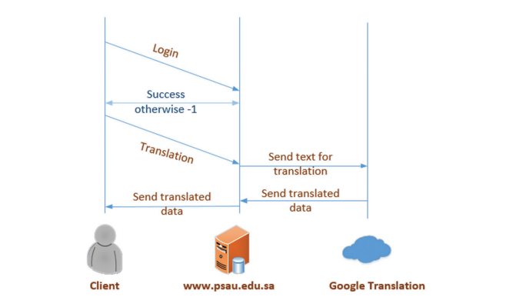
Google Translation
System Server
Client
Figure 3.2: Architectural Diagram of the Proposed System

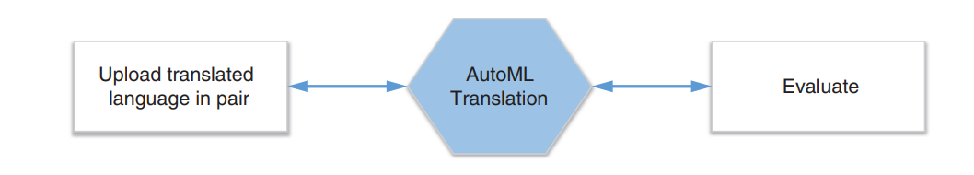
Figure 3.2: Auto Machine Learning Translation Process
Language Translation System using Natural Language Processing (NLP) Techniques: Psudocode
1. Import necessary libraries and datasets
2. Preprocess the input text:
a. Tokenization: Split the input text into words or subword units
b. Text normalization: Convert the text to lowercase, remove punctuation, etc.
c. Optional: Handle special cases like contractions, slang, etc.
3. Apply language detection (if necessary) to identify the source language
4. Translate the text:
a. If source and target languages are known:
i. Utilize a pre-trained translation model for the specific language pair
ii. Translate the text using the chosen model
b. If the language pair is unknown:
i. Train a custom translation model on parallel corpora for the given language pair
ii. Use the trained model to translate the text
5. Post-process the translated text:
a. Perform any necessary adjustments or corrections
b. Handle re-tokenization if needed
6. Output the translated text
3.2 ANALYSIS OF THE EXISTING SYSTEM
The current language translation system in Nigeria relies heavily on manual efforts and lacks automation. The process involves human translators, making it time-consuming and prone to errors. Additionally, the existing system may not efficiently handle the translation of English to local languages due to the complexity and nuances involved in linguistic variations.

3.3 PROBLEMS OF THE EXISTING SYSTEM
The existing language translation has the following shorcomings:
- Cost: While manual method of language translation has a powerful solution, it can be costly for applications with high translation volumes, especially for businesses or projects with budget constraints.
- Time-Consuming Process: Manual translation is a time-consuming process, especially when dealing with a large volume of content.
- Resource Intensive: The need for human translators increases resource requirements, including labor costs and time commitments.
- Error-Prone: Human translators may make mistakes, leading to inaccuracies in translation, which can be a critical issue when precision is essential.
- Limited Scalability: The existing system may face challenges in scaling up to meet the growing demand for translation services.
- Inconsistency: Different translators may interpret and translate content differently, leading to inconsistencies in translations.
3.4 DESCRIPTION OF THE PROPOSED SYSTEM
The proposed system aims to address the limitations of the existing system by developing an in-house AI-based language translation system. Here is how it was achieved:
- Training Custom Models: custom machine translation models using TensorFlow open-source frameworks developed and trained. These models can be trained on domain-specific datasets to improve translation accuracy for specific industries or applications.
- Integration with Open Source Tools: open-source NLP libraries and tools for various tasks such as tokenization, text normalization, and language detection was utilized. This provides more control over the translation pipeline and allows for customization according to specific requirements.
3.5 ADVANTAGES OF THE PROPOSED SYSTEM
The proposed system has the following benefits:
- Time Efficiency: Automation significantly reduces the time required for translation, enabling quick turnaround for users.
- Cost-Effective: Automation reduces the need for manual labor, leading to cost savings in terms of salaries and resources.
- Accuracy: Utilizing NLP and machine learning enhances the accuracy of translations, minimizing errors and inconsistencies.
- Scalability: The system can easily scale to handle increasing translation demands without a proportional increase in resources.
- Consistency: Automated translations ensure consistency across various language pairs, maintaining uniformity in communication.
- User Empowerment: A user-friendly interface empowers individuals to translate content without the need for specialized language skills.
- Continuous Learning: The system's machine learning capabilities allow it to continuously improve and adapt to evolving language patterns.

CHAPTER FOUR
DESIGN, IMPLEMENTATION AND DOCUMENTATION OF THE SYSTEM
4.1 DESIGN OF THE SYSTEM
This is the computation of the particulars of a new system and the determination of what the new system would be and the function it is to perform. This may involve changing from one system to another or modifying the existing system operation.
The most challenging phase of the system life cycle is the change from manual operation to a faster and more accurate one; system design stage covers the technical specifications that will be employed in the implementation of the new system in order to modify the previous system. Some factors are put in consideration. These factors include input design, output design, definitions file and procedure designs and other documentation.
4.1.1 OUTPUT DESIGN
This incorporates the objectives of solving the existing system problems and challenges. This involves the structuring of the desired information and also to enhance efficient and effective language translator. Things taken into consideration in determining the output are represented below:

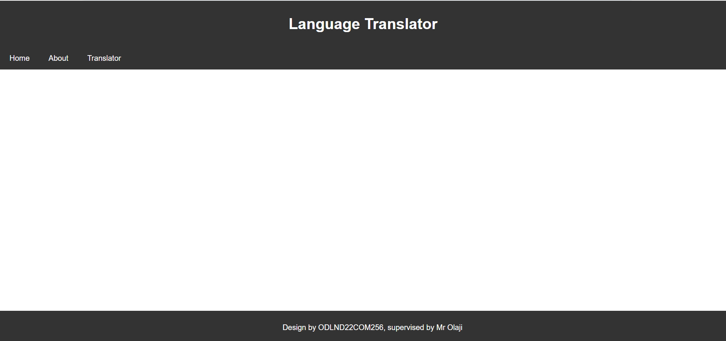
Figure 4.1: Home Page
This is a page where users can navigate from one page to another
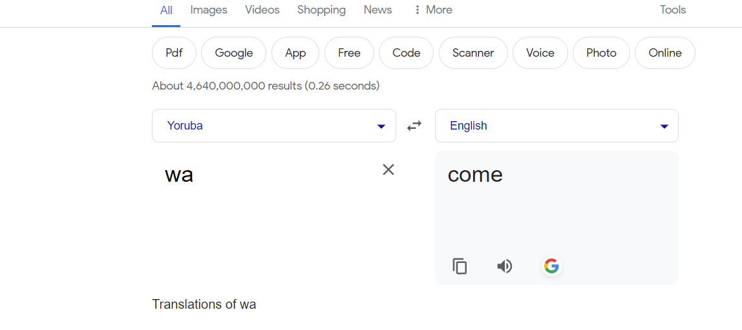
Figure 4.2: Translator
This interface allows user to translate from one language to another
4.1.2 INPUT DESIGN
The input to run this software is obtained from Menstrual cycle monitoring system administrator. The administrator is expected to register any User information. He can achieve this by typing via the keyboard. The input required from the Users is their personal data and answer?
To the questions set by the administrator. It can serve as the various input layouts from the various modules first from the collection of data and module then from the assessment module and input from User respectively.
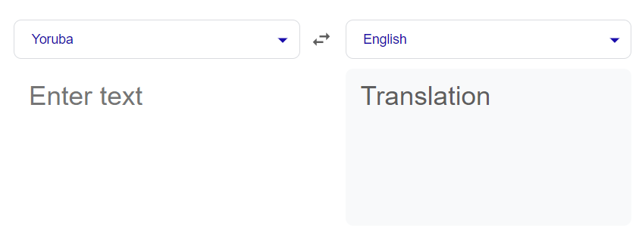
Figure 4.3: Language translator
This interface allow user to select the language of their choice for translation.

Figure 4.6: Translate English-Igbo
This page translate from English language to Igbo language
4.1.3 PROCEDURE DESIGN
These are the steps involved in unifying the whole process to produce the desired output. It involves computer procedures which start from the original input lessons to the output result file. This allows the processing of User information and result to be possible. Menu is provided to aid User in the processing of the output file.
4.2 IMPLEMENTATION OF THE SYSTEM
This entails the choice of the programming language employed to implement the software which should-be suitable for Menstrual cycle monitoring system. The software is designed for the use of Menstrual cycle monitoring system which should serve as an assistant. It is also expected to be used in conjunction with the User. The Menstrual cycle monitoring system admin will prepare data base while the admin will provide personal data about the User.
4.2.1 CHOICE OF PROGRAMMING LANGUAGE
The Application was developed in a .net (dot net) integrated development environment (.net IDE). The Application IDE is chosen following the fact that extracted information needs to be presented in an enhanced pictorial/graphical format and easy communication with the database for program flexibility in windows platform.
4.2.2 HARDWARE REQUIREMENT
i. 500 Hz minimum with CD ROM drive etc.
ii. Hard disk of capacity 10GB Minimum
iii. 126-512 megabyte of RAM
iv. An Uninterrupted power supply (UPS)
v. A voltage stabilizer
vi. A power generating set etc.
4.2.3 SOFTWARE REQUIREMENT
i. Windows operating system such as Windows 7 etc
ii. Dream Weaver
iii. Server Query Language (SQL).

4.3 DOCUMENTATION OF THE SYSTEM
4.3.1 PROGRAM DOCUMENTATION
The program is packaged for use in any system irrespective of either it runs visual studio application or not. After developing a program in Visual studio, there is a facility provided in Microsoft Visual Studio suite called “Package and Deployment Wizard” that is used in Visual studio application packaging and deployment.
The Menstrual cycle monitoring system is packaged into an installable setup that can be run from any system.
4.3.2 MAINTAINING OF THE SYSTEM
The system maintenance refers to making modification to an already existing application/program without necessarily re-writing everything from start. Program maintenance of a program includes modification of the program to meet-up with certain requirements of the Users. In this course, additional features can be added, errors corrected, ambiguous interfaces redesigned to eliminate confusions and unnecessary features removed.
Maintaining this program can be done in a Visual studio environment. Any future modification can be by re-running the program source code in a visual studio environment making necessary changes and updates and recompile the application into an upgrade version of the existing version of the mini word processing application. Further versions of this program can be named following their year of release or it can be given a different version number.
CHAPTER FIVE
SUMMARY CONCLUSION AND RECOMMENDATIONS
5.1 SUMMARY
Artificial Intelligence (AI)-based language translation systems, such as those utilizing Google API, offer powerful solutions for bridging linguistic barriers in today's globalized world. These systems leverage advanced machine learning models trained on vast multilingual datasets to provide accurate translations between different languages. Google API, as part of Google Cloud Platform, provides a convenient and accessible way for developers to integrate language translation capabilities into their applications, websites, and services. However, reliance solely on third-party services like Google API comes with certain drawbacks, including cost implications, privacy concerns, and limited customization options. The positive outcomes observed in Yoruba underscore the broader possibilities for employing similar technologies in other regions facing linguistic challenges, thereby contributing to a more connected and harmonious global society. The system was implemented using Google API and C Sharp as the programming language and MySQL for the database management system.

5.2 CONCLUSION
While Google API and similar services offer convenience and efficiency, organizations should carefully consider the trade-offs associated with relying solely on third-party solutions for language translation. The potential costs, privacy considerations, and limitations in customization may prompt businesses and developers to explore alternative approaches, such as developing in-house AI-based translation systems. By leveraging open-source tools, custom training models, and implementing robust privacy and security measures, organizations can create tailored translation solutions that offer cost savings, improved translation quality, and greater control over sensitive data.
5.3 RECOMMENDATIONS

Based on the findings of this project, the following were recommended:
- Evaluate Cost vs. Benefit: Organizations should conduct a cost-benefit analysis to determine whether relying on third-party translation services like Google API aligns with their budgetary constraints and business goals.
- Consider Privacy Implications: Evaluate the privacy implications of using third-party translation services, especially when dealing with sensitive or confidential information. Consider developing in-house solutions to mitigate privacy risks.
- Explore Customization Options: Assess the level of customization required for translation needs. If specific domain knowledge or terminology is crucial, consider developing custom translation models tailored to the organization's requirements.
- Invest in Security Measures: Implement robust security measures to safeguard translated data, whether using third-party services or developing in-house solutions. This includes encryption, access controls, and secure data storage practices.
- Stay Informed About Alternatives: Stay informed about alternative AI-based translation solutions, including open-source frameworks and emerging technologies, to ensure alignment with evolving business needs and technological advancements.

REFERENCES
Afolabi, A., Omidiora, E., Arulogun, T. (2019). Development of Text to Speech System for Yoruba Language, Innovative Systems Design and Engineering, Vol. 4, Issue: 9. Pp. 1–7.
Akinwale, O. I., Adetunmbi, A. O., Obe O. O. & Adesuyi, A. T. (2019). Web-Based English to Yoruba Machine Translation, International Journal of Language and Linguistics. Vol. 3, Issue: 3. Pp. 154-159.
Anthony, I. (2019). Design and Implementation of an Offline Android-based English to Igbo and Yoruba Machine Translation System. Retrieved January 15, 2024, from https://afribary.com/works/designand-implementation-of-english-to-igbo-and-yoruba
Arikpo, I. & Dickson, I. (2018). Development of an Automated English-to-Local Language Translator using Natural Language Processing, International Journal of Scientific & Engineering Research, Vol. 9, Issue: 7. Pp. 2229-5518.
Ayegba, S. F., Osuagwu, O. E. & Okechukwu, N. D. (2014). Machine Translation of Noun Phrases from English to Igala using the Rule-Based Approach. West African Journal of Industrial & Academic Research. Vol. 11, Issue: 1. Pp. 114-115.
Evelyn, E. C., Bennett, E. o. & Taylor, O. E. (2019). A Natural Language Processing System for English to Igbo Language Translation in Android, International Journal of Computer Science and Mathematical Theory. Vol. 5, Issue: 1. Pp. 64-65.
Eludiora, S. I., Agbeyangi, A. O. & Ojediran, D. I. (2020). Word Sense Disambiguation in English to Yorùbá Machine Translation System, Journal of Multidisciplinary Engineering Science and Technology, Berlin, Germany. Vol. 2, Issue: 7. Pp. 14-18.
Eludiora, A., Safiriyu, I., Odetunji, A. & Odejobi, M. (2016). Development of an English to Yorùbá Machine Translator, International Journal of Modern Education and Computer Science. Pp. 6-8. DOI: 10.5815/ijmecs.2016.11.02.
Etuk, S. O., Oyefolahan, I. O., Zubairu, H. A., Babakano, F. J. & Momoh, L. O. (2020). Development of an English-to-Ebira and Ebira-to-English Machine Translation System, International Journal of Information Processing and Communication (IJIPC). Vol. 10, Issue: 1 & 2. Pp. 119-135.
Greff, K., Srivastava, R K., Koutník, J., Steunebrink, B. R. & Schmidhuber, J. (2022). Language Translator using Natural Language Processing, IEEE Transactions on Neural Networks and Learning Systems, Vol. 28, Issue: 10. Pp. 2222–2232.
Kolhar, M. & Alameen, A. (2022). Artificial Intelligence Based Language Translation Platform, Journal of Intelligent Automation & Soft Computing. Pp. 6480–6486. DOI:10.32604/iasc.2021.014995.
Limbu, S. H. (2020). Direct Speech to Speech Translation Using Machine Learning, International Journal of Modern Education and Computer Science. Vol. 3, Issue: 2. Pp. 22-24.
Nabila, Z., Ayu, H. R. & Surtono, A. (2022). Implementation of Google Translate Application Programming Interface (API) as a Text and Audio Translator, International Journal of Educational Science. Vol. 2. Issue: 3. Pp. 45-46.
Ogundokun, R. O., Awotunde, J. B., Misra, S., Segun-Owolabi, T. & Adeniyi, E. A. (2021). An Android Based Language Translator Application, Journal of Physics. IOP Publishing. Vol. 2, Issue: 1. Pp. 3-4.
Osunade, O., Dawodu, D., Phillips, O. F. (2015). A Simple Data Driven Yoruba Language Dictionary, Journal of Literature, Languages and Linguistics, Vol. 10. Pp. 96–102.
Papadakis, S. & Kalogiannakis, M. (2017). Mobile Educational Applications for Children: What Educators and Parents Need to Know. International Journal of Mobile Learning and Organization, Vol. 11, Issue: 3. Pp. 256-277.
Rishita, M. V. S., Raju, M. A. & Harris, T. A. (2019). Machine Translation Using Natural Language Processing, MATEC Web of Conferences. Pp. 14-15.
Sharma, A. & Sharma, V. (2021). Language Translation Using Machine Learning, International Research Journal of Modernization in Engineering Technology and Science Vol. 3, Issue: 6. Pp. 45-46.

Appendices
Appendix 1: Login Verification
STOP
CLOSE DATABASE
CLOSE DATABASE
MAIN MENU
ENTER USERNAME AND PASSWORD
OPEN DATABASE
START

IS USERNAME AND PASSWORD CORRECT?
No

Yes

Appendix 2: System Flowchart
Start
Open File Dialogue
Read Sound
EOF?
Display Speech text
Stop
Select File/ input Speech
No
Yes

Appendix 3: Load file flowchart
Start
LOAD FILE
READ FILE CONTENT
APPLLY SPEAKER
GENERATE OUTPUT TEXT FILE
INPUT MORE DATA?
Stop
Yes
No
SAVE OUTPUT

Appendix 5: Help Flowchart
START
RETURN
DISPLAY HELP FILE

