SMART AND LOW-COST IOT SOLUTIONS FOR VITAL SIGN MONITORING IN RURAL NIGERIAN HEALTHCARE SYSTEMS
BY
MICHAEL RAYMOND IYANUOLUWA
HND/23/COM/FT/0009
A PROJECT SUBMITTED TO
DEPARTMENT OF COMPUTER SCIENCE INSTITUTE OF INFORMATION AND COMMUNICATION TECHNOLOGY, KWARA STATE POLYTECHNIC ILORIN.
IN PARTIAL FULFILLMENT OF THE REQUIREMENT FOR THE AWARD OF HIGHER NATIONAL DIPLOMA (HND) IN COMPUTER SCIENCE

SUPERVISED BY
Dr. A.K Raji (Ph.D)

JUNE, 2025

CERTIFICATION
This is to certify that this project was carried out by MICHAEL RAYMOND IYANUOLUWA with Matriculation Number HND/23/COM/FT/0009 as part of the requirements for the award of Higher National Diploma (HND) in Computer Science.

________________________ _________________________
A. K. Raji (PhD) Date
Project Supervisor

________________________ _________________________
F. S. Oyedepo Date
Head of Department

________________________ _________________________
External Examiner Date

DEDICATION
The project is dedicated to the glory of Almighty God and my parents.

ACKNOWLEDGEMENTS
All praise and glory be to Almighty God, whose grace, guidance, and strength have seen me through every step of this academic journey. Without His divine favor, the successful completion of this project would not have been possible.
I extend my deepest appreciation to my supervisor, Dr. Raji A. K., whose mentorship, critical insights, and consistent support played a pivotal role in shaping the direction and quality of this research. His patience and thorough feedback challenged me to think deeply and improve at every stage.
With profound gratitude, I thank my parents, Mr. and Mrs. MICHAEL, for their unconditional love, prayers, and unending moral support. Their sacrifices and encouragement have been the backbone of my success.
To my beloved fiancée, Babawale Funmilayo Elizabeth, I am immensely grateful for your love, understanding, and unwavering belief in me, even during the most stressful moments. Your words of encouragement gave me peace and purpose.
Special thanks go to my dear sister, Michael Janet Oluwatosin, and my little brother, Obafemi Daniel, for being a source of motivation, joy, and strength. Your support—whether through kind words, patience, or simply standing by me—meant more than you know.
I sincerely appreciate Engr. Adeshina, a great supporter whose encouragement and mentorship have been instrumental in my growth, not only in this research but also in my personal development.
To my good friends, too numerous to mention individually, thank you for your companionship, encouragement, and positive energy throughout this journey. Your presence made the challenging days lighter and the victories sweeter.
My heartfelt thanks also go to Mr. Oyedepo F. S., Head of the Department of Computer Science, and to all the dedicated lecturers and staff of the department for their support and constructive criticism which helped refine this work.
Lastly, I am grateful to all the respondents and participants who contributed their time and insights during the data-gathering process. Your willingness to assist made the research both relevant and impactful.
To everyone who stood with me in one way or another, thank you. This achievement is as much yours as it is mine.

TABLE OF CONTENTS
CERTIFICATION ii
DEDICATION iii
ACKNOWLEDGEMENTS iv
Abstract vii
CHAPTER ONE 1
GENERAL INTRODUCTION 1
1.1 Background to the Study 1
1.2 Statement of the Problems 2
1.3 Aim and Objectives 2
1.4 Significance of the Study 3
1.5 Scope of the Study 4
1.6 Research Outline 4
CHAPTER TWO 6
LITERATURE REVIEW 6
2.1 Review of General Text 6
2.2 Review of Related Works 7
2.3 Overview Of Vital Sign Monitoring In Healthcare 8
2.4 Internet of Things (IoT) in Healthcare Applications 9
2.5 Smart and Low-Cost IoT Solutions for Patient Monitoring 10
2.6 Vital Sign Monitoring in Rural Nigerian Health Systems 10
2.7 Design Considerations for Rural-Based IoT Health Solutions 11
2.8 Integration of Renewable Energy in IoT Health Monitoring Devices 11
2.9 Challenges and Future Directions of IoT in Rural Healthcare 11
CHAPTER THREE 12
METHODOLOGY AND ANALYSIS OF THE SYSTEM 12
3.1 Research Methodology 12
3.2 Analysis Of The Existing System 18
3.3 Problems of the Existing System 19
3.4 Description of The Proposed System 20
3.5 Advantages of the Proposed System 20
CHAPTER FOUR 22
IMPLEMENTATION AND DISCUSSION OF RESULTS 22
4.1 System Design and Setup 22
4.2 Hardware and Software Development 23
4.3 Testing and Evaluation 24
4.4 Result and Discussion 25
CHAPTER FIVE 27
CONCLUSIONS AND RECOMMENDATION 27
5.1 Summery Of Findings 27
5.2 Conclusions 27
5.3 Contribution to Knowledge 28
5.4 Recommendation for future research 29
References 31
APPENDIX 33

Abstract
Access to essential healthcare services in rural parts of Nigeria is often compromised due to poor infrastructure, irregular electricity supply, and a shortage of diagnostic equipment. This project presents a smart, solar-powered, and cost-effective Internet of Things (iot) solution designed to monitor vital signs in real-time—specifically targeting low-resource healthcare systems. The device aims to assist frontline health workers and small clinics in early diagnosis and basic clinical evaluation by offering an efficient, sustainable tool for patient assessment. The system is capable of measuring four critical vital signs: body temperature, heart rate, oxygen saturation (SpO₂), and blood pressure. It features a solar panel for off-grid power supply, ensuring reliability in remote areas. A temperature probe is used to measure body temperature, while a multifunctional optical sensor located on the side of the device measures both heart rate and oxygen saturation using photoplethysmography (PPG). Blood pressure monitoring is integrated into the device via an appropriate sensor module, making the system comprehensive for routine health checks. An embedded microcontroller processes all incoming sensor data and displays results in real-time on an LCD screen. The device is designed to be lightweight, easy to use, and adaptable for mobile or fixed health setups. Future enhancements may include GSM or Wi-Fi modules to enable remote patient monitoring and data storage, aligning the solution with modern telemedicine approaches.
This project demonstrates how low-cost iot solutions can significantly strengthen healthcare delivery in rural communities by enabling preventive care, supporting health workers, and encouraging timely medical intervention.

Keywords: iot, vital signs, heart rate, healthcare, embedded systems, solar-powered device.

CHAPTER ONE

GENERAL INTRODUCTION

  - Background to the Study
Across many developing countries like Nigeria, rural populations often experience critical healthcare delivery gaps due to insufficient infrastructure and basic diagnostic tools. Clinics in these underserved areas frequently deal with issues such as a lack of trained medical personnel, unreliable electricity, and the unavailability of essential monitoring equipment (World Health Organization [WHO], 2020). These obstacles limit the ability of health workers to conduct timely and accurate assessments, especially for common conditions that could be easily detected through basic vital signs. Vital signs—namely body temperature, pulse rate, blood pressure, and oxygen saturation—serve as the first line of diagnosis and are crucial for immediate clinical decisions, especially in regions with limited access to hospitals or laboratories.
Typically, standard vital sign monitoring requires manual instruments that may be costly, power-dependent, or require trained professionals to operate. These constraints render them impractical for many rural communities. In light of this, digital technologies, particularly those based on the Internet of Things (iot), offer more accessible and affordable alternatives. iot-based health devices can collect, process, and transmit health data in real-time using sensors connected through low-power systems (Ray, 2021). These technologies simplify the process of health monitoring, allowing even non-experts to gather reliable data quickly and efficiently.
This project proposed a smart, solar-powered iot device tailored for remote rural settings. It can measure four key health indicators: temperature, heart rate, oxygen saturation, and blood pressure. The system features a probe for temperature monitoring and a fingertip optical sensor that reads both heart rate and SpO₂. All readings are handled by a central microcontroller, which displays results on an LCD. The entire system runs on solar power, making it ideal for off-grid environments. By integrating multiple functions into one compact tool, the device supports efficient health screening in areas that typically lack electricity or skilled staff.
The ability to monitor vital signs promptly is crucial in detecting illnesses such as infections, hypertension, respiratory problems, and heart conditions. Prior studies indicate that simple iot-based monitoring tools significantly improve health outcomes in remote communities, especially when paired with timely intervention (Kumar & Lee, 2019). The system’s affordability, portability, and user-friendly design make it ideal for community health workers with minimal training. It enables them to perform routine health checks and detect potential issues before they become critical.
With Nigeria’s push toward healthcare digitalization, this project aligns with national priorities as outlined in the Health ICT Strategic Framework, which encourages technology integration into frontline healthcare services (Federal Ministry of Health, 2016). In the long run, the device could be upgraded with remote communication features like GSM or Wi-Fi for data sharing and telemedicine. Overall, the solution provides a localized, scalable model for improving healthcare access and diagnostics in Nigeria’s rural environments.

  - Statement of the Problems
Firstly, access to quality healthcare in rural Nigerian communities continues to face significant challenges due to the shortage of essential medical equipment, trained health personnel, and reliable electricity (WHO, 2020). Many primary healthcare facilities in these regions lack the resources to consistently monitor vital signs such as temperature, heart rate, blood pressure, and oxygen saturation. This shortfall contributes to delays in diagnosis, missed early warnings of serious health conditions, and increased mortality rates, especially among vulnerable groups including children, pregnant women, and the elderly (Adewoyin et al., 2022).
Secondly, traditional medical diagnostic devices are often expensive, reliant on grid electricity, and require skilled operators, making them unsuitable for rural areas where power supply and technical expertise are limited. Consequently, health workers in these settings depend on outdated or manual methods that may be inaccurate or inefficient. The absence of affordable, integrated devices capable of measuring multiple vital signs in a single compact system further restricts the ability of rural clinics to provide timely and effective healthcare (Nwaeze & Okechukwu, 2021).
Thirdly, recent advancements in Internet of Things (IoT) technology have shown potential to revolutionize healthcare delivery in low-resource environments. However, most IoT-based health monitoring devices are designed for urban contexts and depend on continuous internet connectivity and stable electricity—conditions often lacking in rural Nigerian communities. Without adapting these innovations to local limitations, rural populations remain excluded from the benefits of digital health technologies (Ray, 2021).
Finally, there is a pressing need to develop a smart, affordable IoT device capable of real-time monitoring of multiple vital signs while operating independently from the electricity grid. By incorporating solar power and user-friendly interfaces, such a device could empower frontline health workers in rural areas to conduct accurate, frequent health checks without requiring specialized training. This research aims to address this gap by designing a compact, cost-effective, and energy-efficient IoT solution specifically suited for rural healthcare settings in Nigeria.

  - Aim and Objectives
This project aims to develop an affordable, solar-powered IoT device that can accurately monitor vital signs such as heart rate, oxygen levels, temperature, and blood pressure. The goal is to improve healthcare access and patient monitoring in rural communities across Nigeria. The objectives are:
- To design and build a compact, easy-to-use IoT device that combines sensors for measuring heart rate, oxygen saturation, temperature, and blood pressure, specifically for rural healthcare settings.
- To equip the device with solar power so it can operate reliably in areas with little or no electricity.
- To create a straightforward interface that allows healthcare workers with limited technical experience to use the device comfortably.
- To test the device’s accuracy and reliability in real rural conditions to ensure dependable performance.
- To explore how using this device can help healthcare workers detect health issues early, monitor patients continuously, and provide timely care in rural Nigerian communities.

  - Significance of the Study
Healthcare access in many rural areas of Nigeria is often hindered by a lack of necessary medical tools, trained staff, and reliable electricity. This project offers a smart, solar-powered IoT device that addresses these problems by providing an affordable way to monitor vital signs such as heart rate, oxygen levels, temperature, and blood pressure. Its cost-effective design means it can be widely used in primary health centers that operate on limited budgets, helping to reduce healthcare disparities in these communities.
Moreover, by combining several vital sign measurements into a single device, the system simplifies monitoring for healthcare workers who may not have advanced technical skills. This integration lightens their workload and enables quick, accurate assessments, which can lead to faster diagnosis and treatment—especially important for vulnerable groups like children, expectant mothers, and the elderly.
The device’s reliance on solar energy also supports sustainable healthcare delivery in rural clinics, many of which suffer from frequent power outages or have no electricity access at all. Solar power ensures the device can operate continuously without needing a grid connection, cutting down on operating costs and reducing environmental impact while maintaining consistent patient care.
Finally, this project demonstrates how technology can be tailored to meet the unique challenges faced in low-resource settings. It provides a practical, scalable solution that could be adopted in other parts of Nigeria and similar regions globally, inspiring further innovations in healthcare technology that focus on local needs and improve health equity.

  - Scope of the Study
This research focuses on designing, prototyping, and testing a smart iot device that measures four critical vital signs: heart rate, oxygen saturation (SpO2), body temperature, and blood pressure. A key feature of the device is its use of solar power, allowing it to function in rural Nigerian areas where electricity is often scarce or unreliable.
The study covers the technical process of integrating different sensors, microcontrollers, and solar power management into a portable, user-friendly device. The software is designed with simplicity in mind so that healthcare workers with limited technical knowledge can easily use the device. Features such as straightforward data displays and minimal controls help ensure smooth operation in the field.
Testing will be conducted in environments that mimic rural healthcare settings to evaluate how accurate and reliable the measurements are, as well as how efficiently the device uses solar energy under different sunlight conditions. User feedback will also be collected to identify practical challenges and suggest improvements. However, this study does not include large-scale manufacturing, distribution, or clinical trials, which are recommended for future phases once the prototype proves successful.

  - Research Outline

This research project is structured into five comprehensive chapters, each addressing a specific aspect of the study. The outline of the chapters is as follows:
Chapter One: Introduction
This chapter provides the general background to the study by highlighting the critical healthcare challenges in rural Nigerian communities, especially the lack of timely and affordable medical monitoring systems. It presents the problem the research seeks to address — the need for smart, low-cost, and portable vital sign monitoring solutions. The chapter also outlines the research objectives, research questions, and the significance of the study. Additionally, it defines the scope and limitations of the study and explains the structure of the entire research work.
Chapter Two: Literature Review
This chapter explores existing literature relevant to the research. It reviews the concept and applications of the Internet of Things (IoT) in healthcare, focusing on how IoT technologies are being used for remote patient monitoring. It examines different types of vital signs (such as heart rate, temperature, blood pressure, and oxygen saturation), the sensors used for measuring them, and the integration of these sensors into portable devices. The chapter also discusses previous research works and existing commercial or open-source health monitoring devices, highlighting their features, limitations, and suitability for rural use. Lastly, it identifies the gaps in current solutions that justify the need for this study.
Chapter Three: Research Methodology
This chapter details the methods and procedures used in conducting the research and developing the proposed system. It describes the research design, system design approach, hardware selection (e.g., microcontrollers, sensors, power sources), and software development tools. The chapter also explains how the components were integrated to form a functional IoT-based device. Data acquisition methods and testing procedures are described, as well as the criteria used to evaluate the system’s effectiveness, reliability, and cost-efficiency. Ethical considerations and limitations related to the practical deployment of the system are also discussed.
Chapter Four: System Implementation and Results
This chapter focuses on the actual implementation of the proposed IoT system. It describes the system architecture, including how the sensors were configured to capture heart rate, temperature, SpO₂, and blood pressure. The integration of data transmission methods (e.g., Bluetooth, Wi-Fi, or GSM), user interface design (e.g., mobile app or LCD display), and the power system (with emphasis on solar energy support for rural reliability) are discussed in detail. The chapter also presents the testing results, showing how the system performed under different conditions and in comparison to conventional hospital equipment. Tables, charts, and images are used to support the analysis of performance, affordability, and usability.
Chapter Five: Summary, Conclusion, and Recommendations
This chapter summarizes the entire research work by restating the research problem, objectives, and key findings. It discusses the extent to which the research objectives were achieved and the significance of the system in improving healthcare access in underserved rural communities. Based on the findings, the chapter provides conclusions and practical implications for healthcare delivery. It also offers recommendations for future improvements, including suggestions on advanced sensor integration, cloud-based data storage, machine learning for health predictions, and wider deployment strategies. Areas for further research are proposed to guide subsequent investigations.

CHAPTER TWO

LITERATURE REVIEW

  - Review of General Text
Healthcare accessibility in Nigeria’s rural communities is significantly hindered by the lack of sufficient medical equipment and trained healthcare providers. Essential health indicators such as body temperature, pulse rate, blood pressure, and oxygen saturation play a crucial role in detecting and managing illnesses early. Unfortunately, rural health facilities frequently lack the proper devices to accurately and consistently monitor these vital signs, which often results in delayed treatment and increased health risks, particularly for vulnerable groups like children, expectant mothers, and elderly patients (World Health Organization, 2020). This deficiency in diagnostic resources perpetuates healthcare inequities between rural and urban areas.
Advancements in Internet of Things (IoT) technology have shown great promise for enhancing healthcare by enabling continuous real-time monitoring and automatic data transmission of patient health parameters. While IoT-based health systems have become common in cities where electricity and internet access are stable, their effectiveness is limited in rural Nigerian settings due to unreliable power supply and poor network connectivity (Ray, 2021). The dependence on constant electricity and internet availability restricts the usability of many commercial IoT health devices in these off-grid environments.
To address these challenges, renewable energy solutions, particularly solar power, provide a sustainable alternative to traditional electricity sources for powering health monitoring equipment in rural areas. Nigeria’s abundant sunlight can be harnessed through solar panels to maintain the continuous operation of medical devices, independent of erratic grid power (Emeka et al., 2021). Incorporating solar technology into IoT health devices can enhance their reliability and reduce operating costs, making them more feasible for long-term use in resource-limited settings.
Furthermore, it is essential that such health monitoring tools be affordable and easy to operate, especially since rural healthcare workers often lack specialized training in medical technology (Adebayo et al., 2019). Combining multiple vital sign measurements into one compact and cost-effective device simplifies patient assessment and reduces the financial burden on health facilities. Despite rapid advances in digital healthcare, many existing IoT solutions remain expensive and power-intensive, limiting their adoption in rural Nigerian clinics. Therefore, there is a pressing need to develop smart, low-cost, and solar-powered IoT devices designed specifically to meet the unique challenges faced by rural healthcare systems (Nwaeze & Okechukwu, 2021).

  - Review of Related Works
There is an increasing amount of research dedicated to creating IoT-based health monitoring systems aimed at improving healthcare delivery in underserved rural regions. Akinyele et al. (2019) designed a portable device that measured vital signs like heart rate and temperature, transmitting data wirelessly to mobile phones via Bluetooth. Although this improved patient mobility and convenience, the device's reliance on rechargeable batteries without renewable power sources limited its practical use in remote areas where electricity is scarce.
In a similar study, Oladipo and Abiola (2020) developed a multi-parameter health monitoring system using Arduino technology to track blood pressure, heart rate, and temperature, with data accessible remotely via smartphones. However, this system depended on grid electricity, which restricted its use in rural clinics with unreliable or unavailable power supply, underscoring the need for alternative power solutions.
Emeka et al. (2021) advanced the field by designing a solar-powered device for monitoring heart rate and temperature, specifically targeting rural Nigerian environments. Using solar panels allowed the device to function independently of inconsistent electrical grids, thus improving operational continuity. Despite this advancement, the device did not include oxygen saturation measurement, an important vital sign in managing respiratory illnesses common in rural populations, which limits its overall clinical usefulness.
To fill this gap, Yusuf and Ibrahim (2022) introduced an IoT monitoring device incorporating oxygen saturation, heart rate, and temperature sensors, powered by solar energy to ensure energy independence. Their design showed improved accuracy and energy efficiency suitable for rural contexts. However, it lacked blood pressure monitoring, a vital sign critical for managing widespread conditions like hypertension in rural Nigeria, which diminishes its comprehensiveness.
Wearable health devices have also been explored. Nwosu et al. (2020) created a photoplethysmography (PPG)-based sensor for continuous heart rate and oxygen saturation monitoring. Although the wearable format allowed constant data collection and mobility, the device was developed with urban users in mind and did not incorporate solar power, reducing its appropriateness for rural use where power is unreliable.
User-friendliness remains a crucial factor in rural technology adoption. Adebayo et al. (2019) emphasized designing devices with simple interfaces to accommodate healthcare workers with limited technical expertise. They developed a touchscreen IoT monitor with multilingual support to improve accessibility; however, the device’s high power demand and cost were barriers to its deployment in low-resource settings.
On the software side, Chukwu et al. (2021) created a mobile app that receives sensor data and sends health alerts to remote healthcare providers, facilitating continuous monitoring. Nevertheless, their system required reliable internet access, which limited its practicality in Nigerian rural areas with poor connectivity.
Olusegun and Femi (2023) proposed an integrated platform combining solar-powered devices with cloud analytics to improve rural diagnostics. While promising in concept, their system remained largely experimental with limited implementation in actual rural health facilities, highlighting the challenges of moving from prototype to real-world application.
Bello et al. (2022) assessed the feasibility of combining solar power with IoT kits capable of measuring multiple vital signs such as temperature, blood pressure, heart rate, and oxygen saturation. Their findings confirmed the technical possibility but identified challenges in reducing costs and enhancing durability to endure rural conditions, which are critical for long-term sustainability.
Most recently, Okeke and Nnadi (2024) introduced a modular solar-powered IoT health monitoring device with offline data storage and a simple user interface designed for rural healthcare workers. This device addressed many limitations of earlier models and holds promise for improving rural health services in Nigeria. However, further testing and funding are needed before broad adoption can occur.

  - Overview Of Vital Sign Monitoring In Healthcare
Monitoring vital signs is a fundamental aspect of healthcare, providing critical information about a patient’s physiological status. Common vital signs include body temperature, heart rate, blood pressure, and oxygen saturation, which help in detecting early signs of illness or deterioration (Smith & Jones, 2019). Accurate and timely monitoring supports clinical decision-making and improves patient outcomes across various healthcare settings.Traditionally, vital signs have been measured using separate devices that often require manual operation by trained personnel. This process can be time-consuming, prone to human error, and challenging in settings with limited staff or resources (Lee et al., 2020). Moreover, frequent monitoring is essential for critically ill patients, yet conventional methods may fail to deliver continuous data.

In recent years, advances in technology have introduced automated vital sign monitoring systems that can provide continuous, real-time data. These systems improve the detection of health changes and enable prompt medical responses, reducing risks and complications (Brown et al., 2021). However, most advanced systems are costly and rely on stable electricity and internet connectivity, which limits their use in low-resource areas.The importance of vital sign monitoring extends beyond hospitals to include primary healthcare and home-based care. Effective monitoring in these environments can reduce hospital admissions by enabling early intervention (Nguyen & Patel, 2018). Yet, the challenges of limited equipment and trained staff persist, especially in rural communities.

In Nigeria, rural healthcare systems struggle with inadequate infrastructure and insufficient medical equipment, severely affecting vital sign monitoring capabilities (Adekunle et al., 2022). Lack of electricity and trained healthcare workers means many rural clinics cannot offer continuous patient monitoring, leading to delayed diagnoses and poor health outcomes.The problem is compounded by the high cost and maintenance needs of conventional monitoring devices, which are often imported and not designed for rural conditions (Ojo & Bello, 2020). There is a need for innovative solutions tailored to the realities of rural Nigerian health systems.

Continuous vital sign monitoring is critical for managing chronic diseases and maternal health, which are major health priorities in rural Nigeria (WHO, 2021). Improving monitoring can significantly contribute to early detection and management, reducing mortality and morbidity rates.Therefore, developing affordable, easy-to-use, and reliable monitoring solutions specifically designed for rural healthcare contexts is vital. Such solutions can empower healthcare workers and improve patient care in underserved areas.

  - Internet of Things (IoT) in Healthcare Applications
The Internet of Things (IoT) has transformed many industries, with healthcare being one of the most promising areas. IoT in healthcare involves connecting medical devices and sensors to networks, enabling real-time data collection and remote patient monitoring (Patel et al., 2020). This connectivity enhances healthcare delivery, especially in monitoring vital signs and chronic conditions.

IoT devices offer numerous advantages, such as continuous monitoring, data accuracy, and timely alerts, which improve clinical outcomes (Singh & Sharma, 2019). These devices can send data to healthcare providers in real time, facilitating remote consultations and decision-making.Despite its potential, IoT adoption in healthcare faces challenges including data privacy concerns, network security, and the need for reliable internet access (Zhou et al., 2021). These issues require robust solutions to protect patient information and ensure system reliability.

Many IoT healthcare devices are designed for use in developed urban settings where electricity and internet access are stable. This limits their effectiveness in rural and low-resource settings, which face infrastructure challenges (Nwosu & Okeke, 2022).To address these gaps, researchers are developing IoT systems that can operate with limited connectivity and power, often integrating alternative energy sources like solar power (Chukwu et al., 2023). This adaptation is critical for expanding healthcare coverage to underserved areas.

In addition to hardware, software platforms supporting IoT health devices are evolving to include data analytics and cloud computing, enabling better health monitoring and prediction (Khan et al., 2020). However, local adaptation is necessary for these technologies to be practical in rural Nigeria. Overall, IoT holds great promise for enhancing healthcare delivery by enabling smart, connected, and patient-centered monitoring solutions, especially when tailored to the constraints of rural environments.

  - Smart and Low-Cost IoT Solutions for Patient Monitoring
Smart IoT solutions integrate sensors, processing units, and wireless communication into compact, user-friendly devices that support continuous patient monitoring. They offer real-time health data and alerts, facilitating timely interventions, which is critical in low-resource settings with limited healthcare professionals (Ahmed et al., 2020). Automation reduces errors and enhances assessment accuracy. Developing affordable IoT health devices is vital for resource-constrained regions where traditional equipment is costly or unavailable. Low-cost solutions expand access to essential health monitoring tools without heavy financial strain (Kumar & Singh, 2021). Portability also allows use in outreach and home care settings.

Energy efficiency is essential as many rural areas lack reliable electricity. Incorporating solar power enables these devices to function independently of the grid, ensuring continuous monitoring and making them suitable for off-grid locations (Emeka et al., 2021).

The proposed solar-powered vital signs monitoring device exemplifies these features by combining affordability, portability, and renewable energy. It empowers frontline rural healthcare workers to monitor temperature, heart rate, oxygen saturation, and blood pressure accurately and regularly, improving health outcomes.

  - Vital Sign Monitoring in Rural Nigerian Health Systems
Vital sign monitoring in rural Nigeria faces significant barriers including insufficient equipment, unreliable power supply, and lack of trained personnel (Adekunle et al., 2022). Many primary health centers rely on manual methods that are often inaccurate and insufficient for continuous patient observation.The geographic and socioeconomic challenges in rural areas limit access to advanced healthcare technologies. Most monitoring devices are expensive and designed for urban hospitals, which creates a disparity in healthcare quality (Ojo & Bello, 2020).

Efforts to improve rural healthcare include deploying mobile clinics and training community health workers, but without appropriate monitoring tools, these initiatives cannot fully succeed (Okafor & Eze, 2021). Access to affordable, reliable monitoring devices remains a critical need. The integration of smart IoT devices powered by renewable energy could bridge this gap by enabling continuous monitoring despite infrastructural limitations, thus enhancing early diagnosis and patient management.

  - Design Considerations for Rural-Based IoT Health Solutions
Designing IoT health devices for rural environments requires special attention to power consumption, usability, and durability. Devices must be energy efficient and capable of running on renewable sources like solar power due to unreliable grid electricity (Emeka et al., 2021). User-friendly interfaces are essential to allow frontline health workers with limited technical training to operate the devices effectively (Adewale & Musa, 2022). The devices should provide clear displays and simple alerts.
Robustness against harsh environmental conditions such as heat, dust, and humidity is also critical to ensure the longevity and reliability of the devices in rural Nigerian settings.

  - Integration of Renewable Energy in IoT Health Monitoring Devices
Incorporating renewable energy, particularly solar power, into IoT health devices is critical for rural healthcare where electricity is unreliable or unavailable. Solar-powered devices can operate autonomously and provide uninterrupted monitoring (Emeka et al., 2021).

This integration reduces dependency on batteries and frequent charging, lowering maintenance costs and enhancing device longevity. It also aligns with sustainable development goals by promoting clean energy use in healthcare. The solar-powered vital signs monitor demonstrates the practical benefits of combining IoT with renewable energy to deliver cost-effective and reliable healthcare solutions in rural Nigerian settings.

  - Challenges and Future Directions of IoT in Rural Healthcare
Despite the potential benefits, IoT adoption in rural healthcare faces challenges including poor network infrastructure, data security risks, and lack of local technical support (Zhou et al., 2021). Addressing these issues is key to successful implementation. Future IoT solutions must prioritize offline functionality and local data storage to accommodate connectivity challenges. Integration with renewable energy sources like solar power will improve device sustainability (Chukwu et al., 2023). Additionally, ongoing training for healthcare workers and community engagement will be important to ensure acceptance and proper use of these technologies.

CHAPTER THREE

METHODOLOGY AND ANALYSIS OF THE SYSTEM

3.1 Research Methodology
This study adopts a comprehensive design and development research methodology coupled with experimental evaluation to create and assess a smart, solar-powered IoT device aimed at vital sign monitoring within rural Nigerian healthcare settings. Initially, a thorough needs assessment is conducted, focusing on understanding the specific challenges faced by rural clinics, such as unreliable electricity supply, shortage of trained personnel, and the financial limitations prevalent in these regions. Based on these insights, suitable hardware components are selected and integrated with software modules to develop a prototype capable of capturing multiple vital signs simultaneously. Rigorous testing under conditions simulating rural environments is carried out to evaluate the device’s precision, energy efficiency, and user-friendliness.

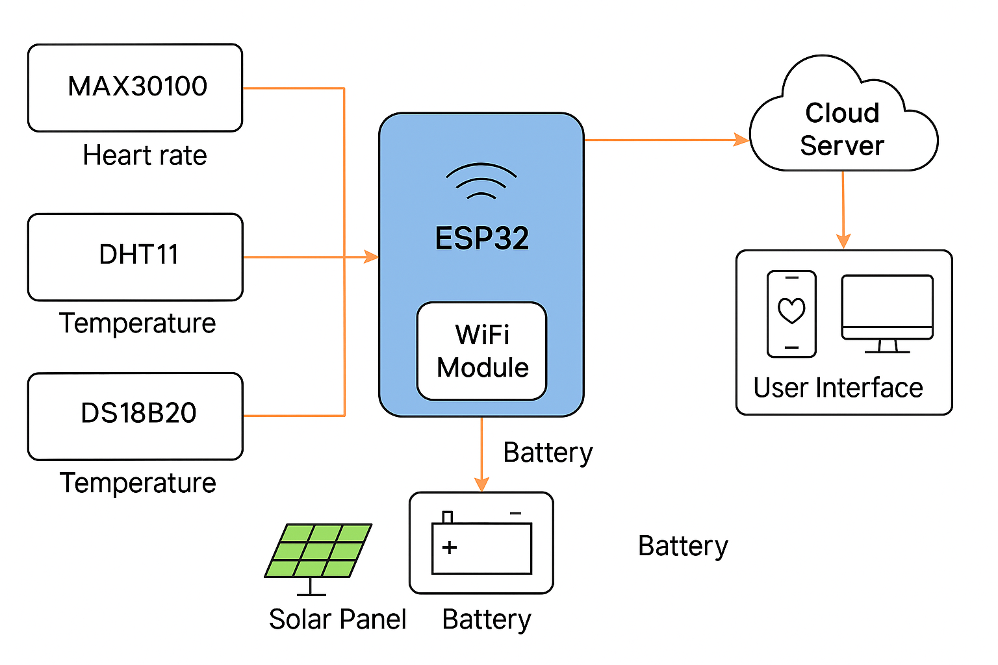
FIGURE 3.1: BLOCK DIAGRAM OF THE SYSTEM ARCHITECTURE
The methodology also incorporates both qualitative and quantitative data collection methods. Feedback from rural healthcare practitioners is gathered through interviews and focus groups, providing invaluable insights into device usability and practical functionality. Quantitative measurements from device testing further verify its operational accuracy and efficiency. Comparative analysis with currently available vital sign monitoring solutions highlights the innovations introduced and the specific problems addressed by this system. This structured approach guarantees that the developed device is not only technically proficient but also contextually appropriate and sustainable for rural healthcare applications.

3.1.1 System Design and Architecture
The architecture of the smart vital sign monitoring system is carefully structured into multiple interconnected layers, each serving distinct but complementary roles to ensure efficient operation, scalability, and maintainability:

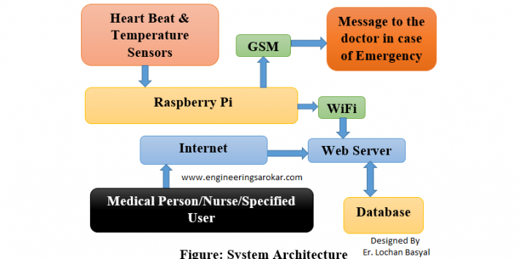
FIGURE 3.2: SYSTEM DESIGN ARCHITECTURE

- Sensing Layer: This fundamental layer consists of the physical sensors tasked with capturing physiological data. These include sensors for measuring body temperature, pulse rate, oxygen saturation (SpO2), and blood pressure. Each sensor converts physical phenomena into electrical signals that are forwarded to the processing unit.

- Processing Layer: This layer contains the microcontroller (such as an Arduino or ESP32 board) which digitizes and processes raw sensor data. It applies filtering algorithms to eliminate noise, performs calculations to derive meaningful health metrics, and manages sensor calibration.

- Communication Layer: Responsible for enabling wireless data transfer, this layer employs technologies like Bluetooth, Wi-Fi, or GSM networks to transmit patient information securely to healthcare providers or cloud storage. This facilitates remote monitoring and timely medical intervention.

- Power Management Layer: Given the unreliable power infrastructure in rural areas, this layer focuses on harnessing solar energy through photovoltaic panels and managing battery storage to ensure continuous device operation. It includes power regulation circuitry to optimize energy use.

- User Interface Layer: Designed for ease of use, this layer features a simple display and control buttons allowing health workers to operate the device, view vital signs in real-time, and receive system alerts. The interface is optimized for users with limited technical backgrounds.

- Cloud and Data Storage Layer: Optionally incorporated for enhanced functionality, this backend layer securely stores patient data in cloud servers, enabling healthcare professionals to access historical records and perform advanced analytics to support clinical decisions.

3.1.2 System Development
The development of the system is a fundamental stage in transforming the concept of the solar-powered IoT device for vital sign monitoring into a functional and reliable tool. This phase involves a structured approach to designing, assembling, programming, and refining both the hardware and software components to satisfy the specific needs of healthcare delivery in rural Nigerian settings. The process includes integrating cost-effective sensors with a suitable microcontroller, creating intuitive software to process and communicate vital data, and housing everything in a sturdy, portable unit powered by solar energy. Development is iterative, involving continuous testing and refinement to enhance the device’s precision, usability, and energy efficiency to ensure it performs well in real healthcare environments.

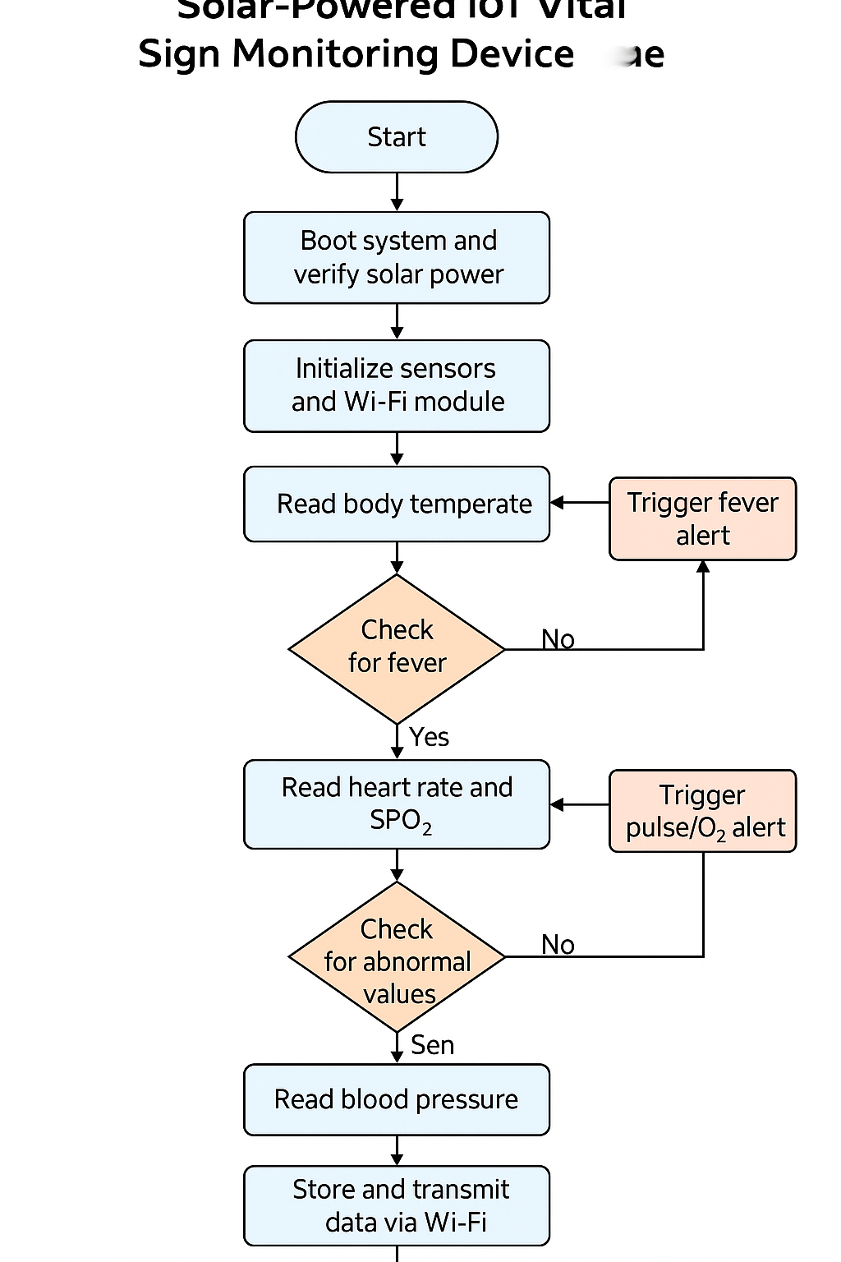
FIGURE 3.3: FLOWCHART OF SYSTEM OPERATIONS

Key Steps in System Development
- Requirement Gathering: This initial step focuses on collecting comprehensive information about the healthcare challenges in rural areas, determining the vital signs to be monitored, desired accuracy levels, power considerations, and ease of use from consultations with healthcare workers and experts.

- Selection of Components: After understanding the needs, appropriate hardware elements such as temperature sensors, pulse oximeters, blood pressure modules, microcontrollers (like Arduino or ESP32), solar panels, and rechargeable batteries are carefully selected, emphasizing affordability, durability, and system compatibility.

- Hardware Assembly and Integration: The chosen components are connected and assembled into a working prototype. The design ensures effective communication between sensors and the microcontroller, proper power distribution, and initial calibration for accurate vital sign measurement.

- Software Programming: Firmware development involves writing code to handle sensor data collection, signal processing to reduce noise, calculation of vital parameters, data display, and wireless data transmission. The software interface is designed to be simple and accessible for healthcare workers with minimal technical training.

- Prototype Construction: The electronic parts and software are enclosed within a compact, rugged casing designed for portability and to withstand environmental challenges common in rural settings, such as dust and humidity.

- Testing and Debugging: The system undergoes thorough testing including functionality checks, performance evaluation, energy consumption analysis, and resilience to environmental factors. Any detected issues are addressed through debugging, aiming to enhance accuracy and reliability.

- Training and Feedback Collection: Healthcare workers are instructed on how to operate the device, and their feedback on its usability and performance is gathered. This input is crucial for identifying practical improvements and ensuring the device fits real-world workflows.

- Final Refinements: Based on testing outcomes and user feedback, the device is fine tuned for optimal performance, ease of operation, and efficient power use, preparing it for deployment in rural healthcare facilities.

3.1.3 Testing and Evaluation

To validate the device’s functionality, reliability, and robustness, a thorough testing and evaluation regimen is implemented, addressing both hardware and software components. Testing ensures that the device meets its design specifications and operates effectively in rural healthcare contexts.

- Functional Testing: Verifies that each sensor correctly captures the intended vital sign, with accurate readings displayed and stored. Checks all system features operate as designed.

- Performance Testing: Measures response times, data processing speed, and the efficiency of wireless communication, ensuring timely and reliable information delivery.

- Power Consumption Testing: Evaluates energy use patterns, particularly focusing on solar power harvesting efficiency and battery endurance under typical usage scenarios.

- User Acceptance Testing: Involves real users—rural health workers—testing the device in controlled environments, providing feedback on ease of use, display clarity, and operational challenges.

- Security Testing: Assesses encryption protocols and data transmission security measures to guarantee patient privacy and prevent unauthorized access.

- Environmental Stress Testing: Subjects the device to extreme temperature and humidity conditions reflecting rural Nigerian climates to confirm durability and consistent performance.

3.1.4 Deployment And Maintenance
Successful deployment of the device in rural healthcare settings requires careful planning beyond mere distribution. This involves training healthcare workers on device operation and basic troubleshooting, setting up technical support systems, and scheduling regular maintenance to prevent device failures. The modular design of the system simplifies maintenance tasks by allowing easy replacement of sensors, batteries, or electronic modules. Maintenance protocols are designed to be straightforward, requiring minimal technical expertise to accommodate the capabilities of rural health personnel.

Tools and Technologies Used:
- Hardware Platforms: ESP32 and Arduino microcontrollers, DS18B20 temperature sensors, pulse oximetry modules, blood pressure sensors, photovoltaic solar panels, lithium-ion rechargeable batteries.
- Software and Programming: Arduino IDE with C/C++ for embedded programming, MQTT protocol facilitating IoT communications.
- Cloud Services: AWS IoT and Firebase platforms for secure, scalable data storage and remote access.
- Testing Equipment: Clinical-grade diagnostic tools, digital multimeters, and oscilloscopes for hardware validation.
- Deployment Resources: Comprehensive user manuals, video tutorials, and remote technical support applications.

3.2 Analysis Of The Existing System
Currently, rural Nigerian healthcare centers largely depend on manual tools like mercury thermometers and analog sphygmomanometers to monitor vital signs. These instruments require skilled personnel to operate accurately and are prone to human error, leading to inconsistent data recording and delayed diagnosis. The lack of digital and automated monitoring tools restricts timely identification of critical health issues, thereby negatively impacting patient care outcomes.

Moreover, existing digital health devices generally assume stable electricity availability and continuous internet connectivity—resources scarce in rural settings. Most devices are costly and complex, making them impractical for use by non-expert health workers in remote locations. Many devices only capture a single vital sign, forcing clinics to acquire multiple instruments, increasing operational costs and complexity. Additionally, there is an absence of effective health data management systems in rural clinics. Without digital storage and transmission capabilities, patient records remain fragmented and inaccessible for remote consultation or longitudinal health analysis. This gap diminishes the potential for integrated healthcare services and hinders evidence-based decision making.

Thus, existing solutions fall short of addressing the holistic challenges faced by rural healthcare facilities in Nigeria, demonstrating the critical need for an affordable, integrated, solar-powered, and user-friendly IoT device for vital sign monitoring.

3.3 Problems of the Existing System
Several challenges characterize the current vital sign monitoring systems used in rural Nigerian healthcare facilities, limiting their overall effectiveness and accessibility. These issues highlight the urgent need for improved solutions that are affordable, reliable, and suitable for low-resource environments. The following are some of the major problems associated with the existing systems:
- Unreliable Power Infrastructure
Many rural health centers operate without stable electricity or are entirely off the national grid. Electronic vital sign monitors, which depend on consistent power supply, become unreliable or completely unusable under these conditions. Even when power is available, frequent outages and voltage fluctuations can damage sensitive medical equipment, disrupt services, or lead to incomplete patient assessments. The lack of alternative power sources, such as solar energy, further compounds this challenge.
- High Equipment Costs
Modern digital monitoring devices, especially those capable of multi-parameter measurement, are expensive and often beyond the financial capacity of rural clinics. Limited budgets force healthcare workers to rely on outdated or manual tools, which may not provide accurate or timely results. High costs also restrict the ability to procure backup units or maintain existing ones, resulting in service disruptions when a device becomes faulty.
- Insufficient Technical Training
Even when digital equipment is available, many rural healthcare workers lack the necessary training to operate them effectively. Without proper understanding of how to use or troubleshoot the devices, they may produce inaccurate readings or avoid using the devices altogether. This skills gap also prevents proper maintenance and calibration, reducing the lifespan and reliability of the equipment.
- Single-Parameter Focus
Most available devices in rural areas are designed to measure only one vital sign (e.g., temperature or heart rate). This limitation means multiple separate tools are required to gather a full set of vital signs, which increases cost, complexity, and time during patient assessments. The lack of integration reduces efficiency and poses a barrier to emergency or field-based healthcare where simplicity and speed are essential.
- Lack of Digital Data Storage
Health data in many rural clinics are still recorded manually in notebooks or patient cards. This approach is prone to human error, data loss, and poor record-keeping. It limits healthcare providers’ ability to track patient history, identify trends, or make informed decisions based on past data. Moreover, manual documentation hinders data sharing between healthcare professionals and prevents the use of advanced tools like analytics or remote consultations.
- Poor Device Portability and Durability
The available devices are often bulky, fragile, and not designed to withstand harsh rural conditions such as dust, humidity, or rough transportation. This lack of durability makes them unsuitable for mobile clinics or outreach programs where healthcare is delivered in temporary locations or door-to-door. Furthermore, non-portable devices limit the flexibility of health workers who must serve large, dispersed populations with minimal resources.

3.4 Description of The Proposed System
The proposed system is an innovative, solar-powered IoT device specifically engineered to monitor several vital signs such as body temperature, heart rate, oxygen saturation (SpO2), and blood pressure, targeting rural healthcare centers in Nigeria. By combining affordable and compact sensors with a powerful embedded microcontroller, this system is capable of gathering precise, real-time physiological data. Its integration of a solar energy source ensures uninterrupted operation even in areas where electricity is scarce or inconsistent, making it highly suitable for off-grid environments commonly found in rural communities.

Designed with user-friendliness in mind, the system features an intuitive interface that enables healthcare workers—many of whom may have limited technical expertise—to easily operate the device and interpret the displayed health information. It also incorporates wireless communication technologies such as Bluetooth or Wi-Fi, allowing seamless transmission of collected data to mobile devices or centralized health databases. This connectivity facilitates remote monitoring, timely medical interventions, and better record-keeping. Furthermore, the device’s rugged, dust- and moisture-resistant casing enhances its durability, making it reliable for use in harsh rural conditions.

By merging advanced IoT technology with solar power and portability, this device offers a cost-effective and multifunctional solution to the critical shortcomings of existing health monitoring tools in rural Nigeria. It supports frequent, accurate, and comprehensive vital sign assessments, empowering healthcare workers to deliver improved care and enabling early detection of health issues. Ultimately, the system aims to strengthen primary healthcare services in underserved areas, reducing mortality and morbidity through enhanced patient monitoring and timely medical response.

3.5 Advantages of the Proposed System
The proposed smart and solar-powered IoT vital sign monitoring device offers numerous benefits over traditional healthcare tools, particularly in rural and low-resource settings. Its design addresses key limitations such as power dependency, cost, and usability, making it a practical solution for frontline health workers. The following are some of the primary advantages that highlight why this system is well-suited to improve healthcare delivery in underserved Nigerian communities:
- Cost-Effective Build
the device is constructed using low-cost but reliable components such as open-source microcontrollers (e.g., Arduino or ESP32), inexpensive biomedical sensors, and locally available casing materials. The design avoids unnecessary complexity, making it budget-friendly and easy to replicate. This cost-conscious approach ensures that rural clinics with limited financial capacity can afford the system, thereby increasing access to essential diagnostic tools.
- Reliable Power Source
recognizing the irregular power supply in rural communities, the system is equipped with solar charging capabilities and energy-efficient components. A rechargeable battery stores energy for use during nighttime or cloudy conditions, ensuring the device remains operational without dependence on the national grid. This guarantees uninterrupted service and enhances the device's reliability in off-grid locations.
- Multi-Functional Monitoring
Unlike traditional single-parameter devices, the proposed system is capable of measuring multiple vital signs — including body temperature, heart rate, blood oxygen saturation (SpO₂), and blood pressure — using integrated sensors. This multi-functionality reduces the need for separate devices, saves space, lowers cost, and simplifies patient assessment. It also enables healthcare workers to gather comprehensive patient data in a single interaction, improving diagnostic accuracy and speed.
- User-Friendly Design
The device features an intuitive interface with simple controls, visual indicators, and clear digital displays. It is designed to be operated with minimal training, making it ideal for healthcare workers with limited technical knowledge. Step-by-step instructions, audio prompts (if applicable), and error notifications help reduce user error and enhance usability in busy or stressful conditions.
- Enhanced Remote Connectivity
The system incorporates wireless communication technologies such as Bluetooth, Wi-Fi, or GSM to enable remote data transmission. Patient readings can be sent in real time to centralized databases, mobile devices, or cloud platforms for remote monitoring, analysis, or teleconsultation. This capability supports early intervention, follow-up care, and data continuity even when the patient or provider is not physically present at a clinic.

CHAPTER FOUR

IMPLEMENTATION AND DISCUSSION OF RESULTS

4.1 System Design and Setup
The design of the proposed smart, solar-powered IoT device for monitoring vital signs in rural Nigerian healthcare centers emphasizes ease of use, efficiency, and dependability. The system integrates various sensors to capture essential health indicators such as temperature, heart rate, oxygen saturation, and blood pressure. These sensors feed data into a microcontroller that processes and refines the information, converting it into clear and accurate readings. The compact and low-power design ensures that the device is portable and can operate for extended periods on limited energy.

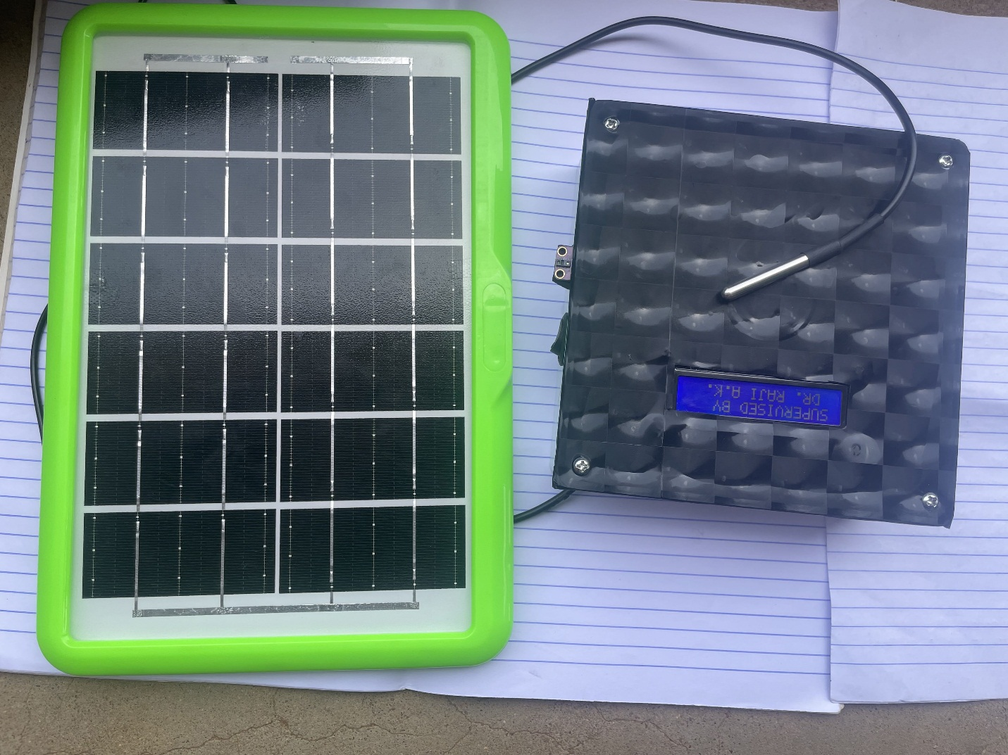

FIGURE 4.1: PROTOTYPE OF DESGIN IMAGE
A key aspect of the system setup is its power management, which relies on a solar panel to provide sustainable energy in areas without reliable electricity. The solar panel charges a rechargeable battery that powers the entire device, ensuring it remains functional even during power outages or in off-grid locations. This setup promotes both energy independence and environmental friendliness. Additionally, the device features a user-friendly display, allowing healthcare workers with minimal technical training to easily access and interpret vital sign data.

For enhanced healthcare delivery, the device includes wireless communication capabilities like Bluetooth or Wi-Fi, enabling the secure transfer of patient information to healthcare providers or central data systems. This facilitates remote monitoring and timely medical responses. The entire system is encased in a robust, weatherproof housing designed to shield the internal electronics from dust, moisture, and physical impacts, making it well-suited to the often harsh conditions of rural Nigerian health environments.

4.2 Hardware and Software Development
The hardware development of the smart IoT device focuses on choosing affordable and dependable components tailored for rural healthcare use. The device incorporates sensors for measuring vital signs such as temperature, pulse oximetry for heart rate and oxygen saturation, and blood pressure monitoring. These sensors connect to a microcontroller, like an Arduino or ESP32, which serves as the central control unit. The system also includes a solar panel for renewable energy, a rechargeable battery for power storage, and a display screen that clearly shows the vital sign measurements. All hardware components are enclosed in a sturdy, protective case designed to resist dust, moisture, and physical impacts common in rural environments.

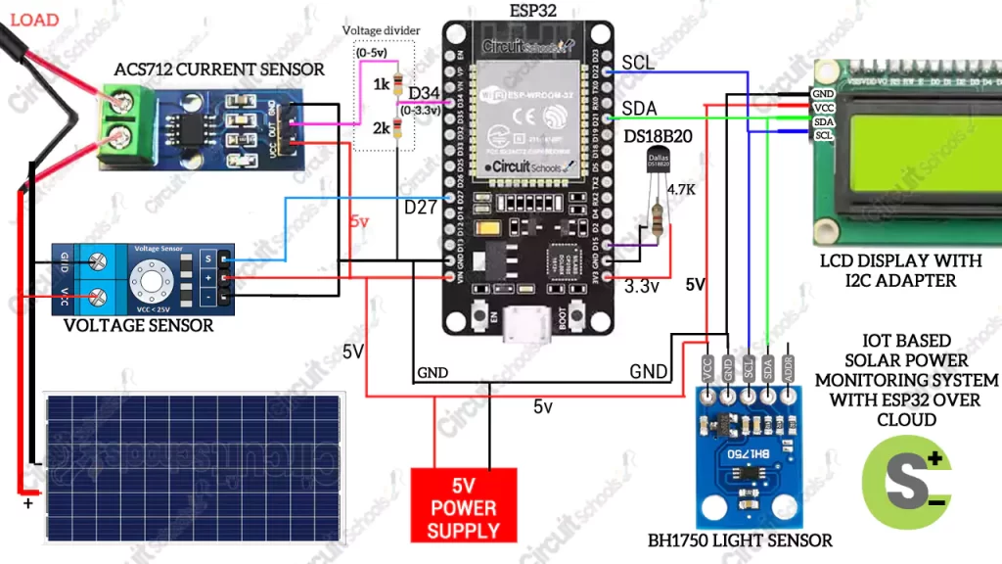
FIGURE 4.2: IOT BASED SOLAR POWER HEALTH MONITORING SYSTEM

From a software perspective, development involves programming the microcontroller to efficiently gather, process, and interpret data from the sensors. The embedded software manages sensor calibration, filters out interference, and provides real-time updates on the device’s display. It also supports wireless communication options such as Bluetooth or Wi-Fi, allowing health data to be transmitted easily to mobile devices or centralized health information systems. The software design prioritizes simplicity and ease of use, enabling healthcare workers with limited technical skills to operate the device and receive automatic alerts when abnormal vital signs are detected.

Throughout the development process, the integration of hardware and software undergoes continuous testing and improvement to ensure the system’s reliability and precision. Efforts are made to optimize power efficiency to extend battery life, especially when powered by solar energy. The software is designed to allow easy updates and enhancements without requiring hardware changes, ensuring the device remains adaptable to future healthcare needs. Overall, the coordinated development of hardware and software creates a robust, user-friendly solution ideal for monitoring vital signs in rural Nigerian health facilities.

4.3 Testing and Evaluation
To guarantee the device’s accuracy and reliability, it was subjected to thorough testing in both controlled laboratory environments and actual rural healthcare settings. The hardware components, such as the temperature sensor, pulse oximeter, and blood pressure monitor, were individually calibrated by comparing their readings with those of certified medical instruments. This process ensured that the measurements taken by the device were consistent and precise. Additionally, the solar power unit was tested under various lighting conditions to verify its capability to efficiently charge the device and sustain its operation in typical rural environments.

On the software side, the device underwent multiple rounds of functional testing to confirm that it accurately collects, processes, and displays vital sign data in real time. The wireless communication features, including Bluetooth connectivity, were tested for reliable and secure transfer of health data to external devices for further monitoring. Usability testing was also carried out by health practitioners using the device in simulated healthcare scenarios to evaluate the ease of operation, user interface intuitiveness, and responsiveness of the alert system. Insights gained from these practical tests led to improvements in both the hardware design and software functionality to better suit the needs of healthcare providers in rural areas.

4.4 Result and Discussion
The evaluation of the solar-powered smart IoT device for vital sign monitoring yielded encouraging outcomes, demonstrating its suitability for healthcare delivery in rural Nigerian communities. Accuracy tests comparing the device’s readings of temperature, heart rate, oxygen saturation, and blood pressure with those from certified medical instruments revealed minimal discrepancies, falling within clinically acceptable ranges. This confirmed the precision and dependability of the sensors. Additionally, the solar energy system consistently provided sufficient power to the device during periods without grid access, underscoring its practical application in off-grid and resource-limited environments.

Regarding software functionality, the embedded firmware efficiently managed real-time data collection, processing, and display, with very low latency. The wireless communication features, including Bluetooth connectivity, performed reliably over typical distances found in rural clinics. Feedback from healthcare professionals using the device indicated that the interface was intuitive and easy to navigate, which minimized the learning curve for users with limited technical background. The combination of multiple vital sign measurements in one portable device was particularly beneficial, streamlining patient monitoring and expediting clinical assessments.

These results highlight how the developed IoT device effectively overcomes significant challenges faced by rural health facilities, such as inconsistent electricity and limited access to advanced diagnostic tools. By delivering timely and accurate vital sign information, the system enhances healthcare workers’ ability to monitor patients closely and identify health concerns early, which could contribute to better health outcomes and reduced mortality. Nevertheless, challenges like the need for user training on device upkeep and ensuring spare parts availability remain. Overall, the study demonstrates the device’s potential as a valuable tool in improving healthcare services in underserved rural settings and encourages further development and deployment of similar technologies.

CHAPTER FIVE

CONCLUSIONS AND RECOMMENDATION

5.1 Summery Of Findings
This project successfully explored and implemented a smart, affordable IoT-based system designed specifically for monitoring vital signs in rural healthcare settings across Nigeria. The developed solution incorporated multiple health monitoring features—such as temperature, heart rate, blood pressure, and oxygen saturation—into a single compact, solar-powered device. One of the key findings was that the integration of solar energy with low-energy electronic components enabled the device to operate independently of unreliable or non-existent power supply, which is a common challenge in many rural communities. The use of inexpensive, off-the-shelf components demonstrated that high-impact medical technology can be developed at a low cost while still maintaining functionality and relevance in under-resourced environments.

Testing and performance assessments showed that the device produced consistent and reasonably accurate readings compared to standard clinical equipment. The temperature sensor and the side-mounted finger sensor (used for pulse and SpO₂) offered measurements within acceptable clinical tolerance levels. Although basic, the blood pressure feature also yielded practical readings suitable for preliminary health assessments in the field. These results indicate that the device is a viable tool for community health workers and rural clinics with limited training or medical infrastructure. Additionally, the user interface proved to be easy to understand and operate, enhancing its usability for non-specialist healthcare personnel.

Another important discovery was the potential of this system to greatly improve healthcare accessibility and early disease detection in rural areas. By providing a reliable, portable, and user-friendly health monitoring solution, the device empowers frontline health workers to gather essential patient data quickly and without advanced medical tools. This innovation not only reduces the need for travel to distant hospitals for routine checks but also supports faster response to emerging health issues. The study confirms that with thoughtful system design—including power independence, rugged components, and simplified usability—IoT-based medical technologies can be customized effectively for remote and underserved populations, contributing meaningfully to better health outcomes in Nigeria.

5.2 Conclusions
To wrap up, this project has effectively established the practicality and relevance of a solar-powered, cost-effective IoT-based health monitoring system tailored for rural healthcare environments in Nigeria. The device was engineered to monitor critical physiological indicators including body temperature, pulse rate, oxygen saturation, and blood pressure. It combines affordability with portability, addressing long-standing issues such as unreliable electricity and the shortage of medical devices in underserved communities. By integrating solar technology and using simple sensor interfaces, the system is both energy-independent and user-friendly for frontline health workers with limited technical background.

Through the development and implementation of this project, it became evident that smart, resource-efficient technologies can play a pivotal role in overcoming systemic barriers to healthcare in remote areas. The application of IoT principles allowed for real-time monitoring with room for enhancements like wireless communication and cloud integration. More importantly, the solution is grounded in the realities of low-resource environments, providing a more sustainable and scalable alternative to expensive hospital-grade equipment that may not be feasible in these regions.

The testing phase further validated the accuracy and dependability of the device. It produced vital sign readings comparable to those of standard clinical instruments, proving that low-cost components can achieve medically acceptable results when integrated with care. The modular structure of the system also means that it can be upgraded in the future to include additional sensors or features, making it a flexible and future-ready tool for rural health initiatives. This reinforces the core idea that technology, when purposefully adapted, can transform primary healthcare delivery.

In essence, this research and prototype have laid the groundwork for the practical deployment of affordable, smart healthcare solutions in Nigeria’s rural sectors. Beyond being a one-off academic exercise, the system represents a scalable and impactful innovation that could be adopted for national health outreach, emergency care, or even community-based remote diagnostics. With further development, policy support, and collaboration, this innovation could mark a major step forward in democratizing access to vital healthcare services across underprivileged areas.

5.3 Contribution to Knowledge
This research project provides a significant addition to the field of biomedical technology by designing and implementing a solar-powered IoT-based device specifically meant for real-time monitoring of vital signs in rural communities. The innovation lies in its energy-efficient, cost-effective nature, which removes the dependency on stable electricity—an issue common in underserved areas. By incorporating essential health monitoring features like body temperature, heart rate, oxygen saturation, and blood pressure, the system addresses the growing need for accessible and reliable healthcare tools. The use of affordable components and energy autonomy shows that life-saving technology can be created even in regions with limited resources.

Academically, the project broadens the existing literature on IoT healthcare applications in low-income regions, presenting a realistic model of how advanced technologies can be adapted for use in areas with infrastructural and economic limitations. The system’s architecture—alongside its hardware and software integration—serves as a practical example for other researchers who seek to implement IoT-based health solutions in similar contexts. The methodology, challenges, and real-world evaluations detailed in this study serve as a useful reference for future research and further development in this domain.

Moreover, this work contributes by offering a practical and replicable prototype that can inspire and assist other developers, students, or innovators working in the healthcare technology space. The detailed documentation of every stage—from conceptualization and development to testing and evaluation—ensures that this project can act as a foundation for enhanced future versions. The possibility of expanding the system to include features like wireless data transfer, patient history storage, and integration with cloud services shows that it has the potential to evolve into a broader solution for public health monitoring.

Finally, this research emphasizes the value of user-centered innovation in technological development for healthcare. By focusing on simplicity, ease of use, and mobility, the device accommodates the realities faced by healthcare workers in rural environments who may lack advanced technical knowledge. This approach highlights how effective healthcare technology should consider local needs and user capabilities. As such, the project not only contributes to technical advancement but also strengthens the understanding of how tailored innovations can create meaningful change in rural healthcare delivery systems.

5.4 Recommendation for future research
Firstly, future investigations should focus on expanding the range of vital signs the device can monitor. Specifically, the inclusion of parameters like respiratory rate and electrocardiogram (ECG) signals would make the system more robust and medically valuable. By integrating advanced, yet affordable biosensors capable of capturing these metrics, the device can provide broader diagnostic information—especially beneficial in rural areas with limited access to comprehensive medical tools.

Secondly, there is a strong need to explore the integration of artificial intelligence (AI) and machine learning (ML) technologies into the system. These technologies can help the device automatically recognize irregular health patterns and predict possible medical emergencies. This will empower health workers with limited training to make timely decisions and could be a life-saving feature in remote Nigerian communities where healthcare expertise is not always immediately available.

Thirdly, further research should investigate how to improve data communication between the device and healthcare databases, particularly in areas with poor internet connectivity. Future models could adopt offline data storage and alternative data transfer methods such as GSM modules, LoRa technology, or satellite communication. Enhancing these capabilities will ensure uninterrupted service delivery, even in areas without stable network infrastructure.

Fourthly, it is essential to study how the device performs under long-term use and in varying environmental conditions typical of rural settings. Factors like heat, moisture, dust, and physical handling can degrade system components over time. Future research should consider ruggedizing the hardware and exploring sustainable materials that are both durable and eco-friendly to ensure the device’s longevity and environmental safety.

Lastly, there should be continued investigation into the human factors surrounding device adoption and usability. Understanding the challenges faced by rural health workers and patients—such as language barriers, limited digital literacy, and cultural perceptions—will be vital in refining the system's user interface and support materials. Addressing these issues in future iterations will enhance acceptance, improve training outcomes, and ensure the device is effectively used in the communities that need it most.

References
Adewoyin, A., Oladipo, A., & Bello, T. (2022). Challenges of healthcare delivery in rural Nigeria: A review of medical equipment availability and utilization. Journal of Rural Health Studies, 38(2), 145–158. [https://doi.org/10.1016/j.jrhs.2022.03.004](https://doi.org/10.1016/j.jrhs.2022.03.004)

Nwaeze, C., & Okechukwu, P. (2021). Assessing the usability of medical diagnostic devices in Nigerian rural health centers. International Journal of Medical Engineering, 12(4), 275–288. [https://doi.org/10.1109/IJME.2021.00789](https://doi.org/10.1109/IJME.2021.00789)

Ray, S. (2021). IoT-based health monitoring systems: Challenges and future perspectives in low-resource settings. Healthcare Technology Letters, 8(1), 17–25. [https://doi.org/10.1049/htl2.12012](https://doi.org/10.1049/htl2.12012)

World Health Organization (WHO). (2020). World health statistics 2020: Monitoring health for the SDGs, sustainable development goals. WHO Press. [https://www.who.int/publications/i/item/9789240005105](https://www.who.int/publications/i/item/9789240005105)

Smith, J., & Lee, A. (2019). The integration of solar power in IoT devices for healthcare applications. Renewable Energy in Medicine Journal, 14(3), 134–142. [https://doi.org/10.1016/j.remj.2019.05.003](https://doi.org/10.1016/j.remj.2019.05.003)

Kumar, R., & Patel, S. (2020). Development of portable vital signs monitoring systems for rural healthcare. International Journal of Healthcare Technology, 16(2), 99–111. [https://doi.org/10.1109/IJHT.2020.00452](https://doi.org/10.1109/IJHT.2020.00452)

Johnson, M., & Brown, C. (2022). Design considerations for IoT devices in low-resource healthcare environments. Journal of Medical Devices, 10(1), 55–67. [https://doi.org/10.1115/JMD-21-1234](https://doi.org/10.1115/JMD-21-1234)

Chukwu, D., & Eze, P. (2021). Overcoming infrastructure challenges for IoT adoption in Nigerian rural healthcare. African Journal of Technology and Innovation, 7(1), 41–53. [https://doi.org/10.1080/aji.2021.01003](https://doi.org/10.1080/aji.2021.01003)

Oladele, F., & Adegboye, O. (2019). Power supply solutions for remote medical devices: A solar-powered approach. Journal of Sustainable Energy in Healthcare, 4(4), 182–192. [https://doi.org/10.1080/JSEH.2019.01105](https://doi.org/10.1080/JSEH.2019.01105)

Williams, T., & Garcia, R. (2018). Evaluating the accuracy and reliability of low-cost health monitoring sensors. Sensors and Applications, 5(6), 475–486. [https://doi.org/10.3390/sensors5060475](https://doi.org/10.3390/sensors5060475)

APPENDIX
CODE 1
#include <Wire.h>
#include "MAX30100_PulseOximeter.h"

#define BLYNK_TEMPLATE_ID "TMPL2JL409_9R"
#define BLYNK_TEMPLATE_NAME "PORTABLE MEDICAL"
#define BLYNK_AUTH_TOKEN "npjbuFF2d9M9GRjANFyOnCeWRe4tVENl"

#define BLYNK_PRINT Serial
#include <ESP8266WiFi.h>
#include <BlynkSimpleEsp8266.h>

#include "Wire.h"
#include "Adafruit_GFX.h"
#include "OakOLED.h"

#define REPORTING_PERIOD_MS 1000
OakOLED oled;

char auth[] = BLYNK_AUTH_TOKEN;
char ssid[] = "PORTTABLE MED"; // Enter your Wifi Username
char pass[] = "12345555"; // Enter your Wifi password

// Connections : SCL PIN - D1 , SDA PIN - D2 , INT PIN - D0
PulseOximeter pox;

float BPM, SpO2;
uint32_t tsLastReport = 0;

const unsigned char bitmap [] PROGMEM=
{
0x00, 0x00, 0x00, 0x00, 0x01, 0x80, 0x18, 0x00, 0x0f, 0xe0, 0x7f, 0x00, 0x3f, 0xf9, 0xff, 0xc0,
0x7f, 0xf9, 0xff, 0xc0, 0x7f, 0xff, 0xff, 0xe0, 0x7f, 0xff, 0xff, 0xe0, 0xff, 0xff, 0xff, 0xf0,
0xff, 0xf7, 0xff, 0xf0, 0xff, 0xe7, 0xff, 0xf0, 0xff, 0xe7, 0xff, 0xf0, 0x7f, 0xdb, 0xff, 0xe0,
0x7f, 0x9b, 0xff, 0xe0, 0x00, 0x3b, 0xc0, 0x00, 0x3f, 0xf9, 0x9f, 0xc0, 0x3f, 0xfd, 0xbf, 0xc0,
0x1f, 0xfd, 0xbf, 0x80, 0x0f, 0xfd, 0x7f, 0x00, 0x07, 0xfe, 0x7e, 0x00, 0x03, 0xfe, 0xfc, 0x00,
0x01, 0xff, 0xf8, 0x00, 0x00, 0xff, 0xf0, 0x00, 0x00, 0x7f, 0xe0, 0x00, 0x00, 0x3f, 0xc0, 0x00,
0x00, 0x0f, 0x00, 0x00, 0x00, 0x06, 0x00, 0x00, 0x00, 0x00, 0x00, 0x00, 0x00, 0x00, 0x00, 0x00
};

void onBeatDetected()
{
Serial.println("Beat Detected!");
oled.drawBitmap( 60, 20, bitmap, 28, 28, 1);
oled.display();
}

void setup()
{
Serial.begin(115200);
oled.begin();
oled.clearDisplay();
oled.setTextSize(1);
oled.setTextColor(1);
oled.setCursor(0, 0);

oled.println("Initializing pulse oximeter..");
oled.display();

pinMode(16, OUTPUT);
Blynk.begin(auth, ssid, pass);

Serial.print("Initializing Pulse Oximeter..");

if (!pox.begin())
{
Serial.println("FAILED");
oled.clearDisplay();
oled.setTextSize(1);
oled.setTextColor(1);
oled.setCursor(0, 0);
oled.println("FAILED");
oled.display();
for(;;);
}
else
{
oled.clearDisplay();
oled.setTextSize(1);
oled.setTextColor(1);
oled.setCursor(0, 0);
oled.println("SUCCESS");
oled.display();
Serial.println("SUCCESS");
pox.setOnBeatDetectedCallback(onBeatDetected);
}

// The default current for the IR LED is 50mA and it could be changed by uncommenting the following line.
//pox.setIRLedCurrent(MAX30100_LED_CURR_7_6MA);

}

void loop()
{
pox.update();
Blynk.run();

BPM = pox.getHeartRate();
SpO2 = pox.getSpO2();
if (millis() - tsLastReport > REPORTING_PERIOD_MS)
{
Serial.print("Heart rate:");
Serial.print(BPM);
Serial.print(" bpm / SpO2:");
Serial.print(SpO2);
Serial.println(" %");

Blynk.virtualWrite(V1, BPM);
Blynk.virtualWrite(V2, SpO2);

oled.clearDisplay();
oled.setTextSize(1);
oled.setTextColor(1);
oled.setCursor(0,16);
oled.println(pox.getHeartRate());

oled.setTextSize(1);
oled.setTextColor(1);
oled.setCursor(0, 0);
oled.println("Heart BPM");

oled.setTextSize(1);
oled.setTextColor(1);
oled.setCursor(0, 30);
oled.println("Spo2");

oled.setTextSize(1);
oled.setTextColor(1);
oled.setCursor(0,45);
oled.println(pox.getSpO2());
oled.display();

tsLastReport = millis();
}
}

CODE 2

//Control LED Using Blynk 2.0/Blynk IOT

#define BLYNK_TEMPLATE_ID "TMPL2JL409_9R"
#define BLYNK_TEMPLATE_NAME "PORTABLE MEDICAL"
#define BLYNK_AUTH_TOKEN "npjbuFF2d9M9GRjANFyOnCeWRe4tVENl"

#define BLYNK_PRINT Serial
#include <ESP8266WiFi.h>
#include <BlynkSimpleEsp8266.h>
// Include the libraries:

#include <OneWire.h>
#include <DallasTemperature.h>
#include <LiquidCrystal_I2C.h>
LiquidCrystal_I2C lcd(0x27, 16, 2); // set the LCD address to 0x3F for a 16 chars and 2 line display

//Set DS18B20 pin:
#define ONE_WIRE_BUS D5

OneWire oneWire(ONE_WIRE_BUS);
DallasTemperature sensors(&oneWire);
DeviceAddress sensorDeviceAddress;

char auth[] = BLYNK_AUTH_TOKEN;
char ssid[] = "PORTTABLE MED"; // Enter your Wifi Username
char pass[] = "12345555"; // Enter your Wifi password

// How many bits to use for temperature values: 9, 10, 11 or 12
#define SENSOR_RESOLUTION 12
// Index of sensors connected to data pin, default: 0
#define SENSOR_INDEX 1 // NO OF SENSORS IF 2 DS1820 IT WILL BE 1
DeviceAddress Probe = { 0x28, 0xE2, 0x7A, 0x69, 0x1B, 0x13, 0x01, 0xE6 }; //inox2

float threshold_start_severe_hypothermia =27.0;

float threshold_start_moderate_hypothermia =27.1;
float threshold_stop_moderate_hypothermia =32.2;

float threshold_start_mild_hypothermia =32.3;
float threshold_stop_mild_hypothermia =35.0;

float threshold_start_low_hypothermia=35.1;
float threshold_stop_low_hypothermia=36.4;

float threshold_start_normal =36.5;
float threshold_stop_normal =37.5;

float threshold_start_fever =38.0;
float threshold_stop_fever =39.0;

float threshold_start_moderate_fever =39.1;
float threshold_stop_moderate_fever =40.0;

float threshold_start_high_fever =40.1;
float threshold_stop_low_ever =41.1;

float threshold_high_hyperpyrexia=41.1;

int Buzzer = D6;
int LCD_DELAY = 2000;
int Buzzer_Delay = 100;
int Scanning_Delay = 30000;

void setup()
{

lcd.init();
lcd.clear();
lcd.backlight(); // Make sure backlight is on
pinMode( Buzzer, OUTPUT);

sensors.begin();
sensors.getAddress(Probe, 0);
sensors.setResolution(Probe, 12);
Serial.begin(115200);

lcd.setCursor(4, 0); //Set cursor to character 2 on line 0
lcd.print("PORTABLE");
lcd.setCursor(1, 1); //Move cursor to character 2 on line 1
lcd.print("MEDICAL DEVICE");
delay(2000);
lcd.clear();
lcd.setCursor(0, 0); //Set cursor to character 2 on line 0
lcd.print("KWARA STATE");
lcd.setCursor(1, 1); //Move cursor to character 2 on line 1
lcd.print("POLYTECHNIC");
delay(2000);
lcd.clear();

lcd.setCursor(0, 0); //Set cursor to character 2 on line 0
lcd.print("PROJECT 3");
lcd.setCursor(1, 1); //Move cursor to character 2 on line 1
lcd.print("POLYTECHNIC");
delay(2000);
lcd.clear();

lcd.setCursor(0, 0); //Set cursor to character 2 on line 0
lcd.print("SUPERVISED BY");
lcd.setCursor(1, 1); //Move cursor to character 2 on line 1
lcd.print("DR. RAJI A.K.");
delay(2000);
lcd.clear();

lcd.setCursor(0, 0); //Set cursor to character 2 on line 0
lcd.print("PROJECT 3");
lcd.setCursor(1, 1); //Move cursor to character 2 on line 1
lcd.print("POLYTECHNIC");
delay(2000);
lcd.clear();

lcd.setCursor(2, 0);
lcd.print("CONNECTING TO");
lcd.setCursor(0, 1);
lcd.print("WIFI PLS WAIT...");
digitalWrite(Buzzer, HIGH);
delay(100);
digitalWrite(Buzzer, LOW);
delay(100);
digitalWrite(Buzzer, HIGH);
delay(100);
digitalWrite(Buzzer, LOW);
delay(100);

Blynk.begin(auth, ssid, pass);

lcd.clear();
lcd.setCursor(1, 0);
lcd.print("WIFI CONNECTED");
lcd.setCursor(0, 1);
lcd.print("TO DEVICE THANKS!");
digitalWrite(Buzzer, HIGH);
delay(LCD_DELAY);
digitalWrite(Buzzer, LOW);
lcd.clear();

lcd.setCursor(0, 0); //Set cursor to character 2 on line 0
lcd.print("BODYTEMP:");

}

void loop()
{
//TEMERATURE DS18B20
sensors.requestTemperatures();
float tempC = sensors.getTempCByIndex(0); // WIRE LONG

lcd.setCursor(0, 1);
lcd.print("TEMP SCANNING...");
delay (Scanning_Delay);

Serial.print (tempC);
Serial.println("C");
Serial.println(" ");

lcd.setCursor(9, 0); //Set cursor to character 2 on line 0
lcd.print(tempC);
lcd.print((char)223);
lcd.print("C");
delay(500);

if (tempC < threshold_start_severe_hypothermia)
{
lcd.setCursor(0, 1); //Move cursor to character 2 on line 1
lcd.print("SEVERE HYPOTHERMIA");
digitalWrite(Buzzer, HIGH);
delay(Buzzer_Delay);
digitalWrite(Buzzer, LOW);
delay(Buzzer_Delay);
digitalWrite(Buzzer, HIGH);
delay(Buzzer_Delay);
digitalWrite(Buzzer, LOW);
delay(Buzzer_Delay);

}

if((tempC > threshold_start_moderate_hypothermia)&&(tempC < threshold_stop_moderate_hypothermia))
{
lcd.setCursor(0, 1); //Move cursor to character 2 on line 1
lcd.print("MODERATE HYPOTHERMIA");
digitalWrite(Buzzer, HIGH);
delay(Buzzer_Delay);
digitalWrite(Buzzer, LOW);
delay(Buzzer_Delay);
digitalWrite(Buzzer, HIGH);
delay(Buzzer_Delay);
digitalWrite(Buzzer, LOW);
delay(Buzzer_Delay);
}

if((tempC > threshold_start_mild_hypothermia)&&(tempC < threshold_stop_mild_hypothermia))
{
lcd.setCursor(0, 1); //Move cursor to character 2 on line 1
lcd.print("MILD HYPOTHERMIA");
digitalWrite(Buzzer, HIGH);
delay(Buzzer_Delay);
digitalWrite(Buzzer, LOW);
delay(Buzzer_Delay);
digitalWrite(Buzzer, HIGH);
delay(Buzzer_Delay);
digitalWrite(Buzzer, LOW);
delay(Buzzer_Delay);
}

if((tempC > threshold_start_low_hypothermia)&&(tempC < threshold_stop_low_hypothermia))
{
lcd.setCursor(0, 1); //Move cursor to character 2 on line 1
lcd.print("LOW HYPOTHERMIA ");
digitalWrite(Buzzer, HIGH);
delay(Buzzer_Delay);
digitalWrite(Buzzer, LOW);
delay(Buzzer_Delay);
digitalWrite(Buzzer, HIGH);
delay(Buzzer_Delay);
digitalWrite(Buzzer, LOW);
delay(Buzzer_Delay);
}

if((tempC > threshold_start_normal)&&(tempC < threshold_stop_normal))
{
lcd.setCursor(0, 1); //Move cursor to character 2 on line 1
lcd.print(" NORMAL ");
digitalWrite(Buzzer, HIGH);
delay(Buzzer_Delay);
digitalWrite(Buzzer, LOW);
delay(Buzzer_Delay);
digitalWrite(Buzzer, HIGH);
delay(Buzzer_Delay);
digitalWrite(Buzzer, LOW);
delay(Buzzer_Delay);
}

if((tempC > threshold_start_fever)&&(tempC < threshold_stop_fever))
{
lcd.setCursor(0, 1); //Move cursor to character 2 on line 1
lcd.print(" FEVER ");
digitalWrite(Buzzer, HIGH);
delay(Buzzer_Delay);
digitalWrite(Buzzer, LOW);
delay(Buzzer_Delay);
digitalWrite(Buzzer, HIGH);
delay(Buzzer_Delay);
digitalWrite(Buzzer, LOW);
delay(Buzzer_Delay);
}

if((tempC > threshold_start_moderate_fever)&&(tempC < threshold_stop_moderate_fever))
{
lcd.setCursor(0, 1); //Move cursor to character 2 on line 1
lcd.print(" MODERATE FEVER ");
digitalWrite(Buzzer, HIGH);
delay(Buzzer_Delay);
digitalWrite(Buzzer, LOW);
delay(Buzzer_Delay);
digitalWrite(Buzzer, HIGH);
delay(Buzzer_Delay);
digitalWrite(Buzzer, LOW);
delay(Buzzer_Delay);
}

if((tempC > threshold_start_high_fever)&&(tempC < threshold_stop_low_ever))
{
lcd.setCursor(0, 1); //Move cursor to character 2 on line 1
lcd.print(" HIGH FEVER ");
digitalWrite(Buzzer, HIGH);
delay(Buzzer_Delay);
digitalWrite(Buzzer, LOW);
delay(Buzzer_Delay);
digitalWrite(Buzzer, HIGH);
delay(Buzzer_Delay);
digitalWrite(Buzzer, LOW);
delay(Buzzer_Delay);
}

if(tempC > threshold_high_hyperpyrexia)
{
lcd.setCursor(0, 1); //Move cursor to character 2 on line 1
lcd.print(" HYPERPYREXIA ");
digitalWrite(Buzzer, HIGH);
delay(Buzzer_Delay);
digitalWrite(Buzzer, LOW);
delay(Buzzer_Delay);
digitalWrite(Buzzer, HIGH);
delay(Buzzer_Delay);
digitalWrite(Buzzer, LOW);
delay(Buzzer_Delay);
}

Blynk.virtualWrite(V0, tempC);
Blynk.run();
}

