DESIGN AND IMPLEMENTATION OF HEART DISEASE PREDICTION USING DECISION LEVEL FUSION MODEL
(A CASE STUDY OF UNIVERSITY OF ILORIN TEACHING HOSPITAL)

BY

ADETONA ABEL
HND/23/COM/FT/0530

THE RESEARCH PROJECT SUBMITTED TO THE
DEPARTMENT OF COMPUTER SCIENCE,
INSTITUTE OF INFORMATION AND COMMUNICATION TECHNOLOGY
KWARA STATE POLYTECHNIC, ILORIN

IN PARTIAL FULFILLMENT OF THE REQUIREMENTS FOR THE AWARD OF HIGHER NATIONAL DIPLOMA (HND) IN
COMPUTER SCIENCE

May, 2025

CERTIFICATION
This is to certify that this project was carried out by ADETONA ABEL with matriculation number HND/23/COM/FT/0530 in the department of Computer Science Institute of Information and Communication Technology, Kwara State Polytechnic, Ilorin.

------------------------------------- ----------------------
MR ABIODUN E.T. Date
(Project Supervisor)

--------------------------------- ----------------------
MR.OYEDEPO Date
(Head of Department)

----------------------------------- ---------------------
External Supervisor Date

DEDICATION
I dedicate this project to Almighty GOD who's protect me, guide me through this work a big thanks to Almighty God.

ACKNOWLEDGMENT
With a grateful hearth, I return all glory to the most Merciful and Mighty Lord for the success of this Project.
My profound appreciation goes to my supervisor in person of MR ABIODUN E .T for his enormous contribution, support and guidance from the beginning to the end of this research work, I pray for her growth in all her aspirations in life.
Special thanks to HOD of Computer Science department, (MR OYEDEPO), and the member of staffs in the department of computer science for their academic support.

ABSTRACT
Artificial Intelligence is currently a popular theme in health care technology predictions. Machine learning is an artificial intelligence (AI) implementation that automatically learns and builds processes from experience. The leading cause of death worldwide at present is cardiovascular disease. The rate of death could be minimized by detecting the risk early. A lot of machine learning models have been developed to predict heart disease. We also introduced a fusion model to produce a better performance than the existing models. In this study, the proposed method analyzes two decision-making fusion models using five and ten-fold cross-validation to estimate the existence and absence of heart disease. The Jupyter Notebook, Scikit-learn, Tensorflow, and Keras were used as implementation tools. Three machine learning algorithms have been used here: the deep neural network (DNN), logistic regression(LR), and decision tree(DT). The decision tree and the logistic regression were merged separately with the deep neural network to form two fusion models (DNN+DT) and (DNN+LR), model-1 and mode-2. Five performance measurements have been used to compare model performance: accuracy, recall accuracy, f1-score, and AUC score. A significant improvement was found in performance parameters after fusing the algorithms in this work. The fusion occurred at the decision level by adding the decision scores of two algorithms. The main target is to enhance the fused model’s performance by combining the individual model’s decision for better classification. For both model-1 and 2, the accuracy has increased. Model-2 has obtained 87.12% classification accuracy for 10-fold cross-validation, which is the highest accuracy.

TABLE OF CONTENTS
PAGE
TITLE PAGE i
CERTIFICATION ii
DEDICATION iii
ACKNOWLEDGEMENT iv
ABSTRACT v
TABLE OF CONTENTS vi – vii
CHAPTER ONE: GENERAL INTRODUCTION
  - BACKGROUND TO THE STUDY 1
  - STATEMENT OF THE PROBLEM 2
  - AIM AND OBJECTIVES 3
  - SIGNIFICANT OF THE STUDY 3
  - SCOPE AND LIMITATION 3
  - ORGANIZATION OF REPORT 4
CHAPTER TWO: LITERATURE REVIEW
  - REVIEW OF RELATED PAST WORKS 5
  - Decision Tree (DT) 6
  - Decision Tree (DT) 6
  - Logistic Regression (LR) 7
  - Computational Intelligence Techniques 7
2.5.1 Common Techniques for Data Mining 8
CHAPTER THREE: METHODOLOGY AND ANALYSIS OF THE EXISTING SYSTEM
3.1 RESEARCH METHODOLOGY 11
3.2 ANALYSIS OF THE EXISTING SYSTEM 13
3.3 DESCRIPTION OF THE PROPOSED SYSTEM 13
3.4 DESCRIPTION OF THE PROPOSED SYSTEM 14
3.5 ADVANTAGES OF THE PROPOSED SYSTEM 15

CHAPTER FOUR: DESIGN, IMPLEMENTATION AND DOCUMENTATION
4.1 DESIGN OF THE SYSTEM 17 4.1.1 OUTPUT DESIGN 18 4.1.2 INPUT DESIGN 29
    - DATABASE DESIGN 20
4.1.4 PROCEDURE DESIGN 21
4.2 IMPLEMENTATION OF THE SYSTEM 21
4.2.1 CHOICE OF PROGRAMMING LANGUAGE 21
4.2.2 HARDWARE SUPPORT 22
4.2.3 SOFTWARE SUPPORT 22
4.2.4 CHANGE OF TECHNIQUE 22
4.3 SYSTEM DOCUMENTATION
4.3.1 PROGRAM DOCUMENTATION 22
4.3.2 OPERATING THE SYSTEM 23
4.3.3 MAINTAINING THE SYSTEM 23
CHAPTER FIVE: SUMMARY, CONCLUSION AND RECOMMENDATION
5.1 SUMMARY 24
5.2 CONCLUSION 24
5.3 RECOMMENDATION 24
REFERENCES

CHAPTER ONE
GENERAL INTRODUCTION
  - Background to the study
The number one worldwide cause of death is cardiovascular diseases (CVDs). CVDs are a category of problems of the cardiac and blood vessels, including stroke, heart attack, rheumatic heart disease, coronary artery disease, and other illnesses. Due to strokes and cardiac attacks,there are four out of five deaths, and people below the age of 70 die prematurely because of it, which is one-third of these deaths (Ayatollahi, et al. 2019). There are several reasons for CVD: unbalanced diet, smoking, stress, alcohol, fast foods, and inactive lifestyles. A study surveyed in 2016 that over 17 million individuals’ deaths are because of cardiovascular disease by the world health organization, which accounts for over 30 percent of deaths worldwide. The same survey found that the number of mortality in under privileged and medium-income countries is more than 70%. The good news is that heart diseases can be prevented by avoiding some critical factors, such as poor diet habits and insufficient physical exercise. To control their general state of health and avoid sudden cardiac failure, prompt detection and predictive mechanisms are needed for people who are at risk of high cardiovascular disease. Speaking about predicting heart disease, one of the well-known prediction is machine learning. AI showed promising outcomes in healthcare. In the Journal of Clinical Analysis (Wang & Summers, 2012) in a 2012 study; it was reported that machine learning plays a significant role in automatically detecting intricate patterns in radiology applications, and it helped radiologists make smart decisions.
Kourou, et al. (2015), the researchers showed that machine learning is essential to improve our understanding of cancer progression. It also has a significant improvement in their accuracy and efficiency in decision making. Clinical diagnosis is a diagnostic task whereby evaluating the qualities of a variety of features; a doctor tries to classify disease. Traditional approaches to treat heart disease, including ECG, blood pressure, level of cholesterol, etc., are costly and require a lot of time. So, to drop the death rate. It is necessary to design a heart disease diagnosis system that is computerized. The number of physicians is low compared to patients. That is why it is essential to develop a medical diagnosis system to identify heart disease that is built on machine learning. It gives more precise results than traditional ways and reduces cost (Karayılan&Kılıç, 2017). Researchers are continually doing their hardest to identify more reliable smart models forsuccessful treatment of this disorder, and a variety of smart models based on professional ML methods have been established with the passing of time. To make the medical diagnosis easy and cheap, we choose to build a fusion model to classify disease effectively. Here, a decision level fusion approach has been presented for heart disease disorder. Decision level fusion has implemented using the summation of scores of separate models (Matin, et al. 2017).The decision score of the separate models has been taken from the trained models. As the fusion occurs at the decision, so it is referred to as decision level fusion.
The supervised algorithms- decision tree and logistic regression are fused with a deep neural network separately to develop a better fusion model that can tell the existence and non-existence of heart disease by analyzing the data. This work contributes by making a fusion modelbesides different machine learning algorithms to achieve better accuracy than them. And in our work, there was a notable improvement in the accuracy after fusion. This work is presented as follows. The concern for the issue of heart disease is discussed in the first segment. The second segment contains the previous work. Materials and methodology are presented in the third segment. In part four, the paper explains the experimental out comes of our suggested architecture for identifying heart disease and also a comparative analysis with previouswork. After that, we have ended with a conclusion and prospects.
  - Statement of the problem
A lot of work has been performed on the classification of heart disease. The goal of all researchers was to improve accuracy. Various algorithms have been applied to thedataset to observe which model performs best. Now this work has been trying to build a fusion model for effectively classifying disease efficiently. Different algorithms are now making using fuzzy logic or merging algorithms to create a new one. This type of computational intelligence techniques plays an important role in medical diagnoses. Hopefully, these techniques make the physician’s works easier. In the future, the same techniques can also be applied to other disease prediction and also some other intelligence techniques will be applied to predict the coronary artery heart disease. The diversity of resources will deliver improved performance in knowledge extraction and a clear understanding of the measuring and collecting data problems. The real-time application will be updated and more features will be added and a real-time website will be designed for the prediction of heart disease. With the help two artificial intelligence Deep Neural Network- Decision Tree (DNN-DT) and Deep Neural Network- Logistic Regression (DNN-LR), the project develop a system for heart disease prediction system.
  - Aim and objectives
The aim of this research work is to develop a comparative analysis of two intelligence based decision level fusion model for heart disease prediction using Deep Neural Network- Decision Tree and Deep Neural Network- Logistic Regression. The objectives of this project are to:-

- Develop a comparative analysis system of two intelligence based decision fusion model
- Predict heart disease develop in (i) using Deep Neural Network- Decision Tree and Deep Neural Network- Logistic Regression
- Evaluate the performance of Deep Neural Network- Decision Tree and Deep Neural Network- Logistic Regression in prediction system
  - Significant of the study
The recent advancements in AI techniques Deep Neural Network- Decision Tree and Deep Neural Network- Logistic Regression have played an important role in biomedical sciences providing a handy role in diagnosis and monitoring of various diseases. The comparative analysis of two intelligence-based decision level fusion model has shown a robust system for the prediction of heart disease.
  - Scope and limitation
A comparative study of computational intelligence techniques in this study Deep Neural Network- Decision Tree and Deep Neural Network- Logistic Regression (LR, DNN, DT,) and the developed system used the same dataset but the implementation techniques are different so we take the direct experimental result from the work.

  - Organization of Report
Chapter one contains the background to the project, statement of the problem, the aim and objectives, significance of the study, justification of the study, scope of the study, definition of technical terms and organization of the report. Chapter two entails the literature review that talks about previous and related work of proposed system.
More so, chapter three examines the method of the proposed system, the existing system which includes analysis of existing system, problems of the existing system, and the description and benefit of proposed system. Chapter Four, explains the implementation and documentation of the system which contains design, implementation techniques, documentation, hardware and software requirements. Lastly, chapter five includes the summary, conclusions and recommendations.

CHAPTER TWO
LITERATURE REVIEW
  - Review of Related Past Works
Christensen, et al. (2018) developed a systemfor different types of disease prediction, four different machine learning approaches were analyzed:LSTM, which is a kind of the recurrent neural network, XGBoost (XGB), random forest (RF), and Logistic regression (LR). Here, XGBoost is performing better than LSTM.
Krishnaiah, et al. (2016) studied a fuzzy k-NN classifier was used, and the performance of the fuzzy k-NN classifier was way better than k-NN classifier. To remove the data’suncertainty, Fuzzy k-NN was used, and it provides higher accuracy than the k-NN classifier.
Tougui, et al. (2020) studied six machine learning algorithms were applied to Cleveland dataset using six data mining tools, and then the result of those algorithms was compared to each other. Based on the data examination and the effects of the output data taken, the best output was given by ANN which was implemented in Matlab,and the best performing tool was Matlab.
Dwivedi, (2018) study several machine learning algorithms were used for medical diagnosis. These methods have been validated by tenfold cross-validation. Logistic regression gives an accuracy of 85% that was highest with an F1 score of 79%. And ANN with an accuracy of 84% with an F1 score of 84%. Among other things, those two algorithms worked better.
Birjais, et al. (2019), work on a system that diabetics dataset was used for classification. It was predicted if a person has diabetes or not. The prediction was made on test data with three-fold cross-validation. In this work, Gradient Boosting offers a maximum accuracy of 86%, which is higher than Naive Bayes and Logistic Regression. Both Naive Bayes and Logistic Regression showed an accuracy of 77% and 79%, respectively.
Karayılan&Kılıç, (2017) predicted heart disease, and a multilayer perceptron was implemented in the suggested architecture. The architecture of the neural network contains 13 features derived from the Cleveland dataset. The proposed system gives 95% accuracy, and different accuracy has been found with the variation of the number ofhidden layers. The improvement in our work compared those that we have used the fusion model to identify the disorder, which results in improved outcome.
Bharati &Podder, (2019) focused on creating a hybrid model to diagnose lung disease from X-ray images. CNN, Vgg16, and other techniques have been applied to predict lungdisease. As CNN gave a poor performance, that’s why a hybrid model was implemented for better results. The hybrid model VDSNet outperforms current methods interms of the evaluation metrics.
  - Decision Tree (DT)
A decision tree is a tree-like structure consisting of branches, nodes, and leaf nodes. It is a branching graph that functions like a splitting rule for each particular attribute. Each feature is treated as a branching node. These nodes build a rule, and, based on the rule, values are grouped
into different classes. In the decision tree, the leaf decides some decisions at ending, and the topmost is theroot, which partitions the tree based on attribute value.Building A DT is easy and simple, and the results arepredicted more accurately.DT is sensitive to overfitting. It happens when themodel is very good at identifying trained data but givespoor performance for test data. It becomes over skilledfor training data by having minimal impurity in the leafnode. That’s why pre-pruning is needed to minimizethe number of leaf nodes that are not that importantfor model building. It gives better accuracy for prediction. Information gain is another important criterion,and attributes with the highest information gain splitfirst. For that method, features with the lowest entropyare selected for splitting (Naz& Ahuja 2020). In the proposed design Gini was used as criterion, maximum dept of the tree was 8,and minimal leaf size was 10. Pre-pruning was done toget the best parameters. The Gini index and entropy aresplit criteria for a decision tree, and they are arranged byapplying (3) and (4).

𝐺𝑖𝑛𝑖∶ 𝐺𝑖𝑛(𝐸)=1−𝑓(𝑥)=1−∫𝑛𝑗=1𝑃𝑗2 (3)
𝐸𝑛𝑡𝑟𝑜𝑝𝑦∶ (𝐸)=1−𝑓(𝑥)=−∫𝑛𝑗=1𝑃𝑗log2𝑃𝑗 (4)
Here 𝑃𝑗is the percentage of a class in a node.
2.3 Deep Neural Network (DNN)
An ANN has more than one layer, then is named a deep neural network (DNN). Like humans, a deep learning (DL) system can teach itself and learn through several hidden layers. DL is a model that is based on a multilayer feed-forward perceptron and uses back-propagation to train with stochastic gradient descent. There are four layers with nodes and neurons for the designed network,which has a uni-direction. It has two hidden layers, and there is a single way connection between every node and the next node. For training, stochastic gradient descent was used with back-propagation. It has been suggested as a very useful tool in different medical sectors for decisionmaking. Proposed Architecture of Deep Neural Network In this proposed approach, an input layer was used for data entrance, an output layer for predicting out- put(presence/absence), and two hidden layers. One of the most challenging tasks is model optimization for machine learning implementation. Model optimization reduces the test error; however, deep learning tunes theparameters outside of the model but has a significant influence on results and classification. The mother of all hyperparameters is the learning rate. The speed of learning of the model depends on the learning rate. The number of hidden units is vital as it regulates the model’s representational capacity. The number of first and second hidden layers in our model is 10 and 8, respectively. L2
regularization was used to block overfitting. Bias, which is a constant, was used to help the model in a way that can fit best for the given data. Batch size ten was used.
2.4 Logistic Regression (LR)
LR is a supervised machine learning technique with continuous/discrete predictors. LR is generally used for binary classification. It is a statistical model that represents the relation between the binary dependent variable’s logit transformation and independent variables (one or more
than one) by determining the best fitted linear model. This model is a simple prediction approach compared to other non-parametric models of machine learning with baseline accuracy scores provided by the model (Cox, 2008)
2.5 Computational Intelligence Techniques
Computational intelligence technique is a collection of computational models. Using it many kinds of problems can be solved easily which are difficult to solve using conventional computational algorithms. There are different applications of computational intelligence in the field of medicine and pathology (Rubio, et al. 2015; Shahid & Singh, 2019; Tizhoosh&Pantanowitz, 2018). The LR, SVM, DNN, DT, NB, RF, and K-NN algorithms which are used in this comparative study are explained in details. Another interesting method is reinforcement learning. Reinforcement Learning works better for classification problems for imbalanced dataset. For classification problems, reinforcement learning has served in removing noisy data and learning better features, which made a great improvement in classification performance. But this technique works better for a large amount of dataset and image dataset. As the dataset size of Cleve and Stat log are not so big and all the attributes are numeric, hence reinforcement technique is not better suited for this study
2.5.1 Common Techniques for Data Mining
Naïve Bayes, Decision trees, Genetic algorithms, and Neural Networks are few of several techniques that have been proposed and used for mining data in recent times. Naïve Bayes, popularly known as Bayesian Network and decision trees are common classifiers applied in many works. For instance, Edin and Mirza (2012), applied decision trees modeled from Naïve Bayes on preoperative assessment data to predict students’ performance in a summer course. Genetic algorithms have been applied to predict their students’ final grade by (Minaei-Bidgoli& Punch., 2013). However, neural network deems less suitable for data mining purpose due to lack of comprehensibility because such models are built on black-box mechanisms. Genetic Algorithm and Neural Network have been hybridized in (Yao 2009), and neural evolutionary programming is proposed in (Martínez., 2016). Review of these operational methods is given herein.

Naïve Bayes :Naïve Bayes is a data mining classification technique that applies Bayes’ theorem with strong independence assumptions between the features using simple probability. This classifier is scalable in that it requires a number of parameters linear with number of attributes in problem domain and maximum likelihood training only takes a linear time because evaluation involves a closed-form expression rather than by expensive iterative approximation as used by many other classifiers (Martínez., et al 2006).
To classify an item $x_{i}$ as an instance of $X$ using Naïve Bayes, the classification model computes a posterior likelihood of $x_{i}$ as:
$P\left(C_{i} | X\right)= P\left(C_{i}\right)\prod_{i=1}^{n}{P(x_{i}|C_{i})}………(1)$
Where $C_{i}$ is a classifier label and ${P(C}_{i}|X)$ is the priori probability that an instance of $X$ is tagged (labeled) in $C_{i}$.
Naïve Bayes is widely used for learning data relationships unlike other complex classification techniques (John and Langley 2005). Despite its simplicity, computational efficiency and performance for real-life problems, results from decision tree are not that accurate making its potential for probabilistic modeling unexploited.

Decision Trees: Decision tree is a support tool with tree-like model used in taking decisions and showing relative consequences, chance of event outcomes, resource costs, and utility. This approach, commonly used in operation research helps to identify a strategy most likely to reach a goal. In a flowchart-like tree structure, the internal nodes denoted by rectangles are used to test values of expressions on given attributes while leaf nodes denoted by ovals depict the class label an entity can be categorized.
Decision trees can adopt classification or regression tree analyses. In the classification tree analysis, predicted outcome is a class to which data belongs while in regression analysis outcome can be a real number. Most decision tree algorithms such as ID3, C4.5, and CART adopt top-bottom, and divide-conquer procedures to learn from training dataset (Kotsiantis 2005). These algorithms starts by assuming an empty tree then split on next best attribute, and hold on to recursion on each leaf. Choosing the best attribute upon which splitting is done is a great challenge. This could be addressed by quantifying the predictive feature of an attribute since outcome at current nodes depends on this. In CART, variance reduction is often employed in cases with continuous target variable (Yi-Horng 2015).
Other recent algorithms include Chi-squared Automatic Interaction Detector which performs multi-level splits when computing classification trees (Satya et al., 2011), multivariate adaptive regression splines extends decision trees to handle numerical data better. The regression technique is a non-parametric extension of linear models that automatically models interactions between variables. In general, there might be multiple independent variables but their relationship to dependent variable(s) is unclear by manual analysis and neither is it visible in plot. Hence, regression techniques are used to discover non-linear relationships in multiple variables.
Decision trees represent rules in format that can be easily read, understood and interpreted by users. Over time, decision trees had been built with conditional inference. Conditional inferential is a statistical technique that takes non-parametric tests as splitting criteria for multiple testing to achieve unbiased prediction without pruning nor over-fitting. ID3 and C4.5 were older techniques used to generate decision trees from a dataset. C4.5 has realized a number of improvements over its successor ID3. An example is its ability to handle both discrete and continuous attributes.

Neural Network: Neural Network is an artificial intelligent technique that hosts a group of interconnected artificial neurons to mimic the properties of biological neurons in human. The technique follows analog and parallel computing system made up of simple processing elements that communicate through a rich set of interconnections with varying contributory weights. Over a period of time, neural network has been used to solve pattern recognition problems such as text, image and medical bioinformatics. Kim et al., (2016) a predictive model based on neural network was applied to estimate the compressive strength of concrete mixture from constituent’s proportion and the prediction accuracy was improved with an iteration method.
Since neural network is an adaptive artificial intelligent technique with self-tuning used that adjusts its structure during learning process, its usage in students’ academic performance prediction can be described as being probabilistic. Probabilistic neural network, implemented based on Parzen non-parametric probability density function estimation and Bayes classification, use feed-forward network to effectively solve prediction problems. The approach was found to build its architecture and train the network in fewer seconds, thence provides probabilistic viewpoints from all input with deterministic classification results. The Probabilistic network usually adopts Radial Basis Function to map any input pattern for classification.
Neural networks have shown success in areas of performance prediction, estimation and approximation, and pattern recognition problems. Probabilistic network model was proven to be more time efficient when compared to conventional back-propagation based models. The network type is recognized as a way to solving real-time classification problems as observed. However, it works better if a desired output is expressed as one of several pre-defined classes. Finally, NN and some statistical methods, like decision trees built on conditional inference, are deemed less suitable for data mining purposes.

CHAPTER THREE
METHODOLOGY AND ANALYSIS OF THE EXISTING SYSTEM
3.1 Research Methodology
Two decision level fusion models were constructed by applying an artificial neural network, logistic regression, and decision tree. Three algorithms were applied individually on the same dataset, and then the decision scores of the DNN and DT algorithm were combined as well asthe scores of DNN and LR.
The fusion models Deep Neural Network- Decision Tree and Deep Neural Network-Logistic Regression(DNN+DT) and (DNN+LR) gave a better result than individual achievement.

The two Artificial Intelligence Based Techniques
- Deep Neural Network- Decision Tree(DNN+DT)
- Deep Neural Network-Logistic Regression(DNN+LR)
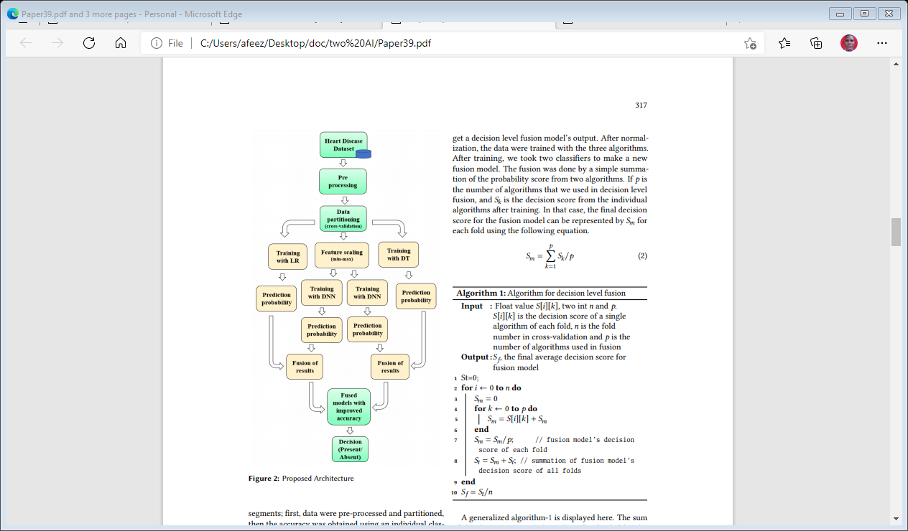

Figure 3.1: Proposed Architecture Model of Deep Neural Network- Decision Tree and Deep Neural Network- Logistic Regression (Karayılan, 2017).

3.2 Analysis of the Existing System
There are now several implementations of predictive modeling algorithms readily available, both asfree and commercial software. The quality of theresults obtained using these models mainly dependson three factors: the quality of the data set employedin model-building, the care with which adjustablemodel parameters were chosen, and the evaluationcriteria used to report the results of the modelingprocess.It is imperative that these details be presented inpapers using predictive modeling, as otherwise the validity of the claims in the papers cannot be assessed by
the reader. We therefore analyze the model-buildingprocess of logistic regression and neural network modelsin some detail, and point out which factors need to beconsidered when judging research results using predictive models.To gauge the current state of reporting results in the
literature, we sampled 72 papers comparing both logisticregression and neural network models on medical datasets. We analyzed these papers with respect to severalcriteria, such as size of data sets, model parameter selection scheme, and performance measure used in reporting model results.
3.4 Description of the Proposed System
This research work is to form a fusion model with improving accuracy to classify cardiovascular disease’s presence and absence. By merging the decision of different algorithms using summation (Deep Neural Network- Decision Tree and Deep Neural Network- Logistic Regression (DNN+DT) and (DNN+LR)), a new fusion model (figure 3.1) has been developed with high accuracy. Two decision level fusion models were constructed by applying an artificial neural network, logistic regression, and decision tree. Three algorithms were applied individually on the same dataset, and then the decision scores of the DNN and DT algorithm were combined as well as the scores of DNN and LR. The fusion models (DNN+DT) and (DNN+LR) gave a better result than individual achievement.

Table 3. 1 Descriptions of Features
Attribute | Description | Values
Age | Age in years |  | Continuous
Sex | Male/ Female |  | 1=male,0=female
Chest Pain Type | Chest pain class |  | 1 = typical type 1  - = typical type angina  - = non-angina pain  - = asymptomatic
Rest Blood Pressure | Rest Blood Pressure |  | Continuous value in mm hg
Serum Cholestoral | Serum cholesterol |  | Continuous value in mm/dl
Fasting Blood Sugar | Resting electrographic results |  | 0 = normal  1 = having_ST_T wave abnormal  2= left ventricular hypertrophy
ResElectrocardiographic | Fasting blood sugar |  | 1 ⩾ 120 mg/dl  0 ⩽ 120 mg/dl
MaxHeartRate | Highest rate of heart |  | Continuous value
Exercise Induced | Exercise induced |  | angina 0= no, 1 = yes
Oldpeak | ST depression induced by exercise associated with rest |  | Continuous value
Slp | Peak exercise’s |  | slope 1 = un sloping  2 = flat  3= down sloping
Major Vessels | Number of major vessels colored by floursopy |  | 0-3 value
Thal | Defect type |  | - = normal  - = fixed  7 = reversible defect

  - Advantages of the Proposed System

Maximum utilization of unstructured data

Elimination of the need for feature engineering

Ability to deliver high-quality results

Elimination of unnecessary costs

Elimination of the need for data labeling

CHAPTER FOUR
DESIGN, IMPLEMENTATION AND DOCUMENTATION OF THE SYSTEM
  - DESIGN OF THE SYSTEM
The proposed system is designed in modules with each modules working together to perform the electronic allocation system in order to enhance the performance of the existing system as earlier discussed in chapter three.
The ability to analyze and give focus to the system is explained in the following formats which are output design, input design, database design and procedure design.
    - OUTPUT DESIGN
Output design for the computerized system to go to the screen and the outputs are designed to present report in a meaningful way. The outputs of the system include import report and lying report.
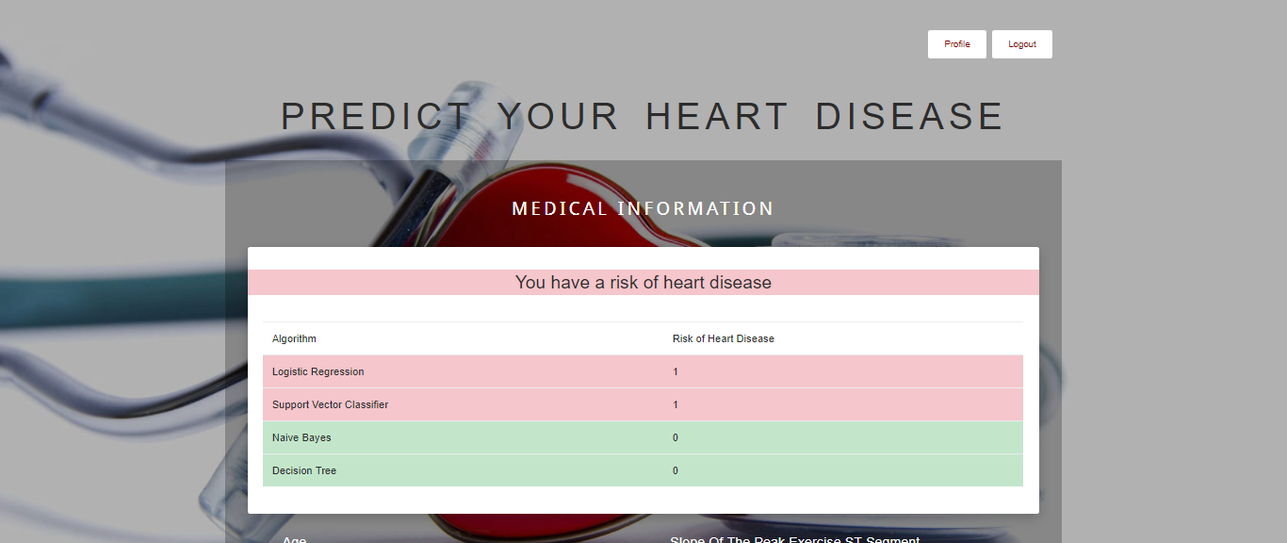
Figure 4.1: Prediction Result

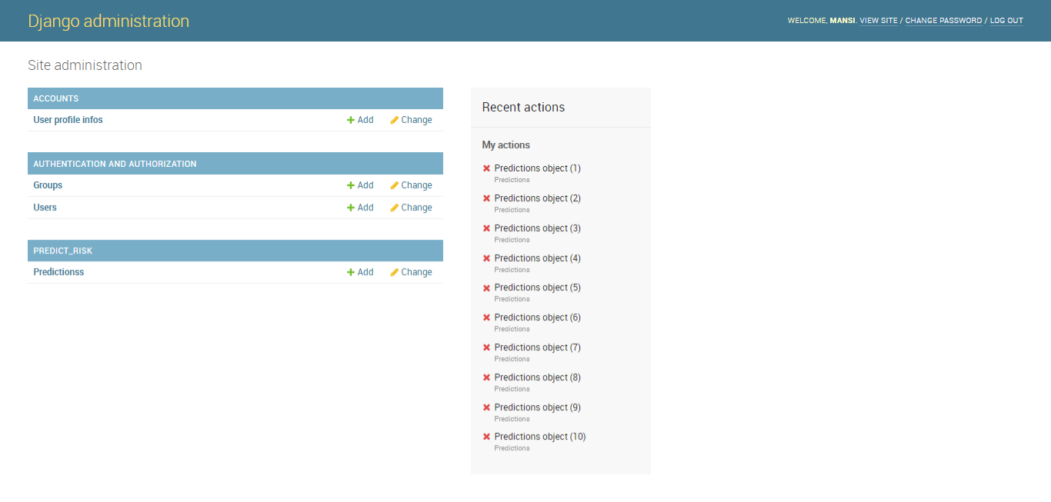
Figure 4.2: Diagnosis Administration
This page display the list of all the registered business operator
4.1.2 INPUT DESIGN
This aspect entails the description of the expected data input that will provide our output as described above. This section list out all the input required for the implementation of Career Guidance System. Data entry is done through the keyboard and mouse selection where required. The sample input interfaces are as shown below:



Figure 4.3: Sign Up page
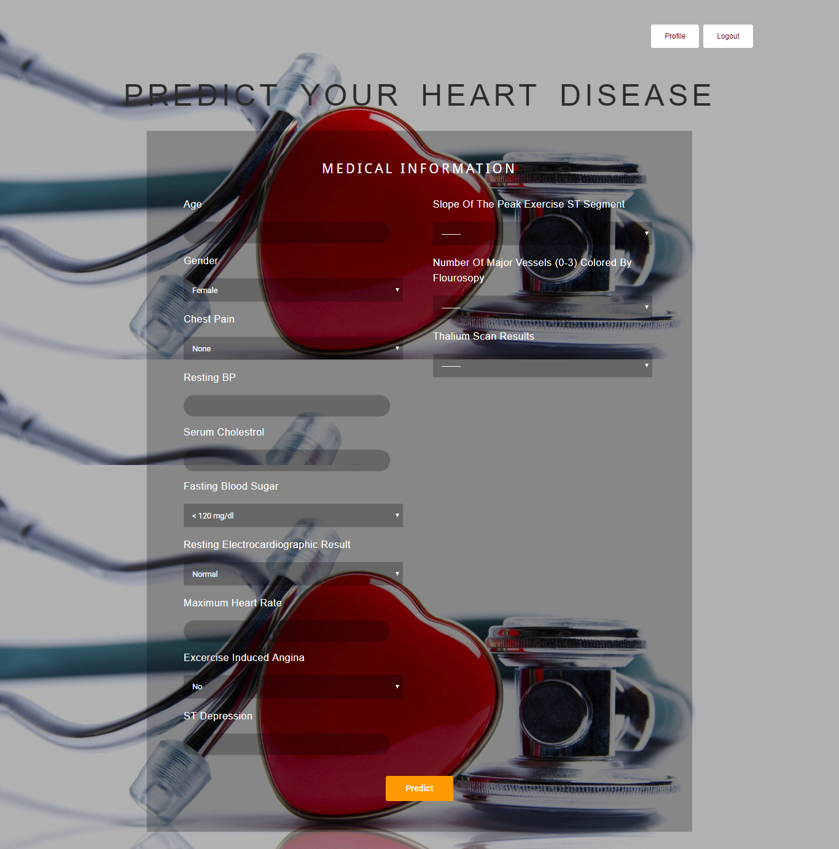
Figure 4.3: Prediction Page

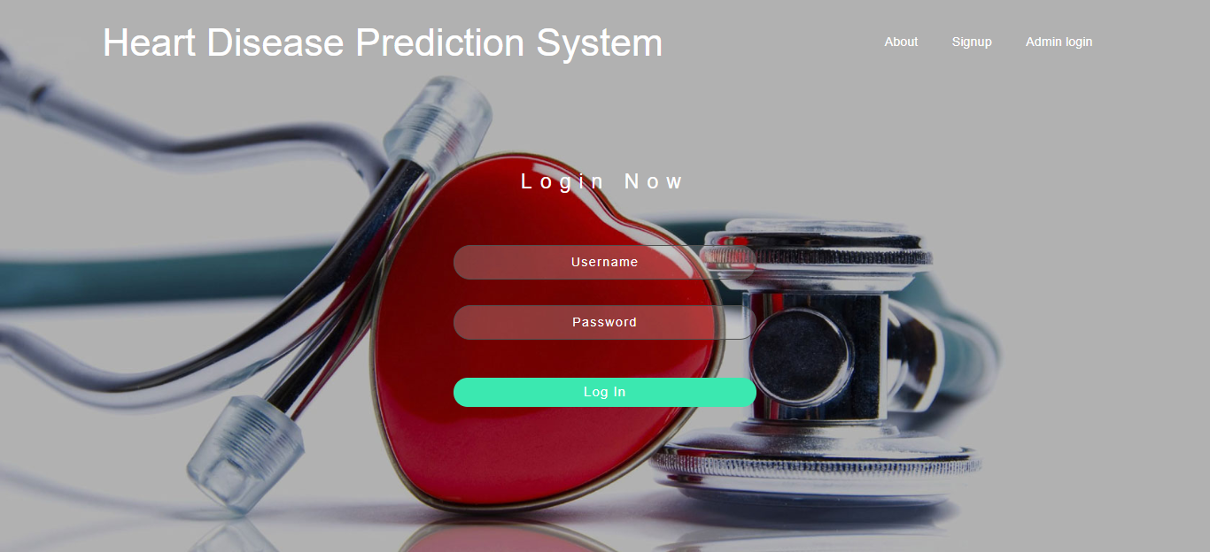
Figure 4.4: Prediction Login Page

    - DATABASE DESIGN
Table 4.2: Prediction Dataset
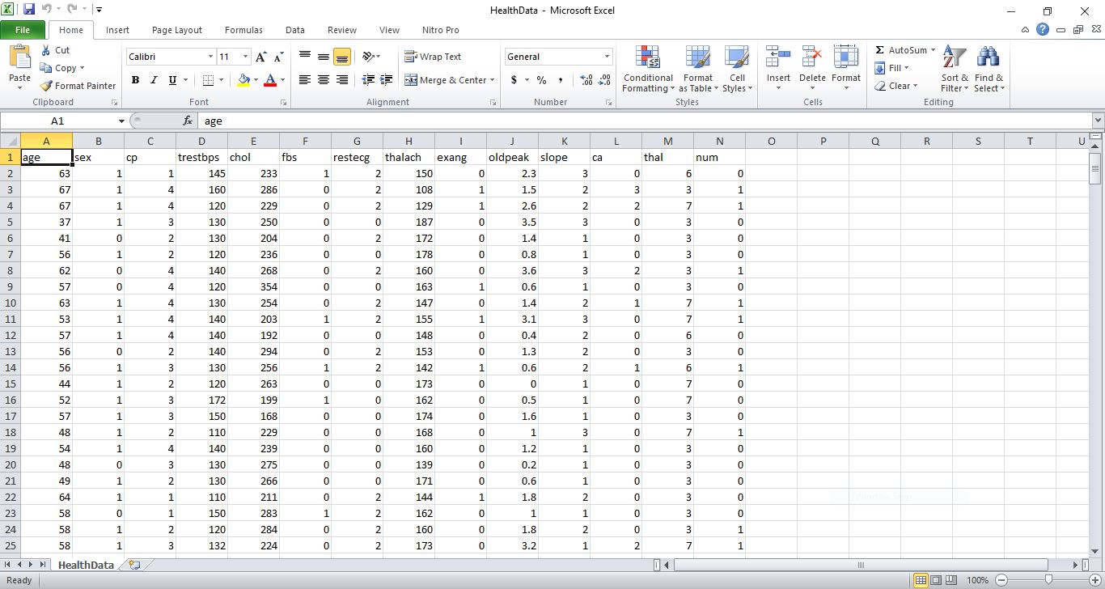

Table 4.2: Prediction Database
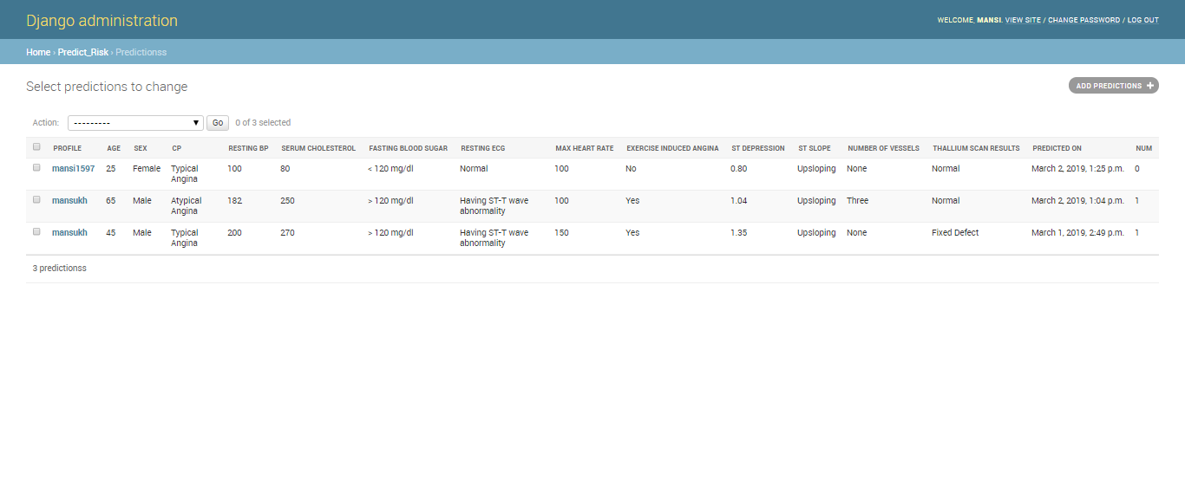
4.1.4 PROCEDURE DESIGN
The administrator can perform the following
- Add new business operator
- Generate shop for the market
- Allocate shop for each operator
4.2 IMPLEMENTATION OF THE SYSTEM
4.2.1 CHOICE OF PROGRAMMING LANGUAGE
In determining a suitable programming language for the design of the online patient management system, the factors to be considered are:-
- The difficulty of the problem
- The technical skills required of the computer program
- The type of processing required
- The availability of sub-programming facilities
- The efficiency of the language translator
- Ease of maintaining and updating the program
- Hardware and software requirement
For the project work, the programming language to be used for the design of the system is PHP and MYSQL for database management system with embedded Structured Query Language (SQL) for database manipulation

4.2.2 HARDWARE SUPPORT
The hardware requirements for this program are:
- PC: The computer should be minimum of Pentium IV with 1000GHs processor speed but preferably Dua Core Processor for greater efficiency
- Memory: This system requires a Higher RAM not less than 512MG, 1GB RAM is recommended.
- Storage: the storage capacity must be 80GB and above.
- VDU: Visual Display Unit required should be a very high resolution not less than 1024 x 768 with 256 colour capability.
- Printer: This system also requires a printer
- Input: The input device required is a mouse, Optical Mouse should be provides for easy use.
4.2.3 SOFTWARE REQUIREMENTS
The software requirements for the operation of this program are as follows:
- Window Operating System
- XAMPP or WampServer (for Apache server on localhost)
- Web Browser e.gMozila Firefox
- Macromedia dreamweaver
4.2.4 CHANGE OVER TECHNIQUE
The method used in the implementation of the proposed system is parallel, simply because parallel system supports the use of the existing system together with the proposed system and when there system failure information will not be totally lost and will not be back to square one for the users.
4.3 DOCUMENTATION OF THE SYSTEM
4.3.1 PROGRAM DOCUMENTATION
In order for the proposed system to be used on any computer system it takes the following ways
- Boot the system
- Copy the folder to www inside wamp folder of the drive C: after WAMP server is installed onto the system.
- Open any browser on the system (Microsoft internet Explorer, Mozilla Firefox, Netscape Navigator, Opera, Flock, Safari e.t.c)
- Type http://localhost/Shop Allocation System/index.php on the address bar and press the return key or enter key.
4.3.2 OPERATING THE SYSTEM
This refers to the step by step method of using the proposed system. The proposed system comprises of. The steps to use the proposed system are as follows
- On the address bar of any browser type http://localhost/www.kpshopallocation/index.php
- You are prompted to supply the username and password this verifies that you are a registered voter and has the privileged to vote.

4.3.3 MAINTAINING THE SYSTEM
- Data cable should be plugged properly
- Repair or replacement of all damaged accessories, system cards, peripheral e.t.c.
- prevention from dust
- Prevention of system from heat and moisture
- Prevention from static charges
- Examination of the new system from time to time to ensure it is performing as specified.
- Operators and users to the system must constantly check the output of the system to make sure that it is working accordingly.

CHAPTER FIVE
SUMMARY, CONCLUSION AND RECOMMENDATION
5.1 SUMMARY
The massive amounts of data generated and increasing availability of computational resources in healthcare systems make many clinical problems ripe for the development of AI applications. These systems will make diagnosis, treatment, prognostic efforts, followup, and decision-making more straightforward, precise, and efficient. This is aided by the fact that physicians worldwide are becoming more receptive towards, and accepting of, AI solutions. However, medical experts struggle with the gap between what is output by an ML-based solution and human explanations. To close the gap requires interdisciplinary work that studies how humans explain, formalizes the patterns in algorithmic forms, and explains outputs in a transparent, easy to interpret manner. With the help machine learning (ML), this system developed two artificial intelligence (DNN+DT and DNN+LR) based decision level for heart disease prediction comparation and perform the experimental comparative analysis.
5.2 CONCLUSION
At present era of ML, machine learning is a must, particularly in the health sector. This systemwas built to predict patients suffering from heart disease with greater accuracy using machine learning algorithms. Two fusion models have been developed to classify the presence and absence of heart disease. A comparative comparison was made to see which model performs better. Here, three algorithms have been used, and then two new decision level fusion models were created by combining the three algorithms. Both fused models gave a better performance than separate algorithms, and between the two fused models, model-2, which is the combination of DNN and LR, performed better than model-1(DNN+DT). Model-2 has an average accuracy of about 86%, where model-1 provided 85% accuracy with five-fold cross-validation. And for ten-fold, model-1 gave an accuracy of 84%, and model-2 gave 87.12%. In terms of other parameters, both models’ parameters improved. Both models’ performance is almost the same for five-fold cross-validation, and in ten-fold, model-2 performed much better than model-1. And in both models, we obtained improved accuracy after fusion, which was our main goal. The classifier can be used for different datasets for other medical diagnoses in the future, and the fusion model can be built with more than two algorithms.
5.3 RECOMMENDATION
This type of computational artificial intelligence techniques plays an important role in medical diagnoses in other to know or to choose which algorithm is better which high accuracy. Hopefully, these techniques make the physician’s works easier. In the future, the same techniques can also be applied to other disease prediction and also some other intelligence techniques will be applied to predict the heart disease. The diversity of resources will deliver improved performance in knowledge extraction and a clear understanding of the measuring and collecting data problems. The real-time application will be updated and more features will be added and a real-time website will be designed for the prediction of heart disease. The feature selection techniques can be applied in order to select the best input features that can improve the performance of the prediction system.
REFERENCES
AyatollahiH., L. Gholamhosseini, M. Salehi, (2019) Predicting coronary artery disease: a comparison between two data mining algorithms, BMC public health 19 (2019) 1–9.
BharatiS., P. Podder, M. R. H. (2020) Mondal, Hybriddeep learning for detecting lung diseases from x-ray images, Informatics in Medicine Unlocked 20(2020) 100391.
BirjaisR., A. K. Mourya, R. Chauhan, H. Kaur, (2019) Prediction and diagnosis of future diabetes risk: a machine learning approach, SN Applied Sciences 1(2019) 1112.
ChristensenT., A. Frandsen, S. Glazier,J. Humpherys, D. Kartchner, (2018) Machine learning methods for disease prediction with claimsdata, in: 2018 IEEE International Conference onHealthcare Informatics (ICHI), IEEE, 2018, pp.467–4674.
Cox D. R., (2008)The regression analysis of binary sequences, Journal of the Royal Statistical Society: Series B (Methodological) 20 (2008) 215–232.
DwivediA. K., (2018)Performance evaluation of differentmachine learning techniques for prediction of heartdisease, Neural Computing and Applications 29(2018) 685–693.
KarayılanT., Ö. Kılıç, (2017) Prediction of heart disease using neural network, in: 2017 InternationalConference on Computer Science and Engineering (UBMK), IEEE, 2017, pp. 719–723.
MatinA., F. Mahmud, T. Ahmed, M. S. Ejaz, (2017)Weighted score level fusion of iris and face to identify an individual, in: 2017 International Conference on Electrical, Computer and Communication Engineering (ECCE), IEEE, 2017, pp. 1–4.
KourouK., T. P. Exarchos, K. P. Exarchos, M. V. Karamouzis, D. I. Fotiadis, (2015) Machine learning applications in cancer prognosis and prediction, Computational and structural biotechnology journal 13 (2015) 8–17.
KrishnaiahV., G. Narsimha, N. S. Chandra, (2016) Heartdisease prediction system using data mining techniques and intelligent fuzzy approach: a review, International Journal of Computer Applications 136(2016) 43–51.
Naz H., & S. Ahuja, (2020) Deep learning approach for diabetes prediction using pima indian dataset, Journal of Diabetes & Metabolic Disorders 19 (2020) 391–403.
RubioE. L.,& D. A. Elizondo, M. Grootveld, J. M. Jerez, and R. M. L. Baena, (2015)“Computational intelligence techniques in medicine,” Comput. Math. Methods. Med., Vol. 2015, Article ID 196976 pp. 1–2, 2015.
ShahidA. H., and M. P. Singh, “Computational intelligence techniques for medical diagnosis and prognosis: problems and current developments,” Biocybern. Biomed. Eng., Vol. 39, no. 3, pp. 638–72, Sep. 2019.
Tizhoosh,H. R. and L. Pantanowitz, (2018) “Artificial intelligence and digital pathology: Challenges and opportunities,” J. Pathol. Inform., Vol. 9, no. 38, pp. 1–6, Nov. 2018.
TouguiI., A. Jilbab, J. El Mhamdi, (2020) Heart diseaseclassification using data mining tools and machinelearning techniques, Health and Technology (2020).
WangS., R. M. Summers, (2012)Machine learning and radiology, Medical image analysis 16 (2012) 933–951.

