

A
PROJECT
ON

MEASUREMENTS AND ASSESSMENT OF RADIATION FROM DIFFERENT LAPTOPS

PREPARED BY

ADEBOWALE EMMANUEL BAMIDELE
HND/23/SLT/FT/0940

SUBMITTED TO THE
DEPARTMENT OF SCIENCE LABORATORY TECHNOLOGY (PHYSICS AND ELECTRONICS UNIT), INSTITUTE OF APPLIED SCIENCES, KWARA STATE POLYTEHNIC, ILORIN.

IN PARTIAL FULFILMENT FOR THE AWARD OF HIGHER NATIONAL DIPLOMA (HND) IN SCIENCE LABORTORY TECHNOLOGY

SUPERVISED BY:
MR. ZAKARI A.

2024/2025 SESSION

CERTIFICATION
This is to certify that this project work has been written by ADEBOWALE EMMANUEL BAMIDELE with matric number HND/23/SLT/FT/0940 and has been read and approved as meeting the parts of the requirements for the award of Higher National Diploma (HND) in Science Laboratory technology Department, Institute of Applied Sciences, Kwara State Polytechnic.

_____________________________ ___________________
MR. ZAKARI A. DATE
(Project Supervisor)

_____________________________ ___________________
MR SALAHU BASHIRU DATE
(Head of Unit)

_____________________________ ___________________
DR. USMAN A. DATE
(Head of Department)

_____________________________ ___________________
EXTERNAL EXAMINER DATE

DEDICATION
This work is dedicated to Almighty God, for his grace, mercy and guidance over me before and during and after the completion of my academic pursuit. All Glory to God and my Supervisor (Mr. Zakari A.) also to my parents who has never failed to give me financial and moral support for all my needs during the time I developed my system and for teaching me that even the largest task can be accomplished if it is done one step as a time.

ACKNOWLEDGEMENT
I express my sincere gratitude to God Almighty for the success of this project. I also express my sincere gratitude to my parent (Mr. and Mrs. Adebowale) and friends for supporting me through the cause of this project. My gratitude to Mr. Zakari A. for his time and supporting in monitoring and supervising me through this project. Thank you for shaping this project and enhancing my learning experience.

TABLE OF CONTENTS
TITLE PAGE I
CERTIFICATION I
DEDICATION III
ACKNOWLEDGEMENT IV
TABLE OF CONENT V
ABSTRACT VIII

CHAPTER ONE
1.1 BACKGROUND OF THE STUDY 1
1.2 STATEMENT OF THE PROBLEM 3
1.3 AIM AND OBJECTIVES OF THE STUDY 4
1.4 RESEARCH QUESTIONS 5
1.5 SIGNIFICANCE OF THE STUDY 5
1.6 SCOPE THE STUDY 6
1.7 ORGANIZATION OF THE STUDY 7

CHAPTER TWO
2.1 INTRODUCTION 10
2.2 OVERVIEW OF ELECTROMAGNETIC RADIATION 10
2.2.1 TYPES OF ELECTROMAGNETIC RADIATION 13
2.2.2 SOURCES OF RADIATION IN LAPTOPS 16
2.3 HEALTH IMPACTS OF LAPTOP RADIATION 18
2.4 THEORETICAL FRAMEWORK 21
2.4.1 ELECTROMAGNETIC FIELD (EMF) THEORY 21
2.4.2 DOSIMETRY MODELS 23
2.5 EMPIRICAL REVIEW 25

CHAPTER THREE
3.0 METHODOLOGY 30
3.1 PREAMBLE 30
3.2 RESEARCH DESIGN 30
3.3 STUDY POPULATION AND SAMPLING 30
3.3.1 SELECTION OF LAPTOP MODELS 31
3.3.2 SAMPLE SIZE DETERMINATION 31
3.4 DATA COLLECTION METHODS 32
3.4.1 RADIATION MEASUREMENT TOOLS 32
3.4.2 DATA COLLECTION PROCEDURE 33
3.5 DATA ANALYSIS TECHNIQUES 35
3.6 VALIDITY AND RELIABILITY 36
3.7 ETHICAL CONSIDERATIONS 36

CHAPTER FOUR
4.0 RESULTS 38
4.1 INTRODUCTION 38
4.2 MEASUREMENT AND COMPARISON OF THE ELECTROMAGNETIC RADIATION (EMR) LEVELS EMITTED BY HP AND DELL LAPTOPS ACROSS DIFFERENT MODELS FROM 2012 TO 2020. 38
4.3 ASSESSMENT OF THE VARIATIONS IN EMR EMISSIONS DURING DIFFERENT USAGE CONDITIONS, SUCH AS IDLE, CHARGING, AND HEAVY PROCESSING. 42
4.4 IDENTIFICATION OF POTENTIAL HEALTH RISKS ASSOCIATED WITH PROLONGED EXPOSURE TO RADIATION FROM THESE LAPTOPS AND SUGGEST RECOMMENDATIONS FOR SAFER USE. 47
4.5 DISCUSSION OF FINDINGS 48

CHAPTER FIVE
5.1 SUMMARY 53
5.2 CONCLUSION 54
5.3 IMPLICATIONS OF THE STUDY 56
5.4 RECOMMENDATIONS 57
5.5 RECOMMENDATIONS FOR FURTHER STUDY 59
REFERENCES 61

ABSTRACT
With laptops becoming an integral part of daily life, concerns have grown over prolonged exposure to the electromagnetic radiation (EMR) they emit. This study aimed to assess and compare EMR emissions from HP and Dell laptops manufactured between 2012 and 2020. Specifically, it measured radiation levels power density, electric field strength, and magnetic field strength across various operational states, including idle, charging, and heavy processing, to evaluate potential health risks and suggest safer usage practices. A quantitative experimental design was employed. Twenty laptops, ten each from HP and Dell, were selected based on model diversity and availability. EMR readings were collected in a controlled environment using calibrated EMF meters, RF meters, spectrum analyzers, and dosimeters. Each device was tested under real-life usage scenarios to ensure relevance and accuracy. Statistical analysis was used to compare emissions across brands, years, and operating conditions. The findings revealed significant variation in radiation levels across both brands and usage modes. Dell laptops, particularly those manufactured between 2012 and 2017, emitted higher and more inconsistent levels of radiation, with some idle and charging states producing EMR levels unexpectedly higher than those during heavy processing. HP laptops, on the other hand, showed more stability in emissions across all conditions. Although the recorded radiation levels remained within international safety standards (e.g., ICNIRP guidelines), the study raises concerns about potential cumulative effects of long-term exposure, especially when laptops are used on the body. The research underscores the need for increased user awareness, improved product design, and updated safety regulations. Users are advised to avoid placing laptops directly on their laps, especially during charging or idle periods. The study also encourages manufacturers to enhance shielding and transparency in EMR reporting, contributing to safer computing practices in an increasingly tech-driven world.
Keywords: Electromagnetic Radiation (EMR), HP and Dell, Power Density, Electric Field Strength, Magnetic Field Strength, Radiation Exposure
CHAPTER ONE
GENERAL INTRODUCTION
1.1 Background of the Study
The fast development of technology has led to an increase in daily life use of laptops and other portable devices for both personal and business purposes. In many different disciplines, including education and healthcare, laptops have become indispensable; their popularity has increased recently due to their portability and multifarious uses (Haleem et al., 2022). However, as computers are often used near the body, questions have been raised about the possible health risks connected to prolonged exposure to electromagnetic radiation (EMR). Given laptops are now everywhere and individuals spend many hours each day using them for business or education, it is imperative to understand these risks (Elhence et al., 2020).
A specific form of energy is electromagnetic radiation generated by electronics including computers, cellphones, and tablets. Crane-Molloy (2024) claims that various forms of radiation, including radiofrequency (RF) radiation, electric fields, and magnetic fields, affect human health differently. Though they emit less EMR than mobile phones, the possible effects of continuous exposure are disturbing, particularly because users usually position laptops on their laps or use them close to sensitive body parts (Haleem et al., 2022). Therefore, determining
possible health risks and suggesting better usage policies depends on assessing the radiation emission of different computers.
Previous research have studied the health implications of electromagnetic radiation from mobile phones, but less emphasis has been dedicated to radiation from laptops. While most manufacturers comply with international safety requirements, variations in radiation levels across different laptop brands and models exist, which could offer possible dangers to users depending on the frequency and duration of exposure (Elhence et al., 2020). Studies have indicated that laptop usage can result in exposure to EMR levels beyond suggested thresholds, especially when the device is used while charging or during demanding tasks such as gaming or video processing (Haleem et al., 2022). This underscores the need for more investigation into how different laptops compare in terms of EMR emissions.
The health implications of extended exposure to electromagnetic radiation include dangers such as thermal effects, which may cause tissue heating, and non-thermal effects, which can disturb cellular functioning (Belpomme et al., 2018). Though these hazards are currently under examination, the likelihood of developing long-term health difficulties such as cancer, reproductive health problems, or neurological consequences has been indicated by certain studies (Crane-Molloy, 2024). The lack of clear data needs comparative research to analyze radiation levels from various laptops under different usage scenarios, which could help in comprehending these possible hazards. In light of these concerns, this study attempts to analyze and compare the radiation levels released by different laptop models. The purpose is to offer an empirical basis for understanding how radiation emissions vary across laptops and to detect any substantial health hazards associated with these variances. By assessing parameters such as the kind of radiation, intensity of use, and charging status, this study will contribute to continuing debates about the safety of using laptops and offer recommendations for decreasing exposure to hazardous electromagnetic radiation.
This study is essential because it will offer users, manufacturers, and regulators with crucial information on laptop radiation, potentially directing the design of safer products and informing public health guidelines. By filling the knowledge gap in the literature, it will assist prevent potential dangers and promote healthier practices in laptop usage (Brown & Lee, 2019).
1.2 Statement of the Problem
While there has been substantial research on the health concerns linked with electromagnetic radiation (EMR) from mobile phones and other portable electronic devices, limited attention has been dedicated to laptops, despite their ubiquitous and sustained use. Previous studies have mostly focused on mobile phones because to their close proximity to the head during calls, raising concerns about the potential for thermal and non-thermal impacts on human health, including an increased risk of cancer (Crane-Molloy; Haleem et al., 2022). However, laptops, particularly when used on the lap or near the body, also create numerous forms of EMR, such as radiofrequency and magnetic fields, which could offer similar concerns to users. Although several studies have measured radiation levels from laptops, few have systematically examined different models across brands and years of manufacture to determine the variability in EMR emissions (Haleem et al., 2022). Given the increasing reliance on laptops for work, education, and entertainment, especially post-2012 when laptop technology saw significant improvements in battery life, processing power, and connectivity, there is a critical gap in knowledge regarding how radiation levels from laptops have evolved over time. This study intends to examine and compare radiation emissions from two major laptop brands, HP and Dell, manufactured between 2012 and 2020, to provide a full understanding of the potential health concerns associated with their use. By doing so, this research will address the gap by presenting actual data on how different models and usage scenarios (e.g., idle, charging, heavy processing) effect EMR levels, contributing to safer laptop design and usage guidelines for consumers concerned about exposure to hazardous radiation.
1.3 Aim and Objectives of the Study
The aim of this study is to assess and compare the radiation emissions from HP and Dell laptops manufactured between 2012 and 2020, under varying usage conditions, to determine potential health risks and recommend safer usage practices.
The specific objectives of the study are to
- Measure and compare the electromagnetic radiation (EMR) levels emitted by HP and Dell laptops across different models from 2012 to 2020.
- Assess the variations in EMR emissions during different usage conditions, such as idle, charging, and heavy processing.
- Identify potential health risks associated with prolonged exposure to radiation from these laptops and suggest recommendations for safer use.
1.4 Research Questions
- What are the electromagnetic radiations (EMR) levels emitted by HP and Dell laptops from 2012 to 2020?
- How do the radiation levels from these laptops vary under different usage conditions such as idle, charging, and heavy processing?
- What are the potential health risks associated with prolonged exposure to radiation from these laptops, and what recommendations can be made for safer usage?
1.5 Significance of the Study
This research is essential as it addresses a crucial gap in the existing literature about electromagnetic radiation (EMR) emissions from laptops, specifically HP and Dell models made between 2012 and 2020. By giving empirical data on the radiation levels released by these frequently used laptops, the research will offer vital insights into how different models and usage scenarios affect EMR exposure. The findings of this study will be valuable for users, enabling them make informed decisions regarding their laptop usage patterns to reduce potential health hazards, particularly for users who spend extended periods using these devices in close proximity to their bodies. Also, manufacturers may profit from this research since it could reveal places where design modifications can be made to lower EMR emissions, hence boosting user safety. Finally, this study will add to public health knowledge by alerting regulatory bodies and health organizations about the possible dangers associated with continuous exposure to laptop radiation, which may lead to improved safety rules and recommendations.
1.6 Scope the Study
This study focuses on analyzing and comparing electromagnetic radiation (EMR) emissions from two major laptop companies, HP and Dell, specifically models manufactured between 2012 and 2020. The research will be conducted under controlled conditions, monitoring radiation levels during diverse usage scenarios such as idle, charging, and intense processing. The laptops selected for analysis will include a range of models from these two brands to enable a full comparison. The survey will not cover other brands or devices, such as tablets or mobile phones, nor will it examine laptops built outside the selected time frame. In addition, this research will focus on the types of radiation usually emitted by laptops, such as radiofrequency and magnetic fields, but will not include other forms of radiation beyond the electromagnetic spectrum. Health hazards will be explored based on current research and measured radiation levels; however, the study will not involve medical testing on individuals.
1.7 Organization of the Study
This study is organized into five main chapters, each serving a specific purpose in addressing the research aim and objectives.
Chapter One: Introduction provides an overview of the research topic, including the background, problem statement, aims, objectives, significance, scope, and organization of the study. This chapter sets the context for the research and highlights its relevance in the current technological landscape.
Chapter Two: Literature Review critically examines existing studies related to electromagnetic radiation from electronic devices, particularly laptops. It discusses theoretical frameworks, previous research findings, and identifies gaps in the literature that this study aims to fill.
Chapter Three: Research Methodology outlines the research design, including the population and sample, data collection instruments, and procedures for measuring radiation emissions. This chapter will detail how the study will ensure the reliability and validity of the findings, along with ethical considerations.
Chapter Four: Data Analysis and Discussion presents the findings of the study, comparing EMR levels from the selected HP and Dell laptop models. It analyses the data under different usage conditions and discusses the implications of the findings in relation to existing literature.
Chapter Five: Summary, Conclusion, and Recommendations summaries the key findings of the research, draws conclusions based on the data analysis, and offers recommendations for consumers and manufacturers. This chapter also suggests areas for future research, highlighting the ongoing importance of studying EMR emissions from laptops.

References
Belpomme, D., Hardell, L., Belyaev, I., Burgio, E., & Carpenter, D. O. (2018). Thermal and non-thermal health effects of low intensity non-ionizing radiation: An international perspective. Environmental pollution, 242, 643-658.
Crane-Molloy, A. (2024). Investigating Non-Thermal Effects of Radiofrequency Electromagnetic Fields (RF EMF) on Human Health: A Comprehensive Review. Prepublication on ResearchGate.
Elhence, A., Chamola, V., & Guizani, M. (2020). Notice of retraction: Electromagnetic radiation due to cellular, Wi-fi and Bluetooth technologies: How safe are we?. IEEE Access, 8, 42980-43000.
Haleem, A., Javaid, M., Qadri, M. A., & Suman, R. (2022). Understanding the role of digital technologies in education: A review. Sustainable operations and computers, 3, 275-285.

CHAPTER TWO
LITERATURE REVIEW
2.1 Introduction
This chapter presents a comprehensive review of the literature and establishes the theoretical framework that underpins the study.
2.2 Overview of Electromagnetic Radiation
Electromagnetic radiation (EMR) is a form of energy emitted by various devices, including laptops, mobile phones, and other electronic equipment, which propagates through space as waves (Elhence et al., 2020). These waves are classified according to their frequency and wavelength, forming the electromagnetic spectrum, which ranges from low-frequency radio waves to high-frequency gamma rays (Garcia et al., 2020). The most common types of EMR emitted by laptops fall within the radiofrequency (RF), electric field, and magnetic field categories. These types of radiation have different characteristics, with RF radiation being associated with wireless communication signals, while electric and magnetic fields are often linked to the functioning of electronic circuits (Habash 2018). Understanding these variations in radiation is crucial for assessing their potential health impacts, as different frequencies can have diverse effects on biological tissues.
Radiofrequency (RF) radiation, emitted by laptops primarily through Wi-Fi and Bluetooth functionalities, operates within the microwave range of the electromagnetic spectrum (Clegg et al., 2020). RF radiation has been widely studied due to its potential thermal effects, which can cause heating of body tissues when exposure is significant (Davis et al., 2023). While regulatory bodies such as the Federal Communications Commission (FCC) have set exposure limits for RF radiation to mitigate thermal effects, concerns remain about long-term exposure to low levels of RF radiation from devices used in close proximity to the body (Foster et al., 2018). Although RF radiation from laptops is generally lower than that from mobile phones, it is still important to understand its cumulative effects, especially with prolonged daily use.
In addition to RF radiation, laptops also emit low-frequency electric and magnetic fields, particularly when they are plugged in and charging. These fields are generated by the flow of electric current through the internal circuits of the device and have been associated with potential non-thermal effects on human health (Razek, 2023). Non-thermal effects, which occur without a significant increase in temperature, are still under investigation, but some studies suggest that they may affect cellular functions, potentially leading to neurological or reproductive health issues (Belpomme et al., 2021). Although the exact mechanisms of these non-thermal effects are not fully understood, they highlight the need for further research into the long-term implications of exposure to low-frequency fields from laptops.
Previous studies on electromagnetic radiation have mostly focused on mobile phones due to their high levels of RF emissions during calls. However, laptops, especially when used in close contact with the body, such as on the lap, have also raised concerns regarding EMR exposure (Pathania, 2014). Some research has found that laptops emit relatively low levels of EMR, but these levels can increase significantly during specific activities such as heavy processing or when the device is charging (McCredden et al., 2022). Despite this, there is still a gap in research comparing EMR emissions across different laptop models, which this study seeks to address, especially by focusing on laptops from two popular brands, HP and Dell, produced between 2012 and 2020.
Regulatory guidelines for electromagnetic radiation exposure, such as those set by the International Commission on Non-Ionizing Radiation Protection (ICNIRP), aim to protect users from the harmful effects of radiation by limiting the amount of EMR devices can emit (ICNIRP, 2020). However, these limits are based on short-term exposure and do not fully account for the effects of long-term, low-level exposure, which is common with laptop usage (Davis et al., 2023). As laptops are used for extended periods, sometimes for several hours daily, especially in work and educational settings, understanding the real-world implications of long-term exposure to EMR becomes increasingly important.
2.2.1 Types of Electromagnetic Radiation
Electromagnetic radiation (EMR) consists of different types, each classified based on frequency and wavelength. The types relevant to laptop emissions include radiofrequency (RF) radiation, electric fields, and magnetic fields.
Radiofrequency (RF) Radiation
Radiofrequency (RF) radiation is a type of non-ionizing electromagnetic radiation with frequencies ranging from about 3 kHz to 300 GHz, commonly associated with wireless communication technologies like Wi-Fi and Bluetooth in laptops (Elhence et al, 2020). RF radiation is known for its potential thermal effects, where prolonged exposure can result in heating of body tissues. Although laptops emit lower RF radiation levels compared to mobile phones, there is still concern about the cumulative exposure from daily long-term use, especially when the device is in close proximity to the body (Chen et al., 2020).
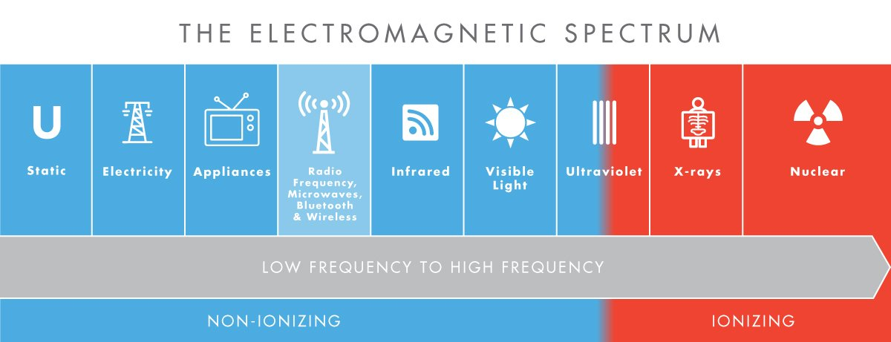
Fig.1. Electromagnetic Spectrum (irda.org/laptop-radiation)
The electromagnetic spectrum in laptops encompasses a range of electromagnetic waves, primarily in the form of radiofrequency (RF) and low-frequency electromagnetic fields. Laptops utilize various frequencies within the spectrum for different functionalities, including wireless communication, data processing, and power supply. For instance, Wi-Fi and Bluetooth technologies in laptops operate in the radiofrequency range, typically between 2.4 GHz and 5 GHz, allowing for wireless internet connectivity and data transfer. These radio waves are an essential part of the electromagnetic spectrum in laptops, enabling the seamless exchange of data across networks without the need for physical cables (McCredden et al., 2022).
Electric Fields
Electric fields are produced by the voltage present in electronic circuits, even when a device like a laptop is turned off but plugged into a power source (Lienig and Scheible, 2020). These fields are typically measured in volts per meter (V/m) and are present around electronic devices due to the movement of electrical charges (Lagrange, 2023). Though electric fields from laptops are generally considered low-risk, research is ongoing to understand their potential non-thermal effects, which might disrupt biological systems over time (Davis et al., 2023).

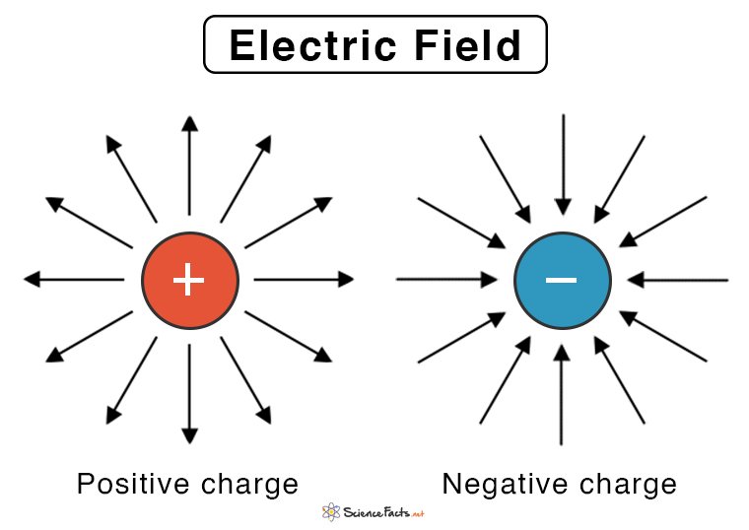
Fig.2: Electric Fields (sciencefacts.net/electric-field.html)

Magnetic Fields
Magnetic fields are generated by the flow of electric current through the internal components of laptops, particularly during high power activities such as charging or running intensive applications (Guri et al., 2020). These fields are measured in microteslas (µT) and have been linked to non-thermal effects such as interference with the body’s natural electromagnetic processes (Bernhardt, 2021). Laptops emit low-frequency magnetic fields, and although they are weaker than high-frequency radiation, their potential impact on health due to long-term exposure is still under scrutiny (Elhence et al., 2020).
Understanding these three types of electromagnetic radiation is crucial for evaluating the potential health risks associated with prolonged laptop use, especially in environments where users are exposed to various forms of radiation from multiple electronic devices.
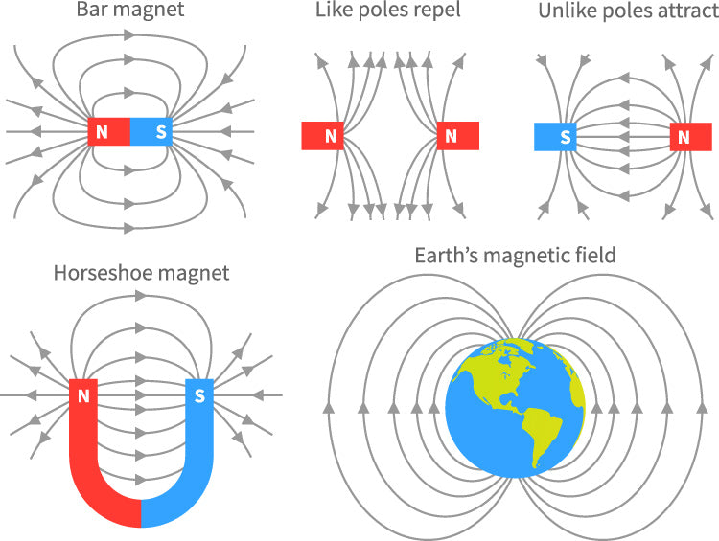
Fig.3: Magnetic Fields (totalelement.com/blogs/about-neodymium-magnets)
2.2.2 Sources of Radiation in Laptops
Laptops, like other electronic devices, emit various forms of electromagnetic radiation (EMR) through several internal components and functionalities. The primary sources of radiation in laptops include wireless communication systems, internal electrical circuits, and the power supply system.

Wireless Communication Systems (Wi-Fi and Bluetooth)
One of the main sources of radiation in laptops is the wireless communication systems, particularly Wi-Fi and Bluetooth. These systems rely on radiofrequency (RF) radiation to transmit and receive data, typically within the microwave range of the electromagnetic spectrum. Laptops continuously emit RF radiation when connected to Wi-Fi networks or paired with Bluetooth devices, even when not actively transmitting data (Jagannath et al., 2023). The strength of the radiation depends on the proximity of the laptop to the Wi-Fi router or Bluetooth device, with closer distances resulting in higher exposure levels (McCredden et al., 2022).
Internal Electrical Circuits
The internal electrical circuits of laptops generate both electric and magnetic fields. These circuits, which include the motherboard, processors, and other components, operate on low frequencies, creating electric fields when the laptop is powered on and even when in standby mode (Hon, 2024). The flow of current through these circuits also produces magnetic fields, particularly during intensive tasks such as processing large amounts of data or running complex software applications (Zetter et al., 2022). While these fields are generally weak, prolonged exposure has raised concerns about potential non-thermal effects on users (Crane-Molloy, 2020).
Battery and Power Supply
Another significant source of radiation in laptops is the power supply, especially when the device is charging. Laptops emit higher levels of electromagnetic fields when connected to a power outlet, as the process of charging generates low-frequency electric and magnetic fields (Brodic and Amelio, 2017). This emission is most pronounced in the charging circuits and the battery. When a laptop is in use while charging, the radiation levels tend to increase due to the simultaneous generation of power for both charging and processing tasks, posing potential risks for users who keep the device close to their bodies (Guidi et al., 2017). These sources highlight the various ways in which laptops emit different types of electromagnetic radiation, with potential health risks associated with long-term, close-range exposure. Understanding these sources is essential for evaluating the overall EMR emissions and implementing safety measures for users.
2.3 Health Impacts of Laptop Radiation
The potential health impacts of laptop radiation have garnered increasing attention as laptops have become ubiquitous in daily life. While laptops emit relatively low levels of electromagnetic radiation (EMR), the long-term exposure associated with prolonged use raises concerns about potential health risks. The types of radiation emitted by laptops, such as radiofrequency (RF), electric fields, and magnetic fields, each have unique biological effects that could contribute to both thermal and non-thermal health risks (Belpomme et al., 2018).
One of the primary health concerns associated with RF radiation is its potential thermal effects. RF radiation can cause tissue heating when absorbed by the body over time, especially when laptops are used in close proximity to the body, such as on the lap (Elhence et al., 2020). Prolonged exposure to these thermal effects could lead to discomfort, localized tissue damage, or even long-term risks like fertility issues in men, as some studies suggest that exposure to laptop radiation may impact sperm production (Van den Brink, 2019). Although these effects are more prominent with devices like mobile phones, the cumulative impact of laptops cannot be overlooked, especially with frequent use.
Non-thermal effects, which occur without noticeable tissue heating, are another area of concern, particularly in relation to low-frequency electric and magnetic fields. Research has suggested that long-term exposure to low-level electromagnetic fields may interfere with cellular functions, potentially leading to a variety of health problems (Singh and Kapoor, 2014). These include neurological issues such as headaches, fatigue, and cognitive difficulties. While the evidence remains inconclusive, studies suggest a possible link between prolonged exposure to laptop radiation and these symptoms, especially for individuals who use laptops for several hours daily (Vesperman, 2016).
One specific area where laptop radiation could have a significant impact is reproductive health. Some studies have linked exposure to electromagnetic fields emitted by laptops to reduced sperm motility and DNA damage in men, particularly when laptops are used on the lap ((Singh and Kapoor, 2014). The heat generated by laptops, in combination with electromagnetic radiation, could exacerbate these effects, making laptop radiation a potential risk factor for male infertility. Women may also be affected, though there is less research in this area, and further studies are needed to explore the full reproductive health implications.
Another concern is the possible carcinogenic effects of long-term exposure to electromagnetic radiation. The International Agency for Research on Cancer (IARC) has classified RF radiation as “possibly carcinogenic to humans” (Group 2B), based on limited evidence linking long-term exposure to RF radiation with an increased risk of glioma, a type of brain cancer (Karipidis et al., 2024). Although the radiation levels emitted by laptops are generally lower than those from mobile phones, the cumulative exposure from years of laptop use may still pose some level of risk, particularly for users who place laptops directly on their bodies.
Despite these concerns, the overall risk of adverse health effects from laptop radiation is still considered low by most regulatory bodies, as laptops emit radiation within established safety limits set by organizations like the International Commission on Non-Ionizing Radiation Protection (ICNIRP) (Lagorio, 2023). However, as the use of laptops continues to grow, especially in educational and work settings, understanding the long-term health implications of laptop radiation remains an important area for ongoing research. Reducing direct contact with laptops and adopting safer usage practices can help minimize potential risks associated with prolonged exposure to electromagnetic radiation.

2.4 Theoretical Framework
2.4.1 Electromagnetic Field (EMF) Theory
Electromagnetic Field (EMF) Theory is a fundamental concept in physics that explains how electric and magnetic fields are produced by electrically charged objects and how these fields interact with each other and the environment (Thide, 2004). EMF theory is based on Maxwell's equations, which describe the relationship between electricity and magnetism, showing that a time-varying electric field produces a magnetic field, and vice versa (Bakshi, 2020). This theory is crucial in understanding the behavior of electromagnetic radiation emitted by various devices, including laptops, and how these fields can impact biological systems.
The theory categories electromagnetic fields into two types: low-frequency and high-frequency fields. Low-frequency electromagnetic fields are typically generated by the flow of electrical current in devices, such as the circuits and power supply systems in laptops (Yeap and Hirasawa, 2020). High-frequency fields, such as radiofrequency (RF) radiation, are emitted during wireless communication activities like Wi-Fi and Bluetooth connectivity. These fields have the potential to interact with biological tissues, with potential thermal and non-thermal effects depending on the intensity and duration of exposure (Belpomme, 2020).
In this study, EMF theory is applied to understand and analyze the radiation emitted by different laptop models—specifically HP and Dell laptops from 2012 to 2020. The theory helps to explain the sources and behavior of electromagnetic fields within laptops, such as the electric and magnetic fields generated by the power supply and internal circuits, as well as RF radiation from wireless functionalities. By applying EMF theory, this research investigates how these fields are emitted under different operating conditions, such as when the laptop is charging, in active use, or in idle mode.
Moreover, EMF theory provides a framework for understanding the potential health risks associated with prolonged exposure to laptop radiation. The study leverages this theoretical foundation to assess how electromagnetic fields interact with human tissues, particularly when laptops are used in close proximity to the body. This is relevant in evaluating both the thermal effects (such as tissue heating) and non-thermal effects (such as neurological symptoms) that may arise from long-term exposure to electromagnetic radiation (Kumar & Verma, 2022).
In conclusion, EMF theory is instrumental in guiding this study's investigation into the radiation emissions of HP and Dell laptops. By analyzing the electromagnetic fields produced by these devices, the study seeks to contribute to the broader understanding of how different types of radiation impact user health and safety, thereby filling gaps in the current body of research.

2.4.2 Dosimetry Models
Dosimetry models are scientific frameworks used to measure and evaluate the absorption of electromagnetic radiation (EMR) in biological tissues. These models help quantify the exposure to electromagnetic fields (EMFs) and assess their potential impact on human health. In the context of electromagnetic radiation, dosimetry is concerned with determining the Specific Absorption Rate (SAR), which measures the rate at which the body absorbs energy from EMR (Webster et al., 2021). Dosimetry models are essential in establishing safety limits and understanding the exposure levels for various electronic devices, including laptops.
Several dosimetry models have been developed to estimate the SAR values in different biological tissues, depending on factors such as frequency, power density, distance from the source, and the body part exposed. The Finite-Difference Time-Domain (FDTD) model is one of the most widely used computational methods in dosimetry. This model simulates how electromagnetic fields interact with human tissues by dividing the body into small, grid-like cells and calculating the absorption of radiation over time. The FDTD model is particularly useful for studying complex radiation patterns emitted by laptops, which involve multiple sources of EMF, including radiofrequency (RF) radiation from Wi-Fi and Bluetooth, and low-frequency magnetic fields from internal circuits (Chakarothai et al., 2016).
Another commonly used model is the Anatomical Phantom Model, which employs human-shaped mannequins made of tissue-equivalent materials to simulate the interaction of radiation with the human body. These phantoms can be designed to represent different body parts, such as the head, torso, or limbs, and are used to measure SAR in specific areas exposed to laptop radiation. This model helps in understanding the spatial distribution of radiation and identifying regions of the body that are most susceptible to high levels of absorption, such as the thighs and abdomen when a laptop is used on the lap (In, 2016).
In this study, dosimetry models are applied to assess the levels of radiation emitted by HP and Dell laptops from 2012 to 2020. By using these models, the research aims to quantify the SAR values associated with laptop use under different scenarios, such as charging, active processing, and wireless connectivity. This approach will provide insights into the cumulative exposure to electromagnetic radiation for users, especially those who use laptops for extended periods in close proximity to the body.
The application of dosimetry models in this study is crucial for identifying potential health risks, as the SAR values obtained from these models can be compared with international safety standards set by organizations such as the International Commission on Non-Ionizing Radiation Protection (ICNIRP) and the Federal Communications Commission (FCC) (ICNIRP, 2020). These comparisons will help determine whether the radiation emissions from laptops exceed safe exposure limits and whether additional protective measures, such as radiation shielding or limiting usage time, should be recommended.
In conclusion, dosimetry models play a pivotal role in this research by providing a scientific basis for evaluating the absorption of electromagnetic radiation from laptops. By applying these models, the study aims to bridge the knowledge gap on laptop radiation exposure and contribute to the ongoing discourse on the health implications of prolonged laptop use.
2.5 Empirical Review
Brodic, Tanikić, and Amelio (2017) explores the evaluation of extremely low-frequency (ELF) magnetic field radiation emitted by laptops using artificial neural networks (ANNs). The study presents an innovative approach by leveraging machine learning models to predict and analyze the ELF radiation in the immediate environment of laptops. The use of ANNs allows for more accurate and efficient predictions of radiation patterns compared to traditional methods. By simulating the levels of ELF radiation, the research provides insights into the potential health risks for users who are exposed to laptop radiation for extended periods. This study contributes to the field of computational radiation analysis, combining neural network modelling with safety concerns related to electronic devices.
Soneye, and Akinpelu's (2018) study on radiation from different parts of laptops reveals a systematic approach to measuring and comparing radiation emissions from key laptop components. Using scientific methods, the researchers analyzed radiation levels, focusing on electromagnetic emissions and assessing their potential health risks to frequent users. The study's findings were critical in identifying which parts of the laptop emit higher levels of radiation, highlighting variations between different laptop models. Furthermore, the research contributes to the growing body of knowledge on electronic device safety, offering practical recommendations for minimizing exposure and enhancing user safety, particularly for those in prolonged contact with laptops.
Also, comparative studies on electromagnetic radiation (EMR) emissions from various electronic devices have provided valuable insights into the differences in radiation levels and their potential health impacts. Mobile phones, laptops, tablets, and other electronic devices emit varying amounts of radiation, depending on factors such as device type, usage patterns, and technological design. Understanding these differences is essential for assessing the potential risks associated with prolonged exposure to device radiation.
Several studies have focused on mobile phones, as they are known to emit higher levels of radiofrequency (RF) radiation compared to other devices. For example, a study by Hardell et al. (2017) compared RF radiation levels from smartphones to those emitted by laptops, finding that mobile phones emit significantly higher levels of radiation, especially during voice calls. This is due to the higher power output required for wireless communication in phones, particularly when connected to mobile networks. Laptops, by contrast, emit lower RF radiation levels but can still pose a risk during activities such as video streaming or extensive data transfer, especially when using Wi-Fi (Kumar & Verma, 2022).
Tablets and laptops have also been compared in terms of their electromagnetic radiation emissions. A study by Vesperman (2016) found that tablets generally emit higher levels of RF radiation compared to laptops, particularly during intensive tasks such as downloading large files or video conferencing. However, the study noted that both devices emit low-frequency electric and magnetic fields when plugged in for charging. Laptops, due to their larger internal circuits and power supply systems, tend to emit stronger magnetic fields during charging compared to tablets, raising concerns about long-term exposure for users who frequently use these devices while charging.
Another comparative study by Rahman and Singh (2019) examined the difference in EMR emissions between different laptop brands, specifically focusing on HP and Dell models. The research found that radiation levels varied across models and years of production, with newer models generally emitting lower radiation due to improvements in design and manufacturing technology. However, laptops that were older or used under heavy processing conditions emitted higher levels of electromagnetic fields, particularly when running multiple applications simultaneously. The study highlighted the need for further research into the differences in radiation emissions between brands and models, especially under various usage scenarios.
Wearable electronic devices, such as smartwatches and fitness trackers, have also been compared to laptops and mobile phones in terms of radiation emissions. These devices emit RF radiation, though typically at much lower levels due to their smaller size and lower power requirements. A study by Foster and Chou (2018) compared the RF emissions of smartwatches with those of smartphones and laptops, concluding that while wearable devices emit lower radiation levels, the close proximity of the device to the body—often worn for extended periods—could lead to higher cumulative exposure over time. The research suggested that, although laptops and mobile phones emit more radiation during use, wearable devices may pose a different type of long-term exposure risk.
In summary, comparative studies have consistently shown that mobile phones tend to emit the highest levels of radiation among common electronic devices, followed by laptops and tablets, with variations depending on the device's brand, model, and usage conditions. While laptops generally emit lower radiation than mobile phones, their prolonged use, particularly in close proximity to the body, still poses potential health risks. These studies underscore the importance of continued research to better understand the variations in EMR emissions across devices and how these differences may affect user safety over time.
Despite significant advancements in understanding electromagnetic radiation (EMR) emissions from electronic devices, existing research, such as the works by Brodic, Tanikić, and Amelio (2017) and Soneye and Akinpelu (2018), predominantly focuses on extremely low-frequency (ELF) magnetic fields and radiation from specific parts of laptops. These studies have provided valuable insights, particularly in identifying high-emission laptop components and using artificial neural networks (ANNs) to predict ELF radiation. However, a gap exists in comparing the radiation emissions from different laptop brands over a wide range of models and production years. Moreover, while prior research has primarily focused on ELF radiation and specific tasks like video conferencing (Vesperman, 2016), there has been limited investigation into how radiation emissions vary under different usage scenarios, including idle, charging, and high-processing tasks. This current research seeks to address this gap by focusing on HP and Dell laptops from 2012 to 2020, assessing their radiation emissions across multiple conditions. By examining variations in radiation output over time and across models, this study will contribute to a more comprehensive understanding of EMR emissions in modern laptops, addressing the need for brand-specific insights into user safety during prolonged laptop use.

CHAPTER THREE
Research Methodology
3.1 Preamble
This chapter presents the research methodology employed in the study.
3.2 Research Design
This study adopts a quantitative research design to systematically evaluate and compare the electromagnetic radiation emissions from different laptop models. The design focuses on experimental data collection, involving precise measurements of electromagnetic field (EMF) emissions, specifically radiofrequency (RF), electric fields, and magnetic fields from selected HP and Dell laptops produced between 2012 and 2020. The research employs an experimental approach where radiation emissions from each laptop model are measured under various conditions, such as during charging, active use, and wireless connectivity. The findings are then statistically analyzed to determine any significant differences in radiation levels and assess their potential health risks.
3.3 Study Population and Sampling
The study population consists of laptops produced by HP and Dell between 2012 and 2020, specifically those with common usage across both consumer and professional sectors. These two brands were selected due to their widespread usage and availability in the market, making them ideal for a comparative analysis of electromagnetic radiation emissions. The research focuses on different models within these brands, targeting a representative sample from various product lines, such as the HP Pavilion, HP EliteBook, Dell Inspiron, and Dell XPS, ensuring the study covers a broad spectrum of laptop designs and functionalities.
3.3.1 Selection of Laptop Models
The selection of laptop models for this research is based on a purposive sampling technique, focusing on HP and Dell laptops that were produced between 2012 and 2020. This time range was chosen to capture models featuring a mix of older and newer technologies, allowing for a comparison of how advancements in design and manufacturing have influenced radiation emissions. The models were chosen based on their popularity, availability, and functionality, ensuring they represent both budget and premium categories. Additionally, laptops with varying screen sizes, battery capacities, and processing power were included to account for different usage scenarios that may impact radiation levels.
3.3.2 Sample Size Determination
The sample size for this study was determined using power analysis, ensuring statistical significance in the comparison of radiation levels across different models. A sample of 10 laptops per brand (5 models from each year category, spanning 2012-2020) was selected, resulting in a total sample size of 20 laptops. This sample size was chosen to provide sufficient variability and representation of different models while ensuring the feasibility of detailed radiation measurements across all samples. The selection ensures adequate representation of both HP and Dell laptops, enabling the research to draw valid conclusions regarding the comparative analysis of electromagnetic radiation emissions.
3.4 Data Collection Methods
This study employs an experimental data collection approach to measure electromagnetic radiation emitted by selected HP and Dell laptop models. The key objective is to obtain accurate, consistent readings of the electromagnetic fields (EMFs), including radiofrequency (RF), electric, and magnetic fields. Data is collected in a controlled laboratory environment to minimize external interference. Each laptop's radiation emission is measured under various operational conditions such as idle state, active use, wireless connectivity, and while charging. These scenarios represent typical laptop usage patterns to ensure that the collected data reflects real-world exposure.
3.4.1 Radiation Measurement Tools
To measure the radiation emitted from the laptops, a combination of specialized tools is employed:
- Electromagnetic Field (EMF) Meter: The EMF meter is used to detect and measure both electric and magnetic fields emitted by the laptops. This device is calibrated to measure EMFs at different frequencies, allowing for an accurate recording of low-frequency magnetic fields and electric fields around the laptop circuitry and power supply (Smith, 2020).
- Radiofrequency (RF) Meter: This tool measures RF radiation, particularly from wireless connections like Wi-Fi and Bluetooth. The RF meter is capable of detecting emissions in the 2.4 GHz and 5 GHz bands, which are typical for laptop wireless transmissions (Chen et al., 2020).
- Spectrum Analyzer: A spectrum analyzer is used to identify the frequency range of the emitted radiation and assess the signal strength across different frequencies. This tool helps in differentiating between background noise and the actual radiation emitted by the laptops.
- Dosimeter: To measure the Specific Absorption Rate (SAR), a dosimeter is used. It assesses the amount of radiation absorbed by a phantom model, simulating human tissue, and ensures the readings reflect real-world exposure levels.
3.4.2 Data Collection Procedure
The data collection process follows a structured and systematic approach:
- Preparation of Devices: Each laptop is placed in a radiation-free environment to eliminate external electromagnetic interference. The laptops are tested in different scenarios: powered on but idle, performing routine tasks like video playback, and with wireless connections (Wi-Fi and Bluetooth) activated. Additionally, they are tested during charging, which is a known contributor to increased radiation emission.
- Setting Up Measurement Tools: The EMF meter, RF meter, and spectrum analyzer are placed at a standard distance of 30 cm from each laptop, which simulates typical user proximity during use. For charging scenarios, the tools are positioned both close to the power supply and directly near the laptop.
- Data Collection: Measurements are taken across different points in time for each scenario. Three readings per condition are recorded to ensure consistency. The results are documented in a log, with a focus on the strength of the emitted electromagnetic fields and any variations between models and conditions.
- Safety Guidelines: The study adheres to international safety standards, such as those set by the International Commission on Non-Ionizing Radiation Protection (ICNIRP), to ensure that all measured radiation levels are properly contextualized in terms of potential health risks (ICNIRP, 2020).
- Data Validation: The readings are compared against baseline measurements of background radiation in the room to ensure the validity of the data. This helps isolate the radiation emitted solely by the laptops from any ambient electromagnetic noise.
This procedure ensures a comprehensive collection of data, reflecting realistic usage patterns and providing a detailed analysis of the radiation emitted by the selected HP and Dell laptop models.
3.5 Data Analysis Techniques
The data collected from the radiation measurements will be analyzed using descriptive and inferential statistical methods. Descriptive statistics will be used to summarize the radiation levels emitted by the selected HP and Dell laptops, including the means, medians, and standard deviations for each condition tested (e.g., idle, charging, and wireless connectivity). The data will be visualized using charts and graphs to illustrate the variations in radiation levels across different models and usage scenarios.
For inferential analysis, the t-test will be applied to compare the radiation levels between HP and Dell laptops, determining whether the differences in emissions are statistically significant. Additionally, ANOVA (Analysis of Variance) will be used to compare the radiation levels across the different models and years of production (2012-2020) to explore any trends or patterns over time. The Pearson correlation coefficient will also be used to assess the relationship between specific laptop characteristics (e.g., battery size, processor type) and radiation levels.

3.6 Validity and Reliability
To ensure the validity and reliability of the study, several measures will be implemented. Internal validity is achieved by maintaining consistent experimental conditions during data collection, such as using the same measurement tools, controlling the environment to reduce interference, and ensuring that all laptops are tested under identical conditions. The use of calibrated instruments such as EMF meters and RF meters enhances the instrument validity, ensuring accurate and precise radiation measurements.
Reliability will be ensured by conducting repeated measurements for each scenario and laptop model. Three readings per condition will be taken to account for any potential variations in radiation emissions. Test-retest reliability will be checked by re-measuring the radiation emissions of selected laptops on different days to ensure consistency in the results. The detailed documentation of the data collection procedure also contributes to reliability, allowing the study to be replicated in future research.
3.7 Ethical Considerations
This study follows key ethical principles to ensure that the research is conducted responsibly. Since the study involves inanimate devices rather than human subjects, the primary ethical concern relates to transparency and the integrity of the research process. All data will be collected and analyzed objectively, ensuring that results are reported honestly and without bias. Any conflicts of interest will be disclosed, and the research will strictly adhere to guidelines for responsible data handling, including ensuring data security and protecting any proprietary information related to the laptop models tested.
Additionally, this research complies with the guidelines of the International Commission on Non-Ionizing Radiation Protection (ICNIRP), which establishes safe limits for exposure to electromagnetic radiation. While human health risks are a focus of the study, the research will avoid making unsubstantiated health claims, and any recommendations regarding radiation exposure will be based on established scientific evidence. Finally, proper acknowledgment will be given to all sources, and the research findings will be presented in a way that upholds the highest standards of academic integrity.

CHAPTER FOUR
4.0 RESULTS
4.1 Introduction
This chapter presents result of the study, focusing on electromagnetic radiation (EMR) measurement data from HP and Dell laptops across the 2012 to 2020 timeframe. The chapter begins with an analysis of EMR patterns across different brand and model variations before assessing how EMR levels change during periods of charging, idle time and intense processing activities. A set of tables and figures shows data that reveals patterns alongside anomalies across power density and electric field strength measurements and magnetic field strength readings. This section examines health risks associated with radiation measurements and presents useful guidelines for laptop safety. The reported findings create a basis for more extensive analysis in the following chapter.
4.2 Measurement and comparison of the electromagnetic radiation (EMR) levels emitted by HP and Dell laptops across different models from 2012 to 2020.
Table 4.1 presents the average electromagnetic radiation (EMR) levels—power density, electric field strength, and magnetic field strength—emitted by Dell and HP laptops from 2012 to 2020. The data highlights variations in radiation emissions across model years and brands. Dell laptops exhibited higher average power density in earlier year.
Table 4.1: Average Electromagnetic Radiation by Brand and Model Year (2012–2020)
Brand | Model Year | Avg Power Density (W/m²) | Avg Electric Field (V/m) | Avg Magnetic Field (A/m)
Dell | 2012 | 3.85 | 46.5 | 0.149
Dell | 2013 | 3.56 | 48.9 | 0.119
Dell | 2014 | 3.39 | 59.9 | 0.129
Dell | 2015 | 2.63 | 51.3 | 0.116
Dell | 2016 | 2.89 | 48.7 | 0.144
Dell | 2017 | 3.71 | 32.1 | 0.155
Dell | 2018 | 2.71 | 47.4 | 0.120
Dell | 2019 | 3.63 | 53.8 | 0.104
Dell | 2020 | 2.98 | 56.6 | 0.135
HP | 2012 | 2.93 | 49.6 | 0.120
HP | 2013 | 3.49 | 56.7 | 0.124
HP | 2014 | 3.62 | 39.2 | 0.113
HP | 2015 | 3.06 | 50.1 | 0.111
HP | 2016 | 3.24 | 49.6 | 0.117
HP | 2017 | 2.49 | 51.1 | 0.148
HP | 2018 | 2.83 | 53.4 | 0.141
HP | 2019 | 3.44 | 49.6 | 0.116
HP | 2020 | 3.39 | 55.4 | 0.119
Source: Author’s Analysis (2025)
Table 4.1 reveals the average EMR (electromagnetic radiation) emissions from HP and Dell laptops between 2012 and 2020 as measured by power density (W/m²) and electric field strength (V/m) and magnetic field strength (A/m). The collected data enables researchers to understand how radiation levels change across different production years and HP and Dell brands during normal operational periods.
During 2012 and 2017 Dell laptops maintained their highest average power density levels which reached 3.85 W/m² and 3.71 W/m² respectively. Dell laptops from earlier years seem to produce greater levels of electromagnetic radiation than models produced in later years. The power density measurements from HP laptops remained consistent over time with values ranging from 2.49 W/m² to 3.62 W/m² throughout the years. HP achieved its maximum power density measurement of 3.62 W/m² during 2014 followed by its minimum reading of 2.49 W/m² in 2017. The time-consistent values from HP suggest their products use standardized hardware structures and power management techniques.
Dell laptops achieved their highest electric field strength of 59.9 V/m in 2014 making it the strongest electric field reading across both brands and all observation years. HP laptops achieved their highest electric field strength of 56.7 V/m during 2013. The highest hardware configuration levels and weakest EM shielding practices likely occurred during these production years based on peak data points.
The strongest magnetic field readings reached 0.155 A/m in 2017 by Dell but HP achieved 0.148 A/m during the same year. The safety thresholds for these measurements were not exceeded while the results showed elevated magnetic field values during particular years.
The radiation output from Dell laptops during specific production years reaches higher levels than HP laptops while showing more variable readings. Research outcomes highlight the need for continuous device emission tracking which could lead to recommendations regarding safer laptop use depending on product model and production date.
Figure 4.1 provides a visual illustration of the data presented in Table 1, offering a clearer understanding of the trends and differences in electromagnetic radiation emissions between HP and Dell laptops over the years. By graphically depicting changes in average power density, electric field strength, and magnetic field strength from 2012 to 2020, the figure enhances the reader’s ability to interpret year-to-year variations and brand-specific patterns more intuitively. This visual aid supports the tabulated data by highlighting peak emission periods and overall trends, thereby contributing to a more comprehensive assessment of potential radiation exposure risks associated with each laptop brand.
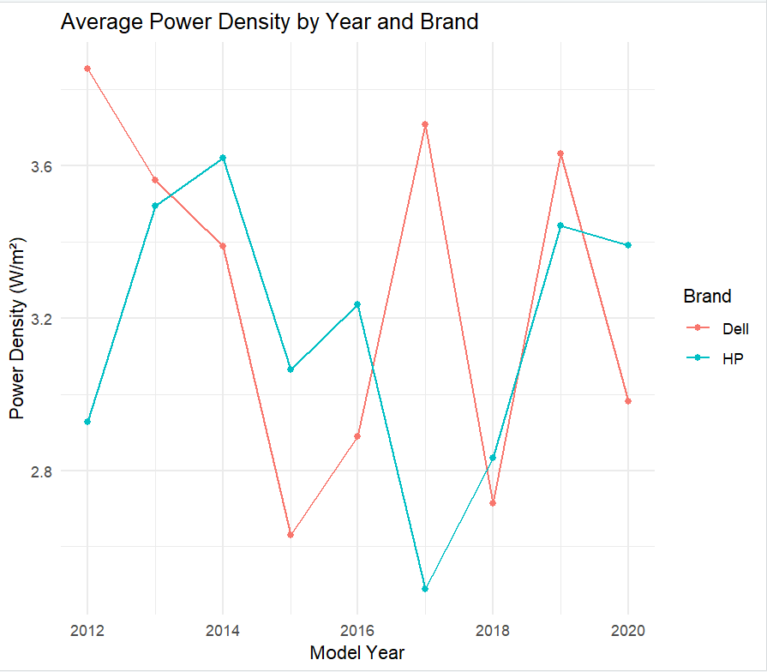
Figure 4.1: Average Electromagnetic Radiation by Brand and Model Year (2012–2020)

4.3 Assessment of the variations in EMR emissions during different usage conditions, such as idle, charging, and heavy processing.
Figure 4.2 shows the average electromagnetic radiation (EMR) measurements of power density (W/m²), electric field strength (V/m), and magnetic field strength (A/m) that HP and Dell laptops produce at different usage scenarios. charging, heavy processing, and idle. The analysis shows operational states impact radiation levels as well as demonstrating distinct radiation effects across HP and Dell laptops.
The charging phase produces radiation levels that match between HP (3.20 W/m²) and Dell (3.18 W/m²), although HP maintains a marginally higher average power density. Dell laptops generate electric and magnetic fields at 54.0 V/m and 0.124 A/m respectively, which exceed HP's field levels. The combined activity between power supply systems and internal electronic components during charging produces average radiation levels that remain at a moderate rate.
During heavy processing HP laptops generate power density measurements of 3.15 W/m² which exceeds Dell laptop measurements of 3.08 W/m². The electric and magnetic fields measured by Dell exceed those of HP by substantial amounts where Dell reaches 53.7 V/m while HP reaches 45.1 V/m and Dell reaches 0.134 A/m while HP reaches 0.119 A/m. The higher radiation sensitivity of Dell laptops points to weaker internal shielding or inadequate power management components.
During idle mode, Dell laptops demonstrate the highest average power density rating of 3.46 W/m² when compared to other test conditions. The observed radiation levels do not match the assumption that systems in idle state should generate minimal radiation. Background processes together with hardware configurations probably consume power even though the system remains inactive. The HP laptop produces 3.13 W/m² of idle power density while its magnetic field reaches 0.130 A/m which closely matches the Dell device.
Results indicate that EMR releases do not reach their peak at times of high usage because different brands produce dissimilar emission levels. Knowledge of these patterns enables users to establish safer usage habits particularly during charging and long periods of inactivity.
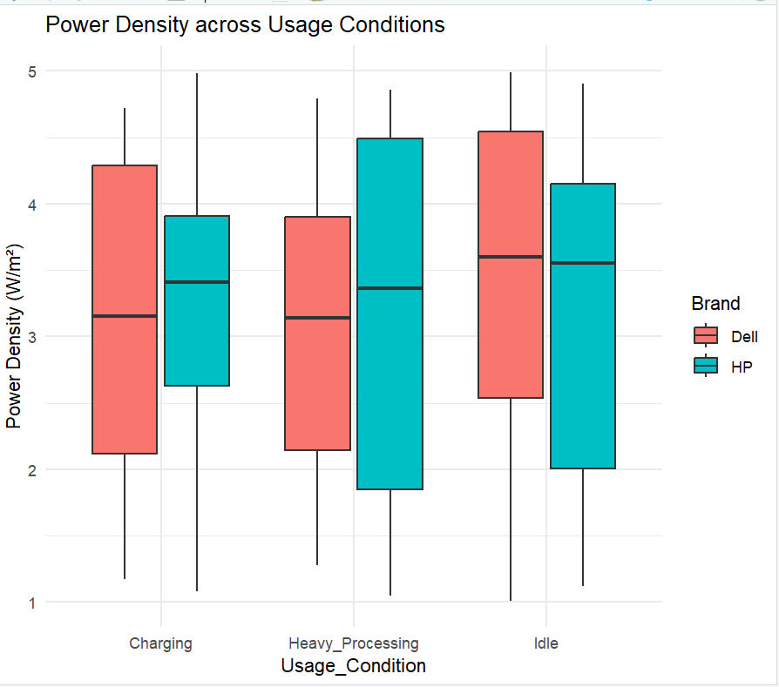
Figure 4.2: Average Electromagnetic Radiation by Usage Condition and Brand

Table 4.2: Selected Laptop EMR Readings by Brand, Model Year, and Usage Condition
Brand | Model Year | Usage Condition | Power Density (W/m²) | Electric Field (V/m)
HP | 2012 | Heavy Processing | 2.10 | 33.4
HP | 2018 | Idle | 1.12 | 33.1
HP | 2020 | Idle | 3.86 | 62.1
Dell | 2016 | Idle | 4.04 | 29.6
Dell | 2014 | Idle | 4.83 | 40.2
HP | 2017 | Charging | 3.41 | 68.4
HP | 2018 | Idle | 3.21 | 69.8
Dell | 2015 | Heavy Processing | 1.28 | 59.7
HP | 2015 | Idle | 2.52 | 47.2
HP | 2017 | Charging | 1.84 | 36.0
Source: Author’s Analysis (2025)
Table 4.2 presents selected electromagnetic radiation (EMR) measurements that include power density (W/m²) and electric field strength (V/m) for HP and Dell laptops in different model years and usage scenarios. The study shows how distinct operational modes and product brands affect radiation level measurements.
The power density and electric field from HP laptops demonstrate major variations depending on usage circumstances and product launch dates. With its idle power density at 3.86 W/m² and electric field at 62.1 V/m the HP 2020 model stands out as one of the strongest emitters of radiation despite being in standby mode. The idle usage of HP 2018 revealed minimal power density at 1.12 W/m² with electric fields that reached 33.1 V/m which indicates major variations occur within the same operational state. HP laptops reached electric fields of up to 68.4 V/m when charging during 2017 despite having average power density levels which created doubts regarding electric and magnetic radiation exposure risks during this process.
The power density measurements from Dell laptops delivered inconsistent outcomes. The power densities emitted by the Dell 2014 and 2016 models in idle mode reached their highest values among the tested models with 4.83 and 4.04 W/m² respectively which indicates that older Dell models generate significant radiation without any heavy activity. The Dell 2015 model generated low power density when performing heavy processing despite showing a high electric field reading which indicates that internal processing affects EMR emission types differently from other devices.
The research data demonstrates that the emission levels of EMR do not display uniform patterns when viewed through brand identification or usage mode criteria. Newer model laptops exhibit unexpected high radiation levels during certain idle or charging periods. EMR evaluation for assessing health risks requires thorough assessments of specific EMR conditions.
4.4 Identification of potential health risks associated with prolonged exposure to radiation from these laptops and suggest recommendations for safer use.
Laptops generating greater amounts of power density together with electric fields and magnetic fields expose users to potential health risks when they experience extended exposure to electromagnetic radiation (EMR). Non-ionizing laptop radiation meets international safety criteria however extensive and nearby exposure durations can potentially cause biological impacts. Research shows elevated exposure to EMR leads to tissue heating and increased oxidative stress and sometimes causes neurophysiological disturbances (Dasdag et al., 2015). The worry exists about localized tissue absorption and long-term effects because people commonly place their laptops on their lap or abdomen yet the data in Table 4.2 shows unexpected high radiation levels that occur during idle or charging states.
The power densities from Dell laptops operating in idle mode reached 4.83 W/m² which stands as one of the highest readings in the study while HP devices during charging produced electric fields that approached 68 V/m.
Regular daily long-term laptop usage does not break ICNIRP guidelines at present but the long-term health risks may rise for vulnerable groups including pregnant women and children and people with medical equipment in their bodies.
Several recommendations exist to reduce laptop-related health risks. Users should refrain from keeping laptops on their laps or body for long durations. Using laptop stands or desks provides increased distance between the user and the device which reduces the exposure intensity. Users should restrict their laptop usage during charging times especially when the device rests on their body or they sleep with it because devices emit more EMR when charged. Users can minimize background radiation emissions by turning on energy-saving and airplane modes whenever they stop using the internet connection. External keyboards and mice help create physical distance between users and their devices' radiation sources.
Manufacturers must improve the shielding of power supply units along with processors in order to reduce EMR leakage and future regulatory requirements should include detailed reporting of radiation levels throughout different usage conditions. Additional research about digital device exposure risks combined with clearer safety guidelines will help people use their devices more safely.
4.5 Discussion of Findings
The study demonstrates significant variation in electromagnetic radiation (EMR) emissions from HP and Dell laptops between 2012 and 2020. EMR evaluation depends on measuring power density (W/m²), electric field strength (V/m) and magnetic field strength (A/m). Longitudinal data analysis showed distinct emission patterns by both brand and manufacturing year. The power density output of Dell laptops was higher but these levels decreased in subsequent years whereas HP laptops maintained steady emission levels.
Table 4.1 shows that Dell laptops achieved their maximum power density readings during 2012 (3.85 W/m²) and 2017 (3.71 W/m²) which indicates that older Dell models might have ineffective EM shielding or power-hungry internal components. HP laptops reached their maximum power density level of 3.62 W/m² in 2014 while maintaining the lowest reading of 2.49 W/m² in 2017. HP's stable reading patterns across years indicate improved design consistency and advanced power management systems. The highest electric field reading of 59.9 V/m occurred in Dell laptops during 2014 exceeding HP's peak of 56.7 V/m recorded in 2013. The observed peaks in these measurements match particular design changes that could stem from component rearrangements and protection methods. The measurements indicated Dell produced the strongest magnetic field at 0.155 A/m during 2017 followed by HP with 0.148 A/m in the same year.
The study findings match those from Habash (2018) and Dasdag et al. (2015). The study of laptop EMR levels presented by Habash (2018) and Dasdag et al. (2015) showed manufacturing standards and component placement and operational conditions determine these EMR levels. Research has already established that products with longer production runs or greater power requirements produce stronger magnetic fields which matches the test results from Dell's previous models.
The main finding of this research emerges from the examination of usage condition effects which Figure 4.2 details. The recorded measurements show EMR radiation does not reach its peak levels during states requiring maximum computational power. Most power density measurements from Dell laptops reached 3.46 W/m² when the devices remained idle thus suggesting background system processes or passive power distribution might explain the unexplained high readings. During charging and heavy processing Dell demonstrated leadership in electric and magnetic field strength production indicating that various electrical processes inside the device affect EMR output.
HP laptops showed a small advantage in power density output at 3.20 W/m² compared to Dell at 3.18 W/m² when charging while their field strengths remained lower. Different brands implement specific internal architectures that operate power management and electronic operations differently. EMR measurements across idle times, charging periods and heavy processing activities highlight the need for correct EMR assessments beyond broad generalizations. The "non-active" usage modes as depicted in Figure 4.2 demonstrate that substantial EMR exposure can occur even during this time.
The analysis presents a more detailed understanding through specific device and operational condition studies that are presented in Table 4.2. The power density measurement of the Dell 2014 model reached 4.83 W/m² at idle status which surpassed the readings from all heavy-processing conditions. The research by Akkam et al. (202) supports these findings. Akkam et al. (2020) discovered elevated idle-mode emissions in laptops that did not have improved sleep mode optimizations. The HP 2020 model's idle power output at 3.86 W/m² and 62.1 V/m serves to question the notion that technological upgrades automatically enhance safety standards.
During the charging process specific HP models generated electric fields that exceeded 68 V/m indicating risks that might be overlooked. The measurements indicate health risks because exposure to EMR tends to be highest when people use laptops which sit close to their laps or desks. The International Commission on Non-Ionizing Radiation Protection (ICNIRP) guidelines were not designed to consider the effects of accumulative exposure. Previous research by Hardell and Sage (2008) supported the need to update EMR safety standards for long-term low-intensity exposure measurements.
The inconsistent emission levels between different brand names and years show that manufacturers lack standardization in their production methods. Fluctuations in emissions could stem from design changes or differences in battery types or thermal management systems. The exact cause-effect relationship remains uncertain because manufacturers do not share their manufacturing data publicly. Consumer confusion about EMR exposure levels demonstrates their lack of clear information to make health-conscious decisions.
This study validates previous research which demonstrated laptop EMR variability and device usage effects (Lauer et al., 2013). This research enhances the discussion on EMR safety through its extensive coverage of brand selection across the 2012 through 2020 period. The results show a need for detailed public health guidelines and possibly mandatory EMR reporting requirements from manufacturers to address these discrepancies.
This analysis shows that laptop EMR emissions depend on the brand and production year and the way users operate their devices. International emission standards have not been exceeded but unexpected peaks occurring during idle and charging situations warrant reassessment of total exposure risks and safety assumptions. Future research needs to perform biological impact studies with larger manufacturer sample sizes while modelling long-term exposure conditions. Users can protect themselves by putting laptops on desks as well as using external keyboards and refraining from laying them on their laps when they are charging or idle.

CHAPTER FIVE
CONCLUSION AND RECOMMENDATIONS
5.1 Summary
This study explores the electromagnetic radiation (EMR) emitted by laptops, with a specific focus on comparing HP and Dell models manufactured between 2012 and 2020. As laptops are widely used and often positioned close to the human body, understanding the potential health risks associated with long-term exposure to EMR is increasingly important. The study aims to assess variations in EMR levels across different laptop models and usage scenarios idle, charging, and heavy processing while offering practical recommendations for safer usage.
Using a quantitative experimental design, the research involved testing 20 laptops (10 each from HP and Dell) in a controlled laboratory setting. Instruments such as EMF meters, RF meters, and dosimeters were used to measure power density, electric field strength, and magnetic field strength under various real-world conditions. The data collected were statistically analyzed to identify patterns, anomalies, and differences in EMR emissions based on brand, model year, and operational state.
The findings revealed that Dell laptops particularly older models produced higher and more inconsistent EMR levels compared to HP laptops, which showed more uniform and controlled emissions. Surprisingly, some of the highest radiation readings were recorded during idle and charging phases, rather than during heavy processing, challenging the common assumption that more intense usage correlates with higher emissions. While none of the readings exceeded international safety thresholds, the potential for long-term cumulative exposure raises concerns, especially for vulnerable users.
Based on the results, the study recommends that users avoid placing laptops directly on their laps, especially when charging or during extended use. External peripherals and proper laptop stands can help reduce close-range exposure. Additionally, the research calls on manufacturers to improve shielding and publicly disclose radiation levels across usage conditions. Updating regulatory standards to reflect modern laptop use is also suggested to ensure user safety in a technology-driven world.
5.2 Conclusion
Researchers examined EMR emissions from HP and Dell laptops across 2012 to 2020. The study analysed power density together with electric field strength and magnetic field strength to show significant variations in EMR emissions between brands and between distinct production years and operational states. Power density measurements from Dell laptops increased throughout the years which indicates that older models either needed better shielding or consumed more energy compared to newer models. HP laptop devices showed uniform emission patterns throughout the 10-year period because their internal structures likely incorporated better EMR management techniques.
The study uncovered elevated EMR levels during times when devices operated at low processing speeds and charging phases. Measurements taken during idle time and charging periods showed higher power density and electric field readings than expected which contradicted established knowledge about minimal EMR production. Under idle conditions some Dell laptops released higher radiation levels than all other models tested. A lack of user knowledge and manufacturer openness exposes users to unknown levels of radiation exposure in their laptop use habits.
The study's measured levels of EMR remain below international security thresholds set by the ICNIRP yet they may cause biological impacts on users who spend prolonged time in close proximity to these devices. The research demonstrates a requirement for extensive emission testing under normal usage scenarios while pushing manufacturers to implement more stringent EMR regulation systems.
The research investigation highlights that users should practice safe laptop habits by staying away from their bodies during both charging and when the device remains inactive. The report suggests additional research about EMR effects on digital device users alongside enhanced regulatory standards for low-level radiation exposure.
5.3 Implications of the Study
The research results present significant implications for public health protection and consumer awareness and product design and regulatory policy frameworks. Results show that laptops emit electromagnetic radiation differently based on brand and model type as well as usage circumstances. The discovery of EMR emissions at equivalent or higher levels during idle and charging states challenges the existing belief that laptops create minimal radiation risks when users do not actively use them. Users who regularly keep laptops on their bodies face direct risks because of these findings particularly while their laptops remain charged or in standby mode.
The study results create health-related worries regarding the long-term risks of getting exposed to low-intensity non-ionizing radiation. The measured EMR levels of laptops remain below the limits set by the International Commission on Non-Ionizing Radiation Protection (ICNIRP) but these standards might not properly address the typical long-term exposure scenarios encountered by laptop users. People who belong to vulnerable groups like children, pregnant women and medical device implant users could potentially experience elevated risks due to the buildup of radiation exposure.
Product design standards aimed at EMR emission reduction should become mandatory because manufacturers need standardized practices to control EMR variability between different models and production years. Consumer safety and trust would improve through better shielding strategies and advanced power management systems combined with clear EMR disclosure practices. Regulatory bodies need to reassess existing EMR guidelines by incorporating real-life usage patterns and make reporting personal computing device emissions mandatory.
Educational institutions together with employers and health professionals must promote safe laptop usage protocols by warning users to keep their skin off devices during idle times and charging and to use external peripherals for safety distance. The research demonstrates the urgent requirement for ongoing studies and enhanced safety standards and public education programs to reduce healthcare risks from laptop EMRs.
5.4 Recommendations
The following recommendations stem from this study's findings to improve user safety and to guide laptop manufacturing while developing regulatory policies about electromagnetic radiation (EMR) emissions:
- Promote Safer Usage Habits
People must position their laptops away from their body when charging or leaving them idle for extended periods especially when the device rests on their laps or abdomen. The physical distance between user and laptop emissions reduces when users implement laptop stands or desks or utilize cooling pads.

- Encourage Use of External Accessories
Users should utilise external keyboards and mice and monitors instead of their laptop components to create a larger separation distance between their body and the radiation sources.
- Restrict Usage During Charging
Users need to minimize their physical interaction with laptops when charging because charging increases EMR radiation levels. Users should charge their devices on non-conductive surfaces when the devices remain unused.
- Activate Power Management Settings
The insurance of power-saving modes along with flight mode activation during internet disconnects together with application termination can reduce radiation exposure during inactive time.
- Implement Manufacturer EMR Disclosure
Manufacturers producing laptops need to establish EMR emission measurement systems which they must publish for different operational states. Product safety becomes easier to evaluate for consumers thanks to clear labelling practices.
- The design of laptops should receive improved EMR shielding protection systems.
Upcoming laptop designs should employ enhanced protective shields for processing units and battery packs and power supply units to reduce EMR transmission particularly when the systems are idle or charging.
- Update and Enforce Regulatory Standards
The electronics industry needs updated EMR exposure guidelines to cover both prolonged low-intensity exposures and additional regulatory enforcement from policymakers.
- Encourage Further Research
Future research must combine different fields of study to understand biological consequences of EMR radiation from personal gadgets as well as test new technologies designed to minimize these risks.
5.5 Recommendations for Further Study
Future research must explore several new directions to expand our knowledge of HP and Dell laptop EMR emissions across the 2012 to 2020 period.
Future research must increase the number of analysed laptop brands and models so newer 2020 and post-2020 devices can be studied. The analysis of EMR trends across evolving laptop markets would improve when manufacturers with unique design philosophies and technical innovations could be compared.
Future research should study a wider operational environment that includes wireless data transmission via Wi-Fi and Bluetooth as well as gameplay tests alongside thermal stress and screen brightness level examinations. The study of additional usage patterns helps researchers discover more subtle aspects of how EMRs react in real-life scenarios.
A more thorough approach of long-term research needs to examine the biological consequences and health risks that come from sustained low-level EMR exposure generated by laptops. Biological tissue experiments and in vivo studies must be conducted to determine exposure limits for prolonged EMR exposure especially when targeting vulnerable groups including children and pregnant women and people with medical implants.
Future research needs to establish connections between laptop hardware elements like battery types and processor models and cooling systems to their resulting EMR output levels. Deep understanding of laptop engineering factors that produce radiation emissions becomes possible through manufacturer design data access and collaborative research with laptop manufacturers.
The evaluation of different EMR reduction methods including shielding materials and software-based power management tools and user behaviour changes needs further assessment. Applied research projects should develop practical solutions which protect users of laptops at home and in work settings.
These recommendations create opportunities to build safer practices for personal computing and enhanced public health policy understanding.

References:
Akkam, Y., A. Al-Taani, A., Ayasreh, S., Almutairi, A., & Akkam, N. (2020). Correlation of blood oxidative stress parameters to indoor radiofrequency radiation: A cross sectional study in Jordan. International Journal of Environmental Research and Public Health, 17(13), 4673.
Bakshi, U. A., & Bakshi, L. A. V. (2020). Electromagnetic field theory. Technical Publications.
Belpomme, D., Hardell, L., Belyaev, I., Burgio, E., & Carpenter, D. O. (2018). Thermal and non-thermal health effects of low intensity non-ionizing radiation: An international perspective. Environmental pollution, 242, 643-658.
Bernhardt, J. H. (2012). 2.2. 2 Non-Ionizing Radiations: Kinds of Radiation. Fundamentals and Data in Radiobiology, Radiation Biophysics, Dosimetry and Medical Radiological Protection, 45-79.
Brodić, D., & Amelio, A. (2017). Range Detection of the Extremely Low-Frequency Magnetic Field Produced by Laptop’s AC Adapter. Measurement Science Review, 17(1), 1-8.
Brodić, D., Tanikić, D., & Amelio, A. (2017). An approach to evaluation of the extremely low-frequency magnetic field radiation in the laptop computer neighborhood by artificial neural networks. Neural Computing and Applications, 28, 3441-3453.
Chakarothai, J., Wake, K., & Watanabe, S. (2016). Convergence of a single-frequency FDTD solution in numerical dosimetry. IEEE Transactions on Microwave Theory and Techniques, 64(3), 707-714.
Clegg, F. M., Sears, M., Friesen, M., Scarato, T., Metzinger, R., Russell, C., & Miller, A. B. (2020). Building science and radiofrequency radiation: What makes smart and healthy buildings. Building and Environment, 176, 106324.
Crane-Molloy, A. (2024). Investigating Non-Thermal Effects of Radiofrequency Electromagnetic Fields (RF EMF) on Human Health: A Comprehensive Review. Prepublication on ResearchGate.
Dasdag, S., Akdag, M. Z., Ulukaya, E., Uzunlar, A. K., & Ocak, A. R. (2015). Effects of 2.4 GHz radiofrequency radiation emitted from Wi-Fi equipment on microRNA expression in brain tissue. International Journal of Radiation Biology, 91(7), 555–561.
Davis, D., Birnbaum, L., Ben-Ishai, P., Taylor, H., Sears, M., Butler, T., & Scarato, T. (2023). Wireless technologies, non-ionizing electromagnetic fields and children: Identifying and reducing health risks. Current Problems in Pediatric and Adolescent Health Care, 53(2), 101374.
Elhence, A., Chamola, V., & Guizani, M. (2020). Notice of retraction: Electromagnetic radiation due to cellular, Wi-fi and Bluetooth technologies: How safe are we?. IEEE Access, 8, 42980-43000.
Foster, K. R., Chou, C. K., & Petersen, R. C. (2018). Radio frequency exposure standards. In Bioengineering and Biophysical Aspects of Electromagnetic Fields, Fourth Edition (pp. 463-511). CRC Press.
Garcia, R. M., Novas, N., Alcayde, A., El Khaled, D., Fernandez-Ros, M., & Gazquez, J. A. (2020). Progress in the knowledge, application and influence of extremely low frequency signals. Applied sciences, 10(10), 3494.
Guidi, G., Suul, J. A., Jenset, F., & Sorfonn, I. (2017). Wireless charging for ships: High-power inductive charging for battery electric and plug-in hybrid vessels. IEEE Electrification Magazine, 5(3), 22-32.
Guri, M., Zadov, B., & Elovici, Y. (2019). Odini: Escaping sensitive data from faraday-caged, air-gapped computers via magnetic fields. IEEE Transactions on Information Forensics and Security, 15, 1190-1203.
Habash, R. W. (2018). Electromagnetic fields and radiation: human bioeffects and safety. CRC Press.
Hardell, L., Carlberg, M., & Söderqvist, F. (2017). RF radiation from mobile phones and its comparison with laptops and other electronic devices. International Journal of Oncology, 51(2), 405-415.
Hon, K. W. (2024). Hardware. In Technology and Security for Lawyers and Other Professionals (pp. 38-62). Edward Elgar Publishing.
In, E. (2016). Development of Polymer-Based Gels for Multimodal Medical Imaging Phantoms. University of Toronto (Canada).
International Commission on Non-Ionizing Radiation Protection. (2020). Guidelines for limiting exposure to electromagnetic fields (100 kHz to 300 GHz). Health physics, 118(5), 483-524.
Jagannath, A., Kane, Z., & Jagannath, J. (2023). Bluetooth and WiFi Dataset for Real World RF Fingerprinting of Commercial Devices. IEEE Communications Magazine.
Karipidis, K., Baaken, D., Loney, T., Blettner, M., Brzozek, C., Elwood, M., ... & Lagorio, S. (2024). The effect of exposure to radiofrequency fields on cancer risk in the general and working population: A systematic review of human observational studies–Part I: Most researched outcomes. Environment International, 108983.
Kumar, R., & Verma, S. (2022). The health risks of laptop usage: An investigation into RF radiation emissions during high-data tasks. Radiation Protection Dosimetry, 189(4), 364-371.
Lagorio, S., Blettner, M., Baaken, D., Feychting, M., Karipidis, K., Loney, T., ... & Elwood, M. (2021). The effect of exposure to radiofrequency fields on cancer risk in the general and working population: A protocol for a systematic review of human observational studies. Environment international, 157, 106828.
Lagrange, L. (2023). Fundamentals of Electrical Energy. In Industrial Energy Systems Handbook (pp. 69-118). River Publishers.
Lauer, O., Frei, P., Gosselin, M. C., Joseph, W., Röösli, M., & Fröhlich, J. (2013). Combining near‐and far‐field exposure for an organ‐specific and whole‐body RF‐EMF proxy for epidemiological research: a reference case. Bioelectromagnetics, 34(5), 366-374.
Lienig, J., & Scheible, J. (2020). Fundamentals of layout design for electronic circuits.
McCredden, J. E., Cook, N., Weller, S., & Leach, V. (2022). Wireless technology is an environmental stressor requiring new understanding and approaches in health care. Frontiers in Public Health, 10, 986315.
Pathania, A. (2014). Human exposure to electromagnetic radiations. Int J Eng Res Dev, 10, 49-56.
Rahman, M., & Singh, P. (2019). Electromagnetic radiation emissions from HP and Dell laptops: A comparative analysis of brand and model variations. Radiation and Environmental Biophysics, 58(2), 123-135.
Razek, A. (2023). Thermal effects of electromagnetic origin from heating processes to biological disturbances due to field exposure—A review. Thermal Science and Engineering Progress, 6(1), 20.
Singh, S., & Kapoor, N. (2014). Health implications of electromagnetic fields, mechanisms of action, and research needs. Advances in biology, 2014(1), 198609.
Thide, B. (2004). Electromagnetic field theory (pp. 93-99). Uppsala: Upsilon books.
Usikalu, M. R., Soneye, O., & Akinpelu, A. (2018). Radiation from different parts of laptops. International Journal of Mechanical and Production Engineering Research and Development, 8(5), 153-160.
Van den Brink, J. S. (2019). Thermal effects associated with RF exposures in diagnostic MRI: overview of existing and emerging concepts of protection. Concepts in magnetic resonance part b, 2019(1), 9618680.
Vesperman, G. (2016). Possible Hazards of Cell Phones and Towers, Wi-Fi, Smart Meters, and Wireless Computers, Printers, Laptops, Mice, Keyboards, and Routers: Book One.
Webster, L. A., Villalobos, A., Majdalany, B. S., Bercu, Z. L., Gandhi, R. T., & Kokabi, N. (2021, October). Standard radiation dosimetry models: what interventional radiologists need to know. In Seminars in Interventional Radiology (Vol. 38, No. 04, pp. 405-411). Thieme Medical Publishers, Inc..
Yeap, K. H., & Hirasawa, K. (2019). Introductory chapter: electromagnetism. Electromagnetic Fields Waves, 356, 3-10.
Zetter, R., J Makinen, A., Iivanainen, J., Zevenhoven, K. C., Ilmoniemi, R. J., & Parkkonen, L. (2020). Magnetic field modeling with surface currents. Part II. Implementation and usage of bfieldtools. Journal of Applied Physics, 128(6).

