KWARA STATE POLYTECHNIC, ILORIN
INSTITUTE OF TECHNOLOGY
DEPARTMENT OF CIVIL ENGINEERING

ASSESS AND ANALYZE TRAFFIC
DELAYS AT THE OJA-OBA ROUNDABOUT, A 4LEGGED INTERSECTION IN ILORIN, KWARA STATE.

BY
KAYODE JOHN KEHINDE
HND/23/CEC/FT/0029

BEING A RESEARCH WORK SUBMITTED TO THE DEPARTMENT OF CIVIL ENGINEERING, INSTITUTE OF TECHNOLOGY, KWARA STATE POLYTECHNIC, ILORIN KWARA STATE

IN PARTIAL FULFILMENT OF THE REQUIREMENT FOR THE AWARD OF HIGHER NATIONAL DIPLOMA (HND) IN CIVIL ENGINEERING

JULY, 2025
DECLARATION
I hereby declare that this project work titled ASSESS AND ANALYZE TRAFFIC DELAYS AT THE OJA-OBA ROUNDABOUT, A 4LEGGED INTERSECTION IN ILORIN, KWARA STATE. is a work done by me, KAYODE JOHN KEHINDE with matric number, HND/23/CEC/FT/0029 of the Department of Civil Engineering, Institute of Technology, Kwara State Polytechnic, Ilorin.

__________________ ______________
Signature Date

CERTIFICATION
This is to certify that this research study was conducted by Kayode John Kehinde (HND/23/CEC/FT/0029) and had been read and approved as meeting the requirement for the Award of Higher National Diploma (HND) in Civil Engineering, Institute of Technology, Kwara State Polytechnic, Ilorin.
……………………………………… …………………….

ENGR, A. O. SAADU DATE
Project Supervisor

……………………………………….. ……………………

ENGR, A. B. NA’ALLAH DATE
Head of Department
……………………….…………… …………………….
ENGR. DR. MUJEDU KASALI ADEBAYO DATE
External Supervisor
DEDICATION
This project is dedicated solemnly to God Almighty, who is the sole inspiration of all things, without whom there would not be, and neither would this project.
Appreciation goes to my loving parents for their support in the fulfillment of my Higher National Diploma (HND) both orally and financially. May God allow them to eat the fruit of their labor (Amen)

AKNOWLEDGEMENT
I begin by expressing my deepest gratitude to the Almighty God, who has blessed me with the wisdom, strength, and resilience to complete this project.
I extend my sincere appreciation to my project supervisor, Engr. A. O. Saadu for his invaluable guidance, support, and encouragement throughout this journey. His expertise and constructive feedback were instrumental in shaping this project.
To my family, I express my heartfelt gratitude for their unwavering support and love. My Dad, Mr. Kayode Babajide Ikubolaje, who made me choose this interesting course, and Mom, Mrs. Kayode Taiye Blessing, my dearest twin sister, who motivates me to make this milestone a success, Kayode Faith Taiye, thank you for being a constant source of motivation, encouragement and financial support. I appreciate your love.
I also acknowledge the entire staffs of the department of Civil Engineering in the Institute of Polytechnic, Ilorin, for their dedication, enlighten and support towards the success of my academics.
To my friends, guardians and colleagues, Bamidele Sijibomi, Ibironke Taiye Pelumi, Atoyebi Abdulqudus, Saliman Ayinde Ridwan, and many others that their names could not be mentioned, I appreciate your encouragement, advice, and camaraderie.
Thank you all for being part of my journey.

TABLE OF CONTENTS
Title page
Declaration i
Certification ii
Dedication iii
Acknowledgement iv
Table of contents vi
List of figure xii
List of table xiii
Abstract xiv
CHAPTER ONE
1.0 INTRODUCTION 1
1.1 Background of the study 1
1.2 Problem statement 3
1.3 Aims of the study 5
1.4 Objective of the study 5
1.5 Scope and limitation of the study 5
1.6 Justification of the study 6

CHAPTER TWO
2.0 Literature review 7
2.1 Traffic congestion 7
2.2 Traffic delays 8
2.3 Intersection 9
2.3.1 Signalized intersection 10
2.3.2 Non-signalized intersection 10
2.3.3 Traffic control at intersection 11
2.3.4 Intersection geometry 13
2.3.6 Causes of traffic congestion 15
2.4 Causes and types of congestion 16
2.4.1 Effects of congestion 19
2.5 Traffic management 21
2.6 Performance Measures 22

2.6.1 Traffic delay at Intersection 22

2.6.2 Control Delay 25

2.6.3 Forms of delay 26

2.6.4 Queue length 27

2.7 Capacity 28

2.8 Saturation Flow 30

2.8.1 Saturation flow rate 32

2.9 Level of Service (LOS) 33

CHAPTER THREE
3.0 Methodology 37
3.1 Description of the area 37

3.2 Data Collection 40

3.2.1 Geometric Features 41

3.2.2 Traffic Data 42
CHAPTER FOUR

4.1 Results and discussions 43

4.2 Traffic Data Analysis 45

4.2.1 Traffic Volume Data 45

4.3 Accumulated Data for Analysis 49
4.3.1 Volume of The Road Traffic Intersection 49
4.4 Delays at the Selected Intersection 63
CHAPTER FIVE

5.1 Conclusion 65

5.2 Recommendation 65

REFERENCE 67

LIST OF FIGURE

Figure 3.1: Map Showing Kwara, Nigeria 38

Figure 3.2: Boundary Roundabout, (Google Earth). 39

Picture 1: Showing the Exiting and Entry of AbdulAzeez Attah Lane 100

Picture 2: Showing the Entry Into Old Yidi Lane 100 Picture 3: Showing the Exit and Entry Into Emir Palace Lane 101

Picture 4: Showing the Entry From Pakata Lane 101

Picture 5: Showing the Entry and Exit from Emir Palace Lane 102

Picture 6: Showing Safety gears and the instrument Used for the Field Assessment102

LIST OF TABLE
Table 2.1: Standard level of service (Highway Capacity Manual, 2000)35
Table 3.1 Intersection and landmark 38
Table 4.1: Geometry Features of Oja-Oba Roundabout intersection 46
Table 4.2: Geometric Features of the Road Intersection; Approach 2 47
Table 4.3: Total volume vehicles at Approach 1 49
Table 4.4: Geometric Features of the Road Intersection; Approach 4 51
Table 4.5: Total volume vehicles at Approach 3 54
Table 4.6: Total volume vehicles at Approach 4 56
Table 4.7: Total volume of the road intersection. 58

ABSTRACT
This study evaluated traffic congestion at the Oja Oba Roundabout in Ilorin, Kwara State, Nigeria, focusing on its geometric and operational characteristics.
(LOS) at the Oja Oba Roundabout, were estimated based on data collected over a week. The results revealed significant congestion issues, with Monday being the busiest day, accounting for a total volume of 5854 vehicles, and Sunday experiencing the lowest volume of 1835 vehicles. The intersection was classified under LOS F, indicating an average control delay exceeding 50 seconds per vehicle. The study highlighted the need for infrastructure improvements, such as redesigning the roundabout or adding traffic signals, and implementing alternative traffic management strategies to optimize traffic flow. The research also pointed to the economic and environmental impacts of prolonged delays, advocating for better traffic management systems and increased public awareness to enhance travel planning and reduce congestion.

CHAPTER ONE

INTRODUCTION

1.1 BACKGROUND OF THE STUDY
The Organization for Economic Cooperation and Development (OECD) concluded in 2007 that the growth of cities and traffic has been intertwined since the earliest human settlements. This suggests that urban development significantly impacts the movement of people, goods, and services, thereby increasing traffic congestion. Today, traffic congestion has become a widespread issue in both small and large cities, causing daily discomfort for commuters, raising living costs, and resulting in lost work hours (Adebambo et al, 2009).
In Nigeria, traffic congestion is a major problem in nearly all state capitals. Ilorin, suffers from severe traffic jams in many areas, underscoring the inadequacy of current traffic management strategies and officials in addressing the issue. Several factors have been attributed to traffic congestion. These factors range from incessant increase in population and increase in household incomes; to poor transport design and planning (Olusina et al, 2014).
The unchecked urbanization and rapid population growth have disrupted the balance between transportation systems and urban areas. This imbalance is clearly seen in the widespread issue of traffic congestion, which has become a global problem affecting cities at all stages of development and significantly impacting urban quality of life.
Traffic congestion occurs when the volume of traffic or the distribution of different modes of transport exceeds the available road capacity (Aworemi et al, 2009). The rapid increase in motor vehicles without corresponding improvements in road infrastructure and traffic management is a common cause of congestion, making it a universal challenge for urban centers around the world.
Despite various efforts, traditional traffic management strategies like one-way systems, odd and even number plate restrictions, flyovers, new route constructions, para-mass transit, and park-and-ride systems have not effectively resolved traffic congestion in Nigerian cities, especially in Lagos. Consequently, a thorough evaluation of the congestion situation and a detailed analysis of the road network are crucial for understanding the problem and proposing effective solutions (Ukpata et al, 2012).
However, the true impact of congestion is profoundly detrimental, manifesting primarily in persistent queues, significant time wastage, and various negative traffic externalities, particularly during peak hours (Aderamo et al, 2012). This study then aims to assess and analyze traffic delays at the Boundary Roundabout, which could help to understand the causes of the identified delays and develop effective strategies to mitigate them.

1.2 Problem Statement
Traffic congestion at intersections is a significant problem in many urban areas, including Kwara, Nigeria. The Oja Oba Roundabout in Ilorin is a crucial junction that experiences severe traffic jams, greatly impacting the daily lives of commuters and the overall economy. This situation has resulted in prolonged commuting times, higher fuel consumption, and increased environmental pollution.
To address these issues, it is essential to focus on the design, capacity, and performance evaluation of these intersections. Understanding the operational capacities of these intersections will improve traffic flow management and help alleviate the traffic delay problem.
A qualitative performance assessment of the Oja Oba Roundabout 4-legged intersection is particularly necessary, as this intersection experiences significant congestion during peak socio-economic periods. The findings from this analysis will provide valuable insights into the factors contributing to the traffic delay problem, such as the design, capacity, and overall performance of the intersection

1.3 Aim and Objectives
This study aim to assess and analyze traffic delays at the Oja-Oba Roundabout, a 4legged intersection in Ilorin, Kwara State.
The Specific Objectives are to:
- Determine the geometric features of the 4-legged intersection.
- Determine the traffic flow at each approach of the 4-legged intersection.
- Determine the delay at the 4-legged intersection and the level of service

1.4 Scope of the study
This study will focus on Identifying intersection performance parameters; obtain a geometric measurement of the intersections and evaluating the performance of four leg intersections (Morning and Evening peak hour) at Oja-Oba Roundabout, Ilorin, Kwara State, Nigeria for seven days.

1.5 Justification of the study
Reducing traffic congestion at the Oja-Oba Roundabout is crucial for improving the quality of life for Kwara residents. Efficient traffic flow can lead to reduced travel times, lower fuel consumption, and decreased air pollution.
Additionally, it can enhance economic productivity by ensuring that people and goods move more efficiently across the city. This project aligns with broader goals of urban development and sustainability. The qualitative performance analysis can be used to identify the legs of the roundabout which are in critical condition and appropriate
measures will be taken to mitigate the problem.
CHAPTER TWO

LITERATURE REVIEW

2.1 TRAFFIC CONGESTION
Traffic congestion represents a significant challenge in urban environments, particularly in rapidly developing areas such as Kwara State, Nigeria. The Oja Oba Roundabout, a prominent four-legged intersection, encapsulates this issue, drawing attention to the complexities of traffic flow management amid increasing vehicular demands. The introduction of this study aims to explore the nuances of traffic delay at this critical junction, emphasizing how a confluence of factors including roadway design, traffic volume, and driver behavior, contributes to frequent bottlenecks.
By systematically assessing these elements, the study seeks to provide insights not only into the specific dynamics at the Oja Oba Roundabout but also into broader implications for traffic management strategies across Kwara. Understanding these delays is crucial for developing effective interventions that enhance transportation efficiency and reduce travel time, ultimately improving the overall quality of urban mobility in this densely populated region (Olusina et al, 2014).

2.2 TRAFFIC DELAYS
Traffic delays are a significant concern in urban environments, profoundly affecting mobility and the overall quality of life for residents. In congested cities such as Lagos, Kwara, the implications of such delays extend beyond inconvenience; they contribute to increased air pollution, extended travel times, and economic losses. Studies on urban transport highlight that delays at critical points, like the Oja Oba Roundabout, can lead to inefficiencies in commuting patterns, undermining the effectiveness of public transportation systems and escalating vehicular emissions.
Furthermore, the impact of traffic delays resonates with broader issues such as public health and safety, as emergency response times can be adversely affected by congested roadways (Gopalakrishnan S, 2012). Addressing these challenges requires innovative traffic management strategies and efficient urban planning to enhance the flow of people and goods, ultimately promoting a more sustainable urban environment.

2.3 INTERSECTION
In urban traffic, intersections are formed by cross roads. The signal control is not necessary for the intersection when the traffic flow is small. In order to reduce the conflicts between the different direction vehicles, there is a basic rule which is accepted by the drivers at the non-signalized intersection. Namely, the right-of-way can only be given one vehicle and the vehicle on the main road has the priority to get it. At first, all vehicles obey this basic rule But with the increase of the waiting time before the intersection, some drivers may change their behaviours and disobey the basic rule, hence; causing congestion and delays (Hongqiang Fan et al, 2014).

2.3.1 Signalized intersection
Signalized intersections are crossing points which are organized by signs such as movement lights and thus give motorists less freedom. Nevertheless, non-signalized intersections, which need such sign control devices, act much contrarily from their signalized counterparts. At such crossing points, the movement condition is generally dictated by the associations between the drivers (Hongqiang Fan et al, 2014).

2.3.2 Non-signalized intersection
A non-signalized intersection operates without been controlled by a signal device and that gives a few vehicles chances to disregard the movement directions to cross through the intersection as quickly as likely. These practices could cause numerous traffic clashes and car accidents (Fan et al., 2014).

2.3.3 Traffic control at intersection
As traffic intensity increments, in any case, there is an improved probability of “cycle failures”. Specifically, a few cycles will start to encounter a surplus line of vehicles that couldn't release from a past cycle. This phenomenon happens randomly, subject to which cycle happens to encounter higher-than-capacity flow rates (Rouphai, Tarko, & Li, 1992).
Traffic control at intersections is a severe problem, particularly in urban regions where traffic demand is continuously increasing. Currently, there is existed numerous approaches which focus on this problem. But, due to the complication of traffic control issue, the approach used in a particular traffic location could not be suitable in another environment (Hongqiang Fan et al, 2014).

2.3.4 Intersection geometry
The complete topography of an intersection defines its capacity towards productivity and carefully serving road user request. Pedestrians are regularly passing paths of traffic, while transfer, bikes, and vehicles traffic are utilizing the movement paths offered by the intersection. The sum of traffic lanes accommodated each phase make a major effect on the ability of the intersection then, subsequently, the capacity for sign control timing to effectively serve the request. For instance, traffic discharged by two lanes as opposed to one lane has a greater capacity and in this manner needs less green time to meet the demand. Nevertheless, increasing the lanes on a specific approach of the crossing point similarly increments the least pedestrian passing time through that approach, which through adding clearance times would counterbalance some of the increment in capacity (Koonce, 2008).

2.3.5 Traffic congestion at intersection
Congestion on a road segment of the traffic system under control of movement signals is a circumstance when the normal span of the vehicle delay surpasses the length of the movement signaling phase. For this situation, the line length may expand, achieving the length of the roadway intersection (Chubukov et al., 2017).
Congestion is a comparative phenomenon used to compare the difference concerning the expected performance of the road system and how the system operates. (Ukpata & Etika, 2012).
Congestion causes an increment in time of travel which might inevitably end up progressively variable and random as congestion increments. Levels of congestion are not constant from time-to-time on the same roadway because of variations in factors that impact congestion is certainly not similar. Road users can be late before or after their distinct appointments (Biliyamin & Abosede, 2012).
Road traffic congestion is referred to a situation of movement delay (traffic moving slower than practical speeds) since the volume of vehicles demanding to utilize the road go beyond the capacity of the traffic network (Adebambo & Adebayo, 2009).
Traffic congestion has to turn out to be a serious issue in numerous cities, particularly in big cities. To relieve traffic jams, and increase the levels of service and proficiency of the transportation system in urban areas, an effective traffic management, and control system is a common target. Assessing traffic flow congestion ranks of roadway systems is essential for traffic control and management because it can allow the relevant organizations to precisely and locate congested roads and time of congestion in the road network. Subsequently, it is fundamental to assess traffic congestion circumstances for metropolitan roadways traffic networks utilizing applicable assessment measures (He, Yan, Liu, & Ma, 2016).
Congestion at the intersection is a major part of traffic congestion in the urban region. It is a result of unbalance among travel time, road capacity and transportation demands.
Through realistic organizing intersection movement flow, we can assign traffic right and increase traffic effectiveness to reduce traffic jam (Zhu et al., 2016).

2.3.6 Causes of traffic congestion
A traffic jam occurred when the traffic volume of movement or integrated split generates needs for road space higher than the existing roadway capacity; the situation is ordinarily termed saturation. Several particular circumstances cause or accumulate jamming; the majorities of them diminish the capacity of a highway at a certain place or along a definite distance or increase the number of automobiles needed for a particular capacity of individuals or products.
Traffic study yet can't absolutely foresee under which conditions a "traffic jam" (instead of vast, so far simply flowing movement) might unexpectedly happen. It was revealed that specific events, (e.g., accident or possibly a vehicle slow down extremely in a previously smooth flow) could affect gradually outstretching effects (a falling disappointment) which at that time spread out and make a succeeded jammed driving situations when unusual, typical flow may have progressed for quite a while longer.

2.4 CAUSES AND TYPES OF CONGESTION
Congestion in the urban transport network is common not only in large agglomerations but also in medium-sized cities in all countries that are characterized by a high level of socioeconomic development. In cities, we are dealing with a large concentration of transport needs in time and space that occur with a specific periodicity. With heavy traffic, a dense road network is conducive to congestion at crossroads, and from there, on a chain reaction basis, it moves to sections of streets between crossroads and then to neighboring crossroads. Different types of transport congestion are distinguished in any country’s traffic network depending on the degree of its escalation (K.J. Burton, 2010).
Bottleneck congestion occurs on sections of the road network where the capacity is smaller than on adjacent sections, and the number of vehicles attempting to cross this section is larger than its capacity, and trigger neck congestion develops when bottlenecks start to hinder traffic on other sections of the network, such as those crossing a jammed street. Network and control congestion occurs when traffic controls programmed for peak-hour traffic inevitably delay off-peak-hour traffic (K.J. Burton 2010).
A recurrent congestion is a complex phenomenon, influenced by socioeconomic, technical, and human factors. The importance of each factor varies from one city to another and across time. The level of congestion in any city depends on the range of supply and demand factors. On the supply side, the principal factor is the size and capacity of the road network. Insufficient capacity of the road network can be caused by lack of investments in the transport infrastructure or lack of possibilities to expand it. Other supply-side factors include the level of investment in the development of public transport as an alternative means of travel. On the demand side, the principal drivers are the amount of travel undertaken by the population, the percentage of the workforce that commutes by car, and the population density (Centre for Economics and Business Research, CEBR, 2014).
The report of the European Conference of Ministers of Transport (ECMT) on managing urban traffic congestion indicates three broad categories of causal factors that impact road traffic congestion: micro-level factors, such as those that relate to traffic on the roadway, known as congestion “triggers”; macro-level factors that relate to demand for road use and exogenous factors that relate to patterns and volumes of trip-making, known as congestion “drivers”; and “random” variables such as weather and visibility. Congestion “triggers” immediately give rise to traffic congestion at the micro level, resulting from too many vehicles for the design of a given roadway and dynamic changes in roadway capacity caused by lane-switching and car-following behavior (Transport Research Centre, European Conference of Ministers of Transport, TRCECMT, 2007).

2.4.1 EFFECTS OF CONGESTION
The goal of every nation is to enhance the social and economic well–being of the citizenry. Thus, it is significant to determine the causes and effects of traffic congestion in the city to be able to propose some recommendations to lessen the traffic problems in terms of physical inadequacy, poor control measures, human errors, and poor maintenance due to the logarithmic increase of car acquisition wherein identifying the primary sources of the problem or accident is essential to properly address the issues and to formulate an effective action plan (Harriet et al, 2013).
Congestion “drivers” operate at the macro level and contribute to the incidence of congestion and its severity. They are linked to factors like land-use patterns, employment patterns, car ownership trends, infrastructure investment, regional economic dynamics, etc. One of the major drivers of congestion and delays is the concentration of economic activity in and around major cities. Economic growth and social development increase mobility in cities and promote the use of private cars. Growth in the size of the city also generates a greater amount of traffic. The activity patterns which are determined by demographic, social, and economic factors have an impact on the travel behavior of individuals, households, and enterprises (e.g. time/schedule, route, mode choice). Travel behavior gives rise to a level of travel demand which is spread out in time and space. Travel demand leads to a general level of traffic flow and specific mixes of vehicles and drivers on roadway networks (Centre for Economics and Business Research, CEBR,
2014).

2.5 TRAFFIC MANAGEMENT
Urban areas worldwide are grappling with escalating traffic congestion, which leads to longer travel times, increased fuel consumption, higher levels of pollution, and general frustration among commuters. Traditional traffic management systems, which rely on static traffic signals and manual interventions, often fall short in effectively addressing the dynamic nature of urban traffic flow. The need for real-time, adaptive solutions has never been more pressing. Optimizing traffic flow is crucial for enhancing urban mobility, reducing environmental impacts, and improving the overall quality of life in cities (Aravind, 2024).
While road safety has always been a focus for road agencies, safety has in the past been typically addressed through reactively addressing road network locations with a crash history. As outlined in Austroads (2016a), road safety practitioners are moving towards the Safe System approach which involves a more proactive approach to road safety based on the assessed potential crash risk of the road. The shift towards the Safe System approach and delivery of safe mobility is a key component of network operation planning.
As outlined in the Guide to Traffic Management Part 4: Network Management Strategies (Austroads 2020a), a network operation plan (NOP), which is the output of the network operation planning process, aims to guide the operation and development of road/transport networks towards managing competing priorities.

2.6 PERFORMANCE MEASURES
According to user perceptive, the two principal operational measures utilized to assess the performance of distinct crossing points are traffic delays and queues length.

2.6.1 Traffic delay at intersection
The metropolitan roadways carry huge traffic volumes for vehicles which they were not basically planned. The unavoidable outcome is delay, congestion, and need for safety. The delay is basic execution degree on interrupted - flow services. The traffic delay at an intersection is characterized as the contrast in travel time experienced by a vehicle because it is influenced and unaffected by the traffic control at a crossing point (Hunter, Wu, Kim, & Suh, 2012).
Movement delay is among the main standards used in deciding the efficiency or level of service of traffic performance of controlled intersections. The total congestion level, road user, comport, fuel consumption and an average waste of travel time, etc, may all be accredited to traffic delay. Traffic delay is similarly a region of concentration in traffic design, signal control plan and traffic management and control (Xi, Li, Wang, & Wang, 2015).
Delay is a significant measure of efficiency in traffic research, as it introduces the immediate cost of fuel utilization and circuitous cost of time misfortune to drivers. Delay, nevertheless, is a parameter that is hard to assess because it incorporates the delay related with vehicle decelerating to stop, stopped delay, as well as the delay related with vehicle accelerating from a stop (Bivina, Landge, & Kumar, 2016).
Signalized intersection level of service could be evaluated based on numerous criteria. The most significant among these criteria is vehicle delay because it is directly related to the lost time that a vehicle encounter while passing through an intersection. Traffic delay is used for performance evaluation, of similar traffic situations. Traffic delay is a factor that couldn’t be easy to calculate as a result of the non-deterministic manner of the entrance and leaving procedures of motor vehicles at junctions also due to the impact of various variables that have doubts and indistinctness, particularly for unrelated traffic situations. Modelling traffic delay becomes a remarkable topic for transportation designers and traffic engineers. Numerous models have been established to determine the normal delay/vehicle at signalized intersections, used for uniform and worst lane controlled traffic (Preethi, Varghese, & Ashalatha, 2016).

2.6.2 Control delay
The overall delay practiced by a motorist/passenger could be termed as the variance between the traveled time truly spent and the bench-mark traveled time that will determine outcome when there is no road traffic sign control, fluctuations in speed as a result of geometric disorders, any events, and the relations with any other road users. Moreover, control delay is part of delay that is attributable to the traffic sign control in addition to the time while slowing down to join a line, waiting time in line, and time when speed up from a line. In place of usual complete phase sequence at a signal control crossing point, control delay and total delay are unchanged when there is no any incident (Koonce, 2008).
Overall delay (control delay) may be classified into slowing down delay, clogged delay and speeding up delay. The clogged delay is easier to estimate, whereas total delay reflects well the competence of traffic signal process (Darma et al., 2005).

2.6.3 Forms of delay
Movement delay at an intersection is commonly computed in the subsequent forms (Jiang, Li, & Zhu, 2005):
- Stopped delay: Is the period when a vehicle is stationary while waiting to cross an intersection.
- Approach delay: Is the time waste when a car slowdown from its average speeds to stop and when accelerating from the stop to its usual speed.
- Travel-time delay: Is the variance among the real time that it takes a vehicle to cross an intersection and the time spent for a vehicle to cross the intersection when the drivers are allowed to move with their desired speed.
- Time-in-queue delay: Is the overall time spent by a vehicle when joining a queue to its discharge to cross the stop line of an intersection.

2.6.4 Queue length
Queue length could be an estimation of the road space cars would occupy while holding up to pass across a junction. It is generally utilized to estimate the total capacity essential for turn paths and to decide whether the motor vehicles from one interchange will substantially overflow into a connecting intersection. Numerous line length approximations are commonly utilized with signalized crossing points. Normal queues, as well as 95thpercentile line, are usually assessed for the time interval for which the control sign turn red. Though, it is occasionally valuable to incorporate the queue founding that happens during green whereas the front of the line is discharging and receiving incoming vehicles from the back. Lines measured in this manner are frequently famous as normal back of the queue (Koonce, 2008).

2.7 Capacity
Capacity investigation attempts to provide a clear understanding of the amount of traffic a particular road could accommodate. Capacity is characterized as the highest amount of vehicles, travelers, or relevant, in a particular time, which could be served in given conditions with a sensible probability of incidence. Capacity is autonomous of the request. It talks approximately the physical sum of automobiles and travelers a street can accommodate.
It is independent of the total amount of vehicles requesting facility. Alternatively, it is subject to traffic situations, roadways geometric pattern and so on. For instance, an inclined or bent roadway has reduced volume equated to flat or straight roadways. Road capacity is conveyed regarding units of a few particular things (vehicles, passengers, etc.), which likewise depend on the road traffic alignment as well as environmental conditions. Capacity may be a probabilistic degree, and it changes concerning time and location. Therefore it isn't continuously likely to absolutely originate the capacity logically. In general, it is achieved, through site investigations (Marfani, Shihora,
Kanthariya, & Kansara, 2018).
The capacity of a particular approach of the signal control intersection is principally a function of a total of lanes and their respective movement flow, the direction of flow circulation, basic saturation flow and signal green time proportion (Bang, Wahlstedt, & Linse, 2016).
Capacity for a particular movement of a signalized intersection is characterized by two components: saturation flow rate of the vehicles passing through a particular point in a period under predominant situations and the proportion of time through which automobiles can cross the intersection (Koonce, 2008).

2.8 Saturation Flow
The geometric design and amount of clash between the conflicting vehicle and in some cases pedestrian activities which are cleared in the same signal phase determined the saturation flow of each lane (Bang et al., 2016). Saturation flow is a significant factor used to estimate delay. It happens to be a measure of the concentrated rate of traffic flow which might be attained if possibly hundred percentage green time was given to an individual approach. In the current research, the saturation flow of the selected intersections was obtained based on traffic count of different classes of vehicles, as they pass across the stop line as an unbroken queue during the green (Preethi et al., 2016). For a signal control lane its saturation flow is definite as stopped traffic flow at line discharge which is influenced by many factors; Geometric design (includes width and length of the lane, either inclined, flat or curve), Proportion of left and right turns of the traffic, the degree of clash with conflicting vehicle movements and in some cases with pedestrians that received green in the same phase (Bang et al., 2016). (Koonce, 2008).
The most significant roadway movement operational measure of the determined rate of traffic flow is saturation flow. It is generally utilized in control and design of signalized intersection. Saturation flow defines the number PCU (passenger car units) out of the high volume of traffic flow in a certain lane group of the intersection. Saturation flow can be explained in another words as, if the approach sign of an intersections were possible to be kept green for a whole hour, and the density of the traffic flow across that intersection were as much as might be predictable, then the saturation flow rate will be the total amount of PCU (passenger car units) that passed across the intersection within that hour (Bester & Meyers, 2007).

2.8.1 Saturation flow rate
The saturation flow rate is a significant factor used for assessing the performance of an individual lane movement. Saturation flow rate for a road network is a directly related to the function of vehicles speed and the gap in between. These are in line with functions of a variety of factors, comprising the total of lanes, lane width, grades, and influencing factors that restrain vehicle movement, for example, conflicting vehicle, illegal parking and pedestrian movements. Accordingly, a saturation flow rate differs with time, movement, and locality and generally ranges from 1,500 to 2,000 (pcph) passenger cars per hour per lane and according to HCM the ultimate saturation flow rate, is normally expected to be 1,900 passenger cars per hour per lane.
For example, if the automobiles leaving from a line has an average headway of 2.2 seconds the saturation flow rate is calculated as 3600 / 2.2 = 1636 vehicles per hour per
(Koonce, 2008).

2.9 LEVEL OF SERVICE (LOS)
Capacity is a word closely connected to and regularly mixed up with it is ability capacity. As capacity provides a quantitative amount of traffic, on the other hand level of service (LOS) tries to give a qualitative measure. Facility capacity is a maximum amount of vehicles, road users, or related, which a particular facility or road system can accommodate for a given period under certain conditions at a particular level of service. In a specific facility or roadway, capacity might be steady. On the other hand, actual traffic flow can differ for a particular day at a different time. The main purpose of LOS is to relate the quality of traffic facility to a particular traffic flow rate. It is a phenomenon that elects a series of functioning circumstances on a specific form of the facility. It could be a term that assigns a run of operational conditions on a specific category of service. HCM (Highway capacity manual) make available some technique to define the level of service. It categorizes the quality of traffic flow into six levels ranging from level A to level F, with level A which symbolizes the best quality of traffic stream where the motorist has the freedom and comfort to drive at or above posted speed and level F been the worst quality of traffic flow. Level of service is characterized based on the MOE (a measure of effectiveness). Ordinarily, three factors are utilized as the MOE’s; travel speed and time, traffic density, and delay.
The quantity of time consumed in traveling is one of the vital measures of service quality. Hence, travel time and speed are measured to be more compelling in characterizing the level of service (LOS) of a facility. Density gives the closeness of other motor vehicles in the traffic stream. Subsequently it affects the capability of drivers to maneuver in the traffic stream; it is as well used to define LOS. Traffic delay is a term that outlines extra or unpredicted time spent in travel. Numerous definite delay measures are defined and utilized as MOE's in HCM (highway capacity manual)
(Marfani et al., 2018).
Table 2.1: Standard level of service (Highway Capacity Manual, 2000)
Level of service | Average control delay  (sec/ veh.) | General description (signalized intersection)
A | 6.10 | Free flow
B | 10.1–20.0 | Stable flow (slight delays)
C | 20.1–35.0 | Stable flow (acceptable delays)
D | 35.1–55.0 | Approaching unstable flow (tolerable delay, occasionally wait through more than one signal cycle before proceeding)
E | 55.1–80.0 | Unstable flow (intolerable delay)  Forced flow (jammed)
F >80.0

2.9.1 Factors that affect LOS
The LOS could be obtained from a roadway operating with different characteristics and volume of traffic (Marfani et al., 2018).
Factors that affect LOS (level of service) are listed below:
- Travel speed and time
- The extent of traffic interruptions and or restrictions
- Freedom to travel with the desired speed
- Motorist comfort and convenience
- Cost of operating.
CHAPTER THREE
METHODOLOGY

3.1 Description of the study area
The study area for this research is the Oja-Oba Roundabout, located in Ilorin, Nigeria. This 4-legged intersection is a critical node within the urban traffic network, known for experiencing significant vehicular congestion and delays. The roundabout serves as a junction for major roads, making it a vital point for assessing traffic flow and delay patterns.
The coordinates are 8.4960⁰ N and 4.5460⁰ E. The intersection has four arms. The
Approach 1 is the Abdul-Azeez Attah Road, the Approach 2 is the Old Yidi Road, and the Approach 3 is the Emir Palace Road while the Approach 4 is the Pakata Road. The study area has around it commercial, social and health, educational and administrative activities carried out in open space and buildings around it.

Table 3.1 Intersection and landmark

S/N | Intersection name | Intersection type | Landmark
1 | Oja-Oba Roundabout | Roundabout | Emir Palace Mosque

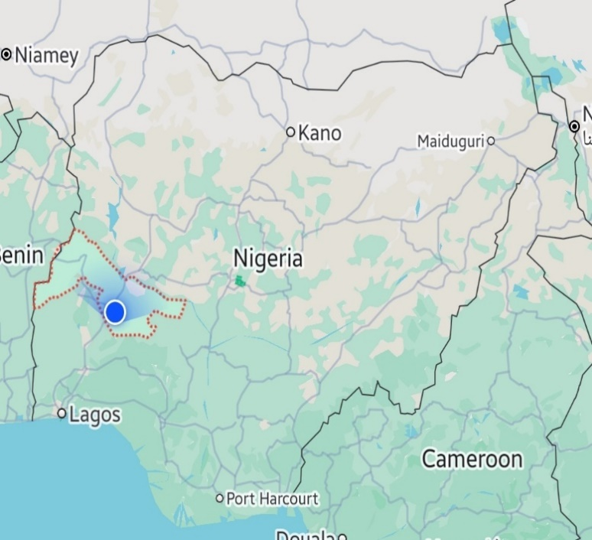
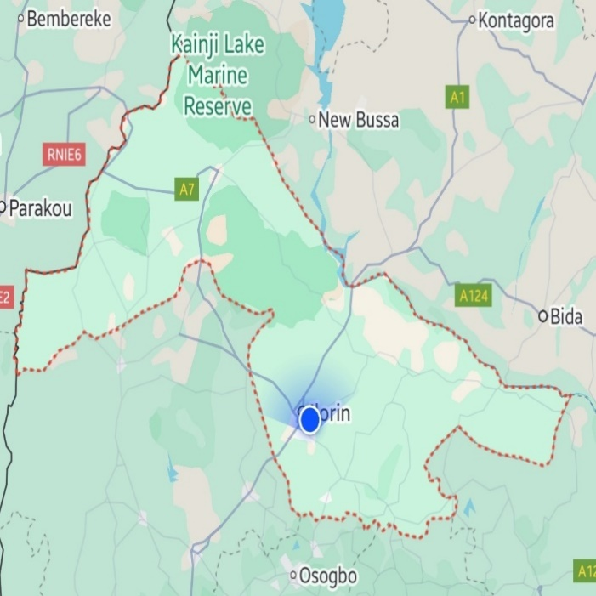

Figure 3.1: Map Showing Kwara, Nigeria

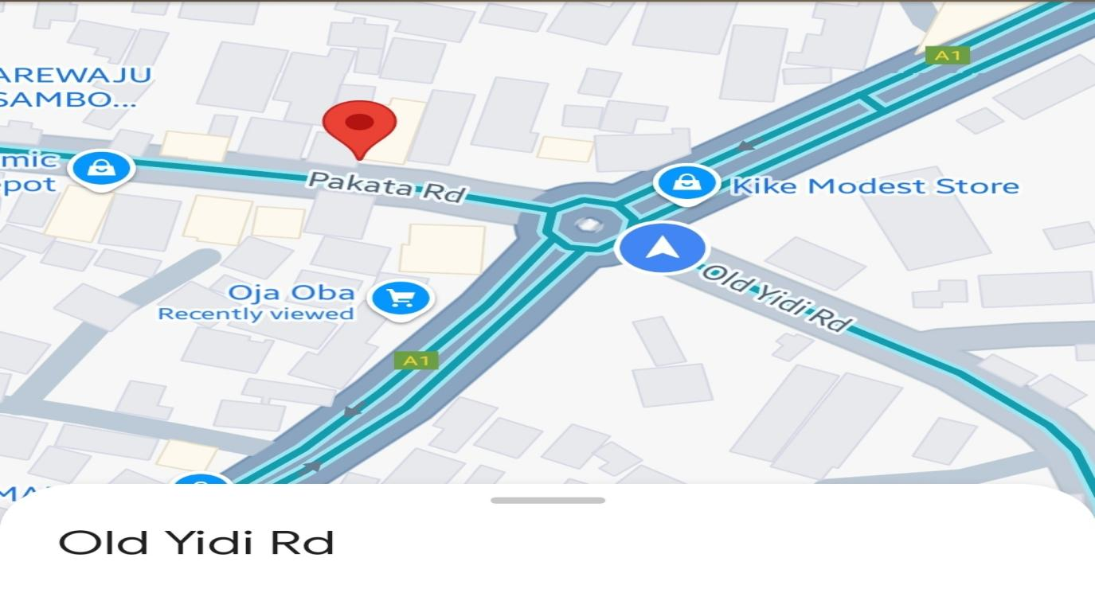

Figure 3.2: Boundary Roundabout, (Google Earth).

3.2 Data Collection
The collection of data involved the measurement of the geometric features and collection of traffic data for the intersection which is broken down below.

3.2.1 Geometric Features
Using a measuring tape, I measured the geometric features of the Oja-Oba Roundabout four legged intersection in Kwara State, Nigeria. The measuring tape gave me key values of features of the lanes such as entry width, approach half-width and average flare-width. The entry width is the distance across the roadway at the point where vehicles enter the intersection, measured by placing the tape perpendicular to the road edges. The approach half-width is the distance from the road’s center line to its edge as the road approaches the intersection. Finally, the average flare length is determined by measuring the distance over which the road widens as it nears the intersection, with multiple measurements taken if the widening is irregular to calculate an average length.

3.2.2 Traffic Data
With a camera I was able to determine the number of vehicles using the road. I positioned the camera at a high point to ensure a clear, unobstructed view of the entire area. I focused on capturing peak traffic hours (8:00 to 9:00 am in morning and 5:00 to 6:00 pm in the evening for 7 days) with high-resolution footage, ensuring every vehicle and pedestrian was clearly visible. To then extract the data, I manually counted and classified traffic. Then I went further to analyze the data to understand traffic volume, flow patterns, turning movements, delays, and queue lengths. Finally, I compiled these insights into a detailed report, complete with actionable recommendations to enhance traffic flow and safety.

3.2.3 Discharge traveling time at intersection
To determine the discharge travel time at a 4-legged intersection, I measured the time it took for a queue of vehicles to clear the intersection. This process involved recording the moment the first vehicle in the queue began to move and timing how long it took for the last vehicle in the queue to pass through the intersection. The discharge time can be influenced by several factors, including the length of the queue, the speed of the vehicles, and any delays caused by turning movements or interactions with pedestrians.

CHAPTER FOUR

4.1 RESULTS AND DISCUSSIONS
This chapter presents the results and discussions of the traffic congestion analysis at Oja-Oba Roundabout intersection in Ilorin, Kwara State. Geometry measurements for Oja-Oba Roundabout intersection was obtained on the site using a measuring tape. The measured geometric elements of the intersection is shown on Table 4.1.

Table 4.1: Geometry Features of Oja-Oba Roundabout intersection

Approach | Approach  Width(m)
Approach 1  (Abdul-Azeez Attah Road) | 11.2 each
Approach 2  (Old Yidi Road) | 11.2
Approach 3  (Emir Palace Road) | 11.2
Approach 4  (Pakata Road) | 8.2

4.2 Traffic Data Analysis
The traffic data collected from the intersection was analyzed in this section in order to streamline data related to traffic flow, traffic volume and traffic patterns. The goal was to understand traffic behaviour and identify trends and patterns which would help me to draw impactful decisions for my research.

4.2.1 Traffic Volume Data
The traffic volume data collected for each approach to the intersection includes peak hour traffic conditions for Oja-Oba Roundabout. The peak hours observed during seven days occurred between 8:00-9:00 am and 5:00-6:00 pm respectively. Video coverage method was used.

Table 4.1: Geometric Features of the Road Intersection; Approach 1
Road Name | Road Features | Units | Measurement (m)
AbdulAzeez Attah Road | Lane | 4 | 3.5
AbdulAzeez Attah Road | Shoulder | 2 | 2.5
AbdulAzeez Attah Road | Median | 1 | 2
AbdulAzeez Attah Road | Carriage width | 2 | 11.2
Total width of the road |  |  | 21

Table 4.2: Geometric Features of the Road Intersection; Approach 2
Road Name | Road Features | Units | Measurement (m)
Old Yidi  Road | Lane | 2 | 3.5
Old Yidi  Road | Shoulder | 2 | 2.5
Old Yidi  Road | Median | 0 | 0
Old Yidi  Road | Carriage width | 1 | 11.2
Total width of the road |  |  | 12

Table 4.3: Geometric Features of the Road Intersection; Approach 3
Road Name | Road Features | Units | Measurement (m)
Emir Palace Road | Lane | 2 | 3.5
Emir Palace Road | Shoulder | 2 | 2.5
Emir Palace Road | Median | 0 | 0
Emir Palace Road | Carriage width | 1 | 11.2
Total width of the road |  |  | 12

Table 4.4: Geometric Features of the Road Intersection; Approach 4
Road Name | Road Features | Units | Measurement (m)
Pakata  Road | Lane | 2 | 3.5
Pakata  Road | Shoulder | 2 | 2.5
Pakata  Road | Median | 0 | 0
Pakata  Road | Carriage width | 1 | 8.2
Total width of the road |  |  | 12

4.3 ACCUMULATED DATA FOR ANALYSIS
Check Appendix II for all traffic flow data.

4.3.1 VOLUME OF THE ROAD TRAFFIC INTERSECTION
Tables below show the average traffic volumes in vehicles per hour at the studied intersection for both morning and evening peaks.
Table 4.3: Total volume vehicles at Approach 1
Days | Morning veh/hr | Evening veh/hr | Total
Day 1 (Tuesday) | 610 | 728 | 1338
Day 2 (Wednesday) | 790 | 682 | 1472
Day 3 (Thursday) | 400 | 682 | 1082
Day 4 (Friday) | 766 | 575 | 1341
Day 5 (Saturday) | 510 | 644 | 1154
Day 6 (Sunday) | 328 | 304 | 632
Day 7 (Monday) | 952 | 800 | 1752
Total | 4356 | 4415
Average total volume | 622.3 | 630.7

Average total volume per hour = (622.3 + 630.7)/2
= 626.5 vph

0

100

200

300

400

500

600

700

800

900

1000

Day 1

Day 2

Day 3

Day 4

Day 5

Day 6

Day 7

TRAFFIC VOLUME FOR APPROACH 1

Morning

Evening

Monday has the highest total traffic volume with 1752 veh/hr, indicating it’s the busiest day. Sunday has the lowest total traffic volume with 632 veh/hr, indicating it's the least busy day. The total evening volume (4415 veh/hr) slightly exceeds the total morning volume (4356 veh/hr), indicating a higher traffic volume in the evening on average.
Table 4.4: Total volume vehicles at Approach 2
Days | Morning veh/hr | Evening veh/hr | Total
Day 1 (Tuesday) | 92 | 448 | 540
Day 2 (Wednesday) | 131 | 210 | 341
Day 3 (Thursday) | 91 | 610 | 701
Day 4 (Friday) | 478 | 245 | 723
Day 5 (Saturday) | 240 | 407 | 647
Day 6 (Sunday) | 128 | 114 | 242
Day 7 (Monday) | 876 | 529 | 1405
Total | 2036 | 2563
Average total volume | 290.9 | 366.1

Average total volume per hour = (290.9 + 366.1)/2
= 328.5 vph

0

100

200

300

400

500

600

700

800

900

1000

Day 1

Day 2

Day 3

Day 4

Day 5

Day 6

Day 7

TRAFFIC VOLUME FOR APPROACH 2

Morning

Evening

Monday has the highest total traffic volume with 1405 veh/hr, indicating it’s the busiest day. Sunday has the lowest total traffic volume with 242 veh/hr, indicating it's the least busy day. Morning peak: Monday with 876 veh/hr. Evening peak: Thursday with 610 veh/hr. The total evening volume (2563 veh/hr) exceeds the total morning volume (2036 veh/hr), indicating a higher traffic volume in the evening on average.

Table 4.5: Total volume vehicles at Approach 3
Days | Morning veh/hr | Evening veh/hr | Total
Day 1 (Tuesday) | 506 | 371 | 877
Day 2 (Wednesday) | 632 | 496 | 1128
Day 3 (Thursday) | 432 | 556 | 988
Day 4 (Friday) | 642 | 604 | 1246
Day 5 (Saturday) | 357 | 555 | 912
Day 6 (Sunday) | 382 | 153 | 535
Day 7 (Monday) | 771 | 659 | 1430
Total | 3722 | 3394
Average total volume | 531.7 | 484.9

Average total volume per hour = (531.7 + 484.9)/2= 508.3 vph
0

100

200

300

400

500

600

700

800

900

Day 1

Day 2

Day 3

Day 4

Day 5

Day 6

Day 7

TRAFFIC VOLUME FOR APPROACH 3

Morning

Evening

Monday has the highest total traffic volume with 1430 veh/hr, indicating it’s the busiest day. Sunday has the lowest total traffic volume with 535 veh/hr, indicating it's the least busy day. Morning peak: Monday with 771 veh/hr. Evening peak: Friday with 604 veh/hr. The total morning volume (3722 veh/hr) exceeds the total evening volume (3394 veh/hr), indicating a higher traffic volume in the morning on average.

Table 4.6: Total volume vehicles at Approach 4
Days | Morning veh/hr | Evening veh/hr | Total
Day 1 (Tuesday) | 601 | 357 | 958
Day 2 (Wednesday) | 669 | 537 | 1206
Day 3 (Thursday) | 163 | 569 | 732
Day 4 (Friday) | 466 | 619 | 1085
Day 5 (Saturday) | 385 | 583 | 968
Day 6 (Sunday) | 329 | 97 | 426
Day 7 (Monday) | 832 | 600 | 1432
Total | 3445 | 3362
Average total volume | 492.1 | 480.3

Average total volume per hour = (492.1 + 480.3)/2
= 486.2 vph

0

100

200

300

400

500

600

700

800

900

Day 1

Day 2

Day 3

Day 4

Day 5

Day 6

Day 7

TRAFFIC VOLUME FOR APPROACH 4

Morning

Evening

Monday has the highest total traffic volume with 1432 veh/hr, indicating it’s the busiest day. Sunday has the lowest total traffic volume with 426 veh/hr, indicating it's the least busy day. Morning peak: Monday with 832 veh/hr. Evening peak: Friday with 619 veh/hr. The total morning volume (3445 veh/hr) is slightly higher than the total evening volume (3362 veh/hr), indicating a higher traffic volume in the morning on average.
Table 4.7: Total volume of the road intersection.
Days | Morning veh/hr | Evening veh/hr | Total
Day 1 (Tuesday) | 1809 | 1904 | 3713
Day 2 (Wednesday) | 2222 | 1925 | 4147
Day 3 (Thursday) | 1086 | 2417 | 3503
Day 4 (Friday) | 2350 | 2042 | 4392
Day 5 (Saturday) | 1462 | 2189 | 3651
Day 6 (Sunday) | 1167 | 668 | 1835
Day 7 (Monday) | 3431 | 2423 | 5854
Total | 13527 | 13568
Average total volume | 1932.4 | 1938.3

Average total volume per hour = (1932.4+1938.3)/2= 1935.4 vph

Chart 4.1: Distribution of Traffic Volume

0

1000

2000

3000

4000

5000

6000

7000

Tuesday

Wednesday

Thursday

Friday

Saturday

Sunday

Monday

TOTAL VPH

DAYS

Total

Table 4.3 and chart 4.1 above shows that for both morning and evening peaks,
Monday recorded the highest volume of traffic among the studied roads. These are 3431 vph and 2423 vph of total volume respectively. This is followed by Friday with 2350 vph and 2042 vph for morning and evening peaks respectively. Wednesday ranks third recording 2222 vph and 1925 vph for morning and evening peaks respectively. Saturday ranks fourth recording 1462 vph and 2189 vph for morning and evening respectively. Tuesday ranks fifth with 1809 vph and 1904 vph for morning and evening peaks respectively. Thursday ranks sixth with 1086 vph and 2417 vph for morning and evening peaks respectively. While Sunday ranks seventh with the least volume of 1167 vph and 668 vph for morning and evening peaks respectively.

0

500

1000

1500

2000

2500

3000

3500

4000

Tuesday

Wednesday

Thursday

Friday

Saturday

Sunday

Monday

ROAD VOLUME

Morning

Evening

The chart above shows the traffic pattern for seven days and it can be deduced that the traffic volumes are relatively high on weekdays, especially Monday mornings and Thursday evenings, reflecting typical workday patterns. While Friday shows a high volume as people likely head out for Jum’at services and weekend activities.

4.4 DELAYS AT THE SELECTED INTERSECTION
Using the peak volume per hour data which is on day 7, Morning, with the value of 3431 vehicles per hour,
The volume of the intersection at  30 minutes interval | Time of delay (sec)
8:00 - 8:35 | 1200
8:30 - 9:00 | 720

Delay for peak volume per hour = average of the time of delay
= (1200+720)/2 = 960 seconds

Table 4.5: LOS criteria for Unsignalized Intersection
LOS | AVERAGE CONTROL DELAY SEC/VEH
A | 0-10
B | >10-15
C | >15-25
D | >25-35
E | >35-50
F | >50

Based on delay the Highway Capacity Manual (HCM) provides thresholds for LOS based on the average control delay per vehicle therefore, the delay for the Oja-Oba Roundabout falls under LOS F: Greater than 50 seconds which implies that there is severe congestion at the intersection which results in these long delays.

CHAPTER 5
CONCLUSION AND RECOMMENDATION

5.1 CONCLUSION
- The geometric features showed that Approach 1 (AbdulAzeez Attah Road), Approach 2 (Old Yidi Road), and Approach 3 (Emir Palace Road) each have a width of 11.2m, while Approach 4 (Pakata Road) has a width of 8.2m. The HCM 6th edition (2016) recommends intersection approach widths of 12-15m based on traffic volume. Given the traffic data from the study area, a redesign is needed. This will ensure a smooth and stress-free driving experience for all commuters.
- The traffic flow analysis showed that Approach 1 has the highest average number of traffic with 626.5 vph. It is followed by Approach 3 with 508.3 vph. Approach 4 has 486.2 vph while Approach 2 has 328.5 vph. Approach 1 handles the most significant traffic and might need priority improvements to handle the load efficiently. Approaches 2 and 4 could potentially benefit from traffic management adjustments.
- While for the delay, according to Highway Capacity Manual (HCM) LOS criteria, the Oja-Oba Roundabout has an LOS F, with an average control delay per vehicle exceeding 50 seconds. This implies severe congestion, long delays, and potential driver frustration.

5.2. RECOMMENDATION
The high level of congestion and delays at the Oja-Oba roundabout point to inadequacies in the current infrastructure to handle traffic volumes effectively which could lead to increased risk-taking behavior from commuters, while potentially compromising safety. Prolonged delays also affect the efficiency of transportation, impacting the economy, particularly for commercial vehicles and public transport. It is therefore very necessary for concerned bodies to find a way of solving this problem.
Based on my research result, I would recommend the following:
- Concerned bodies and agencies should consider redesigning the
roundabout to a larger width that can accommodate traffic freely.
- An improved design should include traffic signals to manage high traffic volumes.
- Also alternative traffic management strategies such as new inner routes could be developed as an option to efficiently distribute traffic even more evenly.

REFERENCE

Adebambo, S., & Adebayo, I. (2009). Impact of bus rapid transit system (BRT) on passengers’ satisfaction in Lagos Metropolis, Nigeria. International Journal of Creativity and Technical Development, 1(3), 106-119.
Akcelik, R. (1981). Traffic signals: capacity and timing analysis.
Akçelik, R. (1997). Lane-by-lane modelling of unequal lane use and flares at roundabouts and signalised intersections: the SIDRA solution. Traffic Engineering+ Control, 38(7), 388-399.
Bang, K., Wahlstedt, J., & Linse, L. (2016). Methodology for timing and impact analysis of signalized intersections. Transportation Research Procedia, 15, 75-86.
Barau, A. S. (2007). The great attractions of Kano: Research & Documentation Directorate.
Bester, C., & Meyers, W. (2007). Saturation flow rates. SATC 2007.
Biliyamin, I. A., & Abosede, B. A. (2012). Effects of Congestion and Travel Time
Variability along Abuja-Keffi Corridor in Nigeria. Global Journal of Research In Engineering, 12(3-E).
Bivina, G., Landge, V., & Kumar, V. S. (2016). Socio Economic Valuation of Traffic
Delays. Transportation Research Procedia, 17, 513-520.
Bui, K.-H. N., & Jung, J. J. (2017). Cooperative game-theoretic approach to traffic flow optimization for multiple intersections. Computers & Electrical Engineering.
Chubukov, A., Kapitanov, V., Monina, O., Silyanov, V., & Brannolte, U. (2017). Calculation of Traffic Capacity of Signaled Intersections. Transportation Research Procedia, 20, 125-131.
Darma, Y., Karim, M. R., Mohamad, J., & Abdullah, S. (2005). Control delay variability at signalized intersection based on HCM method. Paper presented at the Proceedings of the eastern Asia society for Transportation Studies.
Fan, H., Jia, B., Tian, J., & Yun, L. (2014). Characteristics of traffic flow at a nonsignalized intersection in the framework of game theory. Physica A: Statistical Mechanics and its Applications, 415, 172-180.
Ferreira, S., & Couto, A. (2013). Traffic flow-accidents relationship for urban intersections on the basis of the translog function. Safety science, 60, 115-122.
He, F., Yan, X., Liu, Y., & Ma, L. (2016). A traffic congestion assessment method for urban road networks based on speed performance index. Procedia engineering, 137, 425-433.
Hunter, M. P., Wu, S. K., Kim, H. K., & Suh, W. (2012). A probe-vehicle-based evaluation of adaptive traffic signal control. IEEE Transactions on Intelligent
Transportation Systems, 13(2), 704-713.
Jiang, Y., Li, S., & Zhu, K. Q. (2005). Traffic delay studies at signalized intersections with global positioning system devices. Institute of Transportation Engineers. ITE Journal, 75(8), 30.
Koonce, P. (2008). Traffic signal timing manual: United States. Federal Highway Administration.
Marfani, S., Shihora, D., Kanthariya, C., & Kansara, H. (2018). Traffic Improvement for Urban Road Intersection, Surat. Traffic, 5(03).
Mfinanga, D. A. (2014). Ineffective human control of signalised intersections in developing countries; Case of Dar es Salaam city. Transportation Research Part F:
Traffic Psychology and Behaviour, 27, 174-181.
MO, P., & SO, A. Traffic Congestion on Highways in Nigeria Causes, Effects and Remedies.
Okunola, O. J., Uzairu, A., Gimba, C., & Ndukwe, G. (2012). Assessment of gaseous pollutants along high traffic roads in kano, nigeria. International Journal of Environment and Sustainability, 1(1).
Olagunju, K. (2015). Evaluating traffic congestion in developing countries: A case study of Nigeria. Paper presented at the A paper presented at the.
Oskarbski, J., Guminska, L., Miszewski, M., & Oskarbska, I. (2016). Analysis of signalized intersections in the context of pedestrian traffic. Transportation Research
Procedia, 14, 2138-2147.
Preethi, P., Varghese, A., & Ashalatha, R. (2016). Modelling Delay at Signalized
Intersections under Heterogeneous Traffic Conditions. Transportation Research Procedia, 17, 529-538.
ROUPHAIL15, N., TARKO16, A., & LI17, J. (1992). Traffic flow at signalized intersections.
Sun, W., Wu, X., Wang, Y., & Yu, G. (2015). A continuous-flow-intersection-lite design and traffic control for oversaturated bottleneck intersections. Transportation Research Part C: Emerging Technologies, 56, 18-33.
Ukpata, J. O., & Etika, A. A. (2012). Traffic congestion in major cities of Nigeria. International Journal of Engineering and Technology, 2(8), 1433-1438.
Wang, J., Wang, C., Song, X., & Raghavan, V. (2017). Automatic intersection and traffic rule detection by mining motor-vehicle GPS trajectories. Computers, Environment and Urban Systems, 64, 19-29.
Xi, J., Li, W., Wang, S., & Wang, C. (2015). An Approach to an Intersection Traffic Delay Study Based on Shift-Share Analysis. Information, 6(2), 246-257.
Yao, W., Jia, N., Zhong, S., & Li, L. (2018). Best response game of traffic on road network of non-signalized intersections. Physica A: Statistical Mechanics and its Applications, 490, 386-401.
Yoshino, N., & Nakahigashi, M. (2000). The Role of Infrastructure in Economic
Development (Preliminary Version). Unpublished manuscript.
Zhu, Y., Gao, N., Wang, J., & Liu, C. (2016). Study on traffic flow patterns identification of single intersection intelligent signal control. Procedia engineering, 137,
452460.

APPENDIX I:

Table 2.2: Shows some of the literature review
S/N | AUTHORS | RESEARCH PERFORMED | RESULTS OBTAINED | RESEARCH  GAPS
1. | Harriet, T., Poku,  K., Emmanuel,  A.K. (2013) | Assessment of traffic congestion and its effect on productivity in urban Ghana | Identified key congestion points and their impact on productivity | General urban traffic analysis without a specific focus on roundabouts or intersection delays
2. | Rodrigue, J.P. et al. (2009) | The Geography of Transportation System | Comprehensive overview of transportation systems and their geographical implications | Broad scope with limited focus on micro-level traffic  management  strategies at specific intersections
3. | Australian Transport Assessment and Planning (2018) | Overview of transport assessment and planning guidelines | Provided guidelines for transport planning and assessment | General guidelines without specific case studies or focus on roundabout intersections

4. | Austroads  (2013a) | Guide to road safety part 1: road safety overview | Overview of road safety strategies | Focus on safety rather than traffic delay or congestion management
5. | Austroads  (2013b) | Guide to road safety part 2: road safety strategy and evaluation | Evaluation of road safety strategies | Similar to above, lacks focus on traffic delay at intersections
6. | Austroads  (2016a) | Safe system assessment framework | Framework for assessing road safety systems | Primarily safetyfocused, not addressing traffic delay or congestion
7. | Austroads (2020a) | Guide to traffic management part 4: network management strategies | Strategies for managing traffic networks | General network strategies without specific focus on roundabouts or intersection delays

8. | Austroads  (2020b) | Guide to traffic management part 13: safe system approach to traffic management | Safe system approach to traffic management | Safety-centric approach, not addressing specific intersection delays
9. | Department of  Infrastructure and  Regional  Development  (2016) | The safe system approach | Promoted a safe system approach to road management | Safety-focused, lacking in-depth analysis of traffic delays at intersections
10. | Ministry of Transport (2014) | Strategy 2010–2020: the safer journeys strategy | Strategy for improving road safety over a decade | Safety strategy without specific focus on traffic delay or congestion at intersections

11. | Monash University (2003) | Traffic engineering and management | Comprehensive  guide on traffic engineering and management | Broad scope, lacking specific case studies on 4legged roundabouts in  African contexts
12. | Ukpata, J.O.,  Etika, A.A.  (2011) | Traffic Congestion at  Road Intersection in  Ilorin, Nigeria | Identified causes of congestion and proposed solutions | Focused on Ilorin; lacks specific analysis of roundabouts and their unique challenges
13. | Aworemi, J.R.,  Abdul-Azeez,  I.A., Oyedokun,  A.J., Adewoye,  J.O. (2009) | Causes, effects, and ameliorative measures of road traffic congestion in Lagos  Metropolis | Detailed causes and effects of congestion in Lagos | General urban analysis without specific focus on roundabouts or intersection delays
14. | OECD/ECMT  (2007) | Managing Urban Traffic Congestion | Policy-oriented recommendations for managing congestion | Broad policy recommendations without specific case studies on roundabouts or

15. | Ogunbodede, E.F. (2002) | Assessment of Traffic Congestions in Akure (Nigeria) Using GIS Approach | Applied GIS to analyze traffic congestion patterns | Focused on Akure; lacks specific analysis of roundabouts and their unique challenges
16. | Ogunsanya, A.A.  (2002) | Maker and Breakers of  Cities | Discussed the impact of transportation on urban development | Broad discussion on urban transportation without specific focus on roundabouts or intersection delays
17. | Afrin T, Yodo N  (2020) | Survey of road traffic congestion measures towards a sustainable and resilient transportation system | Identified and compared various congestion measures, highlighting their advantages and disadvantages | Lacks specific focus on 4-legged intersections and case studies in African contexts

18. | Al-Turki M,  Ratrout NT,  Rahman SM,  Reza I (2021) | Impacts of autonomous vehicles on traffic flow characteristics under mixed traffic environment | Explored the effects of autonomous vehicles on traffic flow in mixed environments | Limited focus on specific intersection types like 4-legged roundabouts; lacks case studies in  African contexts
19. | Adeleke, O.O.  (2010) | Empirical modelling of delays at traffic warden controlled urban intersections:  Case study of Ilorin,  Nigeria | Developed models to understand delays at traffic warden-controlled intersections | Focused on Ilorin; lacks specific analysis of roundabouts and their unique challenges
20. | Adeleke, O.O.,  Jimoh, Y.A.  (2011) | Sampling of intersections for traffic delay study in an  African sub-region | Provided methodologies for sampling intersections to | General methodologies without specific focus on 4-legged
 |  | urban city | study traffic delays | roundabouts

APPENDIX II:
Day One (Tuesday 11th March, 2025)
Morning: 8:00 – 9:00 am
Time | Approach 1 |  |  |  | Approach 2 |  |  |  | Approach 3 Approach 4
Time | Car | Bus/  Trailer | Minibus | Tricycle | Car | Bus/ truck | Bike | Tri- cycle | Car | Bus/ truck | Mini-  Bus | Tricycle | Car | Bus/  Truck | Bike | Tricycle
8:00  8:30 | 10 | 5 | 18 | 7 | 60 | 9 | 140 | 110 | 102 | 55 | 21 | 80 | 70 | 56 | 167 | 5
8:30  9:00 | 21 | 11 | 15 | 5 | 82 | 5 | 117 | 87 | 89 | 43 | 20 | 96 | 72 | 81 | 142 | 8
Total | 31 | 16 | 33 | 12 | 142 | 14 | 257 | 197 | 191 | 98 | 41 | 176 | 142 | 137 | 309 | 13

Total for Morning (day 1) = 1809 vehicles

Day One (Tuesday 11th March, 2025)
Evening: 5:00 – 6:00 pm
Time | Approach 1 |  |  |  | Approach 2 |  |  |  | Approach 3 Approach 4
Time | Car | Bus/  Trailer | Mini-  bus | Tricycle | Car | Bus/ truck | Bike | Tri- cycle | Car | Bus  /truck | Mini-  Bus | Tricycle | Car | Bus/  Truck | Bike | Tricycle
5:00  5:30 | 74 | 14 | 85 | 12 | 120 | 67 | 131 | 122 | 21 | 10 | 35 | 40 | 12 | 34 | 134 | 10
5:30  6:00 | 120 | 51 | 72 | 22 | 43 | 51 | 78 | 116 | 112 | 74 | 15 | 64 | 9 | 16 | 126 | 16
Total | 194 | 65 | 157 | 32 | 163 | 118 | 209 | 238 | 133 | 84 | 50 | 104 | 21 | 50 | 260 | 26

Total for Evening (day 1) = 1904 vehicles

Day Two (Wednesday 12
Morning: 8:00 – 9:00 am

Time | Approach 1 |  |  |  | Approach 2 |  |  |  | Approach 3 |  |  | Approach 4
Time | Car | Bus/  Trailer | Minibus | Tricycle | Car | Bus/ truck | Bike | Tri- cycle | Car | Bus/ truck | Mini-  Bus | Tricycle | Car | Bus/  Truck | Bike | Tricycle
8:00  8:30 | 23 | 23 | 14 | 8 | 87 | 12 | 187 | 98 | 120 | 65 | 32 | 102 | 112 | 76 | 165 | 4
8:30  9:00 | 20 | 18 | 15 | 10 | 123 | 18 | 153 | 112 | 114 | 72 | 15 | 112 | 96 | 58 | 156 | 2
Total | 43 | 41 | 29 | 18 | 210 | 30 | 340 | 210 | 234 | 137 | 47 | 214 | 208 | 134 | 321 | 6

Total for Morning (day 2) = 2222 vehicles Day Two (Wednesday 12
Evening: 5:00 – 6:00 pm

Time | Approach 1 |  |  |  | Approach 2 |  |  |  | Approach 3 Approach 4
Time | Car | Bus/  Trailer | Minibus | Tricycle | Car | Bus/ truck | Bike | Tri- cycle | Car | Bus/ truck | Mini-  Bus | Tricycle | Car | Bus/  Truck | Bike | Tricycle
5:00  5:30 | 24 | 44 | 25 | 12 | 120 | 21 | 131 | 122 | 64 | 102 | 35 | 40 | 112 | 34 | 134 | 8
5:30  6:00 | 20 | 51 | 12 | 22 | 43 | 51 | 78 | 116 | 92 | 74 | 25 | 64 | 95 | 16 | 126 | 12
Total | 44 | 95 | 37 | 34 | 163 | 72 | 209 | 238 | 156 | 176 | 60 | 104 | 207 | 50 | 260 | 20

Total for Evening (day 2) = 1925 vehicles Day Three (Thursday 13
Morning: 8:00 – 9:00 am
Time | Approach 1 |  |  |  | Approach 2 |  |  |  | Approach 3 |  |  | Approach 4
Time | Car | Bus/  Trailer | Minibus | Tricycle | Car | Bus/ truck | Bike | Tri- cycle | Car | Bus  /truck | Mini-  Bus | Tricycle | Car | Bus/  Truck | Bike | Tricycle
8:00  8:30 | 12 | 12 | 14 | 8 | 87 | 12 | 87 | 18 | 20 | 65 | 32 | 102 | 12 | 16 | 65 | 0
8:30  9:00 | 7 | 18 | 10 | 0 | 123 | 8 | 53 | 12 | 14 | 72 | 15 | 112 | 9 | 5 | 56 | 0
Total | 19 | 30 | 24 | 18 | 210 | 20 | 140 | 30 | 34 | 137 | 47 | 214 | 21 | 21 | 121 | 0

Total for Morning (day 3) = 1086 vehicles Day Three (Thursday 13
Evening: 5:00 – 6:00 pm
Time | Approach 1 |  |  |  | Approach 2 |  |  |  | Approach 3 |  |  | Approach 4
Time | Car | Bus/  Trailer | Minibus | Tricycle | Car | Bus  /truck | Bike | Tri- cycle | Car | Bus/ truck | Mini-  Bus | Tricycle | Car | Bus/  Truck | Bike | Tricycle
5:00  5:30 | 124 | 144 | 25 | 12 | 120 | 21 | 131 | 122 | 114 | 102 | 35 | 40 | 112 | 34 | 134 | 20
5:30  6:00 | 120 | 151 | 12 | 22 | 43 | 51 | 78 | 116 | 112 | 74 | 15 | 64 | 95 | 16 | 126 | 32
Total | 244 | 295 | 37 | 34 | 163 | 72 | 209 | 238 | 226 | 176 | 50 | 104 | 207 | 50 | 260 | 52

Total for Evening (day 3) = 2417 vehicles

Day Four (Friday 14th March, 2025)
Morning: 8:00 – 9:00 am

Time | Approach 1 |  |  |  | Approach 2 |  |  |  | Approach 3 |  |  | Approach 4
Time | Car | Bus/  Trailer | Minibus | Tricycle | Car | Bus/ truck | Bike | Tri- cycle | Car | Bus/ truck | Mini-  Bus | Tricycle | Car | Bus/  Truck | Bike | Tricycle
8:00  8:30 | 123 | 83 | 14 | 8 | 87 | 12 | 171 | 98 | 120 | 65 | 32 | 102 | 112 | 16 | 105 | 4
8:30  9:00 | 127 | 88 | 23 | 10 | 143 | 8 | 135 | 112 | 114 | 72 | 15 | 112 | 96 | 5 | 116 | 12
Total | 250 | 171 | 37 | 18 | 230 | 20 | 306 | 210 | 234 | 137 | 47 | 224 | 208 | 21 | 221 | 16

Total for Morning (day 4) = 2350 vehicles Day Four (Friday 14th March, 2025)
Evening: 5:00 – 6:00 pm
Time | Approach 1 |  |  |  | Approach 2 |  |  |  | Approach 3 |  |  | Approach 4
Time | Car | Bus/  Trailer | Minibus | Tricycle | Car | Bus/ truck | Bike | Tri- cycle | Car | Bus/ truck | Mini-  Bus | Tricycle | Car | Bus/  Truck | Bike | Tricycle
5:00  5:30 | 26 | 54 | 29 | 16 | 20 | 21 | 116 | 122 | 114 | 102 | 75 | 56 | 112 | 28 | 174 | 11
5:30  6:00 | 28 | 59 | 21 | 12 | 39 | 56 | 85 | 116 | 112 | 74 | 26 | 45 | 95 | 62 | 120 | 16
Total | 54 | 113 | 50 | 28 | 59 | 77 | 201 | 238 | 226 | 176 | 101 | 101 | 207 | 90 | 294 | 27

Total for Evening (day 4) = 2042 vehicles Day Five (Saturday 15th March, 2025)
Time | Approach 1 |  |  |  | Approach 2 |  |  |  | Approach 3 Approach 4
Time | Car | Bus/  Trailer | Minibus | Tricycle | Car | Bus/ truck | Bike | Tri- cycle | Car | Bus/ truck | Mini-  Bus | Tricycle | Car | Bus/  Truck | Bike | Tricycle
8:00  8:30 | 23 | 23 | 14 | 19 | 87 | 22 | 86 | 98 | 20 | 54 | 24 | 99 | 82 | 6 | 111 | 12
8:30  9:00 | 27 | 88 | 25 | 21 | 23 | 81 | 51 | 62 | 14 | 27 | 17 | 102 | 76 | 11 | 78 | 9
Total | 50 | 111 | 39 | 40 | 110 | 103 | 137 | 160 | 34 | 81 | 41 | 201 | 158 | 17 | 189 | 21
Morning: 8:00 – 9:00 am

Total for Morning (day 5) = 1462 vehicles Day Five (Saturday 15th March, 2025)
Evening: 5:00 – 6:00 pm
Time | Approach 1 |  |  |  | Approach 2 |  |  |  | Approach 3 Approach 4
Time | Car | Bus/  Trailer | Minibus | Tricycle | Car | Bus/ truck | Bike | Tri- cycle | Car | Bus/ truck | Mini-  Bus | Tricycle | Car | Bus/  Truck | Bike | Tricycle
5:00  5:30 | 74 | 48 | 45 | 12 | 88 | 21 | 132 | 115 | 123 | 52 | 56 | 32 | 122 | 41 | 94 | 30
5:30  6:00 | 98 | 56 | 52 | 22 | 64 | 51 | 76 | 97 | 92 | 98 | 44 | 58 | 77 | 66 | 116 | 37
Total | 172 | 104 | 97 | 34 | 152 | 72 | 208 | 212 | 215 | 150 | 100 | 90 | 199 | 107 | 210 | 67

Total for Evening (day 5) = 2189 vehicles Day Six (Sunday 16th March, 2025)
Morning: 8:00 – 9:00 am
Time | Approach 1 |  |  |  | Approach 2 |  |  |  | Approach 3 Approach 4
Time | Car | Bus/  Trailer | Minibus | Tricycle | Car | Bus/ truck | Bike | Tri- cycle | Car | Bus/ truck | Mini-  Bus | Tricycle | Car | Bus/  Truck | Bike | Tricycle
8:00  8:30 | 23 | 13 | 14 | 8 | 8 | 11 | 87 | 68 | 20 | 65 | 32 | 72 | 92 | 16 | 85 | 0
8:30  9:00 | 27 | 18 | 9 | 16 | 23 | 6 | 53 | 72 | 14 | 72 | 15 | 92 | 66 | 5 | 66 | 0
Total | 50 | 31 | 23 | 24 | 31 | 17 | 140 | 140 | 34 | 137 | 47 | 164 | 158 | 21 | 150 | 0

Total for Morning (day 6) = 1167 vehicles Day Six (Sunday 16th March, 2025)
Evening: 5:00 – 6:00 pm
Time | Approach 1 |  |  |  | Approach 2 |  |  |  | Approach 3 |  |  | Approach 4
Time | Car | Bus/  Trailer | Minibus | Tricycle | Car | Bus/ truck | Bike | Tri- cycle | Car | Bus  /truck | Mini-  Bus | Tricycle | Car | Bus/  Truck | Bike | Tricycle
5:00  5:30 | 24 | 4 | 25 | 12 | 20 | 21 | 71 | 22 | 14 | 10 | 25 | 22 | 12 | 14 | 34 | 0
5:30  6:00 | 20 | 5 | 12 | 12 | 43 | 41 | 70 | 16 | 11 | 14 | 15 | 42 | 5 | 6 | 26 | 0
Total | 44 | 9 | 37 | 24 | 63 | 62 | 141 | 38 | 25 | 24 | 40 | 64 | 17 | 20 | 60 | 0

Total for Evening (day 6) = 668 vehicles Day Seven (Monday 17th March, 2025)
Morning: 8:00 – 9:00 am
Time | Approach 1 |  |  |  | Approach 2 |  |  |  | Approach 3 |  | Approach 4
Time | Car | Bus/  Trailer | Minibus | Tricycle | Car | Bus/ truck | Bike | Tri- cycle | Car | Bus/ truck | Mini-  Bus | Tricycle | Car | Bus/  Truck | Bike | Tricycle
8:00  8:30 | 133 | 123 | 94 | 52 | 87 | 54 | 187 | 98 | 114 | 65 | 79 | 112 | 144 | 87 | 191 | 41
8:30  9:00 | 127 | 188 | 95 | 64 | 123 | 98 | 193 | 112 | 131 | 72 | 66 | 132 | 96 | 75 | 174 | 24
Total | 260 | 311 | 189 | 116 | 210 | 152 | 380 | 210 | 245 | 137 | 145 | 244 | 240 | 162 | 365 | 65

Total for Morning (day 7) = 3431 vehicles Day Seven (Monday 17th March, 2025)
Evening: 5:00 – 6:00 pm
Time | Approach 1 |  |  |  | Approach 2 |  |  |  | Approach 3 |  | Approach 4
Time | Car | Bus/  Trailer | Minibus | Tricycle | Car | Bus/ truck | Bike | Tri- cycle | Car | Bus/ truck | Mini-  Bus | Tricycle | Car | Bus/  Truck | Bike | Tricycle
5:00  5:30 | 67 | 43 | 51 | 80 | 92 | 71 | 132 | 85 | 49 | 85 | 94 | 92 | 45 | 73 | 171 | 42
5:30  6:00 | 72 | 88 | 54 | 74 | 73 | 36 | 186 | 125 | 79 | 79 | 55 | 126 | 64 | 85 | 99 | 21
Total | 139 | 131 | 105 | 154 | 165 | 107 | 318 | 210 | 128 | 164 | 149 | 218 | 109 | 158 | 270 | 63

Total for Evening (day 7) = 2423 vehicles APPENDIX III

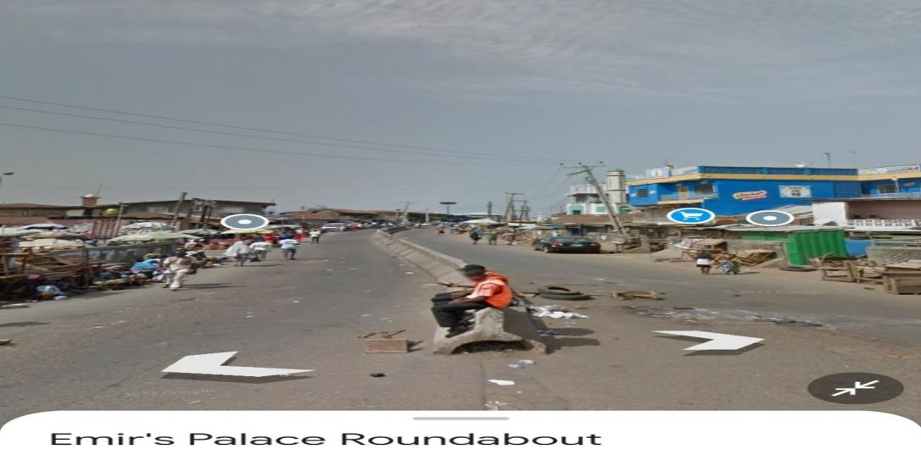

Picture 1: Showing the Exiting and Entry of AbdulAzeez Attah Lane

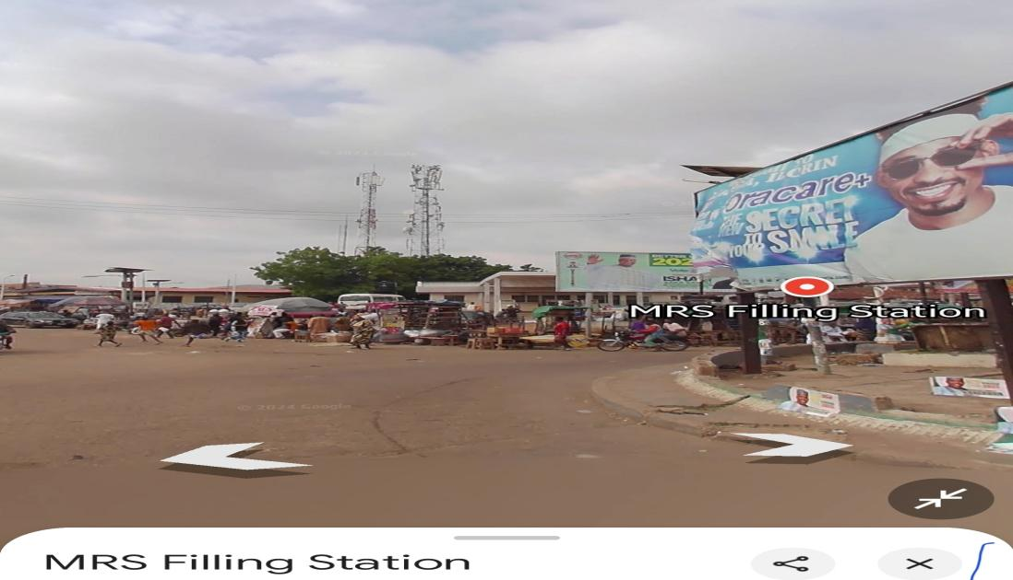

Picture 2: Showing the Entry Into Old Yidi Lane

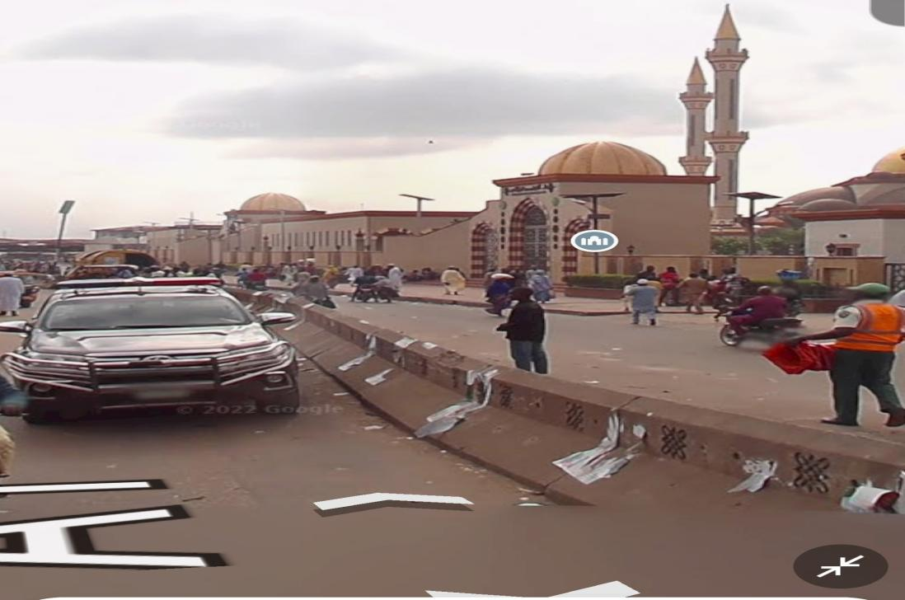

Picture 3: Showing the Exit and Entry Into Emir Palace Lane

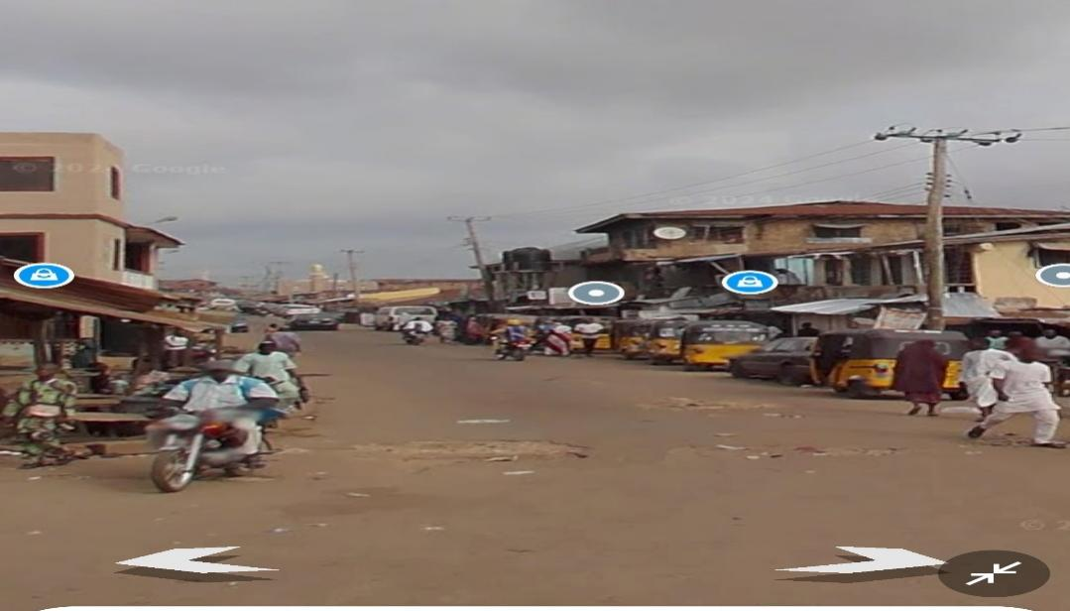

Picture 4: Showing the Entry From Pakata Lane

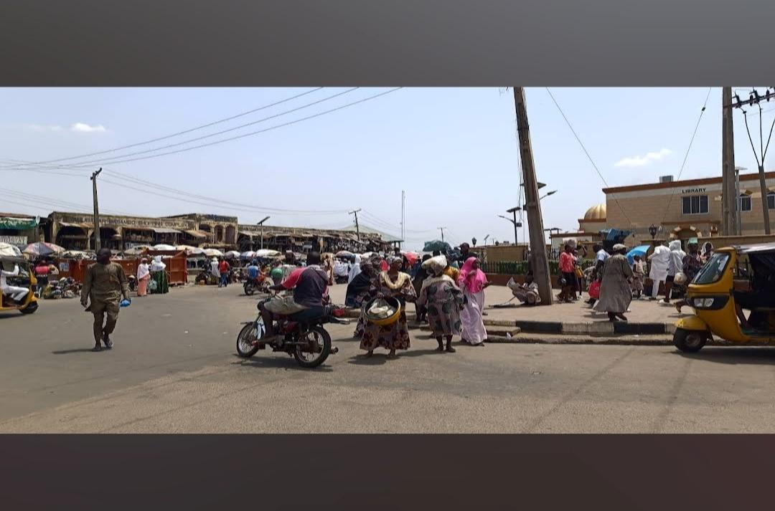

Picture 5: Showing the Entry and Exit from Emir Palace Lane

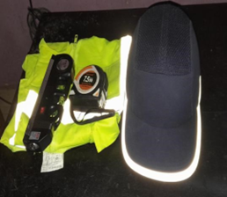

Picture 6: Showing Safety gears and the instrument Used for the Field Assessment

