DEVELOPMENT OF AN INTELLIGENT SECURITY INFRASTRUCTURE WITH INVERTER-BASED POWER BACKUP FOR TERTIARY CAMPUSES

BY

ANIMASHAUN MUSBAUDEEN
ND/23/COM/PT/400

BEING A RESEARCH PROJECT SUBMITTED TO THE DEPARTMENT OF COMPUTER SCIENCE, INSTITUTE OF INFORMATION AND COMMUNICATION TECHNOLOGY, KWARA STATE POLYTECHNIC, ILORIN, KWARA STATE.

IN PARTIAL FULFILLMENT OF THE REQUIREMENTS FOR THE AWARD OF NATIONAL DIPLOMA IN COMPUTER SCIENCE

JUNE 2024

CERTIFICATION
This is to certify that this research works was carried out by ANIMASHAUN MUSBAUDEEN with the matric number ND/23/COM/PT/400 has been read and approved as meeting part of the requirement for the award of National Diploma in Computer Science.

_________________________ __________________
MR. BOLAJI-ADETORO D.F. Date
Project Supervisor

_________________________ __________________
MR. OYEDEPO F.S. Date
Project Supervisor

_________________________ __________________
External Examiner Date

Dedication
This work is humbly dedicated to Almighty Allah (SWT), the Most Gracious, the Most Merciful, whose guidance, blessings, and mercy have sustained me throughout this journey. Alhamdulillah.

ACKNOWLEDGEMENT
The journey through this academic program has been both challenging and rewarding. Through all the trials and triumphs, I give all glory, honor, and adoration to the Almighty God for His unending grace, divine protection, and sustenance from the very first day I stepped into the academic world until this present moment. Without His mercy, I would not have come this far.
I wish to express my heartfelt gratitude to the Head of the Computer Science Department, Mr. Oyedepo F.S., for his unwavering support, fatherly guidance, and consistent encouragement throughout the course of my academic journey. His administrative leadership and personal interest in the success of students have been a source of great motivation to me.
My profound appreciation goes to my project supervisor, Mr. Bolaji-Adetoro D.F., for the invaluable role he played in the successful completion of this research project. His intellectual input, timely corrections, encouragement, and professional mentorship were instrumental in shaping the quality of this work. I consider it a great privilege to have worked under his supervision.
I also wish to extend my sincere appreciation to all the lecturers in the Department of Computer Science for their dedication to academic excellence and for imparting knowledge and discipline throughout my course of study. Each of you contributed uniquely to my academic and personal growth.
To my family, friends, and colleagues who stood by me in prayers, words of encouragement, and support during trying times, I say thank you.
Above all, I am grateful to everyone who, in one way or the other, contributed to the successful completion of this project.
Abstract
The increasing demand for campus security in tertiary institutions has necessitated the development of intelligent, sustainable, and uninterrupted surveillance systems. This project focuses on the development of an intelligent security infrastructure integrated with an inverter-based power backup system to ensure 24/7 operational efficiency on tertiary campuses. The system combines real-time surveillance, sensor-based intrusion detection, and remote alert mechanisms, leveraging Internet of Things (IoT) technology and automation to enhance security responsiveness. Recognizing the frequent power interruptions in many educational environments, the solution incorporates a robust inverter-powered backup to maintain system functionality during outages, thereby ensuring continuous monitoring without compromise. The design also includes energy-efficient components and smart power management for optimized performance. Key features of the infrastructure include motion-triggered alerts, camera feeds with storage, and administrator control via a centralized interface. The system architecture was developed using embedded systems, solar-compatible inverters, and networked security modules. Evaluation of the prototype showed improved reliability, reduced downtime, and enhanced threat detection capabilities compared to traditional systems. This project contributes a scalable model for smart campus security, offering a cost-effective and energy-conscious approach to safety management in tertiary institutions.

TABLE OF CONTENTS
Title
Certification
Dedication
Acknowledgement
Abstract
Table of contents
CHAPTER ONE
- Introduction
- Aim and Objectives
- Statement of the Problem
- Significance of the Study
- Scope of the Study
- Organization of the Report
- Definition of Technical Terms
CHAPTER TWO
2.1 Literature Review
CHAPTER THREE
3.1 Research Methodology
CHAPTER FOUR:
4.1 Output
CHAPTER FIVE: SUMMARY, CONCLUSION AND RECOMMENDATION
5.1 Summary
5.2 Conclusion
5.3 Recommendations
References

CHAPTER ONE
1.0 Introduction
1.1 Background to the Study
Security surveillance is an incredibly important aspect of any project that involves safeguarding people and property. It serves as a powerful tool to monitor and protect against potential threats or incidents. By implementing security surveillance systems, you can enhance safety, deter criminal activities, and provide valuable evidence if needed. It's like having an extra set of eyes that never sleep, ensuring the security and peace of mind for everyone involved. Another one is that Security surveillance is an indispensable component of modern-day project management, encompassing a wide range of techniques and technologies to ensure the safety and protection of assets, individuals, and sensitive information. From closed-circuit television (CCTV) cameras to access control systems, these measures provide round-the-clock monitoring, threat detection, and incident response capabilities. By implementing comprehensive security surveillance measures, projects can mitigate risks, deter potential threats, and maintain a secure environment. It's like having a robust shield that safeguards your project for much potential harm. Due to increasing security concerns, a complete security system should consist of two major components, a computer-based face-recognition system and a real-time automated video surveillance system. A computer based face-recognition system can be used in gate access control for identity authentication. In recent studies, multispectral imaging and fusion of multispectral narrow-band images in the visible spectrum have been employed and proven to enhance the recognition performance over conventional broad-band images, especially when the illumination changes. Thus, we present an automated method that ’specifies the optimal spectral ranges under the given illumination (Andreas Koschon. 2013).
Imagine a security system that does not only keep your property safe but also operates efficiently and independently. That is where smart security surveillance with an inverter comes in this setup, an inverter acts as the power source for the entire surveillance system. It coverts direct current (DC) power from batteries or solar panels into alternating current (AC) power, which power the camera, sensors, and other security devices. The beauty of the system is its flexibility and reliability, the inverter allows the surveillance system to operate even in areas with limited access to the electrical grid or during power outages. Plus, it’s a more sustainable and eco-friendly solution. But it doesn’t stop there! The “smart” aspect kicks in with advanced features like motion sensors, video analytics, and remote monitoring capabilities. These features enable real-time detection of potential security threats and allow you to keep an eye on things from anywhere, anytime. So, with smart security surveillance using an inverter as the means of energy, you get a powerful, independent, and efficient system that keeps your property safe and secure.
1.2 Aim and Objectives
The main aim is development of an intelligent security infrastructure with inverter-based power backup for tertiary campuses with the following objectives;
1. Installation of cameras to supervise
2. The installation of the cameras with the installed inverter
1.3 Statement of the Problem
When it comes to using cameras and inverters for security, the problem at hand is the need for an effective and reliable security system that ensures the safety and protection of homes and schools. This involves addressing concerns such as unauthorized access, theft, vandalism, and other security threats. By identifying and understanding these problems, we can work towards implementing a comprehensive security system that addresses these challenges and enhances the overall security of the premises.
1.4 Significant of the Problem
To address the problems faced in smart security systems, here are some potential solutions and significant considerations:
1. Prevention: Security cameras can help prevent crimes from occurring in the first place. When people know they are being monitored, they are less likely to engage in unlawful behavior.
2. Identification: In the event of a security incident, surveillance cameras can provide valuable evidence for identifying and apprehending perpetrators. Clear video footage can be crucial in investigations and legal proceedings.
3. Peace of Mind: Implementing a robust security surveillance system can provide peace of mind to residents, students, and staff. Knowing that their safety is being prioritized creates a sense of security and enhances overall well-being.
4. Vulnerabilities to hacking: Implementing robust encryption protocols, regularly updating firmware and software, and ensuring strong authentication measures can help mitigate the risk of unauthorized access and breaches.
1.5 Scope and Limitation
The scope of the study is to install security in the department of computer science of kwara state polytechnic, Ilorin to use smart security system.
1.6 Organization of the Report
This study is organized into (5) five chapters and each focuses on different sections, which contribute to the study as a whole.
Chapter one contains the general introduction, which include the background of the study, statement of the problem, aim and objectives of the study, scope of the study, definition of terms and organization of the report.
Chapter two presents the literature review, historical background, and project similar to the study. The intension of this chapter is to review the past research works, which were conducted by other researchers. All relevant journals, conference papers, texts and books taken from this research will be discussed in details.
Chapter three deals with research methodology and analysis of the existing system.
Chapter four present output/result of the study
Chapter five which is the last chapter of this project, gives summary, conclusion and recommendations.
1.7 Definition of Terms
Surveillance: Surveillance is the monitoring of activities, behavior, or information for the purpose of gathering data, ensuring safety, or preventing unauthorized access.
Inverter: An inverter is an electronic device that converts direct current (DC) power into alternating current (AC) power. It is commonly used in solar power systems to convert the DC electricity generated by solar panels into AC electricity for use in homes or businesses.
Camera: A camera is a device that captures and records visual images or videos. It is commonly used for photography, videographer, surveillance, and video conferencing.
Cable: A cable is a flexible, insulated wire or group of wires used to transmit electrical signals or power. Cables are commonly used for various purposes, such as connecting electronic devices, networking, and power distribution.
Security: Security refers to measures taken to protect people, property, and information.
Solar Power: is the conversion of sunlight into electricity, either directly using photo-voltaic (PV), or indirectly using concentrated solar power. Concentrated solar power systems use lenses or mirrors and tracking systems to focus a large area of sunlight into a small beam
Biomass: Is organic matter derived from living, or recently living organisms. Biomass can be used as a source of energy and it most often refers to plants or plant-based materials that are not used for food or feed, and are specifically called lignocelluloses biomass
Geothermal Energy: is the heat from the Earth. It's clean and sustainable. Resources of geothermal energy range from the shallow ground to hot water and hot rock found a few miles.

CHAPTERTWO
2.1 Related Review
Andrejevic (2015) examines the transformation of surveillance practices in the context of automated data collection and processing, particularly in the digital era where predictive analytics and real-time monitoring have largely replaced traditional forms of deterrence-based surveillance. His research challenges the classical Foucauldian panopticon model, which relied on subjects internalizing the gaze of surveillance, arguing instead that modern surveillance is increasingly post-disciplinary—driven by data automation and prediction rather than behavioral conformity.
The central objective of Andrejevic’s work is to explore how surveillance has evolved into a system of pre-emption and prediction through ubiquitous data collection. This shift is enabled by distributed sensing networks that operate continuously and pervasively, offering a form of "frameless" surveillance untethered to specific observers or observational moments. These systems are designed not just to monitor, but to anticipate future actions and intervene accordingly—a transformation that signifies a move from representational to operational logics of control (Andrejevic, 2015).
Methodologically, the article is grounded in theoretical and conceptual analysis, drawing from disciplines such as surveillance studies, sociology, and critical data studies. It engages with real-world examples of surveillance technologies and infrastructures to illustrate how contemporary systems leverage automation to simulate potential futures and enact governance through environmentality—a term denoting control through the shaping of environments rather than direct disciplinary force.
Andrejevic (2015) concludes that automated surveillance is no longer primarily about watching people, but about interacting with data flows to predict behaviors. This approach raises profound concerns regarding privacy, autonomy, and the restructuring of power relations in contemporary society. By decentering the human subject in favor of mechanic perception and algorithmic decision-making, automated surveillance introduces a new paradigm of post-representational monitoring where the focus is on control through data-driven environmental manipulation rather than individual discipline.
Kumar, Eddy, and Ayachandra (2010) proposed an enhanced algorithm for automated video surveillance systems, which are widely applied in both commercial and military contexts. Their research introduces a novel background subtraction technique that diverges from conventional models by replacing background pixel values randomly rather than sequentially based on age. The approach involves comparing current pixel values with a stored set of historical values for each pixel, updating the background model dynamically, and triggering alerts when deviations exceed predefined thresholds.
The aim of the study was to improve the accuracy and responsiveness of motion detection in surveillance systems while minimizing false positives. By incorporating an adaptive model that updates based on observed pixel variations, the system enhances its sensitivity to real-time environmental changes. The methodology includes empirical testing of the proposed algorithm using video datasets, with performance evaluated through accuracy metrics and computational efficiency assessments. Experimental results demonstrate that this technique offers a more robust background model, making it particularly suited for real-time applications (Kumar et al., 2010).
In a related study, Ajeet and Puneet (2014) focused on facial recognition-based surveillance for home and office security. Their system aims to automate the detection of unauthorized individuals using Local Binary Patterns Histograms (LBPH) for facial recognition. By training on a database of known faces and applying a threshold-based matching technique, the system can distinguish between familiar and unknown individuals. Upon detection of an unrecognized face, an alarm is triggered, providing real-time alerts to users.
The primary objective of this research was to develop a non-intrusive and automated security solution capable of improving monitoring accuracy without relying on continuous human observation. The system architecture includes a camera module for capturing facial data, a trained facial database, and an LBPH recognizer to compare incoming data against stored templates. The effectiveness of the system is highly contingent on image quality, emphasizing the need for high-resolution video feeds for optimal results.
Overall, both studies contribute to the advancement of automated surveillance by enhancing motion and identity detection mechanisms. Kumar et al. (2010) offer a computationally efficient model for background subtraction in motion-sensitive environments, while Ajeet and Puneet (2014) emphasize the growing potential of facial recognition in personalized security systems

Tecpanecatl-Xihuitl, Magdy Bayoumi network of sensor-based framework for automated visual surveillance. This paper presents architecture for sensor-based, distributed, automated scene surveillance. The goal of this work is to utilize wireless visual sensors placed throughout an area to detect and track objects of interest and their movements. The architecture consists of Object Processing Units (OPUs) that are wirelessly connected in a cluster fashion. These OPUs communicate with Scene Processing Units responsible for analyzing the information received. The detection and tracking of objects are performed by cooperative agents known as Region and Object Agents. The surveillance area is divided into sub-areas, with each sub-area assigned a camera and a Region Agent (RA) responsible for monitoring it. The RA utilizes background subtraction and foreground masks to Create Object Agents dedicated to tracking detected objects. The aim of this architecture is of wireless visual sensors and cooperative agents. The objectives include detecting and tracking objects of interest, analyzing the information received by Scene Processing Units, and determining if a threat pattern is present in the scene. By achieving these aims and objectives, the architecture aims to enhance the overall effectiveness of scene surveillance and enable appropriate actions to be taken when necessary. The methodology used in this architecture involves the deployment of wireless visual sensors throughout the surveillance area. These sensors capture scenes and perform background subtraction to identify foreground objects. The resulting foreground masks are then sent to the Region Agents responsible for specific sub-areas. The Region Agents create Object Agents dedicated to tracking the detected objects. The tracking information and foreground masks are transmitted to the Scene Processing Units, where the information is analyzed to determine the presence of threat patterns. Based on this analysis, appropriate actions can be taken. In conclusion, this architecture presents a distributed and automated approach to scene surveillance. By utilizing wireless visual sensors, cooperative agents, and scene analysis, the architecture aims to enhance the detection and tracking of objects of interest. The methodology employed, including background subtraction, region-based monitoring, and object tracking, enables efficient surveillance and the identification of threat patterns. The successful implementation of this architecture has the potential to significantly improve the effectiveness of automated scene surveillance systems.
2.2 GENERAL REVIEW
Introduction
This study explores various aspects of sensor-based, distributed, automated scene surveillance. They propose architectures that utilize wireless visual sensors and cooperative agents to enhance surveillance effectiveness. By deploying these technologies, the aim is to automate the detection and tracking of objects of interest, improving the overall efficiency of scene surveillance. The main objective of these architectures is to enhance scene surveillance by utilizing wireless visual sensors and cooperative agents. The aim is to automate the detection and tracking of objects in a given area, improving the efficiency and effectiveness of surveillance systems. By achieving these objectives, the architectures have the potential to enhance security measures and aid in threat detection. While these architectures offer promising solutions, it's important to consider their scope and limitations. The effectiveness of the surveillance systems heavily relies on the deployment and positioning of wireless visual sensors. The range and coverage of these sensors may have limitations, affecting the overall surveillance capabilities. Additionally, the architectures may require sophisticated algorithms and computational resources, which can impact the scalability and feasibility of implementation. In conclusion, the articles you've shared present intriguing architectures for sensor-based, distributed, automated scene surveillance. By utilizing wireless visual sensors and cooperative agents, these architectures aim to automate the detection and tracking of objects of interest, enhancing the effectiveness of surveillance systems. However, it's crucial to consider the scope and limitations of these architectures, such as sensor range and computational requirements. Implementing these architectures has the potential to greatly improve scene surveillance, but further research and development are needed to address these challenges.
Mark and Rejevic (2007) make an article on Automating surveillance. This article delves into the changing dynamics of surveillance in the age of automated data collection and processing. It argues that automation has led to the emergence of new forms of monitoring that don't rely on the subject internalizing the act of being watched. Instead, these forms of monitoring use comprehensive data collection to predict and preempt situations rather than just deter them. The article explores how predictive analytics and simulated futures serve as the basis for ongoing interventions in the present. It also highlights the shift from the panopticon's partial gaze to the comprehensive monitoring enabled by distributed, embedded, and always-on sensing networks. These new forms of automated surveillance operate under post-representational logics, which the author describes operationalism, environ mentality, and framelessness.
Introduction
The article examines the changing logics of surveillance in the era of automated data collection and processing. It explores how automation has given rise to new forms of monitoring that no longer relies on the subject's internalization of being watched. The aim of the article is to analyze the impact of automation on surveillance practices. It seeks to understand how comprehensive data collection enables prediction and preemption, leading to new forms of monitoring. The objective is to shed light on the post-disciplinary nature of these surveillance methods and their departure from traditional deterrence-based approaches. The article employs a theoretical approach to analyze the changing dynamics of surveillance. It draws on concepts such as predictive analytics, simulated futures, and the shift from the panoptic on to distributed sensing networks. The author also introduces the notions of operationalism, environ mentality, and framelessness to describe the post-representational logics of automated surveillance. In conclusion, the article highlights the emergence of post-disciplinary form so surveillance in the era of automation. It emphasizes the shift from deterrence-based approaches to prediction and preemption enabled by comprehensive data collection. The author introduces the concepts of operationalism, environmentality, and framelessness to describe the new logics of automated surveillance.

CHAPTER THREE
RESEARCH METHODOLOGY OF THE SYSTEM
3.0 METHODOLOGY
In the computer science department at Kwara State Polytechnic, the methodology involves the method and procedure used to carry out the project. The approach taken in this project focused on utilizing CCTV with an inverter for power supply, following a whole-to-part strategy. The main goal was to enhance security in the school environment to prevent theft and safeguard school property effectively.
The procedure for executing the project followed a systematic pattern where each step led to the next. To ensure smooth implementation and achievement of the project's objectives, the plan was structured as follows:

1. Battery
2. Inverter
3. Power Box
4. DVR
5. CCTV Camera
6. Cable
7. VGA
8. Monitor
Steps:
1. Battery and Inverter Connection
- Connect the CCTV system to a battery for power backup using an inverter. Ensure the inverter is compatible with the battery and can provide the required power.
2. Power Box and DVR Connection:
- Connect the power box to the DVR to supply power to the DVR unit. Make sure to use appropriate cables to establish a stable power connection.
3. CCTV Camera Installation:
- Mount the CCTV cameras in strategic locations for optimal coverage. Connect each camera to the power source and the DVR using the provided cables.
4. Cable Connections:
- Use high-quality cables to connect the CCTV cameras to the DVR for video transmission. Ensure the cables are securely connected to avoid signal loss.

5. VGA and Monitor Setup:
- Connect the DVR to a monitor using a VGA cable to display the camera feeds. Adjust the monitor settings as needed to view the footage clearly.
By following these steps, you can effectively set up and connect the battery, inverter, power box, DVR, CCTV cameras, cables, VGA, and monitor in your CCTV system.

CHAPTER FOUR
OUTPUT AND DISCUSSION OF INSTRUMENT USED
4.0 DISCUSSION OF INSTRUMENT USED IN IMPLEMENTATION
FIG 4.1 Battery: The battery served as a crucial component to ensure a reliable power source for the security system, enabling continuous operation and functionality even during power outages or disruptions.
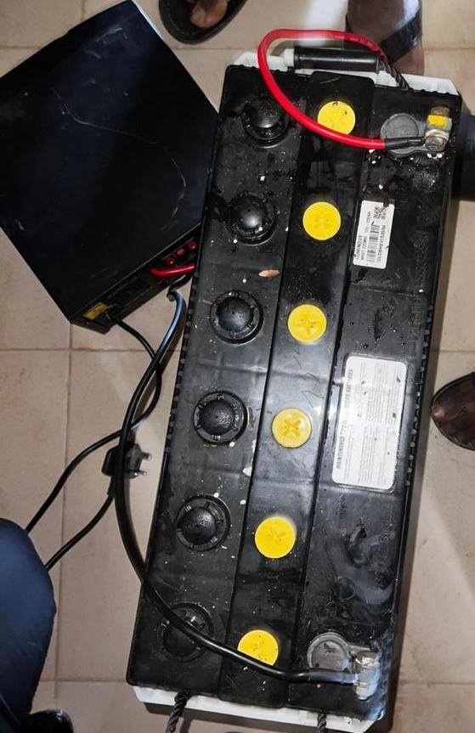
Fig 1: Battery used for the connection

Fig 4.2 Inverter: The inverter's purpose is to convert the DC power from the battery into AC power, which is essential for powering the surveillance system. The inverter plays a vital role in ensuring that the security system receives the appropriate type of electricity for its operation, allowing for continuous monitoring and recording capabilities.
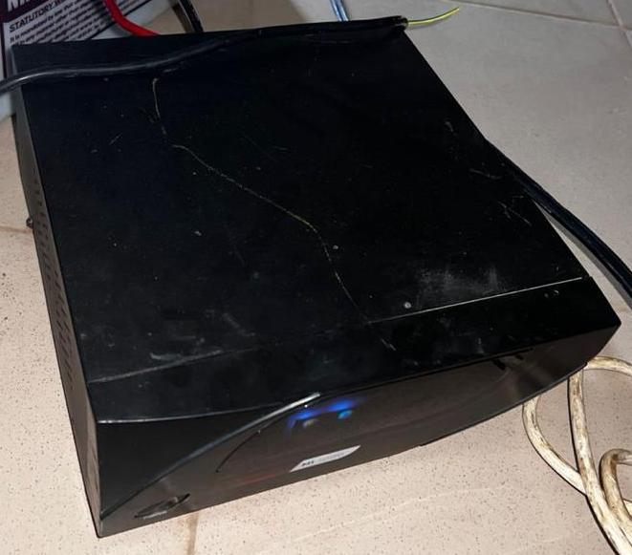
Fig 2: An Inverter connected
Fig 4.3 Power Box: The power box serves as the central hub for distributing power to various components of the security system. It plays a critical role in managing and regulating the electricity flow to ensure that all devices receive the necessary power for their operation.
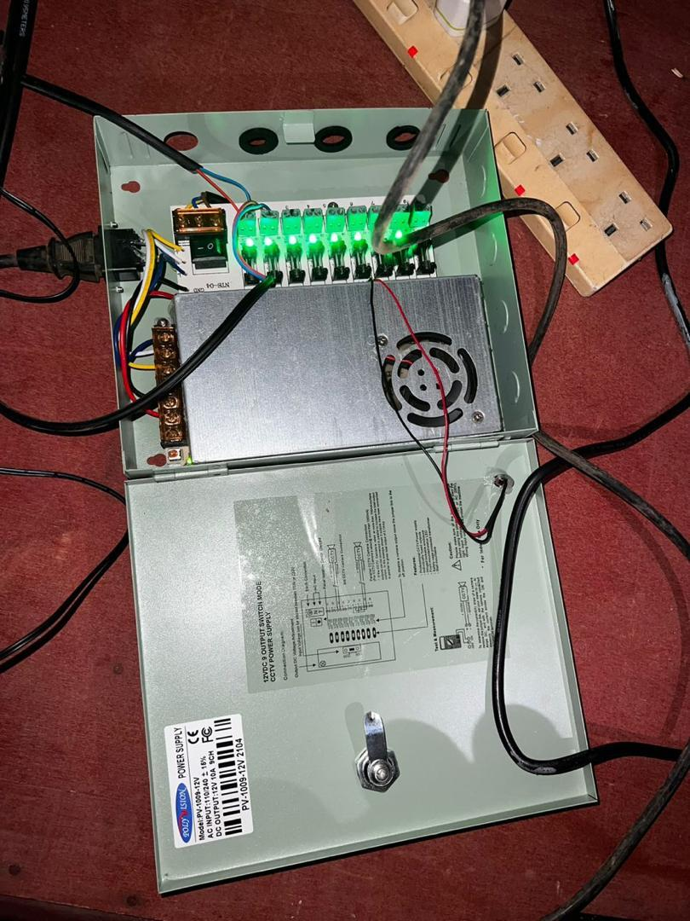
Fig 3: power box
Fig 4.4 DVR: The DVR, which stands for Digital Video Recorder, is an essential component in a CCTV setup. Its purpose is to record and store video footage captured by the cameras. The DVR allows for playback, storage, and remote access to the recorded video, making it a key element in surveillance and security systems.


Fig 4: DVR

FIG 4.5 CCTV Camera: The CCTV camera's main purpose is to capture video footage of the monitored area. Cameras play a vital role in surveillance systems by recording activities, providing real-time monitoring, and enhancing security measures.
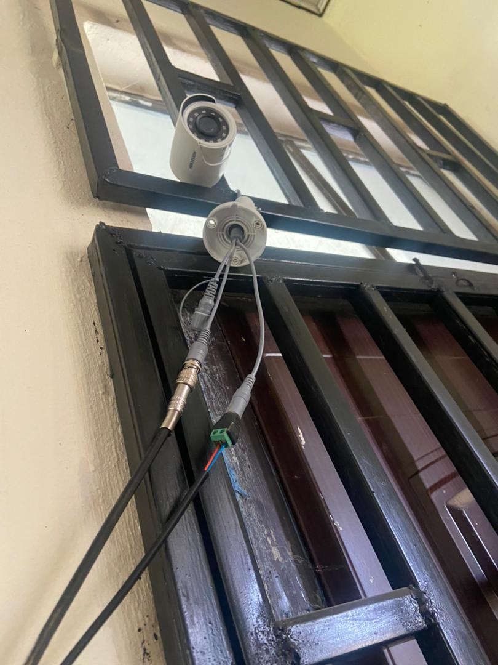
Fig 5: CCTV camera installed outside the department
Fig 4.6 Monitor: The monitor's main job is to display the video feed from the CCTV cameras. It allows for real-time viewing of the surveillance footage, providing a visual representation of the monitored area for security and monitoring purposes.
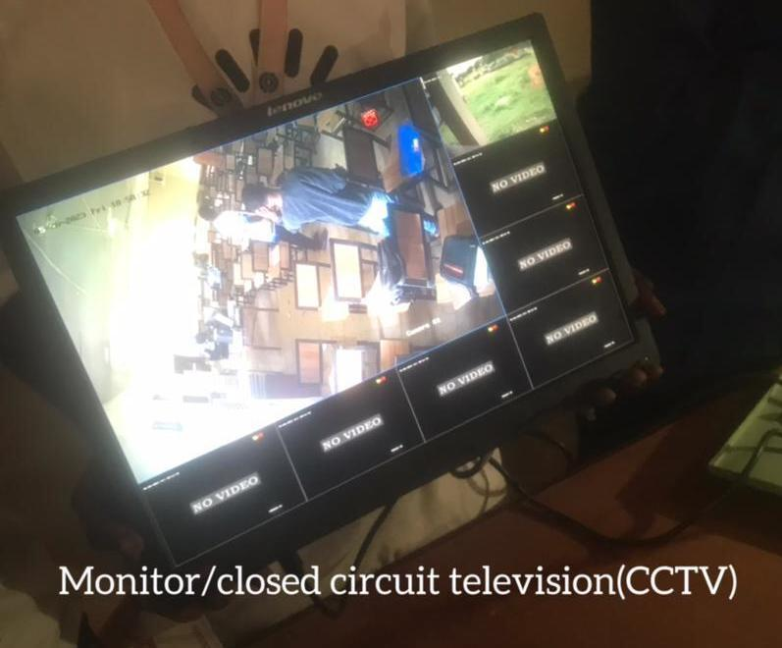
Fig 6: Monitor showing the output from the installed camera
4.1 Output and Result
The outcome and output of the entire process involve having a comprehensive security system in place that effectively monitors and records activities in the designated area. This setup ensures enhanced surveillance and security measures through the integration of CCTV cameras, DVR for recording, power boxes for distribution, and monitors for real-time viewing.
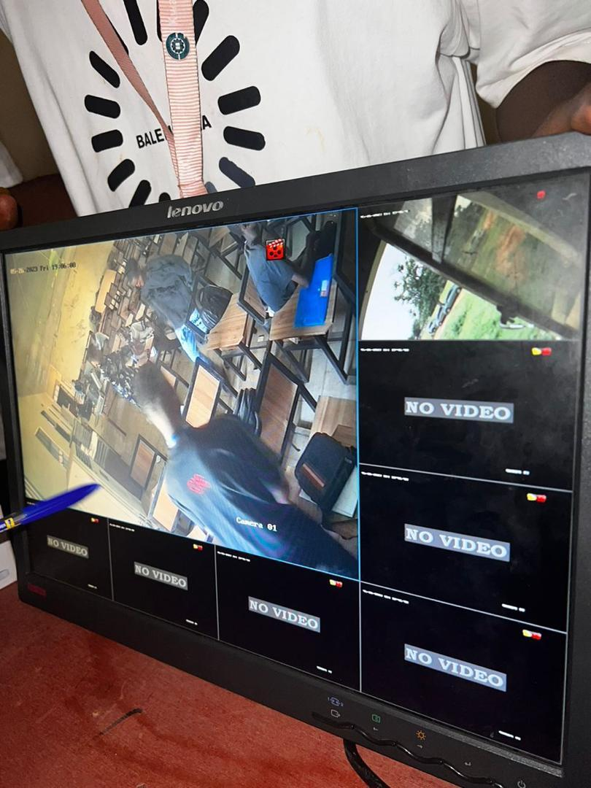
FIG 7: Output Display of first camera
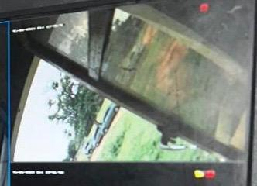
Fig 8: Output display of second camera

CHAPTER FIVE
5.0 SUMMARY, CONCLUSION AND RECOMMENDATION
5.1 SUMMARY
This chapter gives a concise overview of the research report on the manual system. It identifies issues with the manual system such as reliance on the battery for power, limited access, and reliability concerns. The analysis of the proposed inverter and battery system is then presented, outlining its design, components, power management strategies, and surveillance capabilities. The system's goals and objectives are discussed, emphasizing sustainable power supply, cost-effectiveness, improved surveillance capabilities, scalability, and environmental advantages. A smart security system powered by an inverter offers a dependable and effective method to safeguard your property. By utilizing inverter technology, continuous surveillance and recording are ensured, even during power outages. This setup allows for remote monitoring and alert systems, enhancing security and providing peace of mind while optimizing energy usage and reducing expenses.

5.2 CONCLUSION
In wrapping up, incorporating an inverter into a smart security system presents a strong and effective resolution for surveillance and security requirements. It ensures a dependable and uninterrupted power supply, guaranteeing continuous monitoring and recording. By harnessing this technology, individuals and organizations can experience improved security, peace of mind, and cost-effectiveness, making it a valuable investment for protecting their properties, assets, and loved ones. With features like remote monitoring, instant alerts, and efficient energy usage, an inverter-powered smart security system stands out as an innovative solution that establishes a new benchmark in security infrastructure, fostering a safe and protected environment for everyone.

5.3 RECOMMENDATION
When setting up a smart security system that utilizes an inverter for power, you are not only enhancing your home's security but also ensuring uninterrupted operation even during power outages. This innovative approach combines the reliability of an inverter system with the advanced features of a smart security setup. By combining an inverter for power with a smart security system, you're not only boosting your home's security but also ensuring continuous operation even during power outages. This setup marries the efficiency of an inverter system with the advanced features of a smart security solution, providing a reliable and sustainable security option. Highlighting the energy efficiency, uninterrupted monitoring, remote access, integration with other smart devices, and customization possibilities.

REFERENCES
"A survey on smart grid cyber-physical system test-beds,* IEEE Communication.
ACM Computer. Survey, vol. 41, pp. 1-58, Jul. 2009.M. H. Cintuglu, O. A. Mohammed, K. Akkaya, and A. S. Uluagac,
Agency Germany, Dessau-Roblau, Germany, Tech. Rep., Jul. 2010.T.V. Vu, B. L. H. Nguyen, Z. Cheng, M.-Y. Chow, and B.
Andrejevic, M. (2015). The infrastructure of smart surveillance: Tracking, data mining, and anticipation. Surveillance & Society, 13(2), 163–176. https://doi.org/10.24908/ss.v13i2.5336
Chandola, A. Banerjee, and V. Kumar "Anomaly detection: A survey"
Charissé, F Eckermann, R. Herbener, U. Kaulfersch, G. Knoche,
Che, X. Liu, and Z. Li, "Mitigating false data attacks induced overloads using a corrective dispatch scheme. IEEE Trans. Smart Grid, vol. 10. no. 3, pp. 3081-3091, May 2019.
Chen, S. Huang, F. Liu, Z. Wang, and X. Sun, *Evaluation of reinforcement learning-based false data injection attack to automatic voltage control." IEEl: Trans. Smart Grid, vol. 10, no. 2, pp. 2158-2169, Mar. 2019.
Gu, X. Du, Y. Shi, Y. Wu, P. Sun, and H.-M. Tai, "Power control for grid-connected converter to comply with safety operation limits during grid faults,' in Proc.
Jhala, B. Natarajan, A. Pahwa, and H. Wu, *Stability of transitive energy market-based power distribution system under data integrity attack." IEEE Trans. Ind. Information, vol. 15, no. 10, pp. 5541-5550.
Klaus, C. Vollmer, K. Lehmann, K. Müschen, R. Albert, M. Bade,
Kuhnhenn, C. Lohse, C. Loreck, U. Lorenz, B. Lünenbürger,
LEEE Energy Convers. Congr Expo. (ECCE), Sep. 2016, pp. 1-5.L. Wei, A. I.
Memmler, C. Mordziol, A. Ostermeier and B. Westermann, "2050 energy target: 100% renewable electricity supply" Federal Environ.
Oct. 2021.J. H. Hong, C.-C. Liu, and M. Govindarasu, "Integrated anomaly detection for cyber security of the substations, IEEE Trans. Smart Grid, vol. 5, no. 4, pp. 1643-1653, Jul. 2014.V.
Sahoo, T. Dragicevic, and F. Blaabjerg, "Cyber security in control of grid-tied power electronic converters—Challenges and vulnerabilities," IEEE J. Emerg. Sel. Topics Power Electron., vol. 9. no. 5, pp. 5326-5340.
Sarwat, W. Saad, and S. Biswas, "Stochastic games for power grid protection against coordinated cyber-physical attacks,' IEEE Trans. Smart Grid, vol. 9, no. 2, pp. 684-694, Mar 2018.S.
Surveys Tuts., vol. 19, no. 1, pp. 446-464, Ist Quart., 2017
Roy and S. Debbarma, "Detection and mitigation of cyber-attacks on AGC systems of low inertia power grid,' TEEE Syst. J., vol. 14, no. 2, pp. 2023-2031, Jun. 2020.
Zhang, "Cyber-physical micro grids: Toward future resilient communities,' IEEE Ind. Electron. Mag., vol. 14, no. 3, pp. 4-17, Sep. 2020.S.
Ajeet, S., & Puneet, K. (2014). Automated Surveillance Security System Using Facial Recognition for Homes and Offices. International Journal of Computer Applications, 90(8), 25–29. https://doi.org/10.5120/15670-5003.
Kumar, B., Eddy, D., & Ayachandra, S. (2010). Automated Surveillance System and Data Communication. International Journal of Computer Applications, 7(2), 35–41.

