STATISTICAL ANALYSIS ON EARLY CHILDHOOD MORTALITY IN NIGERIA

BY

OMOSULE, BLESSING OMOLAWA
HND/23/STA/FT/022

A PROJECT SUBMITTED TO THE
DEPARTMENT OF STATISTICS,
INSTITUTE OF APPLIED SCIENCES,
KWARA STATE POLYTECHNIC, ILORIN.

IN PARTIAL FULFILMENT OF THE REQUIREMENT FOR
THE AWARD OF HIGHER NATIONAL DIPLOMA (HND)
IN STATISTICS

JULY, 2025

CERTIFICATION
This is to certify that this project was carried out by Omosule, Blessing Omolawa with Matriculation Number HND/23/STA/FT/022.This project has been read and approved as meeting part of the requirement for the award of Higher National Diploma in Statistics.

…………………………. ………………………
Alao, N. A. (Ph.D) Date
(Project Supervisor)

…………………………. ……………………..
Ajiboye R.A. Date
(Project Coordinator)

………………………….. ……………………..
Elepo T. A. (Mrs) Date
(Head of Department)

…………………………… ………………………..
External Examiner Date

DEDICATION
This project is dedicated to the Almighty GOD and My beloved parents, Mr And Mrs Omosule.

ACKNOWLEDGEMENTS
I give thanks to God Most high, for being with me through my academics pursuit in Kwara State Polytechnic. I am indebted to my supervisor Dr. Alao, N. A., for his suggestions, comments and constant scrutinizing of this work led to several improvements in this work and advancement of knowledge to me. May God abundantly reward you all (Amen).
I must also acknowledge the assistance of Mr. Suleiman, S., for his constant support and guidance in the course of this research work. My thank goes to Head of Department, Statistics in person of Mrs. Elepo, T. A., and entire academic staff of the department for their assistance and support throughout my programme, may almighty God guide you and be with you all (Amen).
I am also grateful to my parents, my adorable siblings and my colleagues for their love and ever supportive actions towards my academics. To my ever dynamic friends, I say a big thank you, for without them learning might have been difficult. I pray God blesses us all. Acknowledgement and thanks are due to numerous authors whose great works we have consulted during the course of this project.

TABLE OF CONTENTS
Title page i
Certification page ii
Dedication iii
Acknowledgements iv
Table of Contents v
List of Tables vii
List of Figures viii
Abstract ix
CHAPTER ONE: GENERAL INTRODUCTION
  - Background to the Study 1
1.2 Aim and objectives of the study 4
1.3 Significance of study 4
1.4 Scope and limitation of the study 5
CHAPTER TWO: LITERATURE REVIEW
2.1 Concepts of Early Child Mortality 6
2.1.1 Neonatal Mortality 6
2.1.2 Post-neonatal Mortality 6
2.1.3 Infant and Child Mortality 7
2.1.4 Under-5 mortality 7
2.2 Reviews of Empirical Studies 7
CHAPTER THREE: METHODOLOGY
3.1 Sources of data collection 10
3.2 Statistical Methods 10
3.2.1 Multivariate Analysis of Variance (MANOVA) 10
3.2.2 Assumption of MANOVA 16
CHAPTER FOUR: DATA ANALYSIS AND RESULTS
4.1 Data Presentation 17
4.2 Data analysis and results 18
4.2.1 Descriptive Statistics 18
4.2.2 Multivariate Analysis of Variance (MANOVA) 21
4.2.3 Post Hoc Tests for MANOVA 23
CHAPTER FIVE: SUMMARY AND CONCLUSIONS
5.1 Summary of findings 27
5.2 Conclusion 27
References 29

LIST OF TABLES
Table 4.1. Early Child mortality in Nigeria geo-political zones per 1000 live births 17
Table 4.2. Distribution of Nigeria geo-political zones 18
Table 4.3. Descriptive Statistics of the Early Child Mortality in the six geo political zones 19
Table 4.4. Multivariate Tests 21
Table 4.5. MANOVA Tests of Between-Subjects Effects 22
Table 4.6. Neonatal mortality (NN) Post Hoc Tests 23
Table 4.7. Post neonatal mortality (PNN) Post Hoc Tests 24
Table 4.8. Infant mortality (1q0) Post Hoc Tests 24
Table 4.9. Child mortality (4q1) Post Hoc Tests 25
Table 4.10. Under-5 mortality (5q0) Post Hoc Tests 25

LIST OF FIGURES
Figure 4.1. Graphical representation of the distribution of the early 20
child mortality per geo political zones

ABSTRACT
Despite the global decline in under-five mortality rate from 90 deaths per 1,000 live births in 1990 to 48 in 2012, Nigeria has failed to record any substantial improvement. Under-five mortality in Nigeria increased from 138 per 1,000 live births in 2007 to 158 per 1,000 live births in 2011 against the Millennium development Goal target of71 per 1,000 live births. The study used data from the Nigeria Demographic and Health Survey (NDHS) 2024 to examine distribution of early child mortality across the six geo political zone in Nigeria. Using MANOVA, the results revealed that the number of deaths based on the category of early child mortality are not the same both within and between the six geo political zones in Nigeria. Also, child deaths is most significant in the North West for Neonatal (NN), Post Neonatal (PNN), Infant (1q0), Under-5 (5q0) while the North East is the zone with most significant death for Child mortality (4q1). Finally, the North West geo political zone are mostly affected by early child mortality than any other zones in Nigeria.

Key words: Child, Mortality, MANOVA, Geo political zones.

CHAPTER ONE
GENERAL INTRODUCTION
  - Background to the Study
Childhood mortality is a fundamental measurement of a country ’s level of socio-economic and demographic development, and quality of life, especially of families. The Oxford English Dictionary defines a child as “a young human being below the legal age of maturity”. In Nigeria, the legal age of maturity is 18 years. Reports from Nigeria, sub-Saharan Africa and the world at large have revealed that mortality experiences ranging from neonatal mortality, infant and child mortality to maternal mortality are still high (Adeboye et al., 2010; Yaya et al., 2016 & Okonofua et al., 2016). Nigeria still has high prevalence of mortalities reflected in infants and children amongst others (Adekanmbi et al., 2013; Aremu et al., 2011 & Ojaegbu, 2013).
In Nigeria, the childhood mortality rate stands at 128 per 1000 live births, with large disparities in her different regions. Report from the Nigeria Demographic and Health Survey, 2013 showed that childhood mortality rates range widely across geopolitical zones. Regarding child mortality as a persistent public health challenge in Nigeria and other developing countries, researchers have made immense efforts to identify factors responsible for this menace (Becher et al., 2004 ;Buor, 2003 & Adetunji, 1995). Studies have shown that mortality rates and risk factors varied by bio-demographic and socio-economic characteristics (Antai, 2011; Antai et al., 2010, Anyamele, 2009 & Argeseanu, 2004). The factors associated with childhood mortality from studies done in Brazil and America were reported as maternal obesity, maternal malnutrition, maternal short stature and maternal age less than 25 years or greater than 35 years (Felisbino-Mendes et al., 2015; Myrskylä & Fenelon, 2012). In Nigeria and Burkina Faso, factors associated with under-five mortality were reported as lack of parental formal education, poverty and living in rural areas, season of birth, inter-pregnancy interval and distance from health care facilities (Ezeh et al., 2015 & Heiko et al., 2004). Tackling the death of children, whether during perinatal, early or late neonatal, childhood or adolescent age is posing a difficult task in Nigeria. Findings from previous studies in Nigeria and several developing countries revealed numerous predictors of mortality (Fayeun & Omololu, 2011; Omariba & (Boyle, 2007). These findings triggered intervention initiatives which aimed to identify the factors responsible for the high mortality rates and the most appropriate techniques for tackling them. Nigeria is yet to meet the Sustainable Development Goals (SDGs) targets, regardless of national and international implementation projects on the reduction of mortality. A key factor such as inadequate health care services remains a frontline problem in Nigeria. SDGs identify the minimum requirements to improve the general wellbeing of a population (Ghose et al., 2016; Glass et al., 2012 & Norheim et al., 2014). One of the stated goals is the Good Health and Well-being (SDG3). Ensuring healthy lives and promoting the well-being of the general population at all ages is essential to sustainable development.
Nigeria loses about 2,300 children that are beneath-five months old and 145 women of childbearing age daily. This makes the country to be the second biggest contributor to under-5 and maternal mortality rates in the whole world. Many lives can be saved if global inequalities are reduced (UNICEF, 2017). About 89,700 day-old infants die in Nigeria every year (UNICEF, 2017). Major causes of loss of life among youngsters vary by using age. Children under 5 are vulnerable to infectious illnesses like malaria, pneumonia, diarrhea, HIV, and tuberculosis. For older youngsters, non-communicable illnesses, injuries, and struggles pose sizable threats to them. Despite being totally preventable and treatable, common infectious diseases are still killing younger children in large numbers, according to the Centre for Disease Control and Prevention (CDC, 2020). In West African countries, there was a high incidence of killer diseases which affected maternal and infant health leading to high mortality of infants. This can be attributed to the type of vegetation in West Africa and other factors which include: the sanitary condition of our local populace, mode of feeding, and also lack of health infrastructures. All these created problems that led to high infant mortality (CDC, 2020). Again, other causes of infant mortality are recognized killer childhood diseases, such as measles, malaria, smallpox, tetanus, whooping cough, hepatitis, poliomyelitis, diphtheria, and jaundice. In the late 80s, the government of Nigeria, through the National Program on Immunization and Expanded Program on Immunization, achieved a lot regarding the improvement of infant health (CDC, 2020). The World Health Organization (WHO), in collaboration with UNICEF, implemented the Integrated Management of Childhood Illnesses (IMCI) strategy in the mid-1990s. The proposal is to reduce child mortality. For this, the IMCI has set in motion preventive and curative interventions at the family, community, and institutional levels. A number of studies have demonstrated that this strategy is not only effective but also efficient (Adam, Manzi, Armstrong, et al., 2005). Majumder et al. (2014) and Kulkarni et al. (2007) observed a higher mortality rate among mothers in the age group of 21–25 years. In the study, mortality among females was higher (54.5%) compared to male children (45.5%). These findings were in correlation with the findings of Dalal et al. (2016) who found a greater number of female deaths (53.8%) compared to males (46.2%), and Muzammil et al. (2014) who also reported 58.3% female infant deaths. These findings reflect the differential care and attention given to the female child. It can be addressed by counseling the families regarding the importance of the girl child and improving the literacy status of women.
Progress has been made on increasing access to basic needs to enhance life expectancy, but more effort is needed to fully eradicate a wide range of barriers and address a plethora of persistent and emerging health issues. Statistics show that most sub-Saharan countries in Africa, including Nigeria, have a lot to do in achieving the SDG3. More research is therefore needed to inform the formulation of policies and implementation of programs for appropriate health intervention. Thus, it was against the backdrop this study examined the category of child mortality across six geo political in Nigeria using NDHS, 2024 dataset.
1.2 Aim and objectives of the study
This project work aim at study the early child mortality in Nigeria using Health Demographic survey dataset for 2024.
Objectives:
- To study distribution of the early child mortality in Nigeria based on geo political zones.
- To determine whether there is significant difference in early child mortality in Nigeria both within and between the geo political zones.
- To determine the geo political zone with most significant early child mortality in Nigeria.
1.3 Significance of study
The research work will be of great importance to researchers carrying out their research work on related topics. This research work will be useful for the management of Child mortality rate. It will also create awareness to all the stakeholder in the health sector across the six geo political zones Nigeria to find an everlasting solution to early child mortality.

1.4 Scope and limitation of the study
This study covers the estimates of childhood mortality per 1000 live births for three successive 5-year periods prior to the 2023-24 NDHS. The rates were estimated directly from information collected as part of a retrospective pregnancy history in which female respondents listed all of the children to whom they have given birth, along with each child’s date of birth, survivorship status, and current age or age at death (FMoHSW, et al., 2024). The analysis are based on dataset as described above and results are limited to period under reviews only.

CHAPTER TWO
LITERATURE REVIEW
2.1 Concepts of Early Child Mortality
In this section, there are some technical concepts relevant to the study and demand for clarification in the way and manner being used in this study. The concepts include neonatal, post-neonatal, infant, child, and under-five mortality.
2.1.1 Neonatal Mortality
The first 28 days of life the neonatal period represent the most vulnerable time for a child‟s survival. Neonatal mortality includes deaths that occur during the first 28 days of life (Ouma & Tuno, 2014). The neonatal period begins with birth and ends 28 complete days after birth. Neonatal deaths may be subdivided into early neonatal deaths, occurring during the first seven days of life (0-6 days) and late neonatal deaths, occurring after the seventh day but before the 28th day of life. The WHO (2006) shows that, neonatal deaths in developed countries are declining and this is as a result of changing patterns in reproductive health, socioeconomic progress and improved quality of obstetric and neonatal facilities.
Neonatal mortality: The probability of dying within the first month of life.
2.1.2 Post-neonatal Mortality
Post-neonatal mortality includes death that occurs at ages 1 to 11 months (Ouma; Bashar and Tuno, 2014). Post-neonatal mortality is most often caused by infectious diseases, such as pneumonia, tetanus, and malaria. An important factor in reducing post neonatal mortality is adequate nutrition, particularly breast milk, which provides babies with both the nourishment and the antibodies to fight 7 infectious diseases.
Postneonatal mortality: The probability of dying between the first month of life and the first birthday (computed as the difference between infant and neonatal mortality).
2.1.3 Infant and Child Mortality
Infant mortality is defined as the death of a live born infant between birth and exact age one (1) (UNICEF, et al. 2007). Infant mortality rate is the probability of a child born in a specific year or period dying before reaching the age of one, if subjected to current age specific mortality rates of that period. Infant mortality is a potentially important indicator. This is because mortality tends to decline more slowly among infants than among children aged 1 to 5. Child mortality includes deaths that occur at ages 1 to 5 years.
Infant mortality: The probability of dying between birth and the first birthday.
Child mortality: The probability of dying between the first and the fifth birthday.
2.1.4 Under-5 mortality
Under-5 mortality includes deaths that occur between birth and exact age 5 (Ouma; Bashar and Tuno, 2014). Generally all deaths in childhood occur before age 5, thus the probability of dying by age 5 can be regarded as a good index of overall level of child mortality.
Under-5 mortality: The probability of dying between birth and the fifth birthday.
2.2 Reviews of Empirical Studies
Yaya et al. (2017) findings suggested that age, region, residence, education, wealth index, age at first birth and religion of fathers and mothers are key determinants associated with childhood mortality. The correlation between childhood mortality and fathers’ and mothers’ ages were found to increase the incidence of the outcome for every unit increase in age. The converse was however, true for age at first birth which was also statistically significant. The implication of this study is that policy makers and stakeholders in health care should provide for improved living standards to achieve good life expectancy meeting SDG3.
Baraki et al. (2020) stated that, at the same time, as you consider that infant mortality remains an excessive public health trouble, intervention shall be done giving more attention to infants who were delivered multiple and who are preterm.
Finnerty, Provost, O'Donnell, Selk, Stephens, and Kim et al. (2019) stated that studying infant mortality is helpful for improving child health and maternal health as well.
Okwuwa et al., (2020) stated that the immoderate rate of toddler mortality and incapability of pregnant ladies to get admission to healthcare implicate children’s life chances, maternal psychosocial and economic well-being, future family welfare, and community and national development potentialities.
Okorie et al., (2023), results showed that in 2019, the mortality will be 45 per 1000 and birth will be 124 per 1000; in 2025, the mortality will be 65 per 1000 and birth will be 191 per 1000; in 2030, the mortality will be 90 per 1000 and birth will be 272 per 1000; in 2035, the mortality will be 110 per 1000 and birth will be 340 per 1000. This shows that as the birth is increasing, death is also increasing. From Figure 2, we discovered that mortality is on the increase from year to year. The t-test indicated that there is a linear relationship between infant mortality and birth from 2018– 2037, which shows us that t calculated (0.143) < t tabulated (2.021), thereby giving us room not to reject our H₀.
The estimates of childhood mortality for three successive 5-year periods prior to the 2023– 24 NDHS. The rates were estimated directly from information collected as part of a retrospective pregnancy history in which female respondents listed all of the children to whom they have given birth, along with each child’s date of birth, survivorship status, and current age or age at death.
According to NDHS (2024), during the 5 years immediately preceding the survey, the neonatal mortality rate was 41 deaths per 1,000 live births. This means that approximately 1 out of every 25 infants die within the first month of life. The infant mortality rate was 63 deaths per 1,000 live births. This means that 1 out of every 16 children die in the first year of life. The under-5 mortality rate was 110 deaths per 1,000 live births. This means that 1 out of every 9 children die before their fifth birthday. Neonatal, postneonatal, infant, and under-5 mortality rates during the 10 years preceding the survey were highest in the North West zone and lowest in the South West zone.
Among the states, Kano had the highest neonatal mortality rate (59 deaths per 1,000 live births), Kebbi had the highest postneonatal (41 deaths per 1,000 live births) and infant (90 deaths per 1,000 live births) mortality rates, Yobe had the highest child mortality rate (96 deaths per 1,000 live births), and Jigawa had the highest under-5 mortality rate (161 deaths per 1,000 live births).

CHAPTER THREE
METHODOLOGY
3.1 Sources of data collection
The data used for this project work is secondary data obtained from the Nigeria Demographic Health Survey (NDHS) 2023-2024 key indicators. The data presents estimates of childhood mortality per 1000 live births for three successive 5-year periods prior to the 2023-24 NDHS. The rates were estimated directly from information collected as part of a retrospective pregnancy history in which female respondents listed all of the children to whom they have given birth, along with each child’s date of birth, survivorship status, and current age or age at death (FMoHSW, et al., 2024).
3.2 Statistical Methods
3.2.1 Multivariate Analysis of Variance (MANOVA)
Two-way MANOVA can be considered to be an extension of one-way MANOVA to support two factors and their interaction or as an extension to two-way ANOVA to support multiple dependent variables.

Univariate case
Two-way ANOVA investigates the effects of two categorical variables on a continuous outcome (the dependent variable). In two-way ANOVA, we have r random variables (the levels) for Factor A (the row factor) and c random variables for Factor B (the column factor). For each interaction between the factor levels, we have a sample with m elements (we restrict ourselves to the balanced model here). We can represent the sample for the i^{th} level from Factor A and the j^{th} level from Factor B by X_{ij} = {x_{ij1}, …, x_{ijm}}.
Our objective is to test three types of null hypotheses:
H₀: μ_{1.} = μ_{2.} = … = μ_{r.} (Factor A)
H₀: μ_{.1} = μ_{.2} = … = μ_{.c} (Factor B)
H₀: δ_{ij}= 0 for all i, j (Interaction between A and B, where the δ_{ij} are the interaction effects
We define the following where n = mrc.
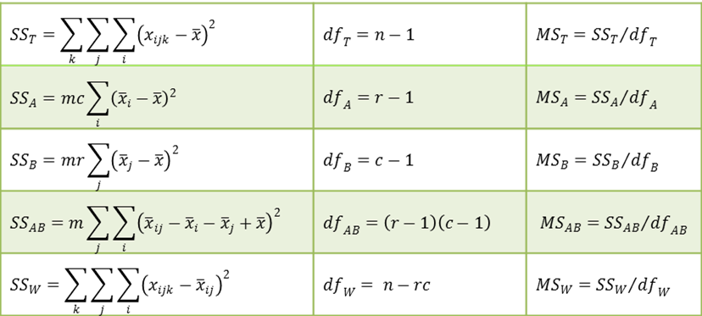
The test statistics F are defined as follows:
For each of the three null hypotheses, we reject the null hypothesis if F > F_{crit}.

Multivariate case
As for one factor MANOVA, two-factor MANOVA is similar to two-factor ANOVA except that in place of simple variables (for each factor) we have random vectors and in place of sample data {x_{ij1}, …, x_{ijm}} for the i^{th} level in Factor A and the j^{th} level in Factor B, we have sample data {X_{ij1}, …, X_{ijm}} where each X_{ijk} is a p × 1 column vector of data elements of the form x_{ijkh}. Here, there are p dependent variables.
The additive model takes the form:
This is exactly as for a two-factor ANOVA model except that x_{ijk} is replaced by X_{ijk} and the other terms are column vectors instead of scalars. With this change, the null hypotheses are as for ANOVA. In place of the ANOVA normality assumption, assume multivariate normality, namely
The df terms are as for ANOVA, as defined above, and the SS terms are defined in terms of the following p × p cross-product matrices.
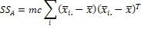
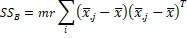
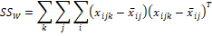
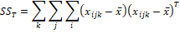
Recall that each of these SS matrices takes the form
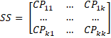
where for SS_{A}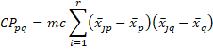
and similarly for the other SS matrices.

Wilk’s Lambda
Each of the three null hypotheses is tested using the appropriate Wilk’s Lambda.
If the Factor H null hypothesis is true (for H = A, B or AB) then
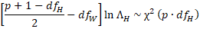
As for one factor MANOVA, a more accurate test is based on the F test, described as follows:
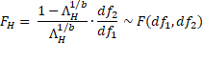
where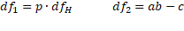
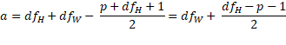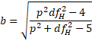
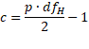If either the numerator or denominator of b equals 0 or results in a negative value inside the square root, then b takes the value of 1.

Hotelling-Lawley Trace
Each of the three null hypotheses is tested using the appropriate Hotelling-Lawley Trace test.
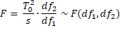
where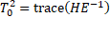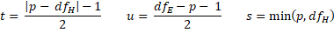

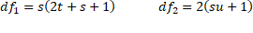

Pillai-Bartlett Trace
Each of the three null hypotheses is tested using the appropriate Pillai-Bartlett Trace test.
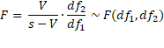
where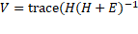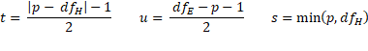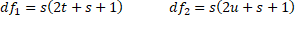
Roy’s Largest Root
Each of the three null hypotheses is tested using the appropriate Roy’s Largest Root test.
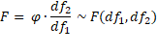
where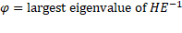
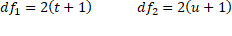
and s, t, u are as for the Pillai-Bartlett Trace test.

3.2.2 Assumption of MANOVA
- One of the assumptions of MANOVA is that the response variables come from group populations that are multivariate normal distributed. This means that each of the dependent variables is normally distributed within group, that any linear combination of the dependent variables is normally distributed, and that all subsets of the variables must be multivariate normal. With respect to Type I error rate, MANOVA tends to be robust to minor violations of the multivariate normality assumption.
- The homogeneity of population covariance matrices (a.k.a. sphericity) is another assumption. This implies that the population variances and covariances of all dependent variables must be equal in all groups formed by the independent variables.
- Small samples can have low power, but if the multivariate normality assumption is met, the MANOVA is generally more powerful than separate univariate tests.

CHAPTER FOUR
DATA ANALYSIS AND RESULTS
4.1 Data Presentation
The dataset used for the analysis are shown in the Table 4.1 below
Table 4.1. Early Child mortality in Nigeria geo-political zones per 1000 live births
Neonatal mortality (NN) | Post neonatal mortality (PNN) | Infant mortality (1q0) | Child mortality (4q1) | Under-5 mortality (5q0) | Zone
25 | 10 | 35 | 26 | 60 | North Central
19 | 15 | 34 | 20 | 53 | North Central
39 | 20 | 59 | 21 | 78 | North Central
12 | 1 | 12 | 2 | 14 | North Central
50 | 20 | 70 | 38 | 106 | North Central
22 | 10 | 31 | 18 | 49 | North Central
31 | 28 | 59 | 42 | 98 | North Central
43 | 33 | 75 | 75 | 144 | North East
48 | 28 | 77 | 52 | 125 | North East
30 | 18 | 48 | 39 | 86 | North East
45 | 36 | 81 | 83 | 157 | North East
38 | 26 | 64 | 66 | 126 | North East
34 | 20 | 54 | 96 | 145 | North East
53 | 28 | 81 | 87 | 161 | North West
47 | 39 | 85 | 74 | 153 | North West
59 | 26 | 86 | 79 | 158 | North West
42 | 21 | 63 | 45 | 105 | North West
49 | 41 | 90 | 75 | 159 | North West
28 | 28 | 56 | 57 | 109 | North West
42 | 18 | 60 | 62 | 119 | North West
27 | 23 | 49 | 21 | 69 | South East
32 | 17 | 50 | 24 | 72 | South East
26 | 16 | 42 | 28 | 68 | South East
25 | 9 | 34 | 16 | 49 | South East
51 | 12 | 62 | 24 | 85 | South East
38 | 17 | 56 | 25 | 80 | South South
32 | 24 | 56 | 18 | 73 | South South
24 | 15 | 39 | 22 | 60 | South South
19 | 7 | 26 | 7 | 33 | South South
7 | 6 | 13 | 6 | 19 | South South
30 | 9 | 39 | 15 | 54 | South South
18 | 8 | 27 | 18 | 44 | South West
25 | 11 | 36 | 11 | 46 | South West
35 | 12 | 47 | 13 | 60 | South West
3 | 5 | 8 | 7 | 15 | South West
36 | 14 | 49 | 6 | 55 | South West
17 | 1 | 18 | 5 | 23 | South West
Source: NDHS 2023-2024, Key Indicators

4.2 Data analysis and results
In this sub section, the data were analyzed using Multivariate techniques with SPSS and the results are shown in the Table 4.2 – Table 4.10.
4.2.1 Descriptive Statistics
Table 4.2. Distribution of Nigeria geo-political zones
 | Zone | Value Label | N
 | 1 | North Central | 7
 | 2 | North East | 6
 | 3 | North West | 7
 | 4 | South East | 5
 | 5 | South South | 6
 | 6 | South West | 6

Table 4.2 show the number (N) of states in each of the six geo political zones in Nigeria. North central and North west comprises of 7states including FCT while others has 6 states each except South east with 5 states, respectively.

Table 4.3. Descriptive Statistics of the Early Child Mortality in the six geo political zones
Neonatal mortality (NN)
Zone | North Central | North East | North West | South East | South South | South West | Total
Mean | 28.29 | 39.67 | 45.71 | 32.2 | 25 | 22.33 | 32.46
Std. Deviation | 12.88 | 6.89 | 9.861 | 10.849 | 10.991 | 12.453 | 13.207
Post neonatal mortality (PNN)
Mean | 14.86 | 26.83 | 28.71 | 15.4 | 13 | 8.5 | 18.16
Std. Deviation | 8.802 | 7.055 | 8.558 | 5.32 | 6.957 | 4.848 | 10.126
Infant mortality (1q0)
Mean | 42.86 | 66.5 | 74.43 | 47.4 | 38.17 | 30.83 | 50.57
Std. Deviation | 20.375 | 13.398 | 14.199 | 10.383 | 16.845 | 16.241 | 21.731
Child mortality (4q1)
Mean | 23.86 | 68.5 | 68.43 | 22.6 | 15.5 | 10 | 35.76
Std. Deviation | 13.347 | 20.773 | 14.444 | 4.45 | 7.765 | 4.98 | 27.481
Under-5 mortality (5q0)
Mean | 65.43 | 130.5 | 137.71 | 68.6 | 53.17 | 40.5 | 84.05
Std. Deviation | 31.527 | 25.002 | 25.447 | 12.896 | 23.387 | 17.83 | 44.657

From Table 4.3, it observed that the average for Under-5 mortality (84.05) is highest follow by infant mortality (50.57), then child mortality (35.76), neonatal mortality (32.46), and post neonatal mortality (18.16), respectively. This implies that early child deaths in Nigeria are mostly Under-5 year and infants.
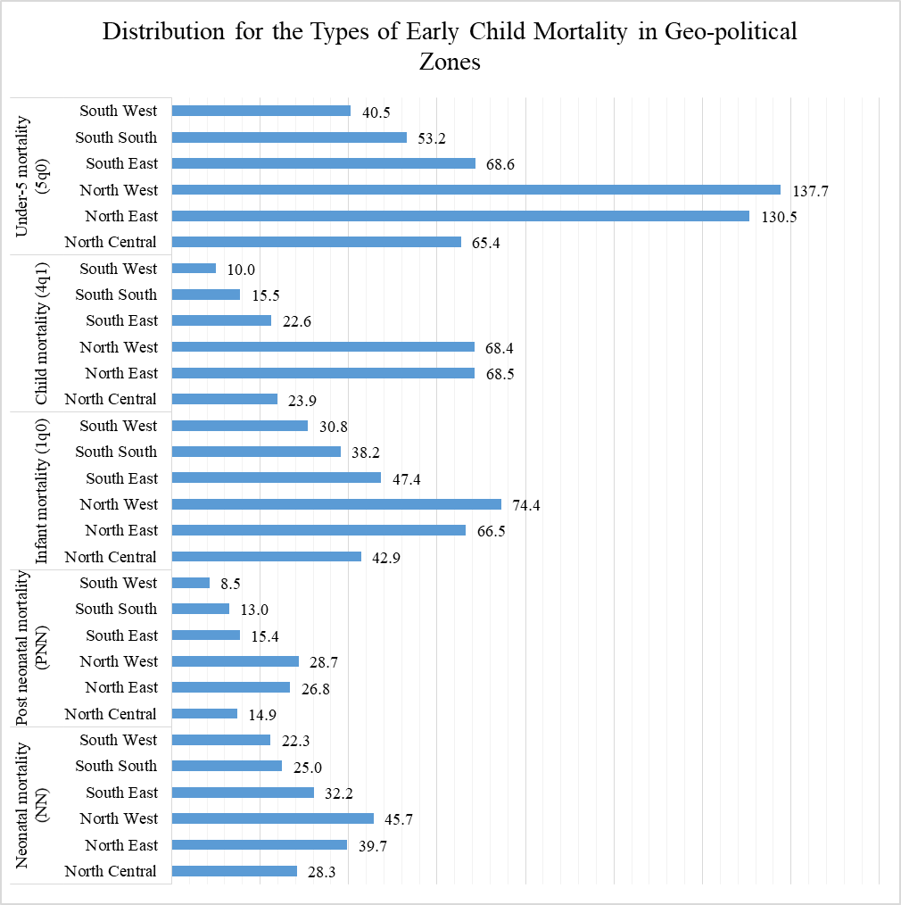
Figure 4.1. Graphical representation of the distribution of the early child mortality per geo political zones
From Figure 4.1, the North west (137.7) have the highest average deaths for the Under-5 mortality, North east (68.5) have the highest average deaths for the child mortality, North west (74.4) average for infant mortality is highest among the zones, also North west (28.7) and North west (45.7) have the highest average deaths for both post neonatal and neonatal mortality, respectively when compare with others geo political zones. This indicate that most early child mortality affects North West geo political zone than any other zones in Nigeria.

4.2.2 Multivariate Analysis of Variance (MANOVA)
Table 4.4. Multivariate Tests
Effect |  | Value | F | Hypothesis df | Error df | p-value
Intercept | Pillai's Trace | .947 | 96.398ª | 5.000 | 27.000 | .000
Intercept | Wilks' Lambda | .053 | 96.398ª | 5.000 | 27.000 | .000
Intercept | Hotelling's Trace | 17.851 | 96.398ª | 5.000 | 27.000 | .000
Intercept | Roy's Largest Root | 17.851 | 96.398ª | 5.000 | 27.000 | .000
Zone | Pillai's Trace | 1.105 | 1.759 | 25.000 | 155.000 | .020
Zone | Wilks' Lambda | .132 | 2.956 | 25.000 | 101.802 | .000
Zone | Hotelling's Trace | 4.933 | 5.011 | 25.000 | 127.000 | .000
Zone | Roy's Largest Root | 4.607 | 28.562^{b} | 5.000 | 31.000 | .000

From Table 4.4, since the p-value for all multivariate test statistics are less than α = 0.05 (level of significance), hence the null hypothesis is rejected and conclude that there is significant difference in child mortality both within and between the six geo political zones in Nigeria. That is, the category of child deaths are not the same both within and between the six geo political zones in Nigeria. Based on the results in Table 4.4, the Multivariate Analysis of Variance (MANOVA) was conducted to determine the category of child mortality as well as geo political zone with significant deaths and the results are shown in Table 4.5 below.

Table 4.5. MANOVA Tests of Between-Subjects Effects
Source | Dependent Variable | Type III Sum of Squares | df | Mean Square | F | Sig. p-value
Corrected Model | Neonatal mortality (NN) | 2612.865ª | 5 | 522.573 | 4.419 | 0.004
Corrected Model | Post neonatal mortality (PNN) | 2065.208^{b} | 5 | 413.042 | 7.876 | 0.000
Corrected Model | Infant mortality (1q0) | 9234.143^{c} | 5 | 1846.829 | 7.371 | 0.000
Corrected Model | Child mortality (4q1) | 22204.039^{d} | 5 | 4440.808 | 27.628 | 0.000
Corrected Model | Under-5 mortality (5q0) | 53827.716e | 5 | 10765.543 | 18.578 | 0.000
Intercept | Neonatal mortality (NN) | 37867.2 | 1 | 37867.2 | 320.18 | 0.000
Intercept | Post neonatal mortality (PNN) | 11681.186 | 1 | 11681.186 | 222.729 | 0.000
Intercept | Infant mortality (1q0) | 91417.426 | 1 | 91417.426 | 364.872 | 0.000
Intercept | Child mortality (4q1) | 44265.607 | 1 | 44265.607 | 275.396 | 0.000
Intercept | Under-5 mortality (5q0) | 249490.404 | 1 | 249490.404 | 430.535 | 0.000
Zone | Neonatal mortality (NN) | 2612.865 | 5 | 522.573 | 4.419 | 0.004
Zone | Post neonatal mortality (PNN) | 2065.208 | 5 | 413.042 | 7.876 | 0.000
Zone | Infant mortality (1q0) | 9234.143 | 5 | 1846.829 | 7.371 | 0.000
Zone | Child mortality (4q1) | 22204.039 | 5 | 4440.808 | 27.628 | 0.000
Zone | Under-5 mortality (5q0) | 53827.716 | 5 | 10765.543 | 18.578 | 0.000
Error | Neonatal mortality (NN) | 3666.324 | 31 | 118.269
Error | Post neonatal mortality (PNN) | 1625.819 | 31 | 52.446
Error | Infant mortality (1q0) | 7766.938 | 31 | 250.546
Error | Child mortality (4q1) | 4982.771 | 31 | 160.735
Error | Under-5 mortality (5q0) | 17964.176 | 31 | 579.49
Total | Neonatal mortality (NN) | 45263 | 37
Total | Post neonatal mortality (PNN) | 15896 | 37
Total | Infant mortality (1q0) | 111613 | 37
Total | Child mortality (4q1) | 74493 | 37
Total | Under-5 mortality (5q0) | 333200 | 37
Corrected Total | Neonatal mortality (NN) | 6279.189 | 36
Corrected Total | Post neonatal mortality (PNN) | 3691.027 | 36
Corrected Total | Infant mortality (1q0) | 17001.081 | 36
Corrected Total | Child mortality (4q1) | 27186.811 | 36
Corrected Total | Under-5 mortality (5q0) | 71791.892 | 36

From Table 4.5, since all the p-value for MANOVA for the zones are less than α = 0.05 (level of significance), hence the null hypothesis is rejected and conclude that there is significant difference in the category of the child mortality both within and between the six geo political zones in Nigeria. Therefore, a post hoc (multiple comparison) test was conducted to determine the zone with most significant child mortality based on the category of early child mortality considered for the study and the results are shown in Table 4.6 to 4.10, respectively.
4.2.3 Post Hoc Tests for MANOVA
In this section a post hoc test was conducted using Duncan multiple range test (DMRT) and results are shown in the Table 4.6 to Table 4.10 below.
Table 4.6. Neonatal mortality (NN) Post Hoc Tests
Zone | N | Subset
Zone | N | 1 | 2 | 3
South West | 6 | 22.33
South South | 6 | 25.00
North Central | 7 | 28.29 | 28.29
South East | 5 | 32.20 | 32.20
North East | 6 |  | 39.67 | 39.67
North West | 7 |  |  | 45.71
Sig. |  | .158 | .093 | .339

From Table 4.6, child mortality based on Neonatal for both the North West (45.71) and North East (39.67) geo political zone are more significant when compare with other zones. However, North West with higher marginal mean of 45.71 mortality is the most significant for Neonatal (NN) mortality.

Table 4.7. Post neonatal mortality (PNN) Post Hoc Tests
Zone | N | Subset
Zone | N | 1 | 2
South West | 6 | 8.50
South South | 6 | 13.00
North Central | 7 | 14.86
South East | 5 | 15.40
North East | 6 |  | 26.83
North West | 7 |  | 28.71
Sig. |  | .138 | .654

From Table 4.7, child mortality based on Post neonatal mortality (PNN) for both the North West (28.71) and North East (26.83) geo political zone are more significant when compare with other zones. However, North West with higher marginal mean of 28.71 mortality is the most significant for Post neonatal mortality (PNN) mortality.
Table 4.8. Infant mortality (1q0) Post Hoc Tests
Zone | N | Subset
Zone | N | 1 | 2
South West | 6 | 30.83
South South | 6 | 38.17
North Central | 7 | 42.86
South East | 5 | 47.40
North East | 6 |  | 66.50
North West | 7 |  | 74.43
Sig. |  | .104 | .389

From Table 4.8, child mortality based on Infant mortality (1q0) for both the North West (74.43) and North East (66.50) geo political zone are more significant when compare with other zones. Also, North West with higher marginal mean of 74.43 mortality is the most significant for Infant mortality (1q0).
Table 4.9. Child mortality (4q1) Post Hoc Tests
Zone | N | Subset
Zone | N | 1 | 2
South West | 6 | 10.00
South South | 6 | 15.50
South East | 5 | 22.60
North Central | 7 | 23.86
North West | 7 |  | 68.43
North East | 6 |  | 68.50
Sig. |  | .090 | .992
From Table 4.9, child mortality based on Child mortality (4q1) for both the North West (68.43) North East (68.50) geo political zone are more significant when compare with other zones. However, North East with higher marginal mean of 68.5 mortality is the most significant for Child mortality (4q1) mortality.
Table 4.10. Under-5 mortality (5q0) Post Hoc Tests
Zone | N | Subset
Zone | N | 1 | 2
South West | 6 | 40.50
South South | 6 | 53.17
North Central | 7 | 65.43
South East | 5 | 68.60
North East | 6 |  | 130.50
North West | 7 |  | 137.71
Sig. |  | .070 | .605

From Table 4.10, child mortality based on Under-5 mortality (5q0) for both the North West (137.71) and North East (130.50) geo political zone are more significant when compare with other zones. However, North West with higher marginal mean of 137.71 mortality is the most significant for Under-5 mortality (5q0).

CHAPTER FIVE
SUMMARY AND CONCLUSION
5.1 Summary of the findings
The following are the summary of the findings;

- the average for Under-5 mortality (84.05) is highest follow by infant mortality (50.57), then child mortality (35.76), neonatal mortality (32.46), and post neonatal mortality (18.16), respectively. This implies that early child deaths in Nigeria are mostly Under-5 year and infants.
- the North west (137.7) have the highest average deaths for the Under-5 mortality, North east (68.5) have the highest average deaths for the child mortality, North west (74.4) average for infant mortality is highest among the zones, also North west (28.7) and North west (45.7) have the highest average deaths for both post neonatal and neonatal mortality, respectively when compare with others geo political zones.
- The multivariate test statistics shows that there is significant difference in child mortality both within and between the six geo political zones in Nigeria.
- the post hoc test reveal that the North West with higher marginal mean is the most significant with child mortality for Neonatal (NN), Post Neonatal (PNN), Infant (1q0), Under-5 (5q0) while the North East is the zone with most significant death for Child mortality (4q1).

5.2 Conclusion
Based on the analysis, the results reveal that the number of deaths based on the category of early child mortality are not the same both within and between the six geo political zones in Nigeria. Also, child deaths is most significant in the North West for Neonatal (NN), Post Neonatal (PNN), Infant (1q0), Under-5 (5q0) while the North East is the zone with most significant death for Child mortality (4q1). Finally, the North West geo political zone are mostly affected by early child mortality than any other zones in Nigeria.

REFERENCE
Adam T, Manzi F, Armstrong J, et al. (2005). Does the Integrated Management of Childhood Illness cost more than routine care? Results from the United Republic of Tanzania. Bull World Health Organ; 83:369-377.
Adeboye MA, Ojuawo A, Ernest SK, Fadeyi A, Salisu OT (2010). Mortality pattern within twenty-four hours of emergency paediatric admission in a resource poor nation health facility. West Afr J Med. ;29(4):249–52.
Adekanmbi VT, Kayode GA, Uthman OA. (2013) Individual and contextual factors associated with childhood stunting in Nigeria: a multilevel analysis. Matern Child Nutr.;9(2):244-59. doi:10.1111/j.1740-8709.2011.00361.x. Epub 2011 Oct 18.
Adetunji JA. (1995) Infant mortality and mother’s education in Ondo State, Nigeria. Soc Sci Med.;40:253–63. doi:10.1016/0277-9536(94)E0067-3.
Antai D, Wedre S, Bellocco R, Moradi T. (2010) Migration and child health inequities in Nigeria: a multilevel analysis of contextual- and individual-level factors. Trop Med Int Health. ;15(12):1464–74.
Antai D. (2011) Regional inequalities in under-5 mortality in Nigeria: a populationbased analysis of individual- and community-level determinants. Population Health Metrics.; 9(6):1–27.
Anyamele OD. (2009) Urban and rural differences across countries in child mortality in sub-Saharan Africa. J. Health Care Poor Underserved.;20(4 suppl):90–8.
Aremu O, Lawoko S, Dalal K. (2011) Neighbourhood socioeconomic disadvantage, individual wealth status and patterns of delivery of care utilization in Nigeria: a multilevel discrete choice analysis. Int J Womens Health.;3: 167–74.
Argeseanu S. (2004) Risks, Amenities, and Child Mortality in Rural South Africa. Afr Popul Stud.;19(1):13–33.
Baraki et al. BMC Pregnancy and Childbirth (2020) 20:299 https://doi.org/10.1186/s12884020-03002-x
Becher H, Muller O, Jahn A, Gbangou A, Kynast-Wolf G, Kouyate B. (2004) Risk factors of infant and child mortality in rural Burkina Faso. Bull World Health Organ.;82:265–73.
Buor D. (2003) Mothers’ education and childhood mortality in Ghana. Health Policy.;64:297–309. doi:10.1016/S0168-8510(02)00178-1.
Centre for Disease Control and Prevention (CDC,2020; Infant mortality https://www.cdc.gov/reproductivehealth/maternalinfanthealth/infantmortality.htm
Dalal S, Khedkar DT, and Bhawalkar JS. (2016) Causes of Deaths among Children be-low Five Years Using Verbal Autopsy Tool in Deharadun, India. Ntl J Com-munity Med; 7(3):226-228
Ezeh OK, et al. (2015) Risk factors for postneonatal, infant, child and under-5 mortality in Nigeria: a pooled cross-sectional analysis. BMJ Open.; 5:e006779.
Fayeun, Olufunke, and Omololu, Obafemi. (2011) Ethnicity and Child Survival in Nigeria. Afr. Popul. Stud., 25 Supplement 2011: (1), 92–112.
Federal Ministry of Health and Social Welfare of Nigeria (FMoHSW), National Population Commission (NPC) [Nigeria], and ICF.(2024). Nigeria Demographic and Health Survey 2023–24: Key Indicators Report. Abuja, Nigeria, and Rockville, Maryland, USA: NPC and ICF.
Felisbino-Mendes MS, Moreira AD, and Velasquez-Melendez G. (2015) Association between maternal nutritional extremes and offspring mortality: a population-based cross-sectional study, Brazil, demographic health survey 2006. Midwifery; 31(9):897–903.
Finnerty P, Provost L, O'Donnell E, Selk S, Stephens K, Kim J, et al. (2019) Using infant mortality data to improve maternal and child health programs: an application of statistical process control techniques for rare events. Matern Child Health J.;23(6):739.
Ghose B, Yaya S, and Tang S. (2016) Anemia status in relation to body mass index among women of childbearing age in Bangladesh. Asia Pac J Public Health.; 28(7):611–9.
Glass RI, Guttmacher AE, and Black RE (2012). Ending preventable child death in a generation. JAMA; 308:141–2.
Heiko B, et al. (2004) Risk factors of infant and child mortality in rural Burkina Faso. Bull. World Health Organ.; 82:265–73.
Kulkarni R, (2007) Investigating Causes of Perinatal Mortality by Verbal Autopsy in Maharashtra, India. Indian Journal of Community Medicine.; 32(4):259-63.
Majumder R, Lahiri S, Roy H, Chakraborty N, and Kaviraj S. (2014) A Study on Infant Mortality in a Rural Block of West Bengal, India. IOSR Journal of Dental and Medical; 13(3):24-26.
Muzammil K, Singh JV, and Shankar R. (2014) Verbal autopsy of neonatal deaths in Khatauli Block of District Muzaffarnagar, Uttar Pradesh, India. Nepal Journal of Epidemiology; 4(5):423-27.
Myrskylä M, and Fenelon A. (2012) Maternal age and offspring adult health: evidence from the health and retirement study. Demography; 49:1231.
Norheim OF, Jha P, Admasu K, et al., (2014) Avoiding 40% of the premature deaths in each country, 2010–30: review of national mortality trends to help quantify the UN Sustainable Development Goal for health. Lancet, 2014: published online Sept 18.
Ojaegbu OO (2013). Perceived challenges of using maternal health care services in Nigeria. Art Soc Sci J.;ASSJ-65:1–7.
Okonofua F, Yaya S, Owolabi T, Ekholuenetale M, Kadio B. (2016) Unlocking the benefits of emergency obstetric Care in Africa. Afr J Reprod Health.; 20(1):10.
Okorie C.E., Balansana K.I., Bulus S.M. (2023), Statistical Analysis of Infant Mortality Rate: A Case Study of Taraba State. African Journal of Mathematics and Statistics Studies, 6(3), 48-58.
Okwuwa, Charles Onuora and Adejo, Simon M. (2020). Infant Mortality, Access to Primary Health Care and Prospects for Socio-Economic Development in Bwari Area Council of Niger State, Nigeria. Journal of International Women's Studies, 21(1), 289-308.
Omariba DWR, and Boyle MH. (2007) Family structure and child mortality in sub-Saharan Africa: cross-National Effects of Polygyny. J Marriage Fam.; 69:528–43.
Ouma, Bashar, K. and Tuno, N. (2014). Seasonal abundance of anopheles mosquitoes and their association with meteorological factors and malaria incidence in Bangladesh. Parasite Vectors 7 doi:10.1186/1756-3305-7-442.
UNICEF (2017). Nigeria has 3rd Highest Infant Mortality in the World. http:/unicef.org/Nigeria
UNICEF, (2007). Fact of the week. 2007 [cited 2007 Nov 23]; Available from: http://www.unicef.org/factoftheweek/index_36456.html
World Bank, (2006). Repositioning Nutrition as Central to Development: A Strategy for Large Scale Action, 25-32 World Bank, Washington, DC.
Yaya S, Bishwajit G, Shah V (2016). Wealth, education and urban–rural inequality and maternal healthcare service usage in Malawi. BMJ Global Health; 1(2):e000085.
Yaya Sanni, Michael Ekholuenetale, Godson Tudeme, Shah Vaibhav, Ghose Bishwajit and Bernard Kadio (2017). Prevalence and determinants of childhood mortality in Nigeria, BMC Public Health, 17:485.

