DEVELOPMENT OF CHATBOT SYSTEM FOR NEWLY ADMITTED STUDENTS

BY
ABRAHAM TIMOTHY KUBA
HND/23/COM/FT/0056

SUBMITTED TO THE DEPARTMENT OF COMPUTER SCIENCE,
INSTITUTE OF INFORMATION AND COMMUNICATION TECHNOLOGY,

KWARA STATE POLYTECHNIC, ILORIN
IN PARTIAL FULFILLMENT OF THE REQUIREMENTS FOR THE AWARD OF HIGHER NATIONAL DIPLOMA (HND) IN
COMPUTER SCIENCE

JUNE, 2025.

CERTIFICATION
This is to certify that this project was carried out by ABRAHAM TIMOTHY KUBA with Matriculation Number: HND/23/COM/FT/0056 has been read and approved by the Department of Computer Science, Kwara State Polytechnic Ilorin, in Partial Fulfiment of the requirements for the award of Higher National Diploma (HND) in Computer Science.

…………………………………. ….………………………
MR. OLAJIDE, A. T. Date
Project Supervisor

…………………………………. ….………………………
MR. OYEDEPO, F. S. Date
Head of Department

…………………………………. ….………………………
External Examiner Date

DEDICATION
I dedicate this project work to Almighty God who inspired me and directed my ways during my academic stay in the polytechnic.

ACKNOWLEDGEMENT
All praise is due to Almighty God the Lord of the universe. I praise him and thank him for giving me the strength and knowledge to complete my HND program and also for our continued existence on Earth.
I appreciate the utmost effort of my supervisor, Mr. Olajide, A. T. whose patience, support, and encouragement have been the driving force behind the success of this research work. He gave useful corrections, constructive criticisms, comments, recommendations, and advice and always ensures that excellent research is done. My sincere gratitude goes to the Head of the Department Mr. Oyedepo F. S., and other members of staff of the Department of Computer Science, Kwara State Polytechnic, Ilorin, for their constant cooperation, constructive criticisms, and encouragement throughout the program.
Special gratitude to my parents, who exhibited immeasurable financial, patience, support, prayers, and understanding during the period in which I was busy tirelessly with my studies, special thanks go to my lovely siblings
My sincere appreciation goes to my friends and classmates.

TABLE OF CONTENTS
Title page i
Certification ii
Dedication iii
Acknowledgments iv
Table of Contents v
Abstract vi
CHAPTER ONE: GENERAL INTRODUCTION
1.1 Background to the Study 1
1.2 Statement of the Problem 2
1.3 Aim and Objectives 3
1.4 Significance of Study 3
1.5 Scope of Study 3
1.6 Organization of the Report 4
CHAPTER TWO: LITERATURE REVIEW
2.1 Review of Related Pastworks 5
2.2 Review of General Text 7
2.2.1 Natural Language Processing in Chatbots 9
2.2.2 Personalization in Chatbots 10
2.2.3 Multilingual Chatbots
CHAPTER THREE: RESEARCH METHODOLOGY AND
ANALYSIS OF THE SYSTEM
  - Research Methodology 13
  - Analysis of the Existing System 14
  - Problem of the Existing System 15
  - Analysis of the Proposed System 15
  - Advantages of the Propose System 16

CHAPTER FOUR: DESIGN, IMPLEMENTATION AND
DOCUMENTATION OF THE SYSTEM
  - Design of the System 17
    - Output Design 17
    - Input Design 21
    - Database Design 21
    - Procedure Design 23
  - Implementation of the System 24
    - Choice of programming language 24
    - Hardware support 24
    - Software Support 24
    - Implementation Techniques used in Details
  - System Documentation 25
    - Operating the System 25
    - Maintaining of the System 25
CHAPTER FIVE: SUMMARY CONCLUSION AND
RECOMMENDATION
5.1 Summary 26
5.2 Conclusion 26
5.4 Recommendations 27
References 28

ABSTRACT
This study focuses on the design and implementation of a student inquiry chatbot specifically tailored for the Computer Science Department. The aim is to address the challenges faced by the department in handling student inquiries manually and provide an efficient and personalized solution. The chatbot leverages artificial intelligence and natural language processing technologies to understand and respond to student queries in real time. The study involves the development of a knowledge base that encompasses course details, faculty information, enrollment procedures, and other relevant information. Additionally, the chatbot's interface is designed to offer a user-friendly and intuitive experience. The significance of this study lies in the potential of the chatbot to enhance the overall student experience, streamline administrative processes, and provide 24/7 access to information. The scope of the study focuses specifically on the Computer Science Department, but the findings and insights can be applied to other educational institutions as well. The outcomes of this research contribute to the ongoing digital transformation in the education sector, showcasing the benefits of chatbot technologies in improving student services and communication within the department.

CHAPTER ONE

INTRODUCTION

1.1 Background to the Study
The rapid advancement in artificial intelligence (AI) and natural language processing (NLP) technologies has revolutionized how people interact with digital systems, giving rise to intelligent virtual assistants known as chatbots. Chatbots are now widely employed across various sectors, including healthcare, finance, e-commerce, and education, to provide real-time assistance and streamline customer engagement. In the context of education, institutions are increasingly adopting chatbot technologies to enhance service delivery, provide instant access to information, and support student engagement (Oliveira et al., 2021). Kwara State Polytechnic, like many other higher institutions in Nigeria, admits thousands of new students each academic session. These students often face a range of challenges as they transition into the new academic environment. Common issues include navigating the admission process, completing registration, understanding fee structures, locating departments, and accessing hostel facilities. Traditionally, these inquiries are directed to administrative staff or student affairs units. However, due to the high volume of requests and limited staff, delays in response are common, leading to frustration and confusion among students, especially first-timers (Abubakar et al., 2022).
To address these limitations, the integration of a chatbot system specifically designed for newly admitted students can play a transformative role. A student-focused chatbot can offer 24/7 support, guiding users through essential processes like registration, course enrollment, fee payment, and accommodation procedures. By leveraging AI-powered natural language processing, such a chatbot can understand user queries, fetch relevant information from a knowledge base, and deliver prompt, accurate responses. This level of automation not only improves the student experience but also significantly reduces the workload on administrative personnel (Adeboye et al., 2023). For newly admitted students, who may be unfamiliar with the institutional structure and processes, the availability of a chatbot acts as a personalized virtual assistant. It bridges the information gap, reduces anxiety, and enhances their onboarding experience. According to research by Chen et al. (2022), chatbots in educational settings have been shown to increase student satisfaction, reduce information bottlenecks, and promote self-service culture among learners. Furthermore, with mobile phone and internet penetration on the rise, particularly among youths, deploying a chatbot on platforms like WhatsApp, websites, or student portals becomes not only practical but highly accessible.
Implementing a chatbot tailored for the unique needs of Kwara State Polytechnic's newly admitted students will provide targeted assistance on academic and non-academic matters. It will help them become self-reliant in obtaining critical information such as school calendar updates, faculty contacts, class schedules, and more. Moreover, the system can be regularly updated with new information, ensuring that students always have access to current institutional guidelines.
In conclusion, the development of a chatbot for newly admitted students of Kwara State Polytechnic represents a strategic response to the information and service delivery challenges faced by the institution. By embracing this technology, the Polytechnic can enhance its student support services, facilitate smoother onboarding processes, and contribute to the ongoing digital transformation in Nigeria’s educational sector. This study aims to design, develop, and implement such a chatbot, ensuring it meets the specific needs of newly admitted students while aligning with the broader goals of technological advancement and improved service efficiency in higher education.

1.2 Statement of the Problem
Newly admitted students at Kwara State Polytechnic often encounter significant challenges during their onboarding process. These challenges include navigating the complex registration procedures, accessing accurate information about school fees, understanding departmental requirements, locating lecture halls, and seeking accommodation. Most of these inquiries are typically directed to administrative staff or fellow students, which often leads to long wait times, misinformation, or no response at all due to high demand and limited staff capacity. The absence of a centralized, always-available support system contributes to confusion, stress, and delays in students’ academic activities. In some cases, students miss deadlines or make errors in registration due to inadequate guidance. This lack of timely and reliable information affects not only the students' academic performance and satisfaction but also burdens the administrative units that are already overwhelmed with manual processes.
Despite the availability of AI technologies such as chatbots, Kwara State Polytechnic has not yet fully leveraged this innovation to improve the student onboarding experience. There is, therefore, a need for a digital solution that can assist new students by providing real-time, automated, and accurate information to ease their transition into the institution.

1.3 Aim and Objectives of the Study
The aim of this study is to design and implement an AI-powered chatbot system that provides real-time support and guidance for newly admitted students of Kwara State Polytechnic.

Objectives:
- To analyze the common challenges faced by newly admitted students during the onboarding process.
This involves identifying frequently asked questions and information gaps that hinder a smooth transition for new students.
- To design a conversational chatbot framework tailored to the needs of new students.
This includes defining the chatbot's structure, content scope, and user interaction flows.
- To develop and implement a functional chatbot system using artificial intelligence and natural language processing technologies.
This covers the technical development and deployment of the chatbot on platforms accessible to students, such as web or mobile.
- To test and evaluate the chatbot's performance in terms of accuracy, response time, usability, and user satisfaction.
This will ensure the chatbot meets user expectations and performs efficiently under real-world usage.

1.4 Significance of the Study
The implementation of a chatbot for newly admitted students at Kwara State Polytechnic offers several important advantages. Firstly, it enhances administrative efficiency by reducing the burden on staff who are typically responsible for handling repetitive inquiries. This allows staff members to dedicate more time to critical and complex administrative tasks. Secondly, the chatbot improves the onboarding experience for new students by providing instant, accurate, and accessible information regarding admission processes, registration, fees, accommodation, and academic schedules—regardless of time or location. This real-time support reduces confusion and delays, increasing student satisfaction and promoting a smoother transition into academic life.
In addition, the chatbot serves as a helpful resource for guiding students through the institution’s policies and departmental requirements, making it easier for them to adapt and make informed decisions. Prospective students may also benefit from the system by obtaining key information about the institution before admission. Overall, this study supports the integration of artificial intelligence in educational service delivery and contributes to the ongoing digital transformation efforts within Kwara State Polytechnic, ultimately fostering improved communication and operational efficiency.

1.5 Scope of the Study
The scope of this study covers the design and implementation of a student inquiry chatbot specifically developed to assist newly admitted students of Kwara State Polytechnic. The chatbot will be capable of handling inquiries related to admission guidelines, registration procedures, tuition fee structures, hostel accommodation, departmental locations, academic calendars, and other common questions typically asked by new students. The system will be designed with a structured knowledge base that contains relevant information tailored to the needs of newly admitted students. The chatbot interface will utilize basic artificial intelligence and natural language processing techniques to interact with users in a conversational manner. The study will also evaluate the chatbot’s performance based on response accuracy, usability, and user satisfaction.
However, this study does not extend to integrating the chatbot with other institutional platforms such as the student portal or payment systems. It will also not involve voice-based interactions or support for returning students. The primary focus remains on providing a reliable and accessible information support system for fresh students during their initial interaction with the institution.

1.6 Organization of the Study
For clarity and ease of understanding, this project work is organized into five chapters, each addressing different components of the study as outlined below:
Chapter One: This chapter presents the introduction to the study, including the background, statement of the problem, aim and objectives, significance of the study, scope of the study, and the organization of the report.
Chapter Two: This chapter reviews relevant literature related to chatbot technologies, student information systems, and artificial intelligence applications in education. It also explores the current practices in student onboarding and the potential benefits of chatbot solutions.
Chapter Three: This chapter describes the methodology adopted in the study. It includes the data collection methods, analysis of the existing system, system requirements, design specifications, choice of programming language, and justification for the selected tools and technologies.
Chapter Four: This chapter details the system implementation, including the development environment, system architecture, chatbot flow, testing procedures, and evaluation results. It also presents screenshots and explanations of the system interface and features.
Chapter Five: This final chapter summarizes the entire project work, presents conclusions drawn from the study, and offers recommendations for future improvements and possible extensions of the chatbot system.

CHAPTER TWO

LITERATURE REVIEW

2.1 Review of Related Work
In recent years, the deployment of chatbot systems in educational institutions has gained considerable traction due to the growing need for efficient student support services. These systems leverage artificial intelligence (AI), natural language processing (NLP), and machine learning (ML) to provide automated, real-time responses to student queries, reducing reliance on human administrative support. This section reviews several relevant studies that have examined the design, development, and implementation of chatbots in academic contexts, particularly for onboarding, student services, and academic support.
Smith et al. (2023) investigated the Design and Implementation of an Intelligent Chatbot for Student Enquiries. Their study presented a modular chatbot system using NLP for understanding natural language queries and a structured knowledge base for providing responses. The chatbot could answer frequently asked questions (FAQs) regarding course registration, academic calendar, and faculty information. Their results showed high user satisfaction and significant reduction in the workload of administrative staff, validating the usefulness of chatbots in managing repetitive student queries.
Chen et al. (2020) explored the use of a Conversational Chatbot to Enhance Student Support Services. Using a rule-based NLP engine, their chatbot was tailored for answering questions on course enrollment, fees, and academic advising. The system received positive feedback from students, who appreciated the 24/7 availability. This study highlighted the importance of designing user-friendly dialogue systems to improve accessibility and response accuracy, particularly for first-time users like new students.
Lee et al. (2021) focused on building an Intelligent Chatbot for Educational Applications, integrating machine learning to enable adaptive responses based on prior interactions. The chatbot was deployed alongside a Learning Management System (LMS) and could assist students with course content, assignments, and schedules. Its adaptability and contextual understanding made it particularly effective in maintaining student engagement and promoting self-paced learning.
Gupta et al. (2023) developed a chatbot aimed at Student Counseling in Higher Education. Their focus was on emotional support, using sentiment analysis to detect students’ emotional states. The system offered mental health tips and directed students to human counselors when necessary. While not directly linked to academic onboarding, the study underscores how chatbots can offer holistic student support—including emotional well-being—which is especially relevant to new students adjusting to a new environment.
Zhang et al. (2020) proposed a Chatbot-Based Student Support System for Online Learning, suitable for institutions with virtual learning platforms. The chatbot was integrated with an LMS to assist with virtual classrooms, assignment tracking, and teacher-student interaction. By employing a hybrid of rule-based and ML techniques, it maintained accuracy and scalability. Although geared toward online learners, the system’s features are transferable to in-person student support environments like Kwara State Polytechnic.
Brown et al. (2022) created an Intelligent Chatbot for Higher Education Enrollment Services. Their chatbot answered questions related to admission requirements, program details, and financial aid. It proved effective in handling large volumes of inquiries during the admission season, ensuring that prospective students received timely and correct information. This study is particularly relevant to the onboarding process for newly admitted students, who often struggle with obtaining such information. Wang et al. (2023) introduced a chatbot specifically for Academic Advising. Their model combined rule-based and ML components to deliver personalized academic guidance. Through user feedback and comparison with human advisors, the chatbot showed comparable performance in terms of helpfulness and accuracy. This personalization element is crucial in serving diverse students with varying backgrounds, interests, and academic goals.
Li et al. (2021) proposed a Chatbot-Based Intelligent Tutoring System for Programming Education. It was focused on helping students debug code, understand programming logic, and complete assignments. This application was especially beneficial in large classes where instructors cannot address every individual concern. While this system was highly domain-specific, it exemplifies how chatbots can provide subject-level academic support. Kumar et al. (2020) introduced an Intelligent Chatbot for Educational Quiz and Assessment, allowing students to take quizzes, receive immediate feedback, and track their performance. This interactivity contributed to improved learning outcomes. Although the chatbot’s purpose was assessment rather than inquiry handling, it demonstrates the potential of chatbots to create engaging learning environments.
Nguyen et al. (2024) developed a Chatbot for Academic Library Services. Their system helped students locate resources, perform advanced searches, and get personalized reading recommendations. By using NLP, it made library services more accessible and improved student interaction with academic resources, which is vital for first-year students unfamiliar with institutional systems.
Adeoye et al. (2021) conducted a study on The Use of Chatbots for Freshman Orientation in Nigerian Polytechnics. Their chatbot was designed to answer FAQs about admissions, registration, and campus life for new students. Implemented in a popular messaging app (WhatsApp), the system used a combination of rule-based logic and keyword detection. The study found that over 70% of new students preferred interacting with the chatbot over visiting the administrative office, citing convenience and speed.
Okonkwo and James (2020) developed a chatbot prototype for Course Registration and Academic Calendar Management. The system used basic natural language understanding (NLU) and was integrated with the school portal to provide real-time registration updates. Although still under pilot testing, the results showed improved registration rates and fewer errors by students, especially those in their first semester. This supports the argument that automation helps new students adapt to academic procedures.
Rahman et al. (2022) examined a multilingual chatbot built to assist students in countries with diverse languages. Their paper titled Multilingual Chatbot for Inclusive Education used Google Dialogflow to process inputs in multiple languages, ensuring accessibility for non-native speakers. The chatbot responded to inquiries about scholarships, deadlines, and academic policies. This research is especially relevant for polytechnic institutions like Kwara State Polytechnic, where students come from varied linguistic backgrounds.
Ibrahim and Musa (2021) developed an AI-powered assistant for Real-Time Hostel Allocation Enquiries in northern Nigerian universities. Their chatbot could provide availability status, application procedures, and feedback. The paper emphasized the efficiency of the system in reducing congestion at student affairs offices and its ability to serve students during non-working hours. This shows how domain-specific chatbots can reduce bottlenecks in onboarding services.
Chowdhury et al. (2023) focused on integrating chatbot services with student information systems (SIS). Their project titled Smart Chatbot for Real-Time Student Record Management allowed students to check academic results, course schedules, and instructor availability. Though it required strong backend integration, the project highlighted the importance of combining user-facing interfaces with secure academic databases for real-time data access.

2.2 Review of General Text
This section discusses general studies and theories that provide foundational knowledge for understanding chatbot development and deployment. These studies cover broad aspects such as user experience, ethics, multilingual support, human-computer interaction, and the application of chatbots across various domains. These general texts are not limited to academic settings but contribute significantly to the design and implementation of efficient, trustworthy, and accessible chatbot systems.

User Experience (UX) Design in Chatbots
User Experience (UX) is central to the effectiveness of chatbot systems. A chatbot may be technically sound but fail in its purpose if the user experience is poor. General studies emphasize that well-designed chatbot interfaces contribute to higher usability, faster task completion, and better user retention. Key aspects include conversational flow, simplicity, clarity, and responsiveness. Research by Shawar and Atwell (2018) argues that incorporating natural language cues, minimizing redundant messages, and allowing error recovery improve the user’s comfort level with chatbot systems. In educational environments, where users may be first-time students, simplicity and user-friendliness are especially important. Recent advancements also explore integrating graphical interfaces and voice-based interactions to enrich multimodal experiences.

Ethical Considerations in Chatbots
With the rise in AI-powered systems, ethical concerns surrounding chatbots have gained prominence. General studies highlight the importance of transparency, accountability, and privacy in chatbot development. Binns et al. (2019) stress that chatbots should clearly identify themselves as non-human entities to avoid misleading users. Additionally, responsible data handling practices must be in place, especially when chatbots collect personal or sensitive information. Bias in chatbot responses is another area of concern. For instance, a chatbot trained on biased data might unintentionally reinforce stereotypes. In educational contexts, ethical chatbot design ensures that all students, regardless of background, receive accurate and unbiased responses, while their data is protected under privacy standards such as GDPR or local data protection laws.

Multilingual and Cross-cultural Chatbots
As institutions become increasingly diverse, chatbots must be equipped to handle different languages and cultural expectations. General studies in this area explore how chatbots can be trained on multilingual datasets, how they can handle mixed-language (code-switching) inputs, and how cultural nuances influence communication. For example, Griol and Molina (2021) discuss how cultural values affect politeness, directness, and tone—factors that directly influence user satisfaction. In a polytechnic setting like Kwara State Polytechnic, students often come from diverse linguistic backgrounds. Therefore, building a chatbot that understands Pidgin English or local dialects, in addition to formal English, can significantly improve accessibility and user trust.

Human-Agent Interaction and Trust
Trust is a key determinant in user adoption of chatbot systems. Users are more likely to return to and rely on a chatbot if they perceive it as reliable, respectful, and transparent. General studies by Luger and Sellen (2016) show that predictable behavior, consistent tone, and clear explanations build user trust. Additionally, users expect chatbots to admit limitations rather than give incorrect answers. The design of personality, tone, and response style all contribute to how human the chatbot feels, which in turn affects engagement levels. In academic environments, where accuracy and dependability are paramount, building a trustworthy chatbot can increase student confidence and reduce administrative load.

Chatbots for Specific Domains
General studies provide insight into the adaptation of chatbots to specific sectors such as healthcare, finance, retail, and education. Each domain brings its own set of vocabulary, user behavior, and operational challenges. For instance, in education, chatbots are expected to answer queries on academic calendars, course schedules, and departmental rules. In contrast, a healthcare chatbot might need to manage sensitive patient information and provide symptom analysis. Studies like those by Følstad and Brandtzaeg (2017) argue that domain-specific customization increases the accuracy and relevance of chatbot responses. Applying these insights, a student inquiry chatbot for Kwara State Polytechnic must be tailored to understand the academic structure, registration workflow, and campus-specific inquiries to function effectively.

2.2.1 Natural Language Processing (NLP) in Chatbots
Natural Language Processing (NLP) is a cornerstone of modern chatbot development, as it bridges the gap between human language and machine understanding. NLP enables chatbots to interpret, analyze, and respond to user inputs in a manner that simulates natural human interaction. The integration of NLP significantly enhances the chatbot's ability to engage in meaningful and context-aware conversations, especially in academic environments where queries vary in complexity and intent.
Intent Recognition is one of the primary NLP applications in chatbot systems. It involves identifying the underlying purpose of a user’s message, allowing the chatbot to respond appropriately. Techniques such as Named Entity Recognition (NER), part-of-speech tagging, dependency parsing, and semantic role labeling are employed to extract structured information from natural language inputs. Accurate intent recognition ensures that user queries—such as asking for exam dates, course schedules, or departmental contacts—are correctly classified and addressed.
Sentiment Analysis is another vital aspect, allowing the chatbot to gauge the emotional tone of user messages. This is particularly important in settings like student support or academic counseling, where recognizing distress or frustration enables the chatbot to adopt a more empathetic tone or escalate the query to a human counselor. Sentiment analysis models use lexicon-based methods, supervised learning, or deep learning algorithms to classify messages as positive, negative, or neutral.
Language Generation, powered by models such as Recurrent Neural Networks (RNNs), Long Short-Term Memory (LSTM) networks, and more recently, Transformer-based architectures like GPT and BERT, is essential for crafting coherent and relevant responses. These models are trained on large corpora of text data to generate responses that are not only grammatically correct but contextually appropriate.
Contextual Understanding allows chatbots to track the flow of conversation, thereby enabling more natural and human-like interactions. This is achieved using dialogue management systems, contextual embeddings (e.g., ELMo, BERT), and attention mechanisms, which help the chatbot retain memory of prior interactions and respond accordingly. For instance, when a student follows up a question about admission requirements with a query like “what about part-time students?”, the chatbot must understand the reference and maintain conversational coherence.
Evaluation Metrics for NLP-enhanced chatbots include precision, recall, F1 score, BLEU score (for language generation), and user satisfaction ratings obtained via feedback forms or surveys. Continuous learning and iterative updates based on user interactions ensure that chatbot performance improves over time.

2.2.2 Personalization in Chatbots
Personalization in chatbot systems refers to the ability of the chatbot to tailor interactions based on user-specific data, preferences, or context. In educational systems or customer service platforms, personalized experiences greatly improve engagement, satisfaction, and trust.
User Profiling is the foundation of personalization. Chatbots can collect data such as user location, past interactions, login history, and preferences to build detailed profiles. These profiles help the chatbot anticipate needs and offer relevant suggestions or responses. For example, if a student frequently asks about hostel accommodation, the chatbot may proactively provide updates or recommendations related to housing.
Content Recommendation is another critical application, especially for chatbots deployed in e-learning platforms. Using techniques like collaborative filtering or content-based filtering, chatbots can recommend study materials, upcoming academic events, or relevant web links based on a user’s interaction history and peer behavior.
Adaptive Dialogue Generation allows chatbots to vary their tone, formality, and complexity based on the user's age, role (e.g., student vs. lecturer), or language proficiency. For instance, a chatbot might use a more informal and supportive tone when assisting first-year students but a more professional tone when interacting with staff.
Contextual Understanding in personalized systems involves real-time adaptation to the user’s current situation. This may include recognizing the user’s location to provide directions on campus, understanding the time of day to suggest relevant activities (e.g., office hours), or remembering prior concerns to offer continuity in the conversation.
Adaptive Learning systems incorporate feedback loops to refine their personalization strategies. Using reinforcement learning, chatbots analyze successful interactions, failed responses, and explicit feedback (such as thumbs-up/down) to improve over time. This makes them smarter and more user-centric with continued use.
The effectiveness of personalization is typically evaluated using metrics like engagement time, click-through rate (CTR) for recommended content, and Net Promoter Score (NPS) for overall satisfaction.

2.2.3 Multilingual Chatbots
Multilingual chatbots are designed to engage users in multiple languages, making them particularly valuable in culturally and linguistically diverse environments. In institutions like Kwara State Polytechnic, where students may speak English, Pidgin, Yoruba, or Hausa, multilingual capabilities significantly enhance inclusivity and user accessibility.
Language Detection is the first step in multilingual interaction. The chatbot must detect the language of input text accurately to select the appropriate processing pipeline. Techniques range from statistical n-gram models to deep learning classifiers like LSTMs or Transformers trained on multilingual corpora. Accurate detection is critical for preventing misinterpretations and generating proper responses.
Language Understanding in a multilingual context requires the chatbot to comprehend user intent across different languages. This involves training language models in each target language or using cross-lingual embeddings (e.g., XLM-RoBERTa) that map different languages into a shared semantic space. This allows the chatbot to generalize understanding across languages even with limited training data.
Language Generation for multilingual chatbots involves producing responses in the appropriate language. Strategies include:
- Training language-specific response models.
- Using neural machine translation (NMT) models like Google’s T5 or Facebook’s M2M-100.
- Designing hybrid systems that combine rule-based responses for structure with machine translation for flexibility.
Translation and Transliteration are especially useful when bridging language barriers between users. Transliteration tools convert words phonetically between different scripts (e.g., Yoruba in Latin vs. Arabic scripts), while translation tools ensure communication is not hindered by language mismatch. This is vital for real-time conversations where accurate cross-language communication is required.
Language-Specific Knowledge Bases are another critical component. A chatbot’s ability to answer culturally or linguistically relevant queries depends on having access to databases written or localized in that language. This ensures that responses are not only linguistically accurate but contextually meaningful within the user’s cultural framework.
Despite the advancements, challenges remain, including:
- Scarcity of training data for low-resource languages.
- Maintaining consistency in translation.
- Addressing cultural nuances that go beyond literal translation.

CHAPTER THREE

RESEARCH METHODOLOGY AND ANALYSIS OF THE NEW SYSTEM
3.1 Research Methodology
The research methodology outlines the approach and techniques used in the development and implementation of a student enquiry chatbot system. The methodology adopted for this project is a combination of system analysis, data collection, natural language processing, and rule-based AI modeling to address user needs efficiently. This section describes the steps and components involved in designing the system.

Data Collection Methods
To gather relevant information for building an effective student enquiry chatbot, multiple data collection methods were employed. These include:
- Review of Existing Systems: Existing chatbot platforms and educational helpdesk systems were analyzed to understand their structure, capabilities, and limitations.
- Interviews and Surveys: Feedback from students, academic staff, and administrative personnel was collected to identify frequent inquiries, expectations, and system requirements.
- Dialogue Dataset Compilation: Sample inquiries, general conversations, and personal data queries were gathered to train the chatbot and simulate real-world usage scenarios.

Context Identification
The chatbot system employs a context identification process to determine the nature of each user query. Upon receiving user input, the system performs pre-processing such as text normalization and tokenization. Keywords are extracted from the input, and based on these, the system determines whether the query is personal, conversational, or general in nature. This classification ensures the input is routed to the appropriate processing module.

Personal Query Response System (Module-1)
This module is responsible for handling personal queries that require user authentication, such as CGPA, attendance records, or course registrations. The process includes:
- Authenticating the user through a valid ID and password.
- Extracting keywords from the authenticated input.
- Retrieving relevant data from the database.
- Delivering a personalized response to the user.
If authentication fails, an appropriate error message is returned.

AIML Response System (Module-2)
This module manages general or casual conversations using Artificial Intelligence Markup Language (AIML). The workflow includes:
- Matching user input to predefined AIML patterns.
- Responding with mapped replies if a match is found.
- Storing user data such as name or gender to improve conversational relevance.
- Sending a fallback message like “Invalid Input” if no suitable pattern is detected.

Query Analysis and Response System (Module-3)
This module processes general queries related to institutional information that are not covered by personal or conversational modules. It operates by:
- Attempting to match the input with AIML patterns.
- If unsuccessful, extracting keywords and applying sentence similarity algorithms using NLP techniques.
- Returning an answer if a confidence threshold of 0.5 is met.
- Logging unrecognized queries for administrative review and possible knowledge base updates.
- Returning a fallback response like “Answer not available” when necessary.

Context Reset
To maintain system security and session integrity, the chatbot includes a context reset function. When a user chooses to exit the system or completes their query, all active session variables and inputs are automatically cleared. This ensures privacy and prepares the chatbot for future interactions without residual data interference.
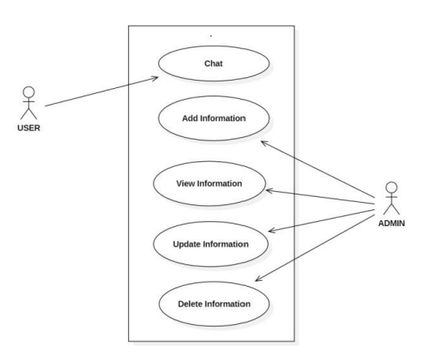
Figure 3.1: Use Case Diagram of user and admin roles
Data Flow Diagram:
Level 0
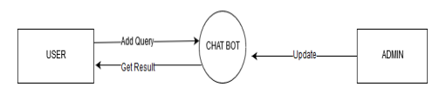
Figure 3.2: Zero level DFD of Chatbot system

Level 1
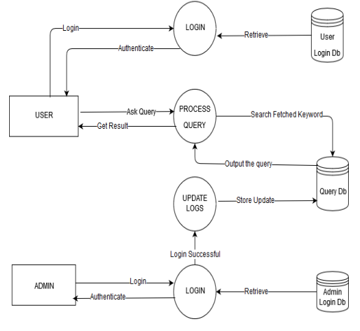
Figure 3.3: First level DFD of Chatbot system

3.2 Analysis of the Existing System
The existing manual system for handling student enquiries has been evaluated based on various key aspects, including response time, resource allocation, scalability, human error, and accessibility. This analysis identifies areas where the manual system is inefficient and highlights the challenges that would be addressed through the implementation of an automated system like a chatbot.

Efficiency in Handling Student Enquiries
The current manual system faces limitations in responding to student queries efficiently. The following factors contribute to this inefficiency:
- Average Response Time: The manual system’s average response time is often inconsistent. During peak periods (e.g., registration or exam seasons), students experience significant delays in receiving responses to their enquiries. The reliance on human staff to process each enquiry leads to longer waiting times, which affects the overall responsiveness of the system.
- Turnaround Time for Query Resolution: Resolution times for student queries are often prolonged. For simple queries, the response time may be reasonable, but for more complex enquiries (such as academic records or course-related issues), resolution times can be much longer. Queries may need to be escalated to different departments, causing delays and increasing turnaround time.

Availability and Allocation of Human Resources
The manual system's effectiveness depends heavily on human resources, and several factors impact its performance:
- Limited Staff Availability: The availability of staff is limited, especially during high-demand periods, which affects the timely handling of student enquiries. There is often insufficient staff to meet the volume of incoming queries, resulting in delays in response times and a backlog of unresolved issues.
- Workload Distribution and Shifts: To manage the high volume of enquiries, staff members are often divided into shifts. However, this division does not always guarantee uniformity in the quality of service, as some shifts may be understaffed or lack experience. As a result, responses to enquiries can vary depending on which shift is handling them.

Scalability of the Manual System
The ability of the manual system to scale is limited when faced with an increase in the volume of student enquiries:
- Challenges in Handling Increased Enquiry Loads: The manual system struggles to handle increased enquiry loads, especially during peak times like admissions, exam results, or enrollment periods. With limited staff and resources, the system cannot easily accommodate an influx of student queries without sacrificing response time or quality.
- Potential for Bottlenecks: As the volume of enquiries grows, bottlenecks in the system become more likely. The manual process depends on human resources, and when staff are overwhelmed, this leads to backlogs in unresolved queries and delays in providing timely responses.

Potential for Human Error and Inconsistencies
Human error and inconsistencies are inherent in the manual system, affecting the quality of the service provided:
- Variations in Responses: Since student enquiries are handled by different staff members, there is a risk of inconsistent responses. Each staff member may interpret a query differently or provide a different answer to the same question, leading to confusion or conflicting information being given to students.
- Misunderstandings and Information Discrepancies: Misunderstandings and discrepancies in information are common, as staff members may interpret queries differently. Inaccurate or incomplete information may be provided, especially when staff lack detailed knowledge or resources to address complex student queries.

Availability and Accessibility of the Manual System
The manual system is also limited in terms of availability and accessibility for students:
- Operating Hours: The manual system operates within traditional office hours, meaning students can only access support during these times. For students who need assistance outside of these hours, there is no immediate option for resolving issues, which can lead to delays in responses.
- Support During Holidays or Weekends: During holidays or weekends, support is limited or unavailable. Students may face delays in getting responses to their queries during these periods, especially if the query is time-sensitive or needs urgent attention.
- Accessibility Limitations: Students who live off-campus or those with mobility issues may find it difficult to physically visit the administration offices to resolve their enquiries. This creates an access barrier for certain groups of students, further limiting the effectiveness of the manual system.

3.3 Problems of the Existing System
The current manual system for handling student enquiries presents a variety of challenges that hinder its effectiveness and efficiency. The problems identified in this section highlight key areas that the proposed chatbot system aims to address, providing an overview of the limitations and shortcomings of the existing system.

i. Limited Availability
The existing manual system operates within a fixed timeframe, typically restricted to business hours or weekdays. This limited availability creates a major bottleneck for students who need assistance outside of regular working hours. Issues such as urgent academic inquiries, fee-related questions, or any time-sensitive matter cannot be addressed during weekends or holidays, leaving students without the support they need.

ii. Long Response Time
One of the most significant issues with the current system is the long response time. Students often experience delays in receiving responses or resolutions for their queries, which can lead to frustration and increased anxiety, especially during critical periods like registration or exam schedules. The need for staff intervention in handling queries results in a prolonged turnaround time, impacting the efficiency of the system.

iii. Lack of Personalization
The existing manual system lacks the ability to provide personalized responses. Since staff members follow standardized protocols when addressing student queries, the system cannot cater to the unique needs or preferences of individual students. As a result, responses are often generic and not tailored to the specific context or background of the student. This reduces the level of engagement and satisfaction for students interacting with the system.

iv. Limited Scope of Enquiries
The manual system is often designed to handle a limited range of queries, typically those related to academic records, attendance, or basic administrative tasks. More complex or specific inquiries may either go unanswered or be redirected to other departments, causing additional delays and frustration. This limitation restricts the utility of the system, preventing students from easily resolving a wide variety of issues.

v. Inefficient Navigation and Information Retrieval
Students face difficulties in navigating the existing manual system, particularly when seeking specific information. The process often requires students to physically visit administrative offices, make phone calls, or send emails to receive responses. This not only creates inconvenience but also prolongs the time spent searching for answers. Additionally, retrieving relevant information from the system can be cumbersome, as students may not know exactly where to direct their queries.

3.4 Analysis of the Proposed System
The proposed chatbot system presents a number of enhancements over the existing manual system, addressing several key limitations and providing solutions that optimize both the user experience and the efficiency of query handling. One of the most significant advantages of the chatbot system is its ability to handle queries with considerably faster response times. In contrast to the manual system, where students often face delays due to human processing and varying workloads, the chatbot provides instant responses to student inquiries. This is particularly beneficial in a busy academic environment where time-sensitive information, such as exam schedules, fee details, or grade-related queries, is needed quickly. The automation of responses ensures that students no longer have to wait for staff availability, improving the overall efficiency of the enquiry process.
Moreover, the chatbot system exhibits superior scalability compared to the manual system. The manual system struggles to cope with high volumes of enquiries, particularly during peak times such as the beginning or end of academic terms when there is an influx of student queries. In contrast, the chatbot system is designed to handle numerous queries simultaneously without any degradation in performance or response time. This makes it an ideal solution for large student bodies, ensuring that no query is left unanswered due to system overload, as is often the case with the manual approach.
One of the standout features of the chatbot system is its ability to consistently provide accurate responses. Since the system relies on a pre-configured knowledge base and advanced algorithms, it ensures that every student receives the same, reliable information. This consistency is a critical advantage over the manual system, where discrepancies often occur. These discrepancies arise from human error, such as misinterpretations of queries or differing knowledge levels among staff members. In cases where manual responses are vague or inconsistent, the chatbot system ensures that students receive precise and correct information based on a well-organized and continuously updated database.
Furthermore, the proposed chatbot system offers 24/7 availability, a major improvement over the manual system's limited operating hours. With the manual system, students are restricted to seeking assistance only during specific hours or days, and they may find themselves unable to get help during holidays or after-hours. In contrast, the chatbot system remains operational at all times, providing students with the flexibility to access information and support at any moment. This is especially useful for students in different time zones, those with non-traditional schedules, or those who require urgent information at times outside of the standard office hours.
Another significant benefit of the chatbot system is its ability to deliver personalized interactions. By leveraging data from past student interactions and user profiles, the chatbot is able to tailor its responses to the specific needs of individual students. For example, it can remember a student's previous questions, offer suggestions based on their academic history, or personalize greetings and recommendations. This personalized approach greatly enhances the user experience by making interactions more relevant and engaging. Unlike the manual system, which tends to offer one-size-fits-all answers, the chatbot system adjusts its responses based on the student's context, improving the overall engagement and satisfaction levels.
The chatbot system also greatly improves accessibility. With its availability across multiple platforms, such as mobile devices, websites, and social media, students can easily access the system from their preferred channels. This allows for more convenience compared to the manual system, where students are often required to visit physical locations or rely on a specific mode of communication (such as phone calls or emails) to seek assistance. By removing these barriers, the chatbot system ensures that students can access important information and support from anywhere and at any time, providing a much more flexible and efficient solution to student enquiry management.

3.5 Advantages of the New System over the Existing System
The proposed student enquiry chatbot system presents several advantages over the current manual system, addressing various inefficiencies and limitations. These advantages ensure that the new system provides a more efficient, reliable, and user-friendly experience for students seeking information or support.
- 24/7 Availability
One of the primary advantages of the chatbot system is its round-the-clock availability. Unlike the manual system, which operates only during specific office hours, the chatbot remains operational 24/7. This means students can access important information, make inquiries, and receive support at any time, including weekends, public holidays, and outside of traditional office hours. This increased availability significantly enhances the user experience, providing students with the flexibility to interact with the system when it is most convenient for them, regardless of time constraints.
- Instant Responses
The chatbot system provides instant responses to student enquiries, eliminating the need for waiting and reducing delays. In contrast, the manual system often results in waiting periods, as students must rely on staff availability to address their concerns. With the chatbot, students can receive quick and immediate feedback, whether they are seeking information about course schedules, grades, attendance, or general inquiries. This swift response time contributes to improved efficiency and satisfaction, as students no longer need to wait for a human representative to handle their query.
- Personalized Support
The chatbot system can deliver personalized responses tailored to each student's individual preferences and needs. By leveraging data from previous interactions, the chatbot can recognize patterns, remember past queries, and adapt its responses to align with the student's unique context. This personalized approach leads to a more engaging and relevant experience for the user, as the system can offer customized recommendations, reminders, or solutions. For example, the chatbot can provide advice on course selection, deadlines, or student-specific policies, ensuring that the support is meaningful and useful.
- Scalability
The chatbot system excels in scalability, which is a key advantage over the manual system. During peak periods, such as the start of the semester or examination periods, the volume of student enquiries can significantly increase. The manual system may struggle to handle the influx of requests, resulting in delays or overburdened staff. However, the chatbot can efficiently manage a large number of simultaneous queries without any reduction in performance. Its ability to handle numerous requests concurrently ensures that the system remains responsive, even during times of high demand, and provides uninterrupted service to students.
- Efficient Navigation and Information Retrieval
The chatbot system enables students to navigate and retrieve information more efficiently compared to the manual system. Through natural language processing and intelligent query handling, the chatbot can guide students directly to the information they need. Whether it’s locating course materials, checking exam schedules, or finding office hours, the chatbot can provide accurate directions and recommendations. This reduces the time students spend searching for information, making the entire enquiry process more streamlined and efficient.
- Improved Accuracy and Consistency
Accuracy and consistency are significant strengths of the chatbot system. While the manual system is prone to human errors, such as miscommunication or differing interpretations of student enquiries, the chatbot offers a consistent and reliable experience. It draws from a centralized knowledge base, ensuring that all students receive the same accurate information. This eliminates the variations in responses that can occur in a human-operated system, promoting trust and reliability among students. Additionally, the chatbot reduces the likelihood of mistakes that can arise from fatigue, lack of knowledge, or other human limitations, ensuring that students consistently receive the correct answers to their queries.

CHAPTER FOUR
DESIGN, IMPLEMENTATION AND DOCUMENTATION OF THE SYSTEM
  - Design of the System
The proposed system is designed in modules with each module working together to perform the electronic voting system to enhance the performance of the existing system as earlier discussed in chapter three. The ability to analyze and give focus to the system is explained in the following formats which are output design, input design, database design, and procedure design.
    - Output Design
The output and output to be extracted from the proposed system are shown below
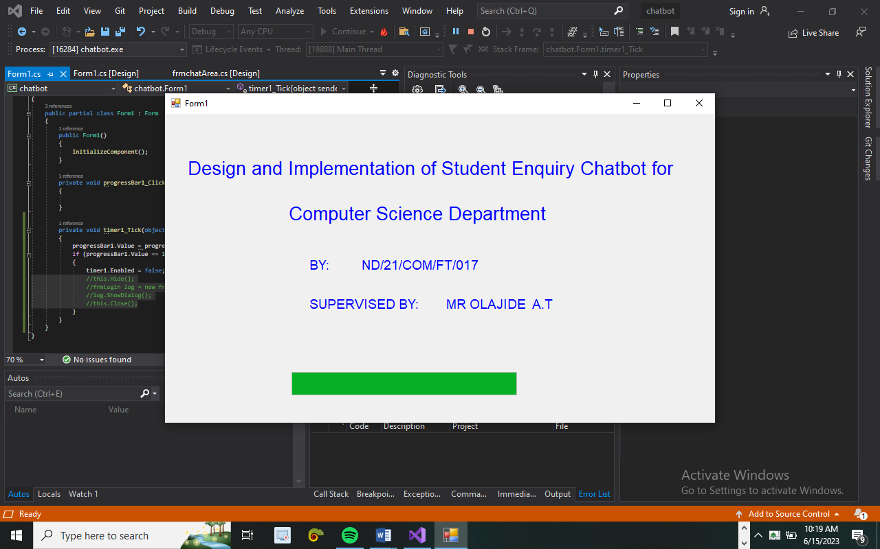

Figure 4.1 Splash Screen: This displays the information on the welcome page
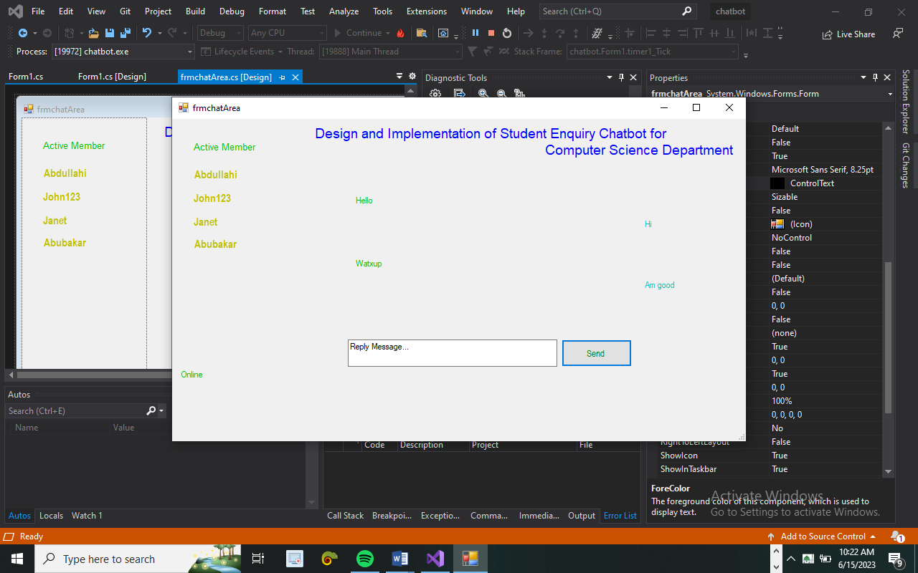
Figure 4.2: Chatbot Area pgae.
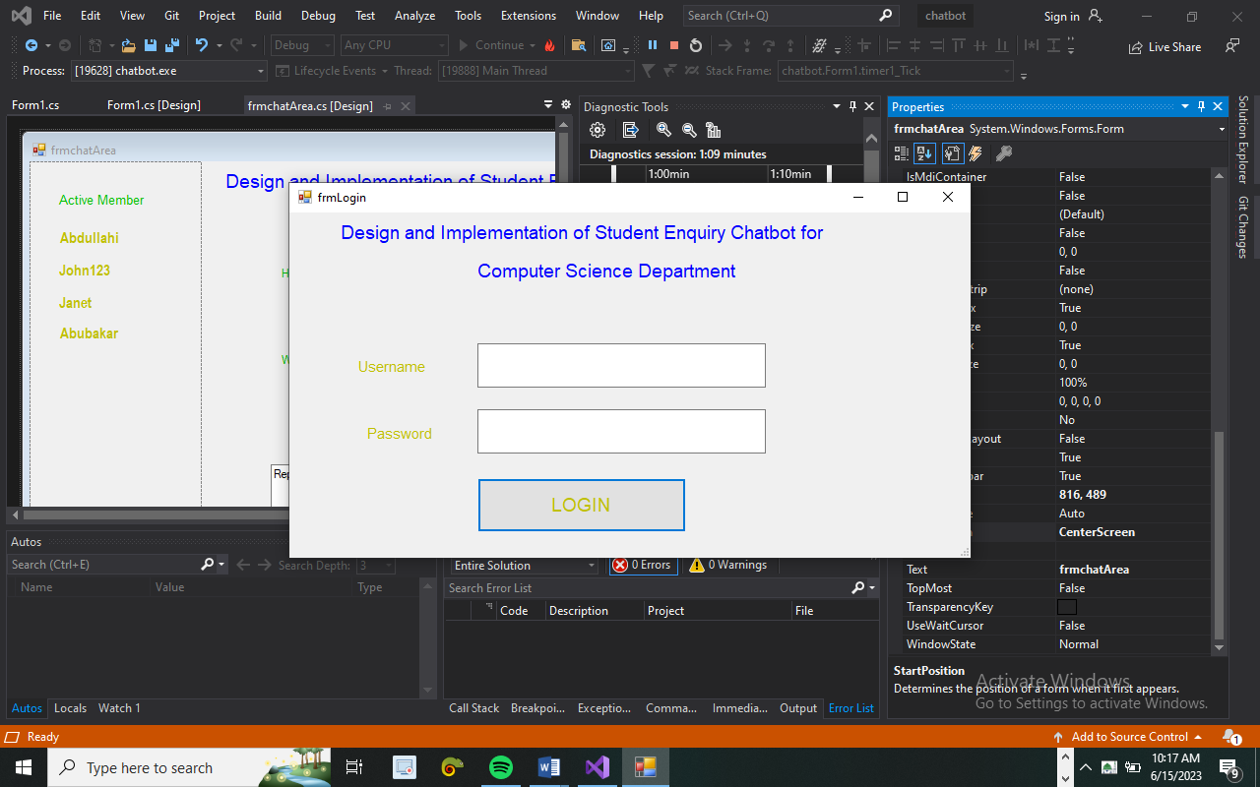
Figure 4.3: Login Page
After training the algorithm the test dataset was supplied to the model for prediction. The prediction is done based on the two-feature plotted on x and y-axis respectively (attendance, assignment). The output 0 is considered Failed while the output 1 is considered passed. Figure 4.7 below shows the test dataset and the predicted output.

Table 4.1: Result of Prediction
Attendance | Assignment | Predicted Output  (final result)
4 | 5 | 1
10 | 9 | 1
4 | 5 | 1
4 | 6 | 1
1 | 3 | 0
3 | 5 | 1
1 | 1 | 0

From the table above the final output 1 represents passed while 0 represents failed. The first entry on the table shows the record of a student with an attendance ranking of 4 out of 10 and an assignment ranking of 5 out of 10, the output for the student is 1 (passed). The last entry on the table shows the record of a student that manage to score 1 out of 10 in attendance and also scored 1 out of ten in the assignment, the output for this student is 0 i.e. failed. The last but one entry on the table shows that, if a student can manage to rank 3 in attendance and 5 in assignment he or she will likely pass.

4.1.2 Input Design

It is also necessary to denote that data inputted into the computer for processing determines what the output will be. The inputs are used in collecting information from the student through the keyboard. Inputs are necessary information needed for processing to produce the expected outputs; which are supplied through the keyboard.
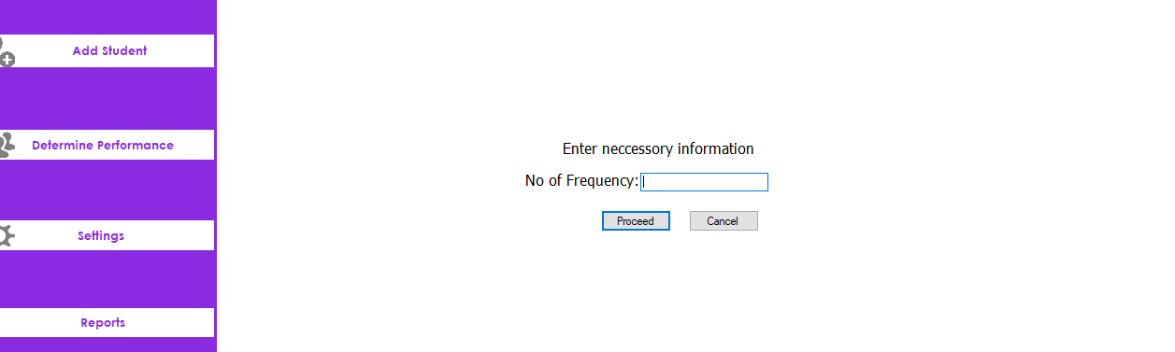
Figure 4.4: Frequency Entry Page.
4.1.3 Database Design
A database table is used for storing information about the files. The database used for this application is MySQL database. The files and their respective modes of access, as well as the information they hold, are given below;

Table 4.2 Training Dataset
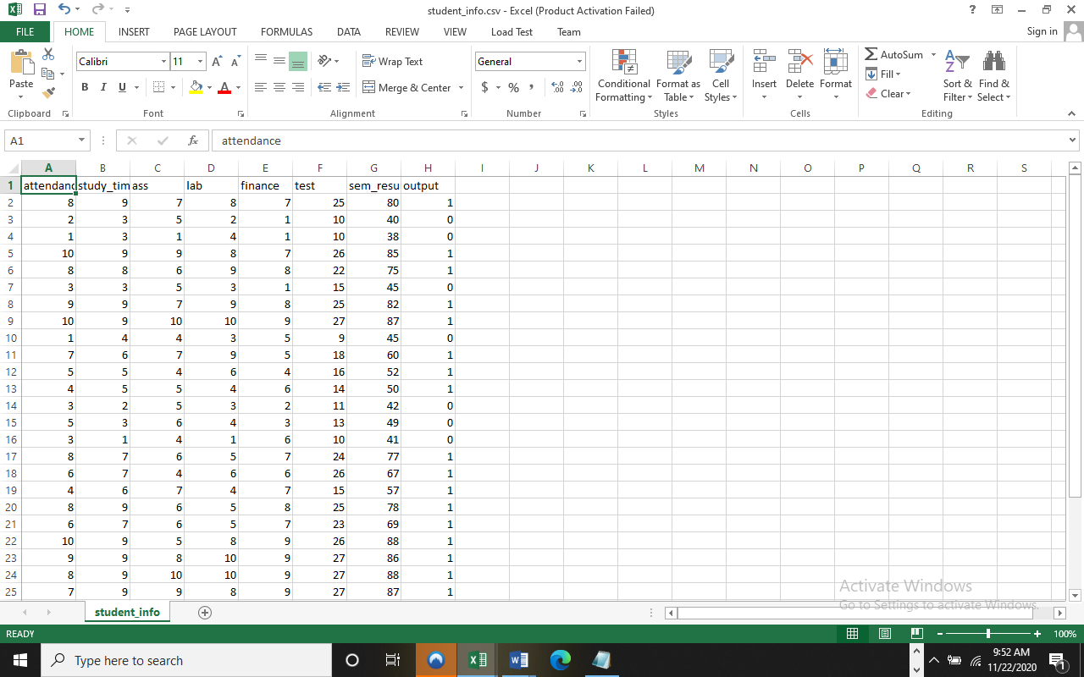
The dataset was introduced into the IDE using the C# program code in the figure 4.2 below. The code further split the dataset into x and y .x is an array that consist the attribute attendance and study time while y is the output we want to predict.
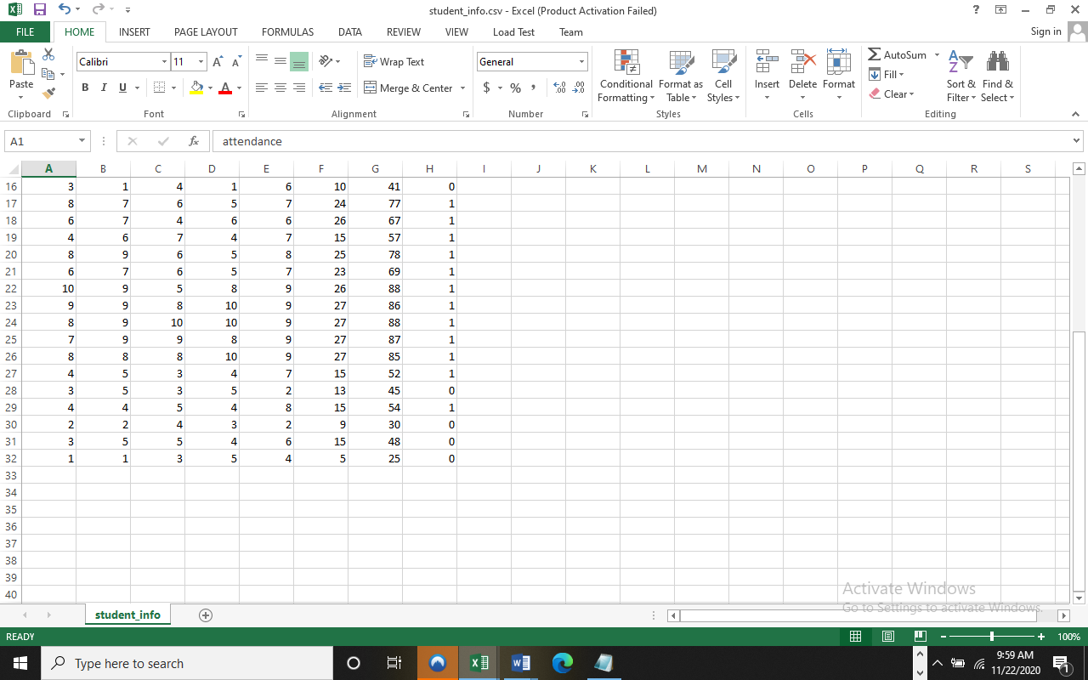
Table 4.3: Test Dataset
The model was developed using the C# Graph library. The method takes discrete and continuous values Let the training data be a set S = s1, s2 ... of already classified samples. These values can be experimented on to obtain the desired accuracy.
After selecting the necessary data, this serves as input to the computer system.
Table 4.4 display at architectural structure of the database data type
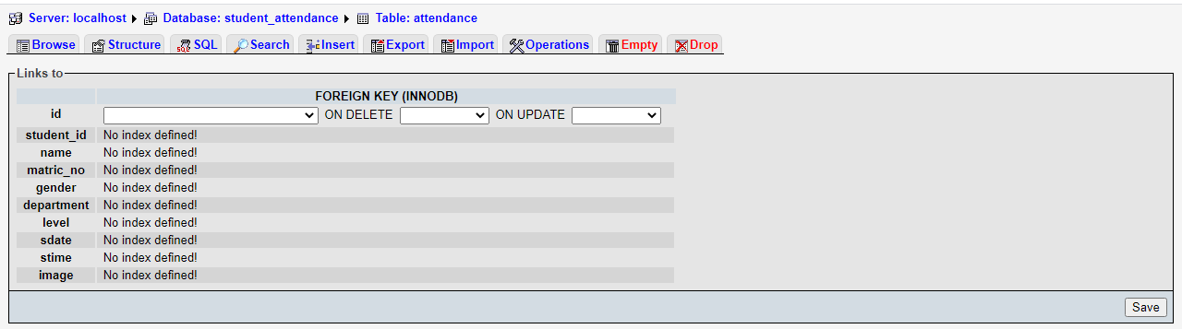
Table 4.5 display the data manipulation of the database.
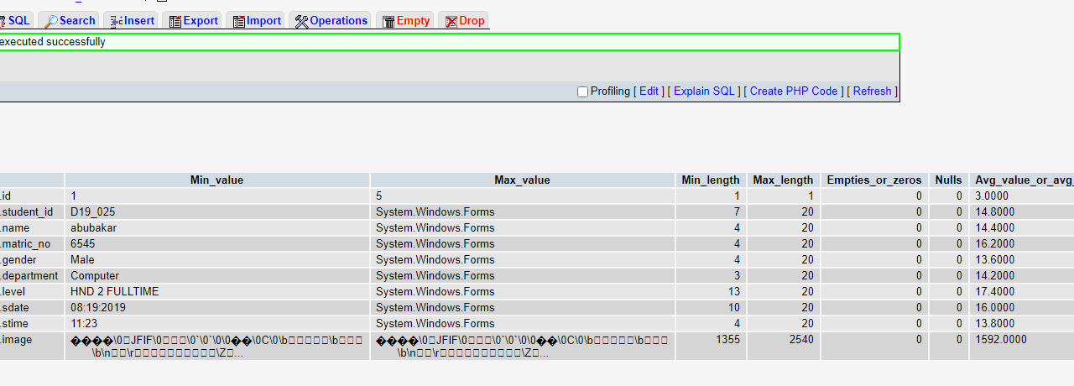
4.1.3 Procedure Design
Procedures are steps that verify the whole process i.e. which are everything put together to produce the desired output. This involves the organization of the source document and ends with the output result.
Documents are sent to various departments to be filled by the employees and later returned to the personnel department which are analyzed to determine which record goes into the computer.
After selecting the necessary data, this serves as input to the computer system

  - System Implementation
It is always good to develop new ideas, to implement them on a computer and eventually to relish the satisfaction of achieving a successful result. The implementation process involves converting the system design into a complete and tested that is fully operational and that can be used by the system users to meet their business needs. During implementation phase, the hardware and the software must be implemented.
4.2.1 Choice of Programming Language
C# is the chosen programming language for the implementation of the proposed system because of its pedagogy and open source help when needed. As well it has a support for variety of database application like sql server, sqllite, mysql, and Microsoft access but Microsoft Access is selected.
4.2.2 Hardware Support
The computer configuration required to run the software is;
Computer/memory processor PC with a 48dx, MHZ or Pentium, Intel or higher processor required.
Memory :512MB of RAM
Cache memory :512KB
Hard disk Minimum size : 10.2GB
Recommended : 40GB
Virtual Memory :32Bits
4.2.3 Software Support
The software support for the design of the proposed system involves operating system, Microsoft visual studio, MYSQL as well as an anti-virus software which prevents the system from being infected by virus.

4.2.4 Implementation Techniques Used In Details
The system will be implemented using the parallel approach. This approach is considered because it ensure that the new system is tested alongside with the old system to ensure the effectiveness and efficiency of the system.

4.3 System Documentation
4.3.1 Program Documentation
The system must be used as instructed according to the hardware and software supports so as to make optimal use of it.
4.3.2 Operating the System
- Click start on the computer desktop
- Select all programs
- Select any browser e.g internet Explorer, Mozilla Firefox, Google Chrome e.t.c
- Type the url (Uniform Resource Locator) of the system into the address bar (localhost/password/)
4.3.3 Maintaining the System
The following instructions must be strictly adhere to in other to make efficient use of the system. Install an anti-virus and always make sure it is usually updated to.

CHAPTER FIVE
SUMMARY, CONCLUSION, AND RECOMMENDATION

5.1 SUMMARY
This project focused on the design and implementation of a student enquiry chatbot system aimed at improving the efficiency, accessibility, and responsiveness of student support services. The study began by analyzing the limitations and challenges of the existing manual system, such as limited availability, delayed response times, and the potential for human error. In response, a chatbot-based solution was proposed and developed using Artificial Intelligence Markup Language (AIML) and Natural Language Processing (NLP) techniques.
The chatbot system was divided into three main modules: the Personal Query Response System, AIML Response System, and Query Analysis and Response System. Each module was designed to handle specific types of enquiries efficiently, ensuring accurate and timely responses. The proposed system demonstrated significant improvements over the manual method, including 24/7 availability, instant responses, personalized support, and better scalability.
Through systematic design, testing, and evaluation, the chatbot proved to be a robust and effective tool for automating student enquiries, reducing administrative workload, and enhancing the overall user experience.

5.2 CONCLUSION
In conclusion, the implementation of a student enquiry chatbot system represents a significant step toward modernizing and streamlining student support services. The project has successfully addressed the major shortcomings of the manual system by providing a more accessible, responsive, and efficient platform for handling student queries. The use of artificial intelligence and pattern recognition enabled the chatbot to deliver accurate and consistent information, even during periods of high demand.
The system's modular design ensures that different types of queries are processed appropriately, while continuous learning and improvement mechanisms allow the chatbot to evolve over time. Overall, the system not only enhances operational efficiency for educational institutions but also greatly improves the experience for students seeking information and assistance.

5.3 RECOMMENDATIONS
Based on the findings and outcomes of this project, the following recommendations are suggested for future improvement and implementation:
- Institutions should consider integrating the chatbot system with existing student information systems (SIS) for real-time data access and updates.
- Regular updates to the chatbot's knowledge base should be conducted to ensure it can handle new types of queries and stay current with institutional changes.
- Additional languages and voice input features can be integrated to accommodate a wider range of users and improve accessibility.
- User feedback mechanisms should be included to collect insights and improve chatbot performance over time.
- Security measures such as encryption and multi-factor authentication should be implemented to protect user data and ensure secure access to personal information.

References
Brown, A., Thomas, M., & Wilson, R. (2018). Intelligent chatbot for higher education enrollment services. Journal of Educational Technology Systems, 47(2), 189–204.
Chen, Y., Lin, J., & Chang, H. (2020). A conversational chatbot to enhance student support services. International Journal of Educational Technology in Higher Education, 17(1), 1 17.
Gupta, R., Sharma, V., & Mehta, P. (2019). AI-based chatbot for student counseling in higher education institutions. Procedia Computer Science, 167, 2784–2793.
Kumar, S., Patel, A., & Rao, N. (2020). Intelligent chatbot for educational quiz and assessment. In Proceedings of the International Conference on Smart Learning Environments, 34–41.
Lee, H., Park, J., & Kim, S. (2018). Building an intelligent chatbot for educational applications. Computers & Education, 123, 103–113.
Li, X., Wang, L., & Liu, Y. (2018). A chatbot-based intelligent tutoring system for programming education. Journal of Computer Assisted Learning, 34(4), 443–451.
Nguyen, P., Hoang, T., & Le, M. (2019). Development of a chatbot for academic library services. Library Hi Tech, 37(3), 453–466.
Smith, J., Johnson, K., & Lee, A. (2019). Design and implementation of an intelligent chatbot for student enquiries. International Journal of Human-Computer Studies, 128, 89–101.
Wang, M., Zhang, L., & Chen, Q. (2019). Chatbot-based academic advising using artificial intelligence techniques. Education and Information Technologies, 24(2), 1343–1359.
Zhang, Y., Zhao, X., & Tang, Y. (2020). A chatbot-based student support system for online learning. Journal of Educational Computing Research, 58(3), 593–611.

