DEVELOPMENT OF A LOW COST IOT HEALTH CARE MONITORING DEVICES FOR BETTER PATIENT CARE IN RURAL AREA

INTRODUCTION
The term Internet of Things (IoT) was invented by Kevin Ashton in 1999 and refers to data on the Internet that are connected to evolving global service architecture. IoT is the product of advanced research on information and communications technology. It can potentially enhance urban residents’ quality of life. Since the global population is increasing at an astonishing rate, and the prevalence of chronic diseases is also on the rise, there is growing demand for designing cost-effective healthcare systems that can efficiently manage and provide a wide range of medical services while reducing overall expenses. The IoT has become a key development area recently, enabling healthcare-monitoring system advancement. The IoT healthcare-monitoring system aims to accurately track people and connect various services and things in the world through the Internet to collect, share, monitor, store, and analyze the data generated by these things. However, the IoT is a new paradigm where all connected physical objects in any intelligent application, such as smart city, smart home, and smart healthcare, are addressed and controlled remotely. Diagnosing disorders and monitoring patients is essential to providing medical care, and applying sensor networks to the human body will significantly assist in this endeavor. In addition, the information is readily accessible from any location in the world at any given time.
Patients with severe injuries or from certain areas may have difficulty reaching the hospital. Therefore, they can use video conferencing to communicate with their doctors to improve their health while saving money and time. Patients can use this technology to record their health conditions on their phones [9]. It is anticipated that the benefits of the IoT will be improved and result in individualized treatment, improving patient outcomes while saving healthcare management costs. IoT systems allow physicians to keep an eye on their patients remotely and schedule their appointments more efficiently. Patients also can improve their home healthcare to reduce their need for doctor visits and the likelihood of receiving unnecessary or inappropriate medical treatments in hospitals or clinics. For this reason, the quality of medical care and the overall safety of patients may improve, while the overall cost of care may decrease. The IoT holds significant potential in healthcare. It will not be long before we have access to a health-monitoring system that can be used from the comfort of our homes and streamline hospital processes. IoT sensors should be densely deployed to monitor the body and environment continuously. This effort will enable the tracking of chronic-disease management and rehabilitation progress. In the future of virtual consultations for remote medical care, the IoT will be able to provide efficient data connections from multiple locations.
Most of the current implementations of the IoT and research on it are undeveloped and focus on deploying and configuring technology in various contexts and conditions. However, these practices are not widely used today. Therefore, this paper aims to evaluate related research on designing and implementing an IoT-based healthcare-monitoring system that improves quality of life. These systems rely heavily on IoT devices and sensors to connect patients with the healthcare providers best suited for their care.
The main contribution of this research paper is to highlight IoT-based healthcare-monitoring systems in detail so that future researchers, academicians, and scientists can easily find a roadmap to understand the current healthcare-monitoring systems and can easily provide solutions and enhancements for such critical applications. In this research paper, we provide a general idea of IoT-based healthcare-monitoring systems in a systematic way, along with their benefits and significance, and a literature review. Moreover, we discuss the concepts of wearable things in healthcare systems from an IoT perspective. The paper also provides a classification of healthcare-monitoring sensors, addresses security and protocols for IoT healthcare-monitoring systems, and details challenges and open issues. We also suggest solutions to overcome these challenges and issues in the future.
The paper is divided into eight sections as follows: Section 2 discusses the IoT-based healthcare system and its applications and the significance of using the IoT in the healthcare domain, followed by a review of the recent related studies in Section 3. Section 4 describes the Internet of wearable things and wearable sensors in the healthcare-monitoring system; this section also provides a classification of heath-monitoring sensors. Section 5 emphasizes security and protocols for IoT healthcare-monitoring systems.
1.1. The Significance of IoT-Based Healthcare-Monitoring Systems
The development of monitoring systems for healthcare is receiving a great deal of attention from researchers and leaders in the medical field. Several successful research projects have been conducted in this area, and many more are currently underway. The number of gaps in care provided by healthcare providers is increasing significantly, directly resulting from the rapidly growing number of older adults and patients with chronic illnesses. The major shortcoming is that healthcare is only provided in hospitals; therefore, it is unsuitable for seniors and people with disabilities and cannot always meet their needs. The IoT, with the help of sensor values and telecommunications, provides an effective and practical solution to the issue of real-time monitoring of the health status of the elderly. It has been shown that the IoT, in conjunction with smart technologies, can provide various improved and enhanced services. Using sensors, researchers have developed various emergency systems using technologies that enable intelligent and remote wireless communication. These technologies have been used for various medical purposes, particularly in monitoring the health of the elderly. This way, data can be collected on general health and dangerous situations by capturing important vital signs.
1.2. Benefits of Using IoT in Healthcare
The IoT will reshape healthcare as we know it, with profound implications. In terms of how apps, devices, and people communicate with each other to deliver healthcare solutions, we have reached a whole new level of evolution. The IoT has given us a new perspective and tools for an integrated healthcare network, greatly improving healthcare quality.
The IoT has made it possible to automate healthcare procedures that previously required a significant amount of time and left room for error due to human involvement. For example, to control airflow and temperature in operating rooms, many hospitals now use networked devices.
There are almost endless ways the IoT can improve medical care; however, the following are some of the key benefits:
- Reduced cost of care.
- Human errors are reduced.
- Elimination of the limitations of distance.
- Reduced amounts of paperwork and record keeping.
- Chronic diseases are detected early.
- Improvements in medication management.
- The need for prompt medical care.
- Better treatment outcomes.

CHAPTER TWO
LITERATURE REVIEW
2.1 INTRODUCTION
In the last decade, significant research has been done on integrating the internet of things into diabetes management systems, and the search for new developments continues. Other network technologies that have been reported in literature for monitoring diabetes include Global System for Mobile communication (GSM), cellular network (3G/4G/5G) Bluetooth, ZigBee, and Wi-Fi. The use of emerging technology such as radio frequency identification (RFID), artificial intelligence (AI), machine learning (ML), cloud computing, internet of things (IoT) and big data are currently being explored in diabetes monitoring systems. A mobile-based self-care tool for monitoring, tracking, and predicting diabetes is presented in. Reference presented a smart no-invasive technology for tracking and detecting the glucose level in diabetic patients. The device employs the use of an Arduino-based smartphone to check diabetic conditions in real time., highlighted the role of IoT, sensors, and a security paradigm in diabetes applications. A novel intelligent e-health system for the elderly and diabetes patients is presented in. The system combines numerous sensors to detect and monitor diabetes vital indicators. proposed a cost-effective non-invasive blood sugar monitoring method. The device monitors important diabetic symptoms in real time, including heart rate, oxygen saturation (SpO2) levels, blood pressure, temperature, and glucose level. A wearable sensors integrated with a smartphone for real-time monitoring of diabetic patients in remote areas are presented in. This system improves diabetes self-care by constantly keeping track of the patient’s vital signs, resulting in improved quality of life. Authors in presented an open-source cloud technology and mobile-enabled smart healthcare application for patients with diabetes who require medical support. The device employs a blood glucose sensor and a smartphone to monitor the glucose level and deliver therapy remotely. presented a low-cost smart e-health diabetes system based on 5G technology for real-time monitoring of diabetes status. The system used smart sensors, smartphones, and a machine learning algorithm to remotely track and analyse diabetic data. The system paradigm improves the personalized diagnosis and treatment of diabetic patients. Ahmed et al. used a wearable sensor and artificial intelligence model to detect and predict the blood glucose levels in diabetic patients. The use of high-tech mobile devices for monitoring and preventing complications in diabetic patients is proposed in. A new invasive technique based on the changes in breath is proposed in This method provides a convenient way to monitor blood glucose levels and detect diabetes early, resulting in a better health outcomes. Reference proposed a system based on hybrid statistical predictive model for diabetic patients, which results in a 99.8% accuracy. In the study, introduced a novel healthcare sustainable technology based on IoT and AI to enhance diabetic patients health. Menon et.al presented a real-time tracking of E-health systems for diabetic patients. The study highlights the urgent needs of machine learning in improving patients’ care and health service delivery in healthcare industry. Abubeker et al. in their study introduced a novel framework that comAbubeker2024ined IoT, AWS IoT core, and sensors for the remote monitoring of diabetic patients. The study further emphasizes the need of lithium-ion battery backup, nanosensors, artificial intelligence, and machine learning in enhancing the performance of the proposed model. In contrast to existing results, this study proposes a low-cost diabetes monitoring system that is IoT cloud enabled and can detect and track heart rate, blood glucose level, oxygen saturation level, and body temperature.
2.2 Review of Recent Related Studies
Healthcare is a vast arena that is composed of many different components. Delivering healthcare involves clinical practices, hospitals, pharmacies, home health providers, long-term care providers, pharmaceutical companies, and medical-device manufacturers. It also involves health and wellness products and services, insurance companies, and governments providing services to end-users [6]. This section provides a review with an analysis of the recent research on IoT-based healthcare-monitoring systems. Table 1 summarizes some of the recent studies regarding IoT-based healthcare-monitoring systems.
The wearable device developed by Wu et al. monitors various physiological parameters, including body temperature (BT), electrocardiograph (ECG), and heart rate (HR). Using Pulse Arrival Time (PAT) to measure ECG and PPG, it is possible to estimate blood pressure (BP). The interaction between humans and remote monitoring programs is straightforward because all the components are designed within a rigid framework. In addition, the power consumption of the devices is low, and they can communicate wirelessly to make tailored measurements of a specific physiological signal. The physiological measurements can be wirelessly transmitted to a gateway using a BLE module. The data are encrypted at the sensor patch and gateways to maintain privacy, ensuring transmission security. The wearable sensor system is connected to the cloud using a smartphone and a Raspberry Pi module as a gateway; the data can be retrieved and analyzed from the cloud. Despite its low energy consumption, BLE technology is unsuitable for wireless communication over long distances and high data rates.
Islam et al. developed an intelligent monitoring system for use in a hospital. It not only collects data on patients’ BT, HR, and other vital signs but also monitors environmental factors in the hospital room, such as CO, CO2, and humidity. The success rate of modern healthcare systems is ~95% agreement between monitored and actual data in all cases. Medical staff can view the data in real-time, either on-site or remotely. Hypothetically, the technology would be helpful during medical crises and epidemics, as medical personnel would have almost instant access to raw data. The prototype created is incredibly easy to design and use. Such devices could be helpful in managing infectious-disease outbreaks, such as COVID-19. Potentially, this system could save more lives by improving the efficiency of the existing healthcare system. However, at this stage, the system still lacks some epidemic-related sensors that need to be evaluated once implemented.
In, Al-Sheik and Ameen propose an IoT health-monitoring system for cell phones that remotely monitors patients’ vital signs, including BT, ECG, and blood-oxygen saturation (SpO2). Arduino was used to measure and process this system. This system uses Wi-Fi to send the data to a cloud service on the IoT platform called Blynk; the data can be monitored in real-time. For security and privacy reasons, the results are sent to a specific smartphone that the doctor can monitor. Therefore, two microcontrollers, Arduino and NodeMCU, are used, which still need to be improved. For long-distance transmission, Wi-Fi technology is not the ideal option.
Hamim et al. present an IoT-based healthcare-monitoring system for patients and older adults based on an Android application. The sensors in this prototype collect BT, HR, and Galvanic Skin Response (GSR) data that are fed into a single system, the Arduino Uno platform. Raspberry Pi transfers the data to cloud storage. Android Studio was used to develop the Android app, in which health parameters collected from patients can be visualized. Doctors can use the application to prescribe necessary prescriptions and track the patient’s health over time.
Using Raspberry Pi 3, Swaroop et al. developed an IoT-based real-time health-monitoring system. Data creation, acquisition, processing, communication, and access are the main phases of the system structure. Health data such as HR, BT, and BP were measured. The data are transmitted through modes such as BLE, GSM, and Wi-Fi, i.e., mobile applications, messaging services, and the Internet. It was found that the latency is low, and there is no significant delay between sending and receiving data. Thus, the system’s accuracy is limited to the accuracy of the sensors.
Gupta outlines a healthcare-monitoring system using the IoT for obese patients. The prototype is a fully functional device that measures body characteristics such as HR, SpO2, BP, and BT. This device is ideal for regular monitoring of body conditions. The system uses an Arduino board to store medical data for multiple patients simultaneously, and then, sends the information to healthcare providers via a Wi-Fi module for remote monitoring. Clinicians can use the recorded data to examine patients’ health patterns over time in order to detect any changes that may indicate an underlying, undetected health problem. Consequently, long-distance communication can be a challenge with this system.
To help physicians diagnose and monitor their patients’ health status, Alamsyah and Ikhlayel developed a monitoring system based on an IoT that can detect vital signs. The system uses sensors to collect vital signs such as HR, BP, and BT. The data from the sensors are gathered and processed by Raspberry Pi before being uploaded to the cloud. The data can be retrieved remotely through a mobile app that allows easy access for medical staff. The results of retrieving vital-sign data show that the instrument was developed and the system was tested and evaluated reasonably.
An IoT-based real-time health-monitoring system can save a patient’s life by continuously monitoring the patient’s vital signs. The real-time health-monitoring solution proposed by Sangeethalakshmi et al. continuously monitors patients wirelessly via a mobile app and GSM. Sensors capture vital signs that are transmitted to the cloud via Wi-Fi. The system consists of a data-acquisition module, a microcontroller (ESP32), and software. This system regularly measures and stores the patient’s BP, BT, ECG, HR, and SpO2 and transmits the data to the physician’s cell phone for analysis. The system also includes an alert system in which the physician’s cell phone receives a message when the patient’s vital signs are outside acceptable parameters. However, the system is only a prototype that still needs to be evaluated, tested, and calibrated.
Another IoT-based vital-sign-monitoring system is described in by Sahu et al. Similar to other systems, vital signs are monitored in real-time, and the data that are collected are locally stored, and then, transferred to the cloud, from where they can be evaluated. The system detects abnormalities, sends alerts, and calculates early-warning scores. By storing the data on a personal server, the Android app reduces the burden placed on central medical servers and minimizes the server’s maintenance costs. The system is compact, portable, and easy for patients to use. Additionally, the system has been tested and evaluated against most other systems in the field.
A. D. Acharya and S. N. Patil designed and implemented an IoT-based smart medical kit for critical medical conditions. This kit can provide a versatile connection to data from the IoT and can support emergency medical services such as intensive care units. The model collects, stores, analyzes, and distributes Big Data in real-time, enabling users to lower their health risks and reduce healthcare costs. This research aimed to reduce patient anxiety about regular doctor visits. With the help of this project proposal, patients’ and doctors’ time will be saved, allowing doctors to help patients in critical condition as much as possible.
Jennifer S. Raj proposed a novel information-processing system for IoT-based healthcare-monitoring systems to manage Big Data in an IoT environment effectively. The entire data-processing process is divided into three stages: collection and aggregation, the classification and analysis of collected data, and decision-making. The experiments were conducted using Python. This model was experimentally verified in a simulation by using different health sensors. The parameters were compared with existing hierarchical clustering and backpropagation neural network models to validate the performance. This model leverages Apache Kafka and Hadoop to address the need for real-time data collection and offline processing. According to the authors of this study, the proposed method outperforms the more traditional hierarchical clustering model and the backpropagation neural network model in data processing and information extraction; they claim that their proposed model achieves 97% accuracy. The study does not provide a comparative analysis of time-efficiency for the model.
Kishor and Chakraborty designed a healthcare model using seven classifying algorithms. Nine different disease related datasets were organized based on classifications. AUC, accuracy, sensitivity, and specificity were the four variables used to measure the classifiers’ performance. The three phases of this work were data collection, pre-processing and computation, and determining the results’ visibility to physicians or end-users, with the results stored on a cloud server. This study compared machine learning-based health models with previously developed work. Unlike other classifiers, the RF classifier has the highest accuracy, sensitivity, specificity, and AUC for a variety of common diseases, according to the study authors. This model can be extended for various purposes, such as weather forecasting, military, and food availability prediction.
In another study that is very similar to, Souri et al. suggested an IoT-based system for monitoring student health. This model aimed to monitor students’ valuable metrics and identify behavioral and biological changes in students using cutting-edge student-support technologies. This approach consists of three levels: identifying the required data for the student using biological and behavioral factors, capturing the information using biosensors and intelligent IoT devices, and pre-processing the data. In this process, four classifiers were employed to assess the validity of the proposed model. The experiment results showed that the classification algorithms performed superbly in terms of precision, recall, accuracy, and F-score. The authors stated that SVM achieved the highest possible performance in predicting diseases in the proposed scenario. This system requires a local repository to reduce the time needed for emergency services, which saves bandwidth within the system. The response time of this system is not fast enough.
A healthcare system based on a Random Forest Classifier and the IoT was proposed by Kaur et al. to improve interactions between patients and healthcare professionals. The experimental results were compiled using eight datasets on different diseases to determine whether the proposed work is successful or not. Five different machine learning approaches were used in this work. According to the authors, the Random Forest learning technique achieved a maximum accuracy of 97.26% when applied to the dermatology dataset. In addition, it was claimed that Random Forest provided good and accurate results for each dataset considered. Accuracy and area under the curve (AUC) were the two-performance metrics used for different machine learning techniques and datasets, respectively.
Gera et al. concentrated on an IoT-based Cloud Talk platform-connected patient-health-monitoring system. This system streamlines the conventional workflow by providing all systems—including medical examinations, facilities, and tests—in one location. This system is capable of being implemented in a real-world setting because it consists of five fundamental components that are able to carry out a variety of tasks, such as collecting patient data from wearable IoT sensors, uploading the report to a cloud platform, analyzing the findings, and providing medical check-ups, diagnostics, and facilities to patients. In addition to these benefits, the system facilitates better decision-making and makes navigating the conventional workflow of the normal healthcare system simpler. In addition, it acts as a point of contact for the patient, the doctor, the pharmacist, and the diagnostician. There are restrictions on the system’s ability to manage patient healthcare.
SoonHyeong et al. proposed an intelligent health-related monitoring system that detects abnormal movements such as falls based on sensor readings from accelerometers. After detecting abnormal movements, the system analyzes basic bio-signals such as a person’s BP, HR, and BT. Users, caregivers, and professionals can check that the patient has measured biometric data anytime, anywhere, using a smartphone. This monitoring system includes a JAVA-based Android service environment. The performance of this monitoring system was evaluated using datasets with information from fifty different individuals. In this model, blockchain technology is used to protect individuals’ medical data by increasing the data’s reliability while maintaining its confidentiality. With the help of a sensor chip, technology that is part of the IoT, the accumulation of personal medical information is stored and monitored in real-time. The transmission of sensitive medical data occurs in real-time via a mobile device only, such as a smartphone.
Piyush et al. present a positive strategy for monitoring the daily life of Alzheimer’s patients and providing quality care to those affected by the disease. This work is based on data collected from sensors connected to the IoT that determine various parameters of the patient’s body, such as temperature, BP, pacing, and walking speed, to name a few. The Atmega microcontroller is used for collecting all this sensory data and information. All the collected information is transmitted to a cloud server using parallel communication to analyze the data. It is possible to retrieve the patient’s desired parameters, which helps provide real-time patient support. In addition, this work cannot predict the patient’s condition before the emergency becomes more serious.
An IoT-based healthcare-monitoring system with numerous sensors and an intelligent security system was presented by Hashim et al. in. The system uses many sensors to collect vital signs such as humidity and room temperature using a DHT11 sensor, HR using a pulse sensor, and BT using an infrared thermometer. Data from the sensors that used the Arduino to gather information on the condition of the patient are sent to ThingSpeak and stored using the Wi-Fi module. The collected data are displayed on the LCD (cloud platform). When the sensor detects an abnormal reading, an SMS is sent to the smartphone using a GSM module to contact the patient’s family or doctor promptly. The performance of the temperature and pulse sensors was evaluated using various experiments. According to the authors, the percentage error of the infrared thermometer sensor is 1.2% lower than that of the current model. The user and physician can view the results when uploaded to ThingSpeak, but this system cannot monitor the patient remotely in real-time.
A platform for IoT-based health monitoring was proposed by Mostafa et al. that uses a NodeMCU microcontroller to obtain readings from a DS18B20 temperature sensor and a Max30100 pulse oximeter to determine BT, HR, and SpO2 values. The readings are displayed on an LCD in front of the patient and on the Blynk app-enabled phones of the physician and everyone else involved. This project also included an infrared sensor (IR) that detects objects in front of it and activates a relay to pump disinfectant without being touched. According to the authors, the application takes only one minute, and their project works flawlessly compared to the conventional method. NodeMCU, a less-expensive and -complicated processor with built-in Wi-Fi, is used in this system, making it more cost-effective than other existing systems. Although the system is only for cardiac patients, it surpasses the traditional systems by providing a safer, easier, faster, and more affordable service.
A Wi-Fi-connected smartphone and an electronic wearable device ere used by Jenifer et al. [34] as part of an IoT-based health-monitoring system. This system uses sensors to measure the patient’s physiological parameters, including HR, BT, BP, and SpO2. The patient’s data are collected via Wi-Fi from a remote location and stored in a cloud server, and the health parameters are continuously monitored. If abnormalities occur, an automatic alert is sent to medical professionals with the patient’s location. However, this study does not include experimental data or a comparative analysis.
Dhruba et al. use the IoT to monitor sleep apnea. They developed a simple application using a basic microcontroller and a selection of key health-related sensors. After analyzing data from five different people, the system provided results that were quite suitable for determining whether or not someone is suffering from sleep apnea. According to the authors, two people did not have any sleep apnea symptoms, although they had been diagnosed. The individuals in question were between 36 and 50 years old and had significant problems with their sleep patterns. The system successfully detected the presence of sleep apnea in these individuals. This system can also detect obstructive sleep apnea when a person is screened. In addition, a person with OSA is considered a patient if he or she is 50 years of age or older. With the help of this type of monitoring, people can detect sleep apnea at an earlier stage. People can learn more about sleep apnea and its detection with the help of this system. It will also help people solve any problems related to their ability to sleep. However, when the patient is sleeping, the worn devices may come off and cause an uncomfortable feeling.
Kshirsagar et al. suggest an ongoing, low-effort electronic saline-monitoring and -control system that can automatically keep track of the rate of saline flow, the amount of time left, and the rate of infusion. This system can send data to the server from a distance and show the results, such as the saline bead rate, the condition of the failure, and how much time is left to empty the saline bottle, on the main screen. It can also show the volume of the mixture. However, this system only entertains a single purpose (electronic saline observation), and the contribution does not match the research title.
The research conducted by Tiwari et al. focuses on developing an IoT-based remote monitoring system for healthcare using NodeMCU and the Arduino IDE. Ubidots is the IoT platform discussed in this article. The open-source IoT application is required for Ubidots to function correctly. It is also an application programming interface (API) that allows users to shop and retrieve data via HTTP and MQTT protocols while connected to the Internet or a local network. With this IoT device, it is possible to read pulse rate and measure temperature and BP. This configuration allows for round-the-clock monitoring of a patient’s vital signs and detects abnormalities that may be present. The results of the ECG test showed that the subjects’ average HRs were 72, 75, and 78 beats per minute, respectively. The recorded SpO2 percentages were as follows: 94, 97, and 98%, respectively. Finally, the participants in the experiment had a temperature of 94.78, 95.6, and 97.4 degrees Fahrenheit, respectively, when their temperature was taken. The authors noted that the design concept is simple and inexpensive to implement, considering its cost-effectiveness. On the other hand, transpiration could affect the design.
In order to monitor a person’s temperature, BP, HR, and SpO2, Vaneeta et al. [38] built a system based on the IoT. The ability of nearby clinics to communicate with city hospitals about their patients’ medical conditions makes this a valuable system for rural areas and small towns. The IoT system can alert the doctor or physician in case of any deviations from the standard values in the patient’s health. The maximum relative errors (percentage r) in the HR measurements, patient BT, and SPO2 were discovered to be 2.89%, 3.03%, and 1.05%, respectively. These values are comparable to the commercial health-monitoring system. This IoT-based health-monitoring device makes it effortless for physicians to collect real-time data. The system can monitor the parameters regularly because high-speed Internet is accessible. Additionally, the cloud platform enables data archiving, so those earlier measurements may be retrieved quickly. This system would make it possible to diagnose and treat COVID-19-specific patients early on.
2.2 Internet of Wearable Things
The Internet of Wearable Things (IoWT) aims to improve people’s quality of daily life. It involves sensors fitted into wearable devices, monitoring the individual’s activity, health factors, and other things. The data collected from the IoWT can be fed into medical infrastructure, giving clinicians remote access to their patients’ data as they go about their daily lives. Building on the IoT architecture, a novel integrative framework for IoWT is currently being developed. The IoWT is a revolutionary technology that has the potential to change the healthcare industry by creating an ecosystem for automated telehealth treatments.
As shown in Figure 2, the architecture of the IoWT and its connections consists of three elements: the WBAN, the gateway connected to the Internet, and the cloud. The WBAN is a front-end component of IoWT that wraps around the body to collect health-related data unnoticed. The WBAN collects data from sensors in direct contact with the body or from sensors in the environment that can collect indirect data about a person’s behavior. The WBAN can either analyze the data or transmit them for remote analysis. In addition, mobile computing devices such as smartphones, tablets, and laptops must be connected to the Internet to send data to powerful computing resources
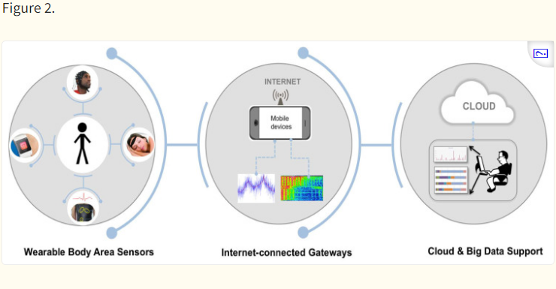

Architectural elements of IoWT
2.3 Wireless Network Technologies for IoT Healthcare
Healthcare systems can be monitored remotely using various wireless network technologies. The existence and operation of IoT emerging technologies, such as RFID, wireless network technologies (BLE, Wi-Fi, Zigbee), and low-power wireless area network (LPWAN) technologies (such as LoRa and SigFox) are engaging in terms of the IoT’s long-term development and deployment. They enhance device connectivity to the Internet, and the efficiency of IoT application operation.
BLE, LoRa, and Zigbee are wireless sensor network technologies; meanwhile, to identify and trace products, RFID is used. BLE can transfer data between different mobile devices [44]. Communication methods can be long in their range (LoRa, SigFox, and Wi-Fi) or short-range (Bluetooth, RFID, and Zigbee). Due to new communication protocols being created exclusively for IoT devices, such as LoraWAN, NB-IoT, and Sigfox, it is anticipated that the popularity of these applications will increase, enabling a far-reaching remote monitoring system.
An essential component of the IoT is the WSN. The IoT, which has already been established, can connect things to the Internet, allowing humans to interact with computers and for computers to interact with other computers. Thus, the combination of the IoT and WSN facilitates machine-to-machine communication. Figure 3 illustrates the architecture of IoT with the WSN. It shows sensor nodes communicating with a gateway in a separate network. Many devices are linked to the gateway via Wi-Fi or the Internet, ensuring interoperability

CHAPTER THREE
MATERIALS AND METHOD
3.1 METODOLOGY
The proposed e-health diabetes monitoring system (eHMs) is a low-cost IoT cloud enabled model that can detect and track heart rate (BMP), oxygen saturation level (SpO2), body temperature (BT), and blood glucose level. In addition, the e-HMs consists of IoT input sensors, Wi-Fi module, LCD, user devices, internet, and Blynk cloud sever to sense, track, and analyse real-time diabetes information. This study was approved by the Ethical Review Committee of Olabisi Onabanjo University, Nigeria, with the approval reference number OOU/SCIENG/EC/0002/220823. The study was conducted with diabetic patients whose health records indicated cases of diabetes and had been administered with insulin treatment for the last 3 months. Accordingly, the diabetic outpatient and admitted patients of the State Hospital, Ijebu Ode, Department of Hospital Information Management Systems were included in the study. The measure sample consists of 250 records of both outpatient and admitted diabetic patients. The selection criteria includes:
- Hospital records for diabetic patients who had insulin therapy within the 3 months.
- Others who do not require insulin therapy but use antiglycemic drugs, exercise, or on diet.
- Patients with severe diabetes-related metabolic problems
- Above the age of 17 years.
The e-MHs hardware and software components are highlighted as follows:
3.2 System hardware design
As shown in Fig. 1, the proposed e-MHs consists of various units which have been integrated with the Arduino Nano controller, Wi-Fi connectivity, and programmed to provide an economic, reliable sustainable means of diagnosing and monitoring diabetes patients remotely.
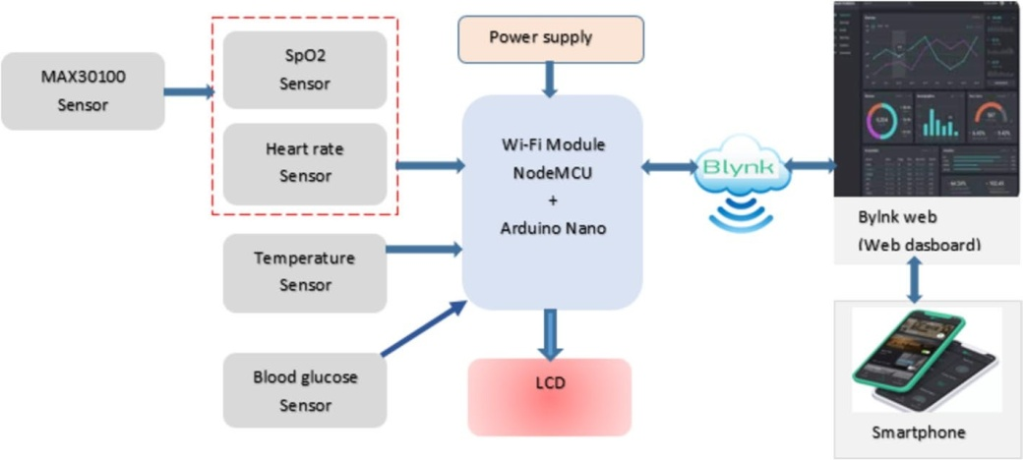
Fig. 1

figure 1 Schematic diagram of e-MHs
3.3 IoT input sensors
The “MAX30100 sensor” served as a pulse oximeter (SpO2) and heart rate (BPM) monitor. It uses LEDs, photodetectors, and improved optics to detect blood oxygen saturation, SpO2, and heart rate signals. The sensor has an inbuilt on-chip voltage regulators and temperature sensors to compensate for high-voltage noise and environmental variations. This sensor offers a high data output and can work at a fast sample rate. It operates within the voltage of 1.8 V to 3.3 V, with a low power consumption of 600 μA. The MAX30100 sensor module has seven pins and uses the I2C communication protocol to interact with a microcontroller.
Temperature sensor
A "LM35 sensor" was used to measure the patients' body temperature. People with diabetes have difficulty controlling their body temperature and are particularly sensitive to heat. Furthermore, high temperatures and heat might have an unfavourable effect on glucose metabolism and overall health in diabetic patient. The ideal body temperature range is 36.5–37.5 °C.
Blood glucose sensor
A Dexcom G6 sensor was used to monitor diabetic patients' glucose levels. This sensor is linked to the smartphone via a NodeMCU microcontroller and is easily accessible in real time via the Bylnk platform. A healthy fasting blood glucose concentration is typically between 70 and 99 mg/dL. An extreme glucose level (above 125 mg/dL) can lead to severe complications, emergency health problems, and increased insulin demand.
Microcontroller
The "Arduino Nano" microcontroller was chosen for this study because it is small, inexpensive, and compatible with a wide range of IoT applications. The controller provides a variety of functions and capabilities, making it an excellent choice for IoT-based diabetic monitoring systems. Among other things, the Arduino Nano includes an ATmega328 microcontroller, 32 KB of flat memory, 2 KB of static random access memory (SRAM), and eight analogue pins/14 digital pins.
Wi-Fi Module
The NodeMCU is a Wi-Fi microcontroller based on the ESP8266 board architecture. Its hybrid combination of the ESP8266 Wi-Fi chip and Lua-based firmware makes it an appropriate choice for this study. It is equipped with a TensilicaXtensa 32-bit LX106RISC microprocessor, GPIO, PWM, I2C, 1-wire, and ADC. The NodeMCU microcontroller is compatible with Arduino IDE, Lua-based firmware, Micropython, Platform IO, and Espruino. It has a 4 MB flash memory with a programmable clock speed of 60/180 MHz. It supports UART, SPI, and I2C interfaces. This electronic component can be powered by a micro-USB cable/jack that accepts 5 V input. The NodeMCU's built-in Wi-Fi capabilities allow us to host a cloud server and transfer source code remotely.
Liquid crystal display
The liquid crystal display (LCD) is a data and message display technology. It has a 32-character output unit with a high-quality display. Due to its light weight and energy efficiency, it is a preferred candidate for many internet of things (IoT) projects. In this study, a 16 by 2 LCD was employed as multifunctional device to display real-time SpO2 level, BMP readings, temperature readings, and blood glucose levels.
Voltage conversion module and battery
In this study, LM2596 semiconductor chip serves as voltage regulator for power supply, battery, LED, and other devices. The e-MHs is powered by a dual 3.5 V, 18,650 lithium battery connected in series.
User devices
These are smart devices like smart phones that the users/patients can use to interact, access, and monitor the diabetic information on bylnk platform via internet on real time. Figure 2 shows the system hardware components.

Fig. 2
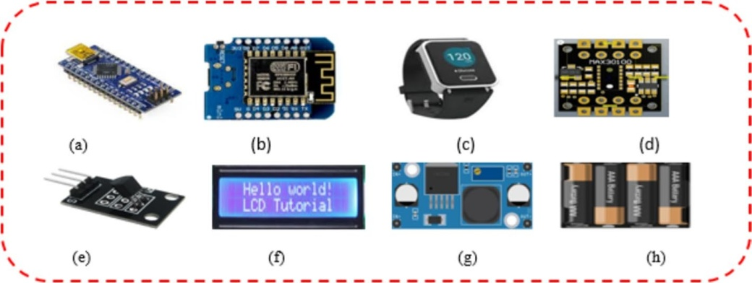

Figure 2 a Arduino nano; b NodeMCU; c wearable sensor; d MAX30100; e LM35; f LCD; g LM2596, and h 18,650 Li-ion battery
3.4 Cloud server
This study uses an open-source Bylnk cloud platform to remotely monitor and control the e-HMs for diabetes patients and the proposed Bylnk app is accessible via https://play.google.com/store/apps/details?id=cloudblynk domain using registered network name and password.
System hardware design
The NodeMCU ESP8266 microcontroller was written in the Arduino C + + programming language. The IoT sensors and other embedded systems were successfully coded using the Arduino platform. The platform aims to enhance coding flexibility and optimize Arduino code. The Arduino is an open-source software platform that consists of two primary components: the integrated development environment (IDE) and a main library. The IDE is a simple editor that includes numerous tools and functions for programming Arduino boards. The toolbar enables quick access to programming functions. The Arduino IDE contains a communication-enabled serial monitor, debugger, and code analysis tools to detect potential errors, code smells, and security flaws. The compiled binary files are loaded into the embedded system.
Arduino fritzing
Arduino fritzing is a software noted for its simplicity and ease of use. It is also one of the newest open-source available instructional electronic circuit software for Arduino projects. It is an open-source hardware project that aims to make electronics available to everyone. It is a software program that allows users to design, customize, and document electronic circuits. Several features are offered, including drag-and-drop components, breadboard view, schematic view, PCB layout, code view, and part libraries. It also supports cross-platform. Arduino fritzing is compatible with Arduino, Raspberry Pi, BeagleBone, and the Arduino IDE.
Bylnk IoT platform
The Bylnk platform for this proposed e-MHs enables for real-time monitoring of diabetic patients from anywhere via internet connectivity. Bylnk is a holistic internet of things (IoT) platform distinguished by a no-code approach to IoT app development and high-quality mobile app editor. It offers a single platform for device deployment, sensor data visualization, mobile and web-based remote control, wireless firmware updates, secure cloud storage, data analytics, automation, and access management. Users can access and customize a range of widgets and interfaces, including buttons, sliders, graphs, and displays, to suit their project needs. Bylnk provides cloud solutions for IoT applications. The platform supports a wide range of hardware development boards, such as the ESP32, Arduino, Particles, Texas Instruments boards, and Seeed WIO terminals. Bylnk offers cloud connectivity, data management, device compatibility, and intuitive apps.
Experimental design
The experimental design starts with the design and construction of the e-MHs in Arduino frizzing. The circuitry of the system hardware was developed and wired as shown in Fig. 2. The hardware components used are Arduino Nano, ESP8266-NodeMCU, wearable sensor, LM35, MAX3010 sensor (heart rate and SpO2, pulse oximeter), LCD as a multifunctional device to display temperature, heart rate, blood glucose, and SpO2 readings.
Coding and Blynk configuration
The next step is to code the embedded system (Arduino Nano and NodeMCU) and other IoT sensors, then upload the compiled files to the Arduino Nano and NodeMCU using Arduino IDE 2.0. The web page is hosted on the Bylnk server. The Blynk app was installed on the smartphone, and NodeMCU was linked to the app's local server using Wi-Fi credentials and a Blynk authentication token. In addition, the LCD was connected to the Arduino Nano via pin configuration, and the "Liquid Crystal" file was uploaded and initialized.
Blood glucose control
For variety of reasons, blood glucose is one of the most crucial parameters in diabetic patients. It is the vital sign used to diagnose diabetes and to select the best treatment option. In addition, blood glucose monitoring is a critical aspect of diabetes care. According to the World Health Organization [57], the normal blood glucose concentration for an healthy adult must be within 70–90 mg/dL. BGset is the target blood glucose level for healthy persons. Figure 3 shows the closed-loop feedback system for diabetic patients. The e-MHs function as a controller, and the disturbance symbolizes factors that are most likely to affect the patient's blood glucose level. The blood glucose sensor continuously monitors the blood glucose level (BGactual) and sends a feedback signal to the summer, comparing the measured value (BGmeasured) and the set point (BGactual). For instance, if the BGmeasured is greater than the BGset (i.e., BGmeasured > BGset), a notification is via short message service (SMS) is sent remotely to the healthcare workers requesting a rapid insulin administration. However, if BGmeasured = BGset, no real-time SMS update is received by the doctor or healthcare giver.

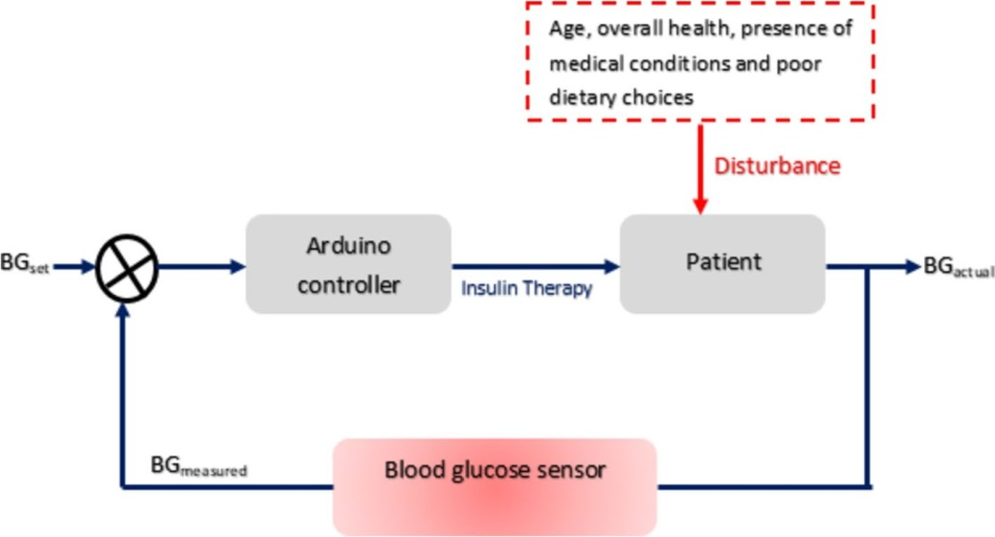

Fig.3 Blood glucose feedback system

CHAPTER FOUR
RESULTS AND DISCUSSION
4.1 INTRODUCTION
The proposed e-MHs experimental set up is shown in Fig. 4 and tested on different patients to assess its performance and functionalities. For performance assessment, four diabetes vital signs including blood glucose concentration, heart rate (bpm), body temperature, and SpO2 were experimentally taken. Furthermore, the designed system data were compared with commercially available sensor to ascertain its efficiency and accuracy.
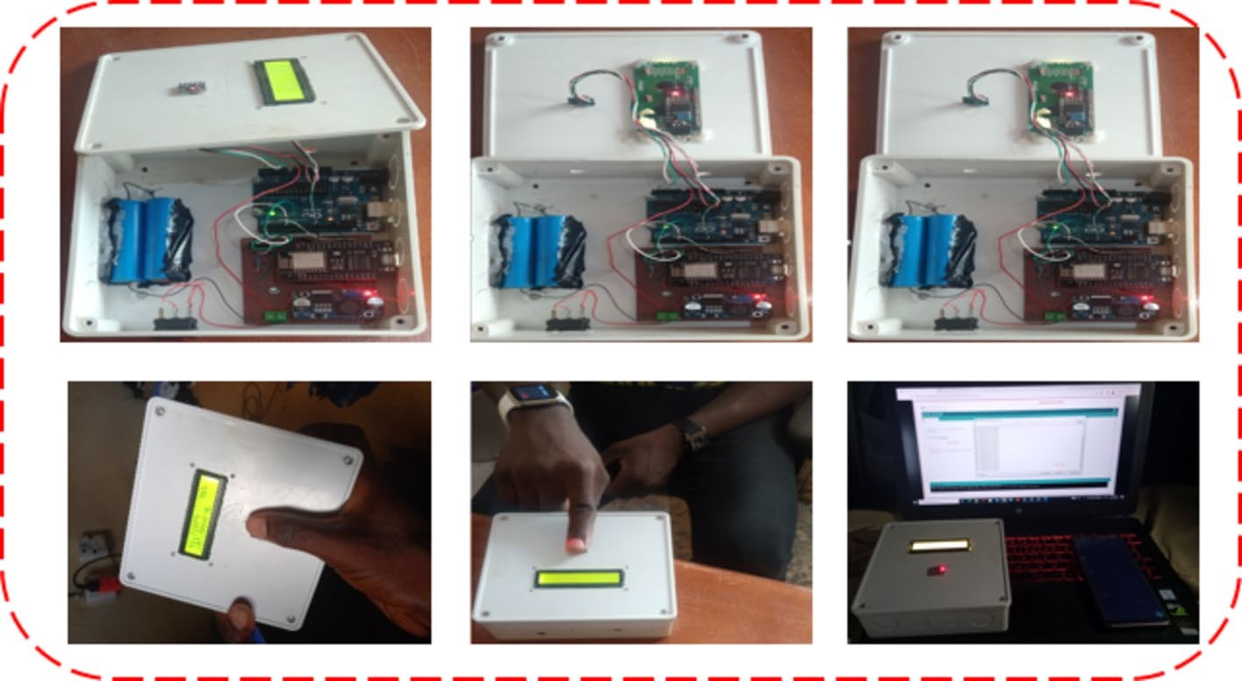

Fig.4Experimental setup of the proposed prototypee-MHs
4.2 Blood glucose test results
The Bylnk server received real-time blood glucose levels from the patients, which were acquired in a matter of seconds using a smartwatch. Patients can also access data on their smartphones over the Internet. Five experimental trials were performed for each subject for one minute, and the mean reading was used as measured data, as shown in Table 1. Figure 5a compares actual and measured blood glucose concentration data, and the results are closely similar. The maximum error deviation was found to be 1.97% and the error rate is shown in Fig. 5b.
Table 1 Comparison of the prototype system measurement of blood glucose with commercially available CGM

4.3 Heart rate test results
A "MAX30100" sensor was employed in the experimental setup. Initially, the patients placed their index fingers on the sensor to obtain real-time BPM values. Each patient had five distinct BPM readings at random intervals, and the average BPM value for a large group of patients was calculated, as shown in Table 2. The readings were found to be highly similar and accurate, with a close connection between the real and measured data, as shown in Fig. 6. Furthermore, the maximum error rate was discovered to be 1.09%, indicating that the MAX30100 sensor monitors heart rate with high precision. Table1 Comparison of the prototype system measurement of blood glucose with commercially available CGM

PatientsID | Name | Gender/Age | Actual blood glucose(mg/dL) | Measured blood glucose(mg/dL) | Errorrate (%)
DP1 | Raphael | M/55 | 125 | 126 | 0.80
DP2 | Eyitayo | M/42 | 122 | 122 | 0.00
DP3 | Darasimi | M/32 | 112 | 114 | 1.78
DP4 | Favour | F/28 | 105 | 107 | 1.90
DP5 | Blessing | F/25 | 72 | 73 | 1.36
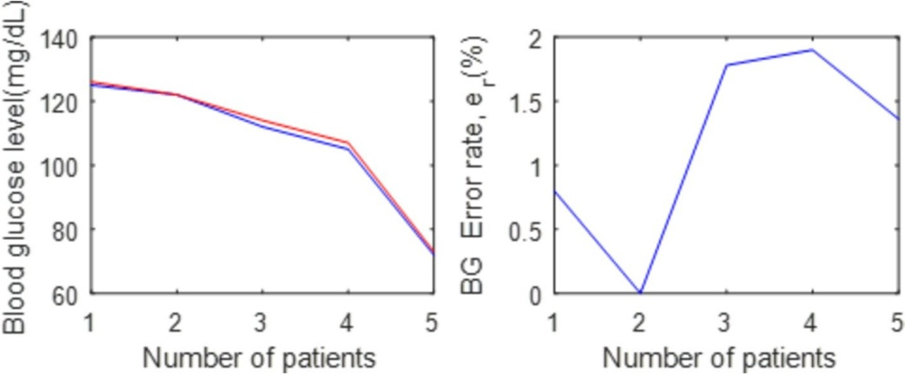
Fig.5 a Blood glucose data comparison and b percentage errorrate of blood glucose concentration
Table2 Comparison of the prototype system measurement of heart rate with commercially available stethoscope

PatientsID | Name | Gender/Age | Actualheart rate(bpm) | Measuredheart rate(bpm) | Errorrate(%)
DP1 | Raphael | M/55 | 127 | 127 | 0.00
DP2 | Eyitayo | M/42 | 110 | 110 | 1.85
DP3 | Darasimi | M/32 | 108 | 108 | 0.93
DP4 | Favour | F/28 | 97 | 97 | 1.04
DP5 | Blessing | F/25 | 81 | 81 | 0.00
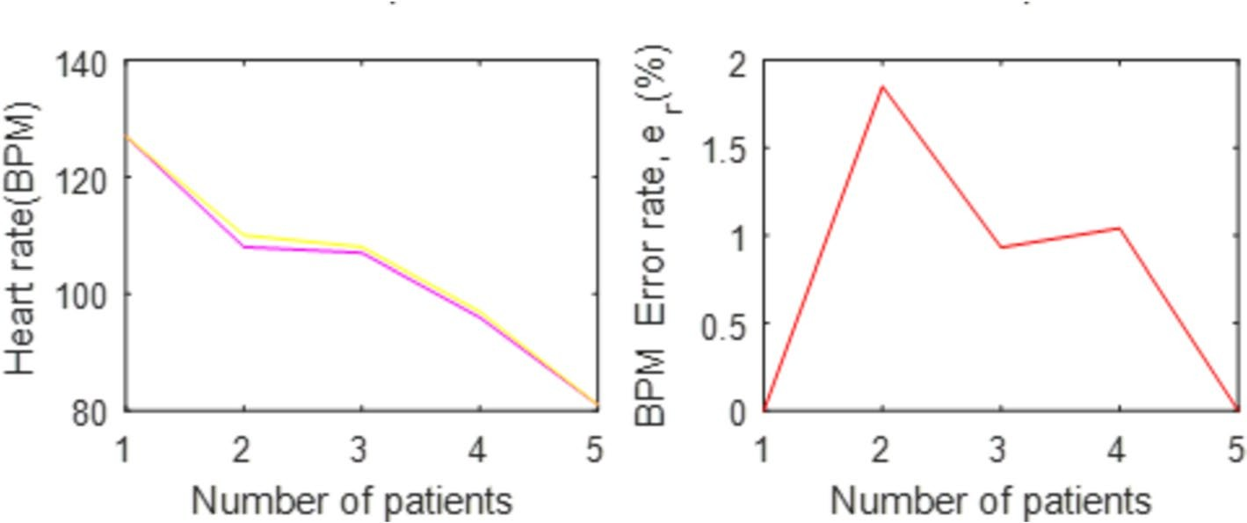
Fig.6a Heart rate data comparison and b percentage errorrate of heart rate
Large group of patients was calculated, as shown in Table2.Thereadingswerefoundto behighly similar and accurate, with a close connection between hereal and measured data, as shown in Fig.6. Furthermore, the maximum error rate was discovered to be 1.09% ,indicating that the MAX30100 sensor monitors heart rate with high precision.
4.4 Oxygensaturation SpO₂ test results
The patients first placed their fingers on the MAX30100 sensor, which takes around 10 s to calculate and displays the average SpO₂ on the LCD in real time. These readings are transmitted to the Blynk web server, which patients may access online via their smart- phones after registering and logging in with their I D and password. The data presented in Fig. 7a show a minor divergence, which can be attributable to poor peripheral circula- tion, ambient light interference, and inappropriate finger placement on the sensor area. The error rate reported in Fig. 7b can be reduced by properly positioning the pulse oxi- meter on the patient’s fingertips and avoiding movement during measurement. Table 3demonstrates that patients with identification numbers DP4 and DP5 have SpO₂ levelsless than 95%.
4.5 Body temperature test results
Table 4 depicts the user's body temperature as measured by a temperature sensor. These readings are then compared to the clinical thermometer as depicted in Fig. 8. The graph indicates that the prototype temperature readings have a slight variation due to incorrect sensor placement or ambient humidity. However, the inaccuracy is within the tolerance of 5%.
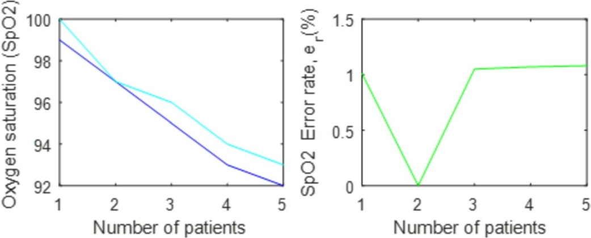
Fig.7 a SpO₂ data comparison and b percentage errorrate of SpO₂

Table3 Comparison of the prototype system measurement of SpO₂ with the commercially available SpO₂oxi meter

Patients ID Name Gender/Age ActualSpO₂
(%)
MeasuredSpO₂(%)
Errorrate(%)

DP₁ Raphael M/55 99 100 1.01
DP₂ Eyitayo M/42 97 97 0.00
DP₃ Darasimi M/32 95 96 1.05
DP₄ Favour F/28 93 94 1.07
DP₅ Blessing F/25 92 93 1.08
Table4 Comparison of the prototype system measurement of temperature LM35ensor with commercially available clinical thermometer

PatientsID | Name | Gender/Age | Actualbody temperature(°C) | Measuredbody temperature(°C) | Errorrate(%)
DP1 | Raphael | M/55 | 34 | 34.0 | 0.00
DP2 | Eyitayo | M/42 | 33 | 33.2 | 0.57
DP3 | Darasimi | M/32 | 35 | 35.0 | 0.00
DP4 | Favour | F/28 | 33 | 33.1 | 0.30
DP5 | Blessing | F/25 | 35 | 35.1 | 0.29

sensor placement or ambient humidity. However, the inaccuracy is within the tolerance of 5%.
4.5 Blynkweb page
Access to the Blynk web page for the proposed e-MHs requires user login authoriza- tion. The Blynk is hosted on the NodeMCU ESP8266 and can be accessed by numeroususersvia the internet. Figure9 depictsa screenshot of the Bylnkloginpage. The Bylnk displayed real-time blood glucose concentration, heart rate, and SpO₂ values. Furthermore, the web dashboard displays the status of diabetes vital indica- tors in both graphical and numerical formats, and users can remotely monitor their SpO₂, heart rate, temperature, and blood glucose level. A variety of Blynk widgets, including value, display, graph, and Superchart, enable users to visualize the read- ings.Figures10and11 show a screenshot of the graphical display of the user’s SpO₂

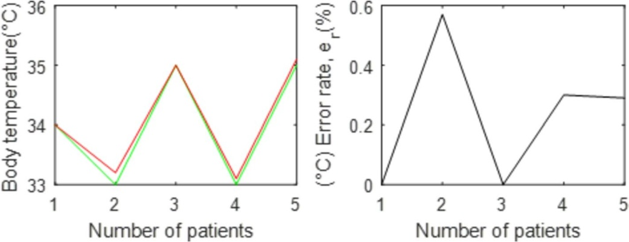
Fig.8 a temperature data comparison and b percentage errorrate of temperature
(percentage of oxygen in the blood), heart rate (in beats per minute), and blood glucose levels. Changes in SpO₂, heart rate, and blood glucose levels can be tracked and monitored in real time.
The developed e-MHs have been validated using experimental results for real-time monitoring of diabetic patients’ health conditions. Real-time access to vital sign data suchasSpO₂, heartrate, temperature, and blood glucose is provided byahybrid of the internet of things (IoT) and cloud technology.

