DIGITAL MAPPING OF INFRASTRUCTURAL FACILITIES OF ROYAL VALLEY ESTATE, SANGO.

BY

OLANREWAJU OLUWATOSIN DAVID
HND/22/SGI/FT/131

SUBMITTED TO THE DEPARTMENT OF SURVEYING AND GEO-INFORMATICS, INSTITUTE OF ENVIRONMENTAL STUDIES,
KWARA STATE POLYTECHNIC, ILORIN.

IN PARTIAL FULFILMENT OF THE REQUIREMENT FOR THE AWARD FOR HIGHER NATIONAL DIPLOMA (HND) IN SURVEYING AND GEO INFORMATICS

JUNE, 2025

CERTIFICATE
I, OLANREWAJU OLUWATOSIN DAVID with Matric Number HND/22/SGI/FT/131 hereby certify that this project was carried out in accordance with survey rules and regulations and departmental instructions in partial fulfillment for the award of HIGHER NATIONAL DIPLOMA in SURVEYING AND GEO-INFORMATICS of Kwara State Polytechnic, Ilorin.

Signature of student:- ________________________________
Name of student:- ________________________________
Date of completion:- ________________________________

CERTIFICATION
This is to certify that this project was carried out by Olanrewaju Oluwatosin David with matric number HND/22/SGI/FT/131 in accordance with survey laws and departmental instructions.

___________________________ ______________________
SURV. R.S. AWOLEYE DATE
Project Supervisor

_____________________________ ______________________
DATE
Project Coordinator

_____________________________ ______________________
SURV. ABIMBOLA I. ISAU DATE
Head of Department

_____________________________ ______________________
EXTERNAL EXAMINER DATE

DEDICATION
I dedicate this project to Almighty God, the Author and Finisher of my faith.

ACKNOWLEDGEMENT
I am so grateful to God for his grace, mercy and protection over my life since my birth up to this moment.
My sincere appreciation goes to the head of the department in person of Surv. Abimbola and my supervisor in person of Surv. R.S. Awoleye, May Almighty bless you sir.
In a special way, I will like to appreciate my lecturers in department of surveying and geo-informatics
I want to use this moment to appreciate and express and express my gratitude to my parent in person of Mr.&Mrs. Olanrewaju for their love, support and encouragement. May Almighty bless them.
I would also like to thank my fellow colleagues for their moral support and guidance throughout my stay as a student in the college and also for his directive through out of my project.
Special thanks goes to my siblings especially my lovely sister who tried all her best to makes me a successful person in life. She is always there for me throughout my education and give me best advice as a good sister.
And also, special thanks goes to my amazing friend like a sibling, they are supportive and wonderful friend with great heart, I love you.
Lastly, my appreciation goes to Jaytech Café Venture for his contribution to the successful completion of my project work. May Almighty God bless you all (AMEEN)

ABSTRACT

This project focuses on the digital mapping of infrastructural facilities within the Royal valley estate sango, Ilorin, Kwara State using modern geospatial technologies. Traditionally, map creation was labor-intensive and prone to inaccuracies, but advancements in digital tools have revolutionized this process. The study integrates surveying principles and digital mapping techniques to accurately represent natural and man-made features in a digital format, enhancing spatial planning and decision-making. Data acquisition was carried out using drone technology, with subsequent processing using Agisoft and ArcMap 10.2 software. The project involved field reconnaissance, data capturing, image processing, and map production. The final outputs orthophotos and a digital map offer a detailed, scalable, and updatable representation of the estate facilities. This digital approach improves efficiency, precision, and utility for infrastructure management, urban planning, and institutional development. The study underscores the critical role of digital mapping in modern surveying and the potential for scalable application across similar environments.

TABLE OF CONTENTS
Title Page i
Certificate ii
Certification iii
Dedication iv
Acknowledgement v
Abstract vi
Table of Contents vii
List of Tables
List of Figures
Chapter One
1.0 Introduction 1
1.1 Background to the study 1
1.2 Statement of problem 6
1.3 Aim of the study 6
1.4 Objective of the study 7
1.5 Justification for the study 8
1.6 Scope of the study 8
1.7 Personnel involved 9
1.8 Project Area 10
Chapter Two
2.1 Literature review 11-16
Chapter Three
3.0 Methodology 17
3.1 Database Creation 17
3.2 Reconnaissance 17
3.2.1 Office Planning 18
3.2.2 Field Reconnaissance 18
3.3 Selection of Instruments 18
3.3.1 Hardware Instruments Used 19
3.3.2 Software Used 20
3.4 Data Acquisition 21
3.4.1 Primary Data Acquisition 22
3.4.2 Secondary Data Acquisition 23
3.5 Data Downloading 24
3.6 Data Editing 25
Chapter Four
4.0 Data processing 26
4.1 Primary Data in Autocad 27
4.2 Process of Secondary Data in Arcmap 30
4.3 Query 38
4.4 Analysis 40
4.5 Application 44

Chapter Five
5.0 Summary, Problem Encountered, Conclusion and Recommendations and Costing
5.1 Summary 45
5.2 Problems encountered 45
5.3 Conclusion 46
5.4 Recommendation 47
5.5 Costing of the Project 48
References
Appendix

CHAPTER ONE
INTRODUCTION
1.1 BACKGROUND OF THE PROJECT
Years back (centuries), people drew and colored their maps by hand. Analyzing data and creating the resulting maps was slow and labor intensive. Digital maps, thanks to the ever-falling cost of processing power and storage, have opened up a whole new range of possibilities. With the click of mouse or a few lines code, your computer analyzes, draw, and color-themes your map data. From Global Positioning System (GPS) in your car to web site displaying local bus routes, digital mapping has gone mainstream. Contrasting the methods of conventional and digital mapping, the power of digital mapping becomes evident. The process of conventional mapping includes hand- drawn observations of the real world, transposed onto paper. If a feature changes, moves, or is drawn incorrectly, a new map needs to be created to reflect that change. Likewise if the map shows extent of a city and that city grows, the extent of the map will need to be changed and the map will need to be completely recreated. These problems are reduced with the help of digital mapping. Because features are stored as distinct layers in a computer file, you can modify a map without starting from scratch. Once a feature is modified, the computer-based map instantly reflects the change the next time the feature is viewed.
This project is based on the fundamental principle of Surveying into Digital Mapping with a dynamic process of representing physical features on the earth surface (natural and man-made features) from spatial data hold in numeric form rather than in graphical or analogue form, for management and decision making. The fact remain that Surveying is a discipline which comprises all method of measurements, storing and analyzing spatial information about the physical earth and our environment. The word “surveying” basically mean to measure access or quality, and its applies to many area of discipline where measurement investigation is carried out, which include market survey, population survey, weather survey, soil survey, land survey etc.
Fajemironkun (1998) define surveying as the branch of geosciences which deals with the location of point on or near the earth surface, the storage, retrieval and management of data obtained, the graphic representation and visual presentation of such point and the determination of figure of the earth and its gravity, using the method of applied mathematics and physics as basic tools. Surveying was considered to be the bedrock of all construction work and development in the whole world, meaning that before any meaningful construction or development can be carried out on the earth surface, surveying must be the backbone of the process. Mapping is the process of showing and representing the physical features on the earth surface, including the natural and man-made features in forms of maps after the data have been acquired and processed. According to geospatial science and engineering mapping usually refers to map-making. A map is created through some cartographic works (i.e determining the scale/level of details and content of geographic database, entry criteria and symbol, specification for geospatial objects, generalization).
Digital mapping is a computer based mapping process involving production of maps from spatial data hold in numeric form rather than graphical or analogue form. Digital mapping can as well be known as the process by which a collection of data is compiled and formatted into virtual image. Digital mapping can be seen as all the process involved in the production of digital maps. These processes depend on the electronic equipment and computer hardware and software.
A detail survey is used to determine and locate the features and improvements on a parcel of land. The word ‘feature’here means both natural and man-made structures on a piece or parcel of land such as vegetation, types of soil, buildings, land utilities, fences and boundaries, roads, lend marks and so on. This can also be stated as estate survey. Estate survey according to Ramsay (1971), is a survey undertaking to define and record the boundaries of properties, legislative area and even countries. Estate according to Encyclopedia, Wikipedia free online dictionary is a large piece of land owned by one person or a group of people. Land surveying is the technique, profession, and science of accurately determining the terrestrial or three dimensional position of points and the distances and angles between them. These points are usually on the surface of the earth, and they are often used to establish land maps and boundaries for ownership or governmental purposes (Encyclopedia, Wikipedia free online dictionary 2011).
Since this project also involve estate survey however, Estate survey can be defined as the science and art of making meaningful measurement of relative position of points on the surface of the earth so as to properly locate the properties on the earth’s surface. For the execution of this project, the following are the processes employed:
- Planning (Reconnaissance)
- Fieldwork (Data Acquisition)
- Computation (Data Processing)
- Plotting/Mapping (Data Presentation)
There are three basic principles guiding the economy and effective surveying, these are:
- Working from whole to parts.
- Choosing the method of surveying most suitable as to meet the desired result.
- Provisions of adequate controls, which will be used as checks to all survey operations so that the aim and objective of survey may be achieved.
In addition, Norman (1996) defines estate survey as one of the branches of surveying which entails simple boundary demarcation that is, the marking of boundaries and determination of locations of natural and artificial features within the limit of the landed property. Therefore estate surveying may be partly regarded to as cadastral or property survey and partly as topographical surveys due to the demarcation of height difference between point within the property. Estate survey which can be define as a topographical and cadastral surveying requires the carrying out of periodic and precise measurement on the horizontal position of point and structures of both natural and man- made features. Estate surveys are usually plotted at large scale plan than topographical surveys.
Infrastructural facilities are those commodity or services that have the ability to satisfy some human want. According to Ajadi (2004) infrastructural facilities are the items in package of basic needs which help in supporting the operation of organization example of infrastructural facilities are roads, air posts, buildings, dams, electricity railway etc. Digital equipment are those equipment that are technologically which are used for the acquisition of data, digital equipment have made job more convenient, faster, attractive, neater and more accurate. It is also an equipment with electronic devices that automate some operational process. Example of the equipment used in surveying and mapping include:
- Digital theodolite
- Total station
- EDM(electronic distance measurement)
- GPS(global positioning system)
For this project work, Drone instrument together with other accessories was adopted.

1.2 STATEMENT OF PROBLEM
Landed property generally is always a subject of dispute when it comes to land demarcation, in view of this, Government, parastatals, firms, associations, or corporate bodies have the necessity to know the extent or limit of their land and properties. It was observed that the project site, Royal valley estate sango lacked an updated digital map showing the present details concerning the current terrain and features on their land.

1.3 AIM AND OBJECTIVES OF THE PROJECT

1.3.1 AIM
The aim of this project is to map out infrastructural facilities as they exist on Royal valley estate sango with the view of identifying their spatial location to solve geo-spatial problems in the area for proper physical planning and decision making.

1.3.2 OBJECTIVES
To achieve the aim of this project, the following objectives were strictly adhered to:-
      - Mapping of infrastructural facilities of the study area using global drone.
      - Data acquisition (office and field recce),
      - Data processing, retrieving data using autocad software
      - Plan presentation in digital format using appropriate scale
      - Comprehensive report writing
      - To facilities future proper planning of the institution.

1.4 JUSTIFICATION OF THE PROJECT
The main justification of this project is to obtain plan in a digital format where some of infrastructural facilities provided are displayed or arranged in layers. To update the map, to create a map for proper monitoring and maintenance within the project area. This would be more suitable and preferable than the conventional method where features appear in a plain form on the paper.

1.5 SCOPE OF THE PROJECT
The scope of the study includes the following:
- Obtaining the coordinate of the boundary points (perimeter survey)
- Knowing the Northing(X), Easting(Y) coordinate and the height(Z) of the identified physical features i.e. infrastructural facilities in the project area.
- Downloading of the acquired data into the computer for storage, retrieving, editing and manipulation purposes.
- Plan production with the use of Autocad software, presented with appropriate scale.

1.6 PERSONNEL

Table 1.1: Personnel

S/N | NAME | MATRIC NUMBER | POSITION
1 | Olanrewaju Oluwatosin David | HND/22/SGI/FT/131 | Author
2 | Popoola Blessing | HND/23/SGI/FT/094 | Member
3 | Alai Abdullah Akanni | HND/23/SGI/FT/105 | Member
4 | Adeyemo Mariam Omowumi | HND/23/SGI/FT/095 | Member
5 | Ogundepo Quadri Olalekan | HND/23/SGI/FT/102 | Member
6 | Alada Toluwani | HND/22/SGI/FT/126 | Member
7. | Adekanbi Abigeal Bimbo | HND/23/SGI/FT/096 | Member
8. | Oke Temitope John | HND/23/SGI/FT/103 | Member

1.7 STUDY AREA
This project was carried out at Royal Valley Estate, Sango, located in Moro Local Government Area of Kwara State, Nigeria. The site lies between latitude 04°30'50"N and 04°31'01"N, and longitude 08°29'21"E and 08°29'43"E.
Royal Valley Estate can be accessed by first getting to the Polytechnic Junction (popularly known as "Poly Gate") in Ilorin. From there, take a bike to Sango, and then another bike to Royal Valley Estate.

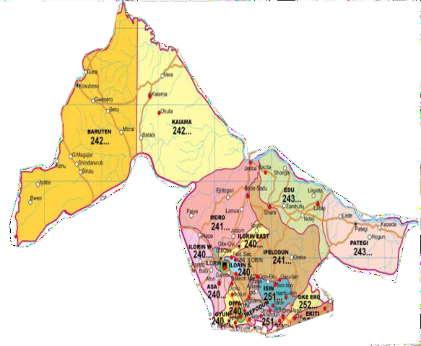
NIGERIA KWARA STATE
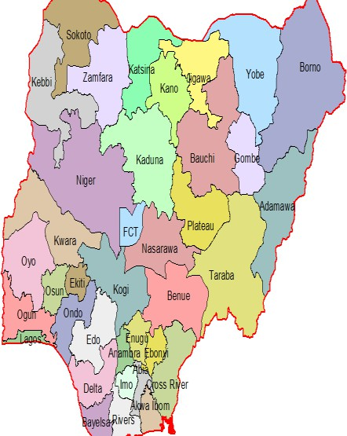

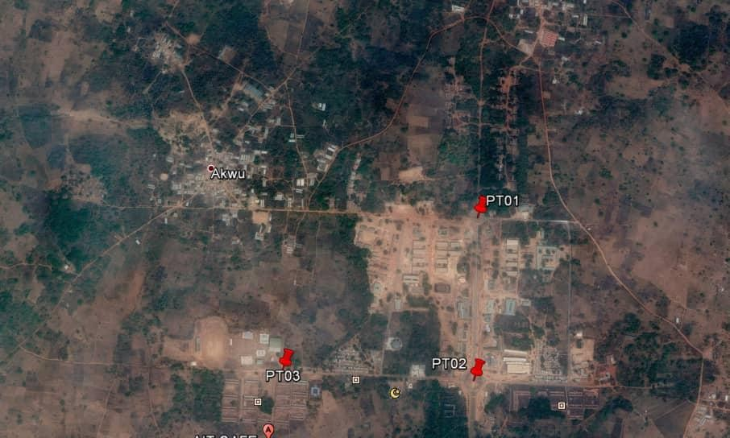
MORO LOCAL

GOVT.

SATELLITE IMAGERY
Figure1.1: Showing the study area with imagery (Not drawn to scale)

CHAPTERTWO
LITERATURE REVIEW
2.1 INTRODUCTION
Surveying is both a scientific and artistic discipline that focuses on determining the relative positions of points on, above, or beneath the Earth’s surface. Traditionally, surveying involves techniques and measurements used to establish these positions with a high degree of accuracy. However, the scope of surveying has expanded beyond simple boundary delineation to encompass all methodologies for collecting, analyzing, and managing spatial and environmental data. According to Bannister and Raymond (1977), modern surveying has incorporated advanced tools and methods developed through innovations in the defense and space industries, such as aerial and satellite technologies. This integration has transformed conventional ground-based surveying into a more versatile and comprehensive practice.
Oriola and Asonibare (2011) assert that land surveying is fundamental to any significant land development project. It forms the basis for urban planning, the design and implementation of infrastructure, and the management of natural disasters such as erosion, flooding, earthquakes, and subsidence. Moreover, it plays a crucial role in coastal zone management, mineral exploration, industrial site selection, and both terrestrial and marine resource assessment. Surveying thus serves as the starting point and continuous guide throughout the lifecycle of developmental and environmental projects.
The functions of a professional surveyor can be broadly categorized into five key areas:
- Research, Analysis, and Decision Making: This phase involves choosing the most appropriate survey method, equipment, and likely reference points or corner markers based on the purpose of the survey.
- Field Work or Data Acquisition: Surveyors gather physical data from the field using tools such as total stations, GPS receivers, and drones. This involves measuring distances, angles, elevations, and coordinates.
- Data Processing and Computation: After data collection, computations are carried out to determine positions, distances, areas, volumes, and other spatial elements. Modern software tools are used to process and verify this information.
- Mapping and Data Representation: The processed data are then presented in the form of maps, charts, or digital formats. This visualization helps clients, engineers, and planners to interpret the data effectively for decision-making.
- Stakeout and Construction Guidance: Surveyors also mark out reference points and boundaries on-site to guide construction projects. This ensures that infrastructure is developed within legal and design specifications.
Surveying is among the oldest known professions, dating back to ancient civilizations. The necessity to demarcate boundaries and allocate land led to the development of early surveying methods. Ancient Egypt is considered one of the birthplaces of surveying. Historical accounts indicate that during the reign of Pharaoh Sesostris around 1400 B.C., land was systematically divided into parcels for taxation purposes. Seasonal flooding of the Nile would often erase these demarcations, necessitating the services of surveyors—then known as "rope-stretchers"—to reestablish property lines using ropes with standard unit markings.
This early practice laid the groundwork for the evolution of geometry as a science. Greek mathematicians, influenced by Egyptian methods, advanced the theoretical underpinnings of surveying. One of the most notable contributors was Heron of Alexandria, who lived around 120 B.C. Heron is recognized for his efforts to merge theoretical knowledge with practical applications. He authored several technical treatises, including a detailed manual on the use of a device called the “dioptra,” one of the earliest known instruments used in surveying. The dioptra was capable of measuring angles and elevations, and it was instrumental in fieldwork for mapping and planning.
Heron's contributions became foundational texts for Greek and Egyptian surveyors and highlighted the potential for technology to improve the accuracy and efficiency of surveying practices. These early developments laid the foundation for the evolution of modern surveying tools and methodologies.
In the contemporary context, surveying has become indispensable in engineering and technological development. Engineers rely on precise measurements for designing and constructing infrastructure such as highways, railways, tunnels, buildings, and pipelines. Furthermore, the role of surveyors is vital in projects related to environmental monitoring, cadastral management, geospatial intelligence, and urban development.
Given the increased complexity of infrastructural and environmental challenges, the surveying profession continues to evolve, incorporating advanced technologies like satellite imagery, LiDAR (Light Detection and Ranging), and Geographic Information Systems (GIS). These innovations have not only enhanced the accuracy of spatial data collection but also expanded the capacity of surveyors to contribute to large-scale projects and strategic planning.
The transformation of surveying from a rope-based measurement activity to a technologically sophisticated profession underscores its relevance in today’s world. Surveying remains a dynamic field, essential to sustainable development, national planning, and scientific discovery. As digital tools become more integrated into everyday surveying practices, professionals in the field must continually update their skills and methodologies to remain effective in their roles.
Significant development in the art of surveying came from the practical minded Romans, whose best-known writing on surveying was by Frontlines. Although the original manuscript disappeared, copied portions have been preserved. This noted Roman engineer and surveyor, who lived in the first century, was a pioneer in the field and his easy remained the standard for many years. The engineering ability of the Romans was demonstrated by their extensive construction work throughout the empire. Surveying necessary for this construction resulted in the organization of a surveyors' guild. Ingenious instruments were developed and used.
One of the oldest Latin manuscripts in existence is the Codex Acerianus, written in about the sixth century. It contains an account of surveying as practiced by the Romans and includes several pages from Frontinus's treatise. The manuscript was found in the 10th century by Gerbert and served as the basis for his text on geometry, which was largely devoted to surveying. During the middle ages, Greek and Roman science was kept alive by the Arabs. Little progress was made in the art of surveying, and the only writings pertaining to it were called "practical geometry."
Determining the true size and shape of the earth has intrigued humans for centuries. History records that a Greek named Eratosthenes, about 220B.C. first attempted to compute its dimensions. He ascertained the angle subtending the meridian arc between Syene and Alexandria in Egypt by measuring shadows cast by the sum at these cities. The arc length was found by multiplying the number of caravan days between Syene and Alexandria by the average daily distance traveled. From the angle and arc measurements, applying elementary geometry, Eratosthenes calculated the earth's circumference to be about 25,000 mi. Subsequent precise geodetic measurements using better instruments and a technique equivalent geometrically to Eratosthenes's have shown his value, though slightly too large, to be amazingly close to the current accepted one. Actually, of course, the earth approximates an oblate spheroid having an equatorial radius about 13.5 miles longer than the polar radius.
In the 18th and 19th centuries the art of surveying advanced more rapidly. The need for maps and location of national boundaries caused England and France to make extensive surveys requiring accurate triangulation; thus geodetic survey in Gbegan. The U.S. Coast and Geodetic Survey was established by an act of Congress in 1807. Initially its charge was to perform hydrographic surveys and prepare nautical charts. Later its activities were expanded to include establishment of control monuments throughout the country.
Increased land values and the importance of exact boundaries, along with the demand for public improvements in the canal, turnpike, and railroad eras, bought surveying into a prominent position. More recently, the large volume of general construction, numerous land subdivisions with better records required, and demands posed by the fields of exploration and ecology have entailed an augmented surveying program. Surveying is still the sign of progress in the development and use of the earth's resources.
Progress continued into the space program where new equipment and systems were needed to supply precise control for missile alignment and moon mapping of proposed landing sites. Electronic distance-measuring (EDM) equipment, laser devices, north-seeking gyroscopes, improved aerial cameras, inertial and Doppler surveying systems, remote sensors, and various-sized computers are but a few products of today's technology now being directly applied in modern surveying with terrific impact. Landsat spacecraft provide images of global coverage every 18 days for down-to-earth projects such as land cover inventories, natural resource mapping, water quality assessment, and flood control.
Land surveying is the first point of reference in all meaningful land development projects. Provision of infrastructures; planning of towns and cities; management of hazardous natural events and human actions such as erosion, flooding, earthquakes, and subsidence; coastal management; exploration and exploitation of minerals; sitting of industries; resources exploitation on the land and on the sea all are dependent on Land Surveying products. Land surveying is the first point of reference in all meaningful land development projects. Provision of infrastructures; planning of towns and cities; management of hazardous natural events and human actions such as erosion, flooding, earthquakes, and subsidence; coastal management; exploration and exploitation of minerals; sitting of industries; resources exploitation on the land and on the sea all are dependent on Land Surveying products.
Fajemironkun (1998) define survey as the branch of geosciences which deals with the location of point on or near the earth surface, the storage, retrieval and management of data obtained, the graphic representation and visual presentation of such point and the determination of figure of the earth and its gravity, using the method of applied mathematics and physics as basic tools.
Furthermore, this project also deals with estate survey which was defined by Bassak, (1994) as a cadastral or property survey since the end product is the cadastral survey plan showing landed property and boundary together with details as it is accurately defined by a survey of point permanently marked on ground. In this case, the survey has legal force. Moreover, the being deals with estate survey, which can be described as an aspect of land surveying. This is because it involves demarcation of the boundaries and required fixation of more details within the landed property.
A traverse is a succession of straight lines along or through the area to be surveyed. The directions and lengths of these lines are determined by measurements taken in the field. There are several types or designs of traverse that can be utilized on any given survey. The terms open and closed traverse are used to describe certain characteristics of a traverse. If not specified, they are assumed to refer to mathematical rather than geometrical properties of the traverse. The traverse ends on one or two points, either on the same point from which it began or on the initial back sight.
There will usually be some discrepancy between the record coordinates and those calculated in the traverse. By inversing between the two sets of coordinates, the linear distance between them can be computed. This value is called the linear closure for the traverse and gives me an idea of how much error was there in the field measurement.
A Smaller or is most likely due to the limitations on how precisely the angles and distances can be measured with the specific equipment. A larger or would indicate that there is a blunder in the measurements.
The linear closure suggests how well the measurements were done. But while a half foot might seem like a smaller or when measuring ten miles, it would seem a rather larger or when cutting an eight–footboard. To better determine whether the error in a particular traverse is acceptable or not, I compared it to the distance traversed. This comparison is frequently called precision, and gives me a much better way to evaluate the error. The precision of a traverse is expressed as the ratio of the “linear error of closure” to the “traverse perimeter”, and is called the “closure ratio”.
DISCREPANCY: Is the difference between two observed values of the same quantity. A small discrepancy indicates there are probably no mistakes and random errors are small. However, small discrepancy does not preclude the presence of systematic errors.
PRECISION: Refers to the degree of refinement or consistency of a group of observations and is evaluated on the basis of discrepancy size. If multiple observations are made of the same quantity and small discrepancies result, this indicates high precision. The degree of precision attainable is dependent on equipment sensitivity and observer’s skill.
ACCURACY: Denotes the absolute nearness of observed quantities to their values. The difference between precision and accuracy is perhaps best illustrated with reference to target shooting. Survey can be précised without being accurate.
Indeed, digital mapping is greatly hampered by non-availability of good horizontal controls. In view of this, digital mapping can be improved upon by establishing basic horizontal control networks by first order geodetic triangulation, precise traverse or Global Positioning System (GPS). Having Digital mapping as a computer based mapping process involving productions of maps form spatial data hold in numeric form rather than in graphical or analogue form. Digital mapping can as well be known as the process by which a collection of data is compiled and formatted into a virtual image.

2.2 CONCEPT OF DIGITAL MAPPING

Digital mapping, also known as computer-assisted mapping or automated cartography, is a technological advancement derived from the evolution of computer science and geographic information systems (GIS). It represents a shift from the traditional analogue methods of map-making—where data is manually drawn and updated on paper or other physical media—to a computerized approach that facilitates the capture, storage, analysis, and presentation of spatial data in a digital format. Unlike the analogue system, digital mapping offers a more dynamic, accurate, and efficient method of managing geographical information.

Fundamentally, digital mapping does not seek to completely eliminate the conventional mapping methods but rather complements and enhances them. The goal is not to discard traditional cartography, but to integrate digital technologies in ways that optimize speed, accuracy, and usability. The digital mapping process involves using computers and various geospatial software to create maps based on spatial datasets, satellite imagery, aerial photographs, GPS data, and other digital sources. Through this process, the traditionally labor-intensive tasks that were previously performed manually by cartographers—such as data plotting, symbolization, and cartographic design—can now be automated or semi-automated, significantly improving productivity.

In essence, digital mapping systems are designed to automate most of the routine operations associated with conventional map-making. These operations may include the extraction and organization of geospatial data, graphical representation of geographic features, and revision or updating of existing maps. As such, digital mapping enables the rapid production of maps while reducing the errors typically associated with manual processes. It further allows for seamless integration with Geographic Information Systems (GIS), which provide a platform for storing, managing, and analyzing spatial information.

One of the defining features of digital mapping is the ability to compile spatial data from multiple sources into a unified and interactive visual representation. Unlike paper maps, which are static and often difficult to update, digital maps are highly versatile. They can be zoomed, layered, edited, and analyzed in real-time. The layers in a digital map may represent different thematic datasets such as roads, land use, vegetation, elevation, infrastructure, and administrative boundaries, all of which can be superimposed for multi-dimensional analysis. This makes digital maps invaluable tools for urban planning, resource management, environmental monitoring, disaster management, and transportation logistics, among others.

Moreover, the integration of digital mapping with remote sensing technology and GPS (Global Positioning System) has revolutionized the way spatial data is collected. Modern survey equipment and geospatial technologies can now capture high-resolution, georeferenced imagery of the Earth’s surface, which can be directly imported into digital mapping software. This eliminates the need for manual plotting and allows for real-time data acquisition. With the continuous advancements in satellite technology, such as the deployment of Earth observation satellites (e.g., Landsat, Sentinel), digital mapping can now provide up-to-date imagery that reflects the most recent changes in the landscape.

Another crucial component of digital mapping is database management. Spatial data in digital maps is stored in geodatabases that allow users to retrieve, manipulate, and analyze data with ease. These databases support attribute information related to spatial features—such as names, dimensions, conditions, and other characteristics—which enhances decision-making in sectors like land administration, transportation, agriculture, and emergency response. For example, in the case of land surveying, digital maps can show parcel boundaries along with ownership information, zoning classifications, and valuation details.

Digital mapping also promotes interoperability, allowing maps and data to be shared across platforms and institutions. Open-source mapping tools such as QGIS, as well as proprietary software like ArcGIS, AutoCAD Map 3D, and Global Mapper, support various file formats and coordinate systems, enabling collaboration across different departments, agencies, or countries. This ease of sharing and integration fosters coordinated responses in times of emergencies and supports evidence-based policymaking.

In addition to its practical applications, digital mapping also enhances public engagement and access to information. Through web-based platforms like Google Maps, OpenStreetMap, and other interactive portals, users around the world can access up-to-date maps for navigation, exploration, and analysis. These platforms often incorporate crowdsourced data, further improving the accuracy and richness of the digital maps. For governments and organizations, this capability ensures transparency and improves service delivery.

However, despite the numerous advantages of digital mapping, the implementation of this technology does come with certain challenges. One of the primary barriers is the high initial cost of setting up digital mapping infrastructure, which includes the acquisition of advanced hardware (e.g., high-performance computers, GPS equipment, plotters) and licensed software. Additionally, the system requires skilled personnel who are proficient in geospatial technology, data analysis, and computer programming. Consequently, institutions that lack adequate funding or trained staff may struggle to fully implement digital mapping solutions.

Furthermore, digital mapping systems demand consistent data quality and maintenance. Spatial data must be accurate, current, and standardized to avoid errors in map outputs and analysis. This necessitates periodic updates, validation, and verification processes. There are also concerns about data security and privacy, especially when dealing with sensitive geospatial data related to military operations, public infrastructure, or private property.

In conclusion, digital mapping represents a transformative approach in the field of geospatial science and cartography. It provides a robust framework for collecting, processing, analyzing, and presenting spatial data in a way that is efficient, precise, and user-friendly. By leveraging modern technologies such as remote sensing, GPS, and GIS, digital mapping enhances our ability to understand and manage the physical environment. Although the transition from traditional methods to digital mapping poses certain challenges—such as cost, training, and data management—the long-term benefits in terms of accuracy, speed, accessibility, and analytical power far outweigh these limitations. Digital mapping continues to evolve and will play a central role in future land development, urban planning, environmental management, and scientific research.

2.3 NEED FOR DIGITAL MAPPING
- Make map updated easily
- High in productivity
- Quick map production process
- Easy storage and retrieval
- Database management techniques.
With the above needs digital mapping allow for the following:
- Revision of updating of existing map is easy and can be done at a highly reduced cost map revision will only entail identifying map element that need to be modified.
- Stored map or mapping materials data do not suffer from dimensional distortion (shrinkage or expansion) due to fluctuating weather condition over the year, which in the case with analogue method is not so.
- Digital mapping has made it possible for digital data to be available for other uses or application ( DBMT-data base management techniques).
- Maps can be produced in layers depicting different themes and several map layers can be superimposed on one another to create a composted map.
- Security is an important attribute of digital mapping the problem of best or misplaced map sheet is dominated because the map is secured in the computer or magnetic tapes.
There is also a limit in using digital equipment for mapping areas follow:
- It involve large capital investment hardware and software.
- It require the recruitment of new personnel
- The installation cost
- Considerable reorganization of existing structures.
- Retraining of existing personnel

2.4 INFRASTRUCTURAL FACILITIES.
Facilities and infrastructure are essential components of societal development and organizational functionality. These elements serve as the backbone of any modern community, playing a pivotal role in improving living standards, ensuring efficient service delivery, and enabling economic progress. In general terms, facilities refer to the physical and organizational structures or services needed for the operation of a community or enterprise. They are fundamental assets that directly influence the quality of life of individuals and the operational efficiency of institutions.
At the most basic level, facilities encompass the various services and physical environments required for human survival, productivity, and well-being. These include housing, healthcare centers, educational institutions, recreational areas, and utility services such as electricity and clean water. When these elements are adequately provided and efficiently managed, they contribute to the enhanced welfare and convenience of individuals and communities. As such, facilities are not just functional assets; they are indicators of a society's development and modernization.
From an organizational perspective, facilities support the smooth running of operations. This includes the provision of buildings, workspaces, logistical resources, and equipment necessary to ensure that an organization functions effectively. The availability and maintenance of such infrastructure determine an organization's ability to deliver services or produce goods at optimal levels. Therefore, facilities management is increasingly recognized as a strategic function that influences productivity, employee satisfaction, and long-term sustainability.
Closely related to facilities is the concept of infrastructure. While the terms are sometimes used interchangeably, infrastructure more specifically refers to the fundamental physical systems and networks that support a nation, city, or enterprise. These systems include transportation networks (such as roads, railways, seaports, and airports), communication channels (like telephone lines, internet connectivity, and broadcasting systems), water supply and sewage disposal systems, power grids, and public institutions such as schools and hospitals.
In essence, infrastructure represents the structural foundation upon which economic and social development is built. It facilitates the movement of people, goods, and information; supports trade and industry; and ensures access to essential services. Without adequate infrastructure, development efforts are significantly hindered, leading to inefficiencies, increased costs, and poor quality of life.
Infrastructure can be broadly categorized into two types: hard infrastructure and soft infrastructure. Hard infrastructure refers to tangible, physical systems such as buildings, roads, bridges, water supply systems, and energy plants. These are typically capital-intensive, long-lasting assets that require substantial investment and ongoing maintenance. Soft infrastructure, on the other hand, includes intangible structures that support the functioning of hard infrastructure. These include governance systems, financial institutions, educational frameworks, legal systems, and health services.
Both forms of infrastructure are vital and interdependent. For example, a well-constructed highway system (hard infrastructure) may not be effective unless there are appropriate traffic laws, enforcement agencies, and public awareness campaigns in place (soft infrastructure) to guide its use and ensure safety.
The relationship between infrastructure and socio-economic development has long been established. Scholars and development practitioners have consistently highlighted the role of infrastructure in poverty reduction, economic growth, and social inclusion. Reliable infrastructure reduces transaction costs, enhances productivity, and improves access to markets and services. It also promotes equity by connecting marginalized and remote areas to economic opportunities and social services. In rural and peri-urban areas, for instance, the presence of roads, electricity, and water systems has been shown to significantly boost agricultural productivity, educational outcomes, and public health.
Furthermore, in the context of urbanization, infrastructure development becomes even more critical. As cities expand, the demand for housing, transportation, water, and sanitation increases. Without adequate planning and investment in infrastructure, urban centers can become overcrowded, polluted, and unmanageable. This, in turn, leads to the growth of informal settlements, increased crime, and public health crises. Therefore, modern urban planning prioritizes infrastructure development as a means to achieve sustainable cities that are resilient, inclusive, and livable.
In developing countries like Nigeria, infrastructure challenges remain one of the major barriers to achieving economic prosperity and improved standards of living. Despite abundant natural and human resources, the lack of reliable infrastructure—such as poor road conditions, inconsistent power supply, and inadequate water and sanitation systems—continues to constrain productivity and limit access to basic services. The government's role in infrastructure provision is thus crucial. Investments in infrastructure not only stimulate economic activity through job creation and industrial growth but also lay the foundation for long-term social development.
In addition to public sector involvement, private sector participation through Public-Private Partnerships (PPPs) has gained attention as a sustainable model for infrastructure development. In this model, private investors collaborate with government agencies to finance, build, and manage infrastructure projects. This approach can help bridge funding gaps, enhance efficiency, and improve service delivery. However, successful implementation requires transparent regulations, risk-sharing mechanisms, and strong institutional frameworks.
Technological innovation is also reshaping the landscape of infrastructure development and facility management. Smart infrastructure systems, powered by digital technologies, are now being deployed to monitor, control, and optimize service delivery in real-time. Examples include smart grids for electricity distribution, intelligent transportation systems, and automated building management systems. These innovations enhance reliability, reduce costs, and promote sustainability by minimizing energy consumption and environmental impact.
Environmental sustainability is another critical dimension of modern infrastructure and facility development. As climate change and environmental degradation become urgent global concerns, there is a growing demand for green infrastructure—projects that integrate natural processes into urban planning and construction. These include green roofs, permeable pavements, stormwater management systems, and energy-efficient buildings. Green infrastructure not only mitigates environmental risks but also improves urban aesthetics, biodiversity, and public health.
In conclusion, facilities and infrastructure are foundational to both community well-being and organizational performance. They are instrumental in shaping the daily experiences of individuals, influencing the efficiency of businesses, and driving national development. To achieve equitable and sustainable growth, stakeholders must prioritize the planning, funding, and maintenance of these essential systems. The future of infrastructure lies in adopting innovative, inclusive, and environmentally responsible approaches that address both current challenges and emerging opportunities.
2.4.1 Types of infrastructural facilities
The types of infrastructural facilities includes:

- Social infrastructural such as health, community, educational facilities fire and security services.
- Physical infrastructural such as water, rural electrification, storage and processing facilities drainage.
- Institution infrastructural: These include the credit and financial institutions and research facilities.
2.4.2 Need for infrastructural facilities in our environment.
Infrastructural is vital in a community. The research of Arndit et al (1999) on Mozambique shows its positive effect on trade and transport cost, and on agricultural growth . According to Chogwill (1997) in infrastructural facilities have to be provided adequately to serve growing population of the city and not provided on incremental basis. Mabogunje (1993) state that there is need for the city planning to be transformed to take into account the need to extend infrastructural facilities and services to individual plot of lead within the city.
2.4.3 Method of mapping infrastructural facilities
The real method by which infrastructural facilities can be acquired for input into a digital mapping system includes:
- Ground surveying methods
- Photogrammetric methods
- Graphic digitalizing
- Remote sensing techniques
For this project Aerial Surveying method was adopted for the acquisition of data in order to determine Northing (X), Easting (Y) and Height (Z) coordinates of the identified physical features.
2.4.4 Benefits of infrastructural facilities
- Good infrastructural facilities and human development programs for poor people promote economic growth and social development.
- Infrastructural provides needs for school such as accommodation, catering, entertainments, leisure and relaxation centre.
- It reduces poverty and many create employment.

CHAPTER THREE

3.0 METHODOLOGY
This stage involves the methods and procedure used in planning, data acquisition, data processing, and creation of database, creation of database management system and information presentation. These operations were logically structured and carried out in stages involving database design. It is normally considered to involve a spatially referenced and structured digital database and appropriate application software for geospatial analysis. This basically describes the techniques and principles adopted in carrying out the project.
Geographic information system methods were adopted in accomplishing the desired results.

3.1 DATABASE DESIGN
The design of any database involves three stages namely;
i Conceptual design
ii Logical design iii Physical design

3.1.1 VIEW OF REALITY
In database design, there is need for reality which is referred to as the phenomenon that actually exists, including all aspects which may or may not be perceived by individuals. The view of reality however, is the mental abstraction of the reality for a particular application or group of applications.
For this application, the view of reality is made of the topography of the project. Since it is not possible to represent the real world, the only option is to conceptualize and model it in a specified manner to represent the real world. The area of interest to us in this project

Includes; Green Reserve, Roads, Electric poles, Trees, Water Facilities, Buildings, Football pitch, Streams.
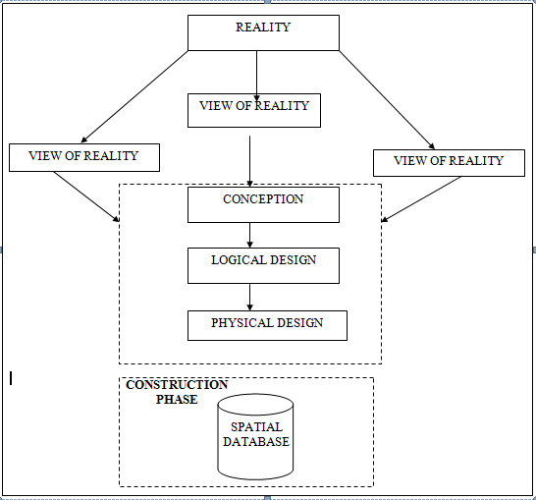

Fig. 3.1 Design and Construction Phases in Spatial Database

3.1.2 CONCEPTUAL DESIGN

Vector data model is the data type adopted for this project, which is represented, by points, lines and polygon. The identified entities are:-
      - Vegetation area (polygon)

      - Roads (line)

      - Trees (point)

      - Boundary line (polygon)

      - Buildings(polygon)
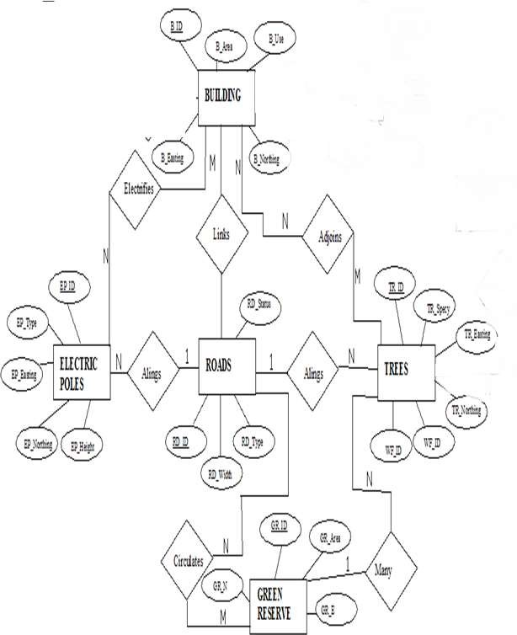

Fig. 3.2.: E-R Diagram (Entity relationship diagram)

3.1.3 LOGICAL DESIGN

This is the design aspect of the database refers to the process of creating a conceptual framework or model that represents the structure and organization of spatial data within the system. It involves defining the data element, their relationship, and the rules for data manipulation and analysis. In this phase, the entities, their attributes and their relationships are represented in a single uniform manner in form of relation in such a way that would be no information loss and at the same time no unnecessary duplication of data. In this study, the logical database design is employed to generate a geo-relation database structure. Each entity has unique identifier in bold type. An attribute type or combination of attribute types that serves to identify an entity type is termed an identifier.
- Building( B_ID, B_Area, B_Name, B_Easting, B_Northing)

- Roads (R_ID, R_Width, R_Type, R-Condition, R_Easting, R_Northing )

- Vegetation (V_ID,GR_Area,)

- Tree (TR_ID, TR_spp, TR_Importance, TR_Easting, TR_Northing )

- Electric Pole (EP_No, EP_Type, EP_Height,EP_Easting, EP_Northing)

- Water Facility (WF_ID, WF_Depth,WF_Type, WF_Easting, WF_Northing)

- Football Pitch (FP_ID , FP_Area, FP_Status)

- Stream(S_ID, Length, Width)

3.1.4 PHYSICAL DESIGN

Table 3.1: Building and its attribute

ENTITY | DESCRIPTION
B_ID | Building Identification
B_name | Building Name
B_Area | Building Area
B_Easting | Building Easting
B_Northing | Building Northings

Table 3.2: Road and its attributes

ENTITY | DESCRIPTION
R_ID | Road Identifier
R_Length | Road Length
R_Width | Road Width
R_Type | Road Type
R_Condition | Road Condition

Table 3.3: Trees and its attributes

ENTITY | DESCRIPTION
TR_ID | Tree Identifier
TR_Spp | Tree specy
TR_E | Tree_Easting
TR_N | Tree Northing

3.2 RECONNAISSANCE

This is the preparatory stage before the execution of this project; it involves collection of available information about the project area.
The necessary step taken for the successful execution of the project involves two stages, which are:-
- Office Planning
- Field reconnaissance

3.2.1 OFFICE PLANNING

This involves the collection of information about the study area, testing the instrument to be used in execution of the project and itemizing the numbers of equipment needed, number of days to be use, how each activity is to be carried out, delegation of works to each team members based on supervisor’s guide/instructions.

Table 3.4 Coordinates of Controls

Station | Northing (m) | Easting (m) | Height (m)
KWCS 625T | 941451.040 | 674200.278 | 255.212
KWCS 623T | 941753.095 | 673845.702 | 250.532
KWCP 690 | 94I802.041 | 673810.314 | 249.087

Source: Surveyor general office Kwara

3.2.2 FIELD RECONNAISSANCE

The field reconnaissance is the first visitation to the project site to get intimated with the environment.
- Boundary points was selected

- The distribution of features was studied

- Controls to be used were located

- Method and type of instrument to be uses was determined

- Subsidiary point for Ground control Points were picked and define using nail and bottle cock
- A diagram of the study area was drawn.
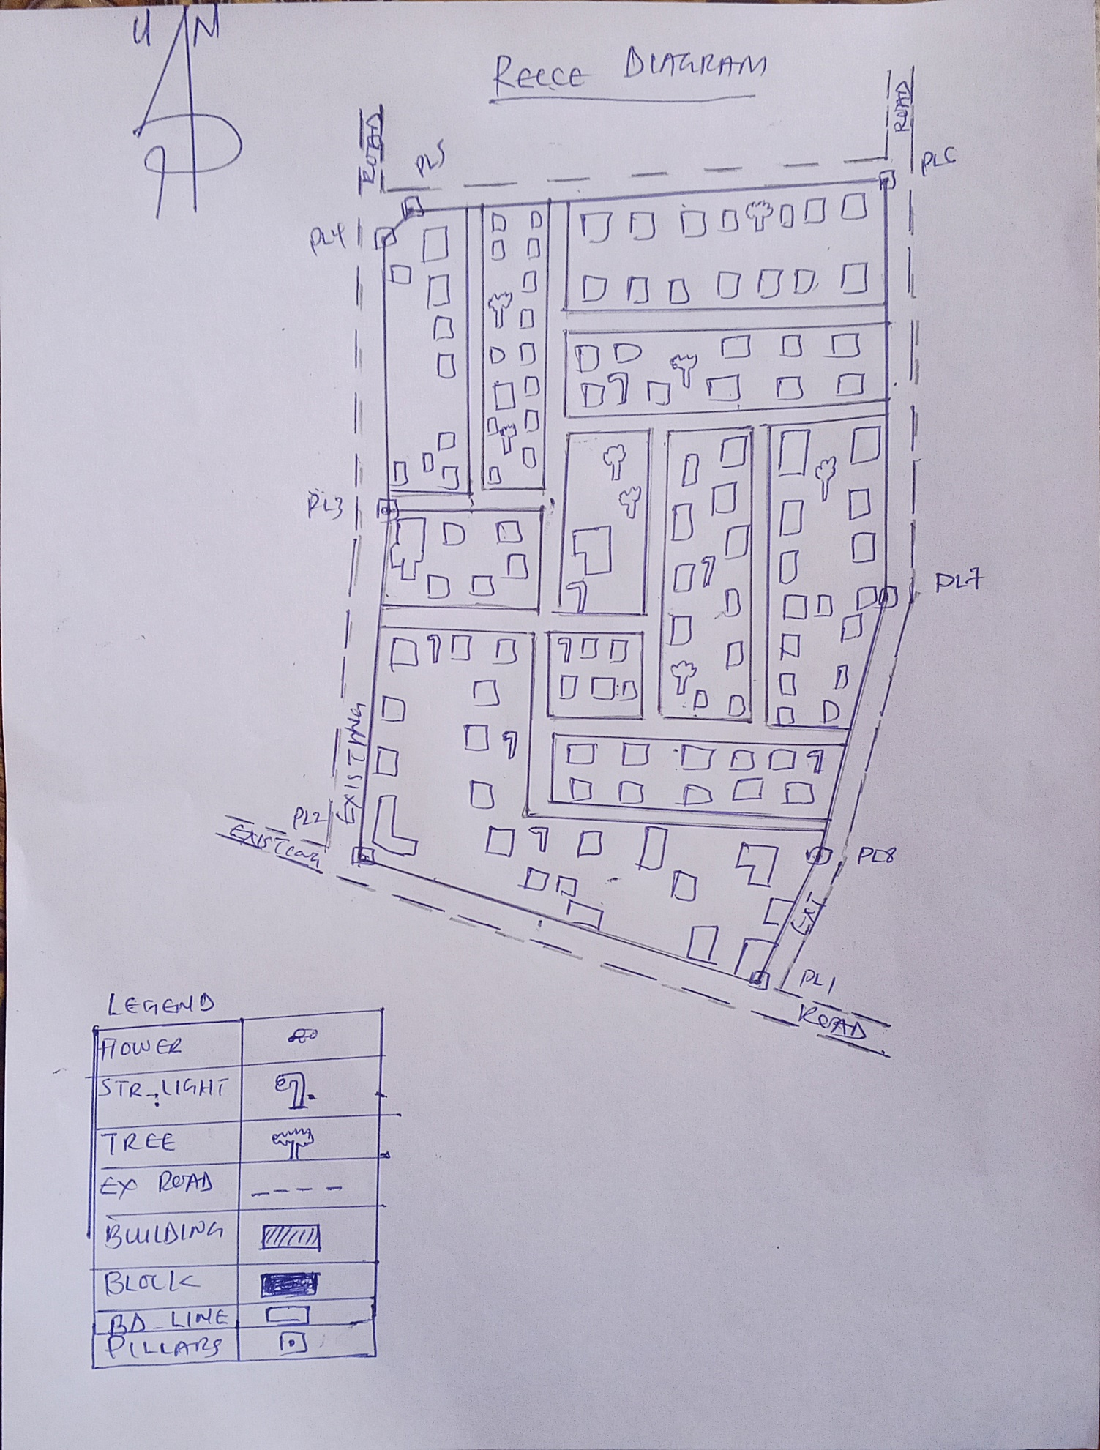

Fig. 3.3: Recce diagram of the study area (not drawn to scale).

3.3 EQUIPMENT USED/ SYSTEM SELECTION AND SOFTWARE

3.3.1 HARDWARE USED

- Total station

- 1 reflector with a tracking rod.

- 1 Tripod

- One (1) 50m tape

- One (1) umbrella

- 1 cutlass

- Hand held GPS

- Hammer

- Nails and bottle cover

- Field book and writing materials

- 1-No of Personal Computer HP655 and its accessories

- 1-No of HP Desk Jet K7100 A3 printer

- 1-No of HP Desk Jet 1110 A4 printer

3.3.2 SOFTWARE COMPONENT

- Notepad.

- Microsoft Excel.

- AutoCAD 2007

- ArcGIS 10.3

- Microsoft Word.

3.4 INSTRUMENT TEST

To ensure data quality, the Total Station used for this project was tested for both vertical index and horizontal collimation errors. It was also to ascertain the efficiency and reliability of the instrument. The procedure used is described below.

3.4.1 HORIZONTAL COLLIMATION TEST
This test was conducted to ensure that the line of sight was perpendicular to the trunnion axis. The Total Station was positioned over a specific point, and initial adjustments were made to ensure proper alignment, leveling, and focus (to eliminate parallax in the telescope). A vertical target was placed at a distance of 100 meters from the Total Station. To access the configuration menu of the Total Station, the menu key was pressed and held for approximately 2 seconds. From the main menu, the calibration sub-menu was selected, and within that, the horizontal collimation test option was chosen. The target was then observed and divided into two halves, with horizontal readings recorded for Face left and Face right. The readings are shown in Table 3.4.1 below.

Total Station
100m
REFLECTO R (TARGET)

STATION A
Fairly Level Ground
STATION B

Fig 3.4: Horizontal Collimation and Vertical Index error test.

Table 3.5: Horizontal Collimation Data

Station | Target | Face | Hz Reading | Difference | Error
A | B | L | 38˚42‟32”
 |  | R | 218˚42‟35” | 180˚00‟03” | 03”

3.4.2 VERTICAL INDEX ERROR TEST

This test was conducted to verify the accuracy of the vertical reading when the line of sight is horizontal. The desired measurement for this test is exactly ninety degrees (90˚), any deviation from this value is referred to as the vertical index error.
The Total Station was positioned over a specific point, and necessary temporary adjustments were made to ensure proper alignment and functionality. A target was placed approximately 100 meters away from the Total Station, and the instrument was aimed at the target. The target was bisected by aligning the instrument on the face left, and the corresponding reading was recorded. Similarly, the target was then bisected on the face right, and the respective reading was also recorded. The recorded readings are provided below:

Table 3.6: Vertical Index Data
Instrument Station | Target Station | Face | Vertical | Sum | Error
A | B | L | 90˚00‟00”
 |  | R | 270˚00‟02” | 360˚00‟02” | 02”

3.4.3 ANALYSIS OF COLLIMATION AND VERTICAL INDEX DATA

The reading obtain during calibration were reduced to obtain new collimation and vertical errors.
Horizontal collimation = {(FR – FL) – 180}/2 = {(00˚00‟03”}/2 = 1.5”

Vertical collimation = {(FL + FR) – 360} = (90˚00‟00” + 270˚00‟02”) - 360} = 02” The result shows that the instrument is still in good working condition.

3.5 CONTROL CHECK
Three control beacons (KWCS 625T, KWCS 623T and KWCP 690) were used. In order to ascertain the in-situ of the control beacons, a check was carried out on them by observing the angle between them and comparing the result obtained with the computed angles from the giving coordinates.
The total station instrument was set on the control beacon KWCS 623T. After performing all the necessary temporary adjustment, the reflector was placed on the control beacon KWCS 625T which served as the back station. The horizontal angular reading was taken and recorded while the instrument was on face left. The reflector was then taken to the control beacon KWCP 690 which serves as the forward station, the horizontal angle reading was then taken and recorded on both face left and face right. The reflector was taken back to the back station, the horizontal angle was then recorded on face right.

Table 3.7: showing the back computation of the control coordinates

From STN | Bearing | Dist (m) | ∆N | ∆E | Northing (m) | Easting  (m) | To STN
 |  |  |  |  | 941451.040 | 674200.278 | KWCS 625T
KWCS 625T | 130°25'37'' | 465.791 | 302.055 | -354.576 | 941753.095 | 673845.702 | KWCS 623T
KWCS 623T | 149°38'02'' | 60.399 | 48.946 | -35.388 | 941802.041 | 673810.314 | KWCP 690

Table 3.8: showing the distance observation result of the control check

FROM | OBSERVED DISTANCE  (m) | COMPUTED DISTANCE  (m) | TO
KWCS 625T | 465.902 | 465.791 | KWCS 623T
KWCS 623T | 60.521 | 60.399 | KWCP 690

Table 3.9 showing the observation result of the control check

STN | SIGHT | FACE | OBSERVED HZ ANGLE | REDUCED  HZ ANGLE | MEAN
 | KWCS 625T | L1 | 195° 14' 07''
KWCS 623T | KWCP 690 | L2 | 64° 47' 29'' | 130°26'38''
 | KWCP 690 | R2 | 15° 14' 13'' | 130°26'22''
 | KWCS 625T | R1 | 145° 40' 35'' |  | 130°26'30''

Difference in angle (observed - computed) =188° 31' 40''-188° 31' 36''

= 00° 00' 04''

Since the allowable accuracy (angular) of third order traverse of one station is 00° 00' 30'' and the result obtained from the control check (00° 00' 04'') is less than allowable error. Therefore, the controls were angularly intact.

3.6 MONUMENTATION
The boundary of the area carved out was demarcated with the precast concrete beacons, after clearing the required line of sights. The identified points of changes in directions were dug and beacons were buried on it, leaving about 15cm part of the beacon above the ground level.
The beacons were buried at convenient distances as dictated by the nature of the boundary

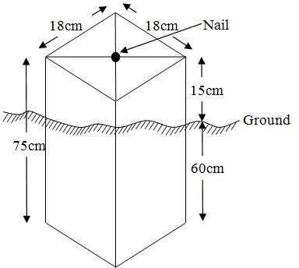

Fig. 3.5: Pillar Description

3.7 DATA ACQUISITION

PRIMARY DATA SOURCE
Field observation was the primary source of data for this project. Ground based method was used in acquiring data with the use of Total Station Instrument, which involved the collection of X, Y, Z data through coordinated Ground control Points (GCP) established at conspicuous points within the study area .

SECONDARY DATA SOURCE
An imagery of the area was acquired through Updated Google earth; this was used to ascertain the extent of coverage of the project area.

3.7.1 GEOMETRIC DATA ACQUISITION
The total station instrument was set carefully on control point KWCS 623T back sight taken to KWCS 625T after necessary station adjustments has been carried out on it. The adjustments includes; centering, leveling and focusing. The following procedures were then followed to determine the position of the next point KWCS 623T and the same procedure were repeated until all we come close to the site. The method used in acquiring data on site was radiation method where two or more points are coordinated from one point.
- Having set up the instrument and temporary adjustment carried out, the instrument was powered „on‟ and a job was created under job menu in the internal memory of the instrument. The job created was named GRP6B
- On the job, the coordinates of the three (3) control points were keyed in to the memory of the instrument and some codes were also saved. The codes include
- „RD‟ for road, „SP‟ for spot height, „BD for buildings, etc.
- The height of the instrument was measured and saved on the memory of the instrument as well as the reflector height.
- On coordinate menu, orientation was set by inputting the coordinates of the instrument station and back sight. The reflector at the back station was perfectly bisected before the orientation was confirmed by clicking „yes‟.
- Having done the orientation, the reflector at the next nail; was bisected and „obs‟ (observe) option was clicked. The three dimensional coordinate of the point (E,N, H) were displayed on the display unit of the instrument and „rec‟ (record) was clicked to save the data into the memory of the instrument. For subsequent observation after this, „all‟ option was used instead of pressing „obs‟ and pressing
- „Record‟ later.
- It was ensured that the center of the prism of the reflector was bisected and that it was set perfectly on the tripod in order to minimize the error on height determination.
- The instrument is been shifted to another nail after all details, spot height and boundary point visible from the instrument station have been picked, set over it and temporary adjustments carried out.
- Nonetheless, the above operations were repeated until all the boundary points with heights were coordinated.
- In this project all spot height are not in grid intervals but randomly acquired. Three edges (3) of building were picked. At the end of data acquisition process all details were acquired and properly recorded to be shown in their respective positions on the plan.

3.7.2 ATTRIBUTES DATA ACQUISITION
Attribute data is information about spatial features. They provide the characteristics, description and nomenclature about spatial objects. Thus the attributes data acquired includes names of buildings and their uses such as classrooms, roads, water facilities and prominent natural features likes river and trees found and vegetation were properly identified within and around the study area.

3.8 DATA DOWNLOADING AND PROCESSING

3.8.1 DATA DOWNLOADING AND EDITING
This is stage whereby all data acquired which were automatically stored in the Total Station were downloaded into personal computer. This was done with the aid of downloading cable connected to the computer and some associated complementing software installed on the System.

3.8.2 DATA PROCESSING AND DATA EDITING
The geometric data downloaded were further processed in order to convert it to a useful format and to enhance its accuracy. The output coordinates, were edited and exported in *.txt, *.xls and *.pdf format. Thereafter, they were imported into Arc GIS 10.3 for further operations and to carry out spatial analysis.

3.8.3 DATA PROCESSING USING ARCGIS 10.3

Before launching of ArcGIS AutoCAD was used in plotting of feature data saving them separately in different file named road, boundary line, buildings, trees and electric poles.
- Launch the Arc Map in ArcGIS 10.3
- Click on A NEW EMPTY MAP on the dialog box displayed after loading
- Click on Tools on the menu bar, then select extensions, mark all and close.
- At the LHS, right click on layers, and then select properties.
- Click on coordinate system to set the projection system to MINNA DATUM ZONE 31N and general to set the unit, then apply and okay.
- Add data was selected at the tool bar all saved AutoCAD fie was selected and load onto the table of content layer section

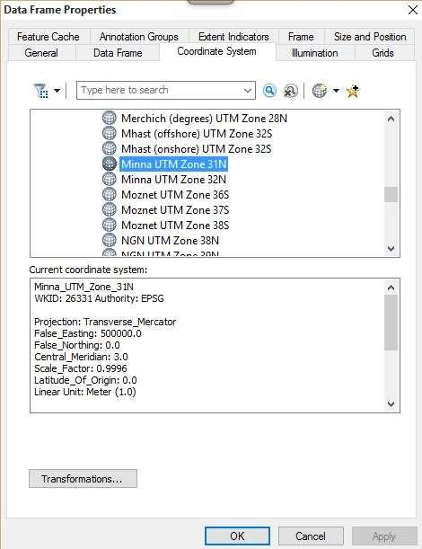

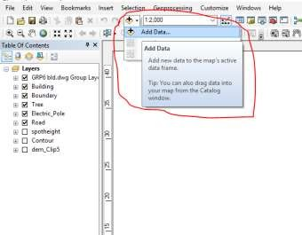

All drawing was exported to shape file. After the feature class has been creates, click on Editor to start Editing, and then click on the load object.

3.8.4 Topographical Map (DEM)
CRATING CONTOUR: Firstly DEM was created by searching in the search icon INTERPOLATION> NATURAL NIGHBOR and selecting THE XYZ data for creation of DEM in respect to the boundary line as extent. In order to create contours, you will need to enable the Spatial Analyst toolbar, which can be found by going to Customize > Toolbars > Spatial Analyst or open the search bar.

You can do this by clicking Windows > Search, or by clicking on the search icon.
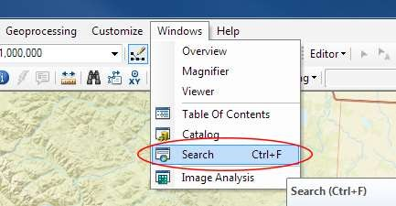

In the search bar type Contour, and select Contour (Spatial Analyst) from the search results list

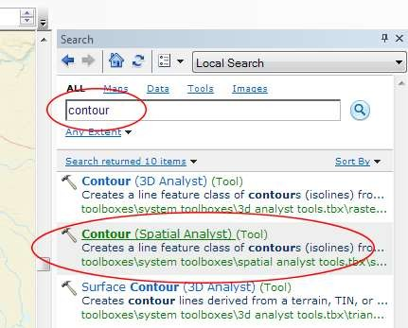

After choosing Contour, a dialogue window will appear, prompting you for five settings: Input raster: select the DEM file from which you want to generate contours by locating it on your hard drive or in the dropdown menu, showing layers present in the Table of Contents Output polyline features: indicate where you want to save your output contours Contour interval: set the distance between contour lines in meters – the smaller the number, the greater the number of lines Base contour (optional): the starting point from which the lines are generated – for example, the default is 0 so with an interval of 25 meters, the contours are generated at 25, 50, 75, 100…, but if the base contour is set at 40, then the contours are generated at 65, 90, 115, 140 and so on Z factor (optional): can be used to adjust the units of data; for example, if you have data in meters and you want to produce your contours in feet, use a z-factor of 3.28 because 3.28 feet equals one meter.

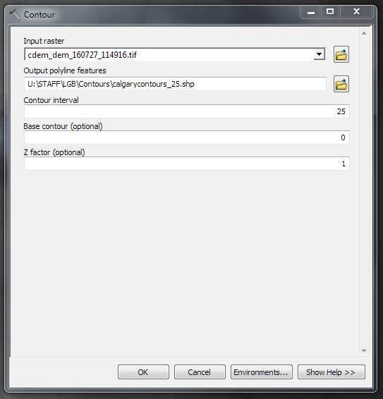

The generated contours will automatically be added to the map.
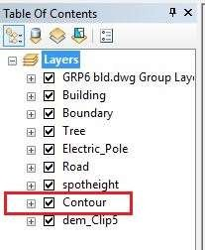

Input the data which is the AutoCAD drawing and select the feature type you want to load,

- Click Add and Next, then select the Target layer you want it to be

- Load it into from the feature class created on the ARCGLS.

- Click on Next, then select “only the features that satisfy the

- Query” and click on Query Builder to query for the feature to be loud e.g. “layer” = Boundary”.
- Click on Next. Then finish

Right click on the Boundary In the table of content and click on zoom to layer to display the feature.

EDITING, CONVERTING AND MERGING GEODATABASE

- Remove all necessary features by right clicking on it and press "REMOVE"

- Convert some features that are not in their correct „features -type‟ like point, line, and polygon features etc.
- To convert a GOEDATABASE FEATURE CLASS to another the following steps were taken:
- FOR LINE FEATURE CLASS TO POLYGON FEATURE CLASS
- Go to WINDOW on the menu bar and select ARC Toolbox.
- Select DATA MANAGEMENT TOOLS, click on FEATURES, and then Select FEATURE TO POLYGON.
- ON INPUT FEATURES, select feature to be converted, on OUTPUT FEATURE CLASS, then save on the GRP6C FOLDER, press OK and CLOSE.
- Then remove the converted feature class in the LAYER Menu and ARC CATALOG files.
- On INPUT DATASETS, select features to be merged, on OUTPUT DATASETS, then save on the GRP6C folder, press OK and CLOSE.
- Then remove the converted feature class in the LAYER Menu and ARC CATALOG files.

ADDING SPOT HEIGHTS DATA
- NOTE: STOP EDITING on the EDITOR MENU before adding data field,
- Go to FIELD ON THE MENU BAR, scroll to add Data and then ADD XYZ DATA
- Browse the EXCEL FILE for SPOT HEIGHTS, select EASTING VALUE on X - FIELD and NORTHING VALUE on Y - IELD and ELEVATION
- « Select DATA the EXPORT DATA, locate the folder created and give it name then YES AND OK, remove the previous layer by right clicking on it and select REMOVE.

TIN, ASPECT AND SLOPE CREATION USING ARCMAP
NOTE: Making sure the 3D Analyst Extension is active, select VIEW on MENU bar, then click TOOLBARS and MARK the 3D Analyst EXTENTION Then X, Y Data
TO CREATE TIN
- Click on 3D Analyst arrow, select create TIN and then create TIN from FEATURE.
- On layers mark the SPOTHEIGHT LAYER, select height data on HEIGHT, then ok.

TO CHANGE THE FACE OF THE TIN ACCODING TO ITS ELEVATION
- RIGHT CLICK on the TIN, select PROPERTIES, and click on SYMBOLOGY.
- Then ADD, select FACE ELEVATION WITH COLOR RAMP, click ADD, and then select APPLY and OK.

TO CREATE ASPECT
- Click on 3D analyst arrow, select SPATIAL ANALYST TOOLS, SURFACE and THEN DOUBLE CLICK on ASPECT.
- Browse to where the raster format of all the acquired data created from the surfer was saved to.
- Browse to where you want the OUTPUT RASTER to be saved
- You can change the OUTPUT MEASUREMENT to Degree OR percent
- Click OK [then it displays on the data view screen], then Close.

3.8.5 Facility Map Production
The buildings were digitized from the downloaded Google earth image using ArcGIS 10.2.1. Shape files for the facilities were created in Arc Catalogue. The created shape files were added to Arc Map and editor was started to digitize out to facilities. The road network, buildings are extracted using polyline and polygon respectively while street lights and trees are represented by point data for 3D map production the generated 2D map is shown in Figure 3.6, Figure 3.7 shows the old 2D CAD map of the campus.

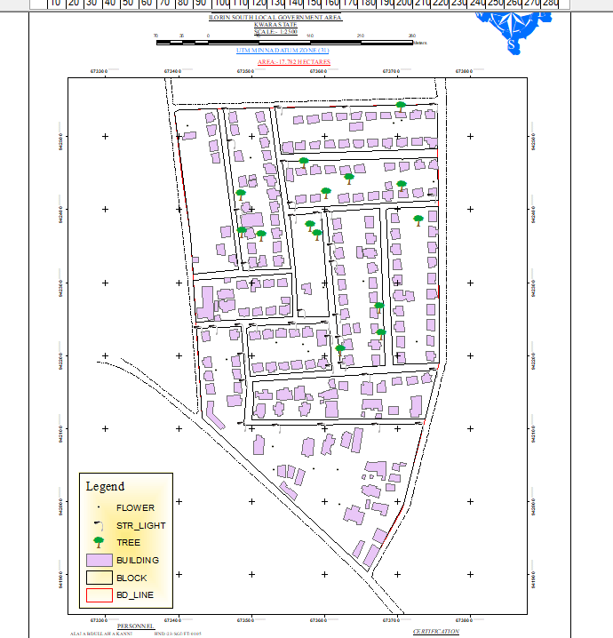

Figure 3.6 showing the 2D facility map of the study area.

3.8.6 3D Map Production
The 3D image was done Arc Scene using the created DEM; the created DEM was added to Arc Scene and extruded with the heights gotten on the field. Extrusion incorporates the height of these features in their representation to give them 3D look and was made to float on DEM to have a true land representation.
The created DEM was also added to Arc Scene, The height of the buildings gotten from the field was added to the already created height field in the attribute table of each of the facility shape file in Arc Map. Arc Scene was launched and all the shape files were added, from the table of content each shape file was right clicked on to access the property dialog box, from the property dialog box the shape files were extruded to give them 3D look and were made to float on the DEM to have a full 3D visualization.

3.8.7 Findings
This study has demonstrated a capability of GIS in facility mapping with different visualizations techniques i.e. 2D and 3D visualization, Figure 3.6 shows the generated 2D map while Figure 4(a) and Figure 4(b) show cross-sections of the generated 3D map of the campus. All the facilities were geo-located with the aid of total station and imported into ArcGIS 10.2, the facilities were also digitized from the Google earth image downloaded for the study area. 3D topographic maps of the study areas were created from the point data gotten from field-work and also from the downloaded SRTM DEM image downloaded from USGS, Figure 5 shows the 2D Topographic map generated from the point data gotten from the field using Total station while Figure 6 shows the 3D topographic map generated using the same data source. Figure 7 shows the 2D topographic map generated from SRTM 30 m while Figure 8 shows the 3D topographic map generated using the same data source. The 2D facility map was produced by digitizing all the facilities out as features from the Google earth image downloaded using Google downloader. The 3D model of the campus was produced by exporting all the features created in Arc Map to Arc Scene for extrusion; the extruded features were made to float on the 3D topography map created through interpolation using Kriging method. The 3D visualization gives the study area a near real life view.
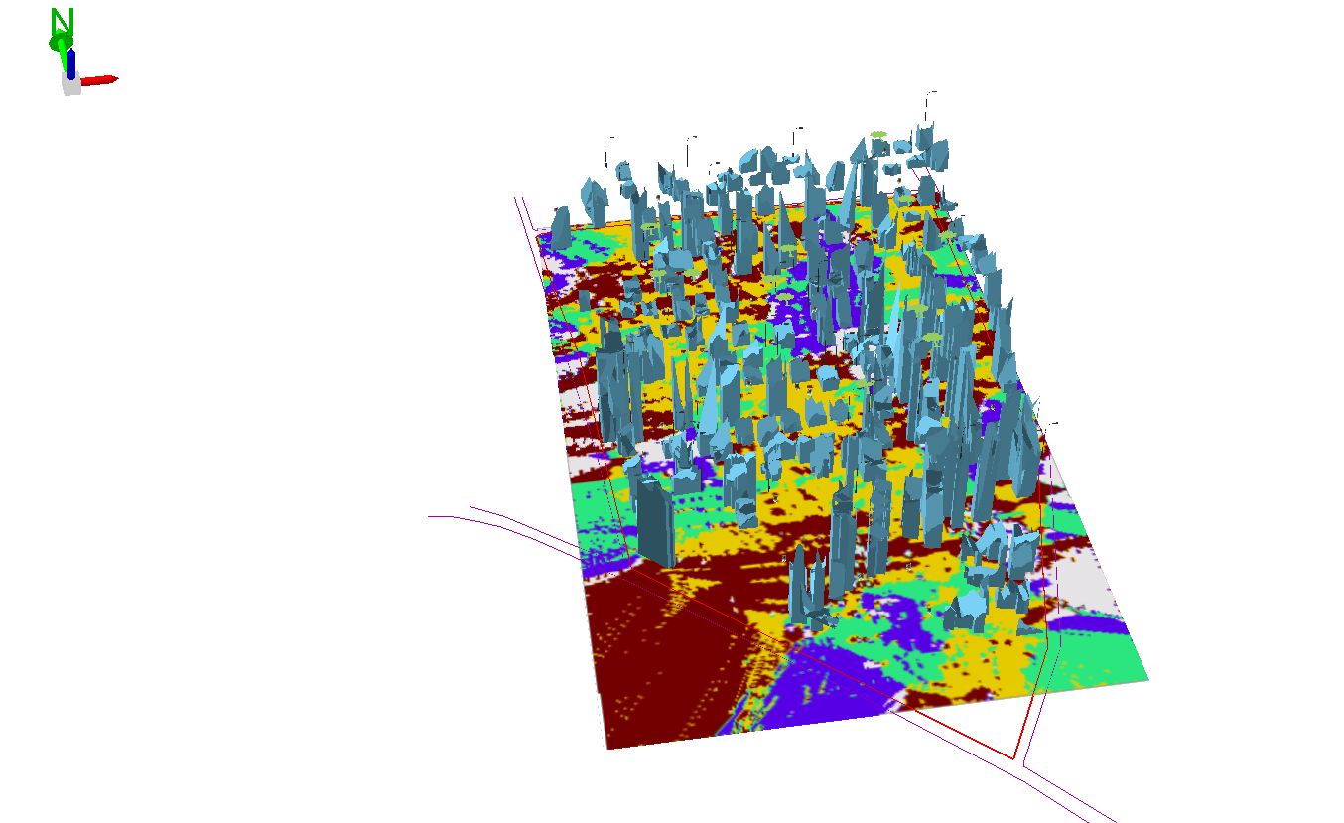

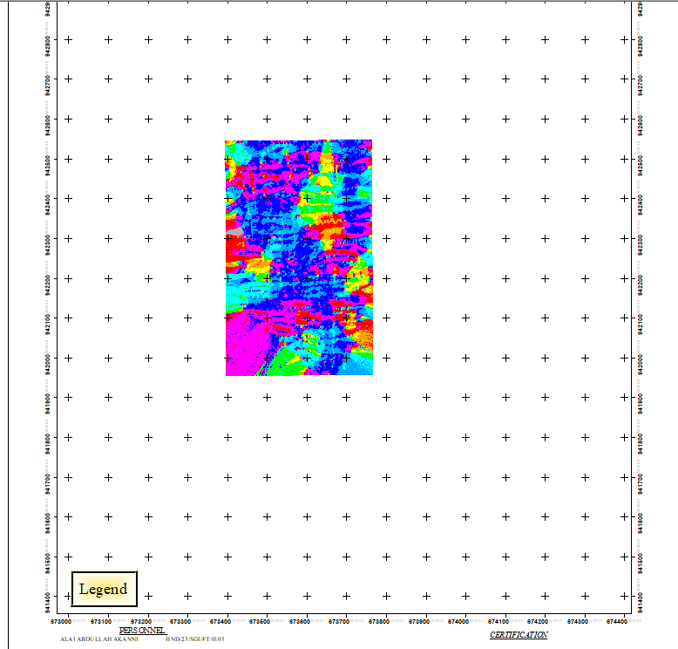
Figure 3.7 (a) Showing 3D model of the study area area

Figure 3.8 showing the 2D DEM (Digital elevation model) of the study area (derived from the field data).

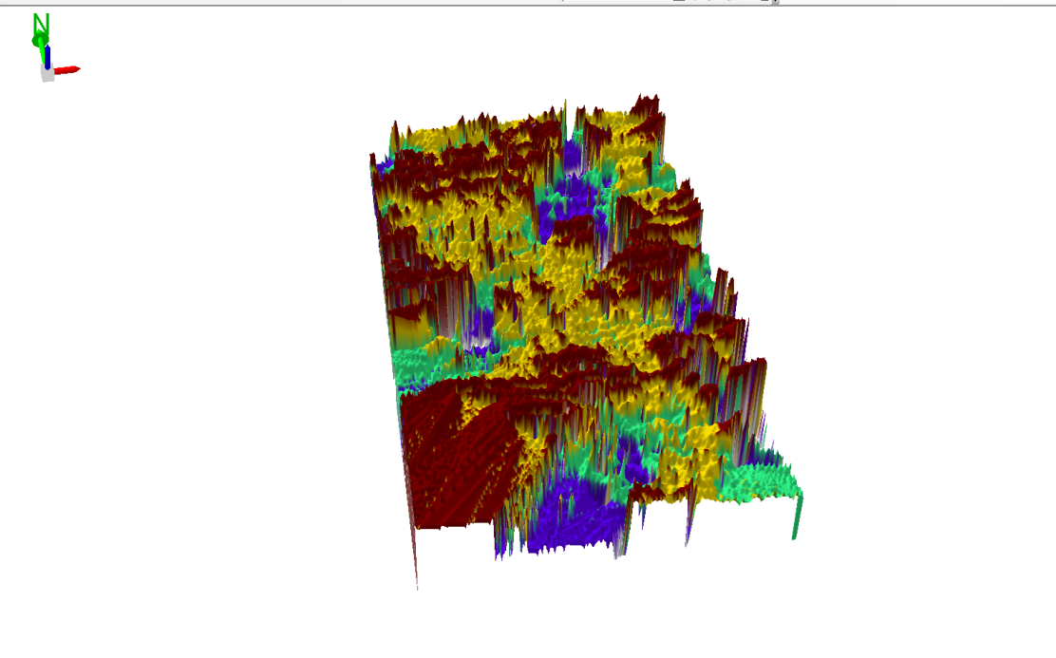

Figure 3.9 Showing 3D DEM (Digital Elevation Model) of the study area (derived from the field data).

3.8.8 Attribute data creation
There is need to create attribute tables for the features so as to be used for queries. NOTE: The editor on the menu bar must be stopped before adding field to its table. THE FOLLOWING PROCEDURES WERE FOLLOWED:
- Right click on the feature class, then select OPEN ATTRIBUTES TABLE click on OPTIONS and select ADD FIELD.
- Give it FIELD NAME, click on TYPE and select [SHORT INTEGER or LONG INTEGER for SHORT or LONG WHOLE VARIABLES or DOUBLE FOR DECIMAL VARIABLES OR TEXT variable or DATE for DATE], then enter precision or LENGTH for text width and scale for DECIMAL PLACES, and then click OK
- To input variables on the ATTRIBUTE TABLE, go to the EDITOR on Menu bar, select START EDITING,
- Click on ATTRIBUTE on menu bar [behind the TARGET], click on the features on the DATA VIEW display, and then input the variables of data acquired through SOCIAL SURVEY or DATA ACQUIRED ON THE FIELD.
- Save it after the input by selecting SAVE EDITS on the editor menu. To switch to other layers, select STOP EDITING on the EDITOR menu. Then repeat the above step to create other fields. Populate the table and save.

Table 3.10: Building

ENTITY | FIELD ALIAS | DATA TYPE | FIELD SIZE
B_ID | Building Identification | Numeric | -
B_name | Building Name | Text | 10
B_Area | Building Area | Numeric | -
B_E | Building Easting | Numeric | -
B_Northing | Building Northings | Numeric | -

Table 3.11: Road

ENTITY | FIELD ALIAS | DATA TYPE | FIELD SIZE
R_ID | Road Identifier | Numeric | -
R_Length | Road Length | Numeric | -
R_Width | Road Width | Numeric | -
R_Type | Road Type | Text | 10
R_Condition | Road Condition | Text | 10

Table 3.12: Trees

ENTITY | FIELD ALIAS | DATA TYPE | FIELD SIZE
TR_ID | Tree Identifier | Numeric | -
TR_Spp | Tree specy | Text | 10
TR_E | Tree_Easting | Numeric | -
TR_N | Tree Northing | Numeric | -

Table 3.13: Electric Poles

ENTITY | FIELD ALIAS | DATA TYPE | FIELD SIZE
EP_ID | Electric pole Identifier | Numeric | -
EP_Type | Electric pole Type | Text | 10
EP_Height | Electric pole Height | Numeric | -
EP_E | Electric pole Easting | Numeric | -
EP_N | Electric pole Northing | Numeric | -

3.8.9 DATABASE IMPLEMENTATION
This is the database creation phase. Having completed the three stages of design phase (i.e. Reality, Conceptual and Logical design), the database was created using ArcGIS 10.3 software. It involves the combination and storage of acquired graphic data and attributes data in creating the database for the purpose of spatial analysis and query.
Database is an organized integrated collection of data stored so as to be capable of use by revenant application with data being accessed by different logical part. After the Attribute table was populated via the keyboard, some attributes such as areas of settlements were automatically displayed by special command in the ArcGIS 10.3 version. The ArcGIS software was used to link the graphic data and table for query generation.

3.8.10 DATABASE MANAGEMENT SYSTEMS

Database management is a collection of software for creating, storing, manipulating, updating, organizing and querying of information in a database (Kufoniyi, 1998). It is a software package whose function is to manipulate a database on behalf of the user.
A good DBMS must provide the following functions:

      - Storage and retrieval of data.
      - Access to by several users at a time.
      - A standardized interface between database and application programmed.
      - Standardized access to data and separation of data storage and retrieval functions from the program using the data.
      - Maintenance of data security and integrity.

3.8.11 DATABASE MAINTENANCE

Having created the database, proper maintenance practice was made to meet its stated objectives. The ability to include more data and remove irrelevant data was possible by way of maintenance. There is every need for the data to be updated regularly because of the physical changes that may occur on the landscape with time. Both security and integrity were also exercised to ensure maintenance and to meet its stated objectives.
Proper observance, updating and management of database ensure its currency and quality to stand a profound chance in Spatial Decision Support System (SDSS). The quality of any database depends on the currency and fitness for use as a decision support system (SDSS). The quality of database depends on its ability to generally fit and use as a decision system (DSS). The storage media should be from time to time justified if otherwise could necessitate data inaccessibility or physical deterioration of the storage media. Also care must be taken during populating any database system, as a database is only good as the data supplied. In archiving stable media should be used. Examples of these are:-
- Computer compatible tape reader
- Magnetic tape
- Optical disc and compact disc

3.8.12 AREA COMPUTATION Table
Table 3.14: shows area computation
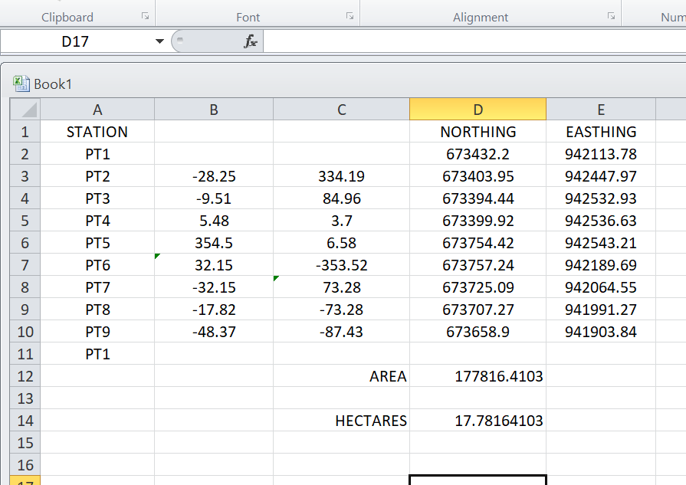

CHAPTER FOUR

4.0 SPATIAL ANALYSES AND PRESENTATION

GIS is distinct among other information system because of its spatial analytical capability; especially overlay operation, buffering, spatial search, topographic operation, and neighborhood and connectivity operations. GIS uses this spatial analytical capability to answer fundamental generic question of location, condition, trend, routing, pattern and modeling by the manipulation and analysis of input data. The major analyses performed in this project were overlay operations, topographic operations and spatial search.

4.1 TESTING OF DATABASE

This is the test carried out to determine whether there exists a relationship between data modeled about entities in a spatial database as well as putting into test its retrieval capabilities. This was done by designing a sample query with certain conditions attached and the query will be ran to see if desired result is achieved.

4.1.1 ANALYSIS OF RESULT

The contour whose value is greater or equal to 350 meters depicts the likelihood that such area may not be prone to flood in the project area as shown in Fig. 4.5(Query 1). This represents the elevation of points that are greater than to 350m. The displayed attribute table confirmed that North-East part of the institute had the highest elevation. Height is an important factor when considering the surface or slope of the terrain. The South-west part of the school had the lowest elevation which is very prone to erosion. Buildings that will be sited in that region must have a very high foundation above the ground level. The result of the query will afford the school management to decide concisely the terrain characteristics and the kind of building that should build in every region of the project area looking critically at the terrain of the area.

SINGLE SELECTION CRITERION

Query 1: shows the completed building

SELECT* FROM Building WHERE "BLD_STATUS" LIKE COMPLETED
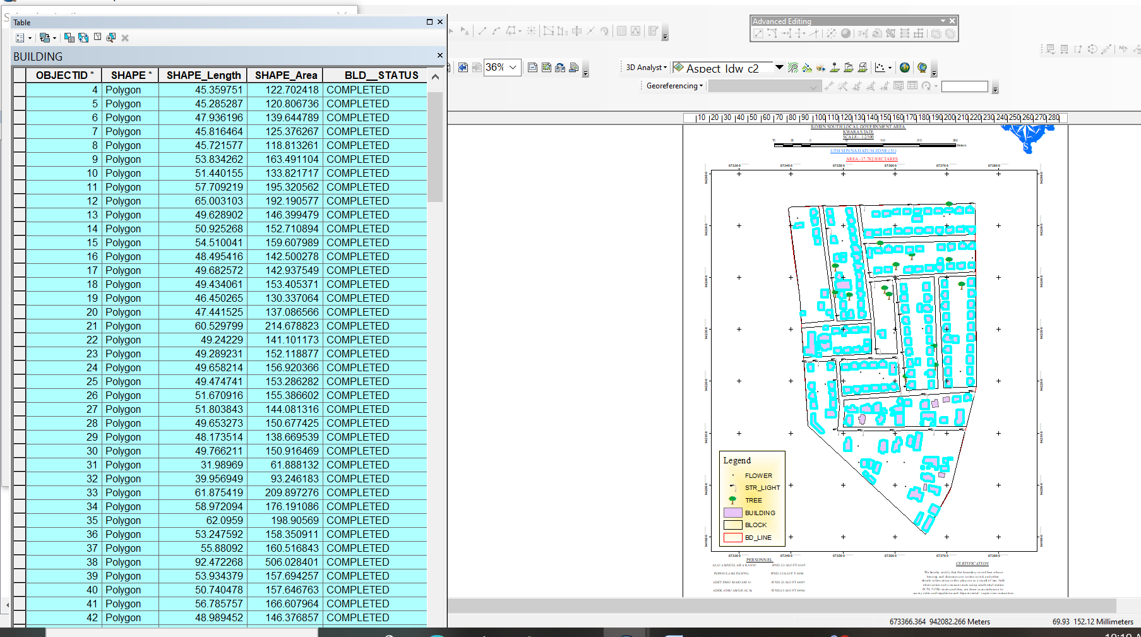

Fig 4.1: shows the completed building

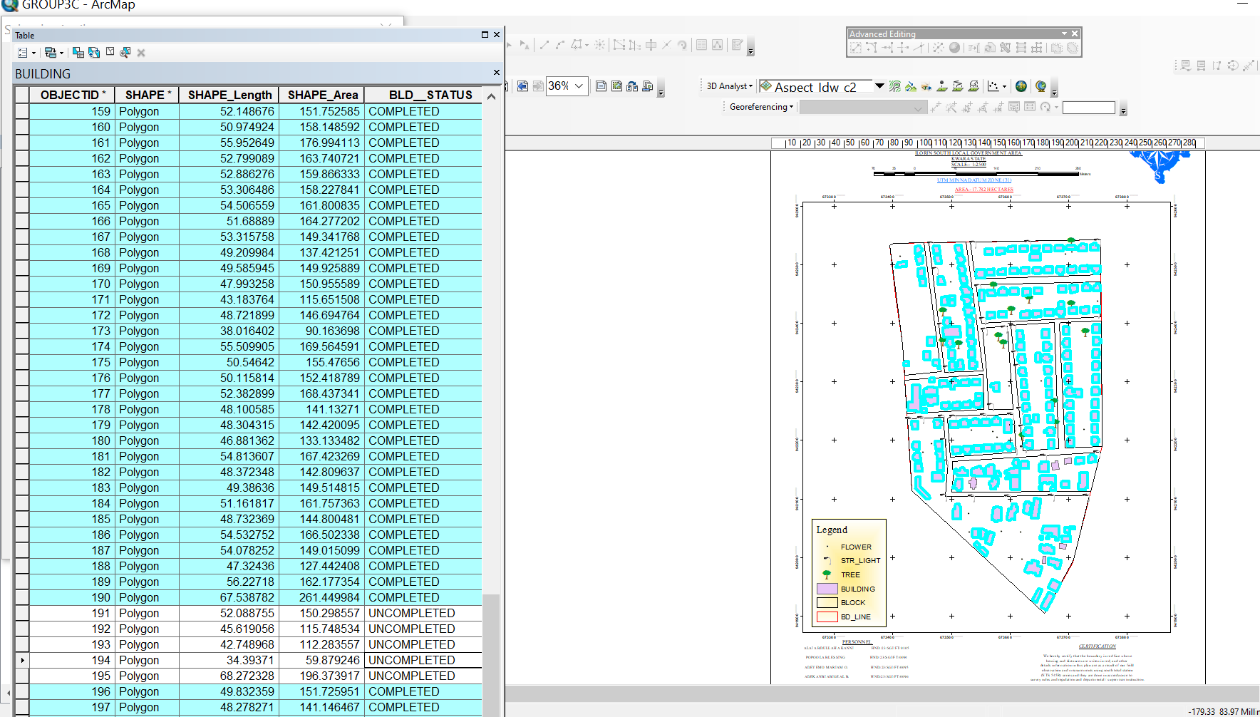

Fig 4.2: shows the 2D completed building

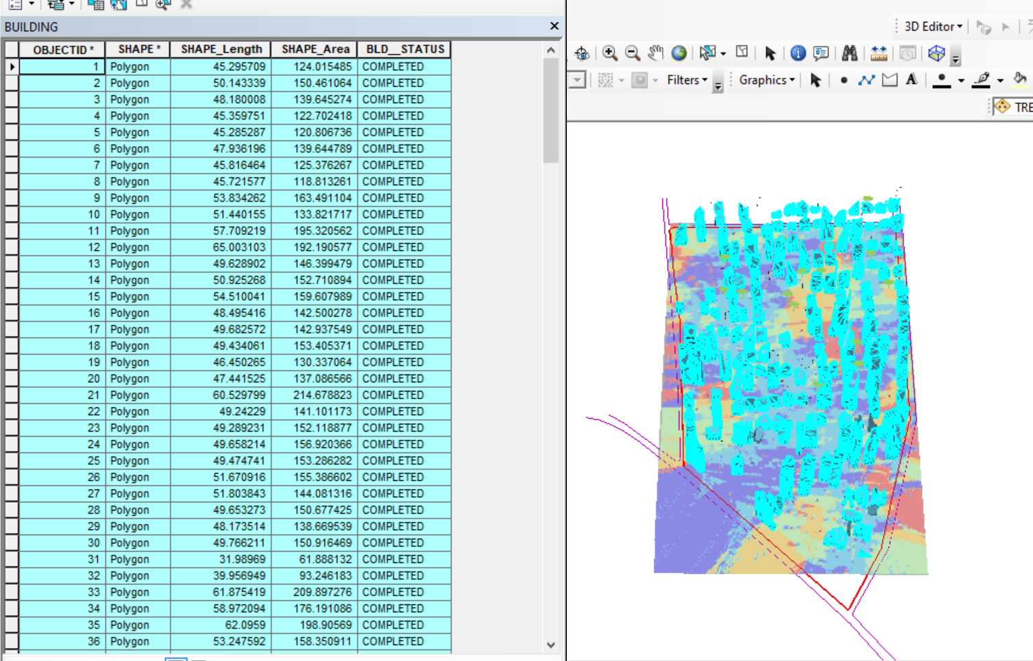

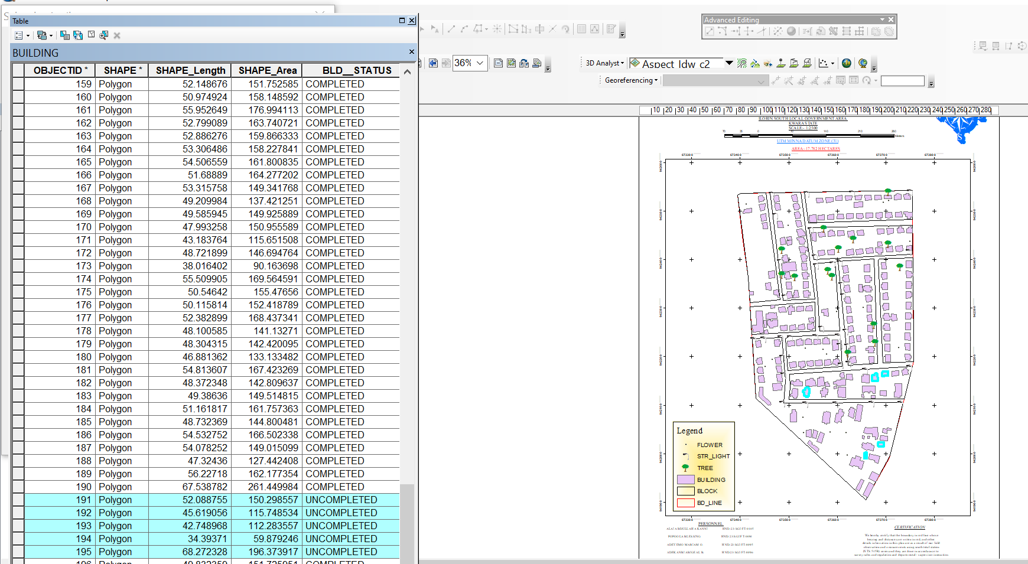
Figure 4.3 shows the 3D of completed building

Fig 4.4 Query shows the 2D of uncompleted building
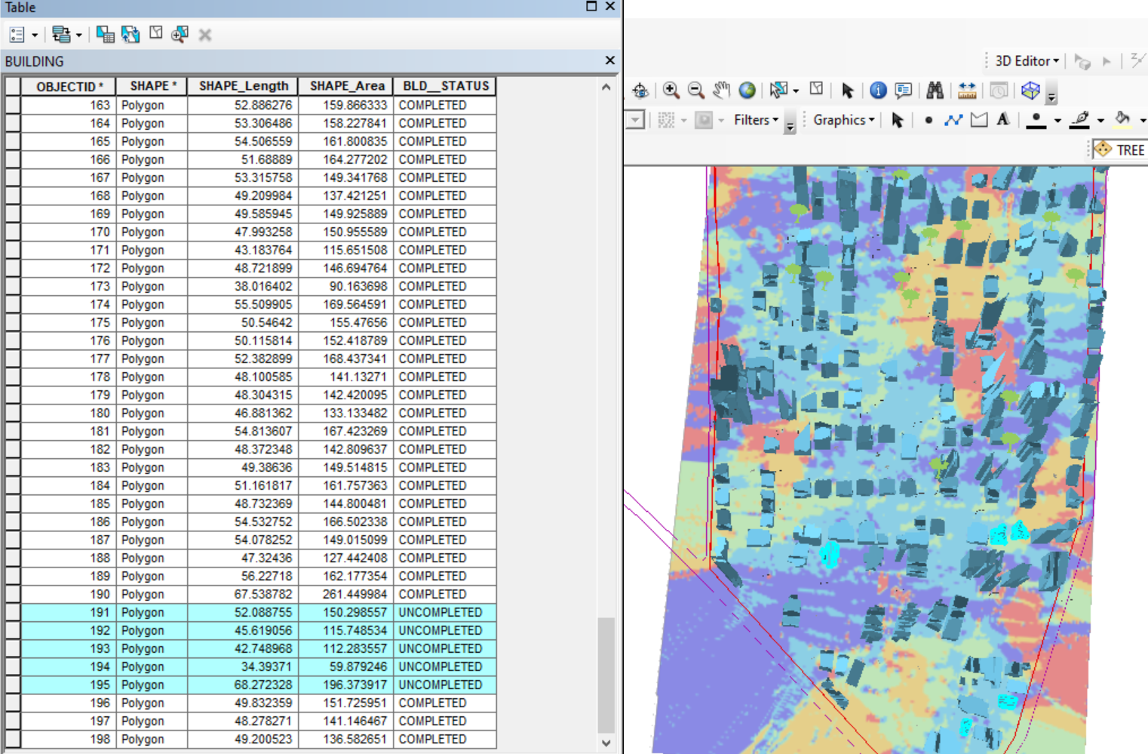

Figure 4.5 shows the 3D of uncomplted building

CHAPTER FIVE
SUMMARY, COSTING, PROBLEMS ENCOUNTERED, CONCLUSION AND RECOMMENDATIONS
5.1 SUMMARY
The aim of this project is to map out infrastructural facilities as they exist on polytechnic land with the view of identifying their spatial location to solve geo-spatial problems in the area for proper physical planning and decision making. And to produce a plan of digital mapping of infrastructural facilities of Royal Valley Estate, Sango, Ilorin, Kwara State.
This project dealt with the digital mapping of Royal Valley Estate, Sango, Ilorin, Kwara State. The project involved the following survey operations such as reconnaissance (recce), perimeter traversing, detailing, and spot heighting. Processing of acquired data was done using softwares which includes: AutoCad, ArcGIS, Microsoft excel, Microsoft word, Notepad, and spss. The various task involves in the process includes: Plotting, database creation, Graphical and numerical representation. Producing the plan to a suitable scale showing the demarcated boundary and details within the project area and finally report written was made.

5.2 COSTING
Costing is act of estimating or assessing how much money is to be charged as professional fee for survey serves.

CONCEPT OF COSTING
- Earn reasonably
- Perform their duties effectively

- Maintain a high standard of professionalism
- Embrace containing professional development

PROJECTCOSTING
This is the total fund needed to complete the project or work that consist of a direct or indirect cost which is an expenditure made or estimated to be made or monetary obligations incurred or estimated to be incurred to complete the project which are listed in the project baseline.

REASONS FOR COSTING
The information issued by a costing system is used by management for a variety of purposes, including:
        - Fine-tuning operations to generate higher profitability
        - Deciding where to cut costs in the event of a business downturn
        - Matching actual costs incurred against budgeted cost levels for control purposes
        - Creating strategic and tactical plans for future operations.

METHOD OF COSTING
CONSULTANCY FEE: This allows surveyors to charge consultancy fees as a percentage of cost of the land or project.
DIRECT FIELD COST: This allows surveyors to charge for the cost of the survey work, in addition to the consultancy. It includes cost for:
- Personnel

- Equipment
- Transportation
- Beacons
For this project, direct cost was adopted.
Features of the surveyor’s scale of fees the correct scale of fees for surveyors is the one updated by the Nigeria Institute of Surveyors in 2006. It is based on the Federal Government approved scale of fees for consultants in the industry, updated for inflation.
The costing of this project was done using the Nigeria Institution of Surveyors (NIS) professional scale of fees for Consultant in the construction industry. The project component and their direct costs were as follows.

RECONNAISSANCE
S/N | PERSONNEL | QTY | DAILY RATE | NO OF DAYS | REMARK
1 | Group leader | 1 | 5,000 | 1 | 5,000
2 | Ass group leader | 1 | 2,500 | 1 | 2,500
3 | Basic equipment | 1 | 25,000 | 1 | 25,000
4 | Transportation | 1 | 3,000 | 1 | 3,000
 | TOTAL |  |  |  | 35,500

MONUMENTATION

S/N | PERSONNEL | QTY | DAILY RATE | NO OF DAYS | REMARK
1 | Group leader | 1 | 5,000 | 1 | 5,000
2 | Ass group leader | 1 | 2,500 | 1 | 2,500
4 | Basic equipment | 1 | 25,000 | 1 | 25,000
5 | Transportation | 1 | 7,500 | 1 | 3,000
 | TOTAL |  |  |  | 35,500

TRAVERSE AND DETAILING

S/N | PERSONNEL | QTY | DAILY RATE | NO OF DAYS | REMARK
1 | Group leader | 1 | 5,000 | 5 | 25,000
2 | Ass group leader | 1 | 2,500 | 5 | 12,500
4 | Transportation | 1 | 3,000 | 5 | 15,000
 | Basic Equipment | 1 | 25,000 | 5 | 125,000
 | TOTAL |  |  |  | 177,500

DATA EDITING AND PROCESSING
S/N | PERSONNEL | QTY | DAILY RATE | NO OF DAYS | REMARK
1 | Surveyor | 1 | 10,000 | 7 | 70,000
2 | Group leader | 1 | 5,000 | 7 | 35,000
3 | Ass group leader | 1 | 2,500 | 7 | 17,500
4 | Standard set |  | 15,000 | 7 | 105,000
5 | Computer accessories | 1 | 10,000 | 7 | 70,000
 | TOTAL |  |  |  | 297,500

PLAN AND MAP PRODUCTION
S/N | PERSONNEL | QTY | DAILY RATE | NO OF DAYS | REMARK
1 | Supervisor | 1 | 10,000 | 2 | 20,000
2 | Group leader | 1 | 5,000 | 2 | 10,000
3 | Ass group leader | 1 | 2,500 | 2 | 5,000
5 | Standard Set |  | 10,000 | 3 | 30,000
6 | Computer Accessories | 1 | 25,000 | 3 | 75,000
 | TOTAL |  |  |  | 140,000

TECHNICAL REPORT
S/N | PERSONNEL | QTY | DAILY RATE | NO OF DAYS | REMARK
1 | Group leader | 1 | 10,000 | 1 | 10,000
2 | Ass group leader | 1 | 5,000 | 1 | 5,000
3 | Computer | 1 | 15,000 | 1 | 15,000
4 | Generator and fuel | 1 | 10,000 | 1 | 10,000
5 | Consumables |  | 10,000 | 1 | 10,000
 | TOTAL |  |  |  | 50,000

Sum total = 736,000.00

Contingency allowance =736,000.00 X 5 = 36,800
100
VAT = 736,000.00 X 7.5 = 55,200
100

MOB/DEMB = 736,000.00 X 10 = 73,600
100

SUMMARY OF THE COST RATE
ITEM | PROJECT QUANTITY | UNIT RATE (N)
1 | Reconnaissance | 35,500
2 | Monumentation | 35,500
3 | Traverse and detailing | 177,500
4 | Data editing and processing | 297,500
5 | Plan and map production | 140,000
6 | Technical report | 50,000
7 | Contingency 5% | 36,800
8 | VAT 7.5% | 55,300
9 | Mobilization/Demobilization 10% | 73,600
 | TOTAL | 901,700
TABLE 5.1 COST IMPLICATION OF THE DIGITAL MAPPING OF ROYAL VALLEY ESTATE

5.3 PROBLEMS ENCOUNTERED

The following are the problems encountered:

- Atmospheric condition which leads to rainfall and causes disturbance. This add to the numbers of days spent on the project site.
- No provision of survey equipment from the department which cost much human effort and money.
- Disturbance from the domestic animal (dog).
- Due to the time spent each day which is long, this cause run down of battery used at the master.

5.4 RECOMMENDATIONS
Having participated in this practical work and due to the experience gained, I hereby make the following recommendations.
- The Government should proper supervise the available resource such as borehole, chairs and table as well as staff.
- The Government should use this plan available for decision making regarding the premises and as well fence the school premises because the school is bounded by many roads.
- Application of computer programming should be fully implemented so as to make the students carry out the data processing exercise more efficiently and faster.
- This project is available for review

5.5 CONCLUSION
Finally, having gone through all the process in this project, it is right to say that the task had been much interesting, particularly at the planning and execution stage, though the field procedure was very tedious and time consuming, the result obtained from the entire operations was quite satisfactory. They compared favourably with the expected results. These show that the job was properly done hence the aim of the project was met.

REFERENCES
Ajadi .O.O. (2004): Journal Infrastructural Production For Poverty Alleviation In Rural Nigeria Vol. 1 no. 1 The Polytechnic Ibadan Campus Ojo Nigeria .
Bannister and Raymond (1992): Surveying 4th Edition London, Pitman,P.38.
BasakN. (2000): Surveying and leveling, 4th Edition, vol.1, London, vanNostra, P.9.
Choguill, (1997): Focus Self Sustaining Infrastructure, DFID, Urbanization issue pp4.
Igbokwe (1999): Digital Mapping- A Big Stride vol. 12 No.1 magazine of Nigeria Institution of Surveying Students, University of Nigeria Chapter.
Kirmerling, A.J (1994): Geographic Information Systems And Cartography, Proceedings Of The Ica Seminar Of Teaching Of The Conventional And Digital Map Production Times, Held At Istanbul, Turkey.
Mabogunje, N (1993): Infrastructure: Crux Of Modern Urban Development, The Urban Age, Vol. 1 Page 3.
Ndukwe. N.K. (2009): Digital Technology In Surveying And Mapping,1st Edition Enugu Rhycekerax.
OriolaE.O., Asonibare R. O (2011): “Topographic information system As A Tool For Environmental Management”Journal of Asian Scientific Research,Vol.1,No.8,pp.441- 450.
Oyinloye J. O. (2016): Project Report of Estate Survey; Case Study Of Part of Kwara State Polytechnic, Ilorin, Kwara
Ramsay (1978): land surveying Eastove Plymouth, PP.1-3.
Sida, (1995): Promoting Sustainable Livelihood Stock holmcited In Bridge Report No. 51, June 1997 Bright IDS1-3.

APPENDIX I
X | Y | Z
673600.438 | 941983.025 | 276.220
673637.669 | 941983.025 | 277.121
673674.900 | 941983.025 | 278.747
673525.976 | 942042.384 | 278.114
673563.207 | 942042.384 | 278.710
673600.438 | 942042.384 | 278.979
673637.669 | 942042.384 | 278.763
673674.900 | 942042.384 | 280.876
673712.131 | 942042.384 | 283.762
673451.515 | 942101.744 | 266.618
673488.745 | 942101.744 | 269.367
673525.976 | 942101.744 | 273.829
673563.207 | 942101.744 | 277.300
673600.438 | 942101.744 | 278.296
673637.669 | 942101.744 | 279.061
673674.900 | 942101.744 | 282.202
673712.131 | 942101.744 | 282.125
673451.515 | 942161.103 | 268.553
673488.745 | 942161.103 | 269.884
673525.976 | 942161.103 | 271.088
673563.207 | 942161.103 | 274.072
673600.438 | 942161.103 | 276.247
673637.669 | 942161.103 | 278.609
673674.900 | 942161.103 | 281.156
673712.131 | 942161.103 | 281.510
673749.362 | 942161.103 | 281.406
673451.515 | 942220.463 | 272.935
673488.745 | 942220.463 | 272.234
673525.976 | 942220.463 | 272.351
673563.207 | 942220.463 | 274.732
673600.438 | 942220.463 | 277.163
673637.669 | 942220.463 | 278.960
673674.900 | 942220.463 | 281.069
673712.131 | 942220.463 | 281.847
673749.362 | 942220.463 | 280.344
673451.515 | 942279.822 | 269.658
673488.745 | 942279.822 | 271.526
673525.976 | 942279.822 | 273.285
673563.207 | 942279.822 | 274.836
673600.438 | 942279.822 | 277.669
673637.669 | 942279.822 | 279.143
673674.900 | 942279.822 | 278.853
673712.131 | 942279.822 | 280.052
673749.362 | 942279.822 | 282.081
673451.515 | 942339.181 | 269.774
673488.745 | 942339.181 | 272.749
673525.976 | 942339.181 | 274.613
673563.207 | 942339.181 | 277.079
673600.438 | 942339.181 | 277.257
673637.669 | 942339.181 | 276.780
673674.900 | 942339.181 | 276.112
673712.131 | 942339.181 | 277.247
673749.362 | 942339.181 | 280.669
673414.284 | 942398.541 | 268.295
673451.515 | 942398.541 | 271.799
673488.745 | 942398.541 | 273.377
673525.976 | 942398.541 | 275.910
673563.207 | 942398.541 | 278.784
673600.438 | 942398.541 | 278.851
673637.669 | 942398.541 | 278.010
673674.900 | 942398.541 | 276.922
673712.131 | 942398.541 | 278.194
673749.362 | 942398.541 | 279.940
673414.284 | 942457.900 | 267.983
673451.515 | 942457.900 | 268.641
673488.745 | 942457.900 | 271.766
673525.976 | 942457.900 | 272.732
673563.207 | 942457.900 | 276.328
673600.438 | 942457.900 | 279.393
673637.669 | 942457.900 | 279.382
673674.900 | 942457.900 | 278.970
673712.131 | 942457.900 | 279.948
673749.362 | 942457.900 | 282.942
673414.284 | 942517.260 | 268.275
673451.515 | 942517.260 | 268.192
673488.745 | 942517.260 | 271.061
673525.976 | 942517.260 | 273.349
673563.207 | 942517.260 | 273.776
673600.438 | 942517.260 | 277.162
673637.669 | 942517.260 | 279.188
673674.900 | 942517.260 | 278.834
673712.131 | 942517.260 | 280.717
673749.362 | 942517.260 | 282.616

