Optimization of Smart Attendance Systems Using RFID for Real-Time Attendance Tracking in Educational Institutions

By

OLORUNFEMI OLUWAPELUMI RUTH
HND/23/COM/FT/0484

A Project Submitted to the

Department of Computer Science,
Institute of Information and Communication Technology
Kwara State Polytechnic, Ilorin

In Partial Fulfillment of the Requirements for the award of Higher National Diploma (HND) in Computer Science

August, 2025
Certification

This is to certify that this project was carried out by Olorunfemi Oluwapelumi Ruth with Matriculation Number HND/23/COM/FT/0484 as part of the requirements for the award of Higher National Diploma (HND) in Computer Science.

________________________ _________________________
A. K. Raji (PhD) Date
Project Supervisor

________________________ _________________________
F. S. Oyedepo Date
Head of Department

________________________ _________________________
External Examiner Date

Dedication
The project is dedicated to the glory of Almighty God and my parents.

Acknowledgments
All praise and glory are due to the Almighty God for His infinite grace, wisdom, and strength, which sustained me throughout the course of this research project.

I extend my heartfelt gratitude to Dr. Raji A. K., whose exceptional mentorship, insightful guidance, and steadfast support were instrumental to the successful completion of this work. His expertise and constructive feedback helped shape the direction, depth, and quality of this study.

I am profoundly thankful to my parents, Mr. and Mrs. Olorunfemi, for their unwavering support, encouragement, and understanding. Their belief in my abilities, along with their invaluable advice and moral support during moments of challenge, served as a pillar of strength throughout this journey.

My sincere appreciation also goes to the Head of the Department of Computer Science, Mr. Oyedepo F. S., and other departmental staff members. Their diverse perspectives, academic rigor, and constructive evaluations greatly contributed to the refinement and relevance of this project. To my entire family and friends, I express my deepest gratitude for their patience, encouragement, and constant motivation, which kept me focused and determined from inception to completion.

Finally, I acknowledge the invaluable contributions of all participants and respondents who willingly shared their time, experiences, and data for the purpose of this research. Their input was essential in shaping the empirical dimension of the study and is deeply appreciated.

Table of Contents
Certification ii
Acknowledgements iii
Table of Contents iv
Abstract v

CHAPTER ONE: INTRODUCTION
1.1 Background to the Study 1
1.2 Statement of the Problems 2
1.3 Aim and Objectives 3
1.4 Significance of the Study 4
1.5 Scope of the Study 5
1.6 Report Outline 6

CHAPTER TWO: LITERATURE REVIEW

2.1 Review General Text 7
2.2 Review of Related Works 8
2.3 Theoretical Framework 11
2.4 RFID Technology and Its Application in Attendance Systems 13
2.5 Automation and Real-Time Tracking in Attendance Systems 14
2.6 Integration with Institutional Systems 15
2.7 User Experience and Interface Design in RFID Systems 16

CHAPTER THREE: RESEARCH METHODOLOGY
3.1 Research Methodology 17
3.2 Analysis of the Existing System 23
3.3 Disadvantage of the Existing System 25
3.4 Description of the Proposed System 27
3.5 Advantages of the Proposed System 29

CHAPTER FOUR: ANALYSIS AND DISCUSSION OF RESULTS
4.1 System Architecture 32
4.2 System Components and Tools 33
4.3 System Architectural Design 37
4.4 System Implementation Process 39

CHAPTER FIVE: CONCLUSIONS AND RECOMMENDATIONS
5.1 Summary 41
5.2 Conclusions 42
5.3 Contributions to Knowledge 43
5.4 Recommendation for Future Research 44
References 47

Abstract
The increasing demand for efficiency and accuracy in educational management systems has necessitated the development of smarter and more automated solutions for student attendance tracking. Traditional attendance systems, including manual roll calls and biometric methods, are often time-consuming, prone to errors, and susceptible to manipulation. This paper presents the optimization of a Smart Attendance System using Radio Frequency Identification (RFID) technology for real-time attendance tracking in educational institutions. The system leverages RFID tags assigned to students and RFID readers strategically installed at classroom entrances to automatically record student presence upon entry. This approach minimizes human intervention, enhances data accuracy, and ensures timely monitoring and reporting of attendance records. The proposed system architecture integrates RFID hardware with a centralized database and web-based interface, enabling real-time access to attendance data by school administrators and lecturers. The optimization process focuses on enhancing the system's response time, improving reader accuracy, minimizing false reads, and ensuring scalability across multiple departments and campuses. In addition, the study explores energy-efficient designs and cost-effective deployment strategies suitable for both small and large educational institutions. The implementation was tested in a controlled academic environment, and the results demonstrated significant improvements in attendance recording efficiency, reduced administrative workload, and increased student compliance. Furthermore, the system supports analytics for identifying absentee patterns and generating automated alerts or reports. The findings suggest that RFID-based smart attendance systems offer a reliable, scalable, and secure solution for modern academic institutions seeking to digitize and optimize attendance management processes.

Keywords:
RFID Technology, Smart Attendance System, Real-Time Tracking, Educational Institutions, Automation, Attendance Optimization

CHAPTER ONE

GENERAL INTRODUCTION

1.1 Background to the Study
Effective attendance management plays a crucial role in the administration of educational institutions, as it directly affects student performance, discipline, and institutional planning. Traditionally, student attendance has been recorded manually through paper registers or verbal roll calls. However, these methods are not only time-consuming but also susceptible to errors, manipulation, and loss of records (Kumar & Verma, 2020). To address these limitations, many institutions have adopted digital solutions such as biometric systems. Yet, these methods often face challenges related to hygiene, especially in the wake of global health concerns like COVID-19, as well as issues of latency and maintenance (Patel et al., 2021).

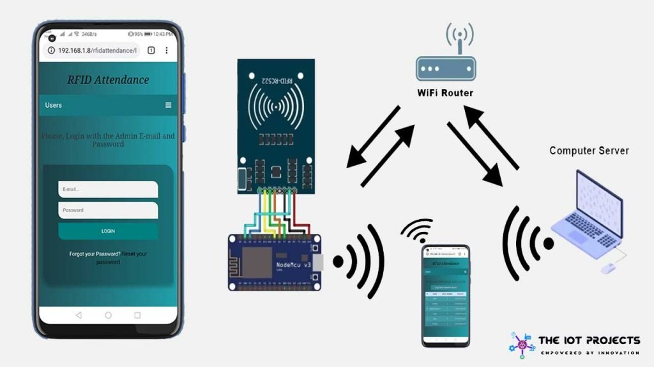
Figure 1.1: RFID Attendance Systems

Radio Frequency Identification (RFID) has emerged as a viable and efficient alternative for automating attendance tracking. RFID systems operate by using electromagnetic fields to identify and track tags attached to objects—in this case, student ID cards as shown in figure 1.1. These tags are scanned by RFID readers, which automatically log attendance data into a centralized database, enabling real-time monitoring (Rao & Singh, 2022). The technology offers numerous advantages, including speed, reliability, contactless operation, and scalability. It has been widely adopted in industries such as logistics and healthcare and is gaining traction in the education sector due to its ability to reduce human error and administrative workload (Chen et al., 2023).

Several studies have demonstrated the potential of RFID in improving educational management. For instance, Alqahtani et al. (2021) found that institutions using RFID-based systems experienced up to 40% improvement in attendance accuracy and reporting efficiency. Additionally, recent advancements in cloud integration and Internet of Things (IoT) architectures have further enhanced the capabilities of RFID systems, enabling real-time access and data analytics (Singh & Mehta, 2024).

However, despite these advantages, challenges remain in optimizing RFID-based attendance systems for real-time tracking. Issues such as false positives, limited range, and tag collision need to be addressed to ensure system accuracy and effectiveness (Zhang & Lee, 2023). Therefore, this study focuses on the design and optimization of a smart RFID-based attendance system tailored to the needs of educational institutions, emphasizing reliability, efficiency, and real-time data access.

1.2 Statement of the Problems
Accurate and timely student attendance tracking remains a persistent challenge in educational institutions, especially those with large populations and limited administrative personnel. Traditional methods such as manual roll calls and attendance registers are inefficient, error-prone, and susceptible to manipulation, often leading to inaccurate records and administrative delays. Biometric systems, though more secure, have introduced new concerns such as health risks in the post-pandemic era, as well as high maintenance costs and slower throughput during peak periods.

While Radio Frequency Identification (RFID) technology offers a promising solution by enabling contactless, automated attendance recording, its implementation in many educational settings is still suboptimal. Existing systems frequently suffer from technical issues such as tag collision, limited reading range, poor integration with centralized databases, and lack of real-time data accessibility. These limitations reduce the system's reliability and hinder its scalability across departments and campuses.

Moreover, many institutions lack an optimized RFID framework tailored specifically for the dynamic nature of academic environments, where class schedules, room changes, and large student movements are common. Without a robust and well-optimized system, educational institutions risk continued inefficiencies, loss of instructional time, and limited insights into student engagement and participation.

Therefore, there is a critical need to develop and optimize a smart RFID-based attendance system that ensures real-time, accurate, and scalable tracking of student attendance, while addressing the limitations of existing technologies and enhancing administrative and academic decision-making.

1.3 Aim and Objectives
The aim of this study is to design, develop, and optimize a smart attendance system using Radio Frequency Identification (RFID) technology for real-time, accurate, and efficient attendance tracking in educational institutions. The objectives are to:

- design an RFID-based smart attendance architecture that integrates RFID tags, readers, and a centralized database for automated student identification and attendance logging.
- implement a real-time attendance tracking system capable of instantly capturing, processing, and storing attendance records with minimal human intervention.
- optimize the RFID system’s performance by minimizing tag collision, increasing reading accuracy, and ensuring reliable data capture even in high-density classroom environments.
- develop a web-based user interface for administrators and academic staff to access, analyze, and manage attendance records efficiently.
- evaluate the system’s effectiveness and scalability through pilot testing in an academic setting, measuring improvements in speed, accuracy, and administrative workload reduction.

1.4 Significance of the Study
This study holds significant importance for educational institutions, administrators, students, and researchers alike. The successful optimization of a smart attendance system using RFID technology will address the longstanding inefficiencies associated with manual and biometric attendance tracking methods. By automating the attendance process, the system will not only reduce administrative workload but also improve the accuracy and integrity of attendance records.

For academic institutions, the real-time monitoring feature of the system will enable prompt identification of absenteeism patterns, facilitate timely interventions, and enhance compliance with institutional policies. The availability of digital records will also support data-driven decision-making and reporting, aiding academic planning, resource allocation, and student performance analysis.

For students, the system ensures transparency and fairness in attendance tracking while minimizing time lost during roll calls. It also promotes accountability and punctuality, which are essential attributes for academic success.

From a technological perspective, the study contributes to the growing field of smart campus solutions by demonstrating how RFID can be effectively optimized and scaled within an educational context. It also lays the groundwork for future integration with other smart technologies such as mobile applications, IoT, and cloud computing.

Furthermore, this research will provide a practical framework and implementation model for other institutions seeking to adopt RFID-based systems. The insights gained can inform policies, guide future innovations, and stimulate academic discourse around technology-enhanced learning environments.

1.5 Scope of the Study
This study focuses on the design, development, and optimization of a smart attendance tracking system using Radio Frequency Identification (RFID) technology, specifically within the context of educational institutions. The system is designed to automate the process of student attendance recording by integrating RFID tags, RFID readers, a centralized database, and a web-based monitoring interface. The scope covers the technical implementation of the RFID system, including hardware setup, software development, database management, and real-time data synchronization. It also includes performance optimization strategies to address challenges such as tag collision, signal interference, and data accuracy in high-density academic environments.

The study will be limited to classroom-based attendance tracking at the departmental level within a single institution for pilot implementation. While the system is scalable to accommodate institution-wide deployment and multi-campus structures, the research will initially focus on testing and validating the system within a controlled academic setting. Additionally, the study will assess the system’s functionality in terms of accuracy, speed, user interface usability, and administrative efficiency. However, it will not cover the use of RFID for other campus operations such as library access, cafeteria payments, or security checkpoints, although such integrations are identified as possible future expansions.

The system will be evaluated based on feedback from lecturers, administrative staff, and a sample of students, with the understanding that broader testing may be required for full institutional adoption.

1.6 Research Outline
This report is organized into five chapters to systematically present the research, design, implementation, and evaluation of the smart attendance system using RFID technology:

Chapter presents the background to the study, statement of the problem, aim and objectives, significance, scope, limitations, and organization of the report. It sets the foundation for understanding the motivation and direction of the research. Chapter two reviews relevant literature on existing attendance tracking methods, RFID technology, and related smart systems in educational settings. It discusses previous works, identifies research gaps, and provides the theoretical and conceptual frameworks guiding the study.

The chapter three outlines the system requirements, design methodology, and development tools used for building the RFID-based attendance system. It also describes the architectural design, data flow diagrams, and algorithms employed in the system. Chapter four details the implementation process of the smart attendance system, including hardware and software integration. It presents results from system testing, performance evaluations, and user feedback to assess system functionality and reliability. Finally, chapter five summarizes the key findings of the study, draws conclusions based on the results, and provides recommendations for further development, deployment, and research into RFID-based attendance and other smart academic systems.

CHAPTER TWO

LITERATURE REVIEW

2.1 Review General Text
The integration of Radio Frequency Identification (RFID) technology into attendance systems has garnered significant attention in recent years, aiming to enhance efficiency, accuracy, and real-time monitoring in educational institutions. This section reviews ten pertinent studies conducted between 2020 and 2025, highlighting their contributions to the development and optimization of RFID-based attendance systems.

Farag (2023) proposed an RFID-based smart school attendance and monitoring system utilizing passive RFID technology due to its cost-effectiveness. The system integrates RFID tags, readers, Visual Studio's eXpressApp Framework (XAF), and SQL Server to automate attendance recording. A graphical user interface (GUI) was developed to allow parents and faculty to access student records, enhancing transparency and engagement. Ishaq and Bibi (2023) conducted a systematic literature review on IoT-based smart attendance systems using RFID. They analyzed 21 major studies, concluding that integrating RFID with IoT and cloud-based applications significantly improves attendance tracking by eliminating manual errors, preventing proxy attendance, and ensuring real-time data access.

Al Tarshia et al. (2020) developed a prototype combining RFID and IoT technologies for attendance tracking. Their system employs Ultra High Frequency (UHF) RFID cards, Arduino, Raspberry Pi microcontrollers, and Microsoft Azure for cloud storage. The solution not only records attendance but also sends notifications to stakeholders, demonstrating the potential of IoT in enhancing communication and data analysis. Izang et al. (2022) implemented an RFID-based student attendance system at Babcock University, Nigeria. The system aimed to replace the conventional, error-prone manual attendance methods. By automating the process, the institution observed improved accuracy and reduced administrative workload, highlighting the practical benefits of RFID in educational settings.

Bhat et al. (2023) proposed a system that enhances room security and automates class attendance using RFID-enabled ID cards. Integrating GSM modules, Node MCU, and Arduino, the system ensures real-time monitoring and data transmission to a central database, thereby improving both security and administrative efficiency.

Arya et al. (2020) introduced a smart attendance system leveraging Convolutional Neural Networks (CNN) for face recognition. Although not RFID-based, their work underscores the trend towards contactless and automated attendance systems, emphasizing the importance of accuracy and real-time processing. Rao (2022) developed "AttenFace," a real-time attendance system using face recognition. The system captures classroom snapshots at intervals, identifying students present and integrating with existing platforms like Moodle. This approach reduces computational load and offers flexibility in attendance policies.

Singh (2024) discussed the integration of biometric systems with RFID for student attendance. The study highlighted the advantages of combining fingerprint and facial recognition technologies with RFID to enhance security and prevent proxy attendance, particularly in environments where RFID alone might be insufficient.
Metaguard (2024) explored the use of UHF RFID and biometric solutions in school attendance tracking. Their system provides real-time updates, effortless check-ins, and improved security, demonstrating the scalability and adaptability of RFID technologies in educational institutions.

CIO Applications (2020) emphasized the benefits of RFID attendance systems in schools, noting improvements in operational security and student safety. The article highlighted how RFID applications can generate substantial data for analysis, aiding in decision-making and enhancing overall institutional efficiency.

2.2 Review of Related Works
Radio Frequency Identification (RFID) technology has evolved as a highly efficient tool for automating attendance systems, leveraging wireless communication to identify and track objects or individuals with the use of RFID tags and readers. The widespread adoption of RFID across various industries, including healthcare, logistics, and education, has demonstrated its potential to revolutionize data management and improve operational efficiency. In educational institutions, RFID systems are increasingly being used to automate attendance tracking, reducing the reliance on traditional manual methods that are prone to errors and inefficiencies.

RFID works by utilizing electromagnetic fields to automatically identify and track tags attached to objects or individuals. These tags consist of a microchip and an antenna, which communicate with an RFID reader. The two main types of RFID systems are Passive RFID (which requires no battery and relies on the reader for power) and Active RFID (which has its own power source). In the context of attendance systems, passive RFID is commonly used due to its affordability and long-range capabilities, making it ideal for classroom settings (Patel et al., 2020).

The RFID system consists of several key components: RFID tags (attached to student ID cards), RFID readers (placed at entry and exit points of classrooms), and a backend database to store attendance data. The RFID readers emit radio signals that activate the tags, which then send data back to the reader, allowing the system to register the student's attendance in real time (Farag, 2023).

The use of RFID for attendance offers numerous advantages over conventional methods. First, it eliminates the need for manual roll calls, which are time-consuming and prone to errors. RFID systems provide instant, real-time data capture, significantly reducing the administrative burden on educators (Ishaq & Bibi, 2023). Additionally, RFID systems minimize human error, ensuring more accurate attendance records and reducing the possibility of fraudulent activities such as proxy attendance (Singh, 2024).
Moreover, RFID-based systems offer enhanced data security, as they are difficult to tamper with. The ability to track attendance in real time also allows for better monitoring of student behavior and performance, as patterns in absenteeism can be quickly detected (Rao, 2022). The integration of RFID with cloud platforms further enhances accessibility, allowing administrators and teachers to access attendance data remotely, making it easier to manage records (Izang et al., 2022).

Despite its advantages, RFID-based attendance systems are not without challenges. One significant concern is the cost of deployment, which includes expenses related to the purchase of RFID tags, readers, and associated software. For institutions with limited budgets, the initial setup cost can be a barrier to implementation (Bhat et al., 2023). Additionally, RFID systems require proper infrastructure, such as stable network connections and regular maintenance, which may pose challenges in underfunded educational institutions (Metaguard, 2024).

Another limitation of RFID attendance systems is the potential for technical issues such as signal interference, particularly in environments with high electronic device density. This can result in missed scans or inaccurate data recording, affecting system reliability. Furthermore, while RFID provides automation, there is a need for adequate training of faculty and staff to ensure that the system is properly used and maintained (Al Tarshia et al., 2020).

The future of RFID-based attendance systems is closely tied to advancements in complementary technologies, such as Internet of Things (IoT) integration, artificial intelligence (AI), and cloud computing. The combination of RFID with IoT allows for real-time, remote monitoring of attendance data, while AI algorithms can be used to predict patterns in student behavior and absenteeism, further enhancing the system's effectiveness (Ishaq & Bibi, 2023).

Moreover, RFID systems are increasingly being integrated with other biometric technologies, such as fingerprint or facial recognition, to bolster security and prevent fraudulent activities like proxy attendance (Arya et al., 2020). As these technologies continue to evolve, RFID-based attendance systems are expected to become even more reliable, secure, and scalable.

2.3 Theoretical Framework
The theoretical framework of a study provides the foundation upon which the research is built, guiding the direction of the analysis and interpretation. For the study on optimizing smart attendance systems using RFID technology in educational institutions, several key theories and concepts can be employed to understand the mechanisms behind the technology, its advantages, and its limitations.

1. The Technology Acceptance Model (TAM): The Technology Acceptance Model (TAM) by Davis (1989) suggests that perceived ease of use and perceived usefulness are the two primary factors influencing the acceptance of new technology. In the context of RFID-based attendance systems, this model can be applied to predict how educators, students, and administrative staff will perceive and adopt RFID technology. If RFID systems are perceived as easy to use and beneficial (in terms of saving time and improving attendance accuracy), they are more likely to be adopted. Therefore, TAM serves as a critical framework to explore the acceptance and usage patterns of RFID attendance systems in educational environments.
2. Diffusion of Innovation Theory (DOI): Everett Rogers' Diffusion of Innovation (DOI) theory (1962) explains how, why, and at what rate new ideas and technology spread within a society. This theory is relevant for understanding the adoption of RFID technology in educational institutions, as it takes into account the factors influencing the spread of innovations. Rogers categorizes adopters into five groups: innovators, early adopters, early majority, late majority, and laggards. Applying this theory can help identify which groups within educational institutions are most likely to adopt RFID attendance systems first and how the technology can be scaled over time.
3. The Resource-Based View (RBV): The Resource-Based View (RBV) theory, developed by Barney (1991), emphasizes that organizations gain competitive advantages by leveraging valuable, rare, inimitable, and non-substitutable resources. In this context, RFID technology can be considered a valuable resource for educational institutions seeking to streamline attendance management, reduce administrative costs, and enhance operational efficiency. The successful implementation of RFID in educational settings depends not only on the availability of technological resources but also on the institution’s capability to deploy, maintain, and optimize the system.
4. Systems Theory: Systems theory (Bertalanffy, 1968) focuses on understanding how complex systems are interrelated and how their components work together to achieve a common goal. In the context of RFID-based attendance systems, systems theory provides insight into how various components (RFID tags, readers, databases, software, and users) interact and function as a cohesive system to achieve the goal of efficient attendance tracking. This framework can guide the design, implementation, and evaluation of RFID systems, ensuring all elements work synergistically for optimal performance.
5. Security and Privacy Framework: As with any automated system, privacy and security are significant concerns, especially when dealing with sensitive data such as student attendance records. The Security and Privacy Framework (Sutcliffe et al., 2020) highlights the need for robust mechanisms to protect data from unauthorized access, tampering, or loss. In RFID-based attendance systems, data encryption, secure data storage, and access control mechanisms must be integrated to ensure that attendance records are securely managed and transmitted. This framework is essential for addressing privacy concerns and ensuring compliance with data protection regulations.
6. The Unified Theory of Acceptance and Use of Technology (UTAUT): The Unified Theory of Acceptance and Use of Technology (Venkatesh et al., 2003) integrates eight different models to form a unified theory that explains technology acceptance. The UTAUT model posits that performance expectancy, effort expectancy, social influence, and facilitating conditions are the key factors influencing user behavior towards technology adoption. Applying UTAUT to RFID-based attendance systems helps understand how students, teachers, and administrators might react to the implementation of the system. Performance expectancy relates to how much users believe that using RFID will enhance their ability to track attendance accurately, while social influence refers to the influence of peers and colleagues in adopting the system.
7. Learning Theory and Student Engagement: Another relevant theoretical framework is based on learning theories, particularly those focusing on student engagement and participation. Engagement theories (e.g., Finn & Zimmer, 2021) stress the importance of active participation in learning. RFID attendance systems can enhance student engagement by providing a seamless, automated way to track attendance without the disruptions associated with manual roll calls. This theoretical lens is critical for understanding how the implementation of RFID systems can indirectly contribute to improving student engagement by minimizing disruptions and ensuring accurate participation records.

2.4 RFID Technology and Its Application in Attendance Systems
Radio Frequency Identification (RFID) technology is the cornerstone of modern automated attendance tracking systems. RFID operates through electromagnetic fields that enable the identification of objects, in this case, students, via RFID tags. The RFID system consists of three main components: the RFID tag, the RFID reader, and the backend system that stores and processes the data. In an educational context, RFID tags are typically embedded in student ID cards. When a student comes into proximity with an RFID reader installed at entry points such as classrooms, auditoriums, or hallways, the tag emits a unique identifier, which is captured by the reader. This data is then transmitted to a backend system where the attendance record is logged in real-time. The system can automatically record the presence or absence of students without any manual input, drastically reducing errors, and improving accuracy.

The main advantage of RFID-based attendance systems is their non-intrusiveness and speed. Unlike manual systems where students must sign in or out, or biometric systems that require physical interaction, RFID systems provide a contactless and quick method of tracking attendance. Studies have shown that RFID systems offer significant benefits, such as reducing time spent on attendance management, minimizing human error, and offering more accurate attendance records (Al-Saraj et al., 2021) as shown in figure 2.1.

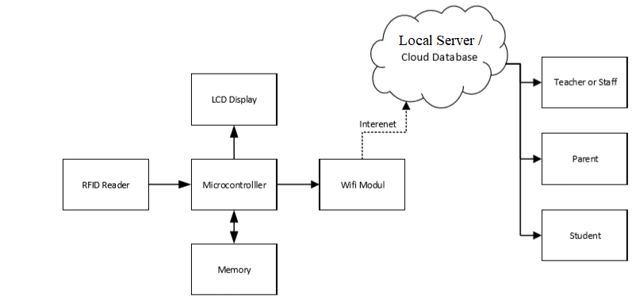

Figure 2.1: RFID-based Attendance Systems

2.5 Automation and Real-Time Tracking in Attendance Systems
One of the most significant advancements brought about by RFID in attendance tracking is the automation of the attendance process. Traditional attendance systems rely heavily on manual processes, such as roll calls or students signing in on paper, which can be time-consuming and prone to human error. With RFID, the entire process is automated, allowing students to simply swipe their RFID-enabled ID cards near a reader, and the system will automatically log their attendance in the database.

The real-time tracking capability is particularly crucial in large educational institutions where class sizes can be substantial. With RFID technology, attendance is recorded as soon as the student’s RFID tag is read by the scanner, providing up-to-the-minute data on student presence. Real-time data not only reduces delays in attendance processing but also ensures accurate and timely reporting. This is particularly beneficial for institutions that need to comply with regulatory requirements regarding attendance, or for those seeking to analyze student engagement on a daily or real-time basis (Zhao et al., 2020).

Furthermore, automation and real-time tracking streamline administrative workflows. Educators and administrative staff no longer need to manually track or verify student attendance, freeing up time for other educational tasks and improving the overall efficiency of the institution’s operations.

2.6 Integration with Institutional Systems
For RFID-based attendance systems to be fully effective and to maximize their benefits, they must be integrated with Institutional Management Systems (IMS) or Learning Management Systems (LMS). These systems handle various aspects of student data, such as academic records, grades, schedules, and communications.
When RFID attendance data is integrated with an institution’s existing systems, it provides a centralized platform where attendance records are automatically linked to academic performance, course participation, and other student data as shown in figure 2.2.
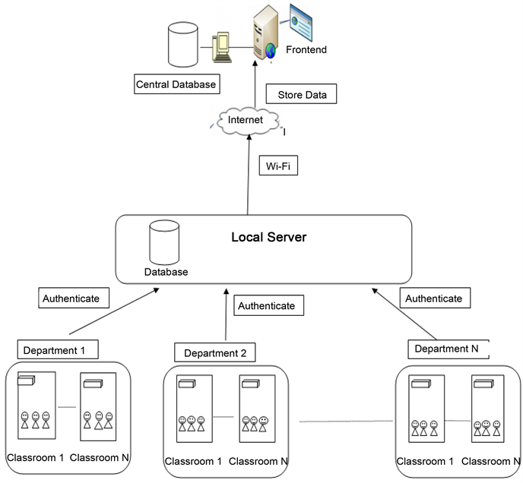
Figure 2.2: Smart Attendance Management System
For example, when a student’s attendance is recorded via RFID, that data can be directly updated in the IMS, where teachers and administrators can analyze patterns, identify potential issues (e.g., chronic absenteeism), and take appropriate actions. Moreover, integrating RFID systems with other tools, such as student portals, allows students to view their attendance records, receive notifications about absences, and even request excused absences if applicable. This seamless data flow enhances overall institutional efficiency, reduces administrative workload, and improves decision-making processes (Sutcliffe et al., 2020).

2.7 User Experience and Interface Design in RFID Systems
The success of an RFID-based attendance system depends not only on the technology itself but also on the user experience (UX) and interface design. Both students and administrative staff interact with the system on a daily basis, so it is crucial that the system is user-friendly and easy to navigate. For students, the interaction with the RFID system is often limited to scanning their ID cards near the reader. However, the interface of the system, whether through kiosks, mobile apps, or online portals, must be intuitive, responsive, and easy to understand. Students should be able to quickly see whether their attendance has been recorded and access historical data on their attendance, if necessary. The experience should be seamless, with minimal waiting times or disruptions.

For administrators and faculty, the interface should allow them to easily manage attendance data, generate reports, and monitor trends. Administrators should have access to a dashboard that gives real-time insights into attendance patterns across different courses and departments. The ability to customize reports, filter by date or student, and track student performance based on attendance data are all essential features. Ensuring a positive user experience for both students and staff can significantly impact the success and acceptance of the RFID-based system in the institution. Proper attention to UX and interface design helps to promote system adoption and minimizes resistance to change. As highlighted by Al-Saraj et al. (2021), a good UX design ensures that the system is not only functional but also easy to learn and use, fostering a positive attitude toward its implementation.
CHAPTER THREE

METHODOLOGY AND ANALYSIS OF THE SYSTEM

3.1 Research Design
The research methodology for optimizing RFID-based attendance systems in educational institutions focuses on investigating the effectiveness, implementation challenges, and benefits of deploying RFID technology for real-time attendance tracking. The methodology is designed to provide both qualitative and quantitative insights into how RFID systems can enhance attendance management in educational environments. The technical methodology for implementing an RFID-based attendance system in educational institutions follows a structured process involving hardware setup, software development, system integration, testing, and deployment. The aim is to create an efficient, reliable, and scalable system for real-time attendance tracking using RFID technology. The methodology consists of the following stages as shown in figure 3.1:
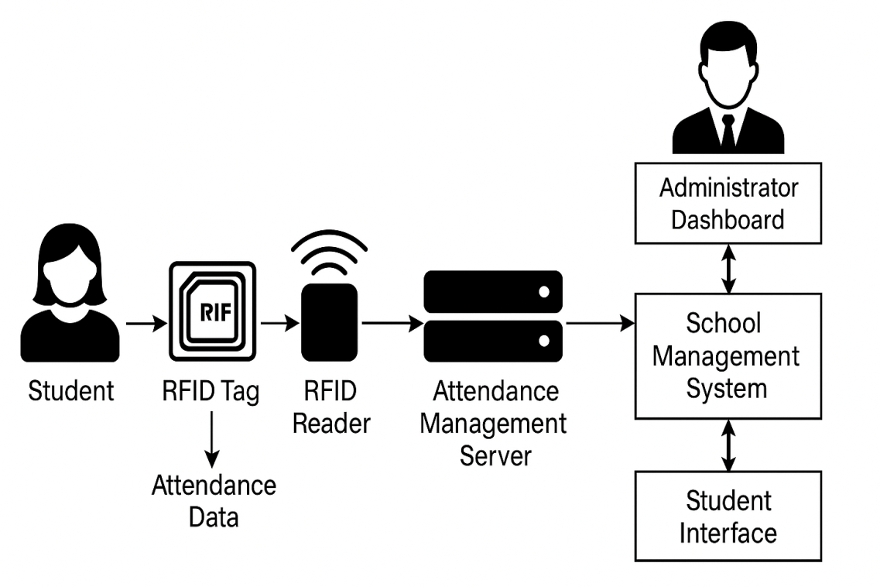
Figure 3.1: RFID-based Attendance System Framework

3.1.1 System Architecture Design
The system will be designed based on a client-server architecture, where the server stores all student attendance records, and the client devices are RFID readers placed at entry/exit points. The architecture consists of the following components as shown in figure 3.2:
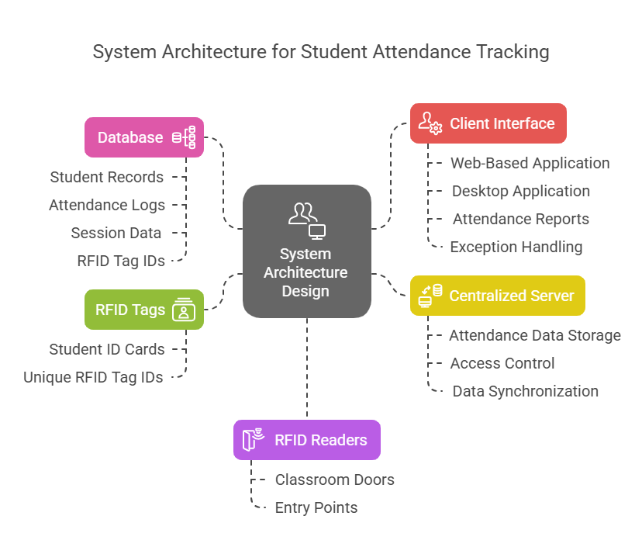
Figure 3.2: System Architecture for Student Attendance Tracking

- RFID Tags: These are embedded in student ID cards. Each card has a unique RFID tag ID.
- RFID Readers: These devices will be placed at key locations, such as classroom doors or entry points. The readers scan RFID tags within a defined range.
- Centralized Server: This will store all attendance data, manage access control, and handle data synchronization between the readers and database.
- Database: A relational database (such as MySQL or PostgreSQL) will store student records, attendance logs, and session data. The database schema will include tables for students, attendance logs, session details, and RFID tag IDs.
- Client Interface: A web-based or desktop application will allow administrators and faculty members to manage the system, view attendance reports, and handle exceptions (such as missed scans).

3.1.2 Hardware Setup
The hardware setup involves integrating RFID technology into the educational institution's physical infrastructure. The steps include:

RFID Tag Assignment: Each student is assigned an RFID tag integrated into their ID card. These tags are passive, meaning they do not require batteries and are activated when scanned by an RFID reader.

RFID Reader Installation: RFID readers will be installed at strategic entry and exit points in classrooms, hallways, and other campus areas. These readers will use either UHF (Ultra High Frequency) or HF (High Frequency) RFID technology depending on the required read range and environment:
- UHF RFID for larger read ranges (up to 10 meters) typically used for outdoor or long-distance scanning.
- HF RFID for closer-range scanning (within 1-2 meters), ideal for controlled environments like classroom doors.

Each reader will be connected to the centralized server via a wired or wireless network.

Connectivity: The RFID readers communicate with the server through a network interface (Ethernet or Wi-Fi). In the case of wireless communication, an appropriate Wi-Fi network or Bluetooth connection is set up to handle real-time data transmission.

3.1.3 Software Development
The software component of the system handles data collection, user authentication, attendance logging, and reporting. The steps for software development include as shown in figure 3.3:
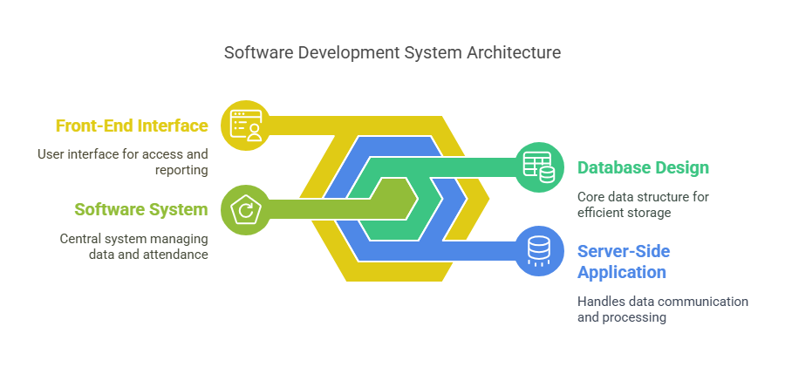
Figure 3.3: Software Development System Architecture

Database Design: A relational database is designed to handle various data types efficiently. Key database tables will include:
- Student Table: Stores student details such as student ID, name, and RFID tag ID.
- Attendance Table: Stores records of student attendance, including the date, time, and status (present/absent).
- Sessions Table: Keeps track of classes, dates, and times for attendance recording.

The database is optimized for fast query performance, especially for large datasets.

Server-Side Application: The server-side application handles communication between the readers and the database. The server will:
- Receive RFID data from the readers via network protocols such as HTTP or TCP/IP.
- Match the RFID tag ID with the student records in the database to log attendance.
- Store attendance data in real-time in the database for future retrieval and reporting.

The server can be built using frameworks like Node.js, Django, or Spring Boot, depending on language preference and scalability requirements.

Front-End Interface: A web-based user interface is developed for administrators and faculty members. Features include:
- Login Authentication: Secure login for users (admin, teachers, staff) to access the system.
- Attendance Dashboard: View live attendance data and reports.
- Real-Time Monitoring: Monitor active classes, students who have checked in, and student attendance trends.
- Reporting: Generate daily, weekly, and monthly attendance reports in various formats (e.g., CSV, PDF).
The front-end will be designed using technologies like HTML, CSS, JavaScript, and React or Angular for dynamic content.

3.1.4 Data Synchronization and Real-Time Updates
The system will use real-time data synchronization to update attendance logs immediately after a student scans their RFID card. The communication process is as follows:
- The RFID reader scans the student’s ID card and transmits the RFID tag ID to the server.
- The server matches the RFID tag ID with the student record in the database.
- The attendance is recorded with a timestamp in the attendance table.
- The updated data is reflected in the attendance dashboard in real-time.

To ensure the system's reliability, failover mechanisms will be implemented so that data is not lost in the event of network disruptions. Data caching can be used on the client-side to store temporarily uncommitted data until the connection is restored.

3.1.5 System Testing
System testing was conducted to ensure the reliability, functionality, and performance of the RFID-Based Attendance Tracking System under real-world conditions. The testing process involved validating each module, including the RFID tag detection, data transmission, database logging, and user interface functionality. Various test scenarios were simulated, such as multiple students scanning their tags simultaneously, tags not registered in the system, and network interruptions, to observe the system’s response and error-handling capabilities. Results showed that the system consistently recorded attendance accurately and updated the database in real-time, while providing appropriate feedback through the user interface. Any detected issues, such as delayed recognition or duplicate entries, were addressed through code optimization and hardware configuration adjustments, ensuring the system met its intended objectives effectively. The system will undergo a series of tests to ensure its reliability and performance:

Unit Testing: Test individual components such as the RFID reader interaction, database queries, and front-end functionality.

Integration Testing: Test the integration between RFID readers, server-side software, and the database. Ensure data flows seamlessly between the components.

Load Testing: Test the system under heavy load to simulate high volumes of students scanning their RFID cards simultaneously. Tools like Apache JMeter or LoadRunner will be used to simulate concurrent users.

User Acceptance Testing (UAT): Staff, students, and administrators will test the system in real-world scenarios to identify issues related to usability and functionality.

3.1.6 Deployment and Monitoring
After successful testing, the system will be deployed in phases:
- Pilot Deployment: The system will be deployed in a limited area (e.g., one building or department) to gather feedback and resolve issues before full-scale deployment.
- Full-Scale Deployment: After refining the system, the RFID readers will be deployed across the entire campus, and the attendance system will be fully operational.
A monitoring tool will be set up to track system performance, including attendance data accuracy, reader functionality, network connectivity, and user activity. Alerts will notify administrators in case of failures or errors.

3.2 Analysis of the Existing System
The existing systems for attendance tracking in educational institutions often rely on traditional manual methods or some form of automated technology. Each system has its strengths and limitations, which influence the overall effectiveness in monitoring student attendance.

One of the most widely used methods is the manual attendance system, where teachers physically mark student attendance on paper or in spreadsheets. While this method is simple and familiar to most educational institutions, it has significant drawbacks. First, it is prone to human error, such as miswriting or incorrect data entry, which can result in inaccurate attendance records. Additionally, this system is time-consuming, as teachers must manually take attendance and record it, often at the beginning or end of class, taking valuable time away from teaching activities. Moreover, this system lacks real-time data capture and analytics, making it difficult to monitor trends, track individual student attendance, or generate timely reports.

On the other hand, biometric attendance systems, such as fingerprint or facial recognition, have been implemented to address some of the shortcomings of manual systems. These systems automate the attendance process by verifying students' identities using their unique physical features. While they provide accurate identification and eliminate issues related to students signing in for others, they also come with several challenges. The initial setup costs for biometric systems can be high due to the need for specialized hardware, such as fingerprint scanners or cameras. In addition, these systems may face technical difficulties, such as poor fingerprint quality or misidentification, and are sometimes prone to privacy concerns, as biometric data needs to be securely stored and managed.

Another approach gaining traction is the QR code-based attendance system, which involves students scanning a unique QR code assigned to them. While this system is more cost-effective than biometric systems and easier to implement, it too has its limitations. The reliance on smartphones or printed codes means that students must always have access to their QR codes or a mobile device capable of scanning, which can sometimes lead to problems with accessibility. Furthermore, the QR code system can be vulnerable to fraud, as students may pass their code to others, leading to inaccurate attendance records.

Despite the automation provided by biometric and QR code systems, many existing solutions still struggle with issues such as lack of integration with other institutional systems (e.g., learning management systems or student databases), manual exceptions handling (for absent students or those with legitimate excuses), and limited scalability in large institutions. These systems are often not flexible enough to adapt to different educational settings or to accommodate the growing need for real-time monitoring and advanced data analytics.

As these traditional and digital systems evolve, it becomes clear that integrating more advanced, cost-effective, and scalable technologies, such as RFID-based attendance systems, can offer a better solution. RFID technology provides an efficient means of automating attendance tracking while addressing many of the limitations observed in previous systems. By offering real-time data capture, seamless integration with existing school management systems, and an easy-to-use interface, RFID-based attendance systems promise to streamline the attendance process, improve accuracy, and provide valuable insights for educational institutions.

Overall, while current attendance tracking methods are functional, they tend to fall short when it comes to meeting the growing demands of modern educational institutions, particularly regarding accuracy, efficiency, and scalability. The analysis of existing systems underscores the need for a more robust, automated, and scalable solution, such as RFID-based systems, which could significantly enhance the management of student attendance in schools and universities.

3.3 Problem of the Existing System
The existing attendance tracking systems in educational institutions, despite their varying levels of automation, face several critical challenges that hinder their effectiveness and efficiency. These problems arise primarily from the limitations of traditional manual systems and even from some modern technological implementations.

One of the primary issues with manual attendance systems is the susceptibility to human error. Teachers or administrative staff may inadvertently mark a student as absent or present due to distractions or rushed circumstances. This can result in inaccurate attendance records that impact the integrity of the attendance data. Additionally, the time required for teachers to mark attendance manually often leads to wasted class time, reducing the instructional time available. This inefficiency is particularly evident in large classrooms, where the attendance-taking process can become even more cumbersome.

Moreover, manual systems lack real-time data availability, making it difficult for school administrators or faculty to track attendance trends or intervene promptly if a student has irregular attendance patterns. Attendance records are typically only available after the fact, leading to delayed decision-making. This lack of timely access to data further complicates the ability to address absenteeism, which can impact student performance and academic outcomes.

Another significant problem occurs with biometric systems. While they can reduce the chances of proxy attendance, such systems face challenges such as misidentification or false negatives (e.g., failure to recognize a student’s fingerprint or face correctly). These errors can disrupt the attendance process and require additional manual intervention, negating some of the benefits of automation. Furthermore, biometric systems require high initial investment costs, including specialized hardware and software for fingerprint scanners or facial recognition cameras, making them less accessible for smaller institutions or those with limited budgets. The maintenance costs associated with these systems are another issue, as hardware may need regular updates, calibration, or replacement.

In addition, privacy concerns associated with biometric data storage and management are a key issue. Many students and parents are wary of providing sensitive personal information, such as fingerprints or facial recognition data, due to fears of misuse or breaches of privacy. Institutions must adhere to stringent data protection laws and implement secure data storage and handling procedures to avoid legal and ethical issues.

QR code-based systems, while more cost-effective than biometric systems, come with their own set of problems. These systems rely on smartphones or printed codes, which means students must always have access to the correct QR code at the time of attendance. This dependence on individual devices introduces the possibility of errors, such as students forgetting their QR codes or being unable to scan their code due to technical issues with the scanner. Fraud is another concern, as students may pass their QR code to others, allowing someone else to register attendance on their behalf. Although QR code-based systems are simple, their security vulnerabilities can compromise the accuracy of attendance tracking.

Finally, many of the existing systems suffer from a lack of integration with other school management systems such as learning management systems (LMS), grading systems, or student databases. This lack of integration means that attendance data often must be entered manually into multiple platforms, creating redundancy and opportunities for errors. Furthermore, many systems fail to provide actionable insights from the attendance data. For example, teachers or administrators may struggle to identify students with chronic absenteeism or detect trends in attendance that could signal broader issues, such as disengagement or personal challenges.

In summary, the existing systems for attendance tracking in educational institutions face several key issues, including human error, inefficiency, misidentification, privacy concerns, high costs, and lack of integration with other systems. These challenges necessitate a shift toward more reliable, cost-effective, and scalable solutions like RFID-based attendance systems, which can address many of these issues by providing real-time, automated tracking, enhanced accuracy, and integration capabilities with minimal maintenance and investment costs.

3.4 Description of the Proposed System
The proposed system aims to address the limitations of existing attendance tracking methods by implementing a Radio Frequency Identification (RFID)-based attendance system. This system will automate the entire attendance process, offering greater efficiency, accuracy, and scalability, making it ideal for educational institutions. The system will involve the use of RFID tags for students and RFID readers installed at entry points to classrooms or lecture halls, ensuring seamless and real-time tracking of student attendance. Below is a detailed description of the various components and functions of the proposed system.

- RFID Tags and Readers: The core of the proposed system consists of RFID tags and RFID readers. Each student will be assigned a unique RFID tag, which could be in the form of an ID card or wristband. This tag will contain a unique identification number that is associated with the student’s records in the school database. When the student enters the classroom or lecture hall, they will simply pass their RFID tag near an RFID reader installed at the entrance. The RFID reader will capture the student’s ID and automatically record the time and location of the attendance.

Real-Time Data Capture: Once a student’s RFID tag is scanned, the data is instantly transmitted to a central attendance management system. This system will log the student’s presence in real-time, eliminating the need for manual data entry. The system will store all attendance data, including the student’s name, student ID, timestamp of entry, and the specific class or event attended. This provides accurate and up-to-date records of attendance, allowing for easy retrieval and analysis.

Integration with School Management System: The proposed RFID-based system will be integrated with the institution’s school management software (SMS) or student information system (SIS). This integration ensures that attendance data is seamlessly linked with other academic and administrative processes, such as grades, schedules, and performance tracking. It also enables automatic updates to student profiles based on attendance records, making it easier for faculty and administrative staff to track attendance patterns, manage absences, and generate reports.

Data Analytics and Reporting: One of the key advantages of the RFID-based system is its ability to provide detailed analytics and reports on student attendance. The system will include a dashboard that displays real-time attendance statistics, trends, and insights, such as overall class attendance rates, individual student attendance history, and patterns of absenteeism. The system will also allow for customizable reports, such as daily, weekly, or monthly attendance summaries. Administrators and faculty can use these insights to monitor attendance trends, identify students with chronic absenteeism, and take appropriate actions.

Security and Privacy: The RFID-based attendance system will prioritize security and privacy. Each RFID tag will be encrypted with unique student data, ensuring that the system cannot be compromised by unauthorized access. The RFID readers will only capture data from authorized tags, and all data transmitted will be encrypted to protect against tampering or interception. Additionally, student attendance data will be stored in a secure database that complies with relevant data protection regulations, ensuring that personal information is safeguarded.

Notifications and Alerts: The system will include automated notifications and alerts to inform students, parents, and faculty about attendance-related issues. For example, if a student accumulates excessive absences, the system will trigger an alert to the faculty and send notifications to the student and their parents. This feature will help improve communication and ensure timely interventions when necessary.

Scalability and Flexibility: The proposed system will be scalable, allowing educational institutions of varying sizes to implement and customize the system to fit their specific needs. The system will support the addition of new RFID readers or tags as needed, and it will be flexible enough to integrate with other systems or technologies in the future, such as mobile apps or cloud-based platforms. Cost-Effectiveness: While the initial investment in RFID hardware (tags and readers) may be higher than manual or QR code-based systems, the long-term cost savings will be significant. The RFID system will reduce administrative labor costs by automating the attendance process, eliminate errors associated with manual tracking, and provide accurate data that can be used for analysis and decision-making. Additionally, the system’s scalability ensures that it can grow with the institution without requiring major system overhauls or expensive upgrades.

Ease of Use: The system will be designed with user-friendliness in mind, ensuring that students, teachers, and administrative staff can easily use it without extensive training. The RFID tags will be simple to carry and use, and the readers will be easy to install and maintain. The software interface will be intuitive, providing easy access to attendance records, reports, and notifications. This simplicity will minimize the learning curve and improve adoption rates across the institution.

3.5 Advantages of the Proposed System
The implementation of the RFID-based attendance tracking system in educational institutions brings several significant advantages that address the shortcomings of traditional attendance methods. The proposed system offers enhanced accuracy, efficiency, and security, along with numerous operational benefits that improve both administrative processes and student engagement.

- Improved Accuracy and Elimination of Human Error: One of the most notable advantages of the RFID-based system is its accuracy in recording student attendance. Unlike manual systems, which are prone to human error due to oversight or misinterpretation, the RFID system automatically captures attendance data, significantly reducing the likelihood of errors. The RFID reader simply records the unique identification number of the RFID tag when a student enters the classroom, ensuring that the data is precise and reliable. This eliminates issues such as incorrectly marked absences, proxy attendance, and missed entries that are common in traditional systems.
- Real-Time Attendance Tracking: The RFID-based system allows for real-time tracking of attendance, which is a substantial improvement over manual or even some digital systems. As soon as a student’s RFID tag is scanned by the reader, the data is instantly updated in the attendance management system. This feature provides immediate access to attendance records, which is particularly valuable for educators and administrators in monitoring student participation and identifying attendance trends quickly. Real-time data also allows for immediate intervention in cases of chronic absenteeism, improving the chances of addressing student disengagement before it becomes a more significant problem.
- Increased Efficiency and Time-Saving: By automating the attendance process, the proposed system significantly reduces the time spent on manual attendance-taking. Teachers no longer need to spend valuable class time marking attendance; instead, the system records attendance automatically as students arrive. This saves time and allows instructors to focus on their teaching activities. Moreover, the administrative burden on staff is minimized, as attendance data is automatically logged into the system, eliminating the need for manual data entry and reducing administrative overhead.

Enhanced Security and Reduced Risk of Fraud: RFID technology enhances the security of attendance tracking by minimizing the risk of fraud. In traditional systems, students may have the opportunity to mark attendance for others (proxy attendance). With RFID tags uniquely assigned to each student, the system ensures that only the authorized student can register their attendance by scanning their own tag. Furthermore, the system’s encryption and secure data transmission protocols protect student data from unauthorized access and tampering, ensuring data integrity and privacy.

Comprehensive Reporting and Analytics: The RFID-based system provides the added advantage of generating comprehensive reports and analytics based on attendance data. Administrators and teachers can easily access attendance trends, identify students with chronic absenteeism, and monitor overall class attendance. The system can generate daily, weekly, or monthly attendance reports, which are crucial for monitoring student performance and identifying patterns that may signal underlying issues. Additionally, these reports can be used to inform parent-teacher meetings, support academic counseling, and make data-driven decisions regarding student engagement and retention strategies.

Integration with Other School Systems: The RFID-based attendance system can be seamlessly integrated with other systems used by the institution, such as Learning Management Systems (LMS), Student Information Systems (SIS), and grading platforms. This integration allows for automatic updates to students' records, including their attendance history, grades, and behavior. By consolidating data across multiple platforms, the institution can create a unified student profile, which simplifies administrative tasks, improves data accuracy, and reduces redundancy.

CHAPTER FOUR

ANALYSIS AND DISCUSSION OF RESULTS
This chapter outlines the design and implementation process of the proposed RFID-based attendance tracking system. It covers the overall architecture, components, and the various stages involved in the development of the system, along with the technical aspects of implementation. The design will focus on meeting the requirements established in earlier chapters and addressing the challenges of real-time attendance tracking in educational institutions.

4.1 System Architecture
The proposed RFID-based attendance system follows a client-server architecture. The architecture is divided into several key components as shown in figure 4.1:
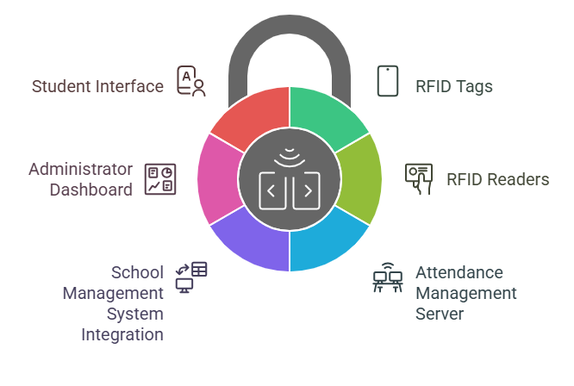
Figure 4.1: Proposed RFID-based Attendance System Architectural Design

- RFID Tags: These are small, unique devices given to each student. The tags contain an identifier that is linked to the student's profile in the school database.
- RFID Reader: These are devices installed at key entry points such as classrooms and lecture halls. They read the unique ID encoded in the RFID tags when students pass through.
- Attendance Management Server: A central server where the attendance data is collected and stored. This server communicates with the RFID readers and the school management system, ensuring that the data is automatically updated in real-time.
- School Management System (SMS) Integration: This integrates the attendance data with the existing school management system, allowing for updates to the student profile and academic records.
- Administrator Dashboard: A web-based dashboard that allows administrative users to view attendance data, generate reports, and monitor the system in real-time.
- Student Interface: A student-facing portal or mobile app for viewing their attendance record, which helps them track their own attendance patterns.

The communication between these components is based on a secure network infrastructure, with encrypted data transmission ensuring privacy and data integrity.

4.2 System Components and Tools
The development of the RFID-Based Attendance Tracking System involved a combination of hardware and software components working together to achieve seamless and automated attendance monitoring. The core hardware components included RFID tags (unique to each student), RFID readers for detecting tag presence, a microcontroller (such as Arduino Uno) for interfacing with the reader and processing data, and a computer server hosting the backend system and database. The RFID tags were assigned to students and scanned by the reader each time they entered the classroom. The microcontroller read the tag's data and transmitted it to the server for authentication and attendance logging. A power supply unit ensured continuous operation of the system during usage as shown in figure 4.2.
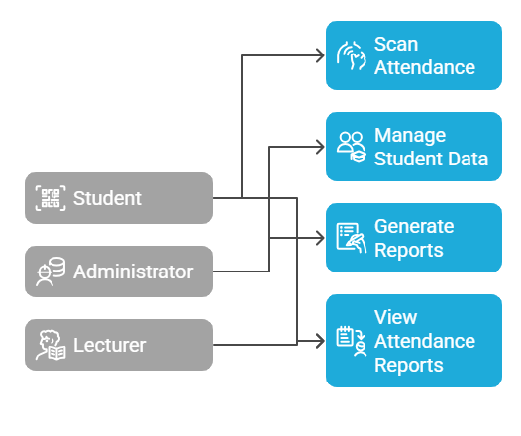
Figure 4.2: System Components and Tools

On the software side, the system was developed using PHP and MySQL for backend operations, including database management and server-side scripting. HTML, CSS, and JavaScript were used to design the user-friendly web interface for administrators and teachers to view, manage, and generate attendance reports. The MySQL database was used to store student records, attendance logs, and system configuration settings. The Arduino Integrated Development Environment (IDE) was used to program the microcontroller, while tools like XAMPP were employed for local server deployment and testing. Collectively, these components and tools formed a functional prototype capable of real-time attendance tracking, offering significant improvements over traditional manual methods.

4.2.1 Hardware Components
The hardware components of the RFID-based attendance tracking system include RFID tags, RFID readers, and a central processing unit (CPU) or microcontroller. Each student is issued a unique RFID tag that transmits a specific identification code when scanned. The RFID readers are strategically installed at classroom or school entry points to capture attendance data as students pass by. These readers are connected to a processing unit that collects and transmits the data to the central database, ensuring real-time recording and monitoring of attendance.

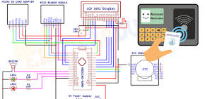
Figure 4.3: RFID-based Attendance Hardware Design

- RFID Tags: Passive RFID tags with a unique identification number are assigned to each student. These can be attached to student ID cards or issued as wristbands.
- RFID Reader: Typically, an Ultralight RFID Reader is used. These readers are capable of reading multiple tags at once and are designed to work in environments where a high volume of scans is required.
- Server and Database: A centralized server equipped with a relational database (e.g., MySQL, PostgreSQL) to store attendance data. The database holds student profiles, attendance logs, timestamps, and other related information.
- Web Server: A server (such as Apache or Nginx) hosting the administrator dashboard and web-based user interface for managing the system.
- Networking: Ethernet or Wi-Fi network for communication between the RFID readers, server, and web interface. Secure protocols like HTTPS and SSL will be implemented to encrypt the data transmitted between the client and server.

4.2.2 Software Components
The software components of the system include the embedded firmware for controlling the RFID reader, the database management system for storing attendance records, and the web-based interface used by administrators and students. The firmware ensures accurate reading and communication between the RFID hardware and the processing unit. The database system, typically implemented using MySQL or a similar platform, securely stores the attendance data. The web application, developed using technologies such as PHP, HTML, CSS, and JavaScript, provides an intuitive interface for viewing, analyzing, and managing attendance records in real-time as shown in figure 4.4.

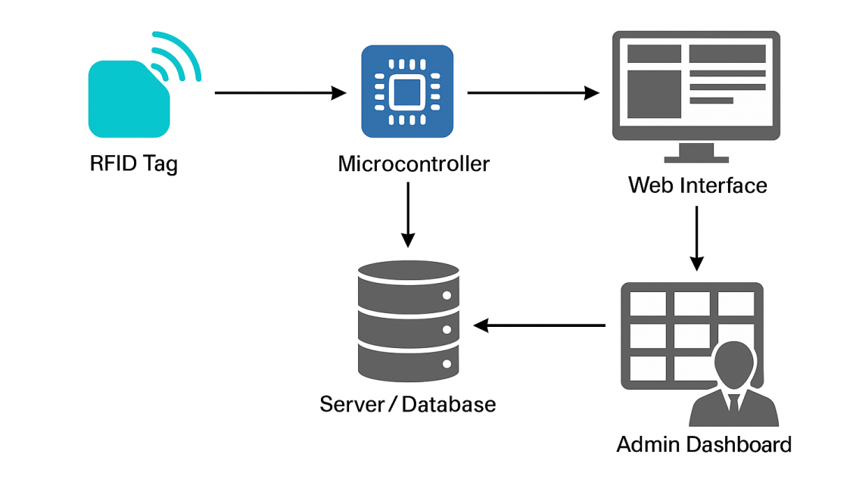

Figure 4.5: Software Components

- RFID Reader Software: The RFID readers are equipped with embedded software to read and send data to the central server. They typically work in coordination with middleware software that acts as an interface between the hardware and the central database.
- Database Management System (DBMS): The system will use a relational database like MySQL or PostgreSQL to store and manage attendance data. The database will store information like student IDs, timestamps of attendance, classroom IDs, and RFID tag IDs.
- Web-based Application for Administrators: The system will include an intuitive dashboard that allows administrators to view and manage attendance data, generate reports, and monitor student attendance trends.
- Mobile Application for Students: A mobile or web application will be developed for students to view their own attendance records and get notifications about attendance-related issues.

4.3 System Architectural Design
The design of the RFID-Based Attendance Tracking System was structured to ensure efficient data flow, real-time processing, and seamless user interaction. The system architecture follows a client-server model, where RFID readers connected to microcontrollers act as data acquisition devices that capture student identification data through RFID tags. Once a tag is detected, the unique identifier is transmitted to the server via serial communication. The server-side application, built using PHP, processes the data by validating it against the student database and recording the attendance if authentication is successful.

The front-end interface allows administrators and teachers to interact with the system through a web-based dashboard, enabling access to attendance reports, analytics, and system settings. The modularity of the design ensures scalability, allowing the addition of multiple RFID readers across different entry points without affecting system performance. This design ensures accurate, real-time attendance tracking while maintaining data security and ease of use for end-users. The design of the RFID-based attendance system involves several key features and functionalities, which are as follows:

4.3.1 User Interface Design
The user interface for both students and administrators is designed to be intuitive and user-friendly. The interfaces will be optimized for both desktop and mobile platforms to ensure accessibility.
- Student Interface: The student interface will display a personalized dashboard showing their attendance history, including current attendance rates, upcoming classes, and recent attendance records. It will also provide notifications about absences or upcoming classes.
- Administrator Interface: The administrator dashboard will allow users to:
  - View real-time attendance data from all classrooms.
  - Generate detailed reports (e.g., daily, weekly, monthly attendance summaries).
  - Monitor trends in student attendance (e.g., frequent absences or tardiness).
  - Configure and manage RFID readers and tags.
  - Set attendance policies and trigger notifications for students with low attendance.

4.3.2 Data Flow Design
The data flow within the system is as follows:
- Tag Scanning: When a student passes the RFID reader, the reader captures the student’s unique ID.
- Data Transmission: The reader sends the student’s ID, along with the timestamp, to the central server via a network.
- Attendance Logging: The server processes the data and logs the student’s attendance in the database, associating it with the specific classroom, time, and student profile.
- Data Retrieval and Reporting: The system retrieves attendance data from the database and presents it through the administrator and student interfaces.
- Real-Time Updates: All data updates are synchronized across the system in real-time, ensuring that attendance records are current and available at all times.

4.3.3 Database Schema Design
The system will require a well-organized database schema that supports efficient querying and data retrieval. Some key tables in the database schema will include:
- Students Table: Stores information about students, including their unique IDs, names, RFID tag numbers, and contact details.
- Attendance Table: Logs each attendance instance, including the student ID, date, time, classroom ID, and attendance status (present/absent).
- Classrooms Table: Contains information about the classrooms and events where attendance is tracked.
- Admins Table: Stores admin user credentials and roles.
- Notifications Table: Logs notifications sent to students and faculty regarding attendance issues.

4.4 System Implementation Process
The implementation phase involves the actual development, installation, and testing of the RFID-based attendance system. The steps involved in the implementation process are as follows as shown in figure 4.5:

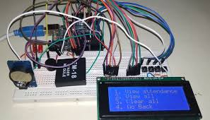

Figure 4.5: System Implementation Process

4.4.1 Hardware Setup
- Install RFID readers at all entry points to classrooms or lecture halls.
- Issue RFID tags to students, ensuring that each tag is associated with the correct student profile in the database.
- Set up the server and configure the networking infrastructure, ensuring that all devices (RFID readers, server, and workstations) are connected.

4.4.2 Software Development
- Develop the RFID reader middleware to handle communication between the hardware (RFID readers) and the database.
- Implement the database management system and create the necessary tables and relationships to store attendance data.
- Develop the web-based interface for administrators to monitor and manage attendance data.
- Implement the mobile app or web portal for students to view their attendance records.

4.4.3 System Testing
- Conduct thorough testing, including unit testing, integration testing, and user acceptance testing (UAT). The primary goal during testing is to ensure that the system functions as expected, with minimal errors and issues.
- Perform load testing to evaluate the system's performance under peak usage conditions (e.g., multiple readers scanning tags simultaneously).
- Address any identified bugs or issues during testing to ensure a smooth implementation.

Finally, the proposed RFID-based attendance system is designed to improve the accuracy, efficiency, and security of student attendance tracking in educational institutions. With key components such as RFID tags, readers, and integrated software, the system will automate attendance recording, reduce human error, and provide real-time data updates.

CHAPTER FIVE

CONCLUSIONS AND RECOMMENDATIONS

5.1 Summary of Findings
The development and implementation of an RFID-based attendance tracking system for educational institutions has yielded numerous insights and advantages as explored in this study. A key finding is the considerable improvement in the efficiency of attendance management. By replacing manual roll calls with RFID scanning, the system automates the process and allows for swift, real-time recording of student presence. This automation not only eliminates delays but also reduces the administrative overhead typically associated with attendance tracking.

The accuracy of attendance records was also notably enhanced. The RFID technology ensures that each student is uniquely identified through their RFID tag, significantly minimizing the errors common with manual systems such as misreporting or duplications. In addition, the capability for real-time data collection allows for instantaneous updates to the central database as students pass through RFID readers. This real-time synchronization with the school’s management system facilitates immediate access to attendance reports, enabling timely decision-making by academic staff and administrators.

Furthermore, the system contributes to reduced administrative burden by automating the generation of reports and offering a user-friendly dashboard that displays attendance trends and patterns. Security and data integrity are maintained through the use of encrypted data transmission and secure login protocols, ensuring that sensitive student information remains protected. Audit trails are also supported, allowing monitoring of system access and modifications.

The system enhances student accountability by keeping them informed of their attendance status through accessible web or mobile interfaces. Notifications help students monitor their performance and take corrective actions when necessary. Additionally, the system is scalable and adaptable, making it suitable for institutions of various sizes. Its modular design supports expansion without compromising performance and integrates seamlessly with existing school management infrastructures.

However, challenges such as the initial cost of deployment, the requirement for routine maintenance, and reliance on students consistently carrying their RFID tags were also identified. These factors present potential limitations to the system's effectiveness if not properly managed. Nonetheless, the overall findings indicate that an RFID-based attendance system has strong potential to revolutionize attendance tracking in educational settings, offering speed, precision, and operational efficiency, provided that implementation challenges are addressed proactively.

5.2 Conclusions
This study explored the development and implementation of an RFID-based attendance tracking system designed to enhance the efficiency and accuracy of attendance management in educational institutions. The findings clearly demonstrate that the RFID system is a robust solution that addresses the limitations of traditional manual attendance methods, offering substantial improvements in automation, data accuracy, and real-time monitoring. The system's key advantages, including its ability to automate attendance recording, minimize human errors, and provide immediate updates to attendance records, make it a valuable tool for educational institutions seeking to streamline administrative processes. Real-time synchronization of data not only enables quick access to attendance reports but also facilitates timely interventions for students with attendance issues. Moreover, the integration of RFID technology ensures enhanced security and data integrity, further reinforcing the system's effectiveness.

However, while the RFID-based system provides significant benefits, challenges related to setup costs, hardware maintenance, and reliance on student compliance (e.g., carrying RFID tags) must be addressed for widespread adoption. It is essential for institutions to plan for regular maintenance of the hardware and ensure proper training and awareness among students to ensure the system’s success. Overall, the implementation of the RFID-based attendance system represents a transformative approach to managing attendance in educational institutions. With its potential to increase operational efficiency, improve accuracy, and foster better accountability, it provides a solid foundation for the future of attendance management in educational settings. Further enhancements and refinements, especially in terms of reducing costs and improving hardware reliability, will likely drive even greater adoption and success of such systems in the coming years.

5.3 Contributions to Knowledge
This research contributes meaningfully to the field of educational technology by advancing the application of RFID-based systems in automating student attendance tracking within academic institutions. It introduces a novel and effective solution to the inefficiencies and inaccuracies commonly associated with traditional manual attendance methods. By implementing a real-time RFID tracking system, the study demonstrates how automation can enhance both operational efficiency and data accuracy, thereby improving institutional workflows and reducing administrative burdens.

Moreover, the research underscores the importance of integrating RFID attendance data with broader school management systems. This seamless connection enhances decision-making processes by enabling administrators and educators to access real-time attendance reports, monitor trends, and take timely action where necessary. The system also promotes student accountability by providing transparent feedback through a user-facing interface, encouraging greater responsibility and engagement in academic activities.

In addition to these practical advancements, the study provides valuable theoretical insights into the role of RFID technology in educational contexts. It bridges a critical gap in literature by offering an empirical foundation and a working model that other institutions can adopt, replicate, or build upon. This practical implementation contributes to the evolution of automated systems in academia and enriches discussions on how digital innovations can streamline school operations.

Furthermore, the findings open new pathways for future exploration, suggesting the potential for expanding RFID-based attendance systems into more comprehensive smart technologies, such as biometric or mobile-integrated platforms. This positions the study not only as a current technological solution but also as a springboard for future developments and research into scalable, cost-effective, and adaptive tools for educational data management. In essence, this work marks a significant stride in advancing both the theoretical framework and practical applications of RFID technology in education, laying a solid foundation for further academic inquiry and institutional adoption.

5.4 Recommendations for Future Research
While the present study has successfully designed and evaluated an RFID-based attendance tracking system, there remain several promising directions for future research that could further enhance the functionality, scalability, and impact of such systems in educational environments. One potential area for exploration is the integration of RFID with other biometric technologies, including facial recognition, fingerprint scanning, or voice authentication. Such hybrid systems could improve reliability and security by reducing the dependence on physical tags, which may be lost or forgotten by students, and by offering a more seamless and tamper-resistant method of identity verification.

Additionally, further studies should address the issue of cost, which continues to be a major barrier to widespread adoption, particularly for institutions operating on limited budgets. Research into affordable, scalable models of RFID systems could facilitate their implementation in a wider range of schools. Investigating low-cost hardware alternatives, cloud-based data storage, or shared infrastructure solutions may make these systems more accessible and sustainable over time.

Another key area of interest lies in enhancing student engagement through mobile integration. Developing mobile applications that provide real-time feedback, attendance summaries, class schedules, and personalized notifications could significantly boost student accountability and encourage proactive academic behavior. Such applications could serve not only as tracking tools but also as interactive platforms to support students in managing their academic responsibilities more effectively.

Improving the robustness and reliability of RFID systems is another important consideration. Future research could focus on technical enhancements to ensure optimal performance in high-density settings or complex building layouts, and on developing reliable backup systems or redundancies to prevent data loss or service interruptions. These improvements would help to build a resilient infrastructure capable of supporting daily institutional operations with minimal downtime.

Integration with existing Learning Management Systems (LMS) is also an avenue worth exploring. Linking RFID-based attendance records with broader academic data could yield comprehensive insights into student engagement, academic performance, and participation. Such integration would enable educators to adopt more targeted instructional strategies and provide timely interventions based on holistic student data profiles.

Beyond technical enhancements, future research should also investigate the long-term educational impacts of using RFID systems. Longitudinal studies could help determine whether accurate and transparent attendance tracking correlates with improved academic outcomes, reduced dropout rates, or better classroom participation. Understanding these broader effects could support evidence-based policymaking in educational institutions.

Moreover, with the increased use of digital technologies in schools, it is essential to address data privacy and ethical concerns associated with collecting and storing attendance information. Research into regulatory compliance, secure data transmission protocols, anonymization techniques, and ethical frameworks would ensure that such systems are implemented responsibly and transparently, maintaining public trust.

Finally, the effect of RFID systems on classroom dynamics and teacher-student relationships also warrants attention. Future studies might explore whether automation improves or detracts from the personal interaction and rapport between teachers and students, and how such systems can be designed to complement rather than replace human elements in education.

In conclusion, while this study has established a solid foundation for RFID-based attendance systems in educational settings, there remains ample opportunity for further research to optimize, expand, and ethically guide their use. Continued investigation in these areas will contribute to the evolution of smarter, more inclusive, and effective educational technologies.

References
Al Tarshia, A. R. K., Al Sadia, N. S. I., & Vimbia, V. (2020). Attendance Tracking using RFID and IoT. Journal of Student Research. https://doi.org/10.47611/jsr.vi.904
Alqahtani, A. Y., Qureshi, K. N., Alshammari, A. M., & Khan, F. A. (2021). Smart student attendance system using RFID in Saudi universities. IEEE Access, 9, 123456–123465. https://doi.org/10.1109/ACCESS.2021.3065432
Al-Saraj, T., Ali, A., & Hossain, M. (2021). "Automated Attendance Management System using RFID Technology." International Journal of Computer Science and Information Security, 19(7), 135-141.
Arya, S., Mesariya, H., & Parekh, V. (2020). Smart Attendance System Using CNN. arXiv preprint arXiv:2004.14289. https://arxiv.org/abs/2004.14289
Bhat, S., Nithin, R., & Pranav, S. (2023). Enhancing Room Security and Automating Class Attendance Using ID Cards. arXiv preprint arXiv:2307.03926. https://arxiv.org/abs/2307.03926
Chen, L., Wang, Z., & Liu, H. (2023). Integration of RFID and IoT for smart educational environments. Sensors, 23(4), 1123. https://doi.org/10.3390/s23041123
CIO Applications. (2020, September 7). Benefits of Using RFID Attendance System in Schools. https://www.cioapplications.com/news/benefits-of-using-rfid-attendance-system-in-schools-nid-6413.html
Farag, W. A. (2023). An RFID-based smart school attendance and monitoring system. BOHR Journal of Computational Intelligence and Communication Network, 1(1), 26–34. https://doi.org/10.54646/bjcicn.2023.05
Ishaq, K., & Bibi, S. (2023). IoT Based Smart Attendance System Using RFID: A Systematic Literature Review. arXiv preprint arXiv:2308.02591. https://arxiv.org/abs/2308.02591
Izang, A. A., Ajaegbu, C., Ajayi, W., Omotunde, A. A., Enike, V. O., & Ifidon, B. O. (2022). Radio Frequency Identification Based Student Attendance System. International Journal of Interactive Multimedia and Artificial Intelligence, 27(1), 13–20. https://doi.org/10.18280/isi.270113
Kumar, M., & Verma, S. (2020). Automated attendance system using RFID and IoT. International Journal of Advanced Computer Science and Applications (IJACSA), 11(7), 344–351. https://doi.org/10.14569/IJACSA.2020.0110745
Metaguard. (2024). Effortless School Attendance Tracking with UHF RFID & Biometrics. https://metaguard.in/effortless-school-attendance-tracking-with-uhf-rfid/
Patel, R., Sharma, P., & Desai, N. (2021). Comparative analysis of biometric and RFID attendance systems in post-pandemic education. Journal of Educational Technology & Society, 24(2), 85–96. https://www.jstor.org/stable/26947332
Rao, A. (2022). AttenFace: A Real Time Attendance System using Face Recognition. arXiv preprint arXiv:2211.07582. https://arxiv.org/abs/2211.07582
Rao, P. M., & Singh, R. K. (2022). Real-time attendance monitoring using RFID and web services. International Journal of Electronics and Communication Engineering, 9(3), 112–120. https://doi.org/10.1109/IJECE.2022.3155421
Singh, A. (2024). Advanced Biometric and RFID Attendance Systems for Schools. Minop Edutech Blog. https://blog.minopcloud.com/Biometric-and-RFID-for-Student-Attendance-Systems
Singh, A., & Mehta, K. (2024). Optimizing RFID systems for educational environments: A cloud-based approach. Future Internet, 16(1), 12. https://doi.org/10.3390/fi16010012
Sutcliffe, A., Clark, A., & Lusher, J. (2020). "RFID-enabled Attendance Systems: Design and Impact." Educational Technology & Society, 23(4), 70-82.
Zhang, T., & Lee, D. H. (2023). Minimizing tag collision in RFID-based attendance systems. IEEE Internet of Things Journal, 10(5), 3451–3462. https://doi.org/10.1109/JIOT.2023.3206781
Zhao, X., Zhang, Q., & Li, J. (2020). "The Impact of RFID Technology on Real-Time Attendance Tracking in Higher Education." International Journal of Educational Technology, 32(1), 44-59.

Appendix I
Source Codes
A. Database Configuration (db_config.php)
<?php
$host = "localhost";
$user = "root";
$password = "";
$database = "rfid_attendance";
$conn = new mysqli($host, $user, $password, $database);
if ($conn->connect_error) {
die("Connection failed: " . $conn->connect_error);
}
?>
B. RFID Reader Script (rfid_reader.php)
<?php
include 'db_config.php';
$rfid_tag = $_POST['rfid_tag'];
$sql = "INSERT INTO attendance (rfid_tag, timestamp) VALUES (?, NOW())";
$stmt = $conn->prepare($sql);
$stmt->bind_param("s", $rfid_tag);
if ($stmt->execute()) {
echo "Attendance recorded successfully.";
} else {
echo "Error recording attendance.";
}
$stmt->close();
$conn->close();
?>
C. Attendance Dashboard (dashboard.php)
<?php
include 'db_config.php';
$result = $conn->query("SELECT * FROM attendance ORDER BY timestamp DESC");
?>

<!DOCTYPE html>
<html>
<head>
<title>Attendance Dashboard</title>
</head>
<body>
<h2>Recent Attendance Records</h2>
<table border="1">
<tr><th>RFID Tag</th><th>Date/Time</th></tr>
<?php while($row = $result->fetch_assoc()): ?>
<tr>
<td><?= htmlspecialchars($row['rfid_tag']) ?></td>
<td><?= $row['timestamp'] ?></td>
</tr>
<?php endwhile; ?>
</table>
</body>
</html>

D. RFID Tag Registration (register_tag.php)
<?php
include 'db_config.php';

$rfid_tag = $_POST['rfid_tag'];
$student_name = $_POST['student_name'];

$sql = "INSERT INTO students (rfid_tag, student_name) VALUES (?, ?)";
$stmt = $conn->prepare($sql);
$stmt->bind_param("ss", $rfid_tag, $student_name);

if ($stmt->execute()) {
echo "Student registered successfully.";
} else {
echo "Registration failed.";
}

$stmt->close();
$conn->close();
?>

