INVESTIGATING THE EFFECTS OF ROAD BUMPS ON THE PASSENGER COMFORT
(A CASE STUDY OF KUNLEDE JUNCTION TO HARMONY ESTATE).

BY

ADEMOLA FELIX OLAREWAJU
HND/23/CEC/FT/0108

BEING A RESEARCH PROJECT SUBMITTED TO CIVIL ENGINEERING DEPARTMENT, INSTITUTE OF TECHNOLOGY (IOT) KWARA STATE POLYTECHNIC,
IN PARTIAL FULFILLMENT OF THE REQUIREMENTS FOR THE AWARD OF HIGHER NATION DIPLOMA (HND) IN CIVIL ENGINEERING TECHNOLOGY

MAY, 2025.

Abstract
This study investigates the effect of road bumps on passenger comfort along the route from Kunlede Junction to Harmony Estate. Road bumps, while serving as essential traffic calming devices, can cause significant discomfort to vehicle occupants when poorly designed or excessively implemented.
The research focuses on evaluating the physical impact of these bumps on passengers, using both objective measurements (such as vehicle acceleration data) and subjective passenger feedback. Data were collected through field observations, instrumented vehicle tests, and structured questionnaires administered to commuters along the selected corridor.
Preliminary findings reveal that factors such as bump height, spacing and vehicle speed significantly influence the level of discomfort experienced by passengers, particularly in smaller vehicles and higher speeds.
The study highlights the need for improved bump design and placement standards to enhance road safety without compromising passenger comfort. Recommendations are provided for urban planners and transportation authorities to optimize traffic control measures in residential and mixed – use areas.

DEDICATION
I dedicate this project to Almighty God who has made everything possible during the course of my study and also dedicated to my beloved families, most especially my parent. Allah spare their live to reap what they have sowed [Amen]

ACKNOWLEDGMENT
All praise and adoration goes to Almighty God the Alpha and Omega of my life who has been my strength right from the beginning of my life to this present moment. He, who made the completion of higher national diploma (HND) program to be a successful one, may his name be praise forever.
My deepest appreciate goes to my parent REV. ADEMOLA JAMES OLUGBENGA AND DEACONES QUEEN GRACE ADEMOLA for their support financially, spiritually and physically, I pray that they will eat the fruit of their labour.
I also want to express my sincere gratitude to my sister OYINLOYE TEMITOPE, DR. JT ALIU and families, friends and course mates, the likes of my lovely and wonderful sisters and also my dynamic brothers, and also my success team.
My gratitude and recognition to my supervisor Engr. Z.D HASSAN for his useful comments which greatly helps in bringing this project work to reality.
I am also grateful to my entire lecturer for their assistance, encouragement throughout the project, may almighty Allah continue to guide you all.
My thanks and sincerely appreciation to the head of department of Civil Engineering Technology in person of ENGR. A. NA'ALLAH for making it successful.

CERTIFICATION
This is to certify that this research study was conducted by ADEMOLA FELIX OLAREWAJU HND/23/CEC/FT/0108and had been read and approved as meeting the requirement for the award of Higher National Diploma (HND) in civil engineering, institute of technology, Kwara State Polytechnic, Ilorin.

_________________________________ ___________________
Engr. Z.D HASSAN DATE
(Project Supervisor)

_________________________________ ___________________
ENGR. A. NALLAH DATE
(Head of Department)

_________________________________ ____________________
ENGR DR. MUJEDU KASALI ADEBAYO DATE
EXTERNAL EXAMINER

TABLE OF CONTENT
Table of Content i
Title Page ii
Certification iii
Dedication iv
Acknowledgment v
Table of Content vi
CHAPTER ONE
1.0 Introduction 1
1.1 Statement of the Problem 2
1.2 Aim and Objectives 3
1.3 Scope of the Study 3
1.4 Justification of the Study 4
1.5 Significance of the Study 4
CHAPTER TWO
2.0 Literature Review 5
2.1 Model of Road Bumps 7
2.2 Different Shapes of Road Bumps 8
2.3 Speed Control Devices 9
2.4 Warning Signs 11
2.5 Bumps 18
2.6 Effects on Vehicles Speed 19
2.7 Impacts on Human Health. 19
2.8 Speed Bumps Maintenance 20

CHAPTER THREE
3.0 Methodology 21
CHAPTER FOUR
4.0 Data Analysis Results and Discussion 24
4.1 Introduction 24
4.2 Demographic Characteristics of Respondents 24
4.3 Passenger Experience with Road Bumps 27
4.4 Speed Reduction Due to Bump. 28
4.5 Observed Physical Impacts on Passengers 29
CHAPTER FIVE
5.0 Summary, Conclusion and Recommendations 31
5.1 Summary of Findings 31
5.2 Conclusion 31
5.3 Recommendations. 32
References 33.

LIST OF TABLE
Table 4.2.1 Average Speed Bumps Dimensions for Each Community 25
Table 4.2.2: Age Group Distribution 26
Table 4.2.3: Occupational Status 27
Table 4.3.1: Passenger Comfort Level 27
Table 4.4.1: Reduction Dues to Bump Height 28
Table 4.4.2: Reduction Due to the Types of Vehicle 29.

CHAPTER ONE
1.1 INTRODUCTION
Road bumps, often implemented as traffic-calming measures, are designed to reduce vehicle speeds in specific areas, such as residential neighborhoods or near schools. While effective at improving safety, road bumps can significantly influence passenger comfort during a vehicle’s motion (Zhang et al. 2020).
Road safety is a critical aspect of transportation infrastructure, especially in urban and suburban areas where traffic congestion and pedestrian safety are major concerns. Traffic calming devices, such as road bumps, are widely implemented to reduce vehicle speeds and improve safety for all road users (Elvik&Vaa, 2017).
Road bumps, including speed humps and speed bumps, are designed to influence driver behavior by physically reducing speed, thereby decreasing the likelihood and severity of accidents particularly those involving pedestrians and vulnerable road users (Hajek et al., 2018).
This study seeks to analyze the effect of road bumps on passenger effort—an aspect related to the physical and perceptual strain experienced by passengers during and after traversing a bump.
Passenger effort encompasses several factors, including muscular strain required to maintain balance, perceived discomfort, and even the psychological response to repeated exposure. These effects depend on various parameters such as the design and height of the bump, vehicle speed, suspension system efficiency, and passenger posture.
By investigating this relationship, we aim to provide insights that can guide the design of more passenger-friendly traffic-calming measures. This study will also evaluate how vehicle speed and passenger seating position influence the intensity of effort experienced. The results can inform vehicle manufacturers and urban planners, ensuring a balance between safety and comfort.
Road humps have been shown in a number of studies to reduce vehicle speeds and accident frequency. They are the most effective traffic calming device currently available and are likely to be in common use for some time. In general, levels of discomfort are higher when humps are traversed at higher when humps are traversed at higher speeds and therefore humps cause discomfort to vehicle occupants if their vehicle is travelling to fast. This increased discomfort if the mechanism which persuades drives to slow down(Samir & El-Gohary, 2021).
The widespread use of road humps has resulted in some members of the public complaining that humps cause long term damage to vehicle components, especially the suspension, and that they can cause damage to the exhausts. Concern has also been raised about whether the use of road humps might cause or exacerbate spinal or other injuries.
1.2 STATEMENT OF THE PROBLEM
Road bumps are widely used as traffic-calming devices to enhance safety by reducing vehicle speeds. However, their design and implementation often fail to consider the impact on passenger comfort and safety. Many passengers experience significant physical strain and discomfort when vehicles traverse road bumps, especially at inappropriate speeds or over poorly designed bumps.
The problem is particularly concerning for vulnerable populations, including elderly individuals, children, pregnant women, and those with pre-existing medical conditions such as back pain or joint issues. --The effects of road bumps extend beyond immediate physical discomfort, potentially causing cumulative fatigue, long-term health issues, and increased psychological stress.
Despite the prevalence of road bumps, there is limited research on their impact on passenger effort, defined as the physical and psychological exertion required to stabilize and endure the jolts caused by bumps. The interplay between vehicle dynamics (e.g., suspension systems, speed), road bump design (e.g., height, shape), and passenger characteristics (e.g., seating position, posture) is not well understood.
1.3 AIM
Aim of this project is to investigate the effect of road bumps on the passenger comfort.
OBJECTIVES
The Objectives of this project is to:
- Characterize the types of existing bumps on the study road.
- Determine the climbing speed of the vehicle on each bump: Higher speeds result in more pronounced vibrations and jolts, increasing the physical effort passengers need to stabilize themselves.
- Determine the Passenger Factors: Seat position, posture, and physical fitness impact how a passenger experiences and responds to these motions.
- Determine the impact of vertical jolting of passenger inside the vehicle.
  - SCOPE OF THE STUDY
The scope of the study is to examine the acceleration of vehicles when crossing speed bumps at different speeds and its influence on passengers comfort using metropolitan areas in Ilorin as a case study.

1.5 JUSTIFICATION OF THE STUDY
This is to explore the effect of road bumps for the passengers comfort and finding possible remedies to decrease discomfort receive by both the driver and the passengers in the study area.
1.6 SIGNIFICANCE OF THE STUDY
Understanding the effects of road bumps on passenger comfort within the study area and finding remedies;
To improved passenger comfort by analyzing how different bump profiles influence vehicle vibrations and ride dynamics.
To reduce discomfort, especially for vulnerable populations such as the elderly, children, pregnant women and individuals with medical condition

CHAPTER TWO
LITERATURE REVIEW

2.0 INTRODUCTION
Road safety is a critical aspect of transportation infrastructure, especially in urban and suburban areas where traffic congestion and pedestrian safety are major concerns. Traffic calming devices, such as road bumps, are widely implemented to reduce vehicle speeds and improve safety for all road users (Elvik&Vaa, 2017).
Road bumps, including speed humps and speed bumps, are designed to influence driver behavior by physically reducing speed, thereby decreasing the likelihood and severity of accidents particularly those involving pedestrians and vulnerable road users (Hajek et al., 2018).
The literature review on speed bumps encompasses wide arrays of enquiries on the development of speed bump system that can respond instantaneously to traffic conditions. Speed bumps are raised section of roadway designed to limit vehicle speed. According to Ashish (2014) speed bump are about 4 metre long and between 75-100mm high and can cover all or portion of the width of the roadway. A speed bump works by transferring upward forces to a vehicle, and its occupants, as it traverses the bump. The force induces a front to back pitching acceleration in vehicle. The acceleration decreases with higher speed due to absorption of impact by the vehicle suspension.
The modern transportation network, while facilitating global mobility and economic activity, presents numerous challenges within urban and residential environments. One critical challenge is managing vehicle speeds to enhance safety, particularly in areas with high pedestrian activity, schools, or residential zones. Road bumps, encompassing a variety of traffic calming devices such as speed bumps, speed humps, and cushions, have emerged as a widely deployed engineering solution to mitigate speeding and reduce accident severity (Tran et al., 2017).
Their effectiveness in slowing down traffic is well-documented in numerous studies (Elvik&Vaa, 2018). However, this intervention comes with an inherent trade-off: the physical interaction between a vehicle's tires, suspension, and the abrupt change in road elevation induced by a bump inevitably transmits forces and vibrations into the vehicle's structure, directly impacting the comfort experienced by its occupants (Chen et al., 2016).
Passenger comfort is a multi-faceted construct, encompassing physical sensations like vibration, jolting, and motion sickness potential, as well as psychological factors related to perceived safety and well-being (ISO 2631-1:2017). It is a crucial determinant of user satisfaction, acceptance of transportation modes, and overall quality of the travel experience (Poussard&Berthoz, 2015).
The physical mechanism by which road bumps affect comfort is rooted in vehicle dynamics. As the leading wheel encounters the bump, the tire deforms, and the suspension system is compressed or extended abruptly. This imparts kinetic energy into the vehicle's sprung mass (the vehicle body and passengers), causing vertical and longitudinal oscillations (pitching and bouncing) (Chen et al., 2016). The severity of these oscillations depends critically on the bump's geometry – its height, width, and profile shape (e.g., triangular, trapezoidal, sinusoidal) – as well as the vehicle's inherent characteristics, primarily its mass distribution, spring stiffness, and damping properties (Poussard&Berthoz, 2015).
The speed at which the vehicle crosses the bump is another critical factor; higher speeds result in greater kinetic energy and impact forces, leading to significantly higher accelerations transmitted to the occupants (Tran et al., 2017). This interaction is complex, and predicting the exact comfort level requires analyzing the resulting vibration patterns and relating them to human perception.
The assessment of passenger comfort induced by road bumps involves both objective and subjective methodologies. Objective methods typically rely on measuring physical parameters using sensors. accelerometers placed at relevant locations, such as the vehicle floor or seat, are commonly used to quantify the magnitude, frequency content, and duration of whole-body vibration experienced by passengers (iso 2631-1:2017). standards like iso 2631 provide frameworks for evaluating vibration exposure, often involving calculations of root mean square (rms) acceleration, frequency weighting (to account for human sensitivity across different frequencies), and metrics like the vibration dose value (vdv) (hull et al., 2018).
These objective measures provide quantifiable data on the physical input to the passenger. Subjective methods, on the other hand, directly assess the human perception of comfort through questionnaires, rating scales (e.g., from 'very uncomfortable' to 'very comfortable'), or interviews (kuge et al., 2016). While objective measures provide a physical basis, subjective ratings capture the holistic experience, including psychological factors. Ideally, a comprehensive understanding requires correlating these two types of data (zhang et al., 2019).
2.1 MODEL OF ROAD BUMPS
The development and implementation of road bump models allows control of vehicular speed in different location. It provides information on the effects of road bumps on vehicular systems, and budgetary information for construction and maintenance purposes. Road bumps are varied in geometry, and are usually a few meters apart in some communities. They have a minimum distance of about 10 meters and a maximum distance of about 100 meters where other ranges come in between.

2.2 DIFFERENT SHAPES OF ROAD BUMPS
- Conical shape
- Hollow rectangular
- Heaped rectangular
- Combined conical and heaped rectangular
- Combined conical and hollow rectangular
- Combined hollow and heaped rectangular
ADVANTAGE AND DISADVANTAGES OF BUMPS
Advantage of Bumps
- It is self-enforcing
ii. It is relatively inexpensive
- It reduces speeds in the vicinity of the bump.
Disadvantages of Bumps
- It can cause discomfort for drivers and commuters or passengers
- Can cause problems for emergency service and buses
- Can also increase traffic noise, especially when large goods vehicles pass by
- Can cause damage to some vehicles
- Should not be placed within severe horizontal or vertical forces on a vehicle traversing the bump.
- May increase volume on other streets
- Slow response time of emergency vehicles.

2.3 SPEED CONTROL DEVICES
The various aids and devices used in control regulate and guide speed may be called speed control devices; the general requirements of speed control devices are attention, meaning, time for response and respect of road users. The most common among these are:
- Road signs
- Signals
- Markings
- Islands
- Bumps
Road signs
The road signs should be backed by law in order to make them useful and effective. Road signs have been divided into three categories according to Indian motor vehicles act. These are:
- Regulatory signs
- Warning signs
- Informatory signs
The signs are to be placed such that they could be seen and recognized by the users easily and in time. The signs will be mounted on sign posts painted alternately with 25cm black and white bands. The sizes, shape, color code and the symbols used and the location of the signs should be as specified under each category.
SIGNAL
At intersection where there are a large number of crossings and right – turn traffic, there is possibility of several accidents as there cannot be orderly movements. The use of signs practice is to control the traffic by means of traffic police by showing stop signs alternately at the cross roads so that one of the traffic streams may be allowed to move while the cross traffic is stopped. Thus the crossing streams of traffic flow are separated by time segregation. Speed signals are control devices which could alternately direct the traffic to stop and proceed at intersections using red and greed traffic light signals automatically. The main requirements of traffic signals are to draw attention, provide meaning and time to respond and to have minimum waste of time.
ROAD MARKING
Road or traffic marking are made of lines, patterns, words, symbols or reflectors on the pavement, kerb, sides of islands or the fixed object with in or near the road way. Traffic marking may be called special signs intended to control, warn, guide or regulate the traffic. The marking are made using paints in contrast with colour and brightness of the pavement or other back ground. Light reflecting paints are also commonly used for the traffic marking. In order to ensure that the markings are seen by the road users, the longitudinal lines should be at least 10cm thick and the transverse lines should be made in such a way that they are visible at sufficient time to respond. There are various types of markings such as:
- Pavement markings
- Centre Lines
- Lane Line
- No Passing Zone Markings
- Stop Line
- Turn Markings
- Cross Walk Lines
- Bus Stops
- Kerb Markings
- Object Markings
- Reflector Unit Markings
Results presented in Table 4.1 can be compared with the general specification of speed bump design parameters ranging from 300 – 1000mm for length and 50 – 150mm for the height as shown in Fig. 1. It was observed that all the bumps heights are outrageously higher than the specification while the bump lengths are at the maximum limit of the range. Health and safety effect of road bumps on vehicle by B.AIbitoyeetal (2018) Although, length of speed bumps is the most important parameter, bump heights can influence the magnitudes of vertical accelerations and the maximum levels of perceived discomfort. This explains why exposure of human body to vibration can cause discomfort to the motorists. This is an indication that the driver and passengers bodies will be exposed to vibration and tilting as their vehicles wheels pitching and rolling on sharp bumps. Previous research by sahoop.k.(2020) suggests that to achieve overall speeds of 25 to 30 km/h, speed bumps should be placed between 40 and 60 meters apart. Greater spacing, up to 100 meters, can be used for speeds of 50 km/h.
  - WARNING SIGNS
Warning or cautionary signs are used to warn the road users of certain hazardous conditions that exist on or adjacent to the roadway. The warning signs are in the shapes of equilateral triangle its apex pointing upwards. They have a white back ground, red border and black symbols. The warning signs are to be located at sufficient distance in advance of the hazard warned against; these distances are 120,90,60 and 40 meter respectively on national/ state highways, major district road, other district road and village roads; on urban road this distance is 50 meter.
- INFORMATORY SIGNS
These signs are used to guide the road users along roués, inform them of destination and distance and provide information to make travel easier, safe and pleasant. The information signs are grouped under the following sub – heads.

- Direction and Place Identification Signs
The direction and place identification signs are rectangular with white back ground, black border and black arrows and letters. The inscriptions should be in English and other languages as necessary.
- Facility Information Signs
The facility information signs are rectangular with blue back ground and white/black letters/symbols. Some of these signs indicate public telephone, petrol pump, hospital, first aid post, eating place and resting place.
- Other Useful Information Signs
Other useful information sings include no through road, no through side road, etc
- Parking Signs
Parking signs are set up parallel to the road using square sign board with blue black ground and white coloured letter “P” Additional definition plate may be used to indicate category of vehicle for which parking speed is reserved, direction of parking space. Etc
- Flood Gauge
Flood gauge sign should be installed at all cause ways and submersible bridges or culverts indicate to the road users the height of the flood above road – level.

2.4.1 SIGNAL
At intersection where there are a large number of crossing and right – turn traffic, there is possibility of several accident as there cannot be orderly movements. The earlier practice has been control the traffic by means of traffic police by showing stop signs alternately at the cross roads so that one of the traffic streams may be allowed to move while the cross traffic is stopped. Thus the crossing streams of traffic flow are separated by time segregation. Speed signals are control deices which could alternately direct the traffic to stop and proceed at intersections using red and greed traffic light signals automatically. The main requirement of traffic signals are to draw attention, provide meaning and time to respond and to have minimum waste of time.
- ADVANTAGE OF TRAFFIC SIGNALS
- They reduce certain types of accidents, notably the right angle collisions
- Pedestrians can cross the roads safety at the signalized intersection.
- The signals allow crossing of the heavy traffic flow with safety.
- They provide orderly movement of traffic and increase the traffic handing capacity of most of the intersections at grade.
- Automatic traffic signal may work out to be economical when compared to manual control.
- DISADVANTAGES OF TRAFFIC SIGNALS
- The rear – end collisions may increase
- Improper design and location of signals may lead to violations of the control system.
- Failure of the signal due to electric power failure or any other defect may cause confusion to the road users.

- TYPE OF TRAFFIC SIGNALS
The signals are classified into the following types:
- Traffic control signals
- Fixed – time signals
- Manually operated signal
- Traffic actuated (automatic) signal
- Pedestrian signal
- Speed traffic signal
The traffic control signals have three coloured light glows. Facing each direction of traffic flow. The red light is meant for stop, the green light indicates “GO” and the amber or Yellow light allows the clearance time, to clear off. A typical signal head is shown below.
2.4.2 ROAD MARKING
Road or traffic marking are made of lines, patterns, words, symbols or reflectors on the pavement, kerb, sides of islands or the fixed object with in or near the road way. Traffic marking may be called special signs intended to control, warn, guide or regulate the traffic. The marking are made using paints in contrast with colour and brightness of the pavement or other back ground. Light reflecting paints are also commonly used for the traffic marking. In order to ensure that the markings are seed by the road users, the longitudinal lines should be at least 10cm thick and the transverse lines should be made in such a way that they are visible at sufficient time to respond.
- THERE ARE VARIOUS TYPES OF MARKINGS MAY BE CLASSIFIED AS,
- Pavement markings
Pavement or carriageways makings may generally be of white paint. Yellow colour makings are used to indicate parking restrictions and for the continuous centre line and barrier line markings longitudinal solid lines are used as guiding or regulating lines and are not meant to be crossed by the driver.
Some of the common types of pavement marking are given below
- Centre Lines
These are meant to separate the opposing streams of traffic on undivided two – way roads. On rural highway with two or three lanes, single broken lines of width 0.1m and length 4.5 segment and 7.5m gaps may be painted on straight stretches of NH and SH, these may be decreased to 3.0m and 6.0m at horizontal curves and approaches to intersection.
- Lane Line
Lines are drawn to designate traffic lanes. These are used to guide the traffic and to properly utilize the carriage way.
- No Passing Zone Markings
These are marked to indicate that overtaking is not permitted.
- Stop Line
These are meant for vehicles to stop near the pedestrian crossing signalized intersection etc. where the vehicles have to stop and proceed.
- Turn Markings
These are useful near intersection to designate proper lateral placement of vehicles before turning to the different directions.
- Cross Walk Lines
The particular places where pedestrian are to cross the pavement are properly marked by the pavement markings.
- Bus Stops
The length of kerb which is reserved for buses to stop are marked by continuous yellow line on the kerb indication “parking prohibited”
- Kerb Markings
These may indicate certain regulations like parking regulations. Also the markings on the kerb and edges of islands with alternate black and white line increase the visibility from a long distance.
- Object Markings
Physical obstruction on or near the road way are hazardous and hence should be properly marked. Typical obstructions are supports for bridge, signs and signals, level crossing gates, traffic islands, narrow bridges, culver head wall etc.
- Reflector Unit Markings
Reflector markers are used as hazard markers and guide markers for safe driving during night. Hazard markers reflecting yellow light should be visible from a long distance of about 150m.
- ROAD DELINEATORS
Road delineators are devices or treatment to outline the roadway or a portion there of to provide visual assistance to drivers about the alignment of a road ahead especially at night. Three types of delineators that may be used are roadway indicator, hazard markers and object markers.
2.4.3 TRAFFIC ISLANDS
Traffic island are raised areas constructed with in the road way to establish physical channels through which the vehicular traffic may be guided. Traffic islands often serve more than one function.
The traffic islands may be classified based on the function as;
(i) Divisional Islands
Divisional islands are intended to separate opposing flow of traffic on a highway with four or more lanes. By thus dividing the highway into two or one – ways the head on collisions are eliminated and in general other accidents are also reduced. The width of the divisional islands should be large if the light glare is to be reduced during night driving. The kerb should be high enough to prevent vehicles from entering into the island.
(ii) Channelizing Islands
Channelizing islands are used to guide the traffic into proper channel through the intersection area. Channelizing islands are very useful as traffic control device fro intersection at grade, particularly when the area is large. The size and shape of the channelizing islands will very much depend upon the layout and dimensions of the intersections. Considerable professional experience and skill is required for the successful design of channelizing islands. If the islands are not properly designed and placed, there is a possibility of violation of rules be the traffic resulting in greater hazards. The various uses of properly designed channelizing islands are listed below:
  - The area of possible conflict between traffic stream is reduced
  - They establish the desired angles of crossing and merging of traffic streams.
  - They are useful when the direction of flow is to be changed
  - They serve as convenient locations for other traffic control devices
  - They serve as refuge island for pedestrians.
(iii) Pedestrian Loading Island
Pedestrian loading islands are provided at regular bus stops and similar places for the protection of passengers. A pedestrian island at or near a cross walk to aid and protect pedestrian crossing the carriageway may be termed as pedestrian refuge islands. For crossing multilane highways, pedestrian refuse island after two or three lanes would be desirable. The area in the roadway adjacent to the kerb which is kept reserved for use by stopped bus may be called a bus kerb loading zone.
(Iv) Rotary Island
Rotary Island is the large central island of a rotary intersection; this island is much larger than the central island of channelized intersection. The crossing manoeuvre is converted to weaving by providing sufficient weaving length.
2.5 Bumps
Also know as road bumps, undulations, or “sleeping policemen”, the purpose of speeds bumps is to promote the smooth flow of traffic at slow speeds of about 32 to 40km/h. (20 to 25mi/h). The speed bumps is an elongated bump with a circular – arc cross section (round-top) or flat-top, rising to a height of 76mm (3m) above the normal pavement surface and having a length of 3.7m to 6.7m (12ft to 22ft) in the direction of vehicles travel. Speed bumps usually extend the full width of the road, excluding the gutter to allow for drainage.
2.5.1 ADVANTAGE AND DISADVANTAGES OF BUMPS
Advantage of Bumps
- It is self-enforcing
- It is relatively inexpensive
- It reduces speeds in the vicinity of the bump.
Disadvantages of Bumps
- It can cause discomfort for drivers and commuters or passengers
- Can cause problems for emergency service and buses
- Can also increase traffic noise, especially when large goods vehicles pass by
- Can cause damage to some vehicles
- Should not be placed within severe horizontal or vertical forces on a vehicle traversing the bump.
- May increase volume on other streets
- Slow response time of emergency vehicles.
  - Effects on Vehicles Speed

The major concern while installing speed bumps is their effectiveness in controlling the speed of the vehicles passing over it. To check the effectiveness Ponnaluri and Groce (2005) 15 conducted a survey by having the speed variation before and after the installation of the speed bumps i.e., this case study features the description for collection and evaluation of comparison of pre and post installation traffic volume and speed measures. Cottrell et al (2006) conducted a before and after study focusing on speeds to assess whether speed bumps had a significant effect on driver behavior in the Netherlands.
They used an experimental design with a control group to further their conclusions. The experimental speed had a speed bump, and the control street did not. Both streets had similar width, length, and vehicle usage roadway characteristics. The study shows that there was 40 percent decrease in speeds on the street with the speed bump and the concluded that the presence of the speed bump changed motorist’s behavior.
2.7 Impacts on Human Health
Speed bumps when not properly designed can be hazardous to human health due to the excessive vibration received by the vehicle occupants. Vibration up to 12HZ affect all human organs. Just one hour of seated vibration exposure may cause muscle fatigue and make the motorists susceptible to back injury (International Standard Organization, 1997).
Another article published by UK Essay (2017) report that speed bumps lead to increase in fuel consumption which result in air pollution, vehicle emission contribute to 40% of total amount of toxic gas emitted each year. Emitting a wide variety of harmful gas such as carbon monoxide, nitrous oxide and other biproducts of partial combustion. Humans as well as animals are directly affected by the immediate environment and being exposed to polluted air on a regular basis led to short- and long-term health related illness such as lung disease.
2.8 Speed Bumps Maintenance
Once the speed bumps are designed and installed, proper maintenance and traffic signing is also required, so Tchemout et al (2015) carried out a study on the critical speed bumps built throughout the triangle Yaounde-Douala-Yaounde-Bafoussam regarding the problems faced both in terms of design material used, and the location of traffic signing. The basic intention was to draw the attention of the authority regarding the problem faced due to improper maintenance in speed bumps. Study was done by traversing the triangle and collecting the field data to identify each retarder by its location, type, geometry. In this study, 310 speed 18 bumps were identified basically of four types: soundtrack, speed bumps, trapezoidal and tray. Out of which 288 had problems of material design and signaling. Over 50% of asphalt concrete materials were either collapsed or the road to the launch of these is padded. Over 70% was not up to the respective standard dimensions. 62% of the problems with speed bumps were either due to the absence of signs or bad signs. 19.

CHAPTER THREE
METHODOLOGY
INTRODUCTION
The method of this study was done to analyze the impact of road bumps on the driver and occupants of the vehicle. The amount of shock, which might harm the health of occupants will, depends on the operating speed, speed hump geometry, vehicle type, the position of occupant and evaluation method.
This experiment was carried out using A vibsensor application to measure the vibration and tilting of human body in the form of acceleration at three seating positions; front, middle and back seats at x, y, and z directions as vehicles climb over the speed bumps. During this study, the device was firmly resting on the vehicle seat platform near the observer in order to measure only the true acceleration.
A compact car carrying passengers sitting in front seat and rear seat crossed different speed bumps at various speeds, 4 runs for each scenario.

There were 35 participants including 20 males and 15 females.
Age / Gender | Male | Female
Under 30 | 10 | 5
30-40 | 5 | 5
Over 40 | 5 | 5

Speeds

Bumps
Gender

Age

Seating

Vertical Acceleration
Passenger Perception
\

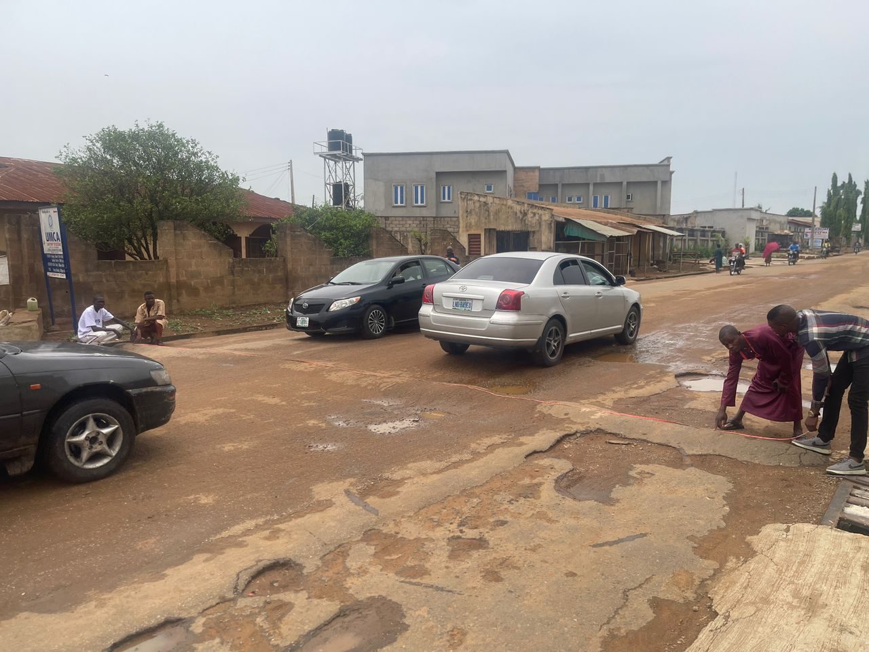

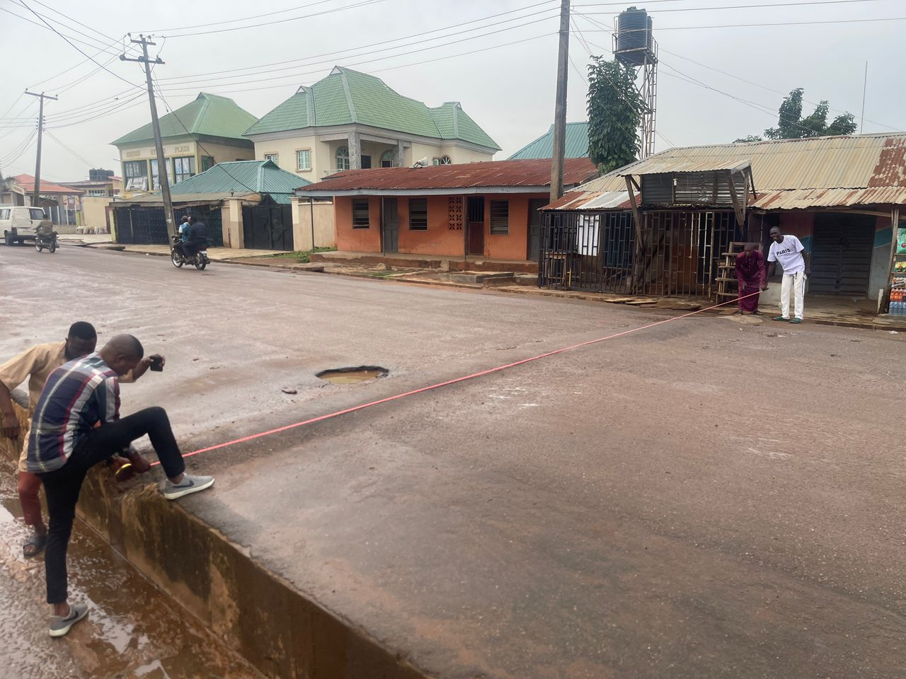
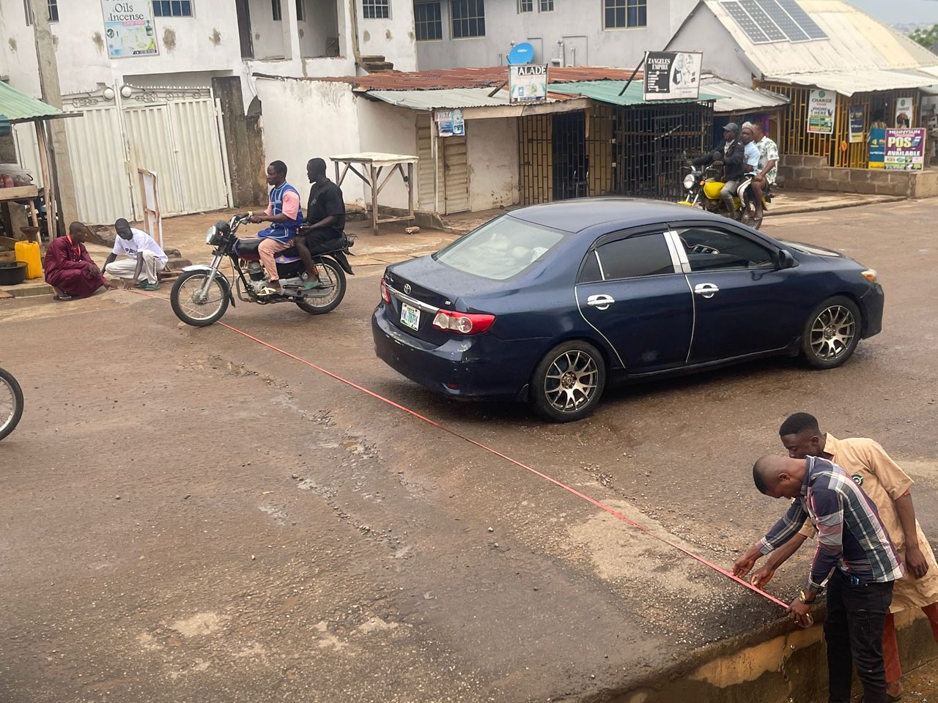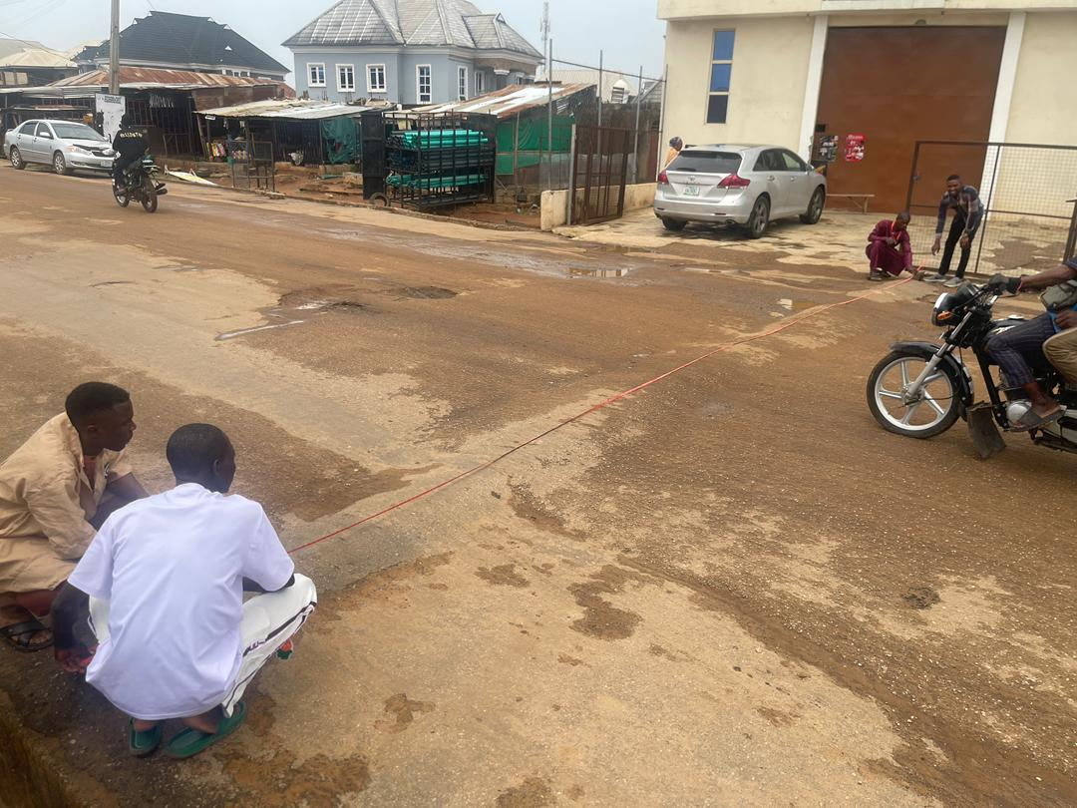
CHAPTER FOUR
4.0 DATA ANALYSIS RESULTS AND DISCUSSION
4.1 INTRODUCTION
This chapter is concerned with the presentation, analysis, and interpretation of data collected during the research. The goal is to provide a systematic evaluation of how road bumps impact passengers in terms of comfort, health, travel time, and vehicle experience. The research adopted a quantitative approach using structured questionnaires and observational methods. A total of 50 respondents participated, including public transport drivers, private car owners, and passengers who frequently travel along routes with road bumps. This chapter reveals major patterns in their responses and the implications for urban road design and passenger welfare.

4.2 Demographic Characteristics of Respondents
Understanding the background of respondents is crucial for interpreting the data. It provides context to how different categories of people perceive and are affected by road bumps.
Gender | Frequency | Percentage
Male | 30 | 66.7%
Female | 20 | 33.3%
Total | 50 | 100%

4.2.1 Average Speed Bumps Dimensions for Each Community
S/N | Location | Bumps width (m) | Bumps  Length (m) | Bumps  Height (m) | Bumps Type
1. | Kulende Estate Junction | 0.35 | 7.10 | 0.02 | Asphaltic
2. | Fct Kulende Estate Junction | 0.80 | 13.35 | 0.04 | Asphaltic
3. | Nigeria Police Division | 0.95 | 13.50 | 0.03 | Asphaltic
4. | National Police University | 0.50 | 7.30 | 0.02 | Asphaltic
5. | Police Medical Service | 1.40 | 10.60 | 0.02 | Asphaltic
6. | Olorunshogo Christ Apostolic Church | 1.40 | 10.60 | 0.02 | Asphaltic
7. | Adewumi Street Beside Railway | 1.40 | 10.60 | 0.02 | Asphaltic
8. | Fortunate Bread | 1.10 | 7.35 | 0.02 | Asphaltic
9. | Favor Natural Estate Hotel | 1.10 | 7.50 | 0.03 | Asphaltic
10. | Beside Irepodun Community | 0.7 | 7.35 | 0.02 | Asphaltic
11. | Itesiwaju Community | 0.7 | 7.35 | 0.02 | Asphaltic
12. | Al – hikman Medicine Store | 0.7 | 7.35 | 0.02 | Asphaltic
13. | Karumo Block Industries | 0.7 | 7.35 | 0.02 | Asphaltic
14. | Rasak Haruna Kanika Street | 1.00 | 8.50 | 0.03 | Asphaltic
15. | Lahsamdat Petroleum | 1.00 | 8.50 | 0.03 | Asphaltic
16. | Daratul Ma’arif for Arabic English Training | 1.00 | 8.50 | 0.03 | Asphaltic
17. | Beside Taiwan Intepress Petroleum | 0.85 | 8.8 | 0.03 | Asphaltic

Results presented in Table 1 can be compared with the general specification of speed bump design parameters ranging from 300 – 1000mm for length and 50 – 150mm for the height as shown in Fig. 1It was observed that all the bumps heights are outrageously higher than the specification while the bump lengths are at the maximum limit of the range. Although, length of speed bumps is the most important parameter, bump heights can influence the magnitudes of vertical accelerations and the maximum levels of perceived discomfort. This explains why exposure of human body to vibration can cause discomfort to the motorists. This is an indication that the driver and passengers bodies will be exposed to vibration and tilting as their vehicles wheels pitching and rolling on sharp bumps.
Table 4.2.2: Age Group Distribution
Age Range | Frequency | Percentage
18–25 | 15 | 25%
26–40 | 20 | 50%
41–60 | 10 | 20.8%
60 and above | 5 | 4.2%
Total | 50 | 100%

Table 4.2.3: Occupational Status
Occupation | Frequency | Percentage
Commercial Driver | 14 | 25%
Private Driver | 6 | 8.3%
Passenger | 25 | 58.4%
Road Safety Agent | 5 | 8.3%
Total | 50 | 100%
From the data, the majority of respondents (58.4%) were passengers who directly experience road bumps regularly, while 33.3% were drivers. This demographic distribution allows for a balanced analysis of the different user experiences.

4.3 Passenger Experience with Road Bumps
Respondents were asked how they generally feel when a vehicle passes over a road bump. Responses varied based on road conditions, speed, and frequency of travel.
Table 4.3.1: Passenger Comfort Level
Level of Comfort | Frequency | Percentage
Very Comfortable | 2 | 4.2%
Comfortable | 4 | 8.3%
Neutral | 8 | 12.5%
Uncomfortable | 25 | 41.7%
Very Uncomfortable | 13 | 33.3%
Total | 50 | 100%
Interpretation: Over 75% of respondents expressed discomfort when passing over road bumps. These discomforts ranged from minor irritation to significant physical distress.

4.4 Speed Reduction Due to Bump
Speed reduction is the factor or percentage with which the vehicle speed has been reduced from its approaching speed (i.e speed from the distance of 10m away from the bump).
Table 4.4.1: Reduction Dues to Bump Height
Bump height | Types of vehicle | Reduction at the bump (in %) | Reduction at 10m a way for the bump
40mm | Car | 34.97 | 16.82
30mm | Car | 28.51 | 12.58
40mm | Bus | 31.00 | 15.50
30mm | Bus | 30.21 | 16.50

Table 4.4.2: Reduction Due to the Types of Vehicle
Types of vehicle | Reduction at the bump (in %) | Reduction at 10m a way for the bump
Car | 30.90 | 15.15
Bus | 30.62 | 16.00

4.5 Observed Physical Impacts on Passengers
A portion of the questionnaire was dedicated to asking passengers about specific physical effects they’ve experienced due to repeated exposure to road bumps. The common responses included:
- Back Pain: Reported by over 45% of passengers, especially on long journeys or in buses with poor suspension.
- Neck Strain: Sudden jolts cause the neck to jerk, especially in older passengers.
- Fatigue and Discomfort: Caused by continuous bouncing, especially in vehicles traveling at moderate speed over multiple bumps.
- Fear or Anxiety: Especially in pregnant women and elderly passengers, due to potential injury or trauma

Drivers’ Observations and Challenges
Drivers gave insights into how road bumps affect driving conditions and passenger satisfaction.
- Increased Fuel Consumption: Due to constant braking and acceleration.
- Wear and Tear on Vehicle Suspension: More frequent maintenance required.
- Reduced Passenger Comfort: Drivers report receiving complaints from passengers.
- Reduced Trip Speed: Bumps prolong journey times, especially on routes with multiple bumps.

CHAPTER FIVE
5.0 SUMMARY, CONCLUSION, AND RECOMMENDATIONS

5.1 Summary of Findings
This study investigated how road bumps influence passenger experience, safety, and vehicle operations. From the findings:
- Over 70% of passengers find road bumps uncomfortable or very uncomfortable.
- Bumps are encountered frequently, with 66.7% experiencing them in every of almost every trip.
- Discomfort symptoms range from physical pain to emotional distress, especially among elderly and pregnant women.
- Drivers reported increased maintenance costs and fuel consumption due to road bumps.
- Poorly designed or unmarked road bumps significantly increased discomfort.

5.2 Conclusion
While road bumps are effective in reducing speeding and enhancing road safety, their improper design and excessive use cause considerable discomfort to passengers. The study concludes that a balance must be struck between road safety and passenger comfort. Poor implementation of traffic calming measures has a negative impact on transportation experience and efficiency.

5.3 Recommendations
Based on the findings, the following recommendations are made:
- Standardization of Road Bump Designs: Authorities should ensure that all road bumps conform to safety standards regarding height, width, and visibility.
- Proper Signage: Clear road signs should be placed before every bump to warn drivers in time to slow down gradually.
- Periodic Review of Bump Placement: Some bumps are unnecessary or redundant and should be reviewed or removed after traffic patterns change.
- Use of Alternative Calming Measures: In areas with low traffic violations, alternatives like rumble strips or speed cameras should be considered.
- Stakeholder Consultation: Urban planners and road users, including drivers and passengers, should be involved in decisions about bump placement.
- Public Awareness Campaigns: Educating drivers on safe speed reduction techniques can reduce the dependency on bumps while enhancing comfort and safety.

REFERENCES
Abaid, U., Salman, H., Ahmad, W., and Mirza, J. (2016). Usage and impacts of Speed Humps on Vehicle. Journal of Advanced Review on Scientific Research, Volume 28, Issue 1 (2016) 1- 17: ISSN 2289-7887.
Ashish, G. (2017).Project Report on Study of Speed Profile Across Speed Bumps: National Institute of Technology, Rourkela, Department of Civil Engineering. 30
CTRE (2020). Traffic and Safety Informational Series: Published by The Institute of Transportation Engineers, Iowa State University, United State of America.
Essays, UK. (2017).The Effects of Speed Humps on Vehicles: Engineering Essay. Retrieved from http://www.ukessays.com/engineering/the-Effects-of-speed-humps-on-vehicles- engineering-essay.php?cref=1 International Standards Organization (1997). Mechanical Vibration and Shock Evaluation of Human Exposure to Whole-body Vibration, part 1: general requirements, ISO 2631-1, 2nd edition.
Tajudeen, A., Adebayo, O., and Sunday, A. (2019).Vehicle Speed Control Using Road Bumps. Department of Mechanical Engineering, University of Ibadan, Ibadan Nigeria, Vol xix, No 3,103-136.
Tchemou G., Madjadoumbaye J., Fokwa D., Pengu R., Tchewou N., and Tamo, T (2022). Crirtical Analysis of Speed Bumps. Case Study of the Triangle Yaounde-Douala-Bafoussam- Yaounde Highway in Cameroon: ISSN 2250-2459, Volume 2, Issue 6.
Weber P.A (2020).Towards a Canadian Standard for the Geometric Design of Speed Bumps. Carleton University Ottawa, Ontario, Canada.
Zaidel D., Hakkert A.S., and Pistiner A.H., (2023). The Use of Road Bumps for Moderating Speeds on Urban Streets. Accident Analysis and Prevention, Vol. 124, N0. 1, pp. 45-56 31.

