KWARA STATE POLYTECHNIC, ILORIN
INSTITUTE OF TECHNOLOGY
DEPARTMENT OF CIVIL ENGINEERING

PERFORMANCE EVALUATION OF GAA-AKANBI INTERSECTION IN ILORIN, KWARA STATE

BY
AFOLAMI SAMUEL ABIDEMI
HND/23/CEC/FT/0289

BEING A RESEARCH WORK SUBMITTED TO THE DEPARTMENT OF CIVIL ENGINEERING, INSTITUTE OF TECHNOLOGY, KWARA STATE POLYTECHNIC, ILORIN KWARA STATE

IN PARTIAL FULFILMENT OF THE REQUIREMENT FOR THE AWARD OF HIGHER NATIONAL DIPLOMA (HND) IN CIVIL ENGINEERING

JULY, 2025.
CERTIFICATION
This is to certify that this research study was conducted by AFOLAMI SAMUEL ABIDEMI(HND/23/CEC/FT/0289) and had been read and approved as meeting the requirement for the award of Higher National Diploma (HND) in Civil Engineering of the Department of Civil Engineering, Institute of Technology, Kwara State Polytechnic, Ilorin

_____________________________ ________________________
S

ENGR.A. O. SAADU Date
Project Supervisor

______________________________ _________________________

ENGR. A. NAALLAH Date
Head of Department

_____________________ _________________
ENGR. DR. MUJEDU KASALI ADEBAYO Date
External Examiner

DECLARATION
I hereby declare that this project work titled PERFORMANCE EVALUATION OF GAA-AKANBI INTERSECTION IN ILORIN, KWARA STATE is a work done by me, AFOLAMI SAMUEL ABIDEMI (HND/23/CEC/FT/0289) of the Department of Civil Engineering, Institute of Technology, Kwara State Polytechnic, Ilorin.

__________________ ______________
Signature Date

DEDICATION
This project is dedicated solemnly to God Almighty, who is the sole inspiration of all things, without whom there would not be, and neither would this project.
Appreciation goes to my loving parents Mr. and Late Mrs. AFOLAMI for their support in the fulfillment of my Higher National Diploma (HND) both orally and financially. May God allow them to eat the fruit of their labor (Amen)
Lastly, I dedicated this project to my lecturers in civil engineering kwara state polytecgnic, for their efforts and contribution to my life. Thank you all.

AKNOWLEDGEMENT
I begin by expressing my deepest gratitude to the Almighty God, who has blessed me with the wisdom, strength, and resilience to complete this project.
I extend my sincere appreciation to my project supervisor, Engr. A. O. Saadu for his invaluable guidance, support, and encouragement throughout this journey. His expertise and constructive feedback were instrumental in shaping this project.
To my family, I express my heartfelt gratitude for their unwavering support and love. Who made me choose this interesting course, and thank you for being a constant source of motivation, encouragement and financial support. I appreciate your love.
I also acknowledge the entire staffs of the department of Civil Engineering in the Institute of Polytechnic, Ilorin, for their dedication, enlighten and support towards the success of my academics.
To my friends, guardians and colleagues, I appreciate your encouragement, advice, and camaraderie.
Thank you all for being part of my journey.

Table of Contents
Title Page ……………………………………… i
Certification …………………………………… ii
Declaration …………………………………… iii
Dedication ……………………………………… iv
Acknowledgement …………………………… v
Abstract ………………………………………… vi
Table of Contents …………………………… vii

CHAPTER ONE: INTRODUCTION
1.1 Background of the Study
1.2 Problem Statement
1.3 Aim and Objectives of the Study
1.4 Justification of the Study
1.5 Scope of the Study

CHAPTER TWO: LITERATURE REVIEW
2.1 Background
2.2 Basic Concepts of Roundabouts and Definitions
2.2.1 Major Geometric Features of Modern Roundabouts
2.3 Types of Roundabouts
2.3.1 Mini-roundabouts
2.3.2 Compact Roundabouts
2.3.3 Normal Roundabouts
2.3.4 Grade-separated Roundabouts
2.3.5 Signalized Roundabouts
2.3.6 Double Roundabouts
2.4 Concept of Roundabout Capacity
2.4.1 Empirical Method
2.4.2 Practical Capacity
2.5 HCM 2010 Roundabout Capacity Method
2.6 Determination of Circulating and Entering Flows
2.6.1 Single-lane Roundabout Capacity
2.6.2 Double-lane Roundabout Capacity
2.6.3 Pedestrian Effects on Entry Capacity
2.7 Performance Analysis
2.7.1 Degree of Saturation
2.7.2 Delay
2.7.3 Queue Length
2.7.4 Level of Service (LOS)
2.8 SIDRA Intersection
2.8.1 Benefits of SIDRA Intersection
2.8.2 Past Use of SIDRA Intersection
2.9 Outcomes of Past Research Works
2.10 Summary

CHAPTER THREE: METHODOLOGY
3.1 Description of Study Area
3.2 Data Collection
3.2.1 Traffic Flow Pattern
3.2.2 Geometric Features
3.3 Data Analysis

CHAPTER FOUR: RESULTS AND DISCUSSION
4.1 Geometric Features
4.2 Traffic Flow on Each Approach of the Roundabout
4.3 SIDRA Software 8 Plus for Performance of Roundabout Intersection
4.3.1 Traffic Data Input
4.3.2 Results of SIDRA Roundabout Intersection - Traffic Flow Analysis
4.3.3 Lane Summary and Flow Rates (Days 1–7)
4.4 Discussion of Results
4.4.1 Effect of Volume on Roundabout Capacity
4.4.2 Capacity of the Roundabout
4.4.3 Degree of Saturation
4.4.4 Average Control Delay
4.4.5 Level of Service (LOS)

CHAPTER FIVE: CONCLUSION AND RECOMMENDATIONS
5.1 Conclusion
5.2 Recommendations

References
Appendices

CHAPTER ONE

INTRODUCTION

1.1 Background of the Study
A modern roundabout is a type of intersection designed to control and manages traffic flow around a central island. It allows vehicles to move in a circular pattern, with priority generally given to those already in the junction (Oxford, 1993; FHWA-RD-00-067, 2000). Roundabouts differ from other traffic circles in their traffic control, pedestrian accessibility, parking, and circulation direction. When well-designed, roundabouts offer superior functional performance by reducing congestion under high traffic volumes and improving safety (Melike & Hilmi, 2014).
A roundabout intersection allows continuous traffic movement at reduced speeds, particularly at lower volumes (Huang, 1993). However, these intersections can still become points of conflict for vehicles, cyclists, and pedestrians (Miaou& Lum, 1993). Intersections are generally classified as either "at-grade" or "grade-separated," each having multiple forms (Saha, 2012). Figure 1.1 illustrates a typical roundabout.
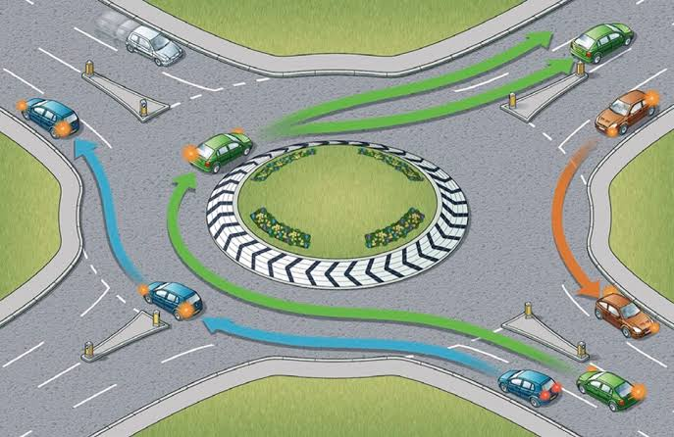
Figure1. 1: Aroundabout (Sourcegoogle)

In addition, a roundabout is defined as a central island or inscribed circle that directs traffic in either a clockwise or anti-clockwise direction, depending on the country’s driving rules. It serves as an example of a channelized intersection.
Geometric modifications may be required to improve a roundabout’s capacity and safety. These may include:
- Enhancing the capacity of external arms and the ring carriageway
- Improving alignment and lane control on the ring carriageway
- Increasing visibility zones at the junction
- Adding measures for pedestrians, cyclists, and public transportation (Robinson et al., 2000).
Geometric modifications can also involve:
- Adding extra directional lanes
- Expanding the size of splitter islands
- Implementing isolated or signal-controlled facilities (Robinson et al., 2000).
Travel time savings from increased highway capacity allow individuals to allocate more time to their activities rather than commuting (Levinson & Kanchi, 2002). However, such travel increases may also lead to environmental drawbacks and other externalities (Cirillo et al., 2011). At most road junctions, conflicting traffic results in time losses as vehicles compete for space (Ritchie, 2013).
For over three decades, modern roundabouts have been used worldwide to manage junctions. Nigeria is no exception, with numerous roundabouts across the country. Roundabout performance is typically assessed by three measures:
- Degree of saturation,
- Delay,
- Queue length (Rodegerdts et al., 2010).
Each of these measures provides a unique perspective on the quality of service delivered by a roundabout under specific traffic and geometric conditions.
SIDRA (Signalised and Unsignalised Intersection Design and Research Aid) is a software tool used to design and evaluate individual and networked intersections. It estimates queue lengths, stops, fuel consumption, emissions, and operating costs at intersections. It has been widely used to analyse various types of intersections, including signalized, unsignalized, roundabouts, and alternative intersection designs (Akcelik and Associates, 2018).
The Gaa-Akanbi roundabout intersection experiences significant congestion, especially during business hours, leading to increased travel times, fuel consumption, and environmental pollution. The primary goal of a roundabout is to allow safe and efficient traffic interchange with minimal delays. The operational efficiency of a roundabout depends on drivers’ willingness to accept gaps in circulating traffic, with lower speeds and angles reducing the severity of accidents (O. Flaherty et al., 2006).

1.2 Problem Statement
Due to the increasing population and economic growth in Nigeria for instance in Ilorin, Kwara State traffic volumes continue to grow especially at roundabouts while the available lanes remain relatively fixed. This has led to many commuters spending hours stuck in traffic everyday thereby prolonging their travel times, increasing their fuel consumptions and polluting the environment.
Attention has to be paid to the design, capacity and performance evaluation of these roundabouts, and the knowledge of its capacities or level of performance will enhance the management of traffic flow at the roundabouts.

1.3 Aim and Objectives of the Study
The aim of this study is to analyze the qualitative performance of the Gaa-Akanbi roundabout intersection in Ilorin, Kwara State, Nigeria.
The specific objectives are to:
- Determination of the geometric features of the roundabout
- Determination of the traffic flow pattern of the roundabout
- Determination of the capacity of the roundabout
- Estimation of the level of service of the roundabout

1.4 Justification of the Study
- To understand the underlying causes of congestion and delays, identify critical bottlenecks, and propose targeted interventions to optimize traffic operations and enhance safety for all road users.
- To contribute valuable knowledge to the field of traffic engineering and urban planning, enabling better traffic management and the sustainable development of transportation infrastructure in Ilorin.

1.5 Scope of the Study
The scope of this study includes the performance evaluation of the Gaa-Akanbi roundabout intersection using geometric and traffic data collected during peak periods. The analysis will follow the Gap-Acceptance method from the Highway Capacity Manual (HCM, 2010) using SIDRA Intersection 8 software.

CHAPTER TWO

LITERATURE REVIEW

2.1 Background
A roundabout, also known as a traffic circle, rotary, or in French, carrefour giratoire, is a type of circular intersection in which traffic flows in one direction around a central island. Priority is typically given to vehicles already within the junction (FHWA-RD-00-067, 2000). Modern roundabouts differ from traditional traffic circles or rotaries, which tend to have higher entry speeds, allow lane changes within the circle, and often result in more high-speed crashes. In contrast, modern roundabouts require vehicles to yield upon entry, prohibit lane changes, and maintain lower speeds, enhancing safety and capacity. These roundabouts generally have entry speeds below 25 mph, whereas traditional rotaries may have speeds exceeding 40 mph (Roundabout-U, 2009).

2.2 Basic Concepts of Roundabouts and Definitions
A roundabout is defined as a channelized intersection where traffic moves counterclockwise around a central traffic island (AACRA Geometric Design Manual, 2003). Unlike traffic circles, roundabouts give priority to circulating traffic. The key feature is that vehicles entering the roundabout must yield to traffic already inside. This design simplifies the driver’s decision-making, reducing confusion and increasing safety (Rodegerdts et al., 2010).

2.2.1 Major Geometric Features of Modern Roundabouts
The performance of a roundabout heavily relies on its geometric design. Proper geometry not only enhances capacity but also improves safety. Some key geometric features of roundabouts include:
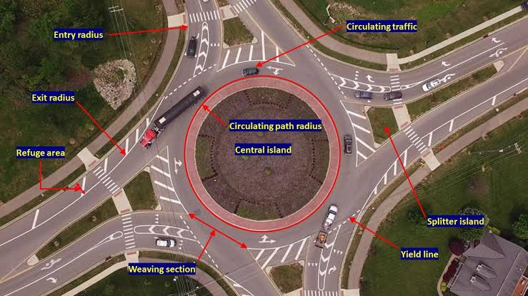
Figure2.1:BasicGeometricFeaturesofModern Roundabout(Source:google)

- Circulatory Roadway: A one way lane around the central island
- Splitter Island: A triangular island that separates entering and exiting traffic, ensuring proper vehicle deflection and safety.
- Yield or Entrance Line: A line that functions as the give-way point for entering vehicles (Rodegerdts et al., 2010).
- Central Island: A raised area in the center for deflection and navigation
- Approach Width: The width of the entering lanes before any influence from the roundabout.
- Bypass Lane: Provides an alternative for vehicles making heavy right turns to bypass the roundabout.
- Truck Apron: A traversable section of the central island designed for larger vehicles.
- Entry and exit curves: Designed to reduce speed and guide vehicles smoothly
- Landscaping: Central island features for aethethics and visibility
- Weaving lenght: Is the roadway segment where vehicles merge, diverge, or change lanes between entry and exit points.

2.3 Types of Roundabouts
Roundabouts come in various forms, each suited to different traffic demands and intersection layouts. The main types are:

2.3.1 Mini-roundabouts
Mini-roundabouts are small intersections used in place of stop controls or signalized intersections. They are most effective in low-speed environments and where space constraints prevent larger roundabouts.

2.3.2 Compact Roundabouts
Compact roundabouts have single-lane entries and exits, making them ideal for accommodating pedestrians and cyclists. Their design limits vehicle speeds, ensuring safety even in higher-speed areas (DMRB, 2007).

2.3.3 Normal Roundabouts
Normal roundabouts feature a central island of at least 4 meters in diameter. These can handle dual or single carriageway approaches and allow multiple vehicles to enter and exit simultaneously (DMRB, 2007).

2.3.4 Grade-separated Roundabouts
Grade-separated roundabouts are designed to link roads at different levels, such as motorways or intersections with underpasses or flyovers, allowing continuous traffic flow without signalization (DMRB, 2007).

2.3.5 Signalized Roundabouts
In signalized roundabouts, traffic signals are installed at one or more entry points. These signals regulate traffic flow where the roundabout's natural priority system does not suffice, enhancing capacity and safety (DMRB, 2007).

2.3.6 Double Roundabouts
Double roundabouts consist of two roundabouts connected by a short link. Designed as a unified system, they manage high traffic volumes efficiently without the need for signalized junctions (DMRB, 2007).

2.4 Concept of Roundabout Capacity
Capacity is the maximum sustainable traffic flow rate through a roundabout, under prevailing conditions. It is a key determinant of operational performance measures such as delay, queue length, and stop rate. Two primary methods are used to estimate roundabout capacity:

2.4.1 Empirical Method
The empirical method, pioneered by Kimber in 1980, uses a linear model to calculate the entry capacity of roundabouts. Kimber’s equation takes into account geometric parameters such as entry width, circulating width, and inscribed diameter. The general form of Kimber’s capacity formula is:
Qe=F−fcQc
Where:
- Qe​ = Entry capacity (vehicle per hour)
- Qc= Circulating flow past the entry (vehicle per hour)
- fc​= Empirical factor representing the reduction in capacity
- F =maximum entry capacity or Intercept (O. Flaherty, 2006)
Kimber's formula is adaptable for roundabouts of various sizes and includes adjustments for geometric characteristics like the flare sharpness and entry width (Tewodros, 2007).

2.4.2 Practical Capacity
Research by Wohl and Brian (1967) suggests using 85% of the calculated capacity as the practical capacity for roundabouts. They developed a formula to calculate the practical capacity and accounting for factors like entry and circulatory widths.
Qp= 0.85x Qc
Where:
- Qp = Practical capacity (vehicle per hour)
- Qc= Theoretical capacity (vehicle per hour )

2.5 HCM 2010 Roundabout Capacity Method
The roundabout capacity model presented in the 2010 edition of the Highway Capacity Manual (HCM 2010) utilizes an empirical regression approach derived from gap acceptance theory. This theory underpins the roundabout capacity model and is influenced heavily by driver behavior and local driving patterns. According to HCM 2010, capacity is primarily driven by the ability of vehicles to find acceptable gaps in the circulating flow.
The roundabout entry capacity is expressed as an exponential function of conflicting traffic, which represents the vehicles already circulating within the roundabout. The general capacity equation for a single entry lane is:
Ce=A⋅exp(−Bqc)
Where:
- Ce=​ is the entry lane capacity (in vehicles per hour, or pc/h),
- qc= is the conflicting flow rate (also in pc/h),
- A and B are constants that reflect the driver’s behavior in terms of follow-up headway (tft_ftf​) and critical headway (tct_ctc​), respectively.
The parameters AAA and BBB can be computed as follows:
A= = frac{3600}/{tf}=​B= frac(tc−0.5tf)/3600B
Where:
- tf= is the follow-up headway (seconds), representing the time interval between two successive vehicles entering the roundabout from the same lane.
- tcis the critical headway (seconds), representing the minimum gap required by a vehicle to enter the roundabout.
HCM 2010 suggests that local conditions and driver behavior heavily influence these parameters, and they can be adjusted using local calibration for greater accuracy. The default parameter values for single-lane roundabouts in the United States are tf=3.19t_f = 3.19tf​=3.19 seconds and tc=5.19t_c = 5.19tc​=5.19 seconds, which gives A=1128A = 1128A=1128 and B=0.001B = 0.001B=0.001 for conflicting flows.
For multi-lane roundabouts, the capacity model adjusts to account for the multiple circulating lanes. For a two-lane roundabout, the model provides distinct capacity estimates for the right lane and the left lane, with different critical headway values for each. The HCM 2010 default parameters for two-lane roundabouts are:
- Right lane: tf=3.19t_f = 3.19tf​=3.19 seconds, tc=4.11t_c = 4.11tc​=4.11 seconds, yielding B=0.0007B = 0.0007B=0.0007,
- Left lane: tf=3.19t_f = 3.19tf​=3.19 seconds, tc=4.29t_c = 4.29tc​=4.29 seconds, yielding B=0.00075B = 0.00075B=0.00075.
These empirical models allow for a generalized capacity analysis of both single-lane and multi-lane roundabouts across varying conditions, but the flexibility to calibrate for local data is critical for improved accuracy in specific environments (HCM 2010).

2.6 Determination of Circulating and Entering Flows
In roundabout capacity analysis, the two critical flow rates that must be determined are the circulating flow rate and the entering flow rate. These are essential inputs for calculating the capacity of roundabouts and determining operational performance under varying traffic conditions.
- Circulating flow is the traffic volume already in the roundabout that conflicts with vehicles trying to enter from an approach. It can be measured or calculated by summing the traffic movements upstream of the subject entry.
- Entering flow refers to the total number of vehicles attempting to enter the roundabout from a given approach. This value is derived from the sum of vehicles turning left, right, or going straight ahead on the subject approach.
To account for the presence of heavy vehicles such as trucks and buses, Passenger Car Equivalents (PCEs) are used. The conversion from vehicle flows to PCE flows is done by applying an adjustment factor based on the proportion of heavy vehicles. The HCM 2010 provides typical PCE values for various vehicle types:
Vehicle Type | Passenger Car Equivalent (PCE)
Passenger Car | 1.0
Heavy vehicle | 2.0

𝑣𝑖,𝑝𝑐
=𝑣𝑖
𝑓𝐻𝑉
(2.11)

𝑓𝐻𝑉
= 1
1+(𝐸𝑇−1)
(2.12
where:

vi,pce= demand flow rate form ovementi(pc/h)

𝑣𝑖=demand flow rate form ovementi(veh/h)

𝑓𝐻V=heavy vehicle adjustment factor

𝑃𝑇=proportion of demand volume that consists of heavy vehicles

𝐸𝑇=passenger care quivalent for heavy vehicles

2.6.1 Single-lane Roundabout Capacity
For single-lane roundabouts, the maximum entry flow is inversely related to the circulating flow. Research by Bruce et al. (2000) suggests that as circulating flows increase, the entry capacity decreases. Their regression-based approach provides capacity estimates for roundabouts with inscribed circle diameters between 25 m and 55 m.
The relationship between maximum entry flow and circulating flow has been empirically modeled, with an approximate maximum entry flow of 1,800 vehicles per hour under ideal conditions. However, higher circulating flows reduce entry capacity significantly, necessitating careful design and potential signalization to avoid congestion.

2.6.2 Double-lane Roundabout Capacity
For double-lane roundabouts, the capacity model also follows a regression-based approach but accounts for more complex interactions between lanes. As noted by Kimber (1980), the right lane typically has a higher entry capacity than the left lane due to its proximity to the circulating flow. This imbalance can be addressed by adjusting lane usage strategies or modifying the roundabout's geometry.
Double-lane roundabouts are typically used when demand exceeds the capacity of a single-lane roundabout. The inscribed circle diameters are usually larger, ranging from 40 m to 60 m, which allows for smoother vehicle maneuvering and increased capacity at moderate to high circulating flows.

2.6.3 Pedestrian Effects on Entry Capacity
Pedestrian crossings at roundabouts, particularly those located at the entry points, can reduce the vehicle entry capacity significantly. Pedestrians are typically given priority, which forces vehicles to yield, leading to increased delays. To account for these effects, capacity reduction factors have been developed to estimate the impact of pedestrian traffic on entry flow.
According to HCM 2010, the presence of pedestrian crosswalks, especially at high-volume locations, may warrant special design considerations such as pedestrian overpasses or underpasses to minimize conflict with vehicular traffic.

2.7 Performance Analysis
Performance analysis of roundabouts involves evaluating several key metrics, including capacity, delay, queue length, and level of service (LOS). The HCM 2010 provides a structured methodology for roundabout performance analysis, consisting of a 12-step process for determining overall operational efficiency.

2.7.1 Degree of Saturation
The degree of saturation or volume-to-capacity ratio (v/c) is a critical performance measure that indicates how well a roundabout is handling its traffic load. A ratio below 0.85 suggests that the roundabout is operating efficiently, while ratios above this threshold may indicate the onset of congestion and excessive queuing. The formula for degree of saturation is:
xi= frac{vi}/{ci}xi​
Where:
- xi_=volumetocapacityratioordegreeofsaturation
- vi= demand flow rate for subject lane I (veh/h)
- ci= ​ is the capacity of lane iii.(veh/h)

2.7.2 Delay
Delay is an essential performance measure that reflects the time lost due to queuing and waiting for gaps in circulating traffic. HCM 2010 defines control delay as the average time a vehicle is delayed at a roundabout approach. This delay accounts for both queuing and gap acceptance behavior. The formula to calculate average control delay is:
Where:
- ddd is the average control delay (seconds per vehicle),
- xxx is the volume-to-capacity ratio,
- TTT is the time period in hours.

2.7.3 Queue Length
Queue length is another critical performance indicator. It reflects the number of vehicles waiting at a roundabout approach. The average queue length can be calculated using Little’s Rule, which relates the number of vehicles in a queue to the entry flow and delay:The95th-percentile queue length is also of interest as it provides insight into the maximum queue length expected under peak conditions
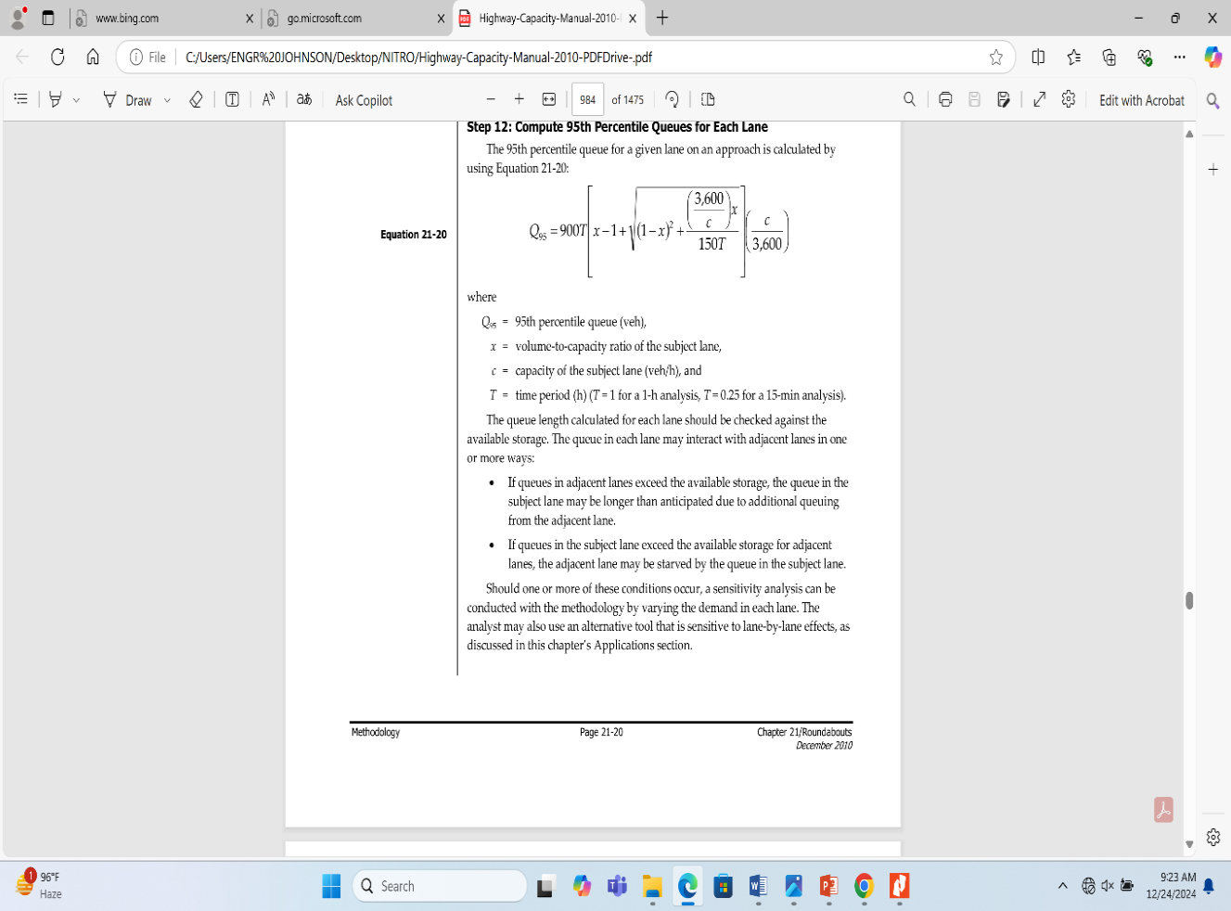

2.7.4 Level of Service (LOS)
The Highway Capacity Manual (HCM, 2010) defines quality of service as the degree to which a transportation facility or service operates in alignment with traveler expectations and needs. It evaluates how effectively the facility handles traffic from the traveler's perspective, considering aspects like ease of travel, speed, and comfort. The Level of Service (LOS) is a quantitative classification that represents this quality of service using measurable performance indicators. LOS for roundabouts, for example, is assessed by control delay (the time spent waiting due to traffic control measures, such as stop signs or signals). Table 2.2 summarizes the relationship between the volume-to-capacity (v/c) ratio and the resulting LOS classification.
In the context of LOS assessment at the approach and intersection levels, LOS is determined solely based on control delay. If the v/c ratio exceeds 1.0, the intersection or lane is considered to be over capacity, which automatically results in a LOS F rating, regardless of the actual control delay. This is consistent with the approach defined in the HCM (2010) for stop-controlled intersections, and the criteria are outlined in Table 2.2 below:
Table 2.2: Level-of-Service Criteria
Table2.2:Level-of-ServiceCriteria

Control Dalay (s/veh) | LevelofServicebyVolume-to-CapacityRatio
Control Dalay (s/veh) | v/c≤1.0 | v/c≥1.0
0-10 | A | F
˃10-15 | B | F
˃15-25 | C | F
˃25-35 | D | F
˃35-50 | E | F
˃50 | F | F
*Forapproachandintersection-wideassessment,LOSisdefinedsolelybycontrol delay.
Source: HCM (2010)
As illustrated in the table, LOS A indicates optimal traffic conditions, where delays are minimal, while LOS F represents severe congestion, where travel time is unpredictable, and traffic is at a standstill. LOS is a critical tool for traffic engineers to analyze highways and intersections, assigning quality levels based on performance measures like traffic speed, density, and vehicle delay.
The LOS system utilizes a letter grading from A to F, with A being the best possible scenario and F representing the worst-case scenario. These levels are based on different traffic performance measures:
- LOS A: Free Flow – Traffic moves at or above the posted speed limit, with minimal delays and complete mobility between lanes. Vehicles are spaced around 167 meters apart, which is roughly 27 car lengths. This condition usually occurs late at night in urban areas and frequently in rural areas.
- LOS B: Reasonably Free Flow – Speeds comparable to LOS A, but with slightly restricted manoeuvrability within the traffic stream. The minimum spacing between vehicles is around 100 meters (approximately 16 car lengths). Motorists still enjoy high levels of comfort and mobility.
- LOS C: Stable Flow – Traffic moves steadily but at or near the free-flow speed, with noticeable restrictions on the ability to change lanes. Lane changes require more driver awareness, and manoeuvrability is more restricted. LOS C is often the target for urban highways, where some slowdowns are acceptable, and for most rural highways.
- LOS D: Approaching Unstable Flow – Speeds begin to decrease as traffic volumes increase, limiting the freedom to maneuver within the traffic stream. The spacing between vehicles is reduced to around 50 meters (about 8 car lengths). Minor traffic incidents or disruptions may cause significant delays. LOS D is frequently the goal for urban streets during peak hours, as achieving better levels (e.g., LOS C) often requires prohibitive costs for additional infrastructure.
- LOS E: Unstable Flow – Traffic operates at capacity, and flow becomes highly irregular with frequent speed fluctuations. There are virtually no gaps available for lane changes, and speeds rarely reach the posted speed limit. The average vehicle spacing is reduced to about 6 car lengths, and this level of service is often accepted in larger urban areas where congestion is unavoidable.
- LOS F: Forced or Breakdown Flow – Traffic comes to a standstill, with vehicles moving in unison with frequent stopping and starting. Travel time becomes unpredictable due to severe congestion, with demand exceeding capacity.
The HCM (2000) describes LOS F as a condition where every vehicle is forced to move at the speed dictated by the vehicle directly ahead, making lane changes and maneuverability difficult or impossible. Travel times become highly variable, and congestion may persist for extended periods, especially during peak hours or in high-traffic zones.

2.8 SIDRA Intersection
The SIDRA INTERSECTION software was first developed between 1975 and 1979 by Rahmi Akcelik. SIDRA is an acronym that stands for Signalized & Unsignalized Intersection Design and Research Aid. Over time, the software has evolved to become one of the most widely used traffic analysis tools globally. The SIDRA INTERSECTION 8.0, released in April 2018, provides significant improvements in processing efficiency for network models and an enhanced user interface, improving overall workflow (Akcelik and Associates, 2018).
SIDRA INTERSECTION is primarily used as a tool for analyzing and designing individual intersections as well as networks of intersections. The software can handle a variety of intersection types and traffic conditions, including:
- Signalized Intersections: Fixed-time or pre-timed signals (EQUISAT) and actuated signals.
- Unsignalized Intersections: Roundabouts, two-way stop sign control, give-way/yield sign control, all-way stop sign control.
- Pedestrian Crossings: Signalized and unsignalized.
- Roundabouts: Unsignalized, roundabouts with metering signals, fully signalized roundabouts.
- Interchanges: Single-point interchanges (signalized), freeway diamond interchanges (signalized, roundabout, sign control), diverging diamond interchanges, and other alternative intersections.
- Uninterrupted Traffic Flow: The software also supports analysis of uninterrupted traffic flow conditions, such as merge and diverge points (Akcelik and Associates, 2018).

2.8.1 Benefits of SIDRA Intersection
The SIDRA INTERSECTION software offers numerous advantages for traffic analysis and design. Some of the key benefits include:
- Lane-Based Analytical Traffic Network Model: SIDRA uses a detailed lane-based approach to model intersections and road networks, making it suitable for complex intersection configurations.
- Energy and Emission Models: SIDRA incorporates energy consumption and emission models to assess the environmental impact of traffic operations. This feature enables planners to evaluate the sustainability of different design and operational strategies.
- Practical Calibration for Modern Vehicles: The software includes an easy-to-use calibration method to reflect the behavior of modern vehicles in traffic, ensuring that simulations and analysis remain accurate and relevant.
- Intersection Geometry and Flow Conditions: SIDRA can automatically incorporate intersection geometry and flow conditions when determining the capacity of sign-controlled intersections, reducing the need for manual input and improving accuracy.
- Network Timing Calculations: The software has advanced timing calculation methodologies that allow for the determination of cycle times, phase times, and signal offsets for coordinated signal networks. These calculations are crucial for optimizing the timing and coordination of signals in larger networks of intersections.
- Customizability for Local Driving Conditions: SIDRA provides users with the ability to adjust traffic and geometric parameters to reflect local driving habits, making it versatile for different regions and traffic environments (Akcelik and Associates, 2018).

2.8.2 Past Use of SIDRA Intersection
Since its first release in 1984, SIDRA INTERSECTION has grown to become the most widely used traffic analysis software. By March 2018, the software was used by approximately 1900 organizations worldwide, with 8150 licenses in use across 86 countries. The software is particularly popular in countries like the USA (600 organizations), Canada (90 organizations), Australia (450 organizations), New Zealand (80 organizations), South Africa (110 organizations), and Europe (180 organizations). It is also extensively used in Malaysia, Singapore, the Arabian Peninsula, and Latin America (Akcelik and Associates, 2018).
Some notable examples of SIDRA's application include:
- Ferntree Gully Rd – Scoresby Rd, Melbourne, Australia: A real-life survey showed that SIDRA’s estimates for actuated signal performance were highly accurate at this intersection (Akcelik and Associates, 2018).
- North Carolina, USA: A study conducted by North Carolina State University evaluated various software packages for signalized intersections, including SIDRA, TRANSYT, HCS/HCM, Signal 94, HCM/Cinema, and EVIPAS. The report concluded that SIDRA offered superior performance, ease of use, and optimization features, making it the preferred choice (Akcelik and Associates, 2018).
- Lucca, Tuscany, Italy: Researchers from the University of Pisa used SIDRA to analyze a 1.5 km road corridor with seven intersections, including signalized intersections, roundabouts, and two-way stop-controlled intersections (Akcelik and Associates, 2018).
Additionally, SIDRA has been applied to various studies focusing on traffic analysis, including research on metering signals at a roundabout in Melbourne, Australia, and on the environmental impacts of roundabout configurations in different countries (Akcelik and Associates, 2018).

2.9 Outcomes of Past Research Works
Numerous research studies have employed the SIDRA INTERSECTION software to analyze the performance of roundabouts across various regions, highlighting the tool's versatility in different traffic environments. A study conducted by Tewodros (2007) in Addis Ababa, Ethiopia provided valuable insights into how roundabouts in densely populated urban areas manage high traffic volumes. The findings revealed that pedestrian crossings and large vehicle entry volumes often resulted in significant congestion, with roundabouts frequently operating at Levels of Service (LOS) E or F. This study underscored the importance of considering pedestrian activity and local traffic conditions when evaluating roundabout performance in emerging cities with growing traffic demands.
In India, Mallikarjuna (2014) conducted an in-depth analysis of roundabouts in various urban centers. His research found that high entry volumes, often exacerbated by complex traffic dynamics and insufficient lane discipline, led to operational levels ranging from LOS E to F. These findings highlighted the challenges of maintaining roundabout efficiency in high-density urban areas and pointed to the need for capacity enhancements and traffic management solutions tailored to local driving behaviors.
Similarly, Akcelik (2005) studied the effectiveness of metering signals at a roundabout in Melbourne, Australia, showcasing the flexibility of the SIDRA tool in assessing modern traffic control interventions. His research indicated a wide range of volume-to-capacity ratios, with LOS varying from B to F, depending on the time of day and the traffic management strategies in place. This study was particularly valuable in demonstrating how metering signals could alleviate congestion during peak hours while preserving roundabout efficiency at other times.
Further research conducted by Nyantakyi et al. (2013) in Ghana illustrated the pressing issue of traffic congestion at roundabouts in growing African cities. The study identified that significant congestion was caused by high entry volumes during peak hours, leading to an overall operational performance of LOS E or F. This work highlighted the need for capacity improvements and better traffic control mechanisms to address the growing demands on urban roundabouts in regions with rapidly expanding vehicular populations.
Yusuf et al. (2018) carried out a similar study in Ilorin, Nigeria, where they identified capacity limitations at key roundabout approaches. Their research emphasized the necessity for intersection upgrades and additional traffic management measures to improve the operational performance and safety of roundabouts in the area. The study concluded that capacity improvements were essential to elevate the roundabout's performance from LOS E-F to more acceptable levels.
Finally, Abubakar and Yusuf (2019) investigated a rotary intersection in Birni Kebbi, Nigeria, and found that it was operating under severe congestion, corresponding to LOS F. The study emphasized the urgent need for infrastructure upgrades and the redesign of the rotary intersection to accommodate increased traffic volumes. Their research demonstrated that the intersection's current configuration was inadequate for the city's growing traffic demands, underscoring the importance of timely interventions to prevent further traffic deterioration.
Overall, these studies indicate that while SIDRA INTERSECTION is an effective tool for evaluating roundabout performance, local traffic conditions, driver behavior, and infrastructural constraints play critical roles in determining operational efficiency. The research findings reinforce the need for tailored traffic management solutions to meet the unique demands of each region.

2.10 Summary
This section explored the methodologies and tools available for roundabout capacity analysis, with a specific focus on empirical and analytical methods. The empirical method relies on roundabout geometry and traffic design features to estimate capacity, offering a straightforward approach to understanding intersection performance. However, this method may not fully account for dynamic driver behavior and local traffic conditions, which can significantly influence roundabout operations. As a result, the empirical approach is often considered less adaptable to diverse traffic environments, particularly in regions with unique traffic patterns or where roundabouts are a relatively new feature in the road network.
In contrast, the analytical method, specifically the Gap-Acceptance Method, provides a more realistic and nuanced assessment of roundabout capacity. This approach takes into account driver behavior, such as the decision-making process involved in entering the roundabout based on available gaps in circulating traffic. By incorporating these behavioral factors, the Gap-Acceptance Method offers a more accurate and context-sensitive evaluation of roundabout performance. This method is especially valuable in regions where traffic behaviors may differ significantly from standardized assumptions, providing a deeper understanding of how local driving habits influence intersection efficiency.
The Highway Capacity Manual (HCM, 2010) advocates for the use of the analytical method for roundabout capacity and Level of Service (LOS) assessments, given its ability to capture more complex and realistic traffic dynamics. Consequently, this research utilizes the SIDRA INTERSECTION 8 software, which employs the Gap-Acceptance Method as part of its comprehensive analysis framework. SIDRA offers a sophisticated platform for evaluating roundabout performance by incorporating real-world traffic conditions, intersection geometry, and driver behavior into its models.
Through SIDRA's advanced simulation capabilities, the research aims to deliver a thorough assessment of roundabout operations, identifying areas for improvement and proposing potential interventions. By simulating different traffic scenarios, SIDRA allows for a detailed examination of how various design and control strategies impact overall intersection performance. This ensures that recommendations are not only theoretically sound but also practically applicable, offering a valuable tool for traffic planners and engineers seeking to optimize roundabout functionality in diverse regions. Ultimately, the combination of the Gap-Acceptance Method and SIDRA INTERSECTION software provides a robust foundation for understanding and improving roundabout performance across a wide range of traffic environments.

CHAPTER THREE

METHODOLOGY

3.1 Description of Study Area
The Gaa-Akanbi roundabout intersection is located in Ilorin, Kwara State, with coordinates of 8°27'49.49"N and 4°34'55.55"E (Google Earth Pro). Figure 3.1 shows the location of the study area.The intersection has four arms:
1. The western approaches is Gaa-Akanbi Road
2. The Southwest approaches is Offa Garage Road
3. The northeast approache is Tipper Garage Road
4. The eastern approach is Agbabiaka Road
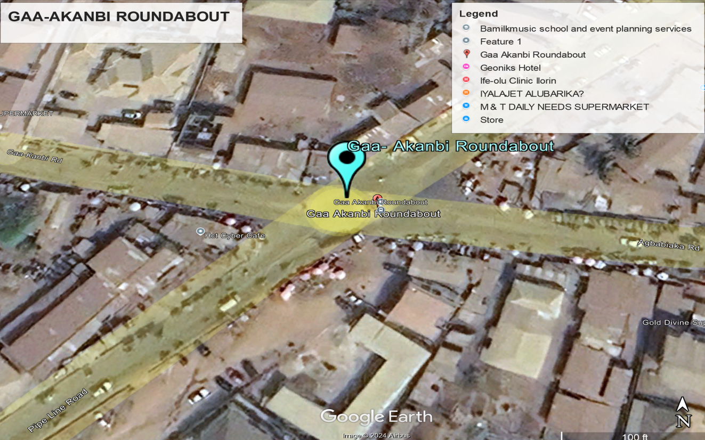
Figure3.1:MapofGaa-Akanbiroundabout intersection
(Source: Google earth)

3.2 Data collection

3.2 .1.TrafficFlow Pattern
The traffic data for this study were gathered using a Video recording method, which involves recording of vehicle movements. This method provides a reliable way to collect traffic data, allowing for detailed observations. Data collection occurred over a two-hour period each day, from 7:30 to 8:30 AM and 3:30 to 4:30PM, conducted at 15-minute intervals over seven days (from Monday, December 2, 2024, to Sunday, December 8, 2024).
The study identified the peak traffic period predominantly between 7:30 to 8:030 AM and 3:30 to 4:30PM.This choice was informed by previous studies indicating that morning hours typically exhibited the highest traffic volume (Atomode, 2013; Yusuf et al., 2018). To ensure accurate data collection, two skilled enumerators were stationed at strategic locations at the Top of the uncompleted building very close to the roundabout, ensuring that their views of traffic movements were unobstructed.
Additionally, the enumerators noted the types of vehicles, which provided insights into traffic composition and potential impacts on the roundabout’s performance. This data was collected systematically for the peak periods, allowing for a comprehensive understanding of vehicle movements and flow dynamics at the intersection.

3.2.2Geometric features
In this study, a measuring tape was employed to collect the geometric features of the Gaa-Akanbi roundabout intersection located in Ilorin, Kwara State, Nigeria. The geometric parameters measured include the entry width, which is critical for determining how many vehicles can safely enter the roundabout simultaneously; the approach half-width, which aids in evaluating the roadway configuration as vehicles approach the intersection; the circulatory width, essential for understanding how vehicles navigate within the roundabout; and the inscribed circle diameter, which represents the overall size of the roundabout. These measurements are vital for assessing the roundabout's capacity and flow characteristics.
Following the geometric data collection, the data was formatted to meet the input requirements for SIDRA Intersection 8 software. This software is widely used in traffic engineering for modelling and analyzing intersection performance. The accurate geometric data ensured that the simulation would reflect real-world conditions, providing a solid basis for subsequent traffic analysis and evaluation

3.3 Data Analysis
The SIDRA Intersection 8 software was used to analyze the collected data using the input data to determine the capacity and level of service (LOS) of the roundabout. This input data was entered into the software through several specific windows designed for various input categories as shown in the figure (3.3-3.8) in the appendix.This window allows users to visualize the overall configuration of the intersection, including arrangement of lanes and approaches.
The inputdata across these various windows, was used to run simulations and produce analytical results. These results provided a detailed performance evaluation of the Gaa-Akanbi roundabout, revealing insights into congestion factors affecting the intersection. Based on the analysis, a redesign of the Gaa-Akanbi roundabout was initiated, involving modifications to the geometric parameters to address identified congestion issues effectively.

CHAPTER FOUR

RESULTS AND DISCUSSION

This chapter presents the results obtained from the data analyzed to evaluate the performance of
Gaa-Akanbi Roundabout.

4.1 Geometricfeatures
The geometryof Gaa-Akanbiroundaboutwere measured onthesiteusing a measuring tape, as summarized in the Table 4.1 and illustrated in on Figure 4.1 .TheentrywidthsforGaa- Akanbi and Offa garage approaches are 7.30 and 5.20m, respectively .Similarly, the entry width of Tipper garage and Agbabiaka approaches have entry width 5.20m and 8.90m respectively. The roundabout lane width and roundabout diameter are 10.3 and 8.00 m respectively. This implies that three lanes exist at the roundabout and this may warrant more vehicles trying to use roundabout at the same time causing traffic congestion at the roundabout.

Figure4.1:GeometricparametersofGaa-AkanbiRoundabout

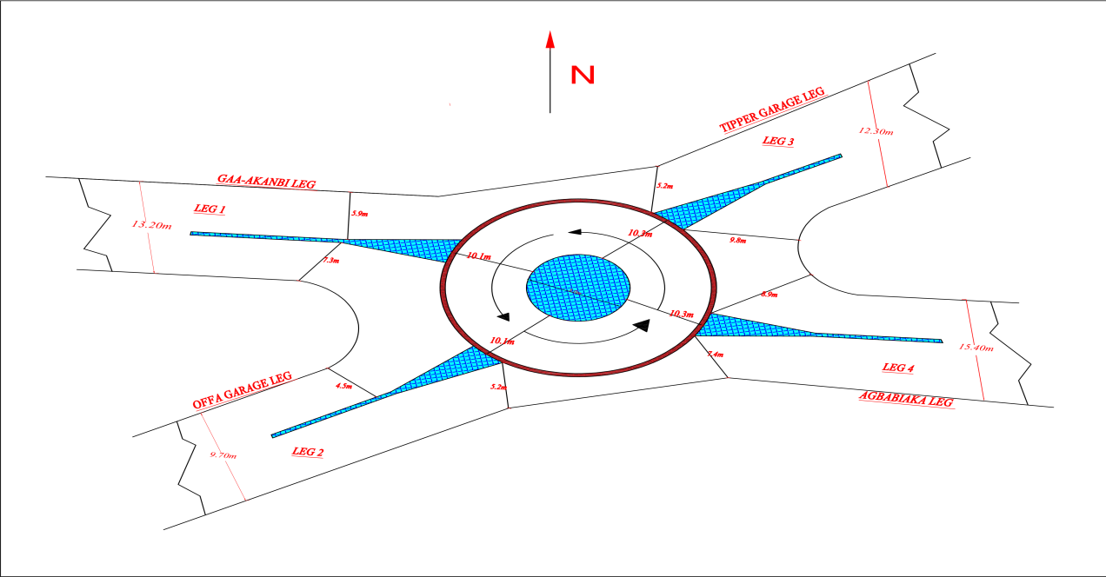

Table4.1:Geometry features of Gaa-Akanbi roundabout

Approach | Entrywidth  (m) | Approach  width(m) | Circulatory  width(m) | Inscribed  diameter (m)
Gaa-Akanbi | 7.30 | 6.9 | 10.1 | 8.0
OffaGarage | 5.2 | 4.7 | 10.1 | 8.0
Tipper Garage | 5.2 | 4.9 | 10.3 | 8.0
Agbabiaka | 8.9 | 7.6 | 10.3 | 8.0

4.2 Trafficflow on each approach of roundabout

The collected traffic data represents the existing peak two hour traffic conditions at the
Gaa- Akanbi Roundabout for all approach lanes: Gaa- Akanbi, Offa garage, Tipper garage and Agbabiaka Road. The data was gathered over seven days from December 2 to December 8, 2024, during two peak hours’ time intervals:7:30-8:30AM and 3:30- :4:30PM.The results were analyzed and computed using Microsoft Excel, as shown below for each day.

Figure4.2: Showing the total, average of flow pattern of each approachesofGaa-Akanbi

Roundabout

Figure4.3: Showing the total, average of flow pattern of each approachesof

Gaa-AkanbiRoundabout

Figure4.4: Showing the total, average of flow pattern of each approachesof

Gaa-AkanbiRoundabout

Figure4.5: Showing the total, average of flow pattern of each approachesof

Gaa-AkanbiRoundabout

Figure4.6: Showing the total, average of flow pattern of each approachesof

Gaa-AkanbiRoundabout

Figure4.7: Showing the total, average of flow pattern of each approachesof

Gaa-AkanbiRoundabout

Figure4.8: Showing the total, average of flow pattern of each approachesof

Gaa-AkanbiRoundabout

4.3 SIDRA Software 8 PlusforPerformance of RoundaboutIntersection

4.31: Trafficdatainput

Table4.2presentstrafficdatainputsuchasEntryDemand Volume;
Peak Hours Factor (PHF).The PHFs were computed from Equation 2.20

Table4.2:SIDRATRAFFIC DATAINPUT
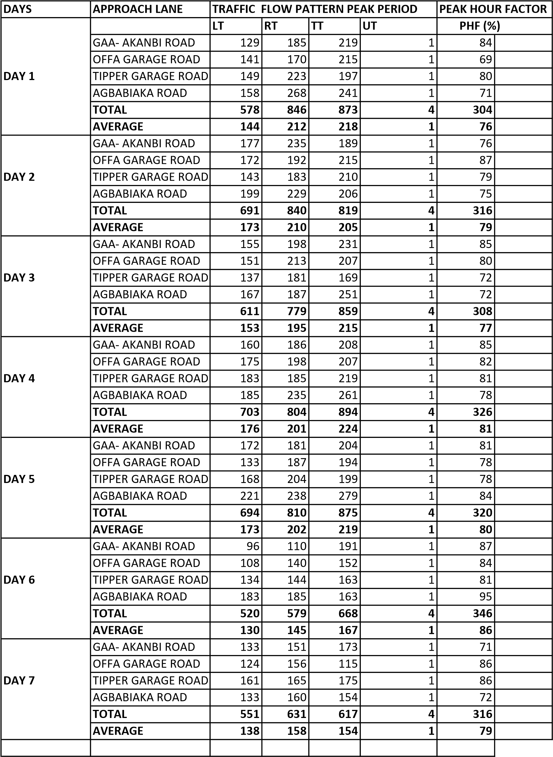

4.3.2 ResultsofSIDRA Roundabout Intersection-Analysisof Traffic Flow

The traffic volume results presented in Tables 4.0.2 to 4.0.8 highlight the peak traffic conditions at the Gaa-Akanbi roundabout. The analysis indicates the roundabout experiences significant congestion, particularly during peak periods on week days (Monday – Friday) Traffic flow data from seven peak-periods were utilized for this analysis. The assessment was conducted using the HCM (2010) roundabout performance method module.
This methodology was implemented within the SIDRA 8 software to evaluate the existing traffic conditions effectively.

LANE SUMMARY
ROUNDABOUT COMPRISING FOUR (4) CONNECTING ROADS WHICH ARE :GAA -AKANBI,OFFA GARAGE
,TIPPER GARAGE & AGBABIAKA

Table 4.3Gaa-Akanbiroundaboutlane performanceonDay

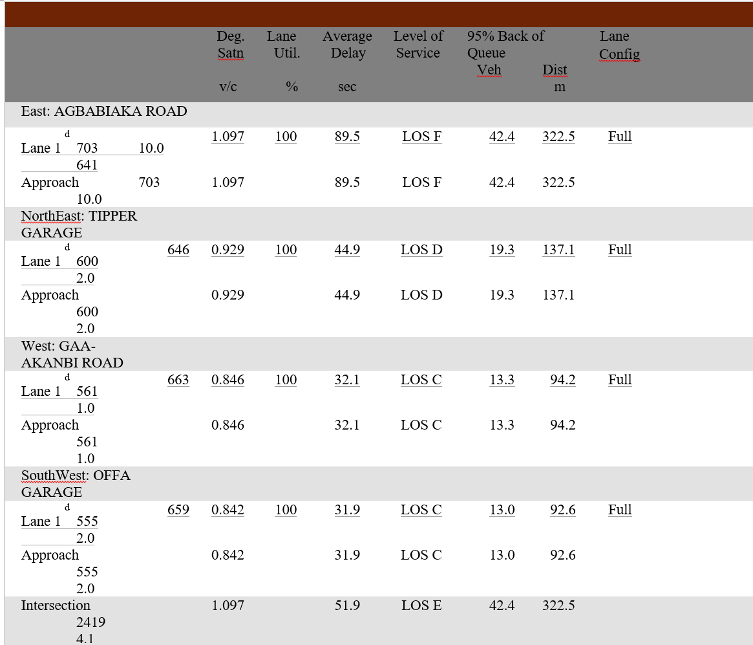

LANE FLOWS
ROUNDABOUT COMPRISING FOUR (4) CONNECTING ROADS WHICH ARE :GAA -AKANBI,OFFA
GARAGE,TIPPER GARAGE & AGBABIAKA

Table 4.4Gaa-AkanbiroundaboutlaneflowsummaryonDay1

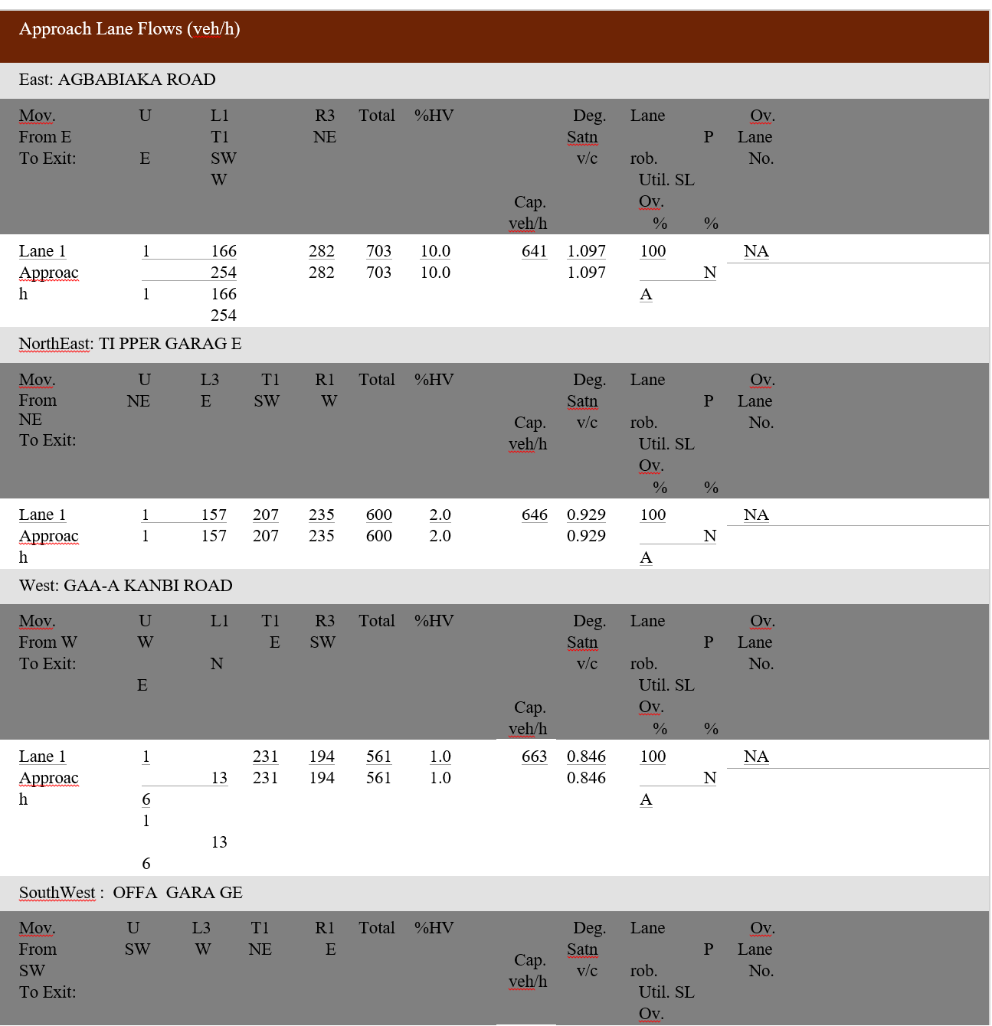

Table 4.5Gaa-AkanbiroundaboutcirculatingflowratesonDay1

Circulating Lane Flow Rates
Lane |  | Circulating Flow Rate
No veh/h |  | pcu/h | Percent
East: AGBABIAKA ROAD
Lane 1 514  Approach 514 |  | 518  518 | 100.0
NorthEast: TIPPER GARAGE
Lane 1 534  Approach 534 |  | 540  540 | 100.0
West: GAA-AKANBI ROAD
Lane 1 519  Approach 519 |  | 524  524 | 100.0
SouthWest: OFFA GARAG E
Lane 1  Approach | 526  526 | 530  530 | 100.0

Table 4.5.1.5 Gaa-AkanbiroundaboutPerformance IntersectionandLOSonDay1

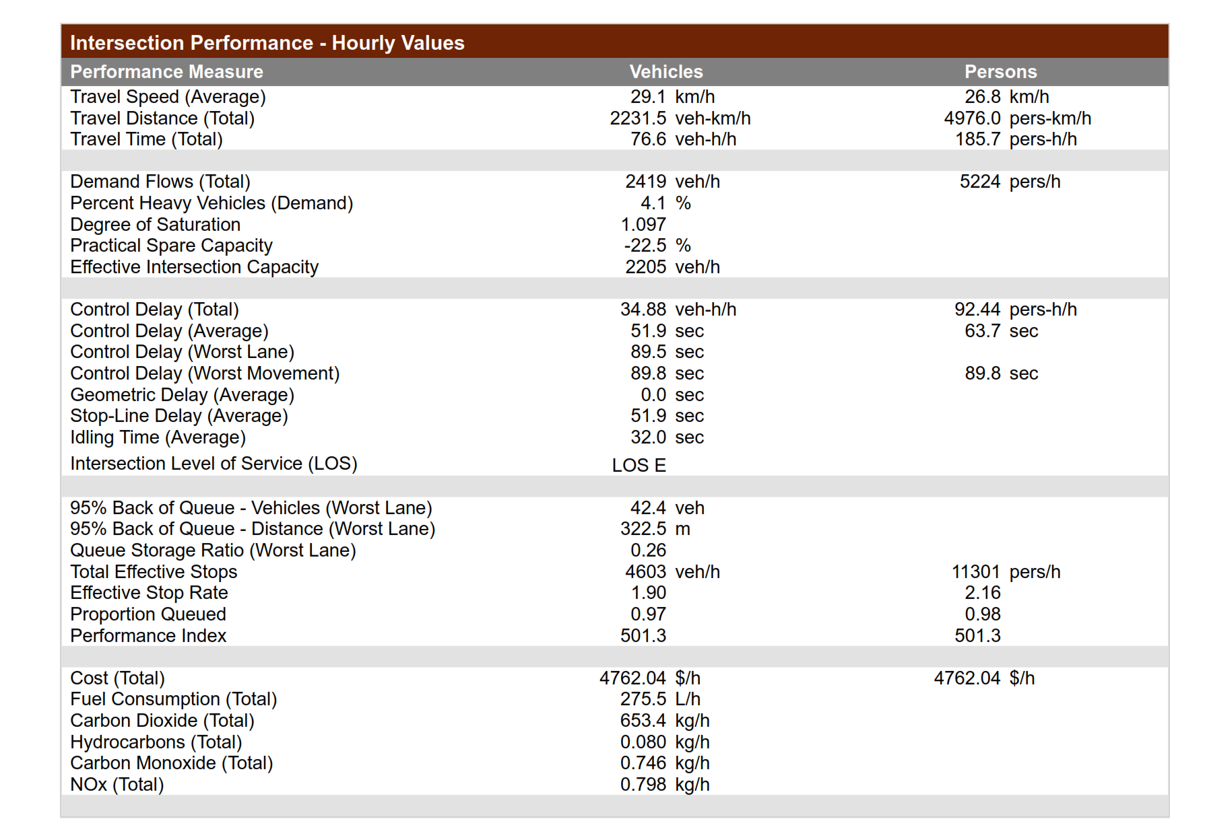

Table 4.5.1.5 Gaa-AkanbiroundaboutcontroldelayandLOSonDay1
Site:
101
[
GAA
-
AKANBI ROUNDABOUT DAY1]

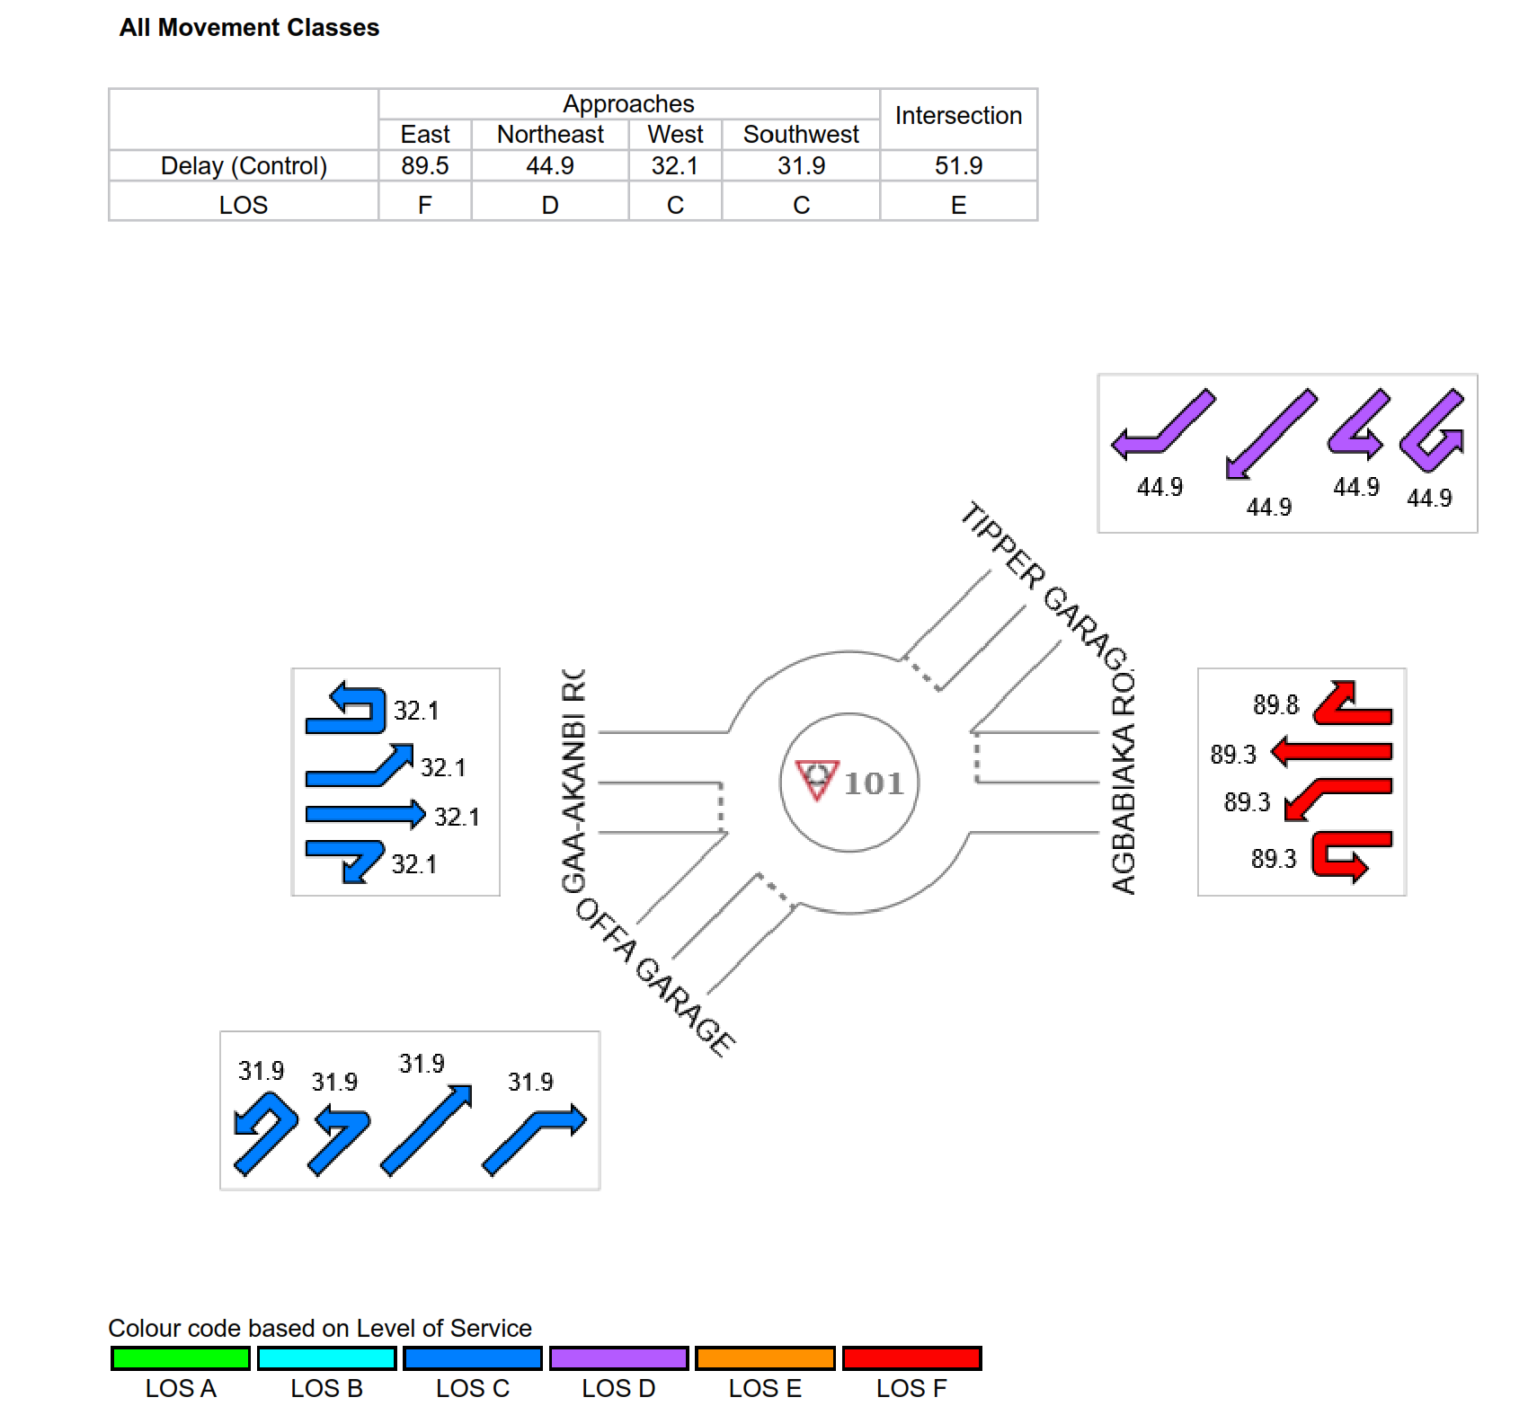

Table4. 15:Gaa-AkanbiRoundaboutDegree ofsaturationof eachapproach Day 1

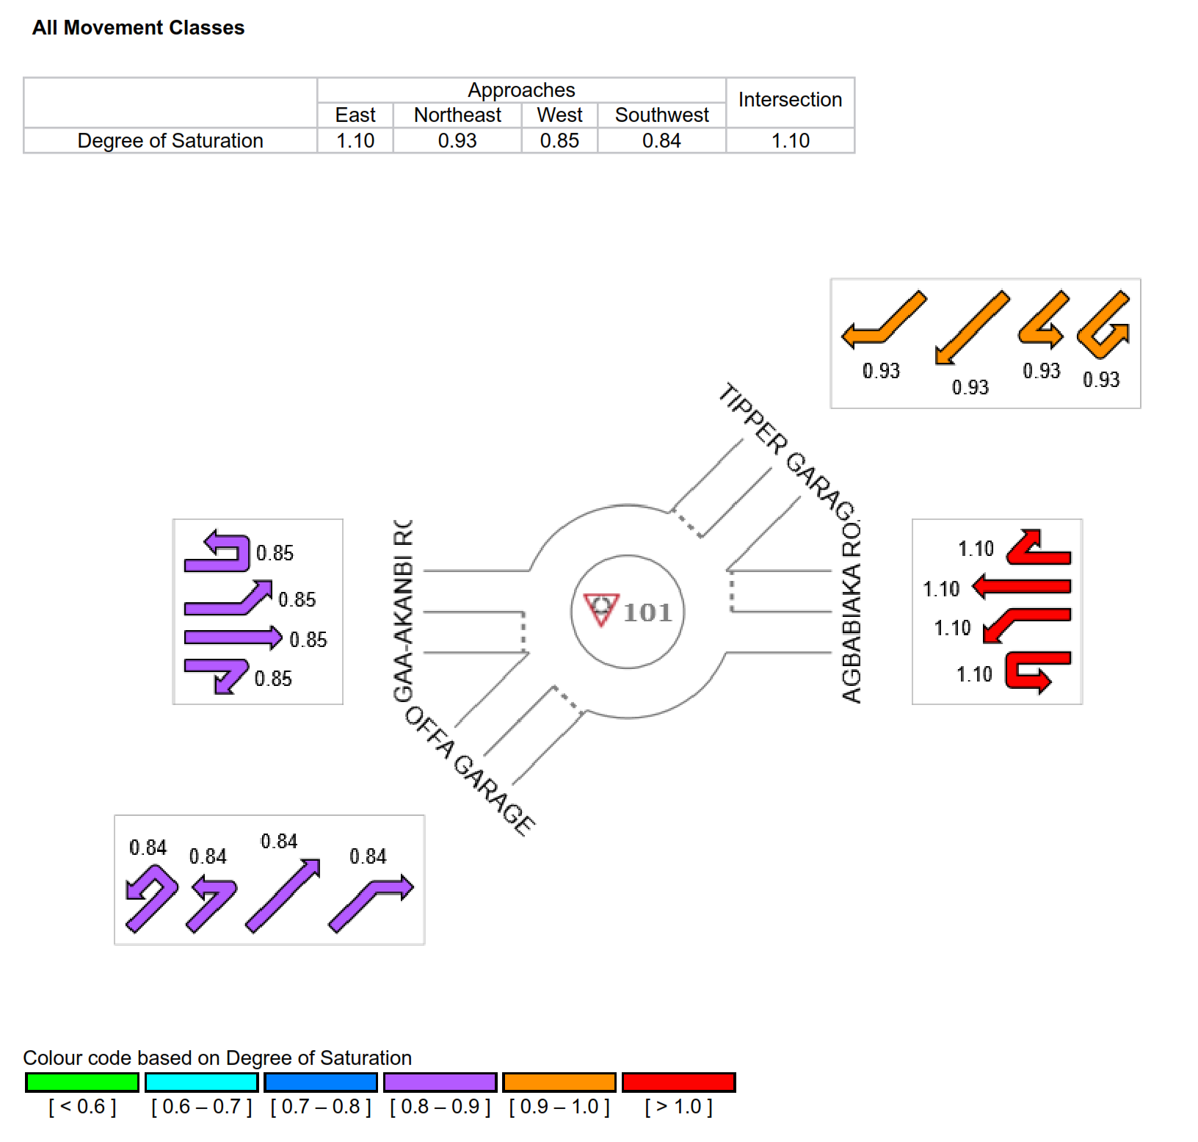

Table 4.1.6.1 Gaa-Akanbiroundaboutlane performanceonDay2
Site:
101
[
GAA
-
AKANBI ROUNDABOUT DAY 2]
LANE SUMMARY
ROUNDABOUT COMPRISING FOUR (4) CONNECTING ROADS WHICH ARE :GAA
-AKANBI,OFFA GARAGE,TIPPER GARAGE & AGBABIAKA
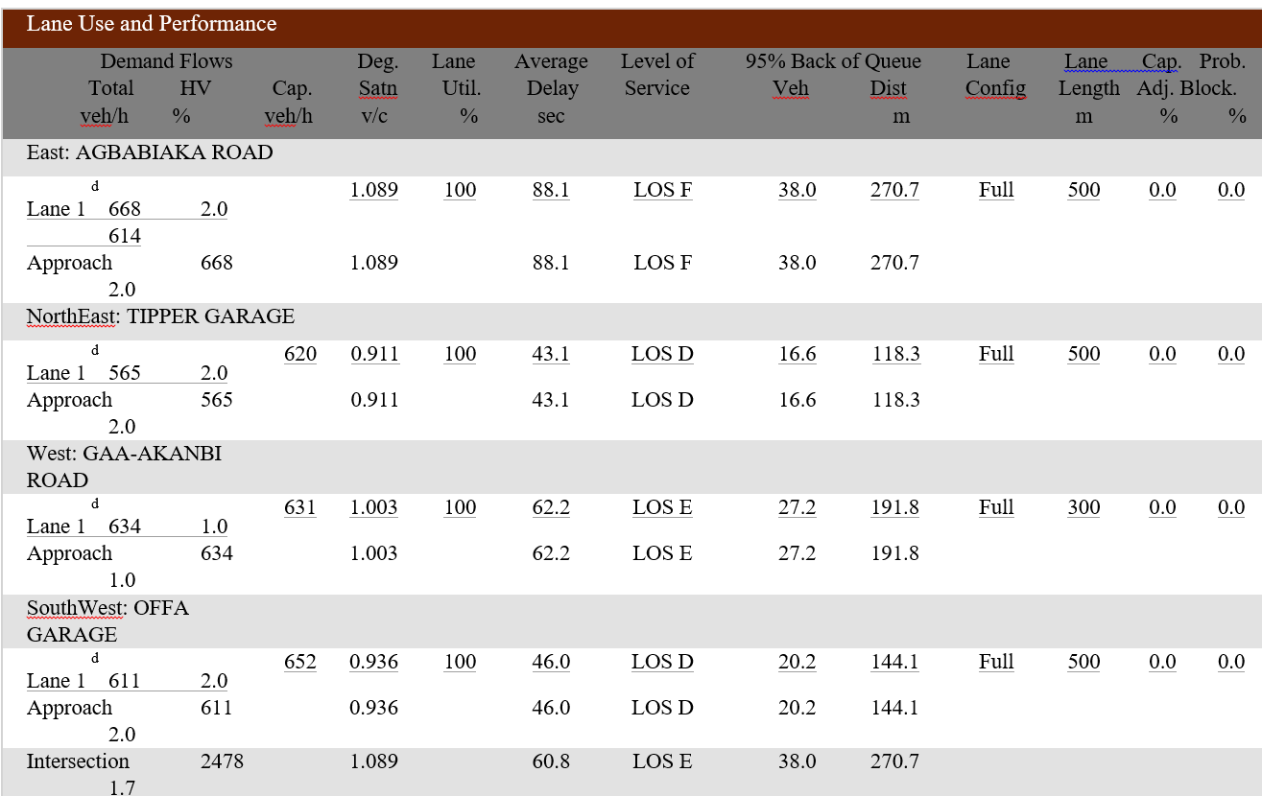

Table 4.1.6.2 Gaa-AkanbiroundaboutlaneflowsummaryonDay2

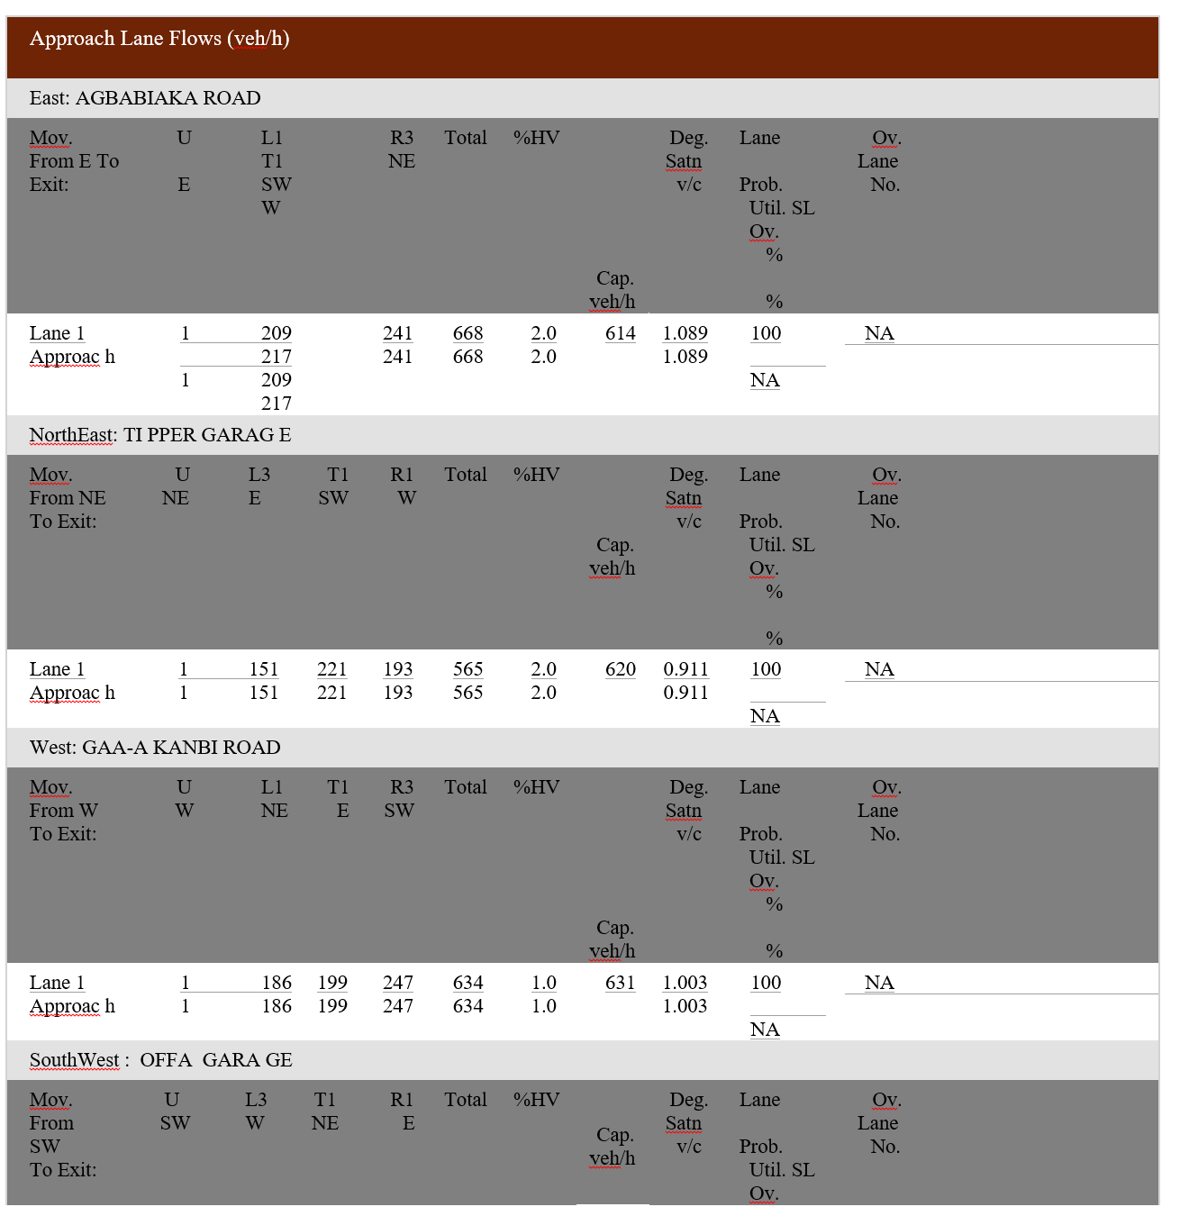

Table 4.1.6.3 Gaa-AkanbiroundaboutcirculatingflowratesonDay2

Site Category: ROUNDABOUT

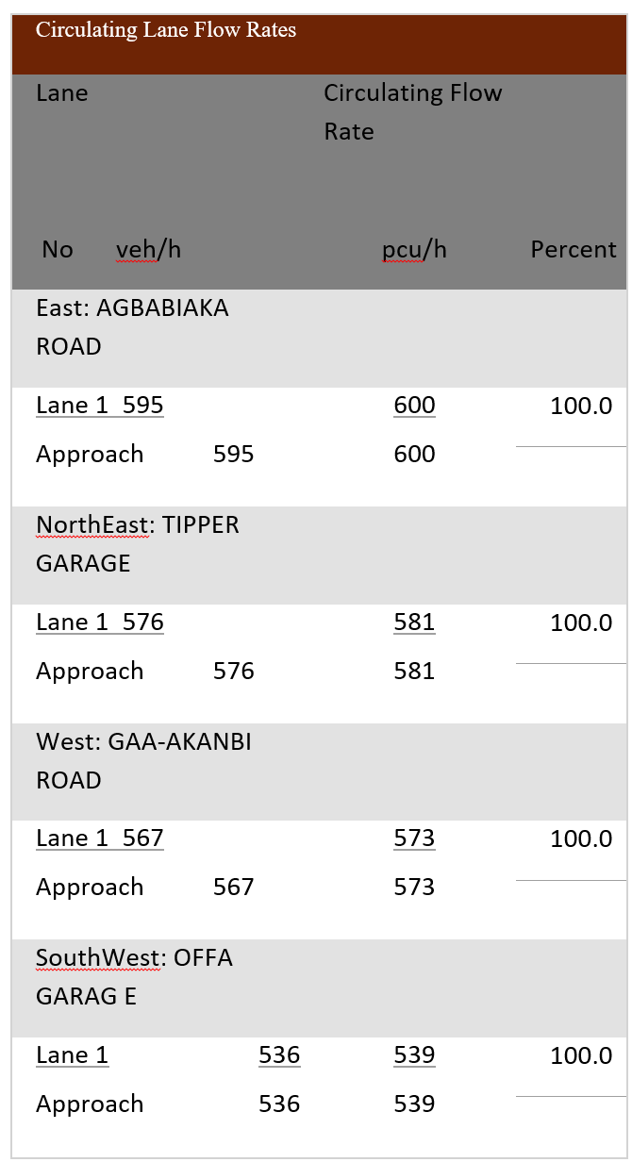

Table 4.1.6.4 Gaa-AkanbiroundaboutperformancesummaryonDay 2

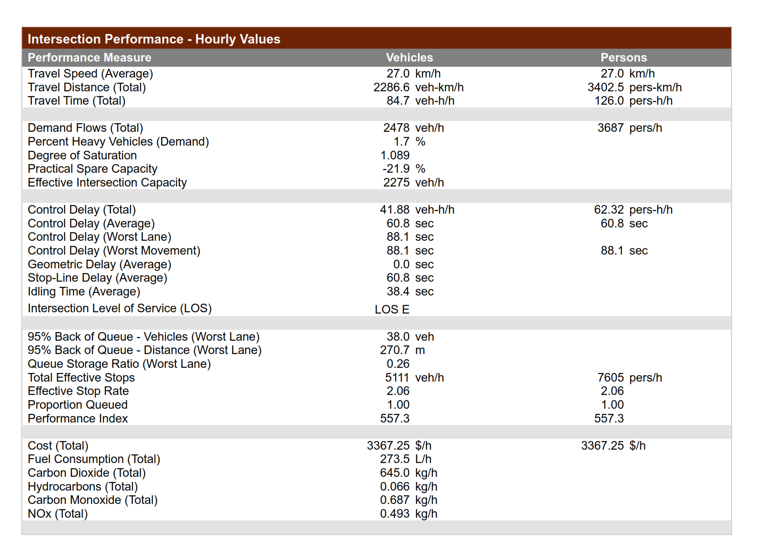

Table4.1.6.5 Gaa-AkanbiroundaboutcontroldelayandLOSonDay2

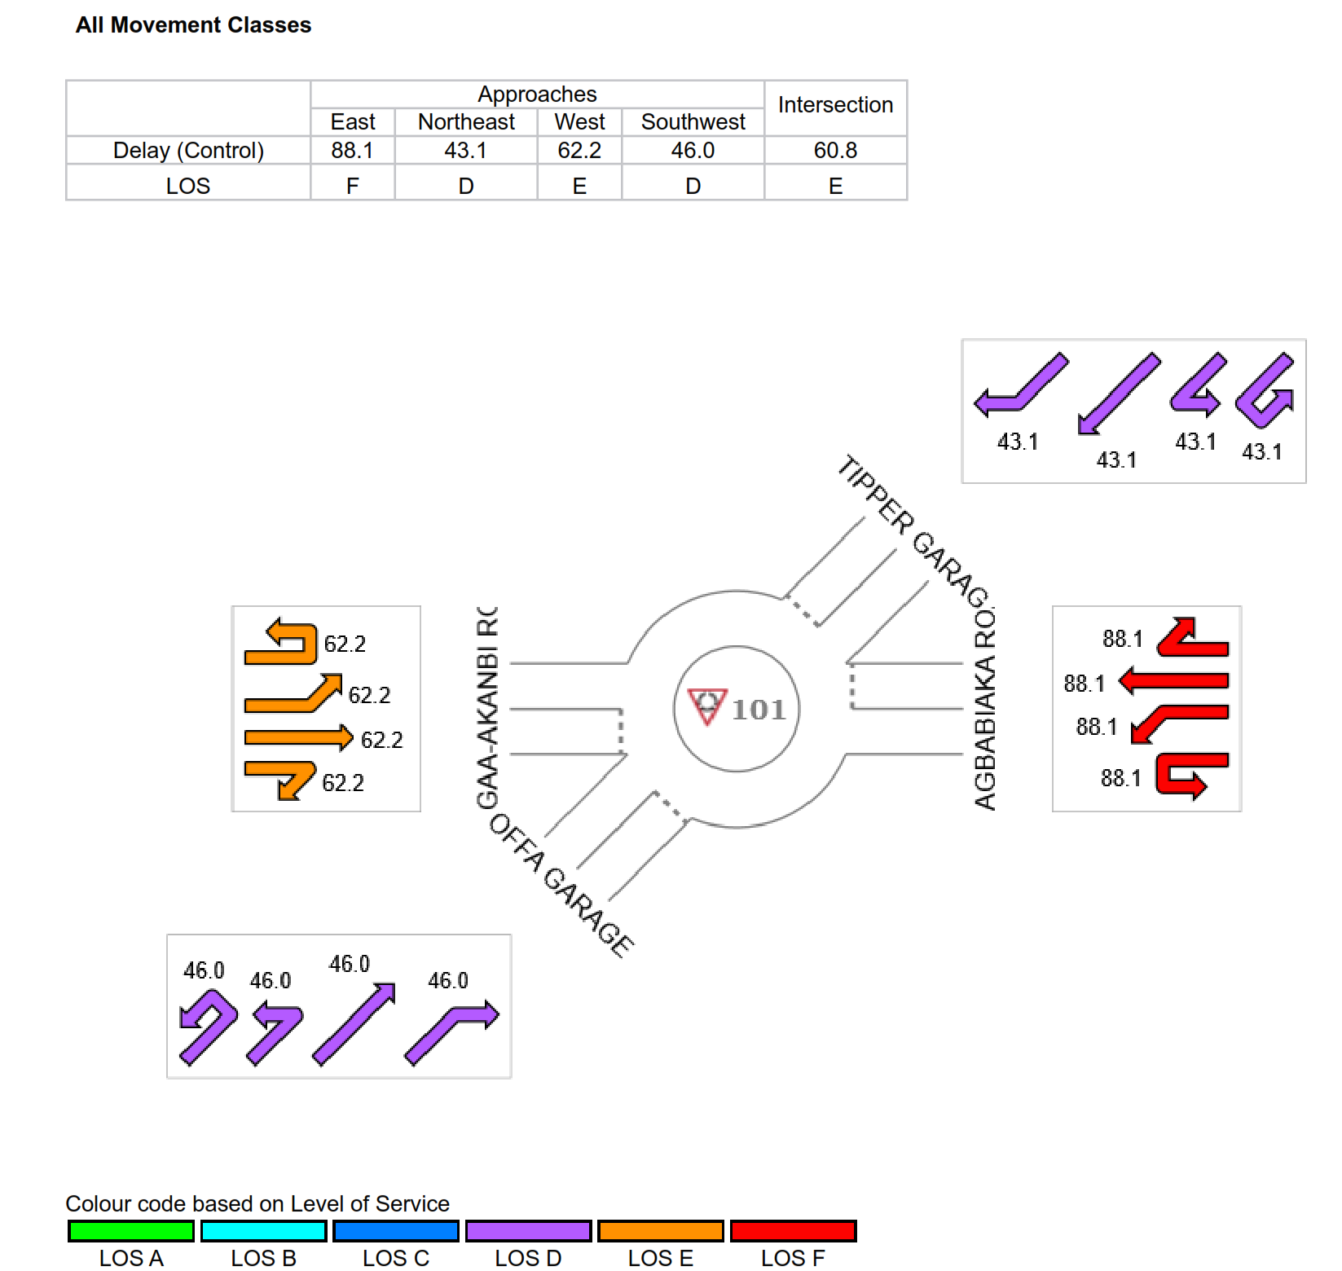

Table 4.1.6.6 Gaa-AkanbiRoundaboutDegree ofsaturationof eachapproach Day 2

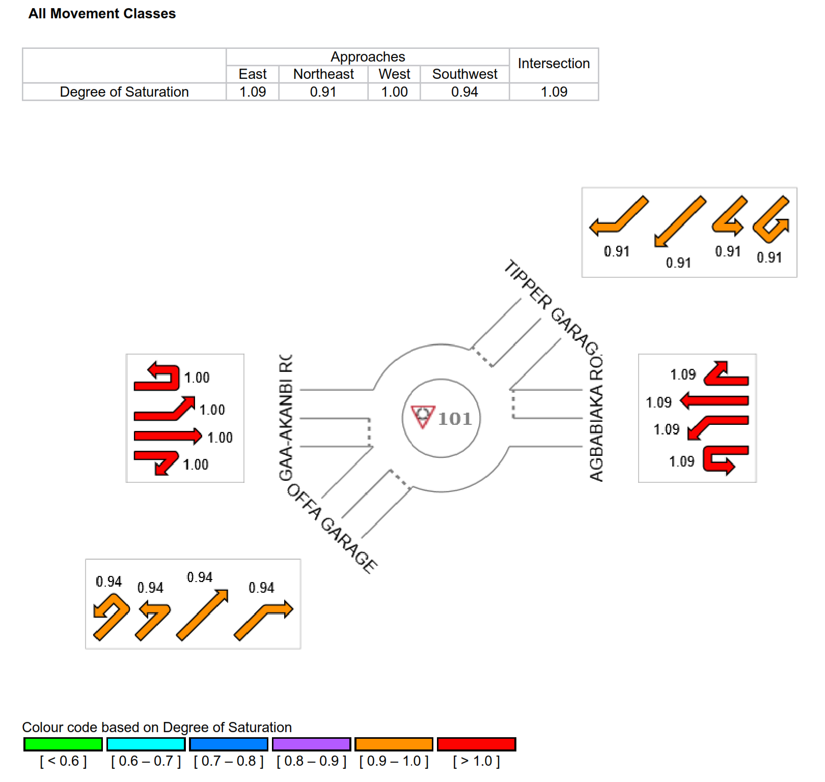

Table 4.1.7.1 Gaa-Akanbiroundaboutlane performanceSummary Day 3
Site:
101
[
GAA
-
AKANBI ROUNDABOUT DAY 3]
LANE SUMMARY
ROUNDABOUT COMPRISING FOUR (4) CONNECTING ROADS WHICH ARE :GAA -AKANBI,OFFA GARAGE,
TIPPER GARAGE & AGBABIAKA
Site Category: ROUNDABOUT
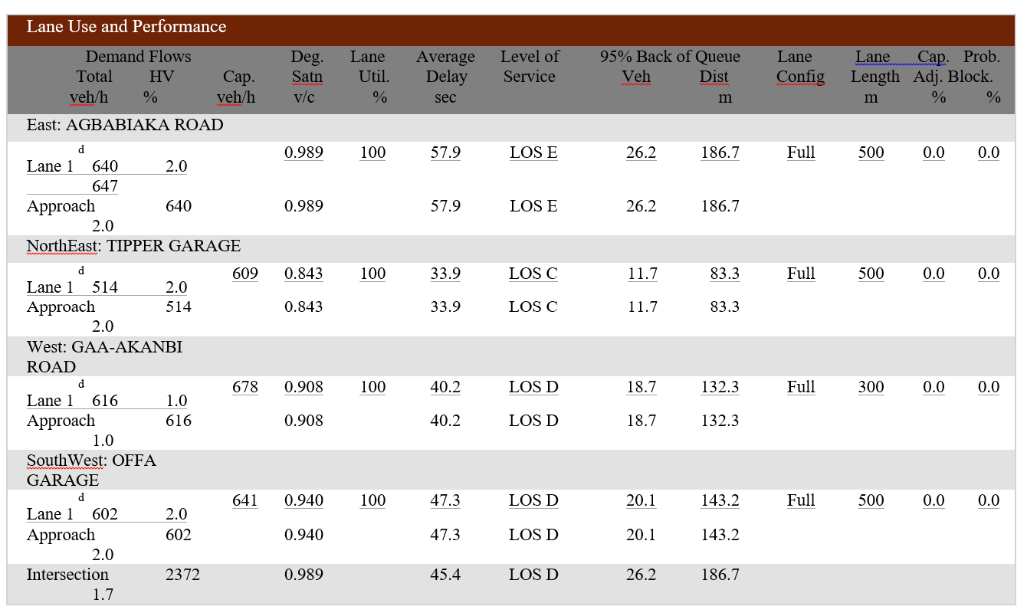

Table 4.1.7.2 Gaa-AkanbiroundaboutlaneflowsummaryonDay3

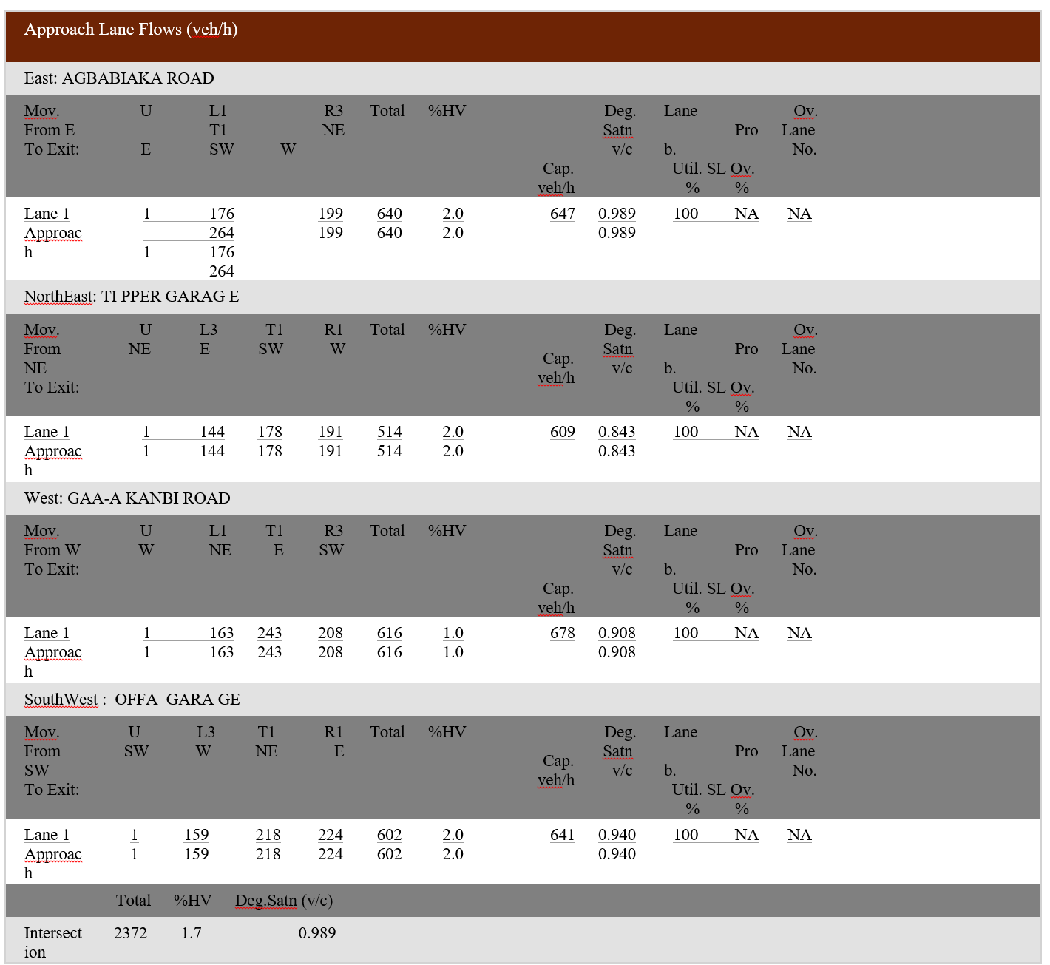

Table 4.1.7.3 Gaa-AkanbiroundaboutcirculatingflowratesonDay3

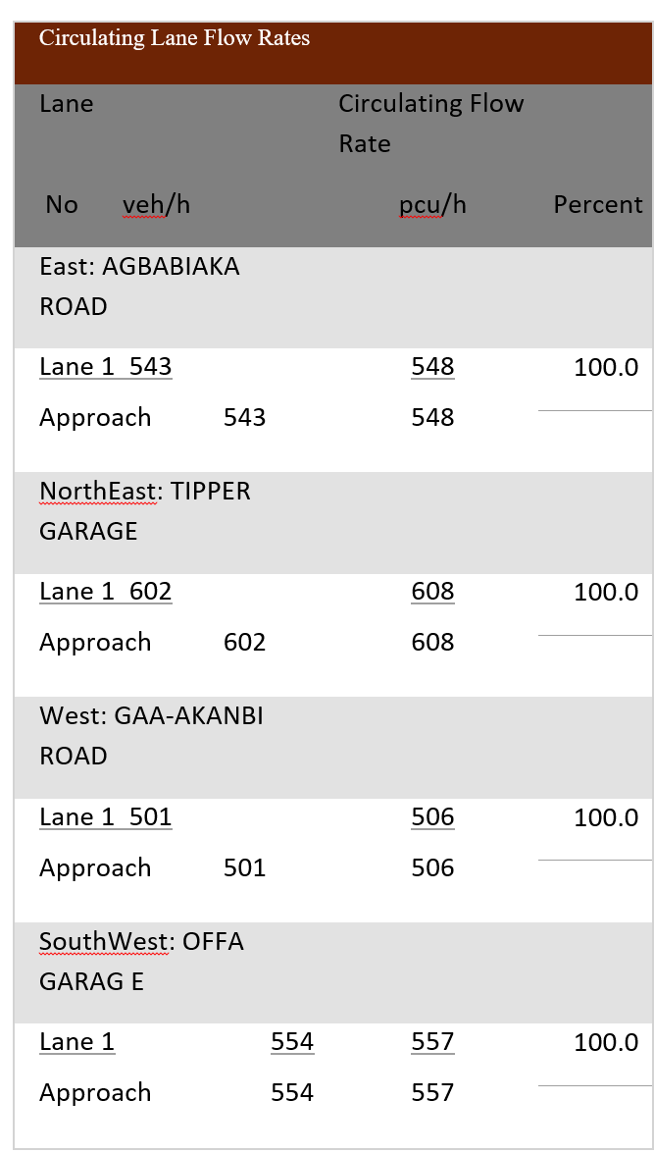

Table 4.1.7.4 performance summary on Day 3

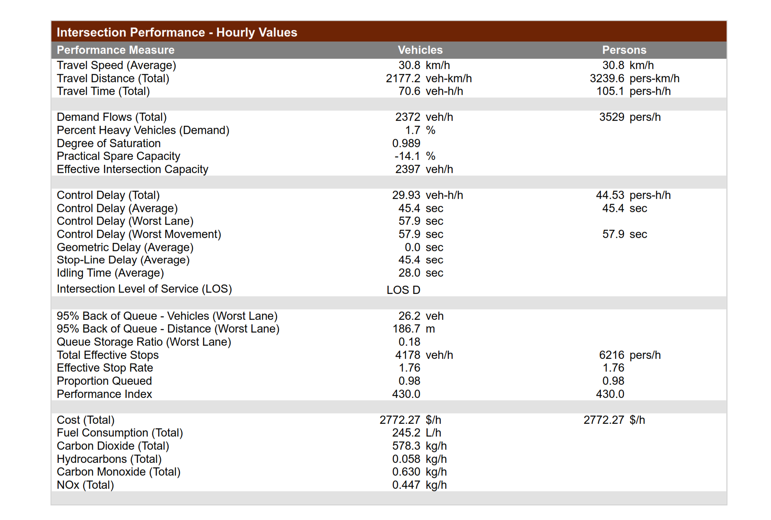

Table 4.1.7.5 Gaa-AkanbiRoundaboutcontroldelayandLOSonDay3

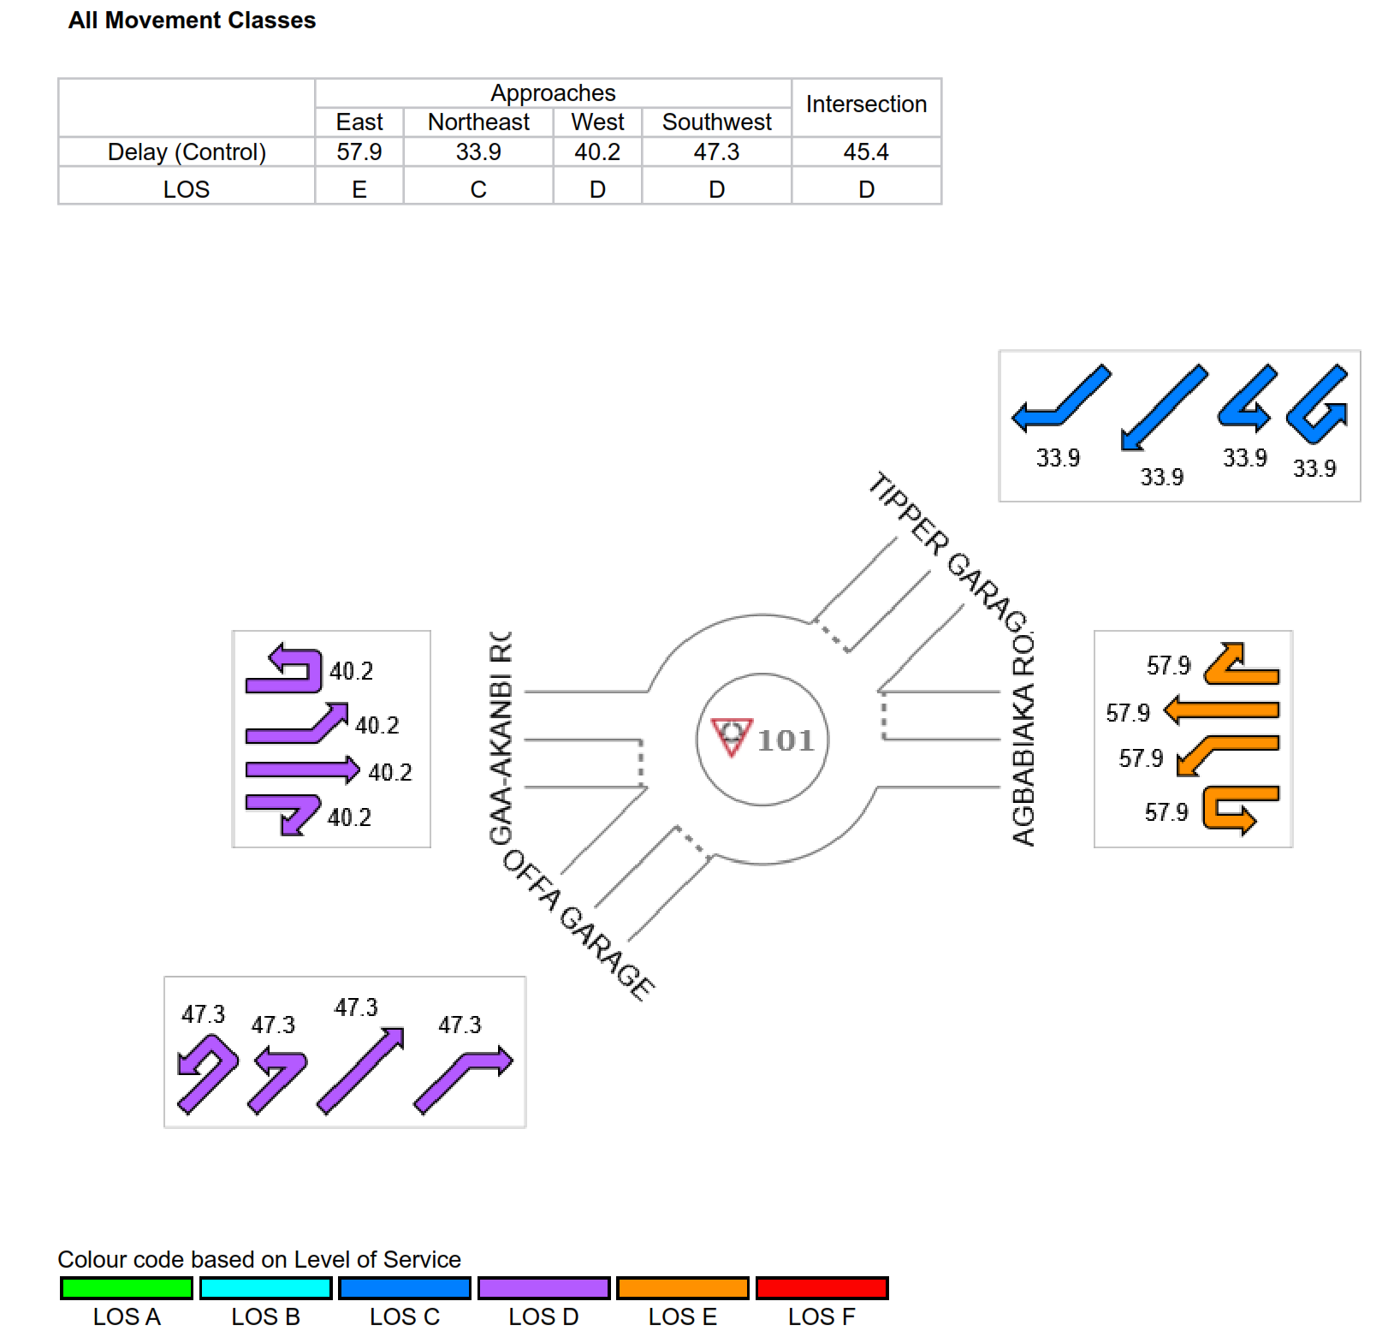

Table 4.1.7.6 Gaa-AkanbiroundaboutdegreeofsaturationonDay3

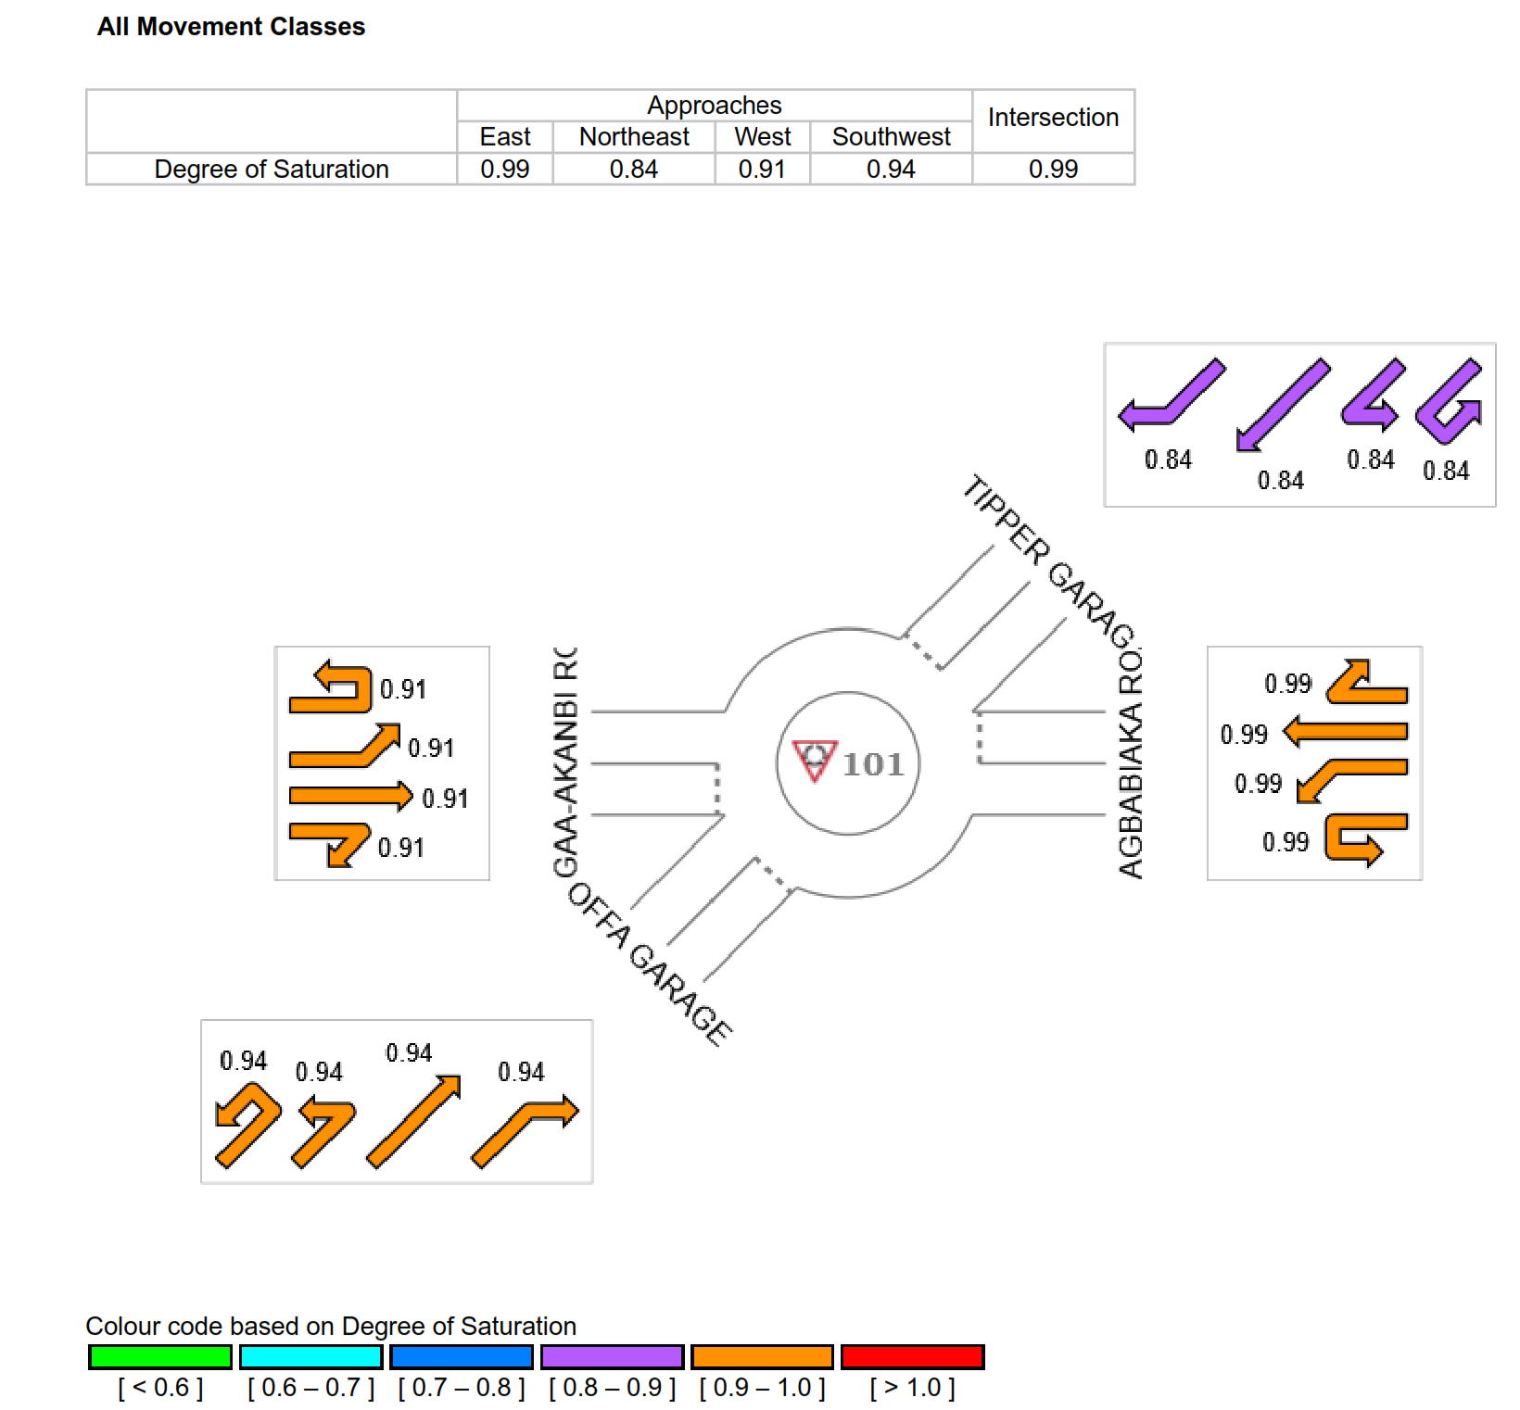

Table 4.1.8.1 Gaa-Akanbiroundaboutlaneperforance summary Day4

LANE SUMMARY
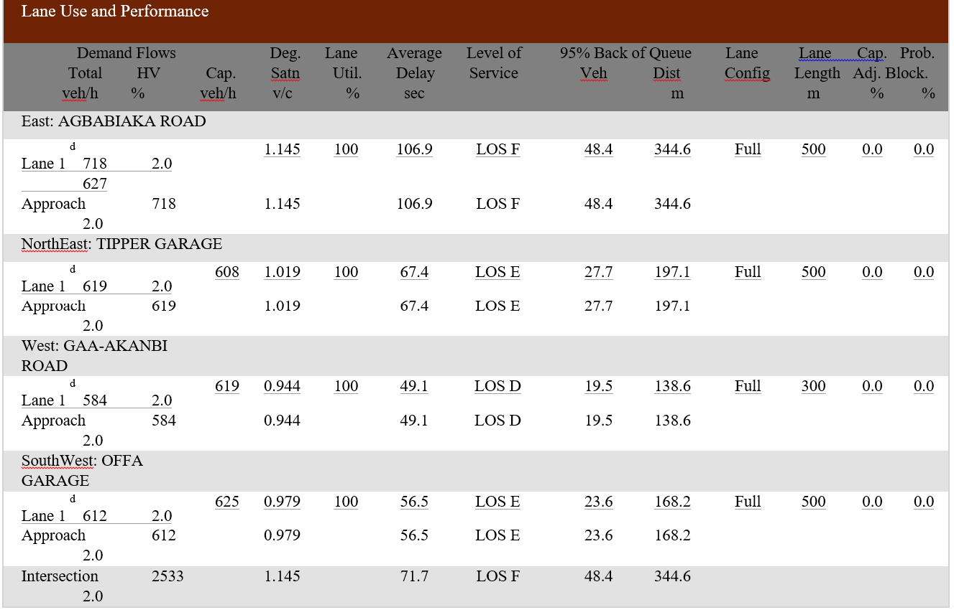

Table 4.1.8.2 Gaa-AkanbiroundaboutlaneflowsummaryonDay4
ROUNDABOUT COMPRISING FOUR (4) CONNECTING ROADS WHICH ARE :GAA -AKANBI,OFFA GARAGE,
TIPPER GARAGE & AGBABIAKA
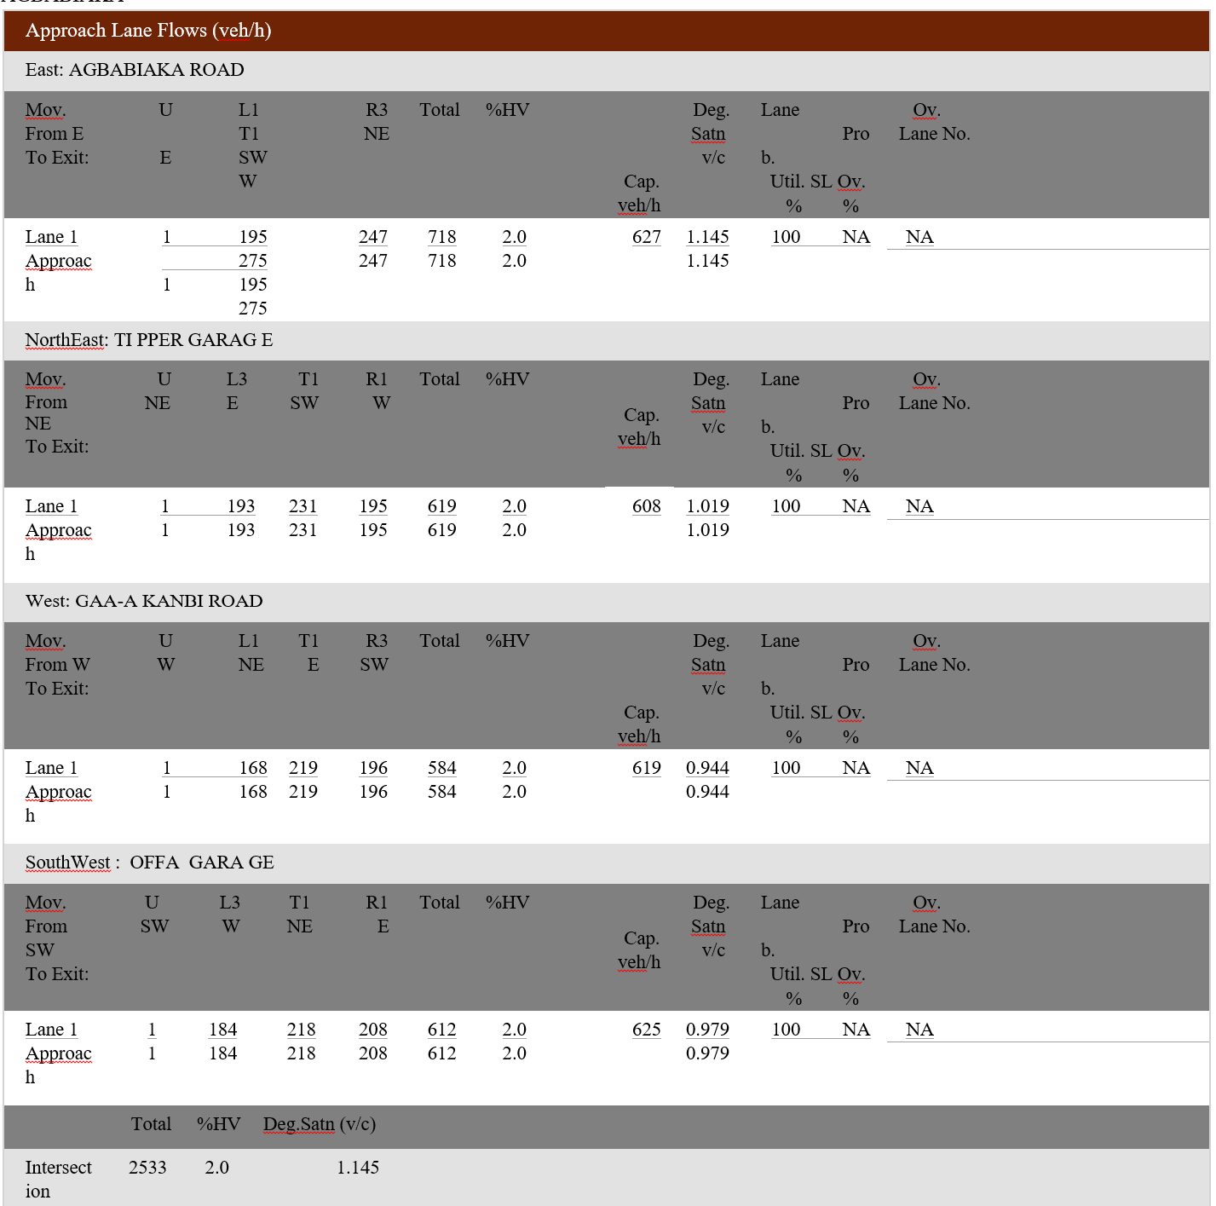

Table 4.1.8.3 Gaa-AkanbiroundaboutcirculatingflowratesonDay4
ROUNDABOUT ANALYSIS
Site:
101
[
GAA
-
AKANBI ROUNDABOUT DAY 4]
ROUNDABOUT COMPRISING FOUR (4) CONNECTING ROADS WHICH ARE :GAA -AKANBI,OFFA GARAGE
,TIPPER GARAGE & AGBABIAKA

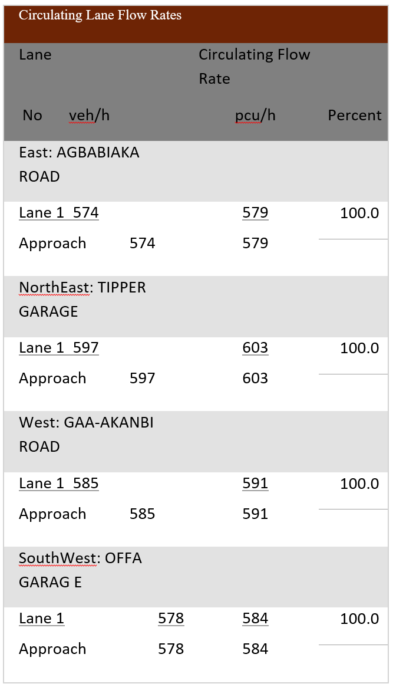

Table 4.1.8.4 Gaa-Akanbi Intersection performance SummaryDay 4

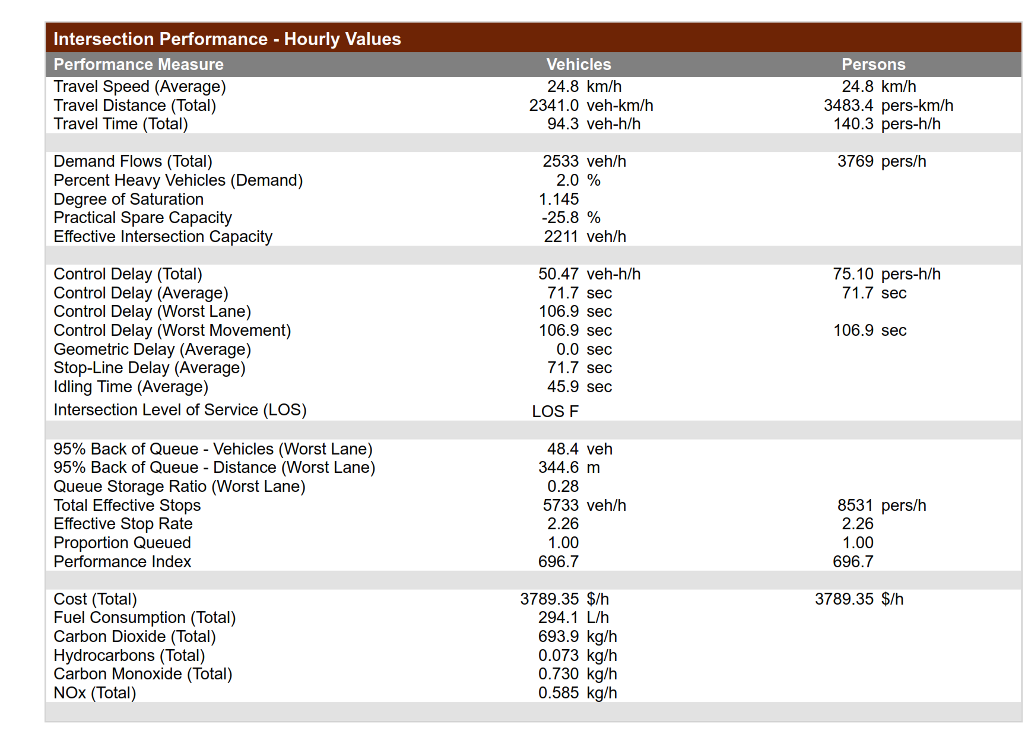

Table 4.1.8.5 Gaa-AkanbiRoundaboutcontroldelayandLOSonDay4

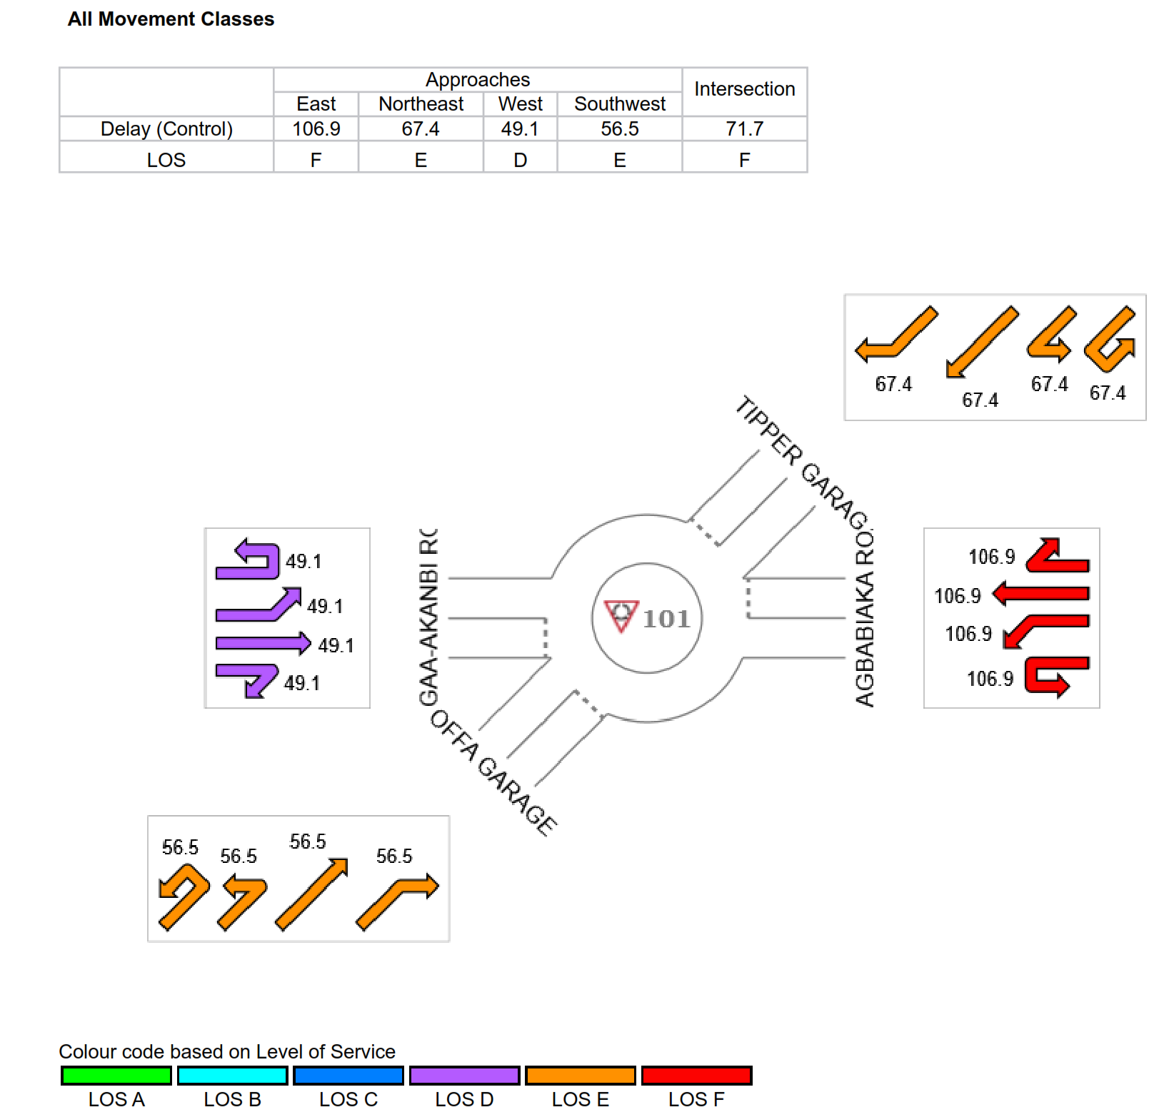

Table 4.1.8.6 Gaa-AkanbiroundaboutdegreeofsaturationonDay4

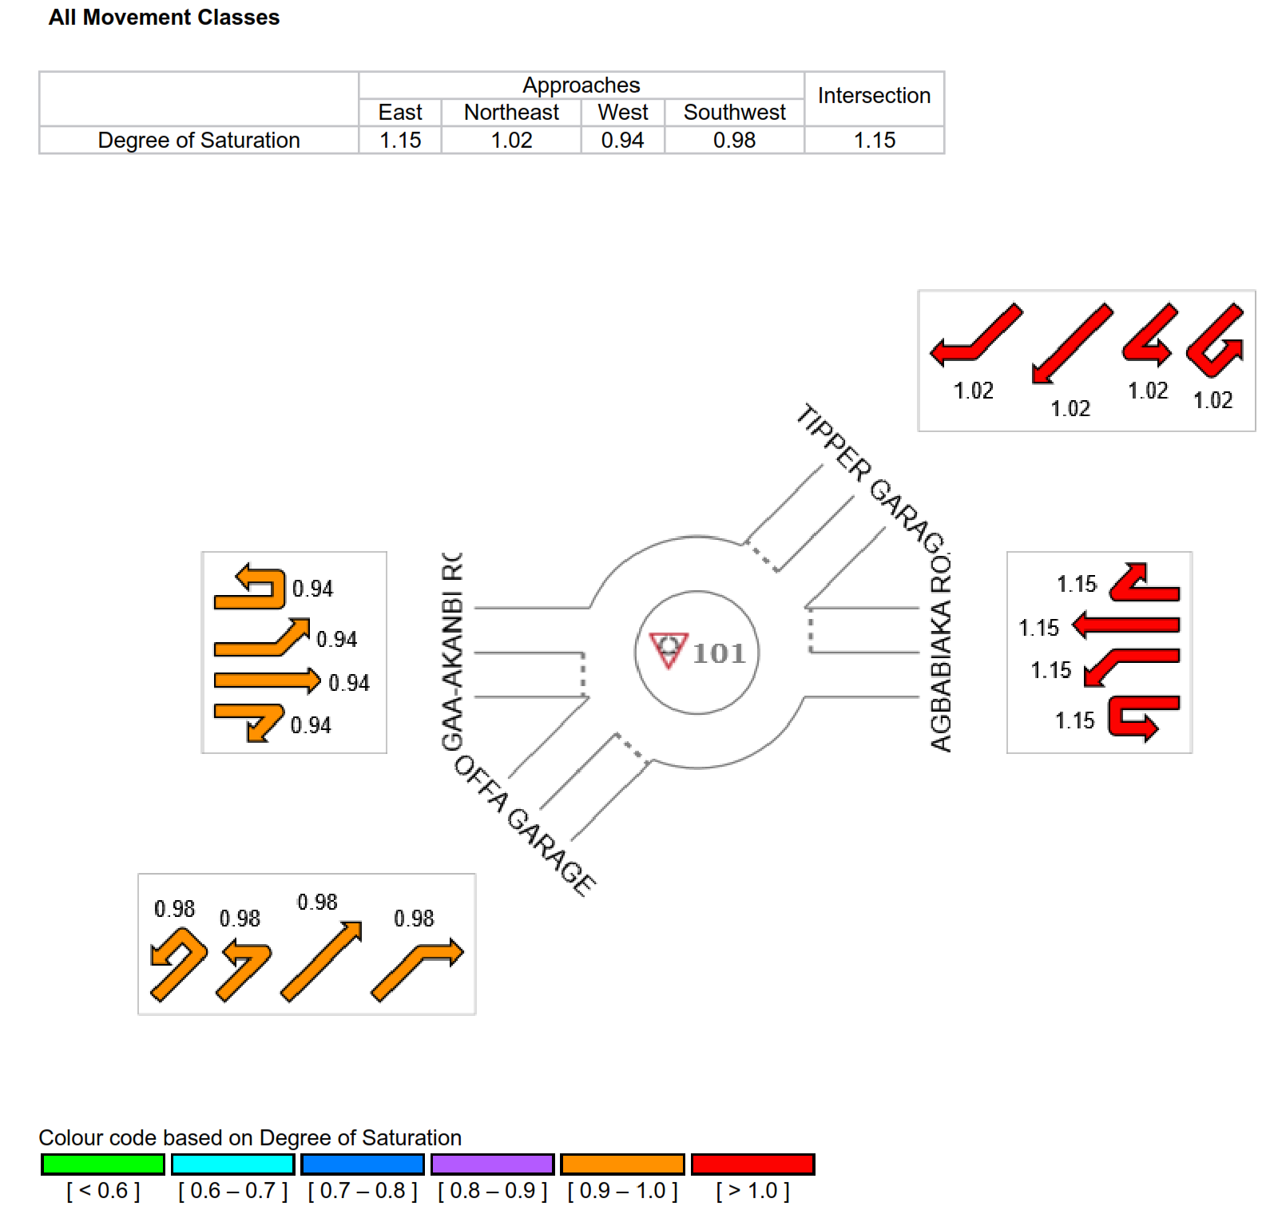

Table 4.1.9.1. Gaa-Akanbi roundaboutlane performance SummaryDay 5
LANE SUMMARY
ROUNDABOUT COMPRISING FOUR (4) CONNECTING ROADS WHICH ARE :GAA -AKANBI,OFFA
GARAGE,TIPPER GARAGE & AGBABIAKA

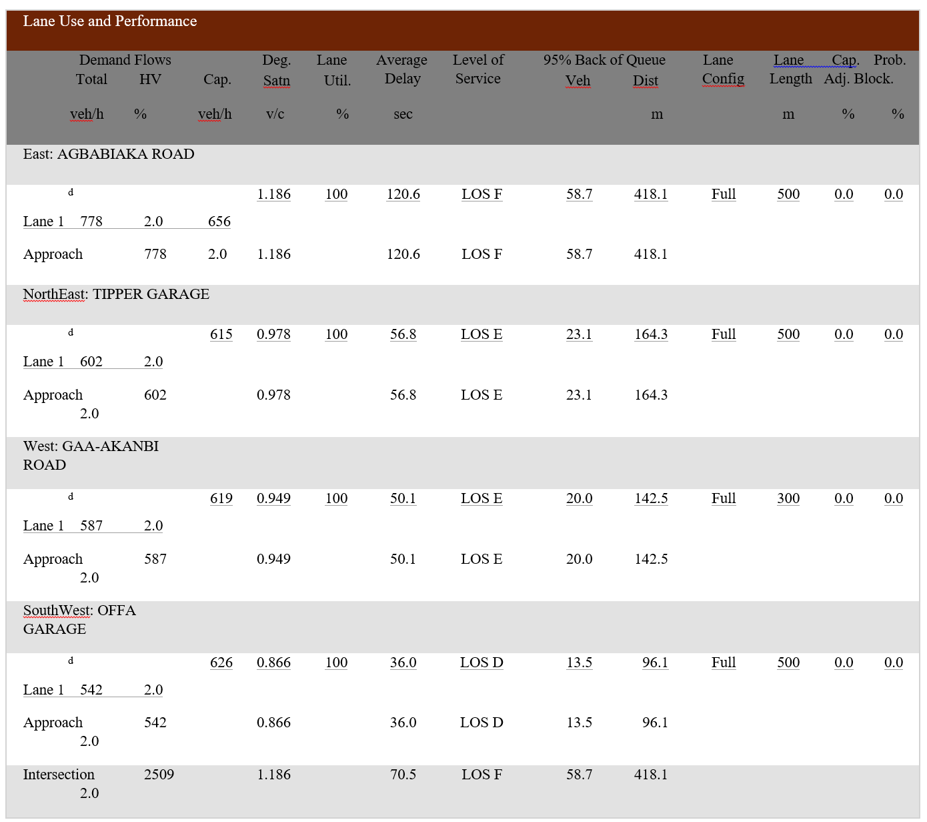

Site Category: ROUNDABOUT
Table 4.1.9.2 Gaa-AkanbiroundaboutlaneflowsummaryDay5

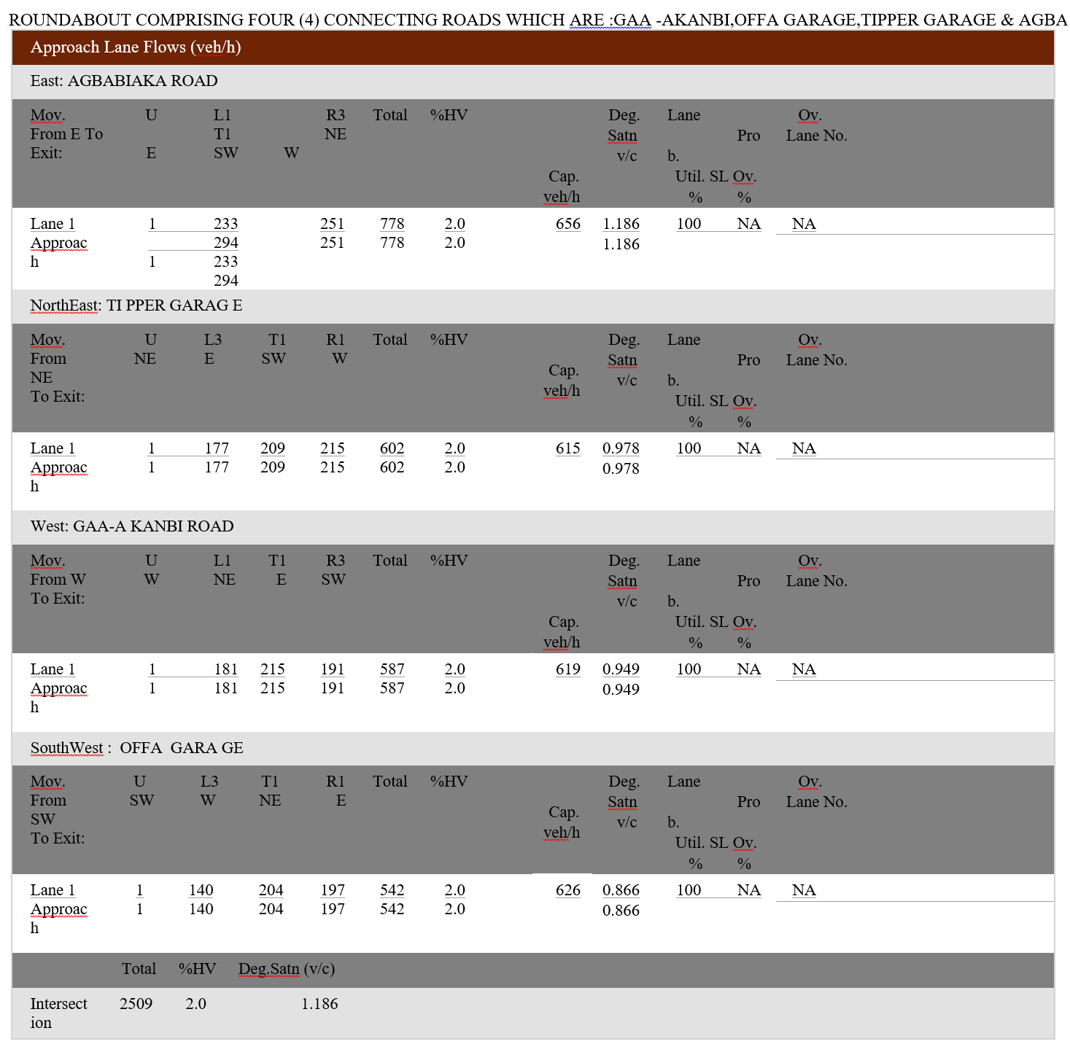

Table 4.1.9.3 Gaa-AkanbiroundaboutcirculatingflowratesonDay5

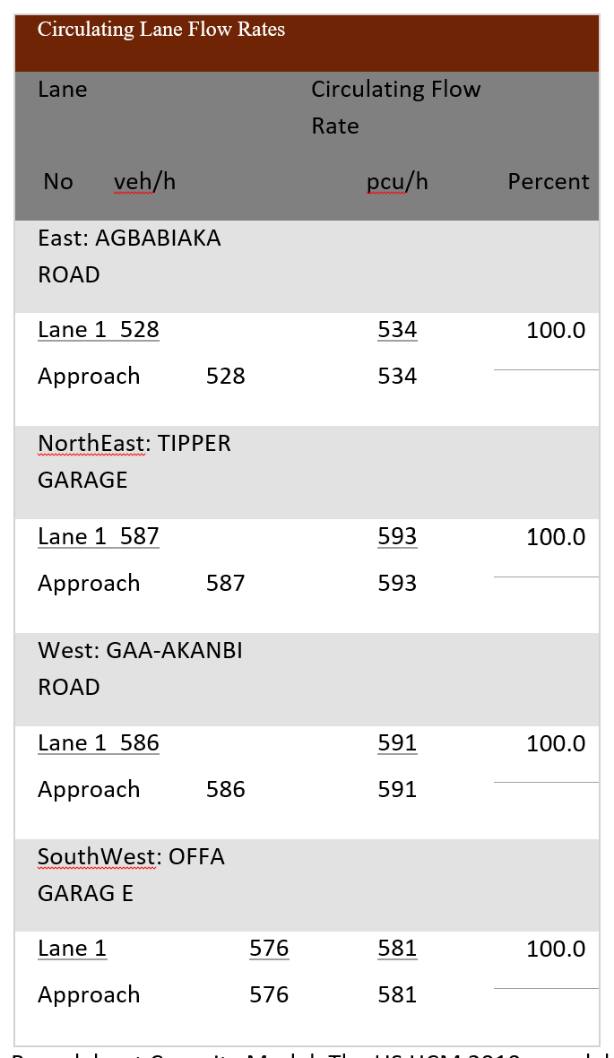

Table 4.1.9.4.Gaa-Akanbi intersection performance SummaryDay 5

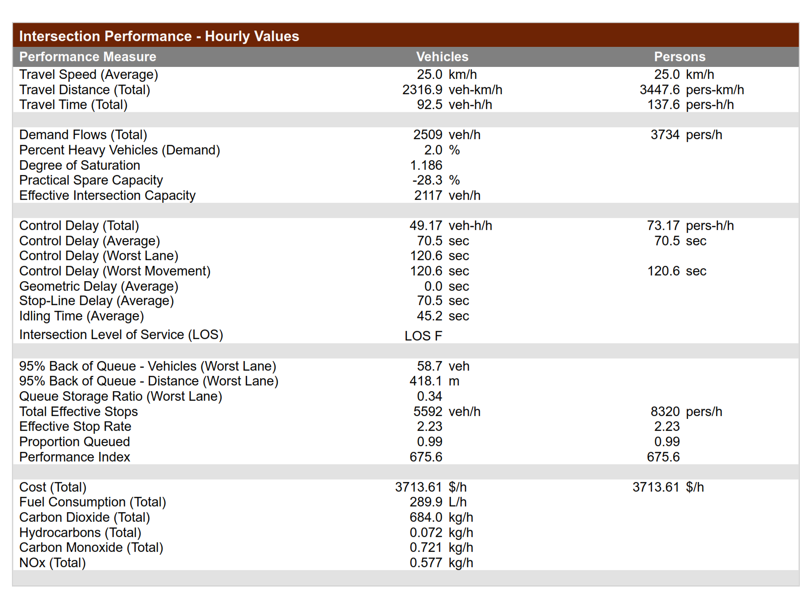

Table 4.1.9.5 Gaa-AkanbiroundaboutcontroldelayandLOSonDay5

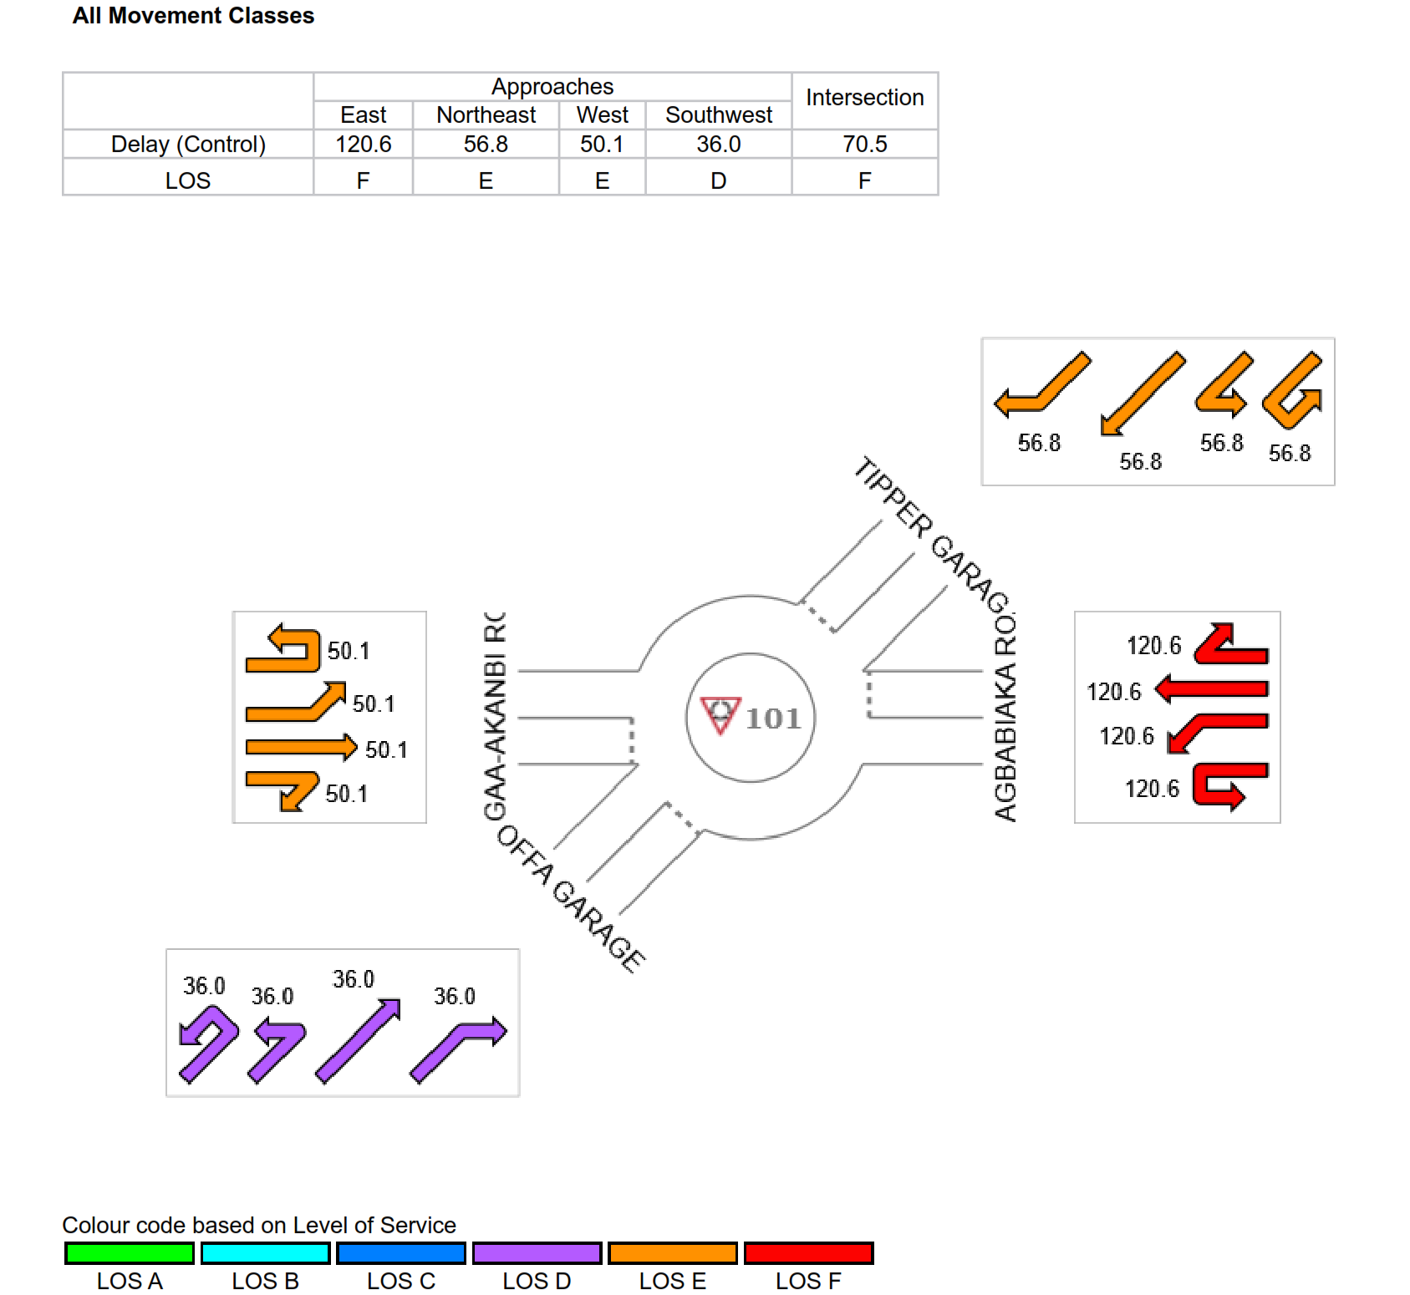

Table 4.1.9.6 Gaa-AkanbiroundaboutdegreeofsaturationonDay5

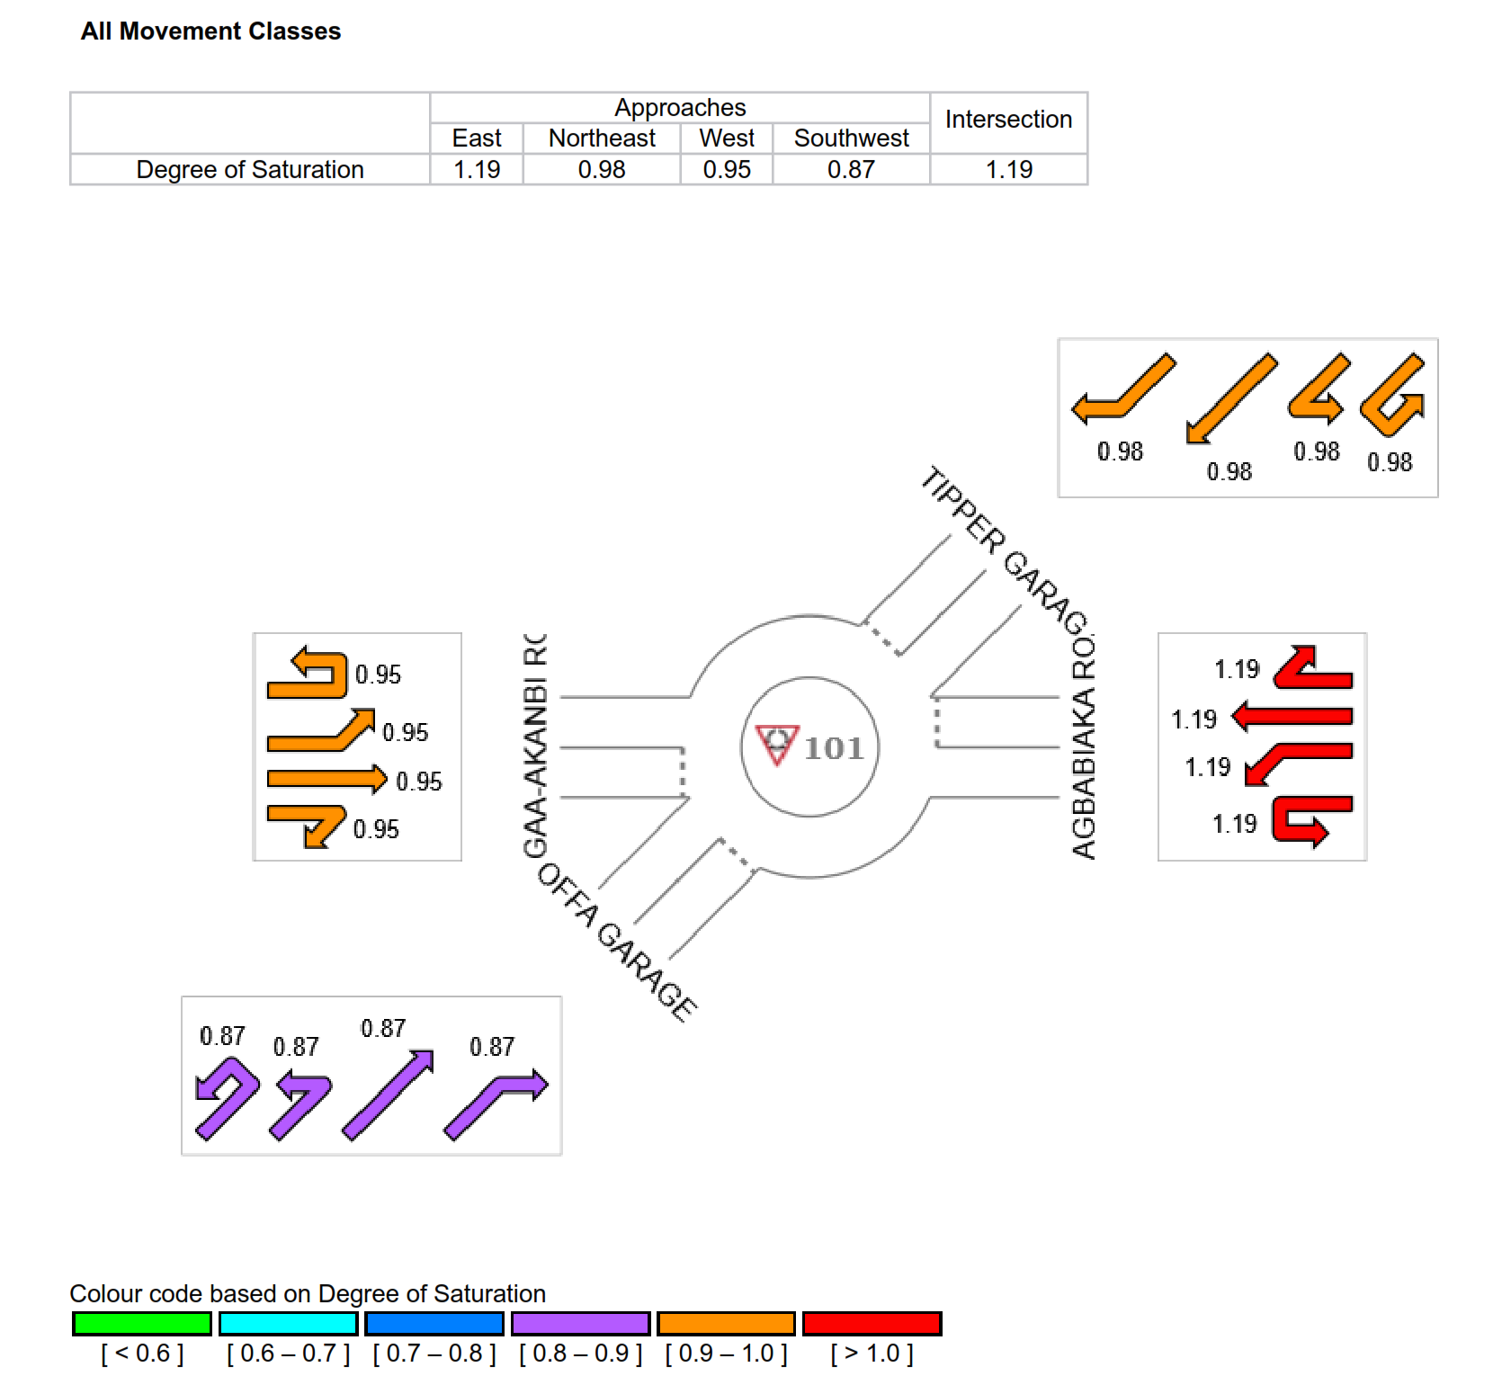

Table 4.1.10.1. Gaa-Akanbi roundaboutlane performance SummaryDay 6

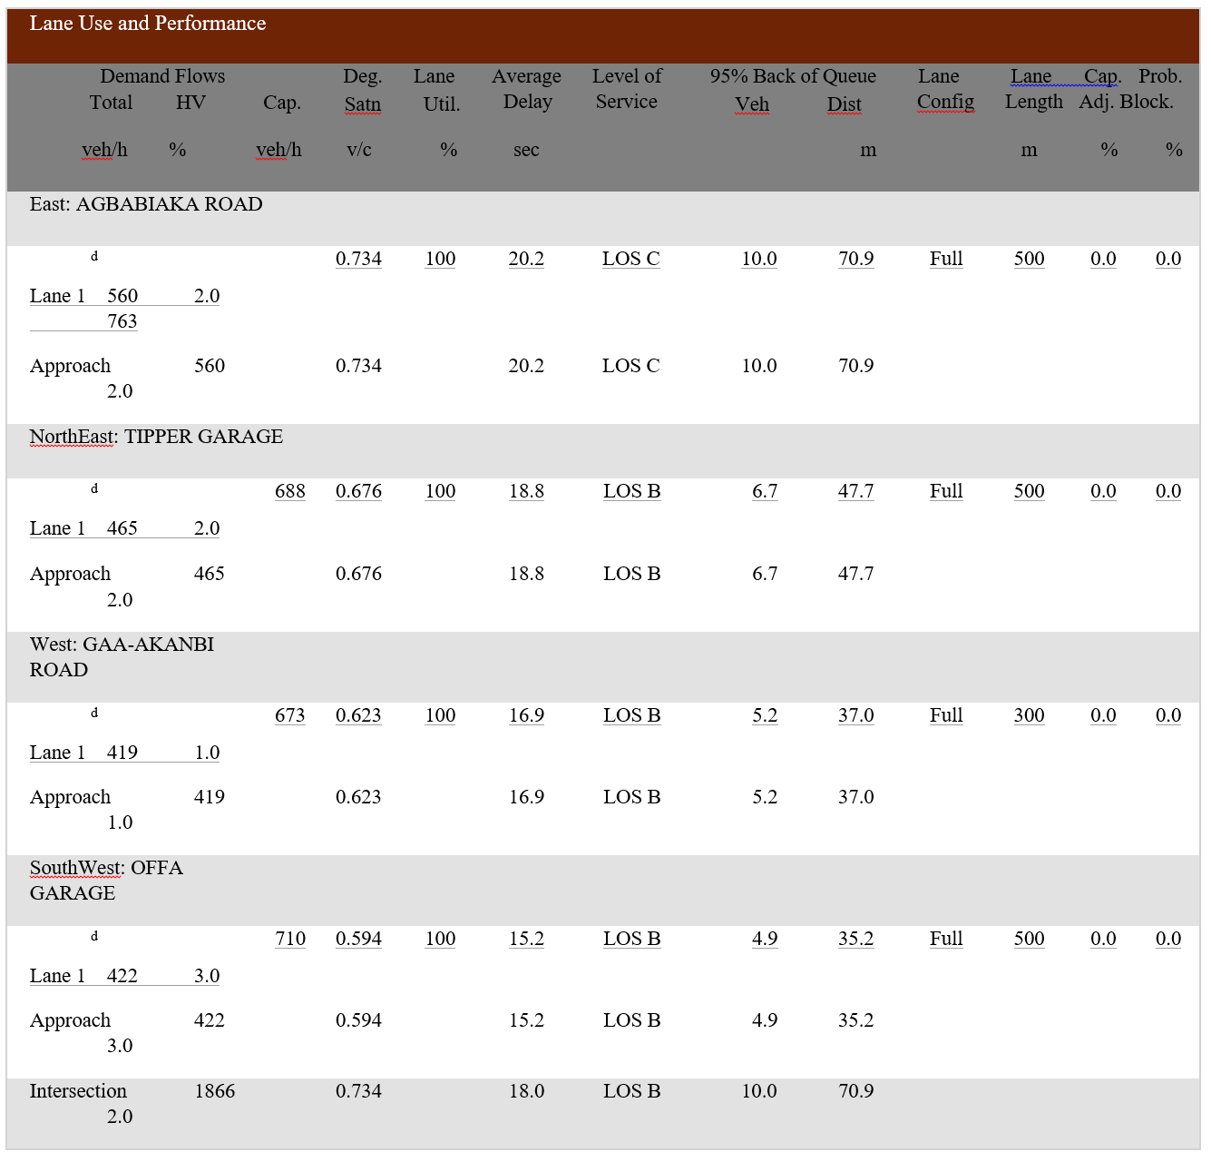

Table 4.1.10.2. Gaa-akanbiroundaboutlaneflowsummaryDay6
ROUNDABOUT COMPRISING FOUR (4) CONNECTING ROADS WHICH ARE :GAA -AKANBI,

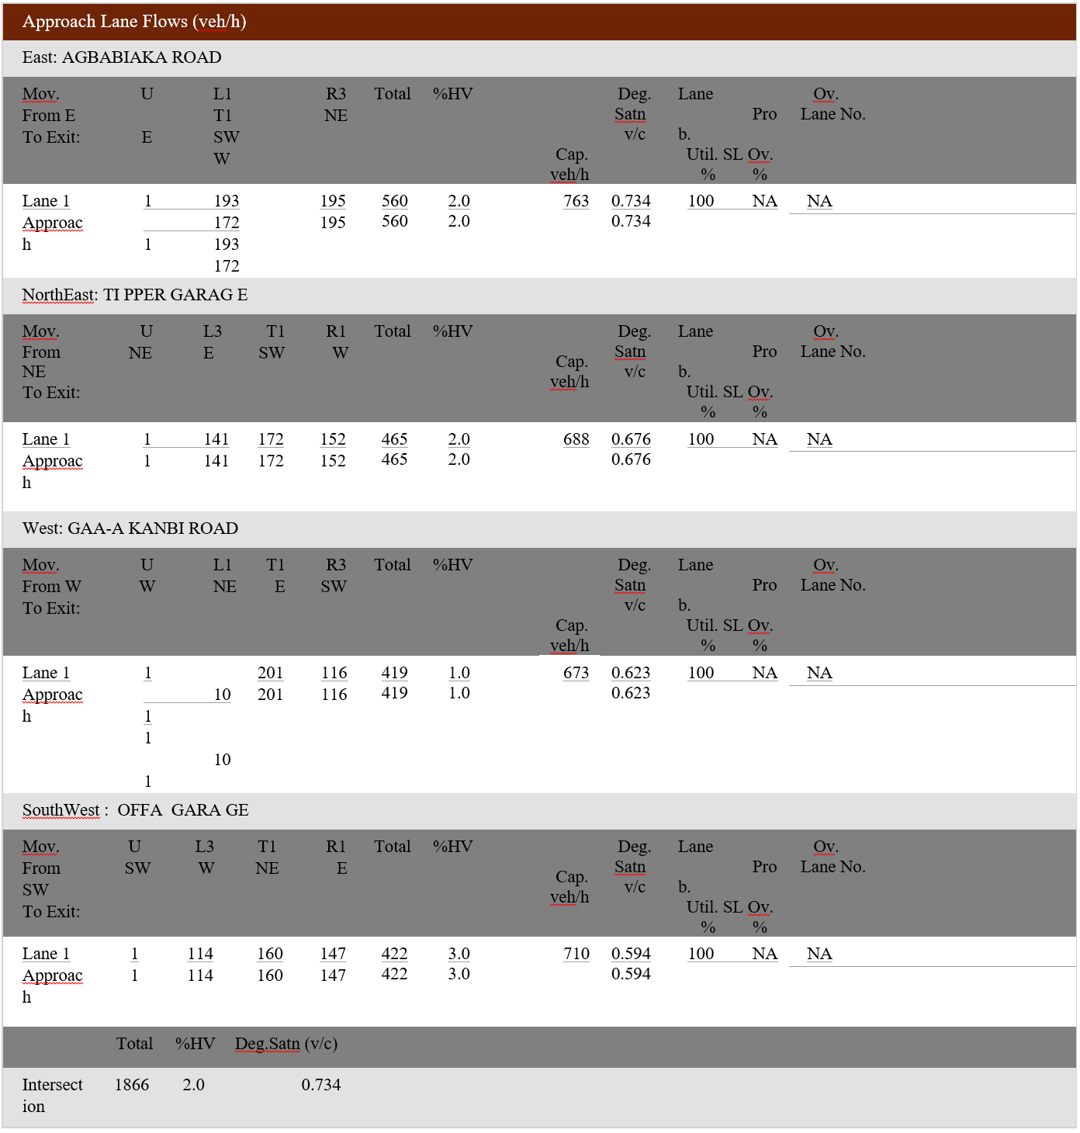

Table 4.1.10.2. Gaa-akanbicirculatory Lane flow rateDay6
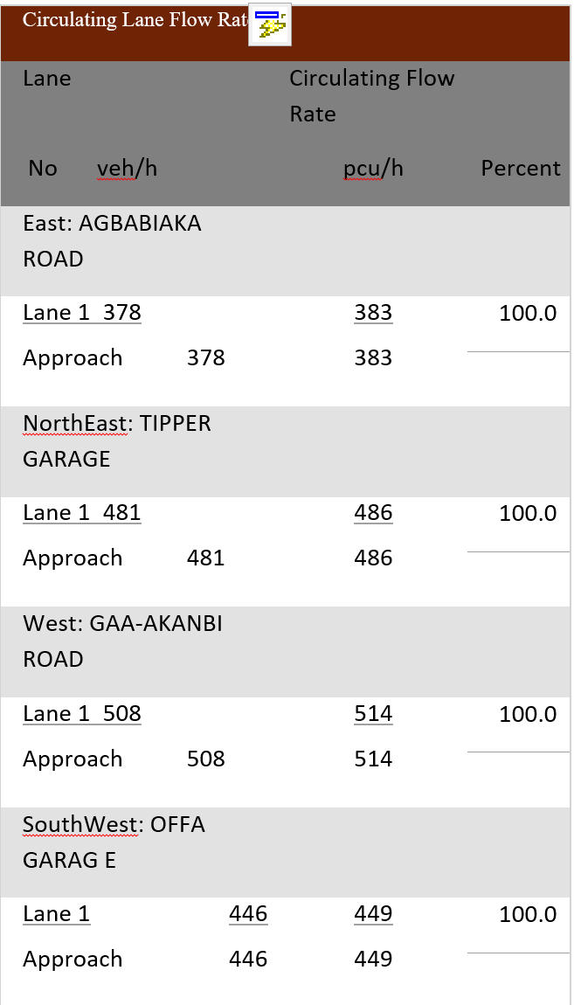

Table 4.1.10.4. Gaa-Akanbi intersection performance SummaryDay 6

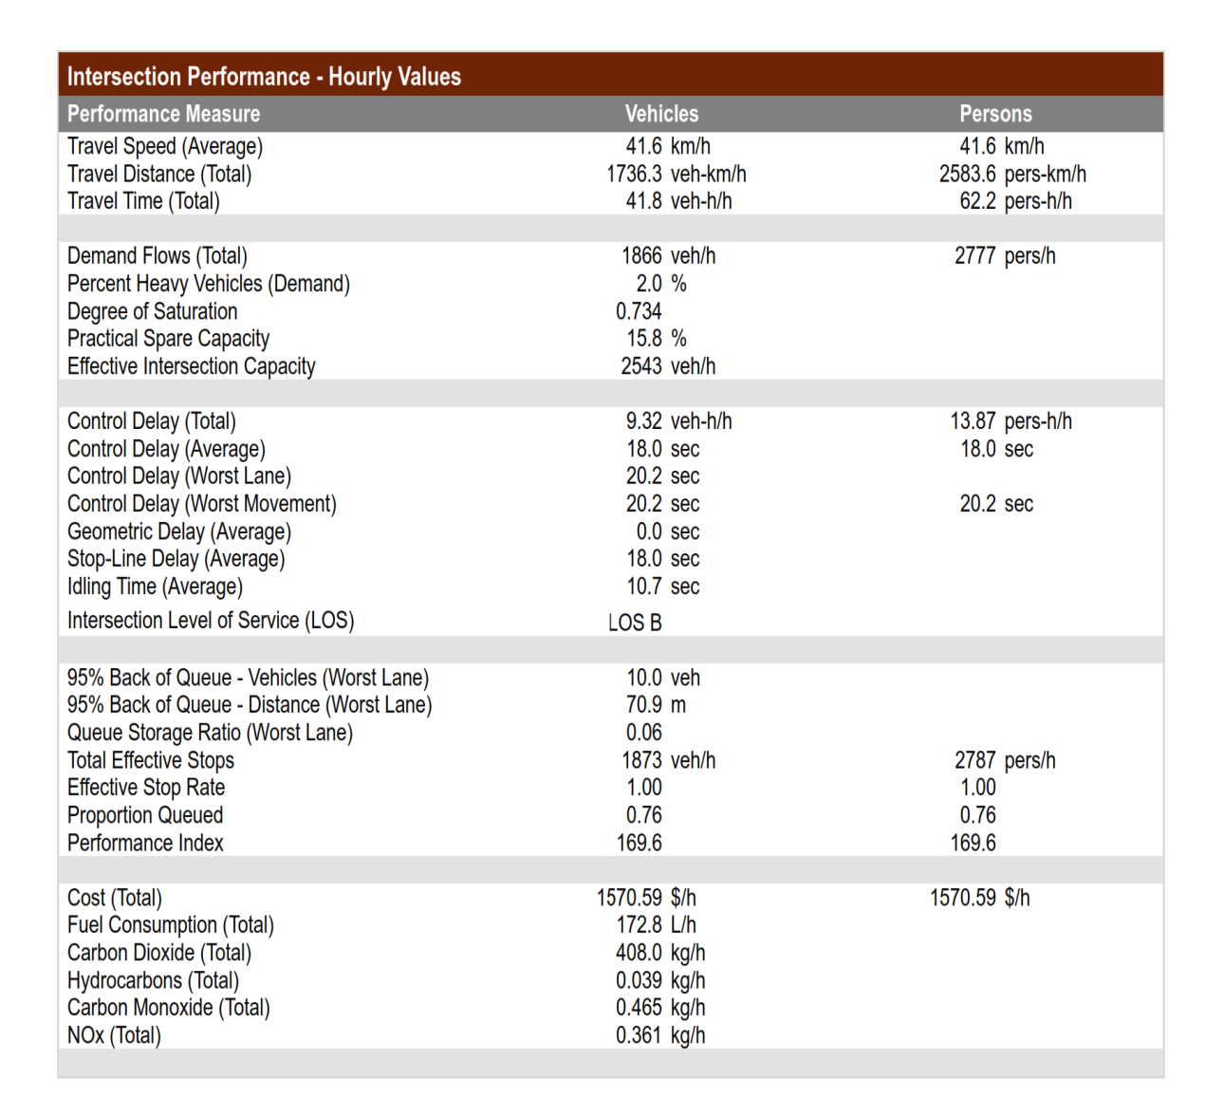

Table 4.1.10.5. Gaa-AkanbiroundaboutcontroldelayandLOSonDay6

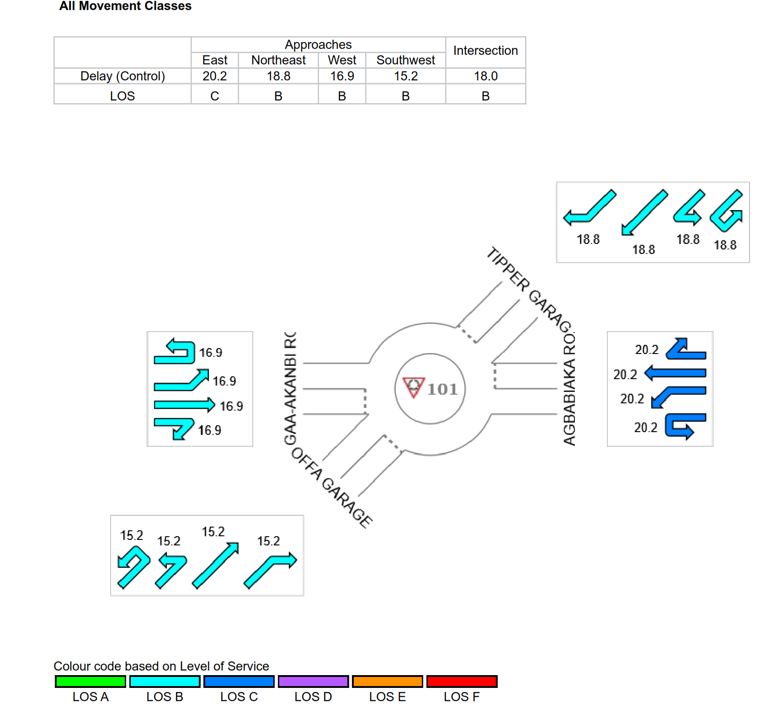

Table 4.1.10.6 Gaa-AkanbiroundaboutdegreeofsaturationonDay6
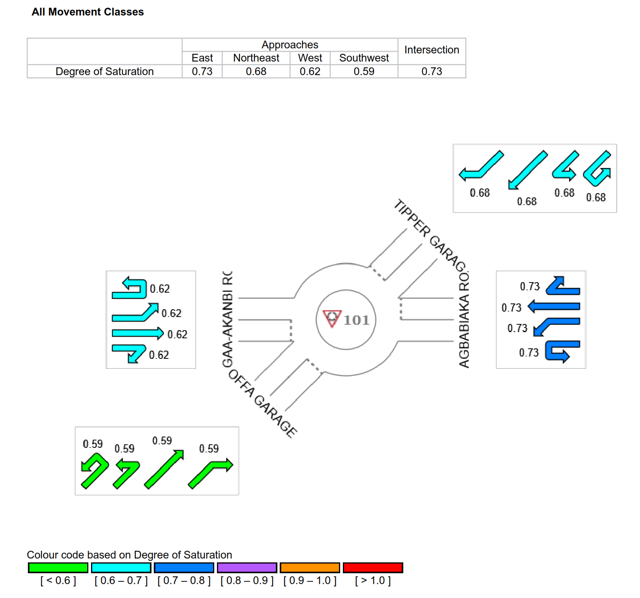

Table 4.1.11.1.Gaa-Akanbi roundaboutlane performance SummaryDay 7

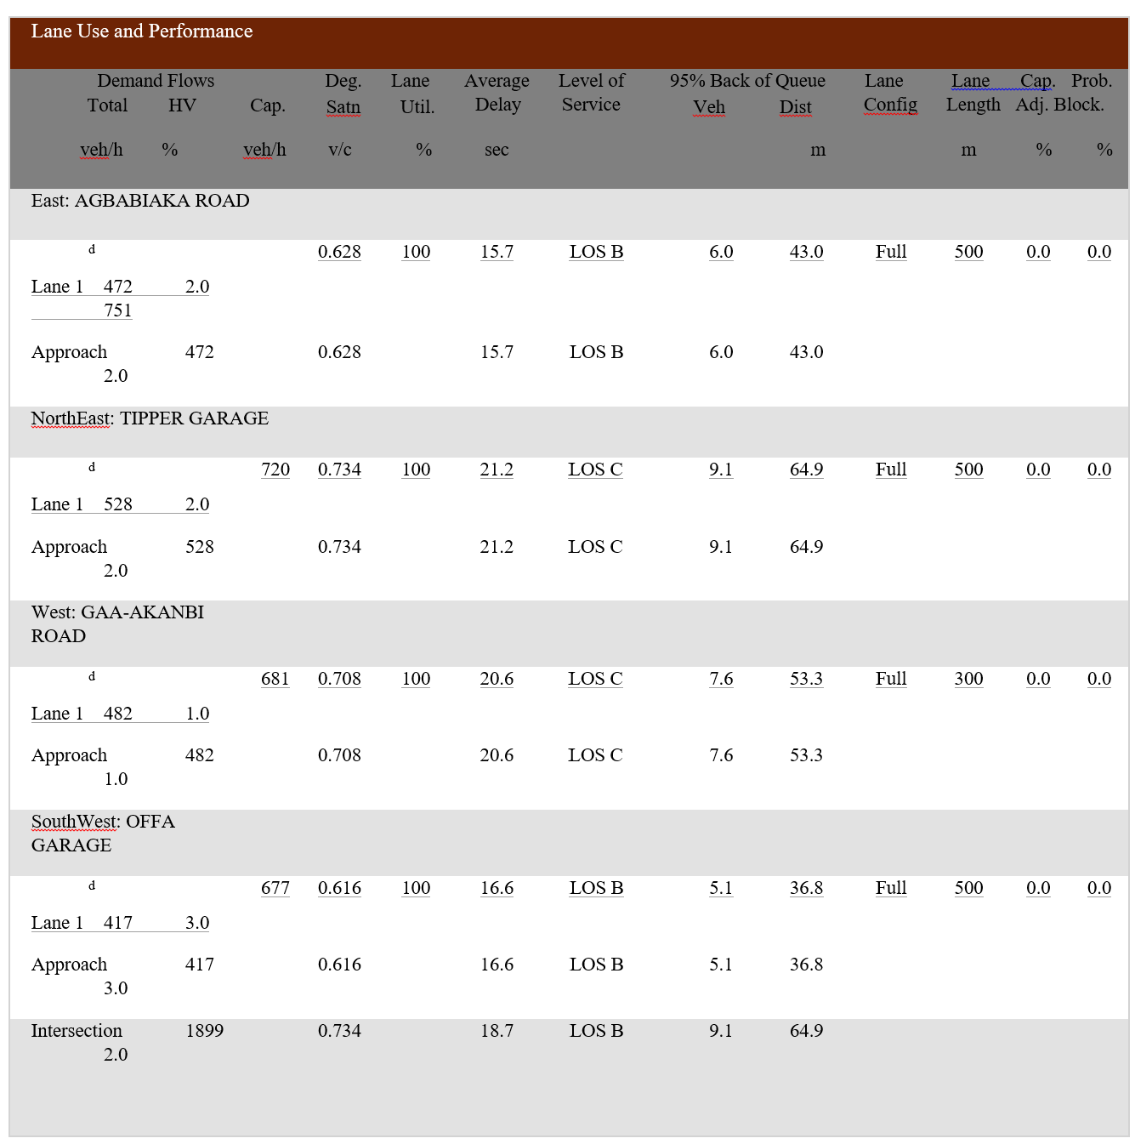

Table 4.1.11.2. Gaa-AkanbiroundaboutlaneflowsummaryDay7

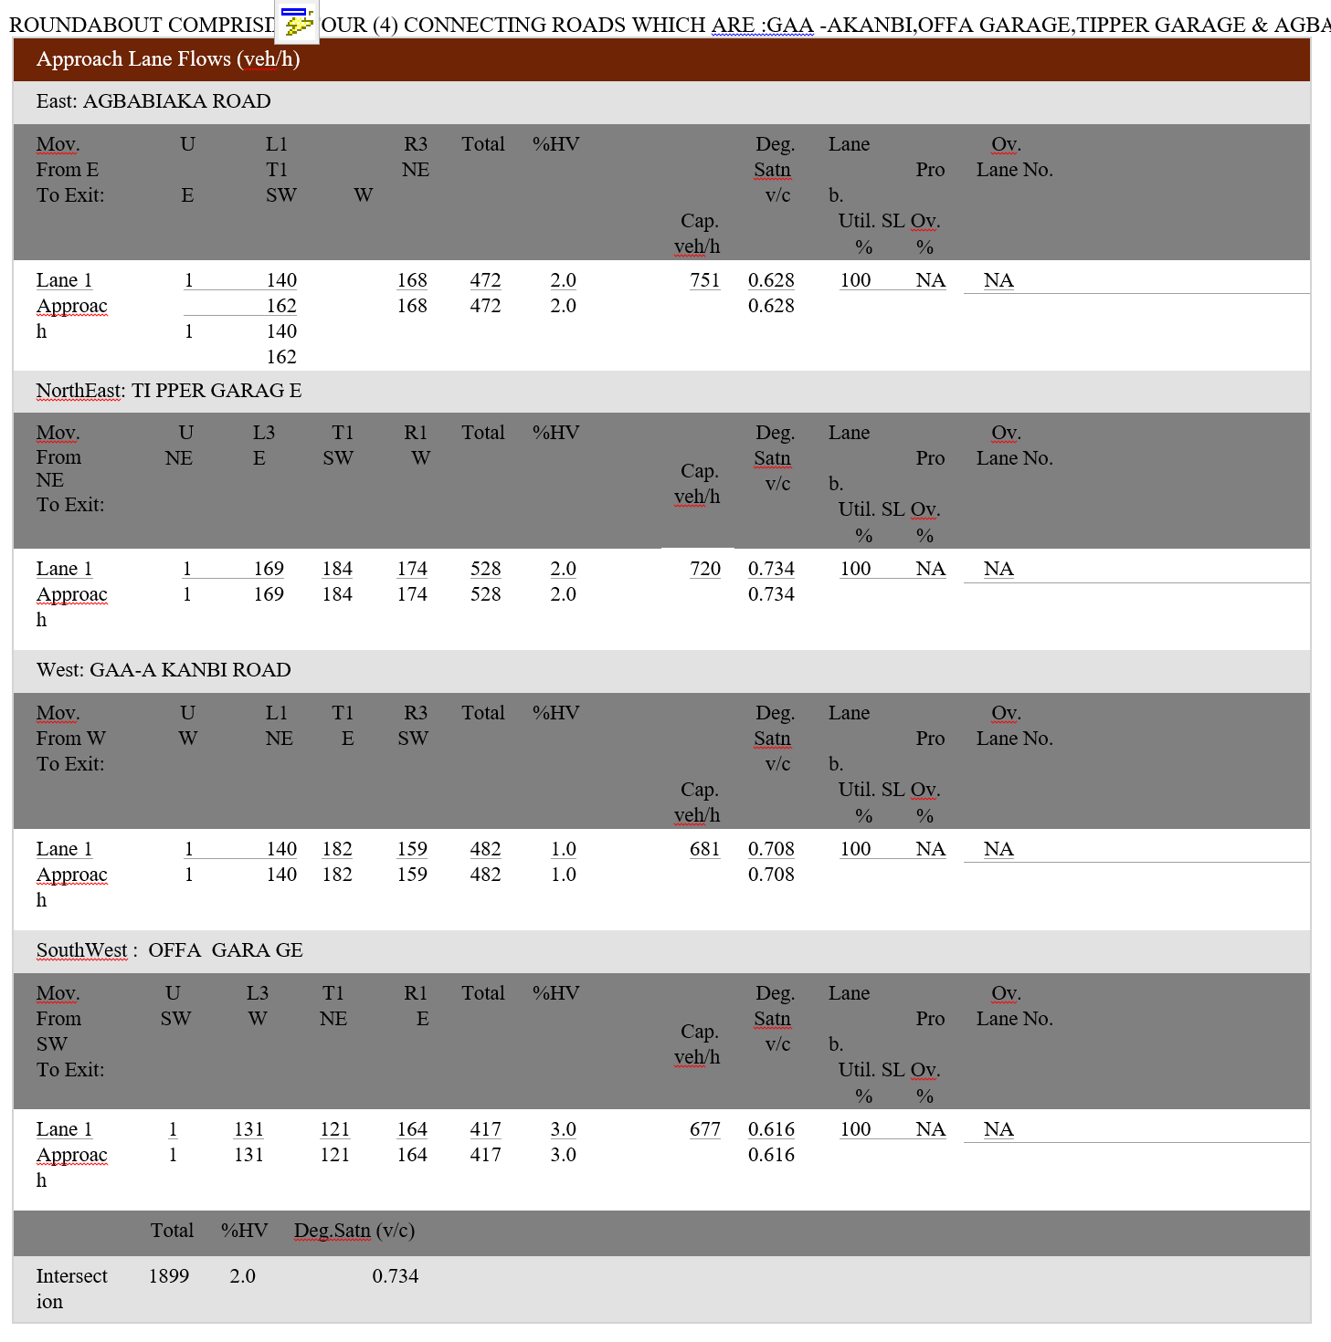

Table 4.1.11.3. Gaa-AkanbiroundaboutcirculatingflowratesonDay7

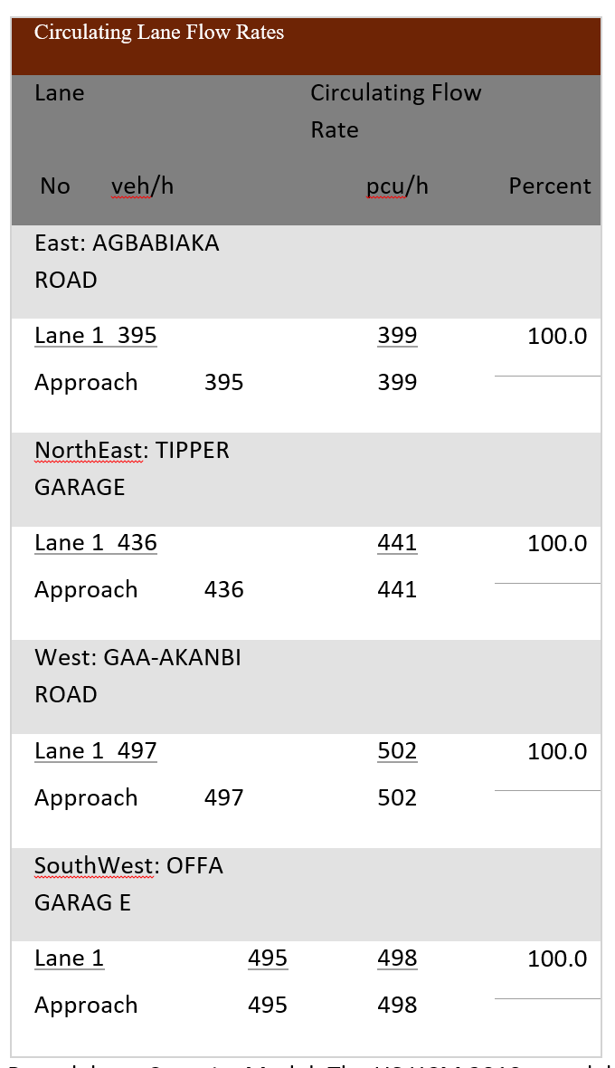

Table 4.1.11.4. Gaa-Akanbi intersection performance SummaryDay 7
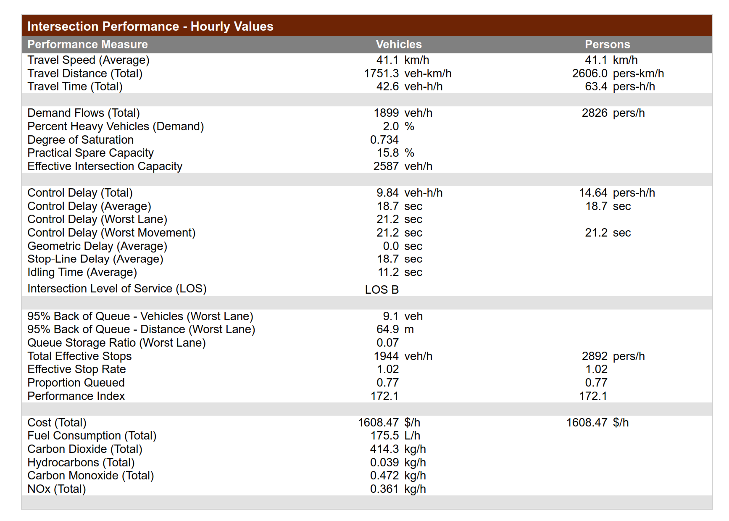

Table 4.1.11.5.Gaa-AkanbiroundaboutcontroldelayandLOSonDay7

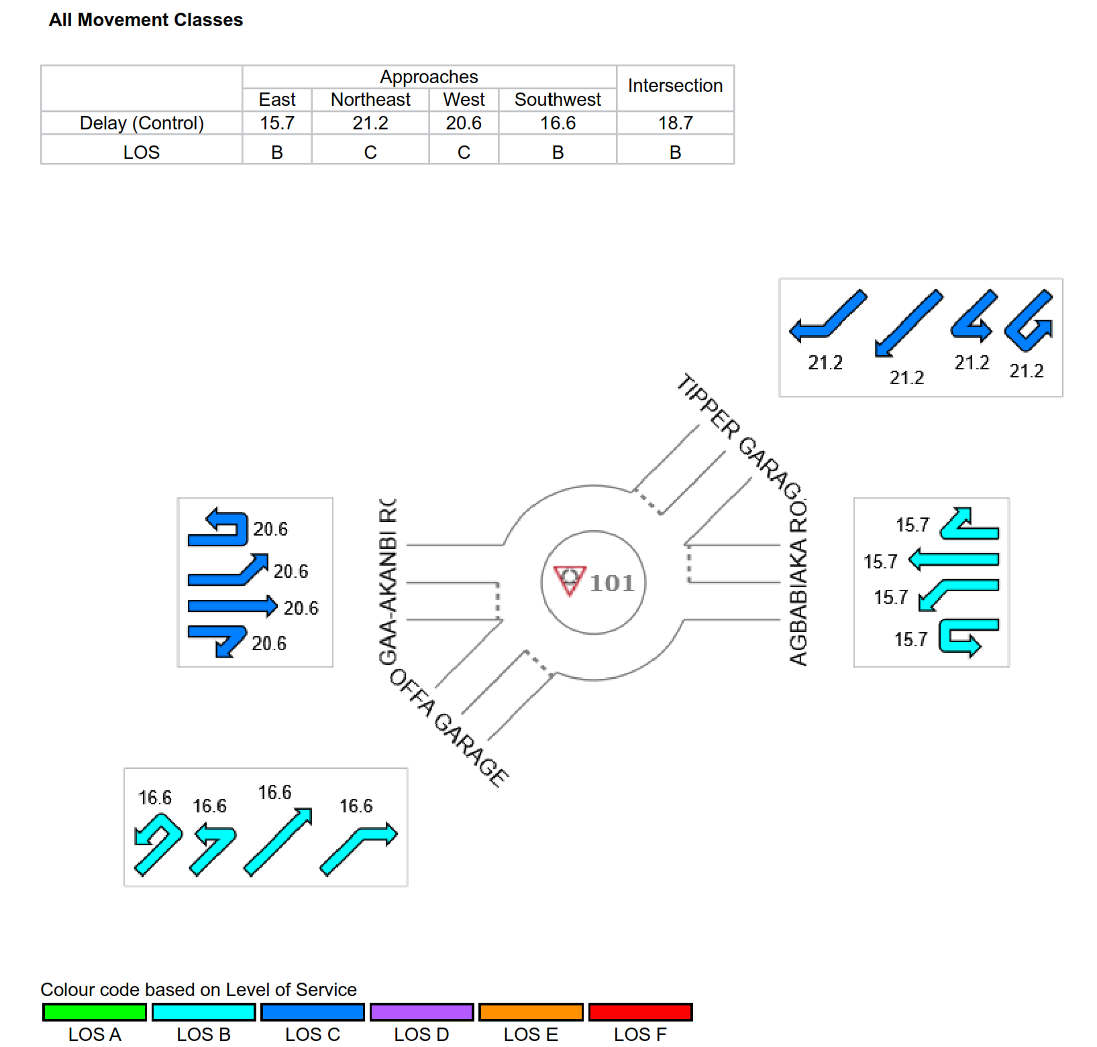
.

Table 4.1.11.6.Gaa-AkanbiroundaboutdegreeofsaturationonDay7

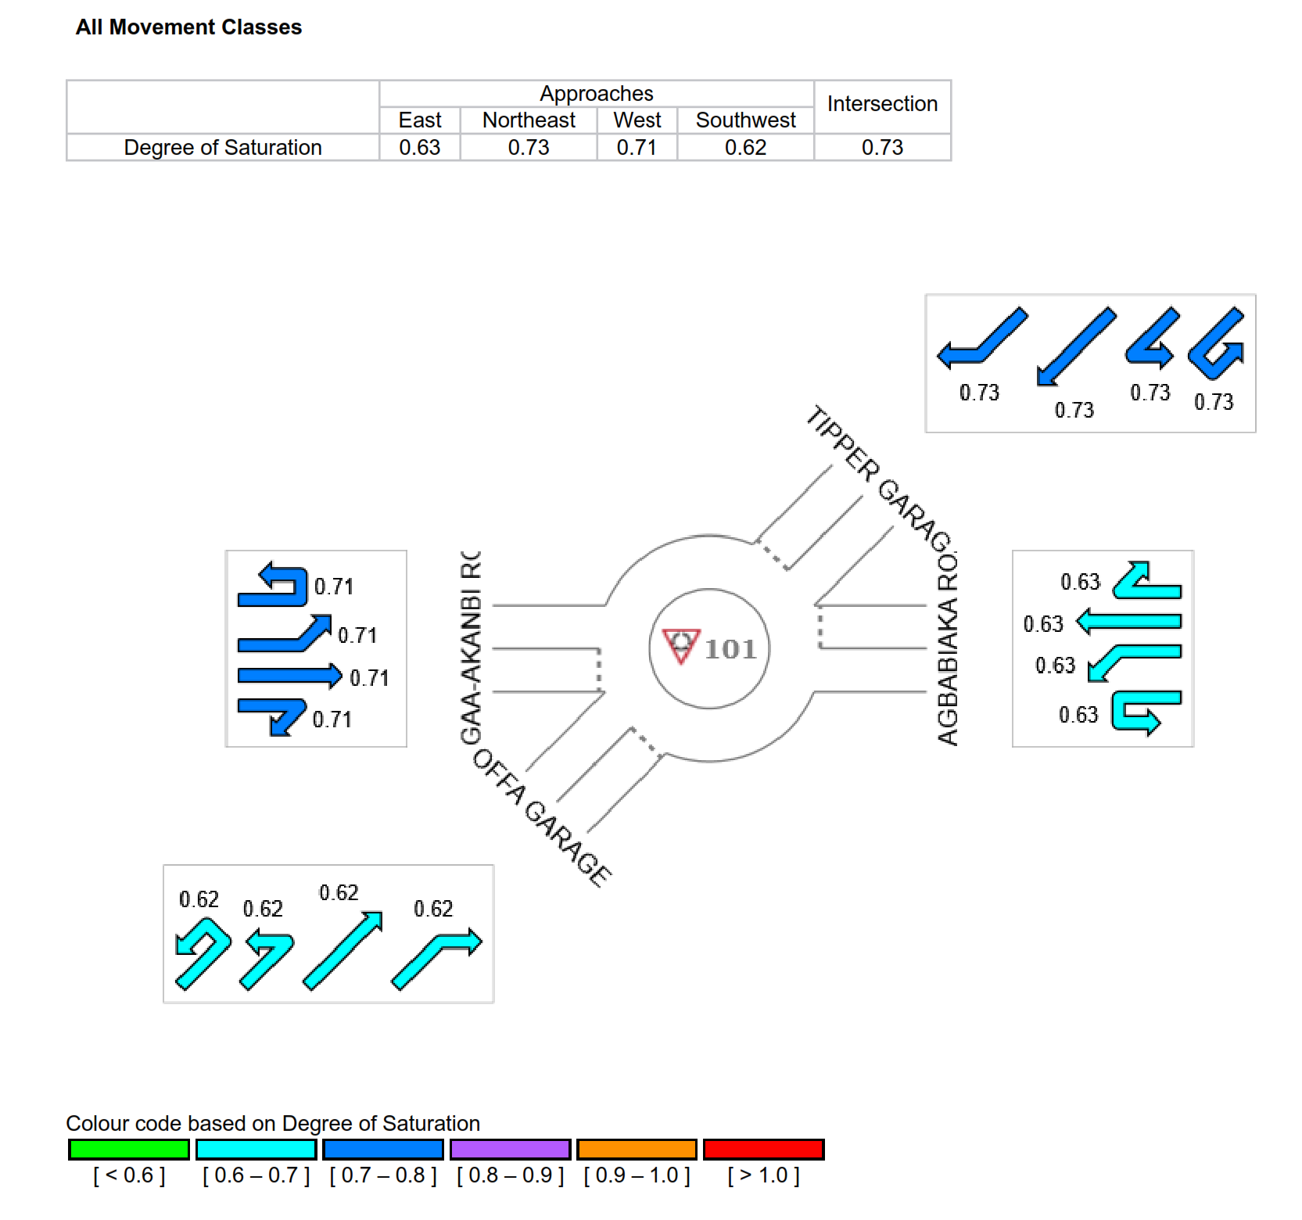

Table 4.1.12.SummaryofGaa-Akanbiperformancecapacityresults

ontheapproaches

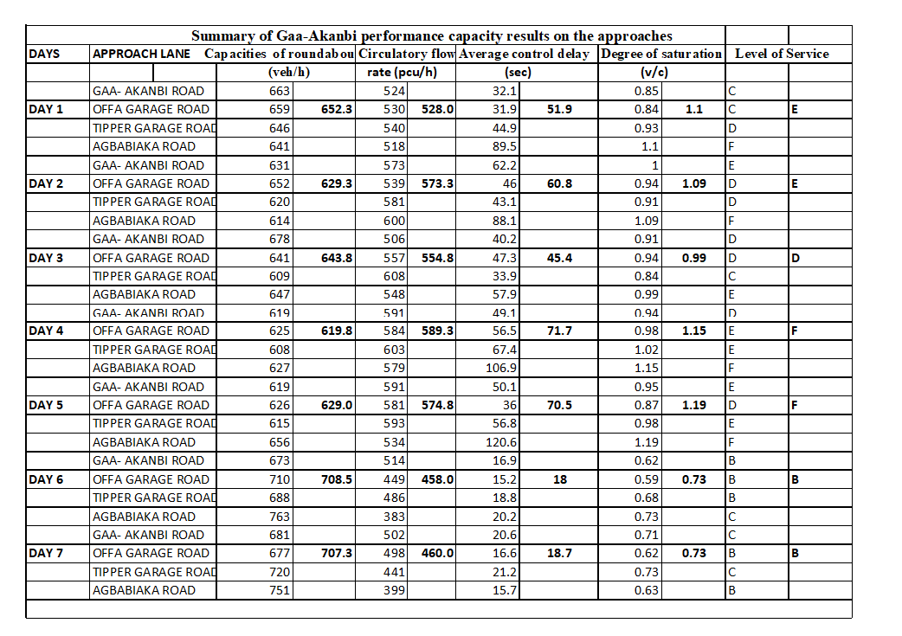

4.2. DiscussionofResults

The key performance indicators used for evaluating the performance analysis of the Gaa- Akanbi roundabout were; capacity, v/c ratio (degree ofsaturation), average delayand LOS.

4.2.1. Effectof volume onthe capacity ofthe roundabout

The traffic data collected at the Gaa-Akanbi roundabout revealed consistent peak hours occurring primarily between 7:30–8:30 AM and 3:30–4:30 PM over the course of seven days.

4.2.2.Capacity of the roundabout

The capacity is a critical metric for evaluating roundabout performance. As shown in Table 4.1.12, the average capacities of the roundabout during these peak times fall within the range of 619.8 to 708.5 veh/h per each day, as detailed in the table.

Figure4.9: Showing the average of capacity of each day at Gaa-AkanbiRoundabout

4.2.3. Degree of saturation (v/c)

Table 4.1.12. reveals that the average v/c ratios, ranging from 0.73 to 1.19, were recorded on Agbabiaka Road and Tipper Garage Road approaches during Days 1 to 7 , These elevated values indicate significant delays, queuing, and service breakdowns at the roundabout.

Figure4.10: Showing the average of degree of satuationof each day at

Gaa-AkanbiRoundabout

4.2.4. Average control delay

Table 4.1.10 shows that average control delays at the Gaa-Akanbi roundabout during peak periods range from 18 to 71.7 seconds across all approaches. The highest delay, 120.6 seconds, occurred on Day 5 at the on Agbabiaka approach, while the lowest delay, 15.2 seconds, was recorded on Day 6 at Offa garage Road. Overall, the roundabout experienced its highest average delay of 71.7 seconds on Day 4 and its lowest of 18.0 seconds on Day 6 during peak periods.

Figure4.10: Showing the average of control delay of each day at

Gaa-AkanbiRoundabout

4.2.5. Levelof service (LOS)

Table 4.1.12. Indicates that the Gaa-Akanbi roundabout operated at LOS ranges from E-F during the analysis period on weekday. Agbabiaka approach operated at LOS F except on weekend when its experienced C and D.
Other approaches operated at LOS between E to C, except on weekend when they operated between E TO B

Figure4.10: Showing the Level of service criteria from HCM 2010

CHAPTER FIVE

CONCLUSIONS AND RECOMMENDATIONS

5.1 Conclusion

Video footage was used to collect traffic data and vehicle movement information. Video recording data was used to validate the obtained data. Utilizing the HCM 2010 approach, SIDRA INTERSECTION 8 was employed to conduct the Gaa-Akanbi roundabout's capacity and performance analysis.
The study's findings included the following conclusions:
(i) The Gaa-Akanbi Roundabout saw its peak on all days, primarily between 7:30 and 8:30 am and 3:30 and 4:30 pm, respectively.

(ii) The average capacities of the roundabout during these peak times fall within the range of 619.8 to 708.5 veh/h, as detailed in the table

(ii) For all Approaches, the average delays encountered during the analysis periods at the Gaa-Akanbi roundabout range from 18.0 to 71.7 seconds as detailed in the table 4 .1.12
(iii) For all the approaches the average degree of saturation interval, which is 0.73 to 1.19, as detailed in the table4 .1.12
(iv) At peak, the Agbabiaka Approach Roundabout runs at LOS F.
(v) The Gaa-Akanbi Roundabout is assessed to be underperforming at its design capacity under the current conditions except on weeekend.

5.2 Recommendations

Thefollowing recommendationsarebased ontheprojectwork.
    - I will recommend that all the bike and Keke Napep (tricycle) at the entry and exit lane of Agbabiaka,Tippergarage,andGaa-Akanbi should be totally relocated to improve the traffic flow and roundabout performance.
    - For smooth and effective driving, I will suggest that the Gaa-Akanbi roundabout be signalized on all approaches
    - A speed limit or control measure should be implemented at the roundabout to ensure smooth traffic flow and efficient utilization
    - To improve driver efficiency, the roundabout's circular width should be expanded by adding extra lane to all the approaches
. (v) To ensure that heavy vehicles operate smoothly, the central island's diameter should be increased.

REFERENCES

Akcelik and Associates. (2013). SIDRA INTERSECTION user guide (Version 8). Melbourne,
Australia: Akcelik and Associates Pty Ltd. (Restricted confidential document - available
under software licence only).
Akçelik, R. (1997). Lane-by-lane modelling of unequal lane use and flares at roundabouts and signalised intersections: The SIDRA solution. Traffic Engineering and Control, 38(7/8), 388–399.
Akçelik, R. (2003). A roundabout case study comparing capacity estimates from alternative analytical models. Paper presented at the 2nd Urban Street Symposium, Anaheim, CA, USA.
Akçelik, R. (2004). Roundabouts with unbalanced flow patterns. Paper presented at the ITE 2004 Annual Meeting and Exhibit, Lake Buena Vista, FL, USA.
Akçelik, R. (2005a). Roundabout model calibration issues and a case study. Paper presented at the TRB National Roundabout Conference, Vail, CO, USA.
Akçelik, R. (2005b). Capacity and performance analysis of roundabout metering signals. Paper presented at the TRB National Roundabout Conference, Vail, CO, USA.
Akçelik, R. (2007). A review of gap-acceptance capacity models. Paper presented at the 29th Conference of Australian Institutes of Transport Research (CAITR), University of South Australia, Adelaide, Australia.
Akçelik, R. (2008a). The relationship between capacity and driver behaviour. Paper presented at the National Roundabout Conference, Transportation Research Board, Kansas City, MO, USA.
Akçelik, R. (2009). Evaluating roundabout capacity, level of service and performance. Paper presented at the ITE Annual Meeting, San Antonio, TX, USA.
Akçelik, R. (2011). An assessment of the Highway Capacity Manual 2010 roundabout capacity model. Paper presented at the TRB International Roundabout Conference, Carmel, IN, USA.
Akçelik, R., Chung, E., & Besley, M. (1996). Performance of roundabouts under heavy demand conditions. Road and Transport Research, 5(2), 36–50.
Akçelik, R., Chung, E., & Besley, M. (1997). Analysis of roundabout performance by modelling approach flow interactions. In Proceedings of the Third International Symposium on Intersections Without Traffic Signals (pp. 15–25). Portland, OR, USA.
Atomode, T. I. (2013). Assessment of traffic delay problems and characteristics at urban road intersections: A case study of Ilorin, Nigeria. IOSR Journal of Humanities and Social Science (IOSR-JHSS, 12(4), 6–16. https://doi.org/10.9790/0837-1240616
Bruce, W. R., Rodegerdts, L., Wade, S., & Kittelson, W. (2000). Roundabouts: An informational guide (1st ed.). Washington, DC: U.S. Department of Transportation, Federal Highway Administration.
Chard, B. (1997). ARCADY health warning: Account for unequal lane usage or risk damaging the public purse! Traffic Engineering and Control, 38(3), 122–132.
Cirillo, C., Eboli, L., & Mazzulla, G. (2011). On the asymmetric user perception of transit service quality. International Journal of Sustainable Transportation, 5(4), 216–232.
Design Manual for Roads and Bridges (DMRB). (2007). Geometric design of roundabouts. Department for Regional Development, Northern Ireland.
Douglas, R. K., Patton, P. E., & Harris, Rust & Associates. (2005). Estimating roundabout performance using delay and conflict opportunity crash prediction. Paper presented at the National Roundabout Conference Draft, Colorado, USA.
Federal Republic of Nigeria, Federal Ministry of Works. (2013). Highway manual: Roundabout design (Part 1: Design, Volume I: Geometric Design).
Figueroa, A. (2012). Modern roundabout design guidelines. ITE-Puerto Rico Spring Seminar Presentation. Retrieved from www.academic.uprm.edu
FHWA-RD-00-067. (2000). Roundabouts: An informational guide. Washington, DC: U.S. Department of Transportation, Federal Highway Administration. https://www.fhwa.dot.gov/publications/research/safety/00067/00067.pdf

APPPENDIX1
The SIDRA specific windows are shown below
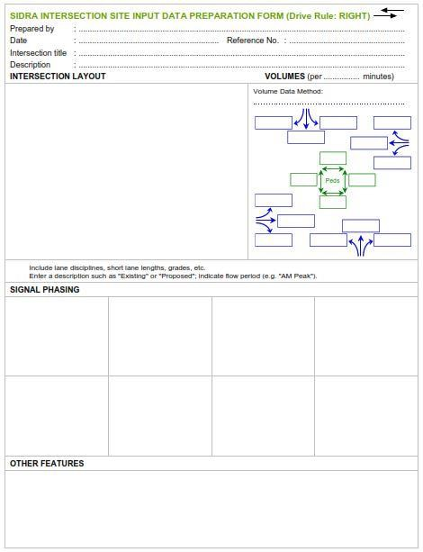

Figure3.3:SIDRAINTERSECTIONsiteinputdatapreparationform
(Source:Akcelikand Associates 2018).

Figure3.4:SIDRAINTERSECTION,INTERSECTION LAYOUT.
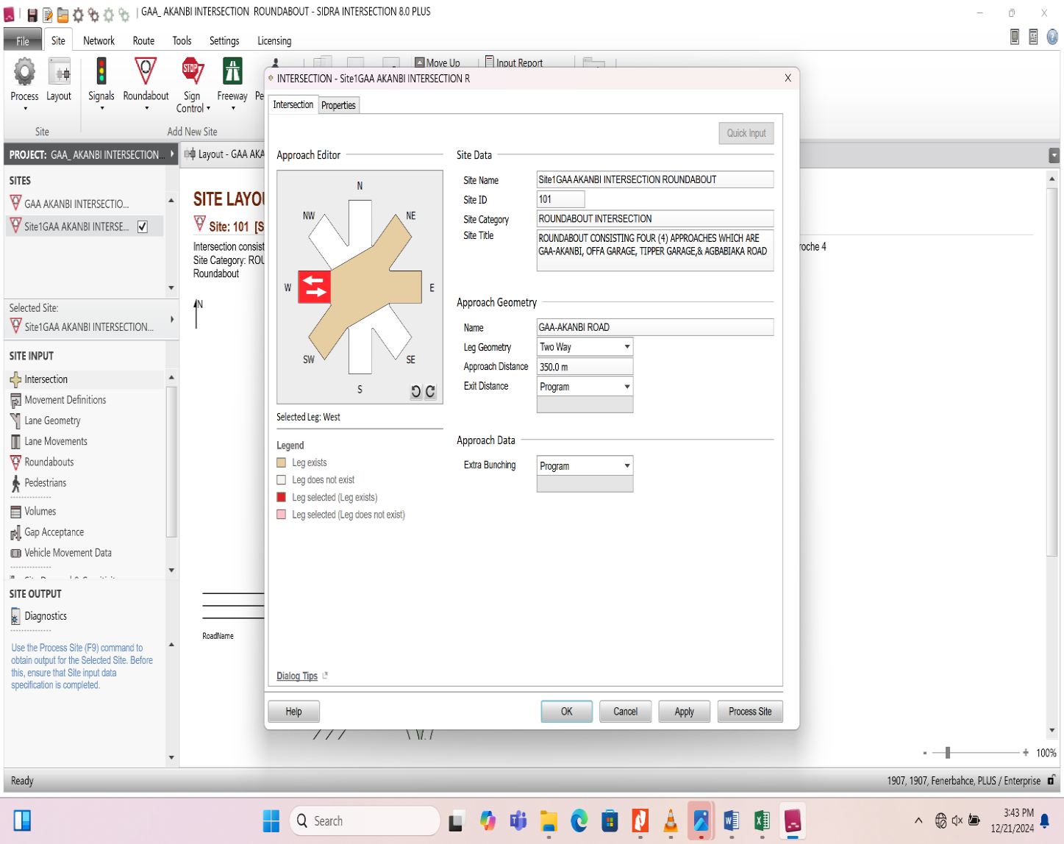

Figure3.5:SIDRAINTERSECTIONMOVEMENT DEFINTION LAYOUT

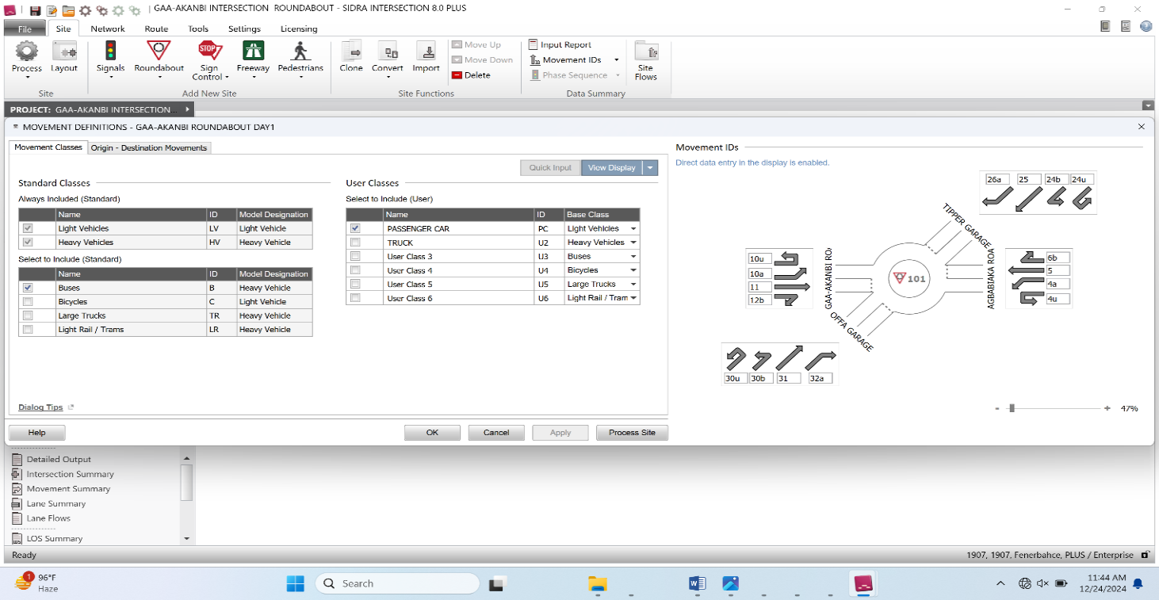
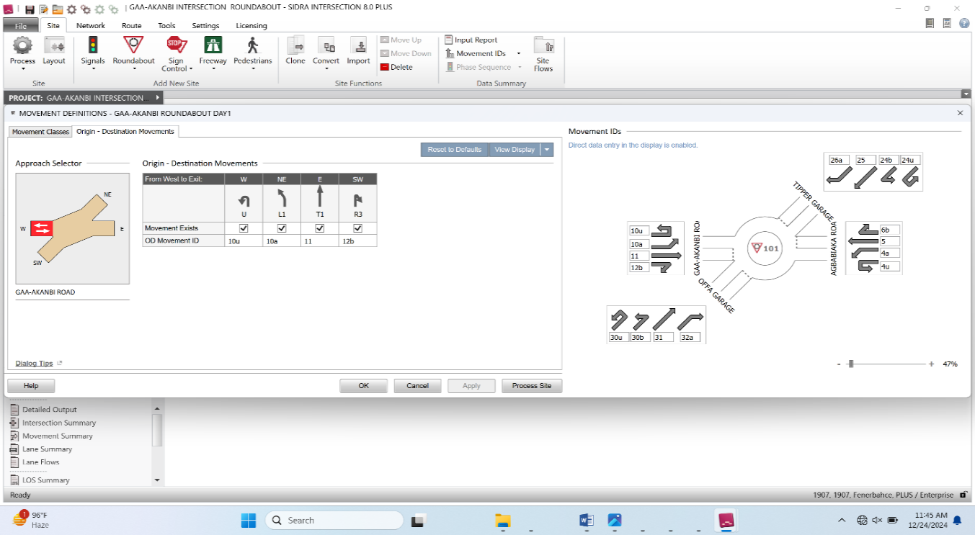

Figure3.6:SIDRAINTERSECTIONLANE GEOMETRYWINDOW
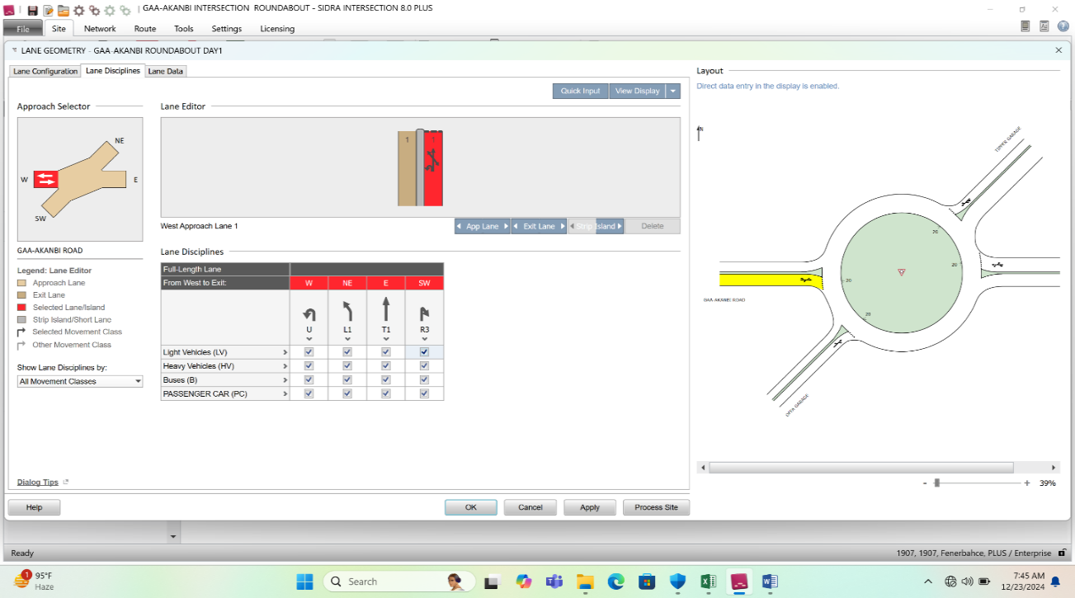
Figure3.7:SIDRAINTERSECTIONROUNDABOUT GEOMETRYWINDOW

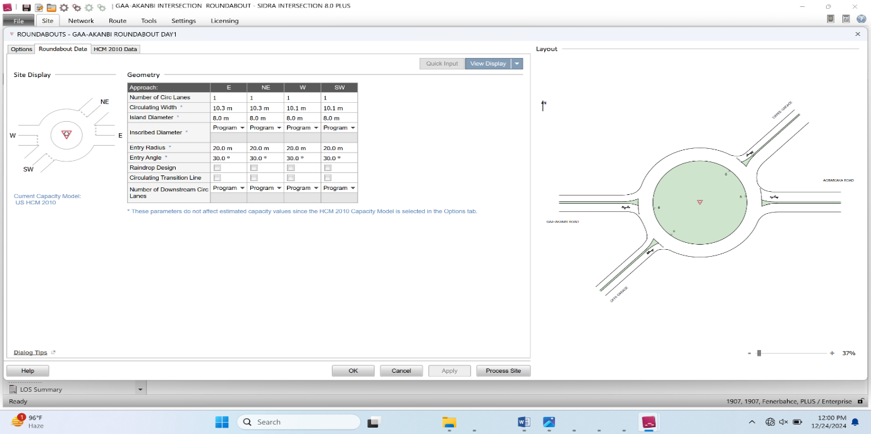

Figure3.8:SIDRA INTERSECTION VOLUMES GEOMETRY WINDOW
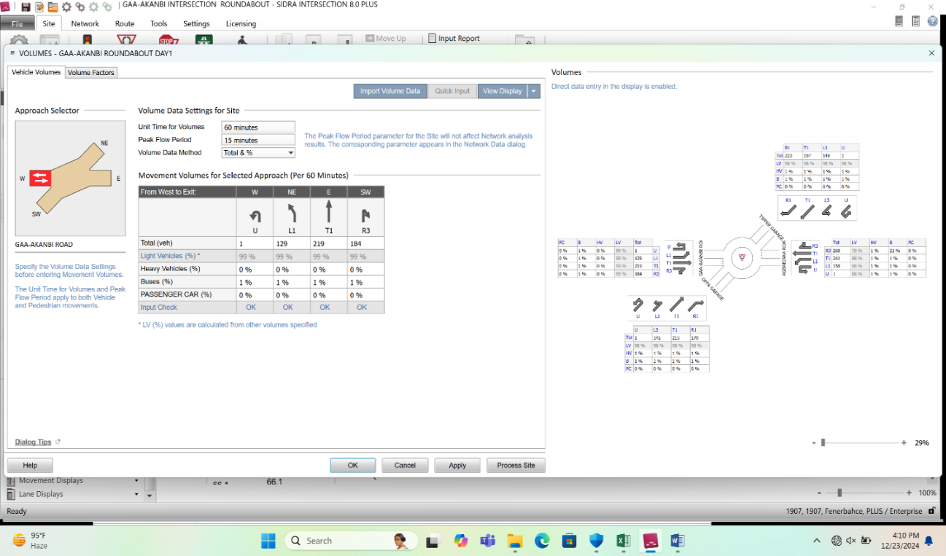

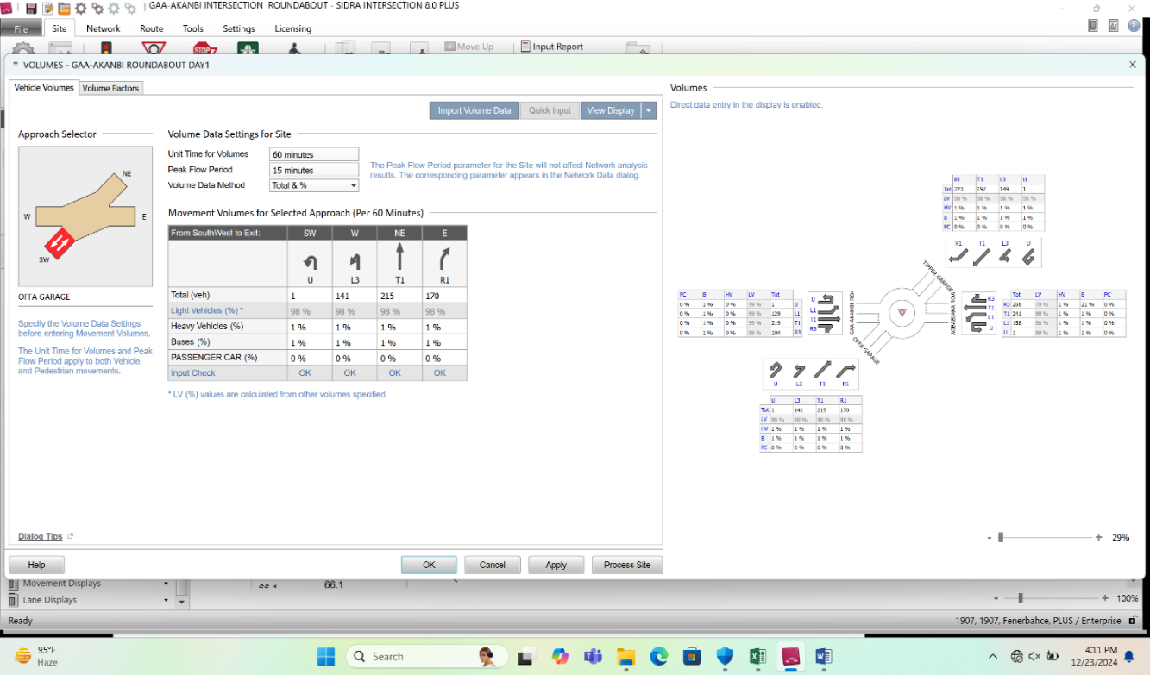

Figure3.8:SIDRA INTERSECTION VOLUMES GEOMETRYWINDOW

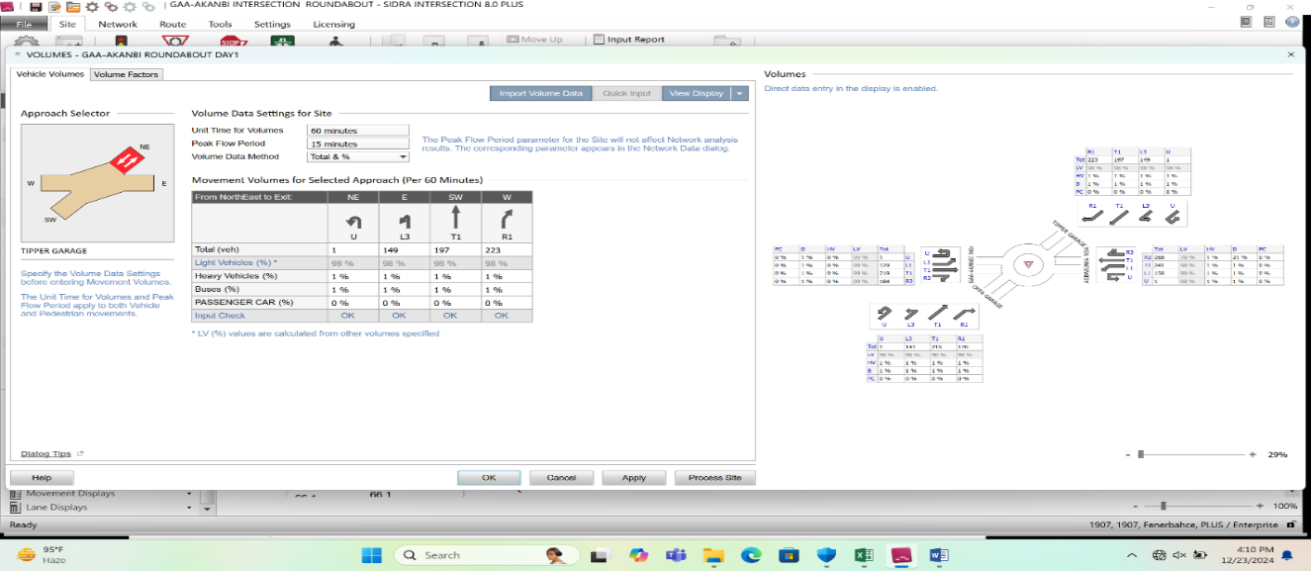

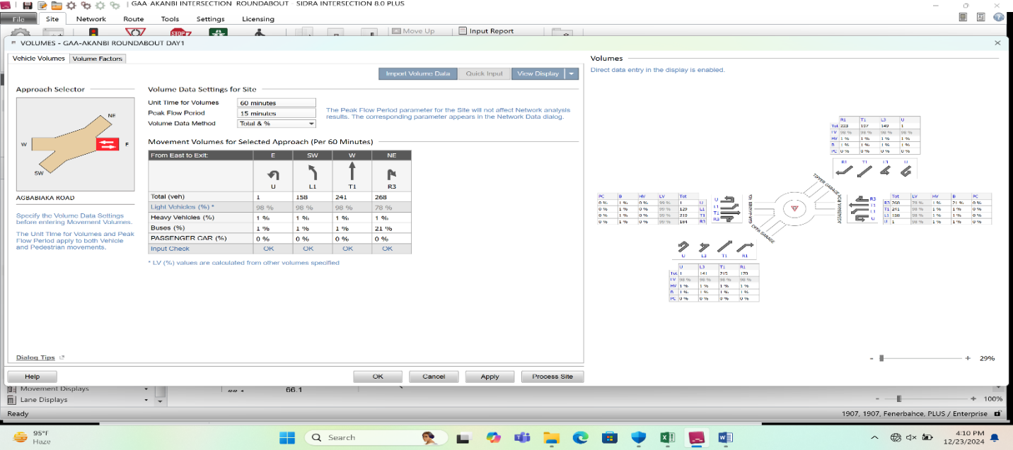

Figure3.8:SIDRA INTERSECTION volume input window

