HEART DISEASE PREDICTION USING ARTIFICIAL NEURAL NETWORK

BY:

GIWA ABDULRAHMAN BABATUNDE
ND/22/COM/PT/119

A Project Submitted to the Department of Computer Science, Institute of Information and Communication Technology, Kwara State Polytechnic, Ilorin

In Partial Fulfillment of the Requirements for the Award of National Diploma (ND) in Computer Science

June, 2025
CERTIFICATION
This is to certify that this project research was carried out byADESHOLA, Timothy Adebayowith matriculation Number ND/22/COM/PT/119,has been read and approve as meeting part of the requirements for the award of National Diploma (ND)in Computer Science.

_______________________ ___________________
Mr. Murtala, K. Date
(Project Supervisor)

_______________________ ___________________
Mr. Oyedepo F.S Date
(Head of Department)

_________________________ ____________________
External Examiner Date

DEDICATION
This project is dedicated to the creator of the earth and universe, the Almighty God. It is also dedicated to my parents for their moral and financial support.

ACKNOWLEDGEMENT
All praise due to Almighty God the Lord of the Universe. I praise Him and thank Him for giving me the strength and knowledge to complete my ND programme and also for my continue existence on the earth.
I appreciate the utmost effort of my supervisor, Mr. Murtala,K. I whose patience support and encourages have been the driving force behind the success of this research work. He gave useful corrections, constructive criticisms, comments, recommendations, advice and always ensures that an excellent research is done. My sincere gratitude goes to Head of the Department and other members of staff of the Department of Computer Science, Kwara State Polytechnic, Ilorin, for their constant cooperation, constructive criticisms and encouragements throughout the programme.
Special gratitude to my parents who exhibited immeasurable financial, patience, support, prayers and understanding during the periods in which I was busy tirelessly in my studies. Special thanks go to all my lovely siblings.
My sincere appreciation goes to my friends and classmates.

TABLE OF CONTENTS
- Title Page
- Certification
- Dedication
- Acknowledgements
- Abstract
- Table of Contents
CHAPTER ONE: GENERAL INTRODUCTION
  - Background to the Study
  - Statement of the Problem
  - Aim and Objectives of the Study
  - Significance of the Study
  - Scope of the Study
  - Organization of the Report
CHAPTER TWO: LITERATURE REVIEW
2.1 Review of Related Works
2.2 Overview of Heart Failure
2.3 Heart Disease Symptoms
2.4 Overview of Machine Learning
2.2.4 Convolutional Neural Network (CNN)
2.2.5 Time Series Analysis for Heart Failure Prediction

CHAPTER THREE: RESEARCH METHODOLOGY AND ANALYSIS
  - Research Methodology
  - Analysis of the Existing System
  - Problems of the Existing System
  - Description of the Proposed System
  - Advantages of the proposed system
CHAPTER FOUR: DESIGN, IMPLEMENTATION AND DOCUMENTATION OF THE SYSTEM
  - Design of the System
    - Output Design
    - Input Design
    - Database Design
    - Procedure Design
  - Implementation of the System
    - Choice of Programming Language
    - Hardware Support
    - Software Support
  - Documentation of the System
    - Program Documentation
    - Maintaining the System
CHAPTER FIVE: SUMMARY, CONCLUSION AND RECOMMENDATION
  - Summary
  - Conclusion
  - Recommendation
References
Appendices
ABSTRACT
Heart disease remains a significant public health concern globally, with high morbidity and mortality rates. Early prediction of heart disease can significantly improve patient outcomes by allowing timely interventions and personalized treatments. However, traditional prediction models often face challenges in accurately capturing complex temporal patterns present in physiological data.The significance of this project lies in its potential to revolutionize heart disease risk stratification and clinical decision-making, enabling timely interventions and personalized treatment regimens. By harnessing the power of ANNs to predict heart disease, healthcare providers can proactively identify individuals at elevated risk of Heart disease, thereby mitigating disease progression and reducing associated morbidity and mortality rates. The findings of this research pave the way for the integration of advanced deep learning techniques into clinical practice, ushering in a new era of precision medicine for heart disease management. The software will be developed in Microsoft Visual C Sharp with MySQL a relational database management system as the backend.

CHAPTER ONE
GENERAL INTRODUCTION
  - BACKGROUND OF THE STUDY
Among all fatal diseases, heart diseases are considered as the most prevalent. Medical practitioners conduct different surveys on heart diseases and gather information of heart patients, their symptoms and disease progression. Increasingly are reported about patients with common diseases who have typical symptoms. In this fast moving world people want to live a very luxurious life so they work like a machine in order to earn lot of money and live a comfortable life therefore in this race they forget to take care of themselves, because of this there food habits change their entire lifestyle change, in this type of lifestyle they are more tensed they have blood pressure, sugar at a very young age and they don’t give enough rest for themselves and eat what they get and they even don’t bother about the quality of the food if sick the go for their own medication as a result of all these small negligence it leads to a major threat that is the heart disease(Kwakye & Dadzie, 2019).
Albahr, et al., (2021) claimed that the term ‘heart disease’ includes the diverse diseases that affect heart. The number of people suffering from heart disease is on the rise. The report from world health organization shows us a large number of people that die every year due to the heart disease all over the world. Heart disease is also stated as one of the greatest killers in Africa. Machine Learning has been used in a variety of applications such as marketing, customer relationship management, engineering, and medicine analysis, expert prediction, web mining and mobile computing. Of late, machine learning has been applied successfully in healthcare fraud and detecting abuse cases.
Machine Learning is a way of manipulating and extraction of implicit, previously unknown/known and potential useful information about data”. Machine Learning is a very vast and diverse field and its scope and implementation is increasing day by day. Machine learning incorporates various classifiers of Supervised, Unsupervised and Ensemble Learning which are used to predict and find the accuracy of the given dataset(Karthick, et al., 2022).
According to the World Health Organization, every year, 12 million deaths occur worldwide due to Heart Disease. Heart disease is one of the biggest causes of morbidity and mortality among the population of the world. Prediction of cardiovascular disease is regarded as one of the most important subjects in the section of data analysis. The load of cardiovascular disease is rapidly increasing all over the world from the past few years. Many researches have been conducted in attempt to pinpoint the most influential factors of heart disease as well as accurately predict the overall risk. Heart disease is even highlighted as a silent killer which leads to the death of the person without obvious symptoms. The early diagnosis of heart disease plays a vital role in making decisions on lifestyle changes in high-risk patients and in turn reduces the complications. Machine learning proves to be effective in assisting in making decisions and predictions from the large quantity of data produced by the health care industry(Bharti, et al., 2021).
The World Health Organization claimed that, 17.9 million people died in 2019 from cardiovascular diseases (CVDs), accounting for 32% of all global deaths. Cardiovascular diseases (CVDs) are a group of disorders of the heart and blood vessels which include coronary heart disease, cerebrovascular disease, peripheral arterial disease, congenital heart disease, and so on. Despite advances in healthcare and medicine research, the rate of coronary heart disease (CHD) has been steadily increasing over time, and researchers all over the world have been working to identify the factors that are associated with future risk of coronary heart disease (CHD) (Ngare, 2019).
This project aims to predict future heart disease by analyzing data of patients which classifies whether they have heart disease or not using machine-learning algorithm.
1.2 STATEMENT OF THE PROBLEM
The major challenge in heart disease is its detection. There are instruments available which can predict heart disease but they are either expensive or are not efficient to calculate chance of heart disease in human. Early detection of cardiac diseases can decrease the mortality rate and overall complications. However, it is not possible to monitor patients’ everyday in all cases accurately and consultation of a patient for 24 hours by a doctor is not available since it requires more sapience, time and expertise. Since we have a good amount of data in today’s world, we can use various machine learning algorithms to analyze the data for hidden patterns. The hidden patterns can be used for health diagnosis in medicinal data. This project aim to predict heart disease using artificial neural network.
1.3 AIM AND OBJECTIVES OF THE STUDY
The aim of the project is to develop a model for heart disease prediction using artificial neural network; this will be achieved with the following objectives, which are to:
- develop a heart prediction system;
- implement Artificial Neural Network to predict heart disease as per the input of the user;
- develop a system that will help to avoid human biasness; and
- design a system that will predict heart disease to reduce the cost of medical tests.
1.4 SIGNIFICANCE OF STUDY
Heart disease can be managed effectively with a combination of lifestyle changes, medicine and, in some cases, surgery. With the right treatment, the symptoms of heart disease can be reduced and the functioning of the heart improved. The predicted results can be used to prevent and thus reduce cost for surgical treatment and other expensive. The overall objective of this work will be to predict accurately with few tests and attributes the presence of heart disease. Attributes considered form the primary basis for tests and give accurate results more or less. Many more input attributes can be taken but the goal is to predict with few attributes and faster efficiency the risk of having heart disease.
1.5 SCOPE OF THE STUDY
Here the scope of the project is the integration of artificial neural network with computer-based patient records could reduce medical errors, enhance patient safety, decrease unwanted practice variation, and improve patient outcome. This suggestion is promising as data modeling and analysis tools, e.g., machine learning, have the potential to generate a knowledge-rich environment which can help to significantly improve the quality of clinical predictions.
1.6 ORGANIZATION OF THE REPORT
The project is organized into five different chapters. Chapter one covers general introduction, which contains introduction to the research topic, statement of the problem, aim and objectives, significance of the study, scope and limitation and organization of the report. Chapter two covers literature review, which contains review of related past work, review of general text and discussions of issues related to this topic. Chapter three explains the project methodology which includes analysis of existing system, problems of the existing system, and the description of the proposed system, advantages of proposed system and design and implementation techniques used. Chapter four covers the design, implementation and documentation of the system which contain system design output design, input design, database design and procedure design, implementation of the system hardware and software support and documentation of the new system installation procedure, operating the system and system maintenance. Lastly, chapter five centres on summary of the research, recommendations and conclusion.

CHAPTER TWO
LITERATURE REVIEW
2.1 REVIEW OF RELATED LITERATURE
Bharti, et al., (2021) developed a prediction of heart disease using a combination of machine learning and deep learning. In the paper, different machine learning algorithms and deep learning are applied to compare the results and analysis of the UCI Machine Learning Heart Disease dataset. *e dataset consists of 14 main attributes used for performing the analysis. Various promising results are achieved and are validated using accuracy and confusion matrix. *e dataset consists of some irrelevant features which are handled using Isolation Forest, and data are also normalized for getting better results. And how this study can be combined with some multimedia technology like mobile devices is also discussed. Using deep learning approach, 94.2% accuracy was obtained.
Karthick, et al., (2022) implemented a heart disease risk prediction model using machine learning. Machine learning (ML) was a plausible option in the system for reducing and understanding heart symptoms of disease. The chi-square statistical test is performed to select specific attributes from the Cleveland heart disease (HD) dataset. Support vector machine (SVM), Gaussian Naive Bayes, logistic regression, LightGBM, XGBoost, and random forest algorithm have been employed for developing heart disease risk prediction model and obtained the accuracy as 80.32%, 78.68%, 80.32%, 77.04%, 73.77%, and 88.5%, respectively. The data visualization has been generated to illustrate the relationship between the features. According to the findings of the experiments, the random forest algorithm achieves 88.5% accuracy during validation for 303 data instances with 13 selected features of the Cleveland HD dataset.
Albahr, et al., (2021) proposed a computational learning model for prediction of heart disease using machine learning based on a new regularizer. In this research, a new computational model for predicting early heart disease is proposed. (e predictive model is embedded in a new regularization based on decaying the weights according to the weight matrices’ standard deviation and comparing the results against its parents (RSD-ANN). (e performance of RSDANN is far better than that of the existing methods. Based on our experiments, the average validation accuracy computed was 96.30% using either the tenfold cross-validation or holdout method.
Kwakye and Dadzie (2019) designed a machine learning-based classification algorithms for the prediction of coronary heart diseases. The report discussed a comparative approach to the classification of coronary heart disease datasets using machine learning (ML) algorithms. The study created and tested several machine-learning-based classification models. The dataset was subjected to Smote to handle unbalanced classes and feature selection technique in order to assess the impact on two distinct performance metrics. The results show that logistic regression produced the highest performance score on the original dataset compared to the other algorithms employed. In conclusion, the study suggests that LR on a well-processed and standardized dataset can predict coronary heart disease with greater accuracy than the other algorithms.
Jeyaganesan, et al., (2020) proposed a diagnosis and prediction of heart disease using machine learning techniques. In the research, the researcher used different machine learning algorithms and data visualization techniques to predict heart disease using available dataset. The dataset consists of 14 main attributes used for performing analysis. The researcher started with data pre-processing step and will apply the machine learning algorithms on dataset of different sizes in order to study stability and accuracy and precision of each of them.
Singh and Singh (2021) worked on machine learning based hybrid model for heart disease prediction. The paper proposed a new hybrid model based on feature selection, feature optimization and ensemble technique. This exclusive combination will build an enhanced model that will have leverage over the existing models in predicting the heart disease more quickly and accurately and thus will assist the medical practitioners in taking the measures to control the mishap.
Jindal, et al., (2020) developed a heart disease prediction using machine learning algorithms.The research paper mainly focuses on which patient is more likely to have a heart disease based on various medical attributes. We prepared a heart disease prediction system to predict whether the patient is likely to be diagnosed with a heart disease or not using the medical history of the patient. We used different algorithms of machine learning such as logistic regression and KNN to predict and classify the patient with heart disease. A quite helpful approach was used to regulate how the model can be used to improve the accuracy of prediction of Heart Attack in any individual. The strength of the proposed model was quiet satisfying and was able to predict evidence of having a heart disease in a particular individual by using KNN and Logistic Regression which showed a good accuracy in comparison to the previously used classifier such as naive bayes etc. So a quiet significant amount of pressure has been lift off by using the given model in finding the probability of the classifier to correctly and accurately identify the heart disease. The Given heart disease prediction system enhances medical care and reduces the cost. This project gives us significant knowledge that can help us predict the patients with heart disease It is implemented on the .pynb format.

2.2 REVIEW OF GENERAL TEXT
2.2.1 Overview of heart Disease
Heart disease describes a range of conditions that affect your heart. Heart diseases include:
- Blood vessel disease, such as coronary artery disease
- Heart rhythm problems (arrhythmias)
- Heart defects you're born with (congenital heart defects)
- Heart valve disease
- Disease of the heart muscle
- Heart infection
Many forms of heart disease can be prevented or treated with healthy lifestyle choices (Kwakye & Dadzie, 2019).

2.2.2 Heart Disease Symptoms
Heart disease symptoms depend on what type of heart disease you have.

Symptoms of heart disease in your blood vessels
A buildup of fatty plaques in your arteries, or atherosclerosis (ath-ur-o-skluh-ROE-sis) can damage your blood vessels and heart. Plaque buildup causes narrowed or blocked blood vessels that can lead to a heart attack, chest pain (angina) or stroke.
Coronary artery disease symptoms may be different for men and women. For instance, men are more likely to have chest pain. Women are more likely to have other signs and symptoms along with chest discomfort, such as shortness of breath, nausea and extreme fatigue.
Signs and symptoms can include:
- Chest pain, chest tightness, chest pressure and chest discomfort (angina)
- Shortness of breath
- Pain, numbness, weakness or coldness in your legs or arms if the blood vessels in those parts of your body are narrowed
- Pain in the neck, jaw, throat, upper abdomen or back
You might not be diagnosed with coronary artery disease until you have a heart attack, angina, stroke or heart failure. It's important to watch for cardiovascular symptoms and discuss concerns with your doctor. Cardiovascular disease can sometimes be found early with regular evaluations.

Heart disease symptoms caused by abnormal heartbeats (heart arrhythmias)
Your heart may beat too quickly, too slowly or irregularly. Heart arrhythmia signs and symptoms can include:
- Fluttering in your chest
- Racing heartbeat (tachycardia)
- Slow heartbeat (bradycardia)
- Chest pain or discomfort
- Shortness of breath
- Lightheadedness
- Dizziness
- Fainting (syncope) or near fainting

Heart disease symptoms caused by heart defects
Serious heart defects that you're born with (congenital heart defects) usually are noticed soon after birth. Heart defect signs and symptoms in children could include:
- Pale gray or blue skin color (cyanosis)
- Swelling in the legs, abdomen or areas around the eyes
- In an infant, shortness of breath during feedings, leading to poor weight gain
Less serious congenital heart defects are often not diagnosed until later in childhood or during adulthood. Signs and symptoms of congenital heart defects that usually but aren't immediately life-threatening include:
- Easily getting short of breath during exercise or activity
- Easily tiring during exercise or activity
- Swelling in the hands, ankles or feet

Heart disease symptoms caused by diseased heart muscle (cardiomyopathy)
In early stages of cardiomyopathy, you may have no symptoms. As the condition worsens, symptoms may include:
- Breathlessness with activity or at rest
- Swelling of the legs, ankles and feet
- Fatigue
- Irregular heartbeats that feel rapid, pounding or fluttering
- Dizziness, lightheadedness and fainting

Heart disease symptoms caused by heart infection
Endocarditis is an infection that affects the inner lining of your heart chambers and heart valves (endocardium). Heart infection signs and symptoms can include:
- Fever
- Shortness of breath
- Weakness or fatigue
- Swelling in your legs or abdomen
- Changes in your heart rhythm
- Dry or persistent cough
- Skin rashes or unusual spots

Heart disease symptoms caused by heart valve problems (valvular heart disease)
The heart has four valves the aortic, mitral, pulmonary and tricuspid valves — that open and close to direct blood flow through your heart. Many things can damage your heart valves, leading to narrowing (stenosis), leaking (regurgitation or insufficiency) or improper closing (prolapse) (Ngare, 2019).
Depending on which valve isn't working properly, valvular heart disease signs and symptoms generally include:
- Fatigue
- Shortness of breath
- Irregular heartbeat
- Swollen feet or ankles
- Chest pain
- Fainting (syncope)
2.2.3 Overview of Machine Learning
Machine learning is a branch of Artificial Intelligence. Its primary focus is to design systems in such a way that it allows them to learn and make predictions based on the experience. It trains algorithms using a training dataset to create a model for better accuracy and prediction. The model uses the new input data to predict heart disease. By using machine learning, we can detect hidden patterns in the input dataset to build models. It gives accurate predictions for new datasets. Before using machine learning algorithm first we need to clean the dataset and fill the missing values. The model uses the new input data to predict heart disease and then tested for accuracy. Machine learning is of 3 types which are classified as:
- Supervised Learning: The model is trained on a dataset that is labelled. It has input data and its outcomes. Data elements are first classified and split in to train and test data. Training dataset used for training our model while testing dataset functions as new data to find the accuracy of the model. The two types under supervised learning are classification and regression.
- Unsupervised Learning Data elements used here for training are not classified or labelled. Aim is to find hidden patterns in the data. The model is trained to develop patterns. It can easily predict hidden patterns for any new input dataset or train data, but upon exploring data, it draws conclusion from datasets to describe hidden patterns. The clustering method is an example of an unsupervised learning technique.
- Reinforcement Learning It does not use any labelled dataset nor the results are associated with data, thus model learns are based on the experience. In this technique, the model improves its performance based on its association with the environment and figures its faults and to get the right outcome through assessment and testing. Classification algorithms are commonly used supervised learning techniques to define probability of heart disease occurrence. Classification Machine Learning Techniques The classification task is used for prediction of subsequent cases dependent on past information. Many data mining techniques as Naïve Bayes, neural network, decision tree have been applied by researchers to have a precision diagnosis in heart disease. The accuracy provided by different techniques varies with number of attributes(Kwakye & Dadzie, 2019).
2.2.4 Artificial Neural Network (ANN)
The neural network is a computational model based on biological neural networks. Artificial Neural Networks (ANN) is based on observation of a human brain. Human brain is very complicated web of neurons. Analogically ANN is an interconnected set of three units such as input, hidden and output unit. In medical diagnosis, the patient's risk factors or attributes is used as an input. The effectiveness of artificial neural network was proven in medicine. ANN are used in predicting coronary heart disease. Here the input layer consisting of 8 neurons corresponds to 8 significant attributes. There is one output class variable which takes the value either 0 or 1. The value 0 means the individual is not suffering from heart disease and the value 1 mean the individual suffers from heart disease. The numbers of nodes used in the hidden layer are 3.
The main advantage of neural networks is high accuracy. The applications of neural network are accounting, medicine, fraud detection and so on. Based on the learned network or training dataset, the neural network is able to predict the presence or absence of heart disease for the testing dataset(Kwakye & Dadzie, 2019).

CHAPTER THREE
RESEARCH METHODOLOGY AND ANALYSIS OF THE EXISTING SYSTEM
3.1 Research Methodology
The proposed methodology showed in Figure 3.1 includes steps to implement the proposed system, where first step is referred to as the collection of the data then in second stage, it extracts significant values; then, the third is the pre-processing stage where the researcher explore the data. Data pre-processing deals with the missing values, cleaning of data and normalization depending on algorithms used. After pre-processing of data, classifier is used to classify the pre-processed data the classifier used in the proposed model is ANN. Finally, the proposed model is undertaken, where we evaluated the model which on the basis of accuracy and performance using various performance metrics. Here in this model, an Effective Heart Disease Prediction System (EHDPS) has been developed using different classifiers. This model uses 13 medical parameters such as chest pain, fasting sugar, blood pressure, cholesterol, age, sex and so on for prediction. Below is neural network diagram and architectural diagram of the proposed model.
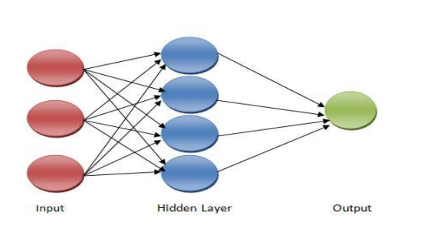
Figure 3.1: Neural Network
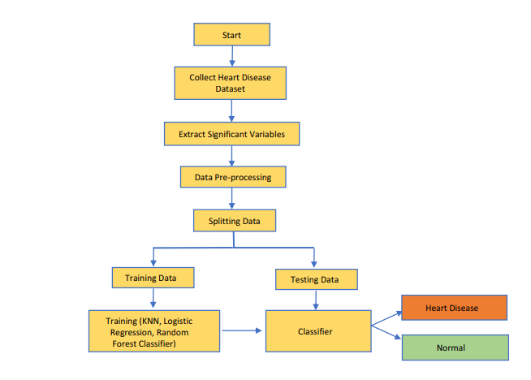
Prediction using Neural Network
Figure 3.1: The Architectural Diagram of the Proposed Model
3.1.1 Artificial Neural Networks (ANNs)
Artificial neural networks (ANNs) consist of input, hidden, and output layers with connected neurons (nodes) to simulate the human brain. The existing nodes process and transmit input signals to the next nodes. ANNs are nonlinear models to classify complicated relationships. The diagram below shows the three-layer neural network language model.
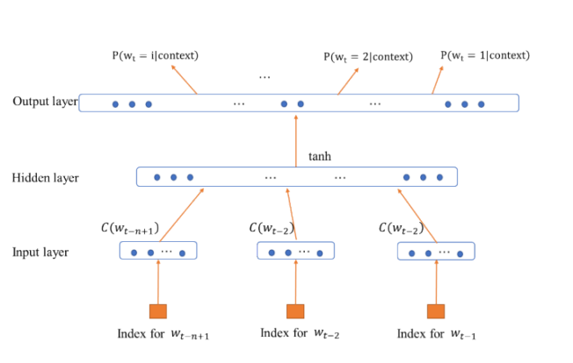
Figure 3.2: Three-layer neural network language model.
The process starts with the collection of patient data. The data are gathered and enter the pre-processing phase. The missing values are filled or removed using the technique elaborated in the data pre-processing section. Several prepossessing techniques were applied to the dataset for its improvement. The cleaned dataset was further divided into two subdatasets: the training and testing datasets. The training dataset was used for training the model using training data on the ANN algorithm. The testing data were used for evaluating the performance of the proposed model. After model training and testing, the proposed system outputs the result. The proposed system categorizes the patient as healthy or diseased.

3.1.1 Dataset
The dataset of the heart patients used for the proposed methodology is gathered from the hospital which is available in Kaggle website. The dataset collected from Kaggle contained the information of 1050 patients, which included 76 attributes. Out of the 76 attributes, 14 were used for the prediction of heart disease. This is because the other attributes do not affect the disease as much as these attributes. To eliminate the missing and redundant values, the dataset is cleaned and filtered before being used for classification. The dataset was randomly divided into training and testing datasets with 80% and 20% of the samples, respectively. Out of 1025 patient records, 820 records were used for training, and the remaining 205 samples for testing. Training data were used for training the model with the CNN algorithm, and validation data were for validating the performance of the trained model.

3.1.2 Data Pre-processing
Data pre-processing removes any ambiguous data from the collected dataset, resulting in reduced accuracy and prediction rate. Human error could be the reason for the loss of data, which needs to be removed before the training of the model. After the collection of the dataset, it is further pre-processed to remove any missing or duplicate values from the dataset. Unnecessary values are also weeded out, and the dataset is further used for training the model. The deletion of instances is carried out only if the missing value is of the missing-at-random (MAR) type, and those rows are dropped from the dataset where multiple missing entries are present in a single row. For inputting missing values, we employed commonly used mean and median methods for numerical and categorical features, respectively.

3.1.3 Explanation on Artificial Neural Network used
The architecture of the proposed ANN model is a feed-forward network with a sequential model in which each layer is connected in a single-input and single-output manner. The heart-disease classification attribute is a binary attribute that is classified as “1” for patients having heart disease, and “0” for patients with the absence of heart disease. The model had 2 convolutional layers followed by 8 dense layers. The 14 selected attributes were joined in the fully connected dense layer. A total of 8 fully connected dense layers were used for building the ANN framework. The first four layers contained 128 neurons, the next contained 64, and the last layer contained 1 neuron. Before the nonlinear transformation, these layers normalize the variables. The exponential linear unit (ELU) was used as an activation function except for in the last layer. The sigmoid function was used as an activation function in the last layer of the ANN model. The Nadam optimizer was used with a learning rate of 0.001. The loss function was set to binary cross-entropy. During the training phase, the number of epochs was set to 100 for better classification. The dropout rate was 3% to avoid overfitting by the model.
3.2 Analysis of the Existing System
Heart disease is even being highlighted as a silent killer which leads to the death of a person without obvious symptoms. The nature of the disease is the cause of growing anxiety about the disease & its consequences. Hence continued efforts are being done to predict the possibility of this deadly disease in prior. So that various tools & techniques are regularly being experimented with to suit the present-day health needs. Machine Learning techniques can be a boon in this regard. Even though heart disease can occur in different forms, there is a common set of core risk factors that influence whether someone will ultimately be at risk for heart disease or not. By collecting the data from various sources, classifying them under suitable headings & finally analyzing to extract the desired data we can conclude. This technique can be very well adapted to the do the prediction of heart disease. As the well-known quote says “Prevention is better than cure”, early prediction & its control can be helpful to prevent & decrease the death rates due to heart disease.
3.3 Problems of the Existing System
Several risk factors play an important role in determining whether or not you’re likely to develop heart disease. Two of these factors, age and heredity, are out of your control.The risk of heart disease increases around the age of 55 in women and 45 in men. Your risk may be greater if you have close family members who have a history of heart disease. The existing system is the method of going to the hospital for checkup and this has some disadvantages which are:
  - Time consumption
  - Queuing due to many people waiting to see the doctor
  - Unavailability of enough doctor to attend to patients
The risk factors for heart disease include the following:
- obesity
- insulin resistance or diabetes
- high cholesterol and blood pressure
- family history of heart disease
- being physically inactive
- smoking
- eating an unhealthy diet
- clinical depression
3.4 Description of the Proposed System
The working of the system starts with the collection of data and selecting the important attributes. Then the required data is preprocessed into the required format. The data is then divided into two parts training and testing data. The algorithms are applied and the model is trained using the training data. The accuracy of the system is obtained by testing the system using the testing data. This system is implemented using the following modules.
1.) Collection of Dataset
2.) Selection of attributes
3.) Data Pre-Processing
4.) Balancing of Data
5.) Disease Prediction
3.5 Advantages of the Proposed System
The proposed system has several advantages; these are:
- User can search for doctor’s help at any point of time.
- User can talk about their Heart Disease and get instant diagnosis.
- Doctors get more clients online.
- Very useful in case of emergency.

CHAPTER FOUR
DESIGN, IMPLEMENTATION AND DOCUMENTATION OF THE SYSTEM
4.1 DESIGN OF THE SYSTEM
This is the computation of the particulars of a new system and the determination of what the new system would be and the function it is to perform. This may involve changing from one system to another or modifying the existing system operation.
The most challenging phase of the system life cycle is the change from manual operation to a faster and more accurate one; system design stage covers the technical specifications that will be employed in the implementation of the new system in order to modify the previous system. Some factors are put in consideration. These factors include input design, output design, the database and procedure designs and other documentation.
4.1.1 OUTPUT DESIGN
This incorporates the objectives of solving the existing system problems and challenges. The outputs extracted from the system are displayed in the screenshot images below:

Figure 4.1: Main menu
The main menu interface contains some menus where the user can navigate to other pages on the system. The menus are create data, access data, modification, logout and so on.
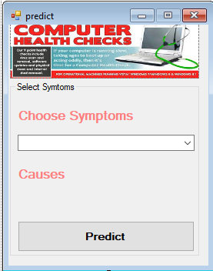
Figure 4.2: Heart Disease Prediction Interface
This is the page where the heart disease will be predicted
4.1.2 INPUT DESIGN
The following input was obtained from the fault detection system. They are:
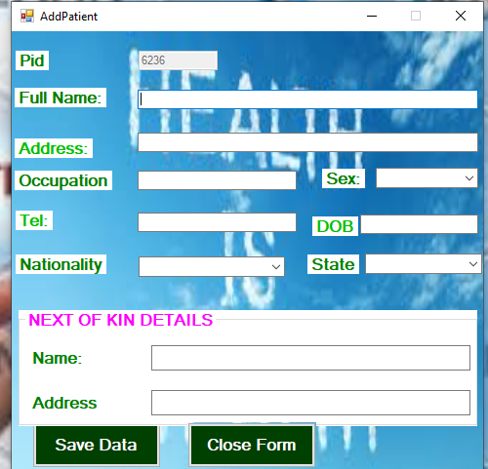
Figure 4.3: The Registration Page
This interface is the page where a user can register on the system and save some data.

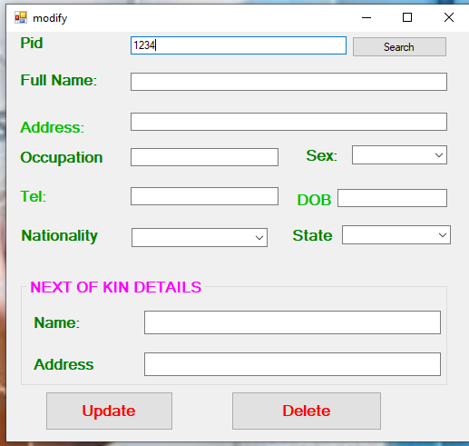
Figure 4.4: Modification Page
This interface shows a page where the user can modify the records saved anytime the need arises.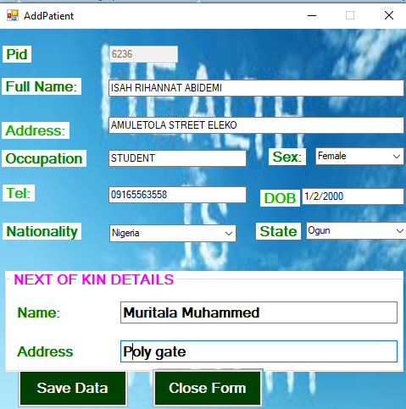
Figure 4.6: Record Creation Page
As displayed above, here the user can registeron the system.
4.1.4 PROCEDURE DESIGN
These are the steps involved in unifying the whole process to produce the desired output. It involves computer procedures which start from the original input lessons to the output result file. This allows the processing of user information and result to be possible. Menu is provided to aid user in the processing of the output file.
4.2 IMPLEMENTATION OF THE SYSTEM
This entails the choice of the programming language employed to implement the system which shouldbe suitable for heart disease prediction for hospital patient. The system is designed for the use of individuals which should serve as an assistant. It is also expected to be used in conjunction with the user.
4.2.1 CHOICE OF PROGRAMMING LANGUAGE
The application was developed in Microsoft Visual Studio (.Net), an integrated development environment (IDE). The Application IDE is chosen following the fact that extracted information needs to be presented in an enhanced pictorial/graphical format and easy communication with the database for program flexibility in windows platform.
4.2.2 HARDWARE REQUIREMENTS
i. 250 Hz minimum with CD ROM drive etc.
ii. Hard disk of capacity 10GB Minimum
iii. 126-512 megabyte of RAM
iv. An Uninterrupted power supply (UPS)
v. A voltage stabilizer
vi. A power generating set and so on.
4.2.3 SOFTWARE REQUIREMENTS
I. Window Operated system such Windows7
ii. Microsoft Visual C#.Net
4.3. PROGRAM DOCUMENTATION
The program is packaged for use in any system. After developing the system, there is a facility provided in Visual Studio suite called “Package and Deployment Wizard” that is used in Microsoft Visual C# .Net app packaging and deployment.
This software is packaged into an installable setup that can be run from any system.
4.3.1 MAINTAINING THE SYSTEM
The system maintenance refers to making modification to an already existing application/program without necessarily re-writing everything from the start. Program maintenance of a program includes modification of the program to meet-up with certain requirements of the users. In this course, additional features can be added, errors corrected, ambiguous interfaces redesigned to eliminate confusions and unnecessary features removed.
Maintaining this program can be done in Microsoft Visual C# environment. Any future modification can be by re-running the program source code in a Visual studio making necessary changes and updates and recompile the application into an upgrade version of the existing version of the mini word processing application. Further versions of this program can be named following their year of release or it can be given a different version number.

CHAPTER FIVE
SUMMARY, CONCLUSION AND RECOMMENDATIONS
5.1 SUMMARY
The prediction of heart diseases in hospitalized patient using artificialneural network based model has been developed. A heart disease detection model has been developed using two ANN classification modeling techniques. This project predicts people with heart disease by extracting the patient medical history that leads to a fatal heart disease from a dataset that includes patients’ medical history such as chest pain; sugar level, blood pressure, and so on. This Heart Disease detection system assists a patient based on his/her clinical information of them been diagnosed with a previous heart disease. The algorithms used in building the given model are Naïve Bayes Theorem and Bayesian Theorem. The accuracy of this model is 87.5%. Use of more training data ensures the higher chances of the model to accurately predict whether the given person has a heart disease or not. By using these, computer aided techniques can predict the patient fast and better and the cost can be reduced very much. There are a number of medical databases that we can work on as these Machine learning techniques are better and they can predict better than a human being which helps the patient as well as the doctors. The system was developed using Visual C # as the frontend and MySQL as the database system.
5.2 CONCLUSION
Heart diseases are a major killer in Nigeria and throughout the world, application of promising technology like machine learning to the initial prediction of heart diseases will have a profound impact on society. The early prognosis of heart disease can aid in making decisions on lifestyle changes in high-risk patients and in turn reduce the complications, which can be a great milestone in the field of medicine. The number of people facing heart diseases is on the increase each year. This prompts for its early diagnosis and treatment. The utilization of suitable technology support in this regard can prove to be highly beneficial to the medical fraternity and patients. In this project, the two different machine learning algorithms used to measure the performance are Naïve Bayes Theorem and Bayesian Theorem applied on the dataset. The expected attributes leading to heart disease in patients are available in the dataset which contains some important features that are useful to evaluate the system are selected among them. If all the features taken into the consideration then the efficiency of the system the author gets is less. To increase efficiency, attribute selection is done. In this n features have to be selected for evaluating the model which gives more accuracy. The correlation of some features in the dataset is almost equal and so they are removed. If all the attributes that are present in the dataset are taken into account, then, the efficiency decreases considerably.
5.3 RECOMMENDATIONS
Prior to the completion of this system the researcher recommend the following:
i. All medical institutions and hospitals should adopt the system as it will help them in predicting heart diseases in their patient.
ii. Future work should include additional algorithm like Logistic regression, Random Forest Classifier, K-Nearest Neighbor and so on.

REFERENCES
Albahr, A., Sigh, M.& Lona, K. (2021). Computational Learning Model for Prediction of Heart Disease Using Machine Learning Based on a New Regularizer. Computational Intelligence and Neuroscience. Vol. 4, Issue: 5. Pp. 54-55. https://doi.org/10.1155/2021/8628335
Bharti, R.,Dapti, F., Walia, K. & Jones, D.(2021). Prediction of Heart Disease Using a Combination of Machine Learning and Deep Learning, Computational Intelligence and Neuroscience. Vol. 2, Issue: 2. Pp. 14-15. doi.org/10.1155/2021/8387680
Deepti, M. (2021). Improved Study of Heart Disease Prediction System using Data Mining Classification Techniques. International Journal of Computer Applications.Vol. 47. Issue: 10.Pp. 44-48.
Jeyaganesan, J.,Kieran, B. & Melon, K. (2020). Diagnosis and Prediction of Heart Disease Using Machine Learning Techniques, Journal of Healthcare Engineering. Vol. 19, Issue 2. Pp. 1817-1827. doi: 10.17051/ilkonline.2020.02.696765
Jindal, H., Paranthi, R., Gudal, K. &Ulul, M. (2020). Heart Disease Prediction using Machine Learning Algorithms, IOP Conference Series, Materials Science and Engineering. Pp. 23-24.
Karthick, K., Martial, A., Saghi, J. &Rawadhi, L. (2022). Implementation of a Heart Disease Risk Prediction Model Using Machine Learning, Computational and Mathematical Methods in Medicine. Vol. 2, Issue: 1. Pp. 9-11. https://doi.org/10.1155/2022/6517716
Krittanawong, C., Santana, B., Forla, K. & Rajesh, L.(2020).Machine Learning Prediction in Cardiovascular Diseases: a Meta-analysis, Science Reports. Pp. 12-13.
Kwakye, K. & Dadzie, E. (2019). Machine Learning-Based Classification Algorithms for the Prediction of Coronary Heart Diseases,International Journal of Computer Applications. Pp. 4-7.
Nagavelli, U., Samanta, D. & Chakraborty, C. (2022). Machine Learning Technology-Based Heart Disease Detection Models, Journal of Healthcare Engineering. Vol. 1, Issue: 2. Pp. 5-7. doi.org/10.1155/2022/7351061
Ngare, K., N. (2019). Heart Disease Prediction System, International Journal of Computer Applications.Vol. 17, Issue: 8.Pp. 143-144
Rajesh, N., Maneesha, T., Hafeez, S. & Krishna, H. (2018). Prediction of Heart Disease Using Machine Learning Algorithms, International Journal of Engineering & Technology. Vol. 7, Issue: 2. Pp. 111-113.
Samagh, J., S. & Singh, D. (2021). Machine Learning Based Hybrid Model for Heart Disease Prediction,Article in Annals of the Romanian Society for Cell Biology, Vol. 25, Issue: 4. Pp. 2199 – 2210.

Appendices: System Flowchart
Appendix 1: Main Menu flowchart
Patient Registration
Start
Main Menu
Predict Heart Disease
Stop
Modify Patients
Records

Report
Exit

Appendix 2: Patient Registration Flowchart
Start
Is Record OK?
CLOSE DB
Another Record?
Return
Yes
Open Database

Accept Patient Record

No
Save Record to DB

No
Yes

Appendix 3: Prediction Flowchart
Login
Open Database
Is Data Correct?
Enter the Data Sets
No
Yes
Predict Heart Disease
Close Database
Return

Appendix 4: Modify Patient Record
Start
Display Record
Return
Open Database
Accept Patient ID
Is Record Found?
Modify Another Record?
Close Database
Display Record Not Found
No
Yes
No
Search Patient Record
Edit/Delete Record

Yes
Update Database
RECORD

Appendix 5: Patient Report Flowchart
START
Open Database
Search Records

View Patient Report
RECORD

Close Database
Return
Is Record Found?
Display Record Not Found
No
Yes

Appendix 6: Source Code
using System;
usingSystem.Collections.Generic;
usingSystem.ComponentModel;
usingSystem.Data;
usingSystem.Drawing;
usingSystem.Linq;
usingSystem.Text;
usingSystem.Windows.Forms;
using System.IO;
usingMySql.Data.MySqlClient;

namespaceFault_detection_in_Cloud
{
publicpartialclassCreateData :Form
{
publicvoidrandomareg()
{
String rid = "Rec-001";
MySqlConnectionmycon = newMySqlConnection(Class1.connectstring);
mycon.Open();
MySqlCommandcmd = newMySqlCommand("select Count(rid) from recor", mycon);
inti = Convert.ToInt32(cmd.ExecuteScalar());
mycon.Close();
i++;
textBox1.Text = rid + i.ToString();

}
publicCreateData()
{
InitializeComponent();
randomareg();
}

privatevoid button4_Click(object sender, EventArgs e)
{
Main_menu mm = newMain_menu(); }

