Bus Arrival Time Prediction Using Google Map and Routine Optimization

By

AZEEZ KABIRU OMOTUNDE
HND/23/COM/FT/0127

A Project Submitted to the Department of Computer Science, Institute of Information and Communication Technology, Kwara State Polytechnic, Ilorin

In Partial Fulfillment of the Requirements for the Award of Higher National Diploma (HND) in Computer Science

June, 2025
CERTIFICATION
This is to certify that this project was carried out by AZEEZ, Kabiru Omotunde with matriculation number HND/23/COM/FT/0127, has been read and approved as meeting part of the requirements for the award of Higher National Diploma (HND) in Computer Science.

………………………….. ………………………….
MR. OLAJIDE A.T. Date
(Project Supervisor)

………………………….. ………………………….
MR. OYEDEPO F. S. Date
(Head of Department)

………………………….. ………………………….
External Examiner Date

DEDICATION
This project is dedicated to the creator of the earth and universe, the Almighty God. It is also dedicated to my parents for their moral and financial support.

ACKNOWLEDGEMENT
All praise is due to the Almighty God, the Lord of the universe. I praise Him and thank Him for giving me the strength and knowledge to complete my HND programme and also for my continued existence on earth.
I appreciate the utmost effort of my project supervisor, MR. OLAJIDE A.T., whose patience support and encourages have been the driving force behind the success of this research work. He gave useful corrections, constructive criticisms, comments, recommendations, advice and always ensures that an excellent research is done. My sincere gratitude goes to Head of the Department and other members of staff of the Department of Computer Science, Kwara State Polytechnic, Ilorin, for their constant cooperation, constructive criticisms and encouragements throughout the programme.
Special gratitude goes to my parents who exhibited immeasurable financial, patience, support, prayers and understanding during the periods in which I was busy tirelessly in my studies. Special thanks go to all my lovely siblings.
My sincere appreciation goes to my friends and classmates.

TABLE OF CONTENTS
Title Page i
Certification ii
Dedication iii
Acknowledgements iv
Abstract v
Table of Contents vi
CHAPTER ONE: GENERAL INTRODUCTION
  - Background to the Study 1
  - Statement of the Problem 3
  - Aim and Objectives of the Study 3
  - Significance of the Study 4
  - Scope of the Study 4
  - Organization of the Report 5
CHAPTER TWO: LITERATURE REVIEW
2.1 Review of Related Works 6
2.3 Review of General Texts 9
CHAPTER THREE: RESEARCH METHODOLOGY AND ANALYSIS
  - Research Methodology 12
  - Analysis of the Existing System 14
  - Problems of the Existing System 14
  - Description of the Proposed System 15
  - Advantages of the proposed system 15
CHAPTER FOUR: DESIGN, IMPLEMENTATION AND DOCUMENTATION OF THE SYSTEM
  - Design of the System 16
    - Output Design 16
    - Input Design 19
    - Database Design 21
    - Procedure Design 23
  - Implementation of the System 23
    - Hardware Support 24
  - Documentation of the System 25
    - Maintaining the System 25
CHAPTER FIVE: SUMMARY, CONCLUSION AND RECOMMENDATION
  - Summary 26
  - Conclusion 26
  - Recommendation 27
References 28
Appendices
Appendix 1 Main Menu Flowchart 30
Appendix 2 Bus Registration Flowchart 31
Appendix 3 Driver Registration Flowchart 32
Appendix 4 Prediction Flowchart 33

ABSTRACT
Transportation modes are aplenty in today’s urban environment. Commuters use public transport such as buses, taxis, personal motor vehicles, walking, bicycles, and so on to travel between places. One of the major concerns for the people who rely on public transportation is the unavailability or inaccuracy of systems that predict the estimated arrival time or the schedule based on the current location of vehicles and the traffic situation. With the advent of technology, a large set of urban transportation operators have begun to use location reporting systems such as GPS devices on-board their fleet, with the primary purpose of monitoring and managing their fleet. This project describes methods for predicting the bus arrival time using neural network. The system pipeline developed is based on a complex event processing engine within which an algorithm is implemented to continuously predict in real-time the estimated arrival time. The developed system in first phase is evaluated using a vehicle simulator that generates vehicle trajectories along real public transportation routes.

CHAPTER ONE

GENERAL INTRODUCTION

1.1 BACKGROUND TO THE STUDY
Buses are the most generally utilized public transportation in urban communities today. To give a high caliber of administration to the vehicle framework, diverse mechanical advancements are utilized. With the help of hardwires, internet -enabled devices, and data control used in this advanced technology, it has become easy to enhance people’s safety, valuables, time and cash. The Internet-of-Things (IoT) gives extraordinary chances to enhance the existing open transport framework by installing keen innovation into the public transportation system (Vignesh et al., 2020).
Abdil and Amrit (2021) asserted that time management in the public transport system must be adequate, so the passengers can use it effectively. Providing accurate information on bus travel time at bus stops is one of the key parameters of high-quality public transport today. This paper proposes a model for the real-time prediction of travel time at bus stops. The proposed model will be based on information about the current location of the bus, the classification of runs into time periods with respect to the historical data, and the data model of the bus network.
In contemporary life with high technologies, analyzing and extending data of human mobility have become significant topic of research. Generating human mobility patterns helps for such surveys as traffic prediction, migration movements, and epidemic distribution. Active mobility of mega-polis inhabitants is one of the crucial points for developing and modern conglomerations. Mobility system in urban areas is ways of individuals travel around the city, for example walking, private vehicles and public transport (Yuan et al., 2020).
According to Fan and Gurmu (2015), bus travel time prediction is an important component of an Intelligent Transport System (ITS). The precise capturing of real-time travel information facilitates the choice of an optimal route by a traveler must be considered. Additionally, with unforeseen events occurring, traffic managers adjust departure schedules in real time to ensure the service quality of a system. Nevertheless, the travel time of the same bus route in the same city is dynamic due to the nature of bus operation because of frequent traffic congestion, traffic accidents, and road construction. Therefore, it is necessary to focus on a real-time and dynamic bus travel time prediction model in depth in order to further improve traffic efficiency. Bus travel time prediction has three dependencies which are Time dependence; due to the strong periodicity of passenger demand, bus scheduling also has a certain periodicity. Moreover, bus travel time also depends on the tendency of recent historical travel times, Spatial dependence. The travel time of a particular line is influenced not only by the current traffic state variables of the running line but also by the traffic state variables of the entire bus line.
Exogenous dependence; some exogenous variables, weather conditions, and emergencies may have a great impact on traffic timing prediction. However, driven by big traffic data, a challenge arises: can one gain broad utilization of the latent knowledge hidden in big traffic data in order to predict bus travel time? Currently, the original statistical-based parameter models (such as K-Nearest Neighbor (KNN) or Autoregressive Integrated Moving Average (ARIMA)) or machine learning models (such as Support Vector Machine (SVM)) are experiencing more and more difficulty in meeting the requirements of big data in some areas, while the research field of neural networks is active. Recently, the neural network shallow prediction model has been used in most scenarios. However, these models have limitations when dealing with large historical data sets and complex nonlinear functions. Traffic congestion is increasing with alarming rapidity and continually posing threat to the quality of life of people in many countries all over the world over the past few decades. It increases travel time, air pollution and fuel use, and decreases accessibility and mobility. In order to alleviate congestion problem, different techniques have been suggested during the past years, including demand-side (congestion pricing, traffic management, and so on) and supply-side (constructing more roads, adding lanes, and so on) or their integration. Expanding public transportation service has been reportedly considered as one of the many promisingly effective improvement techniques on the supply-side. For example, travelers can be provided with reliable travel information through the help of Advanced Public Transport System (APTS), which is one component of ITS (Seitbekova, et al., 2020).
Since travel time information is one of the most preferred information by travelers, its timely and accurate provision is vital in order to attract more people to public transport and increase the contentment of transit users. However, real-time travel time information cannot be easily measured and made available directly. Therefore this system proposed a dynamic bus arrival time prediction using artificial neural network.
1.2 STATEMENT OF THE PROBLEM
Bus travel time prediction has been studied by many researchers in recent years. Thus different approaches were studied for time prediction such as: Historical Approach: Predicts the travel time at a particular time as the average travel time for the same period over different days. Real-Time Approach: Predicts the travel time at the next time interval to be the same as that in the present time interval, this approach assumes that the bus travel time trend fluctuate within a narrow range which is impossible for actual traffic trend, such as incidents, congestion and other unpredictable traffic conditions. The ability to obtain accurate predictions of bus arrival time on a real time basis is vital to both bus operations control and passenger information systems. Several studies have been devoted to this arrival time prediction problem in many countries; however, few resulted in completely satisfactory algorithms. This project aim to use Artificial Neural Network (ANN) to predict a bus arrival time.
1.3 AIM AND OBJECTIVES
The aim of the project is to develop a bus arrival time prediction using Google map. The objectives are to:
- Design a system that will decrease the bus waiting time;
- Develop a system that will use google map to predict the bus arrival time; and
- Evaluate the efficiency of the system using Automatic Vehicle Location (AVL).
  - SIGNIFICANCE OF THE STUDY
Travel duration in public transportation systems is a direct measure of their efficiency and usefulness. Travel time information is also important in planning operations, signal timing coordination and route assignments. Design and implementation of ITS tools depend on accurate predictions of travel durations by extrapolation of existing travel time data. There have been many reports of short-term travel time prediction in the past. These investigations have been performed under conditions of homogeneous traffic. Such models and algorithms may not be directly applicable to Nigerian traffic conditions. However this system will be developed to predict bus arrival time at a particular bus stop.

1.5 SCOPE OF THE STUDY
This study is strives at predicting the bus arrival time which will improve the operation of the public transportation. However, the research is limited to traffic bus arrival time prediction.
1.6 ORGANIZATION OF THE REPORT
This is the overall organizational structure of the work as presented in this project. Chapter one of this project deals with the general introduction to the work in the project. It also entails the aim and objectives of the project, significance of the study, as well as scope and limitation of the study. Chapter two focuses on the literature review, computerization of current state of the art and discussion of related aspects of the project topic relative to computer technology. Chapter three covers the methodology adopted, the methods used for data collection, analysis of the existing system, description of the current procedure, problems of existing system (procedure) itemized, and description of the proposed system and the basic advantages of the proposed decision integration of fingerprint for library management. Chapter four entails design, implementation and documentation of the system. The design involves the system design, output design form, input design form, database structure and the procedure of the system. The implementation involves the implementation techniques used in details, choice of programming language used and the hardware and software support. The documentation of the system involves the operation of the system and the maintenance of the system. Chapter five centres on the summary, conclusion and recommendations.

CHAPTER TWO
LITERATURE REVIEW
2.1 REVIEW OF RELATED WORKS
Seitbekova et al. (2020) proposed the bus arrival time prediction using LSTM neural network and location analysis. In the paper, the researchers presented an approach that predicts bus arrival time using historical bus Geographical Information System (GPS) data and real-time situation on the road. In the study, they divided bus arrival time into bus dwelling time at bus stops and bus travel time between stations and predict each of them separately. The clustering approach used to predict the travel time between stations, and then for each cluster, the researcher applied LSTM NN to predict walking time between stations. The latency at each bus stop we evaluate by historical dwelling time and using location analysis to find the importance of the bus stop as a point of interest during prediction time. The study is trained and tested on GPS data collected from 1200 buses in a period of 3 months. According to tests results our method show small mean absolute error for buses that not far from departure station. The outcomes of this work can be used as additional information for bus passengers to know possible bus coming time and to estimate possible travel time in bus journey. The method for arrival time prediction proposed in this research has several advantages. It considers historical bus travel time information, real time information, and bus dwelling time, riding time, traffic lights and city facilities.
Fan and Gurmu (2015) developed a dynamic travel time prediction models for buses using only GPS data. The purpose of the research was to develop and compare dynamic travel time prediction models which can provide accurate prediction of bus travel time in order to give realtime information at a given downstream bus stop using only Global Positioning Gystem (GPS) data. Historical Average (HA), Kalman Filtering (KF) and Artificial Neural Network (ANN) models are considered and developed in this paper. A case has been studied by making use of the three models. Promising results are obtained from the case study, indicating that the models can be used to implement an Advanced Public Transport System. The implementation of this system could assist transit operators in improving the reliability of bus services, thus attracting more travelers to transit vehicles and helping relieve congestion. The performances of the three models were assessed and compared with each other under two criteria: overall prediction accuracy and robustness. It was shown that the ANN outperformed the other two models in both aspects. In conclusion, it is shown that bus travel time information can be reasonably provided using only arrival and departure time information at stops even in the absence of traffic-stream data.
Yuan et al (2020) designed a bus dynamic travel time prediction using a deep feature extraction framework based on Recurrent Neural Network (RNN) and Deep Neural Network (DNN). The study introduced different historical stages of bus signaling time, taxi speed, the stop identity (ID) of spatial characteristics, and real-time possible arrival time, signified by fourteen spatiotemporal characteristic values. Then, an embedding network is proposed to leverage a wide and deep structure to mate the spatial and temporal data. In order to meet the temporal dependence requirements, an attention mechanism for a Recurrent Neural Network (RNN) was designed in this research in order to capture the temporal information. Finally, a Deep Neural Networks (DNN) was implemented in this research in order to achieve the dynamic bus travel time prediction. Two case studies of Guangzhou and Shenzhen were tested. The results showed that the performance of the algorithm was more efficient than that of the traditional machine-learning model and promoted by 4.82% compared to the deep neural network applied to the initial feature space. Moreover, the study visualized the weighted cost of attention on the bus’s travel time features during a certain running state. Therefore, the study demonstrated the proposed model enabled to understand the characteristic data of transit travel time with visualization.
Abdi1 and Amrit (2021) proposed a review of travel and arrival-time prediction methods on road networks. The paper does not include recent research. To address the shortcomings, the study aims to examine the research on the arrival and travel time prediction on road-based on recently published articles. More specifically, the paper aims to (i) offer an extensive literature review of the field, provide a complete taxonomy of the existing methods, identify key challenges and limitations associated with the techniques; (ii) present various evaluation metrics, influence factors, exploited dataset as well as describe essential concepts based on a detailed analysis of the recent literature sources; (iii) provide significant information to researchers and transportation applications developer. As a result of a rigorous selection process and a comprehensive analysis, the findings provide a holistic picture of open issues and several important observations that can be considered as feasible opportunities for future research directions.
Vignesh et al (2020) developed a dynamic bus arrival time prediction with a temporal difference learning approach. The work proposed a method to address bus travel time prediction in real-time. The central idea of our method is to recast the dynamic prediction problem as a value-function prediction problem under a suitably constructed Markov Reward Process (MRP). Once recast as an MRP, we explore a family of valuefunction predictors using Temporal-Difference (TD) learning for bus prediction. Existing approaches build supervised models either by (a)training based on travel time targets only between successive bus-stops while keeping the number of models linear in the number of bus-stops or (b)training a single model which predicts between any two bus-stops while ignoring the huge variation in the travel-time targets during training. Our TDbased approach attempts to strike an optimal balance between the above two class of approaches by training with travel-time targets between any two bus-stops while keeping the number of models (approximately) linear in the number of bus-stops. It also keeps a check on the variation in the travel-time targets. Our extensive experimental results vindicate the efficacy of the proposed method. The method exhibits comparable or superior prediction performance on mid-length and long-length routes compared to the state-of-the art.
Taparia (2020) Bus Journey and Arrival Time Prediction based on Archived AVL/GPS data using Machine Learning. In the study, the researcher proposed and developed predictive models to predict bus journey and arrival times based on historical Automatic Vehicle Location (AVL)/Global Positioning System (GPS) data and prior bus routes and stops information. There were two parts to this study. The first was to predict overall journey times and the second was to predict bus arrival times at bus stops. To estimate total bus journey times, three models are developed using Linear Regression, Artificial Neural Network (ANN) and Long Short Term Memory Network (LSTM). Evaluation results on ground-truth dataset show that LSTM outperformed the Linear Regression model and its performance was comparable to that of ANN. To predict bus arrival times at bus stops, three different models, namely Historical Averaging, Linear Regression and Gradient Boosting are proposed. Experimental results show that the Gradient Boosting outperformed the other models and is more robust in predicting arrival times.
Gurmu, et al., (2018) developed an artificial neural network travel time prediction model for buses using only GPS data. The objective of the research was to develop a dynamic artificial neural network (ANN) model that can provide accurate prediction of bus travel times to give real-time information at a given downstream bus stop using only global positioning system (GPS) data. The ANN model is trained off-line but can be used to provide real-time travel time information. To achieve this, care was taken in selecting a unique set of input-output combinations for prediction. The results obtained from the case study are promising to implement an Advanced Public Transportation System (APTS). The performance of the proposed ANN model was compared with a historical average model under two criteria: prediction accuracy and robustness. It was shown that the ANN outperformed the average approach in both aspects.
Nandan (2013) proposed an online grid-based dynamic arrival time prediction using GPS locations. The paper described methods for predicting the arrival time taking advantage of the location reports from such devices. The system pipeline developed is based on a complex event processing engine within which an algorithm is implemented to continuously predict in real-time the estimated arrival time in an online fashion. The developed system in first phase is evaluated using a vehicle simulator that generates vehicle trajectories along real public transportation routes.
2.2 REVIEW OF RELATED CONCEPTS
This section talks about some concepts related to the topic of study. These concepts are explained below:
2.2.1 Transportation
Transportation is the movement of goods and persons from place to place and the various means by which such movement is accomplished. The growth of the ability and the need to transport large quantities of goods or numbers of people over long distances at high speed in comfort and safety has been an index of civilization and in particular of technological progress.
Transportation is treated in a number of articles. For the major types of propulsion used in modern forms of transportation, see energy conversion. For forms of transportation for military applications, see military technology. For the engineering infrastructure on which transportation systems depend, see roads and highways; bridge; canals and inland waterways; harbours and sea works; lighthouse; tunnels and underground excavations (Xie et al, 2021).
2.2.2 Road Traffic
The word traffic originally meant "trade" (as it still does) and comes from the Old Italian verb trafficare and noun traffico. The origin of the Italian words is unclear. Suggestions include Catalan trafegar "decant", an assumed Vulgar Latin verb transfricare 'rub across', an assumed Vulgar Latin combination of trans- and facere 'make or do', Arabic tafriq 'distribution', and Arabic taraffaqa, which can mean 'seek profit'. Broadly, the term covers many kinds of traffic including network traffic, air traffic, marine traffic and rail traffic, but it is often used narrowly to mean only road traffic (Yuan et al, 2020).
Traffic comprises pedestrians, vehicles, ridden or herded animals, trains, and other conveyances that use public ways (roads) for travel and transportation.
Traffic laws govern and regulate traffic, while rules of the road include traffic laws and informal rules that may have developed over time to facilitate the orderly and timely flow of traffic. Organized traffic generally has well-established priorities, lanes, right-of-way, and traffic control at intersections.
Traffic is formally organized in many jurisdictions, with marked lanes, junctions, intersections, interchanges, traffic signals, or signs. Traffic is often classified by type: heavy motor vehicle (e.g., car, truck), other vehicle (e.g., moped, bicycle), and pedestrian. Different classes may share speed limits and easement, or may be segregated. Some jurisdictions may have very detailed and complex rules of the road while others rely more on drivers' common sense and willingness to cooperate (Jiang, 2017).
Organization typically produces a better combination of travel safety and efficiency. Events which disrupt the flow and may cause traffic to degenerate into a disorganized mess include road construction, collisions, and debris in the roadway. On particularly busy freeways, a minor disruption may persist in a phenomenon known as traffic waves. A complete breakdown of organization may result in traffic congestion and gridlock. Simulations of organized traffic frequently involve queuing theory, stochastic processes and equations of mathematical physics applied to traffic flow.
2.2.3 Artificial Neural Networks (ANNs)
Artificial Neural Network usually simply called Neural Networks (NNs), are computing systems inspired by the biological neural networks that constitute animal brains.
An ANN is based on a collection of connected units or nodes called artificial neurons, which loosely model the neurons in a biological brain. Each connection, like the synapses in a biological brain, can transmit a signal to other neurons. An artificial neuron receives a signal then processes it and can signal neurons connected to it. The "signal" at a connection is a real number, and the output of each neuron is computed by some non-linear function of the sum of its inputs. The connections are called edges. Neurons and edges typically have a weight that adjusts as learning proceeds. The weight increases or decreases the strength of the signal at a connection. Neurons may have a threshold such that a signal is sent only if the aggregate signal crosses that threshold. Typically, neurons are aggregated into layers. Different layers may perform different transformations on their inputs. Signals travel from the first layer (the input layer), to the last layer (the output layer), possibly after traversing the layers multiple times (Amita et al, 2015).
2.2.4 Time Prediction
A model’s prediction time is when the model will be expected to make prediction relative to what it’s predicting. Understanding prediction time, when things have occurred, and when the predictions are being made is vitally important for systems that are dynamically changing over time. The closer in time your prediction is to the outcome it’s predicting, the more accurate the prediction will be. At the same time, the further in advance your model is making the predictions, the more useful the predictions can be. To examine this, think about using a trip planner to predict how long it’ll take to get somewhere. Your prediction right now can take in current traffic and weather conditions and can be quite accurate. If you made your prediction yesterday, you wouldn’t be able to use the exact traffic or weather conditions, but you’d be better able to plan your day in advance, for instance to plan to leave earlier. The former has a prediction time that is the same as the time of the trip, whereas the other has a prediction time that is one day prior (Chen, 2014).
In order to train these models, we need to calculate historic feature values data representing what the conditions were in the past. For each of these models, we need to understand what information we had available when we would have made those predictions in the past. If we built our models purely using our understanding of the “time of departure,” then we might be tempted to use the actual traffic conditions in our model with prediction time one day in advance. While we’re training the model, it would appear to be as accurate as its counterpart (Chen, 2014).
CHAPTER THREE
RESEARCH METHODOLOGY AND ANALYSIS
3.1 RESEARCH METHODOLOGY
In the proposed system, the model that will be used to suggest bus travel time prediction is google map for off line estimation using previously collected data from traffic database. The basic data that will be used to predict bus travel time includes Distance(D), Waiting Time at Stops (WTS), Red signal Duration at Traffic Signal (RSD), Traffic Density (TD), Turning Density (TRD), Rush hours (RH), Weekends (WE), Weather conditions (WC) and so on. The proposed method uses a routine optimization to predict the waiting time. Various linear and nonlinear route parameters considered to perform the prediction process. By using the proposed methodology, we can increase the accuracy of the system.
In the proposed system google map with routine optimization is used to predict the arrival time of the bus. The routine optimization used was explained below:

Driver Registration
Main Menu
Registration
Vehicle Registration
Arrival Prediction
Modification
Google API

Figure 3.1: Conceptual Framework
3.1.2 Route Optimization
Initialization of initial node and goal node. There are two paths that can be taken and marked using node. Each node will have each function f(x), g(x), and h(x). It will be shown in each node and indicated the next node that will be visited according to cost of shortest path using formula f(x) = g(x) + h(x), where:
- G(x) is the total distance from the initial position into current location.
- H(x) is the heuristic function used to estimate the distance from current location into the destination location.
A star algorithm can be used for the shortest path into destined node that makes it the best first search using the formula f(x) = g(x) + h(x). As mentioned beforehand, the route optimization will choose the lowest f(x). When the destined node is popped up in priority list, then the search is terminated. Below is the Pseudo-Code of A star Algorithm which is used for the route optimization above.
Function A*(start.goal)
- Closed = empty set
- q = make queue (path(start))
- while q is not empty do
- P= remove first (q)
- x = last node (p)
- if x in closed then
- end if
- if x = goal then
- return p
10. end if
11. add x to closed
12. for y successor (x) do
13. enqueue (q, p, y)
14. end for
15. return Failure
16. end while
end function
Algorithm 3.1: A Star Algorithm for Route Optimization. Source: (Nayan & Hassan, 2020)
3.2 ANALYSIS OF THE EXISTING SYSTEM
Various methods have been developed for bus-arrival time prediction including time series, APC data and Kalman filtering technique. Dailey et al. (2001) developed an algorithm to predict bus arrival time based on Kalman filter, which takes data collected by the onboard automatic vehicle location system as input. The time and distance to the destination (bus stop) is predicted once latest information on bus location and time is obtained. This system does not take into consideration any traffic jam that may occur when the bus travels further.
3.3 PROBLEMS OF THE EXISTING SYSTEM
The problem of the existing system is that people waste a lot of times waiting for their relatives at the bus stop without knowing the actual time a bus will arrive. Some on board passengers do call their people to wait for them at a particular bus stop by given them a random time in which they will arrive; they don’t take into consideration any hindrance that may occur. There have been various studies on predicting bus travel times which have used various models and data to develop prediction models with better accuracies. The significant variables that have been prevalent across the various studies include time of the day, distance between the origin and destination and/or stops along the route, bus dwell time, number of passengers boarding and/or alighting, number of signalized and unsignalized intersections between the origin and destination points, and so on.
3.4 DESCRIPTION OF THE PROPOSED SYSTEM
The main idea of this project is to predict the bus travel time using google map and routine optimization with the help of other information such as bus routes, traffic congestion and bus stops information. The models should make good predictions on route travel time as well as segments of route travel time using the three-layer artificial neural networks.

  - ADVANTAGES OF THE PROPOSED SYSTEM
This proposed system has several advantages
- The proposed system will assist the onboard passengers to know a close time they will arrive at a particular bus stop.
- This new system will assist the transport company to know how far they will travel from one location to another.
- It helps onboard relatives waiting for their people to know an abstract time their people will arrive at a bus stop.

CHAPTER FOUR
DESIGN, IMPLEMENTATION AND DOCUMENTATION OF THE SYSTEM
4.1 DESIGN OF THE SYSTEM
This is the computation of the particulars of a new system, the determination of what the new system would be and the function it is to perform. This may involve changing from one system to another or modifying the existing system operation.
The most challenging phase of the system life cycle is the change from manual operation to a faster and more accurate one. System design stage covers the technical specifications that will be employed in the implementation of the new system in order to modify the previous system. Some factors are put in consideration. These factors include input design, output design, definitions file and procedure designs and other documentation.
4.1.1 OUTPUT DESIGN
This incorporates the objectives of solving the existing system problems and challenges. This involves the structuring of the desired information and also to enhance efficient and effective bus arrival time prediction. Things taken into consideration in determining the output are represented below:

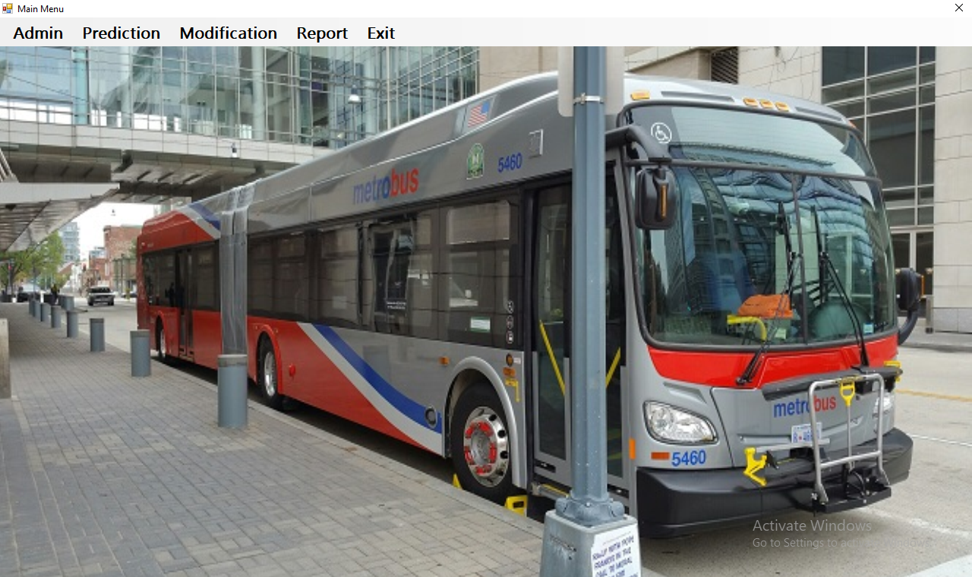
Figure 4.1: Main Menu Interface
This is the main menu of the system; it contains some other sub-menus which user can be clicked to navigate to other pages such as admin, prediction, modification and report.
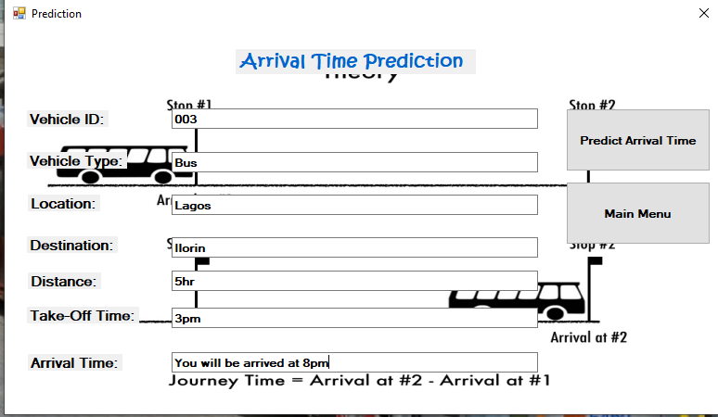
Figure 4.2: Bus Prediction Interface
This is the page where the bus arrival time was predicted. As shown in the image above the arrival time, distance, destination was displayed in the result.
4.1.2 INPUT DESIGN
The input to run this software is obtained from dynamic bus administrator. The administrator is expected to register every bus and driver. He can achieve this by typing via the keyboard or loading from the diskette. The input required from the student is their personal data. To the questions set by the administrator. It can serve as the various input layouts from the various modules first from the collection of data and module then from the prediction module and drivers respectively.
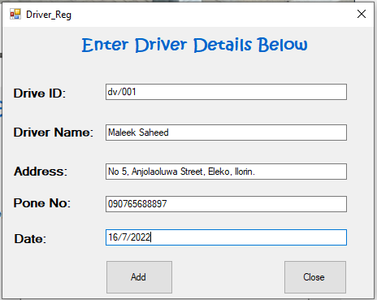
Figure 4.3: Driver Registration Interface
This is the page where the admin can register every driver on the system by supplying some details such as name, Phone number, address and so on.
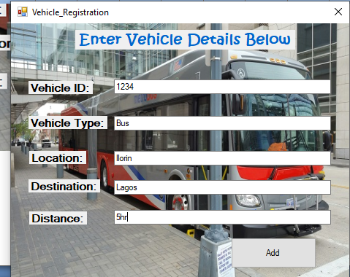
Figure 4.4: Vehicle registration interface
This is the page where the admin can register vehicles on the system by entering the details of the vehicle such as vehicle name, vehicle number, and so on.
4.1.3 Database Design
This involves the list of tables used in the database design. The tables are listed as follows:

Table 4.1: Bus Arrival Prediction Table
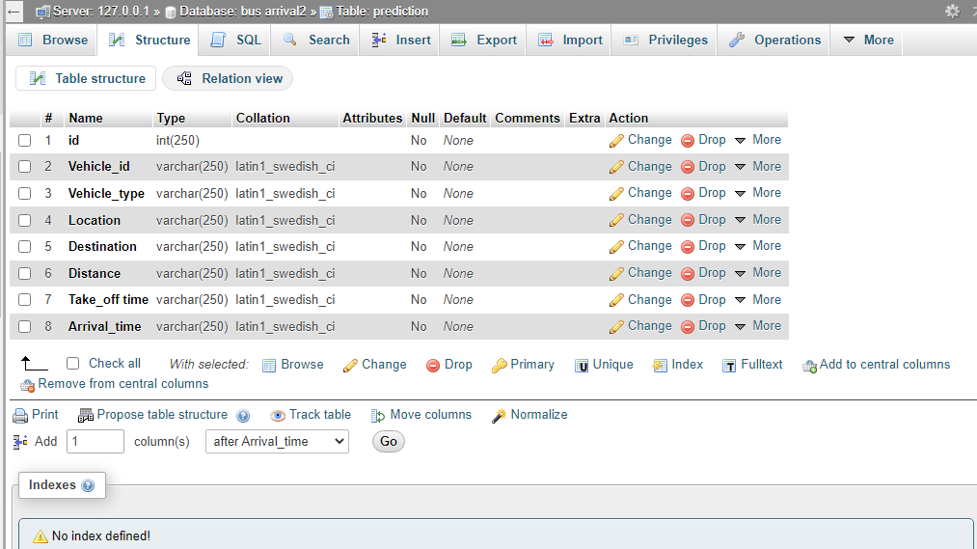
Table 4.2: Vehicle registration table
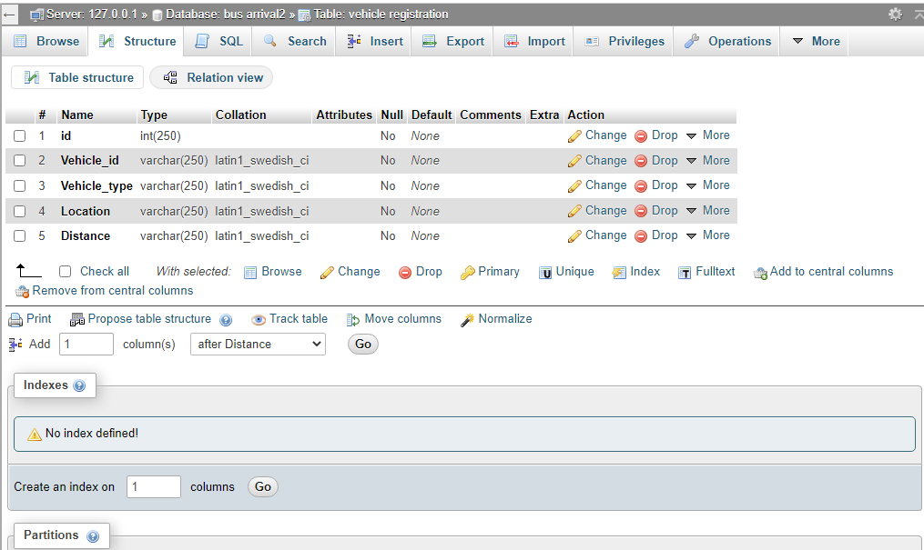
Table 4.3: Driver registration table
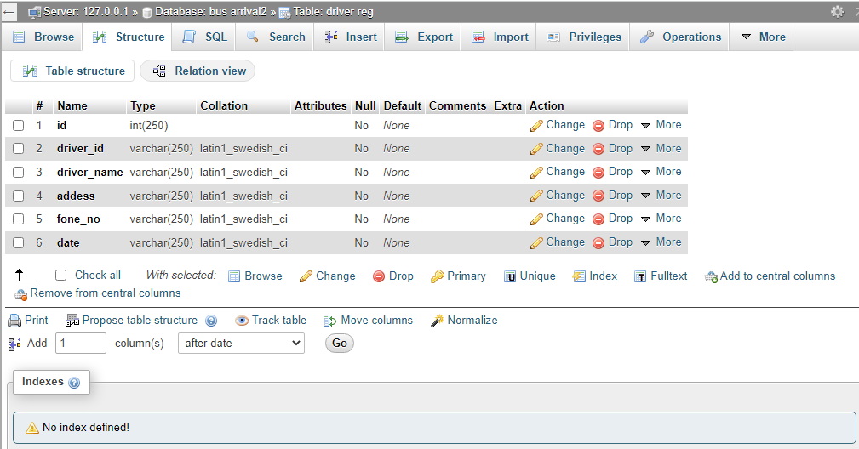
4.1.4 PROCEDURE DESIGN
These are the steps involved in unifying the whole process to produce the desired output. It involves computer procedures which starts from the original input lessons to the output result file. This allows the processing of the information and result to be possible. Menu is provided to aid user in the processing of the output file.
4.2 IMPLEMENTATION OF THE SYSTEM
This entails the choice of the programming language employed to implement the software which should be suitable for bus arrival time prediction. The software was designed to predict bus arrival time.

4.2.1 HARDWARE REQUIREMENT
Minimum of Microcomputer Pentium IV- Intel 1.5 GHZ processor, 1.0 GB RAM, 40GB Hard disk, 14” VGA Monitor Windows XP or higher, Enhanced keyboard, mouse and pad.
4.2.2 SOFTWARE REQUIREMENT
i. Windows Operating system such as Windows 7, Windows 8, Windows 10
ii. Visual Studio 2010 (Enterprise Edition which allows the Programmer to run all the necessary Data, which has been supplied.
4.3 DOCUMENTATION OF THE SYSTEM
After the program has been well tested with input that the output has already been known, the next is to install the software in to the computer system for use.
The process of installing has been stated below:
- Insert the CD into the system through the CD-ROM after the computer is switch on
- Locate the CD drive directory in my computer and click it to open
- After open, locate setup.exe, and then click to install the program by following the necessary step in installing the program.
- Ensure full installing of the software for effective operation of the system.
After the program has been fully installed, the next thing is to locate the package installed and put it into operation. To locate the package for expiration purpose, the following steps are to be taken:
- Click on start menu from task bar. Then select all program
- From the display sub option, select by locating the software installed named Information to load the software.
4.3.1 PROGRAM DOCUMENTATION
The program is packaged for use in any system irrespective of either it runs Visual Studio Application or not. After developing a program in Visual Studio, there is a facility provided in Microsoft Visual Studio suite called “Package and Deployment Wizard” that is used in Visual studio application packaging and deployment.
The bus arrival time prediction is packaged into an installable setup that can be run from any system.
4.3.2 OPERATING THE SYSTEM
To operate the system, the following algorithm must be followed:
- Switch the system on
- Allow it to boot
- Click on start menu
- Select the package name “Bus Arrival Time Prediction” and wait for the application to load.
- From the list of menu that appears on the application main page, user can
- Select any one to navigate and carry the operation of the menu item.
4.3.2 MAINTAINING THE SYSTEM
The system maintenance refers to making modifications to an already existing application/program without necessarily re-writing everything from the start. Program maintenance of a program includes modification of the program to meet-up with certain requirements of the users. In this course, additional features can be added, errors corrected, ambiguous interfaces redesigned to eliminate confusions and unnecessary features removed.
Maintaining this program can be done in a Visual Studio environment. Any future modification can be by re-running the program source code in a Visual Studio environment making necessary changes and updates and recompiling the application into an upgrade version of the existing version of the mini word processing application. Further versions of this program can be named following their year of release or it can be given a different version number.
4.3.3 PROCEDURE DESIGN
The procedure design refers to the construct of the whole program, i.e. how each section functions individually and collectively as a whole to make up the whole execution of the program work/operate according to specification.
The system contains menus, each menu having different forms and they are control by modules.

CHAPTER FIVE
SUMMARY, CONCLUSION AND RECOMMENDATIONS
5.1 SUMMARY
This project presents an algorithm based on an artificial neural network using for predicting the travel time of transit vehicles between current bus location and any downstream bus stop under consideration. The predicted travel times between subsections of the route under consideration were compared with the measured data. The performance of the model was also tested and compared with a historical average approach, where the predicted travel time was taken to be the average of the travel times of previous buses that traveled between any two stops under consideration. Prediction accuracy and robustness were used as performance measures. The overall precision measure determines the average deviation of the predicted travel time from the observed travel time. The robustness measure determines if an algorithm will occasionally give a prediction that is far off the actual arrival time. The routine optimization outperformed the average approach in both performance measures. The standard deviation of the prediction errors reinforced this as well. The Google map, which is used, enabled us to provide real-time travel time information at downstream stations with minimal error. The results obtained from the overall study are promising, and the proposed model can be used to predict the arrival time at bus stops in areas, even where there is undisciplined traffic flow. The implementation of this system improved the reliability of the public transport system, thus attracting more travelers to buses and helping relieve congestion.

5.2 CONCLUSION
In this study, real-world data are used in developing travel-time prediction methodology, which contains an artificial neural network model and a dynamic algorithm. The google map is chosen because of its capability in mapping complicated input/output relations without requiring an explicit function form. Google maps are developed for trips under different patterns. Given trip starting time (time-of-day), day-of-week, and weather (precipitation) condition, the neural network shall generate estimated travel time on each segment along the route.
5.3 RECOMMENDATION
After the successful completion of this project, it is highly recommended that public transport system should adopt this system as it will help their transport services. Further study efforts may be directed towards incorporating schedule adherence information as an additional independent variable to improve the prediction model. Prediction with Kalman filtering algorithms in the absence of traffic data and comparing their results with the proposed model can also be conducted in the future.

REFERENCES
Abdi, A. & Amrit, C. (2020). A review of travel and arrival-time prediction methods on road networks: classification, challenges and opportunities, Peer Journal of Computer Science. Vol. 1, Issue: 1. Pp. 4-6.
Amita, J., et al., (2015). Prediction Of Bus Travel Time using Artificial Neural Network, International Journal for Traffic and Transport Engineering. Vol. 5, Issue: 4. Pp. 410 – 424.
Chen, M., et al., (2014). A Dynamic Bus-Arrival Time Prediction Model Based on APC Data, Computer-Aided Civil and Infrastructure Engineering. Vol. 19, Issue: 8. Pp. 364–376.
Emeka, A., G. (2018). An Algorithm for Efficient Allocation of Courses to Lecturers for Effective Teaching, International Journal of Engineering Science Invention (IJESI). Vol. 7, Issue: 9. Pp. 68-74.
Fan, A. & Gurmu, Y. (2020). Dynamic Travel Time Prediction Models for Buses using only GPS Data, International Journal of Transportation Science and Technology. Vol. 4, Issue: 4. Pp. 353 – 366.
Gurmu, Z., K., Nall, T. & Perkins, W., F. (2018). Artificial Neural Network Travel Time Prediction Model for Buses Using Only GPS Data, Journal of Public Transportation. Vol. 17, Issue: 2. Pp. 46-47.
Jabamony, J. & Shanmugavel, G., H. (2019). IoT Based Bus Arrival Time Prediction Using Artificial Neural Network (ANN) for Smart Public Transport System (SPTS), International Journal of Intelligent Engineering and Systems. Vol. 13. Issue: 1. Pp. 312-313. DOI: 10.22266/ijies2020.0229.29
Jiang, F. (2017). Bus Transit Time Prediction using GPS Data with Artificial Neural Networks, International journal of scientific and engineering research, Vol. 10 Issue: 1. Pp. 120-123.
Longedran, R. (2008). Dynamic Travel Time Estimation Using Regression Trees, Eurasian journal of science & engineering, Vol. 4 Issue: 1. Pp. 23-25.
Nandan, N. (2013). Online Grid-Based Dynamic Arrival Time Prediction Using GPS Locations, International Journal of Machine Learning and Computing. Vol. 3, Issue: 6. Pp. 516-517.
Seitbekova, Assilbekov, Beisembetov & Kuljabekov (2020). Bus arrival time prediction using LSTM neural network and location analysis, Journal of Advances in Technology and Engineering Research JATER. Vol. 6, Issue: 2. Pp. 46-57.
Taparia, A. (2020). Bus Journey and Arrival Time Prediction based on Archived AVL/GPS data using Machine Learning, University of Dublin, Trinity College, Master of Science in Computer Science. Pp. 4-5.
Vignesh, L., K., P., Achar, A. & Karthik, G. (2020). Dynamic Bus Arrival Time Prediction: A temporal difference learning approach, IEEE. Pp. 1-3.
Xie, Z., He, Y., Chen, C., Li, Q. & Wu, W. (2021). Multistep Prediction of Bus Arrival Time with the Recurrent Neural Network, Hindawi, Mathematical Problems in Engineering. Vol. 1. Pp. 3-4.
Yuan, N., Shao, M., Cao, H., He, C., Zhu, M., Wang, T., & Jang, G., (2020). Bus Dynamic Travel Time Prediction: Using a Deep Feature Extraction Framework Based on RNN and DNN, Electronics. Pp. 4-6. doi:10.3390/electronics9111876

Appendices: System Flowchart
Appendix 1: Main Menu flowchart
Start
Display Option

Accept Option

Exit

Report
Prediction
Bus Registration
Modification
Driver Registration
Stop
Main Menu

Appendix 2: Driver Registration Flowchart
Start
Is Record OK?
Close DB
Another Record?
RETURN
Yes
Open Database

Accept Drivers’ Record

No
Save Record to DB

No
Yes

Appendix3: Bus Registration Flowchart
Start
Is Record OK?
Close DB
More Record?
Return
Yes
Open Database

Accept Record

No
Save Record to DB

No
Yes

Appendix 4: Modify Driver Record
Start
Display Record
Return
Open Database
Accept Driver ID
Is Record Found?
Modify Another Record?
Close Database
Display Record Not Found
No
Yes
No
Search Driver record
Edit/Delete Record

Yes
Update Database
RECORD

Appendix 5: View Driver Report Flowchart
Start
Open Database
Display Main Menu

View Driver Report
RECORD

Close Database
STOP

Appendix 7: Source Code
using System;
using System.Collections.Generic;
using System.ComponentModel;
using System.Data;
using System.Drawing;
using System.Linq;
using System.Text;
using System.Windows.Forms;
using System.IO;
using MySql.Data.MySqlClient;

namespace Fault_detection_in_Cloud
{
public partial class CreateData : Form
{
public void randomareg()
{
String rid = "Rec-001";
MySqlConnection mycon = new MySqlConnection(Class1.connectstring);
mycon.Open();
MySqlCommand cmd = new MySqlCommand("select Count(rid) from recor", mycon);
int i = Convert.ToInt32(cmd.ExecuteScalar());
mycon.Close();
i++;
textBox1.Text = rid + i.ToString();

}

