
PROJECT REPORT
ON
PERIMETER AND DETAILING SURVEYING
OF
PART OF KWARA STATE POLYTECHNIC, ILORIN, FROM ENGINEERING BUILDING TO GTBANK.

BY
OGUNBIYI ADENIKE OMOWUMI
ND/23/SGI/FT/037

BEING A RESEARCH PROJECT SUBMITTED TO THE DEPARTMENT OF SURVEYING & GEO-INFORMATICS

INSTITUTE OF ENVIRONMENTAL STUDIES
IN PARTIAL FULFILLMENT OF THE REQUIREMENT FOR THE AWARD OF NATIONAL DIPLOMA (ND) IN SURVEYING & GEO-INFORMATICS
JUNE, 2025
CERTIFICATE
I hereby certify that the field work and information given in this project were obtained as a result of my observation and measurement and were carried out in accordance with survey laws and departmental institution.

______________________________ _______________________
OGUNBIYI ADENIKE OMOWUMI Date
ND/23/SGI/FT/037
CERTIFICATION
This is to certify that OGUNBIYI ADENIKE OMOWUMI with Matric number ND/23/SGI/FT/037 from department of surveying and Geo-informatics, Institute of Environment Studies carried out a practical field work which formed basic of the project in accordance with survey rules and regulations and departmental instruction.

_______________________ _______________________
SURV. R.O ASONIBANIRE. DATE
MRS.S.O ADEOTI
(Project Supervisor)

_______________________ _______________________
SURV. AWOLEYE RAPHEALS DATE
(Project Coordinator)

_______________________ _______________________
SURV. AISAU DATE
(Head of Department)

_______________________ _______________________
SURV. OPALEYE J.O DATE
EXTERNAL EXAMINER

DEDICATION
I dedicate this project to Almighty God for his mercy on me and for giving me strength, wisdom, knowledge, skills and understanding in working towards my arms and objectives through this project period and also to my lovely parent MR and MRS OGUNBIYI who has been giving me financial support, in my academics, may God continue to Enrich your pocket (Amen).

ACKNOWLEDGEMENT
My profound gratitude goes to the Almighty God for his unfeigned admiration towards me for the grace, guidance and opportunity given me to move forward against all odds. Also for his support which lead to successful completion of this project.
My special ovation goes to my dearest energetic hard working caring and loving parents and my loving brothers for their unflinching support, moral advices and their unrelenting effort toward my education.
Also, appreciation goes to my guidance Mr. and Mrs. OGUNBIYI for their advices prayers & financial support, and to my Brothers and sisters for their love, care, advices, prayers and moral supports. I love you.
I also give thanks to my project supervisor and coordinator MRS. S. O. ADEOTI and Surv. R. O. ASONIBANIRE. for their strictly and through supervision. I will like to thank all lecturers of this noble department starting from H.O.D Surv. Abinbola Isau, Surv. A. Ayube, Mr. Bello Felix Diran, Surv. Williams Kzeem, Surv. A.O. Akinyede, and also the Director of IES Surv. A.G. Aremu and other supportive staff of the department of Surveying and Geo-informatics, Kwara State Polytechnic, Ilorin.
And I Like To appreciate myself To a (group leader) Is Not easy may God continue to bless me, Olajide Hannah Ibukunoluwa, Areo Joshua Oluwaseun, Aremu Oluwasayo Ayokunle, AshaoluSamuel Temidayo, Orokunle Idowu Oluwasunkanmi, Lafia Ishiak Alhassah, I pray all our effort shall not be in vain and we shall all meet in our dreamlands (Amen).
Finally, I appreciate the effort of all my colleagues in the department of surveying and Geo-informatics and those who help me in one way or the other. I love you all. And to those whose name were not mentioned who had one way or the other contributed towards the success of this project and those who stayed with me on campus right from day one up till this moments it’s not been easy, and also to my bestie OLAJIDE HANNAH IBUKUNOLUWA thanks for your love and support I love you, I pray God in his infinite mercy will reward everyone I say a big thank you, I love you all. To be a surveyor is not easy.

ABSTRACT
This project report focused on various methods used in exclusion of perimeter and detail survey, part of Kwara State Polytechnic, Ilorin, From Engineering building to GTBANK. The project was carried out using the basic survey operation include reconnaissance which involves filed and office reconnaissance survey, followed by data acquisition which involves third order theodolite traversing, total station for detailing, but we use total station. All the data acquired from the field were deduced, computed and adjusted according to specification and result were analyzed and found to be within the expected accuracy. Finally computed data were presented in graphical form in digital using Civil CAD software and a comprehensive report on how the whole operation was carried out was finally written.
TABLE OF CONTENTS
TITLE PAGE i
CERTIFICATION ii
DEDICATION iii
ACKNOWLEDGEMENT iv
ABSTRACT v
LIST OF FIGURES vi
TABLE OF CONTENT vii
CHAPTER ONE
1.0 INTRODUCTION 1
BACKGROUND OF THE STUDY 1
STATEMENT OF THE PROBLEM 7
STUDY AREA 8
AIM OF OBJECTIVE OF THE PROJECT 9
AIMS 9
OBJECTIVE 9
SCOPE OF THE PROJECT 10
SIGNIFICANCE OF THE PROJECT 10
PERSONNEL 11
CHAPTER TWO
2.0 LITEATURE REVIEW 12
CHAPTER THREE
METHODOLOGY 20
3.1 RECONNAISSANCE 21
3.1.1 OFFICE RECONAISSANCE 21
3.1.2 FIELD RECONNAISSANCE 21
3.2 MONUMENTATION 23
3.3 EQUIPMENT USED 24
3.3.1 PERIMETER SURVEY AND DETAILING OBSERVATION 24
3.3.1.1 TEST OF INSTRUMENT 25
3.4 COLIMATION TEST FOR TOTAL STATION 25
3.5 DATA ACQUISITION 26
3.5.1 GEOMETRIC DATA ACQUISITION OF PERIMETER 27
3.5.2 GEOMETRIC DATA ACQUISITION OF DETAILING 27
3.6 PERIMETER TRAVERSING 28
3.7 DATA DOWNLOADING 29
3.7.1 DATA PROCESSING 33
3.8 COMPUTATION 33
3.8.1 TRAVERSE BACKWARD COMPUTATION 34
3.9 AREA COMPUTATION 34
3.9.1 LINEAR ACCURACY 35
CHAPTER FOUR
4.0 RESULTS 36
4.1 CONTROL ESTABLISHMENT RESULTS 36
4.1.1 CONTROL ESTABLISHED 36
4.4.2 TEST OF INSTRUMENT 36
4.2 TEST OBSERVATIONS 37
4.3 CONTROL CHECK
(COMPUTED VALUE AND OBSERVED VALUE) 37-38
4.4 TRAVERSE BACK COMPUTATION 38
4.5 RESULTS OF THE AREA COMPUTATION 39
4.6 RESULTS OF LINEAR ACCURACY 40
4.7 DATA ANALYSIS 40
4.7.1 THE PERIMETER BOUNDARY POINTS 41
4.8 INFORMATION PRESENTATION 41
CHAPTER FIVE
5.0 SUMMARY, CONCLUSION AND RECOMMENDATIONS 44
5.1 SUMMARY 44
5.2 PROBLEM ENCOUNTERS 44
5.3 CONCLUSION 45
5.4 RECOMMENDATIONS 45
REFERENCES 47
APPENDIX 48

LIST OF TABLES
1. Record of coordinates points
2. Reading obtained during instrument test
3. Back computation of the coordinates

CHAPTER ONE
INTRODUCTION
1.1 Background to the study
Land is the prime natural resource of the world. It is also a very important natural resources of any country due to its limited nature and without land there can be no country. This then implies that the wealth of a nation and its economic and sustainable developments are dependent in the state of its land and its usage. Therefore, the opportunities of tomorrow will be determined by the land use decisions made today (Effiong 2010).
Surveying is a profession with many definitions as applied to it over the years, changing even as the duties of the surveyor had been dynamic over the years. Some years back surveying was defined as the science and art of making reliable measurements of the relief position of features on, above or beneath the earth surface and plotting of these measurements to some suitable scale to form a map, plan or chart (Brinker 1977).
Surveying is the first step for the execution of a construction projects. With the change in time, there has been great development and improvement in the surveying techniques. From the vintage chain surveying to satellite surveying and the modern engineering projects, construction has reached a new modern era of engineering.
Surveying is the branch of engineering that deals with the art and science of
determining the relative positions of distinctive features on or beneath the surface of the earth, by measurements of distances, directions and elevations (Agor 2008). There are different branches of surveying such as Geodetic survey, Topographic survey, Hydrographic survey, Mining survey, Photogrammetry and remote sensing, Engineering survey, Cadastral survey which include perimeter and detail survey.
Cadastral surveying is the sub field of cadastre and surveying that specializes in the establishment and re-establishment of real property boundaries.
Cadastral survey is the branch of surveying which is concerned with the survey and demarcation of land for the purpose of defining parcels of land for registration in the land registry. It is concerned with land management and more specifically with issues of landownership, measurement delineation of property boundaries. It is survey that creates, mark, define or re-establish the boundaries and subdivision of public land and through this, ownership can be recorded in public register.
Perimeter surveying is a type of property survey that determines the particular boundaries of a parcel of land areas by setting corner markers or monuments, to determine coordinates of these corners, and to obtain boundary and area information required for record, deed descriptions and for plotting parcels of real property. These markers are desirable for public record and to ensure correct title for the rightful owner of the land.Cadastral surveys are usually performed for either re-establishment of existing property boundaries or for the creation of new property boundaries in land division process.
Also perimeter survey is used to identify the beating of oldboundaries monumentation and survey plus on they used to set up new ones. A perimeter survey does not identify the features and improvement that east with in a property such as, sheds, unelling, surface utilities, roadways, pool and visible hedros of water, only features that fall within the 15 feet width around the boundary perimeter will be depicted. Also perimeter survey resolute conflicts on map and diets description and shows structure such as fences, hedges, yards and walls.
Detailing is a process whereby features on the ground are surveyed and represented by a suitable scale on a plan, regardless of their shape, all objects can be located by considering them as a composition of a series of connected straight lines, with each line being determined by two points.
Detail survey is a survey that a surveyor needs to record all the permanent features on the ground such as:- Buildings, land utilities, Drain, Culvert, Electric Pole, Road, Fence and all the permanent features on the ground for proper assessment of the existing development in the surveyed area or modification of it and usually confined to the boundaries of the parcel of land.
A perimeter survey is important to find out the exact location at the landed property and determine the extent of such land and also the extent of encroachment can be evaluated in case of the land dispute. Perimeter and detail survey is a survey that requires traversing of the details on the limits of the heights, depicting all detail on the limit of the landed property which consist of both natural artificial features, it also refers to as cadastral survey because it contains coordinates at all in the point of the boundaries and determines at relative position at point of both natural and artificial feature on the earth, surface and addressing them by means of conventional symbol in the plan.
A surveyor is a professional person with the academic qualifications and technical expertise to determine, measure and represent land, three dimensional objects, points fields and trajectories; to assemble and interpret land and geographically related information, to use that information for planning and efficient administration of the land, the sea and any structure thereon.
A surveyor determines the relative positions of natural and manmade features on the earth’s surface and records these in a graphical and usable form. He is also involved in the determination of the size, shape and gravity field of the earth using equipment and techniques which can sometimes be highly sophisticated (Fajemirokun1980).
1.1.1 Advantages of perimeter survey:
Accurate Boundary Definition: Clearly defines the exact boundaries of a property, helping prevent land disputes with neighbors.
Legal Documentation: Provides reliable data for land registration, property titles, and legal ownership records.
Construction Planning: Supplies essential information for designing and constructing buildings, roads, and infrastructure.
Site Mapping: Creates detailed maps that show both the land boundaries and all existing features.
Land Valuation: Helps in determining the accurate value of land for sale, purchase, or taxation.
Conflict Resolution: Assists in resolving boundary-related issues through accurate measurements and records.
Efficient Land Use: Enables planners to make informed decisions about the best use of the land based on its features and layout.
Supports Engineering Design: Provides engineers and architects with detailed ground information necessary for safe and effective project design.
Uses of Perimeter and Detailing Survey
1. Legal Documentation
Confirms the exact boundaries of a property.
Helps resolve or prevent land disputes.
Needed for preparing land titles or Certificates of Occupancy.
2. Construction and Development
Essential before building structures (houses, roads, fences).
Helps architects and engineers plan accurately within legal property lines.
3. Land Purchase or Sale
Provides potential buyers with accurate property dimensions.
Ensures that the land being bought or sold is clearly defined.
4. Fencing and Security
Used to correctly position fences or walls around the property.
Helps plan security systems or patrol routes.
5. Government or Municipal Planning
Used in town planning or zoning.
Helps in allocating public services and infrastructure.

Application of Perimeter and Detailing Survey
1. Application of Perimeter Survey
This survey focuses on marking and mapping the outer boundaries of a land parcel.
Applications:
Fencing and construction: Helps position walls or fences correctly.
Land disputes: Used to resolve conflicts over land limits.
Subdivision or merging: Needed when dividing or combining plots.
Planning permission: Forms part of the documents needed for building approval.
2. Application of Detailing Survey
This survey provides detailed information about the physical features of a land area (like buildings, roads, trees, slopes, drains, etc.).
Applications:
Architectural and engineering design: Guides layout for buildings, drainage, and roads.
Construction planning: Helps determine site conditions and work needed.
Flood control and drainage design: Used to plan water flow and prevent water-logging.
Landscape design: Essential for planning gardens, parks, or outdoor spaces.
Utility planning: Helps locate poles, cables, water lines, etc.
1.2 Statement of the Problem
There is no adequate up-to-date map of the part of Kwara State Polytechnic. To aid decision making by the management. It has been observed that people find it difficult getting to their destination with all the structure and roads on ground, thus the need for ease of movement for the thousands of people passing the route. A map can provide response to questions like: where a particular road is, where it leads to, the distance and the fastest route or shortest route between two points. This survey will be used for future planning regardless of the type of construction to be carried out. Some other project where the survey will be relevant includes in designing the drainage network, road and also new building. This will definitely affect proper planning and decision making for the management.
1.3 Aim and Objectives of the Project
1.4.1 Aim of the Project
The aim of this project is to carry out perimeter and detail survey of part of kwara polytechnic ilorin, The New engineering building to Guarantee trust bank.
1.4.2 Objectives of the Project
The following are the objectives of the study;
To carry out proper planning and reconnaissance in the office and field respectively.
It produce perimeter plan.
Production of a plan showing the physical structure in the school and there are uses.
To carry out traverse and determination of detail features of the survey area using Total station.
Production of a perimeter plan and a detailed perimeter plan of the area.
1.4 Scope of the Project
The scope includes the following:-
Planning
Equipment selection
Data acquisition
Data processing
Comprehensive report writing
Data Downloading and Processing
Traverse connection to established controls.
Perimeter traversing of the project
Detailing of features using offset
Data editing
Analysis of result
Plotting and plan production
Data Analysis
Plan and map presentation
Office Reconnaissance
Field Reconnaissance
Reconnaissance
1.5 Significance of the study
Project specification returns to the requirements to be satisfies while carrying out surveying operation of any order. The specification that was put into consideration for this project are:
As it will help to produce a well detailed survey plan
Building location and facility planning could be well aided.
Proper planning on the usage of the vacant land.
Proper planning of drainage system within the case study.
The length of each traverse line must not met line than 250m.
The liner accuracy must not be less than 1:500
The project fall into 3 order categories of survey job. Hence, misclosure must not be greater than 30d where n refers to the members of static.
1:6 Personnel
The underlined students of surveying and geo-information NDII 2024/2025 session are those who participated in the execution of this project they are:
S/N | NAMES | MATRIC NO | ROLE
1 | OGUNBIYI ADENIKE OMOWUMI | ND/23/SGI/FT/0037 | AUTHOR
2 | OLAJIDE HANNAH IBUKUNOLUWA | ND/23/SGI/FT/039 | MEMBER
3 | REMU OLUWASAYO AYOKUNLE | ND/23/SGI/FT/040 | MEMBER
4 | AREO JOSHUA OLUWASEUN | ND/23/SGI/FT/031 | MEMBER
5 | ASHAOLU SAMUEL TEMIDAYO | ND/23/SGI/FT/030 | MEMBER
6 | OROKUNLE IDOWU OLUWASUKUNMI | ND/23/SGI/FT/036 | MEMBER
7 | LAFIA ISHIAK ALHASSAH | ND/23/SGI/FT/033 | MEMBER

1.7 STUDY AREA
The project site is located at Kwara State Polytechnic (The New engineering building to Guarantee trust bank.), Ilorin Kwara State of Nigeria having a latitude of N 8° 28' 55.4196" and Longitude of E 4° 31' 34.4208"..The Village Area is accessible through several campus roads and is adjacent to academic buildings, hostels, and administrative structures. Due to increased student population and development pressures, this area has grown significantly in both usage and importance

MAP OF STUDY AREA
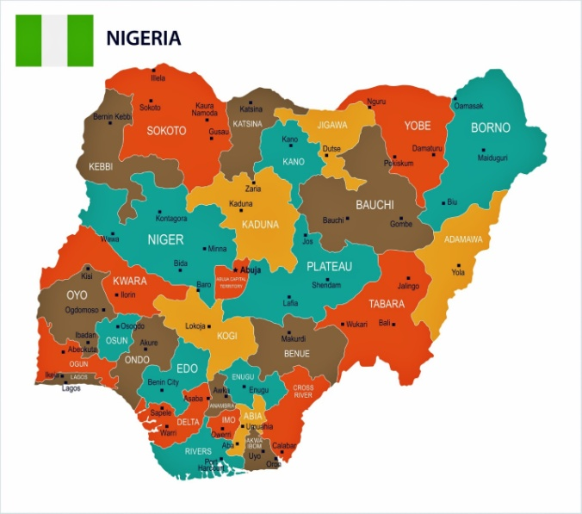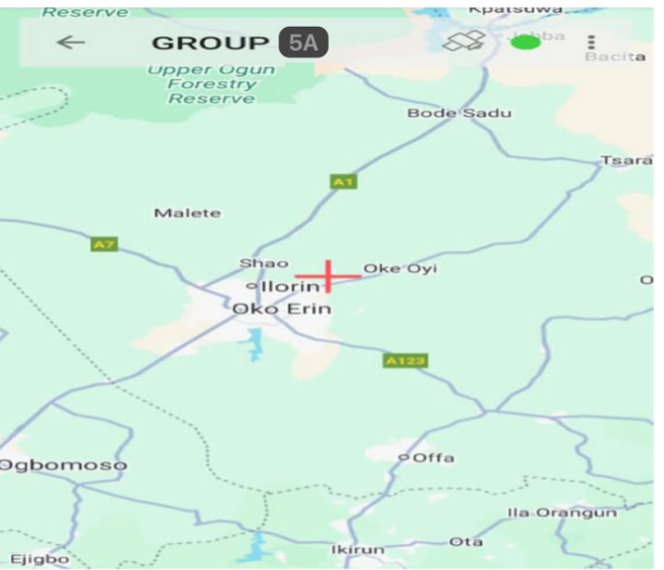
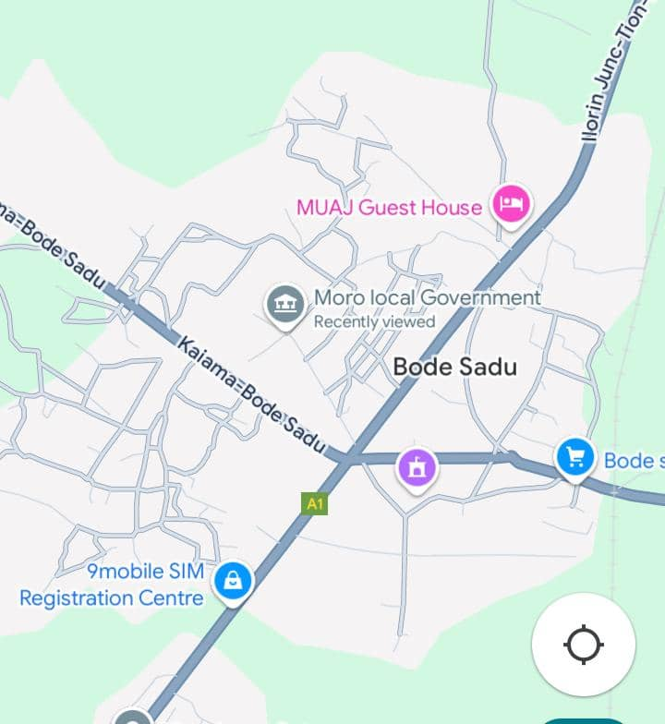
Figure 1, image of study area
CHAPTER TWO
2.1 Literature Review
Anderson and Michael (1985) states that surveying has to do with the determination of the relative spatial location of point or a surface of the earth surface. Therefore the buttressed definition above saying it is the act of measuring angles between lines determining angular and linear measurement. Surveying is generally considered as the foundation of socioeconomic and environmental development in the worlds it plays a vital role in every aspect of physical development because all the activities of other professions in environmental upgrading are base on the land foundation by surveyors.
Encyclopedia Britannic (2011) defines surveying as the act of making relatives large accurate measurement of the earth surface. It included the determination of the measurement of date the reduction and the information of the data to establish usable form and converly the establishment of relative position and size according to given measurement requirement. May improvement and refinement have been resulted in increased accuracy and speed of operations and have opened up possibilities for in round method in the field. In addition to the modification of existing introduced. Photogrammetric mapping from aerial photograph and electric distance measurement (E.O.M) including the adoption of the laser from this purpose as well as for alignment in the 1960s, Important technological development in benefitting surveying in the 1960s important technological development in benefitting surveying in the 1970s, included the use of satellites as reframe points for geodetic to achieve a well planned perimeter and detail survey were reconnaissance traversing, tachometry and detailing.
Reconnaissance could be, office reconnaissance and which has to do with the putting place at field necessary strategy and equipment (instrument) needed in the process of accomplishing the survey operation and field reconnaissance which involves the actual visited proper positioning of nails and pegs are done and finally operation to this effect on expert surveyor must carry out Reece diagram.
Traversing: referred to as series of straight lines connecting successive established point along the route of survey. Anderson and Michael (1985). Bufford (1984) stated that traversing involves the process of measuring of analyzed and distance in sequence a series of established pointer on the ground.
Traversing: can also define as an orderly sequence of determination of length and directions of lines between points.
Traversing is classified into two process open and close traverse in the case of this project closed traversed was carried out. A close traverse is the traverse that originates of a point of known position (coordinates) and else and terminates on another point of known horizontal positioning (coordinates). (Anderson and Michael), 1985.
Detailing could be referred to as man-made (artificial) and natural features on the ground the project site which are determined and obtained with the use of the total stating and are finally represented with a suitable scale or plan. The procedure chosen for a particular job depends on the personnel and instructions given by the project supervisor and also based on the availability of equipment (instruments) applicable for task and land survey data of the earth boundaries and for providing C.C.K.S of construction dimension. Land boundaries are set on measured for proper description; the topography of land forms and natural or artificial objects are depicted on maps; and major construction and civil engineering works such as dams, bridges, rail roads and high ways are controlled by surveying methods. The measurement of a survey is linear and angular principle of geometry and trigonometry are usually applied.
Accompanying the actual measurement surveying is mathematical calculation. Distance analysis direction, location elevation, areas and volume are this determined for data of the survey also much of the information of the survey is portrayed graphically by the construction of maps profile, cross section and diagrams. The equipment available and methods application for measurement and calculation have charged tremendously in the past decade: Aerial photogrammetric, satellite observation, remote sensing inertial surveying, electronic distance measurement, remote sensing inertial surveying, electronic distance measurement and laser techniques are example of modern system utilized to collect data acquisition processing system, the duties of the surveyors have expended beyond the traditional task of the field work of talking measurement and office work of computing and digital system.
Surveying, which has recently also been interchangeably called “geomatics” has traditionally been defined as the science, art and technology of determining the relative positions of points above, on, or beneath the Earth’s surface, or of establishing such points. In a more general sense, however, surveying can be regarded as that discipline which encompasses all methods for measuring and collecting information about the physical earth and our environment, processing that information, and disseminating a variety of resulting products to a wide range of clients. Surveying has been important since the beginning of civilization. Its earliest applications were in measuring and marking boundaries of property ownership. Throughout the years, its importance has steadily increased with the growing demand for a variety of maps and others partially related types of information and the expanding need for establishing accurate line and grade to guide construction operations. (Charles and Paul, 2012)
The name has gained wide spread acceptance in the United States, as well as in other English-speaking countries of the world, especially in Canada, the United Kingdom, and Australia. In the United States, the Surveying Engineering Division of The American Society of Civil Engineers change distance to the Geomatics Division. Many college and university programs in the United States that were formerly identified as “Surveying” or “Surveying Engineering” are now called “Geomatics” or “Geomatics Engineering.” (Charles and Paul, 2012)
The principal reason cited for making the name change is that the manner and scope of practice in surveying have changed dramatically in recent years. This has occurred in part because of recent technological developments that have provided surveyors with new tools for measuring and/or collecting information, for computing, and for displaying and disseminating information. It has also been driven by increasing concerns about the environment locally, regionally, and globally, which have greatly exacerbated efforts in monitoring, managing, and regulating the use of our land, water, air, and other natural resources. These circumstances, and others, have brought about a vast increase in demands for news partially related information. (Charles and Paul, 2012).
Surveying is a mathematical science used to determine and delineate the form, extent, and position of features on or beneath the surface of the earth for control purposes—that is, for aligning land and construction boundaries, and for providing checks of construction dimensions. (Wikipedia, 2012).
Surveying helps to determine accurately the terrestrial or three-dimensional space position of points and the distances and angles between them using various kind of surveying instruments. Instruments such as:- theodolite, total station, G.P.S, level instrument in various combinations, tape, etc.
Land surveying may be required for geographical, agricultural, geological, mineral, ecological, construction, landownership or other purposes. Moreso, the end-product of land survey is a drawn plan, although survey information can be done in digital form. Surveying method of determining accurately points and lines of direction (bearings) on the earth's surface and preparing from them maps or plans. Boundaries, areas, elevations, construction lines, and geographical and artificial features are determined by the measurement of horizontal and vertical distances and angles and by computations based on geometry and trigonometry. (Wikipedia, 2012).
Surveying is typically used to locate and measure property lines; layout buildings, bridges, channels, highways, sewers and pipelines for construction; to locate stations for launching and tracking satellites; and to obtain topographical information for mapping and charting. Before plans and estimates are prepared, boundaries should be determined and the topography of the site should be ascertained. After plans are made, the structures must be staked out on the ground. As the work progresses, lines and grades must be given (Encyclopedia free dictionary, 2013).
Under section 4 paragraphs Dad section 21 of decree A44 of 1989 SUR define the following terms as follows.
Property Beacon: means emplaced on the boundaries of parcel of land for the purpose of defining on demarcating the boundary
Beacon: means any permanent survey marks made of concrete; it on stone and include the pillar boundary post so made
Demarcation means making the boundary line on the ground by emplacement of the beacon such other method as those regulation permit
2.2 Problem Associated to Perimeter and Detailing Survey
Those are problems that may likely to have during the executive of perimeter and detailing survey.
Where there are no well established controls around the given site for correction
Unsatisfactory equipment.
Improper selection of traverse stations
Insufficient horizontal and vertical controls that suitable precision.
2.3 Application of Perimeter and Details Survey
These are the application of perimeter and detail survey, it helps in administration of land.
• To update cadastral information
• For updating existing map
• For land registration
• To resolve land dispute
• To gather or obtain case land related information
• To help individual, cooperative body to have the information about their property
2.4 Tools and Techniques in Perimeter and Detailing
Professional and surveyors use different tools techniques in perimeter survey that include both conventional and modern technologies; however most of the surveyors prefer to use the conventional surveying tools and technologies that include bearing and distance or compass and tape. Although they are considered private tools, they still remain on important asses to land surveyors. A perimeter survey is a specific type of property survey that map and measure a distance long the property boundary.

CHAPTER THREE
METHODOLOGY
3.0 Methodology
This refers to the method and the principles used to achieve the aim and objectives of this project work. The execution of this project was based on the following basic principles of surveying:
Working from whole to part.
The principle of choosing the method of survey most appropriate to meet the desired result.
The principle of provision for adequate checks to meet the required accuracy. The method are traversing and detailing.

Recconaissance
Monumentation
Data acquisition
Control check
Test of instrument
Field recconaissance
Office recconaissance

Selection of instruments
Control establishment
DGPS Data Downloading

DGPS Data Processing

Data processing
Results and Analysis
Conclusion

Figure 3.0:- Research methodology flow chart
3.1 Reconnaissance
Reconnaissance is a pre-requisite stage of any survey project to be carried out. It is the study of the subject matter as regard to a particular survey of an area of land. During reconnaissance, the purpose, specification and required accuracy of the survey were closely examined as these would affect the choice of the instruments and method of survey to be employed. The reconnaissance done comprise of office planning and field reconnaissance.
3.1.1 Office Reconnaissance
At this stage, decisions were made on the easiest approach to achieve the aim of the project using available sources of information about the study area and also the nature of survey. The imagery of the study area, personnel, initial control for orientation, choice of instrument and method to be employed were considered and determined at this stage. Also costing of the survey operation was done in the office.
3.1.2 Field Reconnaissance
The project site was visited to have the true picture of the site for better planning and execution and to locate the control pillars for necessary orientation of the study area. For proper selection of the boundary stations, the following factors were taken into consideration, the position and shape of the boundary, indivisibility of the consecutive stations selected. The boundaries were marked with wooden pegs driven into the ground to avoid disturbance or removal by any one and for the proper identification. The intervisibility of these selected stations were put into consideration.
Controls were not found around the study area which necessitated the transfer of control points to a reasonable distance within the study area. The end product of the field reconnaissance is the recce diagram which is shown in figure 3.2 below.
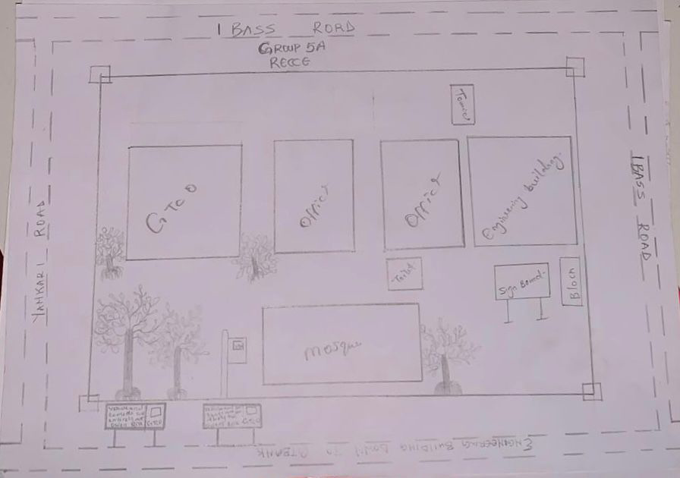
Figure 3.1.2: Reconnaissance Diagram (Not drawn to scale)
3.2 Monumentation
This is the selection of points at all change of directions and defining the points using pegs, beacons upon which centering can be made during field operation. This could be temporary or permanent, depending on the nature of the work. Specifically for this project, precast concrete beacons of dimension 18cm by 18cm by 65cm height were used. Each was buried vertically such that 10cm protruded above the ground surface.

18cm
18cm
18cm
18cm
18cm

Ground surface Level
10cm

65cm
KP
P T
725
Figure 3.2.1: Plan View
Figure3.2.1:-Dimensional Representation Of Boundary Beacon

3.3 Equipment Used
The instrument used for the execution of the project are listed below
Differential Global Positioning System (DGPS)
Total station and its accessories (Trimble)
Reflector stand and target
Beacon
pegs
Tape (5m)
Writing materials
Other Hardware and software used include:
Laptop
GNSS solution
Trimble software office
Trimble Geo office downloading cable.
AutoCAD 2010
Notepad and Microsoft Excel for editing and running of the script
Microsoft word for report writing

3.3.1 Perimeter Survey and Detailing Observation
The perimeter and detail observation was carried out using the total station. This was done carefully in such a way to achieve the desire objective for the project. Before observation, test of instrument was carried out.
3.3.1.1 Test of Instrument
Test of instrument is very important in surveying operation. The accuracy of any work done depends on the quality of the instrument used, using faulty instrument will mar the output of the work.
In view of this, test of instrument was done in order to ascertain the working condition of the instrument acquired from the departmental store.
3.4. Collimation of Test For Total Station
The instrument total station (TRIMBLE PT1) was tested for both horizontal and vertical collimation errors. This was done by setting the instrument on a station and applying all necessary temporary adjustment such as centering, leveling and parallax elimination.
The coordinates of the known station (KW725PT) was inputted into the instrument. The target was also placed on another known station (KW111PT) and was carefully bisected and measured at the end the result supplied were compared with the available result (see table 3.4)

Line of sight
Total station
Target
Tripod
KW 111 PT
KW 725 PT

Terrain
FIG 3.4:- Diagram showing the position of the total station and the reflector during the total station (collimation test).

3.5 Data Acquisition
This involves the processes in acquiring the data needed for the project. This involves the actual making of measurements and recording of observed data on the field. There are different methods of acquiring data in the site with different instrument such as Total station, Theodolite, Compass, Level Instrument etc.

3.5.1 Geometric Data Acquisition For Perimeter Traverse
Geometric data are positional data, that is, they are data having the X, Y, Z coordinates which makes it possible to locate their position on the surface of the earth. The total station (TRIMBLE PT1) was used for collection of geometric data. The third order closed traverse was carried out using Trimble Total Station to determine the positions of all stations in the project area. For perimeter traverse, total station was set up on control pillar KW725PT and temporary adjustment performed. The coordinates of the instrument station, Backsight station the heights of instrument and that of the target were measured with tape and keyed-in into the memory of the total station for storage and the orientation was completed. After this, the target was moved to SC/KW F.RS 4404for observation. With the instrument on KW725PT, the target was focused and the cross-hair bisected msr1 was clicked on the total station. The instrument displayed the coordinates (E, N and H) of the station and the values were stored in the memory of the instrument which serves as field book. Then, the instrument was moved to KW111PT orientation was repeated and the same procedures were taken until we closed back on the control pillar KW725PT.

KW725PT
KW111PT

Figure 3.5:- Description of the traverse connection

3.5.2 Geometric Data Acquisition For Detailing
For the collection of details, the total station was set up on KW111PT and temporary adjustments were performed and back sighted KW725PT for station orientation. Then, various points of interest were coordinated by placing the reflector at such points and measure. The coordinates of such points taken were stored in the internal memory of the instrument and on the field book. For points which could not be visualized from KW111PT, other station points were selected to facilitate their coordination. Feature like buildings, electric poles, trees and water tank, road, security house and mosque were all detailed, after which the traverse was closed back on KW111PT. Having bisected these features, readings were taken and stored in the internal memory of the instrument.

3.6 Perimeter Traversing

After the demarcation, capping and numbering of the beacons, the actual data acquisition using the total station MATO TC1010 commenced. The traverse started from KW725PT with KW111PT as reference point. The total station was set up over control KW725PT, centered, leveled and telescope focused to eliminate parallax. The parameters of the instrument station i.e. station name, height of instrument over the station mark, and the XYZ coordinates of the station were keyed in. The reference control point was then bisected and the station name KW111PT, height of target over the station mark, and the XYZ coordinates of the station were key in. Though the total station was set in coordinate mode it actually measured and recorded horizontal readings, vertical readings and distances automatically into the internal memory of the instrument on both faces which it used to compute and display coordinates. At every set up of the total station, the temporary adjustment was carried out and the following parameters measured:
Height of instrument
Height of the back target
Height of the fore target
Distance to back and fore station
This is the determination of bearing and distance of series of connected lines from known coordinated point so as to obtain coordinate of the newly established station.
3.7 Data Downloading
This explains the method in downloading, retrieving, sorting and analyzing of the acquired data (field data). Here, the data is being downloaded from the total station to a computer system and processed into information using the appropriate method and software.
Steps To Follow When Downloading From Total Station
The downloading software was already installed on the computer system (Trimble Total Station Software) and was launched.
The total station was connected to the computer system via downloading cable
The Total station was switched on and the following options were selected to download the file.
GOTO Data Transfer
SELECT Send data (by pressing F1)
SELECT/CLICK Measure Data
SELECT File Name (Hafiz)
CLICK ENTER
SELECT Yes (Option)
It was ensured that the parameter on total station and the computer system were the same.
A folder was created on the laptop to save the data from the software and the link selected on the software.
Transfer was clicked on the total station software to download the file into a folder on the laptop.
After the transfer was completed, click on transform coordinate on the total station software resident in the computer system. After converting the required data into dxf format.
The coordinates were exported from the software environment to Microsoft excel for further processing
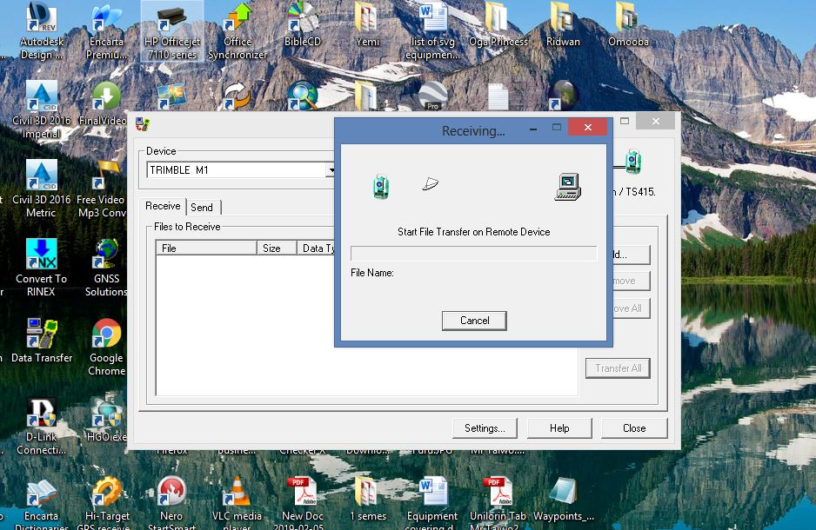
Figure 3.6a: Downloading process from total station
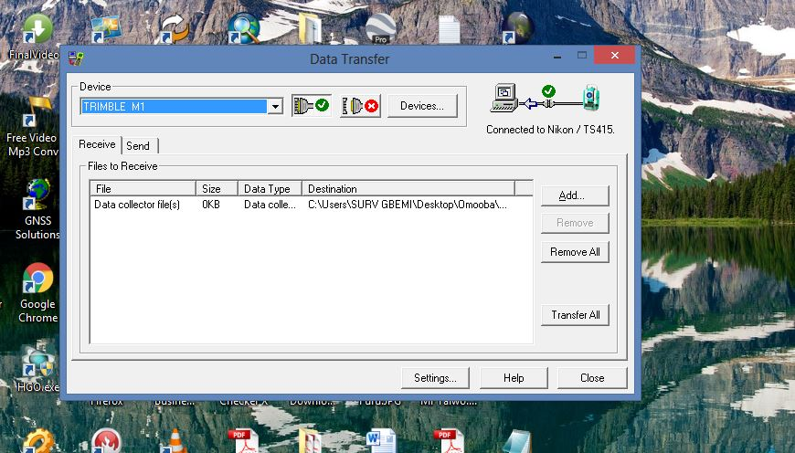
Figure3.6b: Downloading process from total station

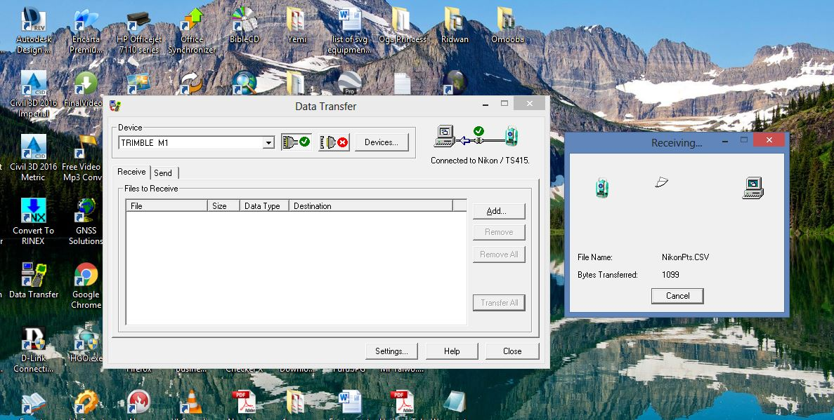
Figure 3.6c: Downloading process from total station
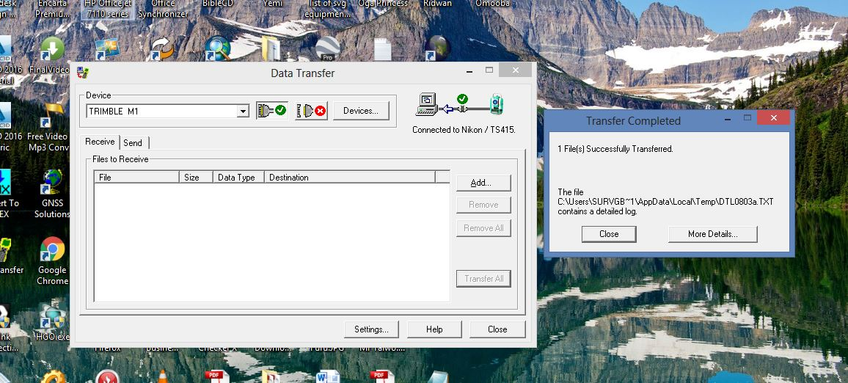
Figure 3.6d: Downloading process from total station
3.7.1.1 Data Processing
As the instrument downloading cable is faulty, Microsoft Excel 2007 Software was used to type the final coordinates of all points except the unwanted
3.7.1.2 Data Editing
The downloaded data were edited in the Microsoft Excel environment before the edited data were exported to Notepad. During the editing process, the irrelevant and redundant data were removed while edited data were saved in a plotable format of file.scr.
3.8 Computations
Computation can be said to be calculations of a kind or another from a large part of the work of surveying and the ability to compute with speed and accuracy is an important qualification for the surveyor.
Computations are made algebraically by the use of simple arithmetical procedures and trigonometric functions and graphically by accurate scaled drawing. Computation come up after field work and is very important in survey work because it serves as the final information shown on plan.
Computation is the operation carried out when the raw data obtain from the field has been processed to obtain final result from which plans were produced.
The various computation procedures carried out in this project are analyzed as follows.
After the field book has been deduced the following computation were carried out
Traverse backward computation.
Area computation.
Linear accuracy.
3.8.1 Traverse Backward Computation
The processed boundary data downloaded from the instrument and the already existing control information were used to determine the latitude, departure, bearings and distances of traverse lines as shown in the table below
Bearing of line =
Distance (L) =
The back computation was done in order o have final bearing and distance of the boundary lines.
The below formulae was used
∆N = N₂-N₁,N₃-N₂
∆E = E₂-E₁, E₃-E₂
Putting the sign they carried into consideration
Distance =
Bearing = Tan-1 DE/DN
Where
∆N is difference in northing (m)
∆E is difference in easting (m)
3.9 Area Computation
Using cross coordinates method, area computation was done by a small program in an excel spread sheet. The results were as shown below:
NORTHING (A) EASTING (A)
NORTHING (B) EASTING (B)
NORTHING (C) EASTING (C)
NORTHING (D) EASTING (D)
NORTHING (A) EASTING (A)
AREA =LEFT SIDE PRODUCT - RIGHT SIDE PRODUCT
2
3.9.1 Linear Accuracy
The linear accuracy was calculated according to the specifications by Surveyors Registration Council of Nigeria (SURCON). Since this is classified as third order job, the following formula was used:
Linear Accuracy =£d/e
CHAPTER FOUR
RESULTS AND DATA ANALYSIS
4.1 Results
This presents the results and explains how data obtained from field were analyzed, processed, plotted and presented.
4.1.1 Control Establishment Result
After processing of the data acquired during the control extension, the results of the controls established are as shown in table 4.1.
Table 4.1: Control Established
PL ID | Easting | Northing | Heights
KW TL02 | 679751.84 | 946272.55 | 343.452
KW725PT | 679689.67 | 946321.81 | 344.737
KW111PT | 679836.92 | 946009.53 | 328.57

4.1.2:- Test Of Instrument
The instrument in view is the total station used to carry out the perimeter survey observations.

Table 4.2:-Test Observation
Station | Readings | Northings(M) | Eastings (M) | Bearing | Dist(M)
Target Station | Initial Reading | 946009.53 | 679836.92 | 141°57’10.6’’ | 321.156
 | Total Station Reading | 946009.89 | 679836.46 | 141°57’10.6” | 321.156
 | Differences | -0.46 | 0.36 | 00°00’00’’ | 0.001
Source: Field Observation
It is evident that the instrument is in good working condition.
4.3 Control check
The controls used were checked to determine if they were still in-situ, the results are given in table 4.3a and 4.3b

Table 4.3a Control Checks (Observed values)
Station  From | Bearing  ( ° ' ʺ ) | Distance (m) | Northings (m) | Eastings (m) | Station  To
KW 725 PT | 154° 45’16.3” | 345.278 | 946321.83 | 679689.66 | KW 725 PT
KW 111 PT | 141° 57’10.6” | 321.156 | 946009.53 | 679836.92 | KW 111 PT
Source: Field Observation

Table 4.3bControl Check (Computed Values)
Station  From | Bearing  ( ° ' ʺ ) | Distance (m) | Northings (m) | Eastings (m) | Station To
KW 725 PT | 154° 45’16.3” | 345.278 | 946321.81 | 679689.67 | KW 725 PT
KW 111 PT | 141° 57’10.7” | 321.156 | 928399.494 | 683747.738 | KW 111 PT

4.4 Traverse Back Computation
Table 4.4:. Back computation of the traverse
Station from | Bearing | Dist (m) | ΔN | ΔE | Northing (m) | Easting (m) | Station To
 |  |  |  |  | 946321.81 | 679689.67 | SC/KW F.RS 4404
SC/KW F.RS 4404 | 03°26’47.8” | 195.61 | 11.76 | 195.26 | 946333.57 | 679884.93 | SC/KW F.RS 4405
SC/KW F.RS 4405 | 81°34’20.37” | 327.58 | - 324.04 | -48.01 | 946009.53 | 679836.92 | SC/KW F.RS 4406
SC/KW F.RS 4406 | 177°0’34.39” | 83.57 | 4.36 | -83.46 | 946013.89 | 679753.46 | SC/KW F.RS 4407
SC/KW F.RS 4047 | 11°42’14.6” | 314.36 | 30.92 | -63.79 | 946321.81 | 679689.67 | SC/KW F.RS 4404

4.5 Area Computation
Table 4.5: Results of Area Computation
 | Coordinates |  |  | Left Side Product |  | Right Side Product
Stn. Id. | Final Northing | Final Easting |  |  |  | Right Side Product
Stn. Id. | (m) | (m) |  | (m²) |  | (m²)
A | 946321.81 | 679689.67
B | 946333.57 | 679884.93 |  | 6433899375749.3232 |  | 643213151903.2219
C | 946009.53 | 679836.92 |  | 643352499521.4044 |  | 643177623083.3829
D | 946013.89 | 679753.46 |  | 643053251210.4738 |  | 643135169254.8187
A | 946321.81 | 679689.67 |  | 642995868709.5162 |  | 643265524620.9626
 |  | SUM = |  | 2572791556990.718 |  | 2572791468862.3857
 | AREA = | LEFT SIDE PRODUCT - RIGHT SIDE PRODUCT
 |  |  | 2
 | AREA = | 2572791556990.718- 2572791468862.3857
 |  |  | 2
 | AREA = | 88128.3323
 |  | 2
 | AREA = | 44064.166 | Sqmtrs
 | AREA = | 4.406 | Hectares
The total area was found to be 4.406Hectares and the perimeter was 1023.052m.

4.6 Linear Accuracy
Linear Accuracy =
Table 4.6: Results for linear accuracy
Remarks | Eastings(M) | Northings(M) | Hts (M) | Stn
Starting Coord. (original) | 679689.67 | 946321.81 | 344.737 | KW725PT
Closing Coord. (observed) | 679689.46 | 946321.89 | 344.71 | KW725PT
Difference | -0.21 | -0.08 | +0.027
Misclosure in northing (∆N) = -0.08
Misclosure in easting (∆E) = -0.21
Total distance = 1059.05
=
=
=
= 1: 8050.412145
The linear accuracy is 1:8050which conforms with the Third order accuracy.

4.7 Data Analysis
Table 4.7 shows the perimeter survey boundary points seven (5) number of points defines the perimeter of the institute.
Table 4.7: The Perimeter Boundary Points
Station | Northings (M) | Eastings (M) | Height (M)
SC/KW F.RS 4404 | 946421.81 | 679689.67 | 344.737
SC/KW F.RS 4405 | 946333.57 | 679884.93 | 338.481
SC/KW F.RS 4406 | 946009.53 | 679836.92 | 328.57
SC/KW F.RS 4407 | 946013.89 | 679753.46 | 325.71
SC/KW F.RS 4404 | 946321.81 | 679689.67 | 344.737

The coordinates of the details such as buildings, GTB, trees, office, mosque, toilets, signboards and roads were also obtained and are as shown in appendix A
4.8 Information Presentation
The end product of this project exercise was the graphical representation of the processed field data of the survey area which was drawn to a suitable scale. The digital representation of the project area was done according to survey rules and regulations as well as departmental instructions.
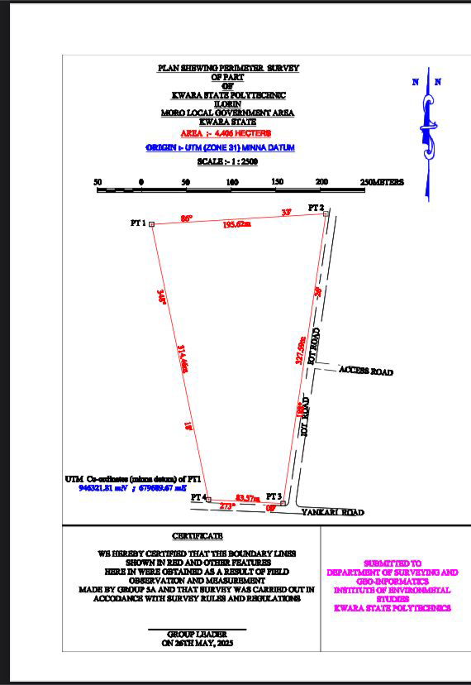
Figure 4.1: Perimeter plan of the study area

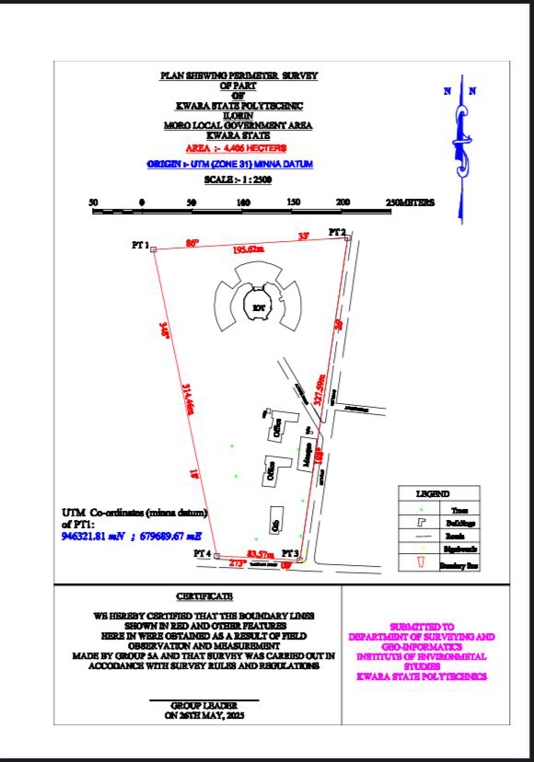
Figure 4.2: Perimeter and detail plan of the study area

CHAPTER FIVE
SUMMERY, CONCLUSION AND RECOMMENDATION
5.1 Summary
The project perimeter and detailing survey was carried out at Kwara State Polytechnic Part of engineering building down to GTBANK. The project is carried out in accordance with the two order specification. The reconnaissance survey was properly carried out and office, this was done for proper planning of the operation by cheating initial controls that is within the project site for the orientation, the instrument to be used, and selected station in which the indivisibility of the selected station were put into consideration and finally, drawing of selected diagram of the area to be surveyed.
The field operation includes (traversing and detailing). Therefore data processing was done and plan was produced in analysis (manual) and digital format tithe plan showing perimeter and detail of all project was executed
5.2 Problem Encounter
The problem encountered during the process of the execution of this project
Student passing by were obstructing the right of observer and causing disturbance.
The weather was not conducive and it was draining all days.
5.3 Conclusion
Have gone through all stages of this project, it is right to say the task is well interesting particularly at the planning and execution stage thought field procedure was very tedious and time consuming from all indications. The project has been successful executed and adequate data acquired processed represented in plans all necessary computations were carried out to meet specification is given finally, the following project has been exposed me to the procedure of cadastral survey and perimeter and detail survey also the task has given me a self confidence on it has improved my skills in carrying out perimeter and details survey. Despite the fact that I have not done this before but in still achieving aim and objective of the project. Plan of the study were produced, the survey was executed in the accordance and respect with survey rules and the departmental instruction in carrying out the project topics. And conclusively the report written was done on how the entire project was executed both field and office work.

5.4 Recommendations
As a result of the experience acquired during the course of executing this project, I hereby recommend that this kind of project should be a continuous one in order to boost the student's knowledge within and outside the citadel of learning. I also recommend that practical within the semester of the project should be given a time and instrument should be distributed on time so that practical assignment will not with the project.
I also recommend this particular project practical to be done often to update the infrastructural features and the society for the development of the particular area, also it should be carried out in school for the next development in the premises, moreover it is necessary for every Survey & Geo-Informatics Students to be able to carry out this particular practical.
Also that the school provide more new digital station, EDM and analogue instruments should be supply to the school store for student in carrying out both their practical and project in order to get accurate data from the field.

References
Surveyor R.S. Awoleye HOD, (2018): surveyor Bayi Akinyele (2018)Barrister A, surveyor
Abdulsalam Ayuba and Raymond (1990):London, pitha publishing limitedSurveying 4th edition
Bassak N.N (1994):surveying and leveling 7th edition Tata N.Ccram. Hill publicity company limited, new delhi paje city
Bonford. G (1984) Geodessy 4th edition, oxford university press city Brinker, R.C (1997). Elementary surveying 2nd edition, Barting the Madam Mahan Das, MM, Das Saikia put int 2010. Maitias walde muitan,19th century 1780.
Microsoft encata (2009). One Microsoft produced was 980326399 USA.
Oxford advance learning dictionary 2001 6th edition, oxford university Puri walter street.
Punmia, B.C (2003) surveying vol 1 and II 6th edition, laxmi india P.32
Ramsay, J. (1971): Land surveying 4th edition chances process limitedbungay lam
Raymond, S (11972):Elementary surveying 6th edition. Simeon(1989) panphlets specification for geodetic survey in Nigeria P,SI.54
Oliver J.G Clending (1978) Principles of Surveying Working Ham Berkshire, England ppl.
Appendices
APPENDIX A: SORTED ACQUIRED DATAS
APPENDIX B: PERIMETER AND DETAIL PLAN IN ENVELOPE
Appendix A
SORTED ACQUIRED DATAS
CONTROL USED
POINT ID EASTING NORTHING HEIGHT
KW725PT | 679689.671 | 946321.807 | 344.737
KW111PT | 679836.916 | 946009.525 | 328.57

PERIMETER POINTS
POINT ID EASTING NORTHING HEIGHT
SC/KW F.RS 4404 | 679689.671 | 946321.807 | 339.655
SC/KW F.RS 4405 | 679884.932 | 946333.571 | 340.917
SC/KW F.RS 4406 | 679836.916 | 946009.525 | 341.958
SC/KW F.RS 4407 | 679753.459 | 946013.889 | 342.848
SC/KW F.RS 4404 | 679689.67 | 946321.807 | 343.452

DETAIL POINTS
POINT ID EASTING NORTHING HEIGHT
EG1 | 679758.321 | 946239.632 | 344.084
EG2 | 679754.063 | 946248.243 | 344.24
BL1 | 679751.63 | 946257.142 | 344.164
EG3 | 679751.011 | 946266.072 | 343.997
EG4 | 679751.841 | 946272.552 | 343.954
BL2 | 679752.551 | 946279.262 | 343.867
EG5 | 679756.371 | 946287.501 | 343.803
EG6 | 679758.576 | 946289.906 | 343.609
EG7 | 679769.145 | 946282.317 | 343.418
EG8 | 679772.746 | 946286.056 | 343.223
EG9 | 679777.631 | 946290.125 | 342.998
BL3 | 679771.545 | 946302.256 | 342.702
BL4 | 679777.585 | 946306.165 | 342.464
OFF1 | 679804.82 | 946130.166 | 342.176
OFF2 | 679806.553 | 946142.711 | 341.918
OFF3 | 679808.381 | 946142.4 | 341.65
BL5 | 679810.251 | 946152.25 | 342.447
OFF4 | 679808.639 | 946152.645 | 342.32
OFF | 679809.212 | 946159.839 | 342.135
BL5 | 679836.221 | 946156.67 | 340.809
Wl1 | 679834.491 | 946148.172 | 340.455
EG10 | 679822.443 | 946149.114 | 339.173
CL1 | 679820.121 | 946136.201 | 337.856
OFF6 | 679818.791 | 946136.312 | 337.259
OFF7 | 679817.762 | 946127.563 | 336.735
OFF8 | 679804.823 | 946130.174 | 336.202
TL1 | 679803.381 | 946161.872 | 338.847
Tl 2 | 679807.183 | 946161.612 | 339.603
TL3 | 679807.433 | 946157.032 | 339.536
TL4 | 679803.541 | 946157.623 | 340.18
TL5 | 679803.382 | 946161.871 | 341.117
OFF9 | 679802.871 | 946114.623 | 341.166
OFF10 | 679829.342 | 946111.532 | 341.589
OFF11 | 679827.832 | 946102.981 | 341.487
OFF12 | 679814.952 | 946103.281 | 342.113
BL6 | 679813.531 | 946091.342 | 342.133
CL2 | 679811.82 | 946082.893 | 342.564
OFF13 | 679798.951 | 946084.122 | 342.686
OFF14 | 679800.742 | 946097.313 | 342.775
OFF15 | 679802.322 | 946097.031 | 343.059
OFF16 | 679803.172 | 946105.841 | 343.277
OFF7 | 679801.641 | 946106.072 | 343.323
OFF18 | 679802.872 | 946114.621 | 343.498
GTB1 | 679807.852 | 946063.82 | 343.941
GTB2 | 679807.871 | 946063.592 | 343.852
GTB3 | 679820.351 | 946063.132 | 343.882
GTB4 | 679818.551 | 946038.839 | 343.833
GTB5 | 679815.629 | 946038.938 | 343.906
GTB6 | 679815.327 | 946035.605 | 343.982
GTB7 | 679806.509 | 946036.039 | 343.685
GTB8 | 679807.865 | 946063.589 | 343.178
MQ1 | 679838.087 | 946133.585 | 342.571
MQ2 | 679853.92 | 946131.287 | 342.041
MQ3 | 679849.725 | 946097.686 | 341.591
MQ4 | 679834.275 | 946100.5 | 340.697
MQ5 | 679838.089 | 946133.579 | 339.655
TL6 | 679846.21 | 946139.201 | 331.519
TL7 | 679850.038 | 946138.648 | 332.814
TL8 | 679849.871 | 946136.692 | 332.786
TL9 | 679846.202 | 946136.941 | 331.939
TL10 | 679846.211 | 946139.201 | 331.861
TR1 | 679768.701 | 946124.21 | 331.818
TR2 | 679772.619 | 946093.729 | 331.736
TR3 | 679807.852 | 946063.82 | 343.941
TR4 | 679793.091 | 946030.537 | 331.36
TR5 | 679837.931 | 946033.652 | 331.418
TR6 | 679839.881 | 946069.127 | 331.478
SB1 | 679840.578 | 946009.091 | 331.542
SB2 | 679842.739 | 946017.61 | 331.488
RD1 | 679733.439 | 946003.161 | 331.519
RD2 | 679733.748 | 946011.162 | 329.899
RD3 | 679838.041 | 946006.852 | 331.927
RD4 | 679843.285 | 946011.141 | 331.497
RD5 | 679860.225 | 946131.321 | 330.103
RD6 | 679814.447 | 946209.941 | 329.427
RD7 | 679820.475 | 946213.501 | 329.048
RD8 | 679859.029 | 946148.369 | 327.577
RD9 | 679862.731 | 946149.111 | 327.887
RD10 | 679889.64 | 946340.005 | 328.09
RD11 | 679896.425 | 946330.871 | 329.036
RD12 | 679873.388 | 946167.387 | 328.9
RD13 | 679923.27 | 946161.85 | 329.899
RD14 | 680019.278 | 945985.8966 | 328.45
RD15 | 680019.5192 | 945985.8926 | 328.452
RD16 | 680049.2592 | 945985.3466 | 329.851
RD17 | 680052.7984 | 945994.9155 | 330.765
RD18 | 680035.8983 | 945995.2747 | 329.206
RD19 | 680021.1428 | 945998.93 | 329.071
RD20 | 680014.553 | 946000.8285 | 328.984
RD21 | 679998.9224 | 946013.2946 | 328.691
RD22 | 679979.8714 | 946033.5673 | 328.071
RD23 | 679965.4018 | 946049.4666 | 328.419
RD24 | 679958.6616 | 946062.734 | 329.066
RD25 | 679959.5686 | 946094.9526 | 331.567
RD26 | 679960.8124 | 946132.8956 | 332.923
RD27 | 679962.2135 | 946229.3587 | 338.138
RD28 | 679966.6673 | 946409.1306 | 342.532
RD29 | 679931.9204 | 946045.2297 | 327.91
RD30 | 679938.595 | 946053.831 | 328.233
RD31 | 679942.537 | 946052.9746 | 328.123
RD32 | 679948.3344 | 946044.4573 | 327.538
RD33 | 679940.406 | 946045.6251 | 327.73

