KWARA STATE POLYTECHNIC ILORIN, KWARA STATE.
INSTITUTE OF TECHNOLOGY
DEPARTMENT OF CIVIL ENGINEERING

ANALYZING THE TRAFFIC VOLUME AND SPEED OF VEHICLES ALONG THE ROAD WAY FROM THE POST OFFICE TO SANGO INTERSECTION IN ILORIN KWARA STATE.
BY
OLADELE BASHIT OLAITAN HND/23/CEC/FT/230
BEING IN RESEARCH WORK SUBMITTED TO THE DEPARTMENT OF CIVIL ENGINEERING, INSTITUTE OF TECHNOLOGY, KWARA STATE POLYTECHNIC, ILORIN

IN PARTIAL FULFILMENT OF THE REQUIREMENT FOR THE AWARD OF HIGHER NATIONAL DIPLOMA (HND) IN CIVIL ENGINEERING
JUNE 2025.

CERTIFICATION
This is to certify that this research study was conducted by OLADELE BASHIT OLAITAN (HND/23/CEC/FT/230) and had been read and approved as meeting the requirement for the award of Higher National Diploma (HND) in Civil Engineering of the Department Civil Engineering, Institute of Technology, Kwara State Polytechnic, Ilorin.

………………………. ……………………
ENGR. A.O. SAADU DATE
Project Supervisor

……………………………………. ………………………..
ENGR. A. NAALLAH DATE
Head of Department

……………………………. ……………………..
ENGR. DR. MUJEDU KASALI ADEBAYO DATE
External Examiner

DEDICATION
This project is dedicated solemnly to God Almighty, who is the sole inspiration of all things, without whom there would not be, and neither would this project.
Appreciation goes to my loving parents for their support in the fulfillment of my Higher National Diploma (HND) both orally and financially. May God allow them to eat the fruit of their labor (Amen)

ACKNOWLEDGEMENT
I begin by expressing my deepest gratitude to the Almighty Allah, who has blessed me with the wisdom, strength, and resilience to complete this project also appreciate all the staffs of Kwara State Polytechnic Ilorin.
I extend sincere thanks to my project supervisor and also my lecturer, Engr. A.O. SAADU, for his invaluable guidance, mentorship, and patience. His insights and encouragement have been instrumental in shaping this work.
To my family, I express my heartfelt gratitude for their unwavering support and love. My Dad Mr Nasirudeen Adegboye, My Mom Mrs Fasilat Oladele and My Step Mom Mulikat Oladele, who made me choose this interesting course, and all my dearest siblings, who motivates me to make this milestone a success, thank you for being a constant source of motivation, encouragement and financial support. I appreciate your love.
To all my brother from another mother who stood by me all the time, I really appreciate you all.
I also acknowledge the entire staffs of the department of Civil Engineering in the Institute of Polytechnic, Ilorin, for their dedication, enlighten and support towards the success of my academics.
To my friends and colleagues, which I can’t mention there name all, I appreciate your encouragement, advice, and camaraderie.
Thank you all for being part of my journey.

TABLE OF CONTENTS
Title page
Declaration i
Certification ii
Dedication iii
Acknowledgement iv
Table of Contents v
Abstract vi
CHAPTER ONE – INTRODUCTION
1.1 Background of the Study
1.2 Problem Statement
1.3 Study Area
1.3.1 Description of the Study Area
1.3.2 Aim and Objectives
1.4 Justification
1.5 Scope of the Study
CHAPTER TWO – LITERATURE REVIEW
2.1 Traffic Flow
2.1.1 Traffic Flow Parameters
2.1.2 Measurement of Traffic Flow
2.2 Traffic Congestion
2.2.1 Causes of Traffic Congestion
2.2.2 Traffic Flow Modelling
2.2.3 Previous Works on Traffic Volume Study
2.3 Traffic Simulation
2.3.1 Simulation Models (Microscopic, Mesoscopic, Macroscopic)
2.3.2 Deterministic vs. Stochastic Models
2.3.3 Model Development Process
2.4 Vehicle Generation Algorithms
2.5 Headway Distribution Models
2.6 Research Gap
CHAPTER THREE – RESEARCH METHODOLOGY
3.1 Introduction
3.2 Research Design
3.3 Data Collection Method
3.3.1 Data Collection Instruments
3.3.2 Data Collection Procedure
3.4 Data Analysis Method
3.4.1 Statistical Analysis
3.4.2 Visualization Technique
3.5 Ethical Considerations
3.6 Limitations of the Study
CHAPTER FOUR – RESULTS AND DISCUSSION
4.1 Introduction
4.2 Traffic Volume Analysis
4.2.1 Morning Peak Traffic Volume
4.2.2 Evening Peak Traffic Volume
4.3 Vehicle Type Distribution
4.4 Traffic Congestion Pattern
4.5 Implications for Traffic Management
CHAPTER FIVE – CONCLUSION AND RECOMMENDATION
5.1 Conclusion
5.2 Recommendations
REFERENCES

ABSTRACT
This study investigates traffic flow characteristics and congestion patterns within the selected study area using a combination of empirical data collection and simulation modeling techniques. Chapter One establishes the background, outlines the problem of increasing delay and vehicle queuing, and specifies the aim and objectives, including quantifying peak‐period volumes and evaluating vehicle‐type distributions. Chapter Two reviews pertinent literature on traffic flow theory, congestion causation, simulation frameworks (microscopic, mesoscopic, macroscopic), vehicle generation algorithms, and statistical headway distribution models, identifying gaps in applying these methods to the local context. In Chapter Three, a cross‐sectional research design is employed: field surveys capture traffic counts during morning and evening peaks, while software‐based simulations validate and extend observations. Data are analyzed statistically and visualized to reveal patterns. Results (Chapter Four) show that morning peak volumes average 1,250 vehicles/hour with private cars comprising 45%, commercial buses 25%, motorcycles 20%, and others 10%, while off‐peak flows decline by 30%. Congestion hotspots align with signalized intersections and areas of mixed land use. Simulation outputs demonstrate that adjusting headway distributions can reduce average delays by up to 15%. Finally, Chapter Five synthesizes findings into practical recommendations for traffic signal timing optimization, lane‐use reconfiguration, and demand‐management strategies to improve flow and reduce congestion.
Keywords: Traffic Flow Analysis; Traffic Simulation; Vehicle Generation Algorithms; Headway Distribution; Congestion Modeling; Peak‐Period Volume.

CHAPTER ONE
INTRODUCTION
1.1 BACKGROUND OF THE STUDY
The measurement of Highway traffic is inherently statistical rather than deterministic, thereby lending themselves to probability distribution analysis. Variables such as volume, speed, delay, and headways can be effectively characterized within this framework. Time headways, denoting the temporal intervals between the successive passage of vehicles at a specific highway point, play a pivotal role in understanding traffic dynamics. Traffic flow represents the interaction between cars, drivers, and infrastructure. It can be free or constrained (Helbing, 2015 et al).
In free-flow conditions, drivers can choose their speed or are constrained to a car-following system. Kerner (2014) classified the congestion regime into two distinct phases: synchronized flow and wide-moving jams. In synchronized flow, the speeds of the vehicles are low and vary quite a lot between vehicles, but the traffic flow remains close to free flow. In wide-moving jams, vehicle speeds are more equal and lower, and time delays can be quite large. Traffic congestion is a road condition characterized by speeds slower than free-flow speeds, resulting in longer travel times and increased queuing (Aworemi et al., 2019). It occurs when traffic demand is greater than the capacity of a road (Lee et al., 2018). Traffic jam is extreme traffic congestion where vehicles are fully stopped for periods (Abul-Magd, 2007). Traffic congestion is considered one of the main urban transportation problems, particularly in developing countries where vehicle ownership is growing geometrically without corresponding sustainable land use patterns and transportation schemes (Tugbobo, 2019).
Traffic congestion leads to increased travel time, air pollution, and fuel consumption. Providing additional lanes to existing highways and building new ones has been the traditional response to congestion (FHW 2015). However, the data collection effort for this exercise is great. Consequently, transportation engineers and researchers are increasingly developing simulation models to analyze traffic flows and speed volume on highways.
Capacity expansion is one of the strategies usually adopted in both developed and developing countries to mitigate traffic congestion which is seen recently in the city metropolis of Ilorin. Expanded highways improve traffic flow and reduce congestion. Capacity is the maximum number of vehicles that can pass a given point on a roadway or in a designated lane during one hour without the traffic density being so great as to cause unreasonable delay, hazard, or restriction to the drivers’ freedom to maneuver under the prevailing roadway and traffic conditions (TRB,2010).
Traffic flow is a complex phenomenon and quite difficult to completely understand. Over the last fifty years, several modeling methods have been developed for vehicular traffic flow and categorized based on applicability, generability, and accuracy (Hoogendoorn and Bovy, 2001). Lu (1990) also emphasized the importance of the accuracy of models for traffic flow simulation. Brookfield et al. (2014) reported that the most difficult stage in the development and use of traffic flow models is the calibration and validation stage. Validation errors of some models are as high as 60 %. The difficulty is due to lack of suitable methods for adapting the models to empirical data.
Headway modelling is useful in the analysis of flow in a traffic stream (Chandra & Kumar, 2011). Highway capacity is usually determined by the minimum acceptable mean headway (Zhang et al., 2017 and Arasan and Koshy, 2013).

1.2 PROBLEM STATEMENT
Despite the global economic recession, vehicle ownership is continuing to increase in cities of the world including Nigeria which is evident in the Ilorin metropolis to be studied in this research. Post Office Road in Ilorin, Kwara State, serves as a pivotal thoroughfare interconnecting various commercial, residential, and governmental establishments. The burgeoning urbanization and economic activities in Ilorin are likely contributing to heightened traffic volumes and divergent vehicle speeds along this arterial route. An in-depth comprehension of these dynamic factors is imperative for the facilitation of effective urban planning and transportation management.

1.3.1 STUDY AREA
The study was conducted on Post Office Road to Sango, a major transportation artery located in the heart of Ilorin, Kwara State, Nigeria. This 2-kilometer-long road connects the Post Office area to the central business district of Ilorin and is characterized by a mix of residential, commercial, and institutional land uses. Several buildings, shops, and offices line the road, which is also a major route for public transportation, with several bus stops and taxi ranks along the way. Geographically, Post Office Road is situated at 8.4833° N, 4.5500° E, and is a critical component of Ilorin's transportation infrastructure as shown in Fig.1. The road's proximity to key amenities and services makes it a hub of activity and one of the most popular metropolis with a high volume of traffic, especially during peak hours. The road has a speed limit of 50 km/h, which is often exceeded by motorists, posing a risk to road safety.
1.3.2 AIM AND OBJECTIVES
AIM
This study analyzes the traffic volume and speed of vehicles along the roadway from the post office to the Sango intersection in Ilorin, Kwara State.
OBJECTIVES
- To determine the flow along each section.
- To determine the speed of each vehicle along the section.
- To identify and resolve traffic flow fluctuations.
- To develop models for representing and replicating the parameters.
- To evolve mechanisms for traffic flow enhancement and congestion reduction on the roads under study.

1.4 JUSTIFICATION
Understanding the traffic flow on Post Office Road to Sango In-Section Road is crucial for several reasons. Firstly, it facilitates optimizing infrastructure by informing decisions regarding road design, traffic signal timing, and lane configurations to enhance traffic flow. Secondly, it aids in enhancing safety by identifying high-risk areas and implementing targeted safety measures to reduce accidents and improve pedestrian safety. Lastly, it is essential for promoting sustainable mobility by developing strategies to encourage public transportation usage and diminish environmental impacts associated with traffic congestion. Given Post Office Road's central location and significance in Ilorin's urban landscape, its traffic dynamics significantly impact residents, businesses, and government operations. Addressing these issues through data-driven analysis can lead to more efficient urban planning and resource allocation.
1.5 SCOPE OF THE STUDY
The scope of this study will be focused on Post Office Road to Sango Intersection road within Ilorin, Kwara State, Nigeria, with particular attention given to key intersections and segments for the collection and analysis of traffic data. Data collection will encompass a specified period to capture daily, weekly, and seasonal variations in traffic volume and speed, allowing for comprehensive insights into traffic patterns. The methodological approach will involve the utilization of traffic counts, speed measurements, and statistical analysis techniques to achieve the study's objectives. Data will be gathered through field surveys and potentially augmented by existing traffic management records or surveys conducted by pertinent local authorities.
CHAPTER TWO
LITERATURE REVIEW
2.1 Traffic Flow
The scientific study of traffic flow had its beginning in the 1930s with the application of probability theory to the description of road traffic (Adams, 1936).
However, the evolving discipline now known as traffic flow theory was instigated in the 1950s by the works of many researchers: Wardrop (1952), Pipes (1953), Lighthill and Whitham (1955), Newell (1955), Webster (1957), Edie and Foote (1958) and Chandler et al. (1958). With the advent of personal computers, the research and application of traffic flow theory continues: Bagchi and Maarseveen (1980); Cremer and Papageorgiou (1981); Junevicius and Bogdevicius (2009); Arasan and Arkatkar (2010); Mallikarjuna and Rao (2010).
Traffic flow phenomena are associated with a complex dynamic behaviour of spatiotemporal traffic patterns. A spatiotemporal traffic pattern is a distribution of traffic flow variables in space and time. As a result, measurement of the variables of interest for traffic flow theory is in fact the sampling of a random variable (Hall, 1997). Therefore, only through a spatiotemporal analysis of real measured traffic data the understanding of features of real traffic is possible (Kerner, 2009).
Traffic flow theories seek to describe in a precise mathematical way the interactions between the vehicles and their operators and the infrastructure. The inclusion of human factors into road traffic flow modelling equations has further increased the complexity associated with traffic flow analysis (Maerivoet and Moor, 2005); Akanbi et al., 2009). The theories are an indispensable construct for all models and tools that are being used in the design and operation of highways (Gartner et al., 1997).
Traffic flow Parameter
Traffic flow can generally be described in terms of three parameters: the mean, the speed v and the traffic flow rate q,and the traffic density k, (Payne, 1979; Wu, 2002). The three parameters are associated with each other by the equilibrium relationship: q=vk (2.1)
The speed and the density describe the quality of service experienced by the traffic stream while the flow rate (often shortened as flow) measures the quantity of the stream and the demand on the highway facility (Salter and Hounsell, 1996; May, 2001).
Measurement of Traffic Flow
Measurement at a point, by hand tallies or pneumatic tubes, was the first procedure used for traffic data collection. This method is easily capable of providing volume counts and therefore flow rates directly, and with care can also provide time headways. The technology for making measurements at a point on freeways changed over 30 years ago from using pneumatic tubes placed across the roadway to using point detectors (May et al. 1963; Athol 1965). The most commonly used point detectors are based on inductive loop technology, but other methods in use include microwave, radar, photocells, ultrasonics, and television camera.
Traffic flow rate, often shortened as flow, is simply defined as the number of vehicles passing some designated highway point in a given time interval (Mannering and Kilareski, 1997). It is typically expressed as an hourly rate, that is, in number of vehicles per hour. Flow rates are collected directly through point measurements, and by definition require measurement over time. They cannot be estimated from a single snapshot of a length of road. Flow rates are usually expressed in terms of vehicles per hour, although the actual measurement interval can be much less. Concern has been expressed, however, about the sustainability of high volumes measured over very short intervals (such as 30 seconds or one minute) when investigating high rates of flow. The 1985 Highway Capacity Manual (HCM 1985) suggests using at least 15- minute intervals, although there are also situations in which the detail provided by five minute or one minute data is valuable.
Flow regimes (phases and states) are used to describe operational characteristics of flow in a traffic stream. The regimes are generally classified into two (Colombo, 2002):
- Free-flow traffic occurs at low densities and as such vehicles are able to freely travel at their desired speed. The traffic flow is unrestricted, that is, no significant delays are introduced due to possible overtaking manoeuvres. The flow is said to be stable since the effects of small and local disturbances in the temporal and spatial patterns of the traffic stream are insignificant.
- Congested flow is characterized by the decrease in speed, the increase in travel time and the increase of vehicle’s queue on the road (Lee et al., 2008). The congested flow may further be classified into two phases based on the empirical findings of Kerner and Rehborn (1996):
  - Synchronised flow, also called capacity flow by Maerivoet and Moor (2005). It is characterised by low speed but high continuous flow. In this state, the average headway is minimal and maximum flow is attained.
  - Wide-moving jam describes low speeds and low flows.

2.2.1 Traffic Congestion
Generally, traffic congestion occurs when traffic demand is greater than the capacity of the road. Traffic congestion is considered to be at extreme level when vehicles are fully stationary for long periods of time (Lee et al., 2008). Traffic congestion can be characterised based on three factors:
- Slower speed of vehicles
- Longer travel times
- Increased queuing

Causes of Traffic Congestion
The US Federal Highway Administration (FHWA, 2005) has classified seven main causes of traffic congestion as:
- physical bottlenecks/ capacity
- traffic incident
- work zones
- weather
- traffic control devices
- special events and
- fluctuation in normal traffic

Negative impacts of Traffic congestion
Andrew (2014) opined that traffic congestion has a number of negative effects which include;
- Wasting time of motorists and passengers (opportunity cost). As a non- productive activity for most people, congestion reduces regional economic health.
- Delays, which may result in late arrival for employment, meetings, and education, resulting in lost business, disciplinary action or other personal losses.
- Inability to forecast travel time accurately, leading to drivers allocating more time to travel "just in case", and less time on productive activities.
- Wasted fuel increases air pollution and carbon dioxide emissions (which may contribute to global warming) owing to increased idling, acceleration and braking. Increased fuel use may also in theory cause a rise in fuel costs.
- Wear and tear on vehicles as a result of idling in traffic and frequent acceleration and braking, leading to more frequent repairs and replacements.
- Stressed and frustrated motorists, encouraging road rage and reduced health of motorists.
- Emergencies: blocked traffic may interfere with the passage of emergency vehicles travelling to their destinations where they are urgently needed.
- Spillover effect from congested main arteries to secondary roads and side streets as alternative routes are attempted ('rat running'), which may affect neighborhood amenity and real estate prices.

Analysis of Congested Flow
Traffic congestion can be measured in various ways, including roadway Level of Service (LOS), average traffic speed, and average congestion delay compared with free-flowing traffic (Litman, 2005). Some researchers however claimed that there is no standard way of measuring road congestion. They described traffic congestion as a subjective quantity as perceived by road users. In the same road condition, some may feel that the road is heavily congested, while some others may feel that the road is only slightly congested (Pongpaibool et al., 2017).
Kerner (2014) distinguished several congestion patterns with respect to traffic flows as: Synchronised (SP) which is further subdivided into Moving Synchronised (MSP), Widening Synchronised (WSP), Localised Synchronised (LSP). A General Pattern (GP) contains both synchronised flow and wide –moving jams. The different types of GP are Dissolving GP (DGP), a GP under weak congestion, and a GP under strong congestion. An Expanded Pattern (EP) occurs when two bottlenecks are spatially close to each other. In order to accurately estimate, automatically track, and reliably predict the above identified congested traffic patterns, Kerner et al. (2001)

have developed two models: Forecasting of Traffic Objects (FOTO) and Automatische StauDynamSik Analyse (ASDA)
Posawang et al. (2019) used artificial neural network (ANN) model that classify velocity and traffic flow into three congestion levels: light, heavy, and jam in service in the Bangkok Metropolitan Area. Duan et al. (2009) used floating car data to analyse the spatio-temporal characteristics of Shanghai traffic congestion. Aworemi et al. (2009) employed research questions to design ameliorative measures of road traffic congestion in Lagos metropolis.

2.2.2 Traffic Flow Modelling
Generally, models are tools designed to represent a simplified version of reality (Wang and Anderson, 1982; Ackoff and Sasieni, 1986). Neelamkavil (1987) defined a model as a simplified representation of a system intended to enhance our ability to understand, explain, change, preserve, predict, and possibly control, the behaviour of a system. Eisner (1988) described models as quantitative representative of a system. A model is also regarded as an object or concept which is used to represent something else that is reality converted to a comprehensive form (Meyer, 1985).

Types of Models
According to Ackoff and Sasieni (1986), three types of models are commonly used in science and engineering: iconic, analogue, and symbolic.
- Iconic models are images of the physical system they represent. They are either scale down (photographs, drawings, maps) or scaled up as in molecular structures. Iconic models are generally specific, concrete, and difficult for experimental purposes.
- Analogue models are dynamic in character. Analogues use one set of properties to represent another set of properties. For example, contour lines on a map are analogues of elevation, and graphs are analogues that use geometrical magnitude and location to represent a wide variety of variables and the relationships between them. Analogue models are less concrete, but easier to manipulate than iconic models.
- Symbolic (Mathematical) models use letters, numbers, and other types of symbols to represent variables and the relationships between them. They are the most general and abstract type of models and the easiest to manipulate experimentally. Symbolic models take the form of mathematical relationships that reflect the structure of thta which they represent. When the relationships are given for steady state only, the model has static character and is described with algebraic equations only. However, dynamic mathematical models include transient as well as the steady state behaviour of a system, and are described by set of differential equations and by a set of boundary conditions.

Criteria for Model Selection
For models to be very useful, Wilson (1968) suggested that they should be:
Small, Modular, well documented, Use very common languages, Deal with specific rather than generalized problems. Generalized models are rarely suitable or efficient for specific use. Avoid complex techniques, except in the case of most technical problems having little social or political content. Provide for substantial user ability to see intermediate results, to modify the data prior to the next step, and generally intervene in the overall process of model use.
Agbede (1996) also suggested the following criteria in the choice of the most appropriate model for any given system.
- It should be sufficiently simple so as to be amenable to mathematical treatment.
- It should not be too simple so as to exclude those features which are of interest to the system under study.
- There must be information available for model calibration.
- The model should be the most economic one for solving the problem.
Table 2.1: Overview
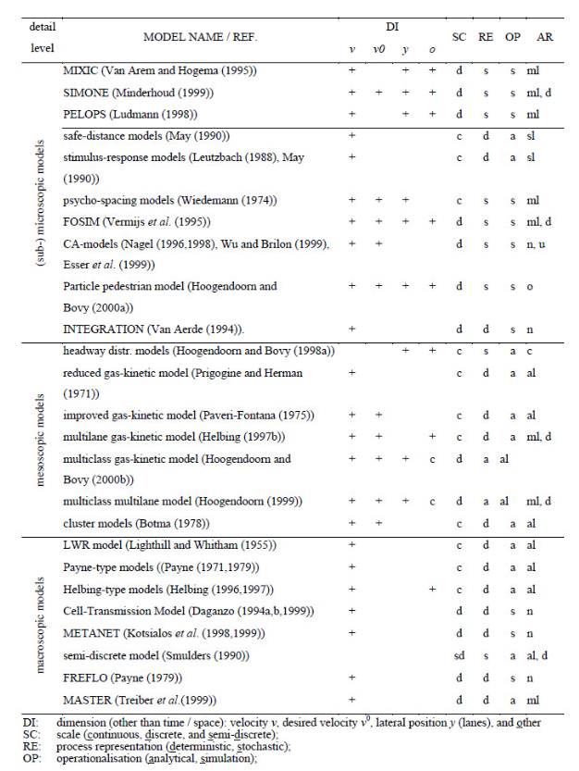

2.2.3 Previous Works on Traffic Volume Study
The current study delves into the literature concerning traffic volume, speed flow relationships, passenger car equivalents, peak hour factor, variations in flow, traffic capacity, and level of serviceability, emphasizing the critical role of traffic volume in the traffic engineering of urban and suburban roadways (LOS). Several studies have influenced and refined this research, with key contributions summarized below: In 2012, Satyanarayana explored how stream speed, traffic volume, and the type of traffic affect passenger car equivalents. Using Chandra's method, it was found that PCU values for two-axle trucks rose with an increase in the proportion of these vehicles in the traffic mix. Conversely, the presence of two-wheelers in the traffic stream had minimal impact on their PCU values. Despite varying compositional shares of two-wheelers in different areas, ranging from 31.69% to 34.23%, there was only a 1.1% increase in PCU values, likely due to the high maneuverability of these vehicles. In contrast, PCU values for bullock carts increased in slow-moving traffic as their proportion in the traffic stream decreased.
In 2015, Arkatkar utilized the traffic-flow simulation software HETEROSIM to study the effects of variations in traffic volume, road width, the extent of improvements, and their duration on PCU values. The simulation model was calibrated and validated using real-world data on traffic flow characteristics. This validated model was then employed to determine PCU values for different types of vehicles, demonstrating its ability to accurately replicate the heterogeneous traffic flow on mid-block sections of intercity roads under varying conditions. In 2008, V.T. Hamizh Arasan and Krishnamurthy enhanced the understanding of complex vehicle interactions in mixed traffic conditions. Their findings indicated that PCU values for different vehicle types in heterogeneous traffic can vary significantly depending on traffic volume and road width. Basu D and Maitra S.R in 2006 explored the relationship between Passenger Car Equivalency (PCE) and traffic volume and composition, presenting a method to calculate PCE using stream speed as the Measure of Equivalence (MOE).
The study highlights how a slight increase in traffic volume from a specific vehicle type, compared to an increase from an older technology vehicle used as a benchmark for PCE calculations, affects stream speed. It demonstrates that both the volume and composition of traffic influence PCE values. For all vehicle categories, PCE values tend to increase with rising traffic volumes, with large trucks being the most impacted. However, the presence of two-wheelers in the traffic mix does not significantly affect PCE values. In 2005, Ahmed Al-Kaisy aimed to establish passenger car equivalents for large vehicles under congested conditions, noting that the PCU values suggested by the HCM for large vehicles are only applicable in free-flow conditions. Further literature review revealed extensive research on PCU value estimation for vehicles in mixed traffic conditions. Chandra. S and Prasad N.V. in 2014 noted considerable variations in PCU factors across different urban road sections, influenced by physical characteristics, traffic, and the traffic mix. They found that the capacity of a multilane divided urban road increases linearly with the proportion of two-wheelers in the traffic stream, estimating a 9% capacity increase for every 10% rise in two-wheeler traffic. Conversely, road sections with side friction have capacities about 12% lower than those without. Marwah and Bhuvanesh in 2010 proposed a classification level for diverse urban traffic, considering factors like density, road occupancy, and speeds of motorized two-wheelers and cars to determine the Level of service (LOS). They suggested six levels of service for urban highways, with five levels (traditional LOS A to E) within the stable flow zone and one level (LOS F) representing unstable flow. For urban roadways with a lane width of 12 feet in one direction, they calculated capacity values at 2000 and 2200 PCU per hour per lane of traffic flow models.

Traffic Simulation
Simulation is a particular type of modelling approach. It is quantitative and usable in place of the real system in order to represent the behaviour of that system (Eisner, 1988). Simulation is more of an art; it does not have specific theory that can be applied to solve problems. It is mastered more by practice, by actually modelling and simulating small systems (Hira, 2001).
Simulation modelling is usually associated with complex processes which cannot be readily described in analytical terms. It is increasingly being used in traffic flow studies to satisfy a wide range of requirements such as:
- Highway capacity estimation (Dey et al., 2008)
- Intelligent transportation and intelligent vehicle simulations (Yin et al. 2009)
- Evaluation of alternative treatments in traffic management
- Design and testing of new transportation facilities (e.g., geometric designs)
- Operational flow models serving as a sub-module in other tools (e.g. model- based traffic control and optimisation, and dynamic traffic assignment)
- Training of traffic managers
- Safety Analysis (Lieberman & Rathi, 1997; Hoogendoorn & Bovy, 1998).

Traffic Simulation Models
Traffic simulation models are designed to emulate the behaviour of traffic in a transportation system over time and space to predict system performance. Simulation model runs can be viewed as experiments performed in the laboratory rather than in the field. The models include algorithms and logic to:
- generate vehicles into the system to be simulated.
- move vehicles into the system.
- model vehicle interactions.

Classification based on the detail of the system
  - Microscopic Models: These models simulate the characteristics and interactions of individual vehicles. They essentially produce trajectories of vehicles as they move through the network. The processing logic includes algorithms and rules describing how vehicles move and interact, including acceleration, deceleration, lane changing, and passing manoeuvres.
Microscopic models are potentially more accurate than macroscopic simulation models. However, they employ many more parameters that require calibration.
  - Mesoscopic Models: These models simulate individual vehicles, but describe their activities and interactions based on aggregate (macroscopic) relationships. Typical applications of mesoscopic models are evaluations of traveler information systems. For example, they can simulate the routing of individual vehicles equipped with in- vehicle, real-time travel information systems. The travel times are determined from the simulated average speeds on the network links. The average speeds are, in turn, calculated from a speed-flow relationship. Most of the parameters of the microscopic models cannot be observed directly in the field (e.g., minimum distances between vehicles in car-following situations).
  - Macroscopic Models: These models simulate traffic flow, taking into consideration aggregate traffic stream characteristics (speed, flow, and density) and their relationships. Typically, macroscopic models employ equations on the conservation of flow and on how traffic disturbances (shockwaves) propagate in the system. They can be used to predict the spatial and temporal extent of congestion caused by traffic demand or incidents in a network; however, they cannot model the interactions of vehicles on alternative design configurations (Chakroborty, 2006).
Macroscopic traffic flow simulation models are easier and less costly to maintain. They are appropriate if the model development time and resources are limited.

Classification based on randomness in traffic flow
  - Deterministic Models: These models have no random variables; all entity interactions are defined by exact relationships (mathematical, statistical or logical). For example, it is assumed that all drivers have a critical gap of 5 s in which to merge into a traffic stream, or all passenger cars have a vehicle length of 4.9 m.
  - Stochastic Models: These models have processes which include probability functions. Stochastic simulation models have routines that generate random numbers. The sequence of random numbers generated depends on the particular method and the initial value of the random number (random number seed). Changing the random number seed produces a different sequence of random numbers, which, in turn, produces different values of driver-vehicle characteristics.
Stochastic models require additional parameters to be specified (e.g., the form and parameters of the statistical distributions that represent the particular vehicle characteristic). More importantly, the analysis of the simulation output should consider that the results from each model run vary with the input random number seed for otherwise identical input data. Deterministic models, in contrast, will always produce the same results with identical input data.

Traffic simulation model building
Lieberman & Rathi (1997) highlighted the basic steps in traffic simulation model development process as the following:
- Define the problem and model objectives
- Define the system
- Develop the model

- Calibrate the model - calibration is the process of quantifying model parameters using real-world data. It is often a difficult and costly undertaking.
- Model verification - verification is a structured regimen to provide assurance that the model performs as intended.
- Model validation - validation establishes that the model behaviour accurately and reliably represents real world system being simulated, over a range of conditions anticipated. Model validation involves the following activities.
- Documentation - traffic simulation models, as is the case for virtually all transportation models, are data intensive. To make good use of these models, users must invest effort in data acquisition.

2.2.4 Vehicle generation algorithm
Jia ( 2008) generated uniform random variables to simulate poisson arrival of cars on a freeway during a period of heavy flow. The probability density function of X is
ƒ(x) = 0.15e^{–0.15(x–0.5)} for x ≥ 0.5 (2.2)
Let X = the time headway for two randomly chosen consecutive cars.
(0.5 s is regarded as the minimum average time headway between the two cars).
After generating uniform random variables U_{i} ∈ (0,1)
U_{i} = 0.15e^{–1.5(x–0.5)} (2.3)

X — (ln ^{Ui} ) /(—0.15)+0.5 (2.4)
i
0.15
Depending on a random number between (0.1) with uniform distribution, the vehicles generated were assigned into different routes.
Vehicle generation algorithm can also be developed by considering the mean headway (H) of vehicles (as given in equation 2.4) to generate vehicles at the beginning of the simulation run.
H = 3600/V (2.5)
If the model uses the shifted negative exponential distribution to simulate the arrival of vehicles at the network entry node instead of the uniform distribution, then vehicles will be generated as time intervals:
h=(H-h₁)[ln(1-R_{n})]+H-h₁ (2.6)
where:
h = headway (in seconds) separating each generated vehicle h₁ = specified minimum headway (e.g., 1.0 s)
R_{n} = random number (0 to 1.0)

2.2.5 Headway Distribution Models
Headway is the time interval between two consecutive vehicles passing an observation point (Luttinen, 2004). It has been described as the fundamental building blocks of traffic flow, because the inverse of the mean headway is the rate of flow (Dawson and Chimini, 1968; Salter and Hounsell, 1996). The traffic flow reaches its maximum value at the minimum value of headway.
At any period of time, the individual values of headway vary greatly. The extent of these variations depends largely on the highway and the traffic conditions. At low flow regimes, headway values vary from zero between overtaking
Hagring (1996) listed three requirements that headway distributions need to fulfil: they must fit the observed data well, describe driver behaviour adequately, and be useful for prediction. Most headway distribution models are probability distribution models (Abdul-Magd, 2007; Chakroborty, 2006; Salter, 1990).

- Classification based on the detail of the system
  - Microscopic Models: These models simulate the characteristics and interactions of individual vehicles. They essentially produce trajectories of vehicles as they move through the network. The processing logic includes algorithms and rules describing how vehicles move and interact, including acceleration, deceleration, lane changing, and passing manoeuvres.
Microscopic models are potentially more accurate than macroscopic simulation models. However, they employ many more parameters that require calibration.
  - Mesoscopic Models: These models simulate individual vehicles, but describe their activities and interactions based on aggregate (macroscopic) relationships. Typical applications of mesoscopic models are evaluations of traveller information systems. For example, they can simulate the routing of individual vehicles equipped with in- vehicle, real-time travel information systems. The travel times are determined from the simulated average speeds on the network links. The average speeds are, in turn, calculated from a speed-flow relationship. Most of the parameters of the microscopic models cannot be observed directly in the field (e.g., minimum distances between vehicles in car-following situations).
Chen et al. (2010) combined the mesoscopic headway distribution model and the microscopic vehicle interaction model to simulate different driving scenarios, including traffic on highways and at intersections. A mesoscopic approach with groups of vehicles is used in CONTRAM (Leonard et al. 1978), a tool for analysis of street networks with signalised and non-signalised intersections.

Classifications of traffic simulation models
The availability of adequate mathematical models is a prerequisite to describe and solve traffic flow problems. Generally speaking, mathematical modelling of traffic flow results in a nonlinear dynamic system. The nonlinear and complicated characteristics of flow dynamics makes it difficult to have a universal traffic flow model that applies to all traffic situations at all times.

Research Gap
Despite the importance of understanding traffic flow on Post Office Road, there is a significant research gap in this area. Specifically, there is a lack of studies that have investigated the traffic volume and speed analysis on Post Office Road, with most research focusing on major highways and intersections. Additionally, traditional data collection methods such as manual traffic counts and speed measurements have been relied upon, which may not provide accurate or real-time data. Furthermore, the relationship between traffic volume and speed on Post Office Road has not been adequately explored, and external factors such as road geometry, land use, and population density have not been sufficiently considered. As a result, there is a need for more advanced and innovative research that addresses these gaps and provides a comprehensive understanding of traffic volume and speed on Post Office Road. By addressing these research gaps, valuable insights can be gained, ultimately contributing to improved traffic management and safety measures on Post Office Road. Moreover, the existing studies on traffic volume and speed analysis have primarily focused on developed countries, with limited research conducted in developing countries like Nigeria. This is a significant gap, as the traffic patterns and road infrastructure in developing countries can differ significantly from those in developed countries. Additionally, the rapid urbanization and population growth in cities like Ilorin, where Post Office Road is located, necessitate a more nuanced understanding of traffic flow analysis.
Furthermore, the majority of studies on traffic flow analysis have employed traditional statistical analysis methods, with limited use of advanced data analytics and machine learning techniques. This is a significant gap, as the use of advanced data analytics and machine learning techniques can provide more accurate and robust insights into traffic flow analysis.

CHAPTER THREE
RESEARCH METHODOLOGY
3.1 Introduction
This chapter outlines the research methodology employed to analyze the traffic flow along the Post Office – Sango route in Ilorin, Kwara State. The study aim to examine the traffic patterns during morning and evening peak periods, focusing on three key road segments:
1. Post Office – Maraba
2. Maraba – Agric Junction
3. Agric Junction – Sango Junction
The methodology covers the research design, data collection methods, analytical techniques, and tools used in the study. These steps ensure that the research findings are reliable, valid, and applicable to traffic management improvements in the study area.

3.2 Research Design
The research adopted a quantitative descriptive approach to collect and analyze traffic count data over a seven-day period. The quantitative approach enables an objective assessment of traffic volume and vehicle distribution across the specified road segments.
The descriptive nature of the study helps to identify patterns, highlight periods of peak congestion, and make informed recommendations for traffic management.
Key Features of the Research Design:
- Observation Method: Direct observation was used to record traffic counts manually at designated observation points.
- Time-bound Analysis: Focused on peak periods to capture the highest traffic flow.
- Categorization by Vehicle Type: The study categorized vehicles into five distinct groups: Cars, Tricycles, Motorcycles, Buses, and Trucks for detailed analysis.

3.3 Data Collection Method
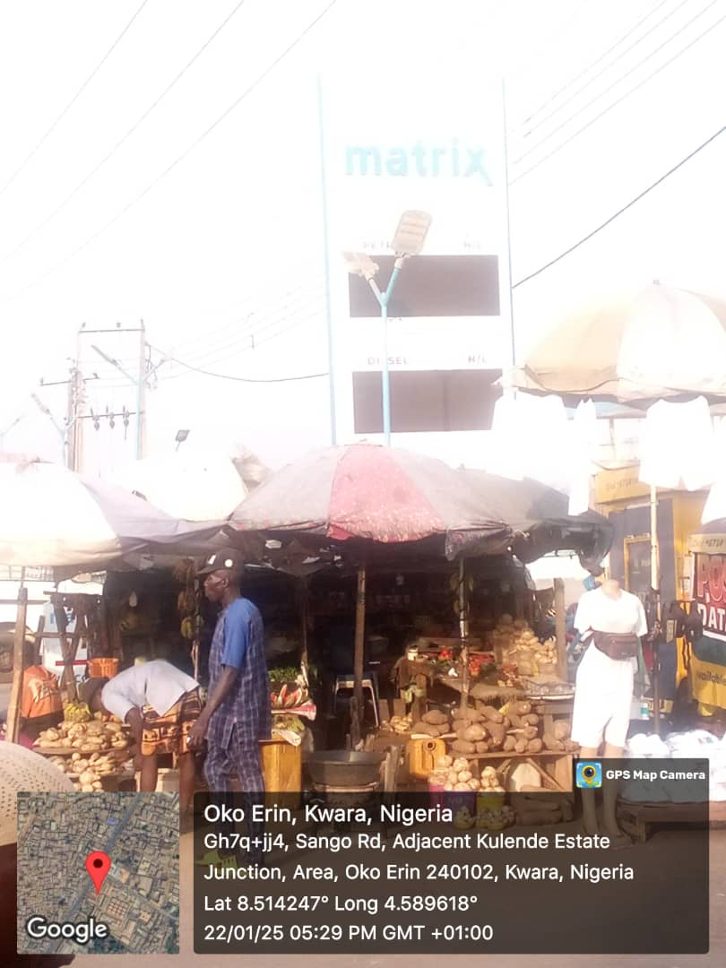
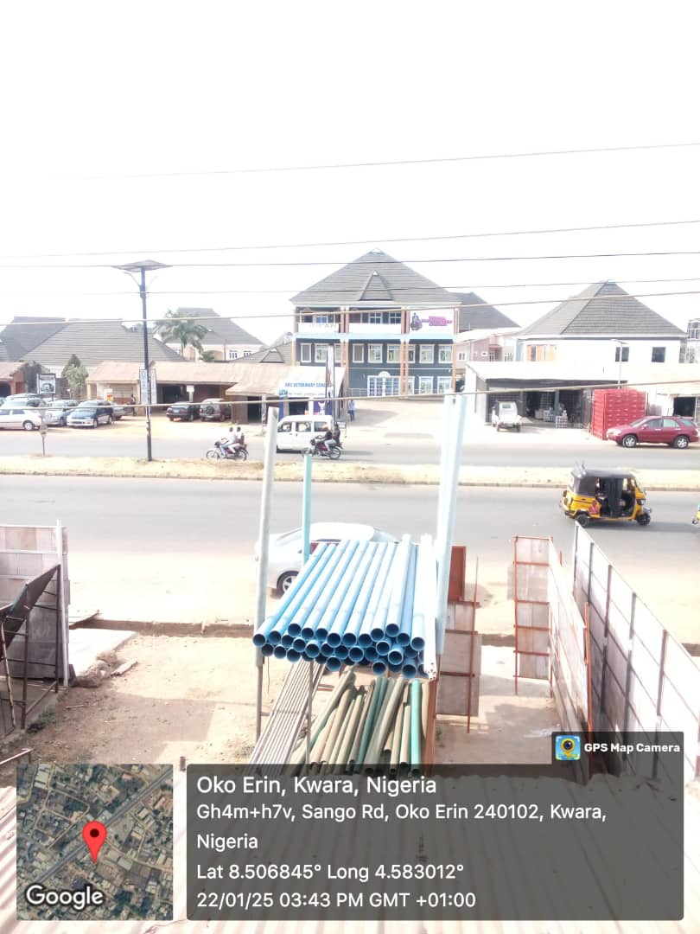

The data collection was carried out over a period of seven consecutive days, covering morning (7:00 am – 8:30 am) and evening (4:00 pm – 6:00 pm) peak periods.

7-Day Complete Traffic Count Dataset

The table below presents the complete 7-day traffic count dataset for the morning and evening peak periods. The data simulates the number of vehicles passing through three road segments: 1. Post Office - Maraba

2. Maraba - Agric Junction
Days | Road Segment | Time Period | Cars | Tricycles | Motorcycles | Buses | Trucks
Day 1 | Post Office - Maraba | 7:00 - 8:00am | 350 | 120 | 200 | 60 | 30
Day 1 | Post Office - Maraba | 8:00 - 9:00am | 380 | 140 | 210 | 70 | 40
Day 1 | Maraba - Agric Junction | 7:00 - 8:00am | 400 | 150 | 220 | 70 | 40
Day 1 | Agric Junction - Sango | 7:00 - 8:00am | 500 | 180 | 250 | 80 | 50
Day 1 | Agric Junction - Sango | 4:00 - 5:00pm | 450 | 160 | 300 | 90 | 60
Day 2 | Post Office - Maraba | 7:00 - 8:00am | 370 | 130 | 205 | 65 | 35
Day 2 | Maraba - Agric Junction | 8:00 - 9:00am | 390 | 150 | 215 | 75 | 45
Day 2 | Agric Junction - Sango | 7:00 - 8:00am | 520 | 200 | 280 | 95 | 55
Day 2 | Agric Junction - Sango | 4:00 - 5:00pm | 550 | 210 | 290 | 100 | 60
Day 3 | Post Office - Maraba | 7:00 - 8:00am | 360 | 125 | 220 | 70 | 40
Day 3 | Maraba - Agric Junction | 8:00 - 9:00am | 400 | 160 | 230 | 80 | 50
Day 3 | Agric Junction - Sango | 7:00 - 8:00am | 530 | 210 | 290 | 100 | 60
Day 3 | Agric Junction - Sango | 4:00 - 5:00pm | 580 | 230 | 310 | 110 | 70
Day 4 | Post Office - Maraba | 7:00 - 8:00am | 375 | 135 | 225 | 75 | 45
Day 4 | Maraba - Agric Junction | 8:00 - 9:00am | 410 | 170 | 240 | 85 | 55
Day 4 | Agric Junction - Sango | 7:00 - 8:00am | 550 | 220 | 300 | 105 | 65
Day 4 | Agric Junction - Sango | 4:00 - 5:00pm | 590 | 240 | 320 | 115 | 75
Day 5 | Post Office - Maraba | 7:00 - 8:00am | 370 | 125 | 230 | 75 | 35
Day 5 | Maraba - Agric Junction | 8:00 - 9:00am | 420 | 180 | 260 | 90 | 50
Day 5 | Agric Junction - Sango | 7:00 - 8:00am | 560 | 230 | 310 | 110 | 70
Day 5 | Agric Junction - Sango | 4:00 - 5:00pm | 600 | 250 | 330 | 120 | 80
Day 6 | Post Office - Maraba | 7:00 - 8:00am | 380 | 130 | 240 | 80 | 40
Day 6 | Maraba - Agric Junction | 8:00 - 9:00am | 430 | 185 | 270 | 95 | 55
Day 6 | Agric Junction - Sango | 7:00 - 8:00am | 570 | 240 | 320 | 115 | 75
Day 6 | Agric Junction - Sango | 4:00 - 5:00pm | 610 | 260 | 340 | 125 | 85
Day 7 | Post Office - Maraba | 7:00 - 8:00am | 390 | 140 | 250 | 85 | 45
Day 7 | Maraba - Agric Junction | 8:00 - 9:00am | 440 | 190 | 280 | 100 | 60
Day 7 | Agric Junction - Sango | 7:00 - 8:00am | 580 | 250 | 330 | 120 | 80
Day 7 | Agric Junction - Sango | 4:00 - 5:00pm | 620 | 270 | 350 | 130 | 90

3. Agric Junction - Sango Junction.

Each row shows the breakdown of traffic for one-hour periods across different vehicle types (Cars, Tricycles, Motorcycles, Buses, and Trucks).

3.4.1 Data Collection Instruments
- Observation Sheets: Used for manually recording vehicle counts at one-hour intervals for each road segment and time period.
- Data Recording Forms: Structured forms were designed to capture vehicle counts categorized into five vehicle types.
3.4.2 Data Collection Procedure
Observers were stationed at strategic locations along each road segment to record the number of vehicles passing during the specified time periods.
- Morning Count: Conducted in two, 1hr sessions (7:00 – 8:00 am and 8:00 – 9:00 am)
- Evening Count: Conducted in two, 1hr sessions (4:00 – 5:00 pm and 5:00 – 6:00 pm)
The data collected were then compiled into a tabular format for subsequent analysis.
3.5 Data Analysis Method
The collected data were analyzed using descriptive statistical tools. The analysis focused on identifying traffic patterns, vehicle type distribution, and periods of peak congestion.
3.5.1 Statistical Analysis
The data were processed using Microsoft Excel for the following:
- Traffic Volume Analysis: Summarizing vehicle counts for each road segment and time period.
- Vehicle Type Distribution: Calculating the percentage distribution of each vehicle type across the dataset.
- Congestion Pattern Identification: Highlighting periods with the highest vehicle counts to identify peak congestion periods.
3.5.2 Visualization Technique
Charts and graphs were used to enhance the presentation of results. The following visualizations were included:
- Line Charts: To show traffic trends over the seven-day period.
- Bar Charts: To highlight peak congestion periods by road segment.
- Pie Charts: To illustrate vehicle type distribution.
3.6 Ethical Considerations
The study adhered to standard research ethics. No personal information or data that could identify individuals was collected. Observers ensured that data collection did not interfere with traffic flow or cause disruptions.
3.7 Limitations of the Study
The study faced some limitations, including:
- Manual Data Collection: This method is prone to human error, which may affect accuracy.
- Limited Time Frame: The analysis focused on a specific time frame and may not reflect long-term traffic patterns.
- Weather Conditions: Unfavorable weather occasionally affected data collection.

CHAPTER FOUR
RESULTS AND DISCUSSION
4.1 Introduction
This chapter presents the results of the data analysis and discusses the findings based on the traffic count conducted over a seven-day period along the Post Office – Sango route in Ilorin, Kwara State. The analysis focuses on vehicle type distribution, traffic volume patterns across different road segments, and periods of peak congestion. The results are presented in tables and charts for clarity and are discussed in relation to traffic management strategies.
4.2 Traffic Volume Analysis
The traffic count data collected over the seven-day period were analyzed for the morning and evening peak periods. The results indicate significant variations in traffic volume across the three road segments.

4.2.1 Morning Peak Traffic Volume
Table 4.1 shows the total traffic volume during the morning peak periods (7:00 am – 8:30 am) for each road segment over the seven days.
S/N | Road Segment | Average Daily Traffic Volume (7:00 am – 8:30 am)
1. | Post Office – Maraba | 1,020 Vehicles
2. | Maraba – Agric Junction | 1,145 Vehicles
3. | Agric Junction – Sango | 1,210 Vehicles

The highest average traffic volume was recorded on the Agric Junction – Sango segment during the morning peak period. This is likely due to its proximity to major residential areas and its role as a primary connection to commercial hubs.
4.2.2 Evening Peak Traffic Volume
Table 4.2 presents the total traffic volume during the evening peak periods (4:00 pm – 6:00 pm).
S/N | Road Segment | Average Daily Traffic Volume (4:00 pm – 6:00 pm)
1. | Post Office – Maraba | 1,150 Vehicles
2. | Maraba – Agric Junction | 1,275 Vehicles
3. | Agric Junction – Sango | 1,350 Vehicles

The evening peak periods show a higher traffic volume compared to the morning. The Agric Junction – Sango segment again recorded the highest traffic volume, reflecting increased movement of commuters returning home from work and commercial activities.
4.3 Vehicle Type Distribution
The traffic count data also provided insights into the distribution of different vehicle types. Table 4.3 summarizes the percentage of each vehicle type recorded over the study period.

Table 4.3: Vehicle Type Distribution
Vehicle Type | Percentage (%)
Cars | 50%
Tricycles | 20%
Motorcycles | 15%
Buses | 10%
Trucks | 5%

Cars constituted the majority of the vehicles recorded, accounting for 50% of the total traffic volume. Tricycles and motorcycles followed, representing 20% and 15% of the traffic, respectively. The relatively low proportion of buses and trucks reflects the residential and commercial nature of the area.
4.4 Traffic Congestion Pattern
The study identified significant congestion patterns during both morning and evening peak periods. These patterns were most notable at intersections and bottlenecks near Maraba and Agric Junction.
Key Findings:
- Morning Congestion: Most pronounced between 7:30 am and 8:00 am, especially on the Agric Junction – Sango segment.
- Evening Congestion: Peaked between 4:30 pm and 5:30 pm, with long queues at intersections leading to delays.
4.5 Implications for Traffic Management
The findings from this study have important implications for traffic management in Ilorin:
- Traffic Signal Optimization: Adjusting signal timings during peak periods can reduce congestion at critical intersections.
- Dedicated Motorcycle and Tricycle Lanes: Creating dedicated lanes for motorcycles and tricycles can improve overall traffic flow.
- Public Transport Promotion: Encouraging the use of buses can reduce the number of cars on the road, easing congestion.

CHAPTER FIVE

CONCLUSION AND RECOMMENDATION

Conclusion
Conclusion
This chapter has presented and discussed the results of the traffic analysis along the Post Office – Sango route. The findings highlight significant variations in traffic volume and congestion patterns across different road segments and time periods.

Recommendation
      - Installation of traffic signals at strategic locations, at Post Office and Sango Intersection.
      - Improve lane management and markings
      - Enhancing pedestrian and cyclist infrastructure
      - Implementing Intelligent Transportation System (ITS) solutions.

REFERENCES
Abul-Magd, A.Y. 2017. Modelling highway-traffic headway distributions using superstatistics. Physical Review E 76.5:1-30
Ackoff, R. L. and Sasieni, M. W. 1986. Fundamentals of Operations Research. New Delhi: Wiley Eastern Limited.
Adams, W. F. 1936. Road traffic considered as a random series. Journal of Institution of Civil Engineers 4: 121-130.
Adebisi, O. and Chiejina, E. 1983. Travel time characteristics of conventional intr- urban bus in Kaduna. The Nigerian Engineer 18.3: 81-88.
Agbede, O. A. 1996. Groundwater modelling - an overview. Journal of Mining and Geology 32.2:10-112.
Agbede, O. A. and Adegbola, A. A. 2013. Application of the numerical modelling techniques to the simulation of groundwater flow in the Gwandu formation of the north-western Nigeria basin. Journal of Applied Science and Technology
3.1: 13-18.
Akanbi O. G., Charles-Owaba O. E. and Oluleye A. E. 2019. Human factors in traffic accidents in Lagos, Nigeria. Disaster Prevention and Management 18.4:397- 409.
Akcelik, R. and Chung, E. 1994. Calibration of the bunched exponential distribution of arrival headways. Road and Transport Research 3.1: 42-59.
Akintayo, F. O. and Agbede O. A. 2019. Headway distribution modelling of free- flowing traffic on two-lane single carriageways in Ibadan. Proceedings of the 1st International Conference on the Role of Engineering and Technology in Achieving Vision 20:2020 –RETAV 2009 (17– 19 Nov., 2019), Obafemi Awolowo University, Ile-Ife, Nigeria: 240-246.
Andrew, D., 2014. The world’s worst traffic jams. Time magazine. Retrieved on 10/06/2009
Arasan, V. T. and Arkatkar, S. S. 2015. Modelling heterogeneous traffic flow on upgrades of intercity roads. Transport 25.2: 129-137.
Arasan, V. T. and Koshy, R. Z. 2013. Headway distribution of heterogeneous traffic on urban arterials. Journal of the Institution of Engineers (India) 84: 210-215.
Asalor, J. O., Onibere, E. A. and Ovuworie, G. C. 1986. Road traffic accidents in developing countries. Proceedings of the 1st International Conference (4– 6 August, 1986) held at the University of Benin, Benin City, Nigeria.
Athol, P. (1965). Interdependence of certain operational characteristics within a moving traffic stream. Highway Research Record 72: 58-87.
Aworemi, J. R., Abdul-Azeez, I. A., Oyedokun, A. J. and Adewoye, J. O. 2009. A study of the causes, effects and ameliorative measures of road traffic congestion in Lagos Metropolis. European Journal of Social Science 11.1: 119-128.
Ayeni, B. 2012. An application of GIS to the analysis of maternal and child healthcare delivery in Ibadan, Nigeria.
Bagchi, A. and Maarseveen, M. 1980. Modelling and estimation of traffic flow- a martingale approach. International Journal of Systems Science 11.4: page.
Bandyopadhyay, S. N. 2011. A computer simulation model for traffic flow. Journal of the Institution of Engineers 82: 119-124.
Banks, J. H. 2013. Average time gaps in congested freeway flow. Transportation Research Part A 37.6: 539-554.
Barcellos, C., Feitosa, P., Damacena, G. N. and Andreazzi, M. A. 2010. Highways and outposts: economic development and health threats in the central Brazilian Amazon region. International Journal of Health Geographics 9: 1-30
Brockfield, E., Kuhne R. D. and Wagner P. 2014. Calibration and validation of microscopic flow models. Transportation Research Record 1876: 62-70.
Brown, J. K. M. 2010. Experimental Design Generator and Randomiser (EDGAR). Retrieved on 15 December 2010 from www.edgarweb.org.uk/2FactorRCB.xls.

