SMART SOLAR BASED CBT EXAMINATION MONITORING SYSTEM

BY

OMOYAJOWO KEHINDE HEEBATULLAH
HND/23/COM/FT/0122

SUBMITTED TO THE DEPARTMENT OF COMPUTER SCIENCE, INSTITUTE OF INFORMATION AND COMMUNICATION TECHNOLOGY,
KWARA STATE POLYTECHNIC, ILORIN.

IN PARTIAL FULFILLMENT OF THE REQUIREMENTS FOR THE AWARD OF HIGHER NATIONAL DIPLOMA (HND) IN
COMPUTER SCIENCE
MAY, 2025.

CERTIFICATION
This is to certify that this project was carried out by OMOYAJOWO KEHINDE HEEBATULLAH of Matriculation Number: HND/23/COM/FT/0122 in the Department of Computer Science, Institute of Information and Communication Technology, Kwara State Polytechnic, Ilorin, Kwara State.

…………………………………. ….………………………
DR. AGBOOLA, O. M. Date
Project Supervisor

…………………………………. ….………………………
MR. OYEDEPO, F. S. Date
Head of Department

…………………………………. ….………………………
External Examiner Date

DEDICATION
I dedicate this project work to the Almighty God who inspired me and directed my ways during my academic stay in the polytechnic.
ACKNOWLEDGEMENTS
All praise is due to the Almighty God the Lord of the universe. I praise him and thank him for giving me the strength and knowledge to complete my HND program and also for our continued existence on earth.
I appreciate the utmost effort of my supervisor, Dr. Agboola, O. M. whose patience, support, and encouragement were the driving force behind the success of this research work. He gave useful corrections, constructive criticisms, comments, recommendations, and advice and always ensured that excellent research was done. My sincere gratitude goes to the Head of the Department Mr. Oyedepo, F. S. and other members of staff of the Department of Computer Science, Kwara State Polytechnic, Ilorin, for their constant cooperation, constructive criticisms, and encouragement throughout the program.
Special appreciation goes to my parent, who exhibited immeasurable financial, patience, support, prayers, and understanding during the period in which I was busy tirelessly with my studies, special thanks go to my lovely siblings.
My sincere appreciation goes to my friends and classmates.

TABLE OF CONTENTS

Title page i

Certification ii

Dedication iii

Acknowledgements iv

Table of Contents v

Abstract vii

CHAPTER ONE: GENERAL INTRODUCTION
  - Background to the Study 1
  - Statement of the Problem 2
  - Aim and Objectives 2
  - Scope of the Study 3
  - Significance of the Study 3
  - Organization of the Study 3
  - Definition of Terms 4

CHAPTER TWO: LITERATURE REVIEW
  - Review of Related Works 6

2.2 General Works 9
CHAPTER THREE: RESEARCH METHODOLOGY AND ANALYSIS
3.1 Research Methodology 12
3.2 Analysis of the Existing System 16
3.3 Problems of the Existing System 16
3.4 Analysis of the Proposed System 17
3.5 Advantages of the New System Over the Existing System 17
CHAPTER FOUR: DESIGN AND IMPLEMENTATION OF THE SYSTEM
4.1 Introduction 19
4.2 System Components 19
4.3 Implementation of Solar-Powered Installation 19
4.4 Installation of CCTV System 22
4.5 Connectivity and Integration 24
4.6 System Benefits 24
CHAPTER FIVE: SUMMARY, CONCLUSION AND RECOMMENDATIONS
5.1 Summary 25
5.2 Conclusion 25
5.3 Recommendations 25
References 27

ABSTRACT
The Smart Solar-Based CBT Examination Monitoring System is an innovative solution designed to enhance the integrity, efficiency, and sustainability of computer-based testing (CBT) environments, particularly in areas with unreliable power supply. This system integrates solar power technology with smart surveillance and monitoring tools to ensure uninterrupted examination sessions and real-time invigilation. By harnessing solar energy, the system provides a dependable power source that reduces reliance on the national grid and supports eco-friendly operations. The monitoring component incorporates advanced features such as biometric authentication, real-time video surveillance, AI-driven anomaly detection, and automated reporting to prevent malpractices and ensure transparency throughout the examination process. The design also includes a centralized dashboard for remote monitoring and control, enabling administrators to oversee multiple exam centers simultaneously. This project addresses key challenges in educational assessment by combining renewable energy and smart technologies, offering a scalable and sustainable solution for modern examination systems, especially in developing regions.
Keywords: Smart Solar System, Computer-Based Test (CBT), Examination Monitoring, CCTV Surveillance, Renewable Energy, Real-Time Monitoring, Academic Integrity, Power Backup, Educational Technology.

CHAPTER ONE
GENERAL INTRODUCTION
1.1 BACKGROUND TO THE STUDY
The smart solar CBT examination system is an innovative solution designed to address the challenges of conducting secure and reliable computer based tests (CBT) in remote or off-grid locations. By integrating solar power generation with advanced surveillance technologY, this system ensures uninterrupted power supply and effective monitoring of examination environment. In many remote areas, the lack of reliable electricity and monitoring infrastructure poses significant obstacles to administering CBTS. Traditional examination setups often rely on grid electricity, which may be unavailable in such regions (Ansari, et al. 2021).
Solar power, also known as solar electricity, is the conversion of energy from sunlight into electricity, either directly using photovoltaic (PV) or indirectly using concentrated solar power. Solar panels use the photovoltaic effect to convert light into an electric current. Concentrated solar power systems use lenses or mirrors and solar tracking system to focus a large areas of sunlight to a hot-spot, often to drive a steam turbine. Photovoltaic (PV) were initially solely used as a source of electricity for small and medium sized applications, from the calculator powered by a single solar cell to remote homes powered by an off-grid roof top (PV) system. Commercial concentrated solar power plants were first developed in the 1980s. Since then, as the cost of solar panels has fallen, grid connected solar PV systems capacity and production has doubled about every three years. Three-quarters of new generation capacity is solar, with both millions of roof top installation and gigawatt - scale photovoltaic power stations continuing to be built (Kavitha, 2019).
Computer based test (CBT) is an examination format where candidates take tests with computers as an alternative to using pen-paper method. Such a test can be conducted online using the internet or a computer - aided faculty. Usually this test or exam is carried out by organizations to evaluate or analyze a candidates performance, skill or capability. CBT has become the optimal choice for most industries because of its varied benefits. For instance, reputed companies use CBT as a way of screening candidates when there are huge number of applicants. Ultimately this assessment enables the employers to shortlist those candidates who meet their criteria for the job and who have the right talent and skill (Yahaya , 2025).
There are a multitude of advantages offered by computer based tests such as large - scale delivery of tests, adjustable and personalized test, exams conducted with integrity, remote test feature, also used for academic exams, recruitment certification and standardized test. Computer Based Tests have become on essential facility provided by the government, corporate and private sectors for conducting assessments or recruiting candidates. It’s not only saves time and resources but also helps in tracking students progress through the data that is being generated (Paliyal, et al., 2024).
A CCTV monitoring system comprises the deployment of a network of surveillance cameras in a designed area, with these cameras transmitting their video feeds to a central recording device, known as Network Video Recorder (NVR). The recorded video can be accessed in real time and achieved for future reference. CCTV monitoring offers a range of valuable benefits across different settings. It enhances security and helps prevent crime before it happens by acting as a deterrent and providing vital evidence for investigations.
1.2 STATEMENT OF THE PROBLEM
CBTs require a reliable power supply to function effectively, but frequent power outages in many examination centers disrupt the testing process, causing frustration for students and administrators. CCTV cameras, which are used to monitor the examination environment, also require a stable power supply to function effectively. Furthermore, the limited coverage area of CCTV cameras makes it difficult to monitor all areas of the examination center effectively.
Solar integration as a solution integrating solar power into examination centers can provide a reliable and sustainable solution to the problems associated with CBTs and CCTV surveillance. A smart solar- based examination monitoring system can harness solar energy to power CBT and CCTV cameras, ensuring uninterrupted testing and surveillance. This system can also include energy storage batteries to provide backup power during periods of low sunlight or at night.

1.3 AIM AND OBJECTIVES
The main aim of this study is to design and implement solar power CBT examination system. The Objectives are:
- Installation of solar panel, surveillance camera and inverter for the monitoring of the CBT examination center; and
- Connection of the solar panel with the batteries.
1.4 SCOPE OF THE STUDY
The scope is based on CBT center of computer science which encompass the availability of panel and solar energy absorption rate, battery health and power storage, CCTV monitoring system.
1.5 SIGNIFICANCE OF THE STUDY
This study is aimed at cost saving, and sustainability, because it is renewable, solar power is more secure than conventional power source, non-dependent on other sources of energy. CCTV monitoring system serves as security benefits (i.e., prevention of cheating, detection of malpractice, protection of examination materials), operational benefits (i.e monitoring of examination processes, improved candidates experience, reduced administrative burdens), investigative benefits (i.e. investigation of incidents, evidence collection, review of examination procedures),technical benefits (i.e high-quality video evidence, secure data storage), cost-effective benefits (i.e reduced costs, increased efficiency, long term investment).
1.6 ORGANIZATION OF THE STUDY
This research work is organized into five chapters. Chapter one is concerned with the introduction of the research study, theoretical background, statement of the problem, aim and objectives of the study, scope of the study, significance of the study, organizations of the report and definition of terms.
Chapter two focuses on the literature review, where the contributions of the other scholars on the subject matter discussed.
Chapter three is concerned with the system analysis and designs. It presents the research methodology, analyzes the present system to identify the problem of the existing system, and provides information on the advantages and disadvantages of the proposed system. The system design is also presented in this chapter.
Chapter four presents the system implementation and documentation. The choice of programming language and system requirements for implementation.
Chapter five focuses on the summary, conclusion and recommendations are provided in this chapter based on the study carried.
1.7 DEFINITION OF TERMS
- Solar Power: It is the conversion of energy from sunlight into electricity.
- PV (PhotoVoltaic): Relating to the production of electric current at junction of two substances exposed to light.
- N (Semiconductor): This is a basic semiconductor device that controls the flow of electric current in a circuit. P (positive side), n (negative side)
- CBT (Computer Based Test): Refers to delivering assessments with computers as an alternative to using pen-paper method.
- CCTV (closed circuit television): This is a type of surveillance system that uses cameras to transmit video signals to a specific, limited set of monitors.
- Surveillance: This refers to the systematic observation, monitoring, recording of individuals, groups, or activities.
- Implementation: It’s the process of making something work in practice after it’s been designed or decided.
- Installation: This means setting something up so it’s ready to use, especially software, equipment, or machinery.
- Solar Panel: Solar panel is a device that converts sunlight into electricity by using photovoltaic cells.
- Inverter: An inverter is an electronic device that converts direct current (DC) into alternating current (AC).
- Cameras: Camera is a device for recording visual images in the form of photographs, film or video signals.
- Switch: A switch is an electrical component that can disconnect or connect the conducting path in an electrical circuit.
- Cable: Electrical cables are used to connect two or more devices, enabling the transfer of electrical signals.
- Router: Router is a computer and networking device that forward data packets between computer networks, including internet works such as the global internet.
- Network Configuration: the router and switch are configured to enable remote access to the CCTV system, ensuring secure and reliable data transmission.
- Inefficiency: The state of not achieving maximum productivity.
- IOT: Stands for Internet of Things. Refers to a network of physical devices, vehicles, and appliances embedded with sensors, software, and connectivity, allowing them to collect and share data with other devices and systems over the internet.

CHAPTER TWO
LITERATURE REVIEW
2.1 REVIEW OF RELATED WORKS
Vincent, Josiah, and Unwana (2019) worked on Development of a Smart Solar Energy Management System (SSEMS) with the aims to efficiently harness solar energy, power electrical loads, and store excess energy for later use, addressing inefficiencies in traditional solar systems and the objective is to design a smart system that optimizes energy collection, storage, and distribution, reducing costs and improving battery management. The Methodology of the design is using photovoltaic modules, independent battery banks, and a smart output unit with AC/DC conversion and automatic change-over switching. It employs a modular design with selective battery charging/discharging based on state of charge (SOH) and health (SOC). The system was designed and simulated using electronic workbench software, followed by hardware implementation on a printed circuit board (PCB) via PCB Wizard and etching processes. The gaps of the Findings in the study lacks detailed performance metrics (e.g., efficiency gains, cost savings and real-world testing data. It does not address scalability, long-term battery lifespan improvements, or integration with advanced IOT systems for remote monitoring. In Conclusion, the SSEMS successfully demonstrates a smart approach to solar energy management, allowing efficient energy use and selective battery charging, enabling the use of old and new batteries together, unlike conventional systems and The recommendation, further research should focus on extensive field testing, scalability for larger applications, and IOT integration for real-time monitoring. Detailed efficiency and cost analyses are needed to validate commercial viability.
Paramjeet, Surajit, Samar, Piyush, and Jitendra (2024) Researched on Automatic Solar Tracking System: A Review Pertaining to Advancements and Challenges in the Current. The aim of the study is to review advancements and challenges in automatic solar tracking systems (STS) with the objective to optimize solar power generation by adjusting panel angles based on the sun’s position, enhancing energy efficiency. The Methodology used, A comprehensive literature review was conducted, analyzing solar tracking technologies based on parameters like axis type, tracking methods, accuracy, and efficiency. Data from Scopus and Science Citation Index were visualized using VOS viewer to identify research trends. Comparative analyses of single-axis, dual-axis, passive, and active trackers were performed, alongside evaluations of a 20 MW solar PV facility using the System Advisor Model (SAM) and The Gaps in Findings is the review highlights limited efficiency in LDR-based trackers under diverse weather conditions and high costs and maintenance needs for active trackers. Environmental factors like clouds and shading also affect tracking accuracy. In conclusion, Dual-axis PV tracking systems outperform stationary systems by over 27% in efficiency, with schedule-based trackers 4.2% more efficient than LDR-based ones. V-trough concentrators are simpler and better suited for commercial solar cells compared to CPCs. Recommendation, Future research should focus on cost reduction, improving tracker durability, and integrating AI and machine learning for enhanced accuracy. Robust designs and regular maintenance are essential to mitigate environmental impacts and ensure reliability.
Isha, Shirbhate, and Sunita (2019) Researched on Solar Panel Monitoring and Energy Prediction for Smart Solar Systems. The project aims to develop a smart solar system for real-time monitoring and accurate prediction of photovoltaic (PV) energy generation to enhance energy management in India with Objectives to creating a real-time monitoring system using IOT and developing a prediction model using the Hidden Markov Model (HMM) to forecast solar power based on environmental data. Methodology used for the Implementation, the system uses IOT with Raspberry Pi 3 and DHT-11 sensors to monitor temperature, humidity, and PV panel power output, with data stored on the cloud using Python and Flask. The HMM predicts energy generation by analyzing time-series data, considering state transition and emission probabilities to forecast solar power accurately. The Gaps of Findings state that study lacks detailed quantitative metrics on prediction accuracy and system scalability. It does not address long-term performance under diverse environmental conditions or integration with larger grid systems. The computational complexity of HMM and real-world implementation challenges are under explored.
Conclusion, the smart solar system effectively monitors PV panels and predicts energy generation using IoT and HMM. It identifies panel faults and provides accurate hourly predictions, improving energy utilization and system reliability compared to simpler models.Recommendation, Future research should focus on scalability, long-term testing across varied conditions, and integration with grid systems. Enhancing HMM efficiency and providing detailed accuracy metrics would strengthen practical applicability.

Nasiru, Hazlee, Hazlie, Nurulafiqah, and Mohd (2025) worked on Solar-Powered Smart Monitoring System for Occupancy and Energy Use in Lecture Rooms. The project aim to reduce energy costs and carbon footprints in lecture rooms with objective to developed a solar-powered IOT-based system to monitor occupancy and environmental conditions, ensuring air conditioners operate only when needed. Methodology used on the design, The system uses two Arduino boards: Wemos D1 with PIR motion and DHT11 temperature sensors for monitoring room conditions, and an AI-Thinker ESP32-CAM for image-based occupancy verification via Telegram. Powered by solar PV-charged batteries, it transmits real-time data using Blynk and Telegram for remote monitoring and control and the gaps in Findings, The study lacks long-term performance data across diverse climates and larger-scale implementations. It does not address potential privacy concerns with camera-based monitoring or system reliability under varying solar conditions. Scalability and cost-effectiveness for widespread adoption are under explored. In conclusion the prototype achieved 41.12% weekly energy savings by deactivating air conditioners during unoccupied periods, reducing electricity costs and CO2 emissions. It supports sustainable energy management, aligning with SDG climate and clean energy goals.The Recommendation, Future research should validate the system in varied environments, address privacy concerns, and assess scalability. Long-term testing and cost-benefit analyses are needed to ensure reliability and broader applicability in educational settings.
Shaheer, Afida, Molla, Mohamad, and Aini (2021) Researched on A Review of Monitoring Technologies for Solar PV Systems Using Data Processing Modules and Transmission Protocols. The review aims to evaluate solar PV monitoring technologies, focusing on data processing modules transmission protocols, with the objective to enhance performance and identify challenges for sustainable energy management. Methodology of the designed system, A comprehensive literature review was conducted using databases like Google Scholar, IEEE Xplore, MDPI, and ScienceDirect, analyzing 148 articles from 2010–2020. It assessed data processing modules (BeagleBone, Arduino, Raspberry Pi, PLC, micro-controllers) and transmission protocols (ZigBee, Wi-Fi, Bluetooth, GSM, LoRa) for design, implementation, specifications, and limitations. Gaps in Findings, The review lacks detailed quantitative comparisons of module performance and real-world scalability. It does not address long-term reliability under diverse environmental conditions or the integration of emerging technologies like 5G for enhanced monitoring. Conclusion, The study provides a detailed analysis of solar PV monitoring technologies, highlighting the strengths and limitations of various data processing modules and transmission protocols. It underscores their role in improving system efficiency and sustainability while identifying key challenges like data handling and security and The Recommendation is, Future research should focus on developing robust, secure, and scalable monitoring systems using advanced technologies like 5G and NB-IOT. Validation under diverse environmental conditions, improved data security, and open-source platforms are recommended to enhance system reliability and accessibility.
2.2 GENERAL WORKS
Kavitha et al. (2019), in their publication titled “IOT-Based Solar Energy Monitoring System,” proposed the use of renewable energy sources, particularly solar photovoltaic (PV) systems, as a reliable and sustainable alternative to meet growing energy demands. The primary aim of the study was to develop a cost-effective and efficient IOT-based monitoring solution for solar PV systems to ensure optimal and stable power generation. The objective was to enable real-time performance tracking for improved maintenance and operational reliability. Methodologically, the researchers implemented a system using a 125-watt solar module integrated with a smart, Wi-Fi-enabled CC3200 micro controller based on an embedded ARM processor. This system collected data on key parameters such as string voltage, string current, temperature, and irradiance, and uploaded the information to a cloud platform via the Blynk application, allowing remote monitoring through smartphones or computers. The findings demonstrated that the IOT-based monitoring system enhances the performance and reliability of solar PV installations by enabling proactive maintenance and maximizing energy yields. However, the study was limited to a small-scale implementation, and it did not evaluate the system’s scalability or effectiveness in larger or more diverse solar installations, presenting a gap for further research. The authors concluded that their proposed system is effective in minimizing operational costs and recommended further studies on its application in larger PV systems. Overall, the research underscores the importance of integrating IOT technologies in renewable energy systems to support sustainable, reliable, and user-friendly energy management.
Lavanya, et al. (2019) in their publication titled “A Method for Remote Monitoring and Analyzing of Photovoltaic Panels Using Internet of Things” proposed a real-time monitoring system aimed at improving the efficiency and maintenance of photovoltaic (PV) panels through the integration of Internet of Things (IOT) technologies. The primary objective of the study was to enable remote monitoring of solar panel performance by measuring current, voltage, and ambient temperature. The system was developed using the Arduino ATMega 2560 micro-controller, which was interfaced with voltage, current, and temperature sensors. A Wi-Fi module facilitated wireless data transmission to a smartphone application, specifically the Blynk App, enabling users to monitor PV parameters in real-time. The system was tested over a period of seven days, from 8:00 AM to 4:00 PM daily, to assess its effectiveness. The results showed that the monitoring system delivered a high degree of accuracy, with an average error rate of less than 10% in output measurements. The study highlighted the effectiveness of using IOT for real-time solar panel monitoring and emphasized the convenience of accessing data remotely. However, it also identified gaps such as the need for further development to support larger PV systems and to assess long-term performance under varying environmental conditions. The authors concluded that the proposed system is both practical and efficient for small to medium-scale PV setups, and recommended its expansion for larger-scale implementations to fully realize its potential in solar energy monitoring.
Abhishek, et al. (2015) in their publication “Continuous Monitoring and Fault Detection for Stable Power Delivery of Solar Panel in Remote Area” aimed to address the challenge of maintaining stable power output from solar panels installed in remote locations. The main objective of their study was to design a system capable of continuous monitoring and fault detection to enhance the reliability of solar power systems where manual inspection is not feasible. The methodology involved the development of a wireless sensor network (WSN) incorporating various sensors—Voltage, Current, Light, Temperature, and Dust—along with XBee S2 modules to facilitate wireless communication. The sensor data was collected and transmitted to a central HUB, which then relayed the information to a server via Ethernet. A user-friendly Python-based Graphical User Interface (GUI) was developed to display the monitoring process and store the data in Excel format. The findings revealed that the system effectively monitored the solar panels in real-time and successfully detected operational anomalies, demonstrating the practical viability of the proposed solution. However, some gaps were identified, such as the lack of detailed discussion on long-term system reliability, scalability for larger solar farms, and energy efficiency of the sensor nodes. Despite these limitations, the system proved to be a functional and efficient solution for remote monitoring, and the authors recommended further work on expanding the system’s capabilities, improving energy consumption, and integrating it with cloud-based IOT platforms for enhanced data analysis and access.
CHAPTER THREE
3.0 RESEARCH METHODOLOGY AND ANALYSIS OF THE SYSTEM
3.1 RESEARCH METHODOLOGY
The Smart Solar CBT Examination Monitoring System is design to provide a reliable and efficient examination monitoring solution for remote or off-grid location. This System integrates solar-powered electricity generation with CCTV Surveillance Technology. This methodology outlines the implementation process for this system, which consist of two primary processes.
- Implementation of solar-powered installation
- Installation of CCTV system
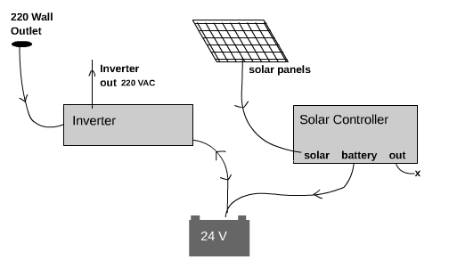
Implementation of solar-powered installation
This process involves the installation of solar panel, charge controller, battery and inverter to generate electricity from sunlight.
- Solar panel: Solar Panel is a device that converts sunlight into electricity by using photovoltaic cells. We have two main types of solar panels which are mono-crystalline and poly-crystalline.
Poly crystalline solar panels have blue cells made of multiple silicon crystals and they are less efficient but more affordable. Mono crystalline panels have black cells made of single crystals and they offer a higher price.
In terms of power production, it is better to wire solar panels in a parallel circuit rather than in series. Parallel solar wiring allows for more independent power production between the panels but also increases the systems upfront costs for materials and installation. We have solar panel in series of volts, it can be of 12v, 24v, 48v, 96v, and in 120v.
- Solar Charge Controller: Charge controller is an electronic device used in off-grid and hybrid off-grid Application to regulate current and voltage input from pv arrays to batteries and electrical loads (lights, fans, monitors, surveillance, cameras, telecom and process Control equipment). The controller safety charges and maintains batteries at a high State of charge without overcharging. Solar charge controllers typically deploy either pulse width modulation (pwm) or Maximum power point tracking (mppt) technology to regulate and deliver the right amount of current and voltage pv arrays to run electrical. Load and safely charge batteries during the day. Charge controller limits the rate at which electric current is added to or drawn from electric batteries to protect against electrical over load, over charging and may protect against over voltage. It also prevent batteries from being damaged by overcharging and over-discharging by controlling the current flow from and to the batteries. Charge controller is connected to the battery, the charge controller is connected to the deep cycle battery which stores excess energy generated by the solar panels.
- Battery: A battery is a system for storing the energy generated by your solar panels until such a time as you need to use that energy. Battery is connected to the 12v inverter, which converts dc power to ac power. A cathode and an anode are the two electrodes found in a battery or an electro chemical cell, which facilitate the flow of electric charge. The cathode is the positive electrode where reduction (gain of electrons) occurs, while the anode is the negative electrode, where oxidation takes place.

There are four main types of batteries which are;
- Lead acid
- Lithium ion
- Nickel cadmium
- Flow batteries
- Lead acid batteries have been used to store energy for a long time. The reliability of lead-acid batteries is great for off-grid solar systems, or for emergency backup storage incase of a power outage.
- Lithium ion batteries are best for residential solar installations because they can hold more power in a limited space and allow you to use more of the energy stored within the battery which is great for powering a home.
- Nickel cadmium batteries are popular for large scale applications like utility solar energy storage, because of their durability.
- Flow batteries: flow batteries are best for large scale installation. They contain a water – based electrolyte liquid that flows between two separate chamber, or tanks within the battery.
Inverter: An inverter is an electronic device that converts direct current (dc) into alternating current (ac). It is commonly used to power household appliances and electronic devices that require ac power when only dc power sources are available such as in solar power systems or car batteries.
A hybrid inverter is essentially a combination of an inverter, a charge controller, and a grid-tie function. The main difference between an inverter and a hybrid, inverter is that a hybrid inverter can work with both renewable and traditional energy sources while an inverter can only work with renewable energy sources. The inverter provides a stable ac power supply, to the CCTV and the ac output from the inverter is connected to the CCTV system’s power supply, providing a reliable power source to the system.

Installation of the CCTV System
This process involves the installation of cameras, switch, storage device, router, cables, tv, connector, toolbox, and power supply to enable video surveillance and monitoring. The cctv system is configured to enable remote access and secure data transmission.
- Cameras: Camera is a device for recording visual images in the form of photographs, film or video signals. It does this through a lens, which focuses the light onto a light sensitive Surface where a picture is formed. We have the fire proof and the explosive secure camera. The CCTV camera can be located at the door, drive ways and halfways. Camera is connected to the switch using RJ45 cables.
- Switch: A switch is an electrical component that can disconnect or connect the conducting path in an electrical circuit, interrupting the electric current or diverting it from conductor to another switch also connect multiple devices together.
- POE (Power Over Ethernet): Network switches provide power and data connectivity over a single ethernet cable simplifying installation and reducing costs. Non-POE network switches require separate power sources for devices.
- Switch: Switch manages data transmission between the cameras and the storage devices. The switch is connected to the storage device DVR (digital video recorder) using RJ45 cables and NVR (Network Video Recorder).
- Storage device: The storage device records and store video footage from the cameras and the cameras are connected to the power supply from the solar powered installation using power cables. We have direct attached storage (DAS) and network attached Storage (NAS). Direct attached storage (DAS) is a digital storage directly attached to the computer accessing it, as opposed to storage accessed over a computer network while network attached storage (nas) is a file-level computer data storage server connected to a computer network providing data access to a heterogeneous group of clients.
- Cable: Electrical cables are used to connect two or more devices, enabling the transfer of electrical signals power from one device to the other.

Types of Cable
- Coaxial cable used for radio frequency signals.
- Paired cable-composed of two individually insullated conductors that are usually used in dc or low frequency ac application.
Twisted pair-consist of two interwound insulated wires.
- Router: Router is a computer and networking device that forward data packets between computer networks, including internetworks such as the global internet. Router is connected to the switch, enabling remote access to the CCTV system.
- Connectivity and integration: Solar-powered and CCTV connectivity: the ac output from the solar-powered Installation is connected to the CCTV systems power supply, providing a reliable power source to the system.
- Network configuration: the router and switch are configured to enable remote access to the CCTV system, ensuring secure and reliable data transmission.
3.2 ANALYSIS OF THE EXISTING SYSTEM
Test directors oversee the process, including scheduling, test administration, and assigning proctors. Proctors also supervise test halls, distributing papers, covering pupil exertion, and collecting accoutrements after the test. Security measures involve transporting and storing test papers in secure locales. Despite its established nature, a homemade system has failings. Proctors cannot be far and wide at formerly, creating eyeless spots vulnerable to cheating. Their alert and judgement can vary, leading to inconsistent monitoring. Fatigue can also affect their capability to catch misconduct. Eventually, homemade systems frequently warrant the capability to record substantiation. These limitations come more pronounced with larger test halls or further examinees. Planting fresh proctors can be precious and requires training. Security enterprises also arise when physically transporting and storing test papers. By understanding these constraints, we can see the eventuality of a solar- powered CCTV system to offer a more robust and dependable result for test monitoring. The coming section will explore this new system in detail.

3.3 PROBLEMS OF THE EXISTING SYSTEM
Structure on the analysis of the traditional system in section3.2, this section cave deeper into the specific problems associated with homemade test invigilation.
- Inefficiency and Space of Coverage: Proctors have limited physical capabilities to cover every pupil contemporaneously, creating eyeless spots where cheating or misconduct might go unnoticed. Large test halls or a high number of examinees can further strain the effectiveness of homemade supervision.
- Subjectivity and Implicit: Bias counting on proctor alert and judgment introduces subjectivity. Variations in alertness, interpretation of test rules, or indeed unconscious bias can lead to inconsistencies in how scholars are covered.
- Fatigue and Mortal Error: Proctors can come fatigued during long examinations, impacting their capability to concentrate and identify suspicious exertion. This can lead to missed incidents or crimes in judgment when assessing pupil geste.
- Limited Substantiation Collection: Manual systems generally warrant the capability to capture and record concrete substantiation of test misconduct. After-the-fact examinations may calculate solely on substantiation statements from proctors, which can be private and prone to memory setbacks.
3.4 ANALYSIS OF THE PROPOSED SYSTEM
The proposed solar- powered CCTV system offers significant advancements. Strategically placed cameras give a wider view, barring eyeless spots. The system can be gauged to accommodate further examinations without demanding fresh proctors. Recorded footage provides objective substantiation, minimizing bias and allowing for standardized monitoring practices. Proctors can take breaks while cameras maintain alert, and suspicious exertion can be reviewed latterly. Footage serves as concrete substantiation for examinations and reduces pressure on proctors to catch everything in real- time. The CCTV system also enhances security. It eliminates the threat associated with transporting and storing paper examinations. Footage can be securely stored electronically, creating a tamper-evidence record. By addressing these failings, the solar- powered CCTV system promotes a fairer and further dependable testing terrain.

3.5 ADVANTAGES OF THE NEW SYSTEM OVER THE EXISTING SYSTEM
- Reduced Installation Costs: Solar- powered CCTV systems exclude the need for expansive trenching and cabling needed for traditional wired systems. This can significantly reduce installation costs.
- Lower Conservation: Needs Solar panels bear minimum conservation compared to traditional systems that calculate on replacing batteries or maintaining complex wiring.
- Energy Independence: By generating its own power, the system reduces reliance on grid electricity, leading to long-term functional cost savings.
- Easy Expansion: Adding fresh cameras to a solar-powered system is fairly simple, as they only bear connecting to the being wireless network. This allows for easy expansion as test monitoring needs grow. Renewable Energy Source Solar panels use renewable solar energy, reducing dependence on fossil energies and lowering the system's carbon footmark.
- Continued Operation: With solar panels and battery backup, the system can continue operating indeed during power outages, icing nonstop test monitoring.
- Data Security: Digital storehouse of recorded footage on a central garçon or pall storehouse can offer better security and protection against tampering or loss compared to physical storehouse styles( like videotapes) used in some traditional systems.
- Reduced Threat of Test Paper Mishap: Eliminates the need for physical transportation and storehouse of test papers, minimizing the threat of loss, theft, or accidental exposure.

CHAPTER FOUR
4.0 DESIGN AND IMPLEMENTATION OF THE SYSTEM
4.1 INTRODUCTION
This chapter outlines the design and implementation of the Smart Solar CBT Examination Monitoring System, a cutting-edge solution that integrates solar-powered electricity generation with CCTV surveillance technology. The system's design and implementation process are crucial to ensuring a reliable and efficient examination monitoring solution for remote or off-grid locations to completely eradicate examination malpractice.
4.2 SYSTEM COMPONENTS
The Smart Solar CBT Examination Monitoring System consists of two primary components, which are:
- Solar-Powered Installation: This component generates electricity from sunlight using solar panels, stores excess energy in a deep cycle battery, and provides a stable AC power supply to the CCTV system.
- CCTV System: This component enables video surveillance and monitoring using IP cameras, switches, storage devices, routers, and power supplies.
4.3 IMPLEMENTATION OF SOLAR-POWERED INSTALLATION
The implementation of the solar-powered installation is as follows:
The Two 280W solar panels are installed to generate electricity from sunlight, with a total power output of 560W under optimal conditions. The panels are connected in parallel to maintain a 12V output while increasing the current and the charge controller is connected to a deep cycle battery, which stores excess energy generated by the solar panels while the battery is connected to a 12V inverter, which converts DC power to AC power, providing a stable AC power supply to the CCTV system and the AC output from the inverter is connected to the CCTV system's power supply, ensuring a reliable power source.

Solar Power System:
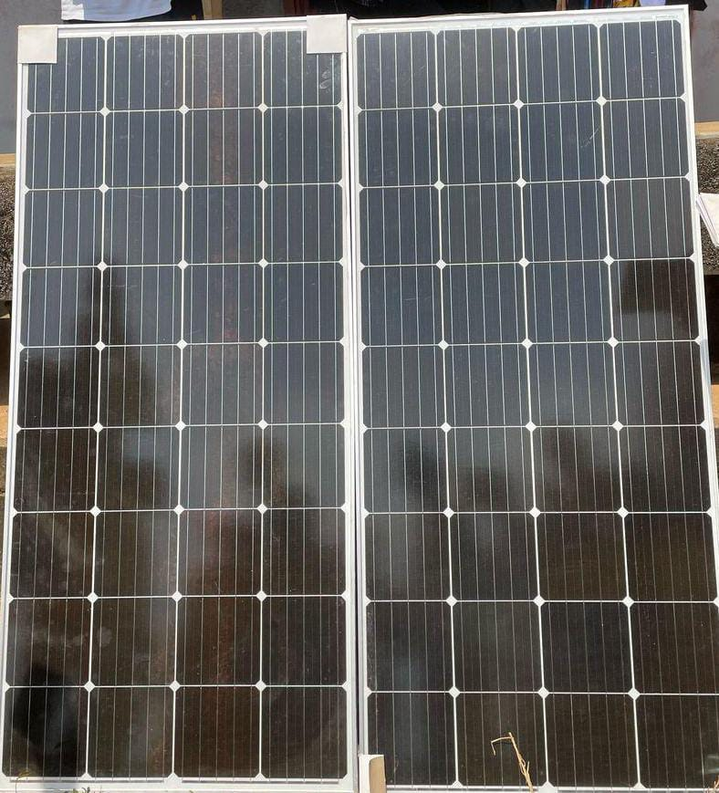

Figure 4.1 Solar Panels: High-efficiency photovoltaic (PV) panels 280W mono-crystalline to generate electricity.
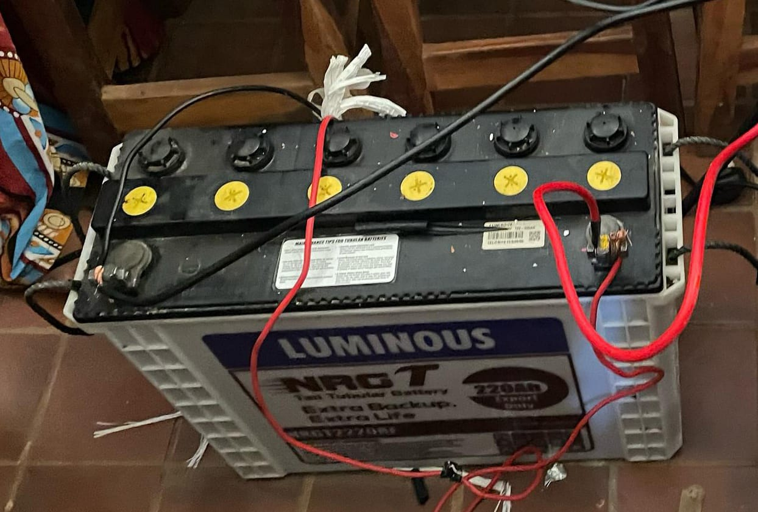
Figure 4.2 Battery Storage: Lithium-ion batteries (e.g., 18000mAh) to store energy for nighttime or cloudy conditions
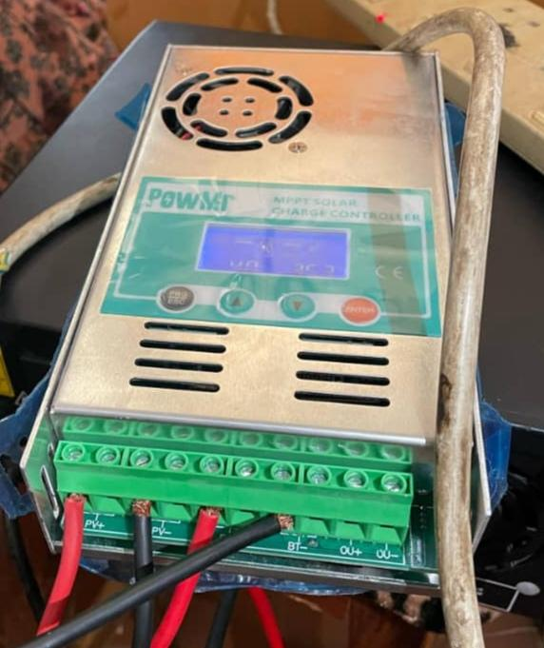
Figure 4.3 Charge Controller: Manages power flow to prevent overcharging or deep discharge.

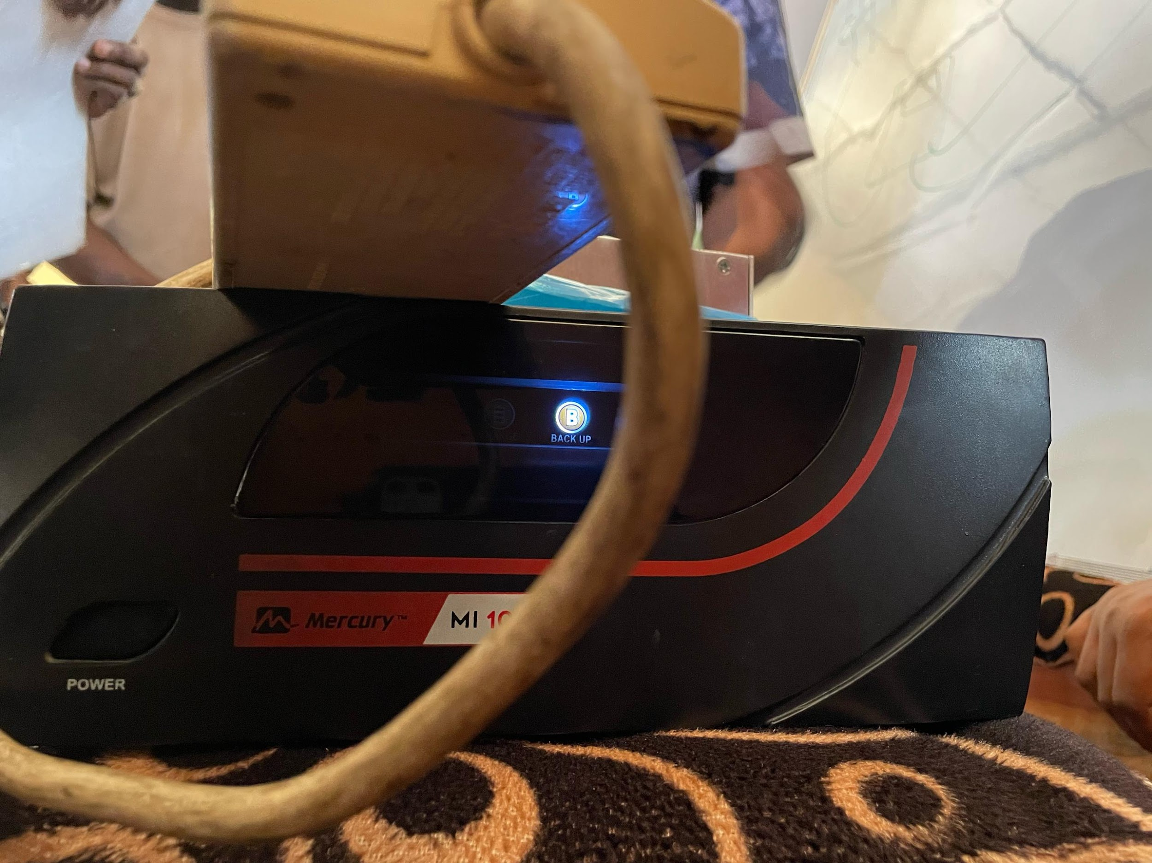
Figure 4.4 Inverter: Converts DC to AC for powering CBT systems and CCTV cameras.

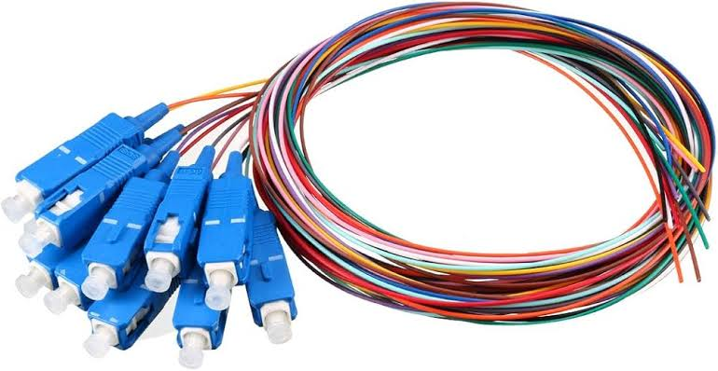
Figure 4.5 Fibre optical cable: can travel in long distance
4.4 INSTALLATION OF CCTV SYSTEM
The installation of the CCTV system involves several key steps:
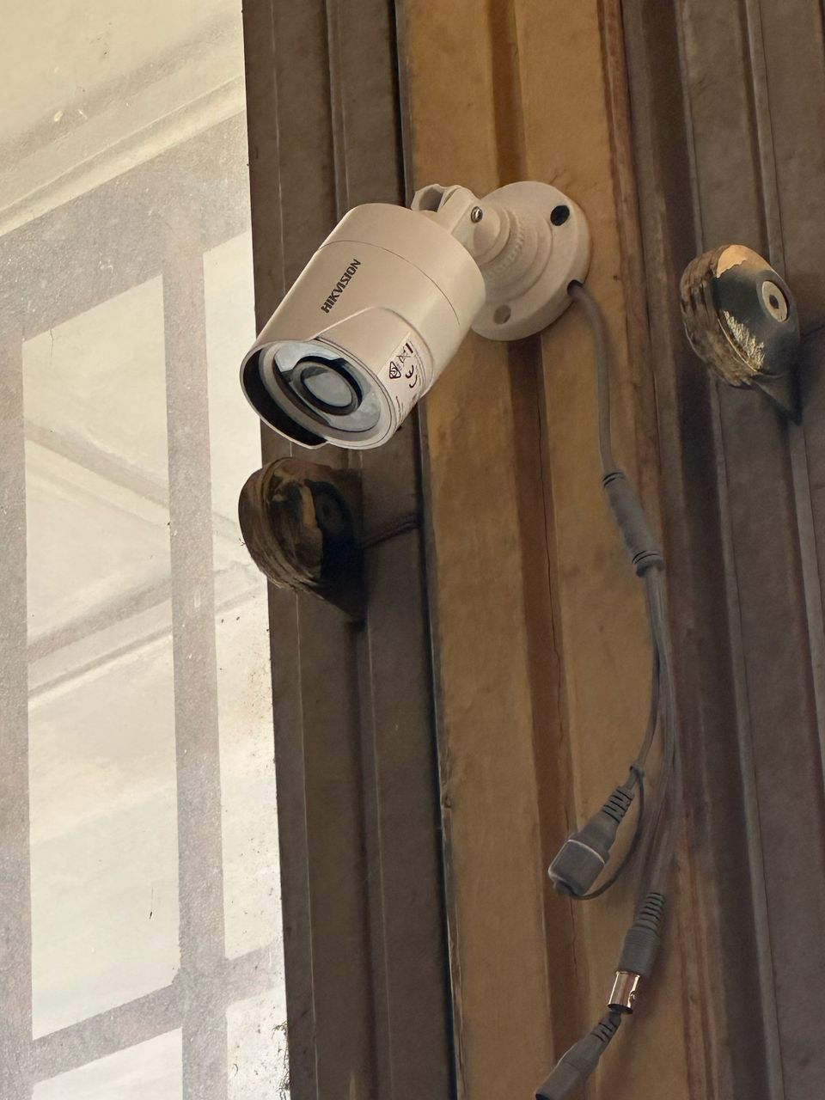
Figure 4.6 Camera Installation: IP cameras are installed and connected to a switch using RJ45 cables, enabling data transmission between cameras and storage devices.

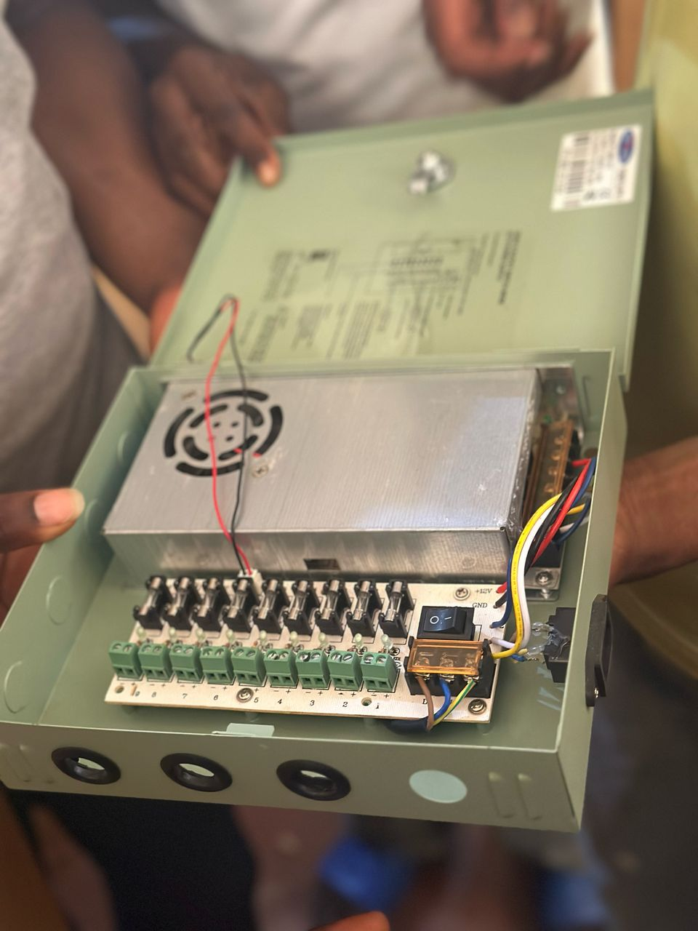
Figure 4.7 Switch: The switch is connected to a digital video recorder (DVR) using RJ45 cables, which records and stores video footage from the cameras.

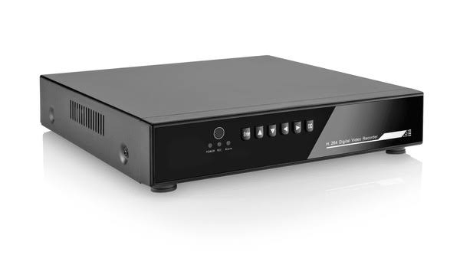
Figure 4.8: DVRs are connected to cameras, monitors, networks, and storage devices to record, display, and store video footage. Specifically, they receive video feed from cameras and output to monitors.

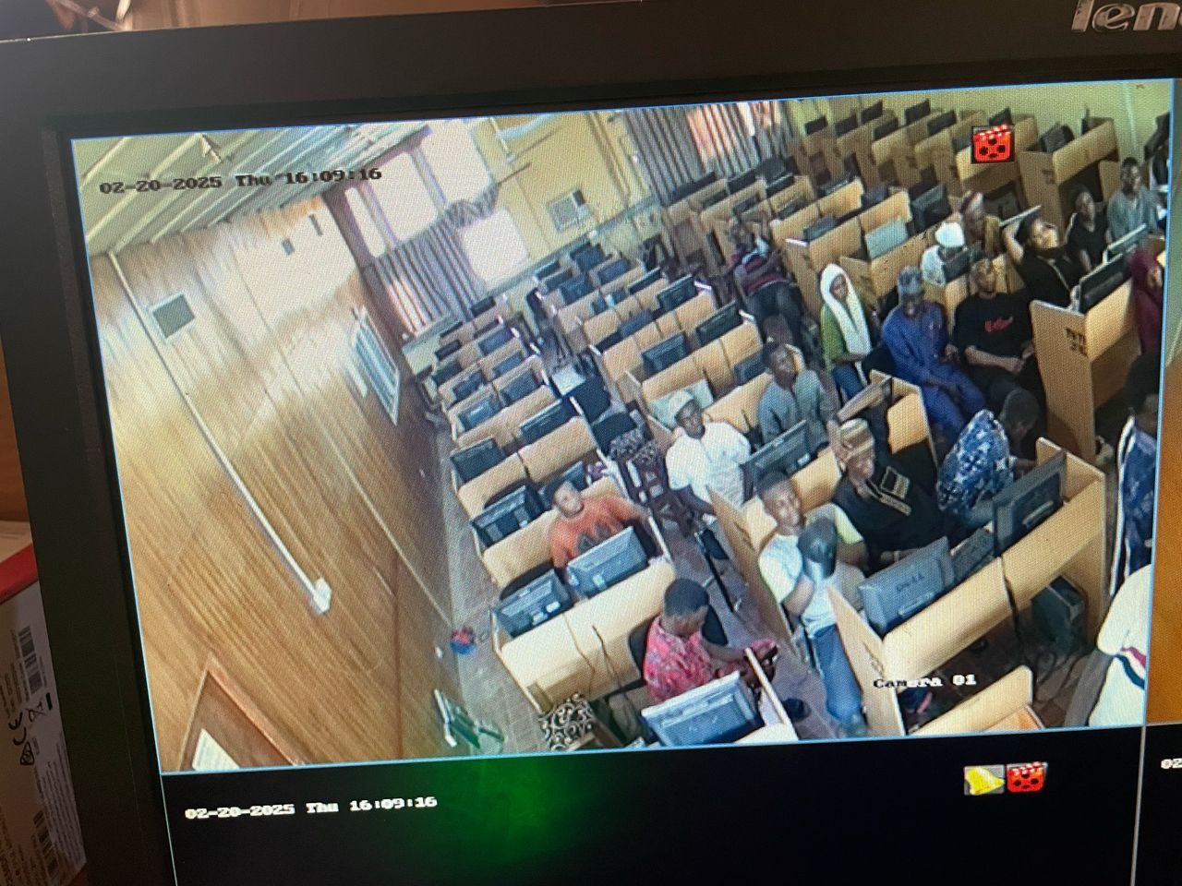

Figure 4.9: Cameras are connected to the power supply from the solar-powered installation using power cables.
4.5 CONNECTIVITY AND INTEGRATION
The system's connectivity and integration involve:
Solar-Powered and CCTV Connectivity: The AC output from the solar-powered installation is connected to the CCTV system's power supply, ensuring a reliable power source.
4.6 SYSTEM BENEFITS
The Smart Solar CBT Examination Monitoring System offers several benefits, including:
Reliable Power Supply: A stable AC power supply from the solar-powered installation ensures continuous operation of the CCTV system.
Remote Access: Remote access to the CCTV system enables real-time monitoring and surveillance.
Secure Data Transmission: The system's network configuration ensures secure and reliable data transmission

CHAPTER FIVE
5.0 SUMMARY, CONCLUSION AND RECOMMENDATIONS
5.1 SUMMARY
The idea of using smart solar CBT examination monitoring system is to eliminate the problems we are facing due to instability power supply, which causes frustration for students when conducting a CBT examination and administrators. All said and done in this project, the integration of solar panel as a source of electricity into examination centers can provide a reliable and sustainable solution to the problem associated with CBTS and CCTV surveillance. The method used for implementation of solar powered installation is by conversion of energy directly from the sunlight to the solar panel, from the panel to charge controller, from the charge controller to the battery, from the battery to the inverter using RJ45 cable which connect multiple devices together.
The implementation of the solar-powered CCTV system at Kwara State Polytechnic yielded positive results. The system provided uninterrupted surveillance throughout the CBT examination period, even during power outages. High-resolution cameras captured all activities in the exam halls effectively, helping to deter and detect potential malpractice. Overall, the project demonstrated that solar-powered surveillance is a reliable and sustainable solution for enhancing examination integrity.
5.2 CONCLUSION
The design and implementation of a solar-powered CCTV system for monitoring CBT examinations at Kwara State Polytechnic have proven to be a practical and effective solution to two major challenges: examination malpractice and unstable electricity supply. The system provided reliable, continuous surveillance powered entirely by renewable solar energy, ensuring that all examination activities were monitored without interruption. This significantly enhanced the credibility and transparency of the assessment process. By integrating key components such as solar panels, inverters, batteries, charge controllers, and CCTV cameras, the institution now benefits from a sustainable, low-maintenance, and eco-friendly security solution. The project not only supports academic integrity but also aligns with global efforts to adopt green technologies in education. This solution serves as a model that can be replicated in other institutions facing similar infrastructural limitations, especially in developing regions.
5.3 RECOMMENDATIONS
Based on the findings, the following recommendation are to be considered for the smooth implementation of the new system:
- Integration of renewable energy: Solar power utilize solar panels to provide a sustainable and reliable source of energy for the examination monitoring system.
- Energy efficiency: Optimize system design to minimize energy consumption and maximize the use of solar power.
- Advanced surveillance features: AI - powered monitoring implement Artificial Intelligence (AI) and Machine Learning (ML) algorithms to detect and flag suspicious behaviour during exams.
- Real-time alerts: Send notifications to proctors or administrator in case of any irregularities or security breaches.
- Secure data storage and management: Cloud-based storage use secure cloud storage solutions to store exam data, ensuring scalability, reliability, and accessibility.
- Data-encryption: Implement robust encryption methods to protect sensitive exam data and prevent unauthorized access.
- Adaptability: Ensure the system can adapt to different exam formats, sizes and environments making it versatile and widely applicable.
The recommendations can help create a robust, efficient, and secure smart solar CBT examination monitoring system that supports fair and reliable assessments.

REFERENCES
Ansari, S., Ayob, A., Hossain Lipu, M. S., Md Saad, M. H., & Hussain, A. (2021). A review of monitoring technologies for solar pv systems using data processing modules and transmission protocols: Progress, challenges and prospects. Sustainability (Switzerland), 13(15). https://doi.org/10.3390/su13158120 https://doi.org/10.11591/ijaas.v8.i2.pp136-142

Kavitha Venkatesh (2019) A Smart Solar PV Monitoring System Using IoT. November 2019 DOI:10.5121/csit.2019.91502

Nasiru Yahaya Ahmed, (2025) Solar-powered Smart Monitoring System for Occupancy and Energy use in Lecture rooms Journal of Building Engineering 104(12):112409 DOI:10.1016/j.jobe.2025.112409. University of Malaya

Paliyal, P. S., Mondal, S., Layek, S., Kuchhal, P., & Pandey, J. K. (2024). Automatic solar tracking system: a review pertaining to advancements and challenges in the current scenario. In Clean Energy (Vol. 8, Issue 6, pp. 237–262). Oxford University Press. https://doi.org/10.1093/ce/zkae085

Parikh, A., Pathan, F., Rathod, B., & Shah, S. (2015). Solar Panel Condition Monitoring System based on Wireless Sensor Network. International Journal of Science, Engineering and Technology Research (IJSETR), 4(12). https://doi.org/10.13140/RG.2.2.18029.69605

Shirbhate, I. M., & Barve, S. S. (2019). Solar panel monitoring and energy prediction for smart solar system. International Journal of Advances in Applied Sciences, 8(2), 136 142.

Umoh, V. B., Obot, J., Limited, E.-C., Macaulay Ekpe, U., Umoh, V. B., Obot, J. J., & Ekpe, U. M. (2019). Development Of A Smart Solar Energy Management System International Journal of Advanced Research and Publications Development Of A Smart Solar Energy Management System. www.ijarp.org

