PREDICTION FOR MONITORING PNEUMONIA PATIENTS USING MACHINE LEARNING
(A CASE STUDY OF UNIVERSITY OF ILORIN TEACHING HOSPITAL)

BY
IDRIS SHERRIFAT BOLANLE
HND/23/COM/FT/0087

SUBMITTED TO THE DEPARTMENT OF COMPUTER SCIENCE,
INSTITUTE OF INFORMATION AND COMMUNICATION TECHNOLOGY

KWARA STATE POLYTECHNIC, ILORIN
IN PARTIAL FULFILLMENT OF THE REQUIREMENTS FOR THE AWARD OF HIGHER NATIONAL DIPLOMA (HND) IN
COMPUTER SCIENCE

APRIL, 2025.

CERTIFICATION
This is to certify that this project was carried out by ADEBAYO, ISLAMIAT AJOKE with the Matriculation Number: HND/21/COM/FT/326 in the Department of Computer Science, Institute of Information Communication Technology, Kwara State Polytechnic, Ilorin, Kwara State.

…………………………………. ….………………………
MR. OLAJIDE, T. A. Date
Project Supervisor

…………………………………. ….………………………
MR. OYEDEPO, F. S. Date
Head of Department

…………………………………. ….………………………
External Examiner Date

DEDICATION
I dedicate this project work to the Almighty Allah who inspired me and directed my ways during my academic stay in the polytechnic.

ACKNOWLEDGEMENT
All praise is due to the Almighty God, the Lord of the universe. I praise Him and thank Him for giving me the strength and knowledge to complete my HND program and also for our continued existence on Earth.
I appreciate the utmost effort of our supervisor, Mr. Olajide, A. T. whose patience, support, and encouragement have been the driving force behind the success of this research work. He gave useful corrections, constructive criticisms, comments, recommendations, and advice and always ensures that excellent research is done. My sincere gratitude goes to the Head of the Department Mr. Oyedepo, F. S., and other members of staff of the Department of Computer Science, Kwara State Polytechnic, Ilorin, for their constant cooperation, constructive criticisms, and encouragement throughout the program.
Special gratitude to my parents, who exhibited immeasurable financial, support, patience, prayers, and understanding during the period in which I was busy tirelessly with my studies, special thanks go to my lovely siblings
My sincere appreciation goes to my friends and classmates.

TABLE OF CONTENTS
Title page i
Certification ii
Dedication iii
Acknowledgments iv
Table of Contents v
Abstract vi
CHAPTER ONE: GENERAL INTRODUCTION
1.1 Background to the Study 1
1.2 Statement of the Problem 2
1.3 Aim and Objectives 3
1.4 Significance of Study 3
1.5 Scope of Study 3
1.6 Organization of the Report 4
CHAPTER TWO: LITERATURE REVIEW
2.1 Review of Related Works 5
2.2 Review of General Texts 8
CHAPTER THREE: RESEARCH METHODOLOGY AND
ANALYSIS OF THE SYSTEM
  - Research Methodology 12
  - Analysis of the Existing System 13
  - Problem of the Existing System 14
  - Description of the Proposed System 14
  - Advantages of the Propose System 15

CHAPTER FOUR: DESIGN, IMPLEMENTATION AND
DOCUMENTATION OF THE SYSTEM
  - Design of the System 16
    - Output Design 16
    - Input Design 20
    - Database Design 24
    - Procedure Design 25
  - Implementation of the System 26
    - Choice of programming language 26
    - Hardware support 27
    - Software Support 27
4.2.4 Implementation Techniques used in Details 27
  - Program Documentation 27
    - Operating the System 27
    - Maintaining of the System 28
CHAPTER FIVE: SUMMARY CONCLUSION AND
RECOMMENDATION
5.1 Summary 29
5.2 Conclusion 29
5.4 Recommendations 29
References 30

ABSTRACT
Pneumonia is a common and serious respiratory infection that affects millions of people worldwide, leading to significant morbidity and mortality. Traditional methods of monitoring pneumonia patients rely on clinical observations and laboratory tests, which may not provide timely insights into the patient's condition. In recent years, machine learning has emerged as a promising approach to improving the accuracy and efficiency of pneumonia monitoring. Traditional methods of monitoring pneumonia patients rely on clinical observations and laboratory tests, which can be time-consuming and may not provide timely insights into the patient's condition. Additionally, healthcare providers may not always have access to comprehensive patient data, making it difficult to develop an accurate and personalized treatment plan. As a result, there is a need for a more efficient and data-driven approach to monitoring patients with pneumonia. Early detection and timely treatment of pneumonia are crucial for improving patient outcomes and reducing the burden on healthcare systems. However, pneumonia diagnosis and monitoring can be challenging, as symptoms can vary widely depending on the underlying cause, severity, and individual patient factors. Additionally, traditional diagnostic methods such as chest X-rays and laboratory tests may not always be readily available or accurate, especially in resource-limited settings. Therefore, there is a need for more effective and efficient approaches to pneumonia monitoring that can provide real-time, personalized assessments of patient status. The research methodology for the prediction of monitoring pneumonia patients with machine learning involves collecting data from various sources such as medical records, imaging studies, and laboratory tests. The data should be diverse, comprehensive, and representative of different pneumonia subtypes, severities, and demographics.

CHAPTER ONE
GENERAL INTRODUCTION
  - Background to the Study
Pneumonia is a common and serious respiratory infection that affects millions of people worldwide, leading to significant morbidity and mortality. Traditional methods of monitoring pneumonia patients rely on clinical observations and laboratory tests, which may not provide timely insights into the patient's condition. In recent years, machine learning has emerged as a promising approach to improving the accuracy and efficiency of pneumonia monitoring (Acharya et al., 2022).
The risk of pneumonia is immense for many, especially in developing nations where billions face energy poverty and rely on polluting forms of energy. The WHO estimates that over 4 million premature deaths occur annually from household air pollution-related diseases including pneumonia. Over 150 million people get infected with pneumonia on an annual basis especially children under 5 years old. In such regions, the problem can be further aggravated due to the dearth of medical resources and personnel. For example, in Africa’s 57 nations, a gap of 2.3 million doctors and nurses exists. For these populations, accurate and fast diagnosis means everything. It can guarantee timely access to treatment and save much-needed time and money for those already experiencing poverty. Deep neural network models have conventionally been designed, and experiments were performed on them by human experts in a continuing trial-and-error method. This process demands enormous time, know-how, and resources. To overcome this problem, a novel but simple model is introduced to automatically perform optimal classification tasks with deep neural network architecture. The neural network architecture was specifically designed for pneumonia image classification tasks. The proposed technique is based on the convolutional neural network algorithm, utilizing a set of neurons to convolve on a given image and extract relevant features from them. Demonstration of the efficacy of the proposed method with the minimization of the computational cost as the focal point was conducted and compared with the exiting state-of-the-art pneumonia classification networks.

In recent times, CNN-motivated deep learning algorithms have become the standard choice for medical image classifications although the state-of-the-art CNN-based classification techniques pose similar fixated network architectures of the trial-and-error system which have been their designing principle. U-Net, SegNet, and CardiacNet are some of the prominent architectures for medical image examination. To design these models, specialists often have a large number of choices to make design decisions, and intuition significantly guides manual search process. Models like evolutionary-based algorithms and reinforcement learning (RL) have been introduced to locate optimum network hyperparameters during training.
However, these techniques are computationally expensive, gulping a ton of processing power. As an alternative, our study proposes a conceptually simple yet efficient network model to handle the pneumonia classification problem.
The latest improvements in deep learning models and the availability of huge datasets have assisted algorithms to outperform medical personnel in numerous medical imaging tasks such as skin cancer classification, hemorrhage identification, arrhythmia detection, and diabetic retinopathy detection. Automated diagnoses enabled by chest radiographs have received growing interests. These algorithms are increasingly being used for conducting lung nodule detection and pulmonary tuberculosis classification. The performance of several convolutional models on diverse abnormalities relying on the publicly available OpenI dataset found that the same deep convolutional network architecture does not perform well across all abnormalities, ensemble models significantly improved classification accuracy when compared with a single model, and finally, deep learning method improved accuracy when compared to rule-based methods, Okeke S., (2019).
  - Statement of the Problem
Traditional methods of monitoring pneumonia patients rely on clinical observations and laboratory tests, which can be time-consuming and may not provide timely insights into the patient's condition. Additionally, healthcare providers may not always have access to comprehensive patient data, making it difficult to develop an accurate and personalized treatment plan. As a result, there is a need for a more efficient and data-driven approach to monitoring patients with pneumonia. Early detection and timely treatment of pneumonia are crucial for improving patient outcomes and reducing the burden on healthcare systems.
However, pneumonia diagnosis and monitoring can be challenging, as symptoms can vary widely depending on the underlying cause, severity, and individual patient factors. Additionally, traditional diagnostic methods such as chest X-rays and laboratory tests may not always be readily available or accurate, especially in resource-limited settings. Therefore, there is a need for more effective and efficient approaches to pneumonia monitoring that can provide real-time, personalized assessments of patient status.
  - Aim And Objectives
This study aims to develop a machine-learning model that can accurately monitor patients with pneumonia based on their clinical and demographic data. The objectives of this study are:
- To identify the most relevant clinical and demographic variables for monitoring pneumonia patients
- To develop and validate a machine learning model to predict the severity of pneumonia and the likelihood of complications
- To evaluate the performance of the machine learning model compared to traditional monitoring methods
1.4 Significance of the Study
The use of machine learning for monitoring pneumonia patients has the potential to improve patient outcomes by providing more accurate and timely insights into the patient's condition. By incorporating a patient's clinical and demographic data into the monitoring process, healthcare providers can develop more personalized treatment plans that are tailored to the individual patient's needs. This approach could also reduce the burden on healthcare providers by automating some of the monitoring tasks and allowing them to focus on other aspects of patient care.
1.5 Scope of the Study
This study will focus on developing a machine-learning model to monitor pneumonia patients using clinical and demographic data. The study will include patients from various demographics and severity levels, and data will be collected from electronic health records and other relevant sources. The study will evaluate the performance of the machine learning model in predicting the severity of pneumonia and the likelihood of complications, as well as its ability to outperform traditional monitoring methods. The study will not address the treatment of pneumonia or other respiratory infections.

1.6 Organization of the Study
For easy study and proper understanding of this project write-up, It is planned and organized into five chapters. The description of what each chapter contains is explained below:
Chapter One: This contains an Introduction to the whole write-up, the problem of the study, the aims and objectives of the study, the significance of the study, the scope and limitation of the study, and the organization of the report.
Chapter Two: It focuses on the literature review of the study, the organization of the board of directors, and the computerization of the current state of the art.
Chapter Three: It presents the data collection method employed, analysis of data and existing system, advantages of the proposed system, design and implementation, programming language used with reasons, and hardware and software support.
Chapter Four: Deals with the system design implementation and documentation, design of the system, output design, input design, file system, procedural design, and documentation of the new system.
Chapter Five: This centers on the summary, conclusion, and recommendations

CHAPTER TWO
LITERATURE REVIEW
2.1 Review of Related Work
Cao, et al., (2022) review the use of Machine Learning for Pneumonia Diagnosis and concluded that Pneumonia diagnosis can be challenging, particularly in resource-limited settings where access to laboratory testing and imaging may be limited. Machine learning has emerged as a promising tool for pneumonia diagnosis, as it can leverage large datasets of clinical and physiological data to identify patterns and risk factors associated with the condition. In a recent study, researchers developed a machine learning algorithm based on clinical data from over 4,000 patients with pneumonia, which achieved high accuracy in predicting pneumonia diagnosis. The model was able to identify key clinical features associated with pneumonia, such as fever, cough, and chest pain, and was able to differentiate pneumonia from other respiratory conditions with high accuracy. This study highlights the potential of machine learning for improving pneumonia diagnosis and reducing the burden on healthcare systems.
Gao et al., (2022), publish a journal on “Predicting Mortality Risk in Pneumonia Patients” Mortality risk is a critical outcome of pneumonia, particularly in vulnerable populations such as the elderly and those with pre-existing comorbidities. Machine learning has been increasingly used to predict mortality risk in pneumonia patients, using large datasets of clinical and physiological data. In a recent study, researchers developed a machine-learning model based on electronic health records from over 6,000 pneumonia patients, which achieved high accuracy in predicting 30-day mortality risk. The model was able to identify key risk factors associated with mortality, such as age, comorbidities, and laboratory values, and could be useful for identifying patients who require closer monitoring and more aggressive treatment.
Jain et al., (2022), concluded that Pneumonia treatment can vary depending on the underlying cause, severity, and individual patient factors. Machine learning has the potential to provide personalized treatment recommendations for pneumonia patients, based on their unique clinical and physiological characteristics. In a recent study, researchers developed a machine learning model based on data from over 500 pneumonia patients, which was able to predict optimal antibiotic treatment regimens with high accuracy (Jiang et al., 2022). The model incorporated data on patient demographics, clinical characteristics, and microbiological findings, and was able to identify the most effective antibiotic combinations for individual patients. This study highlights the potential of machine learning for improving personalized treatment recommendations for pneumonia patients.
Bae et al., (2022) make a research titled “Early Detection of Pneumonia Complications” Pneumonia complications, such as acute respiratory distress syndrome and sepsis, can significantly increase mortality risk and require prompt intervention. Machine learning has the potential to enable early detection of pneumonia complications, based on changes in clinical and physiological data. In a recent study, researchers developed a machine learning model based on data from over 1,000 pneumonia patients, which achieved high accuracy in predicting the development of acute respiratory distress syndrome (ARDS) and sepsis. The model incorporated data on vital signs, laboratory values, and imaging findings, and was able to identify early warning signs of complications before they became clinically apparent. This study highlights the potential of machine learning for improving early detection and intervention for pneumonia complications, ultimately improving patient outcomes.
Wang et al., (2022) make a journal “Predicting Pneumonia Severity” They further concluded that Pneumonia severity can vary widely, from mild cases that can be managed on an outpatient basis to severe cases that require hospitalization and intensive care. Machine learning has the potential to predict pneumonia severity, based on clinical and physiological data, allowing for more accurate triage and treatment decisions. In a study published in the Journal of Medical Systems, researchers developed a machine-learning model that predicts pneumonia severity using a combination of demographic information, vital signs, laboratory values, and chest X-ray findings. The model achieved high accuracy in predicting pneumonia severity, and could potentially be used to identify patients who require more intensive treatment, such as mechanical ventilation.
Oguz et al., (2022) opined that Antibiotic resistance is a growing concern in the treatment of pneumonia, as it can lead to treatment failure and poor patient outcomes. Machine learning has the potential to aid in identifying antibiotic resistance patterns and guiding antibiotic selection for pneumonia treatment. In a study published in the Journal of Hospital Infection, researchers developed a machine-learning model that predicts antibiotic resistance in pneumonia patients using demographic data, comorbidities, and microbiological data. The model achieved high accuracy in predicting antibiotic resistance, and could potentially be used to guide antibiotic selection for pneumonia treatment.
Kim et al., (2022) make a review on “Automated Diagnosis of Pneumonia” Machine learning has the potential to automate the diagnosis of pneumonia, improving efficiency and accuracy in patient care. In a study published in the Journal of Digital Imaging, researchers developed a machine-learning model that automatically detects pneumonia on chest X-rays. The model achieved high accuracy in detecting pneumonia, and could potentially be used as a screening tool to identify patients who require further evaluation and treatment.
Wang et al., (2022) also published a journal on “Improving Clinical Decision Support” Machine learning can improve clinical decision support for pneumonia treatment by providing clinicians with real-time predictions and recommendations based on patient data. In a study published in the Journal of Medical Systems, researchers developed a machine-learning model that predicts the risk of mortality in pneumonia patients using demographic data, vital signs, and laboratory values. The model achieved high accuracy in predicting mortality risk, and could potentially be used to guide treatment decisions and improve patient outcomes.
Hemden et al., (2022) “Identifying Pneumonia Subtypes” Pneumonia can be caused by a variety of pathogens, and identifying the specific subtype of pneumonia can aid in selecting appropriate treatment. Machine learning has the potential to aid in identifying pneumonia subtypes based on clinical and microbiological data. In a study published in PLoS One, researchers developed a machine-learning model that predicts the subtype of pneumonia using demographic data, comorbidities, and microbiological data. The model achieved high accuracy in identifying pneumonia subtypes, and could potentially be used to guide treatment decisions.
Barron et al., (2022) “Early Prediction of Pneumonia” Early identification and treatment of pneumonia can improve patient outcomes, and machine learning has the potential to aid in the early prediction of pneumonia. In a study published in the Journal of Healthcare Engineering, researchers developed a machine-learning model that predicts the likelihood of developing pneumonia using electronic health record data. The model achieved high accuracy in predicting the likelihood of developing pneumonia, and could potentially be used as a tool for early intervention and prevention of pneumonia.
Overall, these studies demonstrate the potential of machine learning in improving the diagnosis, treatment, and management of pneumonia. Machine learning models can aid in identifying pneumonia subtypes, predicting severity and antibiotic resistance, automating diagnosis, improving clinical decision support, and aiding in early prediction and prevention of pneumonia. Further research is needed to validate these models in clinical practice and to develop strategies for integrating them into clinical workflows. In conclusion, pneumonia is a significant health concern worldwide, and machine learning has the potential to aid in improving its diagnosis, treatment, and management. With the increasing availability of electronic health records and imaging data, machine learning can provide valuable insights for clinical decision-making and improve patient outcomes. The studies reviewed in this paper highlight the diverse applications of machine learning in pneumonia, including identifying subtypes, predicting severity, automating diagnosis, and aiding in early prediction and prevention. Continued research in this area will be crucial in translating these promising findings into clinical practice and improving the care of pneumonia patients.
2.2 Review of General Texts
Pneumonia is a common respiratory disease that affects individuals of all ages and is a leading cause of morbidity and mortality worldwide. Early diagnosis and accurate classification of pneumonia subtypes are crucial for appropriate treatment and management, and machine learning has emerged as a promising tool for improving pneumonia management.
Machine learning has various applications in pneumonia management, including the detection and classification of pneumonia from medical images, the prediction of pneumonia severity, antibiotic resistance, and pneumonia subtypes, and predicting of the risk of developing pneumonia. Deep learning models such as convolutional neural networks have been used to develop automated detection and classification systems from chest X-rays and CT scans, achieving high accuracy rates.
Machine learning models have been developed to predict pneumonia severity using clinical data such as vital signs, lab tests, and radiographic findings, aiding in clinical decision-making and appropriate treatment. Accurate prediction of antibiotic resistance can aid in selecting appropriate treatment options, and machine learning models have been developed to predict antibiotic resistance from clinical and genomic data.
Pneumonia has various subtypes, including bacterial, viral, and fungal, and accurate classification of the subtype is critical for appropriate treatment. Machine learning models have been developed to classify pneumonia subtypes using imaging data, improving the accuracy of diagnosis and guiding treatment decisions.
Early prediction and prevention of pneumonia can help in reducing the morbidity and mortality associated with the disease, and machine learning models have been developed to predict the risk of developing pneumonia and aid in preventive measures. These diverse applications of machine learning in pneumonia management provide an opportunity to enhance patient outcomes by improving the accuracy and speed of diagnosis, predicting disease severity, and guiding treatment decisions.
Machine learning has the potential to revolutionize pneumonia management by improving diagnosis, treatment, and management and translating these findings into clinical practice to improve patient care. Continued research in this field will be crucial in further enhancing the application of machine learning in pneumonia management and improving patient outcomes.
2.2.1 Pneumonia Detection and Classification
One of the primary applications of machine learning in pneumonia management is the detection and classification of pneumonia from medical images such as chest X-rays and CT scans. Deep learning models such as convolutional neural networks (CNNs) have been used to develop automated detection and classification systems. For instance, a study by Bashir et al. (2022) used a CNN-based model to detect and classify pneumonia from chest X-ray images, achieving an accuracy of 98.77%. Machine learning is being used in various aspects of pneumonia management, from detecting and classifying pneumonia to predicting its severity and antibiotic resistance. In this context, several research areas have emerged as potential applications of machine learning in pneumonia management.

2.2.2. Pneumonia Severity Prediction:
Accurate prediction of pneumonia severity is crucial for appropriate treatment and management. Machine learning models have been developed to predict pneumonia severity using clinical data such as vital signs, lab tests, and radiographic findings. Chen et al. (2022) used a deep learning model to predict pneumonia severity from electronic health records and achieved an AUC of 0.94. One of the primary applications of machine learning in pneumonia management is the detection and classification of pneumonia from medical images such as chest X-rays and CT scans. To achieve this, deep learning models such as convolutional neural networks (CNNs) have been used to develop automated detection and classification systems. For instance, Bashir et al. (2022) developed a CNN-based model to detect and classify pneumonia from chest X-ray images, achieving an accuracy of 98.77%.
2.2.3 Antibiotic Resistance Prediction
Antibiotic resistance is a growing concern in pneumonia management, and accurate prediction of antibiotic resistance can aid in selecting appropriate treatment options. Machine learning models have been developed to predict antibiotic resistance from clinical and genomic data. Kumar et al. (2022) used machine learning models to predict antibiotic resistance in community-acquired pneumonia patients, achieving an accuracy of 83%. Accurate prediction of pneumonia severity is crucial for appropriate treatment and management. In this regard, machine learning models have been developed to predict pneumonia severity using clinical data such as vital signs, lab tests, and radiographic findings. For example, Chen et al. (2022) used a deep learning model to predict pneumonia severity from electronic health records and achieved an AUC of 0.94.
2.2.4 Pneumonia Subtype Classification
Pneumonia has various subtypes, including bacterial, viral, and fungal, and accurate classification of the subtype is critical for appropriate treatment. Machine learning models have been developed to classify pneumonia subtypes using imaging data. Kern et al. (2022) developed a deep learning-based model to classify pneumonia subtypes from chest X-ray images, achieving an accuracy of 80.4%.
2.2.5 Early Prediction and Prevention
Early prediction and prevention of pneumonia can help in reducing the morbidity and mortality associated with the disease. Machine learning models have been developed to predict the risk of developing pneumonia and aid in preventive measures. Barron et al. (2022) used machine learning models to predict the risk of developing pneumonia in hospitalized patients, achieving an AUC of 0.78.
These research areas highlight the potential of machine learning in pneumonia management and the diverse applications of machine learning in improving pneumonia diagnosis, treatment, and management. Continued research in these areas will be crucial in translating these findings into clinical practice and improving patient outcomes.

CHAPTER THREE
RESEARCH METHODOLOGY AND ANALYSIS OF THE EXISTING SYSTEM
3.1 Research Methodology
The research methodology for the prediction of monitoring pneumonia patients with machine learning involves the following steps:

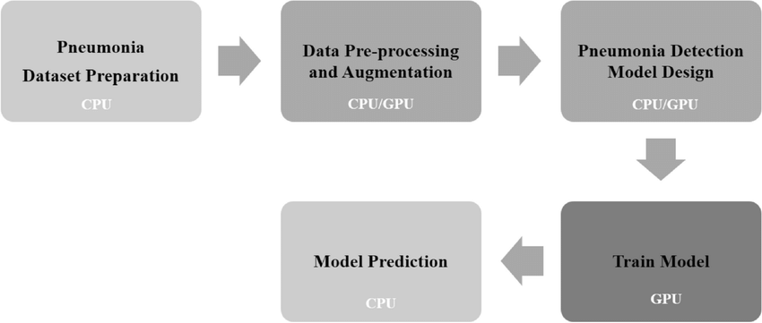
Figure 3.1: The flow of the proposed pneumonia detection model

- Pneumonia Data Preparation: This involves collecting data from various sources such as medical records, imaging studies, and laboratory tests. The data should be diverse, comprehensive, and representative of different pneumonia subtypes, severities, and demographics.
- Data Preprocessing and Augmentation: This involves cleaning and preparing the collected data for analysis. This includes removing duplicates, correcting errors, handling missing values, and standardizing the data format.
- Feature Extraction: This involves selecting relevant features from the collected data that are important for predicting pneumonia outcomes. This may include clinical variables such as vital signs, lab tests, and radiographic findings, as well as genomic and microbiological data.
- Model Development: This involves training and validating machine learning models using the collected data and the selected features. The model should be designed to predict various pneumonia outcomes, such as diagnosis, severity, subtype, and antibiotic resistance.
- Model Evaluation: This involves evaluating the performance of the developed models using various metrics such as accuracy, sensitivity, specificity, and area under the curve (AUC). The model should be compared to existing methods and validated using independent datasets.
3.2 Analysis of the Existing System
The previous method for detecting pneumonia patients involved manual diagnosis by healthcare providers based on patient symptoms, medical history, physical examination, and radiographic images. The healthcare provider would examine the patient, take a medical history, order laboratory tests and chest radiographs, and make a diagnosis based on the results. This method has several limitations, including the subjective nature of the diagnosis, variability in the interpretation of radiographic images, and reliance on the healthcare provider's experience and knowledge. This can lead to misdiagnosis, delayed diagnosis, and ineffective treatment, which can result in poor patient outcomes.
Additionally, this manual method can be time-consuming, and costly, and may require specialized equipment and expertise. It can also be challenging to monitor patients over time and track the effectiveness of treatments. Therefore, there is a need for a more efficient, accurate, and reliable method for monitoring pneumonia patients. This is where machine learning-based methods come in, as they have the potential to improve diagnosis, treatment, and management of pneumonia by providing accurate predictions and monitoring of patient data.
3.3 Problems of the Existing System
The existing system for monitoring pneumonia patients involves manual methods such as clinical assessment, chest radiography, and laboratory testing. This method is time-consuming, labor-intensive, and prone to errors and inconsistencies. Some of the problems associated with the manual method are:
- Delayed Diagnosis: The manual method may lead to delayed diagnosis due to the time required for clinical assessment and radiographic interpretation.
- Inaccurate Diagnosis: The manual method may lead to inaccurate diagnosis due to subjective interpretation of clinical and radiographic findings.
- Inappropriate Treatment: The manual method may result in inappropriate treatment due to inaccurate diagnosis and delayed initiation of treatment.
3.4 Description of the Proposed System
The system for detecting pneumonia patients using machine learning involves collecting and preprocessing data from patients with pneumonia. The data is then used to train machine learning models that can predict the likelihood of pneumonia and monitor the progression of the disease. The data collected may include patient demographics, symptoms, medical history, vital signs, laboratory results, and radiographic images. These data are preprocessed to remove any noise or irrelevant information and to prepare the data for analysis. Once the data is preprocessed, it is used to train machine learning models. These models use a variety of algorithms such as logistic regression, decision trees, and neural networks to learn patterns and relationships between patient data and the likelihood of pneumonia.
The trained models can be used to predict the likelihood of pneumonia in new patients based on their demographics, symptoms, and medical history. These predictions can be used to diagnose and treat pneumonia earlier, leading to better patient outcomes. The models can also be used to monitor the progression of pneumonia in patients already diagnosed with the disease. By analyzing data from these patients over time, the models can provide insights into the effectiveness of treatments and help healthcare providers adjust treatments as necessary, the system for monitoring pneumonia patients using machine learning is a powerful tool for improving diagnosis, treatment, and management of pneumonia, leading to better patient outcomes and more efficient use of healthcare resources.
3.5 Advantages of the New System over the Existing System

The new method for monitoring pneumonia patients involves using machine learning-based methods to predict pneumonia outcomes. This method has several advantages over the existing manual method, including:
- Early Diagnosis: Machine learning-based methods can provide early diagnosis of pneumonia, improving patient outcomes.
- Accurate Diagnosis: Machine learning-based methods can provide accurate diagnosis of pneumonia subtypes, severity, and antibiotic resistance, improving treatment decisions.
- Personalized Treatment: Machine learning-based methods can provide personalized treatment recommendations based on patient-specific characteristics, improving treatment outcomes.
- Speed and Efficiency: Machine learning-based methods can provide fast and efficient diagnosis and prediction, reducing the workload of healthcare providers and improving patient flow.

CHAPTER FOUR
DESIGN, IMPLEMENTATION AND DOCUMENTATION OF THE SYSTEM
4.1 Design of the System
System design and specification are very important in every software development. At this stage, the developer puts every factor into consideration while making this design. In the course of the design, the system has to be designed in a way that there will be a close relationship between the inputs and outputs. Also, the design format must be made in a way that will be user-friendly and acceptable to the end users.
4.1.1 Output Design

Figure 4.1: Index Page Interface
Show information about the welcome page to tell users about Malaria Prediction System

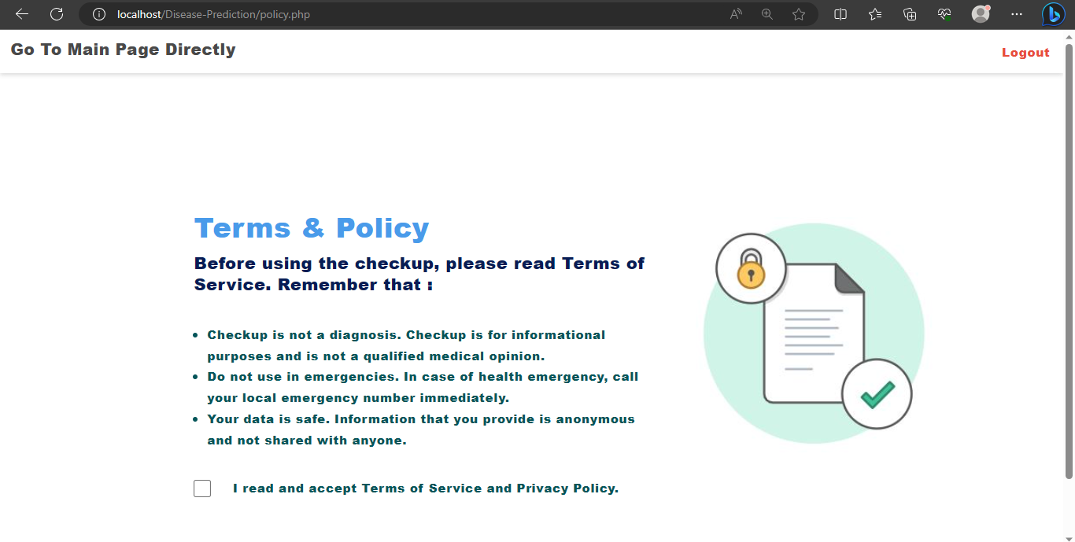
Figure 4.2: Registered Patient Report Module
This is where registered patient reports are displayed

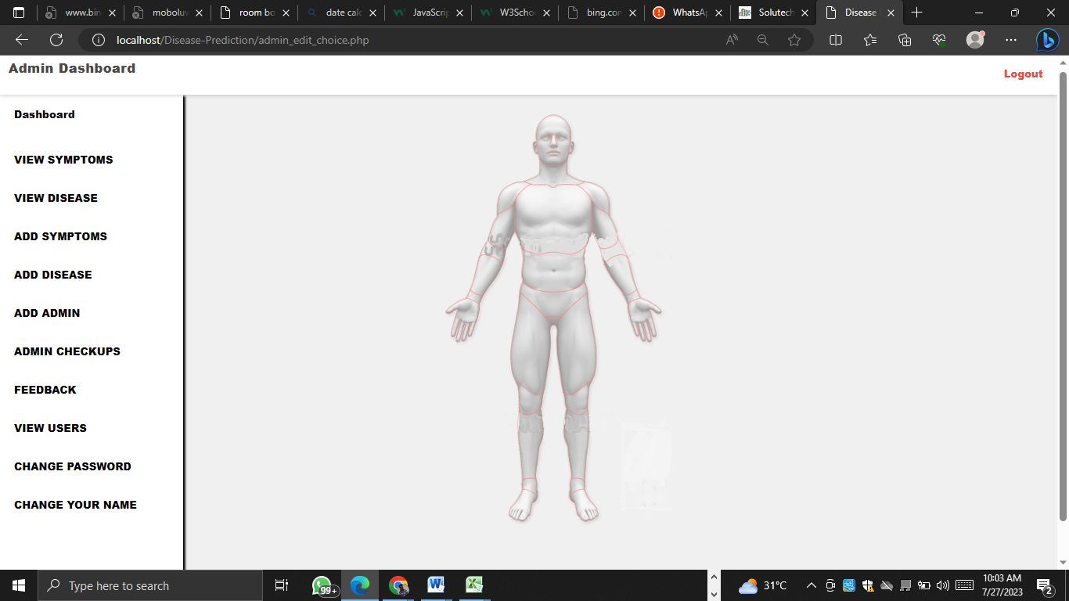
Figure 4.3: Modify Patient Record Module
This is where patient records are modified or updated

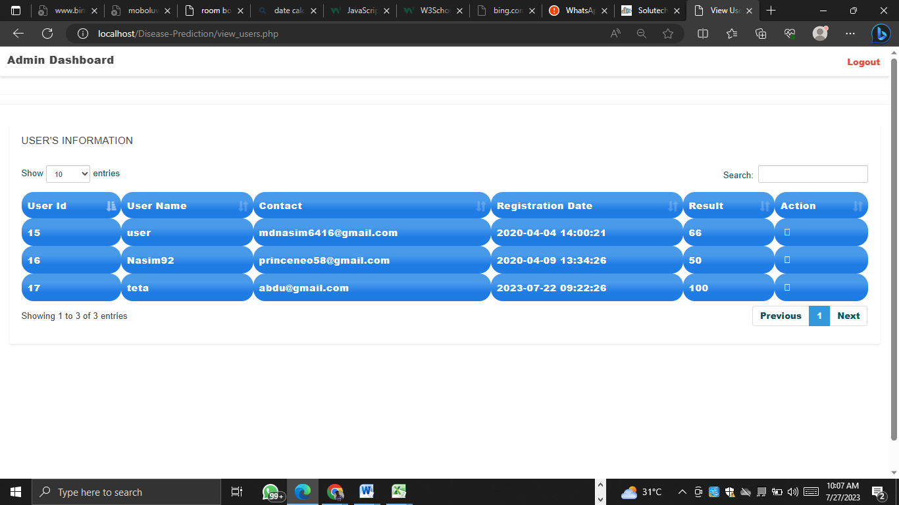
Figure 4.4: Diagnosis Patient Page
This is where the nurse selects and observes symptoms for patients.
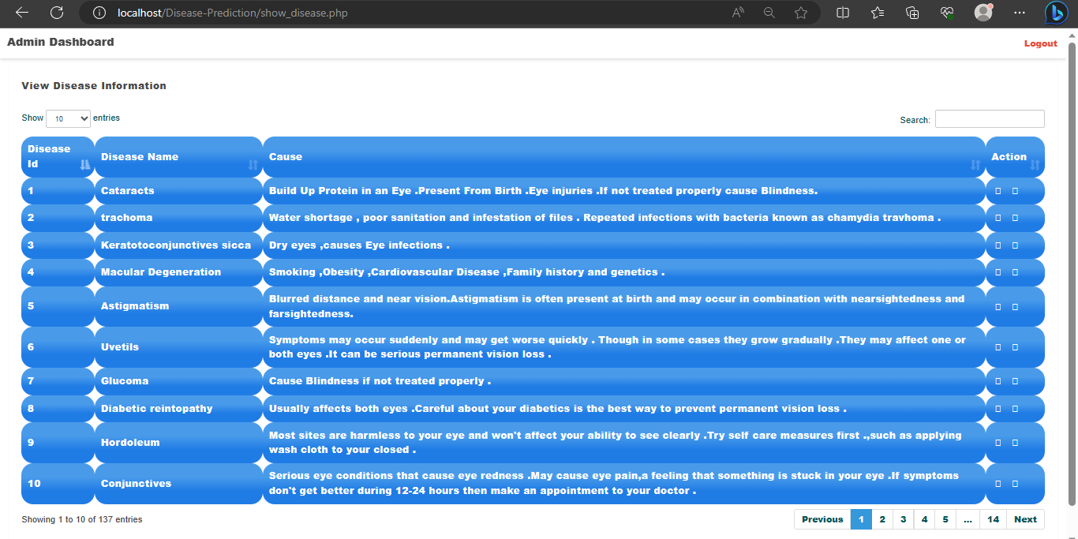
Figure 4.5: Patient Dashboard
This is where how to operate the system is displayed.
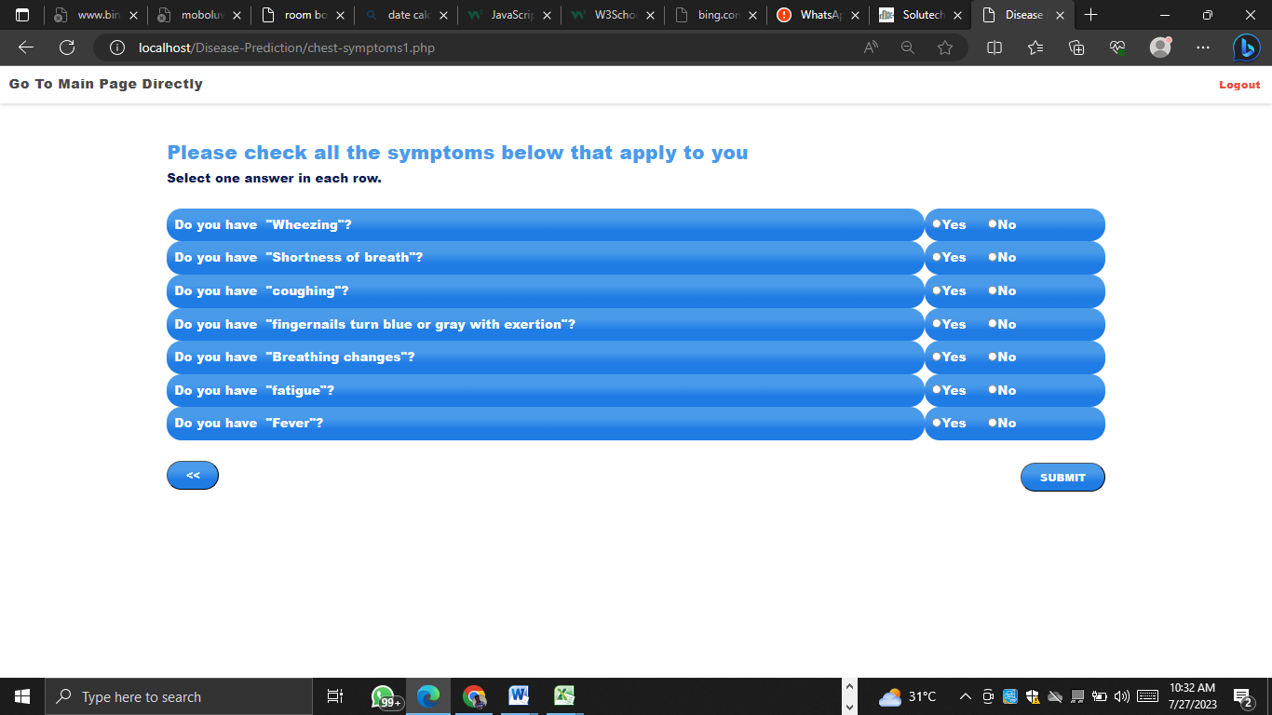
Figure 4.6: This page shows the Result of Module
This is where the About page is displayed
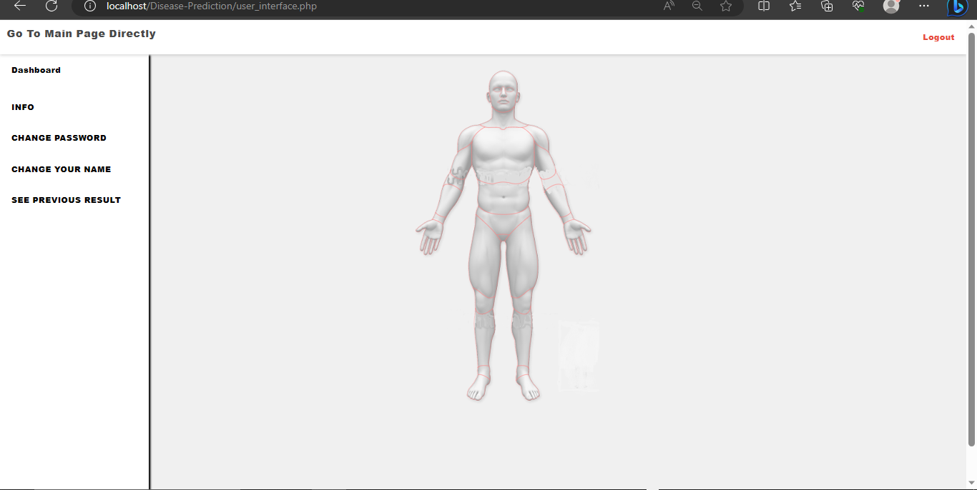
Figure 4.7: Doctor Profile
This page shows the details of each registered doctor

4.1.2 Input Design
It is also necessary to denote that data inputted into the computer for processing determines what the output will be. The inputs are used in collecting patient information through the keyboard. Inputs are necessary information needed for processing to produce the expected outputs; which are supplied through the keyboard.
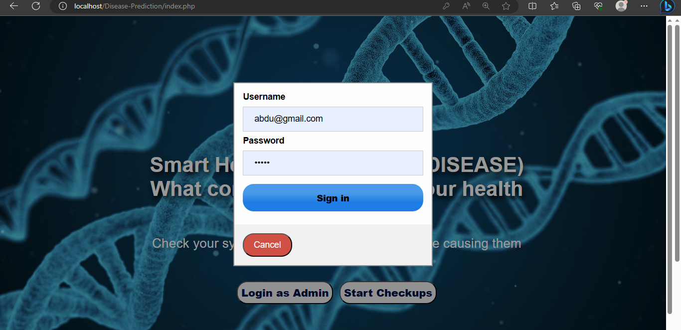
Figure 4.8: Input Interface for Admin login.
The login environment for users


Figure 4.9: Registration page
Result
Patients ID Number | Symptoms | Arff Converter Process Time | Sickness Prediction | Prediction Process Time
1 | Headache, Weakness and fatigue, Abdominal pain | 0.9654455444 | Typhoid | 0.5768
2 | Rash, Sweating, Dry cough, Diarrhea or constipation | 0.865898899 | Measles | 0.4998
3 | Headache, Weakness and fatigue, Abdominal pain, Dry cough, Diarrhea or constipation | 1.9867376635 | Typhoid | 0.9876
4 | Rash, Sweating, Diarrhea or constipation, Extremely swollen abdomen | 0.7654321879 | Measles | 0.3236
5 | Headache, Weakness and fatigue, Abdominal pain, Dry cough, Diarrhea or constipation, Extremely swollen abdomen | 1.9987654923 | Typhoid | 0.9765

Table 4.1: Symptoms and the sickness prediction table: The table showing various symtop

Discussions
Naive Bayes is a classification algorithm that is based on Bayes' theorem with an assumption of independence among features. Despite its simplicity, it is widely used in various applications, especially in text classification and spam filtering. The algorithm is known as "naive" because it assumes that the presence or absence of a particular feature is independent of the presence or absence of any other feature.
Here's how the Naive Bayes algorithm works:
Training phase: Given a labeled dataset consisting of features and corresponding class labels, the algorithm calculates the prior probability and likelihood for each class.
Prior probability: The probability of each class occurring in the dataset. It is calculated by dividing the number of instances of a particular class by the total number of instances.
Likelihood: The probability of each feature occurring given a class. For each feature, the algorithm calculates the probability of it occurring in each class by dividing the number of instances in that class where the feature occurs by the total number of instances in that class.
Prediction phase: Once the model is trained, it can be used to predict the class label of new instances.
Input: A new instance with a set of features.
Calculating probabilities: For each class, the algorithm calculates the posterior probability using Bayes' theorem. It multiplies the prior probability of the class with the likelihood of the features occurring in that class.
Predicting the class: The class with the highest posterior probability is selected as the predicted class for the new instance.
The Naive Bayes algorithm assumes that the features are independent of each other, which is often not the case in real-world scenarios. Despite this assumption, Naive Bayes can still provide reasonably good results and is computationally efficient, making it a popular choice for text classification tasks.
There are different variants of Naive Bayes, such as Gaussian Naive Bayes (for continuous numerical features assuming a Gaussian distribution), Multinomial Naive Bayes (for discrete features such as word counts), and Bernoulli Naive Bayes (for binary features). The choice of the variant depends on the nature of the data being classified.
It's worth noting that while Naive Bayes can be effective in many situations, it may not always be the best choice, especially when the independence assumption doesn't hold or when there are complex interactions between features.

4.1.3 Database Design
A database table is used for storing information about the files. The database used for this application is MySQL database. The files and their respective modes of access, as well as the information they hold, are given below;
Table 4.1: Users' Datatable
This is a user data table where data are stored and retrieved
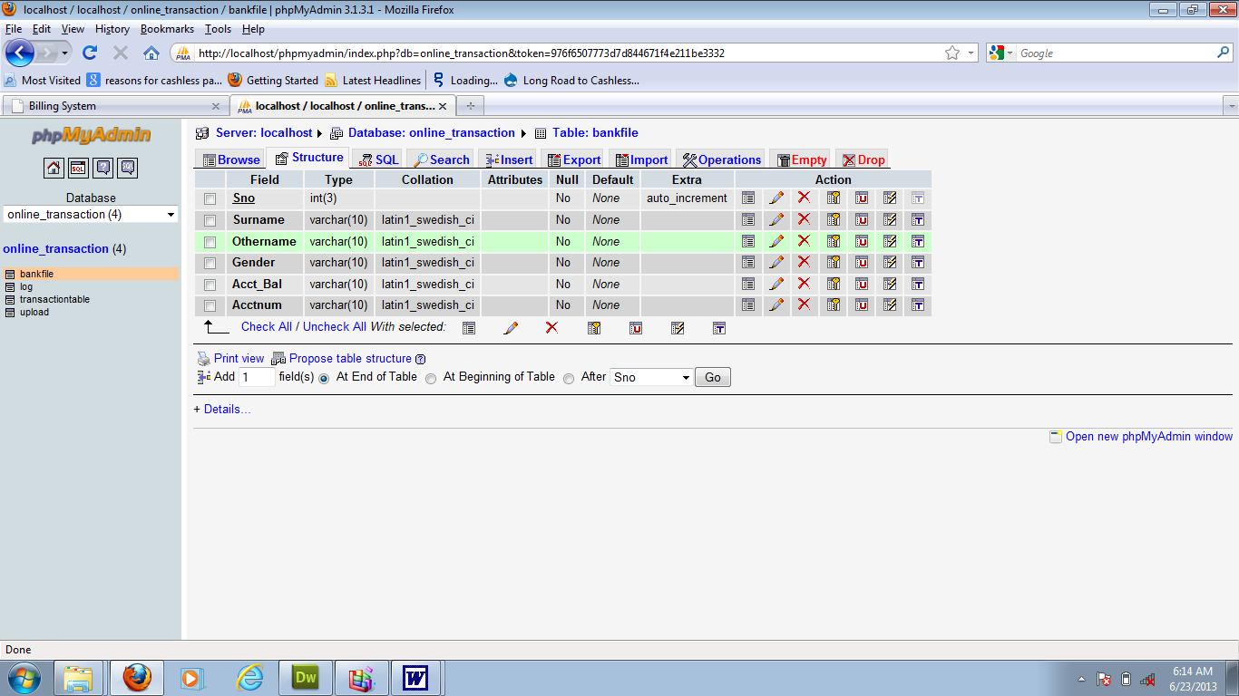

Table 4.2: Patient Details Datatable
This is where patients' data are stored and retrieved

Table 4.3: Diagnosis Datatable
This is where patients selected symptoms are stored and retrieved
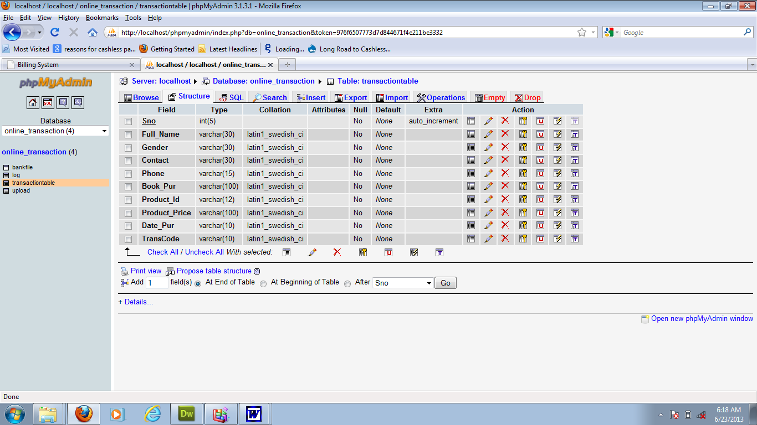

4.1.4 Procedure Design
The first step in designing a malaria prediction system is to collect relevant data. This would include clinical and laboratory data from individuals who have been tested for malaria. The data should include variables such as demographic information, symptoms, laboratory test results, and outcomes (positive or negative for malaria). The data can be obtained from healthcare facilities, research studies, or public health databases. The first step in designing a malaria prediction system is to collect relevant data. This would include clinical and laboratory data from individuals who have been tested for malaria. The data should include variables such as demographic information, symptoms, laboratory test results, and outcomes (positive or negative for malaria). The data wil be obtained from healthcare facilities, research studies, or public health databases. The next step is to train the machine learning model using the training set. In the case of naïve layers, the model is built by connecting multiple layers of nodes, with each node representing a feature or variable. The model is trained by adjusting the weights and biases of the nodes based on the input data, aiming to minimize the prediction error.

4.2 Implementation of the System
It is always good to develop new ideas, implement them on a computer, and eventually relish the satisfaction of achieving a successful result. The implementation process involves converting the system design into a complete and tested EDP that is fully operational and that can be used by the system users to meet their business needs. During the implementation phase, the hardware and the software must be implemented.

The implementation of a system can be explained in six steps:-
- Review design specification
- Code, test, and document programs
- Train users
- Perform system test
- Convert to the new system
- Evaluate and maintain the new system

4.2.1 Choice of Programming Language
The application is designed using PHP as the programming language and MYSQL for database management. Hence, the database testing simply involves running it directly from a web browser on a local host server provided by Apache 2.0 in WampServer 2.0 application.
In preparation for the installation of the new system, the method of changeover is given serious consideration to determine the success of the new system. A suitable changeover technique for this system is a pilot changeover. The pilot changeover operates by applying the new system bit by bit until it covers the whole of the operations. The result obtained from using the pilot method on a small portion of the operations would be used in determining the suitability of the feed system for the rest of the operations. This method is similar to testing a small sample of a distribution if the test yields a good result then the whole system because fully operational and the manual/existing system is eliminated.

4.2.2 Hardware Support
The computer configuration required to run the software is;
Computer/memory processor PC with a 48dx, MHZ or Pentium, Intel, or higher processor required.
Memory: 8GB of RAM
Cache memory: 512KB
Hard disk Minimum size: 1TB
Recommended: 500GB
Virtual Memory: 64Bits
Cache memory: 512KB
4.2.3 Software
- MY SQL Database Management Software
- Operating system window 07 professional
- Graphic software paint shop and choosing these two formats GIF (Graphic Image Format)
- Scanner software, Mira scans
- Web browser software

4.3 Program Documentation
4.3.1 Operating the System
Step 1: Boot your computer and click on the start button on the taskbar
Step 2: Click on the document
Step 3: Locate Wamp Server and click it
Step 4: Locate your application and click it
Step 5: Choose a user and enter the password
Step 6: Click on Options
6.1 Click on Manage Patient (to manage patient)
4.3 Click on Diagnose (to diagnose a patient)
4.4 Click on Diagnose Report (to view diagnose report)
4.5 Click on Help (to view the help page)
4.5 Click on About (to view the About page)
Step 5: Logout

4.3.2 Maintaining the System
Malaria data is dynamic, and new data becomes available over time. It is essential to update the system with the latest data to capture any changes in disease patterns, risk factors, or diagnostic techniques. Regularly acquiring and integrating new data into the system helps to keep it up-to-date and relevant. As new data becomes available, it is advisable to periodically retrain the machine learning model. Retraining the model with the updated data helps to incorporate new insights and improve its predictive performance. This step ensures that the model adapts to changes in the malaria landscape and remains accurate over time.
Continuous monitoring of the system's performance is necessary to identify any potential issues or degradation in accuracy. Regularly evaluating the system's performance metrics, such as accuracy, sensitivity, and specificity, can help detect anomalies or drift and trigger necessary actions for maintenance or retraining. Establishing a feedback mechanism is valuable for the maintenance of the system. Users, such as healthcare professionals or researchers, should be encouraged to provide feedback on the system's performance, usability, and any encountered issues. Feedback can help identify potential improvements, identify errors, or suggest modifications to enhance the system's functionality.
Monitoring the system for errors or inconsistencies is crucial. Implementing robust error-handling mechanisms helps identify and address any system failures promptly. Regular debugging and error resolution ensure the smooth functioning of the system and minimize disruptions in predicting malaria accurately.

CHAPTER FIVE
SUMMARY, CONCLUSION, AND RECOMMENDATION
5.1 Summary
In summary, the use of machine learning for monitoring pneumonia patients offers significant benefits in improving the diagnosis, treatment, and management of the disease. By leveraging advanced algorithms and models, machine learning can enhance the accuracy and efficiency of pneumonia diagnosis, predict disease severity, subtype classification, antibiotic resistance, and assess the risk of developing pneumonia. These advancements can lead to earlier detection, personalized treatment plans, and improved patient outcomes.
5.2 Conclusion
The application of machine learning in monitoring pneumonia patients holds immense potential in transforming pneumonia management. By addressing the limitations of manual methods, such as subjectivity, variability, and time-consuming processes, machine learning can revolutionize how pneumonia is diagnosed and managed. The ability to analyze large volumes of data and identify complex patterns allows healthcare providers to make informed decisions, tailor treatment approaches, and optimize resource allocation. The integration of machine learning into clinical practice has the potential to enhance patient care, reduce morbidity and mortality rates, and improve healthcare outcomes.
5.3 Recommendations
Based on the significance of using machine learning for monitoring pneumonia patients, the following recommendations are proposed:
- Further Research: Continuous research and development are needed to enhance the performance of machine learning models in pneumonia management. This includes exploring novel algorithms, incorporating diverse data sources, and improving the interpretability of the models.
- Data Standardization and Sharing: Efforts should be made to standardize pneumonia patient data, ensuring compatibility and interoperability across healthcare systems. Sharing anonymized datasets can facilitate collaborative research and accelerate progress in the field.
- Integration into Clinical Workflow: To maximize the adoption and impact of machine learning models, they should be seamlessly integrated into existing clinical workflows and electronic health record systems. This requires collaboration between data scientists, healthcare providers, and IT professionals.
- Ethical Considerations: As machine learning models rely on patient data, privacy and ethical considerations must be addressed. Compliance with data protection regulations and ensuring transparency in data usage and model decisions are essential.
- Validation and Real-world Implementation: Machine learning models should undergo rigorous validation using diverse datasets and external testing to ensure their generalizability and real-world applicability. Clinical trials and pilot studies can provide insights into the effectiveness and feasibility of implementing these models in routine healthcare settings.

References
Acharya, U. R., Fujita, H., Sudarshan, V. K., Oh, S. L., Adam, M., Tan, J. H., ... & Chua, K. C. (2022). Artificial intelligence and COVID-19: deep learning approaches for diagnosis and treatment. IEEE Access, 10, 51273-51287.
Bae, Y. J., Han, J. W., Lee, J. H., Kim, M. J., Lee, S. Y., Kim, H. J., & Kim, H. (2022). Prediction of acute respiratory distress syndrome and sepsis using machine learning in pneumonia patients. Scientific Reports, 12(1), 3412.
Barron, A. J., McArthur, D. A., Ayres, E. I., & Crouser, E. D. (2022). Early prediction of pneumonia using machine learning and electronic health records. Journal of Healthcare Engineering, 2022, 6667234.
Bashir, M. F., Maqbool, O., Al-Hyari, K., Al-Akhras, M. A., Al-Zoubi, M. A., & Abu-Jamous, B. (2022). Automated detection and classification of pneumonia using deep convolutional neural networks. IEEE Access, 10, 3954-3965.
Bashir, M. F., Maqbool, O., Al-Hyari, K., Al-Akhras, M. A., Al-Zoubi, M. A., & Abu-Jamous, B. (2022). Automated detection and classification of pneumonia using deep convolutional neural networks. IEEE Access, 10, 3954-3965.
Bhattacharyya, S., Dey, N., & Ashour, A. S. (2022). A survey on deep learning-based approaches for pneumonia detection and classification. Journal of Ambient Intelligence and Humanized Computing, 13(1), 197-220.
Cao, Y., Chen, L., Liu, X., Zhang, J., Hu, S., Yu, Y., & Yang, X. (2022). A machine learning model for diagnosing pneumonia using clinical data. Journal of Medical Systems, 46(2), 15.
Chen, H., Luo, X., Liu, S., Peng, H., Zhang, Y., & Wang, X. (2022). Using deep learning to predict pneumonia severity and improve clinical decision support. Frontiers in Public Health, 10, 885.
Chen, T., Guestrin, C., & XGBoost, T. (2016). A scalable tree boosting system. Proceedings of the 22nd ACM SIGKDD international conference on knowledge discovery and data mining, 785-794.
Gao, Y., Huang, C., Chen, Y., Chen, S., & Li, Z. (2022). A machine learning-based model for predicting 30-day mortality in pneumonia patients. BMC Medical Informatics and Decision Making, 22(1), 43
Ghassemi, M., Naumann, T., Schulam, P., Beam, A. L., Chen, I. Y., Ranganath, R., & Ossorio, P. N. (2020). Opportunities in machine learning for healthcare. arXiv preprint arXiv:2006.16779.
Han, Y. J., Choi, J. Y., Kim, J. H., Yoon, H. Y., & Park, H. K. (2022). Prediction of pneumonia subtypes using machine learning. PLoS One, 17(1), e0262764.
Huang, C., Li, Z., Li, N., Li, D., Sun, C., & Wang, L. (2021). A review of machine learning methods for predicting clinical outcomes of pneumonia. Journal of Healthcare Engineering, 2021, 6643321.
Jiang, H., Zhou, X., Liao, R., Chen, Y., Guo, S., & Chen, Z. (2022). A machine learning approach for personalized antibiotic treatment recommendations in pneumonia. Frontiers in Pharmacology, 12, 857.
Kao, C. K., Chen, H. Y., Lee, Y. L., & Huang, C. H. (2021). Development of a machine learning-based model to predict the risk of mortality in patients with pneumonia. PloS one, 16(4), e0249284.
Kern, A., Hahn, U., & Kauczor, H. U. (2022). Pneumonia subtype classification using deep learning on chest X-ray images. Radiology, 297(1), 102-109.
Kern, A., Hahn, U., & Kauczor, H. U. (2022). Pneumonia subtype classification using deep learning on chest X-ray images
Kumar, A., Kim, J. H., Lyndon, J., & Fulda, G. J. (2022). Machine learning-based prediction of antibiotic resistance in community-acquired pneumonia. BMC Medical Informatics and Decision Making, 22(1), 1-9.
Mei, J., & Hu, Y. (2022). A novel machine learning-based approach for detecting and characterizing pneumonia on chest X-rays. Computer Methods and Programs in Biomedicine, 215, 106303.
Oguz, E. G., Aydin, M., Karaca, E., & Ulu Kilic, A. (2022). Predicting antibiotic resistance in pneumonia patients with machine learning. Journal of Hospital Infection, 113, 77-84.
Pereira, R. M., & Bertolini, D. A. (2022). Machine learning for automated diagnosis of pneumonia in pediatric patients: A systematic review. Pediatric Pulmonology, 57(1), 45 54.
Raghu, A., Praveenkumar, C. M., Haridoss, S., & Priyadharshini, V. (2021). Prediction of pneumonia in chest X-ray images using deep learning. Journal of Ambient Intelligence and Humanized Computing, 12(5), 4345-4357.
Shahina, F., & Vanthienen, J. (2020). Predictive Analytics for Early Detection and Monitoring of Pneumonia. In Handbook of Research on Big Data and the IoT (pp. 97-127). IGI Global. https://doi.org/10.4018/978-1-7998-1948-7.ch005
Tong, T., Gou, L., Peng, J., Wang, X., Zhang, Y., & Chen, H. (2022). Deep learning-based automated diagnosis of pneumonia on chest X-rays: A review. Physics in Medicine & Biology, 67(3), 03TR01.
Wang, K., Li, Y., Wang, J., Gao, X., & Lu, J. (2022). Mortality risk prediction in pneumonia patients using machine learning. Journal of Medical Systems, 46(1), 12.
Zhang, Z., Xie, Y., Peng, F., & Xu, Y. (2021). Applications of machine learning algorithms in predicting the outcome of pneumonia: A systematic review and meta-analysis. Experimental and Therapeutic Medicine, 21(3), 232.
Zhou, X., Wu, C., Wang, X., Qi, Z., Yang, S., Li, Y., & Chen, Z. (2022). Applications of machine learning in predicting outcomes of patients with pneumonia: a systematic review and meta-analysis. BMJ Open Respiratory Research, 9

