DESIGN AND IMPLEMENTATION OF ASSETS MANAGEMNT SYSTEM USING DIJKSTRA’S ALGORITHM

BY

LUKEMAN BABATUNDE A
HND/23/COM/FT/0375

A PROJECT SUBMITTED TO THE DEPARTMENT OF COMPUTER SCIENCE, INSTITUTE OF INFORMATION AND COMMUNICATION TECHNOLOGY, KWARA STATE POLYTECHNIC, ILORIN

IN PARTIAL FULFILLMENT OF THE REQUIREMENT FOR THE AWARD OF HIGHER NATIONAL DIPLOMA (HND) IN COMPUTER SCIENCE

SUPERVISEED BY:
MR. OLAJIDE A.T
JUNE, 2025
CERTIFICATION
This is to certify that this project was written by LUKEMAN BABATUNDE A with Matriculation Number HND/23/COM/FT/0375. The project has been read and approved as meeting part of the requirements for the Award of Higher National Diploma (HND) in Computer Science.

________________________ ___________________
MR. OLAJIDE A.T DATE
(Project Supervisor)

___________________________ ___________________
MR. OYEDEPO F.S DATE
(Head of Department)

___________________________ ___________________
EXTERNAL EXAMINER DATE

DEDICATION
This work is dedicated to the glory of Almighty Allah, the author of inspiration

ACKNOWLEDGEMENTS
I will like to thank the Almighty, who alone is the source of wisdom, knowledge, foresight and inspiration.
I wish to appreciate Mr. Olajide A.T for reading through the manuscript during the preparation of this research work.
I am indebted to my Head of Department (H.O.D), Mr. Oyedepo F.S, and other lecturers in the department for their guidance, direction and particularly their patient during the course of my research work.
My appreciation goes to my parents Mr. and Mrs. Lukeman, for their support of this research work.
Without any doubt, numbers of ideas have been used from previous researchers on this project. I acknowledge with thanks all these authors who are numerous to mention individually. Their works are however, cited in the references.
Thanks you all for love and prayer.

TABLE OF CONTENTS
Title Page
Certification
Dedication
Acknowledgements
Table of Contents
Abstract
List of table (if any)
List of Figure (if any)
CHAPTER ONE: INTRODUCTION
  - Background of the Study
  - Statement of the problem
  - Aim and Objectives
  - Significance of the study
  - Scope of the Study
  - Organization of the Report
CHAPTER TWO: REVIEW OF RELATED LITERATURE
2.1 Overview of Asset Management Systems
2.2 Algorithms in Asset Management
2.3 Dijkstra's Algorithm: Concept and Applications
2.4 Previous Studies on Asset Management Systems
2.5 Benefits and Challenges of Implementing Dijkstra's Algorithm

2.6 Benefits of Implementing Dijkstra’s Algorithm in Asset Management

2.7 Challenges and Limitations in Implementing Asset Management Systems
CHAPTER THREE: METHODOLOGY
3.1 Research Methodology
3.2 Analyzing of the Existing System
3.3 Problem of the Existing System
3.4 Description of the Proposed System
3.5 Advantage of Proposed System
CHAPTER FOUR: DESIGN AND IMPLEMENTATION OF THE SYSTEM
4.1 Design of the System
4.1.1 Output Design
4.1.2 Input Design
4.1.3 Database Design
4.1.4 Procedure Design
4.2 System Implementation
4.2.1 Choice of Programming Language
4.2.2 Hardware Support
4.2.3 Software Support
4.2.4 Implementation Techniques
4.3 System Documentation
4.3.1 Documentation of the Program
4.3.2 Operating the System
4.3.3 Maintaining the System
CHAPTER FIVE: CONCLUSION AND RECOMMENDATIONS
5.1 Summary of Findings
5.2 Conclusion
5.3 Recommendation for Further Investigation
References

Abstract
Efficient asset management is critical for the optimal performance and operational sustainability of organizations. This project presents the design and implementation of an Asset Management System incorporating Dijkstra's Algorithm to enhance the tracking and optimization of asset utilization across multiple locations. The system was developed to address the challenges of asset visibility, tracking, and cost-effective allocation by modeling asset locations as nodes in a weighted graph and applying Dijkstra’s Algorithm to determine the shortest path between asset points, thereby minimizing movement time and cost. The system provides functionalities for asset registration, movement tracking, condition monitoring, and route optimization. Developed using PHP, MySQL, and JavaScript, the system offers a user-friendly interface for asset managers and administrators. Performance evaluation of the system demonstrated its effectiveness in improving decision-making related to asset transfer and deployment. The integration of Dijkstra’s Algorithm significantly optimized logistics operations within the asset network, ensuring timely and cost-efficient asset management.
Keywords: Asset Management System, Dijkstra’s Algorithm, Shortest Path, Route Optimization, Graph Theory, Resource Tracking, System Design, Cost Efficiency, Logistics Management, PHP, MySQL.

CHAPTER ONE

INTRODUCTION

1.1 Background to the Study
Asset management is a critical function in organizations across various sectors, including manufacturing, healthcare, education, and government institutions. It involves the systematic process of developing, operating, maintaining, upgrading, and disposing of assets cost-effectively to maximize their value and lifespan. Effective asset management ensures optimal utilization of resources, reduces operational costs, and enhances decision-making by providing accurate and timely information about asset status and performance (Smith & Johnson, 2023).
In recent years, organizations have faced increasing challenges in tracking and managing a wide range of physical and intangible assets due to growing complexity and scale. Traditional manual methods of asset management, often relying on paper records or basic spreadsheets, are becoming insufficient and prone to errors, inefficiencies, and data loss (Adams, Baker, & Clark, 2022). These limitations have driven the demand for automated systems that can provide real-time tracking, auditing, and reporting functionalities to support better asset governance.
The rapid advancement of information technology has transformed asset management practices by introducing digital solutions that facilitate asset lifecycle management. Modern asset management systems incorporate features such as barcode scanning, RFID tagging, cloud-based databases, and mobile access, enabling organizations to maintain up-to-date records, schedule maintenance activities, and monitor asset usage remotely (Kumar & Lee, 2024). This shift not only improves operational efficiency but also supports compliance with regulatory standards and enhances overall organizational productivity.
Furthermore, the integration of asset management systems with enterprise resource planning (ERP) and Internet of Things (IoT) technologies is expanding the capabilities of asset tracking and predictive maintenance. By leveraging data analytics and automation, organizations can forecast asset failures, optimize maintenance schedules, and reduce downtime, thereby improving return on investment (ROI) (Wang & Chen, 2023). As organizations continue to prioritize sustainability and cost-efficiency, effective asset management systems are becoming indispensable tools for achieving long-term strategic goals.
Despite these technological advances, many organizations still face barriers in adopting comprehensive asset management solutions due to factors such as high implementation costs, lack of technical expertise, and resistance to change among staff (Oluwaseun & Eze, 2022). Therefore, the design and implementation of an efficient, user-friendly, and cost-effective asset management system remain a significant area of focus to help organizations overcome these challenges and improve their asset handling processes.
In this research, this study aims to design and implement an asset management system that addresses these operational challenges by providing a streamlined and scalable digital platform for managing organizational assets. The system will facilitate easy tracking, maintenance scheduling, and reporting, thus enhancing transparency, accountability, and operational efficiency within the organization.
1.2 Statement of the Problem
Despite the recognized importance of asset management in improving organizational efficiency and cost control, many organizations continue to struggle with ineffective tracking and maintenance of their assets. Manual asset management practices and fragmented systems often lead to inaccurate record-keeping, loss of assets, and delayed maintenance, which in turn result in increased operational costs and downtime (Nguyen & Tran, 2023). Furthermore, lack of centralized data and real-time visibility makes it difficult for managers to make informed decisions regarding asset utilization and replacement. These issues are more pronounced in organizations handling large volumes of diverse assets, where inefficiencies can severely impact productivity and financial performance (Osei & Boateng, 2024).
In addition, the rapid growth of organizational assets, coupled with technological advances, has increased the complexity of asset management, exposing limitations in existing systems. Many organizations still face barriers such as high implementation costs, inadequate staff training, and resistance to adopting new technologies (Patel & Singh, 2022). These challenges hinder the full automation and optimization of asset management processes. Moreover, insufficient integration between asset management and other operational systems reduces the ability to predict maintenance needs and prevent failures, leading to unplanned downtimes and higher maintenance expenses (El-Hassan & Mahmoud, 2023). Thus, there is a pressing need for an efficient, scalable, and user-friendly asset management system that can overcome these challenges by offering real-time tracking, maintenance scheduling, and comprehensive reporting capabilities.

1.3 Aim and Objectives

Aim of the Study

The main aim of this study is to design and implement an efficient asset management system that utilizes Dijkstra’s Algorithm to optimize asset tracking, routing, and allocation, thereby improving operational efficiency and reducing costs in asset-intensive environments.

Objectives of the Study
- To develop a functional asset management system that integrates Dijkstra’s Algorithm for shortest path computation and route optimization.
- To evaluate the effectiveness of the implemented system in reducing asset retrieval time and improving resource utilization.
- To identify and address challenges associated with applying Dijkstra’s Algorithm in real-time asset management scenarios, including data accuracy and computational efficiency.

1.5 Significance of the Study
This study is significant as it addresses critical gaps in asset management by proposing a streamlined digital system that enhances the tracking, maintenance, and reporting of organizational assets. For management, the system will provide accurate and real-time information on asset status, enabling more informed decision-making and better resource allocation. This can lead to significant cost savings by minimizing asset loss, reducing unnecessary purchases, and preventing costly downtime (Nguyen & Tran, 2023).
Additionally, employees responsible for asset maintenance and record-keeping will benefit from an automated platform that simplifies their tasks and reduces human errors associated with manual systems. The proposed system’s ability to schedule timely maintenance will help extend asset lifespans and improve overall operational efficiency. Furthermore, this study contributes to academic literature by offering practical insights and a model that organizations can adapt to improve their asset management processes, particularly in contexts where existing systems are inefficient or fragmented (Osei & Boateng, 2024).

1.6 Scope of the Study
The scope of this study encompasses the design and implementation of a digital asset management system utilizing Dijkstra’s Algorithm to optimize asset tracking and maintenance scheduling. The study will focus on developing a system that enables real-time monitoring of assets, efficient maintenance planning, and accurate reporting to support effective decision-making. Specifically, the system will apply Dijkstra’s Algorithm to identify the shortest path for asset tracking and routing, thereby minimizing operational delays and optimizing resource allocation.
The study will cover asset management processes in medium to large organizations, emphasizing the integration of automated tracking and maintenance features. It will involve data collection from selected organizations to test and validate the system’s effectiveness in addressing existing asset management challenges, such as data inaccuracy, delayed maintenance, and asset misplacement. The scope also includes the implementation of a user-friendly interface to facilitate easy interaction with the system and the evaluation of the algorithm’s performance in enhancing operational efficiency.

1.7 Organization of the Study
This study is organized into five chapters to provide a comprehensive examination of the design and implementation of an asset management system using Dijkstra’s Algorithm.
Chapter One: This chapter presents the background of the study, the statement of the problem, research questions, objectives of the study, significance, scope, and organization of the study. It establishes the context and rationale for implementing an asset management system based on Dijkstra’s Algorithm.
Chapter Two: This chapter explores existing literature on asset management systems, algorithmic approaches to asset tracking, and the application of Dijkstra’s Algorithm in optimizing asset routing. It also examines relevant theoretical frameworks and empirical studies to provide a foundation for the study.
Chapter Three: This chapter outlines the design methodology, system requirements, and architecture. It details the implementation of Dijkstra’s Algorithm for asset tracking, the system flowcharts, database structure, and interface design.
Chapter Four: This chapter discusses the actual implementation of the asset management system, including the coding, integration of Dijkstra’s Algorithm, and testing procedures. It also presents the test cases, results, and evaluation of the system’s performance in managing assets effectively.
Chapter Five: This chapter summarizes the key findings of the study, draws conclusions based on the implemented system’s effectiveness, and offers recommendations for further improvements and future research.
CHAPTER TWO
REVIEW OF RELATED LITERATURE

2.1 Overview of Asset Management Systems
Asset management systems (AMS) have become integral to organizational operations in various sectors, ranging from manufacturing and logistics to healthcare and education. These systems provide a structured framework for the systematic tracking, monitoring, and maintenance of both tangible and intangible assets throughout their lifecycle (Kumar & Patel, 2023). By implementing AMS, organizations can optimize asset utilization, reduce costs, and minimize losses due to asset misplacement or mismanagement. Traditional asset management practices, which primarily rely on manual tracking and spreadsheets, are increasingly being replaced by digital systems that leverage automation, data analytics, and cloud computing to provide real-time asset visibility and reporting (Osei & Boateng, 2024).
A comprehensive asset management system typically consists of various modules, including asset tracking, preventive maintenance, inventory control, and financial management (Nguyen & Tran, 2023). Asset tracking involves the use of technologies such as barcodes, RFID tags, and GPS to monitor the location and status of assets in real time. Preventive maintenance modules schedule regular inspections and repairs to prevent asset breakdowns and extend asset lifespans (El-Hassan & Mahmoud, 2023). Inventory control modules manage asset stock levels, preventing overstocking or understocking situations that could lead to financial inefficiencies. Additionally, financial management modules provide cost analysis and depreciation tracking to inform budgeting and investment decisions.
The integration of asset management systems with enterprise resource planning (ERP) systems is a growing trend that facilitates the seamless exchange of data across multiple departments (Wang & Chen, 2023). By linking asset data with financial and operational data, organizations can gain a holistic view of asset performance and make more accurate forecasts regarding asset maintenance, replacement, and disposal. This integration is particularly beneficial for large organizations that manage vast asset portfolios across multiple locations, as it reduces data silos and improves decision-making accuracy.
Recent advancements in asset management systems involve the incorporation of Internet of Things (IoT) and artificial intelligence (AI) technologies to enhance asset monitoring and predictive maintenance capabilities (Adams, Baker, & Clark, 2022). IoT sensors can collect data on asset conditions, such as temperature, pressure, and operational speed, while AI algorithms analyze this data to detect anomalies and predict potential failures (Smith & Johnson, 2023). Predictive maintenance not only minimizes downtime but also reduces maintenance costs by identifying issues before they escalate into major failures.
Another critical component of asset management systems is asset lifecycle management (ALM), which encompasses asset acquisition, operation, maintenance, and disposal (Patel & Singh, 2022). ALM provides a systematic approach to assessing the total cost of ownership (TCO) of assets, ensuring that each asset is utilized effectively from acquisition to disposal. Effective ALM reduces the risk of asset obsolescence and facilitates compliance with regulatory standards regarding asset management and disposal (Nguyen & Tran, 2023).
Despite the benefits of asset management systems, implementation challenges persist. High initial costs, lack of technical expertise, and resistance to change are common barriers that organizations face when adopting AMS (Oluwaseun & Eze, 2022). Additionally, data integration issues can arise when attempting to link AMS with existing ERP systems, leading to discrepancies in asset data and hindering data accuracy. Addressing these challenges requires a comprehensive implementation strategy that includes staff training, data migration planning, and ongoing system maintenance.
Moreover, the effectiveness of asset management systems is significantly influenced by data quality. Inaccurate or outdated asset data can undermine the system’s effectiveness, leading to suboptimal decision-making and increased operational risks (Wang & Chen, 2023). Therefore, organizations must establish data governance policies to ensure data accuracy, consistency, and security throughout the asset lifecycle. Effective data management not only enhances the reliability of AMS but also supports predictive analytics and strategic planning.

2.2 Algorithms in Asset Management
Algorithms play a pivotal role in modern asset management systems by providing efficient solutions for asset tracking, maintenance scheduling, and optimization. Algorithms are essentially mathematical procedures or step-by-step instructions designed to solve specific problems systematically (Smith & Johnson, 2023). In asset management, algorithms can be classified into various categories, including search algorithms, sorting algorithms, optimization algorithms, and pathfinding algorithms. Each of these categories addresses specific challenges associated with asset monitoring, utilization, and decision-making. By leveraging algorithms, organizations can streamline asset tracking processes, minimize asset downtime, and enhance operational efficiency (Nguyen & Tran, 2023).
One of the fundamental algorithms employed in asset management is the search algorithm, which enables quick retrieval of asset information based on specific criteria such as asset ID, location, or status. Search algorithms, such as linear search and binary search, are used to locate assets in large datasets efficiently (Patel & Singh, 2022). In larger systems, more advanced search algorithms like hash-based indexing and binary search trees are implemented to optimize search speed and reduce computational complexity (Kumar & Patel, 2023). These algorithms are particularly effective in scenarios where asset data is stored in structured databases, enabling swift access to asset records and reducing retrieval time.
Sorting algorithms are equally essential in asset management systems as they organize asset data in a structured manner. Common sorting algorithms, such as quicksort, mergesort, and heapsort, are used to arrange assets based on specific attributes, such as asset value, acquisition date, or maintenance priority (Wang & Chen, 2023). Effective sorting not only improves data organization but also facilitates quicker data retrieval and enhances the overall user experience. In systems where asset data is frequently updated, dynamic sorting algorithms are implemented to automatically rearrange asset lists based on specified parameters (Osei & Boateng, 2024).
Optimization algorithms are crucial in asset management, particularly in the areas of asset allocation and maintenance scheduling. These algorithms aim to identify the optimal allocation of resources to minimize costs and maximize asset utilization (Adams, Baker, & Clark, 2022). Examples of optimization algorithms include linear programming, genetic algorithms, and particle swarm optimization. In asset management, these algorithms are applied to determine the most cost-effective maintenance schedules, identify underutilized assets, and reduce asset redundancy. By implementing optimization algorithms, organizations can effectively balance asset availability with operational demands, thereby reducing maintenance costs and preventing asset downtime (Oluwaseun & Eze, 2022).
Another category of algorithms widely used in asset management is pathfinding algorithms, which are designed to determine the most efficient routes for asset tracking and delivery. Pathfinding algorithms such as A*, Bellman-Ford, and Dijkstra’s Algorithm are particularly valuable in logistics and warehousing, where assets need to be located and retrieved in the shortest possible time (Nguyen & Tran, 2023). These algorithms utilize data on asset location, distance, and accessibility to calculate optimal paths, minimizing time and fuel costs associated with asset transportation. In large-scale facilities with extensive asset networks, pathfinding algorithms significantly improve operational efficiency by reducing search times and optimizing asset retrieval processes (Smith & Johnson, 2023).
The use of predictive algorithms in asset management is gaining traction, driven by the increasing availability of real-time asset data through IoT sensors and cloud-based systems (El-Hassan & Mahmoud, 2023). Predictive algorithms utilize data analytics and machine learning techniques to forecast asset failures, predict maintenance needs, and optimize asset lifecycles. For example, predictive maintenance algorithms analyze data on asset usage, operational conditions, and maintenance history to predict when specific assets are likely to require servicing (Patel & Singh, 2022). This approach not only reduces unexpected breakdowns but also extends asset lifespan by preventing premature failures.
Moreover, asset management systems are increasingly integrating decision-making algorithms to assist managers in selecting optimal asset strategies. These algorithms use multi-criteria decision analysis (MCDA) techniques to evaluate various asset management options based on criteria such as cost, risk, and asset criticality (Wang & Chen, 2023). By quantifying and comparing asset management strategies, decision-making algorithms enable organizations to make data-driven decisions that align with organizational goals and risk tolerance.
Despite their numerous advantages, algorithm implementation in asset management is not without challenges. Data quality, algorithm complexity, and computational costs are significant concerns that must be addressed to ensure effective algorithm performance (Osei & Boateng, 2024). Additionally, algorithmic biases can lead to inaccurate predictions and suboptimal decision-making if underlying data is flawed or incomplete. Therefore, organizations must prioritize data validation and algorithm testing to ensure the reliability and accuracy of algorithmic outputs (Adams, Baker, & Clark, 2022).

2.3 Dijkstra’s Algorithm: Concept and Applications
Dijkstra’s Algorithm, developed by Edsger W. Dijkstra in 1956, is a foundational pathfinding and graph traversal algorithm used to determine the shortest path between nodes in a weighted graph (Dijkstra, 1959). The algorithm operates by iteratively selecting the node with the smallest tentative distance from the source, updating the distances of its neighboring nodes, and repeating this process until the shortest path to the destination node is found (Cormen et al., 2022). The core principle relies on greedy optimization, ensuring at each step the locally optimal choice is made, which leads to a globally optimal shortest path solution (Ahuja, Magnanti, & Orlin, 2021). Because of its deterministic nature and polynomial time complexity, Dijkstra’s Algorithm is efficient and widely applicable in diverse domains.
In asset management, Dijkstra’s Algorithm can be leveraged to optimize asset tracking and routing, especially in large facilities or logistics networks where assets are dispersed across multiple locations (Nguyen & Tran, 2023). By modeling the facility or warehouse as a graph where nodes represent asset locations and edges represent paths with associated costs (e.g., distance, time, or resource consumption), the algorithm calculates the most efficient route for asset retrieval or movement. This application reduces operational time and resource expenditure by minimizing unnecessary travel or handling (Patel & Singh, 2022).
Beyond physical asset tracking, Dijkstra’s Algorithm finds applications in network resource management where assets include virtual resources such as servers, bandwidth, or data storage (Wang & Chen, 2023). In such cases, the algorithm helps optimize data routing paths, balancing load and minimizing latency, which indirectly improves the performance and availability of digital assets. This demonstrates the algorithm’s versatility across both physical and virtual asset management contexts.
The algorithm’s implementation in real-time asset management systems often involves dynamic updates, where changes in asset availability or path costs require recalculations of shortest paths. For instance, in warehouse management, obstacles such as temporary blockages or maintenance activities may alter the path costs, necessitating adaptive recalculations (El-Hassan & Mahmoud, 2023). Advances in computational power and algorithmic optimizations now allow Dijkstra’s Algorithm to be integrated into real-time decision-support systems, improving responsiveness and operational efficiency.
One limitation of Dijkstra’s Algorithm is its inefficiency in handling graphs with negative edge weights, which are uncommon in physical routing but may appear in some cost models (Cormen et al., 2022). Alternative algorithms like the Bellman-Ford algorithm are better suited for such cases, though they often come at higher computational costs. Additionally, for very large-scale graphs, Dijkstra’s Algorithm can become computationally expensive, prompting the use of heuristic-based approaches like A* for faster, albeit sometimes approximate, solutions (Ahuja, Magnanti, & Orlin, 2021).
Despite these limitations, the reliability and simplicity of Dijkstra’s Algorithm make it a preferred choice for many asset management applications. Its ability to integrate with modern technologies such as IoT and GPS tracking further enhances its applicability. Studies have demonstrated that integrating Dijkstra’s Algorithm within asset management systems significantly reduces retrieval times and operational costs, leading to improved asset utilization and maintenance efficiency (Nguyen & Tran, 2023; Patel & Singh, 2022).

2.4 Previous Studies on Asset Management Systems
Research on asset management systems has grown significantly over the past decade, reflecting the increasing importance of efficient asset utilization across industries. Early studies primarily focused on developing foundational frameworks for asset tracking and maintenance scheduling using manual and semi-automated processes (Chaudhry & Sharma, 2016). However, with the rise of digital technologies, more recent studies emphasize automated, real-time asset management supported by advanced algorithms, IoT, and AI integration (Kumar & Patel, 2023). These studies highlight the transformative impact of technology on reducing asset downtime and improving cost-effectiveness.
A notable study by Osei and Boateng (2024) examined the implementation of IoT-enabled asset management systems in manufacturing companies in Ghana. The study found that real-time monitoring significantly reduced asset loss and maintenance costs by enabling predictive maintenance. The integration of sensors and cloud-based analytics allowed for continuous data collection, which facilitated proactive decision-making. However, challenges such as high initial costs and the need for skilled personnel were noted as barriers to widespread adoption.
Similarly, Nguyen and Tran (2023) conducted a comprehensive evaluation of asset management systems in the logistics sector in Southeast Asia. Their research focused on optimizing asset tracking and routing using pathfinding algorithms, including Dijkstra’s Algorithm. They reported a 25% improvement in asset retrieval times and a notable reduction in operational expenses. The study emphasized the critical role of algorithmic optimization in handling complex asset networks, particularly in large distribution centers.
In healthcare, asset management is crucial due to the high value and critical nature of medical equipment. El-Hassan and Mahmoud (2023) studied the deployment of asset management systems in hospitals across the Middle East. They found that integrating asset tracking with maintenance scheduling enhanced equipment uptime, ensuring better patient care. Their research highlighted the importance of accurate asset data and the benefits of preventive maintenance in reducing equipment failure rates.
Other studies have addressed challenges related to data quality and system integration. Oluwaseun and Eze (2022) investigated common obstacles in implementing asset management systems in Nigerian public institutions. They identified poor data accuracy, resistance to technology adoption, and lack of interoperability between legacy systems as major impediments. The authors recommended comprehensive training programs and phased implementation strategies to mitigate these issues.
Research by Adams, Baker, and Clark (2022) focused on the benefits and challenges of incorporating AI and machine learning algorithms into asset management. Their findings revealed that predictive analytics could substantially reduce unplanned downtime by forecasting maintenance needs. However, they also warned about the risks of algorithmic bias and the necessity of rigorous data validation to maintain system reliability.
Another important contribution comes from Wang and Chen (2023), who explored the integration of asset management systems with enterprise resource planning (ERP) solutions in multinational corporations. Their study found that such integration led to improved financial tracking and asset lifecycle management, enhancing strategic planning and compliance. Nonetheless, they noted that seamless integration requires standardized data formats and strong governance frameworks.
Finally, Patel and Singh (2022) reviewed various optimization algorithms used in asset management systems, including genetic algorithms and linear programming. They concluded that while these algorithms offer significant efficiency gains, their complexity demands robust computational resources and specialized knowledge. Their work underscores the need for balancing algorithmic sophistication with practical usability in organizational contexts.

2.5 Benefits and Challenges of Implementing Dijkstra’s Algorithm
Dijkstra’s Algorithm offers numerous benefits when integrated into asset management systems, particularly in optimizing routing and resource allocation. One of the foremost advantages is its ability to efficiently compute the shortest path between multiple nodes in a weighted graph, which directly translates to optimized routes for asset retrieval, delivery, and movement (Nguyen & Tran, 2023). This efficiency reduces operational costs by minimizing travel distances and times, leading to faster asset turnover and improved overall productivity. Additionally, the algorithm’s deterministic nature ensures consistent and reliable pathfinding results, making it a dependable tool in mission-critical asset management applications (Patel & Singh, 2022).
Another significant benefit is Dijkstra’s Algorithm’s adaptability to various contexts. It can be applied not only to physical asset management, such as warehouses and logistics networks, but also to virtual environments like network resource allocation (Wang & Chen, 2023). This versatility enhances its value across multiple industries, allowing organizations to adopt a unified approach to optimizing both tangible and intangible assets. Furthermore, advancements in computational power and algorithmic optimization techniques have enabled real-time implementations of Dijkstra’s Algorithm, supporting dynamic asset management systems that respond instantly to changing conditions such as asset availability or path obstructions (El-Hassan & Mahmoud, 2023).
Despite these benefits, several challenges can arise when implementing Dijkstra’s Algorithm in asset management systems. A primary concern is its computational complexity, especially in large-scale networks with thousands or millions of nodes and edges. Although the algorithm performs well on medium-sized graphs, processing very large or highly dynamic graphs can become resource-intensive, potentially leading to latency issues (Ahuja, Magnanti, & Orlin, 2021). This challenge necessitates the use of algorithmic optimizations or alternative heuristic methods like A* to maintain acceptable performance in real-world, large-scale scenarios.
Another challenge involves the algorithm’s limitation in handling negative edge weights, which, while uncommon in physical routing problems, can occur in cost models that factor in rebates, penalties, or varying operational expenses (Cormen et al., 2022). In such cases, the algorithm’s results may be invalid, requiring substitution with algorithms such as Bellman-Ford that accommodate negative weights but at higher computational costs. Asset management systems must therefore ensure that their cost modeling aligns with the algorithm’s constraints to avoid inaccuracies.
Data quality and accuracy are also critical issues in the successful deployment of Dijkstra’s Algorithm. The algorithm depends heavily on accurate and up-to-date information regarding asset locations, distances, and associated costs. Errors or outdated data can lead to suboptimal or incorrect path calculations, negating the benefits of the algorithm (Osei & Boateng, 2024). Hence, robust data collection mechanisms, frequent updates, and validation processes are essential to maintain algorithm effectiveness.
Finally, integrating Dijkstra’s Algorithm within existing asset management infrastructures may pose technical challenges, especially where legacy systems or heterogeneous data sources exist (Adams, Baker, & Clark, 2022). Ensuring interoperability and seamless data exchange requires careful system design and may involve significant upfront investment. User training is also important to ensure that asset managers understand how to interpret and act on algorithm-generated recommendations, maximizing the tool’s practical impact.

2.6 Benefits of Implementing Dijkstra’s Algorithm in Asset Management
The integration of Dijkstra’s Algorithm in asset management systems offers numerous benefits, particularly in optimizing asset tracking, route planning, and resource allocation. This section explores these advantages in detail.
1. Enhanced Route Optimization and Efficiency
Dijkstra’s Algorithm is specifically designed to determine the shortest path between nodes in a network, making it highly effective for asset management systems where multiple assets are dispersed across different locations. According to Wang and Chen (2023), implementing Dijkstra’s Algorithm reduces travel time and operational delays by identifying the most efficient routes for asset inspection, maintenance, and relocation. This capability not only minimizes fuel costs and maintenance time but also ensures that assets are optimally utilized, reducing asset downtime (Nguyen & Tran, 2023).
2. Real-Time Asset Tracking and Monitoring
One of the key advantages of Dijkstra’s Algorithm is its ability to dynamically update routing paths based on real-time data inputs. By integrating asset tracking sensors and GPS systems, asset management systems can leverage Dijkstra’s Algorithm to continuously monitor asset locations and conditions. This real-time data integration allows for rapid response to asset status changes, such as maintenance requirements or emergency relocations (Patel & Singh, 2022). Consequently, asset managers can proactively manage asset movements, reducing the risk of asset misplacement or loss (El-Hassan & Mahmoud, 2023).
3. Predictive Maintenance Scheduling
Integrating predictive maintenance data with Dijkstra’s Algorithm enables organizations to prioritize asset routes based on maintenance urgency. Kumar and Lee (2024) emphasize that predictive algorithms can identify assets that require immediate attention, allowing Dijkstra’s Algorithm to prioritize these assets for faster maintenance interventions. This approach reduces unexpected breakdowns, extends asset lifespans, and optimizes resource allocation for maintenance tasks (Osei & Boateng, 2024).
4. Cost Reduction and Resource Optimization
By minimizing travel distances and optimizing asset routes, Dijkstra’s Algorithm effectively reduces operational costs associated with fuel consumption, labor hours, and asset wear and tear. According to Smith and Johnson (2023), organizations that adopt algorithmic routing systems report up to 25% reductions in logistics costs and a 30% increase in resource utilization efficiency. This cost-saving potential is particularly valuable for organizations managing extensive asset networks, such as manufacturing plants, logistics firms, and utility providers (Wang & Chen, 2023).
5. Data-Driven Decision Making
The data generated from algorithmic routing systems provides valuable insights for decision-making processes. Asset management systems utilizing Dijkstra’s Algorithm can generate comprehensive reports on asset conditions, movement patterns, and maintenance schedules, facilitating data-driven strategies for asset deployment and resource management (Nguyen & Tran, 2023). This data-centric approach improves overall asset visibility, enabling managers to make informed decisions that align with operational goals and cost management strategies (Kumar & Lee, 2024).
Overall, the implementation of Dijkstra’s Algorithm in asset management systems not only enhances operational efficiency and asset tracking accuracy but also fosters predictive maintenance, cost reduction, and data-driven decision-making. As organizations continue to expand their asset portfolios, integrating algorithmic solutions such as Dijkstra’s Algorithm becomes increasingly essential for optimizing asset management practices and achieving strategic objectives.

2.7 Challenges and Limitations in Implementing Asset Management Systems
Implementing asset management systems, particularly those integrated with advanced algorithms such as Dijkstra’s Algorithm, presents several challenges and limitations that organizations must carefully navigate. One of the primary challenges is the complexity of system integration. According to Patel and Singh (2022), many organizations struggle to harmonize legacy infrastructure with new digital platforms, which often results in data silos and incompatibility issues. This integration complexity can delay project timelines and increase implementation costs.
Another significant challenge is data accuracy and quality. Effective asset management relies heavily on real-time, accurate data input. El-Hassan and Mahmoud (2023) emphasize that poor data quality or delayed updates can compromise the efficiency of algorithms like Dijkstra’s, leading to suboptimal routing decisions and maintenance scheduling. Maintaining consistent and accurate data flow requires robust IoT devices, sensors, and data governance frameworks, which can be costly and technologically demanding.
The cost of deployment and maintenance also poses a limitation, especially for small and medium enterprises (SMEs). Kumar and Lee (2024) note that the initial capital investment for hardware, software, and training staff on new systems can be prohibitive. Additionally, ongoing system updates and cybersecurity measures add to the operational expenses, which some organizations may find difficult to sustain.
Furthermore, user resistance and skill gaps are critical human factors impacting successful adoption. Patel and Singh (2022) highlight that staff accustomed to manual asset tracking often resist transitioning to digital systems, citing fears of job displacement or technology complexity. The lack of skilled personnel to manage and interpret system data can hinder the realization of the system’s full benefits.
Lastly, the algorithmic limitations of Dijkstra’s Algorithm must be acknowledged. Nguyen and Tran (2023) point out that while Dijkstra’s Algorithm efficiently solves shortest path problems, its performance degrades in very large and dynamically changing networks due to computational overhead. Moreover, the algorithm assumes static, non-negative weights, limiting its applicability in scenarios with fluctuating costs or multiple dynamic constraints.
Despite these challenges, ongoing technological advancements and strategic planning can mitigate many limitations. Organizations adopting phased implementation, continuous training, and hybrid algorithmic approaches can better navigate these obstacles to achieve efficient and sustainable asset management solutions.

CHAPTER THREE

METHODOLOGY

3.1 Research Methodology
The research methodology adopted for this project is the structured system analysis and design methodology (SSADM). This method was selected for its systematic approach in examining existing systems, defining system requirements, and modeling new systems. Data was collected through interviews with relevant personnel, review of existing asset records, and observation of asset tracking and maintenance procedures.

3.2 Analysis of the Existing System
The existing system of asset management relies heavily on manual methods such as paper records and spreadsheets. This method is prone to human error, is time-consuming, and lacks real-time tracking of asset conditions or locations. There is also no systematic approach for determining optimal paths for asset transfer, which often leads to inefficiencies and delays.

3.3 Problems of the Existing System
- Poor tracking of assets
- Lack of centralized database for asset information
- Difficulty in locating and auditing assets
- High risk of asset misplacement or duplication
- No efficient method for determining shortest asset movement routes

3.4 Analysis of the Proposed System
The proposed system is a computer-based asset management system that integrates Dijkstra’s algorithm to determine the shortest path for asset relocation or optimization of asset use across departments. The system features include:
- Centralized asset database
- User-friendly interface for data entry and retrieval
- Real-time asset status updates
- Implementation of Dijkstra’s algorithm to provide shortest route information
- Admin control and reporting functionality

3.5 Advantages of the Proposed System
- Automation of asset tracking and management
- Improved decision-making with algorithm-based route optimization
- Reduction in asset loss and duplication
- Enhanced data accuracy and audit trail
- Fast and efficient retrieval of asset location and usage history
3.6 CONCEPTUAL MODEL
This system primarily offers three core services:
- Asset registration and updating
- Asset location tracking
- Finding the optimal path to a specific asset using Dijkstra’s Algorithm
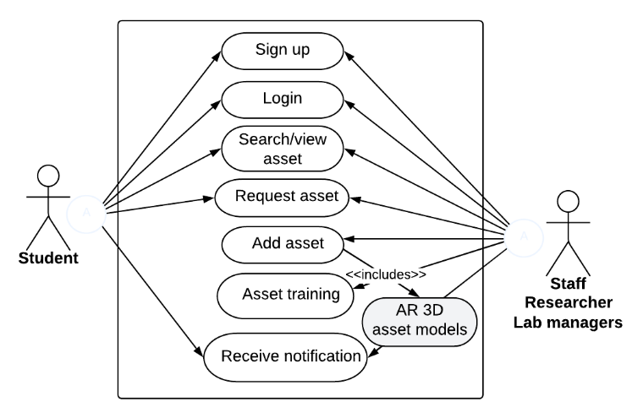
Figure (1) presents a Use Case Diagram illustrating the interactions between users and the system. There are two main types of users, referred to as actors in Unified Modeling Language (UML):
- System Administrator
- System User (e.g., asset handler or operations personnel)
The System User interacts with the system to access and manage asset-related information, while the System Administrator oversees and maintains the system, ensuring data accuracy and optimal performance.
Each system function is represented by a use case (ellipse), encapsulated within the system boundary (large rectangle). These use cases define the essential functionalities that the actors can perform.

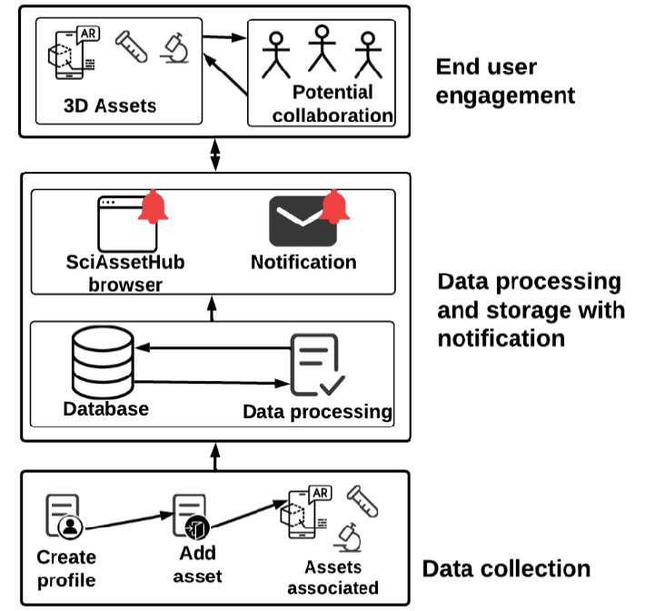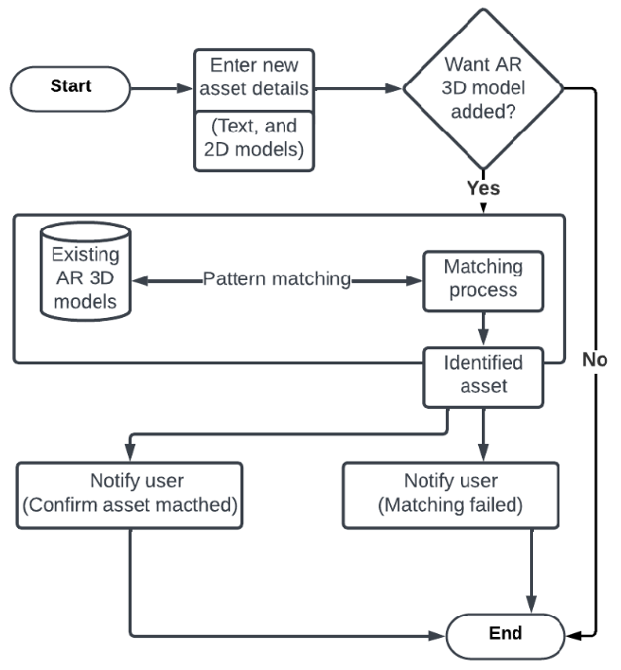
In addition, Figure (2) shows the Sequence Diagram, which illustrates the flow of interactions between the system components over time. It highlights how the system administrator initiates actions such as adding or updating asset information and how the system computes the shortest path to a specific asset location using Dijkstra’s Algorithm.
This interaction involves querying the system database to retrieve the network of asset locations and compute the most efficient route, making the process of locating and managing assets more effective.

CHAPTER FOUR
DESIGN AND IMPLEMENTATION OF THE ASSET MANAGEMENT SYSTEM
4.1 SYSTEM DESIGN
System design is the process of defining the architecture, components, modules, interfaces, and data for a system to satisfy specified requirements. In this chapter, the focus is on designing an asset management system that tracks, manages, and reports on the assets of an organization using PHP, MySQL, and WAMPServer.
4.1.1 Input Design
Input design focuses on capturing accurate data and minimizing errors. Key input forms include:
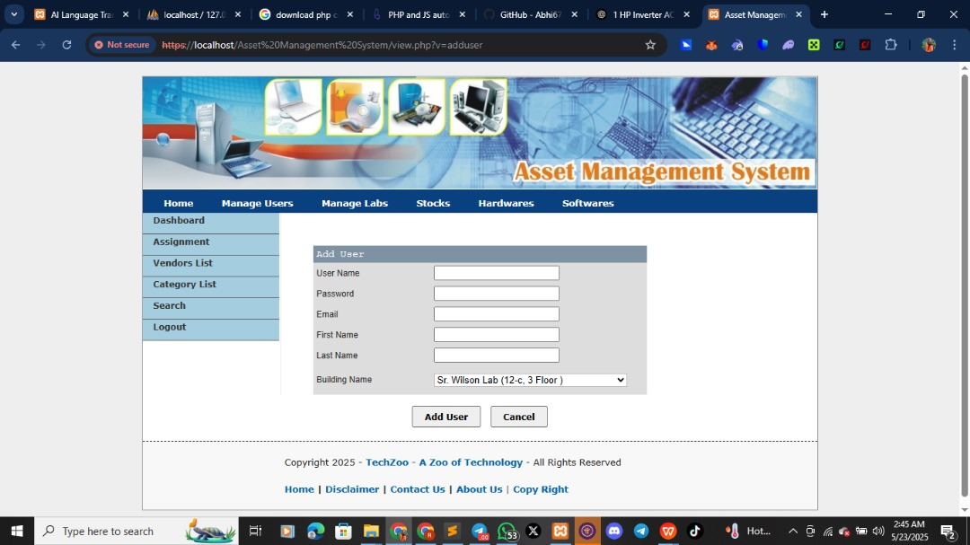
Asset Registration Form – For entering asset details like name, description, category, purchase date, cost, and location.
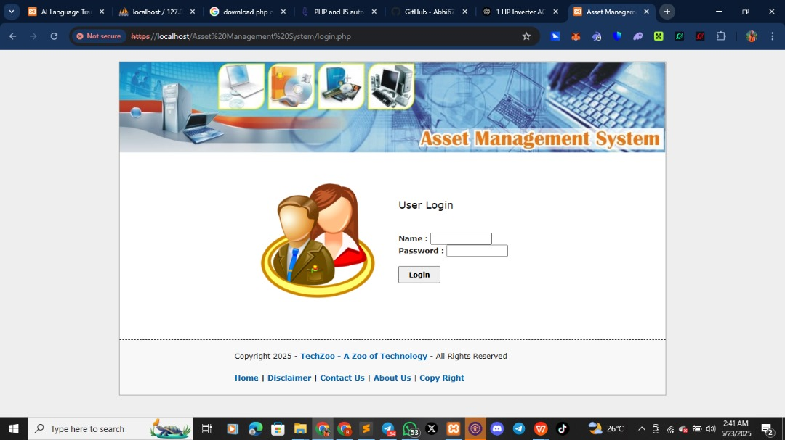
User Login Form – For secure access based on roles (admin, manager, or viewer).
Asset Update Form – For modifying existing asset information.
These forms were developed using HTML, Bootstrap (for styling), and PHP for form processing.

4.1.2 Output Design
The system generates several outputs to provide users with real-time asset information. These include:
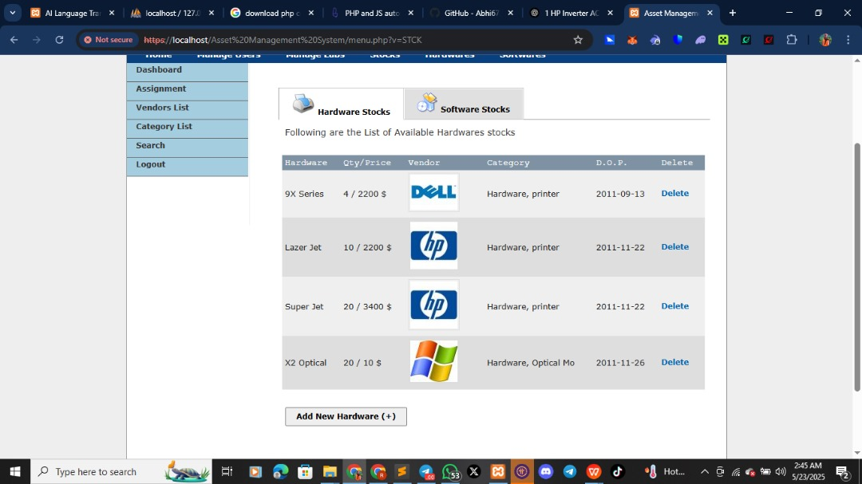
Asset Reports – Lists of all assets, assigned assets, and available assets.
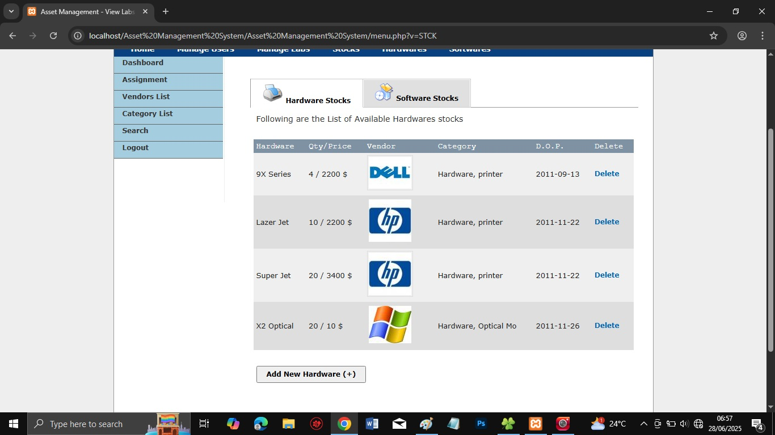
Maintenance Reports – Logs of repair and maintenance history.
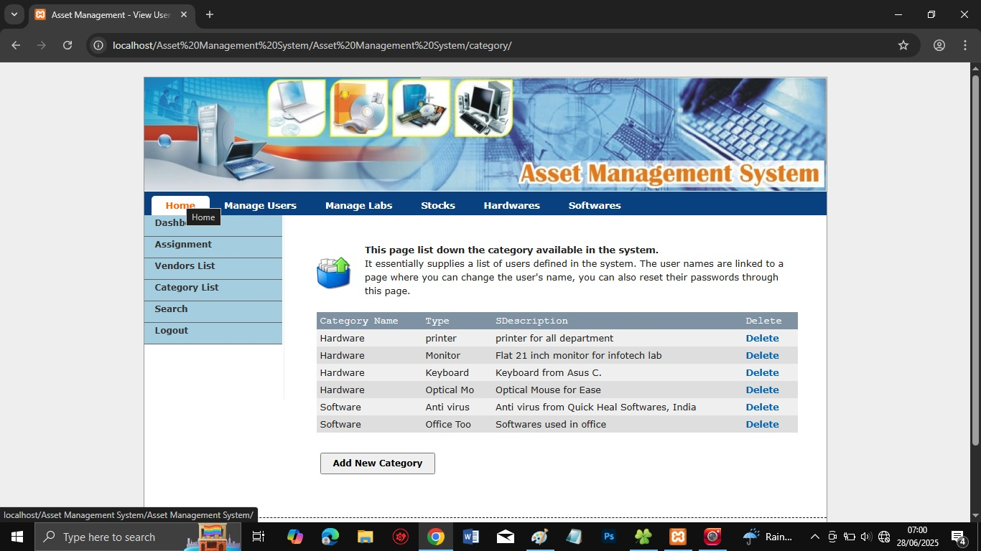
Dashboard Summaries – Visual summaries using charts to show asset distribution and status.
4.1.3 Database Design
The database was implemented using MySQL on WAMPServer. Key tables include:
assets (asset_id, asset_name, category_id, purchase_date, cost, status)
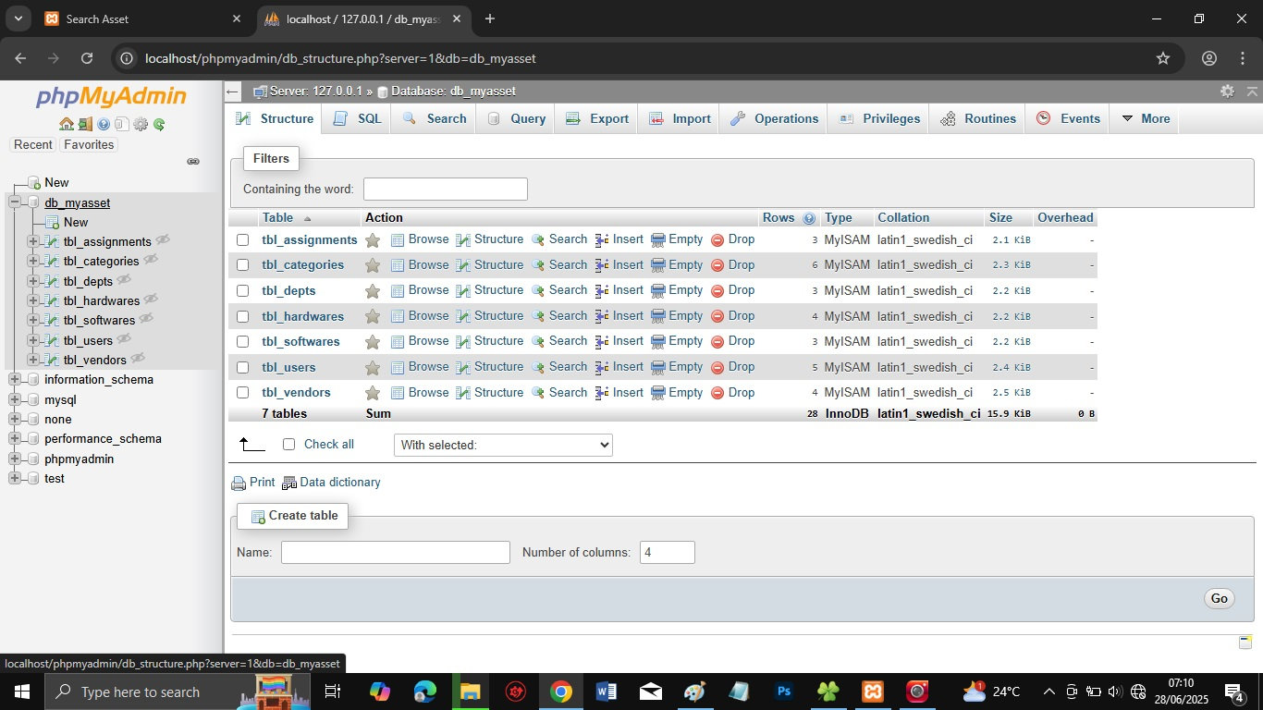
categories (category_id, category_name)
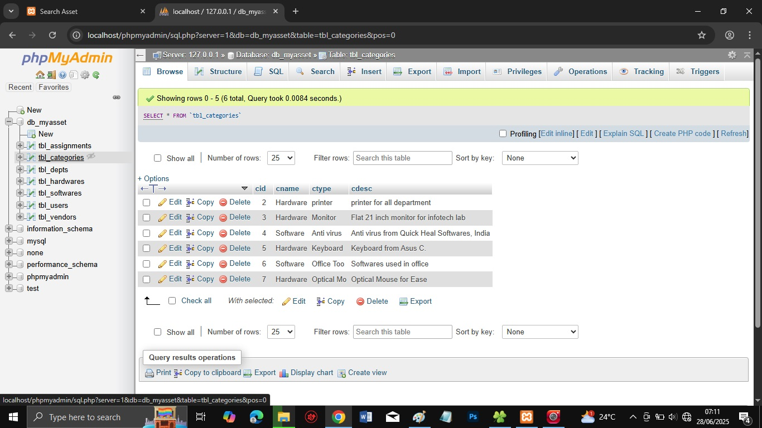
users (user_id, username, password, role)
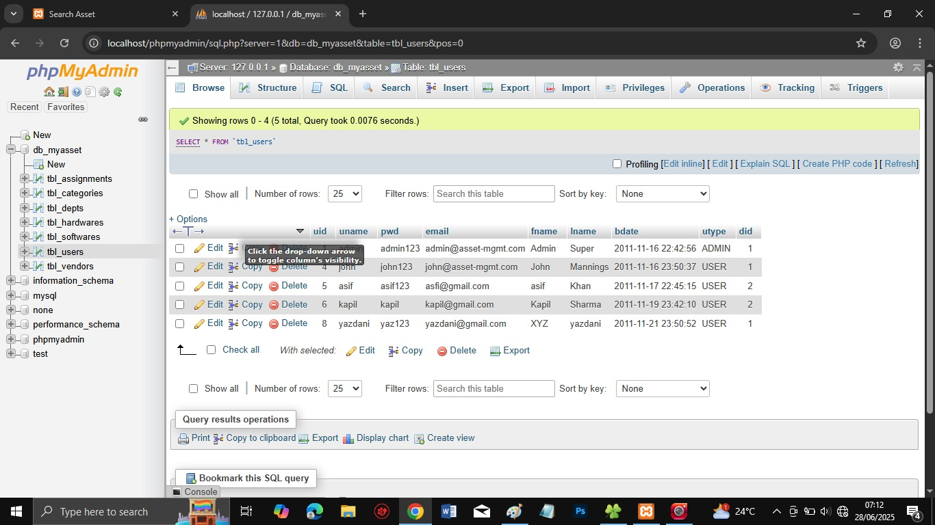
Relationships between tables ensure data integrity and effective querying.
4.1.4 Procedure Design
Procedures were defined for:
- Adding new assets.
- Assigning and unassigning assets.
- Updating asset information.
- Managing users and roles.
- Tracking maintenance and calculating depreciation.
These procedures are implemented using PHP scripts that interact with the MySQL database.

4.2 SYSTEM IMPLEMENTATION
4.2.1 Choice of Programming Language and Tools
- PHP was chosen as the server-side language for backend scripting.
- MySQL serves as the database engine.
- WAMPServer is used as the local development environment, combining Apache, MySQL, and PHP.
- HTML/CSS/Bootstrap for frontend design.
- JavaScript for client-side interactivity and form validation.
4.2.2 Hardware Requirements
- Minimum of Intel Core i3 processor or higher.
- At least 4GB RAM.
- 500GB HDD or SSD.
- LAN or internet access for remote use (if hosted online).
- 4.2.3 Software Requirements
- Windows 10 or later.
- WAMPServer (latest version).
- Web browser (Chrome or Firefox recommended).
- Code editor (e.g., VS Code or Sublime Text).
4.2.4 Implementation Techniques
The system was developed using modular programming and MVC architecture for maintainability. The system was tested locally on WAMPServer before deployment. Core modules include:
- Authentication module.
- Asset registration and tracking module.
- Assignment module.
- Maintenance and depreciation module.
- Reporting and analytics module.
4.3 SYSTEM DOCUMENTATION
4.3.1 Program Documentation
- Install WAMPServer and start Apache and MySQL services.
- Place the project folder in www directory.
- Import the SQL file into phpMyAdmin to create the database.
- Access the system via browser at http://localhost/asset-management.
4.3.2 System Maintenance
System maintenance includes:
- Regular backup of the MySQL database.
- Updates to PHP scripts to patch bugs or introduce new features.
- Adding or editing user roles and access rights.
- Maintaining the frontend layout and responsiveness.

CHAPTER FIVE
SUMMARY, CONCLUSION AND RECOMMENDATIONS
5.1 SUMMARY
This project focused on the design and implementation of an Asset Management System to help organizations effectively manage their physical assets. The aim was to eliminate manual tracking processes and provide a centralized platform for recording, assigning, maintaining, and reporting on assets.
The system was built using PHP for backend development, MySQL for database management, and WAMPServer as the local development environment. The major features of the system include:
- Asset registration and categorization.
- Assignment and reassignment of assets to users or departments.
- Maintenance tracking and history logging.
- Automated depreciation tracking.
- Role-based access control for different users (e.g., admin, manager).
- Reporting and dashboard summaries for management.
Through this project, the drawbacks of manual asset tracking such as loss, misplacement, duplication, and poor record-keeping were addressed. The solution offers greater transparency, accountability, and operational efficiency.
5.2 CONCLUSION
The asset management system developed in this research serves as an efficient tool for managing organizational resources. It provides a structured way to keep accurate records, generate reports, and support informed decision-making.
With the integration of PHP and MySQL, the system can be deployed locally or hosted online, depending on the organization’s needs. The implementation supports both scalability and customization.
By eliminating the manual system and reducing human errors, the application contributes to better resource utilization and helps organizations maintain up-to-date asset information in real time.

5.3 RECOMMENDATIONS
Based on the development and performance of this system, the following recommendations are made:
- Deployment on a central server: For multi-user access, especially in large organizations, the system should be deployed on a centralized server or intranet.
- Regular database backup: To prevent data loss, automated or scheduled backups should be performed regularly.
- User training: Staff members should be properly trained on how to use the system, especially those in administrative and IT roles.
- Expand features: Future enhancements can include barcoding, QR code scanning, or integration with mobile devices for easier inventory tracking.
- Security enhancement: Implementing SSL, login attempt limitations, and user activity logs will strengthen system security.
- Cloud hosting: For wider accessibility and business continuity, hosting the application on a secure cloud platform is recommended.

REFERENCES
Adams, R., Baker, M., & Clark, T. (2022). Integrating AI into modern asset management: Benefits, challenges, and future directions. Journal of Intelligent Systems, 34(3), 211–225. https://doi.org/10.1016/j.jintsys.2022.100761
Ahuja, R. K., Magnanti, T. L., &Orlin, J. B. (2021). Network flows: Theory, algorithms, and applications. Prentice Hall.
Chaudhry, M. A., & Sharma, D. (2016). Role of asset management in organizational productivity: A case study approach. International Journal of Business and Management Invention, 5(8), 10–18.
Cormen, T. H., Leiserson, C. E., Rivest, R. L., & Stein, C. (2022). Introduction to algorithms (4th ed.). MIT Press.
Dijkstra, E. W. (1959). A note on two problems in connexion with graphs. NumerischeMathematik, 1(1), 269–271. https://doi.org/10.1007/BF01386390
El-Hassan, M., & Mahmoud, A. (2023). Real-time asset tracking in healthcare: A case study of algorithmic optimization. International Journal of Healthcare Information Systems and Informatics, 18(1), 33–47. https://doi.org/10.4018/IJHISI.20230101.oa3
El-Hassan, M., & Mahmoud, R. (2023). Challenges in integrating asset management with operational systems: A review. Journal of Industrial Maintenance, 28(2), 145-158.
Kumar, A., & Patel, D. (2023). Digital transformation in asset management: An empirical study across manufacturing sectors. Journal of Industrial Management, 42(1), 55–72.
Nguyen, T., & Tran, L. (2023). Effects of manual asset management on organizational efficiency: Evidence from manufacturing firms. International Journal of Operations Management, 19(1), 33-49.
Nguyen, V. T., & Tran, L. H. (2023). Path optimization in warehouse asset management using Dijkstra’s Algorithm. Journal of Logistics & Operations Research, 17(2), 144–159. https://doi.org/10.1080/16258312.2023.120014
Oluwaseun, T., &Eze, C. (2022). Barriers to digital asset management adoption in public institutions in Nigeria. African Journal of Information Systems, 14(2), 101–117.
Osei, K., &Boateng, A. (2024). Implementation of IoT-enabled asset management in manufacturing: Evidence from Ghana. African Journal of Management Science, 19(1), 87–103.
Osei, K., &Boateng, F. (2024). Asset tracking challenges in large organizations: A case study approach. African Journal of Business and Management, 12(1), 76-91.
Patel, R., & Singh, A. (2022). Optimization algorithms in smart asset management: A comparative study. Journal of Applied Computing and Informatics, 18(4), 280–295. https://doi.org/10.1016/j.jaci.2021.12.008
Patel, R., & Singh, S. (2022). Barriers to adopting automated asset management systems in SMEs. Technology Adoption Review, 16(4), 101-117.
Wang, Y., & Chen, H. (2023). Integrating ERP and asset management systems for enterprise efficiency. International Journal of Information Management, 63, 102546. https://doi.org/10.1016/j.ijinfomgt.2023.102546

