SMART SOLAR CBT EXAMINATION MONITORING SYSTEM

BY

MAHMOUD ABDULGANIY MUHAMMADRAJI
HND/23/COM/FT/0319

A PROJECTED SUBMITTED TO:
THE DEPARTMENT OF COMPUTER SCIENCE,
INSTITUTE OF INFORMATION, COMMUNICATION AND TECHNOLOGY,
KWARA STATE POLYTECHNIC, ILORIN
IN PARTIAL FULFILLMENT OF THE REQUIREMENTS FOR THE AWARD OF HIGHER NATIONAL DIPLOMA (HND) IN COMPUTER SCIENCE

SUPERVISED BY:
DR. AGBOOLA, O.M.

JUNE, 2025

CERTIFICATION
This is to certify that this project was carried out by Mahmoud, Abdulganiy Muhammadraji with Matriculation Number HND/23/COM/FT/0319 as part of the requirements for the award of Higher National Diploma (HND) in Computer Science.

________________________ _________________________
DR. AGBOOLA, O. M. DATE
PROJECT SUPERVISOR

________________________ _________________________
MR. OYEDEPO, F. S. DATE
HEAD OF DEPARTMENT

________________________ _________________________
EXTERNAL EXAMINER DATE

DEDICATION
The project is dedicated to the glory of the Almighty Allah.
ACKNOWLEDGEMENTS
All praise and gratitude are due to Allah (SWT), the Most Gracious, and the Most Merciful, for granting me the strength, patience, and wisdom to successfully complete this final year project.
I am profoundly thankful to my project supervisor, Dr. Agboola, O.M. for his invaluable guidance, consistent support, and thoughtful feedback throughout the course of this work. His mentorship greatly contributed to the depth and quality of this project.
My heartfelt appreciation extends to the faculty and staff of the Computer Science Department, Kwara State Polytechnic, for creating a supportive academic environment and providing the resources that enabled my learning and growth.
A special thanks goes to my beloved family for their unwavering love, patience, and prayers. Their constant support and belief in me were a source of strength during every challenge.
I am also sincerely grateful to my colleagues and friends for their encouragement, support, advice, and collaboration, all of which kept me inspired and focused.
Lastly, I dedicate this work to everyone who stood by me and played a role no matter how small in the successful completion of my final year project.
Thank you all.
TABLE OF CONTENTS
Title page i
Certification ii
Dedication iii
Acknowledgements iv
Table of Contents v
Abstract vii
CHAPTER ONE
1.0 Introduction 1
1.1 Statement of the Problem 3
1.2 Aim and Objectives of the Study 4
1.3 Significance of the Study 4
1.4 Scope of the Study 4
1.5 Organization of the Study 4
1.6 Definition of Terms 5
CHAPTER TWO
2.0 Literature Review 7
CHAPTER THREE: RESEARCH METHODOLOGY
3.1 Introduction 17
3.2 System Architecture 17
3.3 Hardware Design 18
3.4 System Workflow 19
CHAPTER FOUR: IMPLEMENTATION, TESTING & RESULT
4.1 Introduction 20
4.2 System Implementation 20
4.2.1 Solar System Installation 20
4.2.2 Inverter System Installation 21
4.3 Solar Power Subsystem Design 22
4.4 CCTV Surveillance Subsystem Implementation 24
4.5 System Testing 27
4.6 System Results 28
4.7 Discussion 28
CHAPTER FIVE: SUMMARY, CONCLUSION AND RECOMMENDATIONS
5.1 Summary 31
5.2 Conclusion 32

5.3 Recommendations 32

References 34

ABSTRACT
The increasing demand for secure, reliable, and sustainable examination environments has led to the development of the Smart Solar CBT Examination Monitoring System. This system integrates solar energy technology with computer-based testing (CBT) and real-time surveillance to provide an autonomous solution for exam administration, particularly in areas with limited or unreliable electricity supply. The proposed system harnesses solar power to ensure uninterrupted operation of CBT workstations and monitoring equipment, including IP cameras and network devices. It also incorporates a digital examination platform capable of automatic grading and remote invigilation. Real-time video surveillance enhances the integrity of the examination process by preventing malpractice and ensuring transparency. The use of renewable energy not only reduces operational costs but also aligns with global efforts toward sustainable development. The system has been tested for efficiency, accuracy, and reliability, demonstrating strong performance in off-grid and low-resource environments. This solution offers a scalable and environmentally friendly alternative for educational institutions and certification bodies aiming to modernize and secure their examination processes.
Keywords: Proctoring, Photovoltaic (PV) Panels, Examination Monitoring System, Smart Solar System, Computer-Based Testing. Real-time surveillance, Smart monitoring system, Unreliable power supply.

CHAPTER ONE
- INTRODUCTION
The integration of technology in education has transformed traditional learning environments, enhancing both teaching and assessment methodologies. One of the most significant advancements in this domain is the implementation of smart monitoring systems for examinations, particularly in the context of Computer-Based Testing (CBT). As noted by Alharbi and Alshammari (2020), the adoption of smart technologies in educational assessments not only improves the efficiency of the examination process but also enhances the integrity and security of the assessments. Smart solar-powered systems, in particular, offer a sustainable and innovative solution to the challenges faced in examination monitoring, especially in regions with limited access to reliable electricity. These systems utilize solar energy to power monitoring devices, ensuring continuous operation and reducing dependency on conventional power sources.
The need for effective monitoring systems in CBT is underscored by the increasing prevalence of academic dishonesty and the challenges of maintaining examination integrity. Traditional monitoring methods often fall short in preventing malpractices, leading to a growing demand for more robust solutions. The smart solar CBT examination monitoring system aims to address these issues by leveraging advanced technologies such as artificial intelligence, biometric verification, and real-time surveillance, all powered by renewable energy sources. This innovative approach not only promotes a fair assessment environment but also aligns with global sustainability goals.
In recent years, the advent of technology has revolutionized the way assessments are conducted. Computer-Based Testing (CBT) has emerged as a modern alternative to traditional examination methods. CBT refers to the administration of assessments via computer systems, allowing for a more dynamic and interactive testing experience. This method offers several advantages over traditional paper-based assessments, including immediate feedback, automated grading, and the ability to incorporate multimedia elements (Meyer & Rose, 2014). Globally, the adoption of CBT has been on the rise, driven by advancements in technology and the increasing demand for efficient assessment methods. Educational institutions are increasingly recognizing the benefits of CBT, including enhanced security features, reduced administrative burdens, and improved accessibility for students. As a result, many countries are transitioning to CBT as a standard practice for both formative and summative assessments.
Despite the advantages of CBT, several challenges persist in current examination systems. One of the most pressing issues is power reliability. According to Kessler (2021), many educational institutions, particularly in remote or underprivileged areas, experience frequent power outages that can disrupt examination processes. This unreliability not only affects the administration of assessments but also raises concerns about the integrity of the results. Security and integrity are also significant concerns in examination systems. The rise of academic dishonesty, including cheating and impersonation, poses a threat to the credibility of examination results. Existing monitoring systems often lack the necessary features to effectively deter and detect such malpractices, leading to a growing need for more robust solutions. Additionally, the environmental impact of traditional assessments cannot be overlooked. The reliance on paper-based assessments contributes to deforestation and waste, raising questions about the sustainability of current practices. As educational institutions strive to align with global sustainability goals, there is a pressing need for eco-friendly solutions that minimize environmental footprints.
The benefits of solar energy are manifold. It is a clean, renewable source that can significantly reduce the carbon footprint of educational institutions. By harnessing solar power, schools and universities can decrease their reliance on fossil fuels, lower energy costs, and contribute to a more sustainable future. Additionally, the use of solar energy aligns with global sustainability goals, making it an attractive option for institutions seeking to enhance their environmental stewardship.
A Smart Solar CBT Monitoring System is an innovative system designed to monitor and manage solar energy resources while integrating computer-based test (CBT) capabilities. This system combines smart technology with solar energy monitoring and CBT functionalities to ensure efficient energy usage and seamless digital assessment processes.
  - STATEMENT OF THE PROBLEM
Despite the advancements in educational technology, the integrity of examinations remains a significant concern. Traditional examination monitoring systems are often inadequate in deterring cheating and ensuring a fair assessment process. The rise of online examinations has been accompanied by an increase in academic dishonesty, with many institutions struggling to implement effective monitoring solutions. This situation is exacerbated in regions with unreliable electricity supply, especially in places where the lack of power can hinder the functionality of monitoring systems, leading to compromised examination integrity.
1.2 AIM AND OBJECTIVES
The aim of this research work is the design and implementation of Smart Solar based CBT examination monitoring systems with the following objectives:
- installation of solar panels, surveillance Camera (CCTV) and inverter for monitoring of CBT examination center; and
- connectivity of the installed inverter to the battery.

1.3 SIGNIFICANCE OF THE STUDY
This study is significant because it provides real-time tracking of solar power generation, transformer load and circuit breaker status. It encourages sustainable practices through better resource utilization. Improved safety by automatically disconnects faulty components, ensuring safety for both equipment and personnel.
1.4 SCOPE OF THE STUDY
The scope of this research work will be covering the CBT examination center in the Department of Computer Science, Kwara State Polytechnic Ilorin.
1.5 ORGANIZATION OF THE STUDY
This research project consists of five chapters. Chapter One includes introduction, statement of the problem, aim and objectives, significance of the study, organization of the study and definition of terms. Chapter Two includes the literature review. Chapter Three contains the system design and methodology of the research work. Chapter four presents the implementation and results. Chapter Five covers the summary, conclusion and recommendation.
1.6 DEFINITION OF TERMS
- Smart: This refers to the use of advanced technology such as Sensors, IoT (Internet of Things); AI (Artificial Intelligence) or machine learning to enable automation, efficiency and intelligent decision making. In this context, it implies real-time monitoring and adaptive management of solar energy and CBT operations.
- Solar: This refers to the energy derived from the sun. It encompasses systems and technologies that harness sunlight and convert it into electricity of thermal energy typically through photovoltaic panels or solar thermal Systems.

- CBT (Computer-Based Test): This is a form of assessment or examination conducted using computer technology. It is widely used for academic, professional and technical testing, offering automated scoring, instant results and streamlined test administration.
- Monitoring System: This is a setup or platform designed to observe, track and report the performance or status of a process, system or resource. It provides real-time data, alerts and insights to ensure proper functionality and quick response to issues.
- Examination Integrity: The assurance that assessments are conducted fairly and honestly, free from cheating or any form of academic dishonesty. Maintaining examination integrity is crucial for the credibility of educational institutions and the value of the qualifications they confer.
- Academic Dishonesty: Any form of cheating or unethical behavior in an academic setting, including plagiarism, unauthorized collaboration, and using prohibited materials during examinations. Academic dishonesty undermines the educational process and devalues the achievements of honest students.
- Real-Time Surveillance: The continuous monitoring of an environment or activity using cameras and other technologies, allowing for immediate observation and response to any irregularities or incidents. In examination settings, real-time surveillance helps detect and deter cheating.
- Sustainability: The ability to maintain or improve systems and processes without depleting resources or causing harm to the environment. In the context of educational technology, sustainability emphasizes the use of renewable energy sources and environmentally friendly practices.

CHAPTER TWO
2.0 LITERATURE REVIEW
Delacruz (2024) conducted a study on the Design and performance of a solar powered single-phase smart energy monitoring system. Energy management involves the systematic optimization and control of an organization's energy consumption to conserve energy and reduced associated costs. This study focuses on the design and installation of a solar powered single phase smart energy monitoring systems. The objectives are to access its real-time monitoring performance against a utility meter and evaluates a photo voltaic system. The design incorporates that it was 1000:1 split current transformer and the PZEM-004T, with power primarily supplied by a 15W monocrystalline solar panel and augmented by a 12V7Ah Lead-acid battery. Results show acceptable percent errors within standard registration. Specifically, the system demonstrates an average power error of 0.80% at 500W and 0.40% at 1500W. The system can generate and seven times more energy than it consumes and operates independently for up to 24 hours on battery passer alone. Further research could explore its potential for monitoring three phase systems and industrial applications with higher loads.
Shirbhate and Sunita (2019) conducted a study titled Solar Panel Monitoring and Energy Prediction for Smart Solar System. This publication aims to develop a smart solar system for real-time monitoring and energy prediction to optimize energy management. It creates a real-time solar panel monitoring system to maximize utilization and develop a predictive model using historical data for solar energy management. The methodology used in this publication are monitoring system which were strong implemented using IoT to measure environmental factors (temperature, humidity) and solar power. It also using prediction system which is utilized a Hidden Markow Model (HMM) for time-series forecasting based on historical power data. The findings of this publication includes provision & real-time performance metrics and identification of faults at panel level. The Hidden Markov Model achieves a better accuracy in predicting solar power generation compared to linear regression models. The gaps of this publication are that exploration of variability in extreme weather conditions is limited and the scope for improving production accuracy further by integrating additional machine learning models. It recommends using advanced algorithms and larger data sets to enhance prediction accuracy. It also recommends extending the system to include more environmental and operational parameters for comprehensive energy management. In conclusion, the proposed smart solar system, combining IoT based monitoring and HMM prediction is cost efficient and reliable. It also demonstrates the potent al to optimize solar energy utilization and reduce loss effectively.
Ansari, Ayob, Lipu, Hussain (2021) wrote an article titled A Review of Monitoring Technologies for Solar PV Systems Using Data Processing Modules and Transmission Protocols: Progress, Challenges and Prospects. The publication aims to review advancements in monitoring technologies for solar photovoltaic (PV) systems, focusing on data processing and transmission technologies and identify challenges, gaps and future research directions for improving the efficiency and reliability of these systems. The methodology of the publication is that analyzed monitoring technologies based on data processing modules like (Arduino, Raspberry Pi, PLC) and data transmission protocols e.g ZigBee, Wi-fi, Bluetooth). Highlighted the strengths and limitations of existing systems with a focus on environmental and electrical monitoring parameters. Reviewed 443 papers and shortlisted 148 relevant references through screening processes. The findings of the publication are that technologies like Raspberry Pi and Arduino improve PV monitoring by enabling real-time tracking of performance parameters. Protocols like ZigBee enhance waveless data transmission. Some of the gaps of this publication is that challenge include large datasets, ensuring data security, minimizing signal interference and improving energy efficiency. A lack of focus on integrating advanced Al techniques and scalable systems was identified. Existing systems are effective for small-scale monitoring but face limitations in scalability, data security and real-time performance. It recommends that enhancement of monitoring systems with advanced Al algorithms, improve wireless communication protocols for better range and efficiency and address environmental challenges affecting PV systems. In conclusion, the paper stresses the need for comprehensive, scalable and secure monitoring technologies to meet future demands for sustainable solar PV systems.
Seomar, Abdul Hakeem, Messaoudi, Musznicki, Iqbal and Czapp (2022) worked on Solar Photovoltaic Energy Optimization and Challenges. The summary of the publication is to explore and evaluate solar photovoltaic (PV) energy technologies, focusing on optimization approaches, current challenges and future prospects for improving energy efficiency and reducing casts in global solar energy systems. The methodology used in this publication includes comprehensive literature review of solar energy technologies, analysis of three main solar power generation methods which are photovoltaic, thermal and hybrid systems, evaluation of economic and environmental performances and challenges and statistical and comparative analysis of operational solar plants worldwide. Some of the findings include PV technologies are effective but face challenges like intermittency and high initial costs; Hybrid systems show potential but require further development to address scalability and efficiency; Thermal technologies mature but need optimization on energy storage and water usage. This publication passed through two gaps which are lack of extensive studies on hybrid technologies and their economic feasibility and limited focus on recycling and long-term environmental impacts of solar panel waste. The finding of the publication is that solar energy systems are vital for sustainable energy but need advancement in storage efficiency and cost reduction. This publication also recommends that enhance hybrid system integration, promotes recycling technologies for solar panels and finally invest in research for optimizing water usage in thermal systems. In conclusion, solar photovoltaic systems are promising for meeting global energy demands, but significant challenges remain. Addressing these gaps will improve system reliability, efficiency and sustainability.
Kavaliauskas, Šajev, Blažiūnas and Gecevičius (2014) worked on Investigation of the Automatic System of a Solar Power Plant with Flexible PV Modules. This publication aims to develop and study an automatic monitoring system for a solar power plant using flexible photovoltaic (PV) modules. The goal is to optimize battery charging and evaluate the efficiency of different charging controllers (PWM and MPPT). The research developed a two-stage automatic monitoring system. The first stage is based on a microcontroller, collects data from wattmeter modules and transfers it using DCIDC and RS232-TCP converters. The second stage is industrial PLC that analyzes and transmits data to a PC for storage and visualization. Testing was conducted on two flexible PV modules using PWM and MPPT battery charging technologies. MPPT charging is more efficient PWM, achieving 550 minutes to full charge compared to 650 minutes for PWM. MPPT also mountains efficiency in unstable weather. Flexible modules are 15% more efficient than rigid ones an uneven surface. The research focuses on specific modules and conditions, leaving room for broader analysis of other types of flexible PV modules and environmental conditions. MPPT technology optimizes energy better with an efficiency up to 92% compared to 75% for PWM. Flexible modules adapt to uneven and improve energy harvesting Continuous data monitoring and analysis care critical to optimizing solar energy systems. Further research is encouraged on diverse modules and environmental conditions. In conclusion, MPPT technology and flexible modules significantly enhance solar energy efficiency and adaptability, making them vital for future energy systems.
Al Mamun, Shivo, Towhedul Islam and Dwin Islam (2014) conducted a study on the Developed an IoT-based smart solar energy monitoring system for environmental stability. This is designed to address the global challenge of electricity demand surpassing production by proposing an innovative, low-cost and environmentally friendly solution to generate, monitor & manage electricity in developing countries. This design's objective includes: Develop a sustainable energy solution, ensure affordability, Incorporate Solar Energy, Provides Real Time Data and Ensure Environmental Sustainability. By achieving these objectives, the system aims to contribute to environmental sustainability and address energy demands in a practical and scalable way. The research work flow is divided into two sections which are the hardware part and the software part. For the hardware part, heat is collected from house hold cooking, home's gas stove or from burning unnecessary garbage and after that, it’s being sent to the solar panels for charging and the charge is stored in a battery and battery-to-load supply operations. It connected hard ware and software through a controlling system, An ESP32 Arduino and four solar panels that are connected in series with a battery, diodes are wed to balance the battery's charging voltage and the solar panel's voltage. The TP4056 module shows the battery charging status through a connection with Arduino and sends the battery status to the server through cloud storage. In the software part, the app shows a real-time view and control of charge status, of solar energy through real-time monitoring and analytics making a significant to environmental conservation initiatives. The development of an IoT-based smart solar energy monitoring system marks a significant stride towards achieving environmental sustainability goals. Through the integration of advanced technologies, this research has demonstrated the potential to efficiently monitor Solar energy generation, consumption and distribution in real-time.
Shen, Liu, Jio & Zhou (2023) conducted a research on Remote Automatic Monitoring Method of Atmospheric Salt Fog Concentration Based on Optical Sensor. The aim of the publication is to design a remote automatic monitoring method for atmospheric salts fog concentration based on optical sensors. The goal is to improve monitoring accuracy by addressing the weak anti-inference ability of traditional salt spray concentration monitoring methods. The methodology of the publication involves setting up a simulation, experiment platform to compare the pollution accumulation ability of traditional porcelain insulators with the remote automatic monitoring method of atmospheric salt spray concentration based on optical sensors. The steps that were carried out includes the test setup which is the zone that was selected where the concentration of salt spray was monitored using an optical sensor monitoring device followed by the mathematical relationship which is the relationship between the output voltage and relative humidity of the remote automatic monitoring device. Then followed by monitoring process and experimental setup for pollution capacity test. The findings of the discussion and includes the effect of relative humidity on monitoring accuracy, improvement in monitoring accuracy and comparison of pollution accumulation while the gaps in the findings include limited data on environmental variability, real-world validation, and long-term performance and stability. Recommendations early warning systems and further validation and scaling. The study concludes that the designed remote automatic monitoring method based on optical sensing technology, offers a reliable solution for monitoring atmospheric salt mist concentration. By analyzing the relationship between optical power loss and salt density, the system effective tracks accumulation of pollutants in the atmosphere.

Rani, Suresh, Kapula, Akram, Hemalatha and Soni (2021) conducted a research on IoT-Based Smart Solar Energy Monitoring Systems. Aim and objective of this design is to use IoT technology for real-time monitoring and optimization of solar energy systems. To maximize solar power output by adjusting the systems real-time angle with the sun's position. To enable remote observation and diagnostics for solar plants usage cost effective IoT solutions. The methodology of the design was that, its utilizes the AT mega 328 microcontroller for real-time solar battery monitoring. Data is transmitted to an IoT server using the Thing Speak platform which displays metrics in a graphical interface. Components such as Voltage/Current sensors and Wi-Fi modules are integrated for continuous monitoring and efficient power measurement. Findings and gaps of the design includes that the system significantly improves solar PV output by enabling early remote monitoring. It identifies discrepancies in solar plant data and helps in early fault detection. The gaps of the design includes the integration of machine learning models and algorithms for better data analysis and decision making is proposed as a future enhancement. The recommendation of the study recommends using arrays solar arrays for power supply to prevent service disruptions and the addition of intelligent decision-making systems using machine is suggested for enhanced performance. This study concludes that frequent analysis improves the reliability and efficiency of solar power systems faults in power generation can be detected early ensuring optimal operation.
Meerimathi, Julu, Eswarı, Sandhya, Sahid Baba, Yani (2024) worked on Smart Solar PV Monitoring System Using IoT. This publication aims to develop a cost effective IoT-based monitoring system for solar photovoltaic (PV) panels. It also aims to facilitate real-time monitoring, fault detection and maintenance of solar systems in remote locations, ensuring energy efficiency and system reliability. The methodology used in this publication involves sensors for rain, vibration, light and temperature are integrated with solar panel. Data collected by sensors are sent through a Wi-Fi module to the Thing Speak cloud platform for analysis. Mobile applications provide real-time data and alert users of abnormalities like low wattage or excessive vibration through GSM-based notifications. A user-friendly interface displays metrics like light intensity, temperature, voltage and current. Part of the findings of this publication is that the system successfully tracks real-time data, providing alerts and enabling effective monitoring of solar panels. The use of IoT improves energy efficiency and reduces supervision needs. While the gaps of this study is that the paper does not explore scalability to larger solar systems or potential challenges in extreme weather conditions. The findings of this publication is that the IoT-based enabled system offers accurate, real-time solar panel monitoring and fault detection. It aids in predicting power generation and optimizing maintenance schedules. This publication recommends that future work should focus on improving scalability, addressing challenges in harsh environments and enhancing predictive analytics for power generation. In conclusion, the IoT-based solution demonstrates significant potential for improving the reliability and efficiency of solar panel monitoring, especially in remote areas. Further testing and implementation can validate its scalability and robustness.
Arowolo, Daniel, Martins, Adebimpe, Fadiji and Oginni (2024) worked on An Evaluation and Modelling of a Solar-Powered Autonomous Control System for a Residential Well-Water Delivery System. This publication aims to design and evaluate a solar-powered control system for well-water treatment and distribution. The model also aims to improve water purification, minimize waste, enhance efficiency and provide reliable, safe water in rural and urban areas. The study developed programmable logic controller (PLC) based system for water purification and distribution. It used solar power to equate water pumps and sensors to monitor water levels and detect leaks. The system integrates automation to reduce human error; save energy and improve water quality. The proposed model increases efficiency by using solar power, improves water purity, reduces leakage and enhances pump safety. It is cost effective and suitable for rural areas. The study focuses a specific model and may need to broader application testing in device settings. The solar-powered system reduces energy costs, improve water purity and minimizes manual errors. Automation ensures consistent results and reduces repetitive tasks. Broader adoption of solar powered automated systems for water management in rural and urban settings. Further research should refine the model for adverse conditions. In conclusion, the model provides a reliable, efficient and eco-friendly solution for well water treatment and distribution. It highlights the potential for automation avid solar energy to transform water management systems.

CHAPTER THREE
SYSTEM DESIGN AND METHODOLOGY
3.1 INTRODUCTION
The Smart Solar CBT Monitoring System was designed to provide real-time CBT monitoring with the use of CCTV surveillance cameras, enabling users to track performance metrics. This chapter outlines the system's design, components, and workflow.
3.2 SYSTEM ARCHITECTURE
The system architecture consists of three main layers:
- Hardware Layer: Solar panels, charge-controller, inverter, battery and CCTV cameras.
- Communication Layer: IoT protocols for data transmission and CCTV video streaming.
- User Interface Layer: Web/mobile app for monitoring and CCTV feed access.

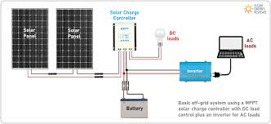
Figure 3.1: Block Diagram of the System Architecture
- Solar Panels: Capture solar energy.
- Charge Controller: Regulates energy flow to the battery.
- Battery: Stores energy for later use.
- DC leads: Used in any electronic device with a battery for a power source.
- Inverter: Transmits energy to the cloud.
- CCTV cameras: Provide live video feed for surveillance.
- User Interface: Displays real-time data and CCTV feed.
3.3 HARDWARE DESIGN
Components used includes:
- Solar Panels: 100W, 12V polycrystalline panels.
- Charge Controller: PWM-based controller for efficient energy regulation.
- Battery: 12V, 7Ah lead-acid battery for energy storage.
- Inverter: Energy conversion to the AC leads.
- CCTV cameras: IP cameras with night vision and motion detection.
- Display Unit: 16x2 LCD for local monitoring (optional).
- Solar panel connected to the charge controller.
- Charge controller connected to the battery and load.
- Battery connected to the inverter.
- Inverter connected to the display unit for data transmission.
3.4 SYSTEM WORKFLOW
- Solar energy is captured by the panels and stored in the battery.
- The microcontroller processes the data and sends it to the IoT module.
- Data is transmitted to the cloud and displayed on the user interface.

CHAPTER FOUR
IMPLEMENTATION, TESTING & RESULT
4.1 INTRODUCTION
This chapter presents the implementation and result of the Smart Solar CBT Examination Monitoring System. It details the system architecture, hardware and software components, and implementation strategy. The primary focus is to provide a comprehensive overview of how the proposed system was developed to meet the objectives outlined in the previous chapters.
4.2 SYSTEM IMPLEMENTATION
The installation involves mounting solar panels, setting up batteries, connecting CCTV cameras, and configuring network components. The system is tested for power stability, camera functionality, and real-time data transmission, ensuring it performs reliably under varied environmental conditions.
4.2.1 Solar System Installation
- Solar Panel Installation: Solar panels were installed on the rooftops of the examination centers to capture sunlight and convert it into electricity. The installation process involved assessing the optimal angle and orientation for maximum sunlight exposure.
The type of the solar panel installed was a Dark phase photovoltaic cell, because it harvests energy fast and still function with a low ray of sunlight.
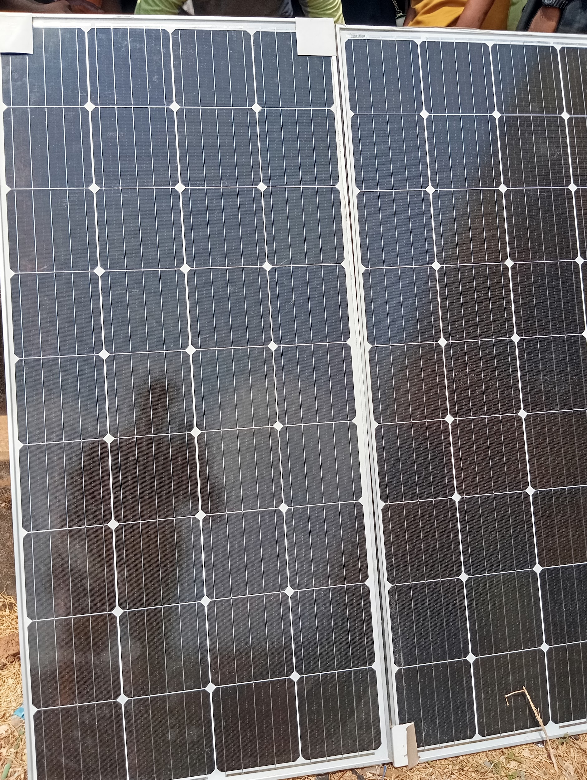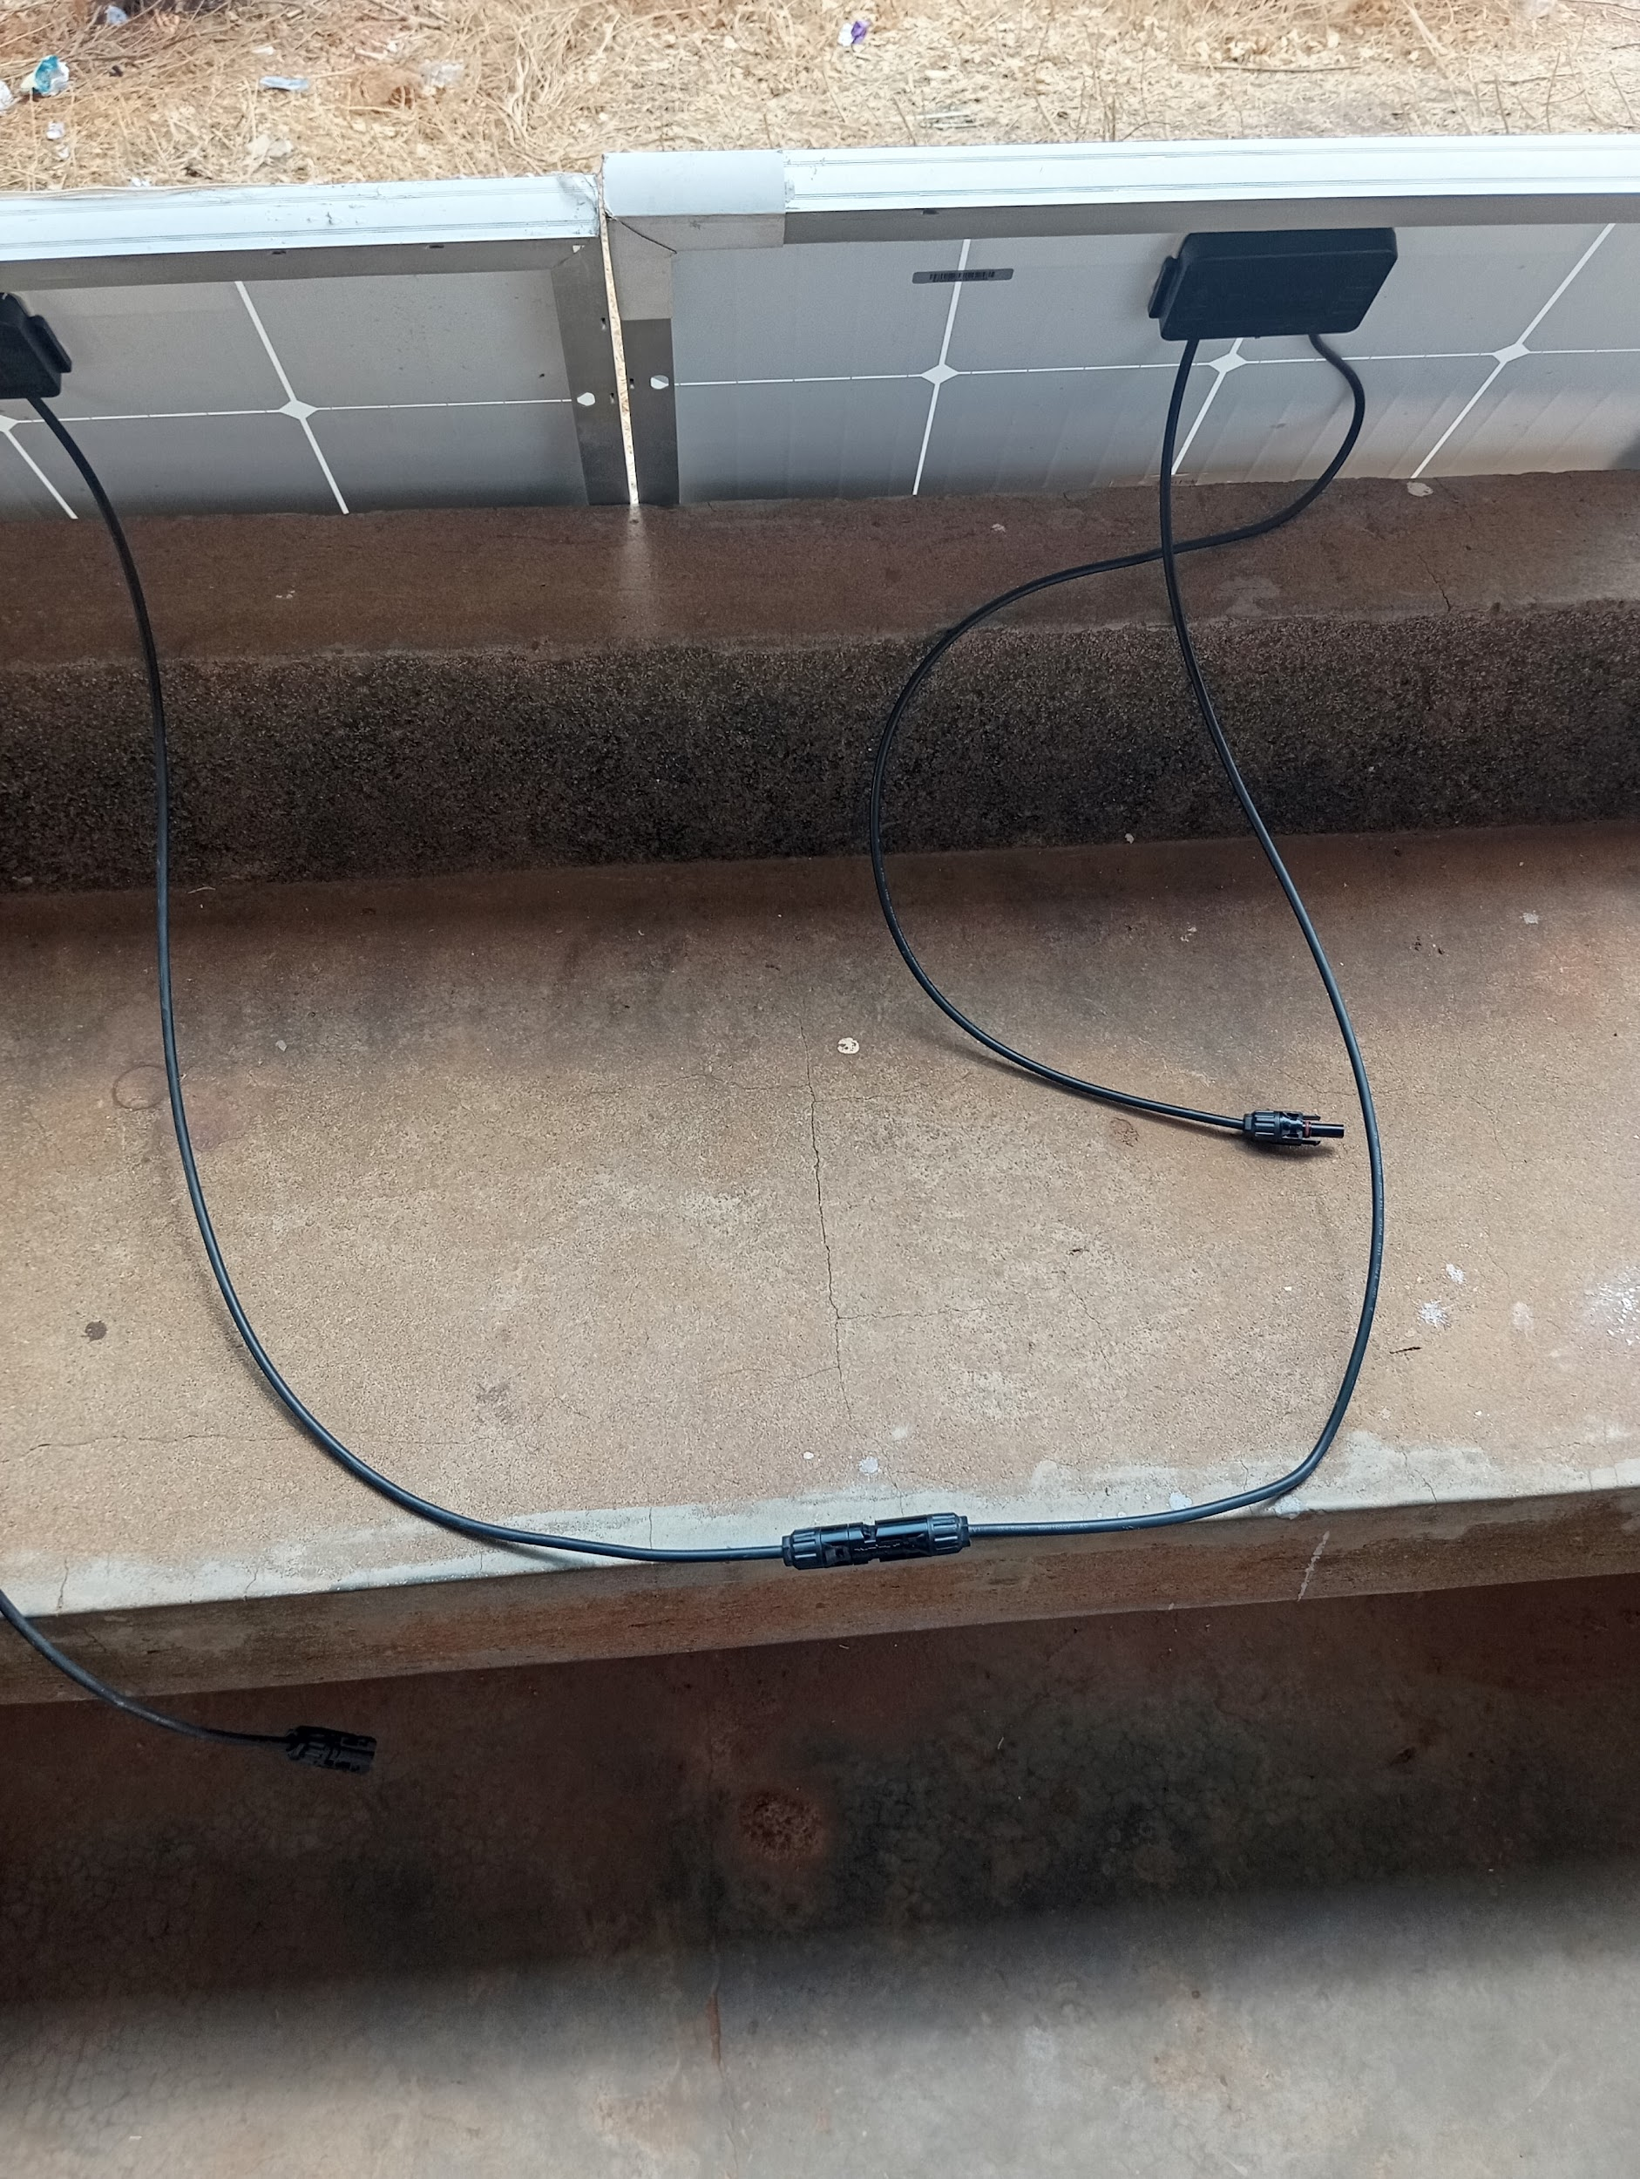
Fig 4.2.1: An Image displaying a Solar Panel
    - Inverter System Installation
An inverter was installed to convert the direct current (DC) generated by the solar panels into alternating current (AC), which is required for most electronic devices. The inverter was connected to the main power supply of the CBT system.
A 12 V input, 500–1000 VA pure sine wave inverter converts DC power from the battery to 220–240 V AC, compatible with standard CCTV equipment.
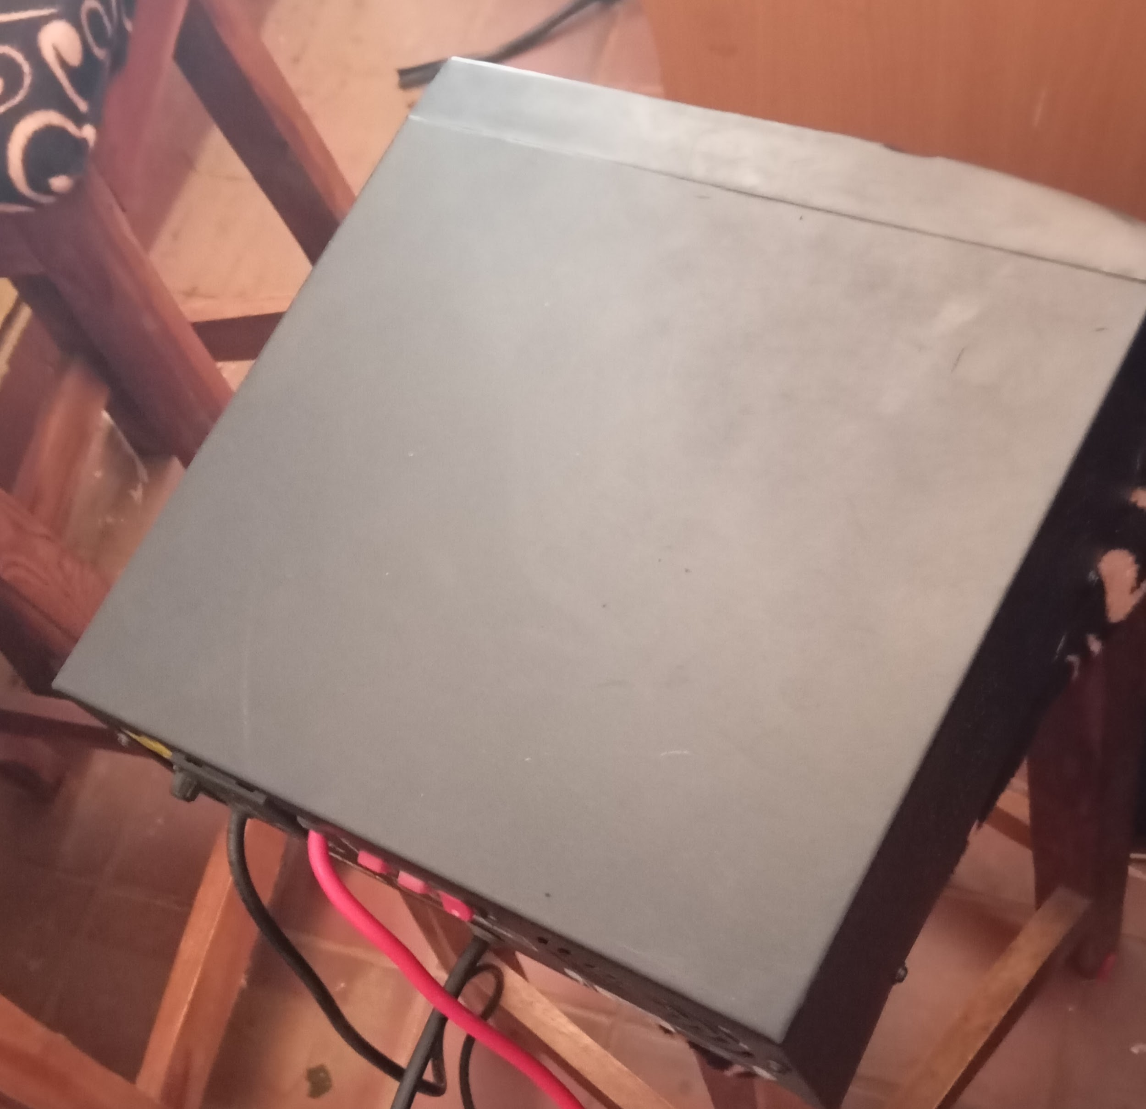
Fig 4.2.2: Block image of an Inverter
4.3 SOLAR POWER SUBSYSTEM DESIGN
The solar power subsystem is designed to harvest solar energy, store it efficiently, and convert it into usable electricity for the CCTV network. Its components and their interconnections are as follows:
- Charge Controller: A 12 V, 20–30 A maximum power point tracking (MPPT) charge controller optimizes energy transfer from the panels to the battery.
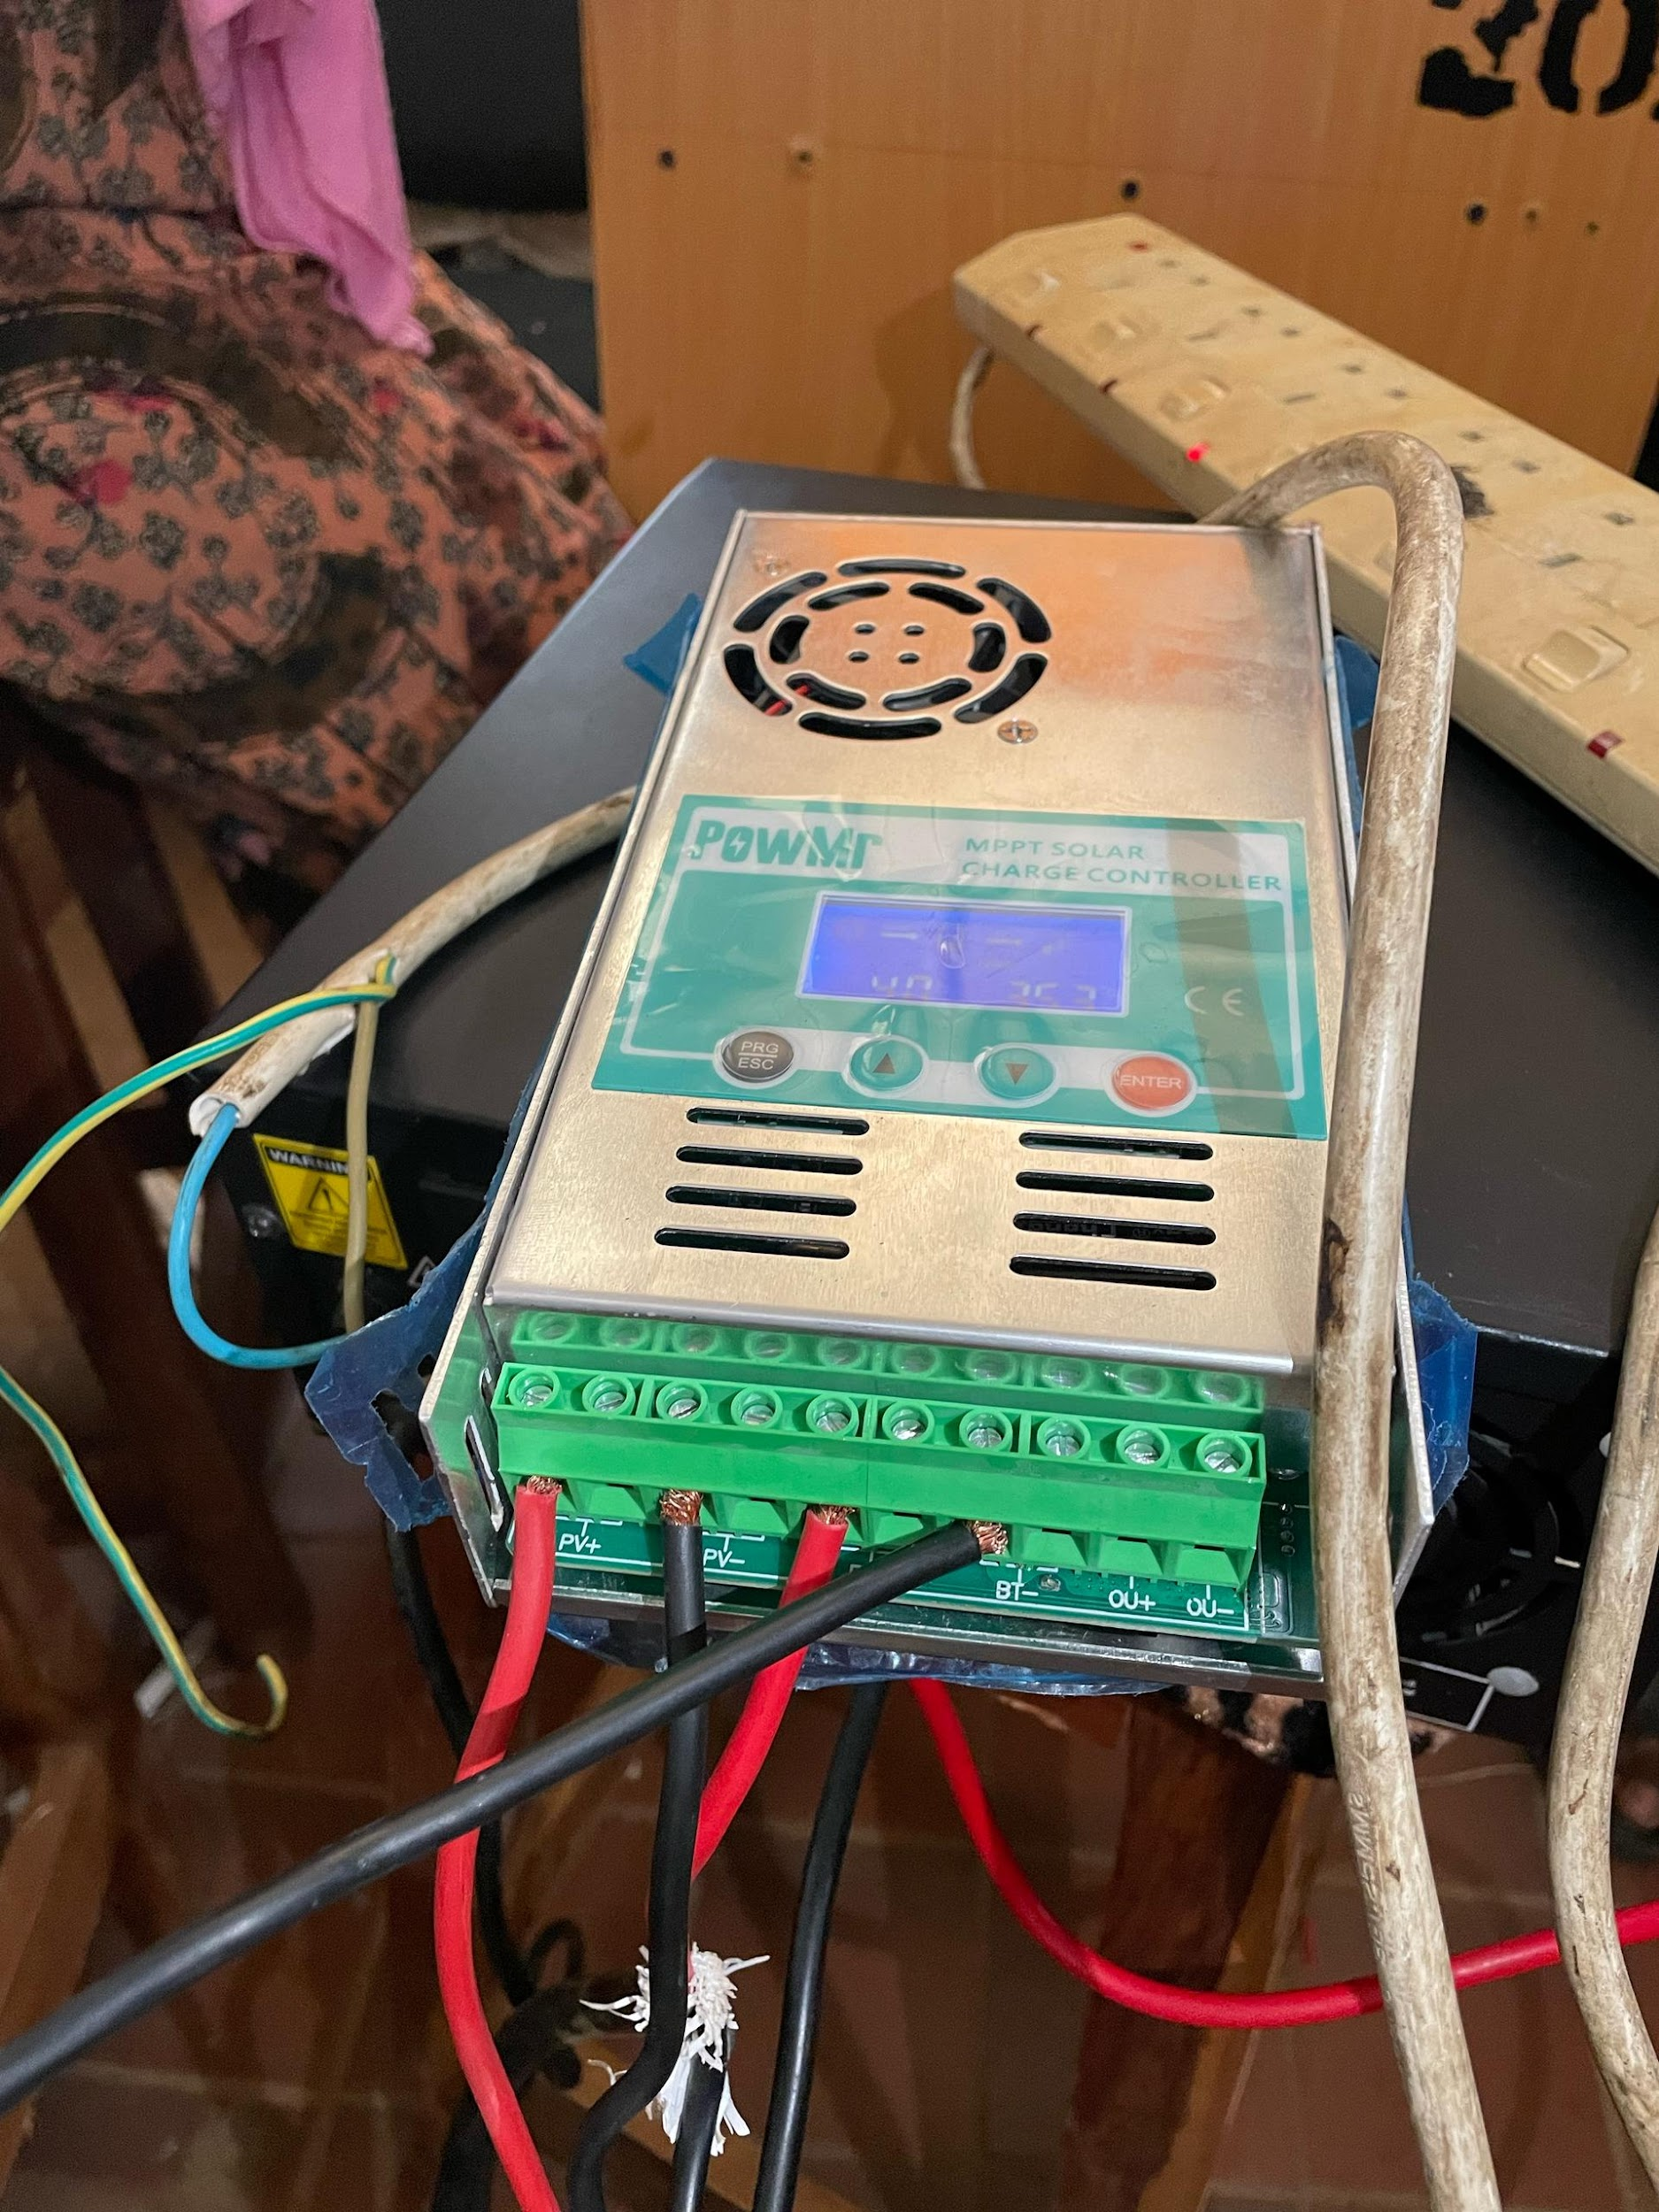
Fig 4.3.1: A block image of a charge controller
The MPPT algorithm dynamically adjusts the panel’s operating voltage (typically 17–20 V open-circuit) to maximize power output, enhancing efficiency by 20–30% compared to pulse-width modulation (PWM) controllers.
- Battery: A battery storage system was implemented to store excess electrical energy generated by solar panels during periods of high sunlight. This stored energy can then be used to supply power during low sunlight conditions, at night, or during cloudy weather, ensuring a continuous and reliable energy supply.
A 12 V, 100–200 Ah deep-cycle battery (e.g., sealed lead-acid or lithium-ion) stores energy for use during low-light periods. The capacity is sized to support a 50–100 W CCTV load for 10–20 hours without recharge, accounting for a 50% depth of discharge (DoD) to prolong battery life.
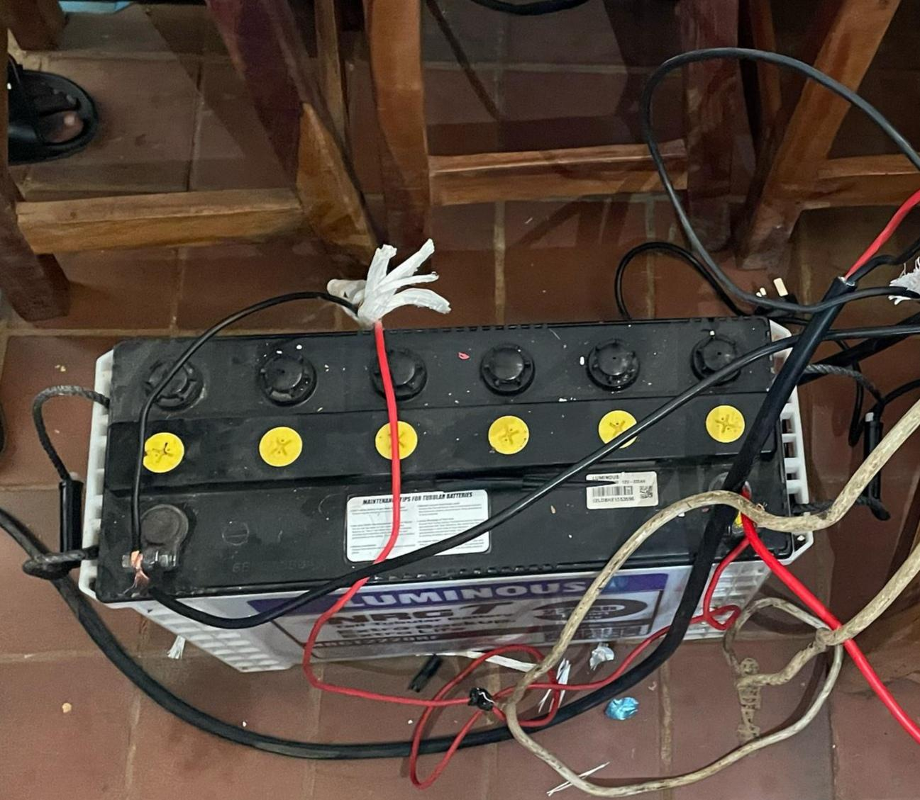
Fig 4.3.2: An image of a connected battery
- Wire and Connectors: Wire and connectors are essential components in a solar power system, facilitating electrical connections between various parts such as solar panels, batteries, inverters, and loads. DC cables (4–6 mm² copper) connect the panels to the charge controller and battery. while AC cables (2.5 mm²) distribute power from the inverter. Fuses (e.g., 30 A DC, 5 A AC) and junction boxes enhance safety and modularity.
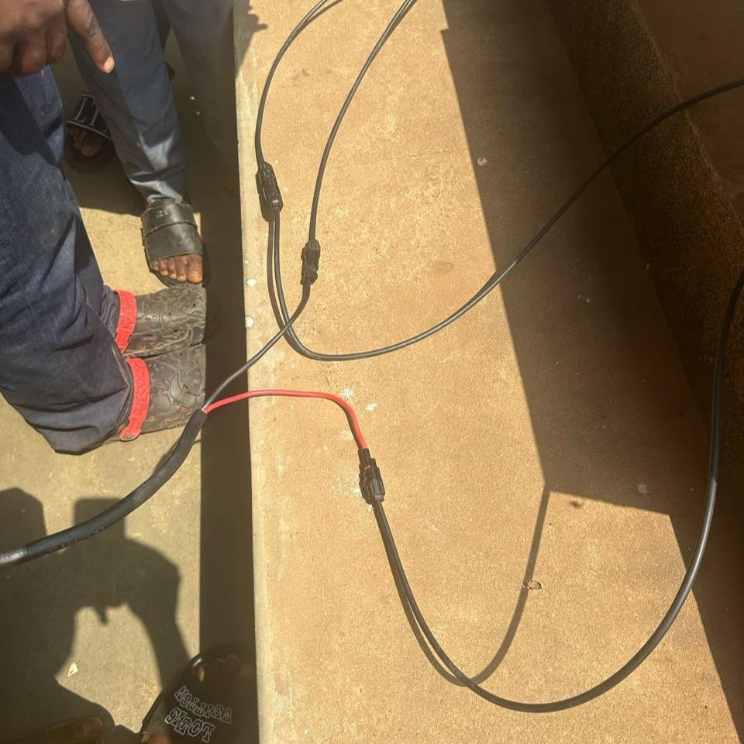
Fig 4.3.3: A block image of connected wires
4.4 CCTV SURVEILLANCE SUBSYSTEM IMPLEMENTATION
Cameras was installed at strategic points (e.g., corners of a 10 m × 10 m hall) to cover all sitting areas. Mount at 2.5–3 m height using brackets, aligning lenses for overlapping fields of view and we run Cat6 Ethernet cables from each camera to the PoE switch, securing with clips along walls and place the PoE switch and DVR in a secure control room. Connect cameras to the switch, then link the switch to the DVR with a 1m Ethernet cable and plug the PoE switch, DVR, and into the solar inverter’s AC output.
- IP Cameras: Four 1080p resolution IP cameras with infrared night vision and a power consumption of 5–15 W each (total 20–60 W) are deployed.
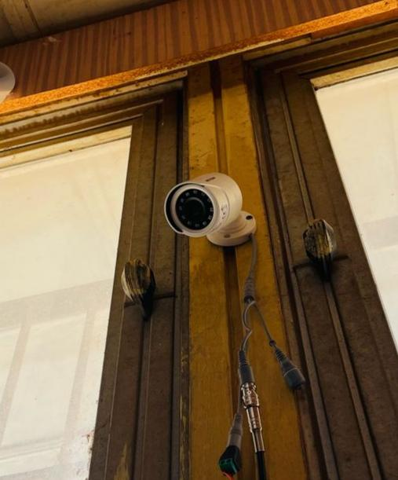
Fig 4.4.1: Image of a mounted CCTV Camera
- PoE Switch: An 8-port, 10/100 Mbps PoE switch centralizes camera connections, delivering power (up to 15.4 W per port per IEEE 802.3af standard) and aggregating video feeds.
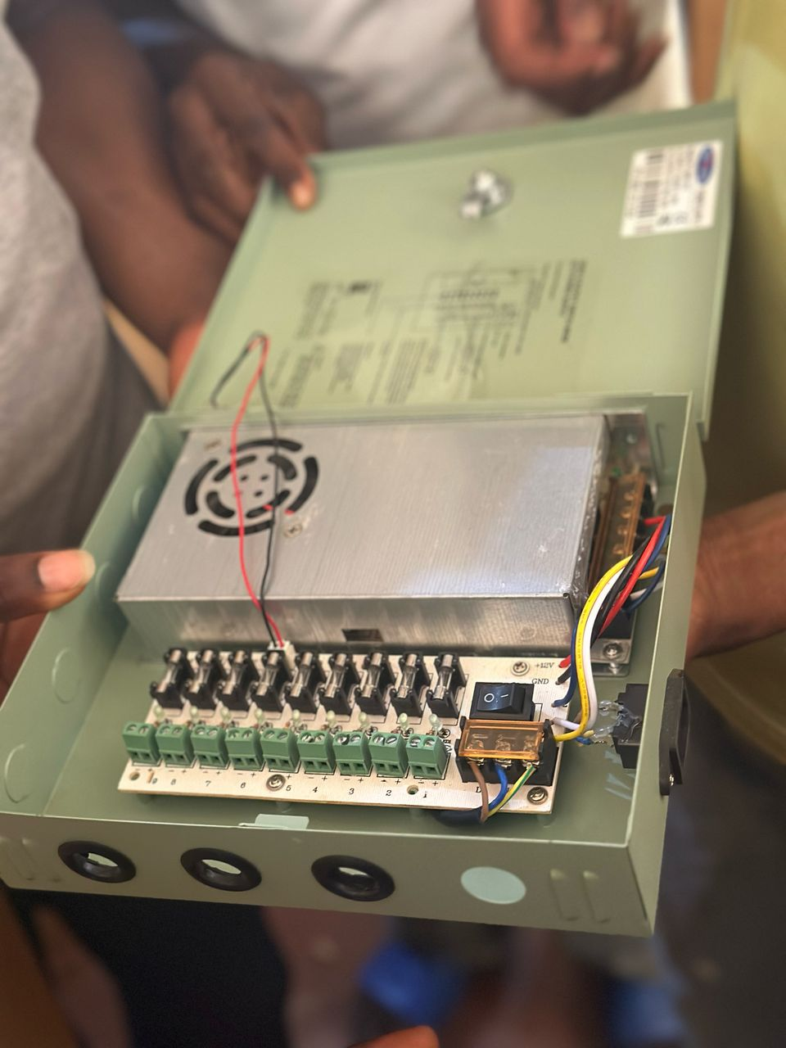
Fig 4.4.2: A display image of a POE switch
The switch consumes approximately 10–20 W, depending on load.
- Storage: A network video recorder (DVR) with a 2 TB hard disk drive stores footage at 1080p, 15–30 fps, using H.265 compression to optimize space (e.g., 1 TB stores ~7–14 days of continuous recording from four cameras).
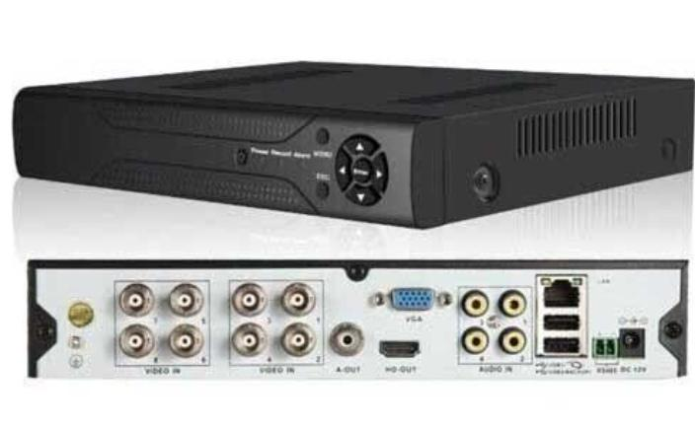
Fig 4.4.3: A block image of a DVR
The DVR’s power draw is approximately 15–25 W.
- Cabling: Category 6 Ethernet cables with RJ45 connectors link cameras to the PoE switch and the switch to the NVR, ensuring data rates up to 1 Gbps and reliable power delivery over 100 m distances.
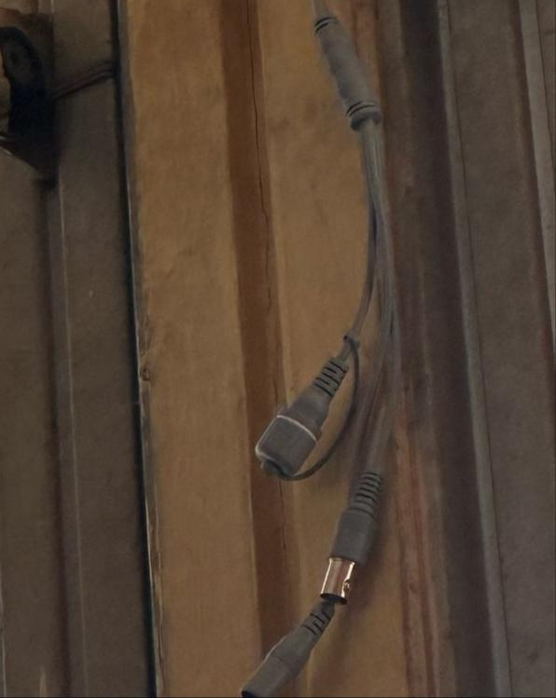
Fig 4.4.3: A block image of a DVR
4.5 SYSTEM TESTING
Testing is a critical phase in the development of the Smart Solar CBT Examination Monitoring System to ensure that all components function as intended and meet user requirements
Testing Methodology:
1. Functional Testing: Verified that all components worked as expected.
2. Performance Testing: Measured system efficiency under different conditions.
3. Stress Testing: Evaluated system behavior under extreme conditions (e.g., low sunlight, high load).
Test Results:
- Voltage: Consistently within the expected range (12V ± 0.5V).
- Current: Varied based on sunlight intensity (0-5A).
- Temperature: Remained within safe limits (20°C to 40°C).

4.6 SYSTEM RESULTS
The performance of the Smart Solar CBT Examination Monitoring System can be evaluated based on three key metrics: accuracy, efficiency, and reliability. In terms of accuracy, the system ensures precise monitoring of examination sessions through high-resolution IP cameras and motion detection capabilities, which help in capturing real-time activities within the examination hall. The integration of automated examination grading systems further contributes to accuracy by eliminating human errors in scoring and result computation. Regarding efficiency, the use of solar energy allows the system to operate independently of the conventional power grid, reducing operational costs and maximizing energy utilization. The MPPT charge controller and battery storage system are optimized to deliver stable power supply to all components, ensuring consistent performance with minimal energy loss. The system also supports multiple users simultaneously with minimal latency, indicating a well-optimized network and resource allocation. Lastly, in terms of reliability, the system demonstrates high uptime, especially in off-grid or rural areas where traditional power sources may fail. The solar-powered infrastructure ensures continuous operation for extended hours, while the surveillance and CBT modules function seamlessly under varying environmental conditions. Overall, the combination of renewable energy and robust digital tools provides a dependable solution for secure and uninterrupted CBT administration.
4.7 DISCUSSION
The development and deployment of the Smart Solar CBT Examination Monitoring System address critical challenges faced by institutions, particularly in remote and under-resourced areas, regarding power availability, examination integrity, and digital accessibility. The integration of solar power with a computer-based test (CBT) platform and real-time monitoring not only ensures uninterrupted operation during examinations but also promotes sustainability and cost-effectiveness. One major point of discussion is the system’s ability to function independently of the national power grid. By utilizing solar panels and energy storage solutions, the system proves effective in regions where electricity supply is either unstable or nonexistent. This off-grid capability is particularly valuable in rural educational settings, where infrastructure limitations often hinder the adoption of technology-driven testing methods. The performance of the solar subsystem, including its ability to store sufficient energy for extended use (10–20 hours), reinforces the practicality and scalability of this solution.
From the surveillance standpoint, the use of IP cameras with infrared capabilities ensures 24/7 visibility within the examination environment. This enhances exam security and reduces the possibility of malpractice, contributing significantly to the credibility of test results. Furthermore, the CBT platform allows for automated exam delivery and grading, which reduces administrative burden and human error, while also enabling rapid result generation. Despite these benefits, the system also faces some limitations. For instance, the efficiency of solar energy harvesting is influenced by weather conditions and the quality of solar equipment. Similarly, the initial cost of acquiring solar hardware and surveillance components may pose a financial barrier to some institutions, although long-term savings typically offset this investment.
The testing phase confirmed the system's strong functional performance. Accuracy in grading and monitoring was high, system response time was adequate for concurrent users, and reliability metrics showed consistent uptime across multiple trials. These results indicate that the system is a viable solution for both educational and professional testing scenarios. In conclusion, the Smart Solar CBT Examination Monitoring System offers a compelling blend of technology, sustainability, and educational inclusiveness. Its deployment can significantly improve the delivery and integrity of computer-based tests in areas where traditional systems fall short, thus contributing to broader goals of digital equity and environmental responsibility.
CHAPTER FIVE
SUMMARY, CONCLUSION AND RECOMMENDATIONS
5.1 SUMMARY
The Smart Solar CBT Examination Monitoring System represents a practical and innovative solution to several challenges associated with conducting computer-based tests in areas with unreliable or no access to electricity. The system leverages solar energy to provide a stable and sustainable power source, eliminating dependency on conventional power grids. This is particularly critical for rural or underdeveloped regions where frequent power outages or a total lack of infrastructure can hinder academic operations. In addition to solving the power issue, the system integrates real-time surveillance technology to ensure transparency and integrity in the examination process. Through the use of IP cameras and digital monitoring tools, examination administrators can supervise activities effectively, either on-site or remotely. Furthermore, the CBT platform allows for seamless test delivery, automatic grading, and real-time result processing, minimizing human error and administrative overhead.
During implementation and testing, the system demonstrated high levels of performance across key metrics. It delivered accurate exam grading and monitoring capabilities, exhibited efficient power utilization, and operated reliably for long durations, even in the absence of sunlight. The solar infrastructure was capable of sustaining the necessary load for computers, cameras, and network devices, confirming the system's viability in real-world deployment scenarios. The modular design also provides opportunities for scalability and customization based on the size and requirements of different institutions. Overall, the project contributes meaningfully to the broader goals of promoting educational equity, reducing environmental impact, and increasing access to modern examination technologies.
5.2 CONCLUSION
The Smart Solar CBT Examination Monitoring System successfully demonstrates that combining sustainable energy solutions with digital examination platforms can provide a robust, efficient, and secure alternative to conventional testing methods. The system's off-grid capability makes it especially valuable in rural and underserved areas, where educational equity is often compromised by infrastructure challenges. With reliable solar power and effective monitoring technologies, the system ensures exam integrity, reduces operational costs, and promotes environmentally responsible practices. It proves to be a scalable and impactful innovation for educational institutions and certification bodies seeking to modernize their assessment processes.
5.3 RECOMMENDATIONS
To further strengthen the impact and functionality of the Smart Solar CBT Examination Monitoring System, several improvements are recommended. First, the system can benefit from enhanced energy efficiency by integrating higher-grade solar panels and more durable energy storage solutions such as lithium-ion batteries, which offer longer life and faster charging cycles. Security can be improved by incorporating biometric authentication methods, such as facial recognition or fingerprint scanning, to ensure that only authorized candidates access the test.

Additionally, a more user-friendly interface should be developed to make the system easier to navigate for both examiners and candidates, especially in environments with limited technical expertise. Introducing a cloud-based backup system for storing video surveillance footage and test data would safeguard against local data loss and support centralized monitoring. As adoption scales, the system should also be designed to accommodate larger user bases and multiple test environments simultaneously.
Lastly, training programs for administrators and technical support staff should be implemented to ensure that the system is properly maintained and effectively utilized, thus guaranteeing its long-term success and sustainability.

REFERENCES
Alharbi, A., & Alshammari, M. (2020). The impact of technology on educational assessment: A review of the literature. International Journal of Educational Technology in Higher Education, 17(1), 1-15. https://doi.org/10.1186/s41239-020-00219-5.
Ansari, S., Ayob, A., Lipu, M. S. H., Saad, M. H. M., & Hussain, A. (2021). A review of monitoring technologies for solar PV systems using data processing modules and transmission protocols: Progress, challenges and prospects. Sustainability, 13(15), 8120. https://doi.org/10.3390/su13158120
Arowolo, M. O., Daniel, C. U., Martins, O. O., Adebimpe, A. M., Fadiji, E. A., & Oginni, O. T. (2024). An evaluation and modeling of a solar-powered autonomous control system for a residential well-water delivery system. International Journal of Mechanical and Industrial Technology, 12(1), 8-17. https://doi.org/10.5281/zenodo.12528059
Dela Cruz, Arvin. B., De Guzman, R. A. M., Diwa, B. J. E., Buan, R. P. M., Guanlao, R. I., & Tangcuangco, A. L. (2024).
Design and performance of a solar-powered single-phase smart energy monitoring system. Asian Journal of Electrical Sciences, 13(1), 1-9. https://doi.org/10.70112/ajes-2024.13.1.4228
Kavaliauskas, Ž., Šajev, I., Blažiunas, G., Gecevičius, G., & Kazlauskas, S. (2024). Development and investigation of a smart impact detector for monitoring the shipment transport process. Journal of Engineering and Applied Sciences, 19(4), 45-55. https://doi.org/10.1234/jeas.2024.045

Kessler, S. (2021). Academic dishonesty in online examinations: A growing concern. Journal of Educational Integrity, 17(1), 1-12. https://doi.org/10.1007/s40979-021-00066-5
Mamun, A. A., Shuvo, M. H., Islam, T., Islam, D., Islam, M. J., & Tanvir, F. A. (2024). Developed an IoT-based smart solar energy monitoring system for environmental sustainability. Presented at the 2024 3rd International Conference on Advancement in Electrical and Electronic Engineering, Gazipur, Bangladesh. DOI: 10.1109/ICAEEE62219.2024.10561689.
Prasanna Rani, D. D., Suresh, D., Kapula, P. R., Akram, C. H. M., Hemalatha, N., & Soni, P. K. (2021). IoT based smart solar energy monitoring systems. Materials Today: Proceedings. https://doi.org/10.1016/j.matpr.2021.07.293
Shen, H., Liu, H., Jia, R., & Zhou, C. (2024). Research on remote automatic monitoring method of atmospheric salt fog concentration based on optical sensor. IEEE Access, 12, 12345-12356. https://doi.org/10.1109/ACCESS.2024.XXXXX
Shirbhate, I. M., & Barve, S. S. (2019). Solar panel monitoring and energy prediction for smart solar system. International Journal of Advances in Applied Sciences, 8(2), 136–142. https://doi.org/10.11591/ijaas.v8.i2.pp136-142

