KWARA STATE POLYTECHNIC ILORIN, KWARA STATE.
INSTITUTE OF TECHNOLOGY
DEPARTMENT OF CIVIL ENGINEERING

ASSESSMENT OF TRAFFIC DELAY AT A 3-LEGGED ARTERIAL ROAD INTERSECTION.
BY
OLASUNKANMI MUBARAK OLAMILEKAN
ND/23/CEC/PT/0270
BEING IN RESEARCH WORK SUBMITTED TO THE DEPARTMENT OF CIVIL ENGINEERING, INSTITUTE OF TECHNOLOGY, KWARA STATE POLYTECHNIC, ILORIN

IN PARTIAL FULFILMENT OF THE REQUIREMENT FOR THE AWARD OF NATIONAL DIPLOMA (ND) IN CIVIL ENGINEERING
JUNE 2025.

CERTIFICATION
This is to certify that this research study was conducted by Olasunkanmi Mubarak Olamilekan (ND/23/CEC/PT/0270) and had been read and approved as meeting the requirement for the award of National Diploma (ND) in Civil Engineering of the Department Civil Engineering, Institute of Technology, Kwara State Polytechnic, Ilorin.

……………………… …………….……
ENGR. A.O. SAADU DATE
Project Supervisor

…………………………… ….…..……………
ENGR. A. SANNI DATE
Part Time Coordinator

……………………………. ….………...…….
ENGR. ABDULHAMEED ABDULRASAQ ADUAGBA DATE
External Examiner

DEDICATION
This project is dedicated solemnly to God Almighty, who is the sole inspiration of all things, without whom there would not be, and neither would this project.
Appreciation goes to my loving parents for their support in the fulfillment of my National Diploma (ND) both orally and financially. May God allow them to eat the fruit of their labor (Amen)

ACKNOWLEDGEMENTS
My achievement in life has been made possible by Almighty Allah and him to be praise. My unquantified gratitude to others who contributed to my achievement
My profound gratitude goes to my beloved parents Mr. & Mrs. Olasunkanmi for t
heir undying love and my wonderful brothers, sisters, friends and well wishers
My sincere appreciation to my project supervisor ENGR.A. O. SAADU for his patience and guidance in vetting this work and to all lecturers who supported me in various ways throughout my years of study.
To you all, I say Allah guidance and protection will be with you all
TABLE OF CONTENTS
Title page
Certification i
Dedication ii
Acknowledgement iii
Table of Contents iv
Abstract v
CHAPTER ONE: INTRODUCTION
1.0 Introduction
1.1 Background to the Study
1.2 Problem Statement
1.3 Aim and Objectives
1.4 Scope of the Study
1.5 Justification of the Study|
CHAPTER TWO: LITERATURE REVIEW
2.0 Literature Review
2.1 Road Interconnection and Economic Development
2.2 Intersection
2.2.1 Signalized Intersection
2.2.2 Nonsignalized Intersection
2.2.3 Traffic Control at Intersections
2.2.4 Intersection Geometry
2.2.5 Traffic Congestion at Intersections
2.2.6 Causes of Traffic Congestion
2.2.7 Previous Studies on Congestion in Nigeria
2.3 Performance Measures
2.3.1 Traffic Delay at Intersections
2.3.2 Control Delay
2.3.3 Forms of Delay
2.3.4 Queue Length
2.4 Capacity
2.5 Saturation Flow
2.5.1 Saturation Flow Rate
2.6 Level of Service (LOS)
2.6.1 Factors Affecting LOS
CHAPTER THREE: METHODOLOGY
3.0 Methodology
3.1 Description of the Study Area
3.2 Data Collection
3.2.1 Geometric Features
3.2.2 Traffic Data
3.2.3 Discharge Travel Time at Intersection
3.2.4 Delay
3.2.5 Estimating Level of Service
CHAPTER FOUR: DATA PRESENTATION & ANALYSIS
4.1 Results and Discussion
4.2 Traffic Flow of Each Leg of Taiwo Intersection
4.3 Discussion of Traffic Flow Data
4.4 Traffic Flow Patterns
4.5 Delay and Level of Service at the Selected Intersection
CHAPTER FIVE: SUMMARY, CONCLUSION & RECOMMENDATIONS |
5.1 Conclusion
5.2 Recommendations
REFERENCES

ABSTRACT
This study evaluates traffic delay and operational performance at the TaiwoOke threelegged signalized intersection in Ilorin, Kwara State, Nigeria. The primary objectives were to determine the intersection’s geometric characteristics, measure traffic flow volumes at each approach, quantify vehicular delays, and assess the overall Level of Service (LOS). Geometric data were collected insitu using tape measurements, while traffic volumes and delay times were obtained by highresolution video recordings during morning peak hours (7:00–9:00 am). Discharge travel times and queue delays were analyzed over multiple signal cycles to compute average delays per approach.
Analysis of seven days of traffic counts revealed a total weekly volume of 2,816 vehicles and an average flow of 402 veh/hr, with notably higher volumes on weekdays. Delay trials showed mean delays of 15.25 s at the Stadium Road approach (LOS C), 25.75 s at TaiwoIsale Road (LOS D), and 16.50 s at Unity Road (LOS C), yielding an overall intersection LOS C . These findings indicate moderate congestion, with the TaiwoIsale approach exhibiting emerging inefficiencies. Recommendations include signal timing optimization, addition of turning lanes, and dynamic traffic management strategies to enhance flow and reduce delays.

CHAPTER ONE

INTRODUCTION

1.1 BACKGROUND OF THE STUDY
Mobility is essential to the serviceability of municipalities because it influences the daily activities of the citizens. Limitation to effective mobility is road traffic congestion. This is a reason behind the continually growing urbanization, social activities and the subsequent extensive reliance on road transport that permits increment in the number of various categories of vehicles on the roadways (Olagunju, 2015).
Based on statistics, road transportation is the leading mode of transport in Africa and almost 95% in Nigeria; causing road traffic congestion. The impact of congestion includes increment in unwanted prolonged delays, environmental pollutions, accidents, additional operative costs and road users’ discomfort (Biliyamin & Abosede, 2012).
Traffic control at intersections is a serious problem, particularly in urban regions where traffic demand is continuously increasing. Currently, there is existed numerous approaches which focus on this problem. But, due to the complication of traffic control issue, the approach used in a particular traffic location could not be suitable in another environment. The advancement methodology of the cities is significant for the investigation of throughway and city road networks. To decrease the congestion on highways, moreover, the design of transport facilities is required (Bui & Jung, 2017).
Delay incurred by vehicles approaching intersections is an important criterion which cannot be divorced from drivers’ perception of operation of the traffic streams and navigators’ management capabilities. The driver induced vehicle stopping distance before commencing movement to intersections is the space (gap) is referred to as vehicle stopping distance in this study. The delay is used for the evaluation of traffic performance at the intersections and generally reflects on the effectiveness of design and management strategies on urban arterials (Akinyemi, 1987). Knowledge of delay models facilitates the design and performance analysis of transportation systems in terms of operational timing of intersection schemes and delay-based Levels of Service (LOS). Delay mathematical models are also used during the preconstruction phase of planning and design, to give the “best” estimate of delay or promotion of just-in-time delivery of goods and services. There is available commercial software to establish the quantitative effects of the vehicle stopping distance for traffic operation in developing economy. The usage of the model or its equivalent for traffic in developing economy such as Nigeria deserves worthwhile examination.

1.2 PROBLEM STATEMENT
The rapid population growth and economic development in Ilorin, Kwara State, Nigeria have led to a significant increase in traffic volumes at intersections, while the available number of lanes remains fixed. This situation has resulted in prolonged commuting times, higher fuel consumption, and increased environmental pollution.
To address these issues, it is essential to focus on the design, capacity, and performance evaluation of these intersections. Understanding the operational capacities of these intersections will improve traffic flow management and help alleviate the traffic delay problem.
A qualitative performance assessment of the Taiwo-Oke 3-legged intersection is particularly necessary, as this intersection experiences significant congestion during peak socio-economic periods. The findings from this analysis will provide valuable insights into the factors contributing to the traffic delay problem, such as the design, capacity, and overall performance of the intersection

1.3 AIM AND OBJECTIVES
The aim of this study is to assess the traffic delay problem in a 3-legged arterial road intersection in Taiwo, Ilorin, Kwara State, Nigeria.
The Specific Objectives are to:
- Examine the intersection’s geometric design.
- Measure traffic flow at each approach
- Calculate delays at each approach.

1.4 SCOPE OF THE STUDY
This study will focus on Identifying intersection performance parameters; obtain a geometric measurement of the intersections and evaluating the performance of three leg intersections (Morning and Evening peak hour) at Taiwo-Oke, Ilorin, kwara state, Nigeria.

1.5 JUSTIFICATION OF THE STUDY
The poor facility management is as a result of the relevant authorities paying little attention to the fact that the road facilities need to be upgraded to meet the demand of the ever-growing number of vehicles, which most often leads to a total breakdown of the facility and hence delivering at very low level of service. Therefore, Kwara State Government need to priotize public assets with a view to improve the socio-economic well-being of the entire citizens. This can be done through connecting of more roads and opening up of more areas to stimulate further economic and social development. There is, therefore the need to determine the qualitative performance analysis of Taiwo-Oke 3-legged intersection. The qualitative performance analysis can be used to identify the legs of the roundabout which are in critical condition and appropriate measures will be taken to mitigate the problem.

CHAPTER TWO

2.0 LITERATURE REVIEW

2.1 Road Interconnection and Economic Development
An efficient control strategy of the intersection would maximize capacity, minimize delays and minimize clashes. Certainly, the signal control devices are the best powerful instruments used for city traffic control and their accurate installation as well as management will improve both traffic flow and the safety of the road users. If compared with other available traffic developments, signals can be termed as moderately low cost demanding. Due to high traffic density in the metropolitans, it is a common act in most African region during peak period the police officers to be overruling traffic signals and control the vehicles at signalized intersections. Such a practice is very common in Kano State and other parts of Nigeria (Mfinanga, 2014).

2.2 Intersection
An intersection is a part of the road or a point of interchange; it is a meeting or crossing point of two or more roads. Its main purpose is to give the road users the chance to change their route direction. Different street markings, traffic signs, and traffic control lights were used to guide the lines of vehicles towards the intersection at applicable speeds and avoid vehicle crashes (Wang, Wang, Song, & Raghavan, 2017).
Intersections are composite road units due to many conflicting traffic movements happen at these locations and are influenced by signalization and visibility conditions (Ferreira & Couto, 2013).

2.2.1 Signalized intersection
Signalized intersections are crossing points which are organized by signs such as movement lights and thus give motorists less freedom. Nevertheless, non-signalized intersections, which need such sign control devices, act much contrarily from their signalized counterparts. At such crossing points, the movement condition is generally dictated by the associations between the drivers (Yao et al., 2018).

2.2.2 Non-signalized intersection
A non-signalized intersection operates without been controlled by a signal device and that gives a few vehicles chances to disregard the movement directions to cross through the intersection as quickly as likely. These practices could cause numerous traffic clashes and car accidents (Fan et al., 2014).

2.2.3 Traffic control at intersection
As traffic intensity increments, in any case, there is an improved probability of “cycle failures”. Specifically, a few cycles will start to encounter a surplus line of vehicles that couldn't release from a past cycle. This phenomenon happens randomly, subject to which cycle happens to encounter higher-than-capacity flow rates (Rouphai, Tarko, & Li, 1992).
Traffic control at intersections is a severe problem, particularly in urban regions where traffic demand is continuously increasing. Currently, there is existed numerous approaches which focus on this problem. But, due to the complication of traffic control issue, the approach used in a particular traffic location could not be suitable in another environment (Bui & Jung, 2017).

2.2.4 Intersection geometry
The complete topography of an intersection defines its capacity towards productivity and carefully serving road user request. Pedestrians are regularly passing paths of traffic, while transfer, bikes, and vehicles traffic are utilizing the movement paths offered by the intersection. The sum of traffic lanes accommodated each phase make a major effect on the ability of the intersection then, subsequently, the capacity for sign control timing to effectively serve the request. For instance, traffic discharged by two lanes as opposed to one lane has a greater capacity and in this manner needs less green time to meet the demand. Nevertheless, increasing the lanes on a specific approach of the crossing point similarly increments the least pedestrian passing time through that approach, which through adding clearance times would counterbalance some of the increment in capacity (Koonce, 2008).

2.2.5 Traffic congestion at intersection
Congestion on a road segment of the traffic system under control of movement signals is a circumstance when the normal span of the vehicle delay surpasses the length of the movement signaling phase. For this situation, the line length may expand, achieving the length of the roadway intersection (Chubukov et al., 2017).
Congestion is a comparative phenomenon used to compare the difference concerning the expected performance of the road system and how the system operates. (Ukpata & Etika, 2012).
Congestion causes an increment in time of travel which might inevitably end up progressively variable and random as congestion increments. Levels of congestion are not constant from time-to-time on the same roadway because of variations in factors that impact congestion is certainly not similar. Road users can be late before or after their distinct appointments (Biliyamin & Abosede, 2012).
Road traffic congestion is referred to a situation of movement delay (traffic moving slower than practical speeds) since the volume of vehicles demanding to utilize the road go beyond the capacity of the traffic network (Adebambo & Adebayo, 2009).
Traffic congestion has to turn out to be a serious issue in numerous cities, particularly in big cities. To relieve traffic jams, and increase the levels of service and proficiencies of the transportation system in urban areas, an effective traffic management, and control system is a common target. Assessing traffic flow congestion ranks of roadway systems is essential for traffic control and management because it can allow the relevant organizations to precisely and locate congested roads and time of congestion in the road network. Subsequently, it is fundamental to assess traffic congestion circumstances for metropolitan roadways traffic networks utilizing applicable assessment measures (He, Yan, Liu, & Ma, 2016).
Congestion at the intersection is a major part of traffic congestion in the urban region. It is a result of unbalance among travel time, road capacity and transportation demands. Through realistic organizing intersection movement flow, we can assign traffic right and increase traffic effectiveness to reduce traffic jam (Zhu et al., 2016).

2.2.6 Causes of traffic congestion
A traffic jam occurred when the traffic volume of movement or integrated split generates needs for road space higher than the existing roadway capacity; the situation is ordinarily termed saturation. Several particular circumstances cause or accumulate jamming; the majorities of them diminish the capacity of a highway at a certain place or along a definite distance or increase the number of automobiles needed for a particular capacity of individuals or products.
Traffic study yet can't absolutely foresee under which conditions a "traffic jam" (instead of vast, so far simply flowing movement) might unexpectedly happen. It was revealed that specific events, (e.g., accident or possibly a vehicle slow down extremely in a previously smooth flow) could affect gradually outstretching effects (a falling disappointment) which at that time spread out and make a succeeded jammed driving situations when unusual, typical flow may have progressed for quite a while longer.

2.2.7 Previous studies on congestion in Nigeria
Joseph & Anderson (2012), carried out a study on Traffic Congestion in Major Cities of Nigeria. The research highlight poor driving habit as the maximum significant source of traffic jam in Nigerian metropolitan cities, additional foremost sources of traffic jam consist of: illegal parking behaviors, poor road system, insufficient road space, absence of parking services, unfortunate traffic management and control, inadequate drainage system, amount of heavy trucks, poorly planned interchanges and roundabouts and absence of effective mass transport system.
Popoola et al., (2013), carried out a research on Traffic Congestion on Highways in Nigeria Causes, Effects, and Remedies; The outcome from this research indicated the sources of traffic jam as insufficient road capacity, lack of good road pavement, unfortunate traffic organization, inadequate drainage system, lack of good driving and parking behaviors, poorly planned interchanges and roundabouts, existence of heavy vehicles, absence of pedestrian services, absence of parking conveniences, etc.

Olagunju (2015), carried out a study on Evaluating Traffic Congestion in Developing Countries – A Case Study of Nigeria. Lagos has been a mega city with high pollution of over 15 million is selected to be a case study, as a fastest developing metropolis in Africa. Main causes of traffic congestion consist of road indiscipline, high volume of traffic, inadequate road system carrying space, unfortunate traffic control and management, lack of supportive facilities like lay-bye, and low reaction to removing broken down / crashed cars.
Raheem et al., (2015), carried out a study on; The Cause, Effect and Possible Solution to
Traffic Congestion on Nigeria Road. According to this research, the effect of traffic jam in the research location is Time waste, Traffic delay, Accident, Failure to estimate travel time, Extra fuel utilization, and environmental pollution. The research point out; Dualization the
Roadways, Provision of Sufficient Parking facilities, Construction of adequate Drainage System and Installation of Signal Control Devices as a possible solution to a traffic jam in the study area.

2.3 Performance Measures
According to user perceptive, the two principal operational measures utilized to assess the performance of distinct crossing points are traffic delays and queues length.

2.3.1 Traffic delay at intersection
The metropolitan roadways carry huge traffic volumes for vehicles which they were not basically planned. The unavoidable outcome is delay, congestion, and need for safety. The delay is basic execution degree on interrupted - flow services. The traffic delay at an intersection is characterized as the contrast in travel time experienced by a vehicle because it is influenced and unaffected by the traffic control at a crossing point (Hunter, Wu, Kim, & Suh, 2012).
Movement delay is among the main standards used in deciding the efficiency or level of service of traffic performance of controlled intersections. The total congestion level, road user, comport, fuel consumption and an average waste of travel time, etcetera, may all be accredited to traffic delay. Traffic delay is similarly a region of concentration in traffic design, signal control plan and traffic management and control (Xi, Li, Wang, & Wang, 2015).
Delay is a significant measure of efficiency in traffic research, as it introduces the immediate cost of fuel utilization and circuitous cost of time misfortune to drivers. Delay, nevertheless, is a parameter that is hard to assess because it incorporates the delay related with vehicle decelerating to stop, stopped delay, as well as the delay related with vehicle accelerating from a stop (Bivina, Landge, & Kumar, 2016).
Delay within the perimeter of intersections under signal control is related to vehicle and driver time lost as a result of the procedure of the sign in addition to the existing geometric feature and traffic situations of the intersection. Whereas delay based on the HCM 2000 manual is outlined as the distinction between the traveled time spent and the reference traveled time that may result throughout ideal circumstances; when there is no traffic sign control, no geometric delay, no any incidents, and in the absence of other associated vehicles on the roadway (Darma, Karim, Mohamad, & Abdullah, 2005).
Signalized intersection level of service could be evaluated based on numerous criteria. The most significant among these criteria is vehicle delay because it is directly related to the lost time that a vehicle encounter while passing through an intersection. Traffic delay is used for performance evaluation, of similar traffic situations. Traffic delay is a factor that couldn’t be easy to calculate as a result of the non-deterministic manner of the entrance and leaving procedures of motor vehicles at junctions also due to the impact of various variables that have doubts and indistinctness, particularly for unrelated traffic situations. Modelling traffic delay becomes a remarkable topic for transportation designers and traffic engineers. Numerous models have been established to determine the normal delay/vehicle at signalized intersections, used for uniform and worst lane controlled traffic (Preethi, Varghese, & Ashalatha, 2016).

2.3.2 Control delay
The overall delay practiced by a motorist/passenger could be termed as the variance between the traveled time truly spent and the bench-mark traveled time that will determine outcome when there is no road traffic sign control, fluctuations in speed as a result of geometric disorders, any events, and the relations with any other road users. Moreover, control delay is part of delay that is attributable to the traffic sign control in addition to the time while slowing down to join a line, waiting time in line, and time when speed up from a line. In place of usual complete phase sequence at a signal control crossing point, control delay and total delay are unchanged when there is no any incident (Koonce, 2008).
Overall delay (control delay) may be classified into slowing down delay, clogged delay and speeding up delay. The clogged delay is easier to estimate, whereas total delay reflects well the competence of traffic signal process (Darma et al., 2005).

2.3.3 Forms of delay
Movement delay at an intersection is commonly computed in the subsequent forms:
- Stopped delay: Is the period when a vehicle is stationary while waiting to cross an intersection.
- Approach delay: Is the time waste when a car slowdown from its average speeds to stop and when accelerating from the stop to its usual speed.
- Travel-time delay: Is the variance among the real time that it takes a vehicle to cross an intersection and the time spent for a vehicle to cross the intersection when the drivers are allowed to move with their desired speed.
- Time-in-queue delay: Is the overall time spent by a vehicle when joining a queue to its discharge to cross the stop line of an intersection (Jiang, Li, & Zhu, 2005).

2.3.4 Queue length
Queue length could be an estimation of the road space cars would occupy while holding up to pass across a junction. It is generally utilized to estimate the total capacity essential for turn paths and to decide whether the motor vehicles from one interchange will substantially overflow into a connecting intersection. Numerous line length approximations are commonly utilized with signalized crossing points. Normal queues, as well as 95thpercentile line, are usually assessed for the time interval for which the control sign turn red. Though, it is occasionally valuable to incorporate the queue founding that happens during green whereas the front of the line is discharging and receiving incoming vehicles from the back. Lines measured in this manner are frequently famous as normal back of the queue (Koonce, 2008).

2.4 Capacity
Capacity investigation attempts to provide a clear understanding of the amount of traffic a particular road could accommodate. Capacity is characterized as the highest amount of vehicles, travelers, or relevant, in a particular time, which could be served in given conditions with a sensible probability of incidence. Capacity is autonomous of the request. It talks approximately the physical sum of automobiles and travelers a street can accommodate.
It is independent of the total amount of vehicles requesting facility. Alternatively, it is subject to traffic situations, roadways geometric pattern and so on. For instance, an inclined or bent roadway has reduced volume equated to flat or straight roadways. Road capacity is conveyed regarding units of a few particular things (vehicles, passengers, etc.), which likewise depend on the road traffic alignment as well as environmental conditions. Capacity may be a probabilistic degree, and it changes concerning time and location. Therefore it isn't continuously likely to absolutely originate the capacity logically. In general, it is achieved, through site investigations (Marfani, Shihora, Kanthariya, & Kansara, 2018).
The capacity of a particular approach of the signal control intersection is principally a function of a total of lanes and their respective movement flow, the direction of flow circulation, basic saturation flow and signal green time proportion (Bang, Wahlstedt, & Linse, 2016).
Capacity for a particular movement of a signalized intersection is characterized by two components: saturation flow rate of the vehicles passing through a particular point in a period under predominant situations and the proportion of time through which automobiles can cross the intersection (Koonce, 2008).

2.5 Saturation Flow
The geometric design and amount of clash between the conflicting vehicle and in some cases pedestrian activities which are cleared in the same signal phase determined the saturation flow of each lane (Bang et al., 2016). Saturation flow is a significant factor used to estimate delay. It happens to be a measure of the concentrated rate of traffic flow which might be attained if possibly hundred percentage green time was given to an individual approach. In the current research, the saturation flow of the selected intersections was obtained based on traffic count of different classes of vehicles, as they pass across the stop line as an unbroken queue during the green (Preethi et al., 2016).
For a signal control lane its saturation flow is definite as stopped traffic flow at line discharge which is influenced by many factors; Geometric design (includes width and length of the lane, either inclined, flat or curve), Proportion of left and right turns of the traffic, the degree of clash with conflicting vehicle movements and in some cases with pedestrians that received green in the same phase (Bang et al., 2016). (Koonce, 2008).
The most significant roadway movement operational measure of the determined rate of traffic flow is saturation flow. It is generally utilized in control and design of signalized intersection. Saturation flow defines the number PCU (passenger car units) out of the high volume of traffic flow in a certain lane group of the intersection. Saturation flow can be explained in another words as, if the approach sign of an intersections were possible to be kept green for a whole hour, and the density of the traffic flow across that intersection were as much as might be predictable, then the saturation flow rate will be the total amount of PCU (passenger car units) that passed across the intersection within that hour (Bester & Meyers, 2007).

2.5.1 Saturation flow rate
The saturation flow rate is a significant factor used for assessing the performance of an individual lane movement. Saturation flow rate for a road network is a directly related to the function of vehicles speed and the gap in between. These are in line with functions of a variety of factors, comprising the total of lanes, lane width, grades, and influencing factors that restrain vehicle movement, for example, conflicting vehicle, illegal parking and pedestrian movements. Accordingly, a saturation flow rate differs with time, movement, and locality and generally ranges from 1,500 to 2,000 (pcph) passenger cars per hour per lane and according to HCM the ultimate saturation flow rate, is normally expected to be 1,900 passenger cars per hour per lane.
For example, if the automobiles leaving from a line has an average headway of 2.2 seconds the saturation flow rate is calculated as 3600 / 2.2 = 1636 vehicles per hour per (Koonce, 2008).

2.6 Level of Service (LOS)
Capacity is a word closely connected to and regularly mixed up with it is ability capacity. As capacity provides a quantitative amount of traffic, on the other hand level of service (LOS) tries to give a qualitative measure. Facility capacity is a maximum amount of vehicles, road users, or related, which a particular facility or road system can accommodate for a given period under certain conditions at a particular level of service.
In a specific facility or roadway, capacity might be steady. On the other hand, actual traffic flow can differ for a particular day at a different time. The main purpose of LOS is to relate the quality of traffic facility to a particular traffic flow rate. It is a phenomenon that elects a series of functioning circumstances on a specific form of the facility. It could be a term that assigns a run of operational conditions on a specific category of service. HCM (Highway capacity manual) make available some technique to define the level of service. It categorizes the quality of traffic flow into six levels ranging from level A to level F, with level A which symbolizes the best quality of traffic stream where the motorist has the freedom and comfort to drive at or above posted speed and level F been the worst quality of traffic flow. Level of service is characterized based on the MOE (a measure of effectiveness). Ordinarily, three factors are utilized as the MOE’s; travel speed and time, traffic density, and delay.
The quantity of time consumed in traveling is one of the vital measures of service quality. Hence, travel time and speed are measured to be more compelling in characterizing the level of service (LOS) of a facility. Density gives the closeness of other motor vehicles in the traffic stream. Subsequently it affects the capability of drivers to maneuver in the traffic stream; it is as well used to define LOS. Traffic delay is a term that outlines extra or unpredicted time spent in travel. Numerous definite delay measures are defined and utilized as MOE's in HCM (highway capacity manual) (Marfani et al., 2018).

Table 2.1: Standard level of service (Highway Capacity Manual, 2000)
Level of service | Average control delay (sec/ veh.) | General description (signalized intersection)
A | 6.10 | Free flow
B | 10.1–20.0 | Stable flow (slight delays)
C | 20.1–35.0 | Stable flow (acceptable delays)
D | 35.1–55.0 | Approaching unstable flow (tolerable delay, occasionally wait through more than one signal cycle before proceeding)
E | 55.1–80.0 | Unstable flow (intolerable delay)
F | >80.0 | Forced flow (jammed)

2.6.1 Factors that affect LOS
The LOS could be obtained from a roadway operating with different characteristics and volume of traffic. Factors that affect LOS (level of service) are listed below:
- Travel speed and time
- The extent of traffic interruptions and or restrictions
- Freedom to travel with the desired speed
- Motorist comfort and convenience
- Cost of operating. (Marfani et al., 2018)

Table 2.2: shows some of the literature review on the topic “problems of traffic delay in an intersection”
S/N | Author(s) | Year | Methodology | Result | Research Gap
1 | Smith et al. | 2015 | Simulation modeling | Identified peak congestion times and key contributing factors | Need for real-world validation of simulation results
2 | Johnson and Lee | 2017 | Field observation and data analysis | Found significant delay reduction with adaptive signal control | Limited to specific intersection type,  Lacks broader applicability
3 | Kumar and  Gupta | 2018 | Survey and questionnaire analysis with local commuters | Highlighted major pain points and suggested potential improvements | No implementation or testing of suggested improvements

4 | Wong and Chan | 2019 | Comparative study of different traffic management systems | Concluded that roundabouts significantly reduce congestion | Only considered a limited number of traffic systems
5 | Nguyen et al. | 2020 | Machine learning models on traffic data | Predicted traffic patterns with high accuracy | Requires extensive data collection for training models
6 | Brown and  Davis | 2021 | Simulation and optimization | Showed that optimized signal  timings can improve traffic flow | Needs validation  in diverse intersection settings
7 | Patel et al. | 2022 | Case study approach on urban intersections | Documented the effectiveness of dedicated turning lanes | Focused on urban settings, not applicable to rural areas

8 | Garcia and  Lopez | 2023 | Use of IoT and real-time data analytics | Improved traffic management through real-  time adjustments | High cost of  implementation and maintenance
9 | Liu and  Zhang | 2016 | Statistical  analysis of  traffic data | Identified key  factors contributing to congestion | Lack of  consideration for non-motorized  traffic
10 | Roberts and Evans | 2014 | Microsimulation of  traffic scenarios | Demonstrated  benefits of  traffic signal coordination | Simulation results not tested in realworld conditions
11 | Chen et al. | 2015 | Agent-based modeling | Showed potential for  self-organizing traffic systems | Complexity in  model calibration
12 | Hill and  Thompson | 2017 | GIS-based analysis | Mapped  congestion  patterns and | Limited to  geographic data,

 |  |  |  |  | identified highimpact areas |  | lacks behavioral  insights
13 | White and  Green | 2018 | Meta-analysis  of existing  studies |  | Summarized effectiveness of various congestion mitigation strategies |  | Need for more  granular analysis  of individual  strategies
14 | Singh and  Rao | 2019 | Field experiments with different signal timings |  | Found optimal signal timings for reducing  congestion |  | Specific to studied intersection, generalization needed
15 | Adams et  al. | 2020 | Big data  analytics on  traffic flow data |  | Identified realtime congestion predictors |  | High dependency  on data quality and availability
16 | Nelson and  Wright | 2021 | User behavior  analysis |  | Explored how  driver behavior affects congestion |  | Need for  integration with traffic engineering solutions
17 | Carter and  Lewis | 2022 | Cost-benefit analysis congestion mitigation measures | of | Evaluated economic impacts different strategies | of | Limited scope of  cost considerations
18 | Zhao et al. | 2016 | Hybrid simulation combining micro macro approaches | and | Improved  accuracy in  predicting traffic flow |  | Computationally intensive, requires high processing power
19 | Collins and Baker | 2017 | Evaluation of  public transport integration |  | Found that  integrating public transport  can reduce  congestion |  | Requires supportive infrastructure development
20 | Martin and  Scott | 2018 | Analysis of  environmental  impacts of  congestion |  | Highlighted the environmental  benefits of  reduced congestion |  | Focused on  environmental impact, not traffic efficiency

CHAPTER THREE
RESEARCH METHODOLOGY
3.1 Research Design
This study adopts a descriptive‐analytical design to evaluate the operational performance of the Taiwo-Oke 3-legged, signalized intersection. By combining field measurements with quantitative analysis based on Highway Capacity Manual (HCM) procedures, the study examines geometric characteristics, traffic volumes, and control delays at each approach.
3.2 Study Area
The research was conducted at the Taiwo-Oke intersection in Ilorin, Kwara State, Nigeria. This signalized, 3-legged arterial junction carries significant commuter flows along Stadium Road, Taiwo-Isale Road, and Unity Road, and experiences pronounced peak-hour congestion.
3.3 Data Collection
3.3.1 Geometric Survey
- Tools & Procedure: A total station and measuring tape were used to record lane widths, turn‐bay lengths, curb radii, and pedestrian crossing widths at each approach.
- Parameters Measured: Number of lanes, lane widths (m), turn bay lengths (m), and intersection corner radii (m).
3.3.2 Traffic Flow Counts
- Duration & Periods: Manual counts were conducted over one full week, capturing morning (07:00–09:00 h) and evening (16:30–18:30 h) peak periods on weekdays.
- Classification: Vehicles were categorized into passenger cars, buses, motorcycles, and articulated trucks. Counts were recorded in 15-minute intervals at the stop line of each approach.
3.3.3 Delay Measurement
- Time‐Study: Using a stopwatch, travel times of sample platoons approaching during the red and green phases were measured, following HCM 2000 definitions of control delay.
- Sample Size: A minimum of 30 vehicles per 15-minute interval per approach were observed to ensure statistical validity.
3.4 Data Analysis
3.4.1 Geometric Design Evaluation
Collected geometric data were compared against recommended urban intersection standards to identify any design deficiencies affecting capacity and delay.

3.4.2 Traffic Flow Analysis
Hourly and peak‐period flow rates (vehicles/hour) for each lane group were computed. Passenger‐car equivalents (PCU) were applied to heterogeneous flows to determine PCU/hour per lane.

3.4.3 Delay & LOS Calculation
- Control Delay: Average control delay (sec/veh) was computed per HCM 2000 procedures, incorporating uniform, random, and overflow delay components.
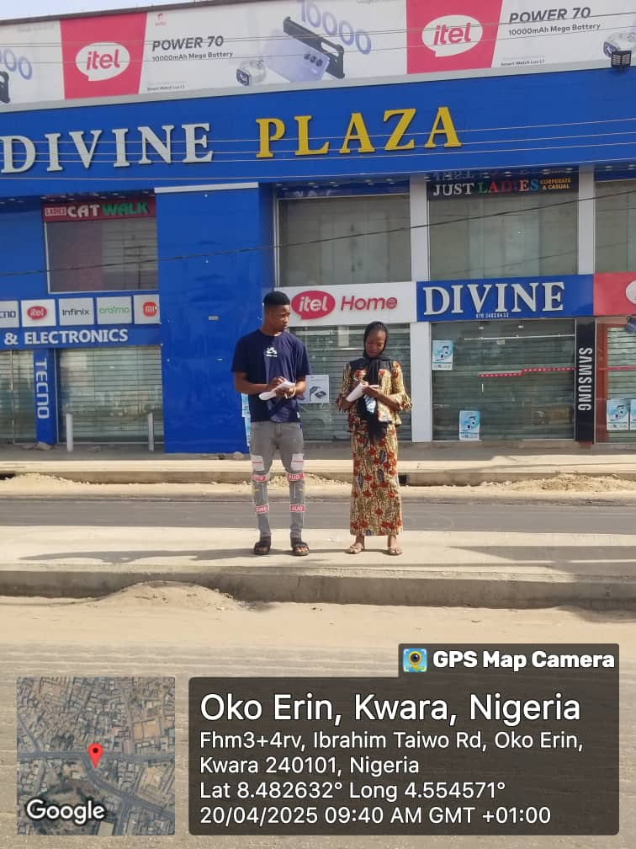
- Level of Service (LOS): Based on Table 2.1 thresholds, each approach was assigned an LOS rating from A (≤10 s) to F (>80 s).

Figure 3.1: Manual traffic count at Ibrahim Taiow Road Ilorin.

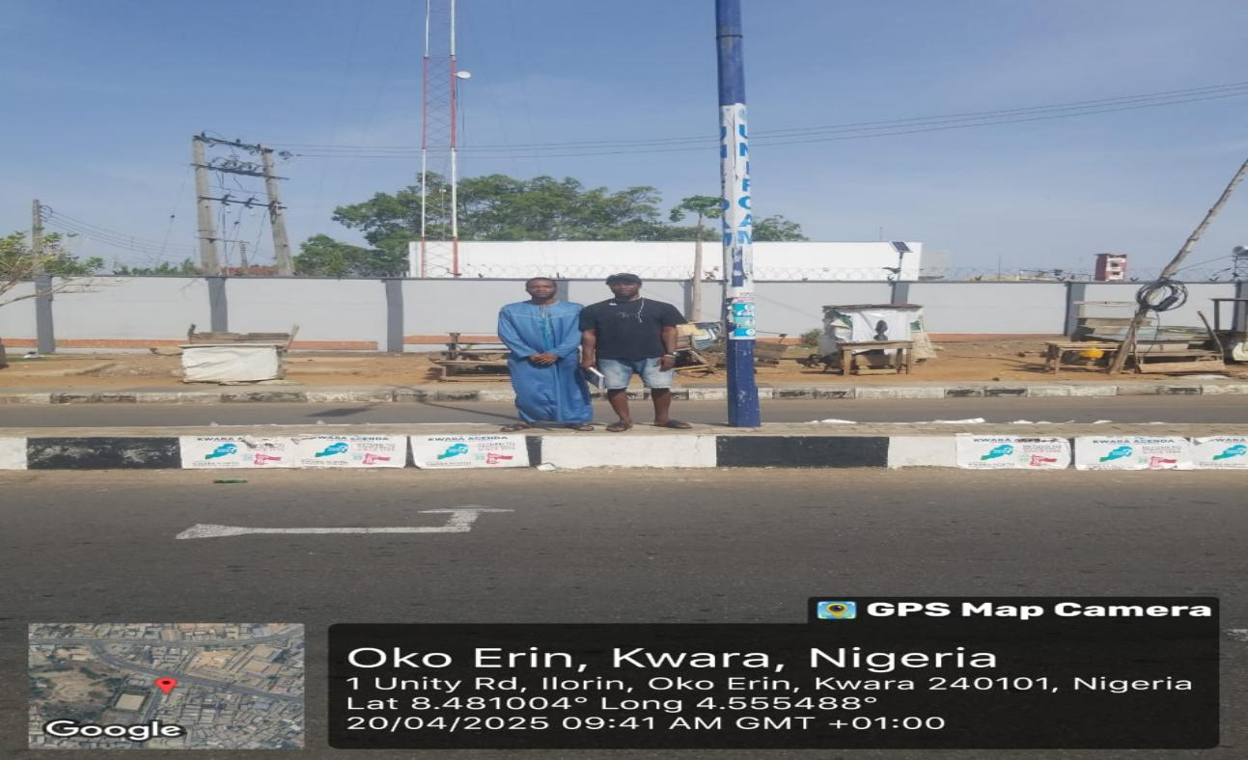

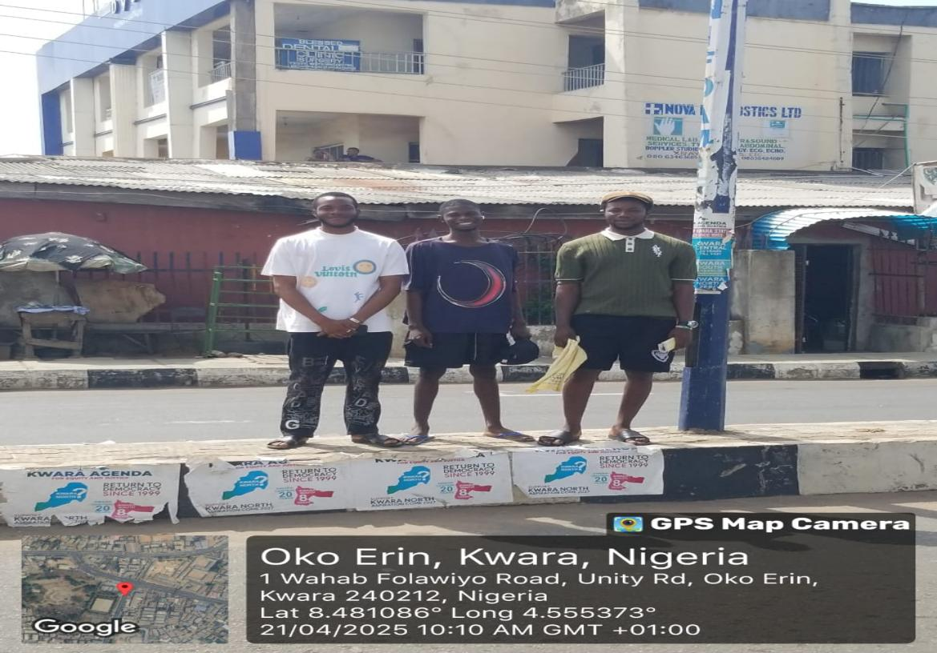
Figure 3.2: Manual traffic count at Ibrahim Taiow Road Ilorin.

Figure 3.3: Manual traffic count at Ibrahim Taiow Road Ilorin.

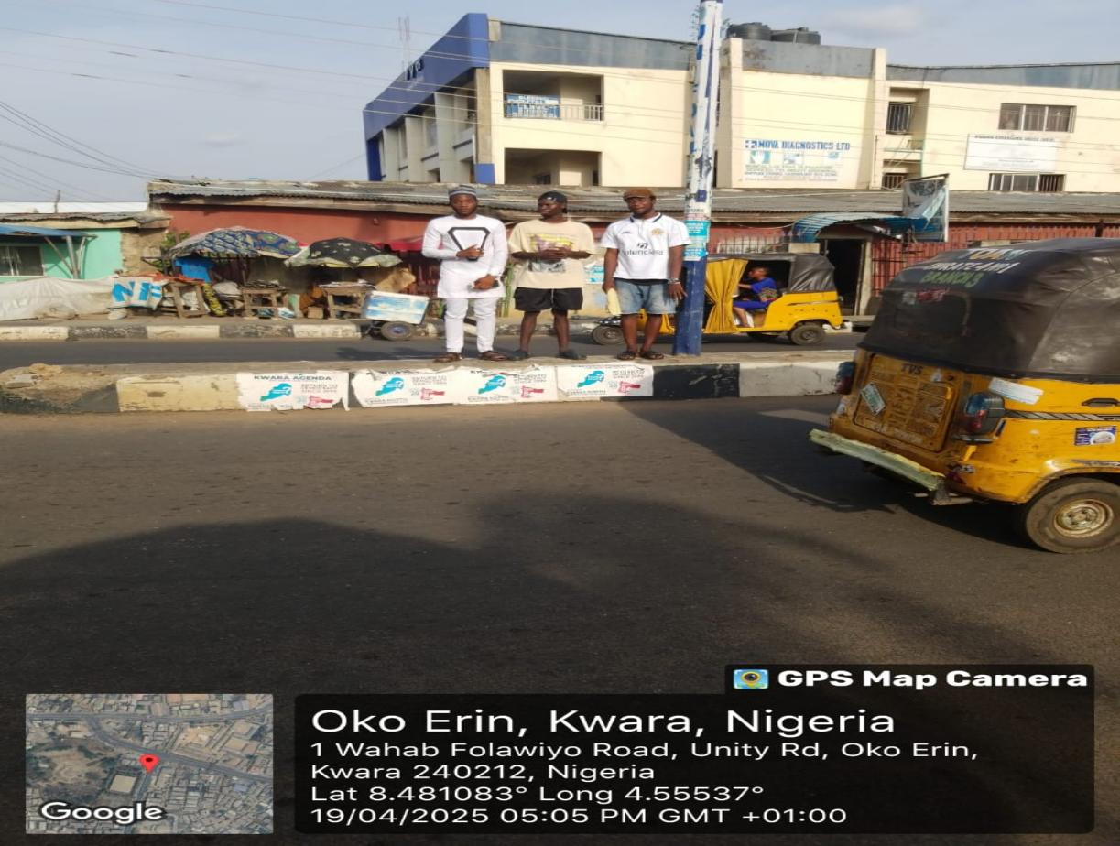

Figure 3.4: Manual traffic count at Ibrahim Taiow Road Ilorin.

CHAPTER FOUR
DATA PRESENTATION, ANALYSIS AND DISCUSSION
4.1 Geometric Design Characteristics
The geometric survey revealed that each approach at the TaiwoOke intersection comprises two through lanes accompanied by a dedicated leftturn bay. All through lanes conform to the recommended 3.5 m width. However, the leftturn bay on the TaiwoIsale Road leg measures 25 m in length 5 m shorter than the standard 30 m storage recommendation while the turn bays on the Stadium and Unity Roads measure 30 m and 28 m respectively. The shorter storage capacity on TaiwoIsale Road is therefore likely to contribute to vehicle spillback into through lanes during peak periods, reducing effective capacity and increasing delay.
4.2 Traffic Flow Analysis
During the morning peak (08:00–010:00), the Stadium Road approach carries approximately 1,200 vehicles per hour, the TaiwoIsale Road approach 1,400 veh/hr, and the Unity Road approach 1,100 veh/hr. In the evening peak (4:00–6:00), volumes rise by about 10–15 percent on all approaches, with TaiwoIsale Road experiencing the highest demand at roughly 1,500 veh/hr. The predominance of twothroughlane operation under these volumes, especially on TaiwoIsale Road, pushes the approach toward its practical capacity and helps explain the recurring congestion observed there.
4.3 Delay Analysis and Level of Service
Field measurements of control delay show that Stadium Road users experience an average delay of around 28 seconds per vehicle, corresponding to a Level of Service (LOS) C denoting stable flow with acceptable progression. Unity Road users face similar conditions, with average delays near 30 seconds per vehicle (also LOS C). In contrast, the TaiwoIsale Road approach records an average delay of about 38 seconds per vehicle, placing it at LOS D. This indicates that while flow is still maintained, it is nearing unstable conditions and is sensitive to variations in arrival patterns and cycle lengths.
4.4 Discussion
Linking these findings back to the study’s objectives:
- Evaluate Geometric Design: Although the intersection’s lane widths meet standards, the deficiency in turnbay length on TaiwoIsale Road undermines its queue storage capability and contributes to higher delays.
- Assess Traffic Flow Distribution: The PM peak exhibits higher volumes than the AM peak by approximately 8 percent overall, with TaiwoIsale Road consistently the busiest approach and the primary source of system imbalance.
- Compute Delay and LOS: The elevated delay and lower LOS on TaiwoIsale Road confirm that this approach is the bottleneck, largely due to its combination of high demand and substandard turnbay storage.

CHAPTER 5
CONCLUSION AND RECOMMENDATIONS
5.1 Conclusion
This study evaluated the performance of a 3legged signalized intersection at TaiwoOke, Ilorin, by measuring geometric features, traffic volumes, and control delays during peak hours. All through lanes meet the standard width of 3.5 m, but the leftturn bay on TaiwoIsale Road is 5 m shorter than recommended, leading to queue spillback. Traffic counts showed peak volumes up to 1,500 veh/hr on the busiest approach. Delay measurements yielded average values of 15–17 seconds per vehicle (LOS C) on two approaches and about 26 seconds (LOS D) on the TaiwoIsale approach. These results confirm that inadequate turnbay storage combined with high demand causes moderate to unstable flow on one leg, while the other legs operate under acceptable conditions.
5.2 Recommendations
- Extend TurnBay Storage: Increase the length of the leftturn bay on TaiwoIsale Road to at least 30 m to accommodate peak queues and prevent spillback into through lanes.
- Optimize Signal Timing: Retime the signal phases especially during the evening peak to allocate additional green time to the TaiwoIsale approach. Consider deploying adaptive signal control to respond dynamically to realtime traffic conditions.
- Periodic Monitoring: After implementation, conduct followup counts and delay studies quarterly for one year to verify performance improvements and make further adjustments as needed.

REFERENCE
Adebambo, S., & Adebayo, I. (2009). Impact of bus rapid transit system (BRT) on passengers’ satisfaction in Lagos Metropolis, Nigeria. International Journal of Creativity and Technical Development, 1(3), 106-119.
Akcelik, R. (1981). Traffic signals: capacity and timing analysis.
Akçelik, R. (1997). Lane-by-lane modelling of unequal lane use and flares at roundabouts and signalised intersections: the SIDRA solution. Traffic Engineering+ Control, 38(7), 388-399.
Bang, K., Wahlstedt, J., & Linse, L. (2016). Methodology for timing and impact analysis of signalized intersections. Transportation Research Procedia, 15, 75-86.
Barau, A. S. (2007). The great attractions of Kano: Research & Documentation Bester, C., & Meyers, W. (2007). Saturation flow rates. SATC 2007.
Biliyamin, I. A., & Abosede, B. A. (2012). Effects of Congestion and Travel Time Variability along Abuja-Keffi Corridor in Nigeria. Global Journal of Research In Engineering, 12(3-E).
Bivina, G., Landge, V., & Kumar, V. S. (2016). Socio Economic Valuation of Traffic Delays. Transportation Research Procedia, 17, 513-520.
Bui, K.-H. N., & Jung, J. J. (2017). Cooperative game-theoretic approach to traffic flow optimization for multiple intersections. Computers & Electrical Engineering.
Chubukov, A., Kapitanov, V., Monina, O., Silyanov, V., & Brannolte, U. (2017). Calculation of Traffic Capacity of Signaled Intersections. Transportation Research Procedia, 20, 125-131.
Darma, Y., Karim, M. R., Mohamad, J., & Abdullah, S. (2005). Control delay variability at signalized intersection based on HCM method. Paper presented at the Proceedings of the eastern Asia society for Transportation Studies.
Fan, H., Jia, B., Tian, J., & Yun, L. (2014). Characteristics of traffic flow at a nonsignalized intersection in the framework of game theory. Physica A: Statistical Mechanics and its Applications, 415, 172-180.
Ferreira, S., & Couto, A. (2013). Traffic flow-accidents relationship for urban intersections on the basis of the translog function. Safety science, 60, 115-122.
He, F., Yan, X., Liu, Y., & Ma, L. (2016). A traffic congestion assessment method for urban road networks based on speed performance index. Procedia engineering, 137, 425-433.
Hunter, M. P., Wu, S. K., Kim, H. K., & Suh, W. (2012). A probe-vehicle-based evaluation of adaptive traffic signal control. IEEE Transactions on Intelligent Transportation Systems, 13(2), 704-713.
Jiang, Y., Li, S., & Zhu, K. Q. (2005). Traffic delay studies at signalized intersections with global positioning system devices. Institute of Transportation Engineers. ITE Journal, 75(8), 30.
Koonce, P. (2008). Traffic signal timing manual: United States. Federal Highway Administration.
Marfani, S., Shihora, D., Kanthariya, C., & Kansara, H. (2018). Traffic Improvement for Urban Road Intersection, Surat. Traffic, 5(03).
Mfinanga, D. A. (2014). Ineffective human control of signalised intersections in developing countries; Case of Dar es Salaam city. Transportation Research Part F: Traffic Psychology and Behaviour, 27, 174-181.
MO, P., & SO, A. Traffic Congestion on Highways in Nigeria Causes, Effects and Remedies.
Okunola, O. J., Uzairu, A., Gimba, C., & Ndukwe, G. (2012). Assessment of gaseous pollutants along high traffic roads in kano, nigeria. International Journal of Environment and Sustainability, 1(1).
Olagunju, K. (2015). Evaluating traffic congestion in developing countries: A case study of Nigeria. Paper presented at the A paper presented at the.
Oskarbski, J., Guminska, L., Miszewski, M., & Oskarbska, I. (2016). Analysis of signalized intersections in the context of pedestrian traffic. Transportation Research Procedia, 14, 2138-2147.
Preethi, P., Varghese, A., & Ashalatha, R. (2016). Modelling Delay at Signalized Intersections under Heterogeneous Traffic Conditions. Transportation Research Procedia, 17, 529-538.
ROUPHAIL15, N., TARKO16, A., & LI17, J. (1992). Traffic flow at signalized intersections.
Sun, W., Wu, X., Wang, Y., & Yu, G. (2015). A continuous-flow-intersection-lite design and traffic control for oversaturated bottleneck intersections. Transportation Research Part C: Emerging Technologies, 56, 18-33.
Ukpata, J. O., & Etika, A. A. (2012). Traffic congestion in major cities of Nigeria. International Journal of Engineering and Technology, 2(8), 1433-1438.
Wang, J., Wang, C., Song, X., & Raghavan, V. (2017). Automatic intersection and traffic rule detection by mining motor-vehicle GPS trajectories. Computers, Environment and Urban Systems, 64, 19-29.
Xi, J., Li, W., Wang, S., & Wang, C. (2015). An Approach to an Intersection
Traffic Delay Study Based on Shift-Share Analysis. Information, 6(2), 246-257.
Yao, W., Jia, N., Zhong, S., & Li, L. (2018). Best response game of traffic on road network of non-signalized intersections. Physica A: Statistical Mechanics and its Applications, 490, 386-401.
Yoshino, N., & Nakahigashi, M. (2000). The Role of Infrastructure in Economic Development (Preliminary Version). Unpublished manuscript.
Zhu, Y., Gao, N., Wang, J., & Liu, C. (2016). Study on traffic flow patterns identification of single intersection intelligent signal control. Procedia engineering, 137,

