DESIGN AND IMPLEMENTATION OF LOAN CREDIBILITY PREDICTION USING DEEP LEARNING ALGORITHM

BY

RASHEED JAMIU OLAMILEKAN
HND/23/COM/FT/0124

SUBMITTED TO THE DEPARTMENT OF COMPUTER SCIENCE,
INSTITUTE OF INFORMATION AND COMMUNICATION TECHNOLOGY
KWARA STATE POLYTECHNIC, ILORIN.

IN PARTIAL FULFILLMENT OF THE REQUIREMENTS FOR THE AWARD OF HIGHER NATIONAL DIPLOMA (HND) IN
COMPUTER SCIENCE

JUNE, 2025.

CERTIFICATION
This is to certify that this project research was carried out by RASHEED JMIU OLAMILEKAN with Matriculation Number: HND/23/COM/FT/0124, has been read and approved as meeting part of the requirement for the award of Higher National Diploma (HND) in computer science

…………………………………. ….………………………
MR. OLAJIDE A.T. Date
Project Supervisor

…………………………………. ….………………………
MR OYEDEPO F.S Date
Head of Department

…………………………………. ….………………………
External Examiner Date

DEDICATION
I dedicate this project work to Almighty God who inspired me and directed my ways during my academic stay in the polytechnic.

ACKNOWLEDGEMENT
All praise is due to Almighty God the Lord of universe. I praise him and thank him for giving me the strength and knowledge to complete my HND programand also for our continued existence on the earth.
I appreciate the utmost effort of our supervisor, Mr. Olajide, A.T whose patience, support and encouragement have been the driving force behind the success of this research work. He gave useful corrections, constructive criticisms, comments, recommendations, advice and always ensures that an excellent research is done. My sincere gratitude goes to Head of Department and other members of staff of the Department of Computer Science, Kwara State Polytechnic, Ilorin, for their constant cooperation, constructive criticisms and encouragements throughout the programme.
Special gratitude to my parents, who exhibited immeasurable financial, patience, support, prayers and understanding during the period in which I was busy tirelessly on mystudies, special thanks go to my lovely siblings
My sincere appreciation goes to my friends and classmates.

ACKNOWLEDGEMENT
All praise is due to Almighty God the Lord of universe. I praise him and thank him for giving me the strength and knowledge to complete my HND programme and also for our continued existence on the earth.
I appreciate the utmost effort of our supervisor, Mr Olajide, A. T., whose patience, support and encouragement have been the driving force behind the success of this research work. She gave useful corrections, constructive criticisms, comments, recommendations, advice and always ensures that an excellent research is done. My sincere gratitude goes to Head of Department and other members of staff of the Department of Computer Science, Kwara State Polytechnic, Ilorin, for their constant cooperation, constructive criticisms and encouragements throughout the programme.
Special gratitude to my parents and siblings, who exhibited immeasurable financial, patience, support, prayers and understanding during the period in which I was busy tirelessly on my studies, special thanks go to my lovely siblings
My sincere appreciation goes to my friends and classmates.

TABLE OF CONTENTS
Title page i
Certification ii
Dedication iii
Acknowledgements iv
Table of contents v
Abstract vi
CHAPTER ONE: GENERAL INTRODUCTION
1.1 Background to the Study 1
1.2 Statement of the Problem 2
1.3 Aim and Objectives 2
1.4 Significance of the Study 3
1.5 Scope of the Study 3
1.6 Organization of the Report 3
1.7 Definition of Technical Term 3
CHAPTER TWO: LITERATURE REVIEW
2.1 Review of Related Works 5
2.2 Review of Related Concepts 7
2.2.1 Credit Analysis 8
2.2.2 Credit Presentation and Decisioning 9
2.2.3 Monitoring 10
2.3 Overview of Loan Management 10

CHAPTER THREE: METHODOLOGY AND ANALYSIS OF THE SYSTEM
  - Research Methodology 15
  - Analysis of the Existing System 15
  - Problem of the Existing System 16
  - Analysis of the Proposed System 16
  - Advantage of the Propose System 16

CHAPTER FOUR: DESIGN AND IMPLEMENTATION OF THE SYSTEM
  - Design of the System 18
    - Output Design 18
    - Input Design 20
    - Database Design 21
    - Procedure Design 22
  - Implementation of the System 23
    - Choice of programming language 23
    - Hardware support 24
    - Software Support 24
  - System Documentation 25
    - Operating the System 25
    - Maintaining of the System 25
CHAPTER FIVE: SUMMARY CONCLUSION AND
RECOMMENDATION
5.1 Summary 27
5.2 Conclusion 27
5.4 Recommendations 27
References 29

ABSTRACT
Lack of planning and control of cash resources is the reason often given for the failure of many businesses. However, good forecasting can help to meet set goals. Faced with intense competition and rising demand for loans by borrowers, most banks are exploring ways to use their data assets to gain a competitive advantage over others. The business of lending is gradually becoming a major target for many banks; as a result, there is high competition among the financial institutions in this regard. With the increasing economic globalization and improvements in information technology, large amounts of financial data are being generated, stored and analyzed, and in the light of changing business environments, managers are seeing the need for more flexible predictive models. A loan is an amount of money given to an individual or institution on the condition that it will be paid back over a given period with interest, which serves as payment for the use of money. There are various types of loans such as credits, finance, and mortgages. Sources of loans range from banks, credit unions, pawnbrokers, and savings institutions to trust companies. The manual process of obtaining and granting loans is stressful, inconvenient and time wasting for the lender and the borrower as well. A lender having geographically dispersed branch offices requires more effective and efficient means to standardize and control the loan procedure and processes. The business objective of providing efficient loan process using technology as an enabler in order to give the company a competitive advantage within the industry suggests automation. Hence, the application is designed in Sublime web development package which involves the use of PHP server-side scripting language, MYSQL for database management and Bootstrap Framework for the page design and layout settings. The program testing simply involves running it directly from a Mozilla Firefox web browser on local host server provided by Apache 2.0 inWampServer 2.0 application.

CHAPTER ONE
GENERAL INTRODUCTION
1.1 BACKGROUND TO THE STUDY
Distribution of the loans is the core business part of almost every banks. The main portion the bank’s assets is directly came from the profit earned from the loans distributed by the banks. In the banking environment, the prime objective is to invest their assets where they are in safe hands. Many banks and financial large companies today approve loans after a verification and validation process of regress, but there is still no guarantee that the applicant selected will be the deserving right applicant out of all applicants. This method helps us to determine whether the applicant is right or not. (Nikhil, 2019)
Loan prediction is very helpful for both the bank employee and the applicant as well. The goal of this paper is to provide the right applicants with a simple, fast and easy way to choose. It can provide the bank with special benefits. The applicant may have a time limit to check whether his / her loan may or may not be sanctioned. Loan Prediction System makes it possible to jump to a specific application so that it can be checked on a priority basis. This paper is specifically for the management authority of the bank and finance organization, no investors would be able to alter the processing of the entire process of prediction is done privately. Report may be sent to different departments of banks against particular Loan Id so that they can take appropriate action on request. It helps to conduct other formalities in all other departments (Siddharth,2019)
Because of their high accuracy and ability to formulate a statistical model in simple language, decision trees are widely used in the banking industry. Because government organizations are closely monitoring lending practices in many countries, executives need to be able to explain why one applicant was rejected for a loan while the others were accepted. Such data is also useful to consumers trying to decide why their credit rating is unsatisfactory. Automated credit scoring systems are likely to be used to automatically accept telephone or internet credit requests. Decision trees are a versatile algorithm for machine learning that can perform tasks of classification and regression. It is an efficient algorithms that can match complex datasets. In addition, decision trees are key components of random forests, which are among today's most powerful Machine Learning algorithms. (Liam, 2022)

1.2 STATEMENT OF THE PROBLEM
With the improvement in the banking sector, lots of people apply for bank loans, but the bank has its limited slots that it only has to give and sell to limited people, so find out who can be given the loan that will be a safer option for the banks. So this system is trying to reduce this risk factor behind choosing the safe individual in this project to save lots of effort and resources from the bank.

1.3 AIM AND OBJECTIVES
The aim of this project is to develop a loan credibility prediction system using decision tree and the objectives are as follows:
- Predict the trustworthy persons who have applied for a loan
- Provide a system that increase the chances of retaining honest customers loan in time
- Reduce the risk factor behind choosing the save individual to give loan

1.4 SIGNIFICANCE OF THE STUDY
The significance of the study is to allow easier way of collecting, processing and giving out loans to make faster than the existing system. It will also help in the problems of storing document or the usage of files. That is storing of documentation of file in one corner of the office which can lead to lost of document. It also reduces stress of searching for file and it will ensure greater trust among the members of the society. With the usage of computer system fraud and inconstitency will be minimized.

1.5 SCOPE AND LIMITATION OF THE STUDY
The area of application of this project will be limited to member registration, savings, loan registration of the customers. This will be limited to the aforementioned due to
- Time constraint
- Finance
- Available material for the research work

1.6 DEFINITION OF TECHNICAL TERMS
- Analysis: Breaking a problem into successively manageable parts for individual study.Data flow: Movement of data in a system from a point of origin to specific destination indicated by a line and arrow.
- Credit: way of delayed payment of goods and service which allow for regular payment over a period of time.
- Dividend: A share profits paid to member who own share in an organization.
- Design: Process of developing the technical and operational specification of a candidate system for implements.
- Guarantor: A person who guarantees on a loan.
- Interest: A calculated sum of money with a given rate charged on load.
- Implementation: In system development phase that focuses on use training site preparation and file conversion for installing a candidate system.
- Loan: A sum of money issued to a person on credit with an accompanying duration of time for repayments to be done.
- Operation System: In database – machine based software that facilitates the availability of information or reports through the DBMS.
- Password: Identity authenticators a key that allow access to a program system a procedure.
- System: A regular or orderly arrangements of components or parts in a connected and interrelated series or whole a group of components necessary to some operation.
- System Testing: Testing the whole system by the user after major programs and subsystem has been tested.
- Saving: This is the monthly amount the member is keeping or saving in the society as his/her assets.
- Shares: This is the mount contribution one to the society that qualities him/her of a state holder.

CHAPTER TWO
LITERATURE REVIEW
2.1 REVIEW OF RELATED PAST WORK
Nikhil, 2019. Loan Prediction Analysis Using Decision Tree This paper proposes a loan approval system based on certain attributes to decide whether or not a loan should be granted to an individual. This paper uses C5.0 decision trees, The prediction outcomes below the expected result.
Paul, 2019:. Algorithm For the Loan Credibility Prediction System This research aims at introducing a new technique which can increase the progress of banking sector This paper compares the result obtained from other classification methods and feature selection methods to prove that proposed algorithm produces better classification accuracy. The experiments were being done using tools such as weka, R, and python programming. This work has a limited datasets
Semiu, 2023: A Boosted Decision Tree Model for Predicting Loan Default in P2P Lending Communities This study aims to develop a data mining model for predicting loan default among social lending patrons, otherwise known as peer-to-peer (P2P) lending This study developed a boosted decision tree model for predicting loan default in P2P lending communities. This study is unable to explore plot analysis of the CAP curve.
Sivasree M S, Rekha Sunny T, 2021: Loan Credibility Prediction System Based on Decision Tree Algorithm This work aim to introduce an effective prediction model for the bankers that help them predict the credible customers who have applied for loan.Decision Tree Induction Data Mining Algorithm is applied to predict the attributes relevant for credibility. Incorporation of other techniques that outperform the performance of popular data mining models is not implemented and tested for the domain.
Anchal Goyal, Ranpreet Kaur, 2019. Loan Prediction Using Ensemble Technique This work aim to introduce an effective prediction technique that helps the banker to predict the credit risk for customers who have applied for loan. The paper uses three different models (SVM Model, Random Forest Network and Tree Model for Genetic Algorithm) and the Ensemble Model, which combines these three models and analyses the credit risk for optimum results.There is a need to overcome fitting problem.
Pidikiti S, 2019. Loan Prediction by using Machine Learning Models. The aim of this paper is to apply machine learning technique on dataset which has 1000 cases and 7 numerical and 6 categorical attributes. In this paper we are predict the loan data by using some machine, learning algorithms they are classification, logic regression, Decision Tree and gradient boosting. Some basic characteristic gender and marital status seems not to be taken into consideration by the company
Sudhamathy&Jothi 2023, the author introduces a framework to effectively identify the Probability of default of a bank loan applicant. The performance metrics derived from the predictions reveal the high accuracy and precision of the built model.The model proposed in an effective prediction model for predicting the credible customers who have applied for bank loan. Decision tree was applied to predict the attributes relevant for credibility. This prototype model can be used to sanction the loan request of the customers or not. The model proposed was built using data from banking sector to predict the credibility loan system. This model uses three classification algorithms namely J48, Bayes Net and naïve Bayes. The model was implemented and verified using Weka simulation tools. The best algorithm j48 was selected based on higher accuracy. An improved risk prediction clustering algorithm that is multi-dimensional was implemented to determine bad loan applicants. In this work, the primary and secondary levels of risk assessments were used and to avoid redundancy.
Lara &Rayo, 2022.develops many credit scoring models that are based on the multilayer approach. The work proves its performance than the other models that uses logistic regression techniques. The results show that the neural network model performs better than the other three techniques. This research compares support vector machine based models for credit-scoring developed using various default definitions. The work concluded that broad definition models are better than narrow definition models in performance. Financial data analysis is also done using the techniques such as decision tree, random forest, boosting, bayes classification, bagging algorithm and others. support vector machine, decision tree, logistic regression, neural network, perception model, all these techniques are combined in this model.
Soni&Varghese, 2019 in a paper title “Algorithm for the loan credibility prediction system” Now a day’s people approach or select bank loans to fulfill their needs, which are very common. This practice has been increasing day by day especially for business, education, marriage, agriculture as well. But several people take advantage and misuse the facilities given by the bank. With technology developing at such a peak stage in these days, data mining plays a key role in computer science to solve such issues. Classification is the most suitable predictive modeling technique in data mining to predict the loan repayment capability of a customer in a banking industry. There are various methods to improve the accuracy of a classification algorithm. The accuracy of random forest classification algorithm can be improved using Ensemble methods, Optimization techniques and Feature selection. Various feature selection methods are available. In this research work a novel hybrid feature selection algorithm using wrapper model and fisher score is introduced. The main objective of this paper is to prove that new hybrid model produces better accuracy than the traditional random forest algorithm. This paper also compares the result obtained from other classification methods and feature selection methods to prove that proposed algorithm produces better classification accuracy. The experiments were being done using tools such as weka, R, and python programming. This research aims at introducing a new technique which can increase the progress of banking sector. The accuracy level of this new algorithm in finding the potential of the customer is much higher than the data mining classification algorithm and thus it proves to be very helpful for bank officers Soni&Varghese, 2019
Sivasree&Rekha. 2015 wrote an article on “Loan credibility prediction system based on decision tree algorithm” Data mining techniques are becoming very popular nowadays because of the wide availability of huge quantity of data and the need for transforming such data into knowledge. Techniques of data mining are implemented in various domains such as retail industry, telecommunication industry, biological data analysis, intrusion detection and other scientific applications. Data mining techniques can also be used in the banking industry which help them compete in the market well equipped. In this paper we introduce an effective prediction model for the bankers that help them predict the credible customers who have applied for loan. Decision tree induction data mining algorithm is applied to predict the attributes relevant for credibility. A prototype of the model is described in this paper which can be used by the organizations in making the right decision to approve or reject the loan request of the customers Sivasree&Rekha, 2015.

2.2 REVIEW OF GENERAL TEXT
2.2.1 LOAN REGISTRATION AND SECURITY
Before user can actually use a loan and contribution transaction system, a registration procedure is performed. During this registration procedure, the security of the system is bootstrapped. The user has to obtain an initial means for entity authentication with which a first secure session can be established with the cooperative, thereafter, the regular security authenticators‟ are enabled. It is clear that something goes wrong during this stage, the security of the rest of the loan and contribution transaction system (Renom, 2019).
In some situations, the ability of delegation within a loan and contribution transaction system system is desired e.g. the manager of a department would like to be able to delegate right to one or more employees who needs to have access to the loan transactions, or that staffs would possibly delegate certain rights to their money, the use of ID and password. These and other security measures must be installed. Security in cooperative society is typically provided through effective prevention not only a breach of privacy, but other security concerns like the alteration of data, IT fraud, etc. But it is in ensuring system availability that loan still have a lot of work to do (Renom, 2017).

2.2.2 DATABASE MANAGEMENT SYSTEMS
Computers permit the collection and aggregation of statistical information which would be time consuming, if not impossible to assemble from manual systems. Data are raw facts that constitute building blocks of information. Database is a collection of information and a means to manipulate data in a useful way, which must provide proper storage for large amount of data, easy and fast access and facilitates the processing of data. Database management system is a set of software that is used to define, store, manipulate and control the data in the database. A database provides integrated and structured collection of stored operational data which can be used or shared by application systems. The advanced database technology along with internet has proved faster communication and worldwide connectivity (Willits, 2022).

2.2.3 SAVINGS
This saving consists of two saving which include the thrift savings and reserved funds.
A. THRIFT SAVINGS: Immediately a person becomes a member of the society, he will start making thrift savings through the use of his passbook. It is this thrift saving that will determine the amount of loan each member could obtain at any point on time.
B. RESERVED FUND: The reserved fund is indivisible and member is entitled to claim specified shares in it. Expect with the written permission of the registry. It shall not be utilized in the business of the society but shall be deposited or invested.

2.2.4 LOAN PROCESSING
1. APPLICATIONS FOR LOANS: Application for loans shall be prepared through the secretary and disposed by the committee and shall be set out for the purpose for which the loan is desired.
2. PURPOSE OF LOANS: Loans shall be restricted to members only and shall be made for provident and productive purpose only or necessary in the best interest of the borrower.
3. RATE OF INTEREST ON LOAN: The rate of interest on loan shall
be fixed from time to time by the committee and approved by the
general meeting but shall no case of exceed 15 percent per annum on an unpaid balances. In case of the default in repayments, penal interest shall be changed twice normal rate.
4. PAYMENT OF LOANS: Every loan obtained must be paid within a specific number of month approved by the management committee, this therefore means that the principle and the interest will be spread over a period of specified months. The principle and the interest are to be paid on install mental basis.
5. BAD DEBT: These are debts that are likely to be paid with society having tried every means receiving them. The committee may cause bad debt to be written off the book of the society.

2.2.5 TRADITIONAL BANKING VS ONLINE BANKING
There is a lot of difference in traditional banking and online banking. Online banking is time saving, fast and efficient than the traditional banking. In these busy days, people are finding it difficult to spend time on personal banking. Internet banking is a boon for all such customers. Internet banks pay higher yields, require low balances to avoid fees, charges less for bounced checks, follow friendlier ATM policies and offer higher percentages of accounts that cost nothing at all. The hurdle that banks must overcome is primarily psychological fear of insecurity.
To encourage more people to use the services, banks are offering incentives such as cash bonus for online payments. Large banks like Citigroup Well Fargo and Bank of America, are making good progress with their online services. Its more cost effective for small banks to start online banking than large banks, because of small investment required establishing the infrastructure (Renom, 1997).
Every cooperative society has different types of accounts designed to suit the needs of their customers. Checking and savings are the widely used accounts in most of the banks. Customer can check information of his checking account, saving account, Mortgage loan, Home Equity loans or credit line using online banking. Most important service that any bank would assure its customer is access of account information in a most secured way. However, there is still some perceived insecurity from hackers and cyber criminals. There are various services that a cooperative society offers its customers and they enable the customer to the following:
• Check multiple account information and account balances
• Balance a checkbook
• Direct deposit of the paycheck
• Transfer money between accounts
• Track recent account activity
• Apply for loans (auto, staffs, home equity, mortgage or personal)
• Receive investment product and service information

2.2.6 THE ROLE OF INFORMATION TECHNOLOGY IN THE MORTGAGE LOAN SYSTEM
Information technology has been an integral part of Mortgage loan system since almost three decades. Since the arrival of internet technology
Cooperative Thrift And Credit Society has taken a new shape and style with a blend of convenience and satisfaction.
Loan from a customer‟s bedroom, office or anywhere in the world has made its way into Cooperative Thrift And Credit Society with the advent of internet technology. Information technology has always helped the cooperative society to serve its customers in a better way. To explain few examples, direct deposit is a method where the employer‟s cooperative society communicates directly with the employee‟s account. This is only possible with the help of information technology. This direct deposit feature saves an employee time to cash his paycheck every fortnight or every month (Olea et al. 2019).
This feature is safe, fast and has no hazels. One more service that an online bank could provide its customer in online loan application. Filling out the documents and comparing options and waiting for approval is a time consuming process. Through the internet, this process is made much easier and sometimes the approval is made within minutes. This explains an efficient way of cooperative thrift and credity society and saves time and money to a customer (Olea et al. 2019).
2.2.7 ADVANTAGES OF INTERNET CHECKING ACCOUNTS OVER THOSE OF TRADITIONAL BRICKAND-MORTAR BANKS
Clear advantages of internet checking accounts over those of traditional brickand-mortar banks are higher yields, a higher proportion of free accounts and much lower balance requirements. statements and pay the bills instantly. Customer has to login into his account using the username and password, check the statement and fill the amount and authorize the payment and it will be posted instantly or in a couple of days. Options are provided to authorize payments on regular intervals. There are many other advantages of cooperative thrift and credit society, some of them are listed below:
• It saves a lot of time
• It is very convenient for business, office or anywhere in the world.
• Low interest.
• It is inexpensive to customer
• Bills can be paid in a very convenient fashion round the clock
• It allows making transaction on weekends
• Help the staff in reducing the costs such as labor, inventory and stationary.
2.2.8 DATA MINING IN BANKING
Due to tremendous growth in data the banking industry deals with, analysis and transformation of the data into useful knowledge has become a task beyond human ability. Data mining techniques can be adopted in solving business problems by finding patterns, associations and correlations which are hidden in the business information stored in the databases. By using data mining techniques to analyze patterns and trends, bank executives can predict, with increased accuracy, how customers will react to adjustments in interest rates, which customers are likely to accept new product offers, which customers will be at a higher risk for defaulting on a loan, and how to make customer relationships more profitable. Globalization and the stiff competition had led the banks focus towards customer retention and fraud prevention. To help them for the same, data mining is used. By analyzing the past data, data mining can help banks to predict credible customers. Thus they can prevent frauds, they can also plan for launching different special offers to retain those customers who are credible. Certain areas that effectively utilize data mining in banking industry are marketing, risk management and customer relationship management.
Marketing: It is one of the most widely used areas of data mining in the banking industry. The consumer behavior with reference to product, price and distribution channel can be analyzed by the marketing department. The reaction of the customers to the existing and new products can also be known. This information can be used by the banks to promote the products, improve quality of products and services, and gain competitive advantages. Bank analysts can also analyze the past trends, determine the present demands and forecast the customer behavior of various products and services, in order to grab more business opportunities.
Risk Management: It is widely used for managing risks in the banking industry. Bank executives need to know the credibility of customers they are dealing with. Offering new customers credit cards, extending existing customers’ lines of credit, and approving loans can be risky decisions for banks, if they do not know anything about their customers. Banks provide loans to their customers by verifying the various relating to the loan, such as amount of loan, lending rate, repayment period etc. Even though, banks are cautious while providing loan, there are chances of loan repaying defaults by customers. Data mining technique helps to distinguish borrowers who repay loans promptly from those who default.
Customer Relationship Management: Data mining can be useful in all the three phases of a customer relationship cycle such as customer acquisition, increasing value of the customer and customer retention. Customer acquisition and retention are very important concerns of any industry, especially the banking industry. Banks have to cater the needs of the customers by providing the services they prefer. This will ultimately lead to customer loyalty and customer retention. Data mining techniques help to analyze the customers who are loyal from those who shift to other banks for better services. If the customer is shifting from his bank to another, reasons for such shifting and the last transaction performed before shifting can be known, and this will help the banks to perform better and retain their customers .

CHAPTER THREE

METHODOLOGY AND ANALYSIS OF THE EXISTING SYSTEM
3.1 RESEARCH METHODOLOGY
Decision tree methodology is a commonly used data mining method for establishing classification systems based on multiple covariates or for developing prediction algorithms for a target variable. This method classifies a population into branch-like segments that construct an inverted tree with a root node, internal nodes, and leaf nodes. The algorithm is non-parametric and can efficiently deal with large, complicated datasets without imposing a complicated parametric structure. When the sample size is large enough, study data can be divided into training and validation datasets. Using the training dataset to build a decision tree model and a validation dataset to decide on the appropriate tree size needed to achieve the optimal final model.
The programming language used in the implementation of this project is by PHP and HTML (Dream weaver). Dream weaver application is interacting in the sense that the user is constantly with the program. The language was used because of its stability, execution efficiency and its support for database. It also support graphical user interface (GUI) and other features that makes an application to be user friendly.
APPLICATION OF DECISION TREE IN LOAN CREDIBILITY
The diagram below represents the working of the model. It basically gives us a rough idea on how the loan prediction system works. After collecting data, it use feature selection process on data. Feature selection can be defined as a process of reducing number of input variables when e develop a predictive model.
Feature selection is divided into two parts i.e. supervised method and unsupervised method. Supervised method is divided into three parts which are wrapper, filter and intrinsic. In supervised method it used target variable to remove discrepancies in data. While in unsupervised method it do not use target variable to remove discrepancies. Unsupervised method uses the process of correlation.
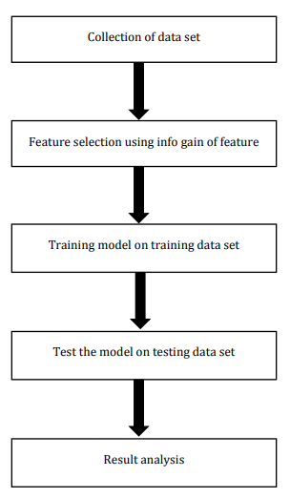
Loan Prediction credibility diagram

3.2 DESCRIPTION OF THE EXISTING SYSTEM
Despite the fact that the banking sector has been operating its major problem is The cost of purchasing foreign applications is high compare to home-base software’s and if any problem arise the loan management organization spends much before any possible modification could be made.

3.3 PROBLEMS OF THE EXISTING SYSTEM
- Members subjected to queue up for hours before being attended to. This waste their precious time because the old system is a computerized system which can only be operated in the cooperative society.
- Delay in preparation of statements of savings and loan accounts.
- Errors in the calculation of balance of accounts thereby making the members feel cheated.
- The existence of large volume of paper files make it very difficult to trace old records as fast as required.
- There is always controversy in the sharing of dividends or profits because there is no set standard.
- Data is easily lost or damaged from time to time which hinders certain operations.

3.4 DESCRIPTION OF THE PROPOSED SYSTEM
Loan Request: this page displays all the loan requested from the member for the administrator to review and approve if the member satisfied the required condition.
View Approve Loan: This page displays the history of all approved loan been carried out by the system administrator.
Loan Payment: This page is used to add loan returned by the members.
Members Environment: The administrator environment entails the following
- Request For Loan
- Application Status
- Logout
- website home page
3.5 ADVANTAGES OF THE PROPOSED SYSTEM
- The new system is Perfect for emergency purpose
- The new system is convenience because it’s a web-base a application which makes it more convenience to use
- Web-Base Loan Management system is easier to access compare to the old computerized standalone application.
- The system will be available for 24 hours which make accessible all the time.
The new system saves both the cooperative administrator and members time

CHAPTER FOUR

DESIGN, IMPLEMENTATION AND DOCUMENTATION OF THE SYSTEM

4.1 DESIGN OF THE SYSTEM
This is the process of designing the input, output and the processing steps to meet the user’s requirement identified in the system analysis. It starts with logical design, which produces a specification of major features of the system. These include the data, input, output, processing storage and other control requirements.

4.1.1 OUTPUT DESIGN
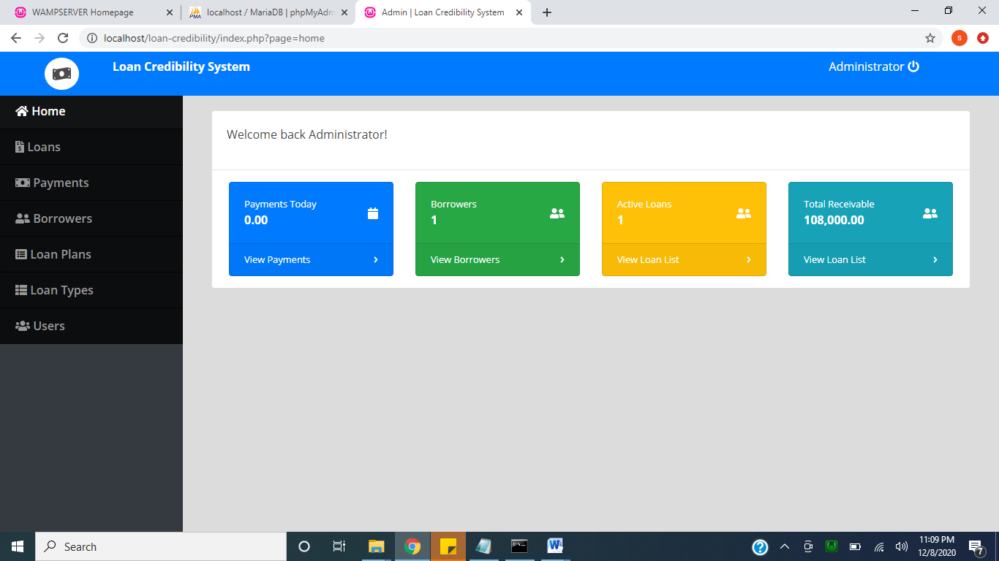
Figure 4.1: Admin Dashboard: This page shows the admin page to navigate to different module.
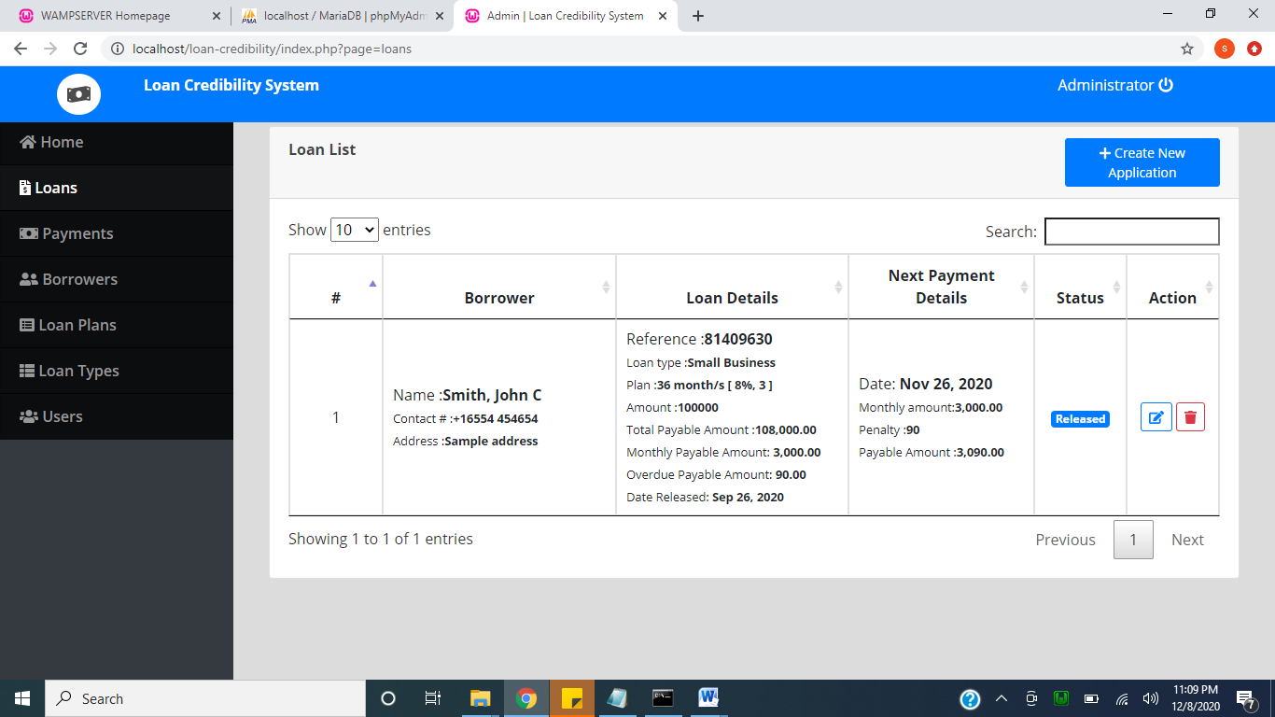
Figure 4.2: List Loan: This shows the list of loan. From the database.

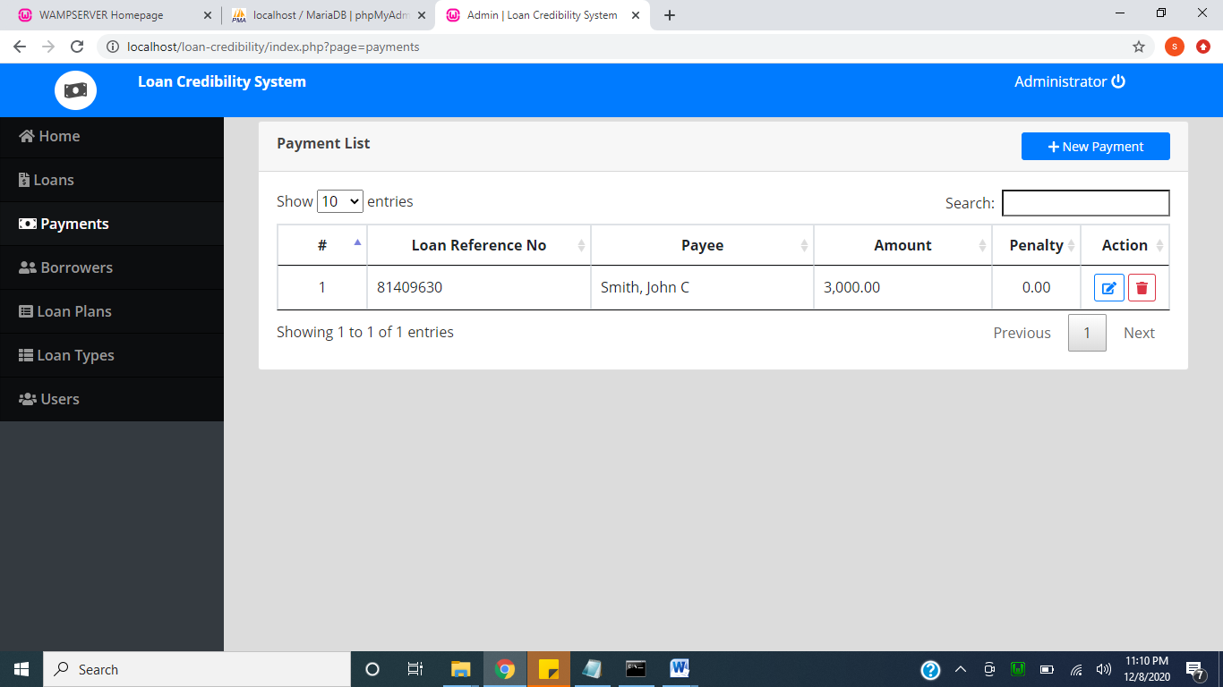
Figure 4.3: payment: This page shows the payment of customer. Here customer payment showing the ref ID.

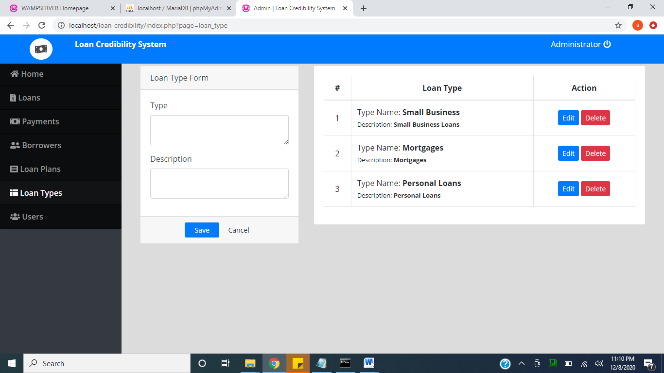
Figure 4.4: Loan type: This page shows loan type.

4.1.2 INPUT DESIGN
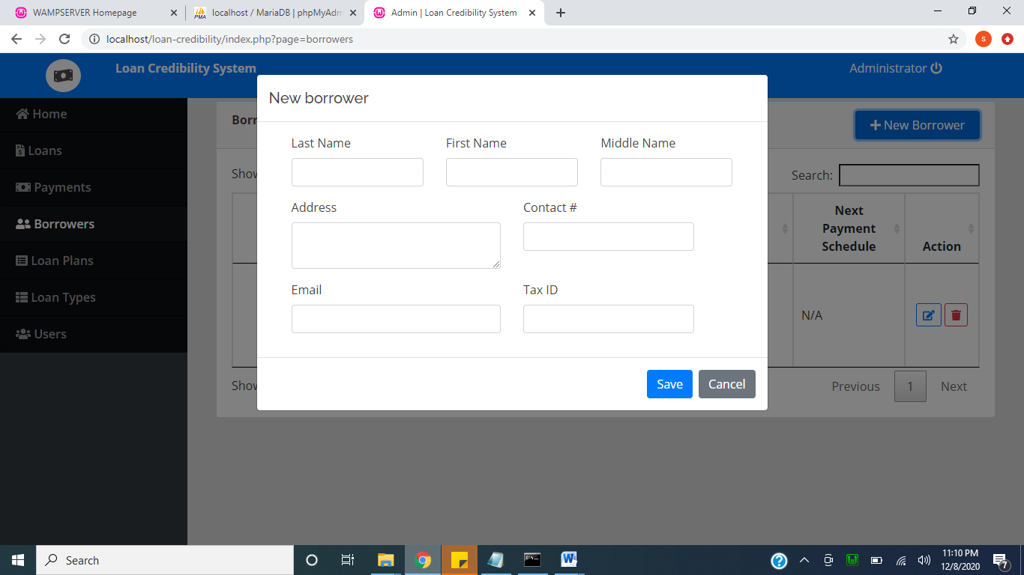
Figure 4.5: New borrower: This is the page that shows where to register new borrower.

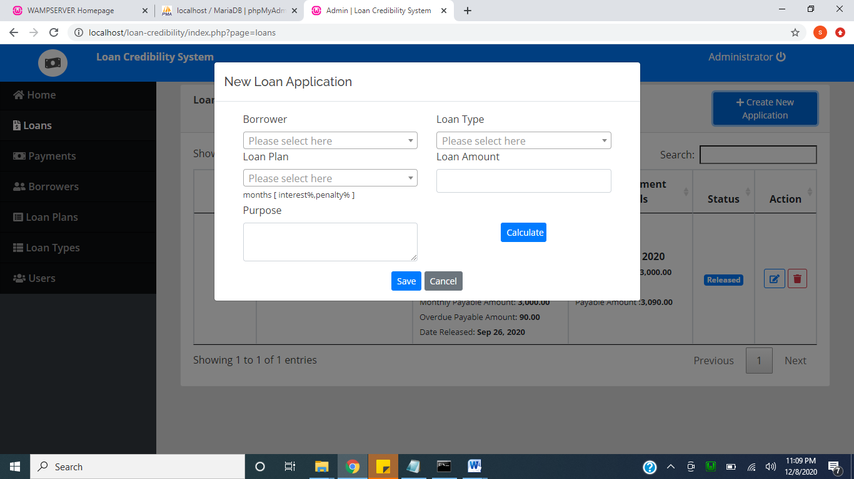
Figure 4.6: New Loan: This page is used to add new loan.

4.1.3 DATABASE DESIGN
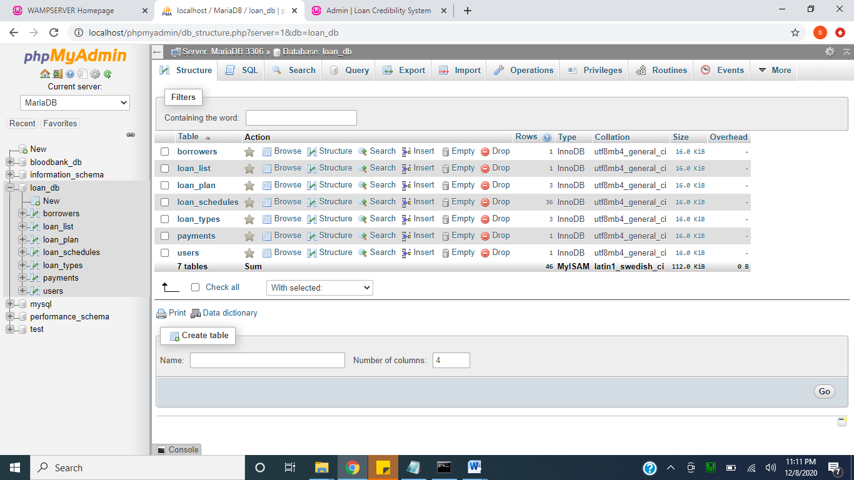
Figure 4.7: Database: This is the database for the loan credibility.

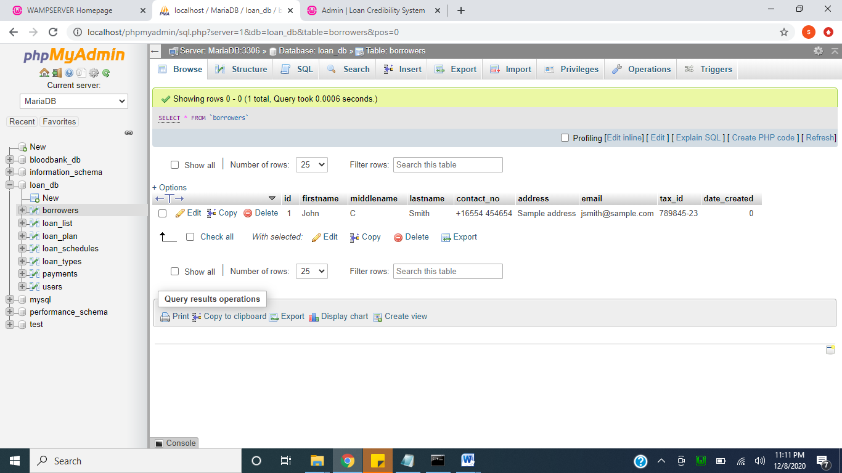
Figure 4.8: Borrower: This table is use holding Borrower details.

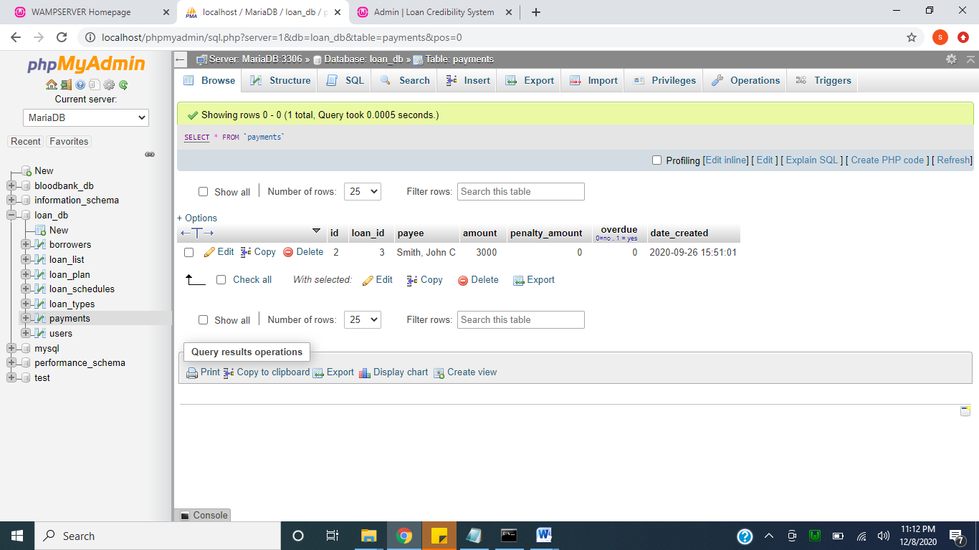
Figure 4.9: Login: This is the table that holds user authentication.

4.1.4 PROCEDURE DESIGN
This refers to the ways in which the proposed system will be used and the steps are as follows:
- Click start on the computer desktop
- Select all programs
- Select any browser e.g Morzilla Firefox , internet Explorer , Google Chrome e.t.c
- Type the url (Uniform Resource Locator) of the system into the address bar (localhost/loan/index.php)

4.2 SYSTEM IMPLEMENTATION
The design system depends on the capabilities and power of the computer on which the application system is installed. However, selecting a choice of application support (Hardware and Software) depends much on:
- How readily the user is to interfere with the computer
- Cost and benefits
- Managements support for changes
Hence, choosing the appropriate hardware and software will enhance the performance of the system.
A most important requirement on which the running of the program basically depends on is the provision of internet facility. So any system that must run this program must be internet ready.

4.2.1 CHOICE OF PROGRAMMING LANGUAGE
The programming language used in the proposed system is php. PHP meaning (PHP Hypertext Preprocessor) is a server-side programming language. It is an open source server-side scripting language that has taken web-based development to a new level of sophistication. The PHP scripting engine is well optimized for the response times needed on web applications, it can even be part of the web server itself improving the throughput even more.
If it were only a matter of improving the speed of the scripts, then PHP will be one of many solutions. But there is more to the PHP equation than that. There is the simplicity and robustness of the language and the scripting engine. There is the connectivity to an ever increasing number of database servers, the shorter development cycles and the ease (encouraged by the syntaxes and constructs) of creating modular and reusable components.

4.2.2 HARDWARE SUPPORT
The hardware that is required in the successful completion of this project includes monitor, CPU, keyboard, mouse, printer and an uninterrupted power supply (UPS) and an internet access.
- An appropriate hard disk storage of at least 120 GB (for the dynamically expandable database)
- A minimum of 1.0 GHz processor
- Random access memory (RAM) of at least 1 GB
- An effective display unit (VGA monitor)
- A suitable printer
- Standard input devices such as keyboard, mouse, etc.
- CD-ROM drive or DVD-ROM drive (since the installation would be made through this medium)
- An uninterrupted power supply (UPS) unit (to prevent abrupt interruption due to power failure)
- A network modem (for internet connection).

4.2.3 SOFTWARE SUPPORT
The software required are basically any web browser (internet explorer, Firefox and the likes), WampServer and a network service, be it wired or wireless.
- A network operating system windows NT from Microsoft, Novell Netware.
- A DBM either PhpMyAdmin
- MySQL as the query language to query the database.
- Wambserver

4.2.4 IMPLEMENTATION TECHNIQUES
The system will be implemented using the parallel approach. This approach is considered because it ensures that the new system is tested along side with the old system to ensure the effectiveness and efficiency of the system.

4.3 SYSTEM DOCUMENTATION
It has to do with the installation and usage of the new system.
After the program has been well tested with input that the output has already been known, the next is to install the software in to the computer system for use.
The process of installing are been stated below
- Insert the CD into the system through the CD-ROM after the computer is switch on
- Locate the CD drive directory in my computer and click it to open
- After open, locate setup.exe, and then click to install the program by following the necessary step in installing the program.
- Ensure full installing of the software for effective operation of the system.
After the program has been fully install. The next thing is to locate the package install to put it into operation, to locate the package for expiration purpose the following step are to be taking
v. Click on start menu from task bar. Then select all program
From the display sub option, select by locating the software installed named loan personality check to load the software.

4.3.1 PROGRAM DOCUMENTATION
- CUSTOMER
- SAVING
- LOGOUT
- DISAPPROVAL
- APPROVE LOAN
- CHECK APPROVAL
- RETURNING
4.3.2 OPERATING THE SYSTEM
- Click on the start button
- Click on control panel
- Click add/remove program
After the configuration, the folder called loan will be created in the local disk.
4.3.3 MAINTAINING OF THE SYSTEM
- Keeping the system free from virus so as not to corrupt the program installed on the system.
- Having an updated anti-virus.

CHAPTER FIVE
SUMMARY, CONCLUSION AND RECOMMENDATION
5.1 SUMMARY
The project discusses development of a Loan credibility prediction system using decision tree. The major operation of the organization worked upon is the member loan and savings, which involves the request of loan online, viewing of their monthly savings and providing a well-organized report for the database records for all transaction performed. Some advantages of the new system developed is stated are stated and the method of implementation to achieve the maximum functionalities of the program.

5.2 CONCLUSION
The system has been developed with much care that it is free of errors and at the same time it is efficient and less time consuming. The purpose of this project was to allow the cooperative member to request for loan and allow the management to approve or disapprove the request.
The important thing is that the system is robust. We have tried our level best to make the system as dynamic as possible. This project helped us in gaining valuable information on several topics like web page design principle, handling the user interface in a powerful way, to access the various pages across the application etc. The entire system is secured. More than anything this project has given us great satisfaction in having designed an application, which processes information from university to the students. This system transfers the user’s needs into a software solution and saves their precious time .This online system can be approved by the cooperative society and if it is implemented it will be much useful for the cooperative society.

5.3 RECOMMENDATIONS
Regarding the problems being faces with the existing system adopted in Loan Predictions system. There is need for them to improve on their existing system.
It is important that organization should always maintain an adequate and constant back up of data in other to prevent loss of data and information and also to guild against fraudulent when the proposed system is in operation. The system can further be upgraded to support SMS notification to alert the member on their loan request status
Online payment gateway can also be included to facilitate the payment of the member monthly savings and loan payment

REFERENCES
Bello, Nnamdi et al (2013). Proposed that in Nigeria, the first producer's cooperative society.
Barn B. (2019). Enterprise Scale CBD: Building Complex Computer Systems From Components. IEEE Computer Society Press STEP'99, , pp. 82-93.
Booch G. (2012). Reusing open Source Software and Practices. Springer Verlag Lecture Notes in Computer Science, Austin, Texas: 7th International Conference on Software Reuse 2319, pp. 123-136. doi: 10.1007/3-540-46020-9_9.
Brown AW. (2019). The Future of Component-Based Enterprise Application Development. OOP'99, , pp. 129-138.
Brown, A.W. (2014). Building Service-Oriented Architectures with the IBM Software Development Platform. Gartner Analyst Conference.
Carney, D.J. (2015). Assessing the Quality of a Large, Software-Intensive System: A Case Study. Springer-Verlag Proceedings of the 5th European Software Engineering Conference, 5th European Software Engineering Conference, pp. 384-404.
Johnston SK. (2016). A Model-driven Development Approach to Creating Service-oriented Solutions'. Springer Verlag Lecture Notes in Computer Science, , pp. 624-636.
Mbam, B.C.E. (2012). loan deduction errors and generate reports.
Pressman S. Roger et, al (2013). The analysis and design of the Loan Software.
Rader, J.A. (2015). Computer-Aided Sub-Processes (CASPs): A Practical Approach to the Use of CASE Technology to Support Process Involvement. IEEE Proceedings of the 7th International Workshop on CASE (CASE'95), 7th International Workshop on CASE (CASE'95), pp. 20-29.
Segun, K. (2012). He used triple des algorithm. He show that co-operative movement in our country shall not only stay but also grow in times to come.
Wallnau, K.C. (1996). Engineering of Component-Based Systems IEEE Computer Society Press Proceedings of 2nd International Conference on Engineering of Complex Computer Systems, 2nd International Conference on Engineering of Complex Computer Systems, pp. 414-422.
Adedini, G.A. (2010). Foundations of Entrepreneurship and Economic Development. Routledge, London and New York.
Claxton, G., (2014). Importance of Cooperatives Societies to National Economic Growth, University of Botsana.
Dogarawa, W. K. (2005). The Nature of Returns: A Social Capital Markets Inquiry into Elements of Investment and Blended Value Proposition. Social Enterprise Series No. 17, Harvard Business School, Boston, MA.
Ekpere, S. (1998). Nigeria Cooperative Societies, Past, Present and the Future.
The International Journal Of Business & Management (ISSN 2321 –8916) www.theijbm.com
443 Vol 3 Issue 4 April, 2015
Kalantaridis, C. (2004). Understanding the Entrepreneur: An Institutional Perspective. Ashgate, England.
Epetimehin, K.O. (2006). The Theory of Economic Development. Harvard University Press, Cambridge, MA.
Gibson, C.O. (2005). Economic Relevance of Community bank in micro economics
Gertler, J.C. (2001). Generalized Experiences for Internal Versus External Control of Reinforcement. Psychological Monographs 80(1, Whole No.609).
Olorunlomerue, A., (2011). Loan Distribution and Management System, A Case study of Islamic Cooperative. Federal Polytechnic Ede.
Onuoha, S. (1986). African Capitalism: A Case Study in Nigerian Entrepreneurship. Hoover Institution Press, Stanford University, Stanford, California.
Osusu, K. O., Adetutu J. (2006). Cooperative Societies, Entrepreneurship. The meeting point
Silberschatz J., Hayek F.A, Kalantradisc C (2008): The Entrepreneur in Microeconomic Theory: Disappearance and Explanation. Routledge, London.
Strickland, K. (2004). Asymmetric Interpretation. Journal des Economistes et des Etudes Humaines, 12(1): 23-29.
Knight, F. (2013). Risk, Uncertainty and Profit (ed. G.J Stigler). University of Chicago Press, Chicago

