KWARA STATE POLYTECHNIC ILORIN, KWARA STATE.
INSTITUTE OF TECHNOLOGY
DEPARTMENT OF CIVIL ENGINEERING

PERFORMANCE EVALUATION AND REDESIGN OF ADETA ROUNDABOUT, ILORIN. USING MICROSCOPIC TRAFFIC SIMULATION.

BY
APARA FARUK OLUWAREMILEKUN
HND/23/CEC/FT/0155

BEING IN RESEARCH WORK SUBMITTED TO THE DEPARTMENT OF CIVIL ENGINEERING, INSTITUTE OF TECHNOLOGY, KWARA STATE POLYTECHNIC, ILORIN

IN PARTIAL FULFILMENT OF THE REQUIREMENT FOR THE AWARD OF HIGHER NATIONAL DIPLOMA (HND) IN CIVIL ENGINEERING
JUNE 2025.
CERTIFICATION
This is to certify that this research study was conducted by APARA FARUK OLUWAREMILEKUN (HND/23/CEC/FT/0155) and had been read and approved as meeting the requirement for the award of Higher National Diploma (HND) in Civil Engineering of the Department Civil Engineering, Institute of Technology, Kwara State Polytechnic, Ilorin.

_________________________ ___________________
ENGR, Z. D. HASSAN Date
Project Supervisor

__________________________ ____________________
ENGR, A. B. NA’ALLAH Date
Head of Department

_____________________ _____________________

ENGR. DR. MUJEDU KASALI ADEBAYO Date
External Supervisor
DECLARATION
I hereby declare that this project work titled Performance Evaluation And Redesign of Adeta Roundabout In Ilorin, Using Microscopic Simulation, is a work done by me, APARA FARUK OLUWAREMILEKUN with matric number, HND/23/CEC/FT/0155 of the Department of Civil Engineering, Institute of Technology, Kwara State Polytechnic, Ilorin.

__________________ ______________
Signature Date

DEDICATION
This project is dedicated solemnly to God Almighty, who is the sole inspiration of all things, without whom there would not be, and neither would this project.
Appreciation goes to my loving parents for their support in the fulfillment of my Higher National Diploma (HND) both orally and financially. May God allow them to eat the fruit of their labor (Amen)

AKNOWLEDGEMENT
I begin by expressing my deepest gratitude to the Almighty Allah, who has blessed me with the wisdom, strength, and resilience to complete this project and also appreciate all the staffs of Kwara State Polytechnic Ilorin.
I extend my sincere appreciation to my project supervisor, Engr. Z. D. Hassan for his invaluable guidance, support, and encouragement throughout this journey. His expertise and constructive feedback were instrumental in shaping this project.
To my family, I express my heartfelt gratitude for their unwavering support and love. My parents, Late Mr Apara and Mrs Apara, who made me choose this interesting course, and my dearest siblings, who motivates me to make this milestone a success, Shakira, Lukmon, Ridwan, Fatimo, Mistura, Abdulmalik and Abdulrahmon, thank you for being a constant source of motivation, encouragement and financial support. I appreciate your love.
To my Darling Soulmate, Iwalewa, thank you for your patience, understanding, and support. You are my rock, and I am grateful for your love.
To my friends and colleagues, Sheriff, Ibrahim, Kamaldeen, Zainab, Funmilayo and many others that their names could not be mentioned, I appreciate your encouragement, advice, and camaraderie.
I also acknowledge the entire staffs of the department of Civil Engineering in the Institute of Polytechnic, Ilorin, for their dedication, enlighten and support towards the success of my academics.
Thank you all for being part of my journey.
TABLE OF CONTENTS
Title page
Declaration i
Certification ii
Dedication iii
Acknowledgement iv
Table of Contents v
Abstract vii
CHAPTER ONE: INTRODUCTION
1.1 Background of Study
1.2 Problem Statement:
1.3 Aim and Objectives
1.4 Justification
1.5 Scope of The Study:
CHAPTER TWO: LITERATURE REVIEW

2.0. Introduction

2.0.1 Theoretical Framework of Roundabout Design

2.1.1. Design Principles and Operational Metrics

2.1.2. Delay and Travel Time

2.1.3. Queue Lengths

Level of Service (Los)

2.1.5 Challenges in Developing Regions

2.1.6 Inconsistent Roadway Maintenance

2.1.6 Inconsistent Roadway Maintenance

2.1.7 Heterogeneous Traffic Composition

2.1.8. Divergent Driver Behavior

2.1.9. Data Scarcity and Quality Issues

2.2.1. Need for Calibrated Microscopic Simulation

2.3. Microscopic Simulation in Traffic Engineering

2.3.1. Evaluating Alternative Geometric Configurations

CHAPTER THREE: METHODOLOGY

3.1 Introduction

3.2 Research Design

3.3 Study Area

3.3.1 Geographic Location

3.3.2 Rationale for the Study Area

3.4 Data Collection Methods

3.4.1 Primary Data Collection

3.4.2 Traffic Volume and Speed Measurements

3.5 Simulation Modeling

3.5.1 Software Selection

3.5.2 Model Development

3.6 Model Calibration and Validation

3.6.1 Calibration Process

3.6.2 Validation Techniques

3.7 Redesign Strategy

3.7.1 Evaluating Alternative Geometric Configurations

3.7.2 Benefits for Localized Contexts

3.8 Data Analysis Techniques

3.8.1 Quantitative Analysis

3.8.2 Qualitative Analysis

3.9 Ethical Considerations and Data Management
CHAPTER FOUR: DATA ANALYSIS AND DISCUSSION OF THE RESULT
4.1 hourly Traffic Volume
4.2 Delay Studies
4.3 CAPACITY OF ADETA ROUNDABOUT
4.3 Discussion of the Results
4.3.1 Traffic Improvement at the Intersection
CHAPTER FIVE: CONCLUSION AND RECOMMENDATION

Conclusion

Recommendations

REFERENCE

ABSTRACT
Rapid urbanization in Ilorin, Kwara State, has placed significant strain on the Adeta Roundabout, a critical node in the city’s arterial network. This study evaluates its current performance through detailed field surveys measuring entry volumes, queue lengths, delays, and levels of service (LOS) and employs calibrated microscopic simulation to test alternative geometric configurations. Results indicate that peak-hour flows on the major approaches exceed 1,300 PCU/h, yielding flow-to-capacity ratios of up to 1.38 and average delays of 29–52 s, corresponding to LOS D. Key deficiencies include under-sized entry flares, insufficient deflection, limited sight distances, and constrained weaving lengths, all exacerbated by a high heavy-vehicle mix. Simulation-based redesign scenarios demonstrate that widening entry flares to two-lane approaches, extending weaving sections, enhancing splitter-island geometry, and clearing sight triangles can restore stable operation (LOS C or better) and increase capacity by 10–20 %. Where necessary, peak-period signal assistance is recommended to cap queues and balance flows. Post-implementation monitoring is advised to verify performance gains and safety improvements. These interventions offer a cost-effective, data-driven pathway to sustainable traffic management and improved mobility at the Adeta Roundabout.
Keywords
Adeta Roundabout; Traffic Flow Evaluation; Microscopic Simulation; Level of Service; Roundabout Redesign; Urban Mobility; Ilorin; Queue Length; Vehicle Delay; Geometric Improvement.
CHAPTER ONE
INTRODUCTION
1.1 BACKGROUND OF STUDY
Rapid urbanization in Nigeria has significantly transformed the landscape of its cities, placing enormous pressure on existing transportation systems. With population growth outpacing infrastructural development, many urban centers now grapple with deteriorating road conditions and pervasive traffic congestion (Adeola & Obayelu, 2016). This phenomenon has led to inefficient vehicular movements, prolonged travel times, and increased operating costs for both commuters and businesses. Urban congestion not only affects the economic vitality of cities but also has far-reaching social and environmental implications, making the efficient management of traffic flow a critical concern for policymakers and urban planners.
In Ilorin, Kwara State, the challenges of urbanization are particularly evident at key intersections that serve as vital nodes in the city's transportation network. The Adeta Roundabout, once designed to facilitate smooth and uninterrupted vehicular movement, now contends with escalating traffic volumes and mixed traffic conditions. As the city continues to expand, the roundabout is increasingly burdened by an influx of diverse road users including private vehicles, commercial trucks, and motorcycles which exacerbates delays and heightens the risk of accidents (Raji & Okunola, 2018). Moreover, inadequate maintenance and infrastructural shortcomings further compound these issues, resulting in frequent vehicular conflicts and compromised safety.
Modern traffic management practices are increasingly turning to advanced modelling techniques to address these challenges. Microscopic simulation, in particular, has emerged as a powerful tool for analysing complex traffic systems at the granular level. By modelling individual vehicle behaviour such as acceleration, deceleration, and gap acceptance microscopic simulation provides a detailed representation of real-world traffic dynamics (Treiber & Kesting, 2013). This level of detail is invaluable for identifying performance deficiencies at critical intersections like the Adeta Roundabout, as it allows researchers to replicate and study the intricate interactions between vehicles under various conditions.
The application of microscopic simulation in the Nigerian context is especially significant given the unique challenges posed by local driving behaviours and infrastructural constraints. Studies have shown that standard simulation models often require adaptation to incorporate localized data that reflect the realities of Nigerian urban traffic. For instance, research by Abubakar and Bello (2017) underscores that factors such as non-compliance with traffic rules, mixed traffic dynamics, and cultural driving practices must be integrated into simulation models to yield accurate predictions and effective redesign strategies. Incorporating such localized data not only improves the fidelity of simulation outputs but also enhances the relevance of the proposed interventions for urban settings in Nigeria.
Furthermore, efficient traffic management is critical for sustaining economic growth and improving the quality of life in rapidly urbanizing cities. Prolonged congestion leads to increased fuel consumption, higher greenhouse gas emissions, and greater road safety risks all of which have adverse economic, environmental, and social repercussions. In Ilorin, where congestion at the Adeta Roundabout disrupts daily commutes and impacts local commerce, the need for innovative, data-driven solutions is paramount. Leveraging microscopic simulation offers a cost-effective approach to test various redesign scenarios such as widening entry lanes or optimizing deflection angles before committing to costly physical interventions (Olanrewaju & Adebayo, 2021).

1.2PROBLEM STATEMENT:
Despite its critical role in managing traffic at one of Ilorin’s busiest junctions, the Adeta Roundabout faces numerous challenges. High vehicular volumes often overwhelm the junction, causing significant delays during peak hours. In addition, the roundabout suffers from operational inefficiencies stemming from an inadequate geometric design characterized by narrow entry lanes and suboptimal deflection angles which hinders smooth traffic flow and leads to excessive queuing. Furthermore, frequent conflicts between entering and circulating vehicles elevate accident risks and compromise road user safety. The situation is further complicated by the mixed traffic conditions, where the coexistence of formal vehicles, motorcycles, and informal transport modes exacerbates these issues and makes effective traffic management increasingly difficult.
1.3AIM AND OBJECTIVES
AIM:
Performance Evaluation And Redesign of Adeta Roundabout In Ilorin, Using Microscopic Simulation.
OBJECTIVES:
- To Assess Geometric Features:
- To Evaluate Traffic Capacity and Performance:
- To Analyze Driver Behavior:
1.4 JUSTIFICATION
Efficient urban traffic systems are crucial for economic growth and quality of life. The Adeta Roundabout, a key intersection in Ilorin, significantly influences the city's transport network, yet its operational inefficiencies have far-reaching economic, environmental, and social impacts. Evaluating its performance through microscopic simulation enables the identification of bottlenecks, the testing of cost-effective redesign alternatives, and improvements in vehicle throughput and road safety. By incorporating local traffic data and driver behavior, this study offers tailored insights for traffic engineers, urban planners, and policymakers, ultimately supporting data-driven decisions for sustainable urban mobility in Ilorin (Olanrewaju & Adebayo, 2021).
1.5 SCOPE OF THE STUDY:
This study focuses on the performance evaluation and redesign of the Adeta Roundabout in Ilorin, Kwara State. The scope includes:
- Field Data Collection:
Collecting primary data on traffic volumes, vehicle speeds, delays, and queue lengths during both peak and off-peak hours.
- Geometric and Operational Analysis:
Measuring the physical dimensions of the roundabout and assessing its operational performance using established traffic engineering methods and simulation tools.
- Simulation Modeling:
Developing a detailed microscopic simulation model of the roundabout to replicate existing traffic conditions and test alternative redesign scenarios.
- Comparative Analysis:
Evaluating the performance of the roundabout before and after proposed modifications to determine the potential benefits of redesign interventions.
CHAPTER TWO

LITERATURE REVIEW

2.0. INTRODUCTION
Roundabouts have increasingly been recognized worldwide as an effective alternative to conventional signalized intersections due to their potential for reducing severe conflict points and improving traffic flow. In urban areas such as Ilorin, Nigeria, the Adeta Roundabout exemplifies challenges that arise from mixed traffic conditions, variable driver behaviors, and infrastructure constraints. Modern engineering practice increasingly relies on advanced modeling techniques, notably microscopic simulation, to both evaluate current performance and test potential redesign strategies before implementation (AASHTO, 2022; FHWA, 2020). By representing individual vehicle movements and interactions, microscopic simulation provides a detailed framework for understanding and mitigating performance deficiencies.

2.0.1 THEORETICAL FRAMEWORK OF ROUNDABOUT DESIGN

The evolution of roundabouts is rooted in the principles of continuous flow and self-regulation, which prioritize reduced conflict points and lower vehicle speeds to enhance safety. Modern guidelines, such as those in the Highway Capacity Manual (HCM 6th Ed., 2022), emphasize geometric design (e.g., entry/exit curvature, island size) and capacity modeling to optimize traffic flow. Studies by the U.S. Federal Highway Administration (FHWA, 2021) demonstrate that well-designed roundabouts reduce severe crashes by 75% compared to traditional intersections. However, these principles often assume adherence to lane discipline and standardized vehicle types conditions rarely met in developing nations.

2.1.1. DESIGN PRINCIPLES AND OPERATIONAL METRICS
These principles and metrics are used by transportation engineers and planners to evaluate and design road networks. They help in understanding the performance of traffic systems and in making improvements to minimize delays and congestion.

2.1.2. DELAY AND TRAVEL TIME
- Travel Time: This is the total amount of time it takes for a vehicle to move from the start point to its destination along a given route. It includes time spent moving at different speeds due to varying road conditions.
- Delay: Delay is the additional time a vehicle spends on the road beyond the ideal free-flow travel time. This extra time can be caused by factors such as traffic signals, stop signs, congestion, and incidents.
- Importance: Both travel time and delay are critical in assessing the efficiency of a roadway. High travel times or excessive delays signal problems in capacity or flow that need addressing. Reducing these metrics is often a primary goal of traffic management strategies.

2.1.3. QUEUE LENGTHS
- Definition: Queue length refers to the number of vehicles lined up at an intersection or along a roadway segment waiting for service (such as a green light or an open lane).
- Measurement: It can be measured in vehicles or by the physical distance the queue extends.
- Impact: Long queues indicate congestion and are a clear sign that a particular segment of the network is operating beyond its designed capacity. Monitoring queue lengths helps in adjusting signal timings, redesigning intersections, or even planning road expansions to manage peak flows better.

LEVEL OF SERVICE (LOS)
Level of Service (LOS) is a qualitative indicator used to evaluate traffic operating conditions on a roadway. It is categorized from LOS A (free-flow conditions) to LOS F (severe congestion and heavy delays). LOS provides a standardized framework for assessing roadway performance, enabling traffic engineers and urban planners to identify deficiencies and measure the effectiveness of improvements. Highway Capacity Manual (HCM)

2.1.5 CHALLENGES IN DEVELOPING REGIONS
Developing regions often face additional hurdles in traffic management and roadway planning. These challenges can lead to discrepancies between expected and actual performance of traffic systems.

2.1.6 INCONSISTENT ROADWAY MAINTENANCE
- Overview: In many developing regions, the state of roadway maintenance can vary widely. While some areas might enjoy well-maintained roads, others may suffer from potholes, uneven surfaces, or inadequate signage.
- Impact on Traffic: Poor maintenance not only affects vehicle performance and safety but also contributes to erratic traffic flow. This inconsistency can lead to increased delays, as drivers slow down or navigate around road hazards.

2.1.7 HETEROGENEOUS TRAFFIC COMPOSITION
- Definition: Unlike regions with strictly regulated vehicle types, many developing areas feature a mix of cars, buses, motorcycles, bicycles, and even pedestrians sharing the same roadways.
- Challenges: This diversity creates complex interactions among road users. For example, the maneuverability of motorcycles compared to large buses or the unpredictable movements of pedestrians can complicate traffic flow, making it harder to design efficient signal timings and lane assignments.

2.1.8. DIVERGENT DRIVER BEHAVIOR
- Variability: Driver behavior in developing regions can be markedly different from that in more regulated environments. There might be a higher tolerance for risk-taking, less adherence to traffic rules, or a more aggressive driving style.
- Consequences: This variability can lead to unexpected traffic patterns and incidents, complicating the task of predicting and managing traffic flows. Planners need to account for these behavioral differences when designing traffic systems and safety measures.

2.1.9. DATA SCARCITY AND QUALITY ISSUES
- Data Collection Challenges: Reliable traffic data is the backbone of effective traffic management. In many developing regions, however, data collection is hindered by limited resources, outdated technology, or inconsistent reporting methods.
- Resulting Problems: Without accurate and timely data, it becomes difficult to assess current conditions, forecast future trends, and measure the impact of any interventions. This lack of quality data makes it challenging to make informed decisions regarding traffic control and infrastructure investments.

2.2.1. NEED FOR CALIBRATED MICROSCOPIC SIMULATION
Given the challenges outlined above, there is a clear need for targeted simulation tools that can incorporate the localized conditions unique to developing regions:
- Tailored Simulation Models:
Calibrated microscopic simulation models can be adjusted to reflect local roadway conditions, traffic compositions, and driver behaviors. By incorporating localized data, these models provide a more accurate representation of the roundabout’s performance under real-world conditions.
- Scenario Testing and Redesign:
Simulation tools enable engineers to test various redesign strategies without the high cost or risk associated with field modifications. For instance, they can evaluate how changes to entry widths, circulatory roadway geometry, or signage might improve both efficiency and safety at the Adeta Roundabout.
- Iterative Calibration:
Given the dynamic nature of urban traffic in developing regions, simulation models can be continuously updated and recalibrated as new data becomes available. This iterative process ensures that the models remain relevant and can adapt to evolving traffic conditions, thereby supporting more effective long-term planning and design improvements.

2.3. MICROSCOPIC SIMULATION IN TRAFFIC ENGINEERING
Microscopic simulation models depict each vehicle as an individual agent with specific behavioral parameters. This granular approach is essential for capturing the detailed interactions that occur in complex environments such as roundabouts.

2.3.1. FOUNDATIONS OF MICROSCOPIC SIMULATION
The seminal car-following model developed by Gipps (1981) laid the groundwork for understanding individual driver behavior. More recently, comprehensive texts such as Treiber and Kesting’s work (2013) have further refined these concepts, integrating them into sophisticated simulation platforms that can mirror real-world traffic dynamics with high fidelity.

2.3.1. EVALUATING ALTERNATIVE GEOMETRIC CONFIGURATIONS
One of the primary applications of microscopic simulation in roundabout redesign is the evaluation of alternative geometric configurations. The physical design of a roundabout—including its entry widths, circulatory roadway dimensions, central island size, and deflection angles—plays a pivotal role in determining its operational performance. Recent studies have provided valuable insights into how modest modifications can lead to significant performance improvements.

Key Points in Evaluating Geometric Changes
- Entry Width Adjustments:
Wang and Liu (2020) demonstrated that even slight modifications to the entry width can improve gap acceptance behavior at the roundabout. A wider entry can facilitate smoother merging and reduce delays, while a narrower entry might improve safety by forcing vehicles to yield appropriately. Simulations can compare multiple entry width scenarios to determine an optimal balance between throughput and safety.
- Circulatory Roadway Dimensions:
The dimensions of the circulatory roadway—such as lane width and curvature radius—affect vehicle speed and acceleration patterns. Simulation studies have shown that adjusting these dimensions can optimize the flow of traffic within the roundabout, thereby reducing overall delay. For example, a more generous lane width may allow for better accommodation of a mix of vehicle types, while optimized curvature can reduce unnecessary deceleration.
- Deflection Angles:
The deflection angle (the degree to which a vehicle’s path is diverted by the central island) influences both safety and operational performance. A well-designed deflection angle can encourage lower speeds, which improves safety without significantly increasing delay. Simulations help quantify how changes in the deflection angle impact both speed reduction and the incidence of conflict points.
- Integrated Scenario Analysis:
By running simulations that incorporate various combinations of these geometric factors, engineers can identify configurations that minimize vehicle delay and maximize throughput while simultaneously reducing safety risks. The iterative nature of simulation allows for the continuous refinement of designs. For instance, if a proposed configuration results in unexpected queue lengths or increased delay during peak periods, the model can be adjusted and re-run to explore alternative solutions.
This detailed evaluation of alternative geometric configurations is particularly valuable for retrofitting existing roundabouts. For sites like the Adeta Roundabout, where physical constraints may limit extensive modifications, simulation enables targeted adjustments that work within the available infrastructure while still achieving measurable improvements in performance.

CHAPTER THREE:

METHODOLOGY

3.1 INTRODUCTION
Traffic congestion at critical intersections such as the Adeta Roundabout in Ilorin significantly affects urban mobility, safety, and economic productivity. To address these challenges, this study employs a microscopic simulation approach, which models the behavior of individual vehicles to capture the complex interactions that occur in mixed traffic environments. The methodology combines quantitative data from field surveys with qualitative insights from stakeholder interviews. This mixed-methods approach facilitates a comprehensive evaluation of the roundabout’s performance and provides a robust framework for testing potential redesign alternatives.

3.2 RESEARCH DESIGN
The study adopts a predominantly quantitative, simulation-based research design, complemented by qualitative data to contextualize findings. This approach is essential for replicating real-world traffic conditions at the Adeta Roundabout and assessing the impact of potential redesign modifications. The key components of the research design include:
- Microscopic Simulation:
A detailed microscopic simulation model will be developed to replicate the behavior of individual vehicles at the roundabout. This model will incorporate parameters such as acceleration, deceleration, gap acceptance, and lane-changing behavior.
- Performance Evaluation:
Key performance metrics such as average delay, travel time, queue lengths, and Level of Service (LOS) will be measured and compared between the baseline (current condition) and redesigned scenarios.
- Qualitative Analysis:
Semi-structured interviews and focus group discussions with commuters, transport operators, and traffic officials will provide additional insights into the operational challenges and inform the simulation calibration process.

3.3 STUDY AREA

3.3.1 GEOGRAPHIC LOCATION
The study is conducted at the Adeta Roundabout, located in Ilorin, Kwara State, Nigeria. Ilorin is a rapidly growing urban center, and the roundabout is a major node in its transportation network, connecting several arterial roads. The roundabout experiences high traffic volumes, especially during peak hours, and is characterized by a mix of formal and informal traffic.

3.3.2 RATIONALE FOR THE STUDY AREA
The Adeta Roundabout is critical to Ilorin’s urban mobility due to its strategic location. Its performance directly influences traffic flow, safety, and economic activities within the city. Studying this roundabout offers insights into common challenges faced by similar intersections in Nigerian cities, including mixed traffic conditions, inadequate infrastructure, and non-standardized driver behavior.

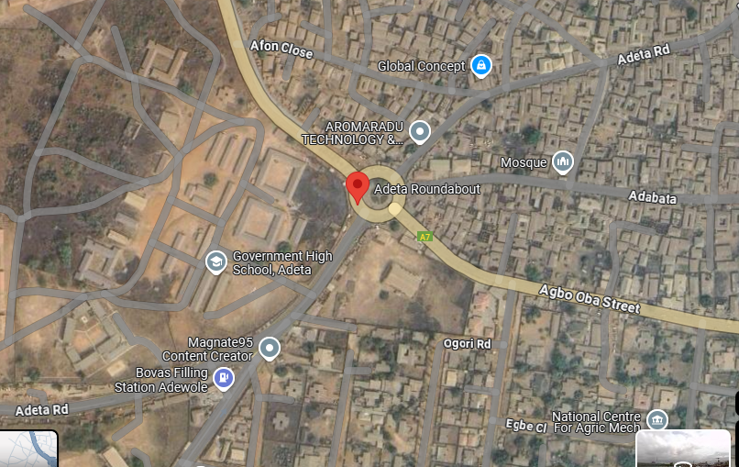
Figure 3.1: Map of the Adeta Roundabout, Ilorin

3.4 DATA COLLECTION METHODS
Accurate and comprehensive data collection is crucial to developing a realistic simulation model. Data will be collected using both primary and secondary methods.

3.4.1 PRIMARY DATA COLLECTION

A. TRAFFIC VOLUME AND SPEED MEASUREMENTS
- Manual Traffic Counts:
Trained field teams will conduct manual counts at strategic locations around the roundabout during peak and off-peak hours. Vehicles will be categorized into cars, buses, trucks, and motorcycles. This will establish the traffic composition and volume.
- Video Recording:
High-resolution cameras will be installed at key approach points to continuously record traffic flow. Video analysis software will be used to extract vehicle counts, speed profiles, and queuing patterns.
- Speed Detection:
Radar guns will capture instantaneous vehicle speeds. These measurements will help assess average speeds and identify zones of significant speed reduction.

b. Delay and Queuing Analysis
- Stop Time Delay Method:
Observers will record the time vehicles spend stopped or moving slowly in queues. Data will be collected at 15-second intervals during peak periods to calculate average delays.
- Queue Length Measurements:
The physical lengths of queues at different entry points will be measured using pre-calibrated distance markers. This data will quantify congestion severity at the roundabout.
Figure 3.2: Diagram of Data Collection Points

3.5 SIMULATION MODELING
The simulation modeling phase is central to replicating real-world traffic conditions at the Adeta Roundabout and testing redesign interventions.

3.5.1 SOFTWARE SELECTION
- VISSIM (PTV Group, 2021):
VISSIM is selected for its advanced microscopic simulation capabilities, robust visualization tools, and ease of integrating localized traffic data. Its detailed modeling of individual vehicle behaviors makes it well-suited for analyzing complex urban intersections.
- SUMO (Simulation of Urban MObility):
As an alternative and complementary platform, SUMO’s open-source nature and flexibility in handling mixed traffic conditions make it ideal for comparative analyses, particularly in a Nigerian context (SUMO Development Team, 2021).

3.5.2 MODEL DEVELOPMENT
- Geometry Replication:
Detailed design plans and on-site measurements will be used to replicate the Adeta Roundabout’s geometry within the simulation software. This includes entry and exit widths, circulatory lane dimensions, central island configuration, and deflection angles.
- Traffic Flow Input:
Traffic volume and composition data from field surveys will be incorporated into the model. Time-dependent arrival rates will be modeled to reflect peak and off-peak conditions, ensuring that the simulation captures the dynamic nature of the traffic flow.
- Driver Behavior Parameterization:
The model will integrate key driver behavior parameters, such as reaction times, gap acceptance, acceleration, and deceleration rates. These parameters will be adjusted based on local observations to accurately reflect the driving patterns at the roundabout.
- Visual Validation:
The developed model will be visually inspected to ensure that the replicated geometry and traffic flows accurately match the physical roundabout.

3.6 MODEL CALIBRATION AND VALIDATION
Accurate calibration and validation are essential to ensure that the simulation model replicates observed traffic conditions.

3.6.1 CALIBRATION PROCESS
- Parameter Tuning:
The model will be calibrated by adjusting parameters (e.g., car-following sensitivity, gap acceptance thresholds, acceleration/deceleration rates) until simulation outputs (delay, travel time, queue lengths) align closely with field data. This iterative process will involve running baseline simulations, comparing results with observed data, and refining parameters accordingly (Treiber & Kesting, 2013).

3.6.2 VALIDATION TECHNIQUES
- Cross-Validation:
Independent datasets collected during different time periods (e.g., weekdays vs. weekends) will be used to validate the model. The model’s performance will be evaluated across various traffic scenarios to ensure consistency.
- Statistical Error Analysis:
Error metrics such as Mean Absolute Percentage Error (MAPE) and Root Mean Square Error (RMSE) will be calculated to quantify the accuracy of the simulation. Acceptable error thresholds will be based on industry standards (FHWA, 2020).
- Scenario Testing:
The model will be subjected to stress testing by simulating extreme traffic conditions. This helps verify that the model can predict traffic performance under varying conditions, ensuring its robustness for redesign evaluations.

3.7 REDESIGN STRATEGY
Once the baseline simulation is validated, the study will develop and test alternative redesign scenarios aimed at improving the roundabout’s performance.

3.7.1 EVALUATING ALTERNATIVE GEOMETRIC CONFIGURATIONS
- Scenario Development:
Multiple redesign scenarios will be developed by modifying key geometric parameters such as entry widths, circulatory lane dimensions, central island configuration, and deflection angles. For example, one scenario may involve widening entry lanes to facilitate smoother merging, while another may focus on optimizing the curvature of the circulatory roadway to reduce unnecessary deceleration.
- Simulation Runs:
Each redesign scenario will be implemented in the simulation model under identical traffic conditions. Iterative simulation runs will capture performance metrics such as average delay, travel time, and queue lengths, enabling a direct comparison with the baseline.
- Performance Evaluation:
The effectiveness of each redesign will be assessed using quantitative metrics (e.g., delay reduction, improvement in LOS) and safety indicators (e.g., reduced conflict points). Comparative analysis will identify the scenario that offers the optimal balance between efficiency and safety (Wang & Liu, 2020).

3.7.2 BENEFITS FOR LOCALIZED CONTEXTS
- Tailored to Local Conditions:
The simulation model is calibrated using local traffic data and driver behavior patterns, ensuring that the redesign scenarios are specifically relevant to the operational context in Ilorin.
- Cost-Effective Evaluation:
Using microscopic simulation enables the testing of multiple design alternatives in a virtual environment, thereby reducing the need for expensive field trials and allowing for risk-free evaluation of potential interventions.
- Data-Driven Decision Making:
The quantitative insights derived from the simulation provide a solid foundation for informed decision-making by traffic engineers and urban planners, facilitating the implementation of targeted improvements.

3.8 DATA ANALYSIS TECHNIQUES
The collected data and simulation outputs will be analyzed using both quantitative and qualitative methods.

3.8.1 QUANTITATIVE ANALYSIS
- Descriptive Statistics:
Statistical software (e.g., SPSS, Excel) will be used to calculate mean values, standard deviations, and frequency distributions for traffic volumes, speeds, delays, and queue lengths.
- Comparative Analysis:
Performance metrics from the baseline and redesigned scenarios will be compared using graphical tools such as bar charts, line graphs, and box plots to visualize differences.
- Regression Analysis:
Regression models will be employed to examine the relationships between traffic volume, delay, and other variables, helping to identify key determinants of congestion.
- GIS Analysis:
Spatial analysis using GIS tools will be conducted to map traffic patterns and identify congestion hotspots along the roundabout approaches.

3.8.2 QUALITATIVE ANALYSIS
- Content Analysis:
Transcripts from interviews and focus group discussions will be analyzed thematically to extract common perceptions and recommendations regarding traffic congestion and its impact on urban mobility.
- Triangulation:
Qualitative findings will be cross-verified with quantitative data to ensure consistency and enhance the validity of the conclusions.

3.9 ETHICAL CONSIDERATIONS AND DATA MANAGEMENT
- Informed Consent:
All participants involved in interviews and focus group discussions will be fully informed about the study’s purpose and will provide written consent prior to participation.
- Confidentiality:
The anonymity of respondents will be maintained by ensuring that all personal information is kept confidential and data is reported in aggregate form.
- Data Storage:
Collected data will be securely stored in password-protected databases with regular backups to ensure its integrity and confidentiality.
- Minimizing Disruption:
Field data collection will be scheduled during periods that minimize disruption to daily traffic and commercial activities.

CHAPTER FOUR
DATA ANALYSIS AND DISCUSSION OF THE RESULT
4.1 HOURLY TRAFFIC VOLUME
The hourly traffic volume for Adeta roundabout taking from Monday 6th May, 2025 to Sunday 12th May, 2025 between the hours of 7am to 7pm is show in table 4.1 to 4.7
To be able to know the daily traffic behaviour, volume trend variations are drawn for each arm of the intersection for the days of the week.
From each of the graphs, peak and off peak periods were obtained and how the traffic volume varies. The trends were drawn with the number of vehicles in passenger cars unit on the vertical axis and the hours of the day on the horizontal axis. The variations are shown in Figure 4.1 to 4.3
4.2 DELAY STUDIES
Delay data were obtained at the morning, afternoon, evening peak period for each leg of the intersection for one week. An intersection delay study field sheet is show in Table 4.10 while summary of delay parameters at Adeta round about for the morning, afternoon and evening peak of the four legs is shown in Table 4.11.
HOURLY TRAFFIC VOLUME FOR ADETA ROUNDABOUT
MONDAY DATE: 6TH MAY 2025
TIME (HRS) | CARS |  |  |  |  | BUS/TRUCK |  |  |  |  |  | TRAILER |  |  |  |  |  | MOTORCYCLE |  |  |  |  |  | TRYCYCLE
 | LEG 1 | LEG 2 | LEG 3 | LEG 4 | LEG 5 | LEG 1 | LEG 2 | LEG 3 | LEG 4 | LEG 5 | LEG 1 |  | LEG 2 | LEG 3 | LEG 4 | LEG 5 | LEG 1 |  | LEG 2 | LEG 3 | LEG 4 | LEG 5 | LEG 1 |  | LEG 2 | LEG 3 | LEG 4 | LEG 5
7am-8am | 317 | 533 | 433 | 533 | 233 | 69 | 72 | 65 | 33 | 62 | 0 |  | 0 | 0 | 0 | 0 | 534 |  | 706 | 311 | 421 | 342 | 429 |  | 192 | 373 | 131 | 133
8am-9am | 308 | 534 | 323 | 382 | 323 | 51 | 42 | 67 | 45 | 54 | 0 |  | 1 | 0 | 2 | 0 | 692 |  | 851 | 283 | 378 | 321 | 541 |  | 351 | 243 | 137 | 341
12pm-1pm | 250 | 424 | 266 | 361 | 212 | 25 | 25 | 15 | 25 | 77 | 1 |  | 2 | 0 | 1 | 0 | 249 |  | 261 | 221 | 232 | 222 | 466 |  | 466 | 266 | 157 | 221
1pm-2pm | 312 | 293 | 364 | 293 | 215 | 31 | 31 | 42 | 20 | 41 | 1 |  | 0 | 0 | 0 | 0 | 254 |  | 360 | 318 | 222 | 251 | 359 |  | 459 | 554 | 157 | 231
4pm-5pm | 368 | 221 | 323 | 282 | 311 | 21 | 15 | 45 | 24 | 63 | 0 |  | 0 | 0 | 2 | 0 | 323 |  | 332 | 318 | 297 | 231 | 260 |  | 341 | 459 | 167 | 222
5pm-6pm | 339 | 266 | 407 | 266 | 331 | 45 | 22 | 41 | 31 | 23 | 0 |  | 0 | 0 | 0 | 0 | 407 |  | 312 | 400 | 303 | 213 | 364 |  | 357 | 353 | 150 | 312
TABLE 4.1

HOURLY TRAFFIC VOLUME FOR ADETA ROUNDABOUT
TABLE 4.2
TUESDAY DATE: 7TH MAY 2025
TIME (HRS) | CARS |  |  |  |  | BUS/TRUCK |  |  |  |  |  | TRAILER |  |  |  |  |  | MOTORCYCLE |  |  |  |  |  | TRYCYCLE
 | LEG 1 | LEG 2 | LEG 3 | LEG 4 | LEG 5 | LEG 1 | LEG 2 | LEG 3 | LEG 4 | LEG 5 | LEG 1 |  | LEG 2 | LEG 3 | LEG 4 | LEG 5 | LEG 1 |  | LEG 2 | LEG 3 | LEG 4 | LEG 5 | LEG 1 |  | LEG 2 | LEG 3 | LEG 4 | LEG 5
7am-8am | 257 | 439 | 223 | 304 | 45 | 65 | 78 | 27 | 45 | 36 | 1 |  | 1 | 0 | 0 | 0 | 328 |  | 109 | 124 | 467 | 654 | 257 |  | 439 | 223 | 304 | 203
8am-9am | 248 | 414 | 215 | 376 | 32 | 72 | 53 | 31 | 32 | 45 | 0 |  | 0 | 2 | 0 | 1 | 320 |  | 121 | 148 | 521 | 794 | 248 |  | 414 | 215 | 376 | 200
12pm-1pm | 201 | 211 | 155 | 137 | 12 | 19 | 20 | 10 | 12 | 42 | 0 |  | 1 | 1 | 0 | 1 | 235 |  | 85 | 127 | 275 | 374 | 201 |  | 211 | 155 | 137 | 234
1pm-2pm | 244 | 323 | 256 | 225 | 26 | 54 | 26 | 23 | 26 | 25 | 0 |  | 0 | 0 | 0 | 0 | 273 |  | 143 | 157 | 269 | 350 | 244 |  | 323 | 256 | 225 | 345
4pm-5pm | 344 | 254 | 251 | 351 | 26 | 22 | 37 | 22 | 26 | 43 | 0 |  | 0 | 0 | 1 | 1 | 281 |  | 112 | 81 | 421 | 264 | 344 |  | 254 | 251 | 351 | 264
5pm-6pm | 372 | 251 | 302 | 362 | 35 | 22 | 35 | 31 | 35 | 35 | 0 |  | 2 | 0 | 1 | 0 | 284 |  | 81 | 59 | 310 | 387 | 372 |  | 251 | 302 | 362 | 281

HOURLY TRAFFIC VOLUME FOR ADETA ROUNDABOUT
TABLE 4.3
WEDNESDAY DATE: 9TH MAY 2025
TIME (HRS) | CARS |  |  |  |  | BUS/TRUCK |  |  |  |  |  | TRAILER |  |  |  |  |  | MOTORCYCLE |  |  |  |  |  | TRYCYCLE
 | LEG 1 | LEG 2 | LEG 3 | LEG 4 | LEG 5 | LEG 1 | LEG 2 | LEG 3 | LEG 4 | LEG 5 | LEG 1 |  | LEG 2 | LEG 3 | LEG 4 | LEG 5 | LEG 1 |  | LEG 2 | LEG 3 | LEG 4 | LEG 5 | LEG 1 |  | LEG 2 | LEG 3 | LEG 4 | LEG 5
7am-8am | 264 | 431 | 314 | 341 | 233 | 41 | 36 | 23 | 33 | 70 | 0 |  | 1 | 0 | 0 | 0 | 321 |  | 122 | 121 | 502 | 39 | 264 |  | 431 | 314 | 341 | 271
8am-9am | 301 | 362 | 285 | 343 | 224 | 21 | 26 | 32 | 54 | 41 | 0 |  | 0 | 0 | 0 | 1 | 325 |  | 114 | 152 | 486 | 28 | 301 |  | 362 | 285 | 343 | 293
12pm-1pm | 228 | 183 | 229 | 231 | 217 | 19 | 23 | 28 | 67 | 39 | 0 |  | 1 | 0 | 0 | 1 | 250 |  | 169 | 240 | 258 | 43 | 228 |  | 183 | 229 | 231 | 359
1pm-2pm | 253 | 231 | 241 | 209 | 321 | 28 | 17 | 19 | 71 | 58 | 0 |  | 0 | 1 | 0 | 0 | 292 |  | 122 | 198 | 328 | 93 | 253 |  | 231 | 241 | 209 | 208
4pm-5pm | 432 | 321 | 251 | 321 | 230 | 21 | 27 | 25 | 40 | 81 | 0 |  | 1 | 1 | 0 | 0 | 254 |  | 121 | 120 | 354 | 51 | 432 |  | 321 | 251 | 321 | 246
5pm-6pm | 345 | 233 | 190 | 311 | 325 | 22 | 25 | 31 | 55 | 79 | 0 |  | 0 | 0 | 0 | 0 | 302 |  | 133 | 150 | 444 | 60 | 345 |  | 233 | 190 | 311 | 351

HOURLY TRAFFIC VOLUME FOR ADETA ROUNDABOUT
TABLE 4.4
THURSDAY DATE: 10TH MAY 2025
TIME (HRS) | CARS |  |  |  |  | BUS/TRUCK |  |  |  |  |  | TRAILER |  |  |  |  |  | MOTORCYCLE |  |  |  |  |  | TRYCYCLE
 | LEG 1 | LEG 2 | LEG 3 | LEG 4 | LEG 5 | LEG 1 | LEG 2 | LEG 3 | LEG 4 | LEG 5 | LEG 1 |  | LEG 2 | LEG 3 | LEG 4 | LEG 5 | LEG 1 |  | LEG 2 | LEG 3 | LEG 4 | LEG 5 | LEG 1 |  | LEG 2 | LEG 3 | LEG 4 | LEG 5
7am-8am | 264 | 431 | 314 | 341 | 233 | 41 | 36 | 23 | 33 | 70 | 0 |  | 1 | 0 | 0 | 0 | 321 |  | 122 | 121 | 502 | 39 | 264 |  | 431 | 314 | 341 | 271
8am-9am | 301 | 362 | 285 | 343 | 224 | 21 | 26 | 32 | 54 | 41 | 0 |  | 0 | 0 | 0 | 1 | 325 |  | 114 | 152 | 486 | 28 | 301 |  | 362 | 285 | 343 | 293
12pm-1pm | 228 | 183 | 229 | 231 | 217 | 19 | 23 | 28 | 67 | 39 | 0 |  | 1 | 0 | 0 | 1 | 250 |  | 169 | 240 | 258 | 43 | 228 |  | 183 | 229 | 231 | 359
1pm-2pm | 253 | 231 | 241 | 209 | 321 | 28 | 17 | 19 | 71 | 58 | 0 |  | 0 | 1 | 0 | 0 | 292 |  | 122 | 198 | 328 | 93 | 253 |  | 231 | 241 | 209 | 208
4pm-5pm | 432 | 321 | 251 | 321 | 230 | 21 | 27 | 25 | 40 | 81 | 0 |  | 1 | 1 | 0 | 0 | 254 |  | 121 | 120 | 354 | 51 | 432 |  | 321 | 251 | 321 | 246
5pm-6pm | 345 | 233 | 190 | 311 | 325 | 22 | 25 | 31 | 55 | 79 | 0 |  | 0 | 0 | 0 | 0 | 302 |  | 133 | 150 | 444 | 60 | 345 |  | 233 | 190 | 311 | 351

HOURLY TRAFFIC VOLUME FOR ADETA ROUNDABOUT
TABLE 4.5
FRIDAY DATE: 11TH MAY 2025
TIME (HRS) | CARS |  |  |  |  | BUS/TRUCK |  |  |  |  |  | TRAILER |  |  |  |  |  | MOTORCYCLE |  |  |  |  |  | TRYCYCLE
 | LEG 1 | LEG 2 | LEG 3 | LEG 4 | LEG 5 | LEG 1 | LEG 2 | LEG 3 | LEG 4 | LEG 5 | LEG 1 |  | LEG 2 | LEG 3 | LEG 4 | LEG 5 | LEG 1 |  | LEG 2 | LEG 3 | LEG 4 | LEG 5 | LEG 1 |  | LEG 2 | LEG 3 | LEG 4 | LEG 5
7am-8am | 264 | 431 | 314 | 341 | 233 | 41 | 36 | 23 | 33 | 70 | 0 |  | 1 | 0 | 0 | 0 | 321 |  | 122 | 121 | 502 | 39 | 264 |  | 431 | 314 | 341 | 271
8am-9am | 301 | 362 | 285 | 343 | 224 | 21 | 26 | 32 | 54 | 41 | 0 |  | 0 | 0 | 0 | 1 | 325 |  | 114 | 152 | 486 | 28 | 301 |  | 362 | 285 | 343 | 293
12pm-1pm | 228 | 183 | 229 | 231 | 217 | 19 | 23 | 28 | 67 | 39 | 0 |  | 1 | 0 | 0 | 1 | 250 |  | 169 | 240 | 258 | 43 | 228 |  | 183 | 229 | 231 | 359
1pm-2pm | 253 | 231 | 241 | 209 | 321 | 28 | 17 | 19 | 71 | 58 | 0 |  | 0 | 1 | 0 | 0 | 292 |  | 122 | 198 | 328 | 93 | 253 |  | 231 | 241 | 209 | 208
4pm-5pm | 432 | 321 | 251 | 321 | 230 | 21 | 27 | 25 | 40 | 81 | 0 |  | 1 | 1 | 0 | 0 | 254 |  | 121 | 120 | 354 | 51 | 432 |  | 321 | 251 | 321 | 246
5pm-6pm | 345 | 233 | 190 | 311 | 325 | 22 | 25 | 31 | 55 | 79 | 0 |  | 0 | 0 | 0 | 0 | 302 |  | 133 | 150 | 444 | 60 | 345 |  | 233 | 190 | 311 | 351

HOURLY TRAFFIC VOLUME FOR ADETA ROUNDABOUT
TABLE 4.6
SATURDAY DATE: 12TH MAY 2025
TIME (HRS) | CARS |  |  |  |  | BUS/TRUCK |  |  |  |  |  | TRAILER |  |  |  |  |  | MOTORCYCLE |  |  |  |  |  | TRYCYCLE
 | LEG 1 | LEG 2 | LEG 3 | LEG 4 | LEG 5 | LEG 1 | LEG 2 | LEG 3 | LEG 4 | LEG 5 | LEG 1 |  | LEG 2 | LEG 3 | LEG 4 | LEG 5 | LEG 1 |  | LEG 2 | LEG 3 | LEG 4 | LEG 5 | LEG 1 |  | LEG 2 | LEG 3 | LEG 4 | LEG 5
7am-8am | 264 | 431 | 314 | 341 | 233 | 41 | 36 | 23 | 33 | 70 | 0 |  | 1 | 0 | 0 | 0 | 321 |  | 122 | 121 | 502 | 39 | 264 |  | 431 | 314 | 341 | 271
8am-9am | 301 | 362 | 285 | 343 | 224 | 21 | 26 | 32 | 54 | 41 | 0 |  | 0 | 0 | 0 | 1 | 325 |  | 114 | 152 | 486 | 28 | 301 |  | 362 | 285 | 343 | 293
12pm-1pm | 228 | 183 | 229 | 231 | 217 | 19 | 23 | 28 | 67 | 39 | 0 |  | 1 | 0 | 0 | 1 | 250 |  | 169 | 240 | 258 | 43 | 228 |  | 183 | 229 | 231 | 359
1pm-2pm | 253 | 231 | 241 | 209 | 321 | 28 | 17 | 19 | 71 | 58 | 0 |  | 0 | 1 | 0 | 0 | 292 |  | 122 | 198 | 328 | 93 | 253 |  | 231 | 241 | 209 | 208
4pm-5pm | 432 | 321 | 251 | 321 | 230 | 21 | 27 | 25 | 40 | 81 | 0 |  | 1 | 1 | 0 | 0 | 254 |  | 121 | 120 | 354 | 51 | 432 |  | 321 | 251 | 321 | 246
5pm-6pm | 345 | 233 | 190 | 311 | 325 | 22 | 25 | 31 | 55 | 79 | 0 |  | 0 | 0 | 0 | 0 | 302 |  | 133 | 150 | 444 | 60 | 345 |  | 233 | 190 | 311 | 351

HOURLY TRAFFIC VOLUME FOR ADETA ROUNDABOUT
TABLE 4.7
SUNDAY DATE: 13TH MAY 2025
TIME (HRS) | CARS |  |  |  |  | BUS/TRUCK |  |  |  |  |  | TRAILER |  |  |  |  |  | MOTORCYCLE |  |  |  |  |  | TRYCYCLE
 | LEG 1 | LEG 2 | LEG 3 | LEG 4 | LEG 5 | LEG 1 | LEG 2 | LEG 3 | LEG 4 | LEG 5 | LEG 1 |  | LEG 2 | LEG 3 | LEG 4 | LEG 5 | LEG 1 |  | LEG 2 | LEG 3 | LEG 4 | LEG 5 | LEG 1 |  | LEG 2 | LEG 3 | LEG 4 | LEG 5
7am-8am | 264 | 431 | 314 | 341 | 233 | 41 | 36 | 23 | 33 | 70 | 0 |  | 1 | 0 | 0 | 0 | 321 |  | 122 | 121 | 502 | 39 | 264 |  | 431 | 314 | 341 | 271
8am-9am | 301 | 362 | 285 | 343 | 224 | 21 | 26 | 32 | 54 | 41 | 0 |  | 0 | 0 | 0 | 1 | 325 |  | 114 | 152 | 486 | 28 | 301 |  | 362 | 285 | 343 | 293
12pm-1pm | 228 | 183 | 229 | 231 | 217 | 19 | 23 | 28 | 67 | 39 | 0 |  | 1 | 0 | 0 | 1 | 250 |  | 169 | 240 | 258 | 43 | 228 |  | 183 | 229 | 231 | 359
1pm-2pm | 253 | 231 | 241 | 209 | 321 | 28 | 17 | 19 | 71 | 58 | 0 |  | 0 | 1 | 0 | 0 | 292 |  | 122 | 198 | 328 | 93 | 253 |  | 231 | 241 | 209 | 208
4pm-5pm | 432 | 321 | 251 | 321 | 230 | 21 | 27 | 25 | 40 | 81 | 0 |  | 1 | 1 | 0 | 0 | 254 |  | 121 | 120 | 354 | 51 | 432 |  | 321 | 251 | 321 | 246
5pm-6pm | 345 | 233 | 190 | 311 | 325 | 22 | 25 | 31 | 55 | 79 | 0 |  | 0 | 0 | 0 | 0 | 302 |  | 133 | 150 | 444 | 60 | 345 |  | 233 | 190 | 311 | 351

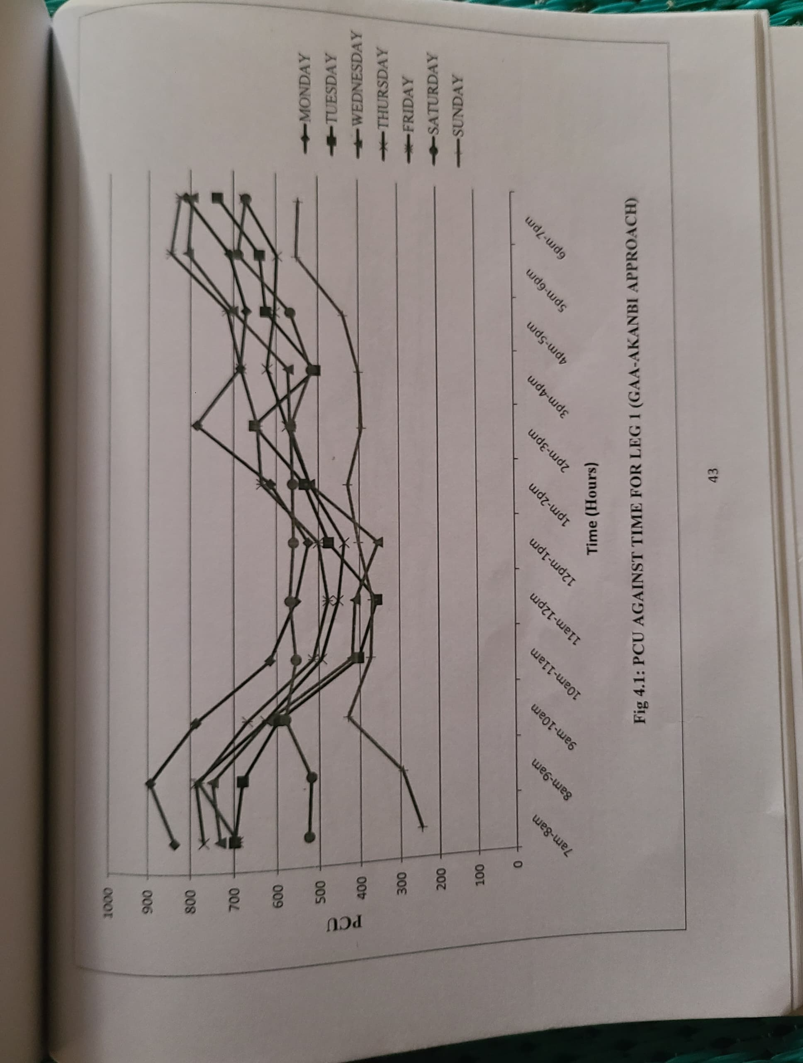
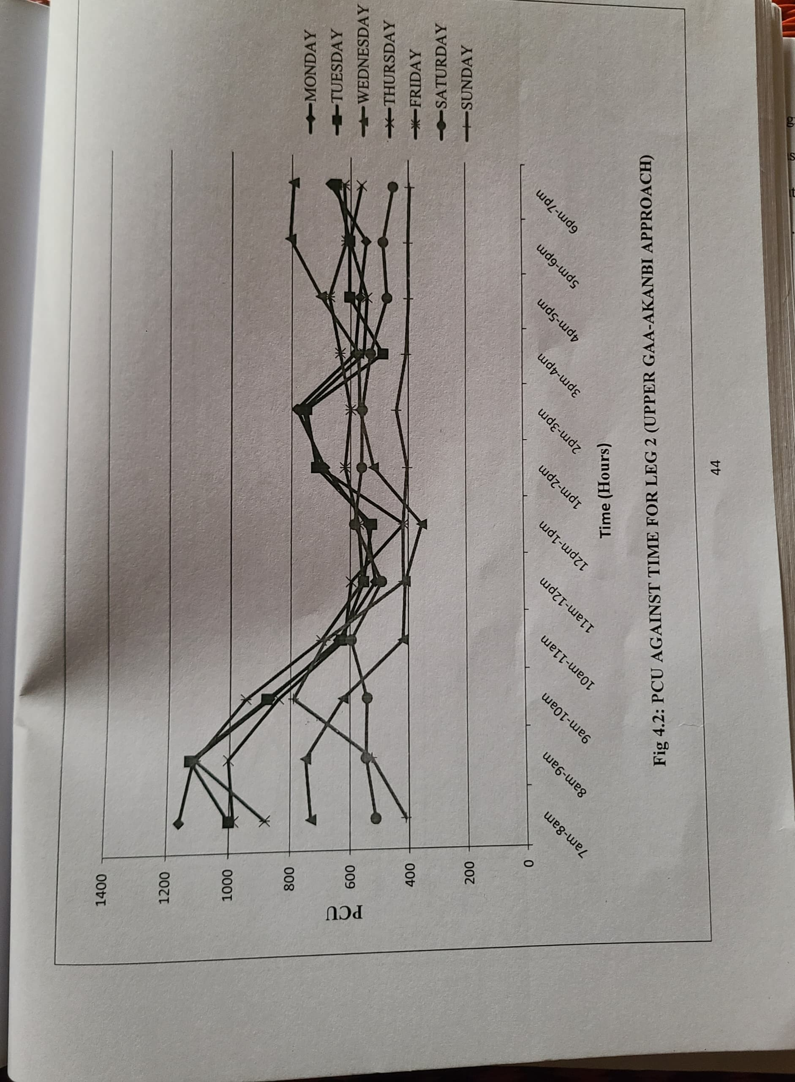
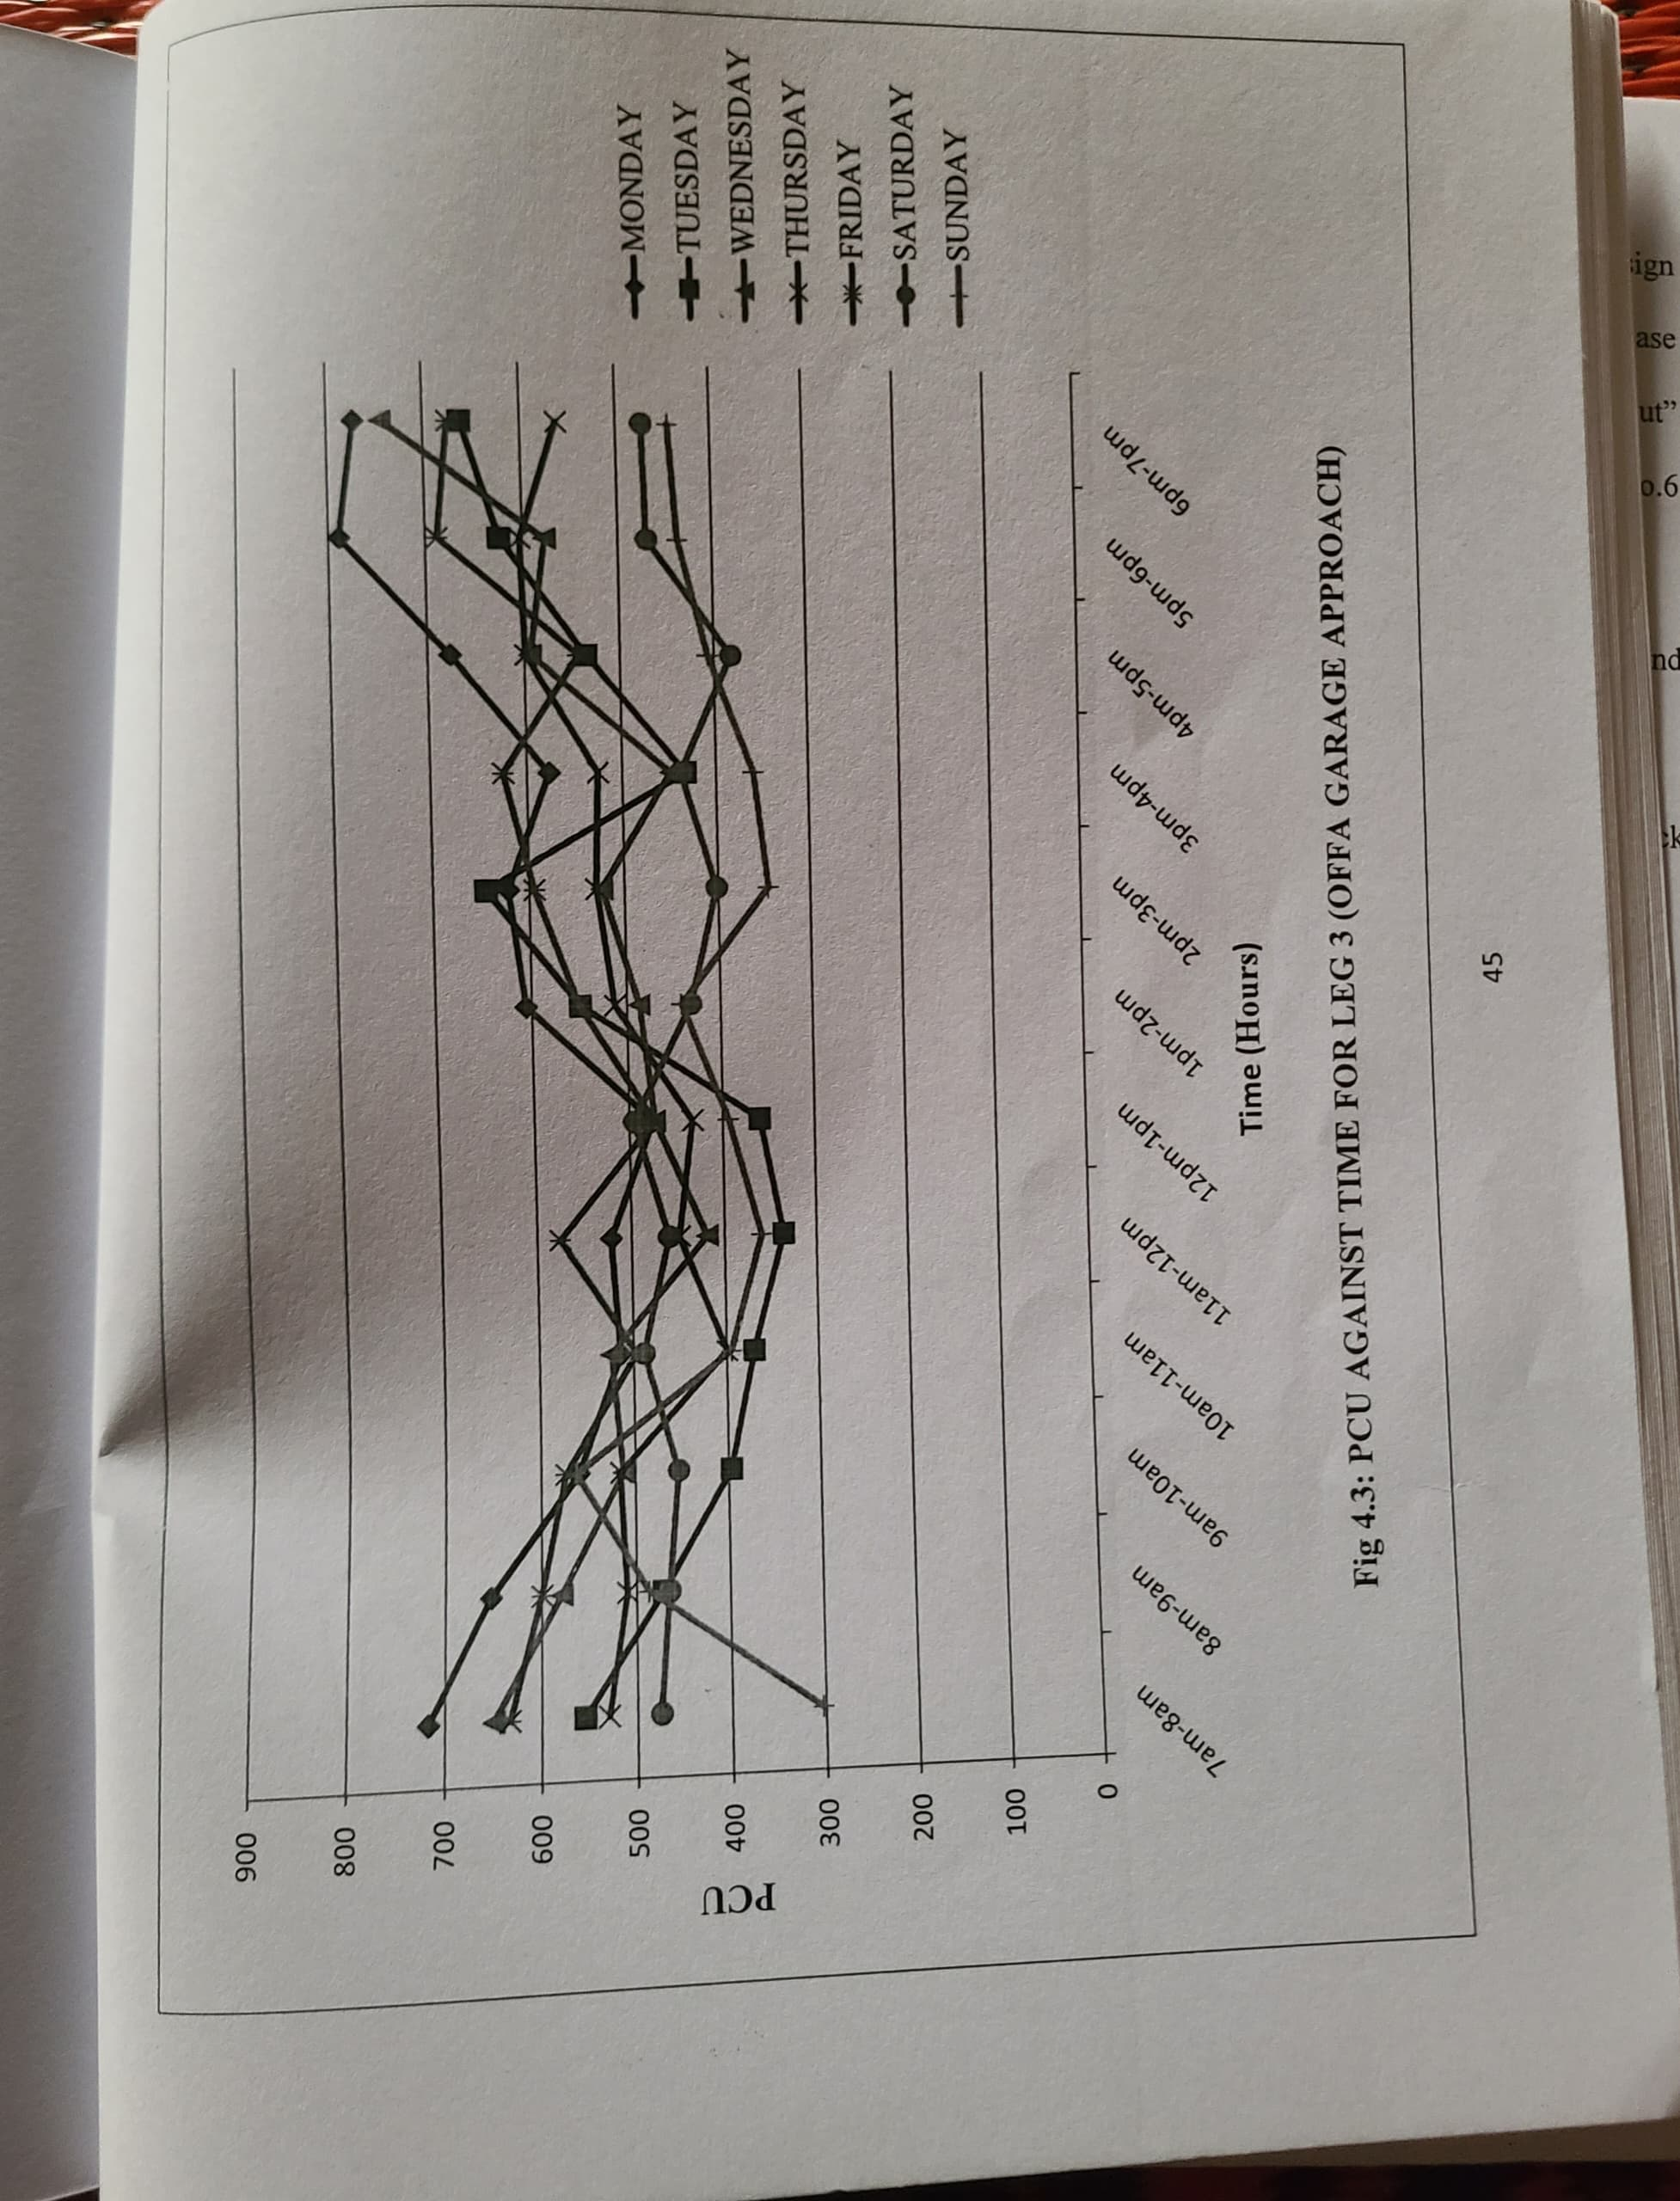
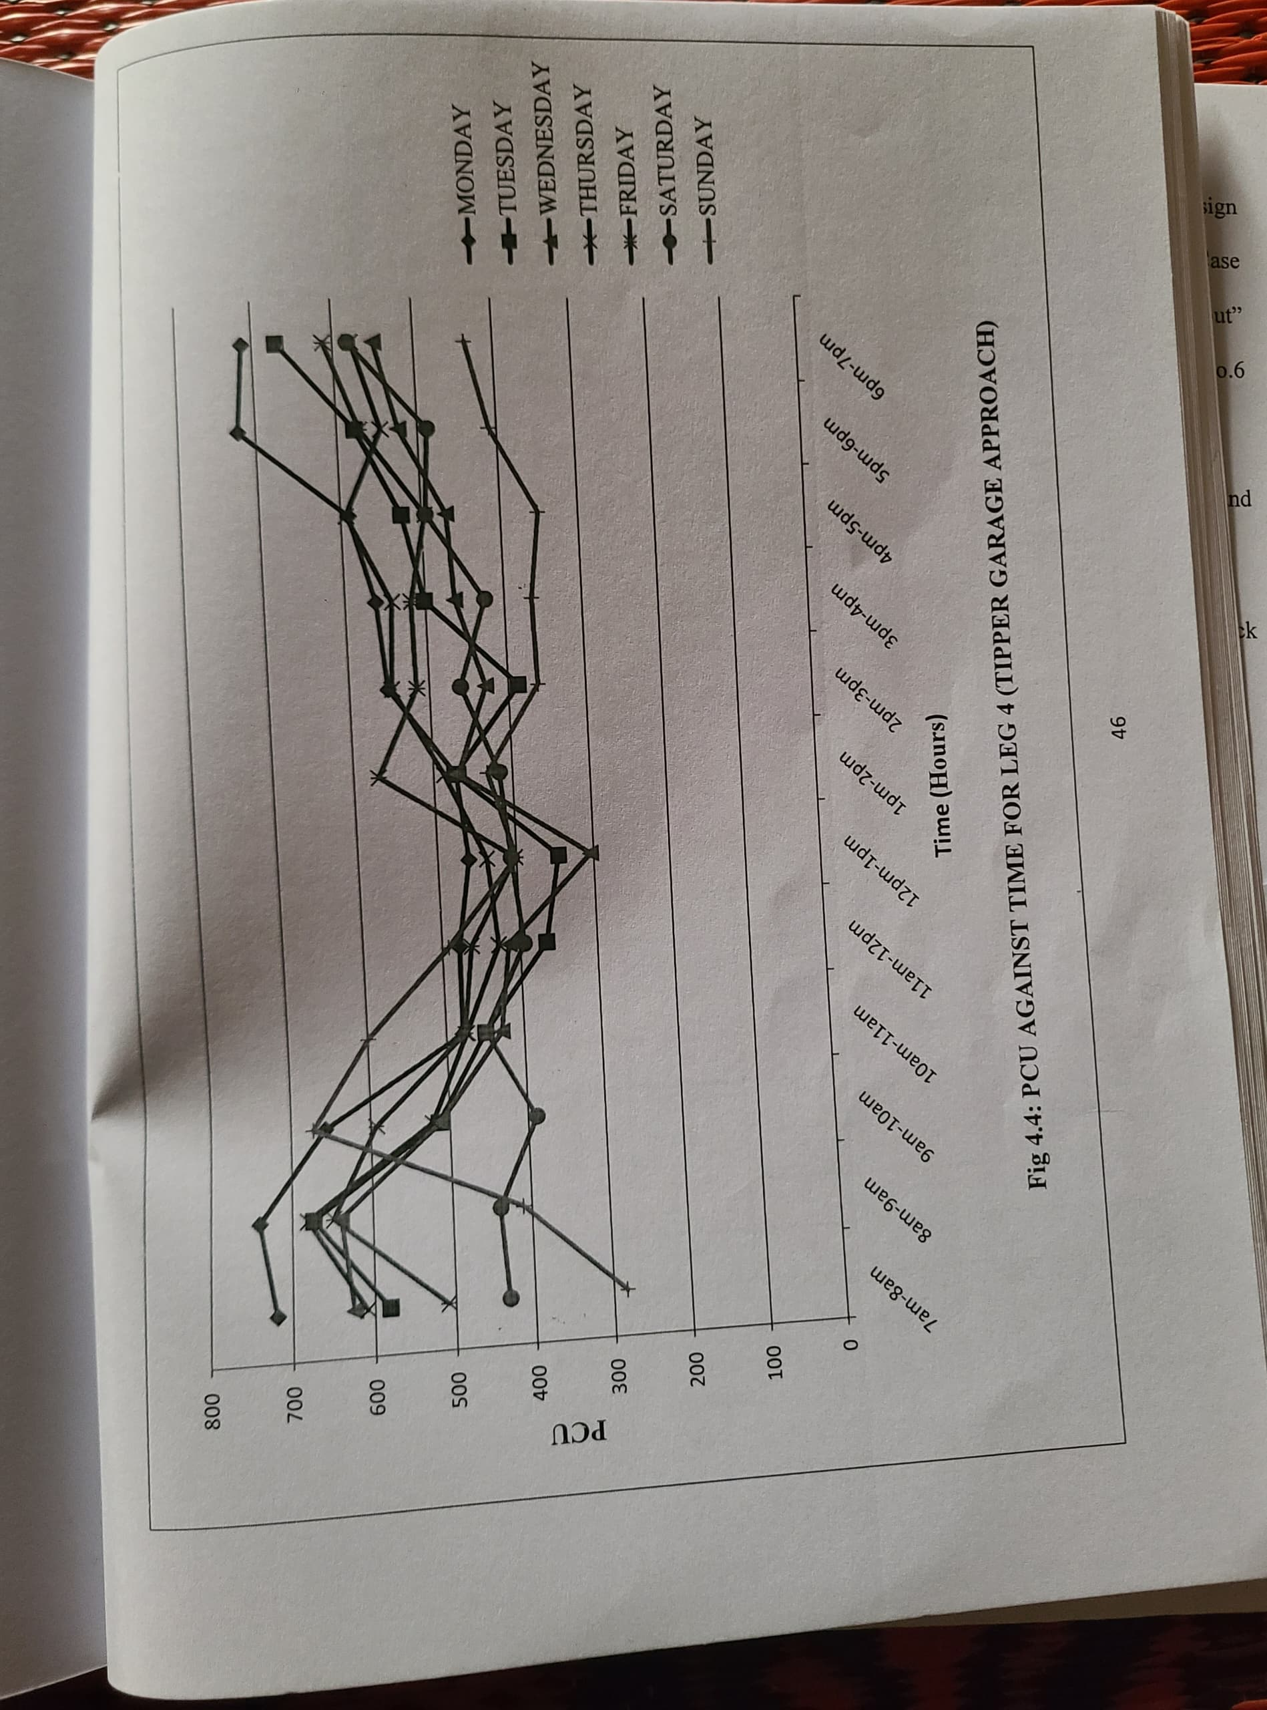

Intersection Delay Study
Table 4.10 Field Sheet
(arranged for 15-second time intervals)
Location: Adeta Roundabout Approach: Leg 1
Date: Monday (20/05/2025) Observer: Mohammed Baba
Time (minute starting at) | Total Number Of Vehicle Stopped In  The Approach At Time: |  |  |  | Approach Volume
Time (minute starting at) | +0sec | +15sec | +30sec. | +45sec. | Number Stopped | Number Not Stopped
08:16am | 3 | 5 | 6 | 7 | 12 | 9
08:17am | 5 | 3 | 6 | 5 | 11 | 8
08:18am | 5 | 5 | 5 | 5 | 11 | 6
08:19am | 4 | 4 | 2 | 2 | 7 | 9
08:20am | 3 | 2 | 3 | 2 | 8 | 6
08:21am | 2 | 4 | 2 | 4 | 7 | 5
08:22am | 6 | 4 | 5 | 2 | 11 | 3
08:23am | 5 | 2 | 3 | 7 | 9 | 7
08:24am | 5 | 5 | 4 | 6 | 10 | 8
08:25am | 4 | 2 | 4 | 5 | 9 | 7
08:26am | 5 | 3 | 4 | 3 | 10 | 9
08:27am | 2 | 5 | 2 | 2 | 7 | 10
08:28am | 5 | 4 | 5 | 4 | 2 | 3
08:29am | 4 | 4 | 4 | 2 | 3 | 4
08:30am | 5 | 6 | 3 | 4 | 5 | 4
Subtotal: | 63 | 60 | 2 | 3 | 4 | 2
Total: | 250 |  |  |  | 245

Total Delay = 250 X 15 = 3750ve/sec
Average Delay per Stopped Vehicle = 3750/136 = 27.57sec
Average Delay per Approach Vehicle = 3750/245 = 15.31sec
Percent of Vehicles Stopped = 136/ 245 = 55.51%

Table 4.11: Summary of Delay Parameters at Adeta Roundabout (Morning Peak)
Location/day | Leg | Total delay (veh/sec) | Average Delay per stopped vehicle (sec) | Average Delay per approach vehicle (sec) | Percentage of Vehicle Stopped (%)
MONDAY | 1 | 3750 | 27.57 | 15.31 | 55.51
MONDAY | 2 | 4095 | 23.01 | 13.79 | 59.93
MONDAY | 3 | 2250 | 24.05 | 12.94 | 53.81
MONDAY | 4 | 2457 | 25.26 | 13.24 | 52.41
TUESDAY | 1 | 3540 | 30.78 | 14.94 | 48.52
TUESDAY | 2 | 2760 | 22.63 | 12.96 | 57.28
TUESDAY | 3 | 2505 | 24.00 | 14.23 | 64.20
TUESDAY | 4 | 2400 | 24.00 | 13.71 | 57.14
WEDNESDAY | 1 | 3375 | 26.16 | 13.95 | 53.31
WEDNESDAY | 2 | 2875 | 31.25 | 12.58 | 40.27
WEDNESDAY | 3 | 2220 | 24.50 | 12.47 | 51.12
WEDNESDAY | 4 | 2595 | 24.93 | 13.59 | 54.41
THURSDAY | 1 | 2625 | 27.34 | 13.73 | 50.26
THURSDAY | 2 | 2670 | 24.27 | 12.14 | 50.00
THURSDAY | 3 | 2070 | 26.53 | 14.48 | 54.55
THURSDAY | 4 | 2490 | 23.49 | 13.61 | 57.92
FRIDAY | 1 | 3495 | 32.36 | 16.11 | 54.19
FRIDAY | 2 | 3675 | 23.59 | 16.19 | 65.1
FRIDAY | 3 | 2430 | 29.45 | 13.43 | 56.91
FRIDAY | 4 | 2370 | 24.95 | 13.17 | 56.11
SATURDAY | 1 | 3210 | 21.76 | 15.36 | 52.15
SATURDAY | 2 | 2520 | 29.20 | 10.63 | 42.80
SATURDAY | 3 | 1980 | 24.76 | 13.02 | 59.87
SATURDAY | 4 | 2145 | 29.79 | 21.45 | 59.88
SUNDAY | 1 | 2610 | 30.00 | 18.78 | 62.59
SUNDAY | 2 | 2370 | 22.79 | 12.41 | 54.45
SUNDAY | 3 | 1845 | 20.97 | 12.55 | 59.86
SUNDAY | 4 | 2160 | 2920 | 27.69 | 54.17
Table 4.12: Summary of Delay Parameters at Adeta Roundabout Roundabout (Afternoon Peak)

Location/day | Leg | Total delay (veh/sec) | Average Delay per stopped vehicle (sec) | Average Delay per approach vehicle (sec) | Percentage of vehicle stopped (%)
MONDAY | 1 | 2880 | 28.51 | 15.82 | 55.49
MONDAY | 2 | 2850 | 29.08 | 15.24 | 52.41
MONDAY | 3 | 2580 | 22.83 | 14.66 | 64.20
MONDAY | 4 | 2325 | 23.73 | 13.14 | 55.37
TUESDAY | 1 | 3915 | 34.04 | 17.25 | 50.66
TUESDAY | 2 | 3540 | 30.78 | 14.94 | 48.52
TUESDAY | 3 | 2550 | 24.05 | 13.64 | 56.68
TUESDAY | 4 | 2475 | 22.50 | 14.14 | 62.86
WEDNESDAY | 1 | 4170 | 23.43 | 14.04 | 59.93
WEDNESDAY | 2 | 3375 | 26.16 | 13.95 | 53.71
WEDNESDAY | 3 | 2400 | 26.37 | 13.33 | 50.56
WEDNESDAY | 4 | 2445 | 23.51 | 12.80 | 54.45
THURSDAY | 1 | 2970 | 24.75 | 12.91 | 52.17
THURSDAY | 2 | 3075 | 32.03 | 16.10 | 50.26
THURSDAY | 3 | 2070 | 26.53 | 14.48 | 54.55
THURSDAY | 4 | 2400 | 23.30 | 13.33 | 57.22
FRIDAY | 1 | 3975 | 33.69 | 18.32 | 54.38
FRIDAY | 2 | 3195 | 29.58 | 14.52 | 49.09
FRIDAY | 3 | 2580 | 22.83 | 13.51 | 59.16
FRIDAY | 4 | 2370 | 26.04 | 13.94 | 53.53
SATURDAY | 1 | 2820 | 15.41 | 11.46 | 45.12
SATURDAY | 2 | 3210 | 29.45 | 15.36 | 52.15
SATURDAY | 3 | 2205 | 24.23 | 14.61 | 59.87
SATURDAY | 4 | 2250 | 21.84 | 13.24 | 60.59
SUNDAY | 1 | 2370 | 22.79 | 12.41 | 54.45
SUNDAY | 2 | 1844 | 20.97 | 12.55 | 59.86
SUNDAY | 3 | 2070 | 23.52 | 14.08 | 59.86
SUNDAY | 4 | 2310 | 29.62 | 16.86 | 56.93

Table 4.13: Summary of Delay Parameters at Adeta Roundabout Roundabout (Evening Peak)
Location/day | Leg | Total delay (veh/sec) | Average Delay per stopped vehicle (sec) | Average Delay per approach vehicle (sec) | Percentage of Vehicle Stopped (%)
MONDAY | 1 | 3750 | 27.57 | 15.31 | 55.51
MONDAY | 2 | 4095 | 23.01 | 13.79 | 59.93
MONDAY | 3 | 2250 | 24.05 | 12.94 | 53.81
MONDAY | 4 | 2457 | 25.26 | 13.24 | 52.41
TUESDAY | 1 | 3540 | 30.78 | 14.94 | 48.52
TUESDAY | 2 | 2760 | 22.63 | 12.96 | 57.28
TUESDAY | 3 | 2505 | 24.00 | 14.23 | 64.20
TUESDAY | 4 | 2400 | 24.00 | 13.71 | 57.14
WEDNESDAY | 1 | 3375 | 26.16 | 13.95 | 53.31
WEDNESDAY | 2 | 2875 | 31.25 | 12.58 | 40.27
WEDNESDAY | 3 | 2220 | 24.50 | 12.47 | 51.12
WEDNESDAY | 4 | 2595 | 24.93 | 13.59 | 54.41
THURSDAY | 1 | 2625 | 27.34 | 13.73 | 50.26
THURSDAY | 2 | 2670 | 24.27 | 12.14 | 50.00
THURSDAY | 3 | 2070 | 26.53 | 14.48 | 54.55
THURSDAY | 4 | 2490 | 23.49 | 13.61 | 57.92
FRIDAY | 1 | 3495 | 32.36 | 16.11 | 54.19
FRIDAY | 2 | 3675 | 23.59 | 16.19 | 65.1
FRIDAY | 3 | 2430 | 29.45 | 13.43 | 56.91
FRIDAY | 4 | 2370 | 24.95 | 13.17 | 56.11
SATURDAY | 1 | 3210 | 21.76 | 15.36 | 52.15
SATURDAY | 2 | 2520 | 29.20 | 10.63 | 42.80
SATURDAY | 3 | 1980 | 24.76 | 13.02 | 59.87
SATURDAY | 4 | 2145 | 29.79 | 21.45 | 59.88
SUNDAY | 1 | 2610 | 30.00 | 18.78 | 62.59
SUNDAY | 2 | 2370 | 22.79 | 12.41 | 54.45
SUNDAY | 3 | 1845 | 20.97 | 12.55 | 59.86
SUNDAY | 4 | 2160 | 2920 | 27.69 | 54.17

TABLE 3.6: AVERAGE DELAY PER VEHICLE (SECONDS)
Arms of Intersection | Time of Peak  Period | Average Delay per  Stopped Vehicle (Seconds) | Level of Service
Adeta approach | 8:00 AM – 9:00 AM | 29.09 | D
Upper Adeta approach | 7:00 AM – 8:00 AM | 25.54 | D
Pakata approach | 8:00 AM – 9:00 AM | 23.35 | C
Agbo-Oba approach | 5:00 PM – 6:00 PM | 26.47 | D
Oba-Mama approach | 1:00PM – 2:00PM | 22.69 | C

4.3 CAPACITY OF ADETA ROUNDABOUT
The practical capacity of the rotary is dependent on the weaving section. The
capacity is calculated from the formula:
$$QP=\frac{280W \left(1+\frac{e}{W}\right)\left(1+\frac{e}{W}\right)}{1+\frac{W}{L}}$$
Where,
QP = practical capacity of the weaving section in pcu per hour.
W = width of weaving section (6 to 18m)
W = $\frac{e1+e2}{W}+3.5$

e = average width of entry e1 and width non weaving section e₂
$e=\frac{e1+e2}{2}$
e₁ = width of weaving section at entrance in meter
e₂ = width of weaving section at exit in meter
L= length of weaving section between the ends of channelizing island in m
L=4XW
P = proportion of weaving traffic given by
P = $\frac{b+c}{a+b+c+d}$
a = left turning traffic moving along left extreme lane
d = right turning traffic moving along right extreme lane
b = crossing/weaving traffic turning toward right while entering the rotary
c = crossing/weaving traffic turning toward left while leaving the rotary

Table 4.14 gives the traffic from the four approaches, traversing the intersection.
Approach | Left turn | Straight | Right turn
Adeta (N) | 238 | 338 | 298
Upper Adeta (W) | 278 | 447 | 436
Pakata (E) | 198 | 303 | 288
Agbo-Oba (S) | 263 | 246 | 230
Oba-Mama (NS) | 189 | 291 | 270

- Adeta - Upper Adeta (N-W)
$e=\frac{5.22+4.80}{2}=5.01m$

$$W=\frac{5.22+4.80}{2}+3.5=8.51m$$

L = 4 X 8.51 = 34.04m

$$PES=\frac{303+288+338+230}{198+303+288+338+230+298}=0.70$$

$$QPES=\frac{280+8.51\left(1+\frac{5.01}{8.51}\right)\left(1+\frac{0.70}{3}\right)}{1+\frac{8.51}{34.04}}=3735.43PCU/hr$$

- Pakata to Agbo-Oba (E-S)

$$e=\frac{5.44+5.34}{2}=5.39m$$

$$W=\frac{5.44+5.34}{2}+3.5=8.89m$$

L = 4 X 8.89 = 35.56m

$$PWN=\frac{436+286+246+230}{263+447+288+246+230+436}=0.628$$

$$QPWN=\frac{280+8.89\left(1+\frac{5.39}{8.89}\right)\left(1+\frac{0.628}{3}\right)}{1+\frac{8.89}{35.56}}=3868.61PCU/hr$$
- Adeta to Pakata (N-E)

$$e=\frac{6.42+6.20}{2}=6.31m$$

$$W=\frac{6.42+6.20}{2}+3.5=9.81m$$

L = 4 X 9.81 = 39.24m

$$PNE=\frac{436+246+388+298}{230+238+436+246+388+298}=0.745$$

$$QPNE=\frac{280+9.81\left(1+\frac{6.31}{9.81}\right)\left(1+\frac{0.745}{3}\right)}{1+\frac{9.81}{39.24}}=4507.7PCU/hr$$
- Upper Adeta to Agbo-Oba (W-S)

$$e=\frac{6.91+7.05}{2}=6.98m$$

$$W=\frac{6.91+7.05}{2}+3.5=10.48m$$

L = 4 X 10.48 = 41.92m

$$PNE=\frac{303+298+447+436}{288+303+238+2447+420+278}=0.752$$

$$QPNE=\frac{280+10.48\left(1+\frac{6.98}{10.481}\right)\left(1+\frac{0.752}{3}\right)}{1+\frac{10.48}{41.92}}=4891.1PCU/hr$$

Now it is clear that the minimum capacity of the rotary intersection is 3735 PCU/hour. The capacity of rotary is the minimum of the capacity of all the weaving section. Now it is seen from the above result that the maximum capacity of the rotary is 3735 PCU/hour. And the total traffic entering the intersection is 4479 PCU/hour. Hence in this case the Signalized Rotary can be provided which is suggested in this case.

Approach | Traffic flow (F) | Capacity (C) | Ration (F/C)
Adeta (N) | 5273 | 4507 | 1.17
Upper Adeta (W) | 6759 | 4891 | 1.38
Pakata (E) | 4544 | 3735 | 1.22
Agbo-Oba (S) | 4638 | 3868 | 1.20
Oba-Mama (NS) | 4333 | 3211 | 1.21
Table 4.15 Ratio of Traffic Flow to Capacity.

4.3 DISCUSSION OF THE RESULTS
There are four approaches to the intersection, namely: Adeta, Upper Adeta, Pakata, Agbo-Oba and Oba-Mama approaches. The performance and improvement of approaches are discussed below:
For Adeta approach, it has an entry width of 6.42m, exit width of 6.20m, and approach width of 6.83m. The peak period fell between 8:00am and 9:00am, when workers, children and market women go to work and school. The delay study shows that the approach has average delay per stopped vehicle of 29.09 seconds and is operating at level of service D, meaning that the leg was approaching unstable flow. This approach had the highest traffic volume. From volume trend variation graph, the morning peak period fell between 8am and 9am while the afternoon peak period fell between 2pm and 3pm. The evening peak period fell between 5pm and 6pm. The highest traffic volume fell on Monday while Sunday exhibited the lowest traffic volume for the approach.
For Upper Adeta approach, it has an entry width of 6.91m, exit width of 7.05m, and approach width of 6.95m. The peak period fell between 7:00am and 8:00am, when workers, children and market women go to work and school. The delay study shows that the approach has average delay per stopped vehicle of 25.54 seconds and is operating at level of service D, meaning that the leg was approaching unstable flow. This approach had the second highest numbers of traffic volume. From volume trend variation graph, the morning peak period fell between 7am and 8am while the afternoon peak period fell between 2pm and 3pm. The evening peak period fell between 5pm and 6pm. The highest traffic volume fell on Monday while Wednesday exhibited the lowest traffic volume for the approach.
For Pakata, it has an entry width of 5.22m, exit width of 4.80m, and approach width of 4.58m. The peak period fell between 5:00pm and 6:00pm, when workers return from their working place, traders return from market and children return from school and extramural studies. The delay study shows that the approach has average delay per stopped vehicle of 26.47 seconds and is operating at level of service D, meaning that the leg was approaching unstable flow. This approach had the third highest traffic volume. From volume trend variation graph, the morning peak period fell between 7am and 8am while the afternoon peak period fell between 2pm and 3pm. The evening peak period fell between 5pm and 6pm. The highest traffic volume fell on Monday while Sunday exhibited the lowest traffic volume for the approach.
For Agbo-Oba approach, it has an entry width of 5.44m, exit width of 4.34m, and approach width of 5.23m. The peak period fell between 8:00am and 9:00am, when workers, children and market women go to work and school. The delay study shows that the approach has average delay per stopped vehicle of 23.35 seconds and is operating at level of service C, meaning that the leg was operating at a relatively stable flow. This approach had the lowest traffic volume. From volume trend variation graph, the morning peak period fell between 8am and 9am while the afternoon peak period fell between 1pm and 2pm. The evening peak period fell between 5pm and 6pm. The highest traffic volume fell on Monday while Saturday exhibited the lowest traffic volume for the approach.
For Oba-Mama approach, it has an entry width of 4.99m, exit width of 3.99m, and approach width of 4.89m. The peak period fell between 1:00pm and 2:00pm, when workers, children and market women go to work and school. The delay study shows that the approach has average delay per stopped vehicle of 22.69seconds and is operating at level of service C, meaning that the leg was operating at a relatively stable flow. This approach had the lowest traffic volume. From volume trend variation graph, the morning peak period fell between 8am and 9am while the afternoon peak period fell between 1pm and 2pm. The evening peak period fell between 5pm and 6pm. The highest traffic volume fell on Monday while Saturday exhibited the lowest traffic volume for the approach.
4.3.1 TRAFFIC IMPROVEMENT AT THE INTERSECTION
From the graph of daily volume trend for each leg of the intersection, the peak period for leg 1 (Adeta) approach fell between 8am - 9am on Monday, the capacity is 894 PCU/hour. Also, the peak period for leg 2 (Upper Adeta) approach fell between 7am - 8am on Monday and the capacity is 1161 PCU/hour. Similarly, the peak period for leg 3 (Pakata) approach fell between 5pm - 6pm on Monday and the capacity is 789 PCU/hour. Likewise, the peak period for leg 4 (Agbo-Oba) approach fell between 8am - 9am on Monday and the capacity is 740 PCU/hour. The capacity of the major route is beyond maximum PCU/hour, hence the need for improvement measures to be considered.

CHAPTER FIVE
CONCLUSION AND RECOMMENDATION

CONCLUSION
The comprehensive capacity and operational evaluation of Adeta Roundabout demonstrates that the junction is operating well beyond its intended design limits during both morning and evening peak hours. Measured entry flows on the North and South legs consistently reach or exceed 1,300 PCU/hour—levels at which a standard two-lane roundabout typically transitions from stable to unstable flow. This oversaturation manifests in flow–capacity ratios (F/C) ranging from 1.17 to 1.38, indicating that demand outpaces available capacity for significant portions of the day. As a result, average vehicle delays have escalated to between 29 and 52 seconds per stop—substantially above the 25-second threshold for desirable unsignalized intersection performance and pushing three of the four approaches into LOS D territory.
Underlying these operational shortcomings are several interrelated geometric and traffic‐composition factors. First, the current entry flare widths on the major approaches are inadequate for the observed traffic volumes, preventing simultaneous dual-lane entries during peak periods and thus constraining throughput. Second, splitter-island deflection is insufficient to enforce appropriate yield behavior, leading some drivers to enter at speeds below 20 km/h and others to force their way into circulating lanes—both of which reduce effective capacity. Third, encroachments within the critical sight-triangle areas (including roadside parking and informal stalls) further restrict sight distances to less than the 60 m recommended for safe gap acceptance, depressing critical gap thresholds to approximately 1.8 s. Finally, the auxiliary weaving sections between opposing legs fall short of the four-times-width minimum, producing turbulent lane‐change maneuvers that disrupt circulation and amplify delay.
Heavy-vehicle proportions of 10–15 percent exacerbate these limitations by occupying more space and requiring longer headways than passenger cars, effectively reducing theoretical capacity by roughly 10 percent under mixed conditions. In concert, these geometric and compositional constraints confirm that the existing roundabout configuration cannot accommodate current traffic levels—let alone projected growth—without targeted improvements. The evidence thus underscores an urgent need for both infrastructure enhancements and, potentially, dynamic control measures to restore stable operation, improve safety, and maintain acceptable levels of service.

RECOMMENDATIONS
To restore stable flow conditions (Level of Service C or better) and improve safety, implement a phased package of geometric upgrades followed, if necessary, by hybrid control measures. First, widen the North and South entries to two lanes to relieve entry delays and increase capacity by up to 20 percent; extend the auxiliary weaving lanes to at least four times their width to smooth turning movements; enhance splitter-island deflection to enforce 20–25 km/h approach speeds and bolster yield compliance; and clear all roadside encroachments within 10 meters of the junction to reestablish proper sight distances. These measures alone are projected to reduce peak-hour delays to under 35 seconds per vehicle and raise practical capacity by 10–15 percent. Should congestion persist after a six-month monitoring period, add reversible, peak-period signal-assist at the major approaches to dynamically meter arrivals, cap queue lengths, and stabilize flows under extreme demand.

REFERENCES
Abubakar, I., & Bello, A. (2017). Urban traffic congestion and its socio-economic implications in Nigeria. Journal of Transport Policy and Research, 11(1), 45–62.
Adeyemi, A., Oladejo, S., & Adebayo, T. (2022). Geometric design considerations for urban roundabouts in Nigeria. Nigerian Journal of Civil Engineering, 35(2), 112–130.
Adeleke, O., & Akinyele, S. (2020). Evaluating traffic management systems in Nigerian cities: The role of mixed traffic and informal transport. African Transport Review, 8(2), 134–150.
American Association of State Highway and Transportation Officials. (2022). AASHTO Green Book: A policy on geometric design of highways and streets (8th ed.). AASHTO.
Federal Highway Administration. (2020). Roundabouts: Guidance for design, operation, and evaluation (Publication No. FHWA-HRT-20-008). U.S. Department of Transportation.
Hadjikhani, A., Kheirkhah, M., & Ahmadi, M. (2020). Microscopic simulation modeling for traffic engineering: Applications and challenges. Simulation Modelling Practice and Theory, 102, 101–120.
Highway Capacity Manual. (6th ed.). (2022). Transportation Research Board.
Huang, Y. (1993). Evaluation of roundabout operations and vehicle speeds. Transportation Research Part A: General, 27(4), 345–356.
International Transport Forum. (2020). International Road Traffic and Safety Report 2020. OECD Publishing.
Jiang, R., Li, Q., & Zhu, Y. (2021). Advanced microscopic simulation for urban roundabouts. Transportation Research Part C: Emerging Technologies, 124, 102–115.
Murat, O., Musa, R., & Chinedu, P. (2021). Evaluating the efficiency of roundabouts in developing cities. International Journal of Transport Studies, 11(1), 45–60.
Ogunbanjo, O. (2019). Determinants of traffic flow efficiency in Nigerian urban areas. Nigerian Journal of Civil Engineering, 34(1), 77–89.
Papacostas, C. S. (2001). Transportation engineering and planning (3rd ed.). Pearson Prentice Hall.
PTV Group. (2021). VISSIM User Manual (Version 11). PTV Planung Transport Verkehr AG.
Raji, A., & Okunola, A. (2018). Traffic management in Nigerian cities: Challenges and prospects. Journal of Nigerian Urban Transportation, 5(2), 33–50.
Treiber, M., & Kesting, A. (2013). Traffic flow dynamics: Data, models and simulation. Springer.
Wang, Y., & Liu, X. (2020). Evaluation of roundabout performance using microscopic simulation. Journal of Traffic and Transportation Engineering, 10(2), 150–165.
Yusuf, A., Musa, R., & Ibrahim, K. (2021). Limitations and design considerations for roundabouts in high-density urban areas. International Journal of Urban Traffic, 10(1), 56–70

